Abstract of Proposed Technical Paper
2nd International Planetary Probe Workshop

Family System of Advanced Charring Ablators
for Planetary Exploration Missions

William M. Congdon
Applied Research Associates, Inc.

Donald M. Curry
NASA Johnson Space Center

Under NASA’s In-Space Propulsion Program, extensive thermal testing was performed during the past two years to characterize and qualify selected ARA ablative materials for NASA planetary exploration missions. Principal facilities were the IHF arc-jet at Ames Research Center for convective heating tests and the Solar Tower Facility at Sandia National Laboratories for thermal radiation tests. Missions of interest included spacecraft aerocapture at Titan and direct entry into Mars. The primary ARA ablators were low-density silicones and phenolics, all under 20 lb/ft³ (0.32 g/cm³). Planned aerocapture at Titan has shown relatively mild levels of convective heating up to approximately 41 W/cm² but more severe radiative heating up to about 150 W/cm². Mars entry for upcoming missions may involve convective heating to as high as 300 W/cm². This proposed paper focuses of finalized test results from the arc-jet and solar facilities and the resulting thermal protection system designs for several planned missions. TPS thickness and weight as a function of alternative aeroshell structures are also addressed.

Because of Titan’s relatively high radiation environment, some initial concerns were that: 1) radiation might penetrate in-depth within the ablator, thus increasing its “apparent” thermal conductivity and degrading insulation performance; 2) radiation might cause high rates of subsurface pyrolysis and generation of high-pressure gasses sufficient to cause ablator spallation; and 3) some radiation might actually penetrate/transmit to the bondline resulting in early and/or significant temperature increase of the aeroshell structure. During thermal radiation testing that was conducted in the Solar Tower all of these concerns were addressed and found to not be a problem for the ARA ablator formulations. The materials were subjected to square pulse environments at flux levels of 100 and 150 W/cm² for times that far exceeded predicted flight durations for such high heat heating. They were also subjected to “exact” flux vs. time environments in test using programmed heliostat focusing in the Solar Tower facility. All of the candidate materials showed no spallation and very good thermal performance to these imposed environments. The figure below shows posttest photographs of the ARA SRAM-17 silicone ablator after exposure to the worst-case predicted radiation environment for the Titan mission, which is a 145-second shaped pulse that peaks at 150 W/cm² with total integrated heating of 10,610 J/cm².

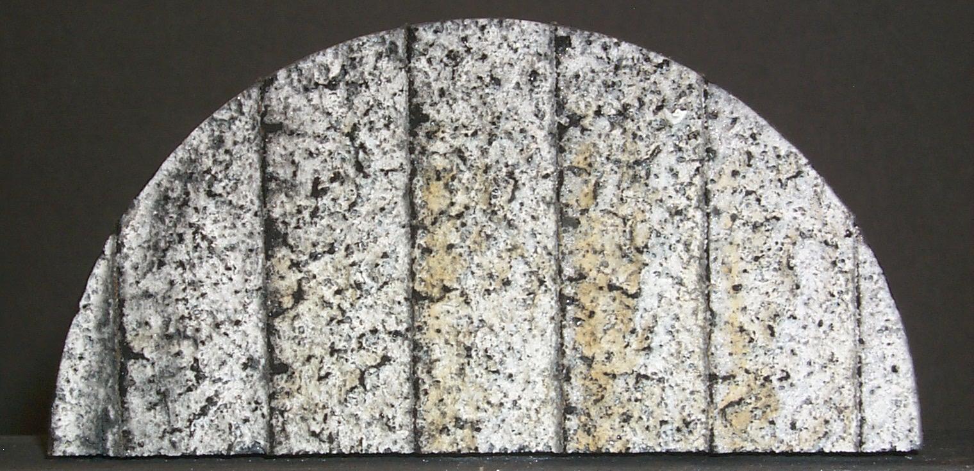

Sample 4056
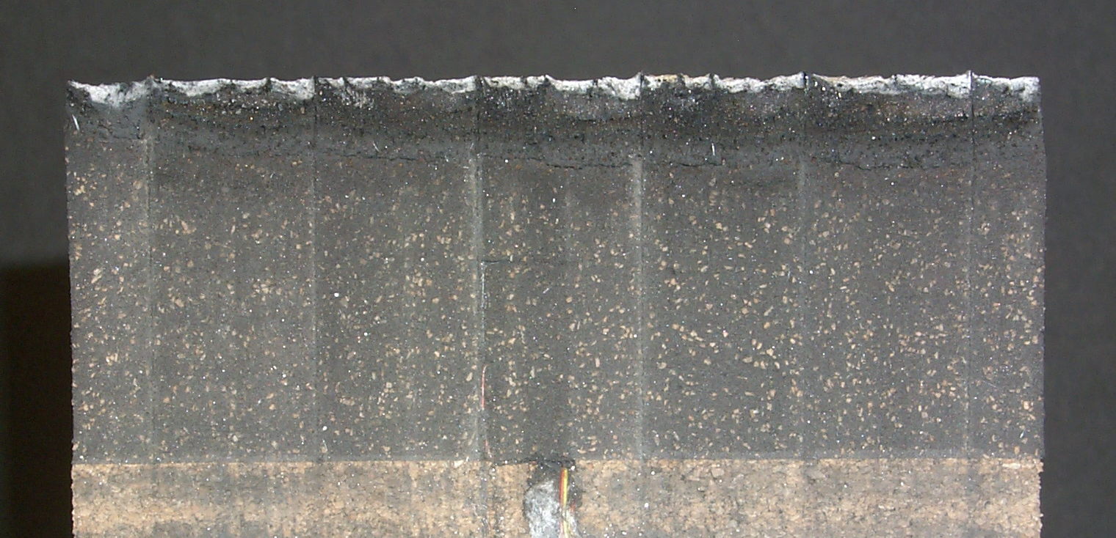

Tunnel Flow

SRAM-17 Sample 4056 After Solar Tower Testing to
Titan’s 150 W/cm² Shaped Radiation Pulse

