Management System: Standard Accounting and Reporting System (STARS)

Subject Area: Accounts Payable

Procedure: Entering Invoices Through the Vendor Inquiry Payment Electronic Reporting System (VIPERS)
Revised Issue Date: 8/14/07 | Lead Subject Matter Expert: Lynda Vinyard | Management System Owner: CFO

1.0 Applicability
The purpose of this document is to provide an overview of the process to submit invoices electronically to the ORFSC and interface them into STARS using the Vendor Inquiry Payment Electronic Reporting System (VIPERS). It is recommended that the plan outlined below be used by Department of Energy vendors to submit electronic invoices and to check status of outstanding invoice payments.

2.0 Required Procedure
Step 1 If you already have a VIPERS logon, go to the VIPERS website https://finweb.oro.doe.gov/vipers.htm, click on “Logon to VIPERS” and enter your e-mail address and password. Go to Step 7.
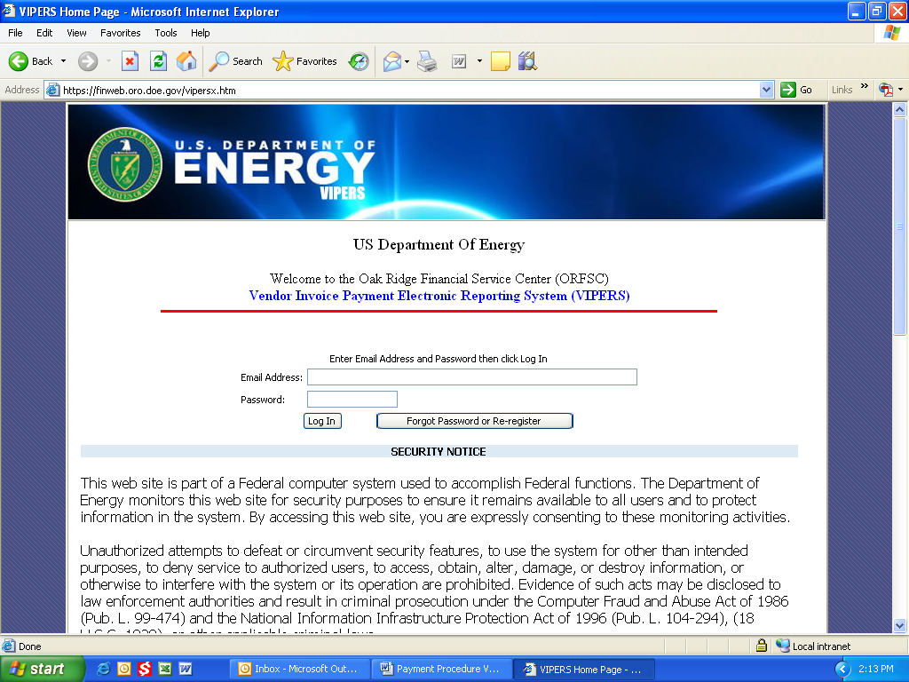

Step 2 If you do not have a VIPERS logon, Go to the VIPERS website https://finweb.oro.doe.gov/vipers.htm and Click on the Request VIPERS Access button.
Step 3 Enter your e-mail address and confirm the e-mail. Enter a password. Passwords must be at least 8 characters and contain at least one upper case and one lower case letter and at least one number. Confirm your password. Enter the company tax id number (TIN) or your social security number if an individual, DOE Contract number, contact name, and business phone number.
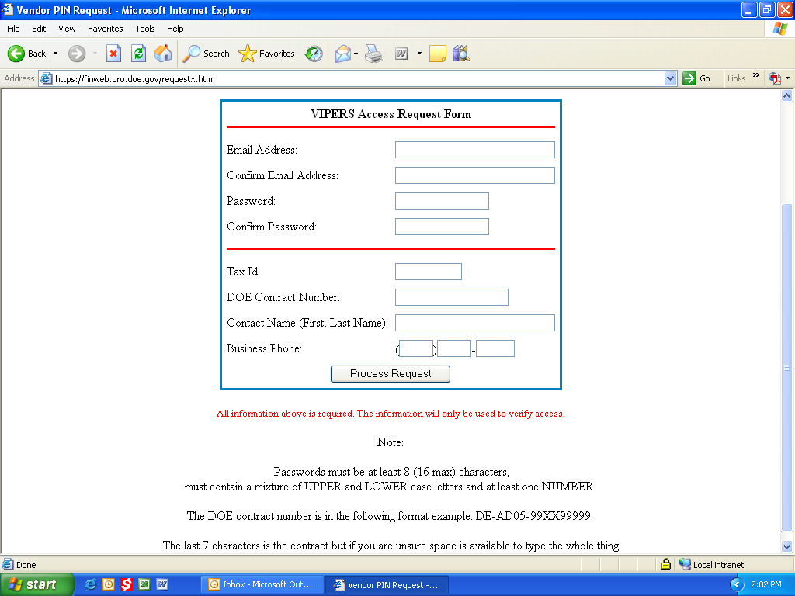

Step 4 Click on Process Request.
Step 5 You will receive an e-mail. You must confirm the registration by clicking the link in this e-mail.
Step 6 Log into VIPERS using your e-mail address and password.
Step 7 You will get a security notice, disclaimer and privacy notice. If you agree with all the terms, click I Understand the Security Notice, Click Here for VIPERS button.
Step 8 The VIPERS home page will be displayed.

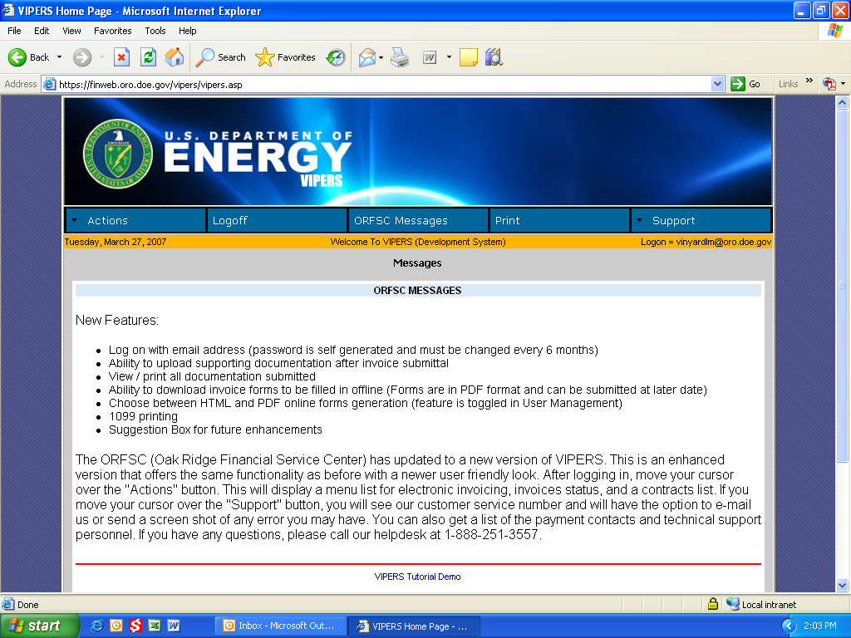
Step 9 Click on the Actions button. You will get a list for Electronic Invoice, Offline Invoicing, Invoice Status, Show Contracts, User Management, 1099 Printing, and Suggestions.

Electronic Invoicing
Step 10 Click on the Electronic Invoice button
Step 11 You will get a list of all the contracts your company has with the Department of Energy.
Step 12 Choose the Purchase order number you wish to invoice against.

Step 13 You will be asked to verify the payment site information by clicking in the circle next to the site.
Step 14 Next you will be given the opportunity to make any changes to banking, contact name, contact phone number, address, or remittance e-mail.
Step 15 If everything is correct, Click the Verify button.
Step 16 If changes need to be made, type in the correct information in the space provided and Click the Verify button. An e-mail will be sent to the Oak Ridge Financial Service Center (ORFSC) and someone will make the changes manually in our accounting system. This is not an automatic update.
Step 17 The appropriate form will be displayed based on your contract type. For contracts, you will get standard form 1034; for grants, you will get standard form 270; for purchase orders, you will get a standard purchase order form; and for employee training, you will get the DOE training reimbursement form.

SF 270 – Request for Advance or Reimbursement
REQUEST FOR ADVANCE  OR REIMBURSEMENT |  |  |  |  |  | OMB APPROVAL NO. |  |  |  | PAGE 1 OF 1
 |  |  |  |  |  | 1.  TYPE OF  PAYMENT  REQUESTED | a. “X” one or both boxes   Advance Reimbursement |  |  | 2. BASIS OF REQUEST  CASH  ACCRUAL
 |  |  |  |  |  | 1.  TYPE OF  PAYMENT  REQUESTED | b. “X” one or both boxes  Final Partial
3. Federal sponsoring agency and organizational element to which this report is submitted |  |  |  |  |  | 4. Federal grant or other  identifying number assigned  by federal agency  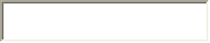 |  |  | 5. Partial payment request  number for this request  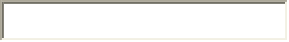
6. Employer Identification Number  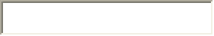 |  | 7. Recipient’s account number or identifying number  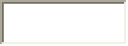  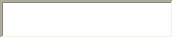 |  |  |  | 8.  PERIOD COVERED BY THIS REQUEST
 |  |  |  |  |  | FROM (month, day, year)  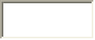 |  |  | TO (month, day, year)
9. RECIPIENT ORGANIZATION (name and address)  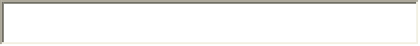 |  |  |  |  |  | 10. PAYEE (Where check is to be sent if different than item 9)
11.
COMPUTATION OR AMOUNT OF REIMBURSEMENTS/ADVANCE REQUESTED
PROGRAMS/FUNCTIONS/ACTIVITIES |  |  |  | (a)   | (b) |  |  | (c) |  |  | TOTAL
a. Total program
outlays to date
b. Less: Cumulative program income
c. Net program outlays (Line a minus
line b)
d. Estimated net cash outlays for advance
period
e. Total (Sum of lines c & d)
f. Non-Federal share of amount on line e
g. Federal share of amount on line e
h. Federal payments previously requested
i. Federal share now requested (Line g
minus line h)
j. Advances required by  month, when requested  by federal grantor  agency for use in making  prescheduled advances. | 1st month
 | 2nd month
 | 3rd month
12. ALTERNATIVE COMPUTATION FOR ADVANCES ONLY
a. Estimated Federal cash outlays that will be made during period covered by the advance
b. Less: Estimated balance of Federal cash on hand as of beginning of advance period
c. Amount requested (Line a minus line b)
AUTHORIZED FOR LOCAL REPRODUCTION STANDARD FORM 270 # (Rev. 7-97)
Prescribed by OMB Circulars A-102 and A-110
13.
CERTIFICATION
I certify that to the best of my  Knowledge and belief the data on the  reverse are correct and that all outlays  were made in accordance with the  grant conditions or other agreement  and that payment is due and has not  been previously requested. |  |  | SIGNATURE OR AUTHORIZED CERTIFYING OFFICIAL |  |  |  |  |  | DATE REQUEST  SUBMITTED
 |  |  | TYPED OR PRINTED NAME AND TITLE |  |  |  |  |  | TELEPHONE (AREA CODE, NUMBER, EXTENSION)

Step 18 Tab through the fields and enter required data.
Step 19 Block 1 – Type an X in either Advance or Reimbursement to indicate the type of payment being requested.
Step 20 Block 2 – Type an X in either Cash or Accrual to indicate the type of accounting system used by your company.
Step 21 Block 3 – Click the down arrow and highlight the name of the DOE office that issued your award. The address for that office will automatically be filled in.
Step 22 Block 4 – Purchase order number/Contract number will be filled in automatically based on what was chosen in Step 12.
Step 23 Block 5 – Enter your invoice number or a sequential payment request number that will be used as an invoice number.
Step 24 Block 6 – Employer Identification Number will be filled in based on what we have in our accounting system for your company.
Step 25 Block 7 – Account number will be filled in based on bank information we have in our accounting system.
Step 26 Block 8 – Enter the period of performance start date in the FROM block and the performance end date in the TO block. These dates should be the time period being billed.
Step 27 Block 9 – Recipient Organization name and address will be filled in based on what we have in our accounting system for your company.
Step 28 Block 10 – If the Payee is different that what is shown in block 9, enter the name and address. If not, leave blank.
Step 29 Block 11 – If your grant has more than one program or type of activity, type the names of the activities in columns entitled Programs/Functions/Activities. The form allows for three different programs. If you only have one program or type of activity, all information can be typed in column (a).
11a. – Enter your total program outlays from the beginning of the grant.
11b. – Enter any program income you may have.
11c. – The net program outlay will be calculated (11a – 11b).
11d. – Enter any estimated net cash outlays for advance requests.
11e. – New total net program outlay will be calculated (11c + 11d).
11f. – Enter any cost share that your company is responsible for.
11g. – Enter the Federal share of line 11e.
11h. – Enter any Federal payments previously requested.
11i. – Federal share now requested will be calculated (11g – 11h).
11j. – Enter any advances that may be required.
Step 30 Block 12 – Fill in required amounts if requesting an advance payment. Otherwise, leave blank.
Step 31 Block 13 – Not required for electronic invoices
Step 32 You can attach up to two documents. If you have supplemental documents to attach, click on Browse. Locate the file you want to attach, and hit enter. Repeat for a second attachment.
Step 33 Click on Send. You will get a message that you are about to transmit an invoice for X dollars, is this correct? Click on OK.
Step 34 You will be prompted to print a copy of the invoice for your files.

SF 1034 – Public Voucher for Purchases and Services Other than Personal

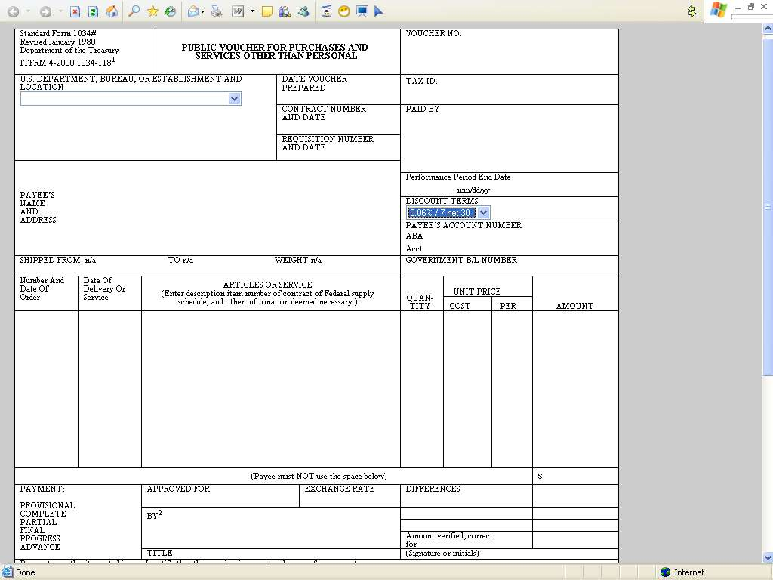

Step 35 In the U.S. Department, Bureau, or Establishment and Location block, click the down arrow and choose the DOE office that issued your award.
Step 36 The Date Voucher Prepared will be filled in with the current date.
Step 37 The Contract number and date will be filled in based on the purchase order chosen in Step 12.
Step 38 The Requisition Number and Date is not required.
Step 39 Fill in the Voucher No. field with your invoice number.
Step 40 Tax ID will be filled in with information from our accounting system.
Step 41 Paid By is not a required field.
Step 42 Payee’s name and address will be filled in with information from our accounting system.
Step 43 Enter the last date of the period you are billing for in the Performance Period End Date field.
Step 44 Discount Terms will default to the payment terms from your purchase order. You can change by offering a discount. Click on the down arrow and choose from the list of discount options.
Step 45 Shipped From, To, and Weight are not required fields.
Step 46 Government B/L Number is not a required field.
Step 47 Number and Date of Order is a free form field. You can either enter dates, numbers or whatever you need to.
Step 48 Enter the date or dates that articles were delivered or services provided in the Date of Delivery or Service block.
Step 49 The Articles or Service bock is also a free form field. You can enter as little or as much information that you need. If you need additional space, you can attach up to two files to the invoice.
Step 50 Quantity is not a required field.
Step 51 Unit Price is not a required field.
Step 52 Enter all amounts in the Amount field. If more than one amount is entered, it will automatically be totaled down.
Step 53 Payee does not enter any additional information on this form.
Step 54 You can attach up to two documents. If you have supplemental documents to attach, click on Browse. Locate the file you want to attach, and hit enter. Repeat for a second attachment.
Step 55 Click on Send. You will get a message that you are about to transmit an invoice for X dollars, is this correct? Click on OK.
Step 56 You will be prompted to print a copy of the invoice for your files.

Standard Purchase Order Form
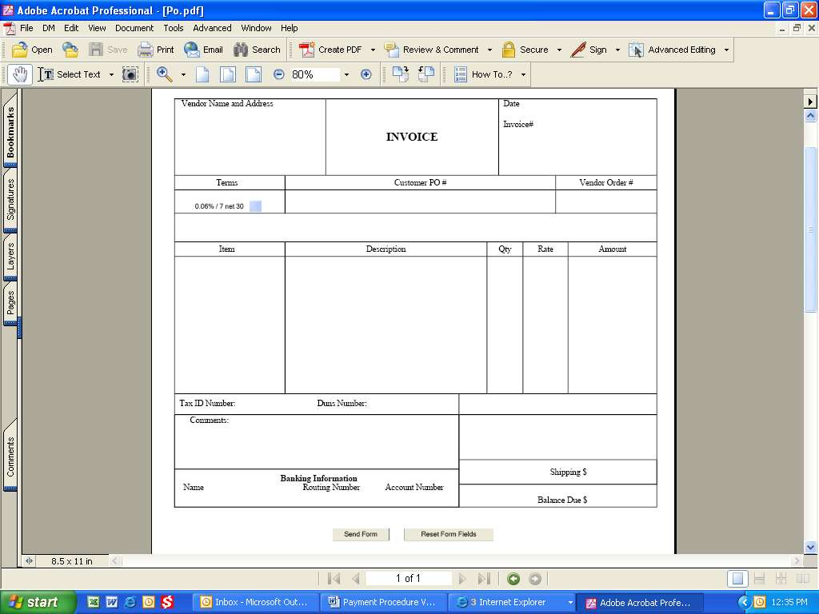

Step 57 Vendor name and address will be filled in with information obtained from our accounting system.
Step 58 Date will be filled is with the current date.
Step 59 Enter your invoice number in the Invoice# block.
Step 60 Terms will default to the ones set up on your purchase order. These can be changed by offering a discount. Click the down arrow and choose the appropriate discount.
Step 61 Customer PO# will be filled with the purchase order number selected in Step 12.
Step 62 Vendor Order# is not a required field.
Step 63 Item is a free form field.
Step 64 Description is a free form field. You can put as little or as much information as needed. If more space is needed, you can attach up to two files to the invoice.
Step 65 Qty is not required but may be used if needed.
Step 66 Rate is not required but may be used if needed.
Step 67 Enter all amounts in the Amount column. If more than one amount is entered, it will automatically total down.
Step 68 Tax ID Number will be filled in with information obtained from our accounting system.
Step 69 Duns Number will be filled in with information obtained from our accounting system if known. If this section is blank, you may enter a valid Duns Number.
Step 70 Enter any comments or special instructions in the Comments field.
Step 71 Banking Information will be filled in with information obtained from our accounting system and verified by you in Step 15.
Step 72 If shipping costs have been authorized, enter them on the Shipping line.
Step 73 Balance Due will calculate from the Amounts and Shipping entered above.
Step 74 You can attach up to two documents. If you have supplemental documents to attach, click on Browse. Locate the file you want to attach, and hit enter. Repeat for a second attachment.
Step 75 Click on Send. You will get a message that you are about to transmit an invoice for X dollars, is this correct? Click on OK.
Step 76 You will be prompted to print a copy of the invoice for your files.

Employee Training Reimbursement Form
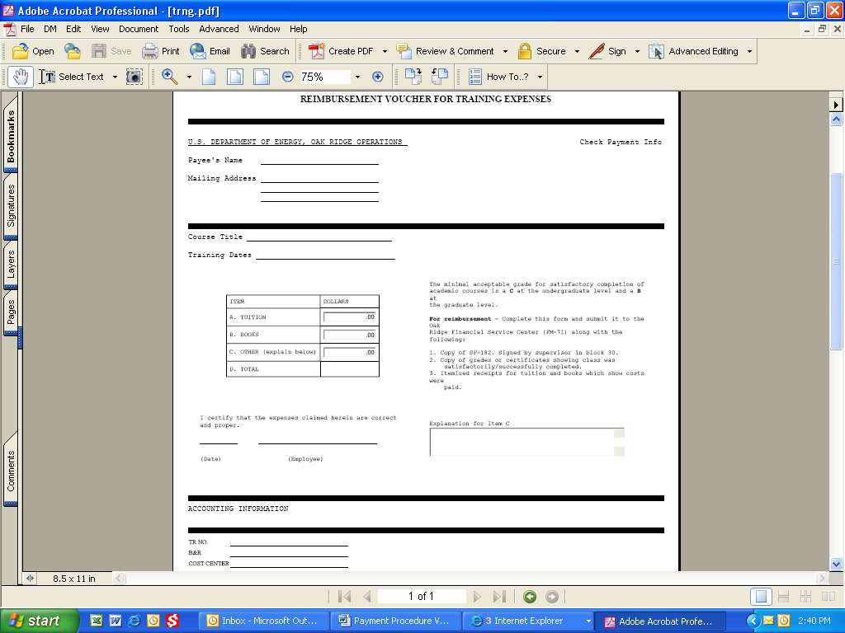

Step 77 Payee’s name and address will be filled in with information obtained from our accounting system.
Step 78 Enter name of class taken as the Course Title.
Step 79 Enter the dates of the class as the Training Dates.
Step 80 Enter the tuition amount in block A, book fees in block B, and any other expenses in block C of the expense section. The total will be calculated automatically.
Step 81 The current date will be filled in on the Date line.
Step 82 The employee’s name will be filled in on the Employee line.
Step 83 If an amount was recorded on the Other expenses in block C, an explanation is required in the box provided.
Step 84 The accounting information will be filled in with information obtained from our accounting system.
Step 85 The TR No. will be filled in with the purchase order number chosen in Step 12.
Step 86 B&R is no longer a required field.
Step 87 Cost Center is no longer a required field.
Step 88 When form is complete, Click on Send Form.
Step 89 You will be prompted to print a copy of the form for your files.

Offline Invoicing
Step 90 Blank invoice forms can be downloaded to your PC to be filled in while not logged into VIPERS. After you fill in the invoice it can be submitted in one of two ways.
- Click on the Submit Invoice button contained on the invoice itself.
This is useful if all you need to do is submit the invoice without any documentation.
Even if this option is chosen documentation can still be uploaded online by submitting it through the Invoice Status section.
Note: You do not need to be logged into VIPERS to use this option. However your VIPERS logon and password will be required to submit the form.
- Save the form to your hard drive. Log into VIPERS and submit it in the OFFLINE Invoicing section.
Supporting documentation can also be uploaded with this option.
The blank invoice is in the Adobe Portable Document Format (PDF).
You must have Adobe Acrobat Reader 7.0 or higher or Adobe Professional installed on your PC in order to update and save the form.

3.0 References

