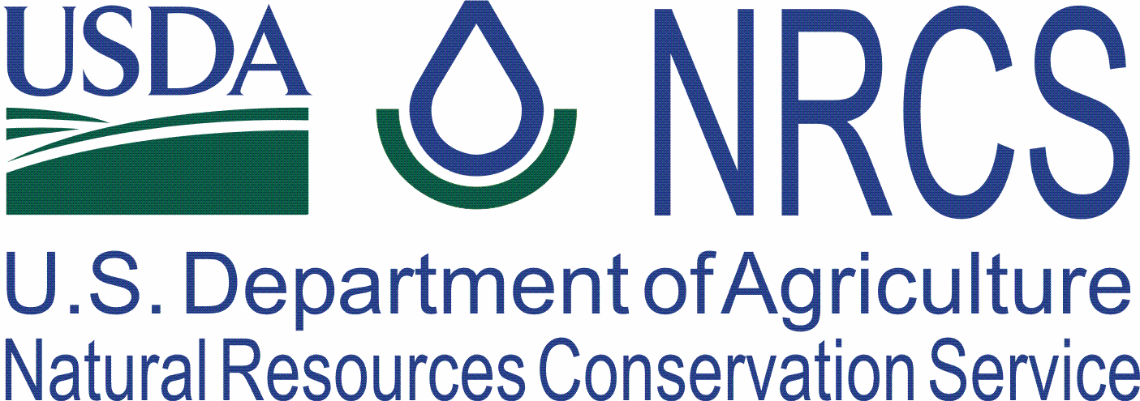

Helping People
Help the Land

Wisconsin
State Outreach Report
FY2007

Wisconsin NRCS Outreach Report 2007

NRCS is dedicated to reaching out to all producers and potential customers to offer our programs and services equitably to those who need them. For over a decade, Wisconsin NRCS has been working closely and productively with the Indian nations in our state to help them restore and manage their resources. Other major groups with special needs for outreach in Wisconsin include the Hmong, Hispanic farmers and farm workers, religious groups, and also beginning and limited resource farmers.

State Level Activities

Assistance to Tribal Nations in Wisconsin
The Wisconsin Tribal Conservation Advisory Council continues to grow and to evolve. In 2007, NRCS assisted WTCAC in crafting a long-range strategic plan to build stronger infrastructure for WTCAC and focus its work for better results. NRCS allocates funds from both the Environmental Quality Incentives Program and Wildlife Habitat Incentives Program for tribal projects, with WTCAC providing review and approval of projects.

- Ten new major EQIP contracts were approved in 2007 for Wisconsin tribes. Projects include well decommissioning, sediment basin, many forestry practices, stream crossing, fencing and erosion control measures. In addition, work continued or was completed on 28 EQIP contracts from previous years.

- Five new major WHIP projects were approved in 2007, including a dam removal, prairie and oak savannah restoration, wild rice seeding, waterfowl habitat development and invasive species control.

Outreach to Hmong Producers – NRCS focused outreach efforts to the growing Hmong population in Wisconsin in 2007. Hmong were US allies during the Vietnam War, and since then, thousands have come to call Wisconsin home. The Hmong have an agricultural heritage and have begun to flourish as producers of fresh market vegetables. Wisconsin now ranks third in the nation for Hmong population. Outreach efforts included participation in the Hmong Mutual Association Annual Conference, Wausau. NRCS Asian Pacific Islander SEPM John Xiong, and Wausau Field Office staff Amy Neigum and Melissa Knipfel provided information on web soil survey and conservation technical assistance to conferees. This is the main conference for the large and growing Hmong population in Wisconsin, and provides an excellent venue for NRCS to reach this audience as well as to network with the Hmong association leadership. Other efforts included distributing information on pest management, poultry biosecurity to prevent Avian Influenza, and working with the USDA National Ag Statistics Service to help identify Hmong growers for the upcoming ag census.

Outreach to Hispanic Farmers
- NRCS developed a direct mail campaign in conjunction with the USDA National Ag Statistics Service. A letter describing NRCS assistance in both Spanish and English was mailed to the NASS mailing list of Hispanic farmers in Wisconsin, along with an NRCS brochure and additional information from other state and federal agencies.
- The North Central Region SARE program funded a grant to the University of Wisconsin Environmental Resources Center for "Effective Outreach for a New Wisconsin Agriculture: a Social Marketing Approach to the Environmental Management Needs of Hispanic And Women Farmers." Wisconsin NRCS has been working with the ERC staff to support the grant application and now in planning to conduct the research.

Outreach Assistance Handbook was distributed to Field Offices in October, 2006, for use in developing a FO Outreach Plan. Handbook was also posted on the Outreach webpage of the WI NRCS website.

Outreach to Beginning and Limited Resource Farmers
- Risk Management Strategies for Beginning and Small Farmers and Ranchers Conference in Milwaukee. This national conference was sponsored by USDA Risk Management Agency and Growing Power, and attracted over 600 participants. All USDA agencies participated. NRCS in Wisconsin took the lead in developing the NRCS breakout session on NRCS Technical and Program Assistance for new and beginning farmers, as well as developing and staffing a display for the Exhibit Hall.
- Produced a short video for the Wisconsin nomination for the Lloyd Wright Small Farmer Award, featuring a small dairy grazing operation in Marathon County. Video emphasized the economical and environmental success of a small grazing farm, and can be used to promote this type of operation for beginning or limited resource farmers. Wisconsin’s nominee placed third in the national competition, sponsored by the National Organization for Professional Black NRCS Employees.
- Coordinated with Wisconsin State Technical College System to distribute NRCS information on web soil survey to all teachers in the agricultural curriculum throughout the 22 technical colleges.

Wisconsin Envirothon 2007
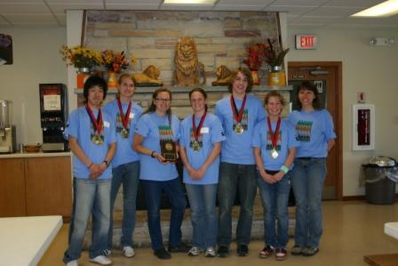
The Envirothon is a problem-solving natural resource competition for high school students. Teams of students are tested in the field on soils, forestry, wildlife, and water. The winning team moves on to the North America contest to compete for scholarships. Wisconsin NRCS works closely with the Wisconsin Land and Water Conservation Association to plan and organize the Wisconsin competition. NRCS staff run the soils testing stations for the event.
Winning 2006 Envirothon High School team from Conserve School.

National FFA
In 2007, the Earth Team Volunteer Program exhibited for the first time at the statewide FFA Convention held in Madison, Wisconsin. Over 700 high school students attended, representing a diverse high school community. NRCS staff Laura Carlson Humphrey and Barb Jansen provided information about the mission of NRCS, the Earth Team, and career opportunities with NRCS. Many were looking at the qualifications and required courses need to be eligible for future employment. Some national statistics about FFA:
- 38% of FFA members are female; women hold more than 50% of state leadership positions
- 77% are Caucasian; 17% Hispanic, 4% African-American
- 89% of FFA members are in grades 9-12; 6% are in grades 7-8; 5% are high school graduates
- 27% of FFA members live in rural, farm areas; the remainder live in rural non-farm (39%), urban and suburban areas (34%)

Special Highlights
NRCS Assistance to Severely Disabled Farmer
At the 2006 Agrability of Wisconsin board meeting, a Polk County farmer gave a presentation about his farm and the assistance he has received to help him farm with his disabilities. He also noted the assistance he has received from NRCS -- Keith Zygowicz, DC in Balsam Lake and Kent Wabrowetz, CET in Spooner. Ed was born without hands and he has managed amazingly well to run a farm, raise a family and be very active in 4-H and his community for many years. Ed has an EQIP contract from 2004 for a grazing plan to improve his sheep operation, and another EQIP contract in 2006 for a waterway, fencing and stream crossing. Ed was pleased with the NRCS assistance he has received and particularly mentioned the quality of the engineering work we provided.

Bad River Fish Production Ponds Completed
The Bad River Tribe just completed a $500,000 fish rearing pond project. This project has been in the planning stages for over five years and represents a giant step forward for the Tribe in its fish re-stocking efforts. The ponds will be primarily used for production of perch. The project consists of 2 one-acre ponds and a half-acre pond. NRCS provided the engineering design and on site construction spot checks. Civil Engineering Technician Keith Sengbusch was the lead on the project assisted by Ashland Field Office CET Paul Johnson.

Beginning Farmer Success story
Medford District Conservationist Bob Plawski began working in 2004 with a female client operating a beef herd of 15 animals. NRCS prepared a grazing plan for 17.2 acres. In 2005 she added another 49.1 acres for a total of 66.3 acres and increased her herd to 50 animals. She has since increased her herd to over 80 animals and now has over 115 acres for grazing. She is direct marketing her products in several stores around the area and has a local outlet store in Medford. She has attended many meat shows and her products have won numerous awards. She has just reached agreements with two stores to sell her products in Chippewa Falls and Eau Claire. She started the operation by herself and now has expanded to include her sister in the operation.

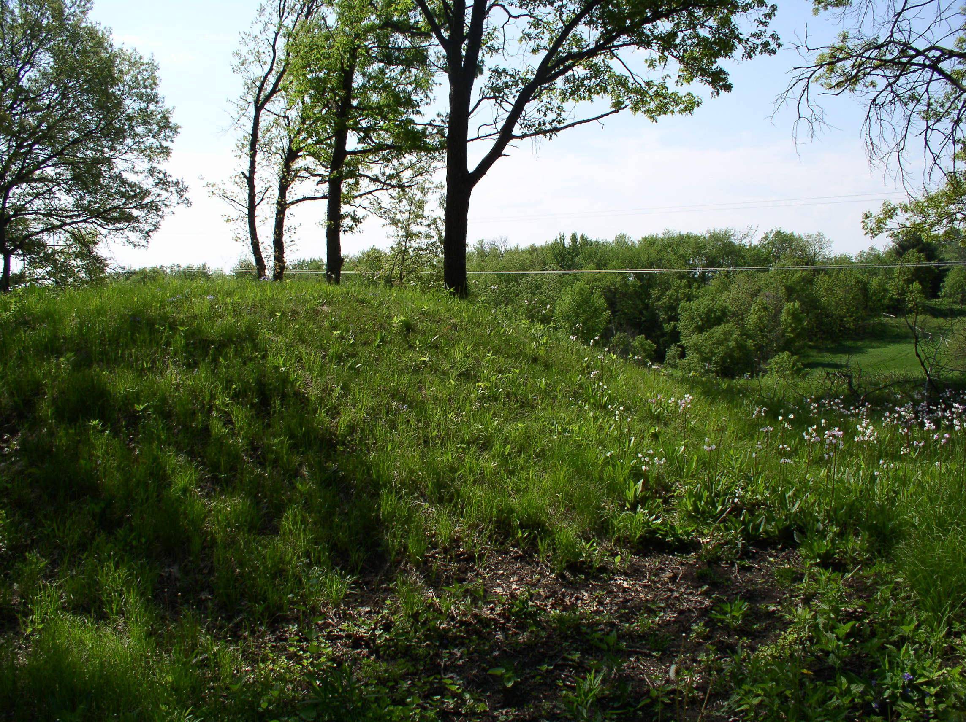
WHIP Helps Clean-up Sacred Burial Mounds for Ho-Chunk Nation
The NRCS Wildlife Habitat Incentives Program (WHIP) is helping restore the Kingsley Bend Indian Mounds that had been long overgrown with brush, pine, and invasive species. The Ho-Chunk Indian Nation assumed ownership of the sacred site from the Wisconsin Dept. of Transportation in 2007 and will restore it as an interpretive educational site. WHIP will help the Ho-Chunk remove the brush and non-native trees and replant prairie grasses to restore the oak savannah. The 40-acre Columbia County site sits on a bluff overlooking the Wisconsin River, and contains 22 mounds, including 2 bear mounds, a bird mound, panther mound, 12 conical mounds, and 5 linear mounds. The mound group is representative of those built by the Effigy Mound Culture, dating between 600-1000 A.D.
Field Office Activities – Northwest Area

Chippewa Falls Field Office, Tammy Lindsay

NRCS hosted a public meeting in the evening in conjunction with the Chippewa Valley Technical College Farm and Business Management class to inform beginning and experienced farmers about EQIP. The FO compiled before and after pictures from this past EQIP construction season to give the group a visual idea of what the program could do. These pictures as well as other topics, such as “Save Energy, Save Money”, and what NRCS has to offer for services were presented in a power point. There were 21 farmers in attendance. Of these, three were female producers, as well as two Mennonite. As a result, the Mennonite farmer has signed an application for the Statewide EQIP Manure Storage and we are currently providing him with technical assistance.

Ladysmith Field Office, Mike Koehler

- Worked a booth with high visibility near the entrance of the Rusk County Farm and Home Show. Spoke with over 100 people about programs including some Amish and Mennonite farmers.
- Worked with the Lac Courte Oreilles on their many EQIP and WHIP contracts. Participate on the Wisconsin Tribal Conservation Advisory Council.
- Worked with several Mennonite farms primarily on wetland compliance. Discussed the EQIP programs available to them.
- Several news articles to area papers and radio stations.

Durand Field Office, Dennis Reimers

- worked with two disabled program participants, one EQIP and the other CSP.
- soils presentation to local boy scout troop.

Whitehall Field Office, Mark Kunz

- worked with two Amish landowners on CRP contracts
- worked with four female EQIP contract holders.

Eau Claire Field Office, Ryan Galbreath

- Feb. 6th 2007 CVTC Fall Creek (2 hour presentations to 20 local farmers on USDA programs: 8:00-10:30PM)

- March 5th 2007: CVTC Eau Claire (2 hour presentations to 17 local farmers on USDA programs 8:00-11:00PM)

- April 18th 2007: Farm in the City Days (Eau Claire Memorial High School). NRCS had a display on careers in the USDA NRCS and presented three 45 minute presentations on how geometry is used in conservation. (200+ students)

- Spring 2007: Developed Toolkit Conservation Plan and Soils maps for four Amish farmers. They agreed to work with the LCD to develop the 590 and the NRCS supplied logistical support with the maps, soils information and conservation plans.

- Eau Claire County NRCS Gave a one hour presentation and activity on the USDA GPS System to the Fall Creek High school Geology Class. NRCS and FSA GPSd the Softball diamond and school perimeter with the students. The use of the GPS in conservation was explained while conducting the activity.

- Breakfast in the Valley (Eau Claire Counties Dairy Breakfast) had 3,350 people served at the breakfast. NRCS had 2 displays to promote conservation programs and the web soil survey. NRCS Staff was on site to answer questions and to restock the candy dish.

- Eau Claire County sponsored a student intern from Puerto Rico. (2 month internship with Bianca Perez)

- WAX 104.5 (5 Minutes of Fame) Once a month, NRCS gives a five to six minute radio announcement to promote conservation. (Discussed programs, practices, and conservation compliance)

- NRCS and UW Extension Co-hosted the Youth Leadership Eau Claire agriculture and environment day. The importance of agriculture and conservation was explained during the tour of a large dairy operation, horseradish farm, hybrid seed corn research facility and aquatic sampling site. Twenty-four students were present.

Medford Field Office, Robert Plawski

- Mailed over 1,000 post cards to customers and potential customers in Price and Taylor Counties informing them about EQIP signup. Mailing list included women, black, American Indian, Asian, and Hispanic owners and operators.
- Working with a disabled landowner, the Dept. of Vocational Rehabilitation and Agrability, to secure funding to clean up a barnyard of polluted runoff. This landowner is a grazer and we have prepared a grazing plan and are assisting with implementing that plan. We are in the process of installing an Animal Trail and Walkway to facilitate better movement of beef cattle to the paddocks. It has been a challenge but a rewarding experience.
- Began working in 2004 with a female client operating a beef herd of 15 animals. Prepared a grazing plan for 17.2 acres. In 2005 she added another 49.1 acres for a total of 66.3 acres and increased her herd to 50 animals. She has since increased her herd to over 80 animals and now has over 115 acres for grazing. She is direct marketing her products in several stores around the area and has a local outlet store in Medford. She has attended many meat shows and her products have won numerous awards. She has just reached agreements with 2 stores to sell her products in Chippewa Falls and Eau Claire. She started the operation by herself and now she has her sister working with her.

Field Office Activities – Northeast Area

Waupaca Field Office, Lisa Neuenfeldt

- Represented NRCS at Waupaca County Conservation Field Day held at Hartman Creek State Park. Over one hundred fifty 5th grade students participated in hands-on learning at six conservation stations (soils, forestry, wildlife, water, land survey techniques, and law enforcement). Made presentations on soil formation, identifying soil types, and soil profiles. Students were allowed to make their own soil profile and to determine what land use their profile would best suit. Received numerous positive comments from teachers regarding the methods employed to convey the importance of conserving soil resources.

- Addressed Waupaca County Pheasants Forever Chapter at annual banquet. Informed audience of conservation opportunities available through CREP and EQIP. A CRP display was featured and informational brochures on USDA conservation programs were made available. Spoke individually with numerous local landowners on natural resource management techniques, and informed them of potential program opportunities available through USDA.

Wisconsin Rapids Field Office, Roy A. Diver
- Special direct contact to two female landowners informing them of EQIP grazing practices. As a result both were approved for new 2007 contracts for 94.1 acres of Prescribed Grazing.
- Outreach letter sent to Ho-Chunk Nation informing them of NRCS programs
- Brief technical assistance to 4 Amish landowners.
- Brief technical assistance to 2 Hispanic landowners.
- With assistance from WI NRCS Hispanic Program Coordinator provided a landowner with a Spanish version of their Emergency Action Plan for a 2007 CNMP.
- One female Earth Team Volunteer worked 67 hours for the fiscal year.
- Provided NRCS career information to 7 female MSTC students during a conservation field trip organized by NRCS.
- Provided NRCS career information to 1 female UWSP student.

Shawano and Menominee Counties, Sherrie Zenk-Reed

- Successfully recruited, through the Wisconsin Civil Rights Committee recruitment initiative, a Native American student to be hired in the summer of 2007. Due to budget restraints, the student was not able to be hired.

- Teamed up with Waupaca County NRCS and set-up the NRCS career booth at the Clintonville Career Fair, April 2007. This annual event invites 8th graders from Shawano, Waupaca, and Menominee counties to explore career opportunities. This year’s event was attended by approximately 1000 students.

- Coordinated with the Lumberjack RC & D grazing specialist, a pasture walk on a local Amish farm. The event was well attended.

- Developing a 2008 EQIP contract with an Amish farmer for a manure pit closure and fencing livestock away from a stream/wetland.

Wausau Field Office, Amy Neigum

- Tou Yang, a Hmong student, was an Earth Team volunteer in Wausau field office this summer.

- The Wausau Field Office hosted the State Civil Rights Committee in June. It included setting up a tour of Hmong gardens. We also had a lunch of traditional Hmong food. We arranged for the Director of the Wausau Hmong Association to speak to the committee.

- Melissa Knipfel contributed a series of articles to the local AgLink newsletter about women in agriculture in 2007.

- We nominated a local farmer for the Small Farmer Award in Wisconsin. We assisted Renae Anderson and Jean Stramel in completing the nomination application and video for the award.

- The Wausau Field office staff participated in staffing the NRCS booth for an Agrabilty workshop in July. Agrabilty serves handicapped farmers.

- A stop on the technician tour was at a farm that is active in Agrability.

- In October of 2006, we sent out letter to local minority organizations about career opportunities within NRCS for students.

Marinette Field Office, Jodie Reisner
Met with an Asian veal farmer. DC contacted him and he came to the office and learned about NRCS programs. Offered him CTA assistance and followed up with several phone calls. (No response - farm has been sold.)

Stevens Point Field Office, Ty Larson

Plainfield School Districts Forest- taught 7th and 8th graders about soil. The school had a soil pit dug out and Marie Opelt (pictured) explained how to describe a soil pit, how to obtain texture, color and depths. They review the high school- FFA soil judging card for competition. Four separate groups of 10 students each went through the pit.

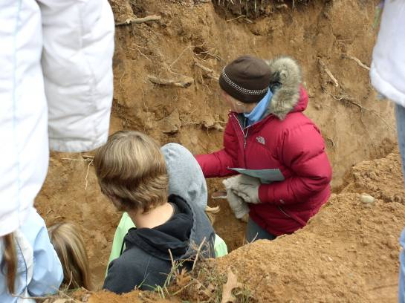
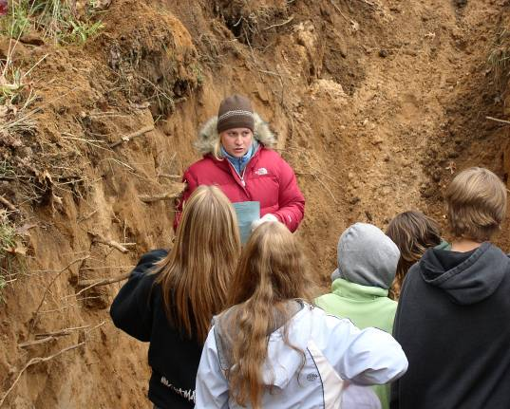

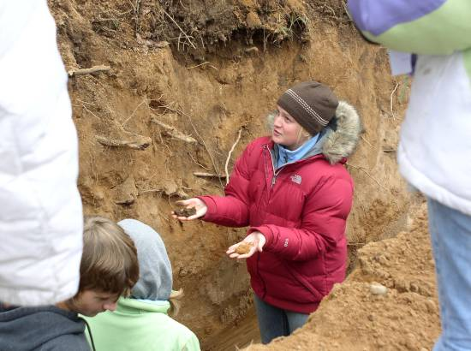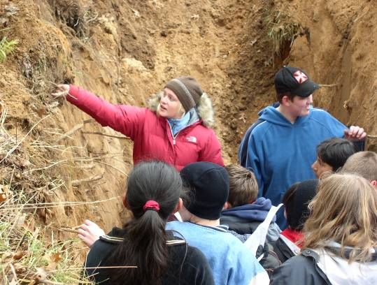

- Roosevelt Elementary School 3rd grade class, Plover taught about 30 students about soil and natural resources. Showed the demonstration using an apple as the world to explain the amount of land we have to grow food on. Used a soil monolith to describe the horizons. Answered questions about plants and soil and talked about jobs in Natural Resources.

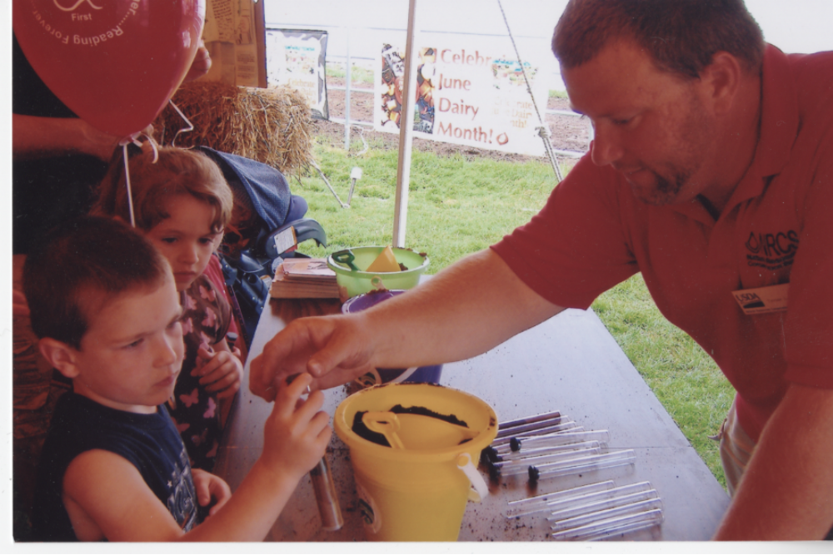

- 2007 Portage County Dairy Breakfast - NRCS exhibit on grazing and a children’s activity on soils. Approximately 400 children “built” their own soil profiles in plastic tubes with soil. The soil profiles were a hit with the kids; they really seemed to enjoy creating them with the different colors of soil and were able to take them home with them. The soil was collected within colored sand buckets by Soil Scientist Jesse Turk.
- University of Wisconsin Stevens Point College of Natural Resources career fair – NRCS staffed an exhibit on careers in the NRCS
- Bannach elementary school - Ty Larson, Lindsay Opelt, and Jesse Turk taught 63 second graders on the soil profile.

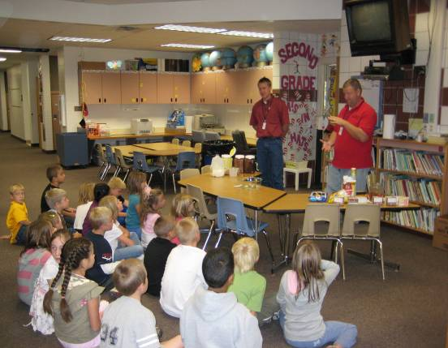
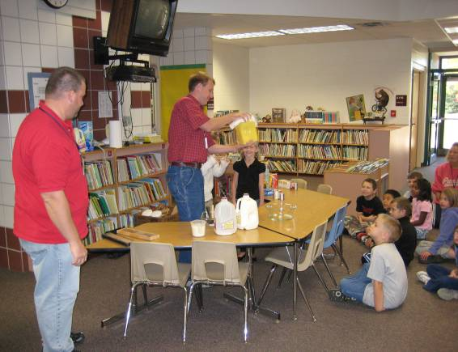

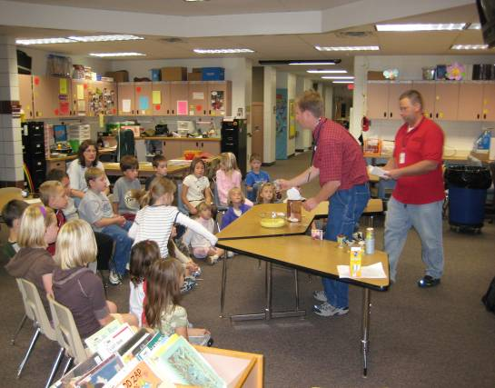
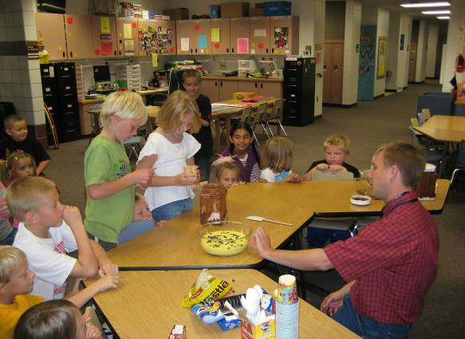

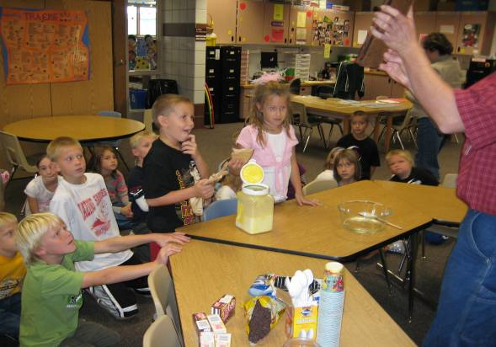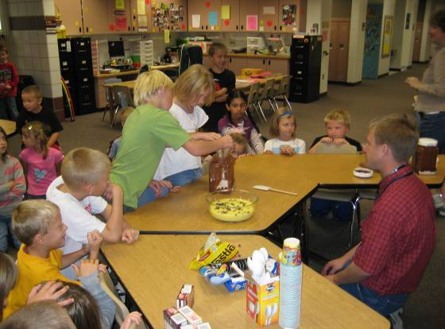

The children created a soil profile with vanilla and chocolate pudding, chocolate chips, gummi worms, and oreo cookies. They were able to answer questions about the names of the soil layers, what is found in each layer, and why soil is important. At the end of each of the three sessions, the kids asked general questions and learned about what each of the presenters do in their job and how they got to become soil scientists and conservationists. They also were able to eat the soil and received Soil Survey temporary tattoos.

Oshkosh Field Office, Merrie Schamberger,

Oshkosh NRCS has an ongoing relationship with Sherman Road Community Garden. This year we started working on a Hmong/English garden newsletter. We are encouraging gardeners to send in hints or tips, favorite recipes, and how to use ethnic vegetables. We are hoping to have our first newsletter come out toward to end of the year to keep gardeners thinking about their garden over the winter. Chiax Vang from ADVOCAP will be doing the Hmong translation.

Appleton Field Office, Lynn Sculzewski

- Participated in a multi agency effort, organized by the LCD involving DNR, NRCS, DATCP, UW-Ext and the private sector, to educate 4th and 5th graders from 15 Outagamie County schools. The 47th Annual Conservation Field Days was a huge success with 850 students attending the 3-day event on September 25-27, 2007. All public and private schools in the county are invited to attend including the Oneida and parochial schools. The Field Days offers an outdoor teaching/learning environment with 8 stations setup throughout a working farm. The students rotate to all the stations throughout the day to learn about soils (at the soils pit), geology (in an actual quarry), forestry, wildlife and farming practices. Although the Oneida schools did not attend the event, other minority groups were represented with approximately 2% being African American, 5% Hispanic and 13% Hmong.
- Informational letters have been distributed to 412 landowners that own land potentially eligible for CREP. The letters are being sent out in a non-discriminating manner with the intent to contact all landowners, not just those currently participating in USDA programs. Mailing list developed through county property records.

Manitowoc Field Office, Matt Rataczak

- Great Lake Protection Fund with Agren. (All of Fiscal year 2007) Assist by providing information on absentee landowners within Manitowoc County. Help distribute and collects surveys to and from these absentee landowners and sending the surveys to Agren.

- Program Update/Outreach at Lakeshore Technical College. Discussed NRCS roles and available programs to landowners. Six attendees (three men and three women) Ka Ying Vang, NRCS soil conservationist in Manitowoc, was available to interpret for any Hmong landowners if needed.

- Program Update/Outreach at Luxemburg, Kewaunee County. Discussed updates and available assistances with USDA programs. Ka Vang was there to interpret if any Hmong landowner were to show up. Four people attended (three men and one woman).

- Civil Rights Meeting & Tour in Wausau. Ka Vang discussed different methods of outreach to minorities, limited resource, and beginning farmers. Peter Yang from the Hmong Association discussed farming lifestyles of Hmong people in Laos and Thailand. Ka Vang provided an informational tour of a Hmong garden for the Civil Rights Committee. The tour gave the committee an idea of the culture. The committee also had a taste of the different kinds of food eaten in the Hmong culture.

- Fox Valley Technical College Presentation Presentation about employment opportunities with NRCS. 25 students attended

Field Office Activities – Southwest Area

Prairie du Chien Field Office, Rick W. Lange

- Youth conservation Day (including black and Asian students)
- Landowners meetings (2) w/ FSA on program information
- EWP, ECP, and EQIP meetings (2) in flood damaged area for landowners and town officials.
- Two presentations to Southwest Wisconsin Technical College farm class on RUSLE and Nutrient Management
- Two landowners meetings on Multi Flora Rose Control
- Joint landowner/GOV personnel field day on native prairie remnant restoration

Mauston Field Office, Greg Wheeler

NRCS & FSA held a joint outreach meeting February, 2007, with a total of 4 people attending. One was late morning, the other early evening.

Viroqua Field Office, Sam Skemp
- Three meetings with the Ho Chunk Nation to discuss ongoing and possible new EQIP contracts. Consulted with 4 different members of the Nation.
- Technical assistance to 3 Amish producers (conservation planning and contour strip layout)
- Hosted an Amish Pasture Walk. Close to a dozen Amish producers participated and many were interested in future follow-up
- Met with leaders of the two largest organic certifying agencies and organic cooperatives (MOSA and Organic Valley) to explain the organic incentives payment through EQIP in hopes of reaching more beginning producers and limited resource producers. Several inquiries resulted.
- Continue working with over one dozen female producers who hold EQIP contracts in Vernon County.
- Hosted a pasture walk with one Hispanic livestock producer.

Monroe Field Office, Jason Thomas
- Green County hosted the Wisconsin Farm Technology Days in 2007 with numerous NRCS exhibits including the very popular Soil Pit. Premiere Wisconsin farm show with 100,000 in attendance offers great opportunities to reach out to all, including urban, non-traditional and youth attendees.
- Conducted a grazing meeting to introduce the concepts of rotational grazing and show how managed grazingcan compete financially with traditional confinement dairy operations. with the assistance of Brian Pillsbury and Jean Stramel, with invitations to the Amish community. An overview of financial assistance available through government programs was presented, and Burt Paris gave a presentation about the Dane-Green grazing group and invited participants to attend a pasture walk in the upcoming grazing season. 14 producers attended, including 2 women and 2 Amish.

Dodgeville Field Office, Andy Walsh
- Met with the CAC to identify potentially underserved groups in Iowa County.
- Iowa County Farmers Appreciation Day NRCS booth provided materials and information to many non-traditional customers.
- Kids Day America particaption offered NRCS exposure to many youth in the Dodgeville area. I represented NRCS for 2 days at
- Farm Progress Days – assisted with educational exhibits for two days
- Contracts (2-EQIP 1-WHIP) were developed with female producers.
- Conservation Reserve Program contracts with numerous female producers. Dodgeville Field Office served as training location for minority STEP summer student

Lancaster Field Office, Karyl Fritsche
- In February, joint Annual Report with the LCD was published in the county newspaper, showcasing conservation practices and environmental education events.
- Exhibited at the Grant County Fair (Backyard Conservation, Conservation Jeopardy)
- Participated in Seneca School Career Fair for grade 6 through 12. Four session for 30 minutes each, explaining careers, duties, qualifications, education and training required, level of earnings, benefits, career ladder and interesting facts and information on conservation careers.
- River Fest 2007 –NRCS assisted in organizing and carrying out this annual, high profile interagency environmental educational event for the region. Features included Effigy Mounds, Aquatic Resources, Blufflands Resources (includes forestry, soils and cultural resources

Field Office Activities – Southeast Area

Janesville Field Office, Roger Allan
- maintains contact with Beloit College, which has an "Environmental/Geology” degree emphasis. NRCS has had several summer students from Beloit College, and continue to look for diverse students to recruit.
- maintains connections with the Amish farm community in Rock County. We have two Amish Contractors on our Contractors list. Their emphasis is on drainage activities.
- increased activity in the Organic" agriculture. In 2007, we had our first EQIP contract for Organic practices. We anticipate increased activity in this area.

Portage Field Office, Twyla Kite

Assisted the Ho Chunk Nation with a WHIP project to restore a 40-acre wayside to oak savannah and preserve a group of 20 Indian burial mounds. Worked with tribe to develop a highway sign for the site to explain the construction activity that is underway. The project was featured in the national NRCS This Week, dated June 13, 2007. http://www.nrcs.usda.gov/news/thisweek/2007/061307/home.html The Restoration of the site will take place over the next couple years.

Juneau Field Office, Brian Briski
Soil Conservationist Peggy Lane spoke to a group of 20-25 people at the Wisconsin Women for Agriculture annual meeting. She presented an overview of NRCS programs and technical assistance, including soils, RC&D and farm bill programs. Questions and discussion centered around programs and understanding NRCS versus other agencies.

Peggy Lane worked with international students attending Fox Valley Tech in Agriculture-related Studies at the 2007 Farm Technolgy Days. The students were very interested in the Web Soil Survey display. Students were from multiple countries in South America (see photo below).
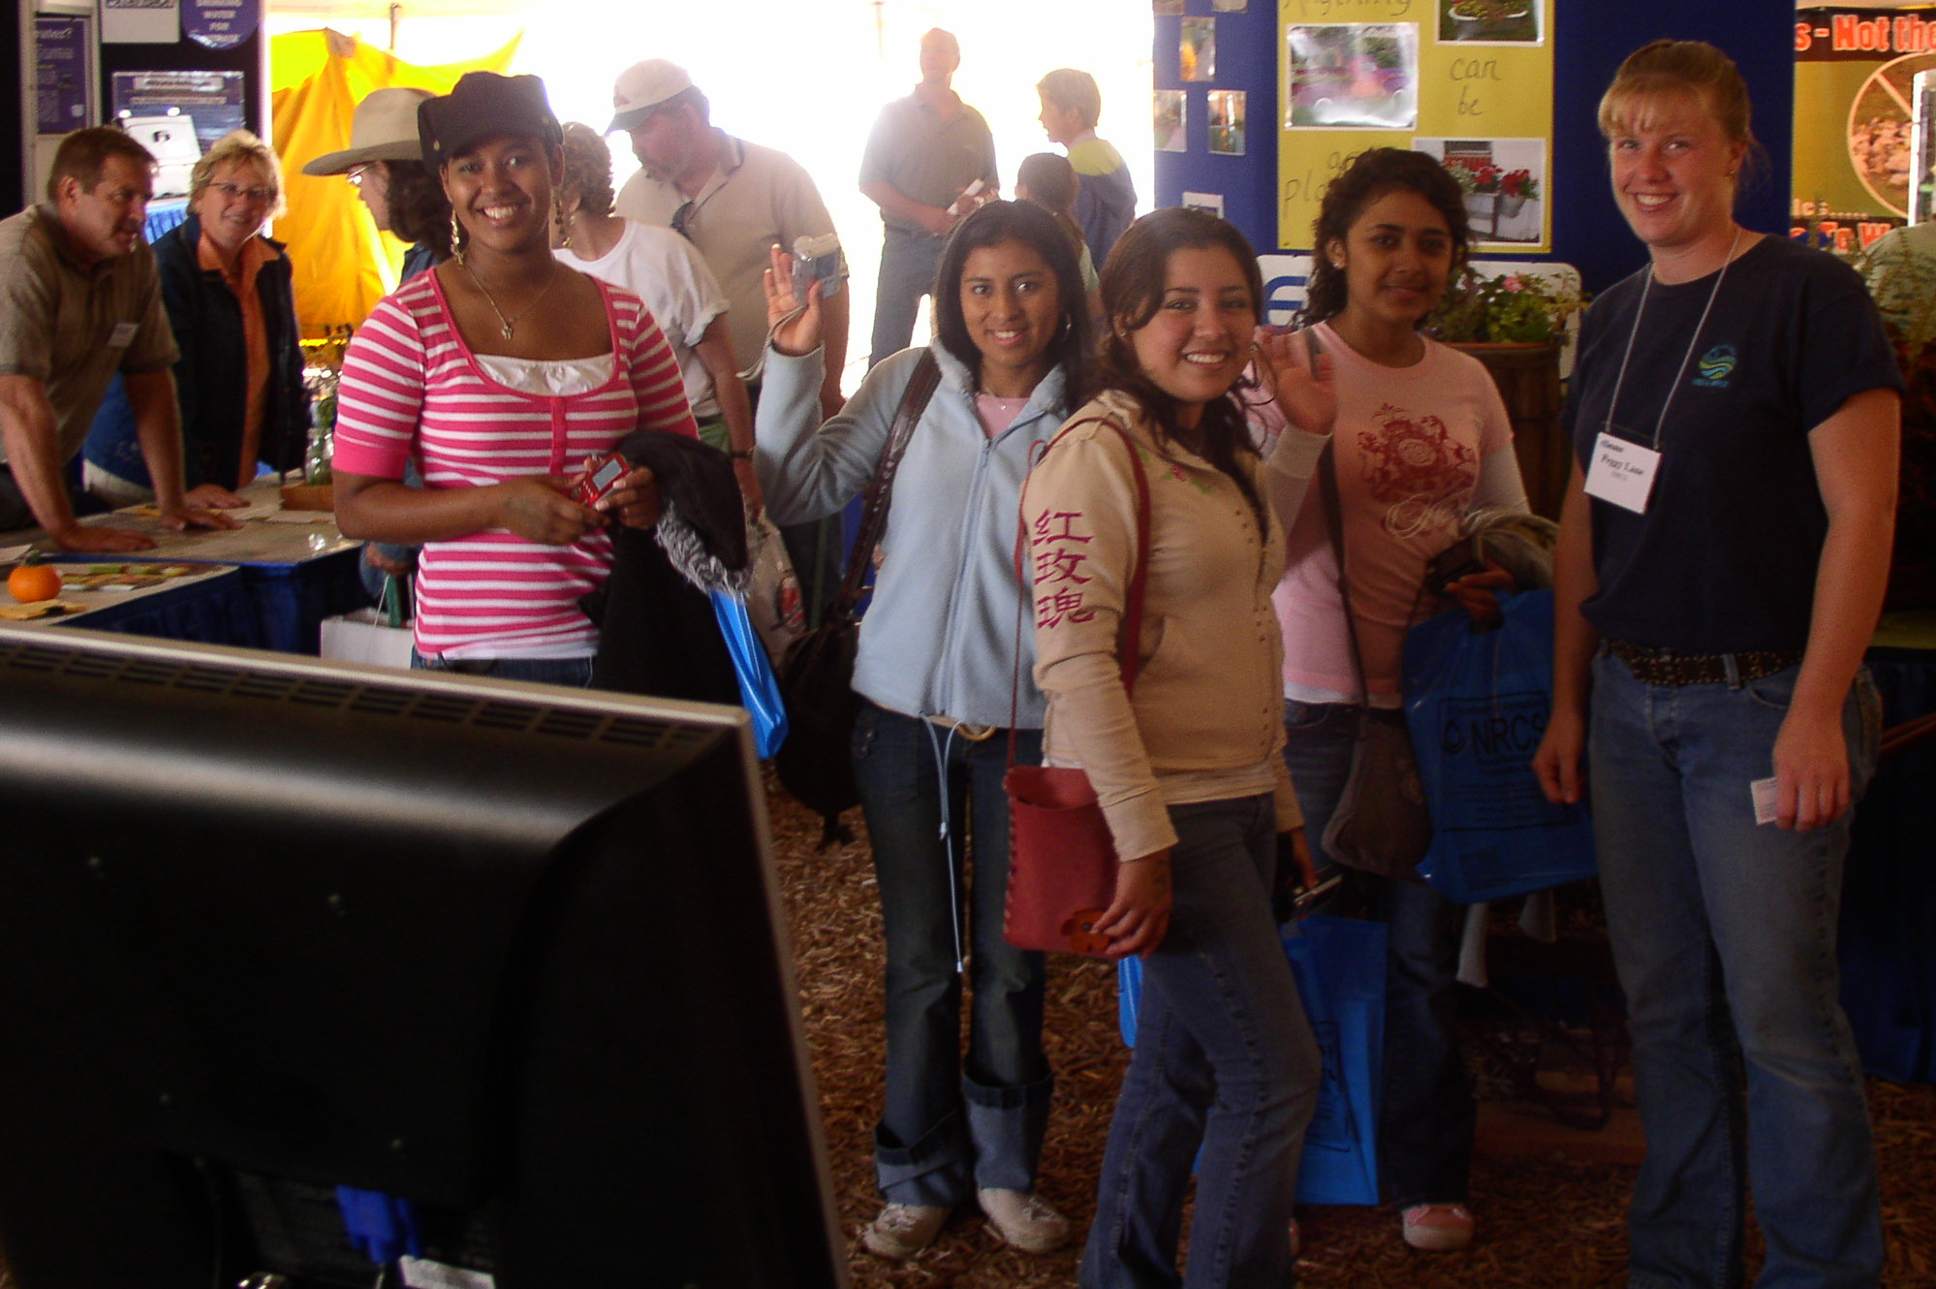

Elkhorn Field Office, Greg Igl

As part of our outreach activities, the following seminars, meetings, walks, or events were completed in FY-07. Most outreach activities were sponsored cooperatively with other agencies including UWEX, DNR, FSA, and LCD.

- Nutrient & Pest Management Workshop for crop consultants, agronomists
- 2007 Prairie Walk- approximately 85 people attending
- Farm Technology Days
- Web Soil Survey display

NRCS serves on technical advisory committee for Southeast grazing network. The following seminars/walks were completed in FY-2007 through the network:

- Winter Seminar-“High Corn Prices-An Opportunity to reduce costs?”
- Small Scale sheep Grazing pasture walk
- Stocker Cattle pasture walk
- Water on Demand Pasture Walk “What Irrigation can do for your Grazing Operation”

The Elkhorn FO publishes a joint newsletter bimonthly – “Your Partners in Farm Business”. Newsletter is sent to all local producers and landowners, and also farm organizations such as Farm Bureau’s Women in Agriculture.

Westfield Field Office, Jon Field

Supported outreach efforts to service under-represented groups of landowners and farm operators. Examples in FY07 include:
- working with a female CRP participant to establish a grass buffer along a pond and stream
- working with a female beef farmer developing a grazing plan with Adam Abel, soil con.
West Bend Field Office, Betsy Gillen
Represented NRCS at the National Risk Management Strategies for Beginning and Small Farmers and Ranchers Conference in Milwaukee. Gave a presentation on NRCS programs, technical assistance and soils information useful for new and beginning farmers.

Green Lake, Abby Gulseth

- Participated in Environmental Education Experience, an annual event teaching third graders about different types of environments.
- Green Lake's Focus on the Farm, a morning on a local farm with many different activities. NRCS booth explained invasive species and how to deal with them
- Green Lake County Junior Fair - invasive species exhibit

Union Grove Field Office, Jerry Hebard

- Taught "Dirt Appreciation" class at Carthage College to a diverse group of students.
- Environmental tour focusing on soil conservation and soil survey interpretation to this same Carthage college class
- Answered numerous questions on the environment for urban participants at the 2007 Racine County Tree Program on April 8th.
- Habitat for Humanity - Provide seeding recommendations to Habitat for Humanity group in urban Racine.

Jefferson Field Office, Brian Resch

- Discussed with FSA CED outreach activities that have taken place in the past and which ones had a higher rate of success.
- Provided the Jefferson County LWCD, Rock River Coalition, Watertown Daily Times and Jefferson County Daily Union articles informing the public about the EQIP program and the process to become involved in it.
- Assisted minority producers with conservation technical assistance and plan updates.
- Through the CAC Outreach Binder documents, FSA has added spouses to the farm records database that is utilized by Customer Service Toolkit.
- Participate in the Jefferson County Animal Agriculture Alliance organization, headed by Daphne Holterman, which assists the United Migrant Workers and the Jefferson County Farm Bureau Women's Group in the county.

Waukesha Field Office, Brandi Richter

- Risk Management Strategies for Beginning Farmers and Ranchers Conference - setup and staffed the NRCS exhibit for the national conference in Milwaukee, conference sponsored by USDA and Growing Power. Answered numerous program related questions and talked with people from all over the United States. Two producers from Michigan (a 200-acre asparagus farm and a blueberry farmer) both were very interested in conservation and indicated that they would be contacting their local NRCS office for additional information. There were also several Native Americans from the Arizona area that were very interested in the web soil survey information and water conservation.

Tribal Outreach and Assistance

Oneida Nation, Tony Bush, Tribal Liaison,

Served as EQIP coordinator for the Wisconsin Tribal Conservation Advisory Council (WTCAC) providing program updates and maintaining records on tribal program activities. Developed the tool used for ranking tribal EQIP applications.

Provided guidance to the Oneida Sustainable Conservation Advisory Council (OSRAC), the Oneida Nation Farm and Tsyunhehkwa Farm concerning all NRCS programs. Made presentations to OSRAC, the Oneida Environmental Resource Board and the Oneida Land Commission concerning potential contract involvement. Maintained records for and provided updates to the Oneida staff concerning NRCS program activities.

Assisted with the development of the Oneida’s Conservation Plan Standard Operating Procedures document used as guidance for Oneida renters concerning conservation requirements, prohibitions and restrictions on tribally leased agricultural lands.

Worked with the Oneida EcoServices Department to assess tribal buffer needs in accordance with Oneida policy.

Provided assistance to the Oneida Nation concerning contract development with the Outagamie Land Conservation Department.

Projects Completed:

Access Roads | 1748 | ft
Animal Trails and Walkways | 700 | ft
Closure of Waste Impoundment Areas | 1 | no
Comprehensive Nutrient Mgt Plans | 1 | no
Critical Area Plantings | 2.3 | ac
Diversions | 252 | ft
Filter Strips | 7.4 | ac
Grade Stabilization Structures | 1 | no
Grassed Waterways | 4.1 | ac
Nutrient Management | 3122 | ac
Prescribed Grazing | 92 | ac
Roof Runoff Systems | 1 | no
Subsurface Drains | 565 | ft
Tree Plantings | 62.6 | ac
Underground Outlets | 650 | ft
Upland Wildlife Habitat Mgt | 23.2 | ac
Water and Sediment Control Basins | 3 | no

Bad River and Red Cliff Tribes, Tom Cogger, Tribal Liaison, Ashland Service Center

Continue to work with Wisconsin Tribal Conservation Advisory Council as a NRCS advisor to the group.
Worked with the North Woods Cooperative Weed Management Area (NWCWMA) to finalize the Memorandum of Understanding creating the organization. NRCS is a signatory partner to the group. Assisted in developing a NWCWMA Management Plan which has now been finalized.
Assisted Sustainable Chequamegon, FEAST, Sustainable Chequamegon and other groups in planning an event that featured well known agricultural economist, John Ikerd . Mr. Ikerd spoke on “Sustainable Capitalism- A matter of Common Sense”. The event was attended by over 400 people.
Provided assistance to FEAST in planning local foods initiatives including a mobile farm market, and local food access in cooperation with local tribal community garden projects.
Provided technical assistance to local VISTA volunteers in various aspects of tribal community gardens.
Working with new and beginning farmers to develop conservation plans on their farms. A Resource Management System level plan which included a Managed Grazing Plan was completed for one farm. The farmer has signed up for EQIP as a result of the planning activities. A second grazing plan with a new farmer is in progress and will be completed soon. The farmer is interested in signing up for EQIP. A third new farmer has been scheduled to begin the conservation planning process soon.

St. Croix Tribe , Tom Fredrickson, Tribal Liaison, Spooner Service Center

- Attended WTCAC meetings held at Bad River (2), Lac Courte Oreilles, Menominee and St. Croix Reservations.
- Provided technical assistance for a wildlife food plot in regards to the Conservation Reserve Program.
- This past winter Spooner Field Office staff met with the St. Croix Environmental & Natural Resource Department to review the 2007 St. Croix obligations for the EQIP, WHIP and CRP programs.
- Met with the St. Croix Natural Resource Department to offer assistance in regards to their Wild Rice special funds project.
- NRCS technical staff worked with the St. Croix on certifying of 20 linear feet of shoreline stabilization on Big Sand Lake.
- Provided soils information to the St. Croix Environmental Department.
- Approved 7 acres of Brush Management for reimbursement as part of a WHIP contract.

Lac du Flambeau, Julie Malvitz, Rhinelander Service Center

Lac du Flambeau Reservation encompasses 86,630 acres, of this, 41,733 acres is forested, there are 260 lakes and 2400 acres of wetlands. The Lac du Flambeau commitment to conservation for present and future generations is evident through the great working relationship they have with NRCS. In the last year NRCS has helped the tribe implement 523 acres of prescribed burning, 485 acres of Forest Stand Improvement, 301 acres of Forest Site preparation and 19, 474 ft. of Forest Trails and Landings. On June 22nd, 2007 , I attended the annual Lakes Fest on the Lac du Flambeau Reservation. NRCS had the Backyard Conservation Display set up where I answered conservation questions and handed out brochures about NRCS programs. Many Native American History Month posters were given away to a very appreciative crowd. Lakes Fest, Keepers of the Water that was held on the Lac du Flambeau Tribal Grounds on Saturday June, 23rd. About 250 people came through the Environmental Tent where there were 22 booths set up, that included Federal, County and Tribal Exhibits dealing with Water Quality and Conservation. I gave out 126 American Indian Heritage Month Posters ( one which is presently hanging in the Chamber of Commerce Building) and 89 Backyard Birds Posters. This event was great exposure for NRCS and represented the partnership and working relationship that we have with the Lac du Flambeau Tribe
Lac du Flambeau Band of Chippewa signed up for 2007 EQIP, where they contracted 450 acres to do Forest Stand Improvement, crop tree release, 7.3 acres of critical area planting, warm season grasses and 6 acres of Heavy Brush Management.

Sokaogon Julie Malvitz, Rhinelander Service Center
On September 14, 2007, I met with the newly formed Forestry Department of the Sokaogon Band of Chippewa’s to explain the NRCS EQIP Program and how the forestry practices offered can benefit the Tribe in their conservation efforts.

Forest County Potawatomi Julie Malvitz, Rhinelander Service Center
Forest County Potawatomi signed up for 2007 EQIP where they contracted to do
a Well decommissioning, Sediment Basin, 5500 feet of Access Roads, 300 feet of Stream Crossing, 5 acres of critical area planting. Under the 2007 WHIP Program, they contracted to do Dam Removal and Culvert Replacement for a Fish Passage.

Ho-Chunk Nation, Greg Yakle, Tribal Liaison, Onalaska Service Center

NRCS staff from the Richland Center Area Office and the Onalaska Field Office surveyed the eroding streambank on the Wisconsin River that are threatening effigy mounds on the Ho-Chunk Bison Ranch near Muscoda, Wisconsin. The engineering office is going to assist in developing a plan that will stabilize the banks without impacting existing burial mounds.

NRCS field staff from Sparta, Viroqua, Black River Falls, and Onalaska Field Offices developed three new WHIP contracts and two new EQIP contracts on Ho-Chunk Nation lands in Monroe, Vernon, Jackson, and La Crosse Counties. The EQIP contracts feature conservation practices to begin a rotational grazing and fencing program for beef cattle and improve forestry resources by removing undesirable species from woodlands. The WHIP contracts center around creating and improving native grass prairie stands on two sites.

Ho-Chunk DNR leaders met with field staff from the Mauston, Sparta, Viroqua, and Onalaska Field offices in September to review progress on existing WHIP and EQIP contracts. Many conservation practices have been applied on these large contracts and the face to face meeting did much to continue the progress on applying outstanding contract items.

Stockbridge-Munsee, Sherrie Zenk-Reed, Tribal Liaison, Shawano Service Center
Tribal projects completed:
Stockbridge-Munsee Community completed their Stream Restoration project (EQIP). The project consisted of restoring the bed and bank of approximately 750 feet of creek that leads from the West Branch of the Red River to Spring Pond. This pond has been historically significant to the tribe for many years for fishing and hunting. The stream had become so grown up and sediment laden that fish passage was virtually impossible. Within the first year of the restoration, trout were observed swimming and spawning within the stream.

Stockbridge-Munsee Community completed a two year buckthorn spraying project (WHIP). The tribe successfully brought the invasion of buckthorn over 50 acres under control through the use of chemical application.

Active tribal contracts:
Stockbridge-Munsee Community
- EQIP 2006: 3 Stream crossings.
- EQIP 2007: 1 Stream crossing.

Menominee Indian Tribe, Sherrie Zenk-Reed, Tribal Liaison, Shawano Service Center
Menominee Indian Tribe of Wisconsin successfully completed a Tree Drop project (WHIP). Trees were felled around the edges of four lakes with an area of approximately 113 acres. The tribe hopes that this will assist fish populations within these lakes as all of these lakes lacked shoreline structure.

- EQIP 2006: 2 Boat launches.
- EQIP 2007: 119 acres of tree planting within Conversion Sites.
EQIP 2008: 297 acres of tree planting within Conversion Sites.

Lac Courte Oreilles Tribe, Mike Koehler, Tribal Liaison, Ladysmith Service Center
- Worked with the Lac Courte Oreilles on their many EQIP and WHIP contracts
- Participate on the Wisconsin Tribal Conservation Advisory Council.
Special Emphasis Program Managers Reports

Terry Kelly, Black Emphasis Program Manager, FY07 Report

1. Communications/Working with Leadership
The BEPM has been networking with George Montgomery, BEMP for MN and secretary of the Minnesota Chapter of the National Organization of Professional Black NRCS employees, regarding availability of students recruited for FY-07 by NRCS in Minnesota. Ideas on student retention and strategies on student placements were also discussed. Agreement was made between BEMP’s to share recruitment resources and possible candidates when making recruitment trips to schools and colleges.

2. Recruitment, Promotions, Recognition and Outreach
Visited with the Vice President of the National Organization Professional Black NRCS Employees on the idea of having their support and input on the project. They agreed to support the commitment by keeping us in contact with student scholarship applicants.

Attended Education and Careers Fair Day @ the University of Arkansas Pine Bluff. Seventeen students were interviewed as potential interns in 2008.

Met with school officials at the Southern University located in Baton Rouge, La. Three presentations was made to several classes (plant propagation, soil fertility and Intro. to Agriculture, 60 attendees). As a result 9 students were interviewed for potential internships in 2008.

Participated with the UW chapter of MANRRS with recruitment of students on campus for the local chapter in the fall of 2008.

Assisted the UW MANRRS chapter with the planning of the Region MANRRS workshop scheduled for November 10-12, 2006, in Madison.

Worked with the Wisconsin MANRRS chapter contacts, Dr. Robert O Ray, Assistant Dean and Professor, Marian Jordon, UW student and president of MANRRS, and Assistant Professor Thomas F Browne, addressing concerns with the Diversity Education Program.

3. Youth Activities
A component of the DRAFT Wisconsin retention plan is to contacted minorities at the HS level who may have interest in natural resources. In an effort to focus on the on minority students presently living in Wisconsin, the Fitchburg H.S. was contacted during the summer of 2007 that have interest in natural resources and a follow up meeting is scheduled to visit with students during the 2008 school year.

Visited with Minnesota Chapter of NOPBNRCS Employees to discuss the idea of conducting a joint summer student activity. They were open to the idea. Plans are to visit with State Conservationist to get her thoughts on the idea.

4. Black History Month
State Bulletin developed in observation of Black History Month.

During the Month of February a special statewide activity titled:” WHO AM I?” was conducted. The activity involved providing Wisconsin NRCS staff (statewide) and Dane County Land Conservation Dept. staff with a biography (150 words or less) of Black Americans that has made significant contributions to America as we know it today. The objective----employees were to guess the identity of the individual upon reading the biography. The “WHO AM I?” FACTOID was sent daily throughout the month of February. Examples of individuals featured were Jean Baptiste Point Du Sable, George Grant and Charles Drew.

5. Training
A training course is being developed by HR for supervisors who have volunteered to assist with the recruitment efforts.

Brunilda Velez, Hispanic Emphasis Program Manager, FY07 Report

1. Communications
Summer Student Featured in FWPM newsletter
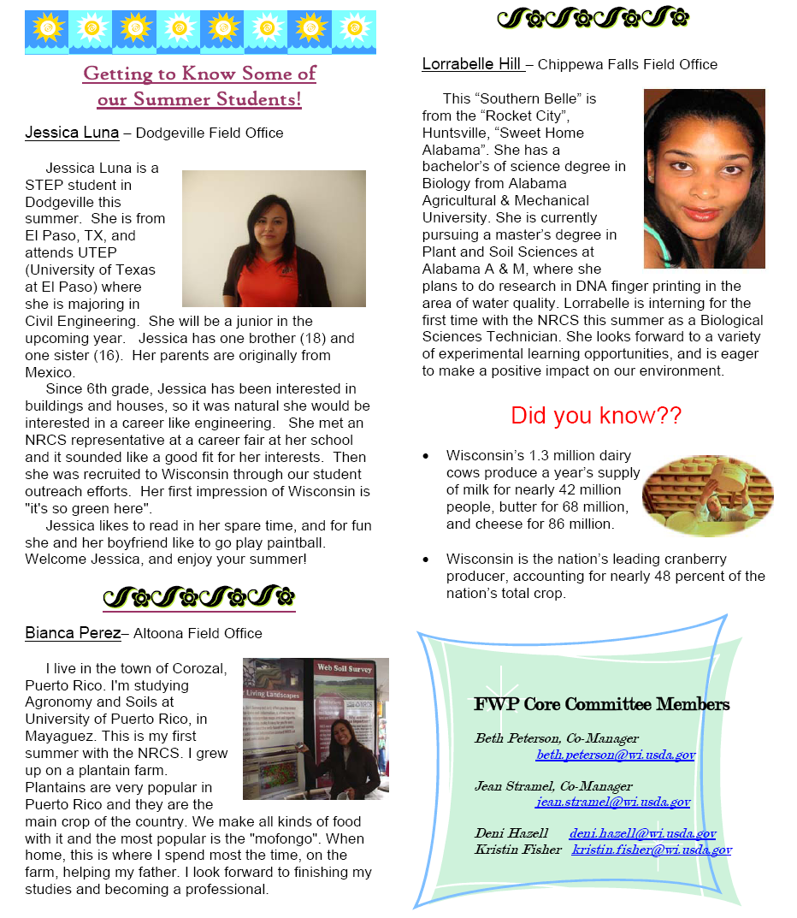
Teleconferences
- HEPM 1st Quarter by Astrid
- HEPM Teleconference Feb 28th, 2007
- HEPM Teleconference July 3rd, 2007
- HEPM Teleconference Sep 11th, 2007
State Reports
- Proved updates during Civil Rights Committee Meetings:
- CRC 1st Quarter meeting
- CRC Teleconference March 13, 2007
- CRC Meeting June 27-28, 2007
- CRC Teleconference August 30, 2007
Fact Sheets
- Worked with the Asian Pacific Islanders Program Manager and the Public Relations, representative for Wisconsin, Renae Anderson and created a fact sheet about Hispanics in Wisconsin. This fact sheet included Hispanic farmers’ data from National Agricultural Statistic Service (NASS). This information was distributed to all employees during area meetings. The fact sheets were also posted on the internet:
ftp://ftp-fc.sc.egov.usda.gov/WI/outreach/hispanicsep.pdf
Networking
- Attended the Hispanic Organization annual Conference in Bloomington, MN
- Attended the Hispanic event for the Greater Madison Federal Agency Association in Madison, WI
- Attended the first Minorities in Agriculture, Natural Resources and Related Sciences MANNARS meeting at UW-Madison
- Attended the Federal Woman Program FWP Conference in March 21, 2007
- North West Area Office meeting March 7th, 2007
- Summer student orientation at Madison, WI July 26, 2007
- North West Area meeting August 2nd, 2007
E-mail messages
- Emailed job openings to the National Organization of Professional Hispanic NRCS Employees (NOPHNRCSE) organization to be distributed nationally among members.
- During the Hispanic Heritage Month: sent e-mail to promote the Hispanic Month among WI NRCS employees.

2. Working with Leadership

- As member of the state Civil Rights Committee, I interacted with the State Conservationist as well as other members from the state office staff.
- Worked with my State Conservationist, CRC and Public Relations coordinator to present a proposal to bring the 2008 NOPHNRCSE Conference to Wisconsin.

3. Recruitment, Promotions, and Recognition
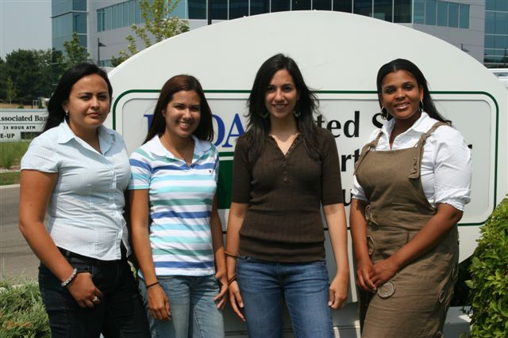
During this year we recruited three minority students. Two of these students, Jessica Luna and Bianca Perez, came from the National HEPMs database. The other student, Lorra Bell from Alabama, was found after utilizing NOPHNRCSE area representatives through e-mail all members.

- From the left: Jessica Luna, Bianca Perez, Bruni (HEPM), Lorra Bell
- These students were recognized by the FWP and included in their newsletter.

4. Outreach
- Attended the Public USDA and College of Agriculture Life Science CALS Job fair in Madison, Wisconsin along with other USDA agencies and national representatives and the Wisconsin APIPM. Networked and met 24 students interested in summer internships with NRCS. Provided report to Sharyn Alvares the acting API and to my state CRC.
- Attended MANRRS meeting as one of the contacts for NRCS as requested by the State Conservationist. We are working to develop a MANRRS chapter in Madison, Wisconsin.
- Worked with Renae Anderson on a packet of NRCS materials that will go out in direct mailing to Hispanic farmers in Wisconsin. The mailing list is from the National Ag Statistics Service in Wisconsin and included farm owner/operators identified as Hispanic in their database. The packet includes a letter and a brochure, in both Spanish and English, explaining NRCS programs and technical assistance. The letter invites people to contact the NRCS office for assistance, or me for assistance in Spanish. The packet also includes information from NASS, DATCP, and Growing Power.
- Translated the CNMP Emergency Action Plan into Spanish, which is posted on our website:
ftp://ftp-fc.sc.egov.usda.gov/WI/cnmp/PlanRespuestaEmergencias.pdf
- Assisted two District Conservationists by completing the CNMP Emergency Action Plan in Spanish:
  - Roy Diver, Wisconsin Rapids
  - Barry Bubolz, Shawano
- Performed the Field Office Civil Rights Review for the following offices:
  - Medford and Taylor County April 16th, 2007
  - American with Disability Act (ADA) Review for Medford and Taylor April 16th, 2007
  - Altoona Service Center August 3rd, 2007
During these reviews, I evaluated the office performance on issues related to Civil Rights and compliance in program delivery and EEO. I reviewed the employees training documentation and suggested training if needed. After the review was completed I provided a report to the ASC-FO with my suggestions.

5. Hispanic History Month
- Sent e-mails to all employees about:
- 2007 Hispanic Heritage Poster Contest winner from Wisconsin
- Facts about Hispanic Americans and Hispanics in the Army
- Article about Hispanic Heritage
- Four e-mails with photos from Bianca’s farm in Puerto Rico and conservation practices
- Biography for Joel Ortiz, new Hispanic employee.
** Wisconsin Hispanic employees at the end of 2007. Adolfo Díaz, Kent Peña, Dennisse Hazell, Joel Ortiz, Brunilda Velez. Students: Bianca Pérez, Jessica Luna. Omar Vega left to work for the Minnesota NRCS.

6. Training
- Attended the NOPHNRCSE and HEPM Training in Bloomington, MN.
- Developed power point presentations used statewide to provide training in EEO Program Complaint and Program Delivery. http://www.wi.nrcs.usda.gov/about/civil_rights.html
- Updated 230-Field Office Civil Rights folders for all the counties in my area and provided training at the area meeting along with training on the Outreach Report Guide developed by Renae Anderson.

John Xiong, Asian Pacific Islander Emphasis Program, FY07 Report

1. Communications
- Sent write-up of API accomplishments to the State Outreach coordinator and National Program Manager.
- Communicate with National Program Manger, Virginia Lewis & Sharon Alvarez, and APIO staff on API related information.
- Assisted national representative by participating in two UW-Madison CALS Career Fairs.
- Networking with other APISEPMs:
- Continue close ties with Amalia Gomez, Michigan APISEPM, to share
information/videos/manuals/translations.

2. Working with Leadership
- Actively participate in Wisconsin Civil Committee Rights meetings/ recruitment process, and planning.
- Contacted APIO President for advises in recruiting one UW-Riverfalls API Female student.
- Assisted National APISEPM, Reed Sims (VT APISEPM), Cheryl Morton (HI APISEPM) in creating (7) NRCS Demographic employee maps to be shared with all SEPMs.
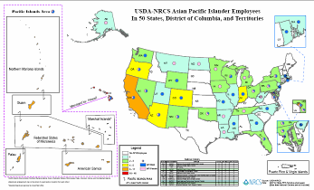
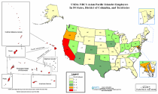

- Contributed and assisted WI CR Chair with the state’s Annual Affirmative. Employment Program (AEP report) and the 2007 State Civil Rights Performance Report.
- Requested by an Rural Development area director to participate in a hiring panel

3. Recruitment, Promotions, and Recognition

- Actively participated in student recruitment opportunities.
- Set up booth for student recruitment in two UW-Madison career fairs on September 25, 2007 with Bruni Velez, WI HEPM.
- Public: Public Career Fair 975 University Ave, 3259 Grainger Hall, UW-Madison
- Student: UW-Madison CALS Career Fair
- From the Career fairs, captured a list of students interested in working for NRCS and will evaluate students for possible student employment opportunities for summer of 2008.
- Assisted newer API employees in the state with questions and concerns.
- Worked with one API prospective student at University of Wisconsin- River Falls
who is applying for the APIO SCHOLARSHIP.
- APISEPM received award of Certificate of Merit: “For Outstanding Support of the WI Digitizing Unit, the CR Committee & for Leadership to the MANRRS Chapter at UW-Madison on behalf of NRCS.”
- Emailed work-study position, other employment information, and scholarship information to MANRRS chapter contacts and all other API contacts.
- Encouraged one API students to join the Earth Team to learn more about NRCS, now volunteering at Marathon County. DC there is pleased to have a good API volunteering in her office.
- Recognized WI API employee, Kara Nelson, winner of the 2007 Hispanic Heritage Month poster contest, a $300 bonus. (see photo of winning poster below)
- Winning poster and creator’s bio were on displayed during GMFAA Hispanic Heritage Month Celebration at the state office.

4. Outreach
- Participate in Minorities in Agriculture and Related Sciences (MANRRS) meetings/ annual picnic
- Networked with local UW-Madison Hmong Engineering student club president.
- Sent out annual scholarship application forms targeting API students.
- Distributed Avian Flu translations and materials (VHS Videos/DCD) to Manitowoc County office to API SC for distribution.

5. Special Emphasis Month celebration
- Emailed and distributed global, nation-wide, and state-wide facts on API to all state employees.
- Requested for and submitted bios of two API employees to highlight them.
- Assisted Club Fed (State Office club) member in hosting Asian box lunch and share the 2006 & 2007API poster entries with co-workers with screen presentation.
- On the last day in May, shared two Asian dishes and the recipe during lunch.
- Continued to assist in the planning and celebration of the Greater Madison Federal Agencies Associations (GMFAA) Heritage Month Celebrations for all special emphasis groups.
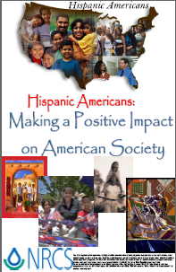

6. Training
- Four NRCS employees attended the 2007 APIO SEPM Training Conference in Miami, FL. Three were API employees.
- APISEPM and API employees who attended the conference assisted in the newsletter write-up highlighting certain key points learned and experienced from the conference.
- Newsletter was shared in state and distributed to the rest of APISEPM in other states.

Winning poster for national Hispanic Heritage Month, created by Kara Nelson, WI NRCS Soil Conservationist in Balsam Lake.
Area and MLRA Offices

Juneau MLRA office
Mark Krupinski:

1) World Dairy Expo--Oct 2006--staffed Web Soil Survey booth--1.5 days, Oct 3 and Oct 5, 2006
2) Demonstration of GPR to Glacierland RC&D meeting in Manitowoc Co--Oct 4, 2006
3) Presentation to WI Tax Assessors Institute in La Crosse on Soil Survey upgrade projects--Oct 16, 2006
4) WI Society of Professional Soil Scientists fall meeting chair--Dec 15, 2006
5) Presentation on Soil Survey upgrade projects and staffed Web Soil Survey booth at WI Fertilizer and Aglime Conference --Jan 17 and 18, 2007
6) Demonstration of GPR to Glacierland RC&D well abandonment workshop in Sheboygan Co--May 30, 2007
7) Volunteer soil scientist at the Chicago Field Museum soils exhibit--Aug 2, 2007
8) Soils training to county, state and federal conservation employees--Sept 11, 2007

Karla Petges:

Farm City Days in Dodge County for 800+ 4th graders from all schools in Dodge Co.
Assisted at Farm Tech Days in Green County in the soils pit and with the soils table making monoliths
Assisted with World Dairy Expo manning the Web Soil Survey booth

Chris Miller:

World Dairy Expo, October 2006, Staffed the Web Soil Survey Booth 1 Day.

Southwest Area Office
- Contacted Experience Works Program to inquire about their training program for retired citizens, in an effort to acquire “host volunteers” to work in the southwest counties to assist with Farm Bill Implementation as well as administrative responsibilities. As a result, 9 of the SW counties qualified for “Experience Works” candidates. These volunteers would be able to work for the agency for 20 or 40 hours per week. The Experience Works Program would pay them a salary to assist with the NRCS Field office workload. This comes at no cost to the agency and each office can maintain an employee for as long as 2 years.
- Conducted a New Employee Orientation at the area office to include topics such as Civil Right/EEO and Ethic. Each Student in attendance’s training plan was reviewed with them, so that they would know the expectations. The training included employees such as, Pheasant Forever Buffer Interns, Intermittent Student, STEP students and Experience Works employees. Seventeen Students were in attendance.
- Encourage the Ho-Chunk Liaison (Greg Yakle) to set up a meeting with the Ho-Chunk Conservation Representative and the SW Badger RC&D Coordinator. The meeting would be an effort to personally invite the Nation to be a part of the SW Badger Council Membership and to discuss opportunities for the Nation to participate in Council Sponsored activities. The meeting was held in The Spring of 07 and the Ho-Chunk indicated their appreciation for setting up such a meeting. The Council will continue to invite them to the SW Badger meetings in the future.
- Contacted 16 Historically Black Colleges and Universities to encourage students to apply for Soil Conservationist, Soil Science and Engineering summer STEP positions. As a result, 12 applications were received from Minority students seeking for opportunities in Wisconsin.
- Presented proposal to Mgmt to submit a Wisconsin Farmer for the Lloyd Wright Small Farmer of the Year Award. This Award is sponsored by the National Association of Professional Black Employees (NOPBNRCSE). As a result of the PAS and the CR Committee, a nomination was submitted and won third place in the national competition.
- Developed a DRAFT “Student Recruitment/Retention Plan” in an effort to support Wisconsin’s mission in diversifying its workforce.
- Hired intermittent Student through the Dept of Social Services. She works as a Student in ADM and is enrolled in the Colleges Administrative Assistant Program.

Resource Conservation and Development Areas

Pri-Ru-Ta RC&D
Chris Borden, Pri-Ru-Ta RC&D Coordinator, assisted the Wisconsin Tribal Conservation Advisory Council in the development of their long range Strategic Plan. The group has made significant progress in planning and implementation to forward their goal of making Farm Bill conservation programs work more effectively on Tribal Nations within the State.

River Country RC&D
- Grazing - River Country staff worked with five Amish/Mennonite families to develop managed intensive grazing plans for their farms. They assisted 12 other families with one-on-one grazing assistance to educate and address concerns of the families.
- Grazing assistance was provided to 10 women farm owners.
- River Country Council successfully secured scholarships for five Hmong families to attend the Midwest Value Added Conference in Red Wing MN, January 25 & 26, 2007.

