Weekly Report - Snowpack / Drought Monitor Update Date: July 19, 2007

SNOTEL SNOWPACK AND PRECIPITATION SUMMARY

Temperature: During the past seven days, temperatures ranged from 12°F above normal over the Northern Cascades and Montana Rockies to 5°F below normal over the Colorado and New Mexico Rockies and lower elevations of central California (Fig. 1).

Precipitation: For the past week, isolated but heavy thunderstorms were experienced over northern California and southwest Oregon (Fig. 2). IsoIated activity was observed over the Rockies. For the Water Year (began 1 October 2006), total amounts have not changed appreciably since last week. The Interior West (Great Basin and Intermountains) including the Sierra Nevada and the Arizona ranges continue to show large deficits.

WESTERN DROUGHT STATUS
The West: Record-setting summer heat waves have been common across the West in recent years, and 2007 has been no exception. Most recently, intense heat struck the Northwest, where all-time-record highs in Washington included 99 degrees F (on July 10) in Hoquiam and 94 degrees F (on July 11) in Bellingham. Seattle, Washington (98 degrees F on July 11), experienced its hottest day since July 20, 1994, when an all-time, record-tying high of 100 degrees F occurred. Meanwhile, the onset of the southwestern monsoon (officially, July 8 in Tucson, Arizona, based on a dewpoint definition) contributed to numerous lightning strikes and a corresponding increase in western wildfire activity. During the first 17 days of July, western wildfires charred nearly 1.7 million acres of vegetation, doubling the nation’s year-to-date total to 3.4 million acres (125 percent of the 10-year average).
Western heat and drought has also taken a toll on pastures, rangeland, and rain-fed summer crops. According to USDA, rangeland and pastures were rated at least 40 percent very poor to poor on July 15 in the following states: California (96 percent), Nevada (64 percent), Arizona (57 percent), Utah (46 percent), and Oregon (40 percent). In Washington, crops rated at least 20 percent very poor to poor included spring wheat (34 percent) and barley (24 percent).
Aside from agricultural impacts, much of the West continued to experience long-term drought and water-supply concerns. At the end of June, water storage in the Colorado River system stood at 9.09 trillion gallons, just 65 percent of average. Lake Mead, near Las Vegas, one of the two huge reservoirs along the Colorado River, held 4.15 trillion gallons (63 percent of average). By mid-July, the 1,112.6-foot elevation of Lake Mead’s surface represented a near-record low level. Prior to the current drought, Lake Mead was last below 1,125 feet in 1965. Lake Mead’s 1939-2003 average August elevation was 1,176 feet, while the record-low level dipped just below 1,100 feet in 1964. Elsewhere, end-of-June statewide reservoir storage stood at 73 percent of average in Oregon (27 of 31 reservoirs reporting) and 76 percent in Utah (25 of 28 reservoirs reporting). Author: Brad Rippey, U.S. Department of Agriculture.

A comprehensive narrative describing drought conditions for the nation can be found at the end of this document.

DROUGHT IMPACTS DEFINITIONS (http://drought.unl.edu/dm/classify.htm)
The possible impacts associated with D4 (H, A) drought include widespread crop/pasture losses and shortages of water in reservoirs, streams, and wells creating water emergencies. The possible impacts associated with D3 (H, A) drought include major crop/pasture losses and widespread water shortages or restrictions. Possible impacts from D2 (H, A) drought are focused on water shortages common and water restrictions imposed and crop or pasture losses likely. The possible impacts associated with D1 (H, A) drought are focused on water shortages developing in streams, reservoirs, or wells, and some damage to crops and pastures (Fig. 3 and 3a).

SOIL MOISTURE
Soil moisture (Fig. 4), is simulated by the VIC macroscale hydrologic model. The detailed, physically-based VIC model is driven by observed daily precipitation and temperature maxima and minima from approximately 2130 stations, selected for reporting reliably in real-time and for having records of longer than 45 years (and various other criteria).

OBSERVED FIRE DANGER CLASS
The National Interagency Coordination Center provides a variety of products that describe the current wildfire status for the U.S. - http://www.nifc.gov/information.html. The latest Observed Fire Danger Class is shown in Fig. 5. Fig. 5a shows the current active wildfires across the West - http://geomac.usgs.gov/.

U.S. HISTORICAL STREAMFLOW

This map, (Fig. 6) shows the 7-day average streamflow conditions in hydrologic units of the United States and Puerto Rico for the day of year. The colors represent 7-day average streamflow percentiles based on historical streamflow for the day of the year. Thus, the map shows conditions adjusted for this time of the year. Only stations having at least 30 years of record are used. Sub-regions shaded gray indicate that insufficient data were available to compute a reliable 7-day average streamflow value. During winter months, this situation frequently arises due to ice effects. The data used to produce this map are provisional and have not been reviewed or edited. They may be subject to significant change.

http://water.usgs.gov/cgi-bin/waterwatch?state=us&map_type=dryw&web_type=map.

VEGETATION HEALTH
The images (Fig. 7) are color-coded maps of vegetation condition (health) estimated by the Vegetation and Temperature Condition Index (VT). The VT is a numerical index, which changes from 0 to 100 characterizing change in vegetation conditions from extremely poor (0) to excellent (100). Fair conditions are coded by green color (50), which changes to brown and red when conditions deteriorate and to blue when they improve.
http://www.orbit.nesdis.noaa.gov/smcd/emb/vci/usa.html. Associated with vegetation health are pasture and rangeland conditions (Fig. 8) as noted at: http://www.cpc.ncep.noaa.gov/products/predictions/experimental/edb/pasture-range-statewide-conditions.pdf

STATE ACTIVITIES
State government drought activities can be tracked at the following URL: http://drought.unl.edu/mitigate/mitigate.htm. NRCS SS/WSF State Office personnel are participating in state drought committee meetings and providing the committees and media with appropriate SS/WSF information - http://www.wcc.nrcs.usda.gov/cgibin/bor.pl. Additional information describing the products available from the Drought Monitor can be found at the following URL: http://drought.unl.edu/dm/

FOR MORE INFORMATION
The National Water and Climate Center Homepage provide the latest available snowpack and water supply information. Please visit us at http://www.wcc.nrcs.usda.gov. This document is available from the following location on the NWCC homepage - http://www.wcc.nrcs.usda.gov/water/drought/wdr.pl

This report uses data and products provided by the Interagency Drought Monitor Consortium members and the National Interagency Fire Center.

/s/ NOLLER HERBERT
Director, Conservation Engineering Division
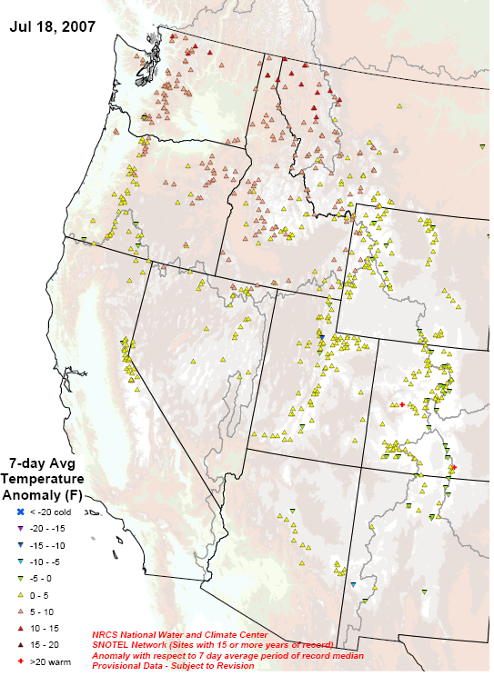

Fig. 1. SNOTEL 7-day average temperature anomaly.
Ref: ftp://ftp.wcc.nrcs.usda.gov/data/water/wcs/gis/maps/WestwideTavg7dAnomay.pdf

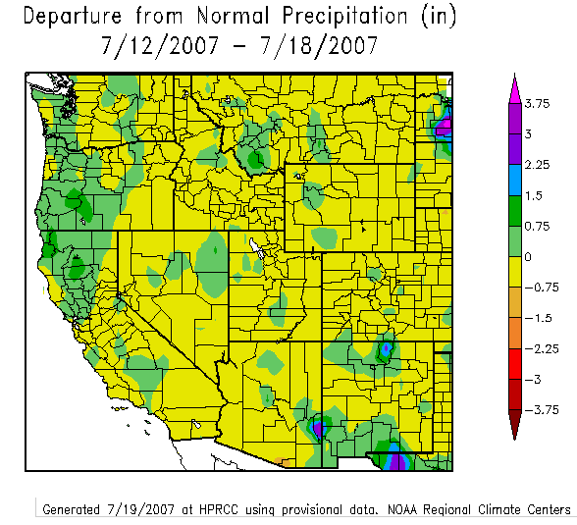
Fig. 2. Preliminary precipitation percent of normal for the 7-day period ending 18 July 2007. Ref: http://www.hprcc.unl.edu/maps/index.php?action=update_product&product=TDept

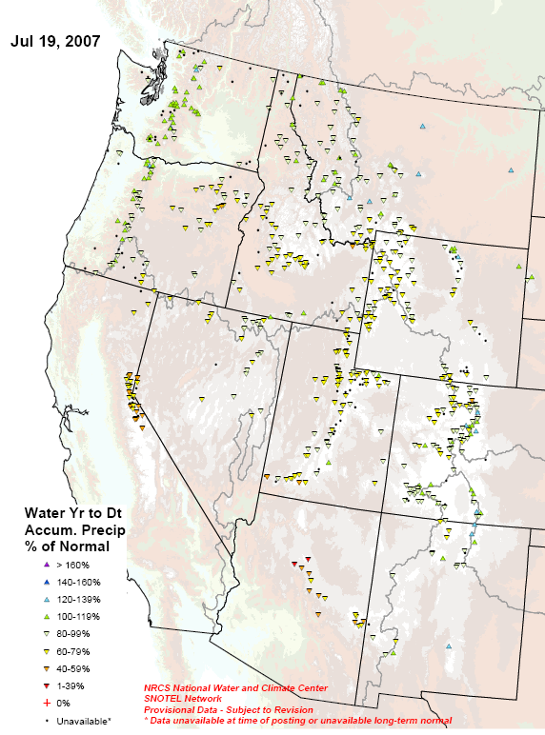
Fig. 2a. SNOTEL station water year (since October 1) precipitation as a percent of normal. Ref: ftp://ftp.wcc.nrcs.usda.gov/data/water/wcs/gis/maps/WestwideWYTDPrecipPercent.pdf

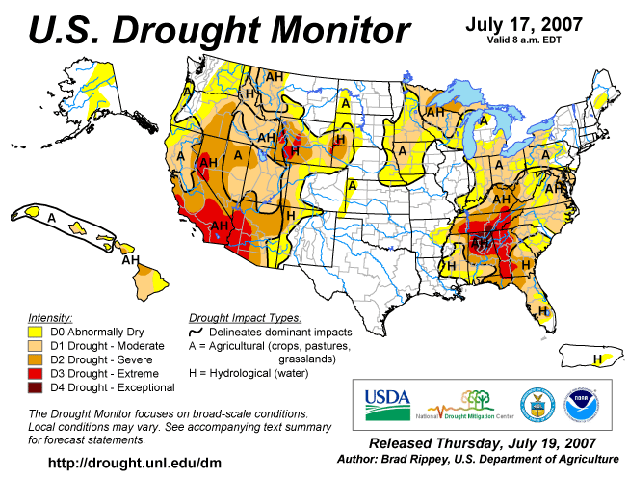

Fig. 3. Current Drought Monitor weekly summary.

Ref: National Drought Mitigation Center (NDMC) - http://www.drought.unl.edu/dm/monitor.html
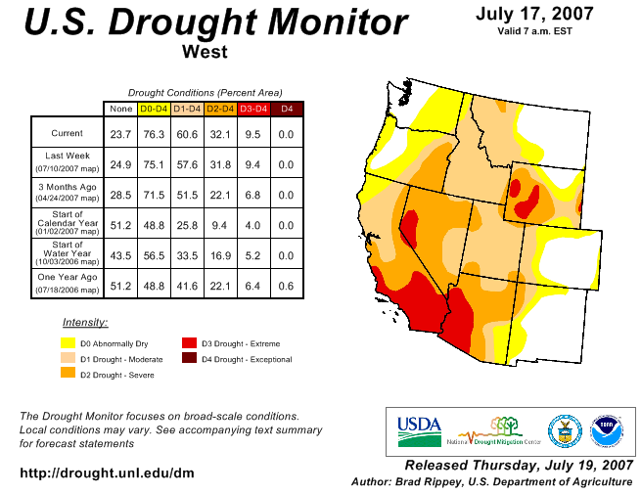
Fig 3a. Drought Monitor for the Western States with statistics over various time periods.
Ref: http://www.drought.unl.edu/dm/DM_west.htm

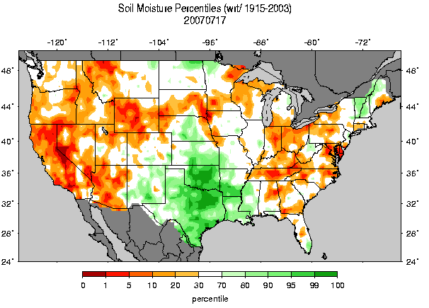
Fig. 4: Soil Moisture Ranking Percentile based on 1915-2003 climatology. (source: Univ. of Washington). Ref: http://www.hydro.washington.edu/forecast/monitor/curr/CONUS.sm_qnt.gif

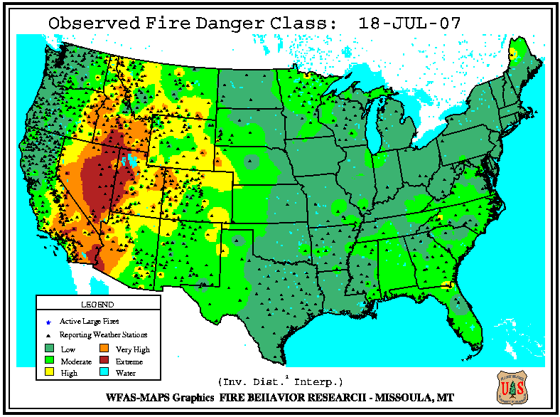

Fig. 5. Observed Fire Danger Class. Source: Forest Service Fire Behavior Research – Missoula, MT Ref: http://www.fs.fed.us/land/wfas/fd_class.gif
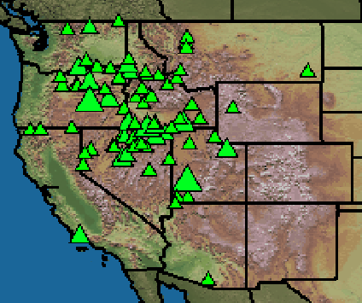

Fig. 5a. Location of active wildfires across the West. Ref: http://geomac.usgs.gov /
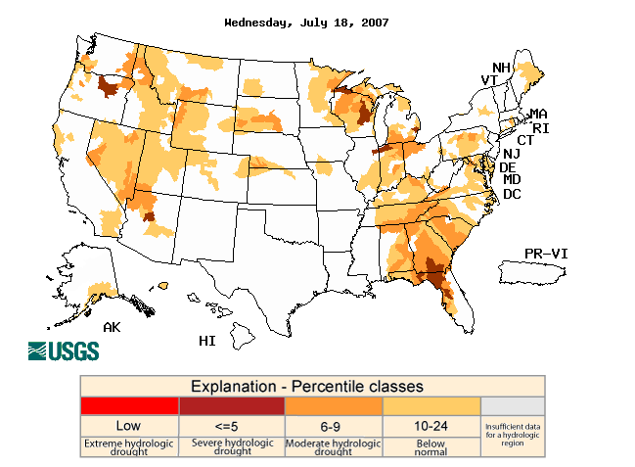

Fig. 6. Map of below normal 7-day average streamflow compared to historical stream flow for the day of the year. Ref: USGS http://water.usgs.gov/waterwatch/?m=dryw&w=map&r=us

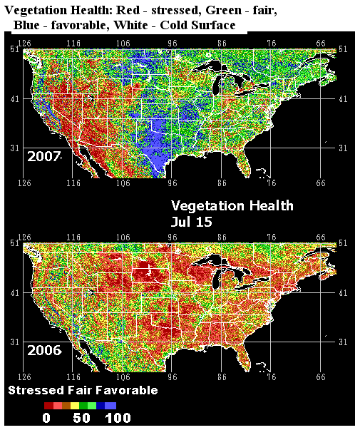
Fig. 7: This remote satellite AVHRR http://www.orbit.nesdis.noaa.gov/smcd/emb/vci/usa.html) map shows very stressed vegetation over the Southwest and Wyoming.
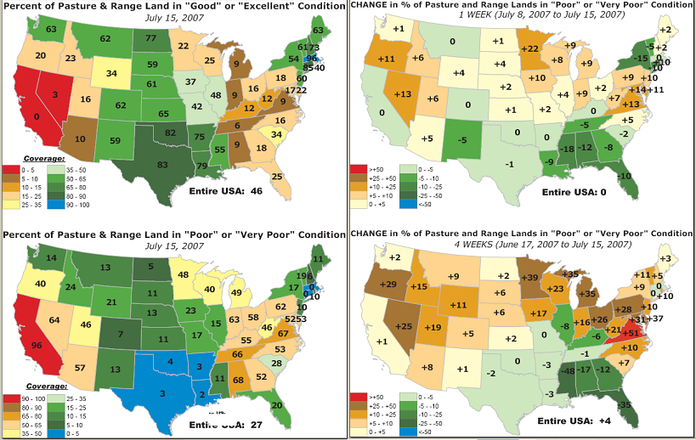
Fig. 8: Pasture and rangeland conditions for various periods. Oregon and Nevada shows the largest increase in poor to very poor conditions during the past week.
Ref: http://www.cpc.ncep.noaa.gov/products/predictions/experimental/edb/pasture-range-statewide-conditions.pdf
National Drought Summary -- July 17, 2007
The discussion in the Looking Ahead section is simply a description of what the official national guidance from the National Weather Service (NWS) National Centers for Environmental Prediction is depicting for current areas of dryness and drought. The NWS forecast products utilized include the HPC 5-day QPF and 5-day Mean Temperature progs, the 6-10 Day Outlooks of Temperature and Precipitation Probability, and the 8-14 Day Outlooks of Temperature and Precipitation Probability, valid as of late Wednesday afternoon of the USDM release week. The NWS forecast web page used for this section is: http://www.cpc.ncep.noaa.gov/products/forecasts/.
The Southeast: Heavy showers continued to erode dryness and drought from the lower Mississippi Valley into parts of the Southeast. The Delta region of Mississippi received as much as 4 to 10 inches of rain during the first two weeks of July, eradicating or significantly reducing the coverage of abnormal dryness and moderate drought (D0 and D1). By July 15, USDA rated Mississippi’s topsoil moisture 81 percent adequate to surplus and 19 percent very short to short. Two weeks earlier, on July 1, those Mississippi numbers had stood at 15 percent adequate to surplus and 85 percent very short to short. Farther east, in Muscle Shoals, Alabama, precipitation during the first half of 2007 totaled just 11.97 inches (40 percent of normal), but July 1-14 rainfall reached 6.25 inches (234 percent).
Rainfall was lighter and more scattered farther to the north and east, where a core area of extreme to exceptional drought (D3 to D4) persisted across large parts of Tennessee, northern Alabama, and western Georgia. Nevertheless, conditions gradually improved for pastures and many later-planted summer crops. From July 1 to 15, the amount of pastures rated very poor to poor improved from 86 to 68 percent in Alabama, 68 to 52 percent in Georgia, 72 to 66 percent in Tennessee, and 62 to 55 percent in Kentucky. More dramatic two-week improvements in very poor-to-poor pasture conditions were noted in Mississippi (from 66 to 11 percent) and Florida (from 60 to 20 percent). In terms of row crops, Alabama’s two-week improvements included 74 to 55 percent very poor to poor for cotton and 64 to 38 percent for peanuts.
The Northeast: Conditions primarily remained unchanged or deteriorated across the northeastern and mid-Atlantic states. In particular, three areas of moderate drought (D1) were blended to make a continuous area stretching from eastern North Carolina to the vicinity of Lake Erie. In addition, a new area of severe drought (D2) was introduced in the mid-Atlantic coastal plain. In Virginia, the percentage of pastures rated very poor to poor surged to 67 percent by July 15, up from 48 percent two weeks earlier. Farther north, enough rain fell in southern Maine to reduce the coverage of abnormal dryness (D0).
The Midwest: Little change in the moderate drought (D1) situation was noted in the eastern Corn Belt, while abnormal dryness and moderate drought (D0 and D1) expanded across the upper Midwest. By July 15, USDA indicated that 20 to 30 percent of the corn and soybeans were rated very poor to poor in Indiana, Michigan, and Ohio. Crop conditions were also beginning to slide in the upper Midwest, where the percentage of Minnesota’s corn rated very poor to poor jumped from 8 percent on July 1 to 19 percent two weeks later. During the 25-day period from June 23 to July 17, less than one-tenth of an inch of rain fell in locations such as Sioux Falls, South Dakota, and Marshalltown and Sioux City, Iowa.
The High Plains: Some severe drought (D2) was introduced on Montana’s High Plains due to record-setting heat and diminishing moisture reserves. Cut Bank, Montana (106 degrees F on July 6), noted its hottest day since August 5, 1961, when an all-time record of 107 degrees F was established. It was easily Cut Bank’s hottest July day on record (previously, 103 degrees F on July 19, 1960). Spring-sown small grains began to suffer in the Treasure State, with the amount of Montana’s spring wheat rated very poor to poor climbing from 6 to 18 percent between July 1 and 15. During the same period, the amount of barley rated very poor to poor in Montana rose from 11 to 26 percent.
In the adjacent mountainous region of western Montana, Missoula endured a historic heat wave during the first 17 days of July. Missoula’s highs reached or exceeded 100 degrees F on July 5-6 and 12-16 (seven days total), breaking its 1936 annual record of six days. From July 1-17, Missoula’s streak of 17 consecutive 90-degree days was its second-longest heat wave behind an 18-day such hot spell in 1960. Meanwhile, poor vegetation conditions and low reservoir levels led to an expansion or introduction of severe to extreme drought (D2 to D3) in an area centered on southwestern South Dakota.
The West: Record-setting summer heat waves have been common across the West in recent years, and 2007 has been no exception. Most recently, intense heat struck the Northwest, where all-time-record highs in Washington included 99 degrees F (on July 10) in Hoquiam and 94 degrees F (on July 11) in Bellingham. Seattle, Washington (98 degrees F on July 11), experienced its hottest day since July 20, 1994, when an all-time, record-tying high of 100 degrees F occurred. Meanwhile, the onset of the southwestern monsoon (officially, July 8 in Tucson, Arizona, based on a dewpoint definition) contributed to numerous lightning strikes and a corresponding increase in western wildfire activity. During the first 17 days of July, western wildfires charred nearly 1.7 million acres of vegetation, doubling the nation’s year-to-date total to 3.4 million acres (125 percent of the 10-year average).
Western heat and drought has also taken a toll on pastures, rangeland, and rain-fed summer crops. According to USDA, rangeland and pastures were rated at least 40 percent very poor to poor on July 15 in the following states: California (96 percent), Nevada (64 percent), Arizona (57 percent), Utah (46 percent), and Oregon (40 percent). In Washington, crops rated at least 20 percent very poor to poor included spring wheat (34 percent) and barley (24 percent).
Aside from agricultural impacts, much of the West continued to experience long-term drought and water-supply concerns. At the end of June, water storage in the Colorado River system stood at 9.09 trillion gallons, just 65 percent of average. Lake Mead, near Las Vegas, one of the two huge reservoirs along the Colorado River, held 4.15 trillion gallons (63 percent of average). By mid-July, the 1,112.6-foot elevation of Lake Mead’s surface represented a near-record low level. Prior to the current drought, Lake Mead was last below 1,125 feet in 1965. Lake Mead’s 1939-2003 average August elevation was 1,176 feet, while the record-low level dipped just below 1,100 feet in 1964. Elsewhere, end-of-June statewide reservoir storage stood at 73 percent of average in Oregon (27 of 31 reservoirs reporting) and 76 percent in Utah (25 of 28 reservoirs reporting).
Puerto Rico: Only light showers dotted Puerto Rico, leaving intact an area of long-term, hydrological dryness (D0H) across eastern portions of the island.
Alaska: Some heavy showers, locally in excess of two inches, fell along the northwestern fringe of the abnormally dry (D0) area over interior Alaska, resulting in a small reduction in the coverage. Alaska’s year-to-date wildfire total climbed above 200,000 acres, and the largest current blaze was the 3,500-acre Big Creek fire in the vicinity of Ruby (west of Fairbanks near the Yukon River).
Hawaii: Most of Hawaii’s leeward areas remained in moderate to severe drought (D1 to D2), following a disappointing wet season. Through July 17, year-to-date rainfall totaled just 2.69 inches (28 percent of normal) in Honolulu, Oahu, and 3.99 inches (35 percent) in Kahului, Maui. Meanwhile, Hawaii’s windward locations were still abnormally dry (D0). On the Big Island, Hilo’s March 1 – July 17 rainfall totaled 22.85 inches, or 48 percent of normal.
Looking Ahead: Weather that could have an impact on drought areas in the next two weeks: 1) a cold front will edge across the midwestern and mid-Atlantic states on July 19-20 before stalling across the South, preceded and accompanied by scattered thunderstorms and trailed by cooler, drier air; 2) scattered showers associated with the monsoon (summer rainy season) will dot the Four Corners States, while frontal rain will fall in the Pacific Northwest; 3) however, the majority of the Intermountain West will continue to experience unfavorably hot, mostly dry weather for the next several days; 4) the NWS 8- to 14-day outlook for July 26 – August 1 calls for unusually hot weather across the northern half of the U.S., excluding the Pacific Northwest, while cooler-than-normal conditions will prevail across the nation’s southern tier; 5) during the same July 26 – August 1 period, drier-than-normal weather across the midwestern, northeastern, and mid-Atlantic states will contrast with above-normal rainfall in southern Florida, the south-central U.S., and parts of the West.
Author: Brad Rippey, U.S. Department of Agriculture
Dryness Categories
D0 ... Abnormally Dry ... used for areas showing dryness but not yet in drought, or for areas recovering from drought.
Drought Intensity Categories
D1 ... Moderate Drought
D2 ... Severe Drought
D3 ... Extreme Drought
D4 ... Exceptional Drought
Drought or Dryness Types
A ... Agricultural
H ... Hydrological

Updated July 18, 2007

