Summary of Safety and Effectiveness Data

I. GENERAL INFORMATION

Device Generic Name: Mycobacterium tuberculosis, Cell mediated immune response EIA test.

Device Trade Name: QuantiFERON®-TB

Applicant’s Name & Address: Cellestis Limited
c/o Edward M. Basile
King & Spalding
1730 Pennsylvania Avenue
Washington, DC 20006

PMA Number: P010033

Date of Panel Recommendation: October 12, 2001

Product Code/Panel: NCD/83 (Microbiology)

Date of Good Manufacturing Practice June 16, 2000
Inspection:

Date of Notice of Approval
of the Application: November 28, 2001

II. INDICATIONS FOR USE

The QuantiFERON-TB test is an in-vitro diagnostic test intended as an aid in the
detection of infection with Mycobacterium tuberculosis.

III. CONTRAINDICATIONS, WARNINGS AND PRECAUTIONS

There are no known contraindications for the QuantiFERON-TB test (QFT). The warnings and precautions can be found in the QFT labeling. (Attachment 1)

IV. DEVICE DESCRIPTION

A. Principle of Operation:

The QuantiFERON-TB is a test of Cell Mediated Immune (CMI) reactivity. Individuals infected with M. tuberculosis have lymphocytes in their blood that recognize specific mycobacterial antigens in tuberculin Purified Protein Derivative (PPD) preparations due to prior exposure of the lymphocytes to M. tuberculosis. This lymphocytic recognition process involves the generation and secretion of the cytokine, interferon-gamma (IFN-γ). The QuantiFERON-TB test measures the amount of IFN-γ secreted in 24-well microplates by M. tuberculosis sensitized lymphocytes in response to the stimulation antigens. QuantiFERON-TB relies upon the stimulation of T cells previously sensitized by exposure to mycobacteria.

B. Test Procedure:

The QuantiFERON-TB assay detects CMI responses in vitro to tuberculosis infection by measuring IFN-γ harvested in plasma from whole blood incubated with tuberculin PPD, Mitogen, and M. avian PPD. The QuantiFERON-TB laboratory test is performed in two stages. First, four aliquots of heparinized whole blood are incubated with PPDs produced from M. tuberculosis (Human) and M. avium (Avian), as well as Mitogen and Nil control antigens.

After overnight incubation, plasma is removed and the amount of IFN-γ quantified by enzyme immunoassay (EIA). The QuantiFERON-TB EIA uses recombinant human IFN-γ standards, which have been assayed against a reference IFN-γ preparation (NIH Ref: Gxg01-902-535). Results for test samples are reported in International Units relative to this standard preparation.

The Mitogen-stimulated IFN-γ is used to normalize Human PPD responses. Only specimens with detectable amounts of IFN-γ from mitogen can be interpreted with the QuantiFERON-TB test. The Nil sample adjusts for background, heterophile antibody effects, or nonspecific IFN-γ in blood samples. Measurement of IFN-γ from the Avian PPD stimulated sample enables identification of specimens that may have predominant responses to non-tuberculous mycobacteria (e.g., M. avium complex) rather than M. tuberculosis. The comparison of IFN-γ levels detected in the four samples are used to determine the likelihood of infection with M. tuberculosis complex.

C. Quality Control of Test:

The accuracy of test results is dependent on the EIA generating a linear curve. Therefore, results derived from the standards must be examined before test sample results can be interpreted.

For the EIA test to be valid:

1. The correlation coefficient (r) calculated from the mean absorbances of the standards must be ≥ 0.98.

2. Replicate absorbances for the Zero Standard must not vary by more than 0.040 optical density units from their mean.

3. The Low, Medium, and High Standards must be within 15% of their individual mean absorbance values (% Coefficient of Variation (CV) < 15 %).

4. The mean absorbance for the High Standard must be ≥ 0.700.

5. If the above criteria are not met the run is invalid and must be repeated.

D. Interpretation of Results:

Under most circumstances, the Nil Control will not generate any IFN-γ. If IFN-γ is detected, it is considered background and is subtracted from the other results for that subject.

QuantiFERON-TB test results can only be interpreted from individuals capable of generating detectable levels of IFN-γ. The Mitogen Control generally elicits the greatest IFN-γ response for any given individual.

Individuals demonstrating a value of less than 1.5 IU/mL for their Mitogen-Nil value are deemed as having an indeterminate result for the QuantiFERON-TB test. In such cases, the test may be repeated to confirm results and/or relevant clinical information sought to determine any possible cause of immunosuppression. An individual’s response to the Human PPD and Nil must be such that the (Human PPD - Nil) response is greater than or equal to 1.5 IU/mL for that individual to be deemed likely infected with M. tuberculosis, if risk is identified.

The % Human Response calculation is used to standardize the variability observed between individual PPD and mitogen responses. Responses above specific threshold values indicate significant reactivity, likely to have been elicited from mycobacterial infection.

The % Avian Difference calculation is used to determine which PPD an individual responds to most significantly.

Figure 1. QuantiFERON-TB results are interpreted as follows:

INTERPRETATION | M –N¹  IU/mL | H –N²  IU/mL | % Human Response³ |  | % Avian  Difference
MTB infection likely | ≥ 1.5 | ≥ 1.5 | >15% but <30% | ≤ 10%
MTB infection  NOT likely  NEGATIVE | ≥ 1.5 | All other response profiles

¹M-N must be ≥ 1.5 IU/mL for a valid QuantiFERON-TB result. Results are deemed INDETERMINATE if M – N < 1.5 IU/mL.
²H-N must be ≥ 1.5 IU/mL for a patient to be considered POSITIVE for MTB infection. If H-N < 1.5 IU/mL the individual is deemed negative for MTB infection regardless of their % Human Response and % Avian Difference results.
³ A 15% Human Response cut-off is used for individuals with identified TB exposure risk and a 30% cut-off for people with no identified risk factors.

- ALTERNATIVE PRACTICES AND PROCEDURES

The only legally marketed device for the determination of latent Mycobacterium tuberculosis is the Tuberculin skin test.

- MARKETING HISTORY

QuantiFERON-TB has not been marketed in the United States.

QuantiFERON-TB has been marketed in Australia since 1995. From 1996/1997 the kit has been marketed in New Zealand, Japan, the United Kingdom, Spain, Malaysia, Denmark, Ethiopia, Kenya, Slovenia, Germany, Italy and Bulgaria.

QuantiFERON-TB has not been withdrawn from the market in any country for any reason related to the safety or effectiveness of the device.

VII. POTENTIAL ADVERSE EFFECTS OF THE DEVICE ON HEALTH

An erroneous result can lead to an adverse effect for the tested patient. A false-negative result could lead to an individual developing active TB disease, adversely affecting their health, and possibly facilitating the spread of M. tuberculosis to other individuals in the community. Tuberculosis is contagious and can be readily transferred from one person to another via air particles expelled from an infectious individual while coughing. A false-positive response could lead to an individual being administered unnecessary prophylaxis for tuberculosis infection.

The only direct adverse effects on patient health from collecting the specimen for testing are those associated with venipuncture, namely a slight risk of bleeding, hematoma, and infection. Pain and redness at the site of injection occur and some people become dizzy and/or faint when blood is drawn.

VIII. SUMMARY OF PRECLINICAL STUDIES

A. Cut-Off Studies:

The objective of the study was to determine the optimal method for Cut-off point selection. Receiver Operating Characteristic (ROC) curves were generated from QuantiFERON-TB results from 599 individuals using American Thoracic Society (ATS, 1990) classification as the gold standard (Class 0, Low exposure risk, n=417 for specificity and Class 2, LTBI, n=182 for sensitivity). ROC analysis identified the % Human PPD Response as the optimal method for distinguishing infected individuals from non-infected individuals (Figure 2).

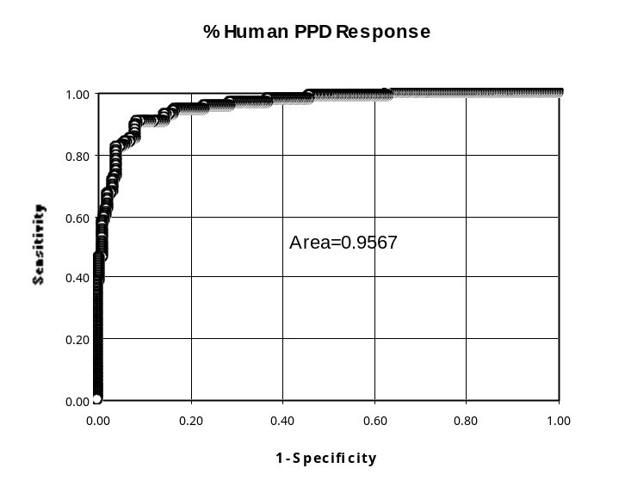Figure 2. ROC Plot for 599 individuals using % Human PPD Response (Streeton et al, 1998)
1. Diagnostic Cut-off criteria:

The objectives of this study were to establish the diagnostic cut-off criteria. Two diagnostic cut-offs were identified for the QuantiFERON-TB test. The % Human PPD Response cut-off was established to distinguish between individuals who are infected and those who are not infected. The % Avian Difference cut-off was established to help identify individuals whose positive % Human PPD Response is likely to be due to infection with a mycobacterium other than M. tuberculosis (MOTT).

2. Human PPD Cut-off – Reactivity to M. tuberculosis PPD:

Heparinized whole blood samples from 952 consenting volunteers were tested to determine the Human PPD cut-off threshold (Streeton et al, 1998).

The % Human PPD Response, expressed as the % Human PPD/Mitogen using IU/mL IFN-γ estimates, was identified as the most sensitive and specific method for assessing an individual's Human PPD induced IFN-γ response.

Analysis was performed comparing QuantiFERON-TB and TST results in all ATS classes. Paired QuantiFERON-TB and TST results were available for 581 of the 952 individuals. The TST reactions were assigned positive status for induration diameters ≥ 10 mm or ≥ 15 mm if BCG vaccinated.

When the % Human PPD Response cut-off was set at 15%, 88.2% of TST positive individuals were positive in the QuantiFERON-TB test. There was no statistical difference between the performance of the TST and the QuantiFERON-TB test using the 15% Human PPD Response cut-off (kappa = 0.786; p = 0.9, McNemar χ² test). Therefore, the most appropriate % Human PPD response cutoff threshold was determined to be 15% from this study.

Data obtained from studies conducted in the US by the Center for Disease Control and Prevention (CDC) and the Walter Reed Army Institute of Research (WRAIR) enabled analysis of the appropriate % Human Response cut-off to use in the intended US populations. Similar to the TST, a “Risk Category” cut-off can be applied to the QuantiFERON-TB, with a higher % Human Response cut-off in low risk individuals and a lower threshold in individuals with identified risk factors.

Data from the CDC low risk group individuals were examined for the optimal cut-off for concordance with the TST, and demonstrated that a 30% Human Response cut-off is appropriate for low risk individuals. Using this cut-off value, 96/98 of individuals in Group 1 of the CDC study were negative by QuantiFERON-TB, equating to a specificity of 98%. For the 2 individuals who were QuantiFERON-TB positive, both had a TST response of >10 mm (11 mm and 14 mm). Two individuals were positive by the TST using a cut-off of 15 mm. Both of these were negative by the QuantiFERON-TB test, one due to a predominant reactivity to M. avium PPD (i.e., % Avian Difference >10%).

The 30% Human Response cut-off for low risk individuals was further evaluated by applying it to data from low risk individuals from the WRAIR study. When the 30% Human Response cut-off (maintaining the 10% Avian Difference cut-off) was applied to the WRAIR low risk dataset, 1431 of the 1463 individuals with no identified risk factors for TB exposure were negative in the QuantiFERON-TB test. This equates to a specificity of 98%. Using the 15 mm TST cut-off, recommended by the ATS/CDC guidelines for these individuals, 1441/1463 (98%) were negative.

Analysis of data from individuals in the CDC and WRAIR study who had identified risk factors for TB exposure (as per the ATS/CDC guidelines) demonstrated that the previously identified 15% Human Response cut-off was appropriate for these individuals.

Following the above data analysis, a risk-stratified cut-off has been adopted for the QuantiFERON-TB test.

3. % Avian PPD Cut-off – Reactivity to non-tuberculous mycobacteria:

The objective of this study was to determine % Avian PPD Cut-off – Reactivity to non-tuberculous mycobacteria.

A 10% Avian Difference cut-off was validated in a study testing 60 individuals with past culture confirmed M. avium complex (MAC) lymphadenitis (n=10) or M. tuberculosis disease (n=50). Patients with past culture proven M. avium infection were used as a representative group for individuals with MOTT reactivity.

The data were analyzed by direct comparison of the % Avian Differences for each individual. Using the 10% cut-off criterion, 96% of tuberculosis patients had a % Avian Difference of <10%, and 100% of MAC patients had a % Avian Difference of >10%. This showed that a % Avian Difference of 10%, calculated as [((Avian PPD – Human PPD)/Human PPD) X 100], was a useful cut-off to aid the discrimination of M. tuberculosis infection and reactivity due to MOTT. Therefore, the most appropriate % Avian Difference cutoff to use was determined to be 10%.

To further validate the % Avian Difference cutoff, data from the CDC study were analyzed as described below. QuantiFERON-TB demonstrated a sensitivity of 81% (44 out of 54 patients) for TB disease in culture confirmed tuberculosis patients from Group 3 of the CDC study. Analysis of QuantiFERON-TB data from these 54 individuals was performed to ascertain what effect altering the % Avian Difference cutoff would have on the test's performance (Figure 3).

In this group of TB patients, where culture of M. tuberculosis is a gold standard, there was no significant loss of sensitivity observed by employing the secondary cutoff for QuantiFERON-TB of greater than 10% Avian Difference. Examination of different cut points for the % Avian Difference demonstrated that there was no significant loss of sensitivity for the QuantiFERON-TB test until the %Avian Difference was lowered to -30%. At cutoffs lower than -30% the sensitivity of QuantiFERON-TB declined rapidly (Figure 3). This analysis indicates that the % Avian Difference cutoff of 10% has no significant effect on the sensitivity of QuantiFERON-TB in truly infected subjects, and is set substantially below a level where an effect on sensitivity may be expected for individuals with LTBI.

There was one case of culture confirmed M. avium infection in Group 3 individuals from the CDC study. This individual was correctly identified by QuantiFERON-TB as being not infected with MTB complex organisms, as their % Avian Difference was 90%, but was positive in the TST with an induration of 11 mm.

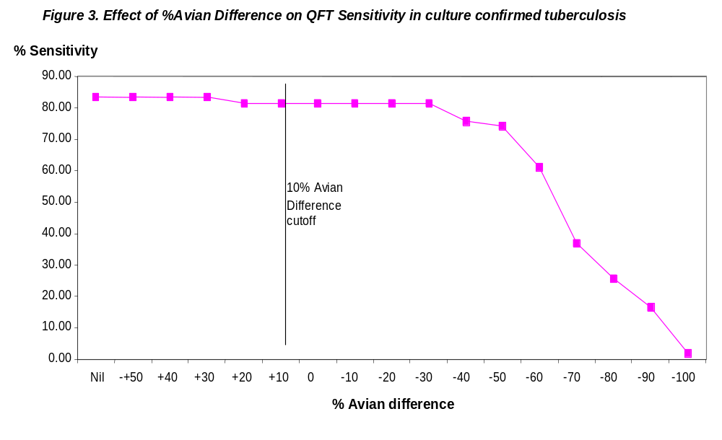

4. Effect of Avian cut-off in high and low risk groups:

For Groups 1 and 2 (low and high risk) individuals in the CDC study there were 227 people with a positive TST, of which 81 had a negative QuantiFERON-TB result. Thirteen of these 81 had a % Human PPD Response greater than the appropriate % Human PPD Response cut-off, but were classified as negative in the QuantiFERON-TB test due to their % Avian Difference being greater than 10% (i.e. the QuantiFERON-TB test detected them as having MOTT reactivity). This represents 5.7% of the TST positive group, but only 1.2% of the population in total. Given that the estimates of false positive TST reactions due to MOTT range up to 3% of the general US population (Margileth, 1994; Huebner et al, 1993; von Reyn et al, 1993) this would accord with known data on MOTT reactivity for the TST.

Within the WRAIR study, 4 of the 29 (13.8%) TST positive QuantiFERON-TB negative subjects were classified as MOTT reactive by QuantiFERON-TB.

5. Utility of Avian Difference cut-off Sensitivity analysis

Further validation of the 10% Avian difference cut-off emerges from sensitivity analysis of the clinical trial data in low and high-risk groups. Sensitivity analysis was performed to test the effect of altering the sensitivity cut-off to 0% or 20%, or removing the Avian comparison completely.

Examining both the CDC and WRAIR low risk Groups, alteration of the % Avian Difference cutoff from 0%, 10% or 20% has little to no effect on the specificity of the test and its concordance with TST. Thus, the 10% Avian Difference cut-off provides a suitable measure. Elimination of the % Avian Difference comparator resulted in loss of specificity for QuantiFERON-TB and a major increase in QuantiFERON-TB positive TST negative discordance.

For higher risk groups in both studies the alteration of the cut-off from 0%, 10%, or 20% has little to no effect on the performance of the test and concordance with the TST remains similar.

Within the high risk CDC Group 2, elimination of the % Avian Difference comparator results in higher levels of QuantiFERON-TB positive subjects, as would be expected, although concordance with the TST as measured by Kappa is only slightly reduced due to the number of subjects positive to both TST and QuantiFERON-TB increasing.

B. Specificity and Interfering Substances

1. Objective: Studies were conducted to determine (a) the length of time in which blood can be stored prior to initiation of incubation with antigens (b) blood storage temperature prior to incubation (c) incubation time of blood with stimulation antigens (d) comparison of different brands of tissue culture plates (e) position of tissue culture plate in the incubator (f) storage of plasma samples and (g) centrifugation of plasma.

Conclusion: The studies provided the information sought and no significant differences were observed.

2. Objective: Studies were conducted to establish that the EIA is specific for IFN-γ and that other cytokines are not detected. Denatured human IFN-γ, natural human interleukin-2 (IL-2), recombinant human IL-4, IL-5, IL-6, IL-10 or IL-12 were diluted in pooled human plasma and tested in the EIA for cross-reactivity.

Conclusion: Results showed that the EIA did not detect significant quantities of denatured human IFN-γ, natural human IL-2 (200 IU/ml), or recombinant human IL-4 (5 ng/ml), IL-5, IL-6, IL-10, or IL-12 (100 ng/ml), which are cytokines likely to be present in cultured blood plasma.

3. Objective: Studies were conducted to investigate if the QuantiFERON-TB test was affected by the presence of either hemolysis or erythrocyte contamination. Two donor blood samples, from a known reactive donor and non-reactive donor were incubated overnight with Human PPD and Mitogen, and the plasma harvested into 1 mL aliquots. One set of plasma samples, from each donor, was then modified by adding various amounts of erythrocytes, while the other was modified by varying the degree of hemolysis, and a third set not modified and used as a control.

Conclusion: Results demonstrated that the QuantiFERON-TB test will tolerate slight to moderate levels of hemolysis and erythrocytic contamination. However, it is recommended that hemolysis and erythrocytic contamination of the plasma sample be avoided.

4. Objective: Studies were conducted to quantify and compensate for interference in the QuantiFERON-TB test by including internal controls.

Cross-reactive Autoimmune or Heterophile Antibodies: The Fc fragment of immunoglobulin is generally the target of cross-reactive autoimmune antibodies or heterophile antibodies. The use of mouse anti-human IFN-γ monoclonal F (ab′)₂ fragments as the solid-phase capture antibody and the inclusion of unconjugated mouse antibodies (normal mouse serum) in the Green Diluent effectively remove the possibility of such factors interfering with the IFN-γ EIA (Desem and Jones, 1998). The unconjugated mouse antibodies (normal mouse serum) prevent any cross bridging from forming between the solid phase capture antibody (mouse anti-human IFN-γ monoclonal F(ab′)₂ fragments) and the HRP conjugated antibody (mouse anti-human IFN-γ monoclonal).

Nil and Mitogen controls: The Nil control antigen is used to detect any background IFN-γ or interference that may occur in a sample. The nil value is subsequently corrected for in calculating the % Human PPD Response and the % Avian Difference. Conversely, the test’s positive control (Mitogen) is used to quantify an individual’s capacity to generate an IFN-γ response.

Conclusion: Known sources of interference in the test are quantified and taken into consideration by the calculation of the results and the test algorithm and interpretation used. Data to support that the nil offsets heterophile (or other interference) was not provided in the submission. It could not be determined whether subtracting this value improved or affected performance. This concern is addressed by a limitation in the labeling.

C. Performance Characteristics:

1. Analytical Sensitivity of the EIA:

Concentrations of IFN-γ of less than 1.5 IU/mL are not distinguishable from zero concentrations. Therefore, individuals demonstrating a value of less than 1.5 IU/mL for their Mitogen-Nil value are deemed as having an indeterminate result for the QuantiFERON-TB test. Moreover, an individual’s response to Human PPD-Nil must be greater than or equal to 1.5 IU/mL for that individual to be deemed as likely to be infected with M. tuberculosis.

2. Linear Range of the EIA:

The linear range of the QuantiFERON-TB test for detecting the concentration of IFN-γ is between zero and 200 IU/mL (correlation coefficient > 0.99, n=75x4).

3. Prozone or High-Dose Hook Effect Studies for the EIA:

No prozone or hook effect were detected in this study with the QuantiFERON-TB EIA for concentrations of IFN-γ up to 100,000 IU/mL. No clinical samples tested yielded IFN-γ levels in excess of 1000 IU/ml. Samples with concentrations of IFN-γ that exceed the upper limit of the standard curve will generate an off-scale reading in the EIA. Samples with off-scale readings should be diluted in normal human serum and re-tested in the EIA. Hence, samples should not give a false-negative result in the assay due to a prozone or high-dose hook effect.

D. Reproducibility:

1. Reproducibility of the IFN-γ EIA:

The firm submitted data from the use of a single EIA test well for IFN-γ assessment in which Desem and Jones (1998) assessed accuracy by spiking four replicates of pooled human plasma with recombinant human IFN-γ (150, 75, 37.5, 18.8, 9.4, and 4.7 IU/ml). This was done on two occasions by two operators with two batches of reagents. Average accuracy for the known concentrations was 105% +/- 11.4%.

Further validation of the reproducibility of the EIA testing was presented from the study of Stapledon et al, which validated the utility of the % Avian Difference. In the Stapledon study, replicates of every sample were used to determine a mean response figure. The replicate testing showed extremely high reproducibility in the replicates of 60 subjects tested for all four Nil, Human PPD, Avian PPD and mitogen plasma samples. As would be expected, the relative differences were greatest at the lowest levels of IFN-γ, and thus Nil plasma samples showed the greatest variation. The intra-class correlation (ICC) using two-way ANOVA was 0.966, 0.995, 0.998 and 0.997 for Nil, Human PPD, Avian PPD, and Mitogen respectively.

2. Reproducibility of Antigen Stimulation:

Results demonstrate that there is a high degree of reproducibility (ICC ≥ 0.949) in the level of IFN-γ expressed during the incubation of bloods with stimulating antigens in the QuantiFERON-TB test.

Two batches of Human PPD were demonstrated to have strong agreement with one another, with a kappa chance adjusted agreement statistic of 92% and a correlation coefficient of 0.97.

3. Reproducibility of QuantiFERON-TB Between Testing Sites:

Reproducibility between sites was evaluated in a blind study using two test sites and 50 replicate blood samples (n= 2 x 50). The reproducibility (agreement) of the test between sites was found to be greater than 98% with a kappa chance adjusted agreement statistic of 90% and an ICC of 0.948.

Since many of the samples gave positive responses, a further study was conducted with a Quality Assurance Panel (QAP) of plasma samples from individuals with a range of responses in the QuantiFERON-TB test.

4. Reproducibility of an Individual’s QuantiFERON-TB Test Results Over Time:

Thirty-six (36) individuals were tested over a period of 12 weeks. Variation in the % Human PPD within an individual was studied and found to have an ICC of 0.84. This level of reproducibility is high. However, variation in an individual’s response could lead to an individual having a different test interpretation over time in some circumstances. The possibility of discordant interpretations is limited to those individuals whose % Human PPD Response is close to the 15% Human PPD Response cut-off.

E. Storage and Shipping, Time and Temperature Studies:

1. Shelf life:

Stability studies (2 - 8°C) revealed no significant loss in performance of the QuantiFERON-TB test kit for up to 30 months (2.5 years) post manufacture. The results support a shelf life of 2 years when stored at 2 - 8°C.

2. Shipping:

Shipping studies have shown that the QuantiFERON-TB package can withstand shipping and handling conditions, when stored at 2 - 8°C, from Australia to the US and return under airfreight conditions. Results support airfreight of the product to the US at a temperature of 2 - 8°C.

F. Animal Studies

In cattle, the bovine TST, using bovine tuberculin PPD has been used extensively for the diagnosis of bovine tuberculosis. This test is essentially the same as the TST in humans and was the forerunner to the human test. Bovine tuberculosis has many parallels with the human disease and the spectrum of immune response of cattle to M. bovis infection and disease is remarkably similar to that for M. tuberculosis in humans. Both species mount a strong CMI and IFN-γ response following exposure and generally control their infection as long as this response is maintained. As for humans, antibody responses are usually only detected in cattle which have progressed to active disease and both bovine TST and IFN-γ responses can be absent in diseased cattle (Wood and Rothel, 1997).

Findings from the bovine animal model indicate that the bovine IFN-γ EIA was able to detect as little as 80 pg/mL of recombinant bovine IFN-γ and exhibited improved detection limits for bovine IFN-γ when compared to the traditional bioassay technique. It could be used in conjunction with a simple whole blood culture technique to discriminate specific CMI reactivity in cattle experimentally infected with different mycobacteria including M. bovis. The level of IFN-γ detected in plasma from blood stimulated in vitro with nil antigen (PBS control), avian PPD, or bovine PPD correlated with the species of mycobacteria used to infect the cattle. Blood from M. bovis infected cattle generated greater levels of IFN-γ in response to bovine PPD than to the other antigens. Conversely, avian PPD generated the greatest amounts of IFN-γ in blood from M. avium or M. kansasii infected cattle.

Extensive field studies in Australia and elsewhere involving more than 100,000 cattle have shown the sensitivity of IFN-γ assay for the detection of bovine tuberculosis to be approximately 90% which is independent of the source of tuberculin PPDs used to stimulate the blood samples. Most studies reported comparable sensitivities between the IFN-γ assay and the skin test, although in Australia and Northern Ireland, the IFN-γ assay was the significantly more sensitive test.

IX. Summary of Clinical Studies:

Two clinical studies were conducted to evaluate the performance of QuantiFERON-TB compared to TST for the detection of Mycobacterium tuberculosis infection.

In the absence of a reference standard for LTBI the QuantiFERON-TB test was compared to the Tuberculin Skin Test (TST) in subjects with no risk of M. tuberculosis infection and in those at risk of LTBI. The TST has been used for more than 50 years to measure cell-mediated immunity resulting from M. tuberculosis infection, and uses PPD injected intradermally to elicit a delayed type hypersensitivity reaction. The diameter of the area of induration around the injection site indicates TB infection in those with known risk factors for infection, and 15 mm for low risk individuals.

A. CDC Study: Evaluation of the QuantiFERON-TB Test for the Detection of Mycobacterium tuberculosis Infection.

1. Study Objectives:

The primary objective of this clinical trial was to establish the clinical performance of the QuantiFERON-TB when compared to the TST in their ability to detect M. tuberculosis infection. Towards this aim, TST and the QuantiFERON-TB test were to be simultaneously performed on 1500 individuals in four groups categorized by their risk of M. tuberculosis infection.

The study objectives were to describe the performance concordance of QuantiFERON-TB and TST among individuals at low to high risk of LTBI, and to determine QuantiFERON-TB “apparent” specificity in individuals with low risk of TB exposure. A further objective was to provide an estimate of the sensitivity of QuantiFERON-TB for detecting individuals with culture confirmed TB disease (Group 3 below).

2. Study Design:

Five institutions participated in a multicenter evaluation sponsored by CDC. Adults being screened for M. tuberculosis infection with TST were candidates for this study QuantiFERON-TB was evaluated on specimens obtained in parallel to Tuberculin Skin Testing. Subjects were categorized into one of the following four groups based on their risk of M. tuberculosis infection:

a. Group 1: Low Risk: Those who were not believed to be infected or at risk of infection with M. tuberculosis because they are from areas or populations of low risk.

b. Group 2: Intermediate Risk: Contacts of patients with tuberculosis, individuals from countries where tuberculosis is prevalent, shelter residents, intravenous drug users, and other individuals determined to be at increased risk by prior local investigations.

c. Group 3: High-Risk: Individuals with diagnostic evaluation of pulmonary symptoms compatible with tuberculosis disease.

d. Group 4: Confirmed: Individuals who have completed an effective course of therapy for culture confirmed tuberculosis disease.

After obtaining informed consent, study volunteers completed a questionnaire related to their possible risk factors for TB exposure and were allocated to the appropriate study Group. A blood sample was collected for the QuantiFERON-TB test, before the placement of a TST. TST responses were measured 48 to 72 hours later. The QuantiFERON-TB test was performed as per the manufacturer’s instructions.

Individuals included in groups 1, 2 and 3 are representative of the Intended Population for QuantiFERON-TB. That is, those with a low to high risk of having latent TB infection, and those with active TB.

3. Patient Demographics:

Subjects ranged in age from 18 to 87 years (mean 39), 50.2% were female, 72% were born in the US, and 38% were white, 35% were black, 13% were Hispanic, 12% were Asian and 2% were of other race. Subjects were excluded if they were 18 years old or younger, pregnant, HIV+, had a history of severe reaction to tuberculin, or were immunocompromised or had taken immunosuppressive drugs during the prior 3 months.

4. Study Population:

A total of 1627 individuals were recruited into the study, of which 409 patients were eliminated from the final analysis. Some of the reasons for these eliminations included: “Indeterminate” QuantiFERON-TB test results (5), the TST was not placed, read, or recorded as specified (133), the QuantiFERON-TB was not performed or recorded as specified (97), complete data for both the TST and QuantiFERON-TB were unavailable (2), or other critical information, including results of mycobacterial culture, were missing (11). No plasma samples required dilution and re-testing in the EIA.

Eighty-seven subjects had culture-confirmed tuberculosis and had completed treatment within the prior two years (Group 4). Ninety-four subjects were suspects who were being evaluated for active tuberculosis and who had received anti-tuberculosis therapy for less than 6 weeks (Group 3). The intended population consisted of 1042 individuals: 944 subjects at risk of infection with M. tuberculosis, i.e., asymptomatic subjects (Group 2), and 98 subjects with no identified risks for M. tuberculosis infection, i.e., individuals requesting pre-employment or pre-school enrollment TST (Group 1).

5. Results:

The specificity of the QuantiFERON-TB test was estimated using a 30% Human Response cut-off for the low-risk individuals in Group 1. In this group, 96 of 98 individuals were negative by QuantiFERON-TB, equating to a specificity of 98%. The two individuals who were QuantiFERON-TB positive, both had a TST response of >10 mm (11 mm and 14 mm).

As shown in Figure 4 below, the raw agreement between the TST and QuantiFERON-TB was 84% for 944 individuals with identified risk factors for TB exposure (Group 2). The study results were analyzed for individuals with discordant results in this group (positive in only one of the test systems). People with a history of BCG vaccination were more likely to be TST positive and QuantiFERON negative. Males were more likely to be QuantiFERON-TB positive and TST negative. Thirteen of the 83 TST positive/QuantiFERON-TB negative subjects were classified as QuantiFERON-TB negative due to predominant reactivity to M. avium PPD. The factors that led to the discordance in other individuals are unknown.

Figure 4(a).

 |  | QuantiFERON-TB
TST |  | + | -
TST | + | 145  (15.5%) | 83  (8.4%)
TST | - | 72  (7.5%) | 644  (68.6%)

Figure 4(b). Comparison of results from QuantiFERON-TB and the TST for 944 people at risk of having LTBI (CDC study).

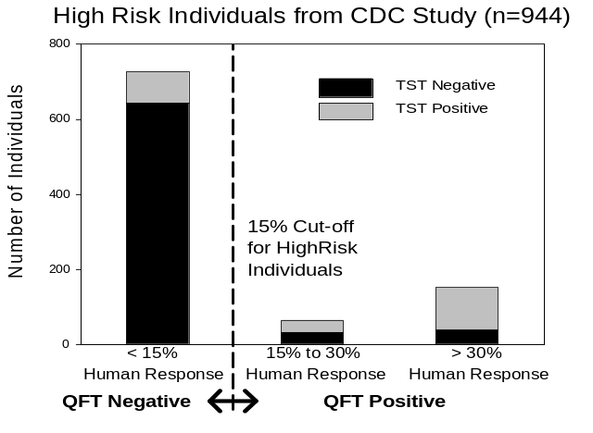

Of 54 individuals in this study, 44 individuals who had cultured-confirmed TB disease were QuantiFERON-TB positive, i.e., a sensitivity of 81.5%, as compared to 49/54 (90.7%) for the TST.

B. WRAIR Study: A comparison of QuantiFERON-TB interferon-gamma test with the TST for detection of M. tuberculosis infection in military recruits.

1. Study Objectives:

The primary objective of this study was to provide data on the performance of the QuantiFERON-TB test in low risk individuals (analogous to Group 1 in the CDC study). A second objective was to compare the concordance between results obtained from the QuantiFERON-TB test to those obtained from the TST.

2. Study Design:

Male and female naval recruits in processing for basic training during the study period were enrolled in this trial. No recruits were excluded. After granting informed consent, recruits completed a questionnaire related to possible risk factors for TB exposure. The next day, blood samples were collected (for the QuantiFERON-TB test) before the placement of a TST. TST responses were measured between 48 to 72 hours later.

3. Patient Demographics:

Subjects represented healthy, young (17–35 years), primarily male individuals (82.0%). Of the 1695 subjects, 232 were identified as having risk for LTBI (born or lived in a country with TB rate >10/100,000 or reported being a contact of a TB case).

4. Study Population:

Of the 1,961 recruits who gave informed consent to the study, valid results for both QuantiFERON-TB and TST were available for 1,695. Individuals were stratified into groups according to their identified risk factors for TB exposure as follows: three-hundred and ninety seven subjects had no identified risk factors (i.e., low risk), 1066 subjects were either born or recruited from a US state with a TB rate greater than 10 in 100,000 (i.e., secondary risk), and 232 were either born in a country with a TB rate higher than 10 in 100,000 or reported as a contact of a TB case.

5. Results:

Low and secondary risk groups in the WRAIR study were classified as those individuals having no identified risk factors for TB exposure as per the ATS/CDC guidelines, 2000. Of the 1463 patients in this group, 1431 had a negative QuantiFERON-TB response. Therefore the specificity of the QuantiFERON-TB test in this group, estimated using the 30% Human Response cut-off was 98% (95% CI 97-99%). This is based on the assumption that none were truly infected with M. tuberculosis. It is important to note that, although these individuals had no identified risk factors, there remains a possibility that some could have latent TB infection.

Figure 5 below shows the QuantiFERON-TB test results compared to TST results for individuals at risk of latent TB infection in this study. Agreement was 83% for those individuals at risk of having LTBI.

Figure 5(a).

 |  | QuantiFERON-TB
TST |  | + | -
TST | + | 11  (4.7%) | 15  (6.5%)
TST | - | 24  (10.3%) | 182  (78.5%)

Figure 5(b). Comparison of results from QuantiFERON-TB and the TST for 232 people at risk of having LTBI (WRAIR study).

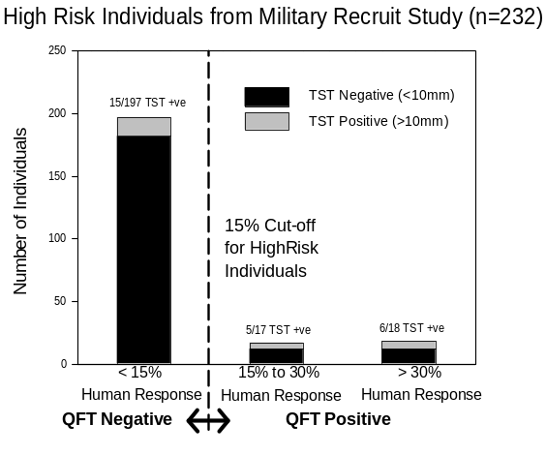

C Overall comparison of QuantiFERON-TB and the TST for people with no TB risk factors.

For estimating specificity, all of the individuals included in the CDC and WRAIR studies, i.e., 1,561 were considered uninfected. Figure 6 below shows the comparison of results from QuantiFeron-TB and the TST for all patients with no TB risk based on this combined patient population.

Figure 6(a).
 |  | QuantiFERON-TB
TST |  | + | -
TST | + | 3  (0.2%) | 16  (1.0%)
TST | - | 31  (2.0%) | 1511  (96.8%)

Figure 6(b). Comparison of results from QuantiFERON-TB and the TST for 1,561 people with no TB risk factors (CDC and WRAIR study populations combined)

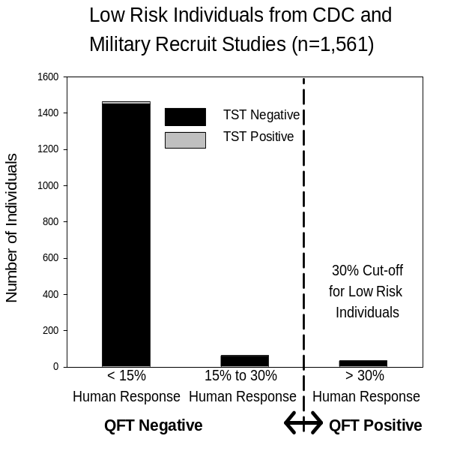
X. Conclusions from the Preclinical and Clinical Studies

A. Animal model studies:

Bovine tuberculosis has many parallels with the human disease and provides a good animal model. The spectrum of immune response of cattle to M. bovis infection and disease appears to be similar to that for M. tuberculosis in humans. Both species mount a strong CMI and IFN-γ response following exposure and generally control their infection as long as this response is maintained. As with humans, antibody responses are usually only detected in cattle that have progressed to active disease and both TST and IFN-γ responses can be absent in diseased cattle.

A major benefit of the bovine animal model is that culture of TB bacterium from culled animals can be used as a gold standard for TB infection. Using this definitive gold standard, the bovine IFN-γ assay has been shown to be more sensitive than the bovine TST for the detection of TB infection.

Extensive clinical trials of the bovine IFN-γ assay have been completed in many countries worldwide and it is approved as an official test for bovine tuberculosis in Australia, New Zealand, Romania, and in the USA.

B. Clinical studies of QuantiFERON-TB:

The protocol for the CDC multi-center clinical trial chose to assign subjects to TB risk groups based on their known exposure risks. Comparison of QuantiFERON-TB with TST results was the primary method of analysis. Data from over 1,000 individuals in this study demonstrated good agreement between the two tests. Taking into account known confounders of the TST, the logistic regression analysis of the data from individuals giving discordant results suggested that the QuantiFERON-TB test is less affected by prior BCG vaccination than the TST and also suggested that reactivity to non-tuberculous mycobacteria is a cause of false-positive TST reactions. Data were available from 98 individuals with no identified risk factors for TB and 96 (98%) were QuantiFERON-TB negative.

The overall conclusion from the CDC multi-center clinical trial was that QuantiFERON-TB was equivalent to TST in its ability to detect latent M. tuberculosis infection.

Physicians at WRAIR initiated a study in Navy recruits at the Great Lakes Naval Station, Illinois, in 1999. Nearly 1,700 recruits were tested with both QuantiFERON-TB and the TST. Subjects were stratified into risk-groups for TB exposure and results for the two tests were compared. In this study, overall concordance was 95.1%. The QuantiFERON-TB test detected more people as positive for LTBI than the TST. Individuals with no identified risk factors for M. tuberculosis exposure were used to estimate the specificity of QuantiFERON-TB. Of the 1463 subjects in this category, 98% were negative for TB infection in the QuantiFERON-TB test. Whole blood IFN-γ testing for TB has been shown to be equivalent to skin testing in a robust animal model. Clinical studies have shown QuantiFERON-TB to be equivalent to TST in the detection of TB infection.

C. Proposed Restrictions or Training Requirements:

The kit should be used in a laboratory environment and the user should be trained in serology and the use of EIA. They should be familiar with the Package Insert and have sound general knowledge of the disease and serology as well as skill in performing enzyme immunoassays.

- Risk / Benefit Analysis

The QuantiFERON-TB is an in vitro diagnostic test and there are safety issues associated with it. Venipuncture and blood collection can cause a slight risk of bleeding, hematoma, infection, pain and redness at the site of needle insertion or fainting and dizziness when blood is drawn. The handling of biological material and QuantiFERON-TB kit reagents can also cause risk to the user. Unacceptable risks were labeled in the form of warnings or cautions on the kit, kit components or in the package insert. The QuantiFERON-TB assay eliminates the subjectivity of placing, reading and interpreting results. It can be completed in less than 24 hours and the patient requires only one visit. This may allow for more truly infected individuals to be treated than is currently the case. It may also increase the likelihood of early detection of TB and allow for better administration of preventive therapy.

XI. Panel Recommendation

At an advisory meeting held on October 12, 2001, the Microbiology Devices Panel recommended that the Cellestis QuantiFERON-TB be approved with conditions. The conditions were:

- Stratification of data by risk group, gender and age, using the proposed QFT cut-off compared to the risk category-appropriate TST cutpoint.
- Statistical modeling of the data for both the CDC study and WRAIR study to include all data as presented for the Streeton data.

- A revision of the package insert modified to include:
- Interpretation of results and recommendations for use of the test provided in the labeling for the laboratory users and separate guidance for clinicians.
- Representation of study data by risk groups using a 2X2 table approach (QFT vs. TST) along with representation of the overlap between TST and QFT, e.g., Venn diagrams.
- A warning for performing the QFT after administration of the TST.
- Warnings that use with specific groups, such as HIV patients, transplant recipients, children under 18 years of age, immunocompromised, and persons with other clinical conditions (diabetes, silicosis, chronic renal failure, hematologic disorders (e.g., leukemias and lymphomas), and other specific malignancies (e.g., carcinoma of the head or neck and lung) not evaluated. Explicit directions for use of the QFT with these groups should be based on data presented.

- A revised package insert incorporating the CDC guidelines for testing with QFT, as soon as possible after CDC publication.

XII. CDRH Decision

CDRH concurred with the Microbiology Advisory Panel’s Recommendation of October 12, 2001, and advised Cellestis that its PMA was approvable subject to the conditions as recommended by the Panel and required by FDA. The sponsor concurred with “The Conditions of Approval” and the postapproval study requirements. On June 16, 2000, the applicant’s manufacturing facilities were inspected and found to be in compliance with the Quality Systems Regulation (21 CFR 820). FDA issued an approval order on November 28, 2001.

XIII. Approval Specifications

Directions for Use: See Product Insert and other Labeling
Conditions of Approval: CDRH approval of this PMA is subject to full
compliance with the conditions described in the
approval order
Post Approval Requirements See Approval Order
and Precautions

IV. References

- American Thoracic Society. Diagnostic Standards and Classification of Tuberculosis . Am Rev Respir Dis 1990; 142: 725-735.

- American Thoracic Society and Centers for Disease Control. Diagnostic Standards and Classification of Tuberculosis in Adults and Children. Am J Respir Crit Care Med 2000; 161: 1376-95.

- Desem N and Jones SL. Development of a human gamma interferon enzyme immunoassay and comparison with tuberculin skin testing for detection of Mycobacterium tuberculosis infection. Clin Diagn Lab Immunol 1998; 5: 531-536.

- Huebner RE, Schein MF and Bass JB Jr. The tuberculin skin test. Clin Infect Dis. 1993, 17: 968-975.

- Margileth AM. What is the diagnostic value of dual skin testing with tuberculous and nontuberculous mycobacterial antigens? Clin Infect Dis. 1994, 19: 21-23.

- Streeton JA, Desem N, Jones SL. Sensitivity and specificity of a gamma interferon blood test for tuberculosis infection. Int J Tuberc Lung Dis. 1998, 2: 443-50.

- Von Reyn CF, Barber TW et al. Evidence of previous infection with Mycobacterium avium - Mycobacterium intracellulare complex among healthy subjects: an international study of dominant mycobacterial skin test reactions. J Infect Dis. 1993, 168: 1553-1558.

- Wood PR, Rothel JS. The interferon gamma assay as a diagnostic test for bovine tuberculosis. In: Schijns VECJ and Horzinek MC (Ed.) Cytokines in Veterinary Medicine, CAB International Press pp. 35-40 (1997).

