Work Order Number BAT 04-020

Costs Related to Compliance with Federal Environmental Laws: Case Studies in the Federal-Aid Highway Program

FINAL REPORT

To

Office of Planning, Environment and Realty
Federal Highway Administration
Washington, D.C.

Office of Policy
Federal Highway Administration
Washington, D.C.

July 2006

Prepared by
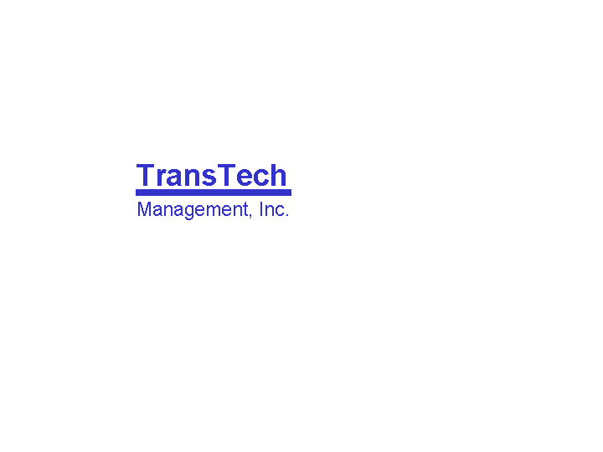
514 10th Street, NW
Suite 700
Washington, DC 20004
Acknowledgements

This report was prepared by Joe Crossett and Craig Secrest of TransTech Management for the Federal Highway Administration (FHWA)’s Office of Planning, Environment, and Realty. Oversight of the study was provided by Nina Kelley (Team Leader, Office of Real Estate Services) and Janet Myers (Program Manager, Office of Real Estate Services). Additional comments were provided by the following FHWA staff: Allen Greenberg (Office of Policy); Shari Schaftlein (Team Leader, Office of Project Development and Environmental Review); and Fred Skaer (Director, Office of Project Development and Environmental Review).

The study team would like to thank the following individuals for their significant contributions throughout the project: Frannie Brindle (Oregon DOT), Lorraine Butler (Oregon DOT), Mike Hancock (Kentucky Transportation Cabinet), Carolyn Ismart (Florida DOT), Brent Jensen (Utah DOT), Melissa Maiefski (Arizona DOT), John Metille (Kentucky Transportation Cabinet), Vickie Murphy (Montana DOT), Josh Nelson (Maryland State Highway Administration), Dan Scudder (Wisconsin DOT), Robert Shreeve (Maryland SHA), Ken Smith (Washington DOT), and Nick Testa (Oregon DOT).

Additional Information

For information concerning FHWA Planning, Environment and Realty activities and similar topics, please go to the internet home page for the FHWA Office of Environment, Planning and Realty at: http://www.fhwa.dot.gov/hep/index.htm. If you have questions concerning this particular study, please contact the current Team Leader for Program/Policy Development in the Office of Project Development and Environmental Review; contact details can be found at: http://www.fhwa.dot.gov/hep/hepoffice.htm.
Table of Contents

Executive Summary ii

1.0. Introduction 1
1.1. Study Purpose, Methodology, and Structure 1
1.2. Literature Review 3

2.0. Definition of Environmental Costs 8
2.1. Compensatory Costs 8
2.2. Avoidance Costs 10
2.3. Environmental Costs Excluded from the Study 12

3.0. Tracking Environmental Costs 13
3.1. Benefits and Barriers to Tracking Environmental Costs 13
3.2. When Do DOTs Incur Environmental Costs? 15
3.3. How do DOTs Track Environmental Costs? 18
3.4. Project-Level Environmental Costs Tracking Method 25
3.5. Observations and Considerations 26

4.0 Case Studies of Environmental Costs 29
4.1. Selecting Representative Case Studies 30
4.2. Case Study Format 31
4.3. Case Studies 32
Highway US 113 Dualization, Maryland 33
Montana Highway 84 (Four Corners - West) Reconstruction, Montana 39
Alexauken Creek Bridge Replacement, Rte 179, New Jersey 44
Bob Creek Bridge Replacement, Pacific Coast Highway, Oregon 48
Highway 12300/12600 South Highway Widening, Utah 53
I-90 Sunset Way Interchange, Washington 58
4.4. Case Study Observations 64

5.0 Conclusions and Recommendations 67

Appendix A A-1
Appendix B B-1

Executive Summary

Introduction

Projects to build or preserve transportation infrastructure sometimes affect human and natural environmental quality. Federal environmental laws such as the National Environmental Policy Act (NEPA) require the Federal Highway Administration (FHWA) and state Departments of Transportation (DOTs) to consider and address mitigation of the environmental impacts of Federal-aid transportation projects.

This study responds to a request by the House Appropriations Subcommittee on Transportation, Treasury, Housing, and Urban Development, the Judiciary, District of Columbia, and Independent Agencies that requires the FHWA “to determine the costs associated with the environmental process on a representative sample of projects.” The purpose of the study is to establish a comprehensive definition of state DOTs’ environmental costs, including mitigation and documentation costs as described in the Congressional request, and use it to gather best available data on complete environmental costs for a set of case studies that represent the kinds of projects routinely undertaken by state DOTs.

The study is based on detailed interviews and information provided by practitioners at selected state DOTs including Arizona DOT, Florida DOT, Kentucky Transportation Cabinet, Maryland State Highway Administration, Montana DOT, New Jersey DOT, Oregon DOT, Utah DOT, Washington DOT, and Wisconsin DOT.

Definition of Environmental Costs

According to practitioners, a comprehensive definition of environmental costs incurred during delivery of transportation projects has two parts:

- Compensatory costs associated with preparing for and undertaking actions to make up for unavoidable environmental impacts during project delivery. Primary compensatory activities for a project might include some or all of the following: wetland and stream restoration, stormwater treatment, wildlife and ecosystems protection, noise reduction, and documentation and other handling of historic and cultural resources. Compensatory mitigation is easily distinguishable from other project activities because it involves discrete environmental activities that go beyond the core scope of a project. Some projects require extensive compensatory activities while others require few or none.
- Avoidance costs associated with evading environmental impacts by not taking an action, or parts of an action, or by minimizing its magnitude. Primary avoidance activities required for a project might include some or all of the following: preparation of environmental documentation, project design and alignment changes, Section 4(f) compliance, project construction changes, and altered project construction practices. Activities to avoid or minimize environmental impacts can be hard to distinguish from overall project activities because they are not discrete efforts that are readily separable from the core scope of the project. Some projects require extensive avoidance activities while others require few or none.
Tracking Environmental Costs

- What are the benefits of tracking environmental costs? Most state DOTs do not track environmental costs, but those that do - including Montana, Oregon, and Washington - report that cost tracking efforts help them provide greater accountability to stakeholders, support better policy-level decision making, and improve project cost estimating and decision-making.
- When do DOTs incur environmental costs? A DOT incurs environmental costs at all phases throughout the lifespan of a project including planning, environmental review, design, land acquisition, permitting, and construction. Costs should be tracked at each phase to ensure accurate information.
- What categories of costs must be measured? Key categories of environmental-related costs that must be tracked in any DOT include:
- In-house staff time and other direct costs
- Consultant services charges
- Land acquisition and relocation expenditures
- Construction contractor costs.
Any of these cost categories may be related to compensatory activities, avoidance activities, or both.
- How can DOTs track environmental costs? Two categories of data are likely to provide the primary sources of information on environmental costs in most DOTs:
- Financial information management system data. State DOTs all maintain agency-wide electronic systems for managing financial information that are a potentially valuable resource for tracking environmental costs. Many DOTs, however, rely on antiquated mainframe-based computer programs to run their financial systems that are poorly set up to disaggregate environmental costs.
- Contractor and consultant contract records. Considerable amounts of information can be gathered from consultant and contractor contracting records, but this usually requires careful project-by-project scrutiny of documentation.
As a rule of thumb, a person knowledgeable about the project must carefully review costs reported in both types of information to ensure complete and accurate data is collected.

What are the challenges to tracking environmental costs? Many of the state DOTs interviewed for this project caution that environmental costs are hard to measure in practice. Some of the difficulties that must be overcome include financial management system limitations, apportioning project costs that have both environmental and non-environmental objectives, tracking in-house costs, separating costs of mandates from good stewardship, and estimating the costs of “the path not taken.”

Case Studies of Environmental Costs

As requested by Congress, this study focuses on a representative set of case studies that give a flavor of typical environmental costs by including projects in a range of geographic locations and urban and rural settings, and by featuring common project types with varying levels of environmental impacts and NEPA documentation. The case studies also feature a range of environmental impacts most commonly encountered by DOTs on projects, such as wetlands, stormwater, historic and cultural resources, and wildlife and ecosystems. The information in the case studies shows how environmental costs are incurred by DOTs. The six case studies include:
- US Highway 113, Maryland – Widening of a rural two-lane state highway in Maryland’s Eastern Shore region to a four-lane divided facility to address safety concerns.
- Montana Highway 84, Montana – Roadway modernization including rehabilitation of pavement and correction of horizontal and vertical pavement design deficiencies on a rural state highway near Bozeman, Montana.
- Alexauken Creek Bridge, New Jersey – Replacement of an old bridge on a rural two-lane minor arterial road.
- Bob Creek Bridge, US Highway 101, Oregon – Replacement of an old bridge on a scenic rural two-lane principal arterial in an area of high natural value on Oregon’s Pacific coast.
- 12300/12600 South, Utah – Widening of an urban principal arterial and replacement of an interchange in a rapidly growing suburban area on the fringe of the Salt Lake City region.
- I-90 Sunset Way, Washington – Interstate interchange replacement in a rapidly growing suburb of Seattle, Washington.

The following table overleaf provides a summary of each project’s characteristics.

Summary of Case Study Characteristics

Project Name | Project Type | State | NEPA Document | Project Duration | Project Cost | Setting
US-113 | Dualization (2-lane to 4-lane) | MD | EIS | 1997 - | $181,125,760 | Rural
MT-84 | Roadway Modernization | MT | EA | 1992-2005 | $10,291,345 | Rural
Alexauken Bridge | Bridge Replacement | NJ | CE | 2005 | $1,979,792 | Rural
Bob Creek Bridge | Bridge Replacement | OR | CE | 2001-2005 | $1,701,222 | Rural
12300/ 12600 S | Arterial Widening | UT | EA | 1999-2005 | $132,291,601 | Urban
I-90 Sunset Way | Interchange Replacement | WA | EIS | 1996-2003 | $112,800,000 | Urban

Case Study Results

- Environmental costs for the case studies range from two to 12 percent of total project costs. The table overleaf provides a summary of environmental costs for each of the case study projects. The share of environmental costs for the case studies ranges from two percent up to twelve percent of total project costs. On average, for the projects studied, environmental costs are eight percent of total project costs.
- Environmental costs increase with project costs. For the projects studied, absolute environmental costs are lower on smaller projects and higher on larger projects. For the smaller projects studied, environmental costs for preconstruction activities outweighed environmental costs incurred during construction; the reverse was true for larger projects.
- Expenditures on stormwater, landscaping, and wetlands during construction are large environmental cost drivers. For the case study projects, the cost to construct stormwater management structures, replace wetlands, control erosion, and conduct landscaping have a much bigger impact on total project costs than staff and consultant time spent on project studies and construction engineering. For example, expenditures to prepare the Environmental Impact Statement (EIS) ($1,103,252) and oversee environmental issues during construction ($325,000) were only 6 percent of total environmental costs ($21,915,152) on the Maryland US 113 case study and less than one percent of total project costs of $181,125,760. Case study projects that did not require extensive wetlands mitigation and stormwater treatment, such as the Utah12300/12600 S case study, feature much lower environmental costs.
- Environmental costs are a significant proportion of total preconstruction (excluding land acquisition) costs. Environmental costs are incurred during preconstruction for NEPA document preparation processes, other environmental studies and coordination with other resource agencies. They usually include a mix of in-house costs and consultant costs, which the case study state DOTs had little trouble identifying. Several DOTs had trouble identifying environmental costs attributable to non-environmental bureau staff or consultants but were confident these costs account for a small share of total environmental-related costs. Environment accounted for an average of 23 percent of total preconstruction costs for the case study projects.
- Environmental-related land acquisition costs vary among projects, but can be a significant cost driver. Environmental costs are not always incurred during the land acquisition phase of a project. Three out of the six case study projects involved no additional land acquisition associated with environmental requirements. Where additional land was required for the project, this appeared to add considerable project costs. For all the case studies, however, methodologies for apportioning environmental-related land acquisition costs could be improved.
- Environmental costs during construction engineering are small. Environmental costs associated with construction engineering during the construction phase of a project are usually small compared to environmental costs associated with the other project activities during construction. The case study states are able to identify environmental staff time charged to the project during construction. They are also able to provide an approximate estimate of non-environmental staff time spent on environmental issues, such as erosion control. Environmental-related construction engineering costs averaged about 5 percent of total construction engineering across the case studies.
- Project design and construction changes to accommodate environmental issues can add or decrease costs, but are hard to measure. For five of the six case study projects, elements of project design and construction were altered in part to accommodate environmental issues. These changes sometimes reduce costs, but they can also increase costs:
  - Cost savings. In the Oregon case study, a one-lane temporary bridge was constructed instead of a two lane bridge to avoid impacts to cultural resources and Federal lands, which generated some cost savings. Likewise in the New Jersey case study, a simpler bridge design that involved replacement of the superstructure only was selected in part to avoid a complicated environmental process, but also to save overall construction costs and time.
  - Cost increases. In the Maryland, Montana, and Utah case studies, larger bridges or culverts were built to avoid sensitive wetlands, improve fish passage, and accommodate a bike trail respectively. In each of these cases, costs were added to the projects.
In each instance, estimates of costs associated with “the path not taken” are heavily reliant on professional judgment.

Overview |  |  |  | Detailed Breakdown
Project | Overall Costs |  |  | Environmental Review and Design |  |  | Land Acquisition |  |  | Construction Engineering |  |  | Construction
 | Environmental-Related Costs (000s) | Total Project Costs (000s) | % | Environmental-Related Costs (000s) | Total Env. Review/ Design Phase Costs (000s) | % | Environmental-Related Costs (000s) | Total Land Acquisition Phase Costs (000s) | % | Environmental-Related Costs (000s) | Total Construction Engineering Phase Costs (000s) | % | Environmental-Related Costs (000s) | Total Construction Phase Costs (000s) | %
US-113 (MD) | $21,915 | $181,126 | 12% | $1,103 | $14,455 | 8% | $2,264 | $15,680 | 14% | $325 | $6,300 | 5% | $18,223 | $144,690 | 13%
MT-84 (MT) | $282 | $10,291 | 3% | $44 | $452 | 10% | NA | NA | NA | $12 | $903 | 1% | $226 | $7,751 | 3%
Alexauken Bridge (NJ) | $240 | $1,980 | 12% | $206 | $498 | 41% | NA | NA | NA | $8 | $196 | 4% | $26 | $1,286 | 2%
Bob Creek Bridge (OR) | $166 | $1,701 | 10% | $141 | $394 | 36% | NA | NA | NA | $5 | $139 | 4% | $20 | $1,168 | 2%
12300/ 12600S (UT) | $2,405 | $132,292 | 2% | $964 | $3,576 | 27% | $500 | $39,918 | 1% | $294 | $2,942 | 10% | $647 | $85,855 | 1%
I-90 Sunset Way (WA) | $12,202 | $112,800 | 11% | $2,350 | $13,730 | 17% | $6,020 | $10,919 | 55% | $380 | $8,816 | 4% | $3,452 | $79,344 | 4%
Average |  |  | 8% |  |  | 23% |  |  | 18% |  |  | 5% |  |  | 4%
Summary of Case Study Results
Findings and Recommendations

This study is the first to give a comprehensive report on state DOTs’ complete environmental costs based on actual cost documentation. As such, the findings and recommendations it makes should be considered a work in progress; but one that provides considerably more detailed and more reliable information than policy makers have received in the past.

Research Findings. Findings are discussed in terms of responding to the Congressional request and observations from the study.

- Congressional language: Identify “costs associated with the environmental process.” Chapter two of the study defines costs associated with the “environmental process” to include compensatory costs associated with preparing for and undertaking actions to make up for unavoidable environmental impacts, and avoidance costs associated with evading environmental impacts by not taking an action, or parts of an action, or by limiting its magnitude. This definition is used throughout the study to estimate environmental costs.
- Congressional language: Analyze “a representative sample of projects.” The study features six case study, or sample, projects that were carefully selected to represent diverse geographic locations, urban and rural settings, a mix of common project types, a range of NEPA documentation requirements, an array of types of environmental impacts, and “middle-of-the-road” project costs that are typical of projects that DOTs must handle on a regular basis. See the introduction and the start of chapter four for more discussion of the criteria by which case study projects were selected.
- Congressional language: Examine environmental “costs associated with the project itself.” For each of the case studies, full estimates of the cost of any physical mitigation required, such as for wetlands and 4(f) are provided.
- Congressional language: Examine environmental “costs associated with preparing the document.” For each of the case studies, detailed estimates of the cost of any preconstruction activities associated with preparation of the NEPA document are provided.
- Congressional language: Examine “related costs associated with the time it takes to complete the environmental process.” For each of the case studies, detailed estimates of other related costs such as mobilization of construction contractors, or DOT staff construction engineering costs are provided. As noted in chapter two, estimates of costs associated with delay caused by environmental issues were not estimated. None of the states interviewed expressed concern about major delays associated with the projects profiled; furthermore, available methods for estimating costs associated with delay and apportioning all or some of those costs to environmental factors are understood to be weak.

Overall, the findings from the study suggest environmental costs are measurable; for a typical DOT project they are likely to be in the range of two to 12 percent of total project costs, which for most states is likely to add up to millions of dollars in environmental expenditures each year. Some of this cost is for NEPA documentation and other “process” costs. The case studies suggest, however, that a large share of environmental costs is likely to be for construction of stormwater facilities, mitigation of wetland losses, erosion control, and landscaping. Key conclusions from the study include:

- State DOTs are investing more in environmental stewardship and streamlining but its effect on project-level costs is unclear. In qualitative terms, all the case study states say they continue to undertake efforts to improve their stewardship of the environment. A consensus emerged across participants in the interviews that DOTs now conduct many environmental responsibilities as the “right thing to do” and therefore at least some environmental costs would be incurred on projects regardless of environmental laws. All the case study states also indicate they are undertaking efforts to streamline their environmental activities and that this is helping expedite project schedules. The US-113 project in Maryland and the Alexauken Bridge project in New Jersey are both recognized nationally as “streamlined” projects; however, practitioners in these states were not willing to estimate absolute cost savings on these projects associated with a faster environmental review process.
- Only a handful of state DOTs currently measure environmental costs. The states identified in this study, including Montana, Oregon, Washington, and Wisconsin, are national leaders in developing comprehensive estimates of their environmental costs. The state-of-the-practice for defining and measuring environmental costs has clear deficiencies that are likely to be addressed over time as DOTs enhance their approaches for measuring costs.
- Environmental costs include compensatory costs and avoidance costs. According to practitioners, a comprehensive definition of environmental costs incurred during delivery of transportation projects should include “compensatory costs” associated with preparing for and undertaking actions to make up for unavoidable environmental impacts, and “avoidance costs” associated with evading environmental impacts by not taking an action, or parts of an action, or by limiting its magnitude.
- Comprehensive estimates of environmental costs should include all phases of project delivery. A DOT incurs environmental costs throughout the lifespan of a project, including planning, environmental review, design, land acquisition, and construction. Cost tracking efforts should account for each phase.
- Not all environmental costs are easily identifiable. Some environmental costs are clear cut, such as NEPA document preparation costs or the cost of a longer bridge to avoid a wetland. Other environmental costs may be harder to identify. A more costly project solution, for example, may yield both engineering and environmental benefits. The bridge constructed in the Oregon, Bob Creek Bridge Case Study was more costly because it avoided in-water piers but this solution minimized environmental impacts to salmon habitat. The same solution also avoided bridge scour problems that would otherwise shorten the bridge’s lifespan and increase maintenance costs.
- Practical constraints limit many DOTs’ ability to track environmental costs. The process of developing the case studies reveals that many DOTs face significant hurdles to developing environmental cost tracking methods. For many states, a primary constraint is the lack of project-level environmental activity codes that support tracking of in-house and consultant costs. Other constraints include difficulty in collecting and analyzing land acquisition data related to addressing environmental impacts, and the increased use of design-build contracting, which often limits the amount of environmental cost data available to DOTs.
- Environmental cost tracking is labor intensive, particularly at the outset but has many benefits. DOTs that are measuring environmental costs report that it is labor intensive, and some practitioners question the relative cost to benefit ratio for tracking environmental costs. Once methodologies are in place, however, DOTs that measure costs find that they are able to use the information to resolve policy questions, improve project decision-making, and increase accountability to stakeholders.

Recommendations. The study conclusions provide the basis for several general recommendations on next steps that may be appropriate, these include:

- More dialogue with state DOTs on the value of environmental cost tracking. The study found that states that track environmental costs see the information as beneficial, but it also found that environmental cost tracking is potentially complex and time consuming. More discussion with state DOTs is needed to help determine whether additional efforts should be pursued.
- Develop additional case studies and refine and enhance cost tracking methods. If cooperating states can be identified, additional case studies could be conducted with ease using the methods established in this study. A larger data set would provide stronger support for drawing conclusions that guide policymaking on this issue. Additional case studies could also be used to refine and enhance methods and approaches used in this study.
- Technical assistance for state DOTs on environmental cost tracking methods. Based on the outcomes of dialogue with state DOTs and efforts to improve and enhance methods for tracking environmental costs, provide state DOTs with technical assistance such as training or guidance documents.

1.0. Introduction

1.1. Study Purpose, Methodology, and Structure

Projects to build or preserve transportation infrastructure sometimes affect human and natural environmental quality. Federal environmental laws such as the National Environmental Policy Act (NEPA) require the Federal Highway Administration (FHWA) and state departments of transportation (DOTs) to consider and address mitigation of the environmental impacts of Federal-aid transportation projects. Projects that are 100 percent state-funded must still sometimes comply with NEPA because of the need for Federal permits or other approvals. The requirements of NEPA and other Federal environmental laws are independent of the state environmental laws that often apply to transportation projects.

Study Purpose. This study responds to a request by the House Appropriations Subcommittee on Transportation, Treasury, Housing, and Urban Development, the Judiciary, District of Columbia, and Independent Agencies that directs the FHWA “to determine the costs associated with the environmental process on a representative sample of projects. Analysis should include information on environmental costs associated with the project itself, such as wetlands mitigation and 4(f); costs associated with preparing the document; and other related costs associated with the time it takes to complete the environmental process.”

The purpose of the study is to establish a comprehensive definition of state DOTs’ environmental costs, including mitigation and documentation costs specifically described in the Congressional request, and use it to gather best available data on complete environmental costs for a set of case studies that represent the kinds of projects routinely undertaken by state DOTs. The FHWA recognizes that environmental expenditures by state DOTs also generate many benefits, but quantification of the environmental benefits associated with NEPA compliance is not addressed as part of this study.

Study Methodology. As requested by Congress, the study relies on a representative sample of projects to provide a better understanding of costs associated with mitigating the environmental impacts of transportation project delivery. The study was conducted in two phases that each involved detailed interviews with selected state DOTs:

- Environmental costs definition phase. In the first phase, knowledgeable practitioners in eight states were interviewed to gather input on how DOTs generally incur environmental costs. Interview states included Arizona, Florida, Kentucky, Maryland, Oregon, Utah, Washington, and Wisconsin. The resulting definition of environmental costs, based on information from the interview states, was used to shape the direction of the second phase of the study.
- Case study development phase. In the second phase, case studies were developed for a set of six recently completed highway projects from Maryland, Montana, New Jersey, Oregon, Utah, and Washington via information collected during site visits and in multiple phone interviews with numerous staff in each state.

Ensuring a representative sample of projects, as specified by Congress, was a major emphasis in the study. The following selection criteria for the case study projects featured in this report help ensure they represent characteristics broadly shared among highway projects underway across the United States, including:

- Diverse geographic locations. The extent and nature of environmental impacts varies across geographic areas. To capture some of this variation, the case studies are located in the states of Maryland, Montana, New Jersey, Oregon, Utah, and Washington, which represent a wide assortment of climatic, ecological, and socio-economic conditions.
- Urban and rural settings. Projects in urban locations often face different environmental challenges from those located in rural areas. Higher real estate prices in urban areas, for example, may add to mitigation costs when projects require additional land for features such as stormwater treatment ponds. The case studies are located across a mix of rural and urban locations.
- Mix of common project types. The projects reflect an emphasis on system preservation and modernization that are common priorities among states as they address aging infrastructure and growing travel demand. The case studies include two bridge replacements, upgrade of a roadway to modern design standards and three projects that add capacity on existing facilities.
- Range of NEPA documentation requirements. The level of effort required for NEPA documentation varies according to the extent of anticipated environmental impacts. The case studies include two processed under NEPA as Categorical Exclusions (CEs), two processed as Environmental Assessments (EAs), and two processed as Environmental Impact Statements (EISs).
- Moderate project costs. The case studies were explicitly chosen to include a range of low to moderate cost projects that are typical of projects that DOTs must handle on a regular basis, rather than case studies of high-profile, but unique “mega” projects that are less representative of typical projects. The total cost of projects studied ranges from under $2 million to about $180 million.

Study Structure. Using information provided by the FHWA’s state DOT partners, this study develops a definition of environmental costs for transportation projects and a method for calculating their magnitude from initial project planning to the time the project is opened for travel. The study uses this definition to quantify environmental costs for six representative case study projects around the nation based on actual data from state DOTs’ financial management information systems and other sources. Following this introduction chapter, the study report includes the following chapters:

- Chapter Two - Definition of environmental costs. This chapter draws on interviews with selected DOTs to provide a definition of the environmental costs incurred as a project moves from planning to completion of construction, i.e. “open to traffic.”

- Chapter Three - Systems for tracking environmental costs. This chapter uses the definition of environmental costs to establish a method for extracting relevant environmental cost information from state DOT electronic financial management information systems and other sources.
Why do so few State DOTs track environmental costs? Most major types of costs associated with development of transportation projects, such as design, right-of-way, or construction, are incurred at discrete time points and are the clear responsibility of individual groups within a DOT. As a result, costs in these categories are generally well understood and easy to identify within an agency’s financial management information system.

Environmental costs, by contrast, are often spread throughout various phases of a project and are incurred by a variety of functional groups. Thus, in addition to specific environmental-related construction and right-of-way costs, a full accounting of a project’s environmental costs must include an allocation of both environmental and non-environmental staff/consultant time that is dedicated to addressing environmental issues. Efforts to quantify these costs are challenging because data must be collected from multiple locations and interpretation of data requires coordination with multiple groups as well as professional judgment about how to apportion costs.
- Chapter Four - Profiles of environmental costs for six case study projects. This chapter provides a detailed assessment of environmental costs for six project-level case studies using the methods described in the previous chapter. The level of detail in the case studies exceeds all previous efforts to estimate the environmental costs of transportation project development among states.

- Chapter Five – Conclusions and recommendations. This chapter provides a brief set of conclusions based on the findings of the study and recommendations on next steps for policy makers.

1.2. Literature Review

Review of the literature on environmental costs in transportation project delivery suggests that the FHWA and most state DOTs lack accurate and easy to use methods for successfully measuring environmental costs. (See sidebar.) In a literature review conducted for this study, three reports were identified that report on national-level or multi-state efforts to analyze environmental costs and all conclude that data on this topic is limited:

- United States General Accounting Office (GAO) - A 1994 study by the GAO observes that the total amount of Highway Trust Fund money that states spent on mitigating environmental impacts could not be calculated because of incomplete data. (Highway Planning: Agencies are Attempting to Expedite Environmental Reviews, But Barriers Remain, Report to the Chairman, Subcommittee on Transportation, Committee on Appropriations, U.S. House of Representatives. GAO/RCED 94 211. Washington, DC. 1994)
- Center for Transportation and the Environment (CTE), North Carolina State University – A statistical study completed in 1997 by CTE examines the correlation between project costs and application of Federal environmental laws. The study notes that all past economic analyses of the costs of environmental regulations have completely overlooked their impacts on the construction and repair of highways but suggests expenditures for Federal-aid construction are affected by environmental mandates. (Environmental Compliance Costs: Where the Rubber Meets the Road. Center for Transportation and the Environment, North Carolina State University. Raleigh, NC. 1997)
- National Research Council, National Cooperative Highway Research Program (NCHRP) - A 2003 NCHRP-sponsored study concluded that a majority of states do not track environmental costs separately from overall project costs. None of the 32 state DOT environmental officials that responded to the project survey associated with this report indicated they have engaged in any study or compilation of planning, design, and environmental costs related to environment and planning activities. (Improving Project Costing and Incorporation of New Attributes – Highways and Transit, NCHRP 20-24 (25) Washington, DC. 2003.)

At the state level, the literature review identified reports from Montana, Washington, Oregon, and Wisconsin DOTs indicating that they are among a small set of state DOTs taking steps to quantify environmental costs associated with transportation project delivery.

Montana and Washington have examined environmental costs as a share of individual project costs while Oregon and Wisconsin have examined environmental costs as a share of total annual transportation budgets. Direct comparisons among the data presented in each state’s report are impossible since Wisconsin and Oregon attempt to calculate total program-wide environmental costs but use different methodologies, while Washington and Montana examine a sample of projects but do not include exactly the same costs in their estimates. Following are some key findings from each state’s efforts.

- Montana DOT Project Cost Case Study – Environmental Mitigation and Context Sensitive Design. (October 2004) Like most DOTs, Montana Department of Transportation (MDT) does not track environmental costs as standard practice. A 2004 study prepared by the Department examined environmental costs for a set of 14 recently completed or almost completed projects. For the 14 projects studied, environmental elements such as document preparation by consultants, erosion control by contractors, or environmental bureau staff time were identified and available data was collected on associated in-house, contractor and consultant costs.
The median total cost per project for the 14 projects in the MDT study was $9.7 million while the median cost of environmental requirements per project was $210,000. Among the 14 projects studied, the median for environmental costs averaged 1.7 percent of total costs per project. Figure 1.1 provides a project-by-project summary of the MDT study results. Projects with an unusually high proportion of environmental costs included “14 K South of Havre S” (at 17 percent of total costs), which was a reconstruction project mostly located in a county park and “Victor Crossing” (at 24 percent of total costs) which was a bridge replacement that required extensive stream mitigation.
Figure 1.1. Montana DOT Environmental Costs Study Results Summary
Total Project Costs
Environmental Share of Total Costs
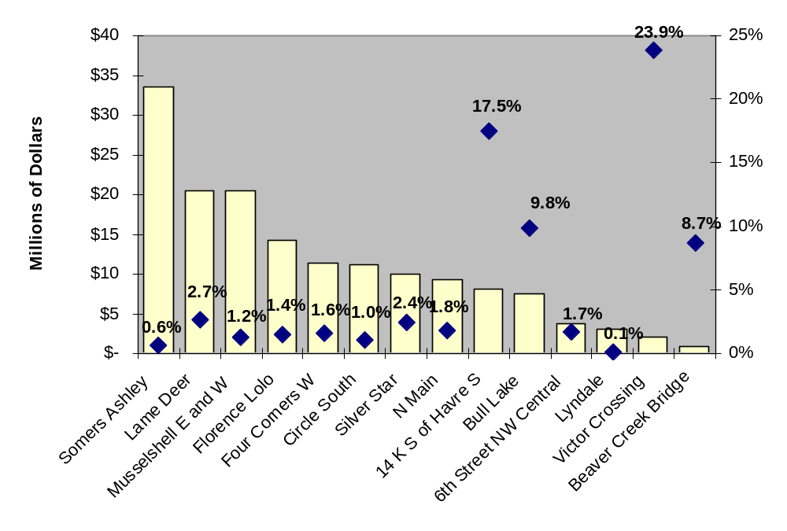
Project Name

- Washington DOT Project Mitigation Costs Case Studies. (May 2003) Washington DOT (WSDOT) has published a set of WSDOT Project Mitigation Costs Case Studies that provides a detailed review of mitigation costs associated with 14 completed projects around the state. The WSDOT report is conceived as a one-time “snapshot” of a few sample projects, although staff indicates a similar analysis may be repeated in the future. Total environmental costs captured for each project include actual construction costs, actual right-of-way costs, an allocated share of contractor mobilization costs, an allocated share of construction engineering, and an allocated share of planning and design costs. The report has helped the Department respond to concerns among legislators and the public, particularly to the public’s misconceptions that excessive funds were spent by the DOT to meet environmental mandates.

The median total cost per project for the 14 projects in the WSDOT study was $16 million while the average cost of environmental requirements per project was $2.1 million. Across the 14 projects, median environmental costs were 15 percent of total costs per project. Figure 1.2 provides a project-by-project summary of the WSDOT study results.
Figure 1.2. Total Costs and Environmental Costs Compared for 14 Projects Completed by Washington DOT
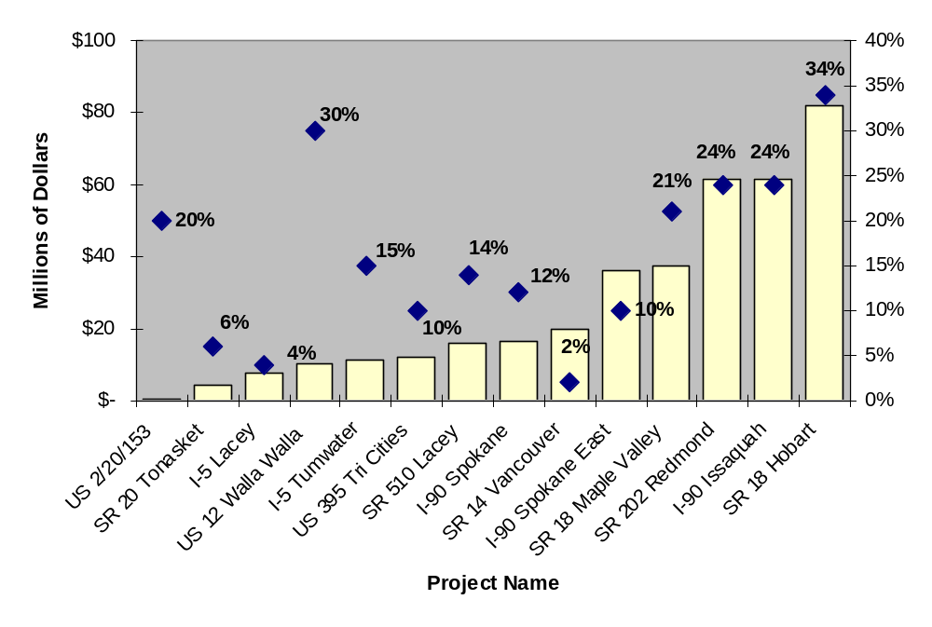
Total Project Costs
Environmental Share of Total Costs

- Oregon DOT Environmental Cost Study for State Fiscal Year 2004. (December 2004) Oregon DOT (ODOT) may well be unique among state DOTs in producing a detailed annual report on its program-wide environmental costs. Oregon DOT’s report responds to a 1999 requirement passed by the Oregon State Legislature that the DOT must provide regular summaries of costs related to state and Federal mandates and environmental regulations. ODOT estimates that total environmental costs were 4.8 percent of total agency costs for fiscal year (FY) 2004, or $33.0 million. These costs include all staff, consultant, and contractor expenditures related to compliance with 68 local, state, and Federal regulations and mandates encountered during planning, design, and construction of transportation projects. Major areas where ODOT tracks costs incurred include air quality, biology, cultural resources, hazardous material, land use, noise, water quality, and wetlands. Biology, wetlands and water quality are noted as major cost contributors.
- Wisconsin Legislative Audit Bureau, An Evaluation of Major Highway Program. (November 2003) The Wisconsin State Legislature’s Legislative Audit Bureau conducted a comprehensive audit of the state DOT’s highway program, which included an examination of environmental costs associated with the program. The audit report concludes that Wisconsin DOT (WisDOT) FY2001 environmental expenditures totaled $29.1 million, or about 1.4 percent of WisDOT’s $2.03 billion FY2001 budget.

At each of the states profiled above, the primary motivation for collecting environmental cost data is to provide greater accountability to external stakeholders, particularly state legislators. The Wisconsin Legislature for example requested a study of WisDOT’s environmental costs and ODOT’s environmental costs initiative is mandated under state law. Washington DOT reports that its efforts are also in part motivated by discussion in the state news media about the DOT’s expenditures on environmental costs. At each DOT, once environmental cost data is available it has also been used to support policy discussions on an as needed basis.

2.0. Definition of Environmental Costs

This chapter draws on the observations made by expert practitioners during study interviews to develop a definition of environmental costs. According to practitioners, a comprehensive definition of environmental costs incurred during delivery of transportation projects has two parts:

- Compensatory costs associated with preparing for and undertaking actions to make up for unavoidable environmental impacts during project delivery, such as creating a new wetland to replace one destroyed by a new road;
- Avoidance costs associated with evading environmental impacts by not taking an action, or parts of an action, or by minimizing impacts. For a transportation project this might include special project location, design, and construction elements that would not otherwise be required to meet the project’s transportation function such as building on a narrower road footprint to avoid a cultural resource site.

The elements that make up compensatory and avoidance costs are discussed in sections 2.1 and 2.2 of this chapter.

2.1. Compensatory Costs

Some projects require extensive compensatory activities while others require few or none. The primary range of compensatory activities required for a project might include some or all of the following:

- Wetland and stream restoration. Adverse impacts to wetlands or streams may be unavoidable during construction of project elements such as roadway fills, approaches to bridges, or culvert installations. To preserve the valuable functions wetlands and streams perform in ecological systems, Section 404 of the Clean Water Act (CWA) may require consultation with the U.S. Army Corps of Engineers and the U.S. Environmental Protection Agency, study of affected natural resources, permits, and restoration or replacement of any losses. If replacement wetlands are required, additional land or an off-site location may be needed. Re-vegetation of riparian areas and repairs to streambeds may also be required.
FHWA data published in 2001 shows a nationwide average wetland mitigation cost of $16,000 per acre. Anecdotal information gathered by FHWA, however, indicates that states are experiencing cost ranges from $4,000 per acre to $100,000 per acre, depending on location and type. An April 2006 study published by the Environmental Law Institute, titled 2005 Status Report on Compensatory Mitigation in the United States, examined wetland and stream mitigation across the CWA Section 404 program, which is administered by the U.S. Army Corps of Engineers. That report found that the range of wetland and stream mitigation costs varied widely, depending on type of mitigation, location, land acquisition, and who provided the mitigation. The lowest reported wetland mitigation cost was $3,000-$4,000 per acre (excluding land costs) for non-tidal wetland restoration. The highest reported cost was $350,000 for an acre of credit from a wetland mitigation bank. The reported wetland mitigation costs were derived from data submitted by 15 of 38 Corps Districts. Fewer Corps districts offered stream mitigation costs. Those reported costs similarly varied by location and other factors. The “per linear foot” reported costs range was $75 to $400, while two districts gave costs of $57,000 and $68,000 based on acreage or combined acreage per linear foot measures.
- Stormwater treatment. Depending on factors such as soil quality, water table levels, and proximity to bodies of water, control of polluted stormwater runoff during and after project construction may be required under the National Pollution Discharge Elimination System of the CWA and the Coastal Zone Management Act. Common controls include silt fencing during construction and creation of permanent stormwater detention ponds, sewers, and runoff swales. Ponds or other features may require acquisition of additional land. A WSDOT study completed in 2003 found that the average cost of stormwater treatment within the State was $1.81 per square foot of impervious surface constructed.
- Wildlife and ecosystems. Construction of highway projects can cause impacts to important natural upland ecosystems and landscapes. Under the Endangered Species Act (ESA), mitigation activities may include investigative studies and consultation with resource agencies. If necessary, land acquisition and other measures to establish mitigation, such as re-vegetation, site preparation, fencing, pest management, access control, fire control, and mitigation performance monitoring may be required. Special sensitive construction techniques – such as avoidance of nesting seasons - may also be required to protect natural resources and communities. The FHWA asks state DOTs to report their threatened and endangered species mitigation-related costs annually. Cost data on Federal agency ESA spending is reported in the U.S. Fish and Wildlife Service’s annual Federal and State Threatened and Endangered Species Report.
- Noise reduction. Construction noise and on-going traffic noise can be a nuisance to humans and wildlife. The FHWA has in place noise abatement standards. If certain criteria are met, a project may require construction of linear concrete, block, brick, metal, or earth barriers to help reduce noise in adjacent areas. Noise walls can sometimes be accommodated within the existing right-of-way, or they may require additional right-of-way. Washington DOT found that the average cost per square foot to build a noise wall is $32.31. A FHWA study, based on analysis of data from 44 states, suggests that the average noise wall construction cost between 1991 and 2001 was $20.00 per square foot when adjusted for inflation. Oregon DOT estimates that noise accounts for about 19 percent of its total environmental compliance costs. Utah DOT (UDOT) requires that noise walls should not cost more than $20,000 to $25,000 per affected resident.
- Documentation and other handling of historic and cultural resources. Construction of highway projects may have adverse impacts on historic and cultural resources. Under Section 106 of the National Historic Preservation Act (NHPA), activities may include consultation with resource agencies, identification of resources, assessment of impacts, and efforts to minimize or mitigate impacts, which most commonly includes documentation.
Of the categories described above, the states interviewed for this study generally find that wetlands and stormwater requirements are the greatest cost drivers. In addition to the cost categories described above, on a less regular basis DOTs may also conduct a range of other mitigation activities including strategies to address secondary and cumulative impacts, strategies to address community impacts, hazardous materials clean up, land use protection, indirect and cumulative impact mitigation, and environmental justice mitigation.

Compensatory mitigation is easily distinguishable from other project activities because it involves discrete environmental activities that go beyond the core scope of a project. Replacement of wetlands, for example, is not undertaken for any reason other than to address environmental quality. As a result, compensatory costs can generally be identified in an objective manner and are reasonably straightforward to compile.

2.2. Avoidance Costs

Some projects require extensive avoidance activities while others require few or none. The primary range of avoidance activities required for a project might include some, or all of the following:

- Preparation of environmental documentation. Under NEPA and other environmental laws, documentation requirements that are sometimes extensive generally place a special emphasis on consideration of efforts to avoid or minimize environmental impacts. Document preparation activities may include preliminary project design work, public involvement, environmental resource studies, and coordination with stakeholders. The cost of environmental documents, however, is also partially related to determining the need for and scope of compensatory actions.
- Project design and alignment changes. Sometimes a project’s design or alignment may be altered to avoid or minimize environmental impacts. A bridge design, for example, may feature longer spans to avoid placing piers in a water channel. Such spans may not be required from a hydraulic design perspective. A road alignment may be specially located to avoid a sensitive habitat or some historic resources. These project elements may require additional design time. Project scope or footprint may also decrease as a result of avoidance activities.
- Section 4(f). “Section 4(f),” is a requirement first established under the DOT Act of 1966 that deserves special mention as a unique factor that often leads to design and construction-related avoidance costs. Section 4(f) requires that a special effort must be made to preserve public parks, wildlife and waterfowl refuges, and historic sites. Section 4(f) applies to all historic sites and publicly owned parks, recreational areas, and wildlife refuges. Any project that affects Section 4(f) land must include a Section (4(f)) assessment. Use of Section 4(f) lands is only granted if no prudent and feasible alternative can be found and all possible planning is done to minimize harm to the land or resources. Section 4(f) impacts may require purchase of additional land and design or construction-related costs if improvements such as grading are needed.
- Project construction changes. The construction cost of projects may increase as a result of design and alignment changes to avoid or minimize environmental impacts. In Washington, for example, several projects reviewed as part of the 2003 environmental costs study were found to require bridge crossings in place of box culverts as part of the conditions for permitting, e.g. State Route 18 at an additional estimated project cost of $3.33 million, and State Route 202 at an additional cost of $1.05 million.
- Altered project construction practices. Project construction practices may sometimes be modified to avoid environmental impacts. Typical alterations include seasonal limits on construction to avoid impacts to wildlife, avoidance of “in-water” construction on bridges, noise limits, or use of “environmental monitor” staff on-site during construction to ensure quality assurance and quality control of environmental procedures.
Activities to avoid or minimize environmental impacts can be hard to distinguish from overall project activities because they are not discrete efforts that are readily separable from the core scope of the project. States with experience in estimating environmental costs raise concerns about attempting to quantify avoidance and minimization costs:
“The preferred project alignment from an environmental perspective may also be supported by the local community so we would do it this way regardless of environmental laws.” – Maryland State Highway Administration (SHA)
“If a project alignment is extended to avoid a wetland, is the added cost of a longer route or structure an environmental cost, or would the additional hurdle of building on unstable wetland soils have been equally expensive?” – WisDOT
“These types of costs and savings lie in the realm of the “road not taken” and are extremely subjective to measure.” – ODOT
In contrast to compensatory costs, avoidance-related costs often require subjective judgments and are harder to compile. Avoidance activities are not necessarily considered “environmental” activities, but might involve changes in the way non-environmental activities are carried out. Also, the discussions leading to such avoidance decisions are not always well documented.

2.3. Environmental Costs Excluded from the Study

Some expenditures that may be considered environmental costs according to the definition above are specifically excluded from the study, either because measurement is hard or opinions are mixed about whether they should be categorized as environmental costs. Costs not included in the study are as follows:

- “Context sensitive solutions” costs. Many DOTs now develop project design and construction solutions that are more sensitive to the specific needs of project stakeholders, such as a special architectural treatment in a bridge design to help it blend aesthetically with its surroundings. These solutions are not mandated and they are often characterized by practitioners as “the right thing to do” regardless of environmental law.
- Costs borne by Federal and state agencies. Other Federal and state agencies, particularly resource agencies, may incur costs for time spent on project review and permitting. These expenditures are thought to be small in comparison to DOT expenditures. Review and permitting costs are tracked by individual agencies and resources for this study did not allow collection of this data.
- Costs of environmental-related maintenance activities. Once a project is constructed, environmental costs may be incurred for activities such as culvert and drainage pipe repair, permit requirements for stormwater run off at maintenance facilities, solid waste disposal, hazardous materials, and control of vegetation and weed pests mandated by laws such as the ESA, the CWA, the Resource Conservation and Recovery Act or the Noxious Weed Act. Apportioning such costs specifically to a stretch of roadway is beyond the scope of the methodology proposed in this study.
- Costs of environmental-related project delays. If a project is substantially delayed, total costs may increase or decrease as a result of inflation or deflation in construction materials and labor costs over time, changes in technology, or changes in regulatory requirements. Empirical evidence suggests that environmental issues can delay projects, however, measuring the extent and cause of delays is often highly subjective and calculating costs associated with delays is complex. The study does not consider costs incurred as a result of delays. None of the projects studied for this report experienced delays and for many projects, environmental activities when performed in an expected manner do not become the critical path and cause delay.

3.0. Tracking Environmental Costs

This chapter examines the benefits and barriers of tracking environmental costs (section 3.1), explains when DOTs incur environmental costs (section 3.2), demonstrates how agencies can use a combination of data from their financial management information systems and detailed review of contracting documents to measure environmental costs with reasonable accuracy (section 3.3), and provides some general observations on tracking environmental costs (section 3.4).

To learn more about the state-of-the-practice among state DOTs in tracking environmental costs, practitioners at eight DOTs were interviewed, including Arizona, Florida, Kentucky, Maryland, Oregon, Utah, Washington, and Wisconsin. The states were selected based on consultation by the study team with the FHWA staff and other experts. They are intended to provide insight on a range of experiences among state DOTs in tracking environmental costs. Summaries of the state interviews are included in Appendix A.

3.1. Benefits and Barriers to Tracking Environmental Costs

The DOT interviews conducted for this study suggest that environmental cost tracking offers DOTs some useful benefits but is also subject to significant barriers. This section briefly discusses the benefits and barriers to tracking environmental costs.

Benefits of Tracking Environmental Costs. Most state DOTs do not track environmental costs. Therefore, a discussion of the benefits of tracking environmental costs necessarily should be considered somewhat speculative. Based on discussions with 23 states, only four DOTs were identified for this study (Maryland, Montana, Oregon, and Washington) that have attempted to track environmental costs in a comprehensive fashion. These state DOTs suggest that environmental cost tracking efforts can have three primary benefits:

- Greater program-wide accountability. By collecting data on environmental costs, a state DOT can show stakeholders how it is performing, for example in maintaining environmental costs within acceptable limits. Both WSDOT and ODOT have found that credible environmental cost data has helped them respond to inquiries from their state legislatures and other stakeholders about perceived excessive expenditures on environmental features or unfunded Federal mandates. Several other states interviewed for this project that do not have cost tracking systems in place report that they have struggled to respond effectively to such inquiries from their state legislatures.
- Better policy-level decision support. The fiscal impacts of new or enhanced environmental mandates for issues such as stormwater or wetlands are often widely debated at a policy level by state DOTs and their resource agency counterparts. While the benefits of such actions are usually understood at least in qualitative terms, the costs are rarely quantified. Several of the DOTs that participated in this study describe instances where environmental costs information has been used to support policy-making. For example, WSDOT has revised its policy governing when noise walls are constructed after finding that the actual cost per square foot of building a noise wall was higher than previously assumed.
- Improved project cost estimating and decision-making. State DOTs often employ sophisticated project cost estimating tools, such as the American Association of State Highway and Transportation Officials (AASHTO) “TRNS*PORT” software, to help improve project cost estimating, but the cost estimating procedures for environmental elements of projects are often weak. Data on actual project-level environmental costs provides a robust basis for helping project engineers and managers to better predict future project costs and may help reduce or avoid cost overruns that would otherwise result from unanticipated environmental expenditures. For example, WSDOT has used environmental cost information to demonstrate the relative cost effectiveness of different “best management approaches,” and has found that this has changed resource agency attitudes considerably during project negotiations once resource agencies understand the cost implications of different choices.
Barriers to Tracking Environmental Costs. Many of the state DOTs interviewed for this project cautioned that environmental costs are often hard to measure in practice. Difficulties that must be overcome include:

- Apportioning costs for activities that have environmental and non-environmental objectives. For example, a more costly bridge design that avoids “in water” pier footings may have lower environmental impacts, but also has reduced scour damage which prolongs bridge life. Alternatively, a contractor’s bid item for excavation may include excavation of stormwater ponds and roadway structures.
- Tracking in-house costs. DOT staff spends considerable time overseeing contractor and consultant-led environmental activities and may also conduct some of these activities themselves. Systems for tracking staff time by activity are not always capable of providing the level of detail needed to apportion staff costs accurately. A primary problem with systems in place at many DOTs is that they lack adequate environmental activity codes that can be used to quickly track staff and consultant environmental costs.
- Separating costs of mandates from stewardship. As DOTs grow more sensitive to the needs of project stakeholders, projects often incorporate features such as special architectural treatments or landscaping that are not mandated by environmental laws, but which help ensure support for implementation of the project and create a better project for the community, socially and economically in the long-term.
- Estimating the cost of “the path not taken.” Changes in project design and construction to accommodate environmental needs, such as building a longer bridge to avoid a wetland, are a large part of environmental costs on some projects. Estimating the change in cost associated with these choices is not easy.
- Monitoring environmental costs across a project’s lifespan. Environmental costs may be incurred throughout a project’s lifespan, which is often measured in years and sometimes decades. Keeping accurate track of all costs on a per project basis over a multi-year period can be challenging and some question the worth of the investment required to do so.
- Staff time requirements at outset are large. The experiences of MDT, ODOT, WSDOT, and WisDOT in measuring environmental costs suggest that collecting data is labor intensive. WSDOT, for example, reports that its efforts to collect data took the equivalent of one full time employee working full time on the project for a year and WisDOT reports a yearlong process to gather data on one fiscal year’s costs.

Several states interviewed as part of this study suggested that the current complexity of retrieving environmental cost information outweighs the benefits of having better environmental costs information. Most states agree, however, that improved cost estimation methodologies, more robust accounting systems, and greater pressure for accountability are likely to make this a topic of increasing interest in the future.

3.2. When Do DOTs Incur Environmental Costs?

A DOT incurs environmental costs throughout the lifespan of a project. Following is an overview of how environmental costs are incurred in the pre-construction and construction phases of project delivery.

Planning. Project delivery begins with planning, which takes place before NEPA documents are prepared and which varies among projects and among DOTs. In general, planning efforts are most extensive for major projects with potential for significant environmental impacts. Minor projects, such as guard rail replacement or roadway resurfacing may involve little or no planning activity. The planning phase helps a DOT identify project needs, community concerns, and potential solutions. In many states, early consideration of environmental issues before a NEPA document is prepared is an increasingly common part of project planning. Maryland SHA, for example conducts all planning activities with an eye towards subsequent NEPA requirements.
A fraction of total project-related planning activity may be attributable to environmental mitigation, such as early identification of environmental resources during corridor studies, or public involvement. Environmental costs at this phase are incurred for a blend of compensatory and avoidance-related activities but they are hard to separate from overall planning activity, which is likely to include public involvement and consideration of issues such as possible project alignments.
- Compensatory costs. Compensatory costs for mitigation of impacts may be incurred during planning if early identification of impacts takes place, such as site searches for mitigation. Traditionally, such efforts were not common for projects at the planning phase. More and more states are conducting compensatory activities early in the planning phase as part of their stewardship and streamlining activities.
- Avoidance costs. Avoidance costs may include state DOT staff time and other direct costs to conduct studies and work with stakeholders and the cost of hiring consultants to prepare studies or conduct public involvement.
Staff at DOTs have mixed opinions about ascribing any costs during planning specifically to environmental mitigation. Some view almost all planning costs as part of a general “good government” ethic that is required to win support for projects regardless of environmental compliance requirements.
Environmental Review. Preparation of a NEPA document can include activities such as coordination with natural resource agencies, detailed review of project alternatives, public outreach, and studies of environmental resources. Other Federal environmental laws, such as the CWA or the NHPA may also require consultations, outreach, or mitigation studies during preliminary engineering. For complex or high profile projects, environmental review can be time-consuming efforts that may take several years to complete. Wisconsin DOT estimates that the average cost of preparing an EIS is $2 million. For the two case studies in this study that required an EIS, the costs were $1.1 million and $2.3 million respectively. For small projects, compliance with environmental requirements is less complex and less costly.

The FHWA’s most recent environmental streamlining progress report indicates that in 2003, 36 projects, or three percent of all projects and nine percent of $30 billion in Federal-aid funds were advanced as EIS documents. The same report indicates that 230 projects, or about six percent of all projects and fifteen percent of all Federal-aid funding in 2003, were advanced as EA-FONSI documents. By contrast, 91 percent of projects and 76 percent of all Federal-aid funds in 2003 required only a CE document.

- Compensatory costs. Compensatory costs incurred during environmental review may include staff or consultant time to coordinate with resource agencies and work during preparation of a NEPA document to plan mitigation strategies. In addition, other studies such as Section 106 (archeological and historic resources), Section 404 (wetlands) or Section 7  (endangered species) reports may include work to identify appropriate compensatory actions.
- Avoidance costs. Avoidance costs may include state DOT staff time and other direct costs incurred during management of environmental review activities. External consultant costs associated with preparation of studies, NEPA documents, or public involvement are common. During environmental review, many alternative alignments and design options may be scrutinized and discussed with a broad range of stakeholders.
Design, Land Acquisition, and Permitting. Once the NEPA process is complete and a basic horizontal and vertical alignment for the project is agreed upon, detailed engineering plans can be prepared. Most design work is unrelated to environmental mitigation. Design of environmental compensation or enhancement features, such as stormwater control facilities, wetland mitigation, or noise walls, may add to overall final design costs. Utah DOT estimates that for a typical project less than 10 percent of its final design costs are related to environmental mitigation.
If avoidance or minimization of environmental impacts requires a more complex design, additional costs may also be incurred because plans may take more time in design. DOTs often observe, however, that distinguishing between the most practicable design solution from an engineering perspective and the environmentally preferred solution is difficult.
Where needed, land is acquired once design plans provide sufficient detail to identify specific parcels. The process of land acquisition includes the payment of market value for land or easements, as well as staff and consultant costs for handling all real estate processes including mapping, appraisals, acquisitions, and relocations. If a relocation is required, costs are incurred for actual moving of residents and, or businesses. Environmental costs are incurred if land is required for environmental purposes, for example to accommodate wetland restoration or a stormwater control facility. Washington DOT reports that stormwater facilities and wetlands mitigation, particularly, can require additional land acquisition. Maryland SHA reports that additional land required for these facilities is usually a small proportion of total land needs on a large project but may be significant as a proportion of the project costs on small stormwater retrofit projects.
Permits from natural resources agencies, such as the U.S. Army Corps of Engineers, may also be required at this phase during project delivery and require time to prepare and approve. Permits may be required for wetland restoration, stormwater runoff control, conservation of historic resources, or special construction management techniques.

- Compensatory costs. Compensatory costs during design may include DOT staff time, consultant time for design of mitigation features, and costs associated with any additional land. These costs include staff or consultant time needed to follow the land acquisition process, actual land costs, relocation of owners and tenants if any, and any costs associated with investigation and clean up of hazardous materials found on properties acquired for the project.
- Avoidance costs. Avoidance costs may include additional state DOT staff or consultant time and other direct costs associated with development of a different project design.
Construction. During construction, DOTs use contractors to build projects and DOTs typically retain an overall project management and oversight role. Many projects require erosion control practices that can reasonably be described as environmental costs. Environmental mitigation costs are also incurred at this phase if the design requires construction of environmental compensatory or enhancement-related elements. Furthermore, if the project design is more complex as a result of efforts to avoid or minimize environmental impacts, overall construction costs may increase.
- Compensatory costs. Compensatory costs during construction may include DOT staff time to manage contractors, and contractor costs for construction of mitigation features, or adherence to special construction methods and procedures. If this is the case, a share of contractor mobilization costs proportional to the extent of mitigation activities may also be attributable to environmental mitigation.
- Avoidance costs. Avoidance costs may include additional state DOT staff or contractor costs associated with construction of a different project design, such as a longer bridge span.

3.3. How do DOTs Track Environmental Costs?

State DOTs all maintain agency-wide electronic systems for managing financial information. Many DOTs still rely on antiquated mainframe-based computer programs to run their financial systems, but several of the states interviewed for this study are switching to more versatile local area network-based software systems such as those produced by Oracle and PeopleSoft.

State DOTs’ financial management information systems track and report employee hours and contractor and consultant payments by project and activity type and are a potentially valuable resource for tracking environmental costs. Every DOT’s financial management information system is unique and therefore the level of detail about environmental costs that can be gleaned varies greatly from one system to another.

The value of a state DOT’s financial management information system for tracking environmental costs depends in part on the number of environmental activity codes it is set up to handle. Appendix B includes listings of environmental codes used by Arizona, Kentucky, and Oregon DOTs. Utah DOT is in the middle of developing a brand-new Oracle-based electronic project management system that doubles as a financial management system and will include more than 25 environmental activity codes. Figure 3.1 provides a sample of the results of a basic data query using MDT’s financial management information system. This example shows total in-house environmental bureau staff costs recorded in the system for each phase of the recently completed MT-84 project near Bozeman, Montana. This data appears in the “In-house environmental staff cost” components of the Montana case study in chapter 4.

Financial management information systems are usually run by a DOT’s office that has responsibility for finance, fiscal services, or business systems. At Maryland SHA for example, the financial management information system is run by the Office of Finance and Information Technology, and in Florida DOT the financial management information system is run by the Business Systems Support Office. Frequently, a DOT’s project staff must make data requests that are then handled by financial management information system staff.

While data from financial management information systems are a useful starting point for gathering information about environmental expenditures, even the most detailed breakdown of environmental costs usually requires additional scrutiny of contracting documents to get a complete picture of environmental costs. This section describes how financial management information can be used in coordination with detailed review of contract documents to estimate environmental costs.

Figure 3.1. Montana FMIS Printout For Environmental Bureau Staff Time Costs by Project Phase (MT-84 Project)

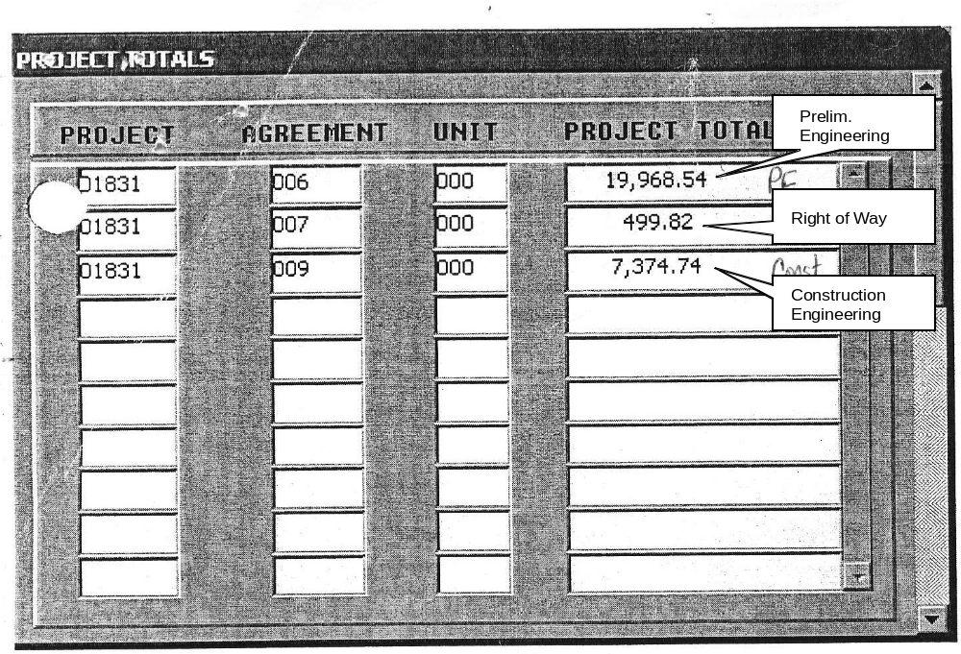

Source: MDT internal document provided by Ms. V. Murphy
In-House Staff Time and Other Direct Costs (ODCs)

During project delivery, most DOTs conduct a proportion of environmental mitigation-related activities in-house using their own staff, and staff also oversees the work of consultants and contractors. Many DOTs are increasing outsourcing of environmental mitigation activities, which suggests the amount of DOT staff costs may be decreasing as a proportion of overall costs.

Costs are incurred whenever DOT staff spends time or incurs other direct costs, such as for travel or supplies, while working on project-related environmental mitigation activities. The extent of in-house staff involvement in environmental-related activities varies from project to project and is not always significant. Some projects may require little or no environmental component. While on other projects, consultants may handle all or some environmental issues.

Tracking Staff Time and Other Direct Costs. Actual in-house staff costs are a simple function of time spent on environmental activities multiplied by a combined hourly labor and overhead rate. DOTs track this information across projects in their financial management information system. Staff is typically required to report time in hourly increments according to projects worked on and types of activities undertaken. These systems use unique alpha-numeric identifiers, often called “object codes” or “activity codes,” to distinguish costs associated with different categories of activities, such as traffic, project management, pavement, or bridge design. Information from any financial management information system must be obtained about two types of staff activity to ensure a reasonably complete assessment of in-house DOT staff time costs:

- Stand-alone environmental activities. Some DOTs’ systems have specific object codes for monitoring stand-alone environmental mitigation activities. For example, Arizona DOT’s financial accounting system has 40 environmental activity codes used by its staff, which are reproduced in Table 3.1. Oregon DOT’s “TEAMS” system includes 11 specific environmental object codes that are used by environmental staff to report time (See Appendix B). Montana DOT’s “CARES” system, by contrast, has one environmental activity code.

Some DOTs are adding to the number of environmental activity codes they use so that they can better track environmental costs. In April 2005, for example, Kentucky Transportation Cabinet introduced a set of 22 environmental activity codes for use in time reporting by its Division of Environmental Analysis staff (See Appendix B). Utah DOT is developing a set of about 25 environmental codes for inclusion in its brand new electronic Project Management (ePM) system, which will enhance project cost tracking.

Table 3.1. Arizona DOT Environmental Activity Categories

General environmental activity | Preparation of noise reports | Cultural resource surveys
Prepare categorical exclusion | Review consultant noise reports | Cultural resource testing
Preparation of draft environmental document | Preparation of air quality reports | Cultural resource data recovery
Preparation of final environmental document | Rev of consultant air quality reports | Cultural resource agency coordination
Review of consultant-prepared documents | National Pollution Discharge Elimination System-related activity | Section 106 consultation
Environmental project scoping activities | Process 404 permits | Cultural resource permit/maintain
Environmental agency coordination | Process 401 permits | Environmental mitigation post-construction review
Environmental field review | Hazardous materials preliminary assessments | Public noise involvement
Environmental project travel | Hazardous materials initial site assessments | Environmental committees
Preparation of public involvement | Hazardous materials site investigation | Partnering
Conduct public involvement | Hazardous materials remediation | Training
Preparation of material sources for environmental documents | Section 7 consultation | Project admin
Review of consultant/ contractor material sources documents | Gen cultural resource activities | Monitoring on-call consultants

Source: AZDOT internal document provided by Melissa Maiefski
- Activities that include environmental elements. Not all environmental activities can be tracked using stand-alone environmental object codes. For some activities, only a fraction of staff time may be directed to environmental issues, such as project management, roadway or bridge design, right-of-way acquisition, or construction engineering activities. In these instances, the DOT must manually estimate the fraction of activity that is associated with environmental compliance.
At ODOT, for example, methodologies have been developed for ascribing the fraction of selected non-environmental object codes, such as geo-technical work, hydraulics, roadway design, or bridge design, that are attributable to environmental activities. Different fractions are applied for different project types, such as bridge replacements, modernization projects, or repaving projects. In most instances, however, combined activities are likely to be easily missed unless a manual review of data for individual projects is conducted.
A simpler approach for estimating in-house costs may be to assume a percentage of overall project costs that is attributable to in-house costs. This number could be based on a combination of professional judgment and review of sample case studies. It could vary by type of project and amount of outsourcing performed.

Consultant Services Costs

State DOTs may rely on support from consultants to conduct some environmental mitigation activities during the pre-construction phases of project delivery. Consultants supplement in-house staff time or expertise and enable DOTs to implement a larger program of projects and tackle projects where specialist expertise is required. Arizona DOT, for example, estimates that about eighty percent of all environmental work is completed by its consultants rather than in-house. Wisconsin DOT estimates that they outsource about 60 percent of their pre-construction project work. WisDOT paid consultants $6.2 million in FY2001 for environmental services or 21 percent of its total expenditures on environmental mitigation.

Costs for consultant services are incurred whenever a consultant works on environmental mitigation-related activities. Consultants are frequently used by DOTs during the environmental review and design and land acquisition phases of project delivery. Common environmental mitigation-related activities performed by consultants include: NEPA document preparation services, mitigation study preparation (e.g. for air quality, biology, historic resources, noise, water quality, and wetlands), preliminary design to support NEPA analysis, parts of project design related to environmental mitigation features (e.g. noise walls or stormwater ponds), and parts of land acquisition related to environmental features (e.g. land for wetlands).
Consultant costs in each of these areas include staff time, overhead, and other direct costs for items such as equipment, travel, and supplies.

Practices for using consultants vary from agency to agency and project to project. At Arizona DOT, for example, the agency relies on an on-call roster of five environmental consultants for most environmental mitigation activities, particularly during NEPA and preliminary engineering. On midsize or large projects, however, many DOTs rely on consultant teams that include sub-consultants with environmental expertise. In these instances costs attributable to sub-contractors may be hard to identify. At Maryland SHA, for example, environmental work incurred during design is sometimes part of an overall design consultant contract. In such instances, SHA’s consultant design team includes specialist sub-contractors and their costs can only be identified via review of original contract documents.

Tracking Consultant Costs. In some instances, individual DOT staff specialists keep their own cost records for consultants used for their area of expertise. Such records can be useful, but obviously provide only a partial record of overall consultant costs.

Sometimes a DOT’s financial management system tracks consultant costs by project and object codes that allow environmental consultant costs to be broken out. More commonly, a manual review of individual consultant contracts and invoices is needed. As with in-house staff time costs, consultant costs fall into two categories:

- Stand-alone environmental activities. Some consultant contract costs are for stand-alone environmental mitigation activities where all consultant costs are environmental-related. On-call consultant costs are often entirely in this category. Arizona DOT indicates that its on-call environmental consultant costs are easily tracked and reported within the DOT’s financial management system. Likewise, UDOT reports that most of its Section 106-related work is conducted using stand-alone contracts that can easily be tracked.
- Activities that include environmental elements. Some consultant contract costs are for other activities (e.g. design), which include an environmental component. Oregon DOT, for example, applies standard percentages by project type to estimate the share of overall consultant costs associated with environmental activities.
As with in-house costs, some DOTs may prefer to use professional judgment based on prior experience to apply a percentage share of pre-construction or overall project costs to consultant costs. WSDOT used this approach in its 2003 study.

Land Acquisition and Relocation Costs

In some instances, projects require more land as part of compensatory mitigation or avoidance mitigation. For example, a roadway widening may require more land for stormwater detention ponds. Land costs include acquisition costs, costs to relocate any affected businesses or residents, and in-house staff costs or consultant services costs associated with these activities.

Ideally, total land acquisition costs should be estimated based on information about specific land parcels acquired for mitigation sites. States interviewed for this study, however, generally indicated that the effort required to match and retrieve site-specific information about individual parcel costs is impractical because it is too time consuming. Several states suggested that, as a simpler approach, a percentage of total land costs may be attributed to environmental mitigation based on the ratio between total land required and additional land needed for mitigation purposes. Caution should be used in adopting this approach, because land costs for environmental mitigation may not always be similar to total land costs. For example, offsite wetland mitigation-related land costs may be lower than those for land acquired for right-of-way because the offsite mitigation site is located in a more rural area with lower land costs and fewer relocations.

Construction Contractor Costs

DOTs rely on private contractors to build projects designed in-house or by consultants. Major elements of contractors’ costs include earthwork, drainage, base courses, pavements, structures, and traffic control. Common environmental features that may be constructed by contractors include wetland restoration, stormwater control facilities to control runoff from new impervious surface, conservation of historic properties, and noise walls. In addition, permitting requirements may stipulate the use of special construction techniques and erosion control best practices.

Environmental mitigation costs vary from project to project, and the magnitude of environmental mitigation-related costs incurred by contractors depends on specifications that are agreed to during a project’s pre-construction phase. Some projects may require little or no environmental mitigation-related construction. If a project involves moderate or extensive environmental mitigation work, a share of contractor mobilization costs should be apportioned to environmental costs.

Tracking Contractor Costs. Project related mitigation costs during construction must be disaggregated from the project’s total construction cost. Review of contract documents is the most accurate way to identify environmental costs, since contract documents provide a detailed breakdown of construction costs by “bid items.” Bid items are used by project engineers to ensure comparable offers of work and supplies from competing contractors.

Each project is described in terms of bid items for measurable quantities of materials and labor required. Some contract bid items are almost never environmental-related, such as asphalt, concrete, or striping, while other bid items are exclusively environmental, such as erosion control. Other bid items reflect a mix of environmental and non-environmental functions, such as facilities to remove stormwater from roadways (required for any project to protect the roadway) and treat it (required for environmental purposes) and care should be taken to apportion these costs appropriately. An engineer familiar with the project should review the contracting documents to determine which bid items are fully or partially related to environmental costs. Several data sources may be used to verify contractors’ environmental mitigation-related costs:

- The winning contractor’s bid document. In response to a bid advertisement issued by the DOT, contractors will submit a bid document that lists their price for all bid items specified by the DOT. It provides a detailed breakdown of fair and reasonable project costs using unit prices for provision of specific bid items such as Portland cement concrete pavement, structural concrete, structural steel, asphalt concrete pavement, or embankments. The successful bidder’s price establishes the overall cost of the project and the cost of individual units. Change orders during construction may result in actual project costs that vary from the bid document price.
- The record of invoices paid. This document shows what the DOT ultimately paid for actual units of bid items used. Discrepancies between the engineer’s estimate or contractor’s bid document may occur; for example a contractor may find that more or less materials are required to complete the job than specified in their original bid. Change orders are used to make the design a better fit for the actual field conditions. Sometimes a change order may result in an increase in project cost. The invoices paid provide the greatest degree of accuracy in determining and categorizing actual costs. Tracking change orders can be complex.
The engineer’s project estimate is an alternative source of cost information. This document is used by the DOT for soliciting and awarding construction contracts. The engineer’s unit prices are based on his or her knowledge about labor and materials costs, industry overhead costs, and profit margins. The integrity of state contracting processes depends on preparation of accurate engineers’ estimates; therefore, this information is likely to be acceptable for use in estimating environmental mitigation costs. Washington, for example, has used engineers’ estimates for estimating construction-related environmental costs.

3.4. Project-Level Environmental Costs Tracking Method

This section describes the major cost elements and primary sources of data that should be part of any reasonable estimate of environmental costs incurred over the life of a project from planning to completion of construction. Even if followed carefully, this method may not capture all environmental costs, however, it is likely to generate a close approximation of the ratio between environmental costs and total project costs that is adequate for policy making purposes. This method is used in chapter four to examine environmental costs for six case study projects.

Part 1. Planning, Environmental Review, and Design Costs

- In-house staff costs. Collect data from DOT’s financial information system for all DOT staff costs attributed to stand-alone environmental activities that take place during planning, environmental review and design (identified by unique activity codes) for the project (identified by a unique project code).

If possible, estimate the fraction of other DOT staff costs attributed to the project that is for activities that are only partially environmental-related. To avoid time consuming review of individual project data, consider development of state-specific assumptions about the range of such costs that are typical for categories of project types. A Delphi approach (in which a group of knowledgeable experts reach agreement on appropriate cost ranges) could be used to provide appropriate ratios.
- Consultant services costs. Review consultant contract records to determine proportion of consultant costs spent on environmental activities and if possible collect data from DOT’s financial information system on consultant costs recorded for stand-alone environmental activities (identified by unique activity codes) as back-up validation to information from contract records. According to the states participating in the case studies, consultant costs are almost always clearly environmental or non-environmental and can be easily separated.

Part 2. Land Acquisition and Relocation Costs (If Applicable)

In theory, land acquisition and relocation costs may be estimated based on review of detailed parcel-by-parcel records maintained by the DOT for each project. Departments of transportation that participated in this study indicated, however, that such a review is too time consuming to be practicable. In its place, they recommend that project managers should estimate the share of total land acquisition and relocation costs required for environmental purposes (e.g. stormwater or wetlands) and use this ratio to apportion costs, including:

- In-house staff costs. If project includes a land acquisition element, collect data from the DOT’s financial information system on all DOT staff costs recorded for right-of-way activities (identified by unique activity codes) attributed to the project.
- Consultant services costs. If project includes a right-of-way element and consultant support was used, review consultant contract records to determine proportion of consultant costs spent on these activities and if possible collect data from financial information system on consultant costs (identified by unique activity codes) as back-up validation to information from contract records.
- Land acquisition and relocation costs. If project includes a right-of-way element, collect data from financial information system on all non-staff time land acquisition and relocation payments to owners and tenants.

If costs are apportioned based on the percent of land required for environmental purposes, the project manager should be consulted to ensure that the project does not feature any wide variances in land acquisition and relocation costs that might generate an over- or under-estimate of environmental costs.

Part 3. Construction Engineering Costs

- In-house staff costs. Collect data from DOT’s financial information system on all DOT staff costs recorded for construction engineering activities (identified by unique activity codes) attributed to the project. The project manager should estimate share of total construction engineering required for environmental purposes and use this ratio to apportion staff costs.

Part 4. Construction Contractor Costs

- Environmental-related contractor payments. Collect data from engineer’s estimate, bid award, or invoice documentation on the cost of stand-alone environmental construction items and the fractional cost of partially environmental construction items, particularly mobilization costs which should be appropriately apportioned to environmental costs if significant mitigation work is required as part of construction. This will often require individualized review of construction contract documentation.

If a project includes significant design alterations to accommodate environmental issues, an estimate of the total additional construction cost should be made. An estimate should be based on the professional judgment of a project engineer familiar with the overall project.

3.5. Observations and Considerations

Observations

- Most state DOTs are poorly equipped to track environmental costs. The interviews with selected state DOTs, and more tellingly the comments from practitioners in state DOTs that turned down the opportunity to participate in the study, suggest that many state DOTs have a long way to go before they are capable of tracking environmental costs efficiently and accurately. A primary constraint for many states is the lack of project-level environmental activity codes and accounting systems that support tracking of in-house and consultant costs.
- States that track environmental costs find the information useful. States that do track all or some environmental costs find the information serves several valuable functions including greater fiscal accountability to external stakeholders, better management of project costs, and useful input on environmental policy decisions.
- Interest in measuring environmental costs varies considerably among DOTs but appears to be growing. Interest in measuring environmental costs is, at present, limited to a small group of state DOTs, many of whom are featured prominently in this report. Practitioners at several DOTs approached for this study make clear that, in their opinion, the benefit to cost ratio associated with tracking environmental costs does not justify investment of resources. Practitioners at some DOTs indicate, however, that their agencies are beginning to invest in systems that will enable better tracking of environmental costs in the future.
- Tracking environmental costs involves a learning curve for DOT staff. States that have experience in measuring environmental costs, such as WSDOT and ODOT, report that their initial efforts involved a steep learning curve and significant staff resources, but that over time they have become increasingly proficient at tracking costs efficiently and accurately.

Considerations

- Further work is needed to refine environmental cost definitions and data collection methods. The study presents a credible and comprehensive definition of environmental costs that is compatible with the types of data collected in the states featured in the case studies. It is a work in progress; further research would be beneficial, particularly in the following areas:
  - Reaching agreement on the share of project planning activities that can reasonably be attributed to environmental requirements
  - Determining the extent to which non-environmental staff at the DOT also perform some environmental activities and methodologies for estimating the cost of these activities
  - Methods for handling costs on projects where preconstruction elements are conducted as a single project, such as study of an entire corridor in a single EIS, but construction is conducted as multiple project;
  - Methods for estimating changes in design and construction costs of project elements that exceed design standards for transportation purposes as a result of environmental requirements
  - Comprehensive review of methods for tracking land acquisition-related environmental costs need improvement
  - Methods for reviewing bid item lists or other contract documents to extract environmental costs to ensure consistency in extracting appropriate costs among projects reviewed
  - Methods for allocating costs on contract items that serve environmental and non-environmental functions (e.g. excavation), which require a subjective judgment by the project engineer
  - Methods for allocating stormwater and erosion control costs that would be required for the project regardless of environmental laws
  - Determining whether landscaping costs should be counted as a complete or partial environmental expenditure
  - Methods for allocating shares of contractor mobilization costs and construction engineering which require a subjective judgment by the project engineer
  - Development of thorough quality assurance and quality control approaches on data collection.

- Tracking via case studies and samples is probably more practical for most states than a comprehensive assessment approach. The complexity and staff time needed to track environmental costs on a statewide level suggest that a case study-based approach is likely to yield useful information while being more timely and cost-efficient to implement.
- Protocols for environmental cost data collection during project delivery are needed to ensure good information. After the fact analysis of costs is inherently difficult unless comprehensive data is collected in the right formats during project delivery. Data collection protocols should be developed in tandem with selection of methodologies for analyzing cost data. They should be designed to minimize additional reporting burdens on staff.
- States should consider upgrading their financial systems to include more environmental activity codes. Lack of reporting for staff time and consultant costs by environmental activity is often a roadblock to more accurate tracking of environmental costs.
- Design-build project approaches reduce availability of environmental cost information. Two of the case studies featured in the study were “design-build” jobs where the same engineering team designed and built the project. State DOTs are increasingly choosing design-build project management structures to administer some of their projects in place of traditional design-bid-build approaches. Environmental cost information is much more difficult to track for design-build projects since the DOT is less directly involved in the project.

4.0 Case Studies of Environmental Costs

As requested by Congress, this study focuses on a representative set of case studies that are intended to provide a sense of typical environmental costs by including projects in a range of geographic locations and urban and rural settings, and featuring common project types with varying levels of environmental impacts and NEPA documentation. The information provided in the case studies gives a detailed contextual analysis of how environmental costs are incurred by DOTs. The six case studies include:
- US Highway 113, Maryland – Widening of a rural two-lane highway on Maryland’s eastern shore to a four-lane divided facility to address safety concerns.
- Montana Highway 84, Montana – Roadway reconstruction and correction of horizontal and vertical pavement design deficiencies on a rural highway near Bozeman, Montana.
- Alexauken Creek Bridge, New Jersey – Replacement of an old bridge on a rural two-lane minor arterial road.
- Bob Creek Bridge, US Highway 101, Oregon – Replacement of an old bridge on a scenic rural two-lane principal arterial in an area of high natural value on Oregon’s Pacific coast.
- 12300/12600 South, Utah – Widening of an urban principal arterial and replacement of an interchange in a rapidly growing suburban area on the fringe of the Salt Lake City region.
- I-90 Sunset Way, Washington – Interstate interchange replacement in a rapidly growing suburb of Seattle, Washington.

Table 4.1 provides a summary of each project’s characteristics. The six case studies should not be considered a statistically valid representation of state DOTs’ environmental costs in general since the sample size of data collected is too small.

For the projects studied, environmental costs range from two to 12 percent of an individual project’s total costs with an average of eight percent. Table 4.2 summarizes the results of the case studies in more detail. The case study descriptions are based on extensive discussions with numerous DOT staff and review of data taken from multiple sources provided by the DOTs involved in the case studies.
Table 4.1. Summary of Case Study Characteristics

Project Name | Project Type | State | NEPA Document | Project Duration | Project Cost | Setting
US-113 | Dualization (2-lane to 4-lane) | MD | EIS | 1997 – not finished | $181,125,760 | Rural
MT-84 | Roadway Modernization | MT | EA | 1992-2005 | $10,291,345 | Rural
Alexauken Bridge | Bridge Replacement | NJ | CE | 2005 | $1,979,792 | Rural
Bob Creek Bridge | Bridge Replacement | OR | CE | 2001-2005 | $1,701,222 | Rural
12300/ 12600 S | Arterial Widening | UT | EA | 1999-2005 | $132,291,601 | Urban
I-90 Sunset Way | Interchange Replacement | WA | EIS | 1996-2003 | $112,800,000 | Urban

4.1. Selecting Representative Case Studies

To ensure consistency with the request from Congress to study a “representative sample” of projects, all the case studies were selected to meet the following criteria:

- Open to traffic. Case studies should be open to traffic and all work contracts closed out to allow full identification of costs.
- Typical for DOT. Case studies should avoid projects that are unusually large in cost and scope, or that were subject to non-typical delays due to environmental issues.
- Recently completed. Case study projects should be constructed within ten years of starting the NEPA process, so they are assumed to reflect the current state-of-the-practice.
- Reflective of a mix of geographic settings. Case studies should include a mix of geographic settings including a variety of climatic, socio-economic, land use, and ecological conditions.
- Representative of a range of NEPA documentation requirements. Case studies should reflect a range of NEPA documentation requirements, including projects that require CEs, EAs, and EISs.
- Reflective of common project types. The project types featured in the case studies include bridge replacements, roadway replacement, roadway dualization, and interchange improvement.
The case studies also feature a range of environmental impacts most commonly encountered by DOTs, such as wetlands, stormwater, historic and cultural resources, and wildlife and ecosystems. (Table 4.3 summarizes environmental impacts by project.)
Table 4.1. Summary of Case Study Environmental Impacts

 | US 113 (MD) | MT-84 (MT) | Alex-auken Bridge (NJ) | Bob Creek Bridge (OR) | 12300/ 12600 S (UT) | I-90 Sunset Way (WA)
Wetlands & Stream Restoration | ▓ | ▓ | ▓ |  | ▓ | ▓
Stormwater Treatment | ▓ |  |  |  |  | ▓
Erosion Control | ▓ | ▓ | ▓ | ▓ | ▓ | ▓
Wildlife & Ecosystems |  | ▓ |  | ▓ |  | ▓
Noise |  |  |  |  | ▓
Historic & Cultural Resources | ▓ |  | ▓ |  | ▓
NEPA Documentation | ▓ | ▓ | ▓ | ▓ | ▓ | ▓
Project Design & Alignment Changes | ▓ | ▓ |  |  | ▓ | ▓
Section 4(f) |  | ▓
Project Construction Changes | ▓ | ▓ |  |  | ▓ | ▓

4.2. Case Study Format

Each of the case studies is presented in a format that includes a brief introduction describing the context for the project; a text box that summarizes key project information; a description of the purpose and need for the project; an overview of the actual project; significant environmental issues affecting the project; a qualitative analysis of environmental cost issues; and a detailed table that lists the project’s environmental and total costs. The table for each case study follows the format identified in Section 3.3 of the study report for breaking environmental costs into:

- Planning, environmental review, and design-related costs. This includes all DOT staff time and other direct costs, consultant services costs associated with portion of planning, environmental review, and design-related costs that are attributable to NEPA document processes, such as document preparation, impact studies, and coordination with other agencies. This section of each table provides the total costs, expressed in dollars and percentages, for the entire environmental review/design phase of the project, as well as the subtotals that represent the environmental costs incurred as a portion of the project’s environmental review/design phase costs.
- Land acquisition costs (if any). This includes all DOT staff time and other direct costs, consultant services costs associated with land acquisition, such as appraisals, acquisitions, and relocations that may be attributed to environmental requirements as well as land acquisition and easement purchase costs. This section of each table provides the total costs, expressed in dollars and percentages, for land acquisition for the project, and the subtotals that represent the environmental costs incurred as a portion of the project’s land acquisition costs.
- Construction engineering costs. This includes all DOT staff time and other direct costs incurred to support construction engineering that may be attributed to environmental requirements. This may include environmental monitoring, permit acquisition, and oversight of erosion control. This section of each table provides the total costs, expressed in dollars and percentages, for construction engineering activities for the project, as well as the subtotals that represent the environmental costs incurred as portion of the project’s construction engineering costs.
- Construction contract costs. This includes costs for all bid items that are completely or partially related to environmental requirements as well as a portion of construction mobilization if appropriate. Costs include both labor and materials. This section of each table provides the total costs, expressed in dollars and percentages, for the construction phase of the project, and the subtotals that represent the environmental costs incurred as a portion of the project’s construction phase costs.

For each cost item, environmental costs are compared to total costs including the environmental cost element.

4.3. Case Studies

Following are the Maryland, Montana, New Jersey, Oregon, Utah, and Washington case studies.

Highway US 113 Dualization, Maryland

Highway US 113 is one of three major highways that form the backbone of the transportation system for Maryland’s lower Eastern Shore. Land uses adjacent to the roadway are predominantly rural including farmland, forested areas, and wetlands. The Eastern Shore is a major regional tourist destination during summer months and has a significant amount of year-round agricultural activity. Highway US 113 provides a critical high-speed travel connection on the Delmarva Peninsula for through and local traffic, including recreational trips.
Roadway Type: Principal arterial - rural
Project Type: Four-lane, divided highway on combined new/existing (two-lane) alignment
Total Project Cost: $181 Million
Environmental Cost: $21.9 Million (12%)
Project Duration: 1997 (still under construction)
Project Length: 24 miles
NEPA Document: EIS
Environmental Issues: Wetlands, stormwater, erosion control, landscaping

Highway US 113 is classified as a rural principal arterial by the FHWA. It departs from Highway US 13 near Pocomoke City, Maryland and extends north for 40 miles in Maryland and 60 miles in Delaware before rejoining Highway US 13 in Dover. The route dates from the late 1600s, and it was paved in the early 1900s, generally along its present alignment. The 60 mile portion of Highway US 113 in Delaware is a four lane facility in its entirety, but when this project began in 1996 about half of the 40 mile stretch of US 113 in Maryland had only two undivided lanes. The EIS for the Highway US 113 project has been nationally highlighted as an example of good environmental streamlining.

Project Purpose and Need

The purpose and need identified by Maryland State Highway Administration (SHA) for the Highway US 113 project was to improve vehicular safety conditions and traffic operations. A local citizens group called County Residents Action for Safer Highways (CRASH) was vocal in its support for a transportation solution that reduced crashes.

Maryland SHA’s 1995 traffic counts for this stretch of highway indicated that summer average daily traffic (ADT) ranged from 4,900 to 18,500 vehicles per day along portions of the corridor. Stretches of the highway were rated level of service “D” in engineering terms. Forecasts prepared for the EIS suggest that summer ADT will grow to between 7,000 and 30,400 vehicles per day in 2020. Prior to completion of this project, the fatal accident rate along the most hazardous two-lane stretches of US 113 was significantly higher than the statewide average at 6.3 fatalities per year compared to a statewide average of 2.5 fatalities per year. The EIS ascribed this poor safety record to a combination of substandard highway geometry and traffic volume that exceeded the capacity of the highway as built.

Project Description

The project solution selected by Maryland SHA through the NEPA process consisted of improving a 24 mile stretch of two lane US 113 by “dualizing” the roadway along a combination of new and existing alignments, i.e. upgrading the two-lane highway to a four-lane, divided highway. This solution improves several locations with substandard horizontal geometrics, adds an additional travel lane in each direction, creates a 34 foot median with crash barriers except at two sensitive wetland crossings where the median is about 10 feet, adds two new bridges, and some interchange improvements.

While pre-construction, right-of-way activities, and wetland mitigation for US 113 dualization were treated as a single project, construction is being completed as two separate projects. Construction of the northern element of the project was completed in three phases and is now open to traffic. The southern element of the project is being built in five phases, of which only one is complete. Cost information about the remaining phases is available from SHA and was used to predict total environmental costs for the project. Further information about the project is available online at a FHWA webpage featuring successful cases of environmental streamlining.

Environmental Issues of Concern

The Highway US 113 project was processed under NEPA as an EIS because of the clear potential for significant environmental impacts associated with the project. The EIS process for the project was completed in 15 months (February 1997 to May 1998). The final EIS for Highway US 113 describes two categories of adverse environmental impacts, regulated under Federal laws, that were considered most significant.

- Cultural Resources (National Historic Preservation Act, Section 106). The new US 113 roadway passes adjacent to a historic church and project alternatives would have resulted in physical destruction and visual impacts to several other historic structures including a farm, a house, and two stores. Under Section 106 of the NHPA, the selected alternative was found to have only an adverse visual effect on St. Martins Church, which is listed on the National Register. The church’s historic setting in an agricultural and forested location was changed visually by the increased roadway width. SHA developed a memorandum of agreement with the Maryland Historic Trust and Advisory Council on Historic Preservation to ensure appropriate mitigation takes place. No historic property was acquired as part of the project; therefore, a Section 4(f) analysis was not required.
- Wetlands (Clean Water Act, Section 404). The distribution and extent of the wetlands and linear nature of this project prevented complete avoidance of construction in wetlands while still meeting project purpose and need and avoiding other substantial adverse environmental impacts. The preferred project alignment was selected to minimize impacts to wetlands, but according to the EIS, the entire northern and southern elements of the US 113 project have an impact on about 12 acres of wetlands. The project’s wetland mitigation plan calls for creation offsite of 25 compensatory acres of wetlands. In addition, the project includes two bridge structures that would otherwise have been built as smaller box culverts.

Overview of Environmental Costs

A majority of the design and all construction work for the Highway US 113 project is being completed by consultants and contractors with oversight from Maryland SHA staff. More than 80 percent of Maryland SHA’s environmental costs associated with the Highway US 113 project will be incurred during construction, primarily for construction of offsite wetlands mitigation, stormwater treatment, erosion control, landscaping, and for construction of two bridge structures of sufficient length to span environmentally sensitive wetlands. A qualitative discussion of environmental costs by project phase, starting with planning and ending with construction, follows.

Planning, Environmental Review and Final Design

During planning, environmental review and final design, a combination of in-house and consultant costs were incurred for investigating environmental issues associated with the Highway US 113 project. Some elements of the project were changed during preliminary engineering to reduce environmental impacts. For example, to avoid wetland impacts, the selected alignment for the project is narrower at some locations. The project footprint was shifted in other locations. Additionally, two longer bridges were built. According to SHA engineers, however, no measurable amount of additional costs at this phase could reasonably be attributed to these changes.

Key components of preliminary engineering costs include:

- In-House Staff Costs - Maryland SHA’s staff time was the main in-house cost at this phase and costs were principally incurred for oversight of: 1) EIS preparation by a consultant, 2) Section 106 (cultural and archeology resources) analysis by a consultant, 3) permit acquisition by a consultant, 4) development of wetland delineation and mitigation plans by a consultant, and 5) other miscellaneous activities. This oversight role included considerable interaction with other state and Federal resource agencies on an expedited schedule to reach agreement over how to handle sensitive environmental issues (particularly wetlands) while maintaining progress on a project of great concern to the local community.

The aggregate cost of these activities is readily available because staff at Maryland SHA records their hourly time to project charge numbers using detailed activity codes. As a result, environmental staff costs by project can be broken out via analysis of data stored in Maryland SHA’s custom-built electronic financial accounting system, which is called the Financial Management Information System (FMIS). Non-environmental in-house staff costs are accounted for in FMIS, which assigns an hourly staff cost rate that includes average fringe benefits and other indirect costs as well as direct labor costs. The activity codes used within FMIS do not support accurate disaggregated analysis of environmental costs by task, e.g. for oversight of EIS preparation or wetland delineation.

- Consultant Costs - The other principal environmental cost incurred during preliminary engineering for the US 113 project was for consultant support. Major environmental-related consultant activities in this phase included 1) EIS preparation, 2) Section 106 (cultural and archeology resources) analysis, 3) permit acquisition, and 4) development of wetland delineation and mitigation plans. At Maryland SHA, consultants bill costs using the same activity codes as used by SHA staff and therefore aggregate costs can be easily be pulled from FMIS.

Special Considerations – In contrast to some of the other case study states, Maryland SHA was unable to identify the amount of non-environmental staff time spent on environmental issues and subsequent costs; however, agency staff is confident that the detailed environmental activity codes used at SHA capture most of the staff time spent on environmental issues.

Land Acquisition

Some of the US 113 project was built within existing SHA-owned right-of-way; however, some land was acquired to accommodate the wider cross section of the project and a portion of new alignment. Maryland SHA completed all land acquisition using in-house staff. A total of 511 additional acres of right-of-way was required to accommodate the new four lane divided highway. An estimated seven percent, or 36 acres out of this additional amount was required for stormwater facilities. An additional 142 acres of land was acquired offsite to mitigate for wetland impacts. Overall, about 27 percent of all land acquired for the project was related to environmental needs, primarily offsite wetland impact mitigation. This proportion was used to allocate costs stored in FMIS that were attributable to project land acquisition.

Construction Engineering

Since most of the US 113 project was structured in part as a “detailed build” job over which the contractor has greater autonomy, SHA’s construction engineering costs are smaller than normal. As with other phases, Maryland SHA is able to identify all Highway US 113 project-related construction engineering costs in FMIS. These costs were incurred for SHA staff time spent to oversee contractors’ work and manage the project. The environmental component of construction engineering costs is attributable to the presence of a SHA environmental manager whose time was dedicated to the Highway US 113 project and who fulfilled all environmental responsibilities. The environmental manager uses a separate activity code in FMIS to report hours spent on the project.

Construction

Maryland SHA was able to identify environmental costs incurred during construction of the Highway US 113 project either from the project engineer’s estimate (used for costs associated with Northern Alignment, Phases One and Three, and Southern Alignment Phases One to Five) or the contractor’s bid documents (used for costs associated with Northern Alignment Phase Two and offsite wetlands mitigation). Maryland SHA staff was able to identify both unit costs that are exclusively environmental-related and those that had to be apportioned to environmental/non-environmental categories based on best professional judgment. Major categories of environmental costs incurred during the construction phase of the Highway US 113 project included:

- Share of overall contractor mobilization
- Offsite wetlands mitigation
- Storm drainage
- Erosion and sediment control
- Seed and mulch
- Landscaping
- Offsite wetland mitigation.

Costs provided for these actions include both materials and labor.

In addition, Maryland SHA constructed two bridges as part of the project that spanned environmentally sensitive wetlands left in place. For hydraulic purposes, a short 18-foot box culvert structure was sufficient in both instances; however, the bridge structures were 450 feet and 222 feet respectively. According to Maryland SHA, the bridges added $4.2 million in additional costs to total costs for the project.
US Highway 113, Maryland – Detailed Environmental Costs

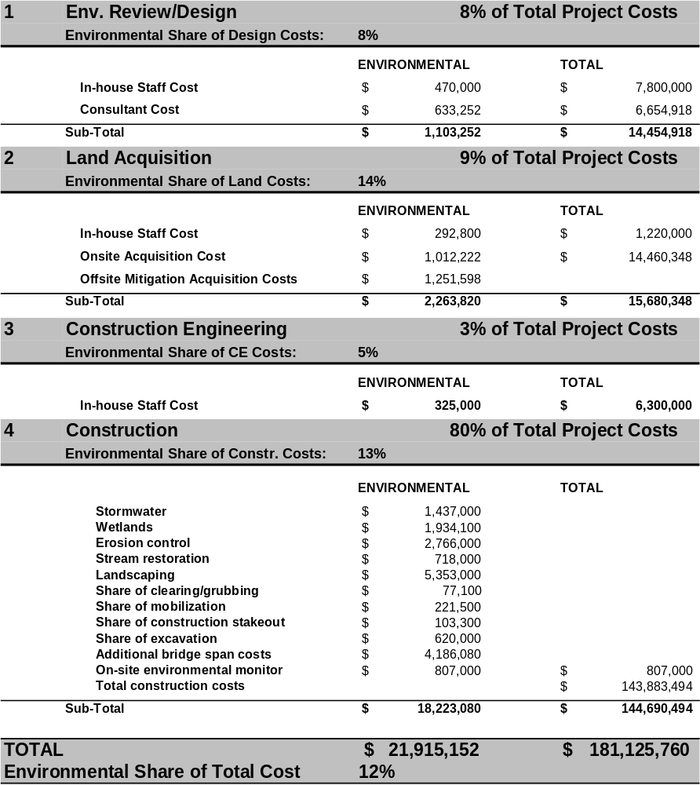

Montana Highway 84 (Four Corners - West) Reconstruction, Montana

Montana State Highway 84 (MT-84) is part of an extensive system of two-lane rural arterial routes in Montana that are important to interstate, statewide, and regional travel. The Four Corners – West project is located on MT-84 about 10 miles west of Bozeman, Montana. It is classified as a rural minor arterial and connects Bozeman to the east and Norris to the west, both of which are connecting points for interstate and intrastate highways. Use of MT-84 is heavily oriented to agricultural farm-to-market traffic and recreational/tourism traffic accessing the nearby Madison River basin. A portion of the corridor also serves increasing amounts of residential traffic as Bozeman grows westward. Projected traffic volumes on the corridor for 2015 range from 2,450 to 5,640 annual average daily traffic, with four to seven percent truck traffic.
Roadway Type: Minor arterial - rural
Project Type: Reconstruction, upgrade to current design & safety standards
Total Project Cost: $10.3 Million
Environmental Cost: $281,700 (3%)
Project Duration: 1992 to 2005
Project Length: 6.7 miles
NEPA Document: Environmental Assessment/ Section 4(f) Analysis
Environmental Issues: Erosion control, wetlands& streams, landscaping

The eastern portion of the Four Corners – West project corridor crosses the Gallatin River floodplain, which is characterized by flat alluvial deposits. The western portion of the project corridor passes through rolling terrain created where runoff from the mountains has eroded deep ravines in the wind-deposited silt material prevalent in the area, necessitating vertical curvature and horizontal alignment changes in many locations.

Land use along the western portion of the Four Corners West project corridor includes dry farm or pasture areas dotted with rural farmsteads. At the eastern end of the corridor, low density residential and light industrial land uses that make up part of Bozeman’s suburban fringe are prevalent.

Montana State Highway 84 was paved in the mid-1950s. At the time, the highway was designed as a best fit to existing terrain. Prior to this project, no major improvements or modifications of the highway had been undertaken since the time of its initial construction. As a result, pavement was in poor condition with a narrow width, surface break up, and rutting that required extensive annual maintenance. The vertical and horizontal alignment of the highway was also substandard in several places.

Project Purpose and Need

The purpose and need identified by MDT for the Four Corners – West project was to improve safety and traffic flow and correct pavement deficiencies. Before the project was completed, several horizontal curves along the corridor were sharper than current design standards recommend; several vertical grades were steeper than current recommended design standards; and lane widths were below design standards. The accident rate along the corridor was slightly higher than the statewide average.

Project Description

The Four Corners – West stretch of MT-84 was fully reconstructed in accordance with MDT standards to meet a 62 mph design speed consistent with the surrounding terrain. Driving lanes and shoulders were widened. The new horizontal alignment predominantly follows the existing highway corridor with the exception of flattening some substandard curves and eliminating some horizontal curves by straightening the roadway. The new vertical alignment also follows the existing highway corridor with the exception of flattening substandard vertical curves and reducing steep vertical grades where possible. The project used existing right-of-way where possible; however, some new land was required on one or both sides of the highway for most of the project. The project was completed as a design-bid-build contract and was overseen by MDT staff.

Environmental Issues of Concern

The Four Corners – West reconstruction project was processed under NEPA as an EA because of the potential for significant environmental impacts associated with the project. At the conclusion of the EA, the FHWA made a Finding of No Significant Impacts (FONSI) determination. By definition, the EA-FONSI for the project describes no major categories of adverse environmental impacts, regulated under Federal laws. Minor issues highlighted in the EA that did contribute to environmental costs included:

- Cultural Resources (National Historic Preservation Act, Section 106). A cultural resources inventory report was completed in 1992. This study found no historic sites eligible for listing in the National Register of Historic Places.
- Parklands (Section 4(f)). The project has minor impacts (a taking of 0.6 acres of public land) at the Shedd’s Bridge Fishing Access point, which is owned by Montana Department of Fish, Wildlife, and Parks (MDFWP). The MDFWP agreed that no mitigation was required for this impact.
- Wetlands (Clean Water Act, Section 404). A wetlands assessment report was prepared for the project. Construction of the preferred alternative resulted in disturbance of 3 acres of wetlands. Mitigation was provided at an existing offsite mitigation bank owned by MDT on the east edge of Bozeman. MDT has in place no methodology for estimating the cost associated with use of the wetlands bank to mitigate for the small amount of wetlands affected by this project; therefore, an estimate of the cost of mitigation was assumed based on FHWA data for average wetland costs per acre.
- Erosion Control. Routine erosion control procedures were followed during construction of the Four Corners – West project. This included development of an Erosion Control Plan that incorporates Best Management Practices. The objective of the Plan was to minimize erosion of disturbed areas during and following construction of the project.
- Fish Passage. For one culvert required on the project, a wider 2400 mm pipe was used, instead of a 1500 mm pipe, to allow for fish passage.

Overview of Environmental Costs

About 80 percent of MDT’s environmental costs associated with the Four Corners – West project were incurred during construction, primarily for wetlands mitigation, construction of a wider culvert suitable for fish passage; erosion control; and removal of the old roadway. A qualitative discussion of environmental costs by project phase, starting with planning and ending with construction, follows.

Planning, Environmental Review and Final Design

During planning, environmental review and final design, a combination of in-house and consultant costs were incurred for investigating environmental issues associated with the Four Corners - West project. These costs included preparation of an EA, a biology report, a wetlands delineation study, and a cultural resources report. During completion of these studies, MDT staff provided an oversight role and consultants completed the reports. According to MDT’s project engineers, no elements of the project were changed significantly during preliminary engineering to reduce environmental impacts, and no measurable amount of additional costs at this phase could reasonably be attributed to these changes.

MDT tracks environmental bureau staff time costs in its financial accounting system but was not able to report costs by individual environmental activity (e.g. EA preparation or wetland study preparation) since this level of detail is not recorded by MDT staff. MDT was able to provide data from its financial accounting system on consultant charges for each report, as well as overall consultant costs incurred during preliminary engineering.

Special Considerations – In contrast to some of the other case study states, MDT was unable to identify the amount of non-environmental staff time spent on environmental issues (and subsequent costs). They estimated that this amount of time, however, is unlikely to exceed more than 100 to 200 hours. In the detailed cost estimate, a placeholder value of 150 hours was used.

Land Acquisition

Some of the Four Corners – West project was built within existing MDT right-of-way; however, a considerable amount of new land was acquired by MDT to accommodate the wider cross section of the project. MDT completed land acquisition using in-house staff and consultants. A total of 123.73 additional acres of land was required to accommodate the project’s needs. MDT indicates, however, that none of the land acquired for the project was related to environmental needs.

Construction Engineering

MDT is able to identify all Four Corners – West project-related construction engineering costs from its financial management information system. These costs were incurred for MDT staff time spent to oversee contractors’ work and manage the project.

Construction

MDT was able to identify environmental costs incurred during construction of the Four Corners – West project based on the Department’s record of actual payments to the contractor. MDT staff was able to identify both unit costs that are exclusively environmental-related and those that had to be apportioned to environmental and non-environmental categories based on best professional judgment. Major categories of environmental costs incurred during the construction phase of the Four Corners - West project included:

- Temporary erosion control
- Construction of a culvert suitable for fish passage
- Roadway removal and reclamation.
Costs provided for these actions include both materials and labor.

Special Considerations – In contrast to some of the other case study states, MDT did not consider inclusion of a share of contractor mobilization in the environmental costs to be appropriate since total environmental costs of $225,667 incurred in construction represents a small fraction total construction costs which were $7.7 million.
Montana Highway 84 – Detailed Environmental Costs

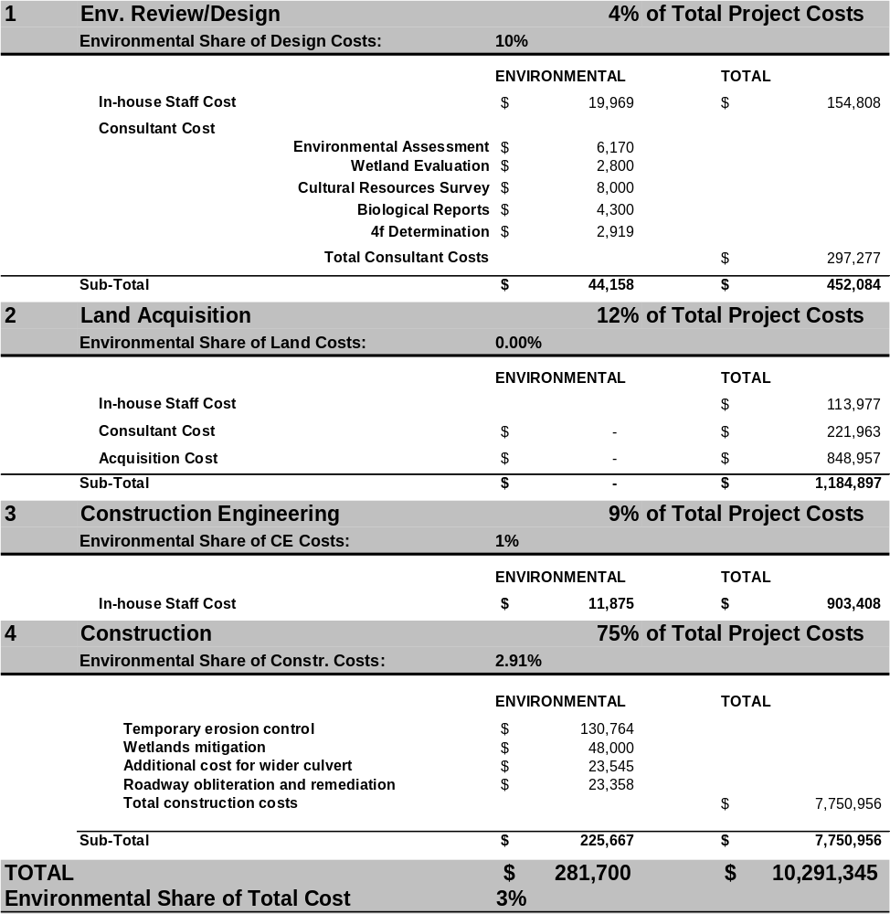

Alexauken Creek Bridge Replacement, Rte 179, New Jersey

Route 179 is a minor rural two-lane road located near West Amwell in New Jersey’s Hunterdon County. The area in the vicinity of the Alexauken Bridge on Route 179 is listed as a part of the Mount Airy Historic District on the National Register of Historic Places, although the bridge itself does not contribute to the historic qualities of the District.
Roadway Type: Minor arterial - rural
Project Type: Bridge replacement on existing alignment
Total Project Cost: $2.0 Million
Environmental Cost: $239,583 (12%)
Project Duration: 4 months
Project Length: 0.1 miles
NEPA Document: Categorical Exclusion
Environmental Issues: Streams, historic & cultural resources

The Alexauken Creek bridge on Route 179 is a two lane facility that serves primarily local traffic. ADT on the bridge, according to New Jersey DOT (NJDOT) is about 5,000 vehicles per day. Route 179 is classified as a rural minor arterial by the FHWA.

Prior to the bridge replacement, Route 179 used a three span bridge to cross Alexauken Creek. New Jersey DOT initially planned this project as a total bridge reconstruction including replacement of the three span structure with a single span, which would have created substantial water quality permitting and Section 106 compliance issues. In particular, a Section 106 study revealed the presence of an early nineteenth century blacksmith shop adjacent to the bridge footprint. As part of its “Hyperbuild” initiative, NJDOT opted to streamline the project design and construction timeline and reduce costs by replacing only the bridge’s superstructure and remaining within the original bridge “footprint.”

Project Purpose and Need

The purpose and need identified by NJDOT for the Alexauken Creek bridge project was to address structural problems in the 76 year old Route 179 bridge including wide cracks in its underside, flaking on its concrete railings, and deterioration of its reinforcing steel beams.

Project Description

The project solution for the Route 179 bridge selected by NJDOT consisted of 1) replacing the superstructure of the Alexauken Creek bridge while reusing the existing abutments and piers on the same alignment and 2) rehabilitating about 25 feet of roadway on either side of the bridge. The project was completed as one of the initial 14 projects statewide that are part of NJDOT’s Hyperbuild initiative to improve project delivery. NJDOT expedited construction by employing a detour on adjacent Route 202 and allowing only one lane of traffic to travel in a single direction through the construction area, which eliminated the need for a temporary bridge outside the current footprint.

Environmental Issues of Concern

The Alexauken Creek bridge replacement project was processed under NEPA as a categorical exclusion (CE), which required minimal NEPA-related processing. In addition, Section 106 (historic resources) phase I and II surveys, a Stream Encroachment permit, and a Freshwater Wetlands permit were completed during project planning to rule out any impacts to historic resources or streams. The environmental documentation for the Alexauken Creek bridge replacement project describes two major categories of environmental impacts, regulated under Federal laws and that were considered a potential concern:

- Archaeological Resources (NHPA, Section 106). Since the project is located in a National Register-listed Historic District, detailed historic investigations were required. Field investigations during a Phase I archaeological survey of the project site revealed the remains of an early nineteenth century blacksmith shop. Phase II archaeological testing of the historic site was conducted as were photographic documentation, informant interviews, and the location of surveyed resources with global positioning system (GPS) technology. By keeping the new bridge on the old footprint, the archeological site was avoided.
- Wetlands/Stream Resources. The project temporarily affected 0.066 acres of wetlands/streams, which required issuance of environmental permits from the New Jersey Department of Environmental Protection (NJDEP). NJDEP has been delegated authority for the CWA, Section 404 program in New Jersey. Since construction involved in-stream work, a Stream Encroachment permit was also required. The permits required erosion control and temporary shielding measures during construction.

Overview of Environmental Costs

The Alexauken Bridge project was designed in-house by NJDOT without consultant assistance. Almost all environmental costs for the project were incurred during preliminary engineering for investigation of potential environmental issues. A qualitative discussion of environmental costs for the Alexauken Creek bridge project by project phase, starting with planning and ending with construction, follows.

Planning, Environmental Review and Final Design

During planning, environmental review, and final design, a combination of in-house and consultant costs were incurred for investigating environmental issues associated with the Alexauken Creek bridge replacement project. Key components of preliminary engineering costs include:

- In-House Staff Costs – NJDOT’s staff time was the main in-house cost at this phase and costs were principally incurred for oversight of Section 106 Phase I and II studies, a wetlands report, NEPA document preparation, and overall design of the new bridge. Staff recorded 558.5 hours worked on environmental activities during preconstruction. Discrete estimates of the cost of each activity are readily available because staff at NJDOT has developed methodologies for extracting such costs from their financial management information system. The NJDOT’s financial management information system assigns an hourly staff cost rate that includes average fringe benefits and other indirect costs as well as direct labor costs.
- Consultant Costs - The other principal environmental cost incurred during this phase for the Alexauken Creek bridge replacement project was for consultant support. Major environmental-related consultant activities in this phase included Section 106 Phase I and II studies, NEPA Categorical Exclusion document preparation, and acquisition of wetlands permits.

Land Acquisition

No additional land was required for the Alexauken Creek bridge replacement project since the replacement bridge was completely within the footprint of the old bridge.

Construction Engineering

In-house NJDOT environmental staff performed only a small construction engineering role on the Alexauken Creek bridge replacement project. All staff time is tracked by project charge number and activity code, therefore detailed information about environmental staff time and other costs is readily available in NJDOT’s financial management information system.

Construction

NJDOT staff was able to identify all environmental costs incurred during construction of the Alexauken Creek bridge replacement project from the final project ledger, which codes unit costs by type. Major categories of environmental costs incurred during the construction phase of the Alexauken Creek bridge replacement project included:

- Erosion control
- Temporary shielding.
Costs provided for these actions include both materials and labor.

Alexauken Creek Bridge, New Jersey – Detailed Environmental Costs

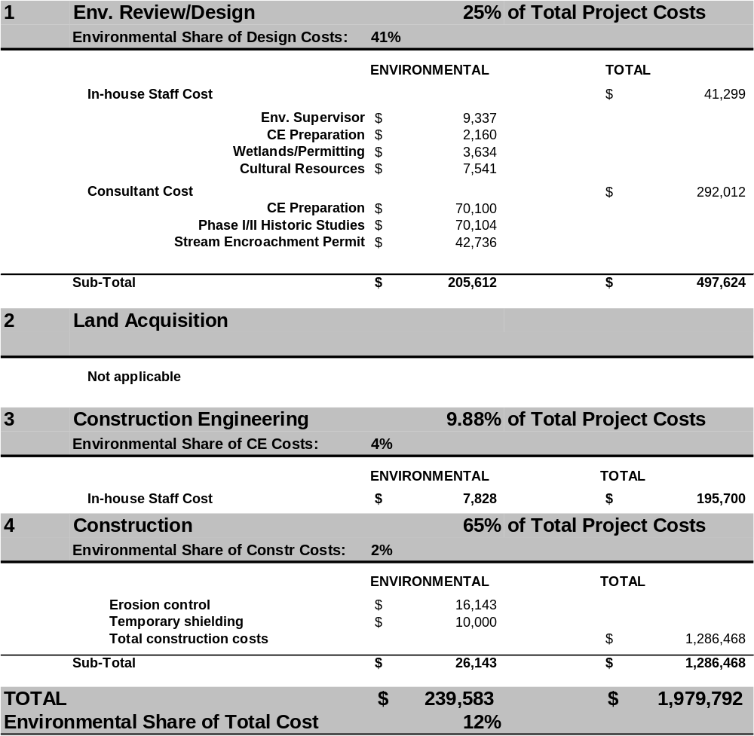

Bob Creek Bridge Replacement, Pacific Coast Highway, Oregon

Oregon’s two-lane Pacific Coast Highway (US 101) runs the length of the state’s Pacific coast. Within Oregon, it is one of two principal north/south intercity routes west of the Cascade Mountains. The entire route gives access to an area of great natural beauty and environmental sensitivity that generates many recreational trips and links several small communities along Oregon’s ocean coast. Highway US 101 is designated as a National Scenic Byway. The rugged topography of Oregon’s coastline, across which are scattered many stream valleys that run perpendicular to Highway US 101, necessitates frequent bridging of streams. The ocean coast and accessible streams provide habitat for naturally spawning populations of coho salmon, which has been proposed for listing as a threatened species under the ESA.
Roadway Type: Principal arterial - rural
Project Type: Bridge replacement on existing alignment
Total Project Cost: $1.7 Million
Environmental Cost: $166,000 (10%)
Project Duration: 2001 to 2004
Project Length: 0.3 miles
NEPA Document: Categorical Exclusion
Environmental Issues: Threatened & endangered species

The Bob Creek bridge on Highway US 101 is a two lane facility that serves a mix of local and through traffic, including frequent logging trucks. An adjacent stretch of Highway US 101 had an annual daily traffic of 19,925 vehicles in 2004. Prior to completion of the project, a three span bridge structure built in 1931 and supported by two columns crossed Bob Creek about 200 meters upstream from its confluence with the Pacific Ocean. The structure included one in-channel column that constrained Bob Creek. Land adjacent to the Bob Creek bridge replacement project is characterized by steep ocean-side bluffs within the Siuslaw National Forest and some private land parcels. Highway US 101 is classified as a rural principal arterial by the FHWA.

Project Purpose and Need

The purpose and need identified by ODOT for the Highway US 101 project was to address several structural problems in the 70 year old Bob Creek bridge including: 1) damage from ocean salt spray, 2) substandard bridge rail and approach guard rail, 3) a badly cracked approach pavement, and 4) scour damage to the bridge’s in-stream column footing.

Project Description

The project solution selected by ODOT through the NEPA process consisted of replacing the Bob Creek bridge with a new two-lane structure that is on the same alignment and meets current bridge standards. Rehabilitation of the bridge was rejected as a practical option because of its advanced state of deterioration. The new Bob Creek bridge structure is a single span bridge supported by two abutments and without any in-channel features. As part of the project, a temporary single-lane detour bridge was constructed and subsequently removed, without in-water work, immediately upstream of the existing bridge.

Environmental Issues of Concern

The Bob Creek bridge replacement project was processed under NEPA as a CE, which required only limited processing. A Section 106 (historic resources) phase 1 survey and a Section 7 (endangered species) Biological Assessment were completed during project planning to rule out any impacts to historic resources or threatened and endangered species. The environmental documentation for the Bob Creek bridge replacement project describes two major categories of environmental impacts that are regulated under Federal laws and that were considered a potential concern:

- Threatened and Endangered Species (Endangered Species Act (ESA), Section 7). Bob Creek supports an anadromous run of coho salmon, which are a proposed threatened species with proposed critical habitat. Critical habitat within Oregon is designated to include all river reaches and estuarine areas accessible to listed coho salmon and Federally funded actions must not destroy critical habitat.
The greatest impact from the project is associated with removal of in-channel portions of the old bridge, such as a column footing and protective riprap. This activity had a higher than negligible probability of affecting coho salmon and their habitat either through direct harm to fish or from an increase in stream turbidity. As a result, the contractor had to follow a special work plan that included use of sandbags to divert flow and other containment measures to minimize sediment contributions to Bob Creek. In addition, all in-water work was required to be completed between July 1 and September 15.

The new bridge enhances habitat for coho salmon because it has no in-channel features. The new single span structure was built using modern engineering techniques that were not feasible when the old bridge was constructed. This approach was more costly in terms of initial construction costs, but the total life cycle costs of the single span approach are less expensive since scour problems are eliminated and the life of the bridge is extended. Due to this overall structural benefit, no environmental costs are recorded. The approach would have been chosen without consideration of environmental issues.

- Archaeological Resources (NHPA, Section 106). Phase 1 archaeological investigations for the Bob Creek Bridge project revealed evidence of Native American artifacts in an area close to the project site. To avoid the potential archaeological site, construction of a two-lane temporary detour bridge that maintained traffic flow was ruled out. ODOT instead opted to construct a single-lane detour bridge immediately adjacent to the new bridge. A traffic control program allowed the bridge to be stage-constructed with 24 hour electronic signals to keep one traffic lane open at all times. This approach actually lowered overall project costs because only a single-lane detour bridge was required.

Overview of Environmental Costs

Design work for the Bob Creek bridge replacement project was completed in-house by ODOT staff, with consultant support for environmental investigations. A majority, 80 percent, of total environmental costs for the project were incurred during preliminary engineering, where about half of all environmental costs incurred were for studies of impacts to cultural resources and to threatened and endangered species. A small amount of costs were also incurred during construction primarily to protect habitat for coho salmon during removal of the old bridge. A qualitative discussion of environmental costs for the Bob Creek bridge project by project phase, starting with planning and ending with construction, follows:

Planning, Environmental Review and Final Design

During planning, environmental review, and final design, a combination of in-house and consultant costs were incurred for investigating environmental issues associated with the Bob Creek bridge replacement project. Key components of environmental-related preliminary engineering costs include:

- In-House Staff Costs – ODOT’s staff time was the main in-house cost at this phase and costs were principally incurred for oversight of: 1) a Section 106 Phase 1 study, and 2) a Section 7 Biological Assessment. Discrete estimates of the cost of each activity are readily available because staff at ODOT has developed methodologies for extracting such costs from their financial reporting system. Note that average fringe benefits and other indirect costs as well as direct labor costs system are all accounted for in the financial management system.
- Consultant Costs - The other principal environmental cost incurred during preliminary engineering for the Bob Creek bridge replacement project was for consultant support. Major environmental-related consultant activities in this phase included 1) a Section 106 Phase 1 study and 2) a Section 7 Biological Assessment.

Special Considerations – In contrast to some of the other case study states, ODOT was able to make an estimate of the amount of non-environmental staff time spent on environmental issues (and subsequent costs). This estimate, however, is based on a general formula for typical costs borne by non-environmental staff on similar projects and, therefore, it may not be completely accurate.

Land Acquisition

No additional land was required for the Bob Creek bridge replacement project because the project remained within the footprint of the old bridge.

Construction Engineering

In-house ODOT staff performed a construction engineering role on the Bob Creek bridge replacement project. All staff time is tracked by project charge number and activity code, therefore detailed information about environmental staff time and costs is readily available in ODOT’s financial management information system. As noted in the planning and environmental review section, ODOT was also able to make an estimate of the amount of non-environmental staff time spent on environmental issues during construction engineering. This estimate, however, is based on a general formula for typical costs borne by non-environmental staff on similar projects, and, therefore, it may not be completely accurate.

Construction

ODOT staff was able to identify all environmental costs incurred during construction of the Bob Creek bridge replacement project from the final project ledger, which codes unit costs by type. For this project, ODOT staff did not identify any unit costs that were only partly environmental-related. Major categories of environmental costs incurred during the construction phase of the Bob Creek bridge replacement project included:

- Erosion control
- Temporary scour holes
- Silt fence
- Permanent seed and mulch
- Temporary slope drains
- Temporary mulch
- Straw wattle sediment barrier
- Jute matting.
Costs provided for these actions include both materials and labor.

Special Considerations – In contrast to some of the other case study states, ODOT did not include a share of contractor mobilization in the environmental costs since total environmental costs in construction were so small.
Bob Creek Bridge, Oregon – Detailed Environmental Costs

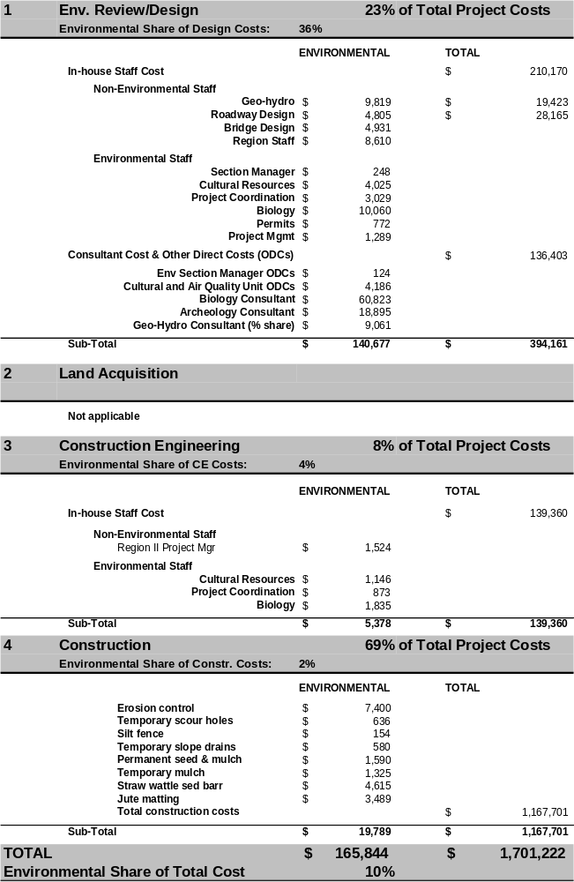

Highway 12300/12600 South Highway Widening, Utah

Riverton and Draper are two rapidly growing suburbs situated at the southern edge of the Salt Lake City metropolitan area on either side of I-15. The 12300/12600S highway connects Riverton and Draper and it is one of the primary east to west travel routes in the southern Salt Lake Valley. The corridor serves regional demand for access to I-15 and the Bangerter Expressway, which are the two major north/south corridors that connect Salt Lake City with fast growing suburbs to the south. The corridor also serves growing suburb-to-suburb travel.
Roadway Type: Principal arterial - urban
Project Type: Arterial widening/bridge replacement/interchange improvement
Total Project Cost: $132 Million
Environmental Cost: $2.4 Million (2%)
Project Duration: 1999 (EA begun) to 2005 (construction completed)
Project Length: 6.2 miles
NEPA Document: Environmental Assessment/ Section 4(f) Study
Environmental Issues: Cultural resources

12300/12600S is classified as an urban principal arterial by the FHWA. Land use along the corridor includes a mix of agricultural, commercial, rural residential, and low density urban residential development that is characteristic of a fast growing suburban area. The corridor includes a crossing of the Jordan River, which is an important natural resource within the region, and several historic properties. Before the widening project, most of the corridor consisted of one travel lane in either direction with no shoulders, curb lane, gutter, or sidewalks; traffic flow in the corridor was impeded by inadequate intersection design; a heavily used at-grade rail crossing; and a substandard interchange with I-15. The corridor also formed a barrier to the Jordan River Parkway Trail, which must cross the roadway.

Project Purpose and Need

The purpose and need identified by UDOT for the 12300/12600S project was to “increase the multi-modal capacity of the 12300/12600S corridor to alleviate existing congestion and to accommodate projected future travel demand along the corridor” (from final Environmental Assessment, prepared by UDOT/FHWA) via better accommodation of travel demand, improved corridor functionality, improved safety at signalized intersections, improved operations at the I-15 interchange, and enhanced opportunities for multi-modal transportation.

Project Description

The 12300/12600S project included the following roadway related improvements:

- Widen the corridor to a consistent cross section of two travel lanes in each direction with a center median and shoulders, curb and gutter, park strips, and sidewalks along a project length of 6.2 miles.
- Add bicycle lanes to the corridor, which entails a striped and signed lane on each side of a roadway for one-way bicycle travel.
- Replace the existing bridge across the Jordan River with a new, wider, and longer structure to accommodate the proposed roadway improvements and the Jordan River Parkway Trail.
- Upgrade the at-grade railroad crossing at the Union Pacific Railroad (UPRR) tracks to provide a new grade-separated crossing of the tracks over the roadway, which accommodates both freight and future commuter rail usage.
- Widen and improve many of the intersections along the corridor with dedicated right and left-turn lanes and upgraded traffic signals.
- Implement mountable raised center island medians at several locations along the corridor for access control and to improve safety and operations.
- Reconstruct the existing diamond interchange on I-15 at 12300 South to provide a more efficient interchange with increased capacity similar to the interchange at 9000 South.
- Accommodate bus service along the corridor by providing 3.0 meter (10 foot) shoulders for bus loading and unloading.

Since the project was completed as a design-build contract and many traditional cost categories established under a typical design-bid-build contract were not identified separately, some individual environmental cost items were estimated.

Environmental Issues of Concern

The 12300/12600S project was processed under NEPA as an EA because of the potential for significant environmental impacts associated with the project. At the conclusion of the EA, the FHWA made a Finding of No Significant Impacts (FONSI) determination. The EA for the project was completed in about two years (1999 to 2001). By definition, the EA-FONSI for the project describes no major categories of adverse environmental impacts, regulated under Federal laws. Minor issues highlighted in the EA that did contribute to environmental costs included:

- Cultural Resources (National Historic Preservation Act, Section 106). The 12300/12600S project had an impact on six historic properties, including a historic church and several historic houses. Most of the impacts involved minor land takings without harm to the structures; however, one structure was completely demolished to allow the project to proceed. A Memorandum of Agreement between UDOT, the FHWA, and state and local historic resources agencies laid out mitigation requirements for the impacts.

- Parklands (Section 4(f)). The project had minor impacts on parkland associated with the Jordan River Parkway. The widened river crossing required taking of 1.4 acres of parkland to construct a new bridge, but the project was also used as an opportunity to enhance the environmental quality of the Jordan River banks and to provide a grade separated connection for the Parkway trail.
- Noise Barriers. Noise walls were found to be a reasonable and feasible mitigation solution along two short stretches of the corridor where they were both practicable and a sufficient number of dwellings benefited to make them worth the expense.
- Wetlands (Clean Water Act, Section 404). The 12300/12600S project resulted in the loss of 2.27 acres of wetlands throughout the corridor. In coordination with U.S. Army Corps of Engineers, UDOT purchased a 15-acre mitigation site alongside the Jordan River, which serves as a combined mitigation site for several transportation projects underway in the region with 5 acres attributable to the 12300/12600S project.
- Hazardous Materials. One leaking underground storage tank located on property acquired for the project required clean up of petroleum contamination in accordance to UDOT standard specifications.

Overview of Environmental Costs

The design and construction work for the 12300/12600S project was completed by a single design/build team with oversight from UDOT staff. Environmental costs for the project totaled about $2.6 million or two percent of total project costs. About 65 percent of UDOT’s environmental costs associated with the 12300/12600S project were incurred during construction. A qualitative discussion of environmental costs by project phase, starting with planning and ending with construction, follows.

Planning, Environmental Review and Final Design

During planning, environmental review, and final design for the 12300/12600S project, a consultant was responsible for completing an Environmental Assessment, as well as several other environmental reports. Historic issues were a particular concern on this project, but according to UDOT engineers, no major elements of the project required changes to reduce environmental impacts. In-house staff costs were tracked in UDOT’s FINET system; however, unlike the financial management systems involved in the other case studies, UDOT’s system does not separate its environmental-related in-house staff costs, although such a system is now in development. By working directly with the project manager, UDOT was able to provide a reasonable estimate of in-house staff time required to oversee preparation of the EA and other tasks. Consultant cost records, which accounted for a majority of the costs during preliminary design on this design/build job, were readily available from contract records.

Land Acquisition

Some of the 12300/12600S project was built within UDOT’s existing right-of-way, however, new land was required to accommodate the wider cross section of the project. A small amount (5 acres) of total additional land acquired was used for environmental mitigation purposes. This fraction was used to allocate total right-of-way costs for staff and land acquisition that were reported for the project in UDOT’s FINET system. In addition, as part of a Section 106 memorandum of agreement, this project involved a $445,000 payment by UDOT to affected local governments and the State Historic Preservation Officer to address Section 106 impacts identified during the planning and environmental review phase. The funds were used to conduct compensatory activities.

Construction Engineering

Since the 12300/12600S project was structured as a design-build job, the contractor had additional responsibilities in the design process and accepted more of the risk for decisions. As with other phases, UDOT was able to identify all 12300/12600S project-related construction engineering costs in FINET. These costs were incurred for UDOT staff time spent to oversee contractors’ work and manage the project. The environmental component of construction engineering costs was estimated by UDOT staff to be about 10 percent of total construction engineering costs.

Construction

UDOT was able to identify environmental costs incurred during construction of the 12300/12600S project based on a combination of reviewing the project engineer’s estimate and discussing environmental costs with the project’s manager. Major categories of environmental costs incurred during the construction phase of the 12300/12600S project included:

- A small amount (about five acres) of offsite wetlands mitigation
- Dust control
- Noise walls
- Erosion and sediment control best management practices
- Hazardous materials clean-up.

Costs provided for these actions include both materials and labor.

In addition, UDOT constructed a longer bridge span as part of the project that spanned environmentally sensitive wetlands along the Jordan River. According to UDOT, the extra length of the bridge added 10 percent, or $130,000 to the total cost of the bridge.

12300/12600 South, Utah – Detailed Environmental Costs

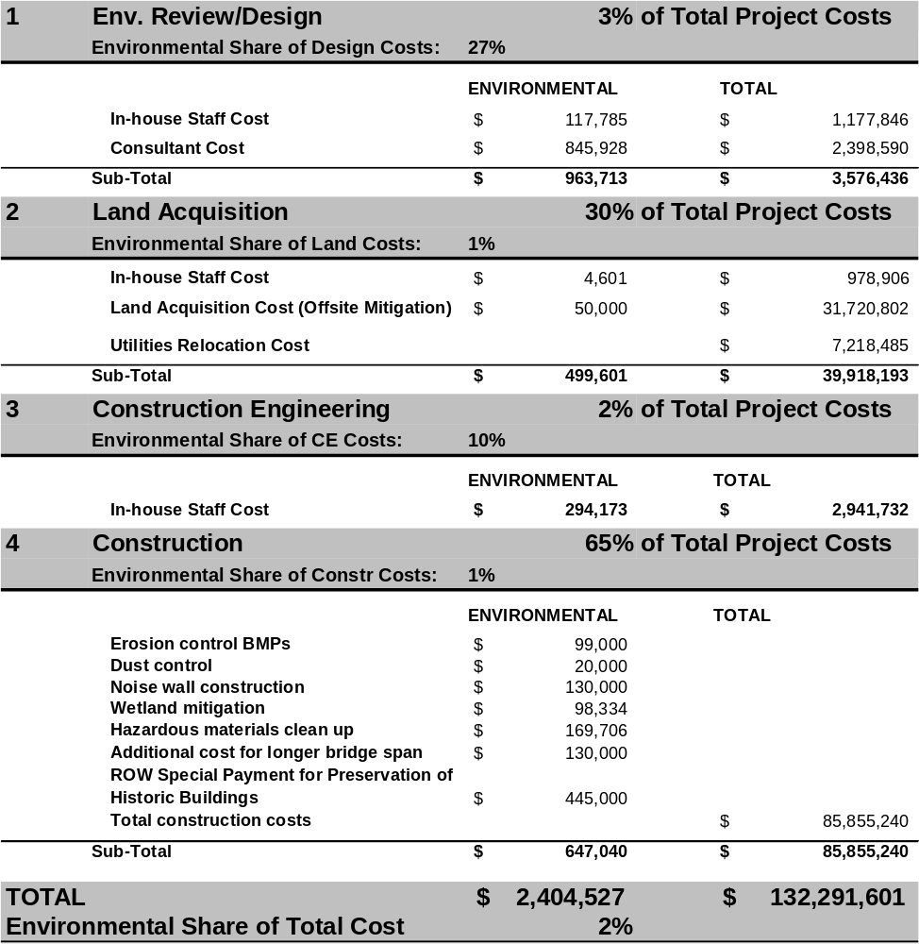

I-90 Sunset Way Interchange, Washington

The I-90 Sunset Way Interchange is located in the City of Issaquah and is part of the Mountains to Sound Greenway National Scenic Byway. The Sunset Way interchange serves Issaquah Highlands, a 2,200-acre development with homes, shops and offices. The City of Issaquah has a population of 17,000 and is a gateway to both Washington’s Cascade Mountains and the Seattle area’s I-90 business and transportation corridor. It is experiencing rapid growth with respect to both residents and jobs.
Roadway Type: Interstate
Project Type: Interchange replacement and modernization
Total Project Cost: $112.8 Million
Environmental Cost: $12.2 Million (11%)
Project Duration: 1996 (EIS begun) to 2003 (open to traffic)
Project Length: 1.5 miles
NEPA Document: EIS
Environmental Issues: Wetlands, stream restoration, stormwater runoff

Project Purpose and Need

The purpose and need identified by the participating agencies for the I-90 Sunset Way Interchange was to replace an antiquated Interstate interchange, reduce congestion on nearby city and county streets, improve safety, and enhance access to the Sammamish Plateau. Prior to completion of the project, the existing I-90 Sunset Way Interchange consisted of only an eastbound on-ramp and a westbound off-ramp; the need for improvements to the interchange had been discussed since the early 1980s. At the time the project was approved, the interchange was operating over-capacity and growth in future travel demand was expected to be significant, particularly in light of new development that already had been approved by the City of Issaquah. In addition, the two nearest interchanges (Front Street and SR 900) were experiencing significant congestion levels which could be relieved by expansion and modernization of the Sunset Way interchange.

Project Description

The I-90 Sunset Way Interchange project entailed replacing the existing eastbound and westbound ramps by constructing four new bridges (one post-tensioned cast-in-place bridge, two structural steel tub bridges, and one precast post-tensioned concrete tub bridge), new on-ramps and off-ramps, and a bicycle and pedestrian trail. The project also required construction of mechanically stabilized earth retaining walls and soldier pile walls, installation of stormwater treatment facilities, implementation of wetland mitigation strategies and stream restoration activities. Due to I-90’s designation as a National Scenic Byway and the strong advocacy of the Mountains to Sounds Greenway Trust, significant efforts were made to develop and implement context sensitive design solutions to maintain the natural aesthetics of the area.
The project was funded, designed and constructed through a partnership that included WSDOT, the FHWA, the City of Issaquah, King County, Sound Transit, the Transportation Improvement Board, Port Blakely Communities, and other state and Federal agencies. The design contract, which included development of the EIS, was overseen by the City of Issaquah, while WSDOT awarded and managed project construction. The Notice of Intent for the project was filed in March 1996 and construction began in summer 2001. Project construction was completed in two years, and the new facility was opened to traffic on August 29, 2003.

Environmental Issues of Concern

The I-90 Sunset Way Interchange project was processed under NEPA as an EIS because of the significant environmental impacts associated with the project. The Final EIS describes several categories of significant adverse environmental impacts, regulated under Federal laws, including:

- Stormwater Runoff – The Sunset Way interchange project created 12.84 acres of new impervious highway surfaces located both in hilly terrain and within the Puget Sound drainage basin. In addition, the project site included a portion of the East Fork Issaquah Creek, and the new facility is adjacent to Lake Sammamish. To address runoff concerns, two sets of stormwater ponds were constructed – the Front Street Ponds with a capacity of 201,590 cubic feet and the Sunset Way Ponds with a capacity of 21,070 cubic feet. Due to a city ordinance requiring new projects to return stormwater runoff to the aquifer, the pond facilities included significant investment in design and equipment to facilitate greater infiltration.
- Stream Restoration – The East Fork Issaquah Creek runs though the project area and its riparian areas were disturbed by construction activities. The creek also is a spawning ground for endangered chinook salmon and a habitat for sockeye salmon. To restore the creek to a natural environment, the project sponsors established in-stream fish habitat structures, built a series of weirs to modify the slope of the channel bottom, and constructed 500 feet of bio-stabilized creek bank. This work could only be completed in a dry creek bed, so creek water was temporarily rerouted by pipe until the construction could be completed.
- Sediment Control – Soil in the I-90 Sunset Way Interchange area is fine and silty, making it difficult to clean construction-related runoff from soil boring activities. To protect the East Fork Issaquah Creek from potential sediment impacts, WSDOT installed a sand filtration system, stormwater ponds, a continuous pumping system, and a series of check dams.
- Wetlands – The I-90 Sunset Way Interchange project affected 0.15 acres of wetland areas and 1.40 acres of wetland buffer area. To mitigate these impacts, the project sponsors created 0.3 acres of replacement wetland areas, made wetland enhancements to another 0.17 acres, and implemented 1.4 acres of buffer enhancement.

Overview of Environmental Costs

WSDOT is one of the few state DOTs that has tried to estimate the full costs of environmental compliance for selected projects through an initiative entitled Project Mitigation Cost Case Studies. While the department does not actively track environmental-related staff costs for non-environmental personnel, the costs developed for the case studies reflect a significant level of effort by the WSDOT Project Manager and a special project team to go back and allocate project costs for environmental and non-environmental purposes based on actual project costs, as opposed to bid items or engineer’s estimates. The I-90 Sunset Way Interchange project was one of 14 projects selected by WSDOT as environmental mitigation cost case studies.

A majority of the design and all construction work for the I-90 Sunset Way Interchange was completed by consultants and contractors. The design contract, including EIS development was managed by the City of Issaquah, while WSDOT awarded and managed the construction contract. A large percentage of the project’s environmental costs were associated with design and right-of-way acquisition activities, primarily related to the stormwater treatment facilities and offsite wetlands mitigation. Costs for temporary erosion and sediment control during construction also were significant. A qualitative discussion of environmental costs by project phase, starting with planning and ending with construction, follows.

Planning, Environmental Review and Final Design

The I-90 Sunset Way Interchange project included significant in-house and consultant costs associated with planning, environmental review and final design costs. The total costs for environmental-related activities and the specific costs for individual environmental activities are difficult to gauge because 1) the contract with the pre-construction consultant did not break out specific costs for addressing discreet environmental activities, and 2) WSDOT’s mechanisms for reporting preliminary engineering-related staff time on projects do not separate “environmental” preliminary engineering costs for non-environmental staff from the cost of their other preliminary engineering activities. As such, the costs for consultant and in-house environmental-related preliminary engineering activities are estimates based on the professional judgment and experience of the WSDOT project manager. Key components of costs included:

- In-House Staff Costs – WSDOT’s staff time was the main in-house cost at this phase and costs were principally incurred for oversight of: 1) EIS preparation by a consultant, 2) permit acquisition by a consultant, 3) design of stormwater treatment strategies and facilities by a consultant, 4) development of wetland delineation and mitigation plans by a consultant, and 5) development of stream restoration plans and; 6) creation of erosion and sediment control strategies. This oversight role included considerable interaction with other local governments, state and Federal resource agencies, and stakeholder groups to reach agreement over how to handle sensitive environmental issues.

- Consultant Costs - The other principal environmental cost incurred during preliminary engineering for the I-90 Sunset Way Interchange project was for consultant support. Major environmental-related consultant activities in this phase included 1) EIS preparation by a consultant, 2) permit acquisition by a consultant, 3) design of stormwater treatment strategies and facilities by a consultant, 4) development of wetland delineation and mitigation plans by a consultant, and 5) development stream restoration plans; and 6) creation of erosion and sediment control strategies.

Land Acquisition

A portion of the I-90 Sunset Way Interchange was built within existing WSDOT right-of-way, but new land was required to accommodate additional ramps and roadway, and to address environmental mitigation requirements. WSDOT completed all land acquisition using in-house staff. An estimated 1.5 acres of additional land was required for stormwater facilities. An additional 1.87 acres of land was acquired offsite to mitigate for wetland impacts.

Construction Engineering

In-house WSDOT staff performed the construction engineering role on the I-90 Sunset Way Interchange project. All staff time is tracked by project charge number and activity code, but specific codes do not exist for environmental work; therefore, construction engineering costs related to environmental activities are based on the professional judgment and expertise of the WSDOT project manager. For this project, 4 percent of total construction engineering costs were allocated to environmental activities.

Construction

As part of the research and analysis of the I-90 Sunset Way Interchange completed for the Project Mitigation Cost Case Studies, WSDOT was able to identify environmental-related costs incurred during construction based on expenditures (i.e., actual cash outlays to contractors) for the project. These costs include both unit costs that are exclusively environmental-related and those that had to be apportioned to environmental and non-environmental categories based on best professional judgment. Major categories of environmental costs incurred during the construction phase of the I-90 Sunset Way Interchange project included:

- Stormwater treatment
- Offsite wetlands mitigation
- Stream restoration
- Erosion and sediment control
- Share of overall mobilization (incorporated into each environmental activity cost estimate).

Costs provided for these actions include both materials and labor.

In some cases, state and local requirements in Washington go beyond Federal requirements. In particular, Washington requires that projects address stormwater runoff needs for both new and existing facilities associated with a project, and a City of Issaquah ordinance requires that runoff be reintroduced to the aquifer. While these added requirements may have added environmental mitigation costs to the project, it is not possible to allocate costs between Federal and non-Federal environmental requirements.
I-90 Sunset Way Interchange, Washington – Detailed Environmental Costs

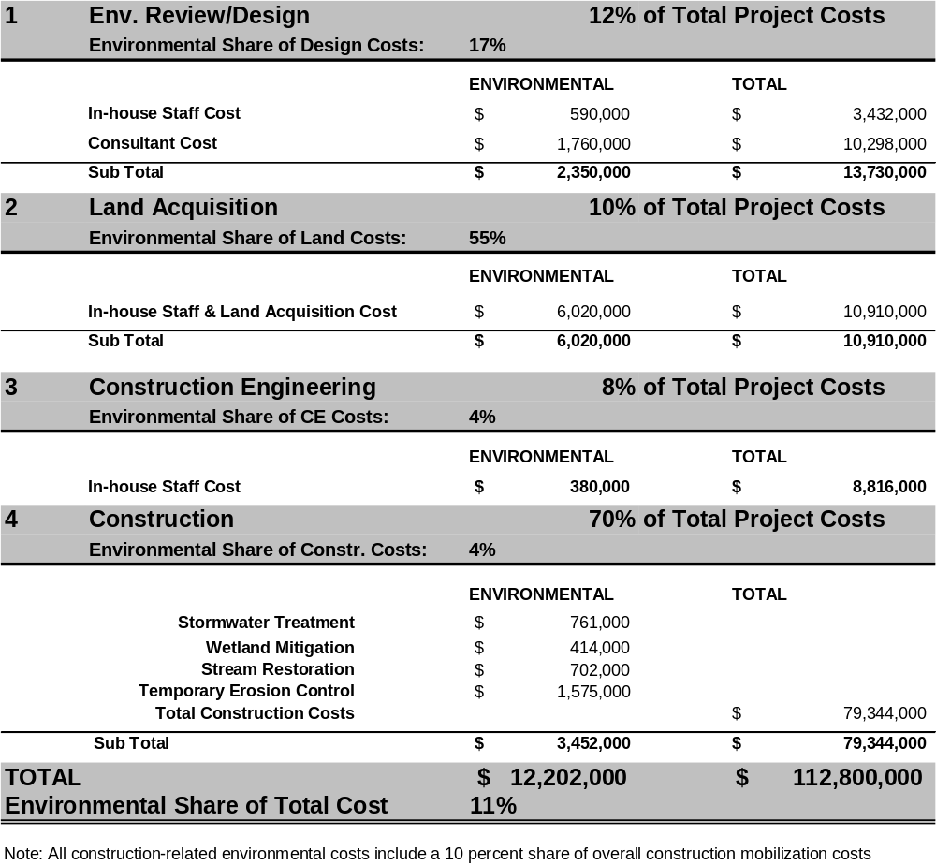

4.4. Case Study Observations

- Preconstruction costs – where most environmental “process” costs are incurred - are a small percent of total project costs. For the projects studied, preconstruction costs (design, right of way, and environmental) ranged from 16 percent of total project costs (Montana Highway 84) to 33 percent of total project costs (12300/12600 S, Utah). Construction accounts for a great majority of total costs on any project.
- Construction mitigation costs are a small percent of total construction costs. For the projects studied, construction mitigation costs ranged from 1 percent of total construction costs (12300/12600S, Utah) to 13 percent of total construction costs (US Highway 113, Maryland).
- Environmental costs for the case studies range from two to 12 percent of total project costs. Table 4.2 provides a summary of environmental costs for each of the case study projects. The share of environmental costs ranges from two percent up to 12 percent. On average, environmental costs are eight percent of total project costs for the projects studied.
- Environmental costs increase with project costs. For the projects studied, absolute environmental costs are lower on smaller projects and higher on larger projects. For the small projects studied, environmental costs for preconstruction activities outweighed environmental costs incurred during construction; the reverse was true for larger projects.
- Expenditures on stormwater, landscaping, and wetlands during construction are large environmental cost drivers. For the case study projects, the cost to construct stormwater management structures, replace wetlands, control erosion, and conduct landscaping have a much bigger impact on total project costs than staff and consultant time spent on project studies and construction engineering. For example, on Maryland’s US Highway 113, expenditures to prepare the EIS ($1,103,252) and oversee environmental issues during construction ($325,000) were only 6 percent of total environmental costs ($21,915,152) for the project and less than one percent of the total project costs of $181,125,760. Projects that do not require extensive wetlands mitigation and stormwater treatment, such as the Utah 12300/12600 S case study, feature much lower environmental costs.
- Environmental costs are a significant proportion of total preconstruction (excluding land acquisition) costs. Environmental costs are incurred during preconstruction for NEPA document preparation processes, other environmental studies and coordination with other resource agencies. They usually include a mix of in-house costs and consultant costs, which the case study state DOTs had little trouble identifying. Several DOTs had trouble identifying environmental costs attributable to non-environmental bureau staff or consultants but were confident these costs account for a small share of total environmental-related costs. Environment accounted for an average of 23 percent of total preconstruction costs for the case study projects.
- Environmental-related land acquisition costs vary among projects, but can be a significant cost driver. Environmental costs are not always incurred during the land acquisition phase of a project. Three out of the six case study projects involved no additional land acquisition associated with environmental requirements. Where additional land was required for the project, this appeared to add considerable costs that ranged from nine percent (US Highway 113, Maryland) to thirty percent of total project costs (12300/126000 S, Utah). The environmental components of those total project land acquisition costs in the Maryland and Utah case study projects were 14 percent and one percent, respectively, and were approximately one percent or less of total project costs. For all the case studies, however, methodologies for apportioning environmental-related land acquisition costs could be improved.
- Environmental costs during construction engineering are small. Environmental costs associated with construction engineering during the construction phase of a project are usually small compared to environmental costs associated with the other project activities during construction. The case study states are able to identify environmental staff time charged to the project during construction. They are also able to provide an approximate estimate of non-environmental staff time spent on environmental issues, such as erosion control. Environmental-related construction engineering costs averaged about 5 percent of total construction engineering across the case studies.
- Project design and construction changes can add costs, but are hard to measure. For five of the six case study projects, elements of project design and construction were altered in part to accommodate environmental issues. These changes sometimes reduce costs, but they can also increase costs:
  - Cost savings. In the Oregon case study, a one-lane temporary bridge was constructed instead of a two lane bridge to avoid impacts to cultural resources and Federal lands, which generated some cost savings. Likewise in the New Jersey case study, a simpler bridge design that involved replacement of the superstructure only was selected in part to avoid a complicated environmental process, but also to save overall construction costs and time.
  - Cost increases. In the Maryland, Montana, and Utah case studies, larger bridges or culverts were built to avoid sensitive wetlands, improve fish passage, and accommodate a bike trail respectively. In each of these cases, costs were added to the projects.
In each instance, estimates of costs associated with “the path not taken” are heavily reliant on professional judgment.
Table 4.2. Summary of Case Study Results
Overview |  |  |  | Detailed Breakdown
Project | Overall Costs |  |  | Environmental Review and Design |  |  | Land Acquisition |  |  | Construction Engineering |  |  | Construction
 | Environmental-Related Costs (000s) | Total Project Costs (000s) | % | Environmental-Related Costs (000s) | Total Env. Review/ Design Phase Costs (000s) | % | Environmental-Related Costs (000s) | Total Land Acquisition Phase Costs (000s) | % | Environmental-Related Costs (000s) | Total Construction Engineering Phase Costs (000s) | % | Environmental-Related Costs (000s) | Total Construction Phase Costs (000s) | %
US-113 (MD) | $21,915 | $181,126 | 12% | $1,103 | $14,455 | 8% | $2,264 | $15,680 | 14% | $325 | $6,300 | 5% | $18,223 | $144,690 | 13%
MT-84 (MT) | $282 | $10,291 | 3% | $44 | $452 | 10% | NA | NA | NA | $12 | $903 | 1% | $226 | $7,751 | 3%
Alexauken Bridge (NJ) | $240 | $1,980 | 12% | $206 | $498 | 41% | NA | NA | NA | $8 | $196 | 4% | $26 | $1,286 | 2%
Bob Creek Bridge (OR) | $166 | $1,701 | 10% | $141 | $394 | 36% | NA | NA | NA | $5 | $139 | 4% | $20 | $1,168 | 2%
12300/ 12600S (UT) | $2,405 | $132,292 | 2% | $964 | $3,576 | 27% | $500 | $39,918 | 1% | $294 | $2,942 | 10% | $647 | $85,855 | 1%
I-90 Sunset Way (WA) | $12,202 | $112,800 | 11% | $2,350 | $13,730 | 17% | $6,020 | $10,919 | 55% | $380 | $8,816 | 4% | $3,452 | $79,344 | 4%
Average |  |  | 8% |  |  | 23% |  |  | 18% |  |  | 5% |  |  | 4%

5.0 Conclusions and Recommendations

Conclusions

This study is the first attempt to report on state DOTs’ environmental costs at a national level. As such, the conclusions it makes should be considered a “work in progress;” but one that provides considerably more detailed and more reliable information than policy makers have received in the past. Conclusions are discussed in terms of responding to the Congressional request and observed findings from the study.

Responding to the Congressional Request. The study results provide information on environmental costs that is consistent with the request from Congress. The original request from the House Appropriations Subcommittee on Transportation, Treasury, Housing, and Urban Development, the Judiciary, District of Columbia, and Independent Agencies requested the FHWA:

“to determine the costs associated with the environmental process on a representative sample of projects. Analysis should include information on environmental costs associated with the project itself, such as wetlands mitigation and 4(f); costs associated with preparing the document; and other related costs associated with the time it takes to complete the environmental process.”

- “Costs associated with the environmental process.” Chapter two of the study defines costs associated with the “environmental process” to include “compensatory costs” associated with preparing for and undertaking actions to make up for unavoidable environmental impacts, and “avoidance costs” associated with evading environmental impacts by not taking an action, or parts of an action, or by limiting its magnitude. This definition is used throughout the study to estimate environmental costs. See chapter two for a detailed discussion on the types of costs associated with the environmental process.
- “A representative sample of projects.” The study features six case study, or sample, projects that were carefully selected to represent diverse geographic locations, urban and rural settings, a mix of common project types, a range of NEPA documentation requirements, an array of types of environmental impacts, and “middle-of-the-road” project costs that are typical of projects that DOTs must handle on a regular basis. See the introduction and the start of chapter four for more discussion of the criteria by which case study projects were selected.
- Environmental “costs associated with the project itself.” For each of the case studies, full estimates of the cost of any physical mitigation required, such as for wetlands and 4(f) are provided. See the case study results in chapter four for more detail.
- Environmental “costs associated with preparing the document.” For each of the case studies, detailed estimates of the cost of any preconstruction activities associated with preparation of the NEPA document are provided. See the case study results in chapter four for more detail.
- “Related costs associated with the time it takes to complete the environmental process.” For each of the case studies, detailed estimates of other related costs such as mobilization of construction contractors, or DOT staff construction engineering costs are provided. As noted in chapter two, estimates of costs associated with delay caused by environmental issues were not estimated. None of the states interviewed expressed concern about major delays associated with the projects profiled; furthermore, available methods for estimating costs associated with delay and apportioning all or some of those costs to environmental factors are understood to be weak.
Findings from the Study. Environmental costs are measurable; for a typical DOT project they are likely to be in the range of two to 12 percent of total project costs, which for most states is likely to add up to millions of dollars in environmental expenditures each year. Some of this cost is for NEPA documentation and other “process” costs. The case studies suggest, however, that a large share of environmental costs is likely to be for construction of stormwater facilities, mitigation of wetland losses, erosion control, and landscaping. Key conclusions from the study include:

- State DOTs are investing more in environmental stewardship and streamlining but its effect on project-level costs is unclear. In qualitative terms, all the case study states say they continue to undertake efforts to improve their stewardship of the environment. A consensus emerged across participants in the interviews that DOTs now conduct many environmental responsibilities as the “right thing to do” and therefore at least some environmental costs would be incurred on projects regardless of environmental laws. All the case study states also indicate they are undertaking efforts to streamline their environmental activities and that this is helping expedite project schedules. The US-113 project in Maryland and the Alexauken Bridge project in New Jersey are both recognized nationally as “streamlined” projects; however, practitioners in these states were not willing to estimate absolute cost savings on these projects.
- Only a handful of state DOTs currently measure environmental costs. The states identified in this study, including Montana, Oregon, Washington, and Wisconsin, are among a small handful that have attempted to develop comprehensive estimates of their environmental costs. The state-of-the-practice for defining and measuring environmental costs has clear deficiencies that are likely to be addressed over time as DOTs enhance their approaches for measuring costs.
- Environmental costs include compensatory costs and avoidance costs. According to practitioners, a comprehensive definition of environmental costs incurred during delivery of transportation projects should include “compensatory costs” associated with preparing for and undertaking actions to make up for unavoidable environmental impacts, and “avoidance costs” associated with evading environmental impacts by not taking an action, or parts of an action, or by limiting its magnitude.
- Comprehensive estimates of environmental costs should include all phases of project delivery. A DOT incurs environmental costs throughout the lifespan of a project, including planning, environmental review, design, land acquisition, and construction. Cost tracking efforts should account for each phase.
- Not all environmental costs are easily identifiable. Some environmental costs are clear cut, such as NEPA document preparation costs or the cost of a longer bridge to avoid a wetland. Other environmental costs may be harder to identify. A more costly project solution, for example, may yield both engineering and environmental benefits. The bridge constructed in the Oregon, Bob Creek Bridge Case Study was more costly because it avoided in-water piers but this solution minimized environmental impacts to salmon habitat. The same solution also avoided bridge scour problems that would otherwise shorten the bridge’s lifespan and increase maintenance costs.
- Practical constraints limit many DOTs’ ability to track environmental costs. The process of developing the case studies reveals that many DOTs face significant hurdles to developing environmental cost tracking methods. A primary constraint for many states is the lack of project-level environmental activity codes that support tracking of in-house and consultant costs. Other constraints include difficulty in collecting and analyzing land acquisition data, and the increased use of design-build contracting, which often limits the amount of environmental cost data available to DOTs.
- Environmental cost tracking is labor intensive, particularly at the outset but has many benefits. DOTs that are measuring environmental costs report that it is labor intensive, and some practitioners question the relative cost to benefit ratio for tracking environmental costs. Once methodologies are in place, however, DOTs that measure costs find that they are able to use the information to resolve policy questions, improve project decision-making, and increase accountability to stakeholders.

Recommendations

The study conclusions provide the basis for several general recommendations on next steps that may be appropriate, these include:

- More dialogue with state DOTs on the value of environmental cost tracking. The study found that states that track environmental costs see the information as beneficial, but it also found that environmental cost tracking is potentially complex and time consuming. More discussion with state DOTs is needed to help determine whether additional efforts should be pursued.
- Develop additional case studies and refine and enhance cost tracking methods. If cooperating states can be identified, additional case studies could be conducted with ease using the methods established in this study. A larger data set would provide stronger support for drawing conclusions that guide policymaking on this issue. Additional case studies could also be used to refine and enhance methods and approaches used in this study.
- Technical assistance for state DOTs on environmental cost tracking methods. Based on the outcomes of dialogue with state DOTs and efforts to improve and enhance methods for tracking environmental costs, provide state DOTs with technical assistance such as training or guidance documents.

Appendix A

State-by-State Interview Reports

Interview Contacts

Arizona DOT

Melissa Maiefski

Florida DOT

Larry Barfield
Josh Boan
Buddy Cunill
Carolyn Ismart
Carl McMurray

Kentucky Transportation Cabinet
Mike Hancock
John Metille

Maryland SHA

Susan Ridenour
Rob Shreeve
Josh Nelson

Montana DOT

Zia Kazimi
Vicki Murphy
Mark Wissinger

Oregon DOT

Lorraine Butler
Frannie Brindle
Donna Kilber
Kate Poole

Utah DOT

Brent Jensen
Reed Soper

Washington DOT

Ken Smith

Wisconsin DOT

Dan Scudder
Shar TeBeest

Arizona DOT

Background. Arizona DOT’s Environmental and Enhancement Group (EEG) has a limited but expanding capacity to track some environmental mitigation costs incurred by the agency during project delivery. The focus of ADOT’s efforts at present is on collection of cost data for biological resource documentation and mitigation as part of a broader environmental project management tool. Cost tracking in other environmental areas is sporadic. The general approach ADOT uses to track biology-related costs, however, appears applicable to other environmental resources for which ADOT has responsibility. ADOT’s new environmental cost tracking system has great potential as a project management and cost measurement tool. When fully implemented, ADOT staff will have the ability to examine actual environmental mitigation costs by resource type (e.g. endangered species, wetlands) for individual projects as they are incurred and they will have a detailed database of historic environmental mitigation costs. The system also will have broader project management benefits, such as improved project-by-project tracking of consultant activities.

Motivation for Cost Measurement. Impacts to biological resources are often a concern for transportation projects in Arizona, where a rapidly growing population and an expanding transportation program necessitate considerable efforts to preserve the State’s unique ecosystems. ADOT staff explains the primary motivation for developing its cost tracking capabilities has been to enable accurate responses to regular questions from sources outside the agency, including legislators and Federal agencies, about expenditures for mitigation of impacts to threatened and endangered species. ADOT does not publish costs data, but it is available on request.

Tracking Systems. ADOT’s biological costs tracking effort is part of a broader electronic environmental information management system that is maintained by EEG staff and was developed by in-house ADOT information technology support staff. Running on a Microsoft Standard Query Language (SQL) platform, the database enables staff to efficiently track every element of the NEPA process on a project-by-project basis from their PCs. Information in the system is easily navigable and is updated on a regular basis. ADOT environmental staff uses the database for a range of functions such as tracking project staffing and workloads, monitoring important environmental study milestones, analyzing key concerns, and reporting the current status of individual projects for each specialty (e.g. air, water, and hazardous materials).

ADOT began its efforts to track biological costs on a comprehensive basis in 2003. Almost all ADOT’s biological mitigation costs are linked to use of consultants and contractors whose work includes biology documentation and any specific actions required as a result of studies. Almost all (about 90 percent) biology-related work is conducted by one of ADOT’s pre-approved, on call consultants. Biological costs are broken into the following fields, based on information collected from these consultants on a project-by-project basis:

- Biological Documentation Cost: This includes pre-construction activities such as coordination with agencies, review of relevant literature, field studies, and preparation of reports. Cost information is collected from consultant task order documentation, which includes detailed standards for reporting hours and costs by activity type that enable costs to be broken out. (See a sample in Table A-1.)
- Bio-Mitigation Cost, Pre-Construction: This includes mitigation efforts required before construction begins, such as species surveys, or exclusionary netting on bridges. Cost information is collected from consultant task order documentation.
- Bio-Mitigation Cost, Construction: This includes mitigation conducted during construction. Cost information is collected from ADOT project managers who generally provide numbers based on bid item documentation.
Table A-1. Arizona DOT: Sample Consultant Task Order Hours and Cost Report
Breakdown of cost items for: Coronado Trail Switchbacks Rubble Retaining Walls
(TRACS Number: 191 GE 175 H6744 01E)
 | Cost | Hours |  | Cost | Hours
Task Management | $6,295 | 89 | Section 404 | $122 | 2
Cultural Resources | $25,796 | 438 | Land Use | $61 | 1
Biology Resources | $2,741 | 44 | Air Quality | $61 | 1
Biology Mitigation | $0 | 0 | Noise | $61 | 1
Floodplains | $61 | 1 | Hazmat | $467 | 7
Public Involvement | $0 | 0 | Socioeconomic | $183 | 3
Visual Impacts | $61 | 1 | Farmlands | $0 | 0
Scenic Rivers | $0 | 0 | Aquifer | $0 | 0
Construction Impacts | $422 | 6 | Utility Impacts | $61 | 1
AZPDES | $61 | 1 | Data Recovery | $0 | 0
Public/Agency | $2,206 | 35 | General Action | $5,718 | 82

Using the database, ADOT staff can report biology-related mitigation costs program-wide, project-by-project, or even species by species. Not included in EEG’s database is in-house staff time, however, this information is tracked via bi-weekly employee timesheets that use 40 environmental codes. EEG has not made an attempt to integrate staff time costs with the consultant and contractor cost tracking capabilities of the database. Staff perceives that staff costs are a small share of total biological costs borne by ADOT and that the effort required to track this information would exceed the value of having it.

State Funded Projects and Mitigation Requirements. Arizona’s state environmental laws are not as broad ranging as Federal environmental laws. ADOT does conduct some projects with state funds only, but it uses the same environmental procedures regardless of funding sources. (An exception is the Section 4(f) process, which is by-passed if state funding is used.) Staff cite several reasons for following Federal-style procedures including the presence of Federal lands throughout Arizona, which necessitates Federal participation in decision-making, and the clarity that Federal regulations assure for working with affected stakeholders and resource agencies.

Environmental Requirements and Project Scope. ADOT staff provided two examples of projects where scopes were scaled back to accommodate environmental concerns:

- Organ Pipe National Monument – The project footprint of a scenic road improvement was reduced by reducing the number of rest areas from three to two, which reduced project costs.
- Highway 82 (Bridge Replacement), Santa Cruz, Arizona – The original detour during bridge construction ran through a dry river bed, however, environmental concerns led to a solution that maintained traffic on the bridge during construction. This solution was also cheaper than building the detour would have been.

Florida DOT

Background. Environmental cost measurement is a lower priority at Florida DOT than it is at any of the other DOTs that participated in this study. Staff at FDOT describes a decentralized organization where practices for collecting information such as environmental costs vary from district to district. FDOT staff provided helpful perspectives on the challenges and value of measuring environmental costs.

Motivation for Cost Measurement. Florida DOT reports limited internal or external motivation for greater measurement of environmental costs.

Tracking Systems. Florida DOT has no comprehensive environmental cost measurement system. The Department tracks selected environmental costs on a regular basis:

- Biology. Since 2001, consultant costs associated with determination of endangered species impacts and any required mitigation have been reported annually to the FHWA. Data is broken out by species using a format requested by the FHWA. In-house staff costs are not tracked. Data for this report is collected from District staff by an e-mail survey
- Wetlands – Since 1997, the Department has tracked annual in-lieu fee costs paid to the State’s wetlands agency for wetlands mitigation. For 85 to 90 percent of wetlands affected by transportation projects, FDOT pays a flat in-lieu fee of $90,000 per acre to the appropriate Water Management District in Florida. Districts coordinate closely with Water Management Districts that are responsible for conducting wetland restoration either on-site or at a bank and maintaining wetlands. FDOT views this approach favorably because it enables a holistic wetland mitigation efforts that ensure best value is achieved for funds spent by considering long-term, watershed implications. Cost data is easily collected for these payments. Remaining wetland impacts (primarily for saltwater wetlands) are mitigated by FDOT and its contractors, but no comprehensive cost tracking exists for these efforts.
Florida DOT has not considered a broader effort to identify in-house staff costs, consultant costs, or construction contractor costs associated with environmental mitigation. Environmental and permitting staff use unique time codes, so their time could easily be identified, but tracking environmental-related time for design engineers or construction engineers would be difficult. Consultant costs are tracked, but environmental costs are not broken out. Florida DOT expressed great concern about the amount of time required to extract environmental cost data from contractor costs. They indicated it would probably be possible on a project-by-project basis using bid item lists or pay item data.

Florida DOT was skeptical about the ability to accurately compare the cost of avoided alternatives to the selected alternative. Staff also questioned whether additional costs could be fairly attributed to environmental requirements, since many factors often influence the selection of a preferred alternative.

Kentucky Transportation Cabinet

Background. In the last several years, Kentucky Transportation Cabinet (KTC) has undergone a significant transformation in its commitment to environmental stewardship. Efforts such as the agency’s innovative “Communicate All Promises” program to ensure all environmental commitments are kept, and its nationally recognized Context Sensitive Solutions initiative are making the agency much more sensitive to environmental considerations. As part of this philosophy, KTC acknowledges it also must practice responsible management of environmental costs. The agency emphasizes strongly that while work is underway in this area, staff understanding of environmental costs has yet to reach maturity. Given the infancy of KTC’s efforts, this interview was most valuable in providing the perspectives of a practitioner at the outset of measuring environmental costs.

Motivation for Cost Measurement. KTC would like to be able to improve its project cost estimates, understand how costs are changing over time, and demonstrate responsible cost management practices. One use for cost information cited by KTC is “benchmark” costs for typical environmental activities that can be used in project development.

Cost Tracking Systems. KTC does not have a comprehensive tracking system in place, but the agency recently undertook an internal review of all 2000 to 2005 environmental costs. The study focused on basic compensatory costs and did not include consideration of many avoidance costs. The agency has chosen not to make the results of its study public, however staff indicated that although costs appear to be steady over time, archaeology costs in particular are a major issue. In Spring 2005, KTC introduced 22 new activity codes for use by environmental staff and a comparable set of 22 codes for tracking consultant activity (See Table A-2) that are expected to improve the Agency’s cost tracking capabilities. Specific comments from KTC about environmental costs incurred during project development include:

- Planning. Some environmental costs are incurred during planning, but these numbers were not included in KTC’s study. A limited Environmental Overview may be prepared for some projects. It usually includes brief field reviews to “raise a flag over showstopper issues.”
- Preliminary Engineering. This includes NEPA document preparation, which may be done in-house, but is often done by consultants. In-house staff time spent on NEPA documents or review of consultants’ work is not tracked, but consultant costs could be tracked. Sub-contractors on a design team often conduct environmental work, but work scopes include costs for environmental components.
- Final Design. A few environmental costs may be incurred at this phase, but not many according to KTC staff.
- Right-of-Way Acquisition. Additional right of way may be required for wetlands and stormwater treatment facilities. Costs include staff time for negotiations as well as land costs.
- In-Lieu Fees. KTC pays an in-lieu fee to the Kentucky Department of Natural Resources for wetland and stream mitigation.
- Construction. Some bid items are unique and clearly environmental such as noise walls, but others such as earth moving may include an environmental component. KTC has no methodology for determining environmental costs in this instance.
KTC believes that avoidance costs are not easily estimated.
Table A-2. KTC Staff and Consultant Activity Codes
Adv. stream mitigation dev. | Env. project manager | Permitting
Adv. wetland mitigation dev. | Facilities | Permitting in-lieu fees
Air quality | General geological | Permitting mitigation
Aquatic ecology | Historic | Socioeconomic
Aquatic mitigation | Historic mitigation | Socioeconomic mitigation
Archaeology | Noise | Terrestrial ecology
Archaeology mitigation | Noise mitigation | Terrestrial mitigation
 |  | UST/HZM

Maryland SHA

Background. Maryland State Highway Administration (SHA) has a decade long track record of collecting selected environmental cost information for internal use to strengthen project cost estimating procedures. Typically, this information is used on an ad-hoc basis by individual project engineers during the design phase. The agency has not, however, routinely used this information to prepare comprehensive estimates of environmental costs.

Maryland SHA estimates that most of its environmental costs are incurred for mitigation related to reforestation (a state-level requirement), stormwater, wetlands, stream restoration, noise walls, and historic and cultural resources. Staff indicates that comprehensive project-level measurement of environmental
costs could be achieved via careful review of existing systems, but would be extremely labor intensive without a major overhaul of the way cost information is collected.

Motivation for Cost Measurement. SHA’s primary motivation for environmental cost measurement is internally driven. SHA uses environmental cost data from old projects to help develop estimates of environmental costs for new projects. Project managers, however, use past data only as a guide to projecting new project costs, since every project is different. This use of cost data occurs on an informal basis, with project managers self-selecting comparative projects and reviewing any data independently. Unlike WSDOT and ODOT, Maryland SHA has not received strong external pressure to provide accounting for its environmental costs.

Cost Tracking Systems. All SHA staff time and pre-construction consultant activities are tracked using SHA’s Financial Management Information System (FMIS). This system assigns a specific alphanumeric code to each project and consultants and in-house staff use project-specific charge codes for different activities. A single EIS document, however, may subsequently be designed and constructed in several phases each with an independent project code. As a result, FMIS data may not provide a straightforward way to track total environmental costs for a project. SHA does not use FMIS data for review of environmental costs.

At SHA, most mitigation activities such as wetland restoration, noise walls, and stream restoration almost always are designed and constructed out under separate contracts from overall design and construction, which ensures data is easily available. By contrast, stormwater and erosion control features are usually conducted as part of overall project design and construction and are therefore harder to track separately.

During construction, Maryland SHA employs environmental inspectors to monitor environmental components of construction.

State Funded Projects and Mitigation Requirements. In Maryland, few if any environmental costs can be avoided by using only state funds on projects. Maryland’s state environmental regulations closely mirror Federal regulations. For example, the Maryland Environmental Protection Act is the same as NEPA. Maryland’s water quality, reforestation, and endangered species requirements are more stringent than Federal regulations.

Environmental Requirements and Project Scope. Maryland SHA staff is skeptical that project costs are ever reduced as a result of environmental regulations, except in instances where a project is not pursued. SHA staff interviewed could identify no examples of scope reductions with cost savings. As an example, staff described a project where the footprint was narrower, but since the median was eliminated crash barriers and other safety devices added to the project costs.

Oregon DOT

Background. Oregon DOT is the only state DOT interviewed that prepares a comprehensive annual estimate of its environmental costs. Since 1999, Oregon DOT has been required by state statute (Oregon Revised Statutes 184.666) to estimate the cost incurred in response to new mandates and legislation relating to environmental concerns:

“The Department shall develop a summary that shows, to the extent it can be determined, how the department’s costs for maintenance, preservation, and modernization are affected by state and Federal mandates, environmental regulations, or other factors that have a significant impact on cost.”

ODOT estimates that 70 mandates, laws, regulations, and ordinances affect its environmental compliance costs. (47 Federal, 22 state, 1 local) For fiscal year 2004, the Department spent $33.0 million on environmental compliance activities, or 4.8 percent of ODOT’s budget for its Transportation Operations Division and Transportation Development Division combined. Biology, wetlands and water quality account for more than half ODOT’s environmental costs.

Motivation for Cost Measurement. ODOT has responded to legislative pressure as an opportunity to account for the costs of all environmental regulations.

Cost Tracking Systems. Oregon DOT has developed detailed methodologies for measuring costs on a program level. Some costs are derived from actual costs as reported in ODOT’s financial accounting systems, such as costs of personnel engaged wholly in environmental compliance. Other costs are estimated based on past experience, such as environmental costs for personnel engaged in a primary activity such as design, where the response to environmental mandates is diffused within the overall work effort. Specific elements of ODOT’s cost tracking methodology include:

- Planning Costs. Budget allocations for activities that address environmental mandates are identified, then a level of effort applicable to the mandate is estimated and finally calculated against the budget for the appropriate activity.

- Preliminary Engineering/Environmental Costs. This is largely a summary of actual costs because all environmental personnel are engaged full time in applying environmental mandates. Since environmental staff is also specialized, there is a very good match between costs and each category, such as wetlands.

- Right-of-Way Costs. The largest cost factor in right of way is the purchase of property for mitigation sites, usually for wetlands and noise walls. These are actual costs. In addition there are some estimated costs that relate to personnel costs.

- Design Costs. Differentiating design work between normal design and design for environmental mandates is very difficult. Managers were asked to estimate the percentage of time spent by their crews on environmental design issues. This percentage was then applied against the aggregate personnel costs expended by each design unit. For some design functions, namely those dealing with water quality, erosion control, and hydraulic design, the costs were more directly discernable.

- Construction. Environmental cost items are most readily discernable in the bid items rather than the progress payments. The item is accounted for in the year that it is bid. This cost grouping experiences significant variability year to year.

- Maintenance. There are some maintenance personnel assigned to environmental issues where true costs could be captured. There are also some activities that are tracked on a true cost basis. However, some costs are estimates and include labor, equipment, supplies and services as well as contract work. Maintenance activities are not performed at the same level, consistently, year after year. This is primarily due to weather influences such as flooding, severe snow, etc. The applicability of environmental requirements varies throughout the state resulting in environmental costs varying from maintenance district to maintenance district.

ODOT does not report what it calls “indirect costs,” such as the cost of providing a small bridge rather than a culvert to enable fish passage, that vary with each individual situation. Nor does the Department calculate costs or savings due to avoidance of impacts to resources calculated. These types of costs and savings, according to ODOT staff, lie in the realm of the “road not taken” and are extremely subjective to measure and arguable as to outcome.

State Funded Projects and Mitigation Requirements. In Oregon, as with several other states interviewed, few if any environmental costs can be avoided by using only state funds on projects. Oregon’s state environmental regulations closely mirror or even exceed Federal regulations.

Environmental Requirements and Project Scope. ODOT staff were unwilling to speculate about whether environmental requirements might reduce a project’s scope without a detailed review of projects. They noted that in general, “the path not taken” is highly subjective and almost impossible to quantify in terms of either added costs or savings.

Utah DOT

Background. Utah DOT tracks some components of overall environmental costs, but the Department anticipates that it may be able to provide a more comprehensive estimate of environmental costs in the future as part of a broader effort to improve efficiency and accountability at UDOT via creation of an electronic project management system called “ePM.”

Motivation for Cost Measurement. Utah DOT’s primary motivations for measuring environmental costs are to provide information to the FHWA and to use for internal project cost estimating processes, particularly for wetlands and noise walls. The Department also seeks to ensure that its environmental practices are fiscally responsible. The State Legislature is likely to start requiring UDOT to report its archaeology costs.

Cost Tracking Systems. At present, UDOT does not have a comprehensive environmental cost tracking system in place. The Department is developing an electronic project management (ePM) system using an Oracle database platform. The system is almost complete and it will enable much better tracking of environmental costs. The ePM will include about 25 environmental-related activity codes that will allow better tracking of staff time and consultant costs. The ePM will also allow project managers to predict environmental costs based on standard defaults for different types of activities. The system will be improved as more information is gathered over time.

At present, UDOT tracks several elements of overall environmental costs on a fairly informal basis, including:

- Noise abatement construction costs per linear foot by height, based on past year’s projects and reported to FHWA
- Threatened and endangered species – reported to the FHWA
- Wetlands monitoring costs – based on Statewide Transportation Improvement plan (STIP) data, typically about $100,000 per year statewide
- Wetlands mitigation costs - $50,000 to $75,000 per acre usually
- In-lieu fees for wetlands mitigation - $100,000 per acre.

Specific comments from UDOT about environmental costs incurred during project development include:

- Planning. Staff time will be tracked by the new ePM system. Most costs incurred during planning are not environmentally related. Activities may include a general scan of sensitive resources in the proposed corridor and some public involvement.

- Preliminary engineering and NEPA. UDOT staff is always involved at this phase, but consultants may be used to prepare an environmental document, particularly if an Environmental Assessment or EIS is required.

- Final design. At this stage, a final project alignment is known and UDOT estimates that less than 10 percent of final design costs are related to environmental mitigation.

- Right of way. According to UDOT, costs may include additional land for stormwater retention ponds or wetlands, and clean up of contamination. UDOT has no simple way to identify these costs other than to pull up each parcel and examine its use in the project. UDOT staff thinks that environmental mitigation-related right of way costs are a small proportion of total project costs.

- Construction. Large UDOT projects include an Environmental Control Supervisor for the contractor and a UDOT environmental monitor. UDOT has not tracked its construction-related environmental costs, but staff thinks that bid item lists could be used to collect this information. Some bid items are exclusively environmentally related, but others would have to be sub-divided, such as erosion control and earthwork. Likewise construction engineers’ time would have to be subdivided.

State Funded Projects and Mitigation Requirements. In Utah, as with several other states interviewed, few if any environmental costs can be avoided by using only state funds on projects. Utah’s state environmental regulations are similar to Federal regulations and a lot of land in Utah is Federally controlled. One exception is use of state funds would avoid Section 4(f) requirements, which UDOT staff estimate could save about $10,000 to $30,000 in staff and capital costs on a typical project where 4(f) issues occur.

Environmental Requirements and Project Scope. UDOT staff acknowledges that environmental requirements might reduce a project’s scope. They cited an instance during Purpose and Need development where a smaller interchange was chosen with consequent money savings.

Washington DOT

Background. Washington is one of only two states interviewed in this study that has examined the environmental cost of its projects in detail. In May 2003, Washington DOT (WSDOT) investigated the environmental mitigation costs associated with 14 projects that have recently been constructed or are planned for construction in the near future. The projects included five interchanges, seven widenings or lane additions, and two preservation projects. Based on the findings reported by Washington, environmental mitigation costs for WSDOT projects are most commonly attributable to stormwater, wetlands/streams, or noise-related requirements.

For the projects studied, the percent of project costs spent on environmental mitigation ranged from 4 percent to 34 percent and the absolute value of mitigation costs ranged from $55,000 to $27.93 million. The median share of costs attributable to environmental mitigation was 12 percent. According to WSDOT, there is no clear pattern for the scale of mitigation costs in relation to project size. The setting of projects in relation to neighborhoods, streams, and wetlands were more critical factors.

Motivation for Cost Measurement. WSDOT’s 2003 report was intended to provide information to the State Legislature about WSDOT’s environmental costs. According to WSDOT staff, a considerable amount of “misinformation” was circulating about how much WSDOT spends on environmental mitigation. The study helped alleviate these concerns. WSDOT has since incorporated the results of the study into its cost estimating procedures. WSDOT may periodically update the study with a fresh sample set of projects, but because this requires considerable effort, no comprehensive cost measurement effort is planned.

Cost Tracking Systems. For each project, the cost components included in the WSDOT estimates include:

- Environmental component of construction cost (taken either from contractor’s bid document or engineer’s estimate)
- Share of total right of way acquisition cost (based on discussion with project team)
- Allocated share of contractor’s mobilization (based on discussion with project team, usually assumed to be 10 percent of overall construction amount)
- Allocated share of WSDOT’s cost for construction engineering and administration (based on discussion with project team)
- Allocated share of WSDOT cost for planning, NEPA, and design (based on discussion with project team, usually assumed to be 5 to 15 percent of overall project costs.

Data for each of these elements is tracked in WSDOT’s electronic Program Delivery System, which provides a comprehensive accounting system for the Department.

WSDOT estimates that the project required approximately 150 person hours per project for compilation of information. For each project, the contractors bid item list had to be reviewed item by item by the project team since WSDOT’s bid item categories often blend environmental and non-environmental activities that must be correctly apportioned. As an example, 15 bid items address stormwater that must be removed from the road regardless of environmental concerns and costs to do this should not be counted as environmental costs. Once removed from the road, however, stormwater becomes primarily an environmental concern. Contractor’s bid item estimates were generally found to be within 1 or 2 percent of actual costs, so bid estimates were used.

Wisconsin DOT

Background. The Wisconsin State Legislature has asked WisDOT to provide a complete accounting for its environmental costs. In 2002, WisDOT prepared a highly labor-intensive estimate of its complete FY01 environmental costs. The State’s Legislative Audit Bureau subsequently conducted its own investigation of environmental costs as part of a broader highway program audit. The LAB study reported that WisDOT’s FY01 environmental costs were $29.1 million for construction bid items, consultant contracts, and staffing related to safeguarding the environment. Stormwater and erosion control are WisDOT’s largest environmental cost categories.

Motivation for Cost Measurement. WisDOT’s primary motivation for attempting to measure environmental costs is direct requests from its State Legislature, however, the Department also sees value in using the data internally to improve project management cost estimating processes.

Cost Tracking Systems. WisDOT’s ability to modify its Financial Management System (FMS) has been a big hurdle to better environmental cost tracking. The FMS was originally developed in the 1950s, according to WisDOT staff, and it includes only a handful of environmental-related activity codes. WisDOT has had difficulty extracting reliable cost information about staff time and consultants’ activities from the FMS. WisDOT’s initial FY01 estimate of its environmental costs was based on review of thousands of printed pages of data from FMS and consultant contracts and is not reproducible on an annual basis. Likewise, Wisconsin has also had difficulty in breaking out bid items that include environmental and non-environmental components. A task force that involves contractors is now attempting to reach general rules of thumb for attempting this activity.

WisDOT is developing a new project management system that is capable of tracking environmental costs project-by-project. WisDOT is now in the process of developing such a system and it is about to be started on a pilot basis.

State Funded Projects and Mitigation Requirements. WisDOT does not use state funds to avoid Federal environmental regulations because, according to WisDOT staff, Wisconsin’s state environmental regulations are similar to Federal regulations.

Environmental Requirements and Project Scope. WisDOT staff doubts that project costs are reduced on a regular basis because of the fact that environmental requirements might reduce a project’s scope. They cited an instance on a highway geometrics project (eliminating bumps, curves, widening shoulders, etc.) where issues related to Native American cultural artifacts led to a reduced footprint with narrow shoulders. While the costs of this alternative were probably lower, the time taken to arrive at this solution was considerable and the solution reflected balancing cultural impacts and safety design options.

Appendix B

Financial Management Information Systems
Environmental Activity Codes

Arizona DOT

General environmental activity | Preparation of noise reports | Cultural resource surveys
Prepare categorical exclusion | Review consultant noise reports | Cultural resource testing
Preparation of draft environmental document | Preparation of air quality reports | Cultural resource data recovery
Preparation of final environmental document | Rev of consultant air quality reports | Cultural resource agency coordination
Review of consultant-prepared documents | National Pollution Discharge Elimination System-related activity | Section 106 consultation
Environmental project scoping activities | Process 404 permits | Cultural resource permit/maintain
Environmental agency coordination | Process 401 permits | Environmental mitigation post-construction review
Environmental field review | Hazardous materials preliminary assessments | Public noise involvement
Environmental project travel | Hazardous materials initial site assessments | Environmental committees
Preparation of public involvement | Hazardous materials site investigation | Partnering
Conduct public involvement | Hazardous materials remediation | Training
Preparation of material sources for environmental documents | Section 7 consultation | Project admin
Review of consultant/ contractor material sources documents | Gen cultural resource activities | Monitoring on-call consultants

Kentucky DOT

Adv. stream mitigation dev. | Env. project manager | Permitting
Adv. wetland mitigation dev. | Facilities | Permitting in-lieu fees
Air quality | General geological | Permitting mitigation
Aquatic ecology | Historic | Socioeconomic
Aquatic mitigation | Historic mitigation | Socioeconomic mitigation
Archaeology | Noise | Terrestrial ecology
Archaeology mitigation | Noise mitigation | Terrestrial mitigation
 |  | UST/HZM

Oregon DOT

Cultural/air quality unit
Project coordination (environmental) unit
Biology unit
Permits, water quality, and wetlands
Project management - environmental
Environmental section manager

Of the six case studies, only the Maryland project was still under construction at the time of report publication.
NEPA documentation range in complexity from a Categorical Exclusion (CEs) to an Environmental Assessment – Finding of No Significant Impact (EA-FONSI) and an Environmental Impact Statement (EIS)
The Council on Environmental Quality (CEQ), which oversees NEPA implementation, considers mitigation to include: (a) avoiding impacts altogether by not taking a certain action or parts of an action; (b) minimizing impacts by limiting the degree or magnitude of the action and its implementation; (c) rectifying the impact by repairing, rehabilitating, or restoring the affected environment; (d) reducing or eliminating the impact over time by preservation and maintenance operations during the life of the action; and (e) compensating for the impact by replacing or providing substitute resources. (40 CFR Part 1508.20)
Language directing FHWA to undertake this study is included in HR 108-671, which accompanied appropriations bill number HR 5025. The specific language is as follows: “The Committee directs FHWA to determine the costs associated with the environmental process on a representative sample of projects. Analysis should include information on environmental costs associated with the project itself, such as wetlands mitigation and 4(f); costs associated with preparing the document; and other related costs associated with the time it takes to complete the environmental process.”
Source: Montana DOT Project Cost Case Study – Environmental Mitigation and Context Sensitive Design. (October 2004) Four Corners W. project is featured as a case study in the report. Environmental costs reported in the Montana study are slightly different from those reported in the case study because MTD staff reported during study interviews some additional costs for environmental activities: as part of construction engineering, wetlands mitigation, and roadway obliteration. These costs were not included in MTD’s internal study.
Source: WSDOT Project Mitigation Costs Case Studies. (May 2003)
Information on WisDOT FY2001 budget from “Summary & Analysis. 1999-2001 Transportation Budget” report prepared by Transportation Development Association of Wisconsin, 1999.
Information on wetland mitigation costs was obtained from FHWA’s Greener Roadsides newsletter, Summer 2001 issue. Data is for a nationwide average and is based on available data obtained from 1992-1994.
Communication from Carol Adkins, FHWA Office of Natural and Human Environment, June 29, 2006
Information reported in WSDOT Project Mitigation Costs Case Studies, WSDOT (2003)
www.http://www.fws.gov/endangered/pubs/
Information reported in WSDOT Project Mitigation Costs Case Studies, WSDOT (2003)
Information reported in Highway Traffic Noise Barrier Construction Trends, FHWA (2003)
Information reported in Oregon DOT Environmental Cost Study for State Fiscal Year 2004, Oregon DOT (Dec, 2004)
States contacted as part of this study included: Arizona, California, Florida, Illinois, Kansas, Kentucky, North Carolina, Maryland, Maine, Minnesota, Mississippi, Missouri, Montana, New Hampshire, New York, Ohio, Oregon, Pennsylvania, Texas, Utah, Washington, West Virginia, and Wisconsin.
Information taken from An Evaluation of Major Highway Program, Wisconsin Legislative Audit Bureau (Nov 2003)
Report to Congress on FHWA Environmental Streamlining Activities During 2003 (FHWA, 2004)
The term “financial management information system” is used in a generic fashion throughout the study and should not be confused with the FHWA’s own Financial Management Information System.
Of the six case studies developed, only the Maryland project is still under construction.
From starting NEPA document to opening road to traffic
Includes staff costs, c
See http://www.environment.fhwa.dot.gov/strmlng/casestudies/md.asp, checked on March 15, 2006.
A detailed breakdown of construction costs is included in an Appendix to this report.

