Ambient Pressure X-ray Photoemission Spectrometer for Chemical Analysis of Planetary Surfaces

P. Grunthaner¹, C. Bryson², M. Kelly², F. Grunthaner¹, V. White¹,
X. Amashukelli¹, R. Quinn³
¹Jet Propulsion Laboratory, California Institute of Technology, Pasadena, CA
²Apparati, Inc., Hollister, CA
³NASA Ames Research Center, Moffett Field, CA

We present a design and initial test results for a low-mass, low-power ambient pressure X-ray photoemission spectrometer (XPS) for the quantitative analysis of the composition and chemical state of elements on planetary surfaces. This instrument targets high priority science objectives for Mars such as understanding geochemical processes especially with respect to the role of water, past habitability, oxidants, organic degradation, and dynamic atmosphere/mineral interactions. It is also suitable for other environments including Europa and small bodies.

A novel approach to the electron energy analyzer and sampling requirements are enabling for reducing the resource requirements of this analytical technique. Commercial XPS systems use dispersive electron energy analyzers, which are not amenable to miniaturization because sensitivity and energy resolution depend upon the size of the concentric hemispheres typically used. In contrast, the new electron energy analyzer discussed here does not spatially disperse electrons according to their energy, but instead uses high-pass and low-pass filters to illuminate the detector with a narrow range of electron energies. This approach is amenable to miniaturization without sacrificing performance and was developed to the breadboard stage by Apparati, Inc. via the NASA SBIR program.
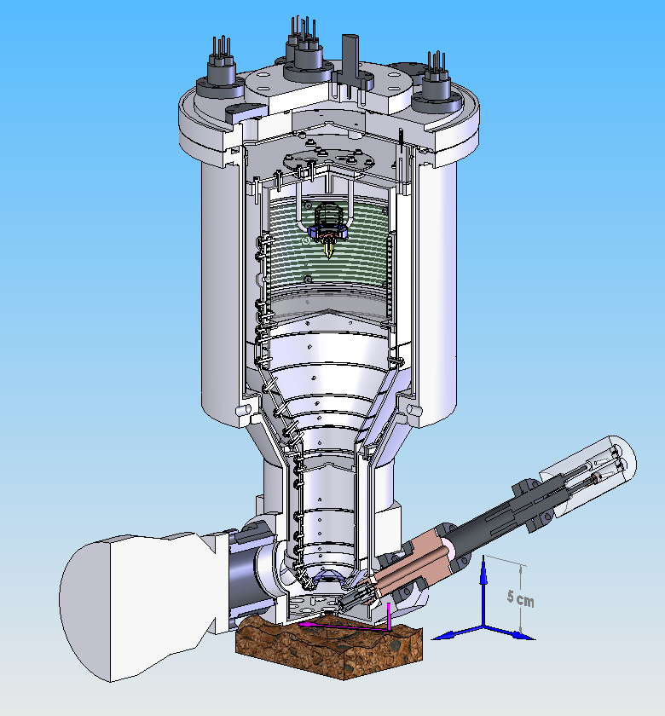 | 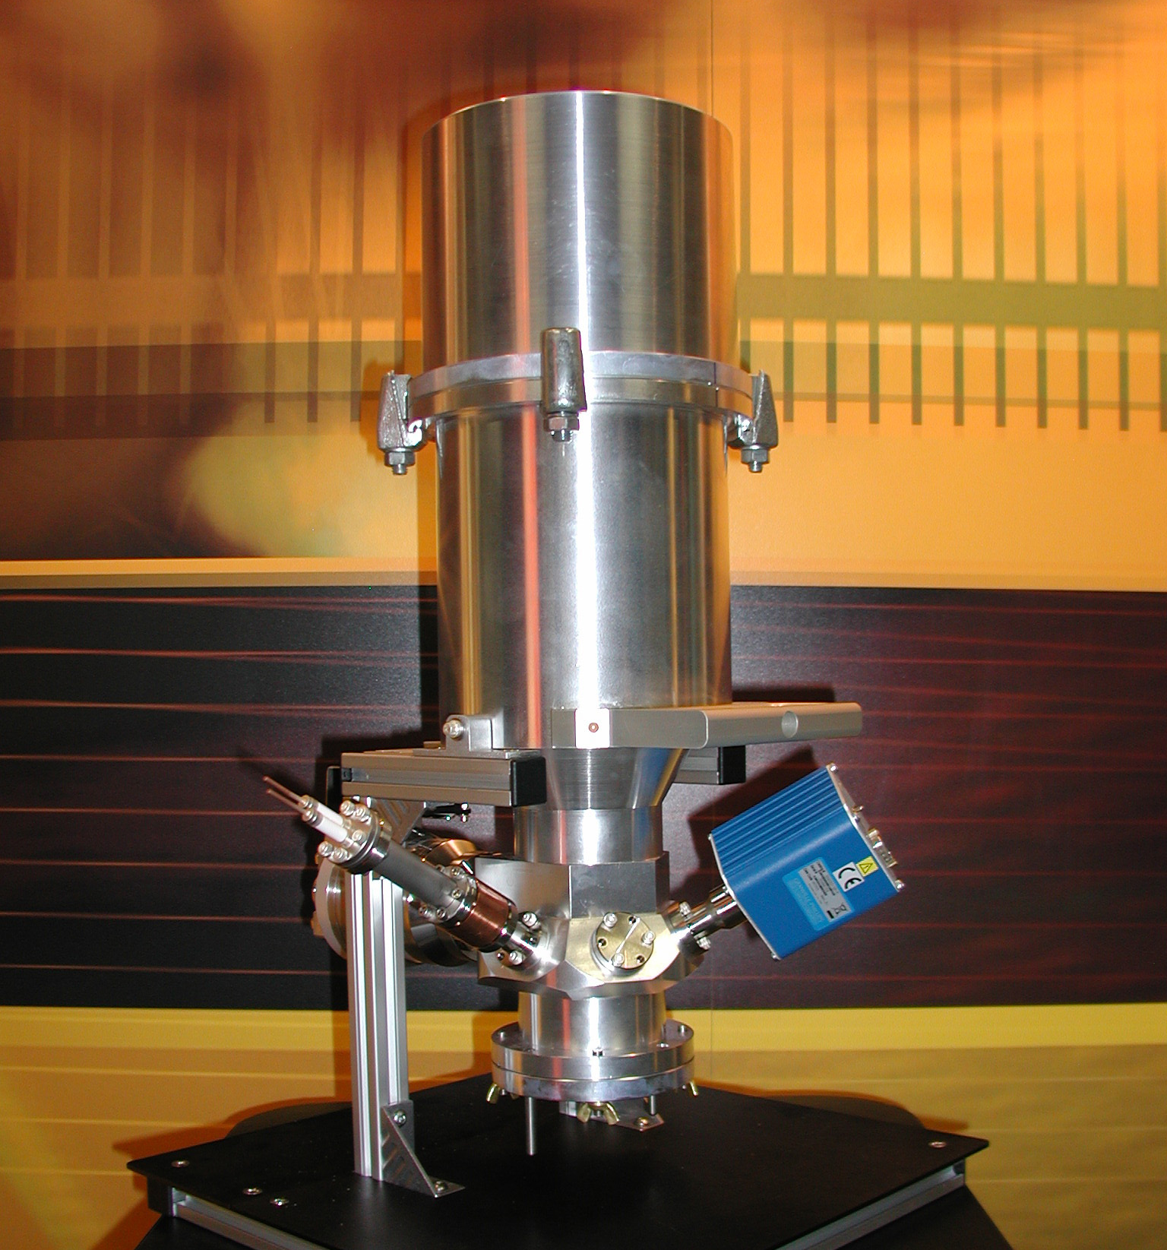
ChemStat will probe the near-surface region of a sample, including the atmospheric species interacting with the surface. It will provide elemental analysis and chemical state information for all elements except H. The photo on the right-hand side shows the electron energy analyzer breadboard. A diagram of the complete instrument concept is shown on the left.

The second enabling component is a dual-layer silicon-nitride structure that isolates the spectrometer from the planet atmosphere. This isolation membrane allows the sample to remain outside of the spectrometer in the ambient environment of the planet, eliminating the needs for sample preparation, mechanisms to transport the sample into the spectrometer vacuum chamber, and the associated peripheral vacuum pumps. Because the sample remains in its ambient environment, scientists will be able to probe, in real time, dynamical changes on the surface of minerals and regolith as a result of atmosphere/solid surface interactions. This may provide insight into such phenomenon as weathering processes, oxidant formation, and the photolytic or chemical degradation of organic compounds.

The key strengths of XPS lie in the return of detailed chemical bonding information, quantitative elemental analysis, and sensitivity to the first 5 to 10 nm of the surface of the sample. Although the basic principles of XPS are different from Mössbauer, both return information on elemental oxidation states. However, while Mössbauer is primarily suited to analysis of iron bearing materials, XPS can provide direct chemical information on all elements, except H, in rocks and soils. In addition to quantifying the distribution of oxidation states in a sample, XPS provides direct information on the chemical bonding, allowing the identification of chemical compounds and quantification of distributions.

This ambient pressure XPS has been dubbed ChemStat, a contraction in reference to the chemical state information this technique will provide. The table below compares the capability and resource requirements for our ChemStat development with current commercial state-of-the-art XPS systems.

Performance Characteristic | Commercial Laboratory XPS | ChemStat  in development | ChemStat  flight instrument
Mass (kg) | 1500 | 14 | 7
Power (W) | 1500 | 15 | 10
Operating Pressure at sample (Torr) | < 10⁻⁶ | <10⁻⁶ to 3x10³ | <10⁻⁶ to 3x10³
Spectral Resolution (eV) | 0.8 | 0.8 | 0.8
Spatial Resolution (µm) | 100 | 100 | 100
Sample preparation required? | yes | no | no

Part of this work was carried out at the Jet Propulsion Laboratory, California Institute of Technology, under a contract with the National Aeronautics and Space Administration and at Apparati, Inc., under a NASA Small Business Innovative Research contract.

