The Constellation-X reflection grating spectrometer

Jean Cottamª, Webster Cash^{b}, Kathryn A. Flanagan^{c}, Ralf K. Heilmann^{c}, Gregory Y. Prigozhin^{c}, Andrew P. Rasmussen^{d}, George R. Ricker^{c}, Mark L. Schattenburg^{c}, Eric Schindhelm^{b}

ªNASA/Goddard Space Flight Center, X-ray Astrophysics Laboratory, Greenbelt, MD, USA 20771;
^{b}University of Colorado, Center for Astrophysics and Space Astronomy, Boulder, CO USA 80309;
^{c}MIT Kavli Institute for Astrophysics and Space Research, Cambridge, MA USA 02139;
^{d}Stanford University, SLAC, Menlo Park, CA USA 94025

Abstract
The Constellation-X Reflection Grating Spectrometer (RGS) is designed to provide high-throughput, high-resolution spectra in the long wavelength band of 6 to 50 Å. In the nominal design an array of reflection gratings is mounted at the exit of the Spectroscopy X-ray Telescope (SXT) mirror module. The gratings intercept and disperse light to a designated array of CCD detectors. To achieve the throughput (A_{eff} > 1000 cm² below 0.6 keV) and resolution (Δλ/λ > 300 below 0.6 keV) requirements for the instrument we are investigating two possible grating designs. The first design uses in-plane gratings in a classical configuration that is very similar to the XMM-Newton RGS. The second design uses off-plane gratings in a conical configuration. The off-plane design has the advantage of providing higher reflectivity and potentially, a higher spectral resolution than the in-plane configuration. In our presentation we will describe the performance requirements and the current status of the technology development.

Keywords: X-ray, spectrometer, grating, CCD, Constellation-X

INTRODUCTION

Constellation-X¹ is one of NASA’s “Beyond Einstein” Great Observatories. It is designed to address such fundamental issues as the physics of strong gravity, the evolution of black holes, and to study dark matter throughout the universe². Constellation-X will provide high-resolution spectra across the x-ray band from 0.25 to 40 keV, with orders of magnitude increased sensitivity over the current Chandra and XMM-Newton spectrometers. The Hard X-ray Telescopes³ (HXT) will cover the high energy band from 10 keV to 40 keV. For energies below 10 keV, the performance requirements of the mission will be met using two complementary spectrometers, the Reflection Grating Spectrometer (RGS), which is a dispersive spectrometer with a resolving power that increases with decreasing energy, and the X-ray Microcalorimeter Spectrometer (XMS), which is a non-dispersive spectrometer with a resolving power that increases with energy and is optimized for the Fe K emission region around 6 keV. The XMS will be described in Kelley et al.⁴ In this presentation we will describe the baseline design for the RGS and the current status of the technology development.

RGS Design

The basic design of the Constellation-X RGS is illustrated in Figure 1. A Reflection Grating Array (RGA) is mounted at grazing incidence relative to the converging beam exiting the Spectroscopy X-ray Telescope⁵ (SXT). The gratings intercept and disperse photons to a dedicated array of detectors, called the RGS Focal-Plane Camera (RFC), where the energy resolution of the detectors is used to separate the spatially overlapping spectral orders. The RFC consists of the Spectroscopy Readout Camera (SRC), which images the diffracted light, and the Zero-Order Camera (ZOC), which images the reflected light, and will be used to anchor the RGS wavelength scale by tracking small aspect drifts. Light not intercepted by the RGA passes through to the focus of the telescope where it is imaged by the XMS. There are four identical RGS systems in the Constellation-X mission.
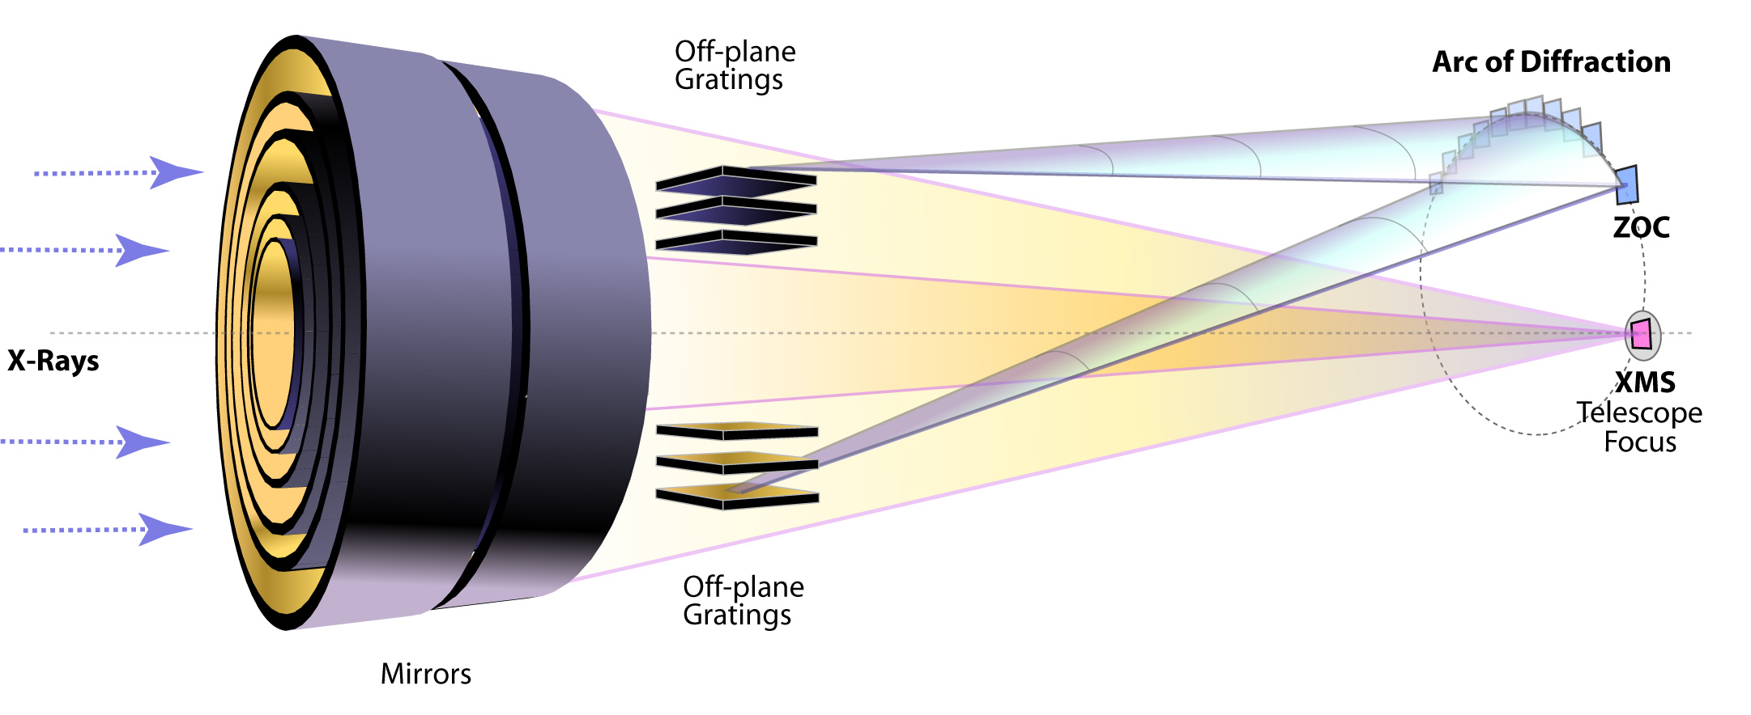
Fig 1: Illustration of one Constellation-X RGS design. Light, incident from the left, is focused by the SXT mirrors. The RGA gratings, represented by the flat rectangles, intercept part of the focused beam and disperse it to the RFC detectors, represented by the blue squares. Light that is not intercepted by the gratings is imaged by the XMS system at the telescope focus. The geometry is highly exaggerated.

Table 1: The performance requirements and goals for the Reflection Grating Spectrometer.
Parameter | Requirement | Goal
Bandpass | 0.25-2.0 keV | 0.1-2.0 keV
Resolving Power  (for E ≤ 0.6 keV) | λ/Δλ ≥ 300 | λ/Δλ ≥ 3000
Throughput  (for E ≤ 0.6 keV) | >1000 cm² | --

The performance requirements and goals for the RGS are given in Table 1. To meet these requirements, two possible grating configurations have been considered, an in-plane, or “classical” configuration, and an off-plane or “conical” configuration. Illustrations and the diffraction equations for an in-plane and off-plane grating are shown in Figure 2. For the in-plane configuration, a grating is illuminated such that the incident ray lies perpendicular to the grating grooves. By illuminating it at grazing incidence, the projected line density for an in-plane grating can made to be very high, thereby increasing the diffraction and hence the spectral resolution. In-plane gratings are used on the XMM-Newton Reflection Grating Spectrometer⁶. For the off-plane configuration, a grating is illuminated such that the incident rays are nearly parallel to the grating grooves. An off-plane grating has a higher efficiency than the in-plane grating since the incident and diffraction angles relative to the facet are nearly identical and the surface acts like a mirror. Although there are advantages to each, the Constellation-X project is currently exploring off-plane grating configurations for the RGS. With higher efficiency, fewer off-plane gratings can be used to satisfy the same effective area requirement. Because off-plane gratings disperse light along a shallow cone, they can be packed much more closely than in-plane gratings, which must be spaced to allow the full range of diffraction angles without significant vignetting. Off-plane gratings can therefore be arrayed to maximize the spectral resolution. Each telescope mirror shell produces an image on the detector. By positioning gratings across a narrow angular subset of the mirror module, or sub-aperturing, the mirror image on the RFC detectors will appear as a bow-tie instead of a full circle. This narrowed line spread function greatly increases the spectral resolution. The advantages of off-plane gratings, including a description of sub-aperturing are given in Cash, and McEntaffer et al.^{7,8} Raytrace results for Constellation-X grating configurations are given in McEntaffer et al., Rasmussen et al., and Flanagan et al.^{8,9,10}

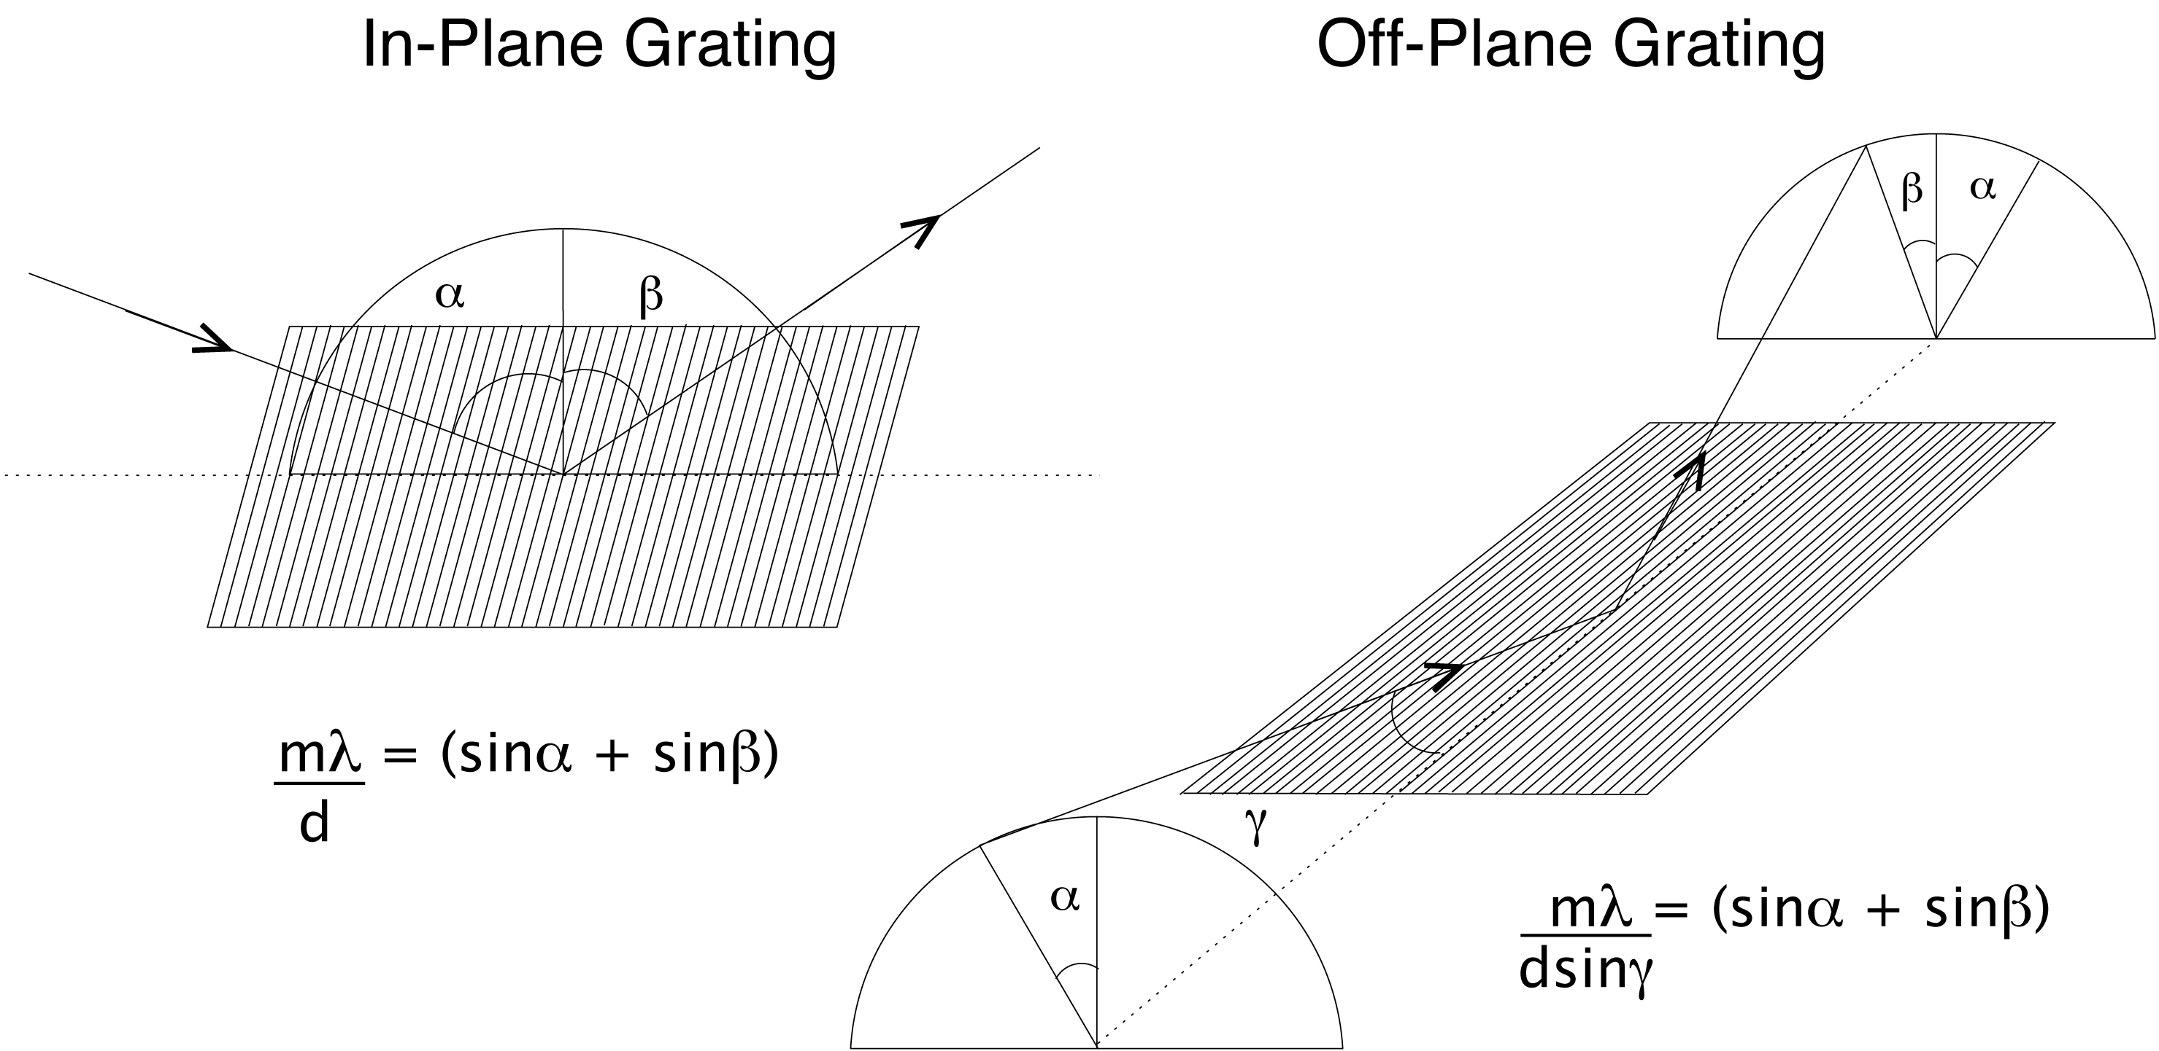

Fig 2: Illustration of an in-plane (left) and off-plane (right) reflection grating. In-plane gratings are illuminated perpendicular to the grooves and disperse light along an arc as shown. For an incident angle of α relative to the grating normal, and a line spacing of d, the in-plane grating will disperse photons of wavelength, λ, in the plane of incidence according to the given equation, where β is the dispersion angle and m is the spectral order. Off-plane gratings are illuminated along the groove and disperse light along the arc as shown. For an incident angle γ relative to the grating grooves and an azimuthal angle of α along the cone of half-angle γ, the off-plane grating will diffract photons according to the given equation, where β is the azimuthal angle along the dispersion cone.

The RGS design that is currently under consideration consists of off-plane gratings arrayed over two 75º segments on opposite sides of the outer shells of the SXT. The gratings are integrated using a modular approach with roughly 13 gratings per module, and 50 modules, all attached to the SXT through a grating integrating structure. The number of grating modules is chosen to satisfy the system-level effective area requirements. In this initial design each reflection grating is ruled with a line density of 1/d = 5800 l/mm and a groove blaze angle of 16.9º. To minimize aberrations caused when focused rays intercept the grating at different incident angles, the grooves are fanned slightly to match the convergence of the telescope beam. The gratings are nominally illuminated at α=16.9º with respect to the grating normal, and γ=2.0º with respect to the grating groove. The RFC/SRC consists of CCDs, which cover a dispersion arc of 43º, or roughly 254 mm (from 0.25 keV to 2.0 keV). The CCDs are nominally formatted in a 1600 by 1600 pixel array where each pixel is 15 μm wide. The RFC/ZOC utilizes an identical CCD design. In this simple configuration, the RGS satisfies the resolution requirements for the mission. Techniques are under investigation to achieve the mission goals by aligning the gratings to make two-dimensional scalloped or C-shaped images^{8,9,10} and correcting for the path-length difference between the grating arrays at opposite sides of the mirror.

Grating Development

The performance requirements for the RGS present technological challenges for grating development. The high effective area of the RGS requires a large number of reflection gratings each with higher spectral reflectivity than traditional methods of fabrication by mechanical ruling can provide. While off-plane gratings have good reflectivity, they must be ruled with line densities and blaze angles that are an order of magnitude higher than in-plane gratings for the same spectral resolution. The mass constraints for the system, combined with the large number of gratings, mean that each grating must be at least a factor of three lighter than the reflection gratings flown on XMM-Newton. The gratings must therefore be thin. In order to achieve spectral resolution approaching the Constellation-X goals, these thin gratings must be flat and aligned to the same ~2” precision as the much heavier and thicker XMM-Newton gratings. With four RGA arrays, each containing roughly 700 gratings, mass production presents an additional challenge. The Constellation-X project is currently pursuing two parallel paths for grating development. Recent developments from both an MIT team and a University of Colorado team are described in the sections below.

Grating Development at MIT
The MIT grating development team is fabricating diffraction gratings using specialized techniques, which can be used for both in-plane and off-plane gratings. Heilmann et al. ^{11,12} describes the process. Gratings are patterned using a “Scanning Beam Interference Lithography” (SBIL) system, which allows for high speed patterning with extremely good groove control (period: Δp/p < 10⁻⁵, phase: ~p/100)^{13,14}. The patterned gratings then undergo anisotropic etching to form the grooves. Their technique exploits the lattice planes of single-crystal silicon to make extremely smooth, high efficiency gratings. They have fabricated gratings that demonstrate each of the parameters that are critical for the Constellation-X RGA. They routinely make gratings with line densities of 5000 to 10000 l/mm. They have fabricated a grating that is 300 mm in diameter¹² (see Figure 3). They have made gratings that meet the mass requirements and that demonstrate the groove form over a range of blaze angles.^{15,16,17} They have also successfully applied two low-stress nanoimprint lithography techniques for replicating the grating, a thermal process and an UV-cure process, that are described in Heilmann et al¹¹. And they have demonstrated flattening of 100 mm-diameter, 0.5 mm-thin grating substrates to better than 100 nm P-V¹⁸. The Constellation-X gratings will be ruled with fanned grooves to match the convergence of the telescope beam. Fabricating these “radial gratings” requires upgrading the MIT SBIL system to a “Variable-Period” SBIL. This upgrade is well under way. MIT and their technology partners are in the process of final assembly and alignment. A flight prototype grating will be fabricated as soon as the new system is online.

Fig 3: (Left) A large MIT grating. This 300mm diameter grating, larger than required for Constellation-X, was patterned on the SBIL system (Image reproduced from Heilmann et al¹².) Gratings of this size have been patterned in as little as 20 minutes. (Right) Atomic Force Micrograph (AFM) of a replicated grating before metal coating. Sharp features are very well replicated, and the microroughness on the blaze facets is < 0.2 nm. The thin, low-stress nanoimprint lithography layers lead to distortions smaller than 1 arcsec on 100 mm-diameter, 0.5 mm-thin substrates¹⁷.

MIT is also developing technology and methodology for assembling and aligning the gratings. To mount gratings to the desired flatness and alignment tolerances they are exploring techniques that use a vacuum chuck to constrain a grating and hold it flat while it is epoxied to thin ribs on a support structure. Precision ribs are then attached to the first grating and a second grating is mounted. A grating module is assembled in alternating layers of ribs and gratings. This process improves grating flatness by a factor of 2 to 3. The process and the measured flatness of gratings in a test module are described in Akilian et al¹⁹.
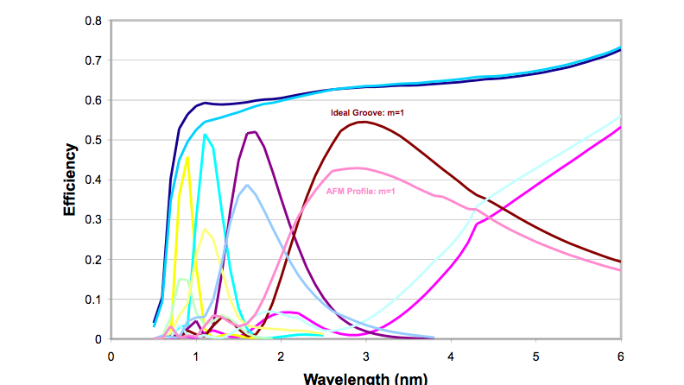
The MIT team continues modeling the grating efficiency and the spectral resolution. Efficiency data for the MIT fabricated gratings has been acquired in collaboration with the University of Colorado team at a test facility maintained by that group^{20,12}. Efficiency as a function of wavelength was acquired at LBNL’s Advanced Light Source (ALS) facility⁹, and at the Brookhaven NSLS facility^{21,18}. Initial modeling of the measured efficiency is described in Seely et al.²¹. The MIT team is using the PCGrate program to investigate non-ideal effects. A comparison between the efficiency modeled using an AFM groove profile of a grating fabricated at MIT and the efficiency for an ideal sawtoothed grating with the same design parameters is shown in Figure 4. This is critical input both for system-level planning and for optimization of the grating design.

Fig 4: Efficiency modeled using the AFM grove profile for a grating fabricated at MIT and for the ideal sawtooth groove of the same design parameters. The incident light is linearly polarized. Efficiency in the spectral orders is significantly reduced for the non-ideal groove.

Grating Development at University of Colorado
The University of Colorado grating development team has concentrated on demonstrating the x-ray performance of off-plane gratings. They maintain a test facility that is used to measure grating efficiency at discrete energies²⁰. Resolution measurements are much more difficult because they require flight-representative illumination of the gratings. The team is preparing for a test at the Max Planck Institute for Extraterrestrial Physics (MPE) Panter facility in Munich in collaboration with the MPE group. The long 120 meter beam line approximates illumination in-flight. The test setup is illustrated in Figure 5. For these tests a spare XMM mirror will be used. It has a ~15” psf, very similar to the projected SXT performance. The grating will be placed 50 cm from the mirror at graze angles ranging from 0.5 to 3 degrees. With a combination of the Panter monochromator, which has a lower wavelength limit of 50 Å, and discrete sources, which extend to the Be line at 114 Å, the Constellation-X RGS range can be sampled. These tests are expected to take place in the coming months.
120 m
grating
7.5 m
detector
source
XMM
mirrors
mask

Fig 5: Diagram of the MPE Panter test configuration. The beam line is 120 m long. An XMM flight spare mirror, with a focal length of 7.5 m will be used to illuminate the grating. A holographic grating will fabricated at Horiba Jobin Yvon for these resolution tests.

The University of Colorado team is working with the Horiba Jobin Yvon company to fabricate a test grating for the Panter campaign. The grating master is holographically ruled and then replicated onto a 16 mm thick pyrex substrate. The groove parameters are designed to optimize the throughput at 1 keV in 3rd order with a quasi-radial fan pattern designed to focus at the ~7.5 focal length of the PANTER test mirror. The average groove density is greater than 5000 l/mm with a 15º blaze.
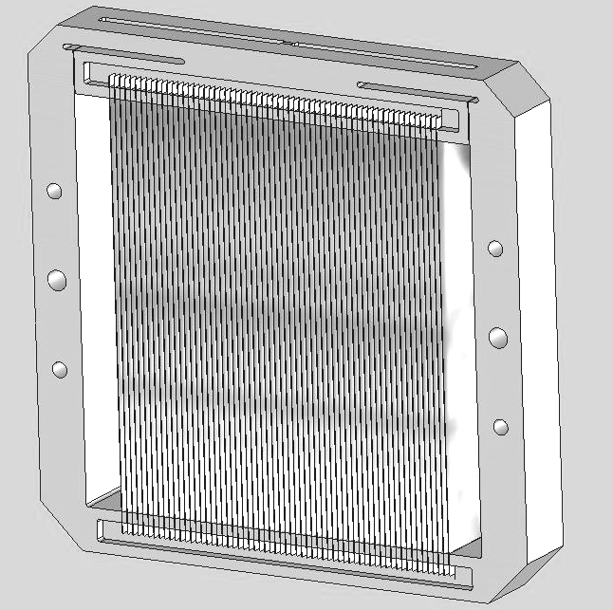
The University of Colorado team is also addressing the challenges posed by thin substrates. Closely packed, thin grating arrays offer maximum throughput with minimal structural blockage. However, it is difficult to meet the surface quality requirements with thin substrates. They have studied a variety of fabrication methods. Pyrex, silicon carbide, and silicon have been used as substrates with thicknesses ranging from 0.5 to 2 mm. Details of these studies are presented in Shipley et al.²² They find that groove profiles replicated onto a thin substrate with polymers share a tendency to bend and cause optical surface error. Distortion is induced during the polymer curing process and is directly proportional to the replication layer thickness. Gratings made of stiff substrates with very thin or no replication layer will result in optimal surface figure. The effects of gravity on thin substrates and its release after launch need to be included in both surface figure and alignment tolerance budgets, as must temperature changes and CTE difference between a substrate and reflection layer that may cause bimetallic bending. Moreover, thin substrate gratings used in flight applications must be robust in a vibration environment and resist fracture.
They have developed closely packed thin substrate gratings as part of a diffuse X-ray spectrometer sounding rocket^{23,24}. This provides an excellent test bed for Constellation-X grating technology. Electroformed nickel is used for the grating substrate and electroless nickel is used for the reflection layer. To achieve spectral resolution of Δλ/λ > 100 the rocket gratings must be flat and parallel to within one part in 2000 along their length. To achieve this, a grating mount was designed which pulls the gratings from each end and holds them in tension. A full complement of gratings in their fixture is shown in Figure 6.

Fig 6: Illustration of the thin substrate grating mount for the University of Colorado sounding rocket.

Detector Development

There are several technological challenges for the RFC detectors. The RGS effective area requirements at low energies mean that the detectors must combine high quantum efficiencies with high transmission of the optical blocking filters. The Chandra ACIS back-illuminated (BI) CCDs had a combined efficiency (quantum efficiency times filter transmission) of 0.73 * 0.20 = 0.15 at 0.25 keV. The Suzaku XIS BI CCDs had combined efficiency as measured on the ground of 0.80 * 0.31 = 0.25 at the same energy. For Constellation-X, the RFC must have a combined efficiency of ~0.78 at 0.25 keV. With four systems, each requiring roughly 13 detectors, the production yield must be substantially higher than the 1% yield typical for past generations of BI x-ray CCDs. System-level power constraints and the radiation environment at L2 provide additional challenges for the technology development.

CCD Development at MIT
The MIT Kavli Institute in collaboration with MIT/Lincoln Laboratory, is developing CCDs for the Constellation-X RGS. They are building special CCDs that are operated in an “Event-Driven” mode. This is described in Doty et al.²⁵ and Ricker et al.²⁶ Briefly, the CCD is scanned for photon events and then only the pixels with photon-induced charge are digitized. Since typically less than 1% of the pixels on a CCD contain signal charge in a given frame, ED-CCDs can be operated at high readout rates and with power reductions of a factor of 100 over conventional readout modes. The MIT team has manufactured two lots of ED-CCDs. The most recent is formatted as 512 by 512 pixels. These are currently undergoing X-ray tests. They have now been successfully readout at a frame rate of 1 Mpix/sec in conventional CCD readout mode. This is 10 times faster than for any other x-ray low-noise MOS CCD, which makes them much less sensitive to optical straylight than previous CCDS. With a 1Mpix/sec readout rate an optical blocking filter of only 150Å aluminum is sufficient to limit the electronic noise due to optical contamination in the 3000-11000 Å band to 1 photon/frame/superpixel.
Back-side processing of the CCDs involves a new Molecular Beam Epitaxy (MBE) technique that has recently been developed at Lincoln Laboratory. Back-side processing thins the silicon deadlayer to optimize the charge collection of low energy photons. The new processes attempt to generate a steep potential gradient at the illuminated surface of the device to minimize electron losses near the surface. Trapping and recombination of electrons at the silicon-silicon dioxide interface is the usual reason for poor energy resolution of back-side illuminated CCDs. The presence of electric field there improves the energy resolution and quantum efficiency of the device. First tests of these MBE-produced CCDS show exciting results. These will be reported in Ricker et al.²⁷. At 0.25 keV, near the low energy end of the Con-X bandpass, the energy resolution of roughly 50 eV is more than sufficient to separate the spatially overlapping spectral orders. The quantum efficiency of these CCDs has not yet been tested. However, the excellent energy resolution and the nearly symmetric profile show excellent charge collection capabilities, and strongly suggest that the quantum efficiency will be high.

Summary

The Constellation-X RGS will provide high-resolution, high-throughput soft x-ray spectra with potentially orders of magnitude improvements in performance over the soft x-ray spectrometers that are currently operating. This requires significant technological advances in the development of both the gratings and the detectors. The high-throughput requirement is perhaps the most challenging both for the development of high-efficiency, closely-packed gratings, and for CCDs with high quantum-efficiency and ultra-thin blocking filters. The technology development teams are making significant progress towards realizing each of these requirements.

References

- N. E. White, H. D. Tananbaum, A. E. Hornschemeier, M. R. Garcia, R. Petre, and J. A. Bookbinder, “Constellation-X mission implementation approach and status,” these proceedings.
- M. R. Garcia, N. E. White, H. D. Tananbaum, R. Petre, A. E. Hornschemeier, and J. A. Bookbinder, “Science Drivers for NASA’s Constellation X-ray mission,” these proceedings.
- P. Gorenstein, S. Romaine, and the HXT Integral Optics Team, “The Con-X Hard X-ray Telescope and its angular resolution,” American Astronomical Society Meeting 207, 2006.
- R. L. Kelley, “The x-ray microcalorimeter spectrometer for the Constellation-X mission,” these proceedings.
- R. Petre, “The Constellation-X Spectroscopy X-ray Telescope: recent technology development,” these proceedings.
- J. W. den Herder, A. C. Brinkman, S. M. Kahn, G. Branduardi-Raymont, K. Thomsen, et al., “The Reflection Grating Spectrometer on board XMM-Newton,” Astronomy & Astrophysics 365, L7-L17, 2001.
- W. C. Cash, “X-ray optics. II: A technique for high resolution spectroscopy,” Applied Optics 30, 1749-1759, 1991.
- R. L. McEntaffer, W. C. Cash, and A. F. Shipley, “Off-plane gratings for Constellation-X,” in X-Ray and Gamma-Ray Telescopes and Instruments for Astronomy,” Proceedings of the SPIE 4851, 549-556, 2003.
- A. Rasmussen, A. Aquila, J. Bookbinder, C. Chang, E. Gullikson, R. Heilmann, S. M. Kahn, F. Paerels, and M. Schattenburg, “Grating arrays for high-throughput soft x-ray spectrometers,” Proceedings of the SPIE 5168, 248-259, 2004.
- K. A. Flanagan, J. E. Davis, R. K. Heilmann, A. M. Levine, M. McGuirk, G. R. Ricker, M. L. Schattenburg, M. Wise, A. Rasmussen, J. Bookbinder, M. Freeman, T. Gaetz, D. Jerius, D. Nguyen, W. Podgorski, P. Reid, W. Cash, A. Shipley, D. Gallagher, P. Huang, and S. Jordan, “The Constellation-X RGS options: Raytrace Modeling of the off-plane gratings,” Proceedings of the SPIE 5488, 515-529, 2004.
- R. K. Heilmann, M. Akilian, C.-H. Chang, C. R. Forest, C. Joo, A. Lapsa, J. C. Montoya, and M. L. Schattenburg, “Thin-foil reflection gratings for Constellation-X,” Proceedings of the SPIE 5488, 283-290, 2004.
- R. K. Heilmann, M. Akilian, C.-H. Chang, C. G. Chen, C. R. Forest, C. Joo, P. T. Konkola, J. C. Montoya, Y. Sun, J. You, and M. L. Schattenburg, “Advances in reflection grating technology for Constellation-X,” Proceedings of the SPIE 5168, 271-282, 2004.
- P. T. Konkola, C. G. Chen, R. K. Heilmann, C. Joo, J. C. Montoya, C.-H. Chang, and M. L. Schattenburg, “Nanometer-Level Repeatable Metrology Using the Nanoruler,” Journal of Vacuum Science Technology B 21, 3097, 2003.
- R. K. Heilmann, C. G. Chen, P. T. Konkola, and M. L. Schattenburg, “Dimensional Metrology for Nanometer-Scale Science and Engineering: Towards Sub-Nanometer Accurate Encoders,” Nanotechnology 15, S504-S511, 2004.
- C.-H. Chang, R. K. Heilmann, R. C. Fleming, J. Carter, E. Murphy, and M. L. Schattenburg, “Fabrication of sawtooth diffraction gratings using nanoimprint lithography,” Journal of Vacuum Science Technology B 21, 2755-2759, 2003.
- A. E. Franke, M. L. Schattenburg, R. M. Gullikson, J. Cottam, S. M. Kahn, and A. Rasmussen, “Super-smooth x-ray reflection grating fabrication,” Journal of Vacuum Science Technology B 15, 2940-2945, 1997.
- C.-H. Chang, J. C. Montoya, M. Akilian, et al., “High fidelity blazed grating replication using nanoimprint lithography,” Journal of Vacuum Science Technology B 22, 3260-3264, 2004.
- R. K. Heilmann, M. Akilian, C.-H. Chang, R. Hallock, E. Cleaveland, and M. L. Schattenburg, “Shaping of Thin Grazing Incidence Reflection Grating Substrates via Magnetorheological Finishing,” Proceedings of the SPIE 5900, 59-65, 2005.
- M. Akilian, R. K. Heilmann, and M. L. Schattenburg, “Assembly of thin gratings for soft x-ray telescopes,” these proceedings.
- R. L. McEntaffer, F. R. Hearty, B. Gleeson, and W. C. Cash, “X-ray test facility for diffraction gratings,” Proceedings of the SPIE 5168, 499-507, 2004.
- J. F. Seely, L. I. Goray, B. Kjornrattanawanich, J. M. Laming, G. E. Holland, K. A. Flanagan, R. K. Heilmann, C.-H. Chang, M. L. Schattenburg, and A. P. Rasmussen, “Efficiency of a Grazing Incidence Off-Plane Grating in the Soft X-Ray Region,” Applied Optics 45, 1680-1687, 2006.
- A. Shipley, R. McEntaffer, and W. Cash, “Studies in Thin Diffraction Gratings for Flight Applications,” these proceedings.
- R. McEntaffer, E. Schindhelm, W. Cash, and A. Shipley, “A sounding rocket payload for X-ray observations of the Cygnus Loop,” these proceedings.
- A. Shipley, R. McEntaffer, and W. Cash, “Foil Reflection Grating Mount for Diffuse X-ray Spectroscopy,” Proceedings of the SPIE 5877, 74-81, 2005.
- J. P. Doty, G. R. Ricker, B. E. Burke, and G. Y. Prigozhin, “Event-driven charge-coupled device design and applications therefore,” United States Patent #6917041, July 12, 2005.
- G. R. Ricker, J. P. Doty, S. E. Kissel, and G. Y. Prigozhin, “Event Driven X-ray CCD Detector Array for the Reflection Grating Spectrometer on the Constellation-X Mission,” American Astronomical Society Meeting 207, 2006.
- G. R. Ricker, et al., in preparation.

