

Caribbean Area

Caribbean Area Phosphorus Index

A Planning Tool to Assess and Manage P Movement

High phosphorus (P) concentrations found in many surface waters throughout Puerto Rico suggest that this may be the leading cause of observed eutrophication. Because agricultural activities are one of many nonpoint sources apparently contributing to P loading, it is important to implement agricultural nutrient management plans. This must be done judiciously because of the unique social and economic conditions that prevail. One component of such plan is the assessment of P transport from soil to water by the use of the Phosphorus Index (PI). The Phosphorus Index (PI) is a site specific, qualitative vulnerability assessment tool used by the USDA, Natural Resources Conservation Service (NRCS) to determine when manure utilization may be based on a nitrogen or phosphorus-based budget. The tool allows a conservation planner to determine, from among a series of proposed manure application sites, which ones are potentially most vulnerable to the off-site movement of phosphorus. The original PI has been modified to consider the unique pedologic and climatic conditions that prevail in the tropical Caribbean. Modifications to the PI for tropical conditions also address characteristics of highly weathered soils. The PI for Puerto Rico considers both transport (soil erosion, runoff class, distance to watercourse) and source (soil test P, fertilizer and organic P ratio and application method and timing) characteristics.

PHOSPHORUS CONCERNS IN THE TROPICAL ENVIRONMENT

Factors affecting P losses from the landscape and movement to surface water are grouped into transport factors. To assess P transport it is necessary to examine soil erosion and runoff rates, P sorption to soil particles and proximity of site to surface water. Since P is considered immobile in most soils, soil erosion and runoff in areas with high soil test P can pollute surface waters. However, the risk is lower if runoff and erosion is minimized. Except in the coastal plains and valleys, the steep topography on the island dominates soil landscape characteristics (Map1) increasing P loss potential via erosion and runoff. With the topographic characteristics of our soils it is obvious that most of the P loss, in traditional cropland and overgrazed sites, is attached to soil particles. If these conditions occur in close proximity to surface water, impairment is likely. Thus, controlling erosion is of prime importance in minimizing P movement. According to RUSLE estimates, soil erosion rates may exceed 40 tons/acre/year in low residue conventional tillage cropland with more than 30 percent slopes. A highly erodible soil map unit list is in Section II of Caribbean Area Field Office Technical Guide. Soil erodibility potential for soils in Puerto Rico is shown in Map 2. The categories used in this map regroup highly erodible land (HEL) into high or very high erosion potential and non HEL into low or very low. The potentially HEL determinations are categorized as a medium class. High category includes all deep red clayey soils formed on 20 to 40 percent slopes and K factor from 0.02 to 0.10 and other shallow soils up to 20 percent slopes. The very high category includes soils with K factor more than 0.10 formed on slopes over 20 percent, all soils over 40 percent slopes with K factor from 0.02 to 0.10 and all rockland complex exceeding 40 percent slope. Low and Very low category soils include those on slopes from 0 to 2 percent. All soils with an aquic moisture regime, and fluventic great group of Soil Taxonomy and others with coarse textures are grouped in the low category.

The island exhibits an intriguing pedologic and mineralogical diversity with soils presenting widely different P sorption – desorption patterns (Jones et al., 1982; Beinroth, 1982). Most highly weathered and alkaline soils have high sorption potential, which could reduce P losses in runoff. Based on soil survey data and soil classification of the soils in Puerto Rico around 30 percent of soils in agricultural production exhibit a high P sorption characteristic. Leaching in P deficient subsoil with high sorption capacity is of less importance because soil particles sorb much of the soluble P. Few exceptions may occur in permeable coarse texture and organic soils with low ability to retain P. Agricultural P sources include organic residues from manure and inorganic fertilizers. In Puerto Rico most of the agricultural activity is concentrated on ecologically fragile ecosystem, commonly exceeding 20% slopes where intense sudden rainstorms are common. Most of the manure comes from poultry, dairy, and swine enterprises. The poultry industry is concentrated in the south central part while dairy is in the north coast, mostly in the Karst formation. The swine producers are distributed throughout the island.

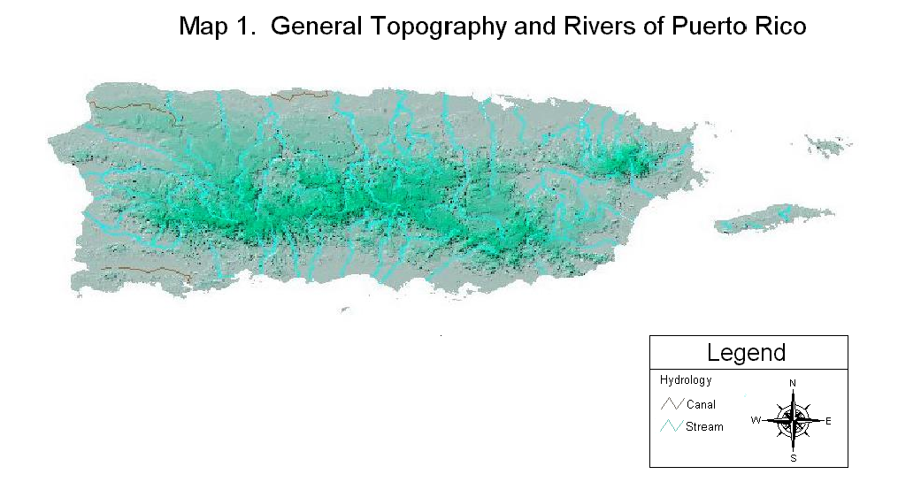
3
Map 1. General Topography and Rivers of Puerto Rico
4

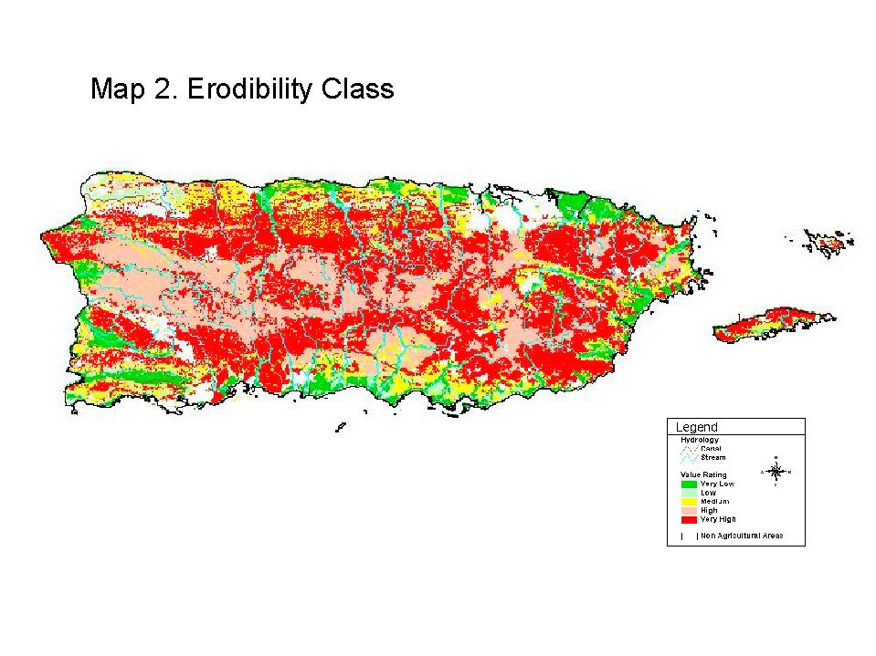
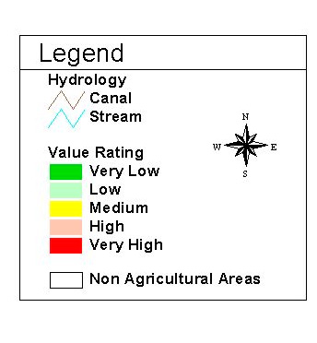
Map 2. General Soil Erodibility Classes of Puerto Rico

Effective management of P requires knowledge of soil properties, P behavior in soils and information obtained from onsite soil and manure test. In Puerto Rico, either the Bray 1, Bray 2 or Olsen P soils tests have traditionally been used to evaluate plant available P. High long term P application rates in the form of fertilizers or manure can increase the soil test P levels. With higher P content present in the soil, there is an increased risk of loss potential. Nevertheless, to assure adequate crop yields in P deficient soils, often the application rate may exceed more than twice the amount utilized by the crop. Thus, heavy application of manure and fertilizer may need to be applied to maintain optimum agronomic yields in highly weathered and alkaline soils.

The risks of P loss increase with increasing P rate and surface application in close proximity to surface water. Those sites with highest probability for P loss merit specific management practices to minimize their contribution to surface water. The key is to apply where and when the risk of major runoff and erosion events is lowest.

PHOSPHORUS INDEX CONCEPT

The Phosphorus Index (PI) is an assessment tool that may be used by resource managers and landusers to assess the risk of phosphorus (P) losses from a field. A work group made up by Scientists from College of Agricultural Sciences of the University of Puerto Rico and USDA – NRCS formed a working group to adapt and validate this technology to our tropical environment. The purpose of the PI is to aid personnel from Natural Resources Conservation, third party vendors, and other environmental agencies in the decision-making processes involved in designing animal by products conservation plans. The risk of P losses is a function of transport and sources characteristics. The P index considers eight field features and management practices, including three transport characteristics which are: (1) soil erosion rate, (2) runoff class, (3) distance to surface water, and buffer strips; and five source characteristics which are: (1) soil test P factor, (2) fertilizer P application ratio, fertilizer P application method and timing, organic P application ratio, and organic P application method and timing.

The weighting factors (WF) show on Table 1 is based on the professional judgement of the scientists that modified the PI. The lowest weighting factor is assigned to the factor that has low relative importance to P loss. For example, the fertilizer P application ratio and method are assigned lower weighting factor compared to organic fertilizer because organic sources nutrient content and balance of manure varies among operations and over time and nitrogen based manure application may cause P build up.

Table 1. Weighting Factors of P Index Parameters

Parameters | Weighting Factor
1. Soil Erosion | 1.0
2. Runoff Class | 1.0
3. Distance to Surface Water and Buffer Strip Width | 1.0
4. Soil Test P | 1.0
5. Fertilizer P Application Ratio | 0.5
6. Fertilizer P Application Method and Timing | 0.5
7. Organic P Application Ratio | 0.75
8. Organic P Application Method and Timing | 1.0

Each field features and management practices are assigned value rating as shown on the next table.

Table 2. Value Ratings of P Index Parameters

P index Parameters | Value Ratings (Points)
P index Parameters | Very Low |  | Low | Medium |  |  | High | Very High
Transport Characteristics | 0.6 | 0.7 |  |  | 0.8 | 0.9 |  |  | 1.0
Site Source Characteristics | 0.1 | 1 |  |  | 2 | 4 |  |  | 8

Multiplying the weighting factor by the value rating yields points for that specific field feature or management practice. Caribbean Area P Index shown on Table 3 takes into considerations all the above data.

The following formula describes the procedure used to compute the PI rating.

PI = ( (SE x C1) x (RC x C2 ) x (PSW x C3)) x ∑ (Source Characteristic Rating x C_{i})

Where:

SE = Soil Erosion rating
C1 = Weighting coefficients for soil erosion
RC =Runoff Class rating
C2 = Weighting coefficients for runoff class
PSW = Distance to Surface Water/Buffer Strips rating
C3 = Weighting coefficients for Distance to Surface Water/Buffer Strips
C_{i} = Weighting coefficients for each source characteristics

This formula separately evaluates the transport and source characteristics of a site and combines them in a multiplicative manner. This procedure allows having a better representation of site vulnerability. A site could have a high rating of source characteristics but if there is no P loss the vulnerability is low. Based on multiplication of transport and source factor, the product is rank into an overall category rating of Low, Medium, High or Very High. The final ranking identifies fields where the risk of phosphorus movement is relatively higher than other sites.

Table 3. Caribbean Area P Index

Caribbean Area P Index
Characteristics | WF | Value Ratings
Transport | WF | Very Low  (0.6 point) | Low  (0.7 point) | Medium  (0.8 point) | High  (0.9 point) | Very High  (1.0 point)
1. Soil Erosion (tons/acre/year) | 1.0 | < 3 | >3 ≤ 6 | > 6 ≤ 10 | > 10 ≤ 15 | > 15
2. Runoff Class | 1.0 | Very low/  Negligible | Low | Medium | High | Very High
3. Distance to Surface  Water; Buffer Strip Width | 1.0 | > 100 feet of high stand cover (>91% cover and > 6” high);  > 21 feet  of buffer strip | > 100 feet of good stand cover(81– 90 % cover and > 6” high); 10 – 20 feet of buffer strip | > 100 feet of medium or better stand cover (> 61 % cover and >6” high) ;  no buffer strip | > 100 feet of  low stand cover (< 60% cover and  < 6” high); no buffer strip | < 100 feet; no buffer strip
Characteristics | WF | Value Ratings
Site Source | WF | Very Low  (0.1 point) | Low  (1 point) | Medium  (2 points) | High  (4 points) | Very High  (8 points)
4. Soil Test P Level (PPM) | 1.0 | Very low | Low | Medium | High | Very high
5. Fertilizer P Application Ratio  (lb./acre)  FPR = Annual P application rate/ P  Crop uptake | 0.5 | ≤1 time crop uptake | ≤ 2 times crop uptake | ≤ 4 times crop uptake | ≤ 6 times crop uptake | > 6 times crop uptake
6. Fertilizer P Application  Method and Timing | 0.5 | None applied | Incorporated < 1 week or trickle applied | Incorporated < 1 month after applied; or contour banded | Surface applied before rainy  Season | Surface applied during rainy season
7. Organic P Application  Ratio (lb./acre)  OPR = Annual P application rate/ P  Crop uptake | 0.75 | ≤ 1 time crop uptake | ≤ 2 times crop uptake | ≤ 4 times crop uptake | ≤ 6 times crop uptake | > 6 times crop uptake
8. Organic P Application  Method and Timing | 1.0 | None applied | Incorporated < 1 week after applied or sprinkler applied during dry season | Incorporated > 1 month after applied or contour banded in crop field  or when sprinkler applied no runoff occurs | Surface applied and not  Incorporated or when applied via irrigation excessive runoff occurs | Surface or sprinkler applied  during rainy season

DESCRIPTION OF FIELD FEATURES AND MANAGEMENT PARAMETERS
- Soil Erosion is the detachment and movement of soil particles predicted from Universal Soil Loss Equation (RUSLE). The value category is given in tons of soils per acre per year (ton/acre/year). The rating is higher as soil erosion increases. This parameter considers the risk of movement of sediment bound P suspended in water runoff. A Caribbean Area RUSLE handbook should be used to calculate soil erosion.

A = R * K * LS * C * P
Where:

A = Average annual soil loss (tons/acre/year)

R = Runoff and erosion factor
K = Soil erodibility factor
LS = Slope length/steepness factor
C = Cover and management factor
P = Supporting practice factor

- Runoff Class considers the relative risk of surface transport of P from a site by water flow over the land surface to water bodies. These groupings are based on runoff producing characteristics of the soil. The current runoff class used in this P indexing is a function of land slope and soil permeability. The method is adapted from National Soil Survey Handbook. Soil survey data is used to determine the classes. The runoff classes are:
Negligible – N Medium - M
Very low – VL High - H
Low – L Very high - VH
The result of using the matrix provides the value categories: Very Low, Low, Medium, High, and Very High. Distribution of soil runoff classes is shown on Map 3. Map Soil runoff class is derived from the following table:
Table 4. Surface Runoff Classes
Slope (%) | Soil Permeability Class
Slope (%) | Very Rapid | Moderately  Rapid and  Rapid | Moderately  Slow and  Moderate | Slow |  | Very Slow
Concave | N | N | N | N | N
< 2 | N | N | N | L | M
2 – 5 | N | VL | L | M | H
5 – 12 | VL | L | M | H | VH
12 – 20 | VL | L | M | H | VH
> 20 | L | M | H | VH | VH

Permeability classes for specific soils can be obtained from a published soil survey or from local USDA – NRCS field offices. Runoff class determination arranged by soil survey and mapping units is included in the Appendix 1.

- Distance to Surface Water and Buffer Strip Width considers the distance in feet from the phosphorus application site to surface water and filtering effect of a vegetative buffer strip. Surface waters include any permanent streams, springs, lakes, sinkholes, wetlands and ditches or waterways that flow intermittently through the year. Buffer strip (BS) considers the filtering effect of a vegetative filter strip at all areas where water will flow from the field, including well-managed pastureland. Filter strips, field borders, contour buffer strips, vegetative barrier grassed waterway and riparian forest buffers are all examples of vegetative buffers or covers. The value class is established based on distance to surface water, buffer strip width and cover management condition. The medium value is based on the average distance required by local Environmental Quality Board (EQB). Plant vigor of permanent vegetation may reduce or increase runoff velocity and infiltration. In a similar ecosystem, a well-managed pastureland might have a lower runoff and higher infiltration than an overgrazed condition. Sites with distances and buffer width greater or lower than average specified on the PI will receive higher or lower rating, respectively. The buffering effect of vegetative strips may compensate distance to surface water.

- Soil Test P Level (STPL) is the soils P nutrient level relative to crop production expressed in part per million (PPM). From an environmental standpoint, soil test P content is not intended to predict the amounts of P leaving land and going into surface waters, as it cannot be assumed that there is a direct relationship between the STPL and nutrient pollution potential. This is because the movement of P can be affected by soil properties such as soil pH, clay content, mineralogy, among others. Nevertheless, there exists quantitative relationship between soil test P extracted by agronomic soil test and water soluble P. Preliminary work by scientist at the University of Puerto Rico has developed empirical relationship between agronomic soil test and water soluble P. From this work, preliminary threshold soil test P levels based on the maximum allowable point source limits established by the local Environmental Quality Board which is 1ppm of total P have been developed.

The range of value used for soil test P interpretation on the table below were chosen so that they would approximately represent the P fertility level of soils throughout Puerto Rico for the most commonly grown crops. The very high-risk class may exceed about four to eight times the expected agronomic STP critical level for the most commonly grown crops.

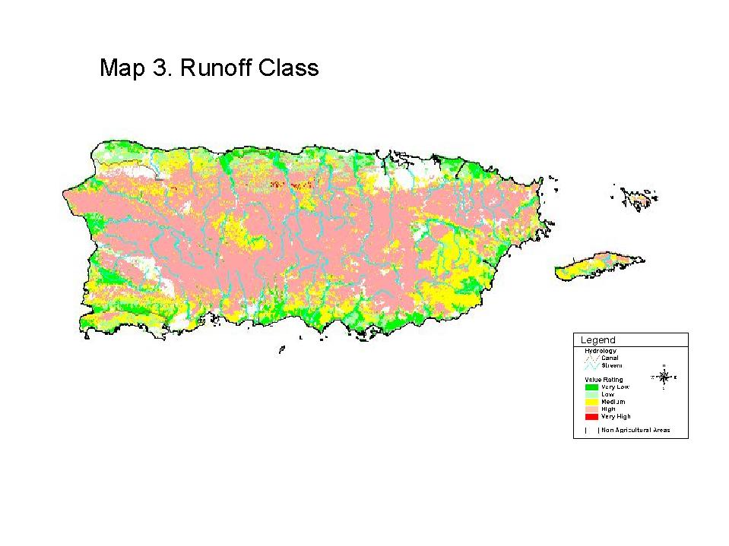
Map 3. General Soil Runoff Classes of Puerto Rico RRico

Table 5. Soil Test P Interpretation Categories by Soils Groups

Soils Groups | Soil Test P Interpretation
Soils Groups | Soil Test (PPM) | Very Low | Low | Moderate | High | Very High
Strongly Acid High P Sorption | Olsen or Bray | 0 - 10 | 11 - 30 | 31 - 130 | 131 - 300 | > 300
Moderate and Slightly Acids Low to Medium P Sorption | Bray | 0 - 10 | 11 - 30 | 31 - 55 | 56 - 100 | > 100
Moderate and Slightly Acids Low to Medium P Sorption | Olsen | 0 - 20 | 21 - 40 | 41 - 90 | 91 - 200 | > 200
Non Acid Low to Medium P Sorption | Olsen or Bray | 0 - 10 | 11 - 30 | 31 - 70 | 71 - 150 | > 150

Table 5 uses the P Sorption Capability Group (PSCG) system to characterize three soils groups based on potential P sorption and soil reaction. The PSCG describes the soil potential to fix phosphorus. Phosphate in the fixed P pool may have a very little impact on the fertility of the soil. The soil grouping is based on soil mineralogy and texture. P sorption is higher in strongly acid soils with oxidic and kaolinitic mineralogy and in alkaline soils with carbonatic mineralogy. Each of these reactions will result in very insoluble compounds of phosphate that are generally not available to plants. Continuous application of more P increases the fertility of the soil, but much of the added P becomes fixed and unavailable. The sorption intensity based on mineralogy for the soils in the Caribbean Area: Oxidic > Carbonatic > Kaolinitic > Mixed > Montmorrillonitic > Siliceous. The sorption capacity of organic soils is considered to be very low. Soil texture is another factor that influence soil sorption. The sorption is higher with an increase in soil clay. Soils with a coarse texture have a lower sorption. High P saturation level of most tropical soils can reduce the amount of soluble P in runoff. The combination of mineralogy and textural classes serve to create different sorption groups varying from very low to very high. A soil with higher sorption capacity may receive a lower rating value. The P sorption capability group may be estimated by the use of Table 6, Phosphorus Sorption Soil Capability Group Classification System.

Map 4 shows distribution of PSCG categories in Puerto Rico. The user may use the soil classification made by soil survey and mapping units included in the appendix 1. Also, soil map unit is correlated with a soil group to facilitate STPL interpretation.

12
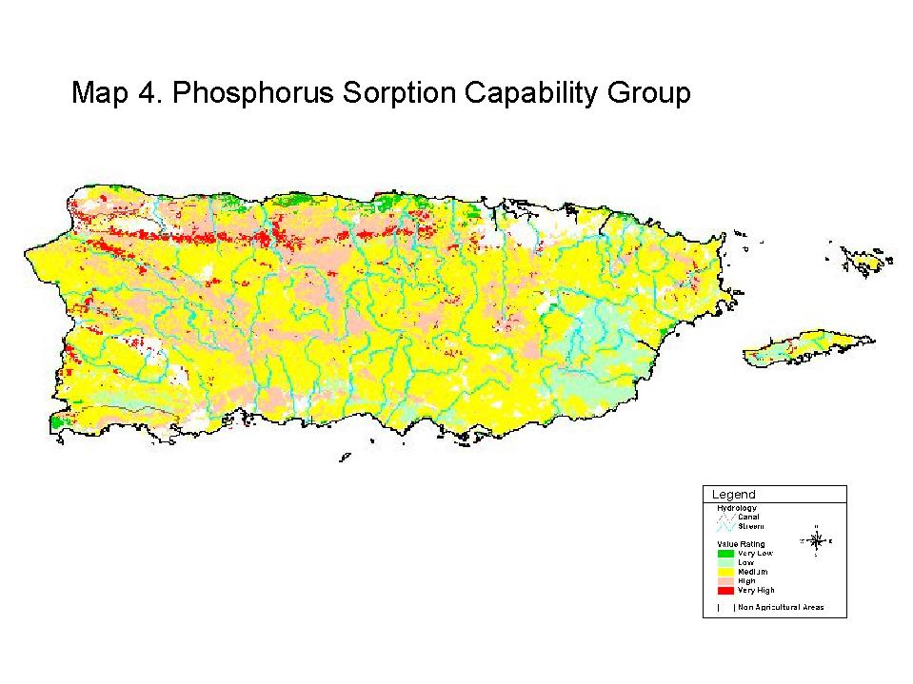
Map 4. General Soil Phosphorus Sorption Capability Groups of Puerto Rico

Table 6. Phosphorus Sorption Soil Capability Group Classification System

Phosphorus Sorption Soil Capability Group Interpretation Categories

Sorption Class | Descriptions
Very Low | - All soils with various mineralogy that have over 70% of sand fraction in the  surface horizon (sand and loamy sand).  - All organic soils.
Low | - Clayey soils with montmorrillonitic mineralogy.  - B. Other soils with mixed mineralogy that have less than 20% clay but no more  than 70% sand (SL, L, SIL and SI textural classes).
Medium | - Soils with mixed mineralogy that have more than 20% clay (SCL, CL, SICL, SC,  SIC and C textural classes).  - Soils with oxidic and carbonatic mineralogy that have no more than 70% sand  and less than 20% clay (SL, L and SIL textural classes).  - C. Other kaolinitic soils with SCL, CL, SICL, SL, L and SIL textural classes
High | - Clayey acid soils with Kaolinitc mineralogy  - Other soils with oxidic or carbonatic mineralogy that have clay between 20 and  35%  - (SCL, CL and SICL textural classes).
Very High | Clayey soils with more than 35% clay (C, SC and SIC textural classes) with oxidic or carbonatic mineralogy.

- Fertilizer P Application Ratio is the amount of P in pound per acre (lb./acre) that is applied to the soil, divided by the amount of P removed by the crop. The amount applied does not include phosphorus from organic sources. The form of phosphorus as well as the quantity is an important predictor of soluble P in runoff. Phosphorus uptakes for tropical crops are in Agricultural Waste Management Field Handbook, Chapter 6, Table 6 - 6 Caribbean Area Supplement.

FPR = Annual P application ratio/ P crop uptake

- Fertilizer P Application Method and Timing considers if the P fertilizer is surface applied, incorporated or irrigated. It also considers the amount of time that the P fertilizer is exposed on the soil surface and the historical weather seasons when most rainfall occurs. Fertilizer incorporation after application reduces the potential for P losses.

- Organic P Application Ratio is the function of total P in manure, in pound of per acre (lb./acre) of total P that is applied to the soil divided by the P crop uptake. An analysis of organic material is necessary to determine the total P content of the manure. This parameter includes all sources of phosphorus whether originating from organic sources such as animal manure, compost or poultry litter. Most of the total will be released over a period of time depending on soil and climatic condition. Phosphorus uptakes for tropical crops are in Agricultural Waste Management Field Handbook, Chapter 6, Table 6 - 6 Caribbean Area Supplement.

OPR = Annual Organic P application ratio / P crop uptake

- Organic P Application Method and Timing considers if the organic P material is surface applied, incorporated or irrigated and the amount of time that manure is exposed on the soil surface and the historical weather seasons when most rainfall occurs. Manure should be incorporated after application to reduce the potential for P losses.

USE OF THE P INDEX

The P Index was developed to rank the relative risk of occurrence, and should not be interpreted as an assurance of actual P loss. The ranking of a site does not reflect a water quality standard or represent a regulatory tool. It is a planning tool that can be used in resource management planning to identify sites that would require direct conservation efforts to minimize P transfer to surface water. A PI analysis helps the planner assist the producer in making nutrient management decisions.

The PI numerical value is interpreted in Table 6 and delineates if the nutrient management plan should be based on nitrogen or phosphorus. The numerical result of the PI is a qualitative rating (Low, Medium, High, or Very high). The transport value rating of 0.25 is the product of a very low erosion rate (0.6), very low runoff (0.6), and low distance to surface water and buffer strip width (0.7). The transport value rating of 0.5 is the product of all the transport characteristics (soil erosion, runoff class, and distance to surface water; buffer strip width) having a medium value rating of 0.8. The transport parameter yield 0.25 and 0.5 numerically depict the environmental vulnerability of average farm condition in Puerto Rico. As an example, multiplication of 0.25 by Very High source characteristics (30 points) results in a rating of 7.5 while Very High transport rating (1) multiplied by Low site source characteristic (3.75) gives a 3.75 rating. These value ratings are used in Table 7 to set P index rating of organic and inorganic low and medium categories. The same approach is used to set the other categories. Some values rating were slightly adjusted, such as increase the value from 7.5 to 7.7, to reflect actual condition. Separate values rating for organic and inorganic and organic or inorganic were set up to avoid rating underestimate when inorganic fertilizer is not applied. In this particular case the overall numerical rating is low but the risk of using organic amendment remain the same.

Table 7. Interpretation of the P Index

Rating P index |  | Generalized Interpretation of P Index for the Site
Organic & Inorganic | Organic or  Inorganic | Generalized Interpretation of P Index for the Site
≤ 3.7 | ≤ 2.7 | LOW potential for P movement from the site. If farming practices are maintained at current level there is a low probability of an adverse impact to waterbodies.
> 3 .7 ≤ 7.7 | > 2.7 ≤ 5.5 | MEDIUM potential for P movement from the site. The chance for an adverse impact to waterbodies exists. Soil and water conservation practices as well as P management practices should be taken to lessen the risk of P movement and potential water quality degradation.
> 7.7 ≤ 15 | > 5.5 ≤ 11 | HIGH potential for P movement from the site. The chance of organic material and nutrients getting to waterbodies is likely unless remedial action is taken. Soil and water conservation practices as well as P management plan are necessary to reduce the risk of P movement and water quality degradation.
> 15 | > 11 | VERY HIGH potential for P movement from the site and an adverse impact on waterbodies. All necessary soil and water conservation practices, plus P management plan must be put in place to avoid the potential for water quality degradation.

For each qualitative rating a description is given for the level of concern that each specifically assessed field has for P loss potential. Some general guidance is given for each qualitative level as to the intensity and type of remedial action or mitigation that would be necessary to reduce P loss risk.

Reviewing each individual site characteristic rating will identify whether the cause and severity of the risk warrants management attention. In a field with a Low or Medium vulnerability rating, it may be possible to manage animal manure using a nitrogen-based budget to determine manure application rates. On sites with a High or Very high rating, it may be desirable to manage animal manure based a phosphorus budget. When this occurs, manure application rate should be planned as a function of estimated phosphorus uptake in harvested plant biomass for the plant growing season or entire crop rotation. The application rate should be reduced as available soil P levels increase. Phosphorus may be applied at rates consistent with Table 8.

Table 8. Application rate according with P Index rating

P Index rating | P application rate
Low | Nitrogen Based
Medium | Nitrogen Based
High | Phosphorus Based ( 1 - 2 times P crop uptake )
Very High | Phosphorus Based ( ≤1 time P crop uptake )

Using the planning process, each individual site characteristic can be used to communicate with the landowner the potential for loss. The conservation planner can identify those site characteristics that have the greatest influence in determining the final vulnerability rating, and may be targeted for remedial action. Management actions and conservation practices can then be planned and implemented to reduce the P loss risk.

The P index assessment in a proposed manure application sites should considers soil diversity and distribution and any other significant variation in P Index components at farm level. However, it must be kept in mind that the P Index is only a crude estimator to rank sites on the relative risk of loss of P to surface water. Therefore, while the site-specific microscale approach can have advantages, it may not be seen to have value by all users.

BEST MANAGEMENT PRACTICES FOR REDUCING SITE VULNERABILITY

A best management practice (BMP) is a practice or combination of practices used in a conservation management system to reduce site vulnerability. The table below lists the most common BMP used in the Caribbean Area to prevent nonpoint source pollution of surface water by agricultural P. It also displays the potential environmental effect that each BMP has on site vulnerability. BMP may decrease, increase or have no effects on site conditions. These BMP may minimize P losses from soil to water or improve management practices. BMP and corresponding effects could be used to reevaluate the current conditions to determine what factors are creating the highest levels of concern. Once these factors have been determined, an onsite assessment should be made to evaluate the feasibility of making changes to reduce the vulnerability rating to an acceptable level. In general any practice which reduces soil erosion and runoff and improves nutrient management will reduce the P loss from landscape. This may require several trials and a combination of BMP to achieve the desired level. When site vulnerability cannot be reduced enough to apply animal waste, an alternate site would need to be considered.

Table 9. Environmental Effects of Best Management Practices on P index
Parameters

Best Management Practices | Environmental Effects on P index Parameters
Best Management Practices | Soil Erosion | Runoff | Surface  Water | Soil Test P Level | P Application  Ratio | P Application  Method
Conservation Cover | - | - | - | 0 | - | 0
Conservation Crop Rotation | - | - | 0 | - | - | 0
Contour Farming | - | - | 0 | 0 | 0 | 0
Diversion | - | - | 0 | 0 | 0 | 0
Field Border | - | - | - | 0 | 0 | 0
Filter Strip | - | - | - | 0 | 0 | 0
Grassed Waterway | - | - | - | 0 | 0 | 0
Hillside Ditch | - | - | 0 | 0 | 0 | 0
Irrigation Water Management | - | - | 0 | - | 0 | -
Land Mechanical Treatment | - | - | 0 | 0 | 0 | -
Manure Transfer | 0 | - | 0 | 0 | 0 | -
Nutrient Management | 0 | 0 | - | - | - | -
Pasture and Hayland Planting | - | - | 0 | - | - | 0
Residue Management, No Till | - | - | 0 | 0 | - | 0
Residue Management, Mulch Till | - | - | 0 | 0 | - | 0
Residue Management, Seasonal | - | - | 0 | 0 | - | 0
Riparian Forest Buffer | - | - | - | 0 | 0 | 0
Roof Runoff Management | - | - | - | 0 | 0 | 0
Use Exclusion | 0 | 0 | - | 0 | 0 | 0
Waste Utilization | 0 | 0 | - | - | - | -

Legend: + Increase effect; - Decrease effect; 0 - No effect

PROCEDURE TO CALCULATE PHOSPHORUS INDEX

Step 1 – Inventory procedure and tools

The following is a list of all the information and procedure needed to make determination, along with where that information is found.

- Field observation and measurements

- Identify predominant soil type in field from soil survey.
- Measure distance to surface water and buffer width and percent cover stand.
- Measure slope length and steepness and estimate cover stand percent in field.
- List existing best management practices, including conservation practices that meet NRCS standards.
- Identify all major resources problems affecting nutrient management.

- Farm operator data

- Soil test report
- Manure test report
- Amount and type of fertilizer and manure applied
- Application method and timing of fertilizer and manure applied
- Crop rotation

- Tools

- National Agronomy Manual
- P Index Worksheets
- RUSLE Handbook of the Caribbean Area
- Field Office Technical Guide Sections I - V
- Agricultural Waste Management Manual
- Soil Survey

Step 2 - Determine the value for each field feature and management

This step serves as a basic guide to arrange and use the information collected to determine the P index factor. The procedure is separated into transport and site source characteristics.
A. Transport Characteristics

- Forecast Soil Erosion using RUSLE.
- Determine Runoff Class using the table provided or selects the value from the database in the Appendix.

- Use measures distance to surface water and buffer width distance and percent cover stand to determine Distance to Surface Water and Buffer Strip Width.

B. Site Source Characteristics

- Use soil test report to determine Soil Test P Level factor.

Step 3 – P index Rating

- Use the Caribbean Area P index Assessment Worksheets (Table 3) to find the class value rating that best describes the site condition determined.

- Score the rating for each factor in the field no. column of the Caribbean Area P Index Rating Worksheet in the Appendix 2.

- Compute the P index following the procedure describes in the Caribbean Area P Index Rating Worksheet.

- Assess overall rating using tables 7 and 8.

- Recommend BMP to reduce P loss using Table 9. Environmental Effects of Best Management Practices on P index Parameters.

Appendix 1. Phosphorus Index Transport Data by Soil Survey

Arecibo Soil Survey P index Transport Data
Map Symbol | Soil Series | Phosphorus  Sorption  Capability  Group | Soil Test P ¹ Level  Groups | Runoff  Class
AaC | Aceitunas | H | Soil Group1 | M
AcC | Aceitunas | VH | Soil Group1 | M
AdF2 | Adjuntas | H | Soil Group1 | H
AgC | Algarrobo | VL | Soil Group2 | L
AlB | Almirante | M | Soil Group1 | L
AlC | Almirante | M | Soil Group1 | M
AmB | Almirante | M | Soil Group1 | L
AmC | Almirante | M | Soil Group1 | M
AnB | Almirante | H | Soil Group1 | L
AnC | Almirante | H | Soil Group1 | M
AoD2 | Alonso | H | Soil Group1 | M
AoE2 | Alonso | H | Soil Group1 | H
AoF2 | Alonso | H | Soil Group1 | H
ArC | Arecibo | VL | Soil Group2 | VL
Ba | Bajura | M | Soil Group2 | L
BcB | Bayamon | M | Soil Group1 | L
BcC | Bayamon | M | Soil Group1 | M
BsB | Bayamon | M | Soil Group1 | L
BsC | Bayamon | M | Soil Group1 | M
ByB | Bayamon | H | Soil Group1 | L
ByC | Bayamon | H | Soil Group1 | M
CaF | Caguabo | M | Soil Group2 | H
CbF | Caguabo | M | Soil Group2 | H
CcD | Caracoles | L | Soil Group2 | M
CcE | Caracoles | L | Soil Group2 | H
CeC | Carrizales | VL | Soil Group2 | L
Cf | Catano | VL | Soil Group2 | N
ClD2 | Colinas | H | Soil Group3 | M
ClE2 | Colinas | H | Soil Group3 | H
ClF2 | Colinas | H | Soil Group3 | H
CmF2 | Colinas | H | Soil Group3 | H
Cn | Coloso | M | Soil Group2 | N
CoE | Consejo | M | Soil Group1 | H

¹ Soils Group 1: Strongly Acid High P Sorption

Soils Group 2: Moderate and Slightly Acids Low to Medium P Sorption

Soils Group 3: Non Acid Low to Medium P Sorption
Arecibo Soil Survey P index Transport Data
Map Symbol | Soil Series | Phosphorus  Sorption  Capability  Group | Soil Test P ¹ Level  Groups | Runoff  Class
CoF | Consejo | M | Soil Group1 | H
CpE | Consumo | M | Soil Group1 | H
CpF | Consumo | M | Soil Group1 | H
CrC | Corozal | M | Soil Group1 | H
CsC | Corozo | VL | Soil Group2 | L
CtB | Coto | H | Soil Group1 | L
CtC | Coto | H | Soil Group1 | M
CuF | Cuchillas | M | Soil Group1 | H
CvF | Cuchillas | M | Soil Group1 | H
DaD2 | Daguey | VH | Soil Group1 | M
EaB | Espinosa | L | Soil Group1 | L
EaC | Espinosa | L | Soil Group1 | M
EbB | Espinosa | M | Soil Group1 | L
EbC | Espinosa | M | Soil Group1 | M
EcB | Espinosa | M | Soil Group1 | L
EcC | Espinosa | M | Soil Group1 | M
Ga | Garrochales | VL | Soil Group2 | N
GeC | Guerrero | VL | Soil Group2 | L
HmE | Humatas | H | Soil Group1 | H
HmF | Humatas | H | Soil Group1 | H
InD | Ingenio | M | Soil Group1 | M
InE | Ingenio | M | Soil Group1 | H
IsC | Islote | M | Soil Group2 | L
Ja | Jareales | M | Soil Group2 | N
JoC | Jobos | M | Soil Group2 | L
JuD2 | Juncal | M | Soil Group2 | M
JuE2 | Juncal | M | Soil Group2 | H
LME | Los Guineos | H | Soil Group1 | H
LME | Maricao | H | Soil Group1 | H
LcE2 | Lirios | M | Soil Group1 | H
LcF2 | Lirios | M | Soil Group1 | H
LgD | Los Guineos | H | Soil Group1 | M
LgE | Los Guineos | H | Soil Group1 | H
LgF | Los Guineos | H | Soil Group1 | H
MaF2 | Maraguez | M | Soil Group2 | H
McF | Maricao | M | Soil Group1 | H

¹ Soils Group 1: Strongly Acid High P Sorption

Soils Group 2: Moderate and Slightly Acids Low to Medium P Sorption

Soils Group 3: Non Acid Low to Medium P Sorption

Arecibo Soil Survey P index Transport Data
Map Symbol | Soil Series | Phosphorus  Sorption  Capability  Group | Soil Test P ¹ Level  Groups | Runoff  Class
MmF | Matanzas | VH | Soil Group1 | L
MnB | Matanzas | VH | Soil Group1 | L
MoC2 | Moca | M | Soil Group1 | M
MoD2 | Moca | M | Soil Group1 | M
MoE2 | Moca | M | Soil Group1 | H
MpF2 | Morado | M | Soil Group2 | H
MuE | Mucara | M | Soil Group2 | H
MuF | Mucara | M | Soil Group2 | H
NaD | Naranjo | L | Soil Group2 | H
NaE | Naranjo | L | Soil Group2 | VH
NaF | Naranjo | L | Soil Group 2 | VH
Pa | Palmar | VL | Soil Group2 | N
PeF | Pellejas | M | Soil Group2 | M
PhC2 | Perchas | M | Soil Group2 | H
PhD2 | Perchas | M | Soil Group2 | H
Re | Reilly | L | Soil Group2 | N
RlC | Rio Lajas | VL | Soil Group2 | VL
RsF | San German | H | Soil Group3 | M
RtF | Tanama | M | Soil Group3 | H
SaB | Sabana Seca | M | Soil Group2 | M
SgD | San German | H | Soil Group3 | L
SgF | San German | H | Soil Group3 | M
SmF | San Sebastian | VH | Soil Group3 | H
SnC | Santa Clara | M | Soil Group3 | L
SoC | Soller | M | Soil Group3 | M
SoD | Soller | M | Soil Group3 | M
SoF | Soller | M | Soil Group3 | H
SpD | Soller | M | Soil Group3 | M
SpF | Soller | M | Soil Group3 | H
SrF | Soller | M | Soil Group3 | H
TaB | Tanama | M | Soil Group3 | L
TaC2 | Tanama | M | Soil Group3 | M
TaD2 | Tanama | M | Soil Group3 | M
Tb | Tiburones | VL | Soil Group2 | N
To | Toa | M | Soil Group2 | N
VaB | Vega Alta | M | Soil Group2 | L

¹ Soils Group 1: Strongly Acid High P Sorption

Soils Group 2: Moderate and Slightly Acids Low to Medium P Sorption

Soils Group 3: Non Acid Low to Medium P Sorption

Arecibo Soil Survey P index Transport Data
Map Symbol | Soil Series | Phosphorus  Sorption  Capability  Group | Soil Test P ¹ Level  Groups | Runoff  Class
VaC2 | Vega Alta | M | Soil Group2 | M
VcB | Vega Alta | M | Soil Group2 | L
VcC2 | Vega Alta | M | Soil Group2 | M
VeB | Vega Baja | M | Soil Group2 | M
Vg | Vigia | VL | Soil Group2 | N
Vm | Vivi | L | Soil Group2 | N
VoC2 | Voladora | VH | Soil Group1 | M
VoD2 | Voladora | VH | Soil Group1 | M
VoE2 | Voladora | VH | Soil Group1 | H

¹Soils Group 1: Strongly Acid High P Sorption

Soils Group 2: Moderate and Slightly Acids Low to Medium P Sorption
Soils Group 3: Non Acid Low to Medium P Sorption

Humacao Soil Survey P index Transport Data
Map Symbol | Soil Series | Phosphorus  Sorption  Capability  Group | Soil Test P ¹ Level  Groups | Runoff  Class
AcC | Aceitunas | H | Soil Group1 | M
Ad | Aguadilla | VL | Soil Group2 | N
Ag | Aguadilla | L | Soil Group2 | N
AmB | Amelia | M | Soil Group1 | L
AmC2 | Amelia | M | Soil Group1 | M
An | Arenales | L | Soil Group2 | N
Ar | Arenales | L | Soil Group2 | N
Ba | Bajura | M | Soil Group2 | L
Bc | Bajura | M | Soil Group2 | L
CbD2 | Caguabo | M | Soil Group2 | M
CbF2 | Caguabo | M | Soil Group 2 | H
CdB | Candelero | L | Soil Group2 | VL
CdC2 | Candelero | L | Soil Group2 | L
Ce | Cartagena | M | Soil Group3 | L
Cf | Catano | VL | Soil Group2 | N
CgC2 | Cayagua | L | Soil Group2 | M
CgD2 | Cayagua | L | Soil Group2 | M
ClB | Coamo | M | Soil Group3 | M
ClC | Coamo | M | Soil Group3 | H
Co | Coloso | M | Soil Group2 | L
Cr | Coloso | M | Soil Group2 | L
Cs | Corcega | L | Soil Group2 | N
DaC | Daguao Variant | M | Soil Group2 | M
DcE2 | Daguao | M | Soil Group2 | H
DeC2 | Descalabrado | M | Soil Group2 | M
DeE2 | Descalabrado | M | Soil Group2 | H
DgF2 | Descalabrado | M | Soil Group2 | H
DgF2 | Guayama | M | Soil Group2 | H
DrF | Descalabrado | M | Soil Group2 | H
FaC | Fajardo | M | Soil Group2 | H
FaC2 | Fajardo | M | Soil Group2 | H
Fo | Fortuna | M | Soil Group2 | L
FrA | Fraternidad | L | Soil Group3 | L
FrB | Fraternidad | L | Soil Group3 | M

¹ Soils Group 1: Strongly Acid High P Sorption

Soils Group 2: Moderate and Slightly Acids Low to Medium P Sorption
Soils Group 3: Non Acid Low to Medium P Sorption

Humacao Soil Survey P index Transport Data
Map Symbol | Soil Series | Phosphorus  Sorption  Capability  Group | Soil Test P ¹ Level  Groups | Runoff  Class
GvF | Guayabota | M | Soil Group2 | H
GvF | Ciales | M | Soil Group2 | H
GvF | Picacho | M | Soil Group2 | H
GyC2 | Guayama Variant | M | Soil Group2 | M
HmB | Humacao | L | Soil Group2 | VL
HtE2 | Humatas | H | Soil Group1 | H
HtF2 | Humatas | H | Soil Group1 | H
HuF | Humatas | H | Soil Group1 | H
InE2 | Ingenio | M | Soil Group1 | H
JaB | Jacana | M | Soil Group3 | L
JaC2 | Jacana | M | Soil Group 3 | M
JgE2 | Jagueyes | M | Soil Group2 | M
JuC | Junquitos | M | Soil Group2 | M
LeE2 | Limones | H | Soil Group1 | H
LoC2 | Lirios | M | Soil Group1 | M
LrE2 | Lirios | M | Soil Group1 | H
LsD | Los Guineos | M | Soil Group1 | M
LsE2 | Los Guineos | M | Soil Group1 | H
LsF2 | Los Guineos | M | Soil Group1 | H
LyF | Los Guineos | M | Soil Group1 | H
LyF | Yunque | M | Soil Group2 | H
MaB | Mabi | L | Soil Group2 | M
MaC2 | Mabi | L | Soil Group2 | H
MaD2 | Mabi | L | Soil Group2 | H
McA | Machete | M | Soil Group2 | N
McB | Machete | M | Soil Group 2 | VL
Me | Maunabo | M | Soil Group2 | L
MlC | Mayo | L | Soil Group2 | M
MrB | Meros | VL | Soil Group2 | L
MuD2 | Mucara | M | Soil Group2 | L
MuE2 | Mucara | M | Soil Group2 | H
NaE2 | Naranjito | M | Soil Group1 | H
NaF2 | Naranjito | M | Soil Group1 | H
PaE2 | Pandura | L | Soil Group2 | M
PaF2 | Pandura | L | Soil Group2 | M

¹ Soils Group 1: Strongly Acid High P Sorption

Soils Group 2: Moderate and Slightly Acids Low to Medium P Sorption

Soils Group 3: Non Acid Low to Medium P Sorption

Humacao Soil Survey P index Transport Data
Map Symbol | Soil Series | Phosphorus  Sorption  Capability  Group | Soil Test P ¹ Level  Groups | Runoff  Class
PdF | Pandura | L | Soil Group2 | M
PeC2 | Parcelas | M | Soil Group2 | M
PlB | Paso Seco | M | Soil Group2 | M
PmD2 | Patillas | M | Soil Group2 | M
PmE2 | Patillas | M | Soil Group2 | H
Po | Poncena | M | Soil Group 3 | L
PrC2 | Pozo Blanco | H | Soil Group3 | M
Re | Reilly | L | Soil Group2 | N
Rp | Reparada | M | Soil Group2 | N
RrB | Rio Arriba | M | Soil Group2 | L
RrC2 | Rio Arriba | M | Soil Group2 | M
SaE2 | Sabana | M | Soil Group2 | H
SaF2 | Sabana | M | Soil Group2 | H
Ta | Talante | M | Soil Group2 | N
TeE | Teja | L | Soil Group2 | M
Tt | Toa | M | Soil Group2 | N
UpF | Utuado | M | Soil Group2 | H
UpF | Picacho | M | Soil Group2 | H
Va | Vayas | M | Soil Group3 | N
Vc | Vayas | M | Soil Group3 | N
VeB | Vega Alta | M | Soil Group 2 | L
VeC | Vega Alta | M | Soil Group2 | M
VgA | Vega Baja | M | Soil Group2 | L
VlC | Via | M | Soil Group2 | M
VmC | Vieques | L | Soil Group3 | L
VmE2 | Vieques | L | Soil Group3 | M
Vs | Vives | M | Soil Group2 | N
VvA | Vives | M | Soil Group2 | N
VvB | Vives | M | Soil Group3 | L
Vw | Vivi | L | Soil Group2 | N
YuF2 | Yunes | M | Soil Group2 | H

¹ Soils Group 1: Strongly Acid High P Sorption

Soils Group 2: Moderate and Slightly Acids Low to Medium P Sorption
Soils Group 3: Non Acid Low to Medium P Sorption

Lajas Soil Survey P index Transport Data
Map Symbol | Soil Series | Phosphorus  Sorption  Capability  Group | Soil Test P ¹ Level  Groups | Runoff  Class
AcD | Aguilita | VH | Soil Group3 | M
AcE | Aguilita | VH | Soil Group3 | H
Ag | Aguirre | M | Soil Group3 | M
AmB | Amelia | M | Soil Group3 | L
AmB | Maguayo* | M | Soil Group3 | L
AmC2 | Amelia | M | Soil Group3 | M
AmC2 | Maguayo* | M | Soil Group3 | M
Ao | Amelia | M | Soil Group3 | L
AsB | Bahia | VL | Soil Group3 | VL
Ca | Cartagena | M | Soil Group3 | L
Cc | Cartagena Variant | M | Soil Group3 | L
DeC | Descalabrado | M | Soil Group3 | M
DeD | Descalabrado | M | Soil Group3 | M
DeF | Descalabrado | M | Soil Group3 | H
Fe | Fe | M | Soil Group3 | M
FrA | Fraternidad | L | Soil Group3 | L
FrB | Fraternidad | L | Soil Group3 | M
Ft | Fraternidad | L | Soil Group3 | L
FvA | Fraternidad | L | Soil Group3 | L
FvB | Fraternidad | L | Soil Group 3 | M
Gc | Guanica | L | Soil Group3 | M
Gf | Guayabo | VL | Soil Group3 | N
GuD | Guayama | M | Soil Group3 | M
GuF | Guayama | M | Soil Group3 | H
JaB | Jacana | M | Soil Group3 | L
JaC | Jacana | M | Soil Group3 | M
JaC2 | Jacana | M | Soil Group3 | M
JaD2 | Jacana | M | Soil Group3 | M
JcB | Jacana | M | Soil Group3 | L
JcC | Jacana | M | Soil Group3 | M
MaD2 | Mariana | M | Soil Group3 | L
MaE2 | Mariana | M | Soil Group3 | M
PaA | Palmarejo | L | Soil Group3 | N
PaB | Palmarejo | L | Soil Group3 | L
PaC2 | Palmarejo | L | Soil Group3 | M

¹ Soils Group 1: Strongly Acid High P Sorption

Soils Group 2: Moderate and Slightly Acids Low to Medium P Sorption
Soils Group 3: Non Acid Low to Medium P Sorption
Lajas Soil Survey P index Transport Data
Map Symbol | Soil Series | Phosphorus  Sorption  Capability  Group | Soil Test P ¹ Level  Groups | Runoff  Class
PcB | Poncena | M | Soil Group3 | M
PcC2 | Poncena | M | Soil Group3 | H
PoA | Pozo Blanco | M | Soil Group3 | L
PzB | Pozo Blanco | H | Soil Group3 | L
PzC | Pozo Blanco | H | Soil Group3 | M
PzD | Pozo Blanco | H | Soil Group3 | M
Sa | San Anton | M | Soil Group3 | N
Sc | San Anton | M | Soil Group3 | N
Se | San Anton Variant | M | Soil Group3 | N
SgD | San German | M | Soil Group3 | L
SgF | San German | M | Soil Group3 | M
SmE | San German | H | Soil Group3 | M
Sn | Santa Isabel | L | Soil Group3 | M
SoA | Sosa | VL | Soil Group3 | N
SsB | Sosa | M | Soil Group3 | VL
SsD2 | Sosa | M | Soil Group3 | L
Tc | Teresa | M | Soil Group3 | N
Va | Vayas | M | Soil Group3 | N

* Complex component

¹ Soils Group 1: Strongly Acid High P Sorption

Soils Group 2: Moderate and Slightly Acids Low to Medium P Sorption
Soils Group 3: Non Acid Low to Medium P Sorption

Mayagüez Soil Survey P index Transport Data
Map Symbol | Soil Series | Phosphorus  Sorption  Capability  Group | Soil Test P ¹ Level  Groups | Runoff  Class
AaC2 | Aceitunas | VH | Soil Group1 | M
AbC2 | Aceitunas | H | Soil Group1 | M
AcD | Aguilita | VH | Soil Group3 | M
AcE | Aguilita | VH | Soil Group3 | H
AdE2 | Aibonito | VH | Soil Group1 | H
AoD | Anones | H | Soil Group1 | M
AoE2 | Anones | H | Soil Group1 | H
AoF2 | Anones | H | Soil Group1 | H
Ba | Bajura | M | Soil Group2 | L
BcB | Bejucos | H | Soil Group2 | L
BeB | Bejucos | M | Soil Group2 | VL
CaC | Cabo Rojo | M | Soil Group1 | M
CaC2 | Cabo Rojo | M | Soil Group1 | M
CbF2 | Caguabo | M | Soil Group2 | H
CcB | Camaguey | L | Soil Group2 | H
Cd | Catano | VL | Soil Group2 | N
Ce | Catano | H | Soil Group2 | L
CfC2 | Cidral | M | Soil Group1 | M
ClD | Colinas | H | Soil Group 3 | M
ClE | Colinas | H | Soil Group3 | H
ClF2 | Colinas | H | Soil Group3 | H
CmD | Colinas | H | Soil Group3 | M
CmE | Colinas | H | Soil Group3 | H
Cn | Coloso | M | Soil Group2 | N
CoE | Consumo | M | Soil Group1 | H
CoF2 | Consumo | M | Soil Group1 | H
Cr | Corcega | M | Soil Group2 | N
CtB2 | Cotito | H | Soil Group1 | L
CuB2 | Coto | H | Soil Group1 | L
CuC2 | Coto | H | Soil Group1 | M
CvB | Coto | M | Soil Group1 | L
CwF | Cuchillas |  |  | H
DaD2 | Daguey | VH | Soil Group1 | M
DaE2 | Daguey | VH | Soil Group1 | H

¹ Soils Group 1: Strongly Acid High P Sorption

Soils Group 2: Moderate and Slightly Acids Low to Medium P Sorption
Soils Group 3: Non Acid Low to Medium P Sorption

Mayagüez Soil Survey P index Transport Data
Map Symbol | Soil Series | Phosphorus  Sorption  Capability  Group | Soil Test P ¹ Level  Groups | Runoff  Class
DcD2 | Delicias | VH | Soil Group1 | M
DeC | Descalabrado | M | Soil Group2 | M
DeD | Descalabrado | M | Soil Group2 | M
DeF | Descalabrado | M | Soil Group2 | H
Du | Dique | L | Soil Group2 | N
Es | Espinal | VL | Soil Group2 | N
GnC | Guanajibo | M | Soil Group2 | L
GoC | Guanajibo | M | Soil Group2 | L
GuB | Guerrero | VL | Soil Group2 | N
HmD2 | Humatas | H | Soil Group1 | M
HmE2 | Humatas | H | Soil Group1 | H
HmF2 | Humatas | H | Soil Group1 | H
HuE | Humatas | H | Soil Group1 | H
Ig | Igualdad | M | Soil Group2 | L
JaC | Jacana | M | Soil Group3 | M
Jd | Jaucas | VL | Soil Group2 | N
JoB | Jobos | M | Soil Group2 | VL
JuD2 | Juncal | M | Soil Group 2 | M
LaB2 | Lares | M | Soil Group1 | L
LaD2 | Lares | M | Soil Group1 | M
LuD2 | Los Guineos | H | Soil Group1 | M
LuF2 | Los Guineos | H | Soil Group1 | H
MaB | Mabi | L | Soil Group2 | M
MaC2 | Mabi | L | Soil Group2 | H
McF2 | Malaya | M | Soil Group2 | H
MdB | Maleza | VL | Soil Group2 | VL
Mh | Mani | M | Soil Group2 | N
Mn | Mani | M | Soil Group2 | N
MoD2 | Maresua | M | Soil Group2 | L
MoF2 | Maresua | M | Soil Group2 | M
MpD2 | Mariana | M | Soil Group2 | L
MpE2 | Mariana | M | Soil Group2 | M
MrF2 | Maricao | M | Soil Group1 | H
MsB | Matanzas | VH | Soil Group1 | L
MtB | Matanzas | VH | Soil Group1 | L
MuC2 | Moca | M | Soil Group1 | M

¹ Soils Group 1: Strongly Acid High P Sorption

Soils Group 2: Moderate and Slightly Acids Low to Medium P Sorption
Soils Group 3: Non Acid Low to Medium P Sorption
Mayagüez Soil Survey P index Transport Data
Map Symbol | Soil Series | Phosphorus  Sorption  Capability  Group | Soil Test P ¹ Level  Groups | Runoff  Class
MuD2 | Moca | M | Soil Group1 | M
MuD3 | Moca | M | Soil Group1 | M
MuE3 | Moca | M | Soil Group1 | H
MvC | Montegrande | L | Soil Group2 | M
MwD2 | Morado | M | Soil Group2 | M
MwE2 | Morado | M | Soil Group2 | H
MwF2 | Morado | M | Soil Group2 | H
MxC | Mucara | M | Soil Group2 | M
MxD2 | Mucara | M | Soil Group2 | M
MxE2 | Mucara | M | Soil Group2 | H
MxF2 | Mucara | M | Soil Group2 | H
NaD | Naranjo | L | Soil Group3 | H
NcD2 | Nipe | VH | Soil Group1 | L
PaC2 | Palmarejo | M | Soil Group2 | M
PeD2 | Perchas | M | Soil Group2 | H
PlE2 | Plata | M | Soil Group2 | H
PlF2 | Plata | M | Soil Group2 | H
QuD2 | Quebrada | M | Soil Group2 | M
QuE2 | Quebrada | M | Soil Group2 | H
QuF2 | Quebrada | M | Soil Group2 | H
Re | Reilly | L | Soil Group2 | N
RlB | Rio Lajas | VL | Soil Group2 | N
RpC2 | Rio Piedras | H | Soil Group1 | M
RpD2 | Rio Piedras | H | Soil Group1 | M
RsD2 | Rosario | VH | Soil Group1 | M
RsE2 | Rosario | VH | Soil Group1 | H
RsF2 | Rosario | VH | Soil Group1 | H
SaD | San German | H | Soil Group3 | L
SaE | San German | H | Soil Group3 | M
ScB | San German | M | Soil Group3 | VL
SdF2 | San Sebastian | VH | Soil Group3 | H
SeB | Santa Clara | M | Soil Group2 | L
SmE2 | Santa Marta | VH | Soil Group2 | H
Sn | Santoni | M | Soil Group2 | L
SrD | Soller | M | Soil Group3 | M
SrE | Soller | M | Soil Group3 | H

¹ Soils Group 1: Strongly Acid High P Sorption

Soils Group 2: Moderate and Slightly Acids Low to Medium P Sorption
Soils Group 3: Non Acid Low to Medium P Sorption
Mayagüez Soil Survey P index Transport Data
Map Symbol | Soil Series | Phosphorus  Sorption  Capability  Group | Soil Test P ¹ Level  Groups | Runoff  Class
SsD2 | Soller | M | Soil Group3 | M
SsE2 | Soller | M | Soil Group3 | H
StB | Soller | M | Soil Group3 | L
StC | Soller | M | Soil Group3 | M
StD | Soller | M | Soil Group3 | M
StE | Soller | M | Soil Group3 | H
Ta | Talante | L | Soil Group2 | N
TcB2 | Tanama | M | Soil Group3 | L
TcC2 | Tanama | M | Soil Group3 | M
TcD2 | Tanama | M | Soil Group3 | M
TcE2 | Tanama | M | Soil Group3 | H
ToA | Toa | M | Soil Group3 | N
Ts | Toa | M | Soil Group3 | N
VoD2 | Voladora | VH | Soil Group1 | M
VoE2 | Voladora | VH | Soil Group1 | H
VrC2 | Voladora | VH | Soil Group1 | M

¹ Soils Group 1: Strongly Acid High P Sorption

Soils Group 2: Moderate and Slightly Acids Low to Medium P Sorption

Soils Group 3: Non Acid Low to Medium P Sorption

Ponce Soil Survey P index Transport Data
Map Symbol | Soil Series | Phosphorus  Sorption  Capability  Group | Soil Test P ¹ Level  Groups | Runoff  Class
AaF2 | Adjuntas | H | Soil Group1 | H
AgD | Aguilita | H | Soil Group3 | M
AgF | Aguilita | H | Soil Group3 | H
AhF | Aguilita | H | Soil Group3 | H
AnE2 | Alonso | H | Soil Group1 | H
AnF2 | Alonso | H | Soil Group1 | H
CbF2 | Caguabo | M | Soil Group2 | H
CdF | Caguabo | M | Soil Group2 | H
CoD | Callabo | M | Soil Group2 | M
CoE | Callabo | M | Soil Group2 | H
CoF2 | Callabo | M | Soil Group2 | H
Cr | Cintrona | M | Soil Group3 | M
Ct | Constancia | M | Soil Group3 | M
CuF2 | Consumo | M | Soil Group1 | H
Cx | Cortada | M | Soil Group3 | N
CyB | Cuyon | L | Soil Group3 | N
DaD | Daguey | VH | Soil Group1 | M
EnC | Ensenada | M | Soil Group3 | M
Fe | Fe | M | Soil Group3 | M
FtB | Fraternidad | L | Soil Group3 | M
FtC2 | Fraternidad | L | Soil Group3 | H
GoF | Guanabano | M | Soil Group3 | H
HmE2 | Humatas | H | Soil Group1 | H
HmF2 | Humatas | H | Soil Group1 | H
HxF | Humatas | H | Soil Group1 | H
Jg | Jacaguas | M | Soil Group3 | N
JnC | Jacana | M | Soil Group3 | M
JzD | Juana Diaz | M | Soil Group2 | M
JzE | Juana Diaz | M | Soil Group2 | H

¹ Soils Group 1: Strongly Acid High P Sorption

Soils Group 2: Moderate and Slightly Acids Low to Medium P Sorption
Soils Group 3: Non Acid Low to Medium P Sorption

Ponce Soil Survey P index Transport Data
Map Symbol | Soil Series | Phosphorus  Sorption  Capability  Group | Soil Test P ¹ Level  Groups | Runoff  Class
LeC | Lares | M | Soil Group1 | M
LmF2 | Lirios | M | Soil Group1 | H
LnB | Llanos | M | Soil Group2 | L
LnC2 | Llanos | M | Soil Group2 | M
LuE | Los Guineos | H | Soil Group1 | H
LuF | Los Guineos | H | Soil Group1 | H
LyFX | Los Guineos | H | Soil Group1 | H
LyFX | Maricao | H | Soil Group1 | H
LnB | Llanos | M | Soil Group2 | L
LnC2 | Llanos | M | Soil Group2 | M
LuE | Los Guineos | H | Soil Group1 | H
LuF | Los Guineos | H | Soil Group1 | H
LyFX | Los Guineos | H | Soil Group1 | H
LyFX | Maricao | H | Soil Group1 | H
LzFX | Los Guineos | H | Soil Group1 | H
LzFX | Maricao | H | Soil Group1 | H
Ma | Machuelo | H | Soil Group2 | L
MeF2 | Maraguez | M | Soil Group2 | H
MkF2 | Maricao | M | Soil Group1 | H
Mr | Meros | VL | Soil Group2 | N
MsC | Montegrande | L | Soil Group2 | M
MtE2 | Morado | M | Soil Group2 | H
MtF2 | Morado | M | Soil Group2 | H
MuD2 | Mucara | M | Soil Group2 | M
MuE2 | Mucara | M | Soil Group2 | H
MuF2 | Mucara | M | Soil Group2 | H
PaB | Paso Seco | M | Soil Group3 | M
PeF2 | Pellejas | M | Soil Group2 | M
QeD2 | Quebrada | M | Soil Group2 | M
QeE2 | Quebrada | M | Soil Group2 | H
QeF2 | Quebrada | M | Soil Group2 | H
Re | Reilly | L | Soil Group2 | N
Sa | San Anton | M | Soil Group3 | N
Se | Serrano | VL | Soil Group2 | N

¹ Soils Group 1: Strongly Acid High P Sorption

Soils Group 2: Moderate and Slightly Acids Low to Medium P Sorption
Soils Group 3: Non Acid Low to Medium P Sorption

Ponce Soil Survey P index Transport Data
Map Symbol | Soil Series | Phosphorus  Sorption  Capability  Group | Soil Test P ¹ Level  Groups | Runoff  Class
Te | Teresa | M | Soil Group3 | N
To | Toa | M | Soil Group3 | N
TuF | Tuque | M | Soil Group3 | M
YcB | Yauco | H | Soil Group3 | L
YcC | Yauco | H | Soil Group3 | M

¹ Soils Group 1: Strongly Acid High P Sorption

Soils Group 2: Moderate and Slightly Acids Low to Medium P Sorption

Soils Group 3: Non Acid Low to Medium P Sorption

San Juan Soil Survey P index Transport Data
Map Symbol | Soil Series | Phosphorus  Sorption  Capability  Group | Soil Test P ¹ Level  Groups | Runoff  Class
AaB | Aceitunas | VH | Soil Group1 | L
AaC | Aceitunas | VH | Soil Group1 | M
AbD | Aibonito | VH | Soil Group1 | M
AbE | Aibonito | VH | Soil Group1 | H
AmB | Almirante | H | Soil Group1 | L
AmC | Almirante | H | Soil Group1 | M
Ba | Bajura | M | Soil Group2 | L
BmB | Bayamon | H | Soil Group1 | L
CaE | Caguabo | M | Soil Group2 | H
CaF | Caguabo | M | Soil Group2 | H
CbF | Caguabo | M | Soil Group2 | H
Ce | Candelero | L | Soil Group2 | L
ClC | Catalina | VH | Soil Group1 | L
Cn | Catano | VL | Soil Group2 | N
Co | Cayagua | L | Soil Group2 | M
CrD2 | Colinas | H | Soil Group3 | M
CrE2 | Colinas | H | Soil Group3 | H
CrF2 | Colinas | H | Soil Group3 | H
Cs | Coloso | M | Soil Group2 | N
CuE | Consumo | M | Soil Group1 | H
CuF | Consumo | M | Soil Group1 | H
CzC | Corozal | M | Soil Group1 | H
DaC | Daguey | VH | Soil Group1 | M
DaD | Daguey | VH | Soil Group1 | M
DeF | Descalabrado | M | Soil Group2 | H
DgF | Descalabrado | M | Soil Group2 | H
Dm | Dique | L | Soil Group2 | L
Dr | Durados | L | Soil Group2 | N
Es | Estacion | M | Soil Group2 | L
GuF | Guayama | M | Soil Group2 | H
Hm | Humacao | L | Soil Group2 | L
HtE | Humatas | H | Soil Group1 | H

¹ Soils Group 1: Strongly Acid High P Sorption

Soils Group 2: Moderate and Slightly Acids Low to Medium P Sorption
Soils Group 3: Non Acid Low to Medium P Sorption

San Juan Soil Survey P index Transport Data
Map Symbol | Soil Series | Phosphorus  Sorption  Capability  Group | Soil Test P ¹ Level  Groups | Runoff  Class
HtF | Humatas | H | Soil Group1 | H
HuF | Humatas | H | Soil Group1 | H
JaE2 | Jagueyes | M | Soil Group1 | M
JnD2 | Juncal | M | Soil Group2 | M
JuC | Juncos | L | Soil Group2 | H
JuD | Juncos | L | Soil Group2 | H
LaB | Lares | M | Soil Group1 | L
LaC2 | Lares | M | Soil Group1 | M
LmE | Limones | H | Soil Group1 | H
LmF | Limones | H | Soil Group1 | H
LoF2 | Lirios | M | Soil Group1 | H
LsE | Los Guineos | H | Soil Group1 | H
LsF | Los Guineos | H | Soil Group1 | H
MaA | Mabi | L | Soil Group2 | L
MaB | Mabi | L | Soil Group2 | M
MaC | Mabi | L | Soil Group2 | H
MlF | Malaya | M | Soil Group2 | H
MoF | Maricao | M | Soil Group1 | H
Mp | Martin Pena | VL | Soil Group2 | N
MsB | Matanzas | VH | Soil Group1 | L
MtB | Montegrande | L | Soil Group2 | L
MtC | Montegrande | L | Soil Group2 | M
MuF2 | Morado | M | Soil Group2 | H
MxD | Mucara | M | Soil Group2 | M
MxE | Mucara | M | Soil Group2 | H
MxF | Mucara | M | Soil Group2 | H
NaD2 | Naranjito | M | Soil Group1 | M
NaE2 | Naranjito | M | Soil Group1 | H
NaF2 | Naranjito | M | Soil Group1 | H
PaD | Pandura | L | Soil Group2 | L
PaE | Pandura | L | Soil Group2 | M
PaF | Pandura | L | Soil Group2 | M
PeF | Pellejas | M | Soil Group2 | M
Re | Reilly | L | Soil Group2 | N

¹ Soils Group 1: Strongly Acid High P Sorption

Soils Group 2: Moderate and Slightly Acids Low to Medium P Sorption
Soils Group 3: Non Acid Low to Medium P Sorption

San Juan Soil Survey P index Transport Data
Map Symbol | Soil Series | Phosphorus  Sorption  Capability  Group | Soil Test P ¹ Level  Groups | Runoff  Class
RoB | Rio Arriba | M | Soil Group2 | L
RoC2 | Rio Arriba | M | Soil Group2 | M
RpD2 | Rio Piedras | H | Soil Group1 | M
RpE2 | Rio Piedras | H | Soil Group1 | H
RpF2 | Rio Piedras | H | Soil Group1 | H
SaF | Sabana | M | Soil Group2 | H
ScB | Sabana Seca | M | Soil Group2 | H
Sm | Saladar | VL | Soil Group2 | L
SoE | Soller | M | Soil Group3 | H
SoF | Soller | M | Soil Group3 | H
TaF | Tanama | M | Soil Group3 | H
To | Toa | M | Soil Group3 | N
TrB | Torres | VL | Soil Group2 | L
VaB | Vega Alta | M | Soil Group1 | L
VaC2 | Vega Alta | M | Soil Group1 | M
Vg | Vega Baja | M | Soil Group2 | L
VkC2 | Via | M | Soil Group2 | M
Vv | Vivi | L | Soil Group3 | N
YeE | Yunes | M | Soil Group2 | M
YeF | Yunes | M | Soil Group2 | M

¹ Soils Group 1: Strongly Acid High P Sorption

Soils Group 2: Moderate and Slightly Acids Low to Medium P Sorption

Soils Group 3: Non Acid Low to Medium P Sorption

Appendix 2. Caribbean Area Phosphorus Index Rating Worksheet

Caribbean Area P Index Rating Worksheet
Name: | Tract no: |  |  |  | Farm no : |  |  |  | Date:
Evaluator : | Value Ratings
Field Features and  Management Parameters | Field no. _____ |  | Field no. _____ |  |  | Field no. _____ |  | Field no. _____
Field Features and  Management Parameters | Current | Planned | Current | Planned |  | Current | Planned | Current |  | Planned

A. Transport Factors
1. Soil Erosion
2. Runoff Class
3. Distance to Surface Water and
Buffer Strip Width
Subtotal A Factors = 1 x 2 x 3
B. Site Source Factors
4. Soil Test P
5. Fertilizer P Application Ratio
6. Fertilizer P Application Method and
Timing
7. Organic P Ratio
8. Organic P Application Method and
Timing
Subtotal B Factors = 5 + 6 + 7 + 8
PI = Subtotal A x Subtotal B

P Index Workgroup:

José A Castro, Agronomist

USDA – NRCS, Caribbean Area

PO Box 364868

San Juan, P.R. 00936 - 4868

Phone: 787 – 766 – 5206 x 226; Fax: 787 – 766 – 5987

E – Mail: jose.castro@pr.usda.gov

David Sotomayor, Assistant Professor of Soil Fertility

Agronomy and Soils Department

UPR – RUM, PO Box 9030

Mayaguez, P.R. 00681 - 9030

Phone: 787 – 832 – 4040 x 3734; Fax: 787 – 265 – 0860

E – Mail: D_Sotomayor@rumac.upr.clu.edu

Gustavo Martínez, Associate Professor of Soil Chemistry

Agronomy and Soils Department

PO Box 21360

San Juan, P.R. 00928

Phone: 787 – 767 – 9705 x 2068, 2350; Fax: 787 – 756 – 8329

E – Mail: tavomarti@hotmail.com

Luis Olivieri, Research Assistant Professor of Soil Science

Agronomy and Soils Department

UPR – RUM, PO Box 9030

Mayaguez, P.R. 00681 - 9030

Phone: 787 – 832 – 4040 x 2092; Fax: 787 – 833 – 7765

E – Mail: olivieri@ece.uprm.edu

REFERENCES

A Phosphorus Assessment Tool; Technical Note Engineering Series No. 1901; USDA-SCS, South National Technical Center, Ft. Worth, TX.

Beinroth, F.H. , 1982. Some highly weathered soils of Puerto Rico, 1. Morphologhy , formation and classification. Geoderma. 27: 261 – 266.

Havlin, J.L., Beaton, J.D., Tisdale, S.L. , and W.L. Nelson. 1999. Soil Fertility and Fertilizers.

Jones, R.C., Hudnall, W.H., and Saki, W.S. Some highly weathered soils of Puerto Rico, 1. Morphologhy , formation and classification. Geoderma. 27: 75 – 137.

Lemunyon, J.L., & Gilbert, R.G. 1993. The concept and need for a phosphorus assessment tool. J. Prod. Agric. 6:483-486.

Muñiz – Torres, O. 1992. Uso de Fertilizantes en Puerto Rico: Enfoques prácticos. Guía Técnica. SEA – UPR – RUM.

Muñoz, M.A., Peña, L., Figueroa, T., and Hallorans J. M. O. 1992. Comparison of available P extracting methods for selected Puerto Rican soils. Proc. Plant Stress in Trop. Environ. 67-70. Prentice Hall Inc.Upper Saddle River, N.J.

Sims. J.T. 2000. Soil test Phosphorus: Bray and Kurtz P. 1 P. 13 – 14; in G.M. Pierzinsky Ed., Methods of Phosphorus analysis for soils, sediments, residuals, and waters. Southern Cooperative Series Bulletin no. 396.

Sims. J.T. 2000. Soil test Phosphorus: Olsen P. P. 20 – 21; in G.M. Pierzinsky Ed., Methods of Phosphorus analysis for soils, sediments, residuals, and waters. Southern Cooperative Series Bulletin no. 396.

Snyder, C.S., Sharpley, A. N., Bruulsema, T. W., Beegle, D.B. Site-specific Use of the Environmental Phosphorus Index concept, Site-Specific Management Guidelines-SSMG-1; Potash & Phosphate Institute.

Sotomayor-Ramírez, D., Martínez, G. A., and Olivieri, L. J. 2000. Phosphorus status of stream - waters in Puerto Rico: 1989-1997. Proceedings Programa Cooperativo para el Mejoramiento de Cultivos y Animales. mayo de 2000.

Gburek W.J. , Sharpley, A.N. , Heathwaite, L. , and Folmar G. J. 2000. Phosphorus Management at the Watershed Scale: A modification of the Phosphorus Index. J. Environmental Qual. 29:130-144.

USDA -NRCS. 2000. Caribbean Area Field Office Technical Guide, Section IV

