INFECTION PREVENTION AND CONTROL
FY 2008 - Denver Medical Center

The key element for every Infection Prevention and Control Program is effective HAND HYGIENE because contaminated hands of health care workers are by far the greatest source for transmission of healthcare–associated infections (HAIs).
This picture describes the elements necessary for an infection to be spread. The focus of hand hygiene is to break the chain at the transmission point.  Without a means of transmission, an infection cannot be passed on. It is that simple! | 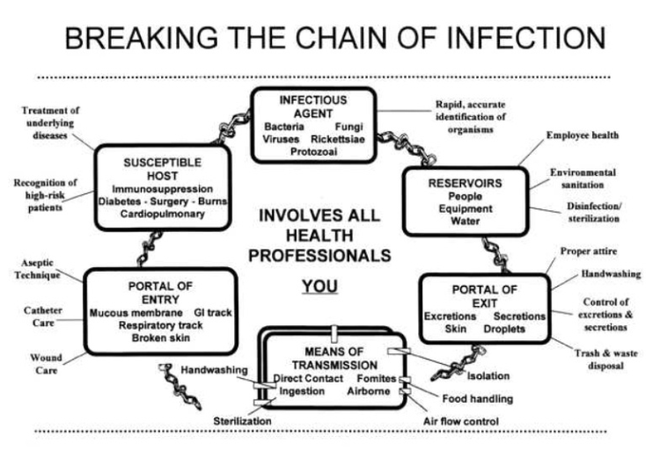

In January 2005, VHA DIRECTIVE 2005-002, “REQUIRED HAND HYGIENE PRACTICES” was released. This directive establishes the basic requirements for hand hygiene practices in VHA facilities including:

- Reinforcing the VA’s commitment to hand hygiene as an infection prevention and control tool
- Stipulating where, when, and with what products hands will be cleaned
- Stipulating appropriate use of gloves as protective barriers
- Prohibiting wearing of artificial fingernails for all personnel who provide direct, hands-on care to patients
- Establishing responsibilities for procurement and distribution of hand hygiene products
- Requiring education of all VA employees

What hand hygiene products are used at the ECHCS?
- Antimicrobial soap and/or alcohol-based hand rubs in all clinical settings (includes inpatient and outpatient areas).
- Hand lotion that is compatible with both the antimicrobial soap and alcohol-based hand rubs.

When should hands be cleaned?
- Before and after patient contact or contact with their immediate environment  - Before inserting any invasive device  - After removing gloves | - Before eating, applying lip balm, or cosmetics  - After using the restroom  - Anytime hands become soiled or have contact with body fluids or non-intact skin

How does hand hygiene work?
Soap (includes antimicrobial soap) and water:  - Wet hands with warm water  - Apply soap  - Rub hands together  - Pay close attention to the spaces between the fingers and area around nails.  - Rinse thoroughly (retained soap can cause skin irritation).  - Dry with paper towel and use the towel to turn off the faucet.  - If desired, apply a compatible lotion to prevent dryness. | Alcohol gels and foams  - These products work by actually killing germs on your hands  - For an alcohol product to work, your hands must be free of gross soiling (i.e. visible dirt)  - Squirt gel/foam into the palm of your hand and rub onto all surfaces of both hands, including between fingers, and allow product to dry.  - Alcohol can be flammable so alcohol-containing gels/foams must be allowed to dry completely before doing activities that may generate sparks.  - Alcohol products SHOULD NOT be used when a patient has C. difficile diarrhea (alcohol will not kill C. diff spores).

JCAHO and Hand Hygiene:
▪ Expiration date
o Hand Hygiene products DO have an expiration date!
o The expiration date is located on bag inside the dispensers as well as the box the bag comes in. For the pocket size bottles, it is on the bottom of the bottle.
o Hand Hygiene products should not be used after the expiration date!
▪ Observations during surveys
o JCAHO has placed a high value on hand hygiene because of its proven value in improving patient outcomes.
o During surveys they will be watching to see if employees wash their hands when appropriate.
o If they observe 3 incidents where staff did not wash their hands it will be a type 1 recommendation.

What about wearing gloves?
- Wear gloves for any anticipated contact with blood, other potentially infectious materials, mucous membranes, and non-intact skin.
- Do not wear the same pair of gloves for the care of more than 1 patient.
- Do not wash gloves between uses with different patients.
- Clean your hands with either an alcohol-based hand rub or antimicrobial soap after removal of gloves.

What about fingernails?
- Natural nails will be clean, neat, and trimmed to ¼ inch or less
- Nail polish is acceptable so long as it is intact and not chipped or worn.
- Artificial nails (including acrylic overlays, gels, silk wraps, or nail jewelry) are prohibited for direct patient-care providers (EVEN occasional direct patient care).

ISOLATION PRECAUTIONS USED AT THE ECHCS

The VA Eastern Colorado Health Care System uses a type of precaution system known as STANDARD PRECAUTIONS.

In this system, caregivers should consider ALL patients potentially infectious regardless of their diagnosis or presumed infection status. STANDARD PRECAUTIONS incorporates the use of protective barriers for ALL contact with: blood, non-intact skin, all secretions, all body fluids, mucous membranes, and all excretions (except sweat).

In addition to STANDARD PRECAUTIONS, it is recognized that additional precautions may be needed to interrupt transmission in patients documented or suspected to be infected with highly transmissible or epidemiologically important pathogens. When such patients are identified, it is important to alert caregivers and intensify standard precautions.

When STANDARD PRECAUTIONS are intensified, one of the three following categories will be advised:

CONTACT PRECAUTIONS:
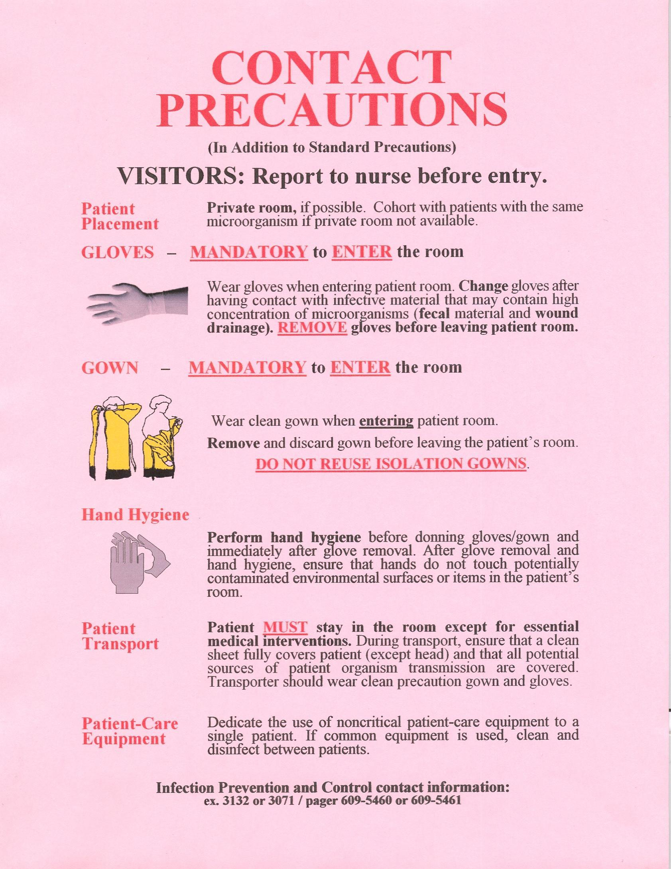 | - Gloves mandatory to enter room – includes visitors  - Gowns mandatory to enter room – includes visitors  Example: MRSA (methicillin resistant Staph aureus)  C. difficile  VRE  Pan resistant gram negative organisms  Staff often enter the room of an isolation patient with the intention of only speaking with the patient but, because isolation frequently results in decreased interactions, the patient immediately requests that the caregiver ‘hand me something’, ‘pull the bedside rail up/down’, ‘check my IV’, etc. This results in the caregiver TOUCHING the environment of the isolation patient, which can contain large numbers of organisms. Caregivers can pick up these organisms on their hands/clothing and carry them to another patient. The mandatory use of gloves and gown to enter the room and good hand hygiene can prevent the transfer of epidemiologically important organisms to others.

AIRBORNE PRECAUTIONS:

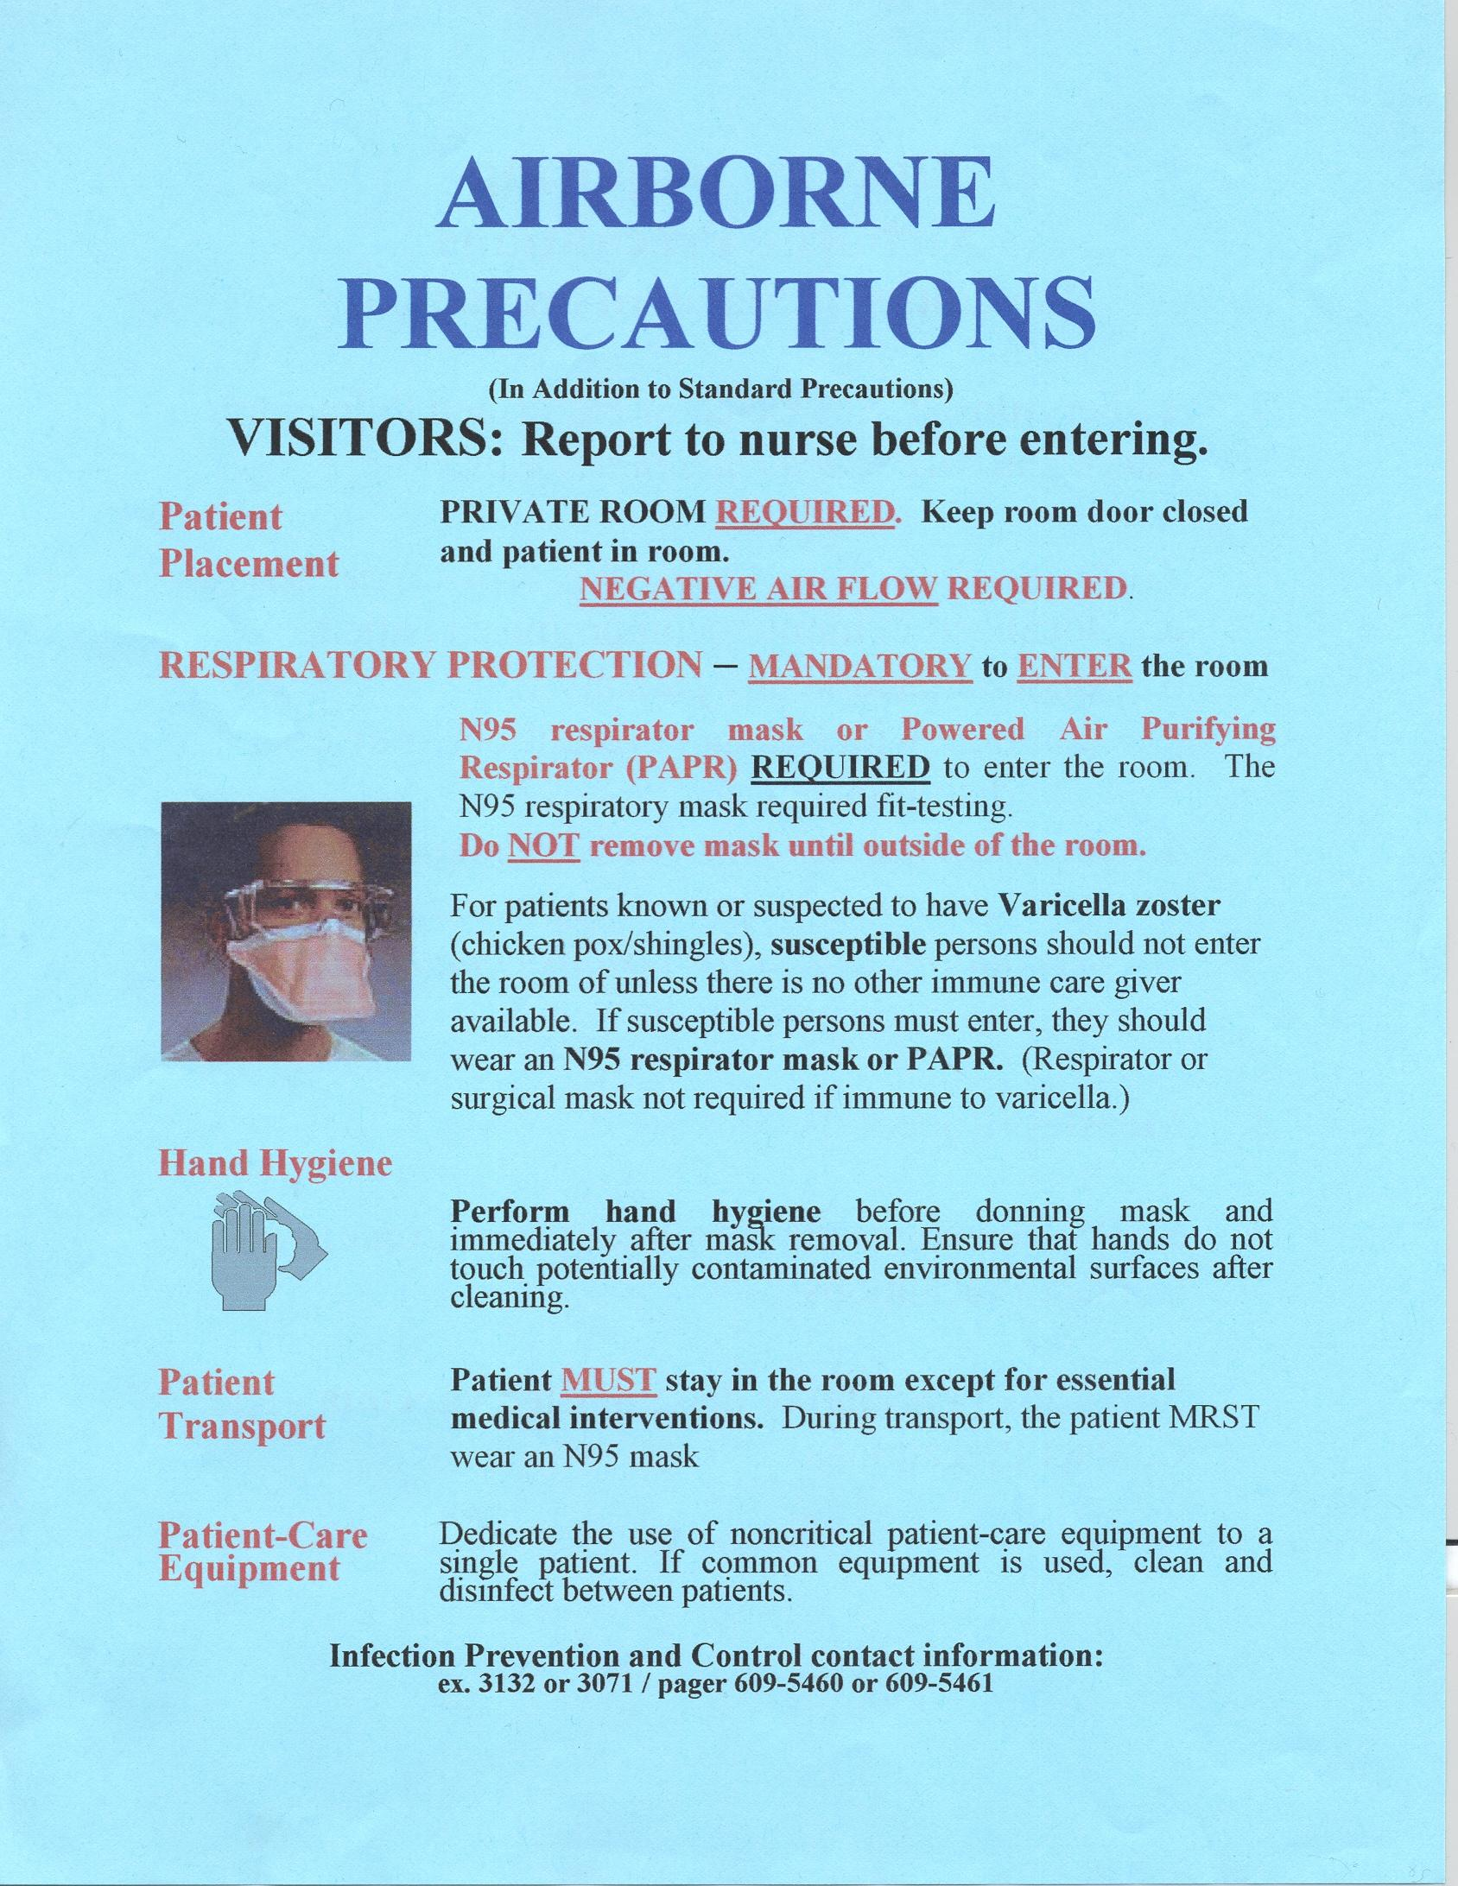 | - Negative airflow room  - Door closed  - Mask mandatory**  Example: TB  SARS  Varicella (including disseminated zoster  Measles  Transmission occurs by dissemination of either droplet nuclei (small particle residue of evaporated droplets containing microorganisms that remain suspended in the air for long periods of time) or dust particles containing the infectious agent.  **Special masks are required by OSHA and require fit testing by a qualified industrial hygiene employee. If you have not been fit tested for the N-95 (orange duckbill) mask, use a hooded respirator called a PAPR. PAPRs do not require fit testing. Both the N95 and the PAPR require a medical clearance. Please contact your supervisor to arrange fit testing or obtain a PAPR.

DROPLET PRECAUTIONS

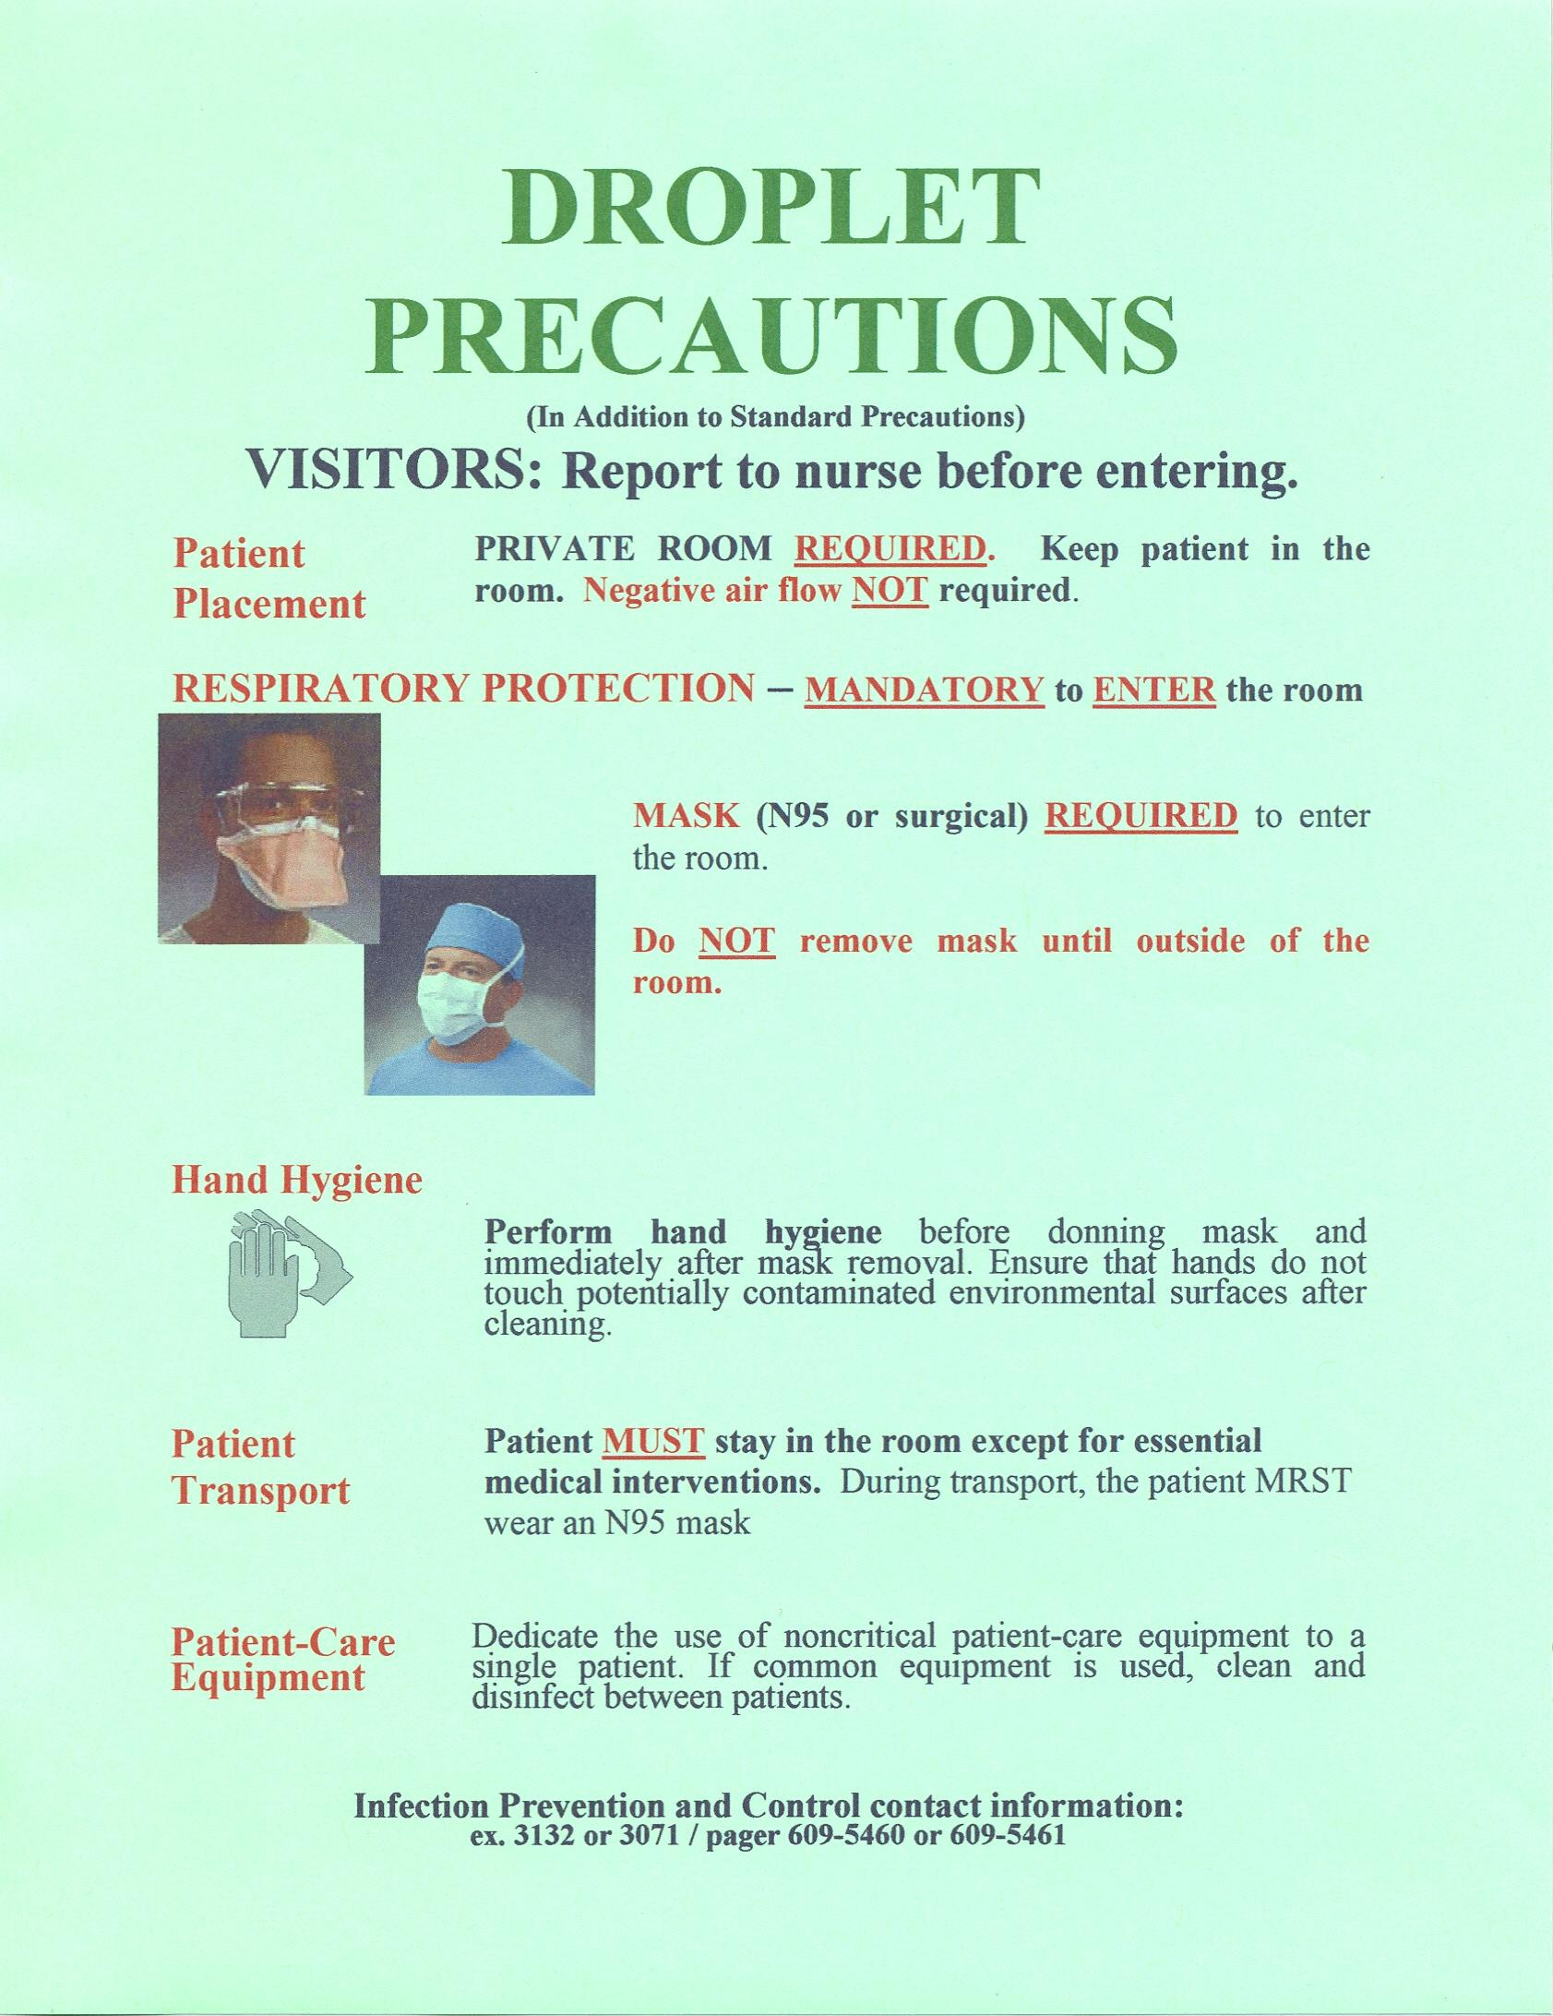 | - Private room (negative airflow NOT necessary)  - Mask mandatory  Example: Influenza  Neisseria meningitidis meningitis  Pertussis  Droplets are large particles generated primarily during coughing, sneezing, and talking. These large droplets usually travel from 3-5 feet from the source. Transmission occurs when droplets containing microorganisms generated from the infected person are propelled a short distance through the air and deposited on the host’s conjunctivae (eyes), nasal mucosa (nose), or mouth. Because droplets do not stay suspended in the air, special air handling and ventilation are not required.

PROPER USE OF ISOLATION PRECAUTION PERSONAL PROTECTIVE EQUIPMENT (PPE)

GOWNS  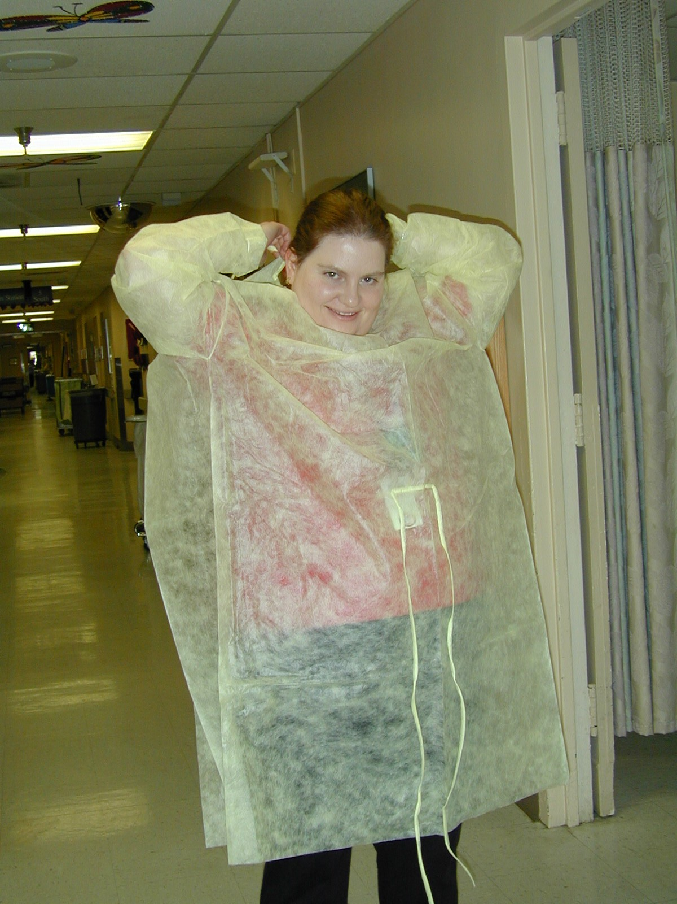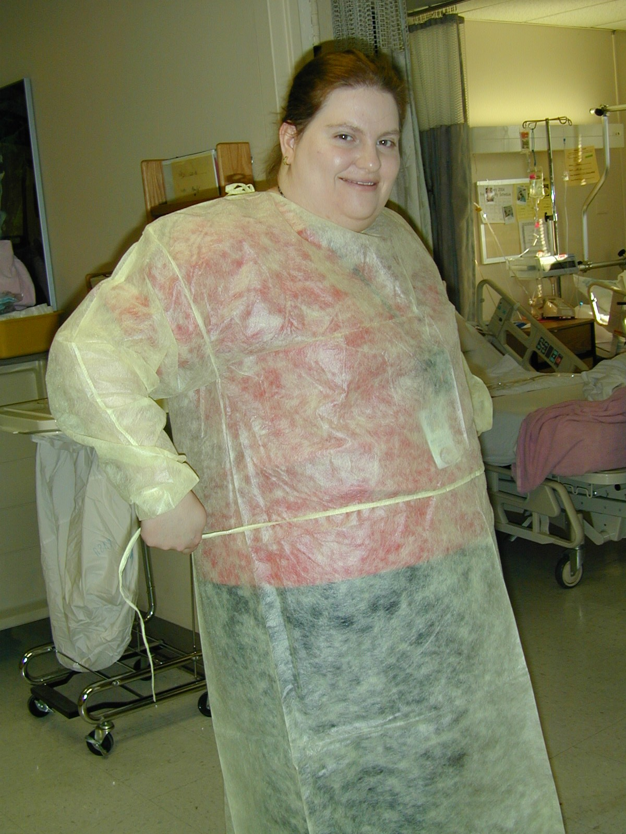 | GOWNS are worn to prevent contamination of clothing and skin when in contact with the patient and his environment (especially the bed). They should be removed and discarded prior to leaving the patient’s room.  Isolation Gowns are SINGLE USE disposable items.  DO NOT re-use gowns.  When isolation or Standard Precautions requires multiple PPE, gowns should always be put on FIRST and tied securely in the back with clean hands.
MASK  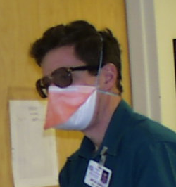 | MASKS are worn for several reasons:  - To prevent spread of diseases spread by the respiratory route (e.g. TB).  - To prevent spread of diseases spread by the droplet route (e.g. influenza).  - To prevent contamination of the nose and mouth from splashes or sprays of body fluids while performing patient care activities.  - To prevent inadvertent contact of the nose and mouth from contaminated hands.  N-95 masks should always be worn with one strap low near the neckline and one high on the head as demonstrated by the arrows here.  When isolation or Standard Precautions requires multiple PPE, mask should be put on SECOND (after the gown and before gloves).

GLOVES  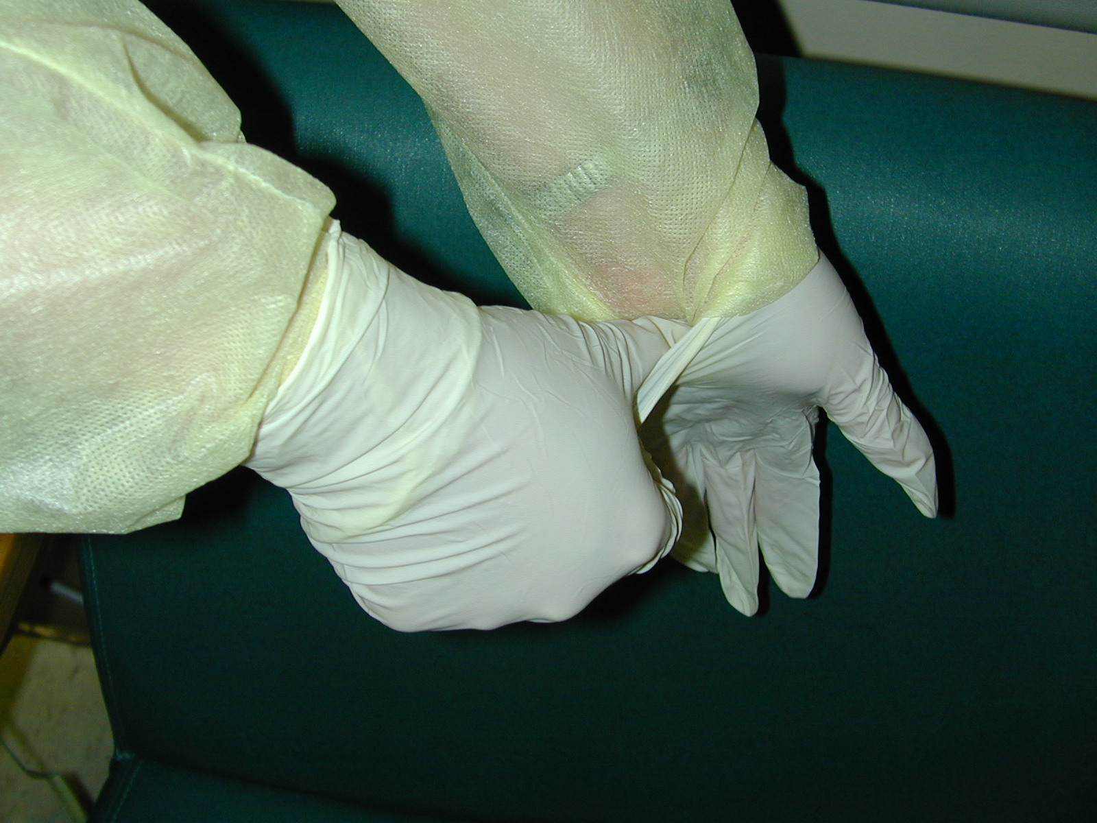 | GLOVES are worn for 3 important reasons:  - To prevent contamination of hands with resistant organisms  - To provide a protective barrier and prevent gross contamination when touching body fluids, mucous membranes and non-intact skin.  - To reduce the likelihood that organisms present on personnel hands will be transmitted to patients during patient care.  When isolation or Standard Precautions require multiple PPE, gloves should be put on LAST and should always cover the sleeve cuff of the gown. Note how the thumb is used to tuck the gown under the glove.

How to Remove Isolation Precaution PPE
1. With gloves in place pull gown ties until they break (waist first, shoulder second) and, starting with the shoulders, pull the gown away from you rolling it with the contaminated side in as you go.  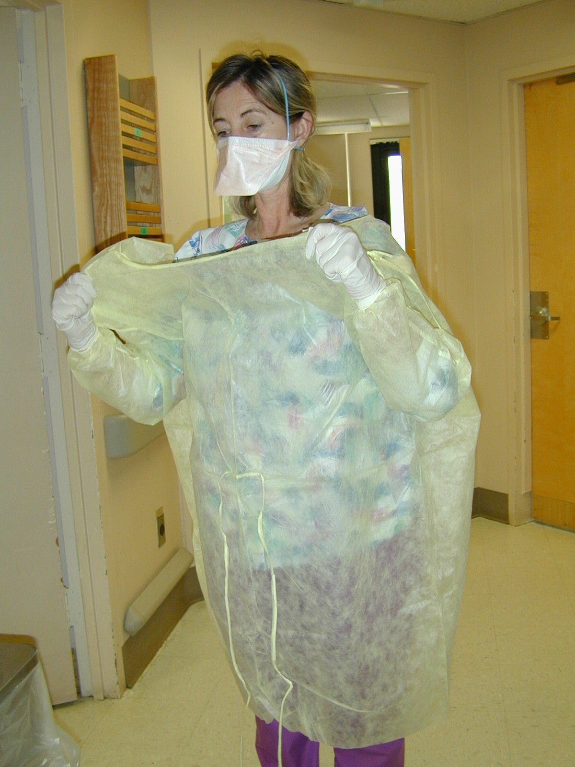 | 2. Remove gloves while rolling the gown. Avoid contaminating the hands by keeping them on the clean side of the gown. Dispose of contaminated gown and gloves in wastebasket.  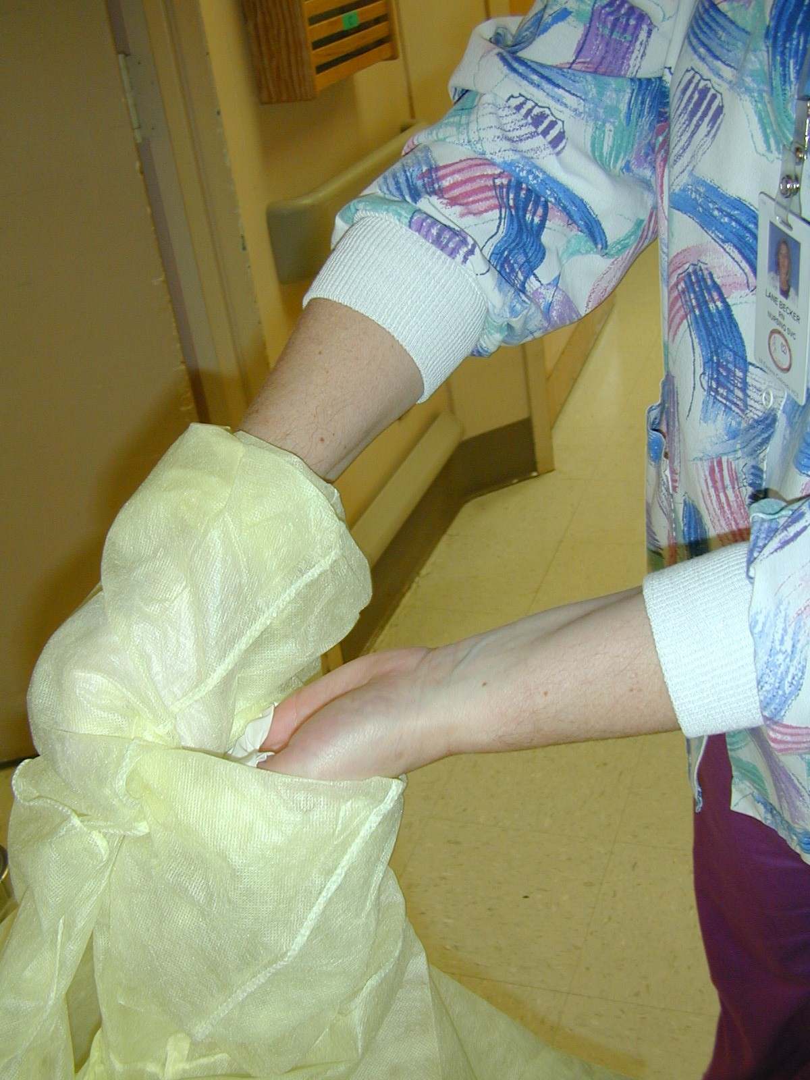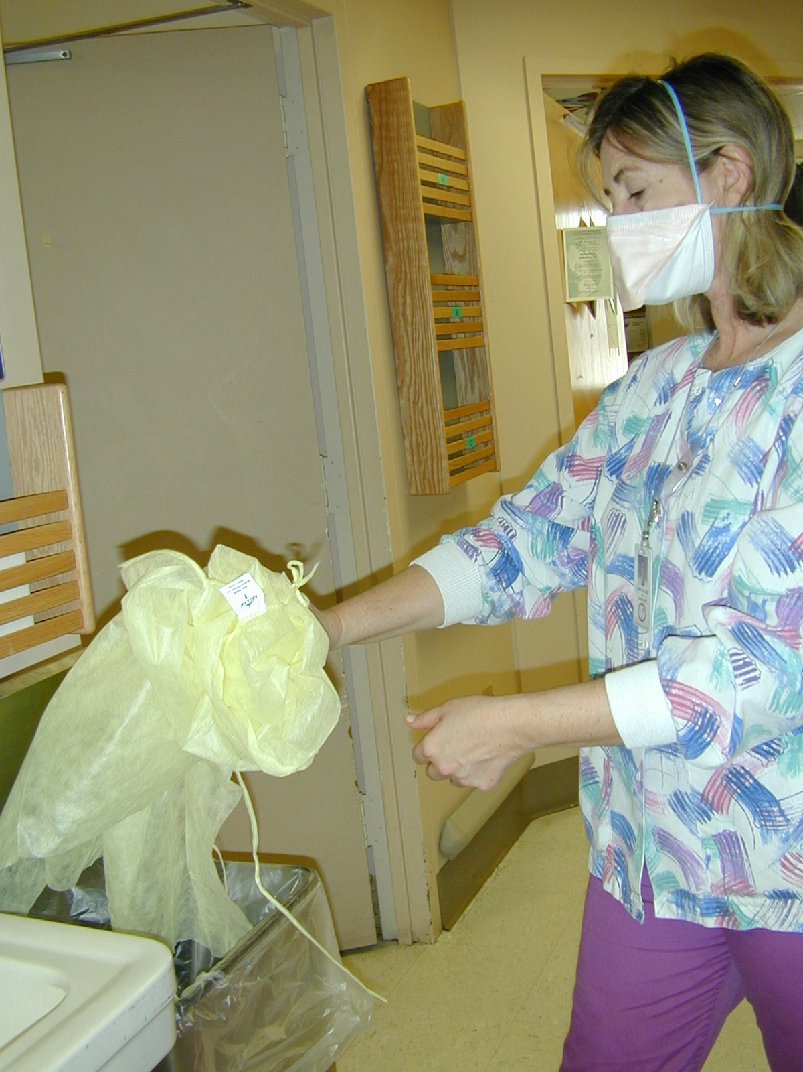 | 3. Remove mask, touching only the straps, and dispose in waste receptacle.  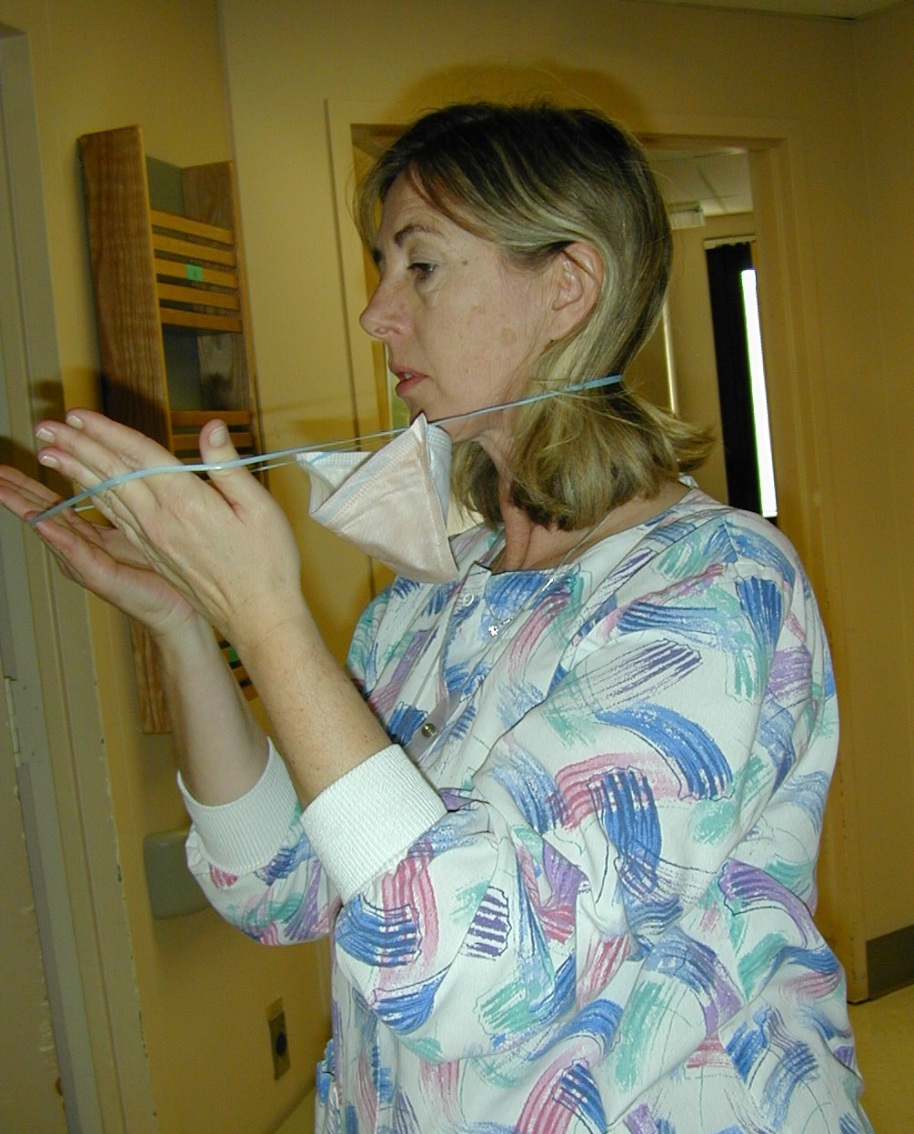 | 4. Clean your hands.  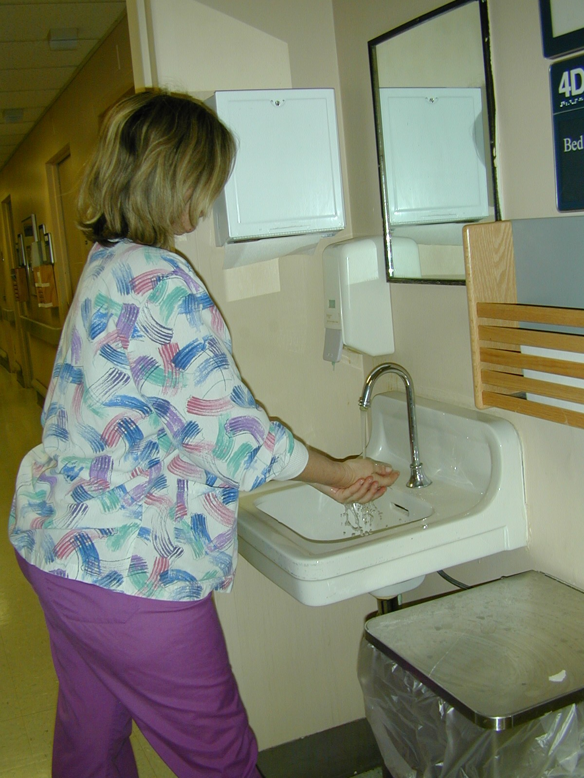

Patients who are in Precautions should leave the room ONLY for essential medical purposes.
ALWAYS notify the receiving area of the type of precautions needed.

Airborne and Droplet Precautions
Patient must wear a fresh N95 mask and be instructed NOT to remove the mask.

Contact Precautions

All wounds/lesions must be covered with fresh dressings
If organism is in respiratory secretions, patient must wear a mask
- Use clean wheelchair or stretcher
- Drape clean sheet lengthwise across wheelchair or stretcher and have patient sit/lay.
- Wrap sheet around patient mummy style so that all skin surfaces except face are covered by clean sheet. Patient does not need to wear gown/gloves. The clean sheet should keep the patient from contaminating surfaces and other people.
- Transport personnel should wear PPE as dictated by the precaution, i.e., gown and gloves.
- Follow same procedure for return to the patient’s room.

IMPORTANT INFECTION PREVENTION AND CONTROL POINTS TO REMEMBER

Needle Disposal

Syringes, needles, and other disposable sharp objects are to be placed in heavy plastic sharps disposal containers located in all patient care areas. Used needles should not be broken off or recapped before disposal. Most needle stick injuries occur during recapping. All areas of the hospital have specific designated locations for storage of used reusable sharps. Familiarize yourself with these locations before use.

Cleaning and decontaminating spills of blood: (For large spills or spills you do not feel qualified to clean, activate the SPIL protocol). For small spills you feel qualified to clean:

- Wear eye and face protection if there is anticipated splashing.
- Wear shoe covers if it is likely that you will contaminate your shoes.
- Put on gloves and cover blood spill with disposable towels. Apply hospital-approved germicide (Caviwipes) or 1:10 dilution of bleach (Hypewipes or Bleachrite) to towels until saturated. Clean spill and dispose of soiled towels in red/biohazard plastic bag.
- Again, decontaminate surface with a hospital approved germicide or 1:10 dilution of bleach.
- Wipe area with clean towels and air dry.
- Remove contaminated items, shoe coverings, etc. and place in red/biohazard plastic bag for disposal in contaminated (red bag) trash. Remove gloves last.
- Wash hands after removing gloves.

Employee Health

Employee health hours are 8:00 - 9:00 AM and 3:00 - 4:00 PM , Monday through Thursday. Friday hours are 8:00 – 9:00 AM only. Employee Health services includes emergency diagnosis and first treatment of illness during working hours to enable the employee to remain on duty through the work shift. Life-threatening emergencies will be handled through the Emergency Room. Non-emergent accidents or injuries will be handled in Employee Health or, if unavailable, the Emergency Room.

Employee Health offers the following vaccines:

- Hepatitis B vaccine - recommended for employees who are expected to have contact with blood or body fluids as a part of their assignment. The vaccine is given in 3 doses over a 6-month period.
- Influenza vaccine - Recommended for all ECHCS employees. The vaccine is offered yearly in the fall.
- Tetanus vaccine – when indicated.

All employees are required to complete a 2 step TB skin test prior to starting work. Annual TB skin testing is not required. However, further skin testing is required if an employee has been exposed to a person with active, infectious TB disease.

Blood Exposures - ALL BLOOD EXPOSURES ARE IMPORTANT AND SHOULD BE REPORTED!

Blood Exposures include:
- Parenteral Exposures (blood to blood): Sharps injuries (needle stick, scalpel cut, pipette break, etc.) or blood/body fluids in fresh open cuts or non-intact skin.
- Mucous membrane exposure (splashing of body fluids into eyes, nose or mouth)

Any blood exposure is important. Detailed instructions on blood exposure follow-up can be found in the Infection Prevention and Control Manual located in the computer on the VA Eastern Colorado Health Care System’s Intra-net home page. In the event of a computer outage, a hard copy can be found in the nursing supervisor’s office and the Administrator of the day (AOD) office.

Should you experience an unprotected exposure to blood or body fluids follow these steps:

- Clean/flush the exposed area thoroughly.
- Report the incident promptly to your immediate supervisor.
- Report to Employee Health ASAP. If Employee Health is closed, report to the Emergency Room.
- Complete an INCIDENT REPORT via the electronic reporting program “ASISTS”
- Notify Infection Prevention and Control

For questions related to Infection Prevention and Control contact:

Linda B. Laxson, RN, BSN, CIC 303-399-8020 ex 3132; pager 303-609-5460
Keith Rains, RN, BSN, CIC 303-399-8020 ex 3071; pager 303-609-5461
Karen Guerin, RN 303-399-8020 ex 3065; pager 303-201-2658
Georgiana Inskeep, RN, CIC 719-553-1026 (covers CBOCs and Pueblo NHCU)

