The Midwest Flood of 2008
A preliminary assessement
NOAA CSI Team

Supported by NOAA’s Climate Program Office Project
“Explaining Climate Conditions to Improve Predictions”

What is the Current Climate Situation?

Historical record high flows are occurring in major Midwest rivers, including the DesMoines, Cedar, and Wisconsin Rivers. These feed directly into the Mississippi River, which now is also expected to sustain near record flows. The 14 June USGS monitor of river gages indicates historic high flows occurring across most of Iowa, southern Wisconsin and northern Illinois (denoted by black circles in Figure. 1)

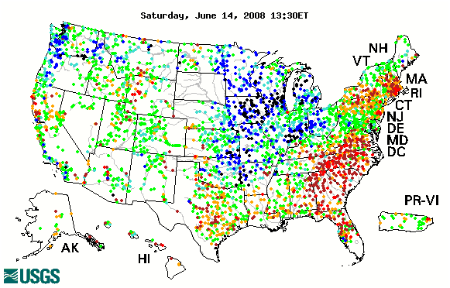

Figure 1. Map of real-time streamflow compared to historical streamflow for the day of the year (United States). The map depicts streamflow conditions as computed at USGS streamgages. The colors represent real-time streamflow compared to percentiles of historical daily streamflow for this day of the year. Above 90 percentile denoted by blue, and record high floe denoted by black circles.

The immediate cause for the flooding streams and rivers has been frequent heavy rain events concentrated in the catchments and headwaters of these Midwest rivers. Rainfall has exceeded the norms by +5” to +10” since June 1 (Figure 2a). This focus zone for rains sits in a boundary between persistent abnormally low pressure over the North Plains and abnormally high pressure over the Southern Plains/Ohio Valley.
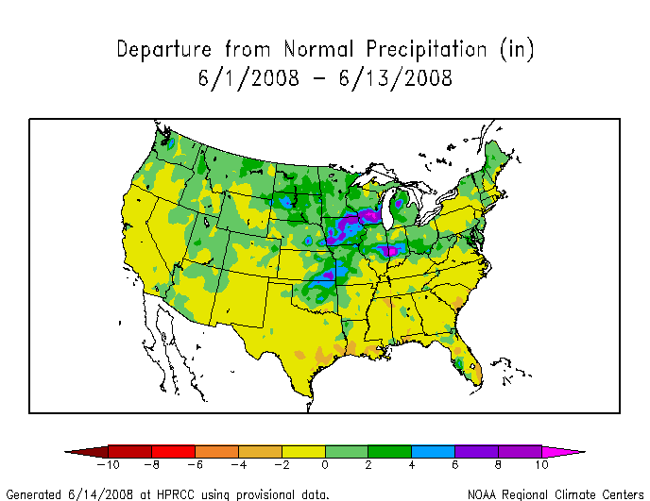

Figure 2a. Map of accumulated rainfall depatures sduring the 13-day period 1 June thru 13 June 2008 (United States). Areas of above normal rainfall denoted in green, and blue shades. Areas receiving more than +10” above their normals for this period are shown in bright magenta.

The time history of daily precipitation at Cedar Rapids, Iowa reveals the sustained high levels of moisture since late summer 2007, and then the recent deluge atop the already wet conditions (Figure 2b). Daily rainfall often exceeding 1”, has been measured almost every day for the past 3 weeks in the area.

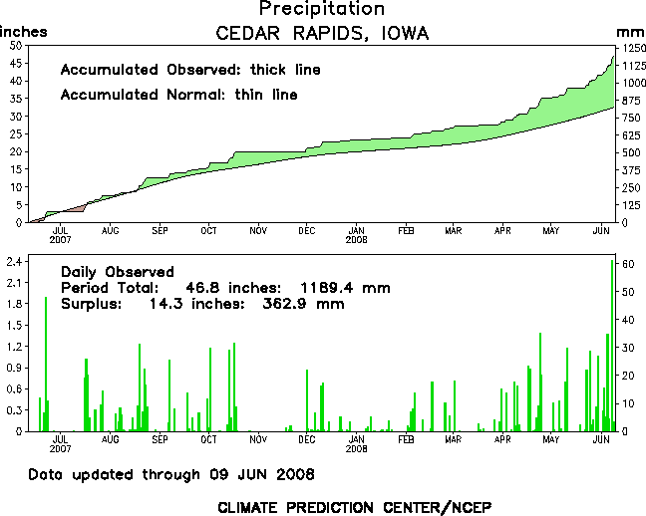
Figure 2b. Daily observed rainfall meaured at he observaing station, Cedar Rapids, Iowa.
The time series spans the 1-year period from 10 June 2007 thru 9 June 2008.

What were the Antecedent Cimate Conditions?

The Upper Midwest has experienced wet conditions for many months prior to the current additional heavy June rains. For the 12-month period 1 June 2007 thru 31 May 2008, some areas in the current flood zone already received +15” to +20” of excess precipitation (Figure 3). The June rains, therefore, have fallen upon saturated soils resulting in the vast majority of recent rains running directly into streams. These antecedent conditions are thus also an important factor responsible for the current floods.

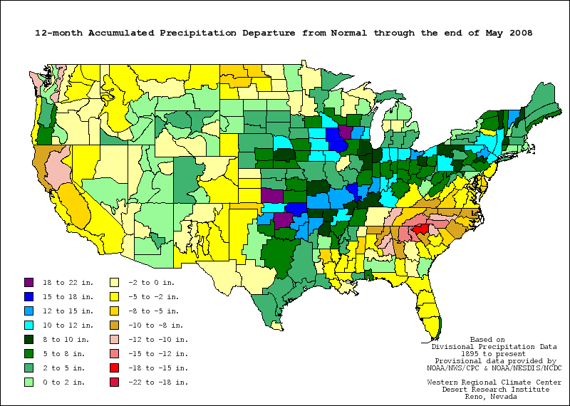
Figure 3. Map of accumulated rainfall depatures during the 12-month period 1 June 2007 thru 31 May 2008 (United States). Areas of above normal rainfall denoted in green, and blue shades. Areas receiving more than +20” above their normals for this period are shown in bright magenta.

The existence of antecedent wet soils in spring 2008, resulting from prior heavy winter percipitation including unusually deep winter snows in the Upper Midwest permitted NOAA to provide early warning for floods (Figure 4). The March 20 spring outlook by NOAA’s Advanced Hydrologic Prediction Service (AHPS) stated that, “Major floods striking America’s heartland this week offer a preview of the spring seasonal outlook… We expect rains and melting snow to bring more flooding this spring… Americans should be on high alert to flood conditions… Above-normal flood potential is evident in much of the Mississippi River basin, the Ohio River basin, the lower Missouri River basin…”

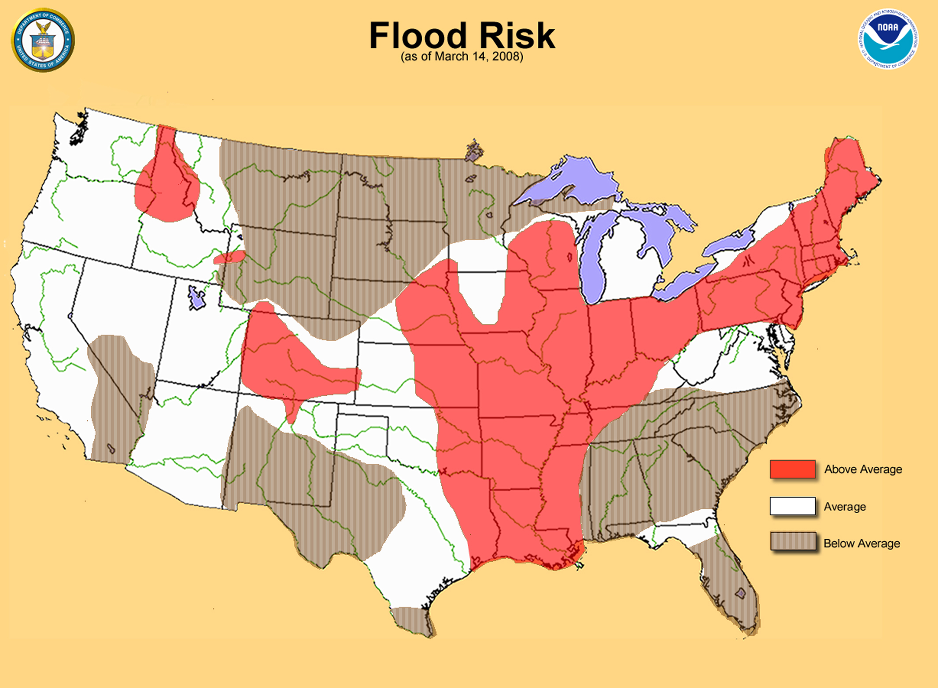

Figure 4. NOAA’s spring flood outlook, issued 20 March 2008. Owing to heavy winter snows and above normal precipitation over parts of Wisconsin and Illinois, as much as a 20 to 30 percent chance of major flooding on some rivers in southern Wisconsin and northern Illinois was predicted.

Is the wet Upper Midwest Climate Condition the Result of La Niña?

Colder than normal sea surface temperatures developed in the equatorial central Pacific in mid-2007, developing into a strong La Niña during winter. According to NOAA’s most recent ENSO Diagnostic Discussion on 5 June 2008, a transition from La Niña to ENSO-neutral conditions is expected during June-July 2008.

Yet, historical observations (Figure 5) of U.S. precipitation anomalies during past La Niñas indicate wet conditions mainly over the Ohio Valley, somewhat south and east of the flood region. In fact, the severe Midwest drought of 1988 coincided with a recent strong La Niña event. It thus appears that canonical La Niña forcing alone was unlikely a principal factor in rendering conducive climate conditions for Midwest flooding. There is some indication, however, that other sea surface temperature conditions may have been contributing factors, as discussed further below.

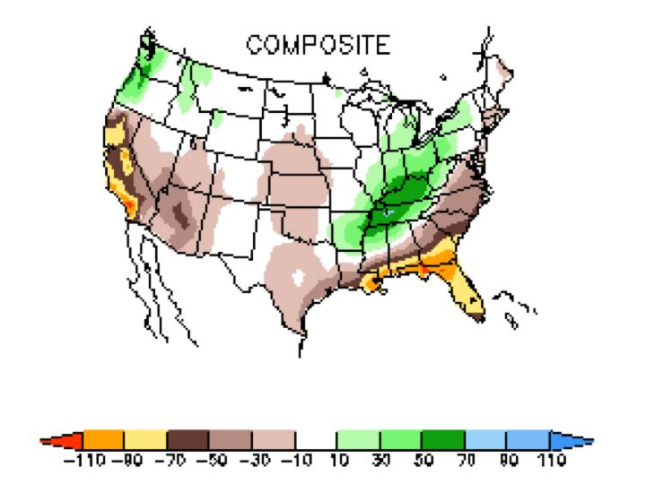
Figure 5. United States map of the observed January- March seasonally averaged precipitation anomalies (mm/month) for the composite of 20th Century La Niña events. Dry conditions are shown in tan and yellow shades, wet conditions in green shades.

Were wet Upper Midwest Conditions during Winter/Spring ‘08 Anticipated?

As indicated above, the antecedent soil conditions were a useful predictor at the end of March for subsequent flooding risks in April-June. The question is whether the meteorological conditions that led to such soil saturation were themselves expected based on climate predictors available at the beginning of the winter season.

The principal predictors that determined the winter and spring 2008 precipitation outlooks issued by NOAA were the historical l La Niña footprint , and the numerical simulations of precipitiation based on climate models influenced by the global sea surface temperature conditions. The official NOAA seasonal precipitation outlook for the January-February-March season, issued on 20 December 2007 (Figure 6) mostly reflected the historical La Niña effect. It departed slightly from that, however, by shifting the expectation for increased precipitation to Indiana and eastern Illinois, north and west of the La Niña signal.

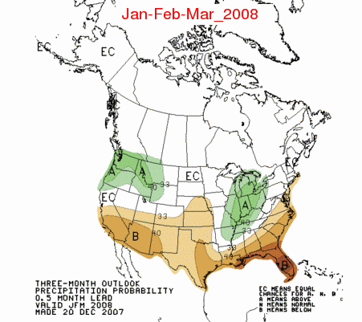Figure 6. United States map of the 3-month precipitation probability outlook for the January-march 2008 season. Forecast is for the change in tercile categories of seasonal precipitation. Increased risk of lower dry terciles shown in tan shades. Increased risk of upper wet terciles shown in green shades.

As part of a NOAA research effort to explain climate variations and to improve their predictions, climate model experiments have been completed in which the actual observed global sea surface temperatures were used to drive the models. Four different models were used to generate 60 simulations for the January-March 2008 period. The comparison in Figure 7 indicates that several features of the winter (JFM 2008) precipitation pattern were consistent with the signal resulting from global ocean forcing, including a dry southern tier, wet over the Interior West, and wet over the Great Lakes. The simulation results suggest that the intensity of observed wet Upper Midwest conditions was unlikely due to global ocean conditions alone, although the simulations do indicate that the Upper Midwest was an epicenter of increased wet risk, somewhat displaced from the La Niña composite location. Additional assessment and supportive modeling is required to determine the features of global sea surface temperatures during the past year 2007-08 that may offered some early warning for wet conditions in the Midwest.
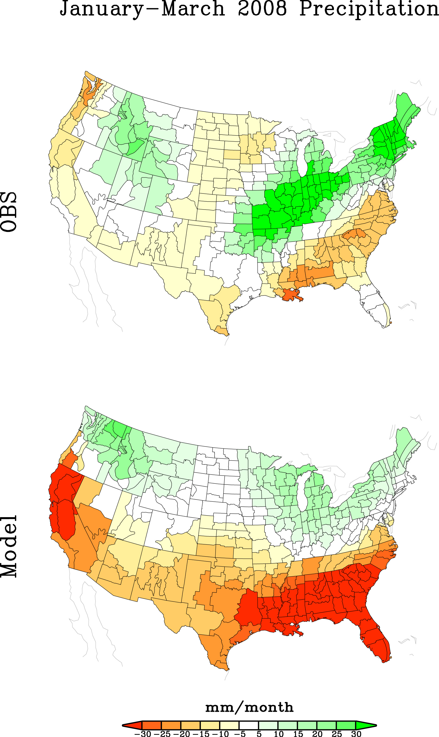
Figure 7. The January-March seasonally avergaed precipitation anomailes (mm/month) observed (top), and simulated by climate models forced with the observed global sea surface temperatures (bottom). Observations based on the CAMS-OPI belnd of insitu and satellite rainfall estimates. Simulations based on 4 models for which a 60-member ensemble was performed. Wet (dry) conditions indicated in green (yellow) colors. Reference is 1979-2000.

What is the attributable impact of greenhouse gas forcing?

In considering possible attribution of changes in the risk of such flooding events to anthropogenic forcing, the findings of several recent assessment reports are relevant, including the Intergovernmental Panel on Climate Change Fourth Assessment Report (IPCC 2007), and the U.S. Climate Change Science Plans Synthesis and Assessment Products SAP1.3 (Attribution of U.S. Cimate Variations and Change, hereafter CCSP 1.3), and SAP 3.3 (Analysis of the Observed Variations and Changes in Climate Extremes, hereafter CCSP 3.3). It should be noted that no single event can be attributed to any specific cause, including anthropogenic forcing; understanding the change in the probability of such events awaits further attribution studies. Nonetheless, whereas no such studies have been attempted yet for the Cedar River, it is useful to place this extreme local event into what is known about larger scale changes now occurring in the water cycle.

The current Upper Midwest extreme rain event fits into an emerging pattern of change in the atmospheric water cycle. There is evidence that the character of precipitation events over many land areas has changed, regardless of whether a region’s mean precipitation has changed and despite indications that yearly and decadal flucuations in precipitation totals are unlikely related to anthropogenic forcing (CCSP 1.3). IPCC (2007) indicates that it is likely that the number of heavy precipitation events (for instance, above the 95th percentile) have increased over many land areas since 1950. Figure 8 illustrates the observed increase in the % of annual precipitation resulting from very wet days. Likewise, CCSP 3.3 notes that heavy precipitation events averaged over North America have increased over the past 50 years. This increase is consistent with observed increases in atmospheric water vapor, which in turn have been associated with human-caused increases in greenhouse gases.

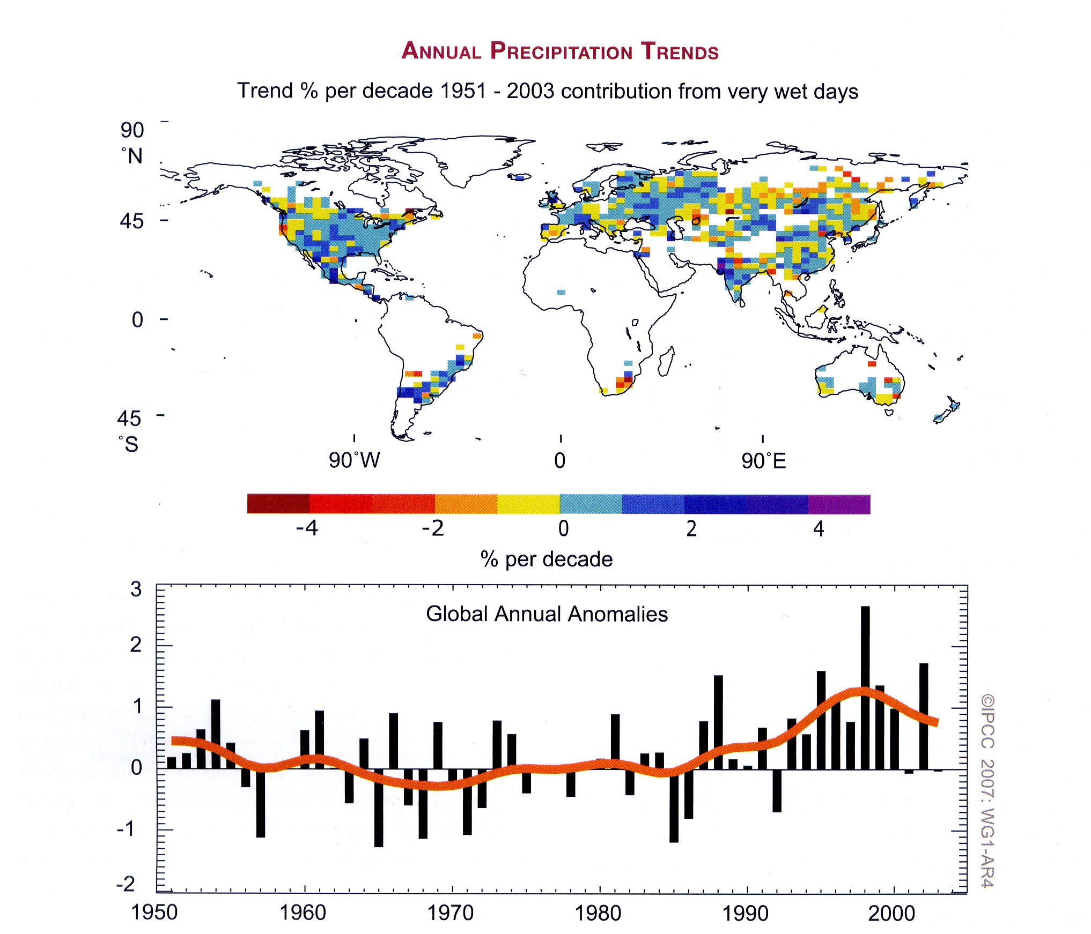
Figure. 8 Observed trends (% per decade) over the priod 1951 to 2003 in the contribution to total annual precipitation from very wet days (top panel). Anomalies (%) of global (regions with data in top panel) annual time series of very wet days defined as the % change from the 1961-1990 base period average (22.5%). Figure from IPCC (2007).
.
Analysis of regional trends in very heavy precipitation events over the past century are well reflected in the Upper Midwest region currently affected by flooding (Groisman et al., 2005). The US National Asessement (2000) and additional work by Groisman has shown that more frequent heavy precipitation events are related to amplified positive trends in the highest riverflows of undisturbed streams across North America. The Midwest flood appears not to be an isolated event, but may be part of larger scale water cycle changes over the extratorpical land areas. . For example, the IPCC (2007) comments that “The observed increase in precipitation variability at a majority of German precipitation stations during the last century…is indicative of an enhancement of the probability of both floods and droughts.” IPCC (2007) notes one study (Milly et al. 2002) in which a significant increasing trend in the frequency of great floods (discharge exceeding 100-year levels) was found, based on very large river basins (drainage areas greater than 200,000 km²). A second study (Kundzewicz et al. 2005) focused on annual extreme flows for a larger sample of rivers and found a mixture of significant increases, decreases, and non-significant changes.

References:

Climate Change Science Program Synthesis and Assessement Product 1.3, 2008: Reanalysis of Historical Climate Data for Key Atmospheric Features; Implications for Attribution of Causes of Observed Change. In press.

Climate Change Science Program Synthesis and Assessement Product 3.3, 2008: Weather and Climate Extremes in a Changing Climate. In press.

IPCC, 2007: Summary for Policymakers. In: Climate Change 2007: The Physical Science Basis. Contribution of Working Group I to the Fourth Assessment Report of the Intergovernmental Panel on Climate Change [Solomon, S., D. Qin, M. Manning, Z. Chen, M. Marquis, K.B. Averyt, M.Tignor and H.L. Miller (eds.)]. Cambridge University Press, Cambridge, United Kingdom and New York, NY, USA.

Milly, P.C.D., et al., 2002 : Increasing risk of great floods in a changing climate.
Nature, 415, 514-517.

Kundzewicz, Z. W., et al., 2005: Trend detection in river flow: 1. Annual maximum
flow. Hydrolog. Sci., 50, 797-810.

