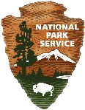
Caves, Canyons, Cactus & Critters
A curriculum and activity guide for Carlsbad Caverns National Park

Middle School Geology
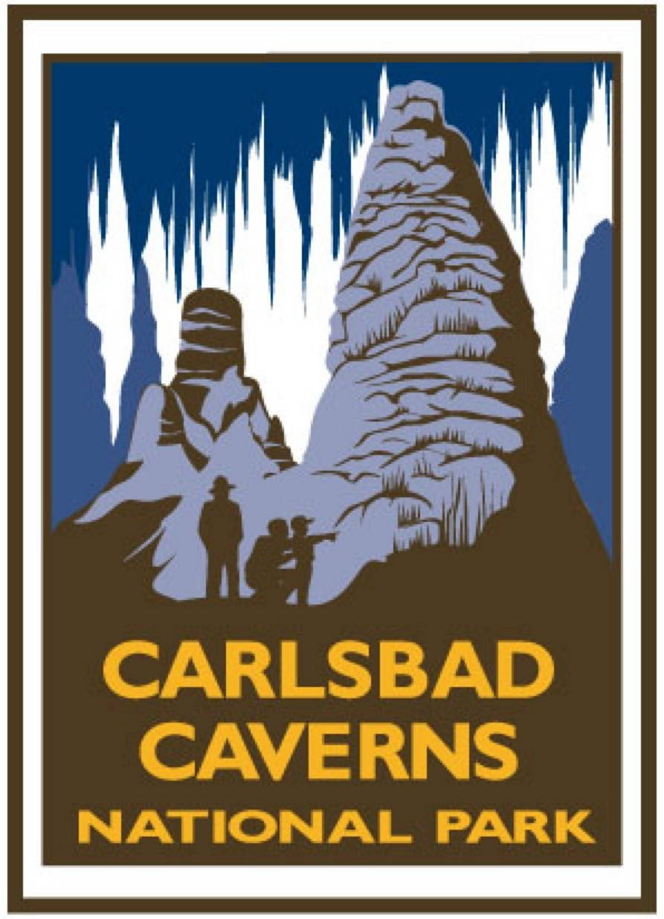
Caves, Canyons, Cactus & Critters
Geology Curriculum

Oil Munchers Activities exploring the role of anaerobic bacteria
in the formation of caves in Carlsbad Caverns National Park. 39
        - It’s More Than Just Dead Dinosaurs An activity designed
to model oil and gas formation and traps. 40
        - Strange Things in Strange Places An activity to explore
bacteria that live in strange places (underground anaerobes,
Lechuguilla Cave, thermal springs, Mars) 45
        - Stinky Gas and Alabaster An activity to demonstrate gypsum
replacement of limestone in the formation of the caves
of the Guadalupes. 48

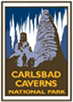

Oil Munchers
Caves form by many different methods. The caves of the Guadalupe Mountains, including the caves of Carlsbad Caverns National Park, were formed by one of the more unusual processes. The formation of the caves is tied very closely to the hydrocarbon deposits of the Delaware Basin, found at the base of the Guadalupe Escarpment.
Massive deposits of gypsum have been found in many of the caves of the Guadalupe Mountains. For many years, geologists attempted to develop models explaining these deposits, but had little success. It is only in the past 20-30 years that a model has been proposed that not only explains the gypsum deposits, but also explains the unique morphology of the caves. In this model, anaerobic bacteria deep underground in the Delaware Basin facilitate a reaction between hydrocarbons and calcium sulfate, or anhydrite. Anhydrite is an anhydrous form of gypsum, which has water included in its crystalline structure.
According to the model, a byproduct of this reaction, hydrogen sulfide gas, rose through cracks in the rocks to the top of the water table in the Guadalupe Mountains. There, oxygen combined with the hydrogen sulfide gas to produce sulfuric acid. This sulfuric acid reacted with the limestone rock of the ancient reef and began to dissolve vast caverns. As the hydrogen sulfide was oxidized deeper and deeper in the cracks, the deep pits of the caves formed. When groundwater levels changed, the passages formed at new levels. One byproduct of the reaction of sulfuric acid and limestone (primarily calcium carbonate) was calcium sulfate, or gypsum, which was subsequently deposited in the great voids.
In this unit, students will engage in activities designed to help introduce various components of Guadalupe Mountain speleogenesis. Very complex chemical reactions and processes have been simplified in these activities. If students are interested in learning more, recommend that they read the book Stories From Stones: The Geology of the Guadalupe Mountains. Also, recommend that they take chemistry as part of their high school course work.

It’s More Than Just Dead Dinosaurs!
How does oil and gas form and why does it collect in one place underground?
Summary: Students will describe how oil and gas form and how they are trapped underground.
Duration: Three or four 50-minute class periods
Setting: Classroom or lab
Vocabulary: hydrocarbons, kerogen, permeable, petroleum, petroleum trap, porosity
Standards/Benchmarks Addressed: SC5-E2, SC6-E1, SC12-E1, SC12-E2, SC12-E5

Objectives
Students will:
- describe how oil and gas form.
- describe three types of oil and gas traps.
Background
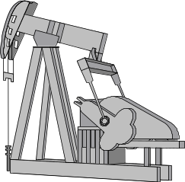
Life, as we know it, would not be possible, without fossil fuels. The most important of these fuels is petroleum. Another word commonly used in reference to petroleum is hydrocarbons. Molecules of petroleum consist mainly of the elements hydrogen and carbon. Most petroleum deposits are found in rocks formed in marine environments.
The formation of petroleum begins in marine basins where microscopic organisms and algae live suspended in the water. As they die, they sink to the bottom where they become mixed in with the mud at the bottom of the basin. The low oxygen environment in the bottom water keeps the organisms from oxidizing, or decaying. As the sediments continue to accumulate, the layer bearing the remains of the microscopic organisms is buried deeper and deeper. Eventually, heat and pressure build to the point that the remains of the organisms begin to undergo chemical changes. First, the remains are converted into a waxy hydrocarbon called kerogen. Further heat and pressure causes the kerogen to convert to the various forms of petroleum with which you are familiar: methane or natural gas, oil, gasoline, kerosene, and diesel oil. The rocks these hydrocarbons come from are called source rocks.
Within the petroleum reservoir, the various hydrocarbons begin to sort themselves based on density and to migrate through rocks with pathways formed by cracks, spaces between grains, or pores in the rocks. These openings are referred to as porosity. If the areas of porosity are connected and fluid can move through them, the rocks are said to be permeable. The hydrocarbons will migrate along a bed with permeability until they reach the surface, or reach some geologic structure that traps them in place. The permeable rock in which the petroleum is eventually stored is referred to as a reservoir rock. Within the reservoir, the gaseous hydrocarbons, being less dense, move to the top. Typically, there is water associated with hydrocarbon reservoirs. Since the water is denser, it is found on the bottom. The liquid hydrocarbons, or oil, are found in the middle.
The structures, or petroleum traps, that stop or slow hydrocarbon migration can take several forms. Four of the more common traps are structural traps, stratigraphic traps, salt domes, and reefs. In the case of a structural trap, features such as faults or folds trap the oil and gas against an impermeable layer. In stratigraphic traps, reservoirs are created by differences in the sedimentary layers. Often a permeable sandstone layer will be “trapped” between two impermeable shale layers. If these layers are tilted, the hydrocarbons will rise through the sandstone layer. If this layer thins and eventually pinches out, it will trap the hydrocarbons, producing a petroleum reservoir. In the case of a salt dome, a bed of salt “blisters” and shifts upward through the more dense layers that overlie it. In doing this, it raises part of the overlying layers, including potential reservoir rocks. Salt is impermeable, so any hydrocarbons moving along a permeable layer will become trapped in the reservoir. Due to the nature of the organisms that form it, a reef becomes a very porous and permeable bed of limestone. If the reef lies near source rocks and is capped by an impermeable layer, it becomes an excellent reservoir rock.
In the Delaware Basin, the hydrocarbons are thought to be of marine origin, resulting from the remains of microscopic organisms that lived in the ancient seas. Within the basin today, most of the petroleum that is found is located in stratigraphic traps. The Capitan Reef certainly meets the requirement of being porous. The caves of the Carlsbad Caverns National Park are just an example of the great porosity to be found in the ancient reef. But current research seems to indicate that no hydrocarbons ever migrated into, or through, the great reef. There is, however, evidence of hydrocarbon migration under the reef from the basin to the southeast, to the backreef, northwest of the park. Why the hydrocarbons did not enter the reef is still a source of speculation and research for geologists from around the world.
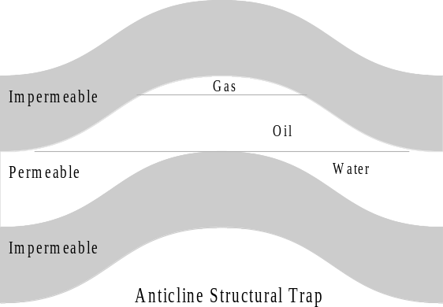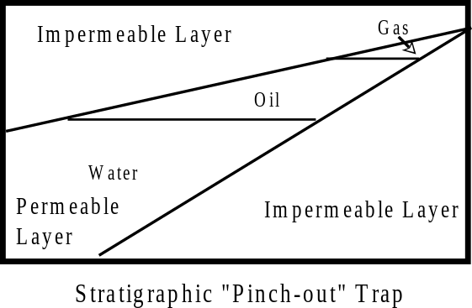
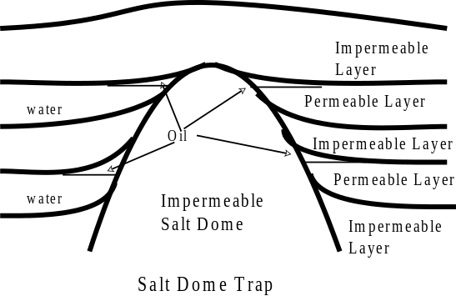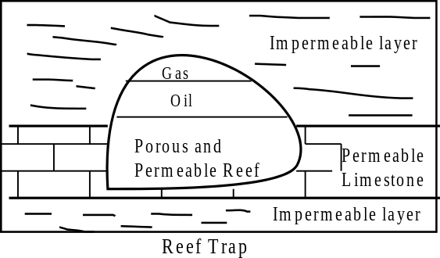
Materials
- graduated 250 ml beakers – 3
- 100 ml beakers – 3
- several 2 or 3-liter soda bottles
- oil (can be cooking oil or motor oil)
- sand (several colors, if possible)
- gravel (several colors, if possible)
- scoria (holy lava rock, batman!)
- clay
Procedure
Warm up: Ask students how oil and gas form. Most students will respond that it forms from dead dinosaurs. Discuss with the students the need for a low oxygen environment if oil and gas are to form from an organism and how most dinosaurs were not in a position to be preserved.
Ask students if much lives in the oceans. Guide the discussion to the topic of microscopic organisms, such as algae, diatoms, and plankton. Ask the students what happens to those organisms when they die. Discuss and describe how these microscopic organisms, small as they are, “pile up” on the ocean floor where the low oxygen environment allows them to be buried and slowly converted into hydrocarbons. If any student doubts that this is possible, you might want to review with the class the diet of the world’s largest mammal, the blue whale, which feeds on these very microscopic organisms.
Discuss and describe with the students how these microorganisms are, with time, pressure, and heat converted into hydrocarbons.
Activity
- Prepare bottles to demonstrate porosity and permeability as follows:
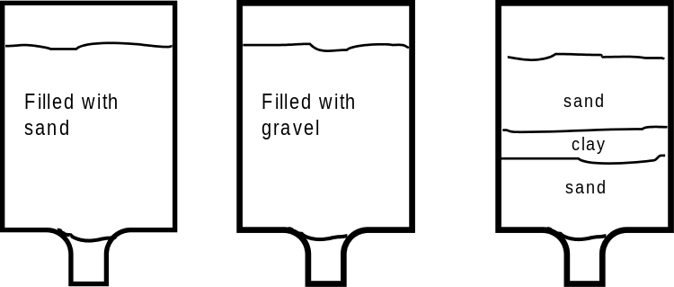
- Cut the bottom 3 or 4 inches from three 3-liter bottles and turn them over.
- Glue a single layer of cloth into the bottom of each to keep the sand and gravel from coming out.
- Fill the bottles as shown
  - Turn all three bottles upside-down with a graduated 250 ml beaker under each. Ask the students, “If I pour 100 ml of water into each of these at the same time, which will it travel through fastest?” Be open to all suggestions. Have the students justify their guesses. Have students assist you and pour 100 ml into each bottle at the same time. Monitor the 250 ml beakers to see which bottle the water passes through fastest. Discuss the results with the class. Solicit their hypotheses regarding the different rates of infiltration through the bottles.
  - Define porosity for the students. Show students a piece of scoria (lava rock with holes in it), a piece of sandstone, and a piece of conglomerate or a handful of gravel. Ask which of the samples exhibit porosity. Students should answer “all three” Ask which would form a rock through which fluids would move the easiest. Some students may select the scoria, due to the size of the pores. Point out to students that even though all three samples have porosity, the holes are not connected in the scoria, so fluid would not move through it as easily. The pores in the gravel are bigger than the pores in the sand or sandstone, so fluid would move through the gravel easier. Discuss the differences in porosity and permeability. Expand discussion to point out that water is not the only fluid that moves through the ground, oil and gas also migrate.
  - Ask the students what happens when you mix oil and water. Mix 100 ml water with 10 ml oil and have students observe and describe the results. Ask them why the oil rests on the top of the water. If necessary, review the concept of density and why some objects float on others. Ask the students what would happen in a permeable layer of rock if water, oil, and natural gas were mixed. Discussion should lead to the idea that they would separate with the gas on top and the water on the bottom.
  - Ask the students, “If the hydrocarbons are moving through the ground in a permeable layer of rock, what could stop them?” Entertain all suggestions. Describe the concept of petroleum traps to the students. Using overhead or board drawings, demonstrate and discuss stratigraphic, structural, salt dome, and reef traps.
  - Cut the bottom off empty 3 liter soda bottles approximately 5 inches from the bottom. Leaving the cap tightly secured, turn empty 3-liter soda bottles over and place the top into the bottom, using the bottom as a stand. In the bottle, have each group use sand, gravel, clay, or other materials you have provided to construct a model of one of the petroleum traps you have assigned them. With several colors of materials, you can have the students be very creative in their models.
Wrap Up: Display the models in view of all students. Using the models in your discussion, briefly review the concepts of porosity, permeability, and the various types of petroleum traps. Ask the students to critique the strong and weak points of using the 3-liter bottle models to discuss these concepts.
Assessment
Have students:
- List three things this lesson taught them that they didn’t already know or that they learned more about as a result of the lesson.
- Describe how oil and gas are formed.
- Define and describe permeability and porosity.
- Describe three types of petroleum traps.
Extensions
Have a guest speaker involved in the oil and gas industry speak on oil and gas exploration and how wells are drilled.
Have students research society’s dependence on petroleum. Have them include alternative energy sources in their research.
Resources
Chernicoff, S., Fos, H.A., and Venkatakrishnan, R. 1997. Essentials of Geology. New York, NY: Worth Publishers.
Hill, Carol. 1996. Geology of the Delaware Basin, Guadalupe, Apache, and Glass Mountains, New Mexico and West Texas: Permian Basin Section SEPM, Publication No. 96-39.
Murck, B.W., Skinner, B.J., and Porter, S.C. 1996. Environmental Geology. New York, NY: John Wiley & Sons, Inc.
Shew, R.D. 1998. Geology of the Guadalupe Mountains. Guidebook prepared for field seminar/workshop conducted by Guadalupe Mountains National Park and New Mexico State University-Carlsbad.
Shew, R.D., and Shew, D.M. 2000. Geology and Natural History of McKittrick Canyon. Guidebook prepared for workshop conducted by Guadalupe Mountains National Park and New Mexico State University-Carlsbad.

Strange Things in Strange Places
Just how extreme an environment can some things live in?
Summary: Students will use information learned in class discussion to play a game in which they describe several environments in which bacteria are found.
Duration: One or two 50-minute class periods
Setting: Classroom
Vocabulary: anaerobic bacteria, corrosion residues, extremophile, moonmilk, pool fingers
Standards/Benchmarks Addressed: SC1-E2, SC12-E7

Objectives
Students will:
- describe three “hostile” environments in which bacteria are found.
Background

When we think of the environments in which organisms live, we tend to think of our own comfort zone. When asked to think of organisms that live in extreme environments, most people will think of polar bears, camels, or birds. Cold weather, hot and dry, or high above the earth are as extreme an environment as most people can imagine for living organisms. However, research has shown that some microorganisms can live in environments far more extreme than was once thought possible.
Microorganisms have been found living in some very hostile environments. Among these are the cold of the Arctic and Antarctic, volcanic vents, hot vents on the ocean floor, in very dry locations, in rocks deep in the earth, in severe chemical environments, in hot springs, and in high-radiation environments. These extremophiles were not really recognized until the 1970s, but after their discovery were found to be located in the harshest environments on earth.
Throughout the course of their evolution, these organisms developed traits that enabled them to live in their particular, peculiar environments. Those living in freezing temperatures have, as part of their cellular composition, anti-freeze compounds, such as salts, sugars, and amino acids. Thermophiles, those organisms that thrive in excessive heat, are found in the hot springs of Yellowstone National Park and deep in the middle of the Atlantic Ocean, near black smokers, vents that spew superheated water. Those living in extreme chemical environments have developed body processes that enable them to deal with excessively acidic, alkaline, or salty environments.
Extremophiles have also been found deep underground. Some of these extremophiles actually live in the rock. They are anaerobic and do not require oxygen to respire. Some of these feed off hydrogen gas released when groundwater reacts with the rocks through which it is passing. In the Delaware Basin, anaerobic bacteria obtained the energy to live by facilitating the redox reactions of sulfur contained in gypsum and carbon contained in methane. At the boundary of the Castile Formation (impermeable gypsum) and the underlying Delaware Mountain Group (permeable oil and gas bearing beds), bacteria facilitated the following reaction:
Ca²⁺+2SO₄⁻²+2CH₄+2H⁺=2H₂S+CaCO₃+3H₂O+CO₂
In this reaction, the sulfur in anhydrite (CaSO₄) was reduced and combined with the acidic hydrogen (H⁺) to produce hydrogen sulfide (H₂S). The carbon contained in methane (CH₄) was oxidized to produce a carbonate ion (CO₃⁻²) that combined with the available calcium ion (Ca²) to produce limestone (CaCO₃). This limestone often carries the structures and bedding seen in gypsum next to it, so it is believed that this alteration from gypsum to limestone occurred in-situ. The hydrogen sulfide then moved through cracks into the reef where, near the water table, it was oxidized to form sulfuric acid (H₂SO₄). This acid dissolved the great voids that became the caves of the Guadalupe Mountains. A byproduct of this reaction occurred when the sulfate ion (SO₄⁻²) combined with calcium ions (Ca⁺²) released in the reaction and water to form gypsum (CaSO₄ 2H₂O).
In the caves of Carlsbad Caverns National Park, an abundance of evidence has been obtained that indicates microbes are responsible for many of the more unusual features seen. Among those unusual features are corrosion residues, a material composed mostly of insoluble residues. Research has indicated that these residues are the offal of the bacteria that have eaten the bedrock. In the areas where this residue is found, it coats the floors and walls of the cave. Pool fingers are slender calcite fingers, up to 30 cm long and around 2 to 6 mm in diameter. These fingers formed below the water level in pools and contained what have been interpreted to be bacterial filaments. Moonmilk is a pasty material consisting of calcite, hydromagnesite, gypsum, or other materials. It occurs in limited deposits in the caves of the Guadalupe Mountains. When studied at high magnification, it appears to contain filaments or fibers that may be bacterial in origin. Much of this research has been conducted in Lechuguilla Cave.
Microbiologists continue to study the life in the caves of Carlsbad Caverns National Park. While the entrance area of Lechuguilla Cave was mined for many years, the first know entry of humans into the depths did not occur 1986. That year, a group of cave explorers from Colorado, following air blowing through a pile of rock and dirt on the floor dug into a passage leading to the depths of the cave. As soon as the park realized what a unique resource the cave was, restrictions were placed on exploration and research in the cave to help preserve its unique environment. Numerous new bacteria have been found in the cave. Dr. L.M. Mallory and others have been very active in studying these bacteria and their possible help in creating a cure for cancer and other illnesses. NASA has shown a great interest in the microbes of Lechuguilla Cave. Exobiologists theorize that any life found on other planets in our solar system will be microbial, similar to that in Lechuguilla Cave. They hope that studying those organisms will show them the “fingerprint” of any potential aliens.
Materials
- markers or crayons
- large (2' x 3') sheets of paper
Procedure
Warm up: Ask the students “What criteria are essential for something to live?”
Have the students name the most extreme environments they can think of where something could still live.
Discuss with the class the various hostile environments on earth in which microbes live. Remind them that a form of e. coli bacteria lives in their gastrointestinal tract.
Discuss the role bacteria have played in the development of the caves of Carlsbad Caverns National Park.
Activity
- Give the students one large (2' x 3') of paper and crayons or markers.
- Tell the students that they are going to design an organism that can live in an extreme environment. Give them several examples of extreme environments to choose from. Tell them that they must explain how their organism adapts to the particular challenges of its environment.
- Have each group present their work to the class and open the floor for questions for each group.
Wrap Up: Ask the students what this lesson has to do with space travel.
Lead in a discussion about how the environments of other bodies in the solar system, such as Mars, Io, Ganymede and Europa, may harbor the same environment in which one of these organisms could live.
Assessment
Have students:
- describe three ways that microbes have adapted to hostile environments.
- briefly, describe the role microbes have played in the development of the caves of the Guadalupe Mountains.
- explain why NASA is interested in the microbes found in Carlsbad Caverns National Park caves.
Extensions
Using the internet, have students locate NASA related websites describing the search for extraterrestrial life. Have students study and report on a potential trip to Jupiter’s moon, Europa, or on the search for life beneath the surface of Mars.
Resources
DuChene, H.R., and Hill, C.A. 2000. The Caves of the Guadalupe Mountains Research Symposium. In Hose, L.D. (ed.) Journal of Cave and Karst Studies 62(2).
Hill, C.A. 1987. Geology of Carlsbad Cavern and Other Caves in the Guadalupe Mountains, New Mexico and Texas. Socorro, NM: New Mexico Bureau of Mines and Mineral Resources, Bulletin 117.
Hill, Carol. 1996. Geology of the Delaware Basin, Guadalupe, Apache, and Glass Mountains, New Mexico and West Texas: Permian Basin Section SEPM, Publication No. 96-39.
Jagnow, David and Jagnow, Rebecca. 1992. Stories from Stones: The Geology of the Guadalupe Mountains. Carlsbad, NM: Carlsbad Caverns Guadalupe Mountains Association.
Sasowsky, I.D. and Palmer, M.V. 1994. Breakthroughs in Karst Geomicrobiology and Redox Geochemistry. Karst Waters Institute, Special Publication 1.
Smith, R.B. and Siegel, L.J. 2000. Windows Into the Earth. New York, NY: Oxford University Press.

Stinky Gas and Alabaster
How did all that gypsum get into the caves of Carlsbad Caverns National Park?
Summary: After class discussion, students will engage in a card game designed to demonstrate the processes leading to the alteration of limestone to gypsum in the caves of Carlsbad Caverns National Park.
Duration: One to two 50-minute class periods
Setting: Classroom
Vocabulary: dissolve, escarpment, joint, lava tube
Standards/Benchmarks Addressed: SC2-E1, SC12-E1, SC12-E7

Objectives
Students will:
- describe the relationship of cave openings in limestone and the gypsum deposits found in them.

Background
Caves form through many different processes. The classic model for the formation of solution caves states that mildly acidic meteoric water dissolves bedrock as it descends through it. As the bedrock dissolves, the widened cracks, or joints, become cave passages. Some of these widened passages may eventually contain large underground rivers, as is the case in Mammoth Cave National Park in Kentucky. Similar processes account for cave formation in gypsum. In the Parks Ranch Cave System in southeastern New Mexico, approximately 10 km southeast of the Carlsbad Caverns National Park, infrequent cloudbursts can fill gypsum cave passages to the ceiling. These caves are often called “desert storm drains.”
On shield volcanoes, such as the extinct volcanoes in El Malpais National Monument, cave passages are found in the old lava flows. During the last eruption in this area, fast moving lava cooled and solidified near the surface while the hot, liquid lava continued to flow inside. Eventually, the lava flowed out of the tube in places, leaving behind an opening, or a cave.
Near the edge of mountain escarpments where faulting has occurred, tectonic caves are found. These caves are formed as a fault or a joint widens along the edge of an escarpment rather that being formed by dissolved bedrock. Several of these caves are found along the Algerita Escarpment, in the Guadalupe Mountains west and northwest of Carlsbad Caverns National Park. These caves are often deep shafts lined with a great deal of loose rock.
Glaciers often have caves along their base. As the ice of the glacier melts, water will work its way to the base of the glacier where it flows along the ice/bedrock boundary. There, it can melt a passage large enough for human to traverse. These glacier caves sometimes go several hundred feet under a glacier.
The caves of Carlsbad Caverns National Park have a different story. They were formed by acidic groundwater. However, this water did not descend from above. Rather, the necessary components actually rose from the nearby Delaware Basin. In the Delaware Basin, the Castile Formation, composed primarily of anhydrite or gypsum, overlays the sands, limestone, and shale of the oil and gas producing Delaware Mountain Group. Methane gas, moving through the rocks of the Delaware, was stopped on reaching the impermeable Castile. At that point, anaerobic bacteria living in the rock facilitated the redox reactions in which the sulfur contained in anhydrite was altered to become hydrogen sulfide gas and the carbon contained in the methane gas became part of a calcium carbonate rock, limestone. Hydrogen sulfide gas is easily identified by its strong, rotten egg odor. The methane gas produced from the Delaware Basin is, for the most part, considered to be “sour gas” due to the amount of hydrogen sulfide it contains. The reaction is summarized in the following formula:
Ca²⁺+2SO₄⁻²+2CH₄+2H⁺=2H₂S+CaCO₃+3H₂O+CO₂
In this reaction, the sulfur in anhydrite (CaSO₄) was reduced and combined with the acidic hydrogen (H⁺) to produce hydrogen sulfide (H₂S). The carbon contained in methane (CH₄) was oxidized to produce a carbonate ion (CO₃⁻²) that combined with the available calcium ion (Ca²) to produce limestone (CaCO₃). This limestone often carries the structures and bedding seen in gypsum next to it, so it is believed that this alteration from gypsum to limestone occurred in place.
The hydrogen sulfide then moved through cracks, or joints, into the reef where it began to migrate upward. Near the water table, it encountered oxygenated water and was oxidized to form sulfuric acid (H₂SO₄). This acid dissolved the great voids that became the caves of the Guadalupe Mountains. The joints along which the hydrogen sulfide gas rose were gradually widened until they became the deep pits that characterize many caves of the Guadalupe Mountains. The Bottomless Pit in Carlsbad Cavern is an example of such a pit.
A byproduct of this reaction occurred when the sulfate ion (SO₄⁻²) combined with calcium ions (Ca⁺²) released in the reaction and water to form gypsum (CaSO₄ 2H₂O). In Carlsbad Cavern, some of these massive gypsum deposits can be found in the Big Room near the Jumping Off Place, the Talcum Passage, and in the New Mexico room. In some caves of the Carlsbad Caverns National Park, such as Lechuguilla Cave, sulfur has been deposited in its native yellow crystalline state.
Materials
- Copies of the cards printed at the end of the lesson (glued to cardboard and laminated). You will need one set of cards for each group of three to four students. Number of each card per set: Methane and gypsum (15); Bacteria (5); H₂S Gas and calcite replacing Anhydrite (10); Oxygen + H₂S = Sulfuric Acid (15); Dissolves limestone and deposits gypsum (10).
Procedure
Warm up: Ask the class how caves form. Write all ideas on an overhead or board. Discuss the various ideas presented.
Describe and discuss with the class the current model of how the caves of the Guadalupe Mountains formed.
Activity
- The objective of the game is to be the first to obtain a complete set of five cards and lay them down in order (Methane and Gypsum, Anaerobic Bacteria, H₂S Gas, Sulfuric Acid, Deposits Gypsum). Provide each group of three or four students with a complete set of game cards. Tell students to shuffle the cards and leave them face down.
- Tell the students to deal each person in the group a hand of five cards and to look at their own hand, but not to show anyone else.
- Tell the dealer to place the remainder of the stack face down on the table. This becomes the “draw pile.” Tell them to then turn over the first card on the deck, placing it on the table next to the draw deck. This will start the “discard pile.”
- The person to the dealer’s left will be the first to go. They have a choice of picking up the top card on the “draw pile” or the top card on the “discard pile.” In selecting, they should remember that they are trying to be the first to get a complete set of five cards.
- After drawing, that player must select a card from their hand to discard. He/she places that card, face up, on the discard pile. Play then moves to the next person who also chooses between the unknown, face down card on the “draw pile” or the known, face up card on the “discard pile.”
- The game continues until one player has a complete set of five cards. They MUST lay the cards down in the proper order. It is the responsibility of the other group members to see that this is done correctly.
- Play can continue through one hand or through several, depending on what time allows.
Wrap Up: Hold up game cards, one at a time, and have students tell which step comes next.
Ask the students to again describe the ways in which caves can form. Ask if they had ever considered that bacteria could be responsible for the formation of a cave like Carlsbad Cavern.
Assessment
Have students:
- describe three different ways in which caves form.
- describe the role of bacteria in the formation of Carlsbad Cavern.
- explain how calcium in the limestone of the Capitan Reef can be altered to become part of large gypsum deposits in caves.
Extensions
Have students conduct internet and library research on other caves with unusual stories. Examples of possible caves to study are Cueva de Villa Luz in Tabasco, Mexico where slimy bacterial formations hang from the ceiling over acidic water. These slimy formations have been given the name “snottites.” This activity does not need to focus on bacterial activity in caves. Rather, the students should look for facts that they find to be interesting and unusual.
Resources
DuChene, H.R., and Hill, C.A. 2000. The Caves of the Guadalupe Mountains Research Symposium. In Hose, L.D. (ed.) Journal of Cave and Karst Studies 62(2).
Hill, C.A. 1987. Geology of Carlsbad Cavern and Other Caves in the Guadalupe Mountains, New Mexico and Texas. Socorro, NM: New Mexico Bureau of Mines and Mineral Resources, Bulletin 117.
Jagnow, David and Jagnow, Rebecca. 1992. Stories from Stones: The Geology of the Guadalupe Mountains. Carlsbad, NM: Carlsbad Caverns Guadalupe Mountains Association.
Stinky Gas and Alabaster
Materials


