SUMMARY OF LAYOUT AND NAMING CONVENTIONS FOR

HV CABLE ASSEMBLIES

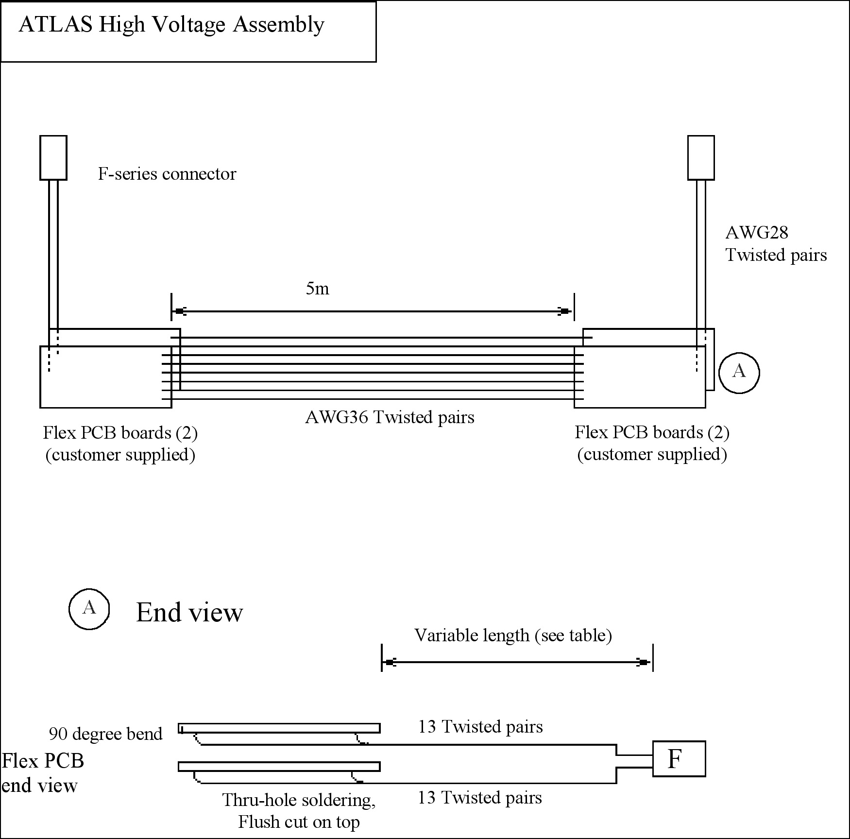

Schematic of HV cable assemblies. Two assemblies are manufactured at same time, AWG36 “inner” wires are cut in middle and attached to different PP0 sets. Each assembly uses two identical Flex PCB boards (designated “A” – top and “B” – bottom). Layout of an individual PCB is shown on next page.

Schematic of Flex PCB for HV cables
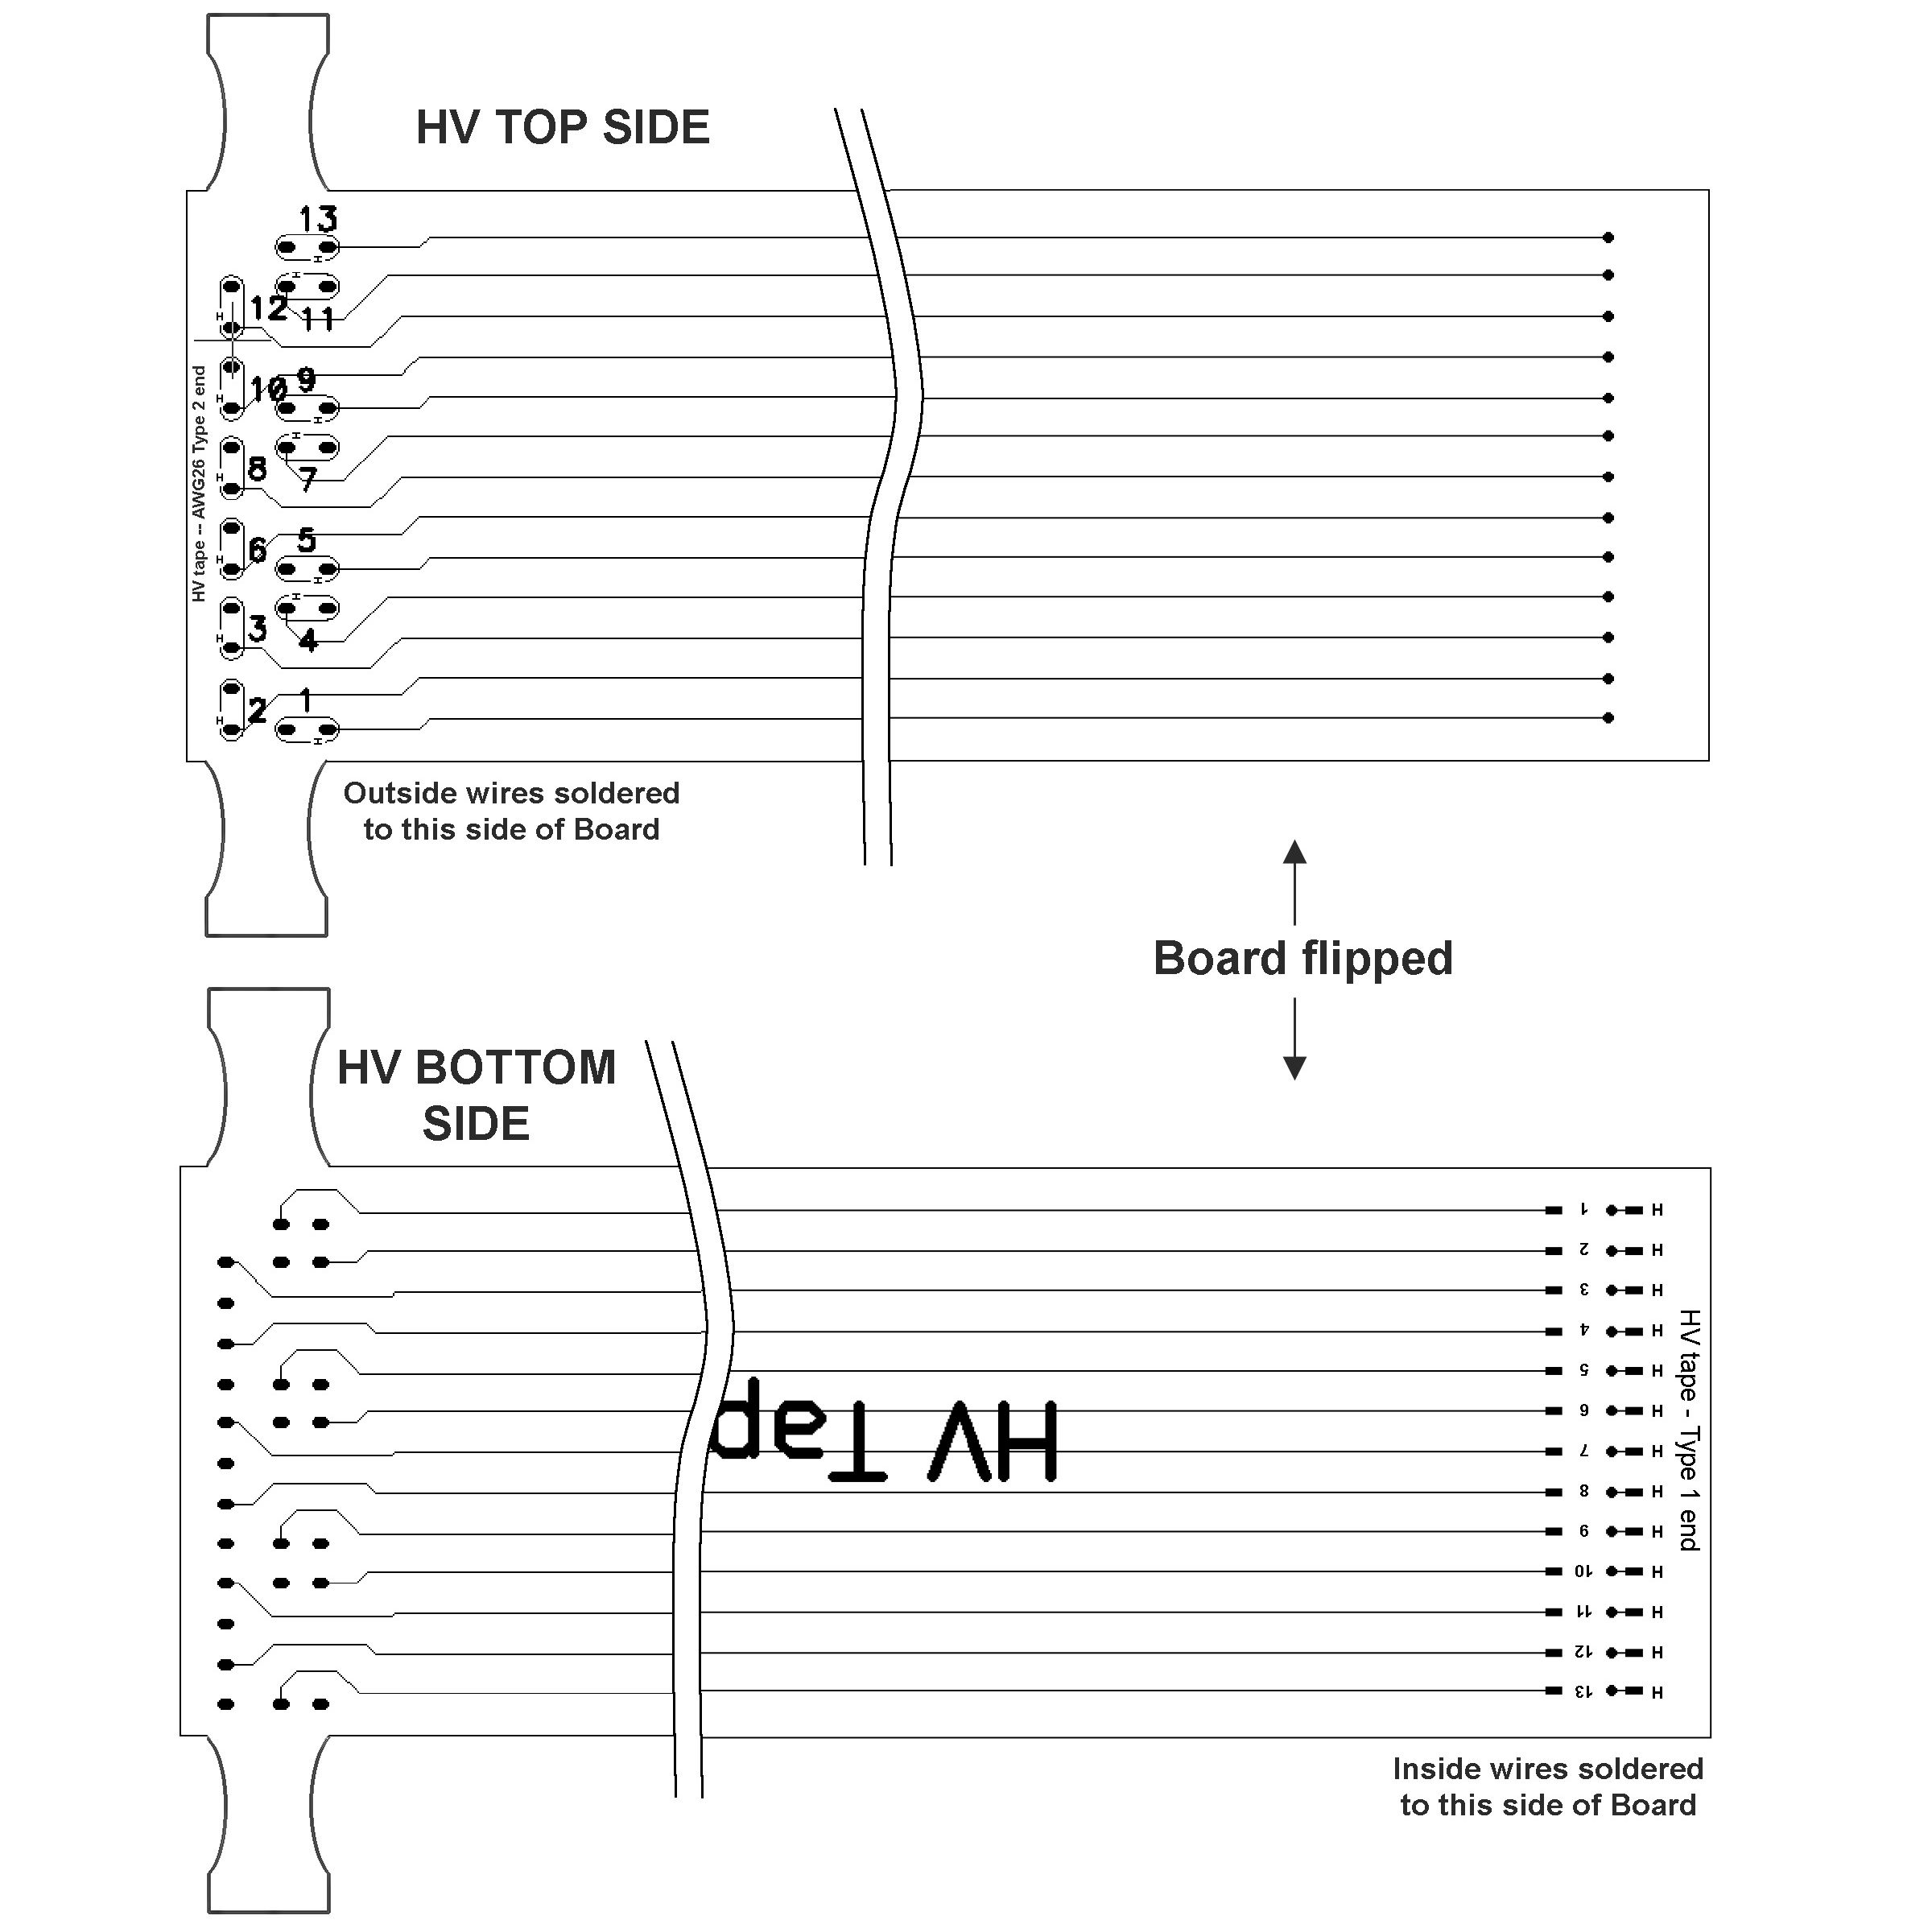

 | Wires | Conductor | Insulation | Manufacturer
Each End | 26 tw pairs | AWG28 7-strand tin plated copper | Polyimide red/green | Raydex
Middle | 26 tw pairs  (2 bundles) | AWG36 solid copper | Polyimide ML clear//green | MWS
PP1 Pinout, FlexPCB pad assignments, and Naming Conventions for HV Cables
F-connector Pin Number | AWG28-Flex A | AWG28-Flex B | Color | Net name | Label PP1-Flex-fcn-PP0
2 | 1H |  | R | HV_1T_A | 2 - A1H - HV - A1T
3 | 1 |  | G | HV_RET_1T_A | 3 - A1 - HVr - A1T
4 | 2H |  | R | HV_2T_A | 4 - A2H - HV - A2T
5 | 2 |  | G | HV_RET_2T_A | 5 - A2 - HVr - A2T
6 |  |  |  | Drain/shield | 6 – Drain/shield
27 | 3H |  | R | HV_3T_A | 27 - A3H - HV - A3T
28 | 3 |  | G | HV_RET_3T_A | 28 - A3 - HVr - A3T
29 | 4H |  | R | HV_4T_A | 29 - A4H - HV - A4T
30 | 4 |  | G | HV_RET_4T_A | 30 - A4 - HVr - A4T
31 | 5H |  | R | HV_5T_A | 31 - A5H - HV - A5T
48 | 5 |  | G | HV_RET_5T_A | 48 - A5 - HVr - A5T
46 | 6H |  | R | HV_6T_A | 46 - A6H - HV - A6T
47 | 6 |  | G | HV_RET_6T_A | 47 - A6 - HVr - A6T
59 |  |  |  | Safety_interlock_A1
60 |  |  |  | Safety_interlock_A2
7 |  |  |  | Drain/shield | 7 – Drain/shield
8 | 7H |  | R | HV_7T_A | 8 - A7H - HV - A7T
9 | 7 |  | G | HV_RET_7T_A | 9 - A7 - HVr - A7T
10 | 8H |  | R | HV_1B_A | 10 - A8H - HV - A1B
11 | 8 |  | G | HV_RET_1B_A | 11 - A8 - HVr - A1B
12 | 9H |  | R | HV_2B_A | 12 - A9H - HV - A2B
13 | 9 |  | G | HV_RET_2B_A | 13 - A9 - HVr - A2B
32 | 10H |  | R | HV_3B_A | 32 - A10H - HV - A3B
33 | 10 |  | G | HV_RET_3B_A | 33 - A10 - HVr - A3B
34 | 11H |  | R | HV_4B_A | 34 - A11H - HV - A4B
35 | 11 |  | G | HV_RET_4B_A | 35 - A11 - HVr - A4B
49 | 12H |  | R | HV_5B_A | 49 - A12H - HV - A5B
50 | 12 |  | G | HV_RET_5B_A | 50 - A12 - HVr - A5B
51 | 13H |  | R | HV_6B_A | 51 - A13H - HV - A6B
61 | 13 |  | G | HV_RET_6B_A | 61 - A13 - HVr - A6B
15 |  | 1H | R | HV_1T_B | 15 - B1H - HV - B1T
16 |  | 1 | G | HV_RET_1T_B | 16 - B1 - HVr - B1T
17 |  | 2H | R | HV_2T_B | 17 - B2H - HV - B2T
18 |  | 2 | G | HV_RET_2T_B | 18 - B2 - HVr - B2T
19 |  |  |  | Drain/shield | 19 – Drain/shield
37 |  | 3H | R | HV_3T_B | 37 - B3H - HV - B3T
38 |  | 3 | G | HV_RET_3T_B | 38 - B3 - HVr - B3T
39 |  | 4H | R | HV_4T_B | 39 - B4H - HV - B4T
40 |  | 4 | G | HV_RET_4T_B | 40 - B4 - HVr - B4T
52 |  | 5H | R | HV_5T_B | 52 - B5H - HV - B5T
53 |  | 5 | G | HV_RET_5T_B | 53 - B5 - HVr - B5T
54 |  | 6H | R | HV_6T_B | 54 - B6H - HV - B6T
55 |  | 6 | G | HV_RET_6T_B | 55 - B6 - HVr - B6T
62 |  |  |  | Safety_interlock_B1
63 |  |  |  | Safety_interlock_B2
20 |  |  |  | Drain/shield | 20 – Drain/shield
21 |  | 7H | R | HV_7T_B | 21 - B7H - HV - B7T
22 |  | 7 | G | HV_RET_7T_B | 22 - B7 - HVr - B7T
23 |  | 8H | R | HV_1B_B | 23 - B8H - HV - B1B
24 |  | 8 | G | HV_RET_1B_B | 24 - B8 - HVr - B1B
25 |  | 9H | R | HV_2B_B | 25 - B9H - HV - B2B
26 |  | 9 | G | HV_RET_2B_B | 26 - B9 - HVr - B2B
41 |  | 10H | R | HV_3B_B | 41 - B10H - HV - B3B
42 |  | 10 | G | HV_RET_3B_B | 42 - B10 - HVr - B3B
43 |  | 11H | R | HV_4B_B | 43 - B11H - HV - B4B
44 |  | 11 | G | HV_RET_4B_B | 44 - B11 - HVr - B4B
56 |  | 12H | R | HV_5B_B | 56 - B12H - HV - B5B
57 |  | 12 | G | HV_RET_5B_B | 57 - B12 - HVr - B5B
58 |  | 13H | R | HV_6B_B | 58 - B13H - HV - B6B
64 |  | 13 | G | HV_RET_6B_B | 64 - B13 - HVr - B6B

