Technology Team, Inc. History

Judd E. Squitier, Chief Executive Officer, founded TEAM in September 1993. For over a year, it served as a platform for his after-hours consulting assignments. In October 1994, the company began full-time operations when Mr. Squitier brought two long-time associates, Angel J. Garcia III and Jacquelin Hux-Cain, into the organization as partners; Mr. Garcia as Chief Operating Officer, and Mrs. Hux-Cain as Chief Marketing Officer. In 1999, John F. McClure, a senior technical expert on the staff, became a partner and Chief Technology Officer. The four (4) principals manage TEAM as a customer-focused, solutions-driven partner providing support and services to our customers.
Name of Firm | Technology TEAM, Inc.
Main Office Address | 6315 Bren Mar Drive, Suite 250  Alexandria, VA 22315
Corporate Web Site | www.tteam.com (and www.secdog.com, a wholly-owned subsidiary)
Date/Place of Incorporation | September 1993; Delaware
FTIN | TIN-541688451
DUNS Number | 879828754
Point of Contact | Judd E. Squitier, CEO
Voice/Fax Numbers | (V) 703.256.6661 /  (F) 703.256.3810
E-mail | info@tteam.com
Figure 1: TEAM is an established, stable corporation.

Early (1994) contracts involved IT support and miscellaneous policy development and consulting to environmental organizations within the Department of Defense and various Federal Agencies, including the United States Postal Service. Within the first three (3) years, TEAM’s focus shifted to an emphasis on Internet solutions, including web site development, web-enabled applications, and web migration strategies.

Now, TEAM counts among its clients:

- Air National Guard
- Alexandria Earth Day
- America Recycles Day
- Department of Defense, Defense Environmental Information Technology Management (EITM) Program Office
- Defense Command, Control, Communications & Intelligence (C3I)
- Defense Occupational Health Program
- Department of Justice
- Department of Transportation
- Deputy Assistant Secretary of the Army, Environment, Safety & Occupational Health
- Georgia Technology Authority
- National Oceanic and Atmospheric Administration (NOAA)
- North Atlantic Treaty Organization
- Partnership for Peace Information Management System (PIMS)
- United States Geological Survey
- United States Postal Service

It is important to note that the Department of Defense and the United States Postal Service remain our customers in 2003, nine (9) years after we first began supporting them.

Key Competencies

TEAM specializes in Internet Technologies. TEAM boasts a tradition of creating websites to support management, communication, issue advocacy and commerce. When developing a site, the Company seeks to integrate functionality with the mission and goals of the customer. Dedication to learning about and understanding the customer’s business enables TEAM to provide effective solutions to its customers. TEAM provides dynamically generated websites with content management efficiencies that make modifications and updates a breeze.
TEAM Specializes In:
- Information Architecture;
- Website Development, Deployment, and Maintenance;
- Application Development; and
- Hosting Services.
Figure 2: TEAM began specializing in
Internet Technology in 1995.

Recent shifts in website development methods include the rise in database-driven, dynamically generated websites that include online content management systems (CMS) with a graphical user interface (GUI). Dynamic websites with CMS offer the advantages of easy maintenance an enhancement by staff members that are not trained webmasters. TEAM helps its customers by developing and implementing a CMS designed to store all of the website content in a database that can categorize the information by subject, date, and viewing permissions. The CMS also stores several custom templates for the site, and associates the content with the correct template(s). The web page templates act as the frame for the dynamic content, which is pushed to the web through the use of the middleware technology interfacing with the back-end database.

In addition to our web architecture, design, development and maintenance services, we also provide hosting services through our SecureDogHosting© subsidiary. Our hosting service features:

- Redundant T-1 Lines
- 24x7 Reliability
- Private ATM Switched Network with One Hop to Internet Backbone
- Real-Time Intrusion Detection System Tools
- Multiple Security Protocols and Firewalls∗
- All Major Operating Systems and Development Platforms

We’re so confident in the system we built we offer all our clients 100% availability service level agreements. Our hosting customers include the U.S. Postal Service Environmental Management Policy, Department of Defense Office of the Secretary of Defense, Air National Guard, Alexandria Earth Day Environmental Organization, Databill, Green Quill Communications, CH2MHill, among others.

Corporate Financial Stability

Since unofficial start-up in late 1994, TEAM’s total revenues total nearly $30 million. The company’s annual revenue topped $1 million for the first time in 1997. Revenues during the period from 1998-2001 were nearly $15 million, and annual revenues for 2002 exceeded $11 million. TEAM’s financial stability is a hallmark of the philosophy of its principals, who maintain stringent finance and accounting policies and procedures.

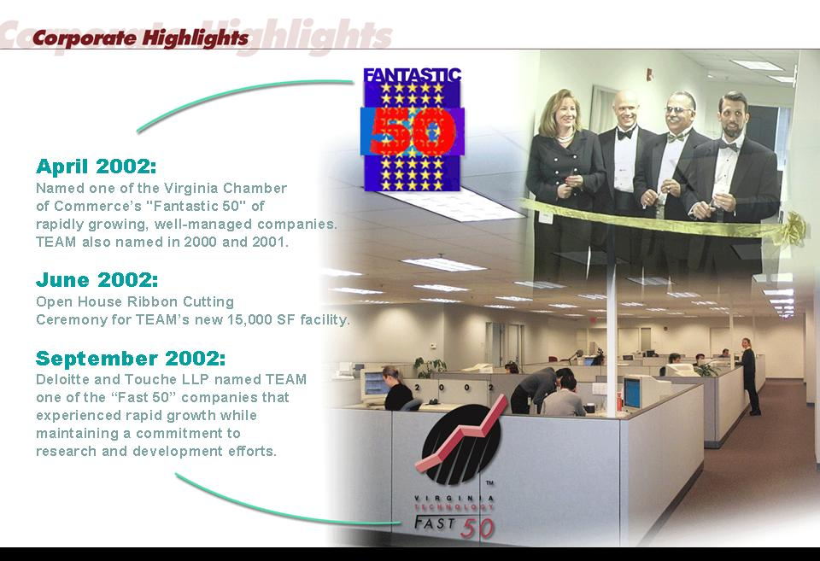
TEAM Awards and Recognition

TEAM received recognition in 2002 from the Virginia Chamber of Commerce and Deloitte & Touche LLP for its sound management practices as it continued consistent growth. Interestingly, TEAM received recognition from both groups four (4) of the last five (5) years.

Additionally, TEAM opened its new Headquarters in 2002. Located in Alexandria Virginia, TEAM occupies state-of-the-art office space within a newly refurbished building in an industrial park setting. Incorporating office ergonomic principals that focused on workflow,
Figure 3: TEAM’s proud of its success.
maximum utility, safety and
employee comfort, TEAM designed a complete build out of approximately 15,000 sq. ft. Our space includes the following:

- 56 individual cubicles.
- 19 offices with some large enough of 2 people.
- 1 Data Center.
- 1 Collaboration Room that has wall-to-wall white boards and online capability.
- 1 Conference Room with a center table that accommodates 14 people and plenty of space along the outer wall for additional seating. Fully functional for upscale IT industry briefings/presentations.
- 5 Administrative workstation areas nested throughout the office for printers, copiers, binding, collating, etc.
- 5 Storage rooms for operational materials, client equipment for project support, etc.
- Reception Area.
- Employee Kitchen.

TEAM’s Data Center was built with security in mind. It is completely walled in with it’s own HVAC system. It has both access card and biometric controls along with a state-of-the-art video camera security system. We maintain two (2) UPS backup power units that can run up to 8 hours per unit. A natural gas supplied generator located above the Data Center on the roof backs this up. It has a capacity for hosting hundreds of servers within several rows of standard floor to ceiling racks. It is the highlight of the tour through our office.

Customer Satisfaction

TEAM’s experience includes supporting federal, state and local government agencies, as well as International and Commercial customers. After nine (9) years in business, TEAM’s customer loyalty exemplifies our reputation for innovative technology deployment and quality professional services. TEAM counts both the Department of Defense and United States Postal Service among its first customers in 1994 that we continue to supporting 2003.

To ensure the ongoing success of our long-term relationships, TEAM establishes a single point of contact on both the TEAM and customer sides. The two representatives meet regularly to review any outstanding issues that arise, as well as to fine-tune the project to achieve the highest level of satisfaction and maximize performance.

TEAM’s point of contact for each project is the Project Leader, who tracks the project using a Microsoft Project Management approach that we present in a web environment. We develop and implement custom designed project management web sites for all of our customers. These secure sites make project tracking extremely efficient – information is disseminated in real-time. From their offices, homes and conference rooms, managers easily access critical information about their projects such as, meeting minutes, draft documents, plans, reports, and budget information. The response from our customers about this convenient method of managing projects has been overwhelmingly positive. The following represents a typical web analysis, planning and restructuring project:

- Front Page of the Web Project Site
- Contract Information, Statements of Work, Modifications
- Project Plans, MS Project, Gantt/PERT Charts
- Task, Responsibility, and Deadline (TRD) tracking tool
- Web Site Storyboards
- Schedules
- Project Roles, Relationships, and Responsibilities Profiles
- Financial Information, Invoices, Cost/Resource Tracking
- Points of Contact

 SecureDogHosting’s © secure data center is poised for Department of Defense Information Technology Security Certification and Accreditation Process (DITSCAP) certification; we’ve been cleared through Phase II of the four phases of certification.

