

Department of Housing and Urban Development

Audit of Loans with Downpayment Assistance
Contract Number C-OPC-22550

Final Report

February 6, 2004

733 Fifteenth St. NW, Suite 340; Washington, DC 20005 * (202) 969-2880

Contents

Page Number

Executive Summary v.

I. Introduction 1

II. Audit Methodologies 4

III. Key Findings 7

IV. Intrinsic Data Summary
Description of Sample 9
Spotlight on Gifts 14

V. Data Integrity Missing Data Elements 26 TINs 27
FICO or Credit Scores 29
Remaining Elements 31

VI. Insights and Recommendations Clarity of Source Documentation 36
Timing Impacts Accuracy 37
Data Entry Errors 38
Systemic Issues 38
Other Observations 39

Appendix I Data Entry Form Guide 41
Appendix II SMSA Gift Source Distribution By Year
Figure 9-1A: Relative Gifts vs. Non-Profit Gifts 52
By Fiscal Year of Endorsement (ATL SMSA)
Figure 9-2A: Relative Gifts vs. Non-Profit Gifts 53
By Fiscal Year of Endorsement (IND SMSA)
Figure 9-3A: Relative Gifts vs. Non-Profit Gifts 54
By Fiscal Year of Endorsement (SLC SMSA)
iii

Appendix III Discrepancies between the Binder Data and
CHUMS Data
Table 19-1A: Dollar Fields Where Gift Amounts Were 56
Greater in the Case Binder Than In the
CHUMS Records
Figure 19-2A: Dollar Fields Where Total Assets Available 58
Were Greater in the Case Binder Than In
The CHUMS Records
Figure 19-3A: Dollar Fields Where Borrower Required 60
Investment was Greater in the Case Binder
Than In The CHUMS Records
Table 20-1A: Dollar Fields Where Gift Amounts Were 62
Less in the Case Binder Than In the
CHUMS Records
Figure 20-2A: Dollar Fields Where Total Assets Available 64
Were Less in the Case Binder Than In
The CHUMS Records
Figure 20-3A: Dollar Fields Where Borrower Required 66
Investment was Less in the Case Binder
Than in the CHUMS Records

Appendix IV Implied Average Source of Funds When
Gifts Are Present
Figure 13-1A: National Sample 69
Figure 13-2A: Combined SMSA Sample 69
Figure 13-3A: Atlanta SMSA Sample 70
Figure 13-4A: Indianapolis SMSA Sample 70
Figure 13-5A: Salt Lake City SMSA Sample 71
Executive Summary

The Department of Housing and Urban Development (HUD) and the HUD Office of Inspector General (OIG) are concerned about the potential for high claim rates on mortgages originated using downpayment assistance programs offered by non-profit organizations. This concern has led the OIG to question the risk prudence of insuring these loans. In addition, the OIG’s examination of a small number of binders raised concerns that data on gift sources submitted by lenders via the Computerized Home Underwriting Mortgage System (CHUMS) were in many cases inaccurate or missing all together. In order to objectively assess the risk of these mortgages and to identify appropriate actions to reduce the risk, HUD engaged Concentrance Consulting Group Inc., (Concentrance) to conduct an audit of at least 8,000 mortgage binders selected by HUD.

The target sample distribution for review and coding included 5000 binders from the national insurance portfolio and 1000 binders each from three SMSA target areas (i.e., Atlanta, Indianapolis and Salt Lake City). The final sample of 8294 binders reviewed and coded met or exceeded targets in each instance. The final sample included loans where there are no gifts and loans where gifts were provided from sources other than non-profit organizations.

The scope of the audit included a comparison of data found on key documents in the case binder to the information lenders had transmitted via the CHUMS system. The audit also encompassed the collection of information on gift sources and amounts. The findings resulting from this audit were coded in a Microsoft Access Database, pre-approved by HUD. To ensure the accuracy of the data a three-stage quality control review process was conducted. This audit was simply a comparison of data elements found in the binder and the information transmitted by lenders via the CHUMS and did not encompass traditional mortgage underwriting. No additional, independent verification was conducted to determine the validity of documentation contained in the case binders.

This report contains a high level analysis of selected intrinsic data trends derived from the information collected during the review of the binders. Our analysis of these trends is intended to provide insights into the characteristics of the sample and is not deemed conclusive. Some of these observed trends require further study, because our analysis was limited to readily observed trends in the data and did not include the depth of study required to make risk-based decisions.

Audit Results

Data quality for the most part was good in the CHUMS and the binders, with data quality issues centered on borrower asset-related fields. Data discrepancies between CHUMS and the binders occurred most often in the total assets available field and the borrower required investment field. In the CHUMS, most data elements were populated at least 98% of the time, however the Tax Identification Number (TIN), gift amount and gift source fields were frequently missing or different from the information in the binder. Below are a list of key findings related to data quality, gifts and other characteristics of the sample:

- TINs were missing 74% of the time when the binder indicated the presence of a non-profit gift.
- Gift source and amount were missing from the CHUMS 28 % and 22% of the time respectively when a gift was known to be present based upon the binder review.
- In the binder, supporting documents such as gift letters were frequently missing or incomplete.
- The average gift from a relative was 9% higher than the average gift from a non-profit.
- Median House prices and seller contributions tended to be higher when gifts from non-profits were present.
- The CHUMS data quality was not greatly compromised by the limitation posed by the lack of multiple gift source fields. The number of instances where more than one gift source was present was minimal, 155 cases.
- Use of gifts from non-profit organizations increased over time (FY 1999 – FY 2002). This is especially evident in the SMSA sample.
- In most cases total assets reported in the CHUMS were higher than total assets found during the binder review.
- The binder review revealed an additional 1,012 gifts not reported by lenders via the CHUMS, representing over 28% of all gifts.

Our recommendations relate to the key findings above: (1) address ways to improve data quality by enhancing validation capabilities in CHUMS for gift-related data fields, (2) conduct further study to determine the relationship between non-profit gifts and other file characteristics to including median house price and seller contribution, and (3) conduct primary research and analysis to determine the underlying source of discrepancies between CHUMS and the binder for borrower required investment and total assets available fields.

I. Introduction

The Department of Housing and Urban Development (HUD) engaged Concentrance Consulting Group Inc. (Concentrance) to conduct an audit of data integrity of loans where downpayment assistance was provided. The audit focused primarily on loans where non-profit organizations provided gift funds to the borrower. The goals of the audit were to determine the extent to which the Computerized Home Underwriting Mortgage System (CHUMS) data is accurate and to collect information on sources of funds used by the borrower for downpayment and closing, including gift funds.

HUD’s Government Technical Representative (GTR) for the audit randomly selected case binders (binders) for the audit sample from single family insurance portfolios at a national level as well as three Standard Metropolitan Statistical Area (SMSA) levels. SMSA level binders were selected from the Atlanta (ATL), Indianapolis (IND) and Salt Lake City (SLC) portfolios. The GTR indicated that:
- The resulting data samples were uniform across time based on insurance endorsement dates, which were between October 1999 and September 2002. This timeframe coincides with the timeframe when non-profit downpayment gift programs were becoming an important component of FHA’s single-family insurance business, and is recent enough so that HUD can track default and claim experience of these loans.
- The samples were comprised of purchase-money mortgages with loan-to-value ratios above 95 percent. This subset of the FHA portfolio represented first-time homebuyers with limited personal finances and a mandated target audience of both FHA business and downpayment gift providers.

The target sample distribution for review and coding included 5000 binders from the national insurance portfolio and 1000 binders each from the three SMSA target areas. The final sample distribution of 8294 binders reviewed and coded met or exceeded these targets. The final sample included loans where there are no gifts and loans where gifts were provided from sources other than non-profit organizations.

In order to conduct the audit, data was provided to Concentrance from two sources:
- The CHUMS, which is HUD’s vehicle for lenders to submit electronically the data on insured mortgage loans.
- The case binder, which is a paper storage file used to house the documents associated with the HUD insured mortgage. The case binders include copies of legal instruments and other closing forms, the borrower’s financial information and the property appraisal or other indication of property value.

In order to meet the goals of this audit, one of the key tasks was to compare data found in the case binder to data reported by lenders via the CHUMS and to code that data into a database developed by Concentrance. Concentrance was instructed to use the Mortgage Credit Analysis Worksheet (MCA Worksheet), HUD-1 and credit report as the primary basis for comparison to information previously submitted to HUD via the CHUMS. Other documents in the case binder were reviewed as needed to assist in clarifying inconsistencies in the primary documents.

The primary case binder documents used for this audit serve the following purpose in the lending and insurance process:
- The MCA Worksheet is used as a pre-closing instrument by the lender and is completed to document compliance of the proposed loan with HUD’s underwriting requirements.
- The HUD-1 is a post-closing form used to record the settlement transaction.
- The credit report contains the borrower’s credit history and historical information found in the public record about any borrower involvement in legal proceedings.

Another task of this audit was to collect information on gifts provided to borrowers to assist them in making their required downpayment. To satisfy this requirement of the audit, Concentrance reviewed the binders for additional information about the amount and sources of downpayment assistance and coded these findings in the database. HUD required Concentrance to provide this report of its findings on data integrity in the CHUMS versus the case binders. HUD asked that particular attention be given in the report to how and why sources of “gift” monies for downpayment might be miscoded or not-coded in the CHUMS. Based on the review and analysis of the data from the case binder audit, HUD asked Concentrance to formulate recommendations HUD might need to give to mortgagees to assure complete, accurate and correct data entry for gift-money amount and sources and what quality checks HUD should consider incorporating into the CHUMS to identify mistakes at initial submission of the mortgage data.

This report represents our final findings based on the review and coding of 8,294 binders out of the total sample of 8,877. For various reasons, 583 binders were not available and not provided by the particular HUD Homeownership Center (HOC). This audit is a comparison of data elements found in the binder and the information transmitted by lenders via the CHUMS. This audit did not encompass traditional mortgage underwriting for accuracy, verification or prudence in decision-making relative to any of the information within the binder. The lender’s underwriting and presentation within the case binder was presumed to be correct and meet HUD requirements. No additional, independent verification was conducted to determine the validity of documentation contained in the case binders.

This report contains a high level analysis of selected intrinsic data trends derived from the information collected during the review of the binders. Our analysis of these trends is intended to provide preliminary insights into the characteristics of the sample and is not deemed conclusive. Some of these observed trends require further study, because our analysis was limited to readily observed trends in the data and did not include the depth of study required to make risk-based decisions.

Our objectives for this report are to:
- Provide an overview of our approach to this audit, including binder review methods and quality control. (Section II)
- Share our key findings resulting from the audit (Section III)
- Summarize selected intrinsic data trends. (Section IV)
- Share insights relative to data integrity particularly as it relates to sources of funds for downpayment. (Section V)
- Provide recommendations for steps that HUD might consider to improve the accuracy of data submitted by lenders via the CHUMS, particularly in the case of sources of funds for downpayment and closing. (Section VI)
- Show additional detailed information to augment or further explain information in the body of the audit report. (Appendix I – IV)

II. Audit Methodologies

Review Process

Concentrance employed a team of ten data analysts to review mortgage case binders selected by HUD and to code their findings into a database developed by Concentrance. The data analysts were instructed to locate the HUD-1, MCA Worksheet, credit report and gift documentation in the mortgage binder. They were made aware of nuances associated with differences in real estate practices in the various locations sampled and alerted to the presence of multiple versions of the source documents in the binders. For example, we initially encountered two versions of the MCA Worksheet, a 4/95 version and a more recent 10/98 version. After finding a few of the 4/95 version in the early stages of the audit we discovered lenders were overwhelmingly using the 10/98 version. Less than 20 copies of the 4/95 version were found in the binders. In other instances, binders contained several copies of the HUD-1 and multiple copies of the MCA Worksheet. When multiple copies of the same documents were present determining the correct copy to use required a more extensive review. In those instances, the on-site manager or the business analyst assisted the data analysts in making the correct determination.

With a HUD approved electronic data entry form and a Microsoft Access database, the Concentrance team of data analysts worked in pairs to review case binders and code results. The analysts compared selected data elements on these forms to the data entered by the lender via the CHUMS transmission. In instances where the information was inconsistent with or missing from the CHUMS, the analysts entered their findings from the binder review into the database. In cases where the information from the binder review matched the pre-populated CHUMS data, the database was programmed to allow the analysts to select the data resident in the applicable CHUMS field and automatically duplicate it in the binder field.

For each data element the analysts were provided a description of the element, the location on the source document for coding the data element, and special instructions for selected data fields. The specific data elements subject to the audit along with special audit rationale and instructions can be found in Appendix I to this report.

Quality Control

Concentrance performed three quality control reviews:
- Pre-data entry
- Analyst specific
- Outlier

Pre-data entry quality control involved a second-level review of more complex binders by the on-site manager or business analyst in collaboration with the data analysts. Data entry was completed based upon decisions made after the second-level review. Examples of binders that required pre-data entry quality control included but were not limited to cases where:
- Multiple source documents were in the binder
- Multiple entries for the same data element were on the HUD-1 or MCA Worksheet
- Items in a column were changed but totals were not adjusted
- The case number was not in the CHUMS sample database
- Information on the source documents was illegible or missing.

Analyst specific quality control reviews involved a random sample of at least 5% of binders for each data analyst. All results of the analyst’s binder review were examined for accuracy. The results of this quality control showed an accuracy rate ranging from 98%- 99.9% for all data analysts.

Outlier quality control reviews involved tests on data elements resident in the CHUMS. Data values from the binder results were compared to the CHUMS to test for differences beyond a reasonable tolerance, the tolerance level chosen varied by data element. For example, on such items as appraised value, original mortgage amount and borrower social security number the tolerance was zero. For other items such as gift amount, total assets and downpayment the tolerance started as low as $500. Every attempt was made to verify the accuracy all outliers above the tolerance.

Outlier quality control was performed on the following data elements:
- Closing Costs
- Appraised Value
- Cash Required to Close
- Borrower Required Investment
- Original Mortgage Amount
- Monthly Mortgage Payment
- Total Assets Available
- Total Closing Costs
- Borrower Closing Costs
- Gross monthly Income
- Contract Sales Price
- Gift Amount(s)

A test was also performed to determine if the amount of borrower reserves after closing was greater than $1,000, which was our threshold for this outlier. In cases where reserves were greater than $1,000 we conducted an additional review of the binder documentation to ensure that borrower assets were coded correctly. Quality control results revealed that borrower assets above $1,000 were not that unusual since 4,754 of the binders did not show a gift to the borrower and therefore, larger asset amounts would be expected. Even some of the binders with gifts had assets above $1,000. In several cases, gifts from relatives exceeded $30,000. The average gift from a relative was close to $4,200, while the average gift from a non-profit was slightly over $3,700. The median gift from a relative was $3,500 and the median gift from a non-profit was $3,566.

Corrections resulting from quality control reviews were entered in the appropriate binder data fields in the database.

III. Key Findings

Data Quality

Data quality for the most part was good in both the CHUMS and in the binders. Binder source documents (MCA Worksheet, HUD1 and Credit Report) were present in all but a few cases. There were a limited number of fields where the data were missing or where there were major discrepancies between the CHUMS and the binder. Missing data and discrepancies were associated with borrower assets and investment-related fields.

Data quality issues are centered on borrower asset related fields…

  - In the binder, supporting documents such as gift letters were frequently missing or incomplete. The lack of this documentation was a major driver in missing TINs for non-profits. The gift source was missing in only 84 binders.

  - In the CHUMS, most data elements were populated at least 98% of the time, however the TIN, gift amount and gift source fields were frequently missing. TINs were missing 74% of the time when the binder indicated the presence of a non-profit gift. Gift source and amount were missing in the CHUMS 28 % and 22%, respectively, when a gift was known to be present based upon the binder review. Conversely, a gift source and amount were present in both the CHUMS and the binder 72% of the time.

  - Data discrepancies between CHUMS and the binders occurred most often in the total assets available field and the borrower required investment field.

- It was difficult to determine the borrower’s total investment in the transaction because there was no uniformity among lenders as to what to include in the total assets available field on the MCA worksheet.

The CHUMS data quality was not greatly compromised by the limitation posed by the lack of multiple gift source fields, as the number of instances where more than one gift source was present is minimal…

- There were only 155 instances in the sample with multiple gift sources. However, when multiple gifts occur there is no systematic choice of which source code is reported by the lender to the CHUMS.

Non-Profit Gifts

Non-profit gifts represented 45% of the total sample. Over 81% of these non-profit gifts in the sample were provided in FY 2001 and FY 2002. Differences in the characteristics of the transaction were evident in the data between binders with non-profit gifts and gifts from relatives or the absence of a gift. For example, the average gift from a relative was 9% higher than the average gift from a non-profit.

Nearly 29% of all gifts in the national sample were from a non-profit, while nearly 62% of gifts in the SMSA samples were from a non-profit. The majority of non-profit gifts were in FY 2001 and FY 2002.

In the Indianapolis SMSA sample median house price and seller contribution tended to be higher when gifts from non-profits were present…

- Median house prices were 4.55% higher than when the gift came from a relative.
- Seller Contributions on average represented 38% of the funds required to close the transaction, while only 29% was required of the seller if the gift came from a relative.

When builders were involved, gifts from non-profits were more prevalent as compared to other gift sources. Furthermore, the proportion of gifts from non-profits was higher in the SMSA sample than in the national sample...

- In cases where a builder was the seller, gifts from non-profits represented 31% of these cases while gifts from relatives represented only 12%. Furthermore, in the national sample non-profits provided gifts 19% of the time and relatives provided gifts 13% of the time. Compared to the SMSA samples these percentage were 40% and 11%, respectively.
- Gifts from non-profits represented 62% of all gift sources in the SMSAs. The percentage of non-profit gifts in the national sample is 29%.

IV. Intrinsic Data Summary

Description of Sample

In this section an overview of the basic characteristics of the sample is provided. We examined the distribution of the sample by origination year and geography. Also examined was a segmented view of the extent to which gifts from all sources, including family and non-profits, were represented in the sample.

Figure1.

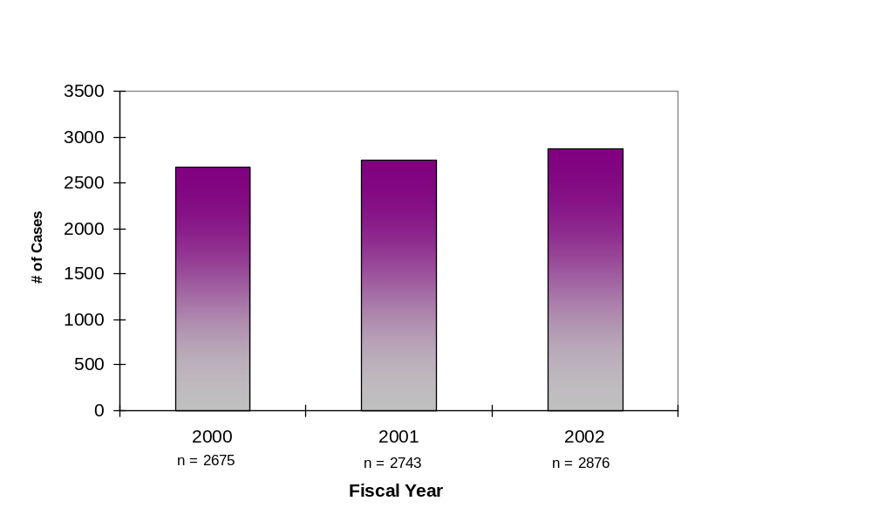
Sample Distribution by Fiscal Year of Insurance Endorsement
Total Sample = 8,294
32%
33%
35%

Concentrance coded 8,294 binders out of a total population of 8,877. As depicted in Figure 1 above, the binders were distributed almost evenly across the three Fiscal Years. This distribution is uniform across time and was based on insurance endorsement dates between October 1999 and September 2002. This timeframe coincides with the timeframe when non-profit downpayment gift programs were becoming an important component of FHA’s single-family insurance business, and is recent enough so that HUD can track default and claim experience of these loans.

In Figure 2 below, the distribution of case binders by HOC shows that the Atlanta HOC, which included the Atlanta (ATL) and Indianapolis (IND) SMSAs, comprised the largest number of binders in the sample. In the Atlanta HOC, 40% of the binders were part of the national sample and the remaining 60% were part of the SMSA sample. The second highest number of binders came from the Denver HOC, which included the Salt Lake City (SLC) SMSA. The split in the Denver HOC between the national sample and the SMSA sample it 54% and 46%, respectively. All of the binders in the Philadelphia and Santa Ana HOCs were part of the national sample.

Figure 2
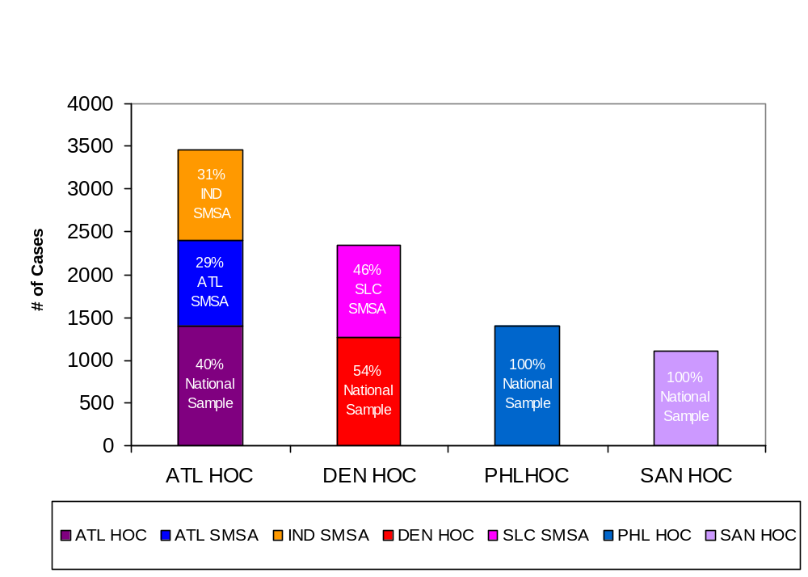
Coded Binders
By HOC
3459
3459
1398
1101
2336
To meet the 8,000 coded binder goal, roughly a 10% “bad” case rate was factored into the 8,877 binder request to the HOCs. In general, a bad case is defined as any case missing critical documents, such as the HUD-1 or MCA Worksheet, or binders requested but not provided by the HOCs. As shown in Figure 3 below, the geographic distribution of coded binders closely mirrored the targeted distribution. This distribution reflects the sampling strategy and the availability of binders from the various HOCs. For a variety of reasons, 583 binders out of the 8,877 requested were not available, or could not be provided in time to be included in the audit. However, every HOC provided enough binders to meet the minimum established sample requirements. Binders from the Philadelphia and Santa Anna HOCs were received very early in the process while binders from the Atlanta and Denver HOCs comprised the majority of the binders reviewed and coded in the second half of the project.
Coded percentages in the Philadelphia and Santa Anna HOCs are slightly higher than coded percentages in the other HOCs (105% and 107% percent of the coding target, respectively).

Figure 3

Binders Coded vs. Goal
Coded Binders Versus Goal

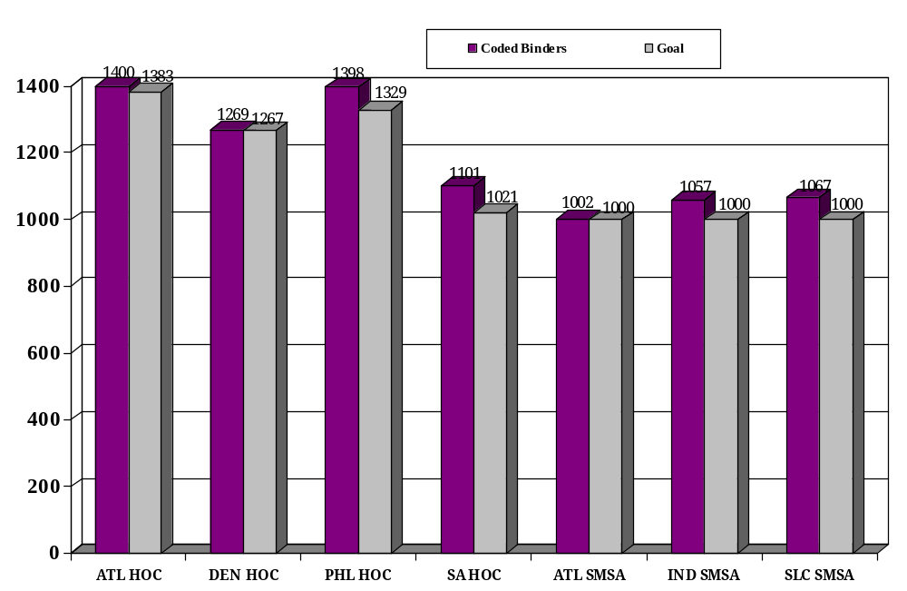

SMSA Sample

National Sample

Figure 4 below represents the extent to which homebuilders are the sellers of the properties within the sample. Builders as sellers indicate that the properties securing the mortgages are new construction. The Atlanta HOC had the largest number of binders (1,103), where builders were the sellers of the properties. This represents 63% of the total number of binders where the builder was also the seller of the property. The HOC with the next highest number of binders where builders were the sellers of the properties was Denver with 409 binders or 23%.
Figure 4

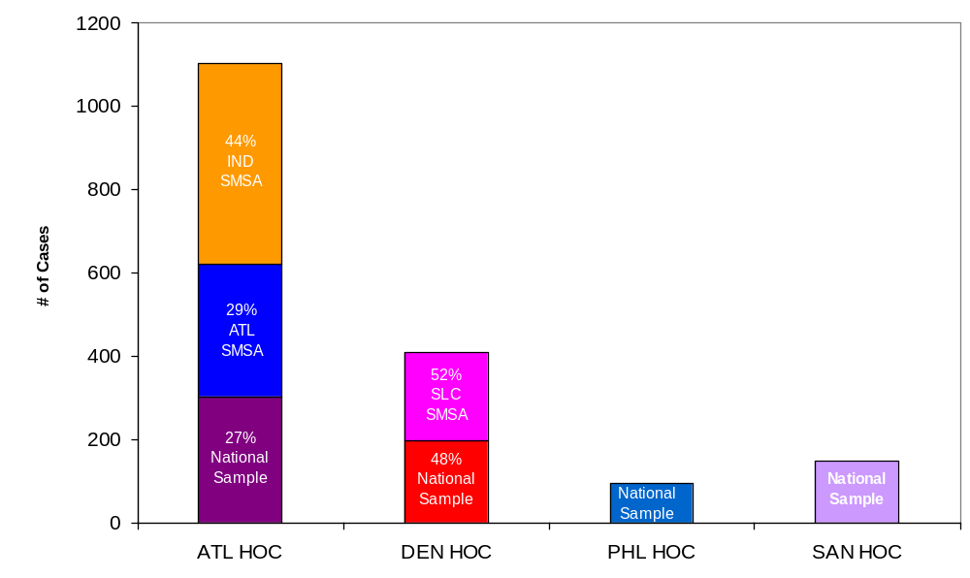
Distribution of Binders Involving Builders
By HOC
1103
409
95
147
Total Cases Involving Builders = 1754

Figure 5 below examines the distribution of case binders with gifts by HOC. Binders with gifts in the sample totaled 3,574. The Atlanta HOC had the most binders with gifts. At 1,698 gifts this represents approximately 48% of the total number of binders with gifts in the sample. The next highest HOC, Denver, had 35% fewer gifts than Atlanta. Denver binders with gifts represented 31% of the total gifts in the sample. The Philadelphia and Santa Anna HOCs had the least number of gifts in the sample representing 11% and 10% of total gifts respectively.

Figure 5

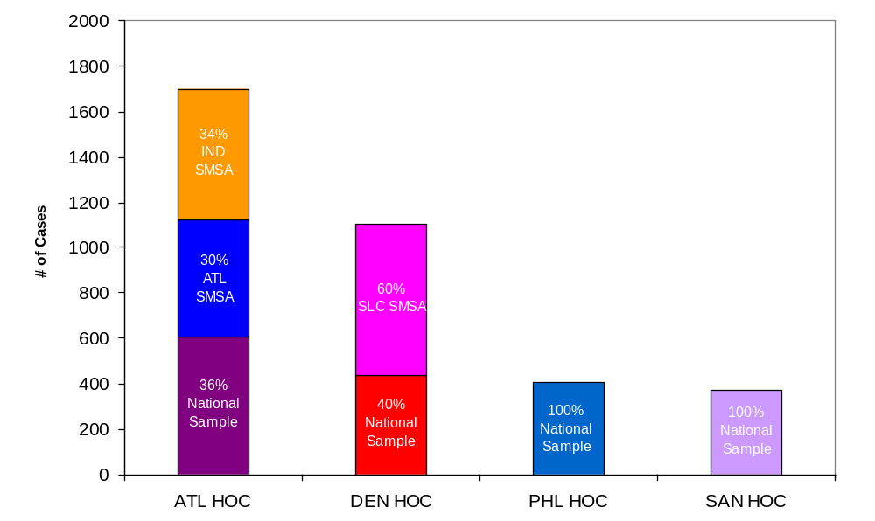
Gifts
By HOC
1698
(48%)
1101
(31%)
406
(11%)
369
(10%)
Total Gifts = 3574

Spotlight on Gifts

An objective of the audit was to gather information on gift assistance provided to the borrower for downpayment and closing. This section highlights our findings relative to the characteristics of binders with gifts in the sample. Particular attention was given to binders where gifts were provided by non-profit organizations. Various comparisons are presented among binders where non-profit gifts are involved and binders where gifts are provided by relatives or where gifts were not present in the transaction.

Figure 6
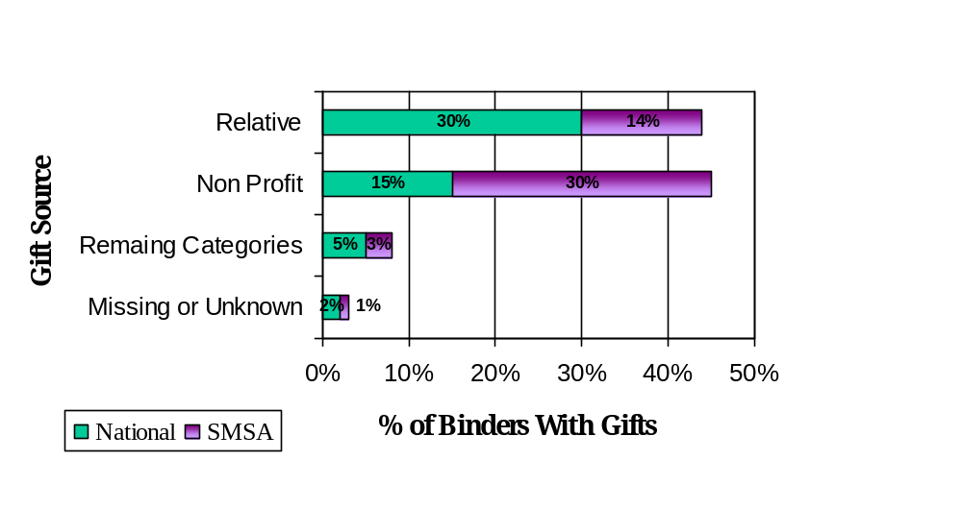
44%
45%
8%
3%
Primary Gift Sources

Total Number of Binders with Gifts = 3574

Figure 6 above, shows a comparison of the percentage of binders with gifts for downpayment by gift source in the national and SMSA samples. Each category is represented as a percentage of the total number of gifts in the sample. Gifts from relatives and non-profit organizations collectively accounted for 89% of all gifts. The composition of non-profit versus relative gifts was nearly the exact opposite in the National and SMSA samples. The gift from a relative category included 30% in the national sample and 14% in the SMSA sample. While in the non-profit gift category 30% of the gifts were in the SMSA sample and the remaining 15% were in the national sample. The remaining categories (sources 3 through 12, most of which are now obsolete due to changes made by HUD) are 8% of all gifts and missing gift source makes up the balance of about 3%. There were no real differences in the national versus SMSA sample for these categories.

A Gift from a relative was a major source of funds for homeowners in the sample, and the average gift from a relative tended to be higher than the average gift from any other source. For example, the average gift amount from a relative was $4,192 while the average gift from a non-profit was only $3,723. The median gift from a relative was $3,500 and the median gift from a non-profit was $3,566. The other gift sources were small in number and thus average gift amount is not a material finding.

The gift source descriptions used by HUD during the sampling period (October 1999 through September 2002) were as follows:

Gift Source Code Gift Source Description

- Relative
- Non-profit, religious or community organization
- Government Assistance (Formerly Federal)
- State Program (now obsolete)
- Local Government (now obsolete)
- Employer
- Own Funds (now obsolete)
- Unsecured Loan (now obsolete)
- Seller contribution (now obsolete)
- Other (now obsolete)
- Premium Interest Rate (now obsolete)
- Secondary Financing (now obsolete)
99 Missing

As noted earlier, all the above gift sources are now obsolete with the exception of gift source 1 (Relative), gift source 2 (non-profit) and gift source 6 (Employer). Most binders in the audit contained only one gift source. There were only 155 binders that contained multiple gift sources.

Figure 7

Distribution of Gift Sources
By Sample
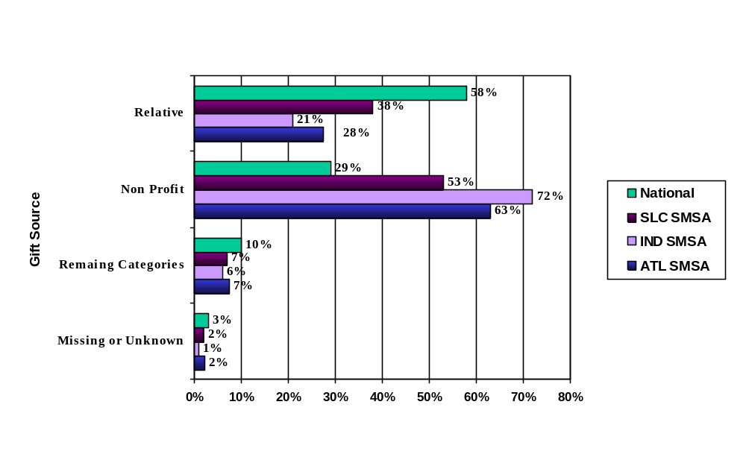
Total Number of Binders with Gifts: Nat =1817, ATL = 517, IND = 575, SLC = 665
Figure 7 above shows the distribution of gifts by source, further segmented by the four samples, National and the three SMSAs. The chart reflects that gifts from non-profits are more prevalent in the SMSA samples than in the national sample. The ATL and IND SMSAs were included in the sample due to their higher than average population of loans with gifts from non-profits. The national sample had 1817 binders with a gift. When compared to the entire universe of binders with gifts (see figure 6), the percentage of binders with gifts from a relative increased to 58% for the national sample, versus 44% for all binders. Gifts from non-profit organizations drop to 29% in the national sample, down from 45% for all loans. The Remaining Categories and Missing or Unknown was about the same as the total sample. Gifts from relatives and non-profit organizations account for 87% of all gifts in the national sample, compared to 89% for all loans.

The ATL sample had 517 binders with gifts. Of these cases, gifts from relatives were 28% of the sample, whereas 58% of gifts in the national sample were from relatives. However, gifts from non-profit organizations were 63% of the total in the ATL sample, versus 29% in the national sample. The Remaining Categories and Missing or Unknown were lower than the other samples at, 7% and 2% respectively. Even though the gift source distribution changed dramatically, favoring non-profit organizations, both the non-profit and family gift categories still accounted for 91% of all gifts in the ATL sample, compared to 89% for all loans and 87% for the national sample.

IND sample had 575 binders with gifts. Compared to the national sample, gifts from relatives decreased to 21% of the sample, down from 58% in the national sample and 28% in the ATL sample. As in the ATL sample, gifts from a non-profit organization increased dramatically in IND to 72% compared to the national sample at 29% and 63% in the ATL sample. The Remaining Categories and Missing or Unknown were lower than or about the same as the other samples at 6% and 1% respectively. Gifts from relatives and non-profit organizations were 93% of all gifts in the IND sample, compared to 89% for all loans, 87% for the national sample and 91% for the ATL sample.

The SLC sample had 665 binders with gifts. Compared to the national sample, gifts from relatives were 38% of the sample, versus 58% in the national sample. When compared to the ATL and IND gifts from relatives reflected an increase of 10% and 17% respectively. Gifts from non-profit organizations represent 53% of the SLC sample, compared to the 29% in the national sample, 63% in the ATL sample and 72% in the IND sample. The Remaining Categories and Missing or Unknown were similar to the other samples at 7% and 2% respectively. Gifts from relatives and non-profit organizations were 91% of all gifts in the SLC sample, compared to 89% for all loans, 87% for the national sample, 91% for the ATL sample and 93% for the IND sample.

Figure 8

Relative Gifts and Non-Profit Gifts
By Fiscal Year of Insurance Endorsement
(National Sample)

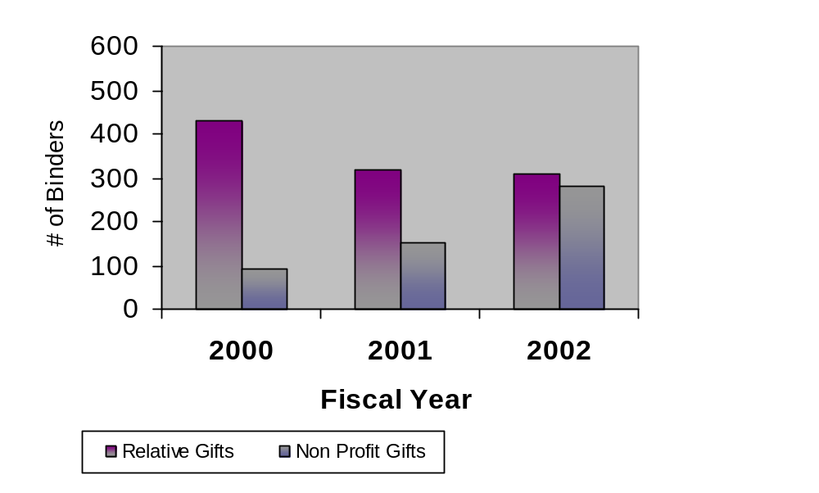

69%

58%
47%
43%

28%

15%

n=662
n=543
n=652

In Figure 8 above, we examined the distribution of relative and non-profit gifts using the national sample only (excluding the SMSA samples). The chart shows gifts from relatives are greater than gifts from non-profits for all fiscal years. In 2002, the percentage of gifts from the two sources evens out.

Figure 9

Relative Gifts and Non-Profit Gifts
By Fiscal Year of Insurance Endorsement
(SMSA Sample)

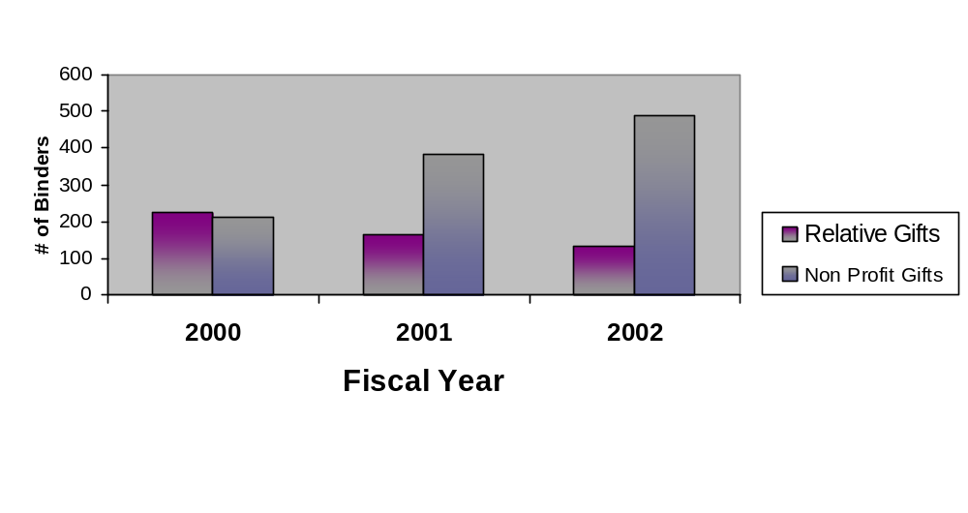

74%

64%

46%
44%
27%
20%

n=487
n=605
n=665

An examination of the relative and non-profit gift sources, Figure 9, in the combined SMSA samples (i.e., ATL, SLC and IND) revealed a total of 1,757 binders that contain gifts. As Figure 9 above shows, gifts from non-profit organizations were the major gift source. Only in 2000 did the family gift source exceed gifts from non-profits. Information on the individual SMSAs can be found in Appendix II.

Figure 10
Median House Price
By Gift Source

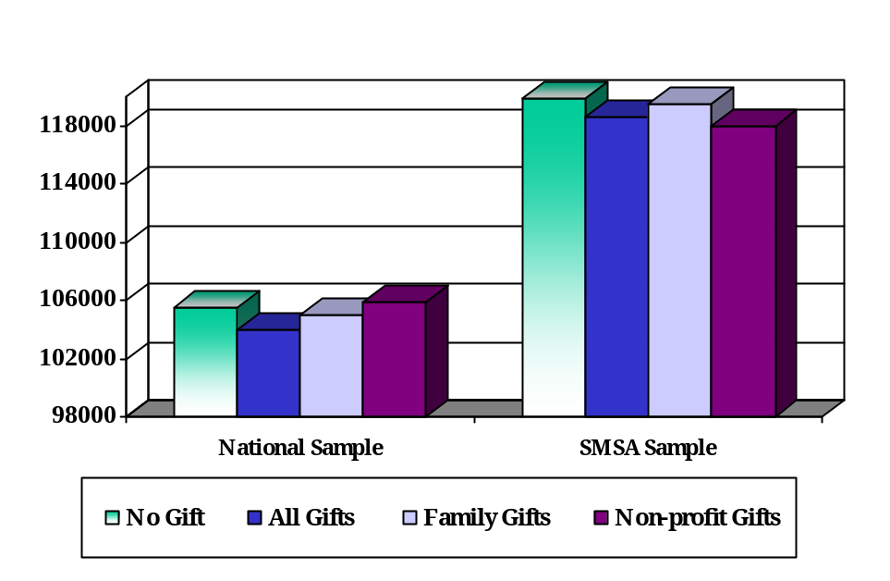

Note: Total binders 8,294; 3,574binders with gifts and 4,720binders with no gift.

The chart above, Figure 10, depicts differences in median house prices among binders in the national and SMSA samples by gift source. In the national sample, the data seems to indicate that if the borrower received a gift from a non-profit, the median house price was approximately 1% higher than the median house price for borrowers receiving a gift from a relative. However, in the SMSA sample if the borrower received the gift from a non-profit organization, the median house price was 1.27% lower than the median house price for borrowers receiving a gift from a relative.

Figure 11
Median House Price
By Gift Source and SMSA Samples

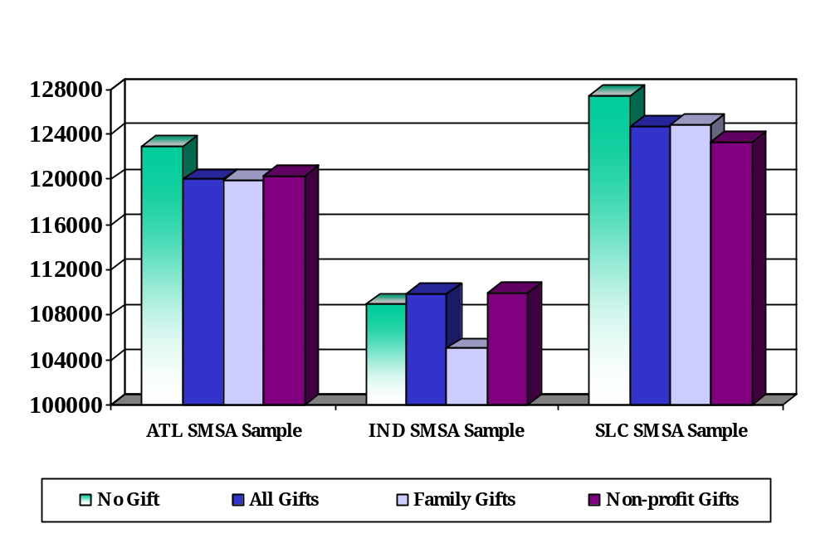

Note: Total binders 8,294; 3,574binders with gifts and 4,720binders with no gift.

The chart above, Figure 11, shows the median house price for each SMSA by gift source. In the ATL and SLC samples, the difference in median house price for gift from a non-profit versus a gift from a relative was not significant. The difference was less that .5% in the ATL sample and a little over 1% in the SLC sample. However, in the IND sample, the median house price was 4.55% higher if the gift came from a non-profit versus a relative.

Figure 12

Distribution of Binders Involving Builders
By Gift Source

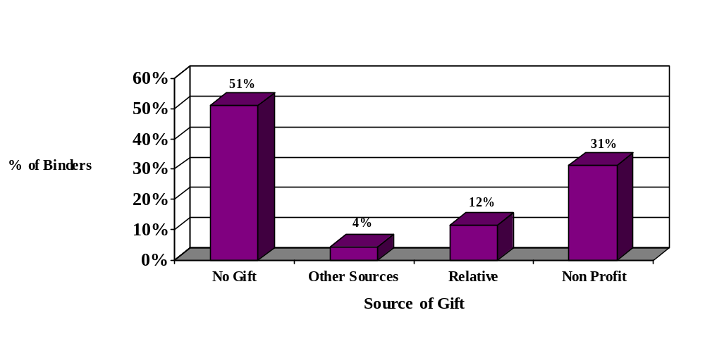

As shown in Figure 12 above, non-profit organizations provided downpayment assistance in 31% of the binders involving a builder. Relatives provided assistance in 12% of these binders. In 51% of the binders no gift was provided and in 4% of the binders other sources provided the gift. Figure 12 also shows that the most used gift source is non-profit when a builder is involved.

Figure13

Implied Average Source of Funds
When Gifts Were Present (Total Sample)
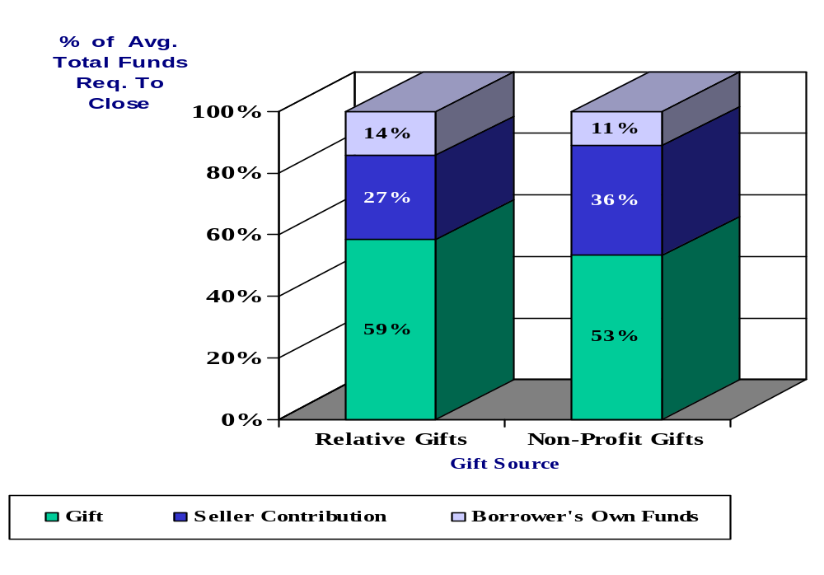
Figure 13 above shows an implied calculation of the source of funds for closing. It was necessary to derive the borrower’s total investment because there is no uniform representation of the borrower’s total investment on either the MCA worksheet or the HUD-1. For example, lenders were adding gifts from relatives to the Borrower Assets Available in accordance with the HUD Handbook 4000.2 REV-2, however, many lenders were not reflecting these gifts separately on the MCA worksheet or reporting them via the CHUMS.

If the gift came from a non-profit organization, the task of determining how much of the borrower’s own funds were in the transaction is a little less problematic. All gift funds from a non-profit organization were funneled through an approved settlement agent and thus are less likely to be co-mingled with the borrowers own funds.

When gifts or contributions came from other gift sources, it was not always possible to determine how the funds were used in the transaction. This is especially true when the funds came from the seller of the property. In some cases, the underwriter detailed what portion of the seller contribution covered customary closing costs and what portion was used to cover pre-paid items. In other instances, the seller contribution was listed on the HUD-1 or MCA Worksheet without any indication of how the funds would be used.

The implied source of funds used in Figure 14 was calculated based on the findings of the binder review. The calculation is as follows:
Average Total Cash Required to Close From Borrower (Line 12G, MCA Worksheet)
+Average Seller Contributions (Line A3, MCA Worksheet)
=Average Total Cash Required for Settlement
Average Seller Contributions (Line A3, MCA Worksheet)
Average Gift Funds (Binder review results)
=Average Borrower Investment from own funds.

The chart in Figure 13 illustrates what portion of the funds for closing came from the borrowers’ own funds and was not a gift or seller contribution. An interesting observation is the correlation between the source of gift funds and the extent of the contribution from the seller. If the gift came from a relative, the seller contributed an average of 27% of the funds in the transaction and the borrower is contributed 14% of his or her own funds. However, if the gift came from a non-profit or government agency, the seller contributed an average of 36% of the funds in the transaction while the borrowers’ own funds represented 11% of the transaction costs. The borrower portion of the funds in the transaction was very similar in the two examples; however there was a noticeable difference in the amount contributed by the seller in the two situations.

One explanation for the difference in the seller contributions between the two gift sources is that the average gift from a non-profit was smaller than the average gift from a relative, thus requiring that the borrower and/or others invest more funds into the transaction. Anecdotally, when relatives were involved we observed gifts covered not only the downpayment and closing costs but additional amounts targeted to pay off debts and even for reserves.

Information on the individual samples can be found in Appendix IV.

Figure 14

Seller Contributions
By Gift Source (Total Sample)

Incidence
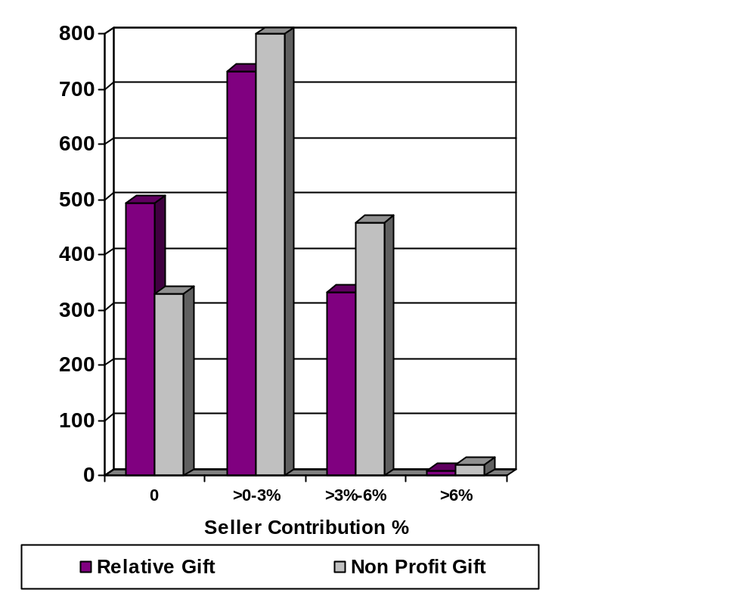

The information shown above in Figure 14 should be considered in the context of the information in Figure 13. Figure 14 shows seller contributions as a percentage of the sales price. While Figure 13 reflects that the seller contribution as a percentage of the total cost of closing was higher in instances where non-profit gifts were present, the overall seller contribution as a percent of sales price reflected in Figure 14 rarely exceeded the 6% limitation, in accordance with HUD guidelines.

V. Data Integrity

Missing Data Elements

Figure 15

Top Five Missing Data Elements in Binders
By Sample

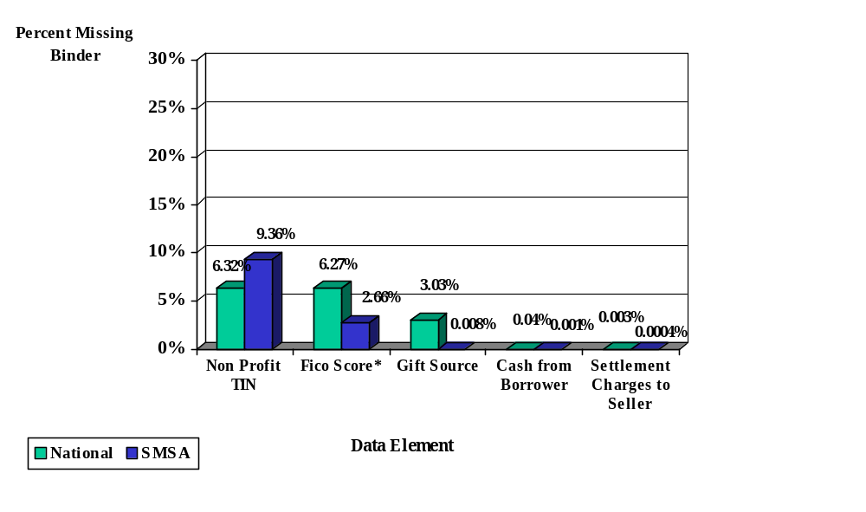

*FICO Score is one of the new data elements collected during the audit. The percent of missing FICO Scores is the number of times the FICO Score was missing from the credit report in the binder. It does not relate to CHUMS.

The chart above, Figure 15, represents data missing from the binder based on the number of instances where the data should have been present or instances where the FICO score was missing from the credit report.

At the outset of the project, we coded binders even if they were missing critical documentation such as the HUD-1 or MCA Worksheet. If the binder was missing both documents it was deemed a “bad case” and was not coded. The HUD-1 and MCA Worksheet contain all of the data elements except for FICO score, which is found on the credit report.

There are 48 data elements on the data entry form. New data elements include gifts from up to 3 additional sources and FICO credit score.

Tax Identification Numbers (TINs)

The data field limitations of the CHUMS system to accept only one gift amount and one gift source contributed only marginally to the large number of missing non-profit Tax Identification Numbers (TINs) in the CHUMS as the number of multiple gift sources was not substantial. However, to the extent that multiple gifts were present in the binder, the lender had to choose which gift amount and source to report. In many of these instances, the lender added the multiple gifts and reported them as if they were one gift from one source. If the lender chose to report a gift source other than the non-profit or government agency this eliminated the opportunity to report the TIN.

As a result of the binder reviews, we found 1,012 gifts associated with downpayment assistance programs that were not reported via the CHUMS. In addition, there were many instances where gifts were reported via the CHUMS as non-profit gifts but without a TIN. However, TINs for many of these binders were located during the binder review. In many instances the TIN numbers were not specifically identified in the binders. However, for many of the larger non-profits the letterhead on the gift letters allowed us to match TINs amongst the binders. Therefore, our ability to populate the TIN in the database by name and program association substantially reduced the final number of missing TINs.

Table 1 below shows the distribution of TINs missing from the binders by HOC. In the Philadelphia HOC over 35% of the TINs were missing from the binders when the gift source was identified as a non-profit. In the 109 binders in the Santa Anna HOC, where the gift source was identified as a non-profit, the TIN was missing in nearly 34% of the cases. In the two HOCs, Denver and Atlanta, with the largest number of gifts from non-profits, the percentage of missing TINs was 11.22% and 11.38 % respectively.

Table 1

Percent of Cases with Evidence of Non-profit Gift in Binder
Where TIN was not recorded in the Binder
By Sample

Sample | Number of Non-Profit Gifts | Number Missing  TINs | Percent Missing
National Sample | 526 | 102 | 19.39
Atlanta HOC | 246 | 28 | 11.38
Denver HOC | 98 | 11 | 11.22
Philadelphia HOC | 73 | 26 | 35.62
Santa Ana HOC | 109 | 37 | 33.95
SMSA Sample | 1088 | 151 | 13.88
ATL | 324 | 69 | 21.30
IND | 414 | 19 | 4.59
SLC | 350 | 63 | 18.00

In Table 2 below, the percent of missing TINs in the CHUMS for loans with a non-profit gift source is higher than the percentages reflected in Table 1 for binder missing TINs by HOC. Santa Anna had only 109 loans identified in the Binder with a non-profit gift source, and 73.39% of the time the TIN was not provided. Upon binder review, the number of TINs missing in Santa Anna cases dropped to 33.95%. A similar comparison for Atlanta reveals that while only 11.38% of the TINs were missing from the case binders, that rate increases to over 79% in the CHUMS. In the Philadelphia HOC, the TINs were missing in 35.62% of the binders and 91.78% of the CHUMS records. And in Denver, the TIN was missing in 11.22% of the binders compared to 83.67% of the CHUMS records.

Although the SMSA samples had the highest number of non-profit gifts they had the lowest number of missing TINs in both the binder review and in the CHUMS.

Table 2

Percent of Cases with Evidence of Non-profit Gift in Binder
Where TIN was not recorded in the CHUMS
By Sample

Sample | Number of Non-Profit Gifts | Number Missing  TINs | Percent Missing
National Sample | 526 | 425 | 80.80
Atlanta HOC | 246 | 196 | 79.68
Denver HOC | 98 | 82 | 83.67
Philadelphia HOC | 73 | 67 | 91.78
Santa Ana HOC | 109 | 80 | 73.39
SMSA Sample | 1088 | 764 | 70.22
ATL | 324 | 226 | 69.75
IND | 414 | 241 | 58.21
SLC | 350 | 297 | 84.56

FICO or Credit Scores

The FICO score was the next highest missing data element. A missing FICO score is an indication of nontraditional credit use by the borrower applying for the loan. Although a credit report was present in the binder for the borrower, the credit repository or credit reporting service was unable to provide a credit score due to the limited number of trade lines reported for the borrower. Trade lines are types of credit such as credit cards, installment loans and mortgages. Usually, the borrower has to have at least three trade lines open for at least six months in order for the credit repository to produce a credit score.

Two other conditions may have contributed to the absence of a credit score in the binder. One, if the borrower had or appeared to have had multiple social security numbers, the credit reporting service either reported credit scores for each social security number or did not report a credit score at all. This situation occurs quite often when there are family members with the same name such as a father and son, junior and senior. Or, two, if someone with the same or a similar name as the borrower was reported as deceased the credit reporting service may not have provided a credit score. In the majority of the binders that we reviewed without a credit score, the reason was insufficient credit or trade lines to generate a score. A number of the borrowers with limited credit were infrequent users of credit. There were letters in the binder stating that the borrower operated on a cash basis.

Figure 16

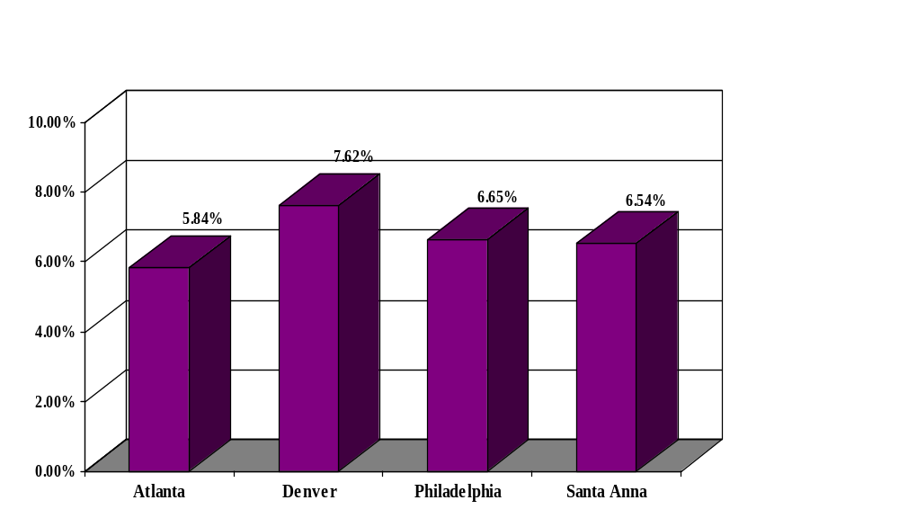
n=3459
n=2336
n=1398
n=1101
n= Total Binders in HOC
Missing FICO Scores
By HOC
(Represented as a % of total binders per HOC)

Figure 16 above, shows the distribution of missing FICO scores by HOC. Of the 1101 binders coded in the Santa Anna HOC the FICO score was missing from the credit report 6.54% of the time. In the Atlanta HOC the FICO score was missing 5.84% of the time, 7.62% of the time in Denver and 6.65% of the time in Philadelphia.

Figure 17

Missing FICO Scores
By Gift Source

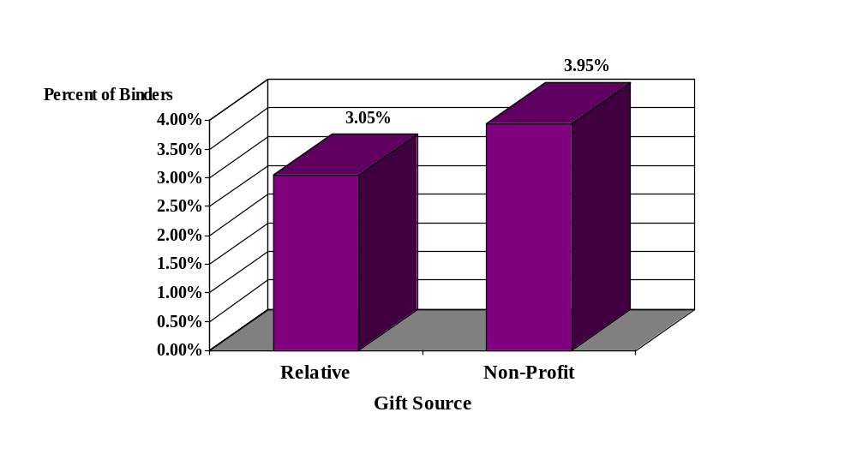

Note: Percent of all missing FICO scores as a percentage of all gifts (3,574)

There is a marginal percentage difference shown in Figure 17 above for missing FICO scores by gift source. There is less than a one percent difference in missing FICO scores if the gift source was relative or non-profit. The FICO score was just as likely to be missing if the gift came from a relative or if the gift came from a non-profit.

Remaining Elements

While the data elements “Gift Source”, “Cash from Borrower” and “Settlement Charges to Seller” made the Top 5 Missing Data Elements in the binder review; the incidence of missing data for these elements actually represents a very small percentage. For instance, there were 3574 gifts and the gift source was identified in nearly 98% of the binders. Relative to the other two remaining elements, most of the missing data was due to incomplete or illegible HUD-1 forms, as we were instructed to collect this data from the HUD1.

Figure 18
Missing Gift Source By HOC

Missing Gift Source in Binder
By Sample

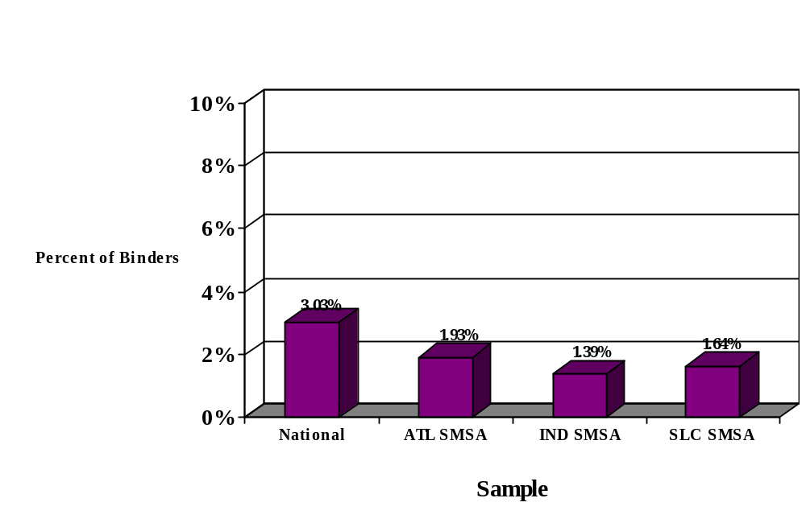

N = 1817
N = 517
N = 575
N = 665
N = Total Number of Gifts in Sample

In Figure 18, the distribution of missing gift sources is shown by sample. In the national sample the gift source was missing in 3.03% of the 1,817 binders with gifts. In the ATL, the gift source was missing in 1.93% of the binders, 1.39% of the binders in IND and in 1.64% of the binders in SLC.

Table 3
Binder Showed Evidence of a Gift
However,
Gifts Were Not Fully Identified in CHUMS
And

Criteria | Number | Percent
Cases where the CHUMS Gift #1 Source not reported and Binder showed evidence of Gift Source | 1012 | 28.32%
Cases where the CHUMS Gift #1 Amount was not reported and Binder showed evidence of Gift Amount | 792 | 22.16%

Total Number of Gifts = 3574

Approximately 43.09% of the 8294 binders reviewed had a gift. As shown in Table 3 above, the CHUMS system was missing gift source data that was found as a result of the binder review in 1012 cases. And the CHUMS system was missing a gift amount in 792 cases where the binder review had a gift amount. In 220 cases neither gift amounts nor sources were identified in the CHUMS. A gift source and amount was present in both the CHUMS and the binder in 72% of the cases.

Of the 8294 binders in this analysis, 3574 had at least at least one gift. There were 155 binders with multiple gifts. The CHUMS is designed to collect information on only one gift. As a result of this limitation, lenders often combine gifts from different sources. If a borrower receives downpayment assistance from a non-profit organization and a gift from a relative the lender is likely to record the entire gift as either from the non-profit organization or from the relative. We found evidence of both situations during the file review.

The database used by Concentrance for coding was designed to accept up to four gifts and gift sources. If a borrower received multiple gifts from the same source the gifts were combined. Only one binder had a gift from more than two different sources.

Figure 19
Fields Where Dollar Amounts Were Greater in the Case Binder than in the CHUMS …

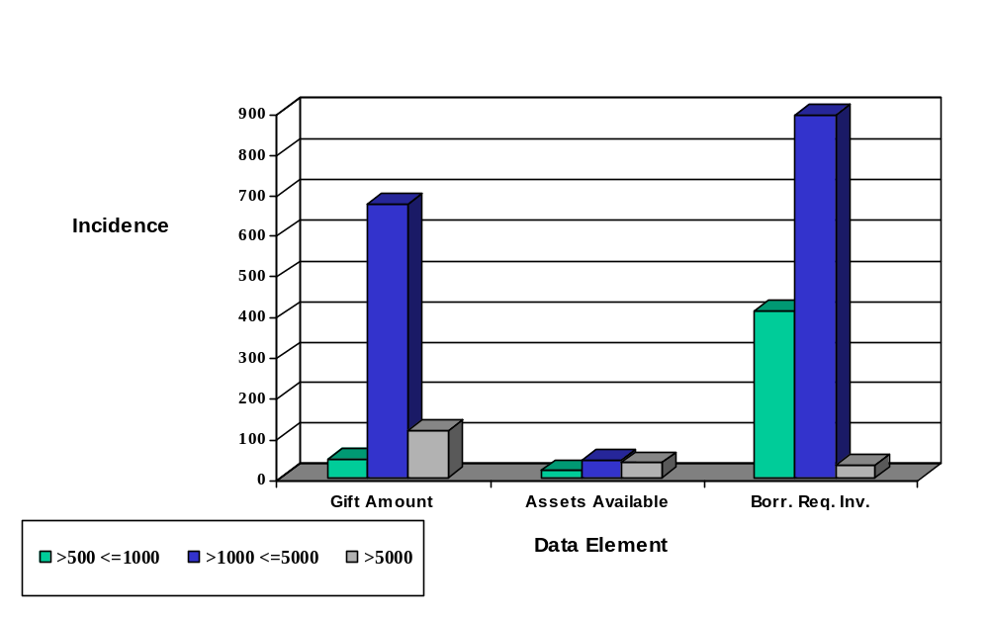

Dollar Difference Categories

Figure 19 above provides a comparison between data in the CHUMS and data from the binder review for three data elements where the dollar amount in the binder was greater than the amount in the CHUMS. For gift amount, the primary gift recorded in the binder exceeded the CHUMS reported gift by between $1,000 and $5,000 in over 800 instances. For assets available, the discrepancies were far less frequent in every dollar group. However, the binder review revealed significant problems with binder calculations of required investment. The binder calculations of borrower required investments exceeded CHUMS in 1332 instances or 16% of the total sample. Refer to Appendix III for additional detailed information on these three data elements.
Figure 20
Fields Where Dollar Amounts Were Less in the Case Binder than in the CHUMS

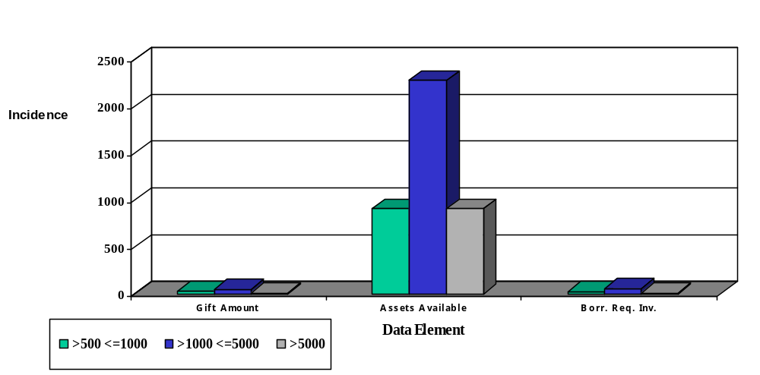

Dollar Difference Categories

Shown in Figure 20 above is the comparison between data in the CHUMS and data from the binder review for three data elements where the amount in the binder was less than the amount in the Chums. For gift amounts, differences were infrequent. For assets available, however, the binder had an amount less than what was reported by the lender in the CHUMS 3,534 times, or roughly 43% of the total sample. In 91 binders, the Borrower Required Investment was less than the amount in the CHUMS. Appendix III provides additional detailed information on these three data elements.

VI. Insights and Recommendations

The data integrity in the CHUMS was good for most data elements. Five areas were identified where major differences between the CHUMS and the binder were observed. These areas all relate to the identification of required and available funds for downpayment and closing. The specific data elements where information was missing or different in the CHUMS were total assets available, gift source, gift amount, borrower required investment and Non-profit TIN.

Relative to the borrower assets and required investment fields, lenders did not calculate and report this information uniformly in the sample of case binders that were the subject of this audit. This leads us to believe that lenders were confused and needed further guidance in these areas. And, it should be noted that HUD has since issued guidance addressing these areas which can be found in the HUD Handbook 4155.1 Rev-5, released October, 2003. In addition, updated instructions for endorsing a case were issued as of 9/2003 which provided specific direction relative to the source documents to be used when transmitting information for endorsement (see Appendix IV). The binders Concentrance reviewed were originated prior to the issuance of these directives. While Concentrance found these instructions to be clear, HUD might consider conducting an audit of binders subject to the new instructions to determine if the instructions in the revised HUD Handbook 4155.1 Rev-5 and the instructions for endorsing a case have improved the quality of data transmitted by the lenders.

For the binders subject to this audit, the absence of the above instructions may have contributed to the data integrity issues for the fields in question. However, other reasons are also possible. Following is a synopsis of other possible reasons and associated recommendation:

Clarity of Source Documentation

Description of Problem

For nearly every binder reviewed, the source documents containing the fields to be transmitted were available in the file. However, multiple versions or heavily marked up MCA Worksheets increased the difficulty of discerning which version or numbers to used as the final or definitive source for the lender’s transmission to the CHUMS.

Recommended Solution

HUD might consider issuing a directive to lenders requiring that the MCA worksheet included in the case binder submitted to HUD, represent the “final” loan data as well as the data transmitted via the CHUMS. Furthermore, the worksheet should be completed fully, without erasers and cross-outs.

Timing Impacts Accuracy

Description of Problem

Because the MCA worksheet in the binder is completed prior to closing and in many cases changes occur after the MCA worksheet is completed, our reliance on this MCA worksheet as a source for many of the data elements may help to explain the difference in these fields (e.g.., required investment, borrower assets, etc.,). The data in the CHUMS may in fact be correct. However, the source documentation used in the binder review may not be the same as the source documentation used to transmit the data to the CHUMS.

Recommended Solution

HUD should conduct additional compliance reviews to determine if lenders are following issued directives for data integrity, documentation and transmission to HUD via the CHUMS. During the compliance review particular attention should be given to whether or not the lender has included in the binder a copy of the source documentation used as the basis for transmitting data to the CHUMS.

The CHUMS should be enhanced to include data edits, tabulation logic and “if, then” test to improve the quality of the data at submission. This approach takes advantage of the electronic tools available to provide, track and check data in “real time”. Specifically, changes for editing the following data elements are recommended as enhancements to CHUMS:

Data Element | Issue | Recommendation
Gift Amount | Gift amount reported with no gift source | Add logic to the CHUMS that would prohibit a lender from entering a gift amount without a gift source.
Gift Source | Gift source reported with no gift amount | Add logic to the CHUMS that would prohibit a lender from entering a gift source without a gift amount.
Non-profit TIN | Gift Source 2 reported with no TIN | Add logic to the CHUMS that would prohibit a lender from entering a gift source of 2 without entering a TIN. In addition, instruct the lender to enter the non-profit gift source 2 if multiple gifts are involved.

Data Entry Errors

Description of Problem

In many instances lenders simply made mistakes in keying by transposing numbers. In other instances lenders made mathematical mistakes. These types of errors were resident in the CHUMS and the binders.

Recommended Solution

Enhanced editing, if not already implemented, could be added to the CHUMS to correct these problems.

Systemic Issues

Total Assets Available

Description of Problem

The total assets reported in the Binder were less than the total assets in the CHUMS in 43% of the sample (see Figure 20).

Recommended Solution

Provide clarification to mortgagees on the definition of total assets on the MCA Worksheet (12 J) and what is expected to be transmitted to the CHUMS (e.g., verified assets only or all liquid assets on the application).

Note: If the loan origination system (LOS) is the source of the transmission to the CHUMS, the LOS in some cases may automatically transmit all liquid assets versus verified liquid assets.

Borrower Required Investment

Description of the Problem

The binder review revealed a greater required investment from the borrower than the amount transmitted via the CHUMS in 16% of the sample.

Recommended Solution

Further analysis is required to determine the cause of this difference. Interviews with lenders are recommended to gain further insight as to the lenders process for determining the borrower required investment. After determining the reason for the discrepancies recommendations can be formulated.

Other Observations

Seller Contributions

Description of Problem

A preliminary analysis of the binder data suggests that there may be a correlation between gift source and the amount contributed by the seller. In both the total sample and the IND sample, we found a 9 percentage point difference between the dollar amounts contributed to the transaction by the seller if the borrower received a gift from a relative versus a gift from a non-profit. For these transactions, the seller contribution rarely exceeded 6% of the sales price however; the total dollar contribution from the seller was greater than when gifts were provided by relatives.

Recommended Solution

Additional research, including interviews with some of the parties in the transaction, should be conducted to determine if this observation is the result of ordinary market conditions or other factors.

Median House Price

Description of Problem

The median house price was over 4% higher in the IND sample where borrowers received gifts from non-profits versus cases in which borrowers received gifts from relatives. All other samples showed no material difference in median house prices based on gift source. (See Figure 10 and 11 and Appendix IV)

Recommended Solution

Additional research should be conducted to determine if the seller contributions and gifts from non-profits contribute to the noted differences in the median house price in the IND sample. Attention should also be given to instances where the seller was a builder. Some thought should be given to the possibility that these differences could be an indication that the sales price for the property was adjusted to recover some, or all of the seller contribution including the required donations to the non-profit.

Appendix I
Data Entry Form Guide

Data Entry Form Guide

Data Element | Source Document | Description | Special Audit Rationale and Instructions
General Information
Case number | Binder | A unique 10-digit identifier for each loan assigned by HUD. | Analysts were instructed to check the case number in the CHUMS field for a match with binder data.
Case Status | Data Entry Form/Access Database | 0 – default (good case)  1 – file is missing from folder  2 – Wrong file in folder (case number mismatch)  3 – HUD-1 and MCA Worksheet are BOTH missing  4 – HUD-1 only is missing  5 – MCA Worksheet only is missing | Initially, analysts were instructed not to code binders with status 1, 2 or 3. Subsequently, based on the small number of bad cases with this status the GTM decided not to code binders with status 1 through 5.
Data Entry Operator ID | Data Entry Form/Access Database | A two digit designation for Concentrance employees coding and keying data into the database
Data Entry Status | Data Entry Form/Access Database | Complete or Incomplete (i.e., skipped, or all fields do not have values)
Time | Data Entry Form/Access Database | The time the audit database automatically stamps the file as complete.
Today’s Date | Data Entry Form/Access Database | The date the audit database automatically stamps the file as complete.
Comments | Data Entry Form/Access Database | Place for explanation or comment on any binder field in the system.
HUD-1
Borrower Name | HUD-1  Item D | Person listed as the borrower. | The data analysts were instructed to distinguish between the borrower and co-borrower comparing the information on borrower application with the HUD-1.
Name of Seller | HUD-1  Item E | Person or entity selling the property
Is the Seller of the Property a Homebuilder? Yes or No | HUD-1  Item E | Based on the name listed in Item E and other documentation in the file a determination is made if the seller of the property is a builder. | Analysts were cautioned that in instances where the property was new construction there was an increased likelihood that the seller was also the homebuilder.

Data Element | Source Document | Description | Special Audit Rationale and Instructions
Settlement Date | HUD-1  Item I | The date the closing/settlement agent collected documents, signed by the buyer and seller that complete the purchase of the property. | Analysts were instructed to use the settlement date and not the disbursement date. If there were multiple HUD-1s the latest or copy marked “Final” should be used.
Contract sale price | HUD-1  Line 101 | The price agreed upon by the seller and buyer in the sales contract as consideration for sale of the property. | Analysts were instructed to check the Sales Contract if the HUD-1 and MCA Worksheet have different numbers and use the number that matches the sales contract.
Deposit or Earnest Money | HUD-1  Line 201 | Money provided prior to closing by, or on behalf of the buyer to reduce the contract sales price, prepaids and closing costs. | Analysts were instructed to look for a cancelled check or notations on the sales contract if the deposit or earnest money amount is missing. If an earnest money deposit is located enter that amount in the database.
Original Mortgage Amount | HUD-1  Line 202 | The balance owed by the borrower prior to the application of any payments. | Analysts were instructed to look on the note and mortgage if the original mortgage amount was missing. And, if the mortgage amount is the same on both documents enter that amount in the database.
Cash from Borrower | HUD-1  Line 303 | The difference between any earnest money, prepaids and mortgage(s) the borrower is responsible for at closing. | Analysts were instructed to:  - Conduct a more extensive review if the cash from the borrower is substantially higher than the “Required Investment”.  - Ensure that a mortgage is listed on Line 202. If no mortgage amount is listed on Line 202, check the binder to see if there is another completed HUD-1. If Line 202 is completed on the second HUD-1, enter any cash from the borrower in the database.
Settlement charges to Seller | HUD-1  Line 502 | Normal and customary charges to the seller plus any other amounts the seller agrees to pay. The seller is usually limited to paying up to 6% of the sales price as a seller contribution. | Analysts were instructed to include the amount on Line 502 even if it includes paying off mortgages. If the right side of the HUD-1 is blank, and there is only one HUD-1 in the binder, “999999” was chosen to indicate the information is missing.

Data Element | Source Document | Description | Special Audit Rationale and Instructions
MCA Worksheet (4/95 or 10/98 version)
Borrower SSN | MCA Worksheet  Line 2a. /2a. | The primary borrower’s Social Security Number | Analysts were instructed to check the Credit Report and make sure the SSN matches the borrower’s name.
Property Appraised Value | MCA Worksheet  Line 4. /4. | The indicated value by sales comparison approach (i.e., compared to other properties in the sales market. | Analysts were instructed to locate the property value on the appraisal if the information was missing from the MCA Worksheet. The appraised value by sales comparison approach was the only value entered in the database.
Total Closing Costs | MCA Worksheet  Line 5.a. /5a. | Normal and customary costs paid to third parties to transfer title to the property from the seller to the buyer. | Analysts were instructed that it is not unusual for the closing cost to be zero if there is a large enough seller contribution to cover all closing costs.
Closing Costs paid by Borrower | MCA Worksheet  Line 5c. /5c. | The portion of the closing costs not paid by the seller. | Same as above.
Contract Sales Price | MCA Worksheet  Line 10a. /10a. | The price agreed upon by the seller and buyer in the sales contract as consideration for sale of the property. | Analysts were instructed to check the Sales Contract if the sales price is missing. Enter the sales price as indicated on the sales contract in the database.

Data Element | Source Document | Description | Special Audit Rationale and Instructions
Required Investment from borrower | MCA Worksheet  Line 10h/12a | 4/95 Version - Line 10h: Required Investment is 10e-10g, or Mortgage Basis (10e) minus Mortgage (without UFMIP) (10g). The Mortgage Basis is 10a+b+c-10d), or Contract Sales Price (10a) plus Repairs and Improvements (10b) plus Borrower Closing Costs (from Line 5c) (10c) minus Sales Concessions (10d). The Mortgage (without UFMIP) (10g) is the lesser of 10f (1) or 10f (2). Line 10f (1) is derived by multiplying Mortgage Basis (line10e) by 97/95/90%, if $50,000 or less, multiply by 97%. Line 10f (2) is derived by multiplying the Value (line 4) by 97.75%, if $50,000 or less, multiply by 98.75%.  10/98 Version – Line 12a: Minimum Downpayment is 10c-11d, or Unadjusted Acquisition (10c) minus Mortgage Amount (11d). The Unadjusted Acquisition (10c) is Contract Sales Price (10a) plus Borrower Paid Closing Costs (from 5c) (10b). The Mortgage Amount (11d) is Mortgage Basis (11c) times LTV Factor 97% or less). Mortgage Basis is Lesser of Sales Price (10a) or Value (from Line 4) plus Required Adjustments (+/-) (11b). | Analyst were instructed to record what’s on the form - do not calculate!

Data Element | Source Document | Description | Special Audit Rationale and Instructions
Borrower Costs at Closing | MCA Worksheet  Line 10m/12g | 4/95 Version – Line 10m: Total Requirements is the sum of lines 10h-10l, or Required Investment (10h) plus Discounts (10i) plus Prepayable expenses (10 j) plus MIP paid in cash (10 k) plus Non-Realty and other items (10l)  10/98 Version – Line (12g): Total Cash to Close is the Sum of 12a-12f, or Minimum Downpayment (12a) plus Prepaid Expenses (12b) plus Discount Points (12c) plus Repairs/Improvements (Non-  Financeable) (12d) plus Upfront  MIP Paid in Cash (12e) plus Non-  Realty and Other Items (12f).
Amount Paid | MCA Worksheet  Line 10n/12h | 4/95 Version – Line 10n: Amount Paid in Earnest Money or other contributions such as Sweat Equity.  10/98 Version – Line (12h): Amount Paid (Earnest Money, etc). | Analysts were instructed to count sweat equity as a gift if someone other than the borrower performed the work.
Amount Paid Source | MCA Worksheet  Line 10n/12h | 4/95 Version - Cash or Other (explain). 1 = Cash, 2 = Premium Rate, 3-6 defined as needed  10/98 Version – Same as 4/95 Version | Analysts were advised that the “Amount Paid” source is generally cash. If the lender is providing a gift through an increase in the interest rate (i.e., Premium Rate) it may be listed on the HUD-1 as a lender credit.
Amount To Be Paid in | MCA Worksheet  Line 10o/Defined as needed | 4/95 Version – Amount coming from third party sources such as secondary financing, etc.  10/98 Version – Same as 4/95 Version | Analysts were advised that some gifts might be Secondary financing (i.e., a grant with conditions). If the gift was a grant, gift source 12 was used and the gift amount was entered in one of the binder gift amount fields.
Amount to be Paid in Source | MCA Worksheet  Line 10o/Defined as needed | 4/95 Version – Cash or Other. 1 = Cash, 2 = Premium Rate, 3 -6 defined as needed  10/98 Version - Same as 4/95 Version | Since the 10/98 version of the worksheet did not contain a line item for secondary financing, the database was programmed to accept code 3 for secondary financing.

Data Element | Source Document | Description | Special Audit Rationale and Instructions
Assets Available | MCA Worksheet  Line 10p/12j | 4/95 Version – Line 10p: Liquid Assets the borrower has available to meet the Cash To Close requirement.  10/98 Version – Line 12j: Same as 10/95 Version | Analysts were advised that it is not unusual for assets available to be zero as the borrower may have received a gift large enough to cover all costs.  They were also instructed to code what was on the MCA Worksheet, even if the amount shown was zero. However, if the field was “blank” the analysts were told to enter “999999999” to indicate the data was missing.
Gross Monthly Income | MCA Worksheet  Line 11f/13f | 4/95 Version – Line 11f: Gross Monthly Income is the borrower’s total monthly income without any deductions.  10/98 Version – Line 13f: Same as 10/95 Version | In cases where the gross monthly income is missing, analysts were instructed to locate the application and enter the total amount of income for all borrowers shown on the application in the database.

Data Element | Source Document | Description | Special Audit Rationale and Instructions
Total Mortgage Payment | MCA Worksheet  Line 13h/15h | 4/95 Version – Line 11f: Total Mortgage Payment is 13a-13g, or Principal & Interest – 1st Mortgage (13a) plus Monthly MIP (13b) plus Homeowners Association fee (13c) plus Ground Rent (13d) plus Principal & Interest –2nd Mortgage (13e) plus Hazard Insurance (13f) plus Taxes & Special Assessments (13g).  10/98 Version – Line 15h: Same as 10/95 Version | Analysts were advised that if there were handwritten changes to the typed numbers, calculators are to be used to verify the correct total.
Total Fixed Payment | MCA Worksheet  Line 13j/15j | 4/95 Version – Line 13j: Total Fixed Payment is 13h+13i, or Total Mortgage Payment plus Recurring Expenses (from Line 12d). Recurring Expenses are all debts and obligations.  10/98 Version – Line 15j: Same as 10/95 Version | Analysts were advised that if there were handwritten changes to the typed numbers, calculators are to be used to verify the correct total.
Total Monthly Payments (non-mortgage) | MCA Worksheet  Line 12d/14d | 4/95 Version – Line 12d: Total Monthly Payment is 12a-12c, or Total Installment Debt plus Child Support, etc. plus Other.  10/98 Version – Line 14d: Same as 10/95 Version | Analysts were advised that if there were handwritten changes to the typed numbers, calculators are to be used to verify the correct total.
Total Seller Contribution | MCA Worksheet  Line A3/A3 | An amount contributed by the seller to cover borrower costs, including downpayment as part of the gift downpayment program. | In some cases the total seller contribution may be in two parts, 6% towards closing costs and a separate amount toward downpayment. Analysts were advised to ensure that contributions and gifts are distinguished and coded appropriately.
Tax Identification Number of Non-profit Agency | MCA Worksheet  Line D | The agency’s federal Identification Number issued by the Internal Revenue Service (IRS). | Analysts were instructed not to enter not applicable (i. e.,“888888888”) if the gift source is 2. The TIN is always available or missing (i.e., “999999999”).
New Fields
Gift1 Amount | MCA Worksheet and/or Gift Letter | An amount given to the borrower for downpayment and closing costs. | Analyst were instructed to determine the gift amount by locating and examining in order of priority the MCA Worksheet, HUD-1, Gift Letters or Application.

Data Element | Source Document | Description | Special Audit Rationale and Instructions
Gift1 Source | MCA Worksheet and/or Gift Letter | The source of funds given to the borrower for downpayment and closing costs. | Analysts were instructed to locate and determine the source using the gift letters, if available. If the gift was from a non-profit, the analysts were told to enter the gift amount in the binder gift1 amount field and enter the binder1 source field in the database. In instances where no gift letter was available, analysts were advised to review the remarks section of the MCA Worksheet for references to the gift source. Finally, if no gift source was found “999999” was used to reflect that the gift source was missing.
Name of non-profit or Govt Agency | MCA Worksheet and/or Gift Letter | The non-profit or govt Agency providing the gift or acting as the conduit between the borrower and the provider of the gift. | Analyst were instructed to look at the letterhead and signature block as a source for the name of the non-profit community organization providing the gift and compare the name found to the list in the lookup table on the system.
Program Name used by Agency | MCA Worksheet and/or Gift Letter | The name of the program the non-profit or govt Agency is using to provide the gift. | Analysts were instructed to read the remarks section of the MCA Worksheet and if available the gift letter to determine program or agency.
Gift2 Amount | MCA Worksheet and/or Gift Letter | Same description as Gift1 Amount | Same instructions as Gift1 Amount
Gift2 Source  Govt Agency | MCA Worksheet and/or Gift Letter | Same description as Gift1 Source | Same instructions as Gift1 Source
Name2 of non-profit or govt Agency | MCA Worksheet and/or Gift Letter | Same description as Name1 non-profit or govt Agency | Same instructions as Name1 non-profit or govt Agency
Program Name2 used by Agency | MCA Worksheet and/or Gift Letter | Same description as Program1 used by Agency | Same instructions as Program1 used by Agency
Gift3 Amount | MCA Worksheet and/or Gift Letter | Same description as Gift1 Amount | Same instructions as Gift1 Amount
Gift3 Source  Govt Agency | MCA Worksheet and/or Gift Letter | Same description as Gift1 Source | Same instructions as Gift1 Source
Name3 of non-profit or govt Agency | MCA Worksheet and/or Gift Letter | Same description as Name1 non-profit or govt Agency | Same instructions as Name1 non-profit or govt Agency

Data Element | Source Document | Description | Special Audit Rationale and Instructions
Program Name3 used by Agency | MCA Worksheet and/or Gift Letter | Same description as Program1 used by Agency | Same instructions as Program1 used by Agency
Gift4 Amount | MCA Worksheet and/or Gift Letter | Same description as Gift1 Amount | Same instructions as Gift1 Amount
Gift4 Source  Govt. Agency | MCA Worksheet and/or Gift Letter | Same description as Gift1 Source | Same instructions as Gift1 Source
Name4 of non-profit or govt Agency | MCA Worksheet and/or Gift Letter | Same description as Name1 non-profit or govt Agency | Same instructions as Name1 non-profit or govt Agency
Program Name4 used by Agency | MCA Worksheet and/or Gift Letter | Same description as Program1 used by Agency | Same instructions as Program1 used by Agency
Credit Report
Fico Score | Credit Report | Proprietary numeric score between 350-850 that indicates level of risk. | Analyst were given the following guidance and instructions:  The borrower may have three scores, one from each of the major credit repositories. Scores may vary based on the amount of data at the repository. If the borrower has three scores, choose the middle score and enter that number in the database. If the borrower has two score, choose the lower of the two and enter that score in the database. If the borrower has only one score, enter that score in the database.  If the borrower has multiple scores from the same repository, drop the lower of the two scores and then follow the above instructions.  Enter “99” if the credit report is missing from the binder and “9” if the credit report is in the binder but the credit score is missing.

Appendix II
SMSA Gift Source Distribution By Year

Figure 9-1A

Relative Gifts vs. Non Profit Gifts (ATL SMSA)
By Fiscal Year

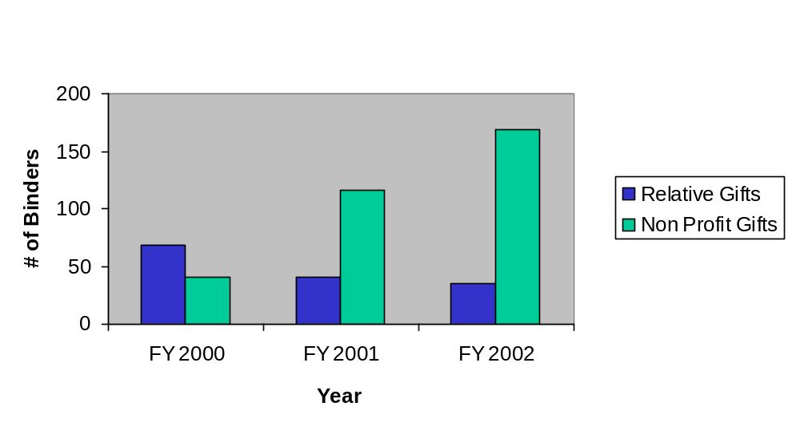

77%

65%

57%
23%
16%
33%

n=121
n=178
n=218

Figure 9-1A above shows Relative Gifts versus Non-profit Gifts by Fiscal Year (ATL SMSA). The two gift sources are shown as a percentage of total gifts for each insurance endorsement year in the ATL SMSA sample. Gifts from a non-profit organization were higher than gifts from relatives in every year except 2000.

Figure 9-2A
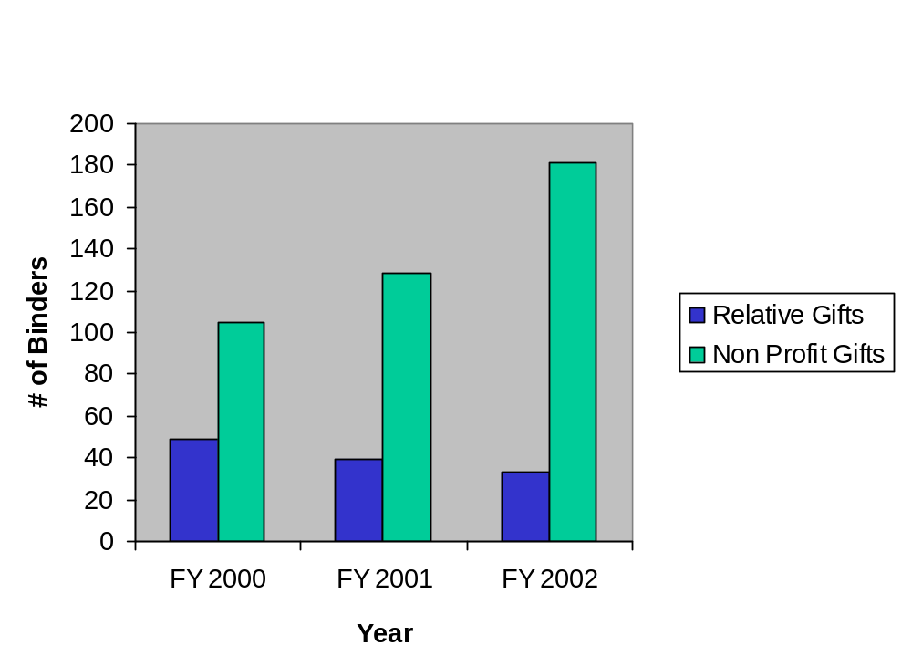
Relative Gifts vs. Non Profit Gifts (IND SMSA)
By Fiscal Year

81%

70%
62%

29%
21%
15%

n=169
n=183
n=223

Figure 9-2A above shows Relative Gifts versus Non-profit Gifts by Fiscal Year (IND SMSA). The two gift sources are shown as a percentage of total gifts for each insurance endorsement year in the IND SMSA sample. Gifts from a non-profit organization were higher than gifts from relatives in every year.
Figure 9-3A

Relative Gifts vs. Non Profit Gifts (SLC SMSA)
By Fiscal Year

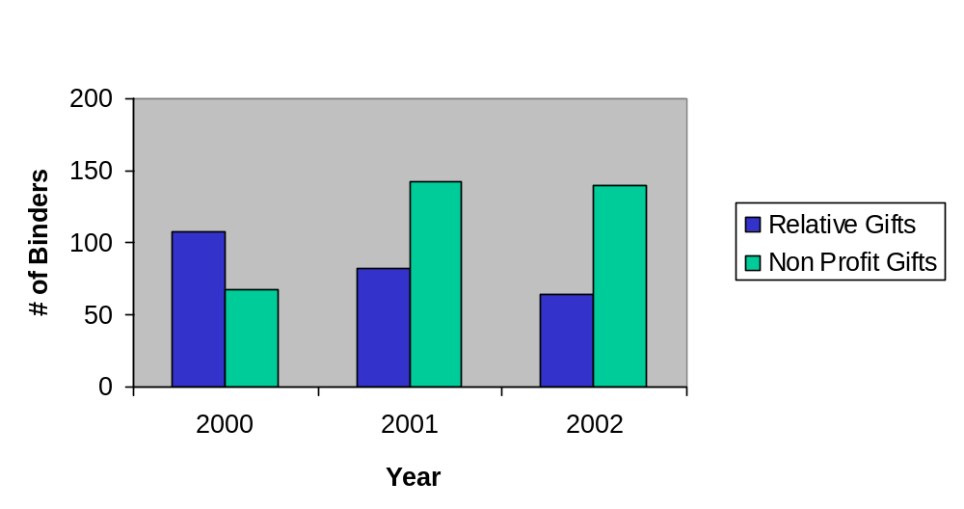

58%
63%
55%

35%
34%
29%

n=244
n=224
n=197

Figure 9-3A above shows Relative Gifts versus Non-profit Gifts by Fiscal Year (SLC SMSA). The two gift sources are shown as a percentage of total gifts for each insurance endorsement year in the SLC SMSA sample. Gifts from a non-profit organization were higher than gifts from relatives in every year except 2000.

Appendix III
Discrepancies Between the CHUMS Data and Binder Findings

Table 19-1A

Fields Where Gift Amounts Were Greater in the Case Binder than in the CHUMS

Gift Amount | FY 2000 | FY 2001 | FY 2002 | Total
>500 <=1000 | 13 | 22 | 12 | 47
>1000 <=5000 | 235 | 208 | 230 | 673
>5000 | 35 | 44 | 37 | 116
Total Cases | 283 | 274 | 279 | 836
ATL HOC
>500 <=1000 | 9 | 10 | 6 | 25
>1000 <=5000 | 104 | 83 | 108 | 295
>5000 | 12 | 18 | 12 | 42
Total Cases | 125 | 111 | 126 | 362
DEN HOC
>500 <=1000 | 2 | 8 | 6 | 16
>1000 <=5000 | 83 | 89 | 79 | 251
>5000 | 9 | 12 | 13 | 34
Total Cases | 94 | 109 | 98 | 301
PHL HOC
>500 <=1000 | 1 | 1 | 0 | 2
>1000 <=5000 | 29 | 26 | 33 | 88
>5000 | 9 | 11 | 9 | 29
Total Cases | 39 | 38 | 42 | 119
SAN HOC
>500 <=1000 | 1 | 3 | 0 | 4
>1000 <=5000 | 19 | 10 | 10 | 39
>5000 | 5 | 3 | 3 | 11
Total Cases | 25 | 16 | 13 | 54

Gift Amount | FY 2000 | FY 2001 | FY 2002 | Total
National Sample
>500 <=1000 | 9 | 15 | 8 | 32
>1000 <=5000 | 120 | 84 | 116 | 320
>5000 | 28 | 32 | 22 | 82
Total Cases | 157 | 131 | 146 | 434
Atlanta SMSA
>500 <=1000 | 3 | 2 | 1 | 6
>1000 <=5000 | 28 | 34 | 40 | 102
>5000 | 3 | 3 | 2 | 8
Total Cases | 34 | 39 | 43 | 116
Indianapolis SMSA
>500 <=1000 | 1 | 3 | 1 | 5
>1000 <=5000 | 44 | 30 | 23 | 97
>5000 | 2 | 2 | 4 | 8
Total Cases | 47 | 35 | 28 | 110
Salt Lake City SMSA
>500 <=1000 | 0 | 2 | 2 | 4
>1000 <=5000 | 43 | 60 | 51 | 154
>5000 | 2 | 7 | 9 | 18
Total Cases | 45 | 69 | 62 | 176
Table 19-2A
Fields Where Total Asset Available Amounts Were Greater in the Case Binder than in the CHUMS

Total Assets Available | FY 2000 | FY 2001 | FY 2002 | Total
>500 <=1000 | 9 | 1 | 8 | 18
>1000 <=5000 | 12 | 11 | 19 | 42
>5000 | 12 | 15 | 10 | 37
Total Cases | 33 | 27 | 37 | 97
ATL HOC
>500 <=1000 | 2 | 0 | 2 | 4
>1000 <=5000 | 2 | 4 | 8 | 14
>5000 | 7 | 7 | 2 | 16
Total Cases | 11 | 11 | 12 | 34
DEN HOC
>500 <=1000 | 6 | 0 | 4 | 10
>1000 <=5000 | 5 | 3 | 5 | 13
>5000 | 2 | 2 | 3 | 7
Total Cases | 13 | 5 | 12 | 30
PHL HOC
>500 <=1000 | 0 | 1 | 2 | 3
>1000 <=5000 | 4 | 0 | 5 | 9
>5000 | 2 | 4 | 0 | 6
Total Cases | 6 | 5 | 7 | 18
SAN HOC
>500 <=1000 | 1 | 0 | 0 | 1
>1000 <=5000 | 1 | 4 | 1 | 6
>5000 | 1 | 2 | 5 | 8
Total Cases | 3 | 6 | 6 | 15

Total Assets Available | FY 2000 | FY 2001 | FY 2002 | Total
National Sample
>500 <=1000 | 7 | 1 | 6 | 14
>1000 <=5000 | 8 | 7 | 14 | 29
>5000 | 4 | 10 | 6 | 20
Total Cases | 19 | 18 | 26 | 63
Atlanta SMSA
>500 <=1000 | 0 | 0 | 1 | 1
>1000 <=5000 | 1 | 1 | 2 | 4
>5000 | 3 | 0 | 0 | 3
Total Cases | 4 | 1 | 3 | 8
Indianapolis SMSA
>500 <=1000 | 0 | 0 | 0 | 0
>1000 <=5000 | 1 | 2 | 2 | 5
>5000 | 4 | 3 | 2 | 9
Total Cases | 5 | 5 | 4 | 14
Salt Lake City SMSA
>500 <=1000 | 2 | 0 | 1 | 3
>1000 <=5000 | 2 | 1 | 1 | 4
>5000 | 1 | 2 | 2 | 5
Total Cases | 5 | 3 | 4 | 12

Table 19-3A
Dollar Fields Where Borrower Required Investment Amounts are Greater in the Case Binder than in the CHUMS Records…

Borrower Req. Inv. | FY 2000 | FY 2001 | FY 2002 | Total
>500 <=1000 | 122 | 152 | 135 | 409
>1000 <=5000 | 312 | 281 | 298 | 891
>5000 | 10 | 13 | 9 | 32
Total Cases | 444 | 446 | 442 | 1332
ATL HOC
>500 <=1000 | 51 | 69 | 82 | 202
>1000 <=5000 | 95 | 83 | 113 | 291
>5000 | 0 | 4 | 0 | 4
Total Cases | 146 | 156 | 195 | 497
DEN HOC
>500 <=1000 | 39 | 52 | 32 | 123
>1000 <=5000 | 102 | 113 | 89 | 304
>5000 | 1 | 1 | 2 | 4
Total Cases | 142 | 166 | 123 | 431
PHL HOC
>500 <=1000 | 19 | 25 | 19 | 63
>1000 <=5000 | 79 | 69 | 95 | 243
>5000 | 8 | 8 | 7 | 23
Total Cases | 106 | 102 | 121 | 329
SAN HOC
>500 <=1000 | 13 | 6 | 2 | 21
>1000 <=5000 | 36 | 16 | 1 | 53
>5000 | 1 | 0 | 0 | 1
Total Cases | 50 | 22 | 3 | 75

Borrower Req. Inv. | FY 2000 | FY 2001 | FY 2002 | Total
National Sample
>500 <=1000 | 76 | 95 | 73 | 244
>1000 <=5000 | 236 | 205 | 216 | 657
>5000 | 9 | 12 | 7 | 28
Total Cases | 321 | 312 | 296 | 929
Atlanta SMSA
>500 <=1000 | 9 | 23 | 24 | 56
>1000 <=5000 | 22 | 17 | 34 | 73
>5000 | 0 | 0 | 0 | 0
Total Cases | 31 | 40 | 58 | 129
Indianapolis SMSA
>500 <=1000 | 25 | 23 | 28 | 76
>1000 <=5000 | 14 | 15 | 18 | 47
>5000 | 0 | 0 | 0 | 0
Total Cases | 39 | 38 | 46 | 123
Salt Lake City SMSA
>500 <=1000 | 12 | 11 | 10 | 33
>1000 <=5000 | 40 | 44 | 30 | 114
>5000 | 1 | 1 | 2 | 4
Total Cases | 53 | 56 | 42 | 151

Figure 20-1A
Cases Where Gift Amounts were Less in the Case Binder than in the CHUMS Records…

Gift Amount | FY 2000 | FY 2001 | FY 2002 | Total
All Cases
>500 <=1000 | 11 | 10 | 8 | 29
>1000 <=5000 | 16 | 13 | 16 | 45
>5000 | 1 | 2 | 9 | 12
Total Cases | 28 | 25 | 33 | 86
ATL HOC
>500 <=1000 | 3 | 6 | 3 | 12
>1000 <=5000 | 10 | 2 | 8 | 20
>5000 | 1 | 0 | 4 | 5
Total Cases | 14 | 8 | 15 | 37
DEN HOC
>500 <=1000 | 4 | 4 | 4 | 12
>1000 <=5000 | 3 | 4 | 6 | 13
>5000 | 0 | 2 | 3 | 5
Total Cases | 7 | 10 | 13 | 30
PHL HOC
>500 <=1000 | 1 | 0 | 0 | 1
>1000 <=5000 | 1 | 5 | 2 | 8
>5000 | 0 | 0 | 1 | 1
Total Cases | 2 | 5 | 3 | 10
SAN HOC
>500 <=1000 | 3 | 0 | 1 | 4
>1000 <=5000 | 2 | 2 | 0 | 4
>5000 | 0 | 0 | 1 | 1
Total Cases | 5 | 2 | 2 | 9

Gift Amount | FY 2000 | FY 2001 | FY 2002 | Total
National Sample
>500 <=1000 | 7 | 5 | 4 | 16
>1000 <=5000 | 9 | 8 | 8 | 25
>5000 | 1 | 1 | 6 | 8
Total Cases | 17 | 14 | 18 | 49
Atlanta SMSA
>500 <=1000 | 1 | 1 | 2 | 4
>1000 <=5000 | 3 | 2 | 3 | 8
>5000 | 0 | 0 | 1 | 1
Total Cases | 4 | 3 | 6 | 13
Indianapolis SMSA
>500 <=1000 | 2 | 3 | 0 | 5
>1000 <=5000 | 1 | 0 | 2 | 3
>5000 | 0 | 0 | 1 | 1
Total Cases | 3 | 3 | 3 | 9
Salt Lake City SMSA
>500 <=1000 | 1 | 1 | 2 | 4
>1000 <=5000 | 3 | 3 | 3 | 9
>5000 | 0 | 1 | 1 | 2
Total Cases | 4 | 5 | 6 | 15

Table 20-2A
Cases Where Total Asset Available Amounts were Less in the Case Binder than in the CHUMS Records…

Total Assets Available | FY 2000 | FY 2001 | FY 2002 | Total
>500 <=1000 | 117 | 133 | 101 | 351
>1000 <=5000 | 697 | 787 | 789 | 2273
>5000 | 260 | 302 | 348 | 910
Total Cases | 1074 | 1222 | 1238 | 3534
ATL HOC
>500 <=1000 | 46 | 58 | 43 | 147
>1000 <=5000 | 306 | 350 | 408 | 1064
>5000 | 92 | 123 | 132 | 347
Total Cases | 444 | 531 | 583 | 1558
DEN HOC
>500 <=1000 | 32 | 46 | 29 | 107
>1000 <=5000 | 189 | 259 | 240 | 688
>5000 | 70 | 83 | 89 | 242
Total Cases | 291 | 388 | 358 | 1037
PHL HOC
>500 <=1000 | 25 | 18 | 13 | 56
>1000 <=5000 | 122 | 108 | 88 | 318
>5000 | 46 | 54 | 71 | 171
Total Cases | 193 | 180 | 172 | 545
SAN HOC
>500 <=1000 | 14 | 11 | 16 | 41
>1000 <=5000 | 80 | 70 | 53 | 203
>5000 | 52 | 42 | 56 | 150
Total Cases | 146 | 123 | 125 | 394

Total Assets Available | FY 2000 | FY 2001 | FY 2002 | Total
National Sample
>500 <=1000 | 77 | 89 | 74 | 240
>1000 <=5000 | 436 | 400 | 407 | 1243
>5000 | 161 | 171 | 214 | 546
Total Cases | 674 | 660 | 695 | 2029
Atlanta SMSA
>500 <=1000 | 7 | 12 | 6 | 25
>1000 <=5000 | 58 | 103 | 106 | 267
>5000 | 27 | 45 | 53 | 125
Total Cases | 92 | 160 | 165 | 417
Indianapolis SMSA
>500 <=1000 | 21 | 13 | 10 | 44
>1000 <=5000 | 111 | 122 | 152 | 385
>5000 | 27 | 39 | 30 | 96
Total Cases | 159 | 174 | 192 | 525
Salt Lake City SMSA
>500 <=1000 | 12 | 19 | 11 | 42
>1000 <=5000 | 92 | 162 | 124 | 378
>5000 | 45 | 47 | 51 | 143
Total Cases | 149 | 228 | 186 | 563

Table 20-3A
Cases Where Borrower Required Investment Amounts were Less in the Case Binder than in the CHUMS Records…

Borrower Req. Inv. | FY 2000 | FY 2001 | FY 2002 | Total
>500 <=1000 | 6 | 12 | 3 | 21
>1000 <=5000 | 23 | 21 | 14 | 58
>5000 | 5 | 3 | 4 | 12
Total Cases | 34 | 36 | 21 | 91
ATL HOC
>500 <=1000 | 1 | 6 | 1 | 8
>1000 <=5000 | 4 | 4 | 5 | 13
>5000 | 3 | 2 | 2 | 7
Total Cases | 8 | 12 | 8 | 28
DEN HOC
>500 <=1000 | 5 | 1 | 1 | 7
>1000 <=5000 | 6 | 5 | 3 | 14
>5000 | 0 | 0 | 1 | 1
Total Cases | 11 | 6 | 5 | 22
PHL HOC
>500 <=1000 | 0 | 4 | 1 | 5
>1000 <=5000 | 5 | 7 | 4 | 16
>5000 | 2 | 1 | 1 | 4
Total Cases | 7 | 12 | 6 | 25
SAN HOC
>500 <=1000 | 0 | 1 | 0 | 1
>1000 <=5000 | 8 | 5 | 2 | 15
>5000 | 0 | 0 | 0 | 0

Borrower Req. Inv. | FY 2000 | FY 2001 | FY 2002 | Total
Total Cases | 8 | 6 | 2 | 16
National Sample
>500 <=1000 | 2 | 8 | 1 | 11
>1000 <=5000 | 16 | 16 | 7 | 39
>5000 | 5 | 3 | 3 | 11
Total Cases | 23 | 27 | 11 | 61
Atlanta SMSA
>500 <=1000 | 0 | 2 | 1 | 3
>1000 <=5000 | 3 | 3 | 4 | 10
>5000 | 0 | 0 | 0 | 0
Total Cases | 3 | 5 | 5 | 13
Indianapolis SMSA
>500 <=1000 | 1 | 1 | 0 | 2
>1000 <=5000 | 1 | 0 | 0 | 1
>5000 | 0 | 0 | 0 | 0
Total Cases | 2 | 1 | 0 | 3
Salt Lake City SMSA
>500 <=1000 | 3 | 1 | 1 | 5
>1000 <=5000 | 3 | 2 | 3 | 8
>5000 | 0 | 0 | 1 | 1
Total Cases | 6 | 3 | 5 | 14

Appendix IV
Implied Average Sources of Funds When Gifts Are Present
By Sample

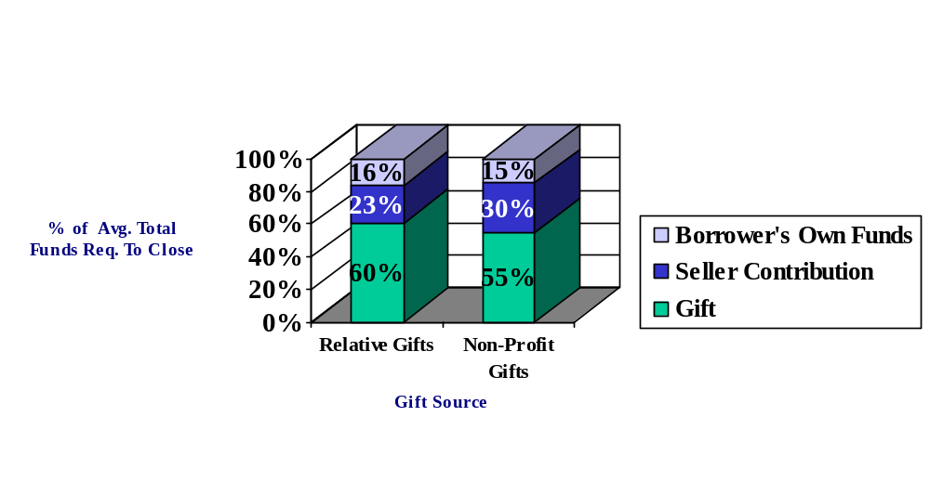
Implied Average Sources of Funds When Gifts Were Present
(National Sample)
Figure 13-1A

Figure 13-2A

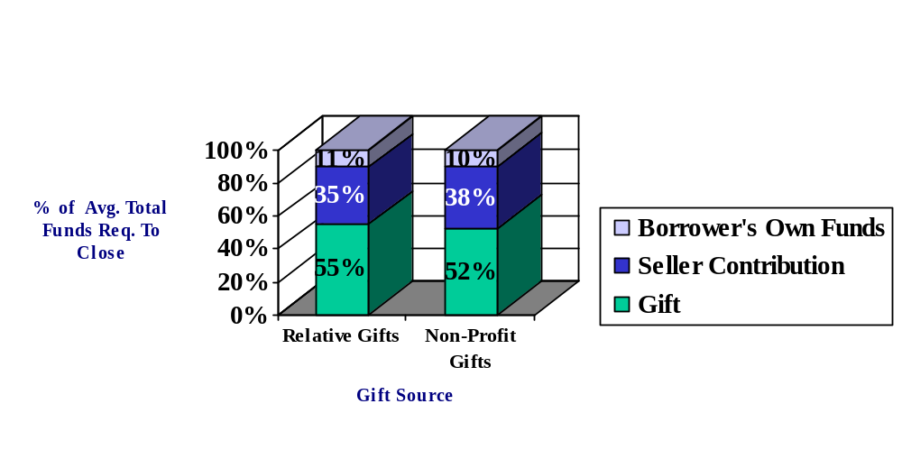
Implied Average Sources of Funds When Gifts Were Present
(Combined SMSA Sample)

Figure 13-3A

Implied Average Sources of Funds When Gifts Were Present
(ATL SMSA Sample)

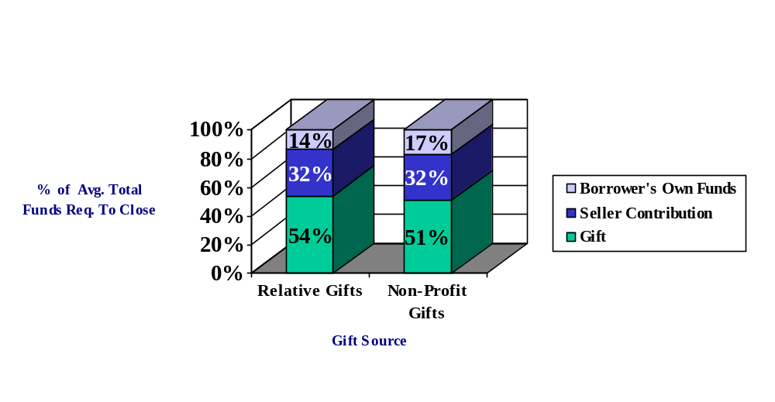

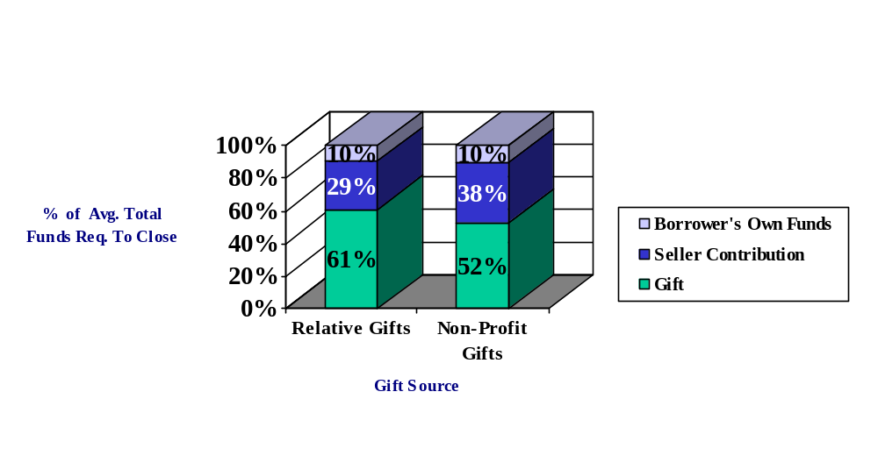
Implied Average Sources of Funds When Gifts Were Present
(IND SMSA Sample)
Figure 13-4A
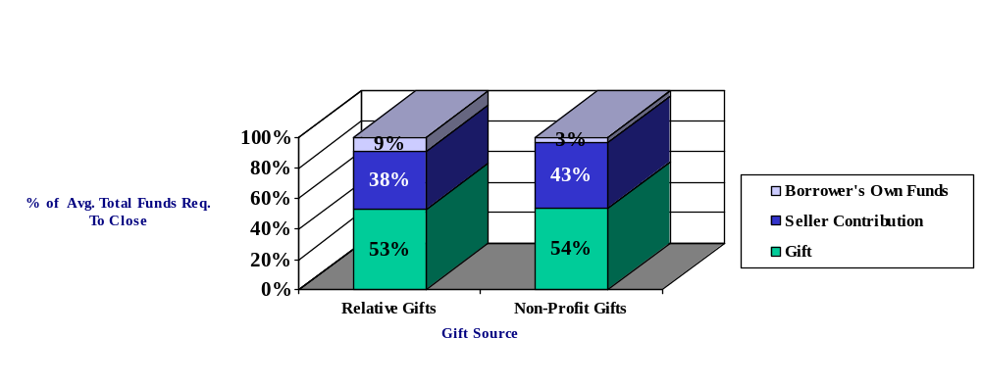
Implied Average Sources of Funds When Gifts Were Present
(SLC SMSA Sample)
Figure 13-4A

