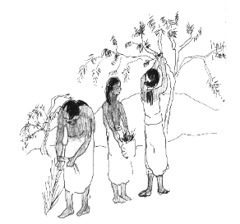

DESCRIPTION: THROUGH PLAYING THE “WEB OF LIFE “ GAME, STUDENTS WILL LEARN ABOUT THE COMPONENTS AND COMPLEXITIES OF A 17TH CENTURY PIMERIA ALTA ECOSYSTEM, INCLUDING THE EFFECT THAT PEOPLE (THE O’ODHAM, AND JESUIT MISSIONARIES) MIGHT HAVE HAD ON THE ECOSYSTEM.

Subjects:
Science, Social Studies and Language Arts.

Materials:
Species Cards (See Master Page III - 27 and III - 28); ball of yarn, string or rope (a type that does not easily tangle).

Preparation:
Use the information on Master Page III - 27 and III - 28 to make up cards, one for each student, representing natural components of the Pimeria Alta ecosystem. (Cards will be displayed as name tags. Consider using string, tape or safety pins to attach them.)

Time:
One session.

Vocabulary:
bosque, cienega, riparian

1. Wild Resource Match activity (Red)
Mission Edibles (Red)
Riparian Area Management (Env)
THE PEOPLE - NATURE NETWORK

BACKGROUND INFORMATION

The Pimeria Alta region contains several natural communities. The one in which Father Kino met the O’odham people at Tumacacori was mostly swampy grassland, cut by washes and the waterways of the Santa Cruz River. The environment then, as it is today, was rich and diverse with abundant flora and fauna.

Cottonwoods and willows lined the channel along the riparian-or riverside-zone; as well as walnut, ash, netleaf hackberry, and Mexican elder. Birds like kingfishers, warblers, grey hawks and phoebes; mammals like foxes, javelina, jaguar, and bobcats; frogs, and fish all found homes among this dense riparian forest or in the flowing water. Vast stands of mesquite (much taller and denser than their small relatives we see on the hillsides today, because their roots could reach the shallow groundwater near the river) followed the wide upper terraces along the river's floodplain in thick bosques (woodlands) which also included other trees and shrubs. The bosques sheltered grizzly bear, wild turkeys, rabbits, deer, and other wildlife, and gourd vines, wild honeysuckle and morning-glory, tree-tobacco, and many other plants.

Cienegas, or marshes, sheltered the river's course and provided habitat for great blue herons, ducks, dragonflies, turtles, fish, and possibly beaver. Sacaton grass stood in wide meadows along the river where pronghorn grazed. In contrast, the "uplands" (surrounding higher ground) were mostly covered with bunch grasses, interspersed with prickly-pear and other cactus, ocotillo, yucca, and agave. 1

The riparian or other stream-side environments (riparian forest, mesquite bosque, or cienega, or all three habitat types combined) might be a good place to start your “web of life,” as more than seventy-five percent of all of Arizona's wildlife still depend in some way on these systems. The O’odham and later the Jesuits also depended on the river. The availability of reliable surface water was the reason places like Calabasas (now Rio Rico), Tumacacori, Tubac, and San Xavier were settled.
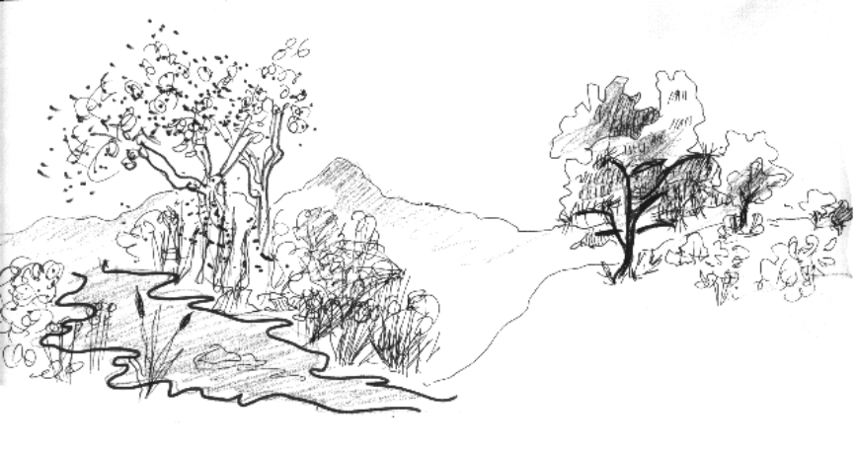

ACTIVITY

- Ask for a volunteer and write his or her name on the blackboard. Next, ask students to identify all of the components needed for this person to live such as a house, food, air, clothes, etc. Explain that all of the components combined create a system very similar to an ecosystem that you would find in nature. Using this example as a transition, further define and discuss the idea of an ecosystem.

Part I - The Nature - Nature Connection
- Pass out the cards (See Master Page III - 27 and III - 28) or have students make their own and have students display them as name tags. Assign one card / component to each student.

- Have all of the students form a circle except those with the following cards: corn, beans, wheat, cattle, O’odham Indian, Spanish missionary. (Students may stand or sit.)
- Starting with the student representing the mesquite tree, ask him or her to identify one other species / student from anywhere in the circle that needs the mesquite to survive, and to explain why. (It may provide, food, shelter, shade, hiding, etc.)

- Give the student with the “mesquite” card the end of the ball of yarn to hold, and stretch it across the circle to the selected species / student. Ask the second student to hold the yarn taut where it connects to him or her. (Example: mesquite ï mesquite beetle)
- Proceed the same way with the second species / student, connecting the yarn to a third student. (Example: Mesquite ï Mesquite Beetle ï Roadrunner)
- Continue to connect each species / student to the other species / students on which they depend.

- Complete the web when the yarn returns to “mesquite.” Explain and discuss the implications and importance of the “web of life” idea.

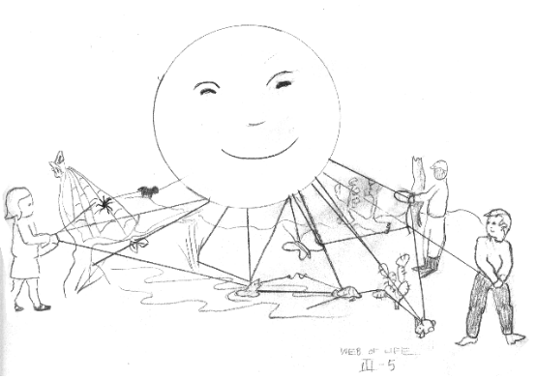

Part II - The Indian - Nature Connection

- Introduce the O’odham Indian representative and his or her domestic crops of corn and beans. Have these three students join the circle at different spots across from one another.

- Pass the yarn from the student representing mesquite to the O’odham Indian, explaining how the O’odham Indian relies on the mesquite for food, firewood, etc.

- Continue tying together other species / students while discussing the species - Indian relationship until both corn and beans are introduced.
- Ask the students their opinion about the role of the Indian and the ecosystem in which they lived. Do they think the Indian has helped or hurt the system and why? (More complexity generally makes an ecosystem more stable, and because the O’odham did not overtax any resources, they probably improved the system's stability or had little impact.)

Part III - The Missionary - Nature Connection

- Introduce into the circle the students representing the Spanish missionary and his or her introduced crops of wheat and cattle.

- Pass the yarn to the missionary and discuss the connection between the species / student and the missionary. Continue making connections while discussing the missionary - species relationship. Did the missionaries‘ presence affect the interrelationship between the different species? How? Did the missionaries rely on the different species as the Indians had? Etc.

- Ask the students their opinion about the role of the missionary and the ecosystem in which they lived. Do they think the friars helped or hurt the system and why? (The missionary presence had more of an impact because of the expanded wheat and cattle production. Nevertheless, because the population remained small, there was probably positive or little effect in total).

Part IV - The Importance of the Web

When all of the species / students have been introduced, ask all participants to stand still and keep the web taut.

- Ask one species / student gently to begin tugging until other species / students are feeling it. Explain that the tugging represents pressure on the ecosystem through natural (e.g., drought) or human-made events (e.g., new plant introduction that crowds out natural plants). How does it affect the system?

- Continue this process with introduced components such as corn, beans, wheat or cattle. How might these have affected or damaged the ecosystem? (New single crop fields replaced natural ecosystems, destroying native plants and displacing wildlife.) How about the Spanish or the Indians? (They hunted wild animals. They cleared areas of wild plants for agriculture, buildings and food. They might have competed with animals and plants for water, introduced new plants that took over the habitats of wild plants; etc.)

- To emphasize the importance an individual species has in an ecosystem, ask students to pick a component that does not seem important and have that student drop his or her yarn. This represents the disappearance of some part of the system. How does this affect the rest of the ecosystem? What if people overused a resource, and it was lost? Repeat the process, removing components while explaining the adverse effects it might have on the ecosystem.

RESOURCES AND REFERENCES

Project Learning Tree ("Web of Life"); Dr. Thomas Sheridan article, "Kino's Unforeseen Legacy"; Phoenix Desert Botanical Garden guide; Shrubs and Trees of the Southwest Deserts, Janice Emily Bowers, Southwest Parks and Monuments Ass., Tucson, AZ, 1993; Mammals of the Southwest Deserts, George Olin, Southwest Parks and Monuments Ass., Tucson, AZ, 1982; Rocky Mountain Tree Finder, Tom Watts, Nature Study Guide, Box 972, Berkeley, CA 94701, 1974; Desert Tree Finder, May Theilgaard and Tom Watts, Nature Study Guide, Box 972, Berkeley, CA 94701, 1974.
Enhancements
- Have students draw a picture of their component on one side of the card and list survival needs and "uses" on the other side.
- The "web of life" activity can be run for several different time periods, following the same procedure previously outlined and asking most of the same questions. Some examples; the coming of the Apaches in the late 1600's or early 1700's; the development of large-scale mining and grazing, mostly by Anglos, in the late 1800's, and resulting land destruction; the expansion of irrigated agriculture from the 1930's through the 1960's and the resulting lowering of water tables and loss of Santa Cruz River surface flow.

THE PEOPLE - NATURE NETWORK, SPECIES CARDS

COTTONWOOD  TREE | WILLOW  TREE | WALNUT  TREE | ASH  TREE | MESQUITE  TREE
VERMILLION  FLY CATCHER  (BIRD) | KINGFISHER  (BIRD) | WARBLER  (BIRD) | GREY  HAWK  (BIRD) | SAYS  PHOEBE  (BIRD)
FOX | JAVALINA | BOBCAT | FROG | DEER
RATTLESNAKE | WHIP-TAILED LIZARD | RABBIT | TURKEY  VULTURE | BULL SNAKE

THE PEOPLE - NATURE NETWORK, SPECIES CARDS

HONEYSUCKLE  (FLOWER) | SILVERLEAF  NIGHTSHADE  (FLOWER) | GREAT  BLUE  HERON | OREGON  GRAPE | MEXICAN  ELDER  TREE
DRAGONFLY | SACATON  GRASS | CORN | BEAN | MESQUITE  BEETLE
ROADRUNNER | MOSQUITO | MAYFLY | COTTON | CATTLE
O’ODHAM  INDIAN | JESUIT  MISSIONARY | WHEAT | CHOLLA | PRICKLY  PEAR  CACTUS

