RAINFALL PATTERN AND CROP CULTIVATION
IN NGOKETUNJIA DIVISION OF THE
NORTH WEST PROVINCE OF
CAMEROON

Presented BY :

SELECTED STUDENTS OF GLOBE SCHOOLS IN CAMEROON

Tindatie Delphine Nkwewoh - Government Bilingual High School ( GBHS) Ndop

Tamsu Fogue Marcelin - Lycée Technique Industriel et Commerciale (LTIC) de
Bafoussam

Mbouzae Malibi Octavie - Lycée Classique et Moderne (LCM) de Mvomeka'a

Ashu Ekule Clovis - Governmennt Bilingual Secondary School (GBSS) Down-Town
Bamenda

Che Claudette - Governmennt Bilingual Secondary School (GBSS) Down-Town Bamenda

Um Bilong Adele - Government Bilingual High School (GBHS) Limbe

AT the Global Learning Expedition (GLE)
Croatia, 25th June – 6th July 2003

Accompanied by the GLOBE Teachers:

- AFONG George NSOH – GBHS Ndop
- NGOUFFO Grace – LTIC Bafoussam

TABLE OF CONTENTS

CONTENT Page N°
Table of Content i
ABSTRACT 1
General Background 1
The problem statement 3
Objectives of the study 3
Methodology 3
RESULTS 4
INTERPRETATION AND DISCUSSION 8
CONCLUSION 9
PROJECTIONS AND RECCOMENDATIONS 9
BIBLIOGRAPHY 10
APPENDIX 10

ABSTRACT

This project investigated the effects of changing rainfall pattern on crop cultivation in Ngoketunjia Division of the North West Province of Cameroon. GLOBE Students of Government Bilingual High School (GBHS) Ndop obtained information from all the thirteen villages that make up Ngoketunjia Division by direct field observation, and interviews with farmers and co-operatives. GLOBE students atmosphere data used in this study were collected from November 2001 - October 2002. All data collected was compiled and analysed graphically in regard to the above topic. From this investigation it was concluded that the planting season of most crops corresponds to the rainy season when the soil moisture is good enough to carry the crops through to harvest except for garden vegetables, which can be cultivated in the dry season by irrigation or in the swamps. Furthermore, food crops, garden vegetables and conventional cash crops were identified as the three main crop types cultivated in Ngoketunjia Division.
__________________
Key words: Rainfall pattern, crop cultivation, GLOBE students' data, Ngoketunjia

GENERAL BACKGROUND

LOCATION AND SIZE

Ngoketunjia is one of the seven Divisions that make up the North West Province of Cameroon. It is bounded to the North by Bui division, West by Boyo and Mezam divisions, East and South by the West Province. The chief town of the division is Ndop, where the GLOBE School is located at latitude 06.1008°N and longitude 10.2709°E, at an elevation of 1172m. The division has a total surface area of about 1,117 km² with a population of about 189000 inhabitants. The highest and lowest altitudes are at 1500 meters and 1156 meters respectively above sea level (etrex-GPS Receiver).

CLIMATE AND SOILS

The climate is characterised by a short dry season of about 4-5 months (November – mid-March) and a longer wet season (mid-March to October). The topography is generally mountainous and undulating characterised by a broad alluvial plain. The two main types of soils are hydromorphic and ferrallitic soils on which a wide variety of crops are grown.

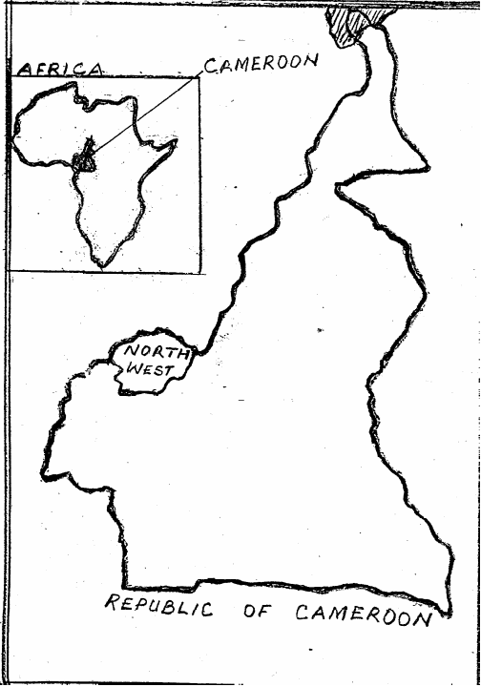
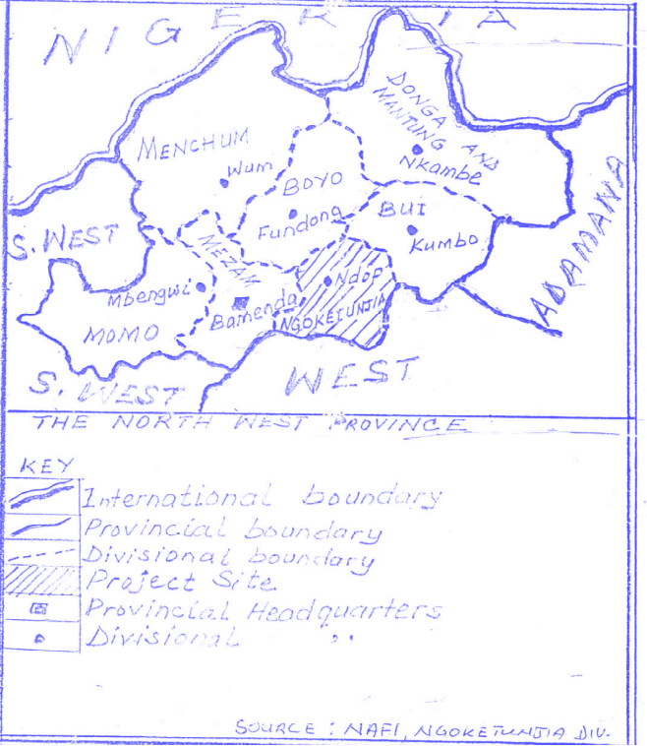

Map of Cameroon Map of the Northwest Province highlighting Ngoketunjia

MAIN ECOSYSTEMS AND HUMAN ACTIVITIES

Ngoketunjia is situated in the Sudan savannah zone and its vegetation is principally grass. The trees are mostly shrubs with thick barks, which shed leaves in the dry season. Other main vegetation types include:
- small montane forests
- oil palm and raffia palm bushes
- bamboos occurring around the peaks of hills.
The small patches of forest and the extensive bushes serve as habitats for small and larger mammals, reptiles, amphibians, Arthropods and numerous birds. Many of these animals are hunted by expeditions organised mostly during the dry season by the traditional authorities.
The ecosystem supports thirteen different villages. Agriculture is at the heart of the division's economy and employs more than 70% of the population. The general pattern of agricultural land use is that crops are cultivated on the plains, and animal rearing (cattle, sheep and goats) on the hilly areas, which are characterised by poor soils. The ecological diversity of Ngoketunjia Division provides potential for the cultivation of a wide range of crops species.
The seasonal variations in rainfall cause the herdsmen to move their cattle to the plains during the dry season, in search of greener pastures and water. This frequently leads to disputes between arable farmers and graziers.
Other specific economic activities of the division are fishing on the Bamendjim reservoir, woodcarving, pottery and weaving.

THE PROBLEM STATEMENT

What effects do seasonal variations in rainfall patterns have on crop cultivation in Ngoketunjia division?

OBJECTIVES

General objective: To find out the relationship between atmospheric conditions and crop cultivation in Ngoketunjia Division.
Specific Objectives:
- To find out the monthly average rainfall, current air temperatures and relative humidity in Ngoketunjia for a period of one year.
- To find out the influence of rainfall, current air temperatures and relative humidity on the time (month) crops are cultivated in Ngoketunjia division for a period of one year.
- To find out the influence of rainfall, current air temperatures and relative humidity on the types crops cultivated monthly in Ngoketunjia Division, for a period of 12 months.

METHODOLOGY

Fifteen GLOBE students carried out field observations, and interviewed 25 farmers from each of the thirteen villages of the study area. Information on the time (month) of the year and the types of crops cultivated were collected and recorded (Figure 1). The number of the different types of crops cultivated each month, as well as the mean monthly rainfall, relative humidity and current air temperatures were recorded as on Table I.
All atmosphere data was collected following GLOBE protocols. Rainfall was measured using the GLOBE rainguage, while relative humidity and air temperature data were collected using the digital thermo hygrometer.
The mean monthly rainfall, relative humidity and current air temperatures were calculated by dividing the total of each month by the number of days of the particular month. Graphs of the mean monthly rainfall (mm), mean relative humidity (%), mean current air temperature (°C) and number of types of crops cultivated were plotted against the months to show their relationships, Fig. 6.

RESULTS

Fig. 1 Crop cultivation in Ngoketunjia from November 2001 to October 2002
Seasonal Transition
Dry Season Rainy Season
 | Nov.  2001 | Dec.  2001 | Jan.  2002 | Feb.  2002 | Mar  2002 | Apr.  2002 | May  2002 | June  2002 | July  2002 | Aug  2002 | Sept  2002 | Oct.  2002
Cow pea |  |  |  |  |  |  |  |  |  |  | ♣ | ♣
Carrot |  |  |  |  |  |  |  |  |  | ♣ | ♣
Onion |  |  |  |  |  |  |  | ♣ | ♣
Rice |  |  |  |  |  |  |  | ♣ | ♣ | ♣
Pepper |  |  |  |  |  |  | ♣ | ♣
Coffee |  |  |  |  |  |  | ♣ | ♣
Orange |  |  |  |  |  |  | ♣ | ♣ | ♣
Pear |  |  |  |  |  |  | ♣ | ♣ | ♣
Mangoes |  |  |  |  |  |  | ♣ | ♣ | ♣
Oil palm |  |  |  |  |  |  | ♣ | ♣ | ♣
Egusi |  |  |  |  | ♣ | ♣
Ginger |  |  |  |  | ♣ | ♣
Sugar cane |  |  |  |  | ♣ | ♣
Pumpkin |  |  |  |  | ♣ | ♣
Maize |  |  |  |  | ♣ | ♣
Okro |  |  |  |  | ♣ | ♣
Coco yams |  |  |  |  | ♣ | ♣
Yams |  |  |  |  | ♣ | ♣
Ground Nuts |  |  |  |  | ♣ | ♣ | ♣
Plantains |  |  |  |  | ♣ | ♣ | ♣
Banana |  |  |  |  | ♣ | ♣ | ♣
Melon |  |  |  |  | ♣ | ♣ | ♣ | ♣ | ♣ | ♣
Pineapple |  |  |  |  | ♣ | ♣ | ♣ | ♣ | ♣ | ♣
Cassava |  |  |  |  | ♣ | ♣ | ♣ | ♣ | ♣ | ♣
Potatoes |  |  |  |  | ♣ | ♣ | ♣ | ♣ | ♣ | ♣
Sweet potatoes |  |  |  |  | ♣ | ♣ | ♣ | ♣ | ♣ | ♣ | ♣
Soya beans |  |  |  |  | ♣ | ♣ | ♣ | ♣ | ♣ | ♣ | ♣
Beans |  |  |  |  | ♣ | ♣ | ♣ | ♣ | ♣ | ♣ | ♣ | ♣
Leeks | ♣ | ♣ | ♣ | ♣ | ♣ | ♣ | ♣ | ♣ | ♣ | ♣ | ♣ | ♣
Celery | ♣ | ♣ | ♣ | ♣ | ♣ | ♣ | ♣ | ♣ | ♣ | ♣ | ♣ | ♣
Lettuce | ♣ | ♣ | ♣ | ♣ | ♣ | ♣ | ♣ | ♣ | ♣ | ♣ | ♣ | ♣
Cabbage | ♣ | ♣ | ♣ | ♣ | ♣ | ♣ | ♣ | ♣ | ♣ | ♣ | ♣ | ♣
Huckleberry | ♣ | ♣ | ♣ | ♣ | ♣ | ♣ | ♣ | ♣ | ♣ | ♣ | ♣ | ♣
Tomatoes | ♣ | ♣ | ♣ | ♣ | ♣ | ♣ | ♣ | ♣ | ♣ | ♣ | ♣ | ♣

Table I: GLOBE ATMOSPHERIC data AND number OF DIFFERENT TYPES of
crops cultivated ( November 2001 to October 2002).

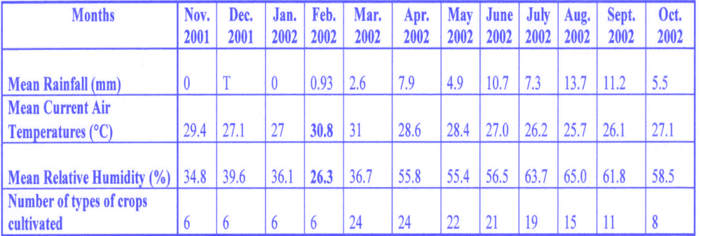

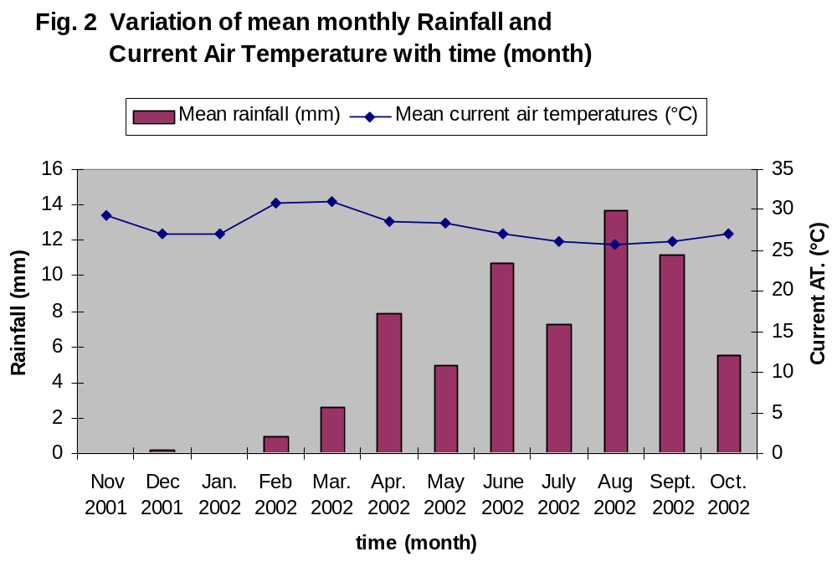

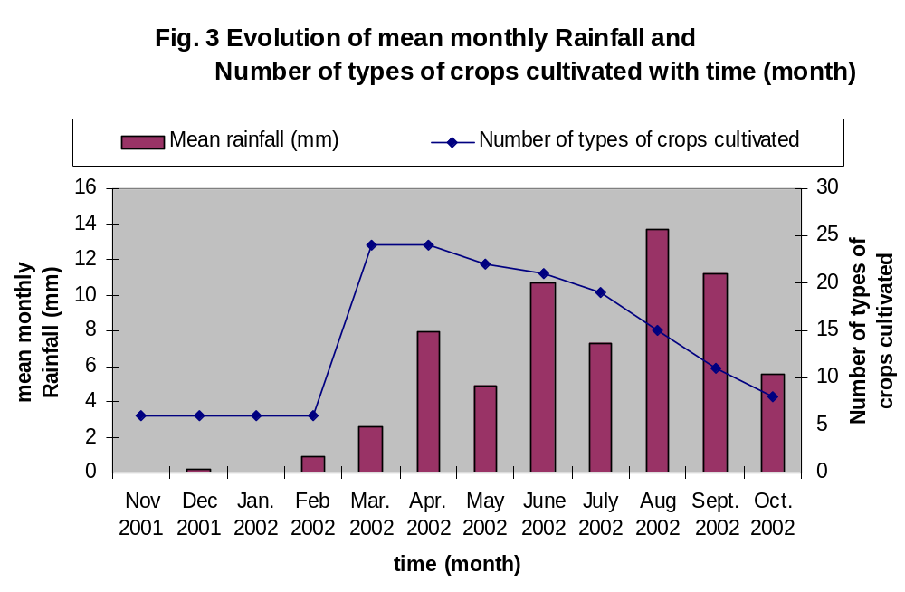

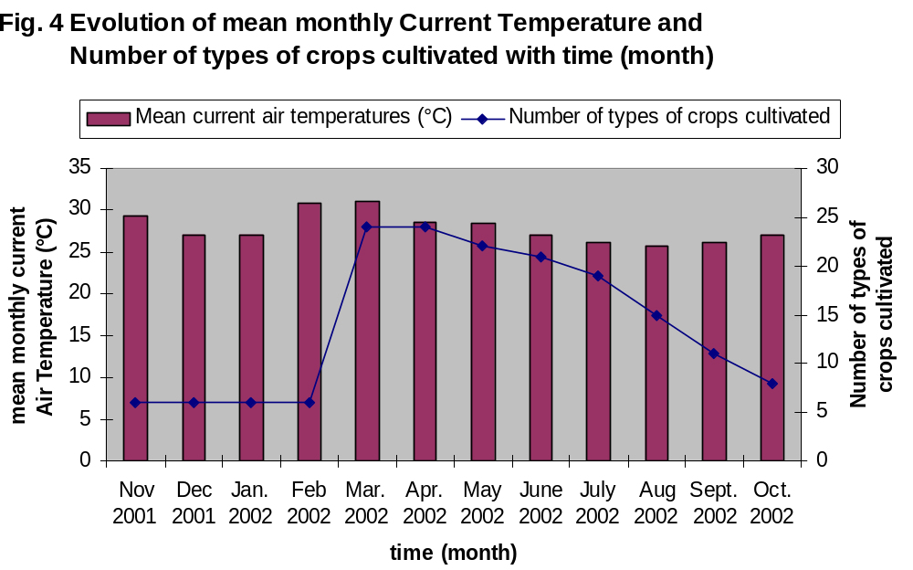

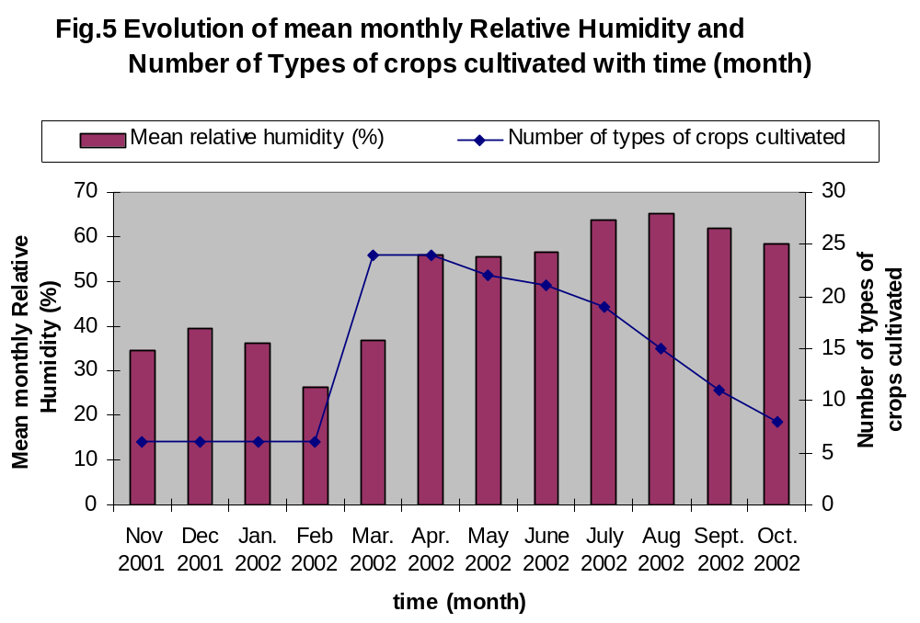

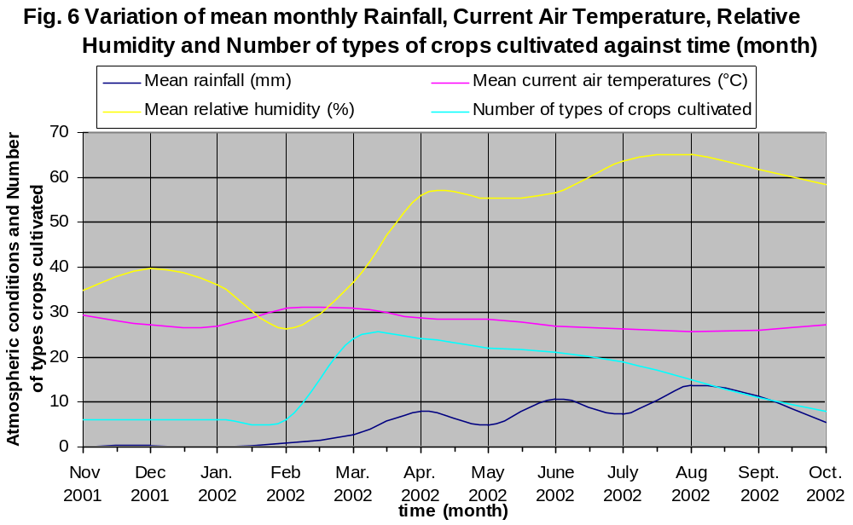

Interpretation And Discussions Of The Results

As can be seen on Table I and Fig. 2, there are two distinct seasons, the dry and rainy seasons. It was observed that the dry season sets in at the beginning of November and is at its peak in February. This is evidenced by the very low mean relative humidity and the high mean current air temperatures, Table I. The dry season begins to subside from mid-March gradually giving way to the rainy season which ends in October. The rainy season lasts for about 7 - 8months (mid-March to October) and the duration of the dry season is usually about 4 to 5 months (November to mid-March). The graph of mean current air temperature shows that the month of August was the coldest while February and March were the hottest, Fig. 2.
It was also noticed that crop cultivation in Ngoketunjia is based principally on a rain-fed system, Fig. 3. The planting season of most crops occurs at the start of the rainy season when soil moisture and temperatures are sufficient for germination and growth, Fig. 4. Most garden vegetables (tomatoes, huckleberry, cabbage, lettuce, celery and leeks) are also cultivated in the dry season by irrigation or in swampy areas. The pattern for relative humidity and number of types of crop cultivated was similar to that of rainfall, Fig. 5.
Apart from the above mentioned crops, others like bean, soybean, sweet potatoes, cassava, pineapple and melon are cultivated only during the rainy season, Fig. 1.
Interviews with farmers and co-operatives revealed that the popular legume beans, is generally intercropped during the first planting season (March to August) and cultivated as a pure crop during the second planting season (September to October) when there is less rot due to low rainfall.
Other crops as shown on Fig.1 like banana, plantain, groundnuts, yams, cocoyams, okro, maize, pumpkins, sugar cane, ginger and egusi are planted only in the first planting season (March to May). This is because they require much water to complete their growth cycles.
It was also observed that perrennials such as oil palms, mangoes, pears, oranges, coffee and pepper are planted only much later in the first planting season (May - July). Farmers explained that this is to enable them pick-up before the onset of the dry season
Swamp rice is cultivated in the low-lying areas of the division, where soils are easily flooded at the heart of the rainy season (June - August). The Upper Nun Valley Development Authority (UNVDA) has developed about 3000 hectares of land for rice cultivation.
Onion is grown upland in June and July probably because it requires much water to complete it's growth cycle and to enable the bulb mature in the dry season.
Carrots and cowpeas are grown in August - October because they require much water to grow but dryer conditions to mature.

CONCLUSION

This project showed that the number of types of crops cultivated each month follow a similar pattern as the mean monthly rainfall. More crops are cultivated in the rainy season than in the dry season. Infact, crops cultivated in the dry season are mainly gardent vegetables, grown only where irrigation is possible.
This project has therefore revealed that crops cultivated in Ngoketunjia Division, follow the rainfall pattern and seasonal variations. These crops can be broadly grouped into three categories as follows:
- Food crops: These are maize, beans, groundnuts, potatoes, rice, Soya beans, cowpeas, cassava, yams, cocoyams, sweet potatoes, plantain, bananas, okro, egusi melon, pumpkins.
- Garden vegetables: These are tomatoes, carrots, onions, cabbage, lettuce, celery, leeks and huckle berry
- Conventional Cash crops: Rice, arabica coffee and oil palm. Only arabica coffee is a significant foreign exchange earner in the division. Palm oil is a significant source of domestic revenue.
The findings of this project can be very helpful to local farmers, most of whom lack a proper knowledge of modern agricultural techniques to maximise output by following the appropriate planting seasons for their different crops.

Projections for THE future and recommendations

This project was carried out only on the rainfall pattern and crop cultivation. The crops’ life cycles and conditions favourable for maturation and harvesting were not investigated. However in this study, not all crops grown in the study area were covered. We therefore suggest that separate studies be carried out to include:
- All the other crops grown in the study area.
- The effects of atmospheric conditions on the maturation and production of specific crops.
- The ways by which most food crops can be cultivated continuously throughout the year to curb food shortages.
- The evolution of pests and diseases with respect to monthly variations in atmospheric conditions.
- We also call on the UNVDA to improve the farm-to-market roads, develop more irrigation systems, for the cultivation of more food crop types to check the rising food insufficiency.
- Agroforestry should be encouraged, to conserve the soil and stabilise atmospheric conditions.

Bibliography

- Akendo I.G, (1988) : The Environmental Resources and Associated Developmental Problems of Wetlands. A case study of Bamunka, pp. 20 – 21 (unpublished).
- Bamenda Highlands Forest Project, (2002): North West Province Relief Climate and Soils . A Teachers Guide, pp. 80 - 82.
- Fonye, C (1997): Ministry of the Environment and Forestry, Annual Report, 1996/1997 pp. 1-2.
- The GLOBE Program,(1997): Teacher’s Guide.

APPENDICES

APPENDIX 1: Rainfall in mm

Date | Nov.  2001 | Dec.  2001 | Jan.  2002 | Feb.  2002 | Mar.  2002 | Apr.  2002 | May  2002 | June  2002 | July  2002 | Aug  2002 | Sept  2002 | Oct.  2002
1 | 0 | 0 | 0 | 0 | 8.0 | 0 | 0 | 0 | 2.54 | 6.4 | 0 | 6.35
2 | 0 | 0 | 0 | 0 | 0 | 2.54 | 17.8 | 0 | 6.35 | 44.5 | 0 | 16.51
3 | 0 | 0 | 0 | 0 | 0 | 0 | 0 | 0 | 12.7 | 14 | 8.9 | 3.81
4 | 0 | 0 | 0 | 0 | 0 | 0 | 24.13 | 3.8 | 6.35 | 1.27 | 0 | 27.94
5 | 0 | 0 | 0 | 0 | 0 | 7.62 | 0 | 0 | 0 | 27.9 | 5.1 | 2.54
6 | 0 | 0 | 0 | 0 | 0 | 4.5 | 0 | 72.4 | 0 | 6.4 | 15.2 | 21.59
7 | 0 | 0 | 0 | 0 | 0 | 0 | 0 | T | 1.27 | 0 | 28.2 | 7.62
8 | T | 0 | 0 | 0 | 0 | 1.91 | T | 34.29 | 5.08 | 2.5 | 27.1 | 3.81
9 | 0 | 0 | 0 | 0 | 0 | 29.2 | 0 | M | 0 | 11.4 | 0 | 12
10 | 0 | 0 | 0 | 0 | 0 | 21.59 | 24.35 | 2.54 | 5.1 | 1.3 | 25.4 | 0
11 | 0 | 0 | 0 | 0 | 0 | 21.46 | T | 7.62 | 12.7 | 3.1 | 0 | 10.16
12 | 0 | 0 | 0 | 0 | 0 | 0 | 0 | 0 | 25.4 | 3.8 | 60.4 | 6.35
13 | 0 | 0 | 0 | 0 | 0 | 0 | 0 | 0 | 0 | 10.2 | 8.9 | 5.08
14 | 0 | 0 | 0 | 0 | 0 | 0 | T | 0 | 5.1 | 20.3 | 24 | 0
15 | 0 | 0 | 0 | 0 | 0 | 0 | 2.54 | 15.24 | 0 | 15.2 | T | 0
16 | 0 | 5.0 | 0 | 0 | 2.54 | 15.24 | 2.54 | 8.89 | 0 | 3.8 | 0 | T
17 | 0 | 0 | 0 | 0 | 5.08 | 19.05 | 0 | 25.0 | 24.1 | 21.6 | 0 | 0
18 | 0 | 0 | 0 | 0 | 12.7 | 20.32 | 0 | 5.08 | 2.54 | 7.6 | 10.2 | 7.62
19 | 0 | 0 | 0 | 0 | 5.08 | 0 | 0 | M | 20.32 | 5.1 | 10.16 | 2.54
20 | 0 | 0 | 0 | 0 | T | 0 | 0 | M | 21.6 | 45.7 | 6.35 | 6.35
21 | 0 | 0 | 0 | 0 | 0 | 0 | 62 | 25.4 | 6.4 | T | 33.02 | 3.81
22 | 0 | 0 | 0 | 0 | 0 | 0 | 4.45 | 8.89 | 8.9 | 1.3 | 1.27 | 0
23 | 0 | 0 | 0 | 0 | 8.9 | 0 | 0 | 50.8 | 3.8 | 7.8 | 25.4 | 10.16
24 | 0 | 0 | 0 | 0 | 0 | 17.62 | 0 | 22.86 | 21.6 | 2.4 | 29.21 | T
25 | 0 | 0 | 0 | 0 | 1.02 | 0 | 0 | 25.4 | 7.6 | 6.4 | 0 | 0
26 | 0 | 0 | 0 | 0 | 5.08 | 35.6 | 6.35 | M | 7.6 | 1.3 | T | 0
27 | 0 | 0 | 0 | 26 | 25.4 | 0 | 1.27 | M | 11.4 | 19.1 | 0 | 0
28 | 0 | 0 | 0 | 0 | 6.35 | 7.62 | 0 | M | 6.4 | 19.1 | 17.8 | T
29 | 0 | 0 | 0 |  | 0 | 0 | 0 | M | 2.5 | 6.4 | 0 | 15.24
30 | 0 | 0 | 0 |  | 0 | 18.42 | 0 | 12.7 | T | 82.6 | 0 | 0
31 |  | 0 | 0 |  | 0 |  | 0 |  | T | 24.1 |  | 0
Total | 0 | 5.00 | 0 | 26.0 | 80.15 | 238.1 | 152 | 320.9 | 227.4 | 424.6 | 336.6 | 169.5
Mean | 0 | T | 0 | 0.93 | 2.6 | 7.9 | 4..9 | 10.7 | 7.3 | 13.7 | 11.2 | 5.5

APPENDIX 2: Temperatures (°C)

Date | Nov.  2001 | Dec.  2001 | Jan.  2002 | Feb.  2002 | Mar.  2002 | Apr.  2002 | May  2002 | June  2002 | July  2002 | Aug  2002 | Sept  2002 | Oct.  2002
1 | 17 | 28 | 25 | 29 | 27 | 33 | 27 | 29 | 27 | 24 | 24 | 27
2 | 28 | 31 | 26 | 30 | 29 | 32 | 25 | 30 | 23 | 24 | 28 | 27
3 | 28 | 29 | 24 | 32 | 28 | 30 | 28 | 30 | 28 | 24 | 29 | 28
4 | 31 | 30 | 26 | 31 | 33 | 32 | 25 | 30 | 27 | 26 | 29 | 27
5 | 30 | 29 | 27 | 32 | 33 | 27 | 30 | 29 | 27 | 24 | 25 | 27
6 | 31 | 29 | 27 | 33 | 33 | 31 | 28 | 28 | 26 | 24 | 27 | 24
7 | 30 | 28 | 27 | 31 | 33 | 30 | 29 | 28 | 28 | 25 | 28 | 27
8 | 28 | 27 | 26 | 31 | 32 | 23 | 29 | 29 | 23 | 26 | 20 | 28
9 | 29 | 28 | 26 | 34 | 30 | 32 | 30 | M | 28 | 25 | 26 | 28
10 | 30 | 29 | 26 | 31 | 32 | 29 | 29 | 18 | 26 | 27 | 19 | 29
11 | 29 | 29 | 26 | 27 | 31 | 20 | 28 | 22 | 26 | 25 | 26 | 29
12 | 31 | 29 | 27 | 30 | 33 | 29 | 29 | 27 | 28 | 27 | 19 | 28
13 | 32 | 27 | 24 | 29 | 33 | 30 | 29 | 28 | 26 | 24 | 27 | 26
14 | 30 | 28 | 26 | 33 | 34 | 31 | 29 | 27 | 27 | 26 | 27 | 26
15 | 30 | 26 | 26 | 31 | 32 | 27 | 30 | 25 | 27 | 27 | 26 | 29
16 | 27 | 23 | 27 | 17 | 30 | 26 | 27 | 28 | 28 | 28 | 26 | 28
17 | 31 | 28 | 26 | 32 | 30 | 30 | 28 | 28 | 27 | 26 | 27 | 27
18 | 27 | 30 | 28 | 34 | 33 | 21 | 30 | 25 | 27 | 28 | 23 | 25
19 | 30 | 25 | 27 | 34 | 28 | 29 | 29 | M | 27 | 28 | 26 | 27
20 | 30 | 27 | 29 | 33 | 28 | 30 | 28 | M | 27 | 27 | 27 | 29
21 | 30 | 26 | 29 | 34 | 32 | 30 | 30 | 27 | 28 | 27 | 27 | 23
22 | 28 | 24 | 25 | 35 | 29 | 30 | 29 | 29 | 23 | 25 | 26 | 26
23 | 30 | 25 | 28 | 33 | 29 | 31 | 28 | 27 | 27 | 29 | 26 | 26
24 | 31 | 24 | 27 | 31 | 31 | 28 | 25 | 27 | 27 | 25 | 24 | 27
25 | 30 | 25 | 28 | 30 | 33 | 30 | 30 | 25 | 27 | 24 | 28 | 27
26 | 30 | 27 | 29 | 33 | 29 | 25 | 29 | 25 | 25 | 26 | 29 | 30
27 | 31 | 27 | 30 | 22 | 30 | 30 | 30 | M | 25 | 24 | 29 | 28
28 | 32 | 25 | 29 | 29 | 31 | 26 | 27 | M | 27 | 27 | 26 | 26
29 | 33 | 25 | 30 |  | 31 | 27 | 27 | M | 26 | 22 | 31 | 26
30 | 29 | 26 | 30 |  | 31 | 28 | 29 | 28 | 23 | 27 | 29 | 29
31 |  | 26 | 27 |  | 32 |  | 28 |  | 21 | 26 |  | 27
Total | 883 | 840 | 838 | 861 | 960 | 857 | 879 | 649 | 811 | 797 | 784 | 841
mean | 29.4 | 27.1 | 27 | 30.8 | 31 | 28.6 | 28.4 | 27.0 | 26.2 | 25.7 | 26.1 | 27.1

APPENDIX 3: Relative Humidity ( %)
.

Date | Nov.  2001 | Dec.  2001 | Jan.  2002 | Feb.  2002 | Mar.  2002 | Apr.  2002 | May  2002 | June  2002 | July  2002 | Aug  2002 | Sept  2002 | Oct.  2002
1 | 31 | 33 | 48 | 23 | 53 | 34 | 62 | 50 | 54 | 70 | 72 | 63
2 | 43 | 30 | 34 | 23 | 37 | 42 | 66 | 45 | 79 | 64 | 52 | 61
3 | 31 | 34 | 50 | 20 | 49 | 46 | 61 | 44 | 61 | 70 | 48 | 61
4 | 31 | 30 | 41 | 20 | 22 | 38 | 67 | 40 | 62 | 65 | 53 | 57
5 | 41 | 32 | 46 | 20 | 26 | 55 | 49 | 51 | 63 | 67 | 68 | 53
6 | 31 | 30 | 42 | 22 | 27 | 50 | 52 | 55 | 67 | 69 | 61 | 72
7 | 44 | 41 | 44 | 20 | 28 | 48 | 57 | 54 | 53 | 60 | 56 | 57
8 | 53 | 46 | 42 | 21 | 33 | 75 | 56 | 47 | 84 | 64 | 89 | 56
9 | 44 | 40 | 35 | 18 | 38 | 43 | 52 | M | 58 | 69 | 97 | 60
10 | 33 | 33 | 35 | 21 | 27 | 59 | 58 | 40 | 64 | 57 | 91 | 52
11 | 39 | 35 | 37 | 39 | 39 | 88 | 53 | 78 | 65 | 60 | 65 | 54
12 | 38 | 34 | 34 | 29 | 27 | 56 | 54 | 59 | 52 | 61 | 46 | 60
13 | 28 | 32 | 46 | 31 | 25 | 47 | 55 | 56 | 68 | 71 | 57 | 63
14 | 39 | 40 | 48 | 28 | 19 | 46 | 50 | 61 | 52 | 66 | 60 | 64
15 | 44 | 70 | 48 | 28 | 28 | 61 | 43 | 68 | 57 | 65 | 54 | 48
16 | 51 | 79 | 45 | 20 | 40 | 65 | 59 | 50 | 60 | 56 | 62 | 54
17 | 22 | 34 | 38 | 20 | 44 | 48 | 56 | 47 | 65 | 63 | 57 | 64
18 | 38 | 29 | 34 | 17 | 33 | 80 | 47 | 64 | 61 | 58 | 72 | 72
19 | 27 | 45 | 33 | 14 | 49 | 53 | 48 | M | 61 | 57 | 68 | 61
20 | 29 | 37 | 28 | 14 | 60 | 53 | 52 | M | 53 | 60 | 65 | 48
21 | 32 | 35 | 30 | 16 | 25 | 47 | 49 | 68 | 53 | 59 | 57 | 75
22 | 33 | 49 | 38 | 23 | 42 | 48 | 48 | 60 | 80 | 68 | 67 | 63
23 | 33 | 44 | 28 | 27 | 51 | 46 | 63 | 60 | 51 | 69 | 57 | 62
24 | 27 | 44 | 37 | 22 | 38 | 66 | 74 | 60 | 58 | 70 | 62 | 59
25 | 35 | 45 | 30 | 38 | 37 | 56 | 50 | 73 | 65 | 75 | 48 | 56
26 | 28 | 34 | 29 | 31 | 41 | 73 | 48 | 67 | 72 | 62 | 53 | 40
27 | 26 | 34 | 26 | 83 | 51 | 53 | 58 | M | 67 | 76 | 56 | 45
28 | 25 | 41 | 24 | 47 | 41 | 70 | 67 | M | 57 | 62 | 68 | 62
29 | 35 | 46 | 21 |  | 42 | 63 | 62 | M | 66 | 79 | 40 | 64
30 | 34 | 36 | 21 |  | 33 | 64 | 46 | 60 | 80 | 58 | 52 | 49
31 |  | 37 | 28 |  | 33 |  | 56 |  | 86 | 61 |  | 58
Total | 1045 | 1229 | 1120 | 735 | 1138 | 1673 | 1718 | 1357 | 1974 | 2011 | 1853 | 1813
Mean | 34.8 | 39.6 | 36.1 | 26.3 | 36.7 | 36.7 | 55.4 | 56.5 | 63.7 | 65.0 | 61.8 | 58.5

