Notes on Telescope Design Compiled by H. Heetderks 2004-07-30

Mirror Design

Optic Bench Design
Requirements on optic bench include:
  - Stable dimensions with change in temperature
  - Stable dimensions over time
  - Limited outgassing to avoid contamination issues
  - Meets stiffness and strength requirements
  - Has hard points for mounting bipods and other items
  - Can be made sufficiently black and opaque

Possible materials and fabrication techniques:
- Invar machine from stock (needs careful heat treatment)
- Invar bolted together plates. Heat treat as pieces or assembly.
- Invar machine from forging (needs careful heat treatment)
- Invar machine from casting (needs careful heat treatment)
- Invar weldment and machine (needs careful heat treatment)
- Graphite re-enforced epoxy, custom layup from pre-preg. Material lay up directions can be used to control temperature coefficient of expansion
  - Option: molded in inserts for hard points
  - Option: glued in inserts
  - Option: Added laid in K1100 or other yarn to control thermal conductivity and temperature coefficient of expansion
  - Option: Laid in heat pipes to control thermal conductivity
- Pre-formed graphite re-enforced epoxy panels or plates glued together with dove tail or other joints. Would use glued in inserts? Could also lay in extra K1100 or other yarn to control strength and thermal conductivity. Pre-formed plates will be optimized for low temperature coefficient of expansion in two dimensions? Can we improve this by laying on additional yarn in a controlled way?

Telescope Thermal Control
Since proper focus of the telescope is very sensitive to mechanical stability, and all materials exhibit some dimensional change with temperature, it is important to maintain the telescope at a constant temperature. This may be done by having a large number of heater elements each with its own control system and separately adjustable set point. Drawing 00014-PP02 shows a technique for controlling a large number (the example shown is for 1,024) of separate heater circuits using a redundant set of 2 wires in a fully redundant system with multiple levels of graceful degradation.

Mirror unweighting for 1 g testing
R. Besuner calculations have shown that a perfectly made primary mirror will grossly deform under gravity so as to greatly degrade the point spread function. Thus demonstrating proper function of the telescope will require unweighting at least the primary and perhaps other mirrors. One way to do this involves use of an airbag which is slid between the mirror and the optic bench prior tot the test. A more accurate and controlled technique is to use a forest of push rods, each of which is adjusted to push upward with a force which accurately cancels out the weight of the portion of the mirror above it. R. Besuner has calculated the limiting accuracy of the system as a function of the number and distribution of pushers. The required force on each pusher is calculated from the mechanical model and mass distribution of the mirror. Since the system is fairly sensitive to the location of each pusher, a set of small buttons with a dimple in the center to locate the push rod may be glued to the back of the mirror. Possible means for applying the force include:
  - Weighted pivots. The force of each can be adjusted by varying the weight or the length of the lever arm.
  - Electro-mechanical solenoids. Force is adjusted by varying the current thru each.
  - Elastomeric or thin metal pneumatic diaphragms. Tiny stainless steel or other material tubes run from each of the 100 or so pushers to a manifold. Each pusher has a miniature load cell between the diaphragm and the point which goes into the dimpled button on the back of the mirror described above. A feed back system would adjust the air pressure in each line so as to get the correct force on each pusher. This system could be either permanently built into the optic bench, or it could be inserted only during testing as a GSE item. R. Lafever drew up a solid model representation of this system 6 months or so ago.

Mirror Attachment
To avoid strain in the mirrors, industry practice is to mount them on hexapods. This can be done with either normal hexapods (three mounting points on the mirror with six mounting points on the optic bench) or inverted bipods (six mounting points on the mirror with three mounting points on the optic bench). M. Sholl has done a calculation and determined that there is relatively little difference in the strain introduced in the mirror due to movement of the mounting points of the bipods between the two techniques. In either case, the bipod elements terminate in a plate which is attached to the mirror. Some possible ways to do this include:
  - Machining a flat pad on the back of the mirror and gluing the attachment plate.
  - Machining a nub on the back or side of the mirror to which the bipod termination is clamped or glued or even bolted into inserts in the mirror.
  - Providing a recessed cavity in the back of the mirror so that the attachment point can be on the neutral axis.
  - Having no machining of the mirror, but rather machining the plate to have the same curvature as that of the back of the mirror. This is probably best because it generates the minimum amount of discontinuity in the mirror structure.
  - Gluing is probably the best way of attaching the plate because it minimizes the amount strain put into the mirror from the mounting process.
Mounting plate gluing:
- Since the glue and the plate material will have a different T.C. from that of the glass, there will be strain developed in the mirror as the temperature changes. R. Besuner will do some FEM calculations to determine how bad this is for various plate materials with different glues. I suspect a soft material such as RTV will give the best results. The thickness of the glue bond will probably have to be controlled quite closely. It might be a good idea to control bond thickness by having removable spacers or nubs which control the thickness. These could be screwed into threaded holes in the plate and then removed after the glue has cured.

Bipod design

1 Bipod End Flexing
The ideal bipod (a hexapod consists of three bipods) will terminate in an ideal ball joint at each end which is perfectly rigid under axial loads and swivels with zero resistance if the angle between the mirror and the bipod is changed. In practice it is imperative that the pod has very high axial stiffness or the position of the mirror and hence the focus of the telescope will be poorly controlled. This suggests that any sort of real bearing or ball joint would be completely impractical. Meanwhile the termination should generate only a low and well controlled moment back into the mirror when one of the legs is moved. This suggests the use of some sort of flexure element at each end of the bipod. The following solid sections are under consideration and are being analyzed for this application:
  - Simply have a length of small diameter solid cylindrical section at each end of the pod. The cross sectional area must be high enough to resist collapse under the maximum launch load. The L/D ratio must be such as to resist Eueler buckling. It is optimized under those constraints to have the minimum moment with deflection of the pod. See Figure 1.

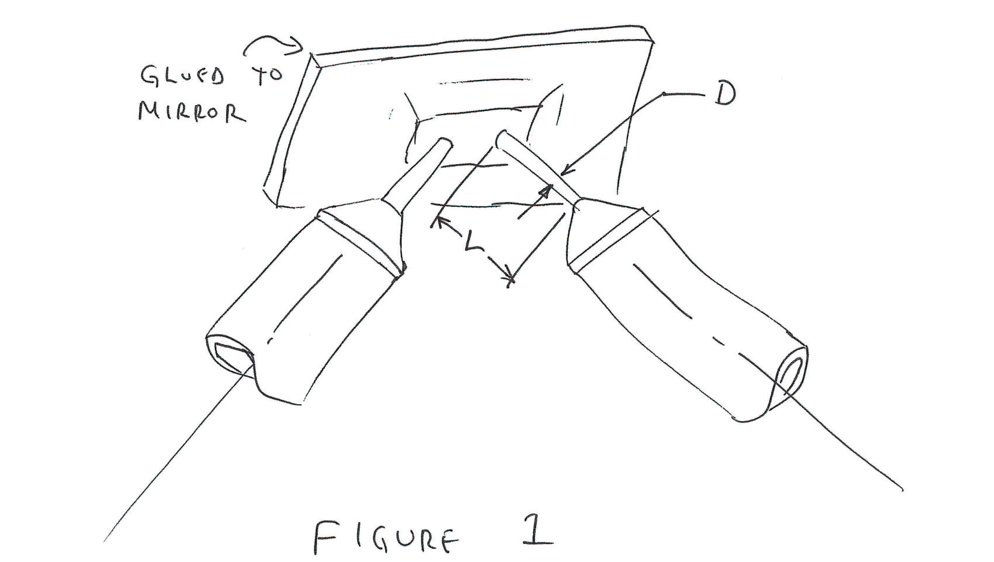
  - Use a blade to provide high compliance in one direction only. Still have to design for collapse and for buckling. Since now have compliance in only one direction we have a complicated calculation to see how the mirror is strained as a result of various kinds of movement of the bipod. See Figure 2.

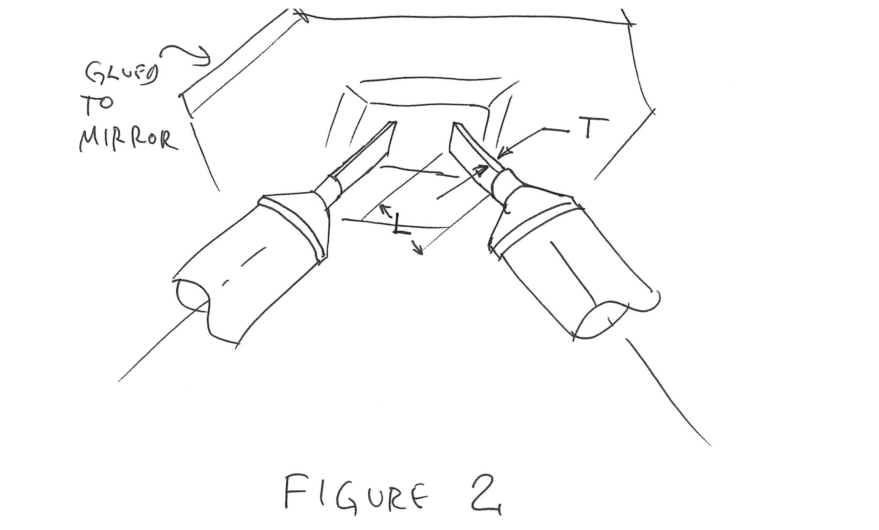
  - Use a pair of blades set orthogonal to each other. This may or may not be more efficient than item 1) above. This system is used as the place holder in R. Besuner’s mirror and telescope solid models. See Figure 3.

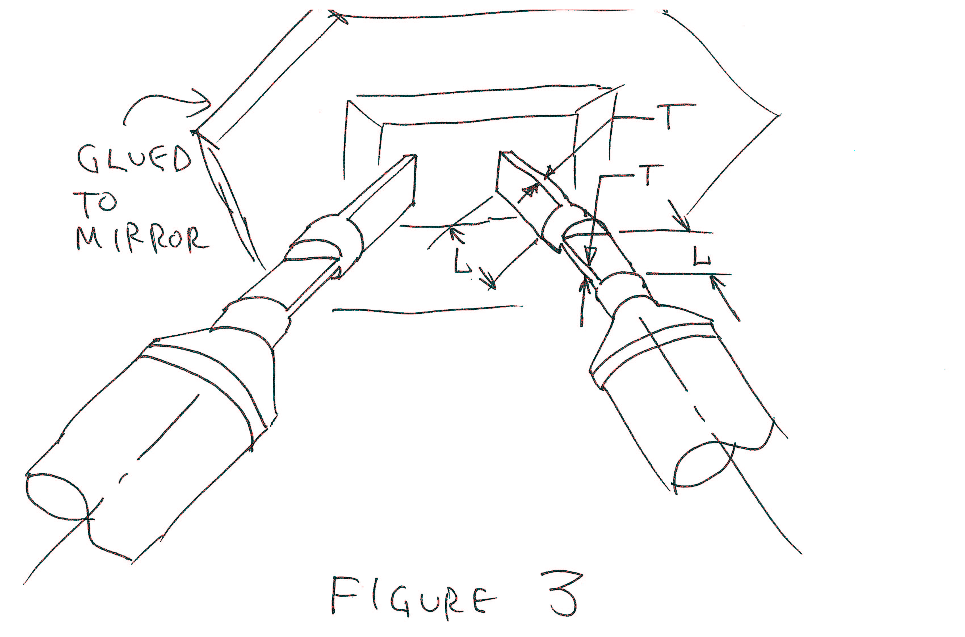
  - Use a version of the “Keck” bipod end termination. See Figure 4.

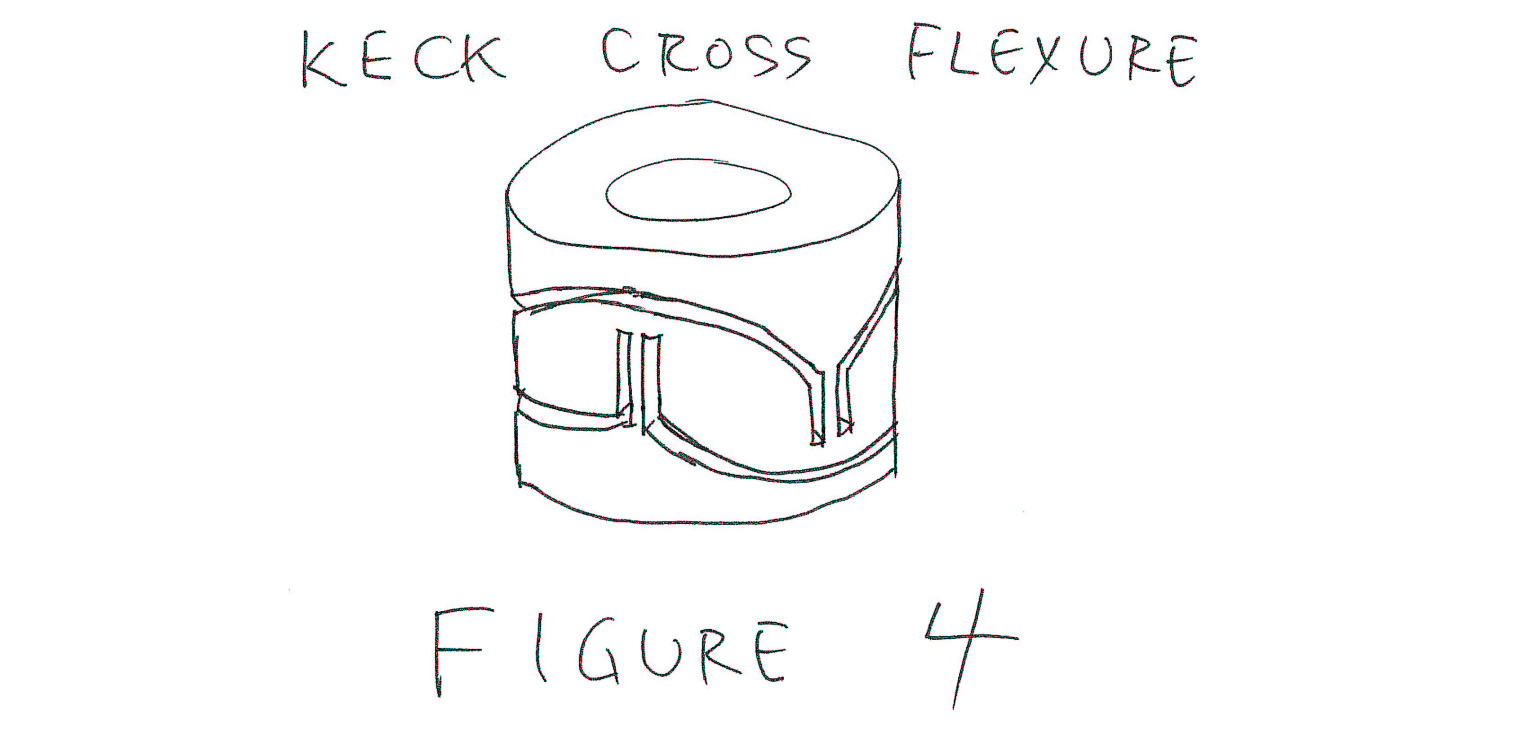
  - As an alternative, or in addition to the end flexure, something close to the ideal could be approached by having the pods terminate in a sharp point which goes into a cone shaped depression in the end fitting on the mirror and at the optic bench. The object is still to attain maximum axial stiffness with minimum resistance to angular movement. To maximize stiffness, the point should be made of a very hard and strong material such as diamond or osmium. The socket should also be hard and should have a low friction with the point material. A possible material for this is carbon rich tantalum carbide. This is very hard and naturally has a kind of greasy surface but also has very low outgassing properties. Other materials to consider include the tertiary refractory metal-carbon systems including tantalum, tungsten, hafnium, niobium, molybdenum, and titanium.
This system would require a well controlled alignment force to keep the pod axially compressed and in the region of high stiffness. This could be provided by a set of springs or alternatively with a system of permanent magnets. The system may not be sufficiently robust to survive launch loads (this should be calculated) and may therefore require a mechanism for caging during launch. Figure 5 shows an example of such a mechanism. Note that this assumes normal bipods on the mirror. Each of the three bipod termination plates at the mirror end has a cone shaped assembly mounted between the pods which is clamped between two cone sections during launch. To activate the cage a planetary gear motor drives a geared nut which pushes the inner cone upward and so raises the mirror off the bipods and clamps the mirror cone between the inner fixed conical surface and the outer conical surface of the moving inner cone. A spring through the center of the assembly provides a static load to compress the bipods when the system is uncaged. The motor can be driven either forward or reverse to cage or uncage the system during ground testing or while on orbit. In the event that the system fails in the caged state it can be uncaged in a one time operation which operates as follows: Note that the lower bearing supporting the rotating nut rests on a pad which is supported by a slug made to indium or hard wax. The upper nut bearing is pressed downward by a stack of Bellville washers which load the bearings and push the nut down onto the indium pad. In the event that the motor or gears fail or the threaded nut jams, a heater may be activated which melts the indium slug and allows the Bellville washers to push the nut down and uncage the mechanism. This is a one time operation and the mechanism cannot be caged again without extensive refurbishment. The entire caging mechanism is mounted on the optic bench and is effectively out of the mirror load path when it is in the uncaged position.

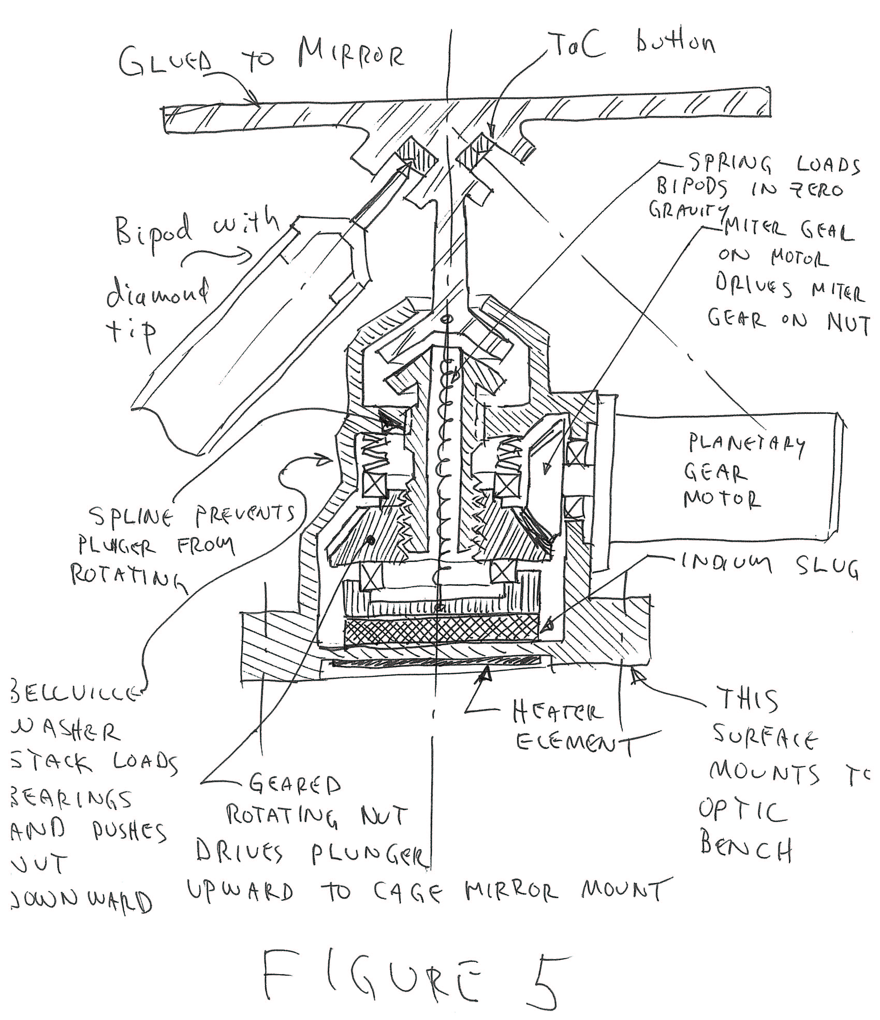
  - Another approach is to use a set of points on the bipods as described above, but to then devise a system to lock the ends of the bipods in place once the system is assembled and all of the bipod terminations are securely mounted on the mirror and the focal plane. This would be used in conjunction with one of the controlled stiffness flexures described in sections 1), 2), 3), or 4) above. Figure 6 shows one way such a system might be implemented. Here the bipod end fits into a socket in the plate which is glued to the mirror as was done in 5) above. But now in addition there is a spherical surface with its center at the point where the diamond pivots in the tantalum carbide socket which defines the distal edge of the hole in the plate assembly into which the end of the bipod is inserted. The bipod leg has a mating spherical surface which is spaced off the stationary surface by a distance of the order of 5 microns. This forms a more or less sealed space around the end of the pod which is filled with wax or indium or another material with the requisite stiffness, melting point, and low outgassing properties. Activation of a heater on the plate assembly or in the end of the pod melts the wax or indium and allows the bipod end to move freely in angle and so relieve any stress introduced in the assembly of the system which could induce moments and hence strain in the mirror. This strain relieving operation could be done either on the ground with the mirror unweighters in place and activated, or it could be done after the instrument is on orbit and in zero gravity. This system depends on surface tension in the wax material to prevent it from leaking out of the spherical gap when the wax is melted. This effect may be augmented by selection of the fill material and also by design of the edges of the sphere assembly and by control of the surface properties of the area where it is desired to prevent material from flowing.

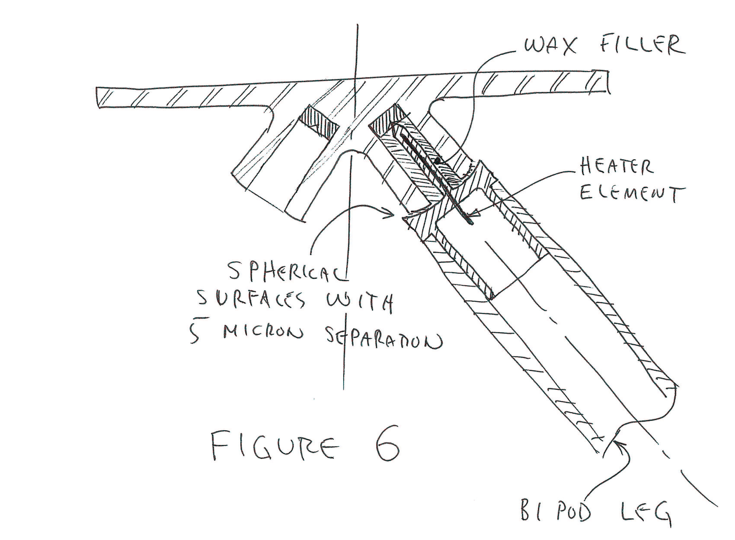
  - Similar to 6), but using a thin metal or elastomer bellows or boot to contain the wax.
  - Similar to 6), but using a system of o-rings or other seals to contain the wax.
  - Similar to 6), but using gravity to keep the wax in place.

Bipod Thermal Stability
To meet requirements on stability of the telescope system it may be necessary to provide thermal compensation of the bipods (and perhaps other elements) in addition to the control of overall temperature described in Section 3 above.
Techniques being considered and evaluated for this function include:
- Manufacture of the body of the pods from a material such as Invar which has low coefficient of thermal expansion.
- Manufacture of the body of the pods using fabrication techniques which allow active control of the thermal expansion characteristics of the final product, e.g. use of graphite re-enforced epoxy composites for which the coefficient of thermal expansion in one or two dimensions can be controlled by manipulation of the angle of lay of the yarns used in the lay up, or by varying the orientation of special prepreg fabrics used in the lay up.
- Use of a higher rate of rate of expansion material to offset the expansion of the main body material by design of a mechanical system in which they operate in the opposite direction, such as was developed for clock pendulums in the 18th century. Figure 7 shows how such a system might be applied to control the length of a bipod. Note that the high rate of expansion section may be made of a number of sections in series with the lengths of each calculated to cancel second and higher order terms in the overall expansion coefficient so as to make it more flat over temperature. Note also that this system will negatively impact the radial stiffness of the pod and may introduce unwanted low frequency dynamic modes. The function of the radial stiffening rings shown in Figure 7 is to ameliorate this situation to the extent possible.
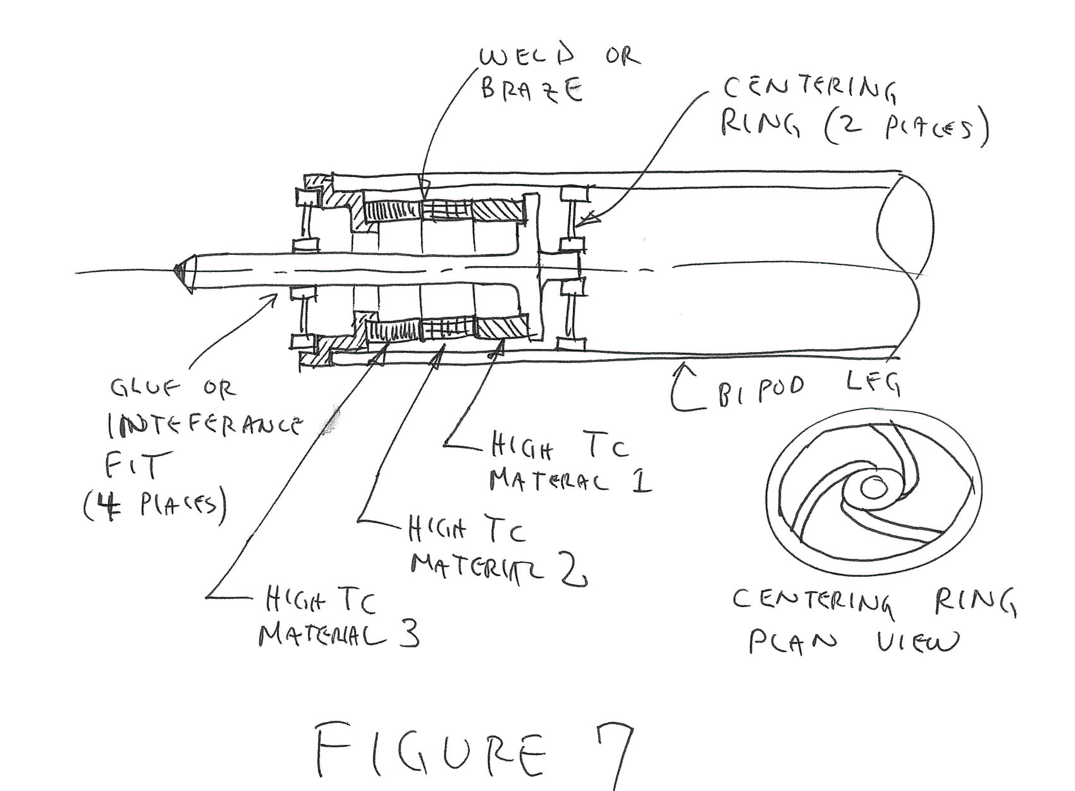
- Use of active temperature control. The individually controlled system of heaters described in Section 3 above may be used in combination with the compensation techniques of 1), 2), and 3) above to provide an active closed loop control to compensate for thermal variations in parts of the system which go outside the range of heater control. E.g., if the bipods on one side of the telescope go above the temperature at which they can be controlled by heater system, this may be compensated by an adjustment of the temperatures at other points in the system to counteract the effect of the out of spec bipods.

Bipod Length Adjustment
A mirror mounted on a hexapod has six fundamental degrees of freedom which allow it to be arbitrarily oriented in position. Thus by adjusting the lengths of the six pods supporting each mirror it is possible to adjust any aspect of the telescope imaging with 9 adjustments left as redundant: the six for one mirror considered to be the reference for the system, and three more which correspond to rotation of the remaining 3 mirrors.
The length adjustment can be either a manual operation done prior to launch, or it could be done with a motorized mechanism allowing adjustment and some portion of the refocusing to be done after the instrument is on orbit. Current plans for SNAP call for motorized adjustments on the secondary and tertiary mirrors with manual adjustment on the primary, the folding flat, and the detector focal plane.
For either the manual or motorized system, the problem is to be able to make very small and repeatable changes to the pod length of the order of a fraction of one micron. The classic problem with for example a screw adjustment is that the smallest amount that the operator can rotate the screw will change the length by too large an amount and so it is not possible to close in on the desired value. The solution is to use differential springs and screws so as to greatly “gear down” the amount of length change in the pod for a given amount of screw or motor rotation.
Figure 8 shows a differential screw incorporated into bipod mounting foot at the optic bench end to make a manual adjustment. There are two screw adjustments: the one for coarse movement is first adjusted and a circumferential clamp is tightened to lock it in place and keep the assembly rigid and stiff. Then the differential screw is adjusted to make a fine adjustment and it is staked (glued) in place to preserve the setting. The diaphragm spring at the front of the unit is set to heavily load the differential screw assembly to keep it stiff. Figure 9 shows an alternative configuration.
Figure 10 shows a motorized adjuster using a differential spring. The gearmotor rotates a normal screw so as to compress the compression spring. This spring acts on a much stiffer diaphragm type spring which moves in the ratio of the spring constants. Thus if the ratio is 20:1, and the screw on the motor has a travel of 20 mm, the adjuster will have a travel of 1 mm with a resolution which is roughly 20 times that of the motor screw. Note that this system has a large intrinsic hysteresis so that in practice you must always “come up” onto the final adjustment.

