Solid Waste Processing and Resource Recovery Workshop Report – Volume I

Engineering Directorate
Crew and Thermal Systems Division

CTSD-ADV-474

March 1, 2001



National Aeronautics and Space Administration
Lyndon B. Johnson Space Center
Houston, Texas 77058

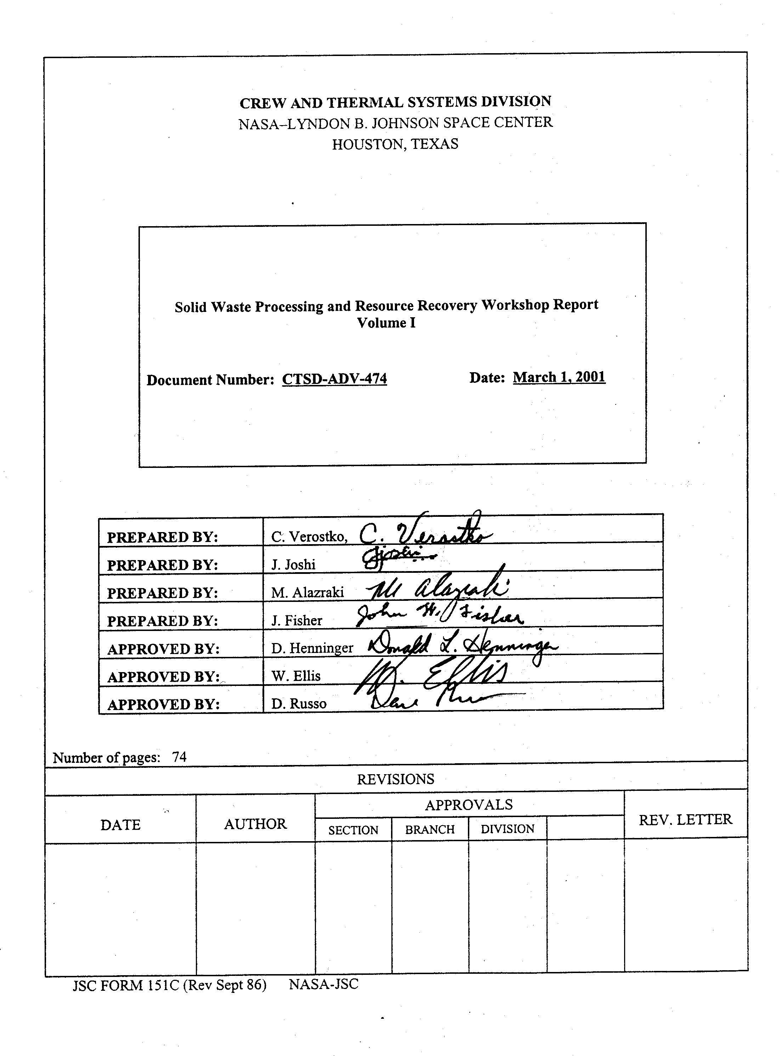

SOLID WASTE PROCESSING AND RESOURCE RECOVERY WORKSHOP REPORT

TABLE OF CONTENTS

Page Number
1. PREFACE 1

2. EXECUTIVE SUMMARY 2

3. INTRODUCTION 4

4. RESULTS & DISCUSSION 6
4.1 Pre- and Post-Processing Technologies 6
4.2 Biological Technologies 19
4.3 Physicochemical Technologies 35
4.4 Conclusions 55

5. SUMMARY ANALYSIS 56

6. FUTURE DIRECTIONS 68

7. ACRONYM LIST 70
- REFERENCES 71

9. ACKNOWLEDGEMENT 74

SOLID WASTE PROCESSING AND RESOURCE RECOVERY WORKSHOP REPORT

1. PREFACE

The mission of the Biological and Physical Research Enterprise is to use the synergy between physical, chemical and biological research in space to acquire fundamental knowledge and generate applications for space travel and Earth applications. It is the intended long-term objective of the Human Exploration and Development of Space (HEDS) Enterprise of the National Aeronautics and Space Administration (NASA) to establish a human presence on the Moon, Mars, or elsewhere in the Inner Solar System. In order to attain this objective, it will be essential to develop a closed-loop life support system that relies on minimal or no re-supply. The strategy, therefore, is to develop regenerative physicochemical and biological technologies that will reduce the system’s mass, power, and volume requirements on the entire mission. To have a truly closed-loop system, it is necessary to produce and process food and recover resources from wastes while providing clean air and water. NASA recognizes the particular challenges of solid waste processing and resource recovery for its proposed long-term space missions. Over the years considerable effort has been directed towards storage and safe handling of wastes due to the nature of the missions. As NASA plans for more long-duration missions, the focus broadens from storage to resource recovery.

There is a plethora of waste processing technologies on Earth. The use of a specific waste processing technology is often dictated by the level of pollution abatement and, more often than that, the economics of the operation. To direct NASA’s efforts in the area of solid waste processing, it is important to realize the full potential of these technologies and relate them to the critical requirements of the various exploration mission scenarios.

A workshop titled “Solid Waste Processing and Resource Recovery (SWPRR)” was held in Houston on April 4 - 6, 2000. The main objective of the SWPRR workshop was to assess these technologies to develop a research and technology development strategy for SWPRR in NASA’s Advanced Life Support (ALS) program. Evaluations included assessments of the technology readiness and their suitability for use in space-based life support systems. Various pre- and post-processing and resource recovery technologies were evaluated for their mass, power, and volume requirements and their particular strengths and shortcomings. Specialists from industry, government and academia participated in this event. Data on each technology relevant to the technology’s development and use for waste processing were pooled and evaluated based on their applications for various operating scenarios. Technology assessments and an attendee’s list with contact information are located in the Volume II (Solid Waste Processing and Resource Recovery Workshop Report Appendix), along with other pertinent information that describes the mission scenarios and the waste model.

At the time of these assessments it was understood that many of the technologies were not mature enough to fully recognize their strengths and weaknesses. Also, the technology assessment forms that were used could not be fully completed at the time of the workshop, as some of the information sought at the time of the meeting was either too speculative or unavailable.

The experts were encouraged to identify the critical research and technology development needs as part of the technology assessment. In instances where they were unsure of the data that was sought, the attendees were asked to give estimates that would be accurate to within an order of magnitude.

NASA realizes that this document may not provide a true technology assessment in all the research areas, but the intent is to have a dynamic document that the research community will be able to access to understand the areas that require research.

2. EXECUTIVE SUMMARY

2.1 Workshop Planning And Development Of Pre-Workshop Documents

Weekly teleconferences were held between Johnson Space Center (JSC), Ames Research Center (ARC), and NASA Headquarters (HQ) to develop the technology assessment documents based on five mission scenarios. The Systems Modeling and Analysis Project (SMAP) led the development of these documents. The intent was to gather as much data as possible on solid waste processing technologies. These documents were sent to the workshop participants a month in advance for them to do an individual preliminary analysis. The completed documents were compiled according to the different technology types and made available to the participants prior to the workshop.

2.2 Panelists

An effort was made to bring together the top waste treatment experts in the nation, along with currently funded NASA researchers in the area of solid waste processing. Expertise was drawn from national laboratories, small-scale industries, aerospace industry, academia, consulting firms, and the federal government. The intent was to bring about a thorough exchange of ideas and draft a thorough technology evaluation document for each of the technologies.

2.3 Invited Talks

Dr. Donald Henninger (Chief Scientist & Deputy Manager, Advanced Life Support Program) gave an overview of NASA’s Advance Life Support (ALS) program to the participants. This was an educational presentation about the status of research and development in ALS.

Dr. Joan Vernikos (Director of NASA Office of Life and Microgravity Science and Applications Division) advised the participants about the need for a waste treatment strategy for long-term space missions. In her address, she also gave a perspective of the nascent stage of development in waste collection and treatment aboard the short-duration space missions.

Dr. Shannon Lucid (astronaut aboard MIR and various shuttle flights) spoke to the workshop participants about the state of the art on the US and Russian space-flight operations. Her talk focused on solid waste collection devices and storage of wastes on MIR and the shuttle. She also spoke about the problems in microgravity and mitigation procedures to overcome microgravity effects for efficient collection of wastes in orbit.

2.4 Workshop Structure And Function

The participants were divided into three working groups (Pre-Processing/Post-Processing, Physicochemical Processing, Biological Processing). Each working group was headed by an external expert and assisted by a NASA scientist.

Pre-Processing/Post-Processing
The charge to this group was to take input from the other two working groups on pre- and post-processing needs for the different waste treatment technologies. Once this information was provided, this group identified 20 generic pre-processing technology areas applicable to the pre- and post-processing needs. Of these 20 technologies, twelve main categories of technologies for detailed assessments were selected and placed into three technological groupings. These groupings included particle size reduction, drying/mixing, and transport/conveyance.

Physicochemical (PC) Processing
The main charge for this group was to examine the PC technologies that are currently used (activated carbon manufacture, incineration, pyrolysis, lyophilization, supercritical water oxidation, peroxide oxidation, electrochemical oxidation, plasma arc thermal destruction, gasification and biomass acid hydrolysis) and study their potential application in satisfying NASA’s needs as defined in the five mission scenarios.

Biological Processing
Like the charge to the PC group, this group was charged to evaluate the potential of currently used biological processing technologies for NASA applications. The technologies this working group considered were the following: composting, anaerobic digestion, single cell protein (SCP) production, paper-making as an intermediate product, and methods for recovering inorganic nutrients for preparation of plant growth hydroponics solutions.

The panelists discussed the different technology assessment forms that were submitted prior to the workshop and refined their preliminary assessments. The goal was to create a single technology assessment form with all the available information for each technology assessed. To accomplish this, panelists were instructed to give realistic information on the basis of the current knowledge that exists in the literature.

At the end of the two days of assessments, each working group presented a summary of their findings to the entire workshop.

2.5 Open Discussion

At the end of the workshop there was a two-hour open discussion addressing different aspects of solid waste treatment. One of the focal points of this discussion was the BIO-Plex project and its use as a test bed for testing various waste processing technologies.

2.6 Summary of Findings

A total of thirty-one technologies were assessed - eleven pre-processing technologies, thirteen physicochemical and seven biological. Results showed that all technologies are below TRL 5, with the exception for storage equipment. Particular areas that require significant research and technology development include the following: 1) development of integrated waste processors for end-to-end automated operation; 2) assessment of technologies for gravity dependence; 3) optimization of pre-Processing, physicochemical and biological processes; and 4) testing and validation in relevant environments. Methods for collection and storage of solid wastes have been flight demonstrated in the Shuttle, Russian Space Station and previous missions. These methods will require evaluation for use in transit and planetary missions.

3. INTRODUCTION

3.1 Background and Purpose of the Workshop

Successful long duration missions will require regeneration of life support resources from wastes generated in space-based habitats. Losses of resources vital to life support due to wastes (i.e. consumables) that cannot be processed and recovered will require resupply. A loss in essential life-supporting elements could jeopardize crew performance and well being, whereas any resupply from Earth will be cost prohibitive. Thus, resource recovery from wastes becomes a critical component to closure in future ALS systems (1)*. Utility of waste processing technologies is a function of the resources bound to the wastes that can be recovered and mission duration. Mission duration will be a determining factor in resource recovery requirements. Without recycling needed resources, resupply cost will increase more for a longer mission than a shorter mission (2).

Assessment of potential technologies and development of a strategy for development of solid waste processing hardware for collection, pre-processing, processing, post-processing, and storage of unusable residues / unprocessed solid waste residues are essential to having mature technologies for space-based habitats on the Moon and Mars (2).

* Numbers in parentheses represent references.
The ALS team at NASA invited a team of experts from academia and industry to contribute to a research and technology development roadmap for solid waste processing and resource recovery. Along with the specific technology assessment forms the workshop participants were given a broad charter to seek the information.

3.2 Charter to the Workshop

Advanced life support (ALS) systems will be required for long duration human missions of the future. Recycling of air and water, production of crops and processing into storable items or food, and solid waste processing are key elements of an ALS. Solid waste processing and resource recovery (SWPRR) can be more aptly stated as recovery and recycling of useful resources from solid wastes.

The goal of the proposed SWPRR workshop is to provide input to NASA to develop a research and technology development strategy for SWPRR. Candidate waste processing technologies for possible use in future space-based human life support systems would be assessed at this workshop. Each candidate solid waste processing technology will be independently assessed in terms of established criteria including mass, power, volume, reliability, use of expendables, technology readiness level, and operational scenarios (e.g., microgravity vs. hypogravity; vehicle vs. planetary surface applications). Evaluations will also include an assessment of the technology readiness and its suitability for use in space-based ALS in the context of specific mission scenarios.

The workshop will be structured into four functional components of solid waste processing: 1) collection, transport, storage and pre-processing; 2) physico-chemical primary processing; 3) biological primary processing; and 4) post-treatment and disposition of ‘unprocessed’ wastes.

Waste models that will describe the components and quantities of wastes expected for specific elements of the mission scenarios will be provided. It is expected that a technology assessment will be done on the basis of these waste models. Tools will be provided to record data needed on each technology. Assessment of the technologies will include identification of limitations of the technology in the context of NASA mission applications and possible approaches to overcoming these limitations. Finally, new technologies, which might be potentially applicable to space-based life support systems, will be solicited.

The recommendations and findings of this workshop are expected to serve as a guideline to solicit and conduct research in ALS in the area of SWPRR.

4. RESULTS & DISCUSSION

4.1 Pre- and Post-Processing Technologies

4.1.1 Introduction

The pre- and post-processing (PPP) working group identified and analyzed pre-processing and post-processing technologies that could support the physicochemical (PC) and biological (Bio) conversion systems being considered at the workshop. With reference to the ALS program, pre-processing technologies are those that prepare solid waste for PC or Bio processing. An example of pre-processing technology is size reduction, i.e., shredding (or synonymously, grinding), that may be required by a primary processing system to provide for adequate treatment (i.e. physicochemical or biological conversion of the wastes to a resource). Pre-processing includes: 1) processes that select or separate the wastes into a feedstock that can be processed by a primary processing system, 2) preparation of the wastes into a physical form (e.g., dried, micron-sized particles, a slurry) that is optimal for the primary processing system, and 3) transport of the waste. Post-processing generally refers to those operations that refine a material to a higher quality or to another physical form so that it may be used, treated further, or disposed. Examples of post-processing include processing of the solid residues for particle size separation and treatment of some of the secondary products (ash, slurry). The water and gases recovered as by-products from any of these processes would be further treated by a water recovery system designed for the application, or by the air revitalization system, respectively.

With regard to throughput rates and processing flexibility, PPP technologies may be designed to operate in batch, continuous, or both modes of processing. Articles and books that discuss handling and preparation of wastes for solid waste processing are references (3-7).

4.1.2 Major Activities of the PPP Working Group

- Definition of the governing characteristics of the waste and solid product streams from the PC and Bio conversion systems that might have to be post-processed
- Definition of the universe of applicable generic PPP technologies for solid wastes
- Narrowing of the universe to those technologies selected as being more relevant to PC and Bio primary processing systems
- Description of the characteristics of the selected technologies, analysis of the technologies, and estimation of their TRLs

4.1.3 Selection of Relevant PPP Technologies

The initial work of the working group revolved around the need to secure waste stream properties, both on a wet and dry weight basis, and the waste characteristics desired by the PC and Bio technologies. A summary of the waste input information received from the PC and Bio conversion system working groups is given in Table 1. Prior to receiving the waste input information for the other two working groups, the PPP working group identified about 20 generic areas of PPP technology. The areas are summarized in Table 2.

From the list of PPP technologies presented in Table 2, the working group selected twelve main categories or subcategories for detailed analysis. The technologies were selected based primarily on the estimated processing rates, the raw (i.e., as collected) solid waste characteristics, and the required input feedstock characteristics of the PC and Bio technologies, as identified and analyzed by their respective working groups. A secondary consideration was the applicability of the technologies to post-processing of the solid by-products generated by the PC and Bio systems.

The twelve selected technologies were coalesced into three technological groupings. An assessment group (i.e., subgroup of members of the PPP working group) was established subsequently to conduct the evaluation of the technologies within a particular technological grouping. The names of the technological groupings were as follows:
Transport, Conveyance, and Phase Separation;
Drying and Mixing; and
Particle Size Reduction and Control.

For each technology within the technology groupings, the assessment groups analyzed the advantages and disadvantages, the potential effect of micro- and hypogravity, and the current technology readiness level (TRL). Additionally, each assessment group selected one or two technologies in their grouping for further analysis in terms of the specific technical tasks that would be required in order to develop the technology to a status of TRL 5 (reference 2). A summary of the results of these analyses is given in Tables 3 through 5, respectively, for each of the three technology groupings and their subcategories of technologies.

4.1.3.a Pre- and Post-Processing Requirements

Table 1. Pre- and Post-Processing Requirements for PC and
Bio Conversion Systems Configured for Resource Recovery
 | Pre-Processing |  |  |  |  | Post-Processing
Solid Waste Technologies | Required Particle Size | Bulk Density | Desirable or Acceptable Moisture Content | Items Technology WILL Process | Items Technology WILL NOT Process | Products

Physicochemical
Freeze Drying | 100 μm to 0.3 cm | 0.5 g/cc | normally  > 10 % | feces and biomass |  | need to store
Super Critical Wet Oxidation | < 100 μm | 1 g/cc | normally 75 to 95 % | like a puree;  7% to 10% organic, 2% to 3% inorganic | 1,500 ppm HCl or H₂SO₄ | organic free oxides; salts; oxides; CO₂, O₂, N₂, and some N₂O; moisture < 50%
Incineration – Fluidized Bed | < 0.6 cm |  | < 50% to 70% | anything that can be ground to small size | remove alkali and chlorides | CO₂, ash; trace organic compounds, HCl
Incineration – Batch | < 5.0 cm |  | lower is better | none if small | minimize alkali, chlorides, and inorganic nitrogen | CO₂, ash; trace organic compounds, HCl
Incineration – Plasma | n/a |  |  | combustibles | metals or glass | CO₂, nitrates; NO_{x}
Indirect Electrochemical Reduction | 0 (soluble) up to < 10 μm |  | high content is better but not necessary | soluble organic materials | fluorinated plastics, chlorides | CO₂, trace volatile organic compounds, Cl₂ and HCl
Carbonization | 0.05 to 1.0 cm |  | < 50% | cellulose waste | human waste | activated carbon; pyrolysis gas or synthesis gas (CO, CH₄, H₂O, H₂ and volatile organic compounds) => energy

Table 1. Pre- and Post-Processing Requirements for PC and
Bio Conversion Systems Configured for Resource Recovery (cont.)

 | Pre-Processing |  |  |  |  | Post-Processing
 | Required Particle Size | Bulk Density | Desirable or Acceptable Moisture Content | Items Technology WILL Process | Items Technology WILL NOT Process | Products
Hydrogen Peroxide Oxidation | < 15 cm |  | 0% | paper, plastics, inedible biomass, human waste, and food | water or oil | CO₂, ash; energy from steam
Pyrolysis | n/a  < 10 cm | 0.5 g/cc | < 80% | batch or continuous | no fluorine or chlorine; metal or ceramic | A range of solids: 20% to 35% by weight; liquids 0% to 50% by weight; gas 30% to 80% by volume. This split alters due to temperature
Gasification  (steam reforming) | < 0.1 cm  (< 10 cm) |  | any | high heat value materials |  | Produce a solid, liquid,  and a gas; range of solids: 20% to 35% by weight; liquids 0% to 50% by weight; gas 30 to 80% by volume. This split alters due to temperature.

Biological
Composting | 0.5 to 5.0 cm |  | 40% to 70% | biodegradable | non-biodegradable  (plastics, metals, tapes, etc.) | produce solid, liquid (water), leachate (high organic), gas (CO₂, H₂O, and NH₃ plus trace organic compounds)
Slurrying | < 0.5 cm | 1 g/cc | > 90% | separate biological and non-biological components | non-biodegradable (plastics, metals, tapes, etc.) | produce solid, liquid (water), leachate (high organic), gas (CO₂, H₂O, and NH₃ plus trace organic compounds)
Leaching | < 10 cm | 1 g/cc | < 10% | inedible biomass | non-biodegradable (plastics, metals, tapes, etc.) | Leachate with high organic content + inorganic nutrient + microbial cells and trace NH₃ gas

4.1.3.b Technology Areas

Table 2. Universe of Technology Areas for Pre- and Post-Processing of Solid Wastes
Source separation (i.e., manual separation)
Storage (using various types of containers or bins)
Drying:
freeze drying
thermal drying
vacuum drying
air drying
Compaction (bulk compaction; product is a large, dense unit (e.g., bale))
Pelletization (or densification; product is a small, dense unit (e.g., pellet))
Size reduction:
wet (defined as size reduction of wastes with a moisture content greater than 60%, or slurry or pulping of the waste)
dry (defined as size reduction of wastes with a moisture content less than or equal to 60%)
Transport and conveyance:
fluidic:
gas working fluid
liquid working fluid
mechanical (e.g., belt or screw conveyors)
manual (e.g., using containers)
Mixing:
liquid/solid (to dissolve solids or to slurry them)
solid/solid (to achieve homogenous a mixture of two or more different types of solids)
Phase separation (physical, e.g., sieving of different sized particles)
Air classification (gas (e.g., air) is the working fluid affecting separation of two or more solid phases)
Metal separation (e.g., ferrous and non-ferrous)

4.1.3.c Mixing and Drying Technologies

Table 3. Summary of Analysis of Selected Mixing and Drying Technologies
Technology | Advantages | Disadvantages | Gravity Issues | Current TRL*
A. Force Air Thermal Convection  B. Forced Air Drying  C. Thermal Vacuum Drying  D. Freeze Vacuum Drying | - Principle concept is proven  - Minimal complexity  - Scaleable | - Mass/volume/size of major/minor components not known  - May produce volatile contaminants  - Not proven in this application (needs validation in relevant environment, micro- and hypogravity) | - Needs to be determined  - May be restricted to batch operation  - Material probably will need to be fixed in position | 3 or 4
E. Solid/Solid Blender | - Principle concept is proven  - Flexibility of operation (throttle process)  - Scaleable  - Handling of wide variety of wastes  - Less energy | - Mass/volume/size of major/minor components not known  - Not proven in this application (needs validation in relevant environment, micro- and hypogravity)  - May produce dust with dry feeds | - Needs to be determined  - May need to test concept in relevant environment | 2 or 3
F. Solid/Liquid Blender | - Principle concept is proven  - Flexibility of operation (throttle process)  - Scaleable  - Handling of wide variety of wastes | - Mass/volume/size of major/minor components not known  - Not proven in this application (needs validation in relevant environment, micro- and hypogravity) | - Needs to be determined | 2 or 3
*See Volume II (Appendix) for definitions of TRLs.

Technical Tasks to Achieve TRL 5 for Solid/Liquid Mixers
- Evaluate and select best mixing concept for micro- and hypogravity
- Select major/minor components
- Size and design system
- Build breadboard system
- Performance test (validation in relevant environment) and make modifications as required

Development Time: 2 years

Cost to Achieve TRL 5: $150,000 to $200,000

4.1.3.d Transport, Conveyance and Separation Technologies

Table 4. Summary of Analysis of the Selected Transport, Conveyance, and Separation Technologies
Technology | Advantages | Disadvantages | Gravity Issues | Current TRL*
Vacuum transfer | - Handles wide range size and moisture content  - Good for intermittent operation | - Requires a “receiver tank” (pumped down)  - Sewage becomes anaerobic in tank if left in tank for any length of time  - Needs validation in relevant environment | - Material/gas separation in receiver tank | 4
Slurry pump | - Simple, commercial technology | - Separation and settling in transfer line  - Large hold-up volume  - Need for flush or recycle  - Needs validation in relevant environment | - Requires positive feed | 4
Dry pneumatic | - Simple, commercial technology  - Good for intermittent operation | - Potential static charge and dust reactions  - Potential for clogs  - Requires separator and filter  - Needs validation in relevant environment | - Gas/solid separation (cyclone on receiver) | 4
Screw conveyor | - Simple, commercial technology | - Potential for jams  - Large hold-up volume  - Needs validation in relevant environment | - Requires positive feed | 4
*See the Volume II (Appendix) for definitions of TRLs.

Technical Tasks to Achieve TRL 5 for Vacuum Transfer
- Build unit of required scale
- Operate with representative waste stream (validation in relevant environment)

Development time:
Specify, procure, and fabricate 5 months
Set up 1 month
Test 6 months

Cost to Achieve TRL 5: $150,000

Technical Tasks to Achieve TRL 5 for Dry Pneumatic Transfer
- Build unit of required scale
- Operate with representative waste stream (validation in relevant environment)

Development time:
Specify, procure, and fabricate 5 months
Set up 1 month
Test 6 months

Cost to Achieve TRL 5: $150,000

4.1.3.e Particle Size Reduction and Control Technologies

Table 5. Summary of Analysis of the Selected Particle Size Reduction and Control Technologies
Technology | Advantages | Disadvantages | Gravity Issues | Current TRL
Dry particle size reduction and control | - Much terrestrial experience  - Short time constant  - Throughput flexibility  - Low energy requirement | - Product size limited to 0.1 cm  - Dust and noise generation  - Validation in relevant environment | - Sizing process is gravity dependent  - Unknown effect of gravity on size reduction process | 3
Wet particle size particle reduction and control | - Can produce product sizes less than 0.1 cm  - Compatible with slurry-based back-end systems | - High water requirement  - Unpredictable liquid/gas problems in microgravity  - Energy intensive  - Reliability  - Validation in relevant environment | - Compatibility with microgravity | 3

Technical Tasks to Achieve TRL 5 for Dry Particle Size Reduction and Control
- Select best particle size reduction technology for feed stream and particle size goal
- Review microgravity considerations
- Design and fabricate breadboard system
- Test under terrestrial conditions (validation in relevant environment)
- Optimize system

Development Time: 3 years

Cost to Achieve TRL 5: $900,000

4.1.4 Summary

Conclusions of the PPP working group are as follows:
- Many of the PPP technologies have potential applications for the different mission scenarios. The list of technologies in this document should be scrutinized further to encompass some PPP technologies that may not have been mentioned in this workshop. (References 3-7)
- As per the requirements of the PC and Bio technologies discussed in this document it is imperative that the waste streams as envisioned should undergo pre-processing for size reduction and drying (moisture contents range from air dry to 80% water content for different technologies).
- The successful application of any of the PPP technologies requires that they be integrated with the other processing unit operations; the integration requires material transport (i.e., conveyance) systems.
- Four generic processing technologies were selected to meet the compatibility criterion, namely particle size reduction and control, mixing and drying, transport/conveyance, and phase separation.

The working group also identified the following issues and potential problems associated with the selected PPP technologies and their application in space:

- Waste quantities and characteristics: The successful design and operation of pre-processing technologies are strongly dependent upon the rate of processing and the characteristics of the waste. Thus, the analysis of the solid waste generated by space missions and mission simulations should be ongoing. The methods and procedures of the waste sampling and laboratory analysis program should specifically be designed such that the results of the analysis are relevant to pre-processing technologies.

- Effect of waste generation rates: The waste generation rates during crewed flight missions and planetary surface stays are estimated to be low in the early years of exploration. This important fact must be considered when designing PPP systems, including the advantages and disadvantages of batch and continuous processing of waste. The low waste generation rates (and, therefore, average processing rates) may limit some technological options for pre- and post-processing.

- The effect of micro- and hypogravity: The results of the analysis among all of the selected PPP technologies indicate that the effect of micro- and hypogravity on the technologies is difficult to determine with any degree of certainty without actual testing of the technologies in the appropriate gravitational environment. It is recommended that all of the technologies be analyzed for gravitational dependency, the functional relationship of the dependency, and whether or not any control systems, methods of engineering, or both can be designed to facilitate the abilities of the technologies to operate successfully in micro- and hypogravity environments. The following are some of the issues identified by the workshop team for the transport/conveyance and mixing/drying technologies: 1) forced-air convection drying may require fixing the waste materials in place; 2) a slurry pump and a screw conveyor may require the provision for a positive feed (i.e., a mechanical means for introducing wastes into the conveyor or pump); and 3) a vacuum transfer technology may require a means of separating the gas from the solid waste in the receiver tank.

- Maximum particle size requirements of the PC and Bio conversion systems: The currently available, terrestrial, solid waste size reduction technologies likely cannot meet the more stringent particle size requirements of some of the primary processing systems. Some primary processing systems require a particle size of 10 microns or less and it is doubtful that conventional size reduction equipment can meet this fine particle size requirement in a feasible manner without technological improvements.

- Engineering and operational problems: Historically, the transport (conveyance) of raw and processed solid waste in terrestrial solid waste processing systems has generated substantial problems, including, for example, jamming of screw feeders, pneumatic pipelines, and hydraulic piping. This circumstance must be considered prominently in the design and testing of PPP technologies for application in space.

Based on the results of the analysis, the following three technologies are recommended for further study based on perceived need for crewed space missions.

High Priority:
1. Transport and Conveyance
Detailed study of candidate transport and conveyance technologies is required because they are a necessary and integral part of any type of solid waste processing system. Most of the systems for transport and conveyance of solid waste on earth depend explicitly or implicitly on the earth’s gravity and a transporting medium, e.g., conveyor belt or fluid (such as air or water). The lack of the equivalent of Earth’s gravity and of working fluids for the near-term space missions (or, conversely, the provision of the resources to meet the requirements of the systems) must be taken into consideration when selecting transport and conveyance systems. Thus, a recommendation is made that an analysis be conducted of the gravitational and fluidic dependence of the various transport and conveyance systems (listed in Table 3) and of the preliminary feasibility of the various systems. These analyses can be performed using theoretical or semi-empirical methods since the scientific and engineering bases of these transport/conveyance systems are well known. The successful design and operation of solid waste transport/conveyance systems on Earth also are critically dependent on the rate of processing and on the composition and other properties of the waste. Thus, the analysis recommended above must also present the findings in terms of the throughputs and characteristics of processed solid waste that are expected from space missions. In terms of priority, the analyses should be conducted simultaneously for belt, pneumatic, and screw conveyors. If the results of the preliminary feasibility study of potential gravitational limitations and resource supply are positive, then the design and bench-scale testing of these three technologies is indicated and should be the subject of a dedicated research and development program.

2. Particle Size Reduction and Control
There are a variety of particle size reduction processes, each with its own set of governing physical principles. Many of the commercially available, terrestrial technologies are dependent to one degree or another on Earth’s gravity. In terrestrial waste processing systems, particle size reduction equipment is bulky, has a large mass, and has a high specific energy and wear requirement. Basic research and development in size reduction is recommended because: 1) the need for some degree of size reduction of the input feedstock was common among all of the PC and Bio conversion systems identified in the workshop; 2) the large number of variables that affect the design, operation, and performance of size reduction equipment make judgments of equipment feasibility extremely risky without the benefit of experimental testing; and 3) the supporting resource requirements may be substantial. Both wet (e.g., pulping processes) and dry size reduction processes should be the subjects of detailed study. To the extent that size reduction equipment cannot meet the requirements for certain particle size distributions, research and development is warranted for analysis of screening (particle size separation) equipment. Screening technologies are subject to many of the same governing parameters and conditions that have been described above in the subsection, Transport and Conveyance. Based on prevalence and performance in terrestrial waste processing, the research and development priorities for particle size control technologies should be: flat-bed vibratory, trommel (rotating cylindrical screen), and disc screens. Screening technologies other than those mentioned in the preceding sentence (e.g., cyclone separators) may also be warranted for certain applications.

Moderate Priority:
3. Mixing and Drying
Mixing and drying are given a lower priority than the two preceding technology groupings. The reasons for the lower ranking are that mixing and drying technologies are well developed on Earth, and the technologies are considered transferable to space missions without requiring substantial modifications. Mixing systems may be required in space missions to homogenize materials of different compositions. Based on terrestrial experience in solid waste processing, mechanical mixers (e.g., with rotating elements) are the most prevalent mixing technology and would be a candidate for application in space missions. The mixing process is highly dependent on the characteristics of the materials to be mixed. Thus, research in mixing would be particularly warranted if the materials have proven to be difficult to mix on Earth (examples of such feedstocks would include stringy materials), or would be difficult to mix in micro- or hypogravity environments. Both wet and dry mixing technologies should be investigated.

Drying systems generally have not been used in terrestrial waste processing systems because of the energy cost and because the processed feedstocks generally have an inherently acceptable moisture content. Drying was an important aspect of some early, but limited in number, fuel preparation systems that produced a densified refuse-derived fuel (dRDF). The typical system used convective drying. Research and development in the areas of convective or vacuum drying of organic wastes may be warranted by NASA if a dry feedstock would be required for primary processing systems. For example, an incineration system would provide better performance with a dry feedstock.

4.1.5 Conclusion

Regardless of the PPP technologies that are selected for further study, each must be subjected to testing under conditions relevant to space missions. This testing would normally occur after the technologies have been identified and their preliminary feasibility determined. The relevant operating conditions should include the appropriate gravitational force and the use of solid wastes characteristic of those generated in space missions.

4.2 Biological Technologies

4.2.1 Introduction

4.2.1.a Background

Biological treatment is a very common approach to handling waste in Earth systems. Waste (i.e., unused materials), such as residues from plant and animal systems, biodegrades and recycles nutrients for the next generation of organisms. Large-scale systems process biosolids (sludge) using anaerobic/aerobic digesters (liquid), or more recently, large composting systems (solid). They also process other residue streams such as yard and food wastes. Removal of non-biodegradable materials from the waste stream will increase system performance while producing a product that is useable with positive impacts. This is born out by experiences in Europe in the 1980s and North America in the 1990s.

Biological treatment systems can be constructed using organisms at all size levels and complexities. {An example is a food residue processing system using large animals and microorganisms, i.e., swine eating food residue and microorganisms processing swine manure.} However, those using microorganisms are the simplest systems in terms of components and process control requirements. These systems handle highly variable biodegradable waste streams and often require minimal preprocessing. Considerations of set points for temperature, moisture content, oxygen, volatile solids, carbon, nitrogen, pH and particle size are the major controllable factors. Output products to be considered are organic residue, biomass, water (liquid and gas), heat, and gases of CO₂, CH₄, volatile organic compounds (VOCs), NO_{x} and NH₃, to name the most common.

4.2.1.b Determination of Waste Stream Constituents Suitable for Biological Processing

Not all components of the given waste model are biodegradable. Given the current state of materials technology, it was assumed that plastics of all types and tape are non-biodegradable and therefore excluded from the biological processing system waste stream. It is recommended that further efforts be conducted with regard to the development and/or testing of biodegradable packaging and other consumables (e.g., air filters) where appropriate.

Although it is possible to treat urine and/or urine solids using certain biological solid waste processing technologies, the working group concluded that urine/urine solids would best be treated by other systems (gray-water processing) and are therefore not included in the solid waste stream. A primary reason involves the high concentration of salts in the process residue if urine was added, which can severely hinder further utilization and resource recovery (i.e., extraction for plant nutrients). Additionally, the high nitrogen loading imposed by the addition of urine will promote microbial ammonification with a consequent increase in pH and ammonia volatilization. This will result in nitrogen loss from the system, and ammonia volatilization could impose substantial demands on downstream trace air contaminant control systems.

Biological systems universally require water for growth, metabolism, solute transport, and other functions. Each biological waste processing technology requires specific moisture conditions, ranging from the lower moisture contents of 50-70% for solid-phase systems such as composting, to upper levels of ~98% for aqueous systems. Because of these constraints, the moisture content of the waste stream components is important, both in relation to the individual waste and to average of the overall wastes. This is particularly true for systems that employ low moisture such as composting, in that excessive moisture will impede treatment. Materials that are high in moisture (e.g., certain inedible plant biomass) may require some pre-drying or can be mixed with drier materials (e.g., paper) to render suitable average moisture content.

Table 6 is a summary of the identified waste stream for NASA scenario 3, a 6-member space mission crew. This stream consists of both biodegradable and non-biodegradable constituents. The biodegradable flow rate was 8.13 kg_{db}/day or 29.18 kg_{wb}/day (72.1% water content) and the non-biodegradable flow rate was 2.42 kg_{db}/day.

Table 6. Waste Stream for a 6-Person Space Mission (One Growth Chamber)
Waste Component | Waste Stream¹  (kg_{db}/day) | Biological Treatment¹  kg_{db}/day | Biological Treatment²  (kg_{wb}/day) | Other Treatment¹  kg_{db}/day
Daily Feces  Urine  Shower/Hand wash  Sweat  Inedible Plant Biomass  Trash  Packaging Material  Paper  Tape  Filters  Miscellaneous (Teflon, PVC) | 0.180  0.360  0.060  0.120  5.450  0.556  2.017  1.164  0.246  0.326  0.069 | 0.180  0  0.060  0.120  5.450  0.556  0.600  1.164 | 1.200  1.200  2.400  21.800  0.618  0.667  1.164  1.293 | 0  0.360  0  0  0  0  1.417  0  0.246  0.326  0.069
Total | 10.548 | 8.130 | 29.178 | 2.418
¹ = dry matter basis ² = wet basis

Table 7. Estimated Chemical Composition and Density for Waste Stream for a 6-Person Space Mission
ITEM | Ash% | C% | N% | C/N | Moisture | Density
 |  |  |  | (available) | % w.b. | kg/m³
Feces | 0.43 | 42 | 8 | 5.1 | 85 | 949
Urine | 0.56 | 18 | 22 | 0.8 | 0 | 1009
Shower/…/Sweat | 0.50 | 25 | 4 | 6.3 | 95 | 1009
Inedible Plant Biomass (1) | 0.15 | 34 | 4 | 9.0 | 75 | 300
Trash | 0.02 | 45 | 1 | 90.0 | 10 | 148
Packaging Material (2) | 0.05 | 44 | 4 | 11.0 | 10 | 148
Paper | 0.02 | 45 | 1 | 90.0 | 10 | 148
Tape |  | 0 | 0 | 0.0 | 0 | 148
Filters |  | 0 | 0 | 0.0 | 0 | 148
Miscellaneous |  | 0 | 0 | 0.0 | 0 | 148
Recycled compost |  | 26 | 2 | 13.0 | 49 | 550
Composite mixture |  | 37 | 3 | 11.6 | 72 | 308

4.2.1.c Safety Considerations

Biological waste treatment systems are typically operated at near-ambient temperatures, pressures, and pH, and therefore pose little threat due to explosions, fires, or acute corrosivity. Areas of potential safety concern include by-product formation and pathogenic or undesired microbial growth. Anaerobic biological waste treatment systems by design produce significant amounts of methane, while aerobic systems produce methane only if aeration is not uniform. While methane can potentially be separated and utilized as a fuel, it simultaneously poses an explosive risk. Other potentially harmful gaseous by-products include various volatile organic and inorganic compounds. These will require treatment to avoid accumulation in the cabin atmosphere.

Any waste treatment system utilized will need to provide reliable human (and possibly plant) pathogen control. Biological systems typically do not sanitize the waste stream and will require post-treatment pathogen destruction, preferably in conjunction with the waste-processing unit. An exception is composting: the inherent microbial self-heating can be controlled to elevate matrix temperatures to levels that effectively destroy both human and plant pathogens. Pathogen dissemination can also occur through the production of airborne bio-aerosols, which may require capture and treatment prior to release to cabin atmosphere. This is true of most, if not all, biological solid, liquid, and gaseous treatment systems.

4.2.1.d Pre-Processing Requirements

Each biological technology exerts variable pre-processing demands. Composting systems will require little to no drying, with minimal particle size reduction requirements (1-5cm). The aqueous systems will require nearly complete drying of the material to allow the size reduction required to obtain optimal system performance (0.5 cm). Complex pre-treatment may be required in the case of bio-conversion technologies such as paper-making, including size reduction, heating, or chemical addition.

4.2.1.e Batch vs. Continuous Systems

Biological systems can be designed to operate in either batch or continuous mode. The batch mode will likely require greater system volume and mass than continuous systems, as matrix volume reduction during processing will create unused space within the reactor. In contrast, continuous systems will likely exert greater mechanical requirements, due to increased material translocation and mixing requirements. Process control/stability may also be a significant factor in whether a batch or continuous process is more desirable.

Another factor that strongly influences whether batch or continuous systems should be employed involves the immediate waste loading requirements. For instance, harvesting and/or processing a large crop will create a large plug of inedible biomass waste. This waste must either be stored and fed incrementally to a continuous system, or alternatively fed to properly sized batch reactors. Additionally, the impact of batch reactors must be assessed with regard to demands exerted on air revitalization systems and other mass buffering systems; e.g., biological batch processing will transiently require high amounts of oxygen supply and carbon dioxide removal.

4.2.2 Candidate Biological Solid Waste Treatment Technologies

The potential biological waste treatment technologies examined during this workshop included:
Aerobic Composting
Anaerobic Composting
Continuously Stirred Tank Reactor
Fixed Film Bioreactor
Conversion Technologies (production of single cell protein, ethanol, blotter paper)

Each system possesses specific criteria for operation. The following are brief descriptions of each technology. Detailed analyses are presented in Volume II (Appendix).

4.2.2.a Composting

Composting is the accelerated biological decomposition process of organic materials in a predominantly aerobic environment. The process is carried out in a solid matrix (moisture generally < 75%) as opposed to a water-based system (moisture generally > 90%). During the process, bacteria, fungi and other microorganisms (including microarthropods) break down organic materials to stable, usable organic substances called composts. The process consumes oxygen and releases heat, water, and CO₂ (8). The compost that remains resembles humus and may be used as a soil conditioner, organic fertilizer or as a food base for microorganisms for disease control. Composting reduces the volume of the parent materials and many pathogens are destroyed if the process is controlled properly (T_{compost} > 55ºC for >3 days). Efficient composting requires the control of many factors to avoid nuisance problems such as odors and dust.

Under controlled conditions, composting is accomplished in two main phases: a composting phase and a curing phase (9). The typical batch composting phase involves three subphases: 1) an initial phase, when mesophilic microorganisms degrade constituents such as sugars, starch, proteins, etc., and compost temperature rises rapidly; 2) a high-rate thermophilic phase, in which temperatures rise above 40ºC and fats, hemicellulose, cellulose and some lignins are degraded (also pathogens are destroyed at this time); and 3) a stabilization phase during which the temperature declines and further degradation of cellulose, hemicellulose and lignins occurs. The high rate phase is accompanied by high rates of O₂ uptake, CO₂ and biological heat production. Excessive production of NH₃ and other gases (VOCs) may occur if the process is not effectively controlled. During the curing phase, mesophilic organisms recolonize the compost.

The ideal water content of the compost during the curing phase is 45-50% wet weight basis. The length of field operation curing time typically represents a minimum of 1 month and generally lasts 3 to 6 months (9). The length of time for any one phase of composting or curing is affected by the composition of the parent materials, processes temperature, oxygen levels, C/N ratio, particle size, turning frequency, and many other factors (see Appendix Accession Number B-05, Sequential Batch Anaerobic Composting). During the curing stage, specific microorganisms that control plant diseases can be inoculated into the compost to produce “designer” composts (10). Commercial-scale inoculation of composts with beneficial microflora is beginning to take place. Numerous articles and books that review factors affecting composting (11, 12, 13, 14, 15, 16, 17, 18, and 19).

A process termed anaerobic composting is somewhat similar to (aerobic) composting with the major difference being operation in the absence of oxygen. Operating conditions include moisture contents of 65-75%, temperatures of 45-50ºC, and microbial production of substantial amounts of methane gas.

Aerobic Composting - ALS Systems
Figure 1 illustrates material and gas flow in a top-fed, plug-flow composting system designed for solid waste treatment in ALS systems. For this process, wastes are shredded and blended with limited recycled compost to achieve acceptable ranges for particle size, initial C/N, and moisture before the mix is charged to the reactor. The matrix is agitated at a frequency determined by the operational requirements of the system. In this design, air is forced through the compost to control temperature and keep the pile supplied with oxygen. Additionally, air is recycled through the system to maximize decomposition rates by minimizing temperature gradients in the system. Water in the recycled air stream is condensed, constituting a major output from the system. Process gas recirculation significantly decreases the demand for fresh air and can decrease overall emission both in respect to total gas as well as trace contaminants. This stage is anticipated to run 21 days and yield a 50% mass and volume reduction. At termination of treatment (little or no heat output is observed), the material is moved to a second reactor, which serves as a biofilter for treatment of process air (remove VOCs, NH₃) and allows the compost to recolonize with mesophilic microorganisms (curing stage). This stage may allow microbial nitrification in order to transform NH₃/NH₄⁺. The length and necessity of curing operations will be based upon the final utilization/disposition of the process residue. At the completion of this cycle, this strategy proposes that the compost be used within the biomass production unit as a plant growth medium. Other composting treatment strategies exist, including treating the waste only to the point that effective nutrient extraction and subsequent utilization of the extract for plant growth is allowed (initial prediction ~7 days). While this significantly decreases treatment time and reactor size/mass requirements, further extraction operations will be necessary. Regardless of the strategy utilized, both human and plant pathogens will be effectively destroyed, as the process is carried out at 55-60ºC over an extended period (12).
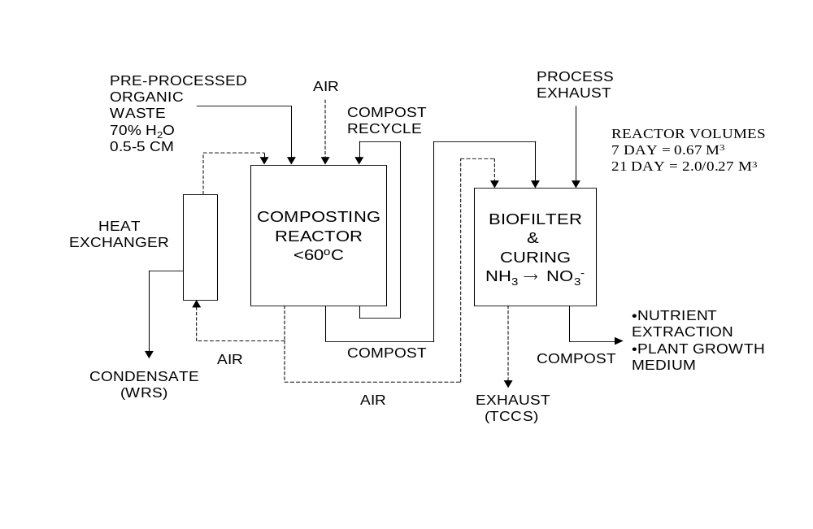
Figure 1. Aerobic Composting - ALS Systems

Advantages Identified for Aerobic Composting:
- Well-established operational theory and experience
- Operate in batch or continuous operation
- Minimal pre-processing requirements
- Near ambient temperature and pressure conditions
- Minimal mass/water requirements
- Resistant to loading and control perturbations
- Low power requirements
- Very effective human and plant pathogen destruction
- Can transform NH₃ to NO₃ (preferred plant N form)
- Effective integrations: Compost can be utilized for plant nutrient recovery, growth medium, and biofilter material

Disadvantages:
- Significant residue production (~50%)
- Large reactor volume requirements – retention time dependent
- Exhaust can contain VOCs, NH₃, NO_{x}, CH₄
- Requires hardware development for material translocation

Microgravity Considerations for Aerobic Composting:
Composting is seen as having limited application in a microgravity environment unless specialized equipment is developed to move material. Also, such an operation would most likely require specialized air-water separation equipment.

Technical Readiness Level of Aerobic Composting:
The current level of development is a TRL of 4. To complete development to a TRL 5 would cost $500,000 and take 2-3 years.

Research and Development Steps Needed to Fully Develop Aerobic Composting Technology:
- Develop and test individual system components
- Integrate composting and biofilter components
- Optimize completed system with appropriate feedstock
- Pathogen, perturbation, and product studies

Anaerobic Composting-Sequential Batch Anaerobic Composting
The high-solids sequential batch anaerobic composting process (SEBACTM)* is a treatment method for conversion of wastes into methane, carbon dioxide, and compost (Figure 2). The process involves maceration and three stages of digestion, which occur sequentially as conversion proceeds. Wastes are macerated by adding enough liquid waste and recycled water to make the water content >65% and passing the mix through a high-solids macerator pump. Once in the digester, the waste is not moved but goes through the various stages of treatment in the same reactor; that is, there are four 0.8 m³ reactors and different stages of treatment at all times. The shredded waste (7 days inventory) is placed into the new reactor. Recirculation of leachate between reactors at the new and final stages inoculates and adds inorganic matter needed for startup. Volatile acids formed during startup are conveyed from the new to the final reactor for conversion. After startup (7 days) the reactor is mature and leachate is recycled upon itself to keep the system moist. For the third stage the final stage is recycled with a new stage for startup. If well insulated, this three-reactor system will operate at 50ºC and affect 60-90% (depends on quality of paper used) conversion of the volatile solids. Note that this system is on a seven-day cycle, i.e., it is fed every 7 days. The waste is collected for 7 days; the digester residence time is 21 days.

After anaerobic digestion is complete (21 days), the remaining solids are aerated with ambient air for 3 (1-7) days to remove lingering reduced compounds and dewatered to 50%. The compost will act as a biofilter to purify the air. The effluent air must be filtered to remove particles, chemicals and microorganisms. The solids will be used for compost and the wastewater will be used for required process recycling and plant growth. The biogas is collected

* Does not imply NASA endorsement.
and stored under pressure. It can be used directly as an energy source; some cleanup may be necessary to remove hydrogen sulfide, if present.

Particle Size (2
–
5 cm)

Add Water to 70%

by weight

Pretreatment

Activated

Stage

11 days days

Complete

Stage

5 da
ys

New

Stage

5
-
days

Aerobic

Reactor

7 days

Ambient

Air

Anaerobic Treatment

Post
-

Treatment

Acids

Biogas

Biogas

Biogas

Dewater

Compost
Inoculum

Digester

Biodegradbles

(Excluding Urine)

Figure 2. High-Solids Sequential Batch Anaerobic Composting Process (SEBACTM)

Advantages Identified for Anaerobic Composting:
- Dry biodegradable feeds without pretreatment
- Produces methane and compost and conserves nutrients
- Does not require oxygen
- Low energy requirements
- Operates at low temperatures and pressures
- Produces minimal microbial biomass
- Sanitizes wastes
- Simple design and operation
- Proven technology

Disadvantages:
- Limited to feed batch operation with design modification
- Long residence time (large reactor)
- Conversion is limited (50-90%; depends on feedstock)
- Effluent solids may require storage or further treatment if not used as compost

Microgravity Considerations for Anaerobic Composting:
High-solids sequential batch anaerobic composting process (SEBACTM) is seen as having limited application in a microgravity environment unless specialized liquid recycle and gas collection equipment are developed.

Technical Readiness Level of Anaerobic Composting:
The current level of development is a TRL of 4. To complete development to a TRL 5 would cost $500,000 and take 2-3 years.

Research and Development Steps Needed to Fully Develop Anaerobic Composting Technology:
- Design and operation for microgravity
- Test proposed feeds
- Test uses of effluent for plant growth and air purification
- Analysis of biogas for micro contaminants

4.2.2.b Continuous Stirred Tank Reactor (CSTR)

Biological processing of ALS solid wastes in a continuous stirred tank reactor (CSTR) utilizes a suspension of aerobic, heterotrophic microorganisms (bacteria, fungi, and microfauna--protists such as ciliates, amoebae, and flagellates, rotifers, nematodes, etc.) to degrade soluble and/or particulate organic materials. This process is most similar to a typical activated sludge process commonly used worldwide to bioprocess dilute solutions of human fecal wastes. It has also be termed suspended growth culture, to differentiate it from fixed-film bioreactors and from ‘solid-state fermentation’ such as composting. For ALS solid waste applications, the CSTR-suspension culture process has been adapted to receive oven- or freeze-dried, milled (> 2 mm dia.) crop residues – leaves, stems, roots, etc. – with typically higher solids loading rates than used for conventional activated sludge sewage treatment systems on Earth. Substrate addition to a CSTR is usually continuous, so maintenance of microbial metabolic activities is relatively constant with time. Compared to composting, this process can operate at vastly accelerated hydraulic retention times (HRT). Soluble organic compounds/monosaccharides and some oligo- and polysaccharides can be completely biodegraded within 3 to 6 hours CSTR retention time. Other polysaccharides, cellulose and hemicelluloses, can be approximately 50% biodegraded within a hydraulic retention time of 8 to 10 days. Very long retention times of 24 to 48 days will give 60 to 80% bioconversion of these polymers to CO₂ and H₂O. The stabilized particulate end product, sludge, consists of microbial cells, extracellular microbial matrix material, and undegraded crop residues and human waste solids. These solids resemble humus and could be used as a soil conditioner or as an input to a composter or combustion apparatus. At longer HRT, a curing stage is probably not needed for use of bioprocessed solids as a soil conditioner.

Integration of CSTR bioprocessing of ALS solid wastes has been well demonstrated. Crop residues from ALS crop growth chambers have been fed into CSTR suspension culture bioreactors. Crop growth chamber condensate water has been used for the water source in these bioreactors. Most important, CSTRs have successfully been used to recycle inorganic nutrients from the crop residues back to hydroponic crop production systems. Over a wide range of hydraulic retention times (1 to 48 days), upwards of 80% of the inorganic nutrient mass contained in crop residues can be recovered in CSTR bioreactor effluent. These effluents have been used successfully at both laboratory (3 month studies) and breadboard (418 days) scales to replenish at least 50% of nutrients for crop hydroponic solutions in a number of integrated studies with crop production (Garland et a. 1993 (20); Mackowiack et al 1996 (21); and Mackowiack et al. 1997 (22)). Bioreactor oxygen has been supplied by O₂ generated in ALS plant growth chambers. CSTR biologically generated CO₂ in the offgas has been recycled back to the plant growth chamber. CSTR filter retentate solids have been tested as a feed source in NASA-funded research on fluidized bed incinerators and other combustion devices. CSTR bioreactor solids have been tested, on a limited basis, as a solid seed germination support/matrix.

Aerobic microbial oxidation of biodegradable organics including soluble and particulate components from crop residues, inedible biomass, paper waste, trash, food remains, and human solid wastes (feces, urine solids, shower/hand wash solids, and sweat) could be processed in a CSTR. Soluble organics can be taken as primarily carbohydrates. Using this assumption the balanced stoichiometric reaction (assuming no net accumulation of microbial biomass is: CH₂O + O₂ → CO₂ + H₂O. Particulate organics can be taken as primarily carbohydrates (high molecular weight polysaccharides, cellulose, hemicellulose). Using this assumption the balanced stoichiometric reaction (assuming no net accumulation of microbial biomass) is: C₁₂H₁₀O₅ + 12 O₂ → 12CO₂ + 5 H₂O.

The additional step involved in degradation of particulate organics involves depolymerization, usually carried out through hydrolysis reactions. The hydrolysis reactions are not oxidation/reduction reactions so their stoichiometry is not important here. The difference between the reactions for soluble and particulate organics can be accounted for kinetically as demonstrated in the rate equations. Additional reactions that are potentially favorable can occur in the reactor. The extent and rate of these reactions depend on environmental conditions (e.g., temperature, dissolved oxygen, pH) and operating parameters (e.g., solids residence time, hydraulic residence time). Microbial oxidation of ammonia by autotrophic nitrifiers can occur, i.e., nitrification (ammonia is released from the degradation of proteins, amino acids, and other nitrogen containing organic compounds): NH₄⁺ + 2 O₂ → NO₃⁻ + H₂O + 2 H+. The actual reaction is carried out in two steps by different classes of nitrifiers. Both steps are carried out with oxygen as the terminal electron acceptor (aerobic reaction). Ammonia oxidizers oxidize ammonia to nitrite; nitrite oxidizers oxidize nitrite to nitrate: NH₄⁺ + 1.5 O₂ → NO₂⁻ + H₂O + 2 H+, and NO₂⁻ + 0.5 O₂ → NO₃⁻. Microbial oxidation of organic compounds with nitrate as the terminal electron acceptor can also occur, i.e., heterotrophic denitrification: CH₂O + 0.8 NO₃⁻ + 0.8 H+→ CO₂ + 1.4 H₂O + 0.4 N₂. Potential undesirable side reactions include the formation of NO and N₂O as gaseous intermediates in the formation of N₂ during denitrification.

Advantages Identified for Continuous Stirred Tank Reactors:
- Previously demonstrated in integrated ALS tests at various scales
- Easily controlled (e.g., change process parameters like temperature, hydraulic & solids retention times)
- Recovers majority of plant nutrients in a form directly compatible with various plant production systems
- Low power requirements
- Near ambient operating conditions
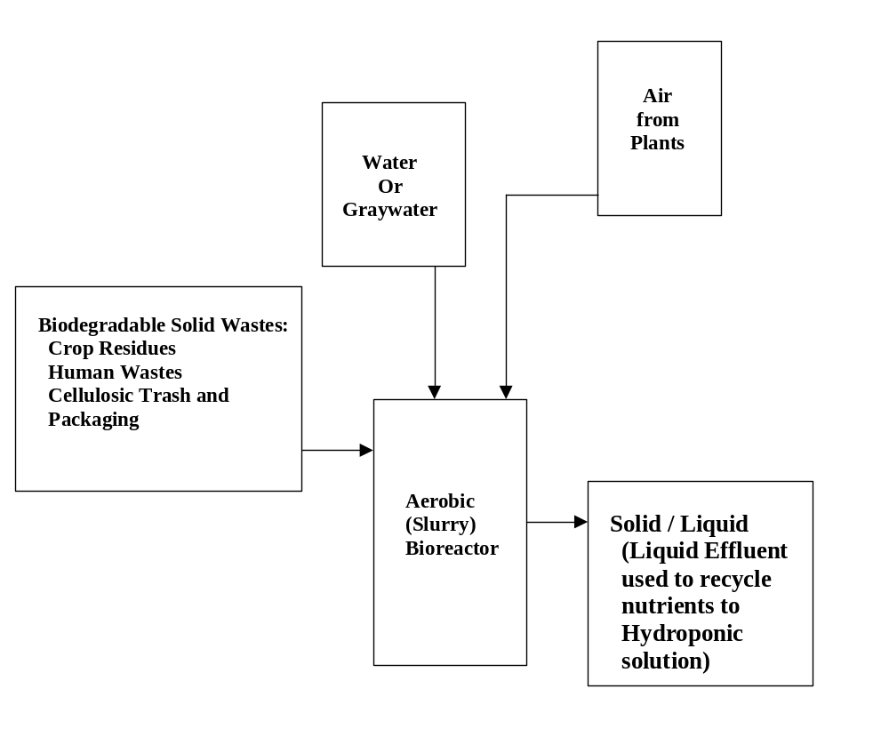
- Not limited by mode of operation, can function in either batch or continuous operational modes.

Figure 3. Continuous Stirred Tank Reactor

Disadvantages:
- Incomplete carbon degradation
- Large volume/mass (water) requirements
- Solid/liquid separation issues at post-harvest
- Some pretreatment (i.e., size reduction) necessary
- Pathogen survival/exposure issues if human waste added

Microgravity Considerations for Continuous Stirred Tank Reactors:
Continuous stirred tank reactor is seen as having limited application in a microgravity environment unless specialized two-phase separation (liquid, gas) equipment is developed.

Technical Readiness Level of Continuous Stirred Tank Reactors:
The current level of development is a TRL of 3. To complete development to a TRL 4 would cost $300,000 and take 2-3 years.

Research and Development Steps Needed to Fully Develop Continuous Stirred Tank Reactor Technology:
- Integration with other ALS components has been well documented for crop residues Other solid wastes – human feces, paper trash, etc., in combination with crop residues, need to be tested and optimized
- Current pre-processing and post-processing components are undesirable, thus need to develop and test better individual components for these steps
- Develop automation (reduce crew interactions) of feeding, harvesting and post-processing
- Pathogen, perturbation, and product studies

4.2.2.c Fixed-film Bioreactor (FFB)

Fixed-film bioreactors (FFBs) are a mature technology with widespread uses. The use of FFBs in space ALS has been proposed and studied. AlliedSignal Corp., in conjunction with the Johnson Space Center, has designed, built, and operated an immobilized cell graywater processor (Nacheff-Benedict et al. 1994 (23); and Edeen et al. 1995 (24). Miller et al. 1991 (25) showed that a packed bed, fixed film bioreactor, operating at a 27-hour retention time, could remove up to 99.8% of phenol in a 100 PPM phenol-laced waste stream. KSC has utilized FFBs for the dual use of total organic carbon (TOC) reduction and nitrification (Strayer et al. (26)). Steady-state TOC reduction and nitrification rates of 80% and 98% respectively, were demonstrated during the experiment. Effluent from the bioreactor was successfully used in a concurrent plant growth experiment.

The major advantage of fixed-film designs is retention of high concentrations of decomposer microbes in the attached biofilms. This advantage would enable the reactor to have lower volume, mass, and probably power requirements than CSTR. Disadvantages relate to diffusion-limited transfer of dissolved oxygen into biofilms with a resulting potential for denitrification, which is undesired in ALS (Stutte 1996 (27)). Also, fixed film bioreactors are generally designed to process soluble, or low particulate waste streams, thus upstream particle/liquid separation would be needed. Because bacterial or greater sized pathogens would be removed by the particle/liquid separation step, operation of the fixed-film bioreactor will not have to be concerned over exposure to these pathogens.

The input to a fixed film bioreactor would have to be soluble, since particulate solids would clog the void volume between attachment media. Thus, this bioreactor would have the limited function of rapidly bioprocessing soluble biodegradable compounds from aqueous extraction (i.e., leached) of crop residues and human solid wastes (generally, carbohydrates -- soluble monosaccharides and polysaccharides/hemicelluloses). The reaction for generalized carbohydrate would be CH₂O + O₂ ↔ CO₂ + H₂O (equation NOT balanced). Significant side reactions would include denitrification, if low oxygen conditions were allowed: NO₃⁻ + CH₂O ↔ N₂ + H₂O + CO₂ (equation NOT balanced), or NO₃⁻ + CH₂O ↔ NH₃ + H₂O + CO₂ is also possible (again, equation NOT balanced).

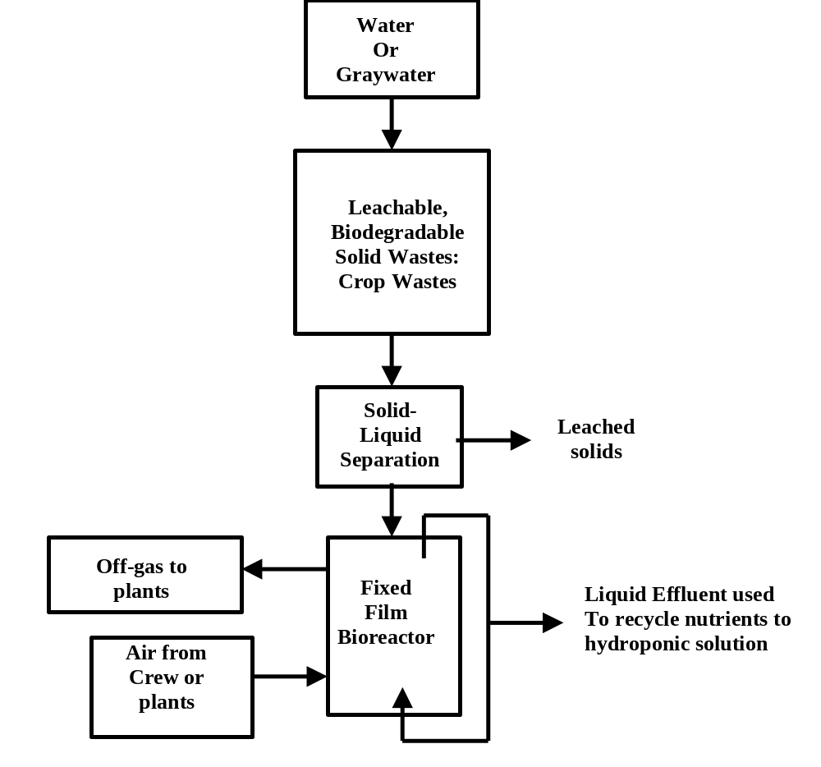

Figure 4. Biological Processing, Fixed-Film Bioreactor

To integrate an FFB in an ALS, crop residues from crop growth chambers would undergo a leachate pretreatment step to produce a liquid stream for input to the fixed-film bioreactor. Crop growth chamber condensate water can be used for water source in fixed-film bioreactors. Filtered (to remove biofilm-sloughed material) FFB effluent would be recycled back to the crop hydroponic production system to replenish crop nutrients. FFB oxygen would be supplied by plant growth chamber generated O₂. Bioreactor-generated CO₂ in the offgas would be cycled back to the plant growth chamber. Filter retentate solids may be used as feed material for composters, fluidized bed incinerators and other combustion devices. Filtration solids may also be useful as a solid seed germination support/matrix.

Advantages Identified for Fixed-Film Bioreactors:
- Recovers the majority of plant nutrients in a form directly compatible with various plant production systems
- Rapid processing rates equate to low mass/volume requirements
- Microbial biofilms are very resistant to stress
- Produces solid stream with low inorganic content
- Minimal size reduction required in preprocessing
- May utilize dual-function bioreactor (solid waste and wastewater)
- Minimal solid-liquid separation (post-harvest)

Disadvantages:
- Some pretreatment (i.e., drying) needed
- Minimal organic degradation (~20%)
- Only addresses one solid waste stream (although it is the largest waste stream)
- Limited to continuous operation modes (but can withstand variable rates)
- Need to develop continual crop residue leaching component

Microgravity Considerations for Fixed-Film Bioreactors (FFB):
FFB is seen as having limited application in a microgravity environment unless specialized two-phase separation (liquid, gas) equipment is developed.

Technical Readiness Level of FFB:
The current level of development is a TRL of 2-3. To complete development to a TRL 4 would cost $300,000 and take 2-3 years.

Research and Development Steps Needed to Fully Develop FFB:
- Develop and test individual system components
- Integrate fixed-film bioreactor components with crop production and crew fecal production inputs – leaching step required and bioreactor effluent and gas stream outputs
- Optimize completed system with appropriate feedstock
- Pathogen, perturbation, and product studies

4.2.2.d Single Cell Protein (SCP) and Paper Manufacture
Lignocellulosic biomass can be used as a feedstock for biologically based processing into other consumable products on board. The feedstream would include paper and inedible biomass but would need to be segregated from human waste due to pathogen concerns.

The workshop participants discussed two major types of bioproducts from this biomass feedstream: fermentation products (e.g., ethanol, organic acids, amino acids) for use as solvents, cleaners or even as food supplements; and single cell protein (SCP) as a highly nutritive food supplement. For the fermentation products, ethanol will be used as the model product; with minor modifications other products could be made (acetic acid, lysine, etc.). It should be noted that these methods as applicable to space missions would not give 100% conversion of biomass into usable products; 50% to 80% conversion of the biomass is a more reasonable target.

The core of the processes is pretreatment, bioconversion, and post-treatment (e.g., separation and concentration). The process equipment could be adapted to these other bioproducts. The processes have been extensively studied on Earth for commodity chemical production with technological success but without a current commercial operation. The challenge for this report and for adaptation into a space mission is to assess and evaluate the wide variety of workable approaches and to optimize the process into a low lift mass, low energy input configuration. Each of the pieces of a terrestrial process would have advantages and disadvantages.

The fermentation ethanol process:
Pretreatment will partially break the biomass and paper into its sugars. Size reduction is required. The two most reliable hydrolysis methods are steam explosion and acid hydrolysis.
Steam explosion is simple but high energy and will require a pressure vessel (high mass and safety). Dilute acid hydrolysis requires acid (0.2M sulfuric) and moderate temperatures.

Conversion:
The bioconversion/fermentor will be a simple, ambient temperature, controlled, mixed vessel. Gas addition and disengagement are the technical challenges in microgravity operation. Oxygen or air will be required for SCP production while significant coproduction of carbon dioxide will occur in either SCP growth or anaerobic ethanol production. This means that a conventional stirred tank is not likely to work. A recycle loop attached to the vessel via pumps can also be used to accomplish the mixing. The gas disengagement may then be accomplished in this sidestream via a membrane system. This adds another unit but all units can be made of low weight plastics capable of withstanding sterilization. Low-level waste heat will be produced in the fermentation. The key element is the microbial catalyst. Several genetically engineered microbes exist to convert both pentose and hexose sugars. Cellulolytic enzymes will also be required to improve the fermentation. These can also be produced microbially from the same feedstocks. This could require a second vessel, but more simply a two-stage fermentation process: 1) a longer slower growth of the cellulolytic microbe or fungi followed by 2) the addition of the rapid fermentative microbe to produce ethanol.

Separation:
On Earth distillation is the standard unit of operation; for space or Mars application, the participants felt that the vacuum resource should be exploited. Vacuum distillation of dilute ethanol or acetic acid solution should allow concentration to 90% purity, which should be sufficient for most mission applications. Pervaporation (vacuum via a membrane) might be used directly with the conversion step to preconcentrate the ethanol and improve the conversion. Freeze drying may be effective for the nutrients or the SCP protein after a simple centrifugation step to remove the bulk water.

SCP production:
The method shown could be performed after the pretreatments discussed above or just after size reduction. There is a proposed three-stage bioconversion: an anaerobic cellulolytic stage to produce a “cleaned solids” and a rich organic aqueous stream that is used to grow yeast for SCP. The clarified liquid effluent from the SCP production will be rich in soluble minerals that can be run through a biodenitrification reaction to yield recycled water rich in fertilizer minerals and nitrate to be used for the crop growth. Again these conversions will require mixed fermentors with gas disengagement. The first two will be high solids. The approaches discussed above should apply here.

The main unit operation is solid/liquid separation or dewatering after the pretreatment, after the anaerobic conversion to separate the recalcitrant solids and after the yeast production to remove the SCP. This could be accomplished via either a simple centrifugal separator or via a membrane system.

Advantages Identified for Single Cell Protein and Paper Manufacture:
- Batch operation as needed
- Process units adaptable to a limited variety of products: ethanol, acetic acid, SCP with mostly just a change in microbial catalysts
- Most fermentation units could be built of plastic
- Provides consumables currently used on mission from planned waste product– ethanol is not the best solvent or degreaser but it is effective and safe. SCP is an effective nutrition supplement
- Generally simple operation and equipment

Disadvantages:
- Requires technical skills (maintenance of several microbial cultures)
- Intermediate analysis of process steams may be limited
- Pretreatment requires some moderate hazard conditions (steam or acid at greater temperatures of 200 °C or 150 °C respectively)
- Incomplete conversion – will still have some wet biosolids to deal with
- Pumping and pumps add energy and weight
- If membranes used, membrane replacement adds to consumables. Some porous steel membranes do work for dewatering.

Recommendations (for both the “ethanol” and the SCP product streams):
- Assessment activity of the technologies
- Assessment of units/ rates/ conversions
- Equipment mass, power, consumable, volumes, added CO₂ loads, etc.
- Potential radiation effects, microgravity on the processes
- Potential uses of the products within the recycle system

Then, some confirmatory integrated experimentation can be done, perhaps using waste biomass from ALS plant growth studies. After that, perhaps innovative approaches will be solicited to improve/solve this base system of biomass to bioproducts.

4.3 Physicochemical Processes

4.3.1 Introduction

Physicochemical (PC) processes are very commonly used to handle waste; combustion is a common example. PC processes can rapidly convert waste to products either completely or partially. PC processes can also produce useful products including carbon dioxide, water, inorganic nutrients, activated carbon, fuels, organic chemicals, solvents, and paper.

Combustion is perhaps the most widely used PC process used to treat waste. Combustion has been used by farmers to burn crop residues in the field in order to rapidly return the nutrients to the soil. Cities and towns commonly use combustion in incinerators to burn waste. Industry uses incinerators to destroy hazardous wastes. Many small-scale incinerators are used to destroy wastes in hospitals, on ships, and in remote locations. Advantages for combustion include rapid conversion of waste to carbon dioxide, water, and inorganic minerals.

PC processes other than incineration can also completely convert the wastes. Supercritical water oxidation oxidizes waste to the same products as combustion, but without the contaminants produced by combustion. Pyrolysis and gasification completely convert complex hydrocarbon wastes to solid, liquid, and solid hydrocarbons that are generally simpler in chemical structure, more easily handled, and free of biological contamination.

Products other than carbon dioxide, water, and minerals can be obtained from wastes by PC processes. Activated carbon, fuel, plastic, paper, and solvents are examples of products produced from waste by commercial PC processes.

A very large number of PC processes could be considered for treating biomass, feces, and the other wastes of the various mission scenarios. However, the main functions of the waste processing system for near term space missions is likely to be stabilization or complete oxidation of waste. Stabilization of waste is needed on missions with little food production, and complete oxidation of biomass is needed for missions where more than about 50% of the food is grown from plants.

A sampling of individual PC technologies was assessed at the workshop. These technologies were: lyophilization, supercritical water oxidation (SCWO), incineration, plasma (oxidation), carbon activation, electrochemical (oxidation), hydrogen peroxide (oxidation), pyrolysis, and gasification. The sampling was fairly representative of oxidation technologies. Stabilization and alternative product formation technologies were not as thoroughly represented. Lyophilization is an example of a stabilization technology. Pyrolysis and activated carbon formation are examples of alternative product producing technologies. A list of the technologies and summaries of some of the key information are shown below in Table 8. Following the table is a discussion of each of the technologies.

Table 8. Summary Information on Physicochemical Technologies Assessed
Technology | Advantage | Disadvantage | Microgravity Concerns | TRL | $ to  TRL 5
Lyophilization | - Useful on near-term missions  - Reclaims water | - Low TRL  - Does not sterilize | - Possible water-gas separation | 2 | $600K
SCWO | - All waste  - Clean Products | - High Temperature (T) and Pressure (P)  - Solids plugging | - Liquid and solid separation issues | 4 | $1-5 M
Incineration | - All wastes  - Hi process conversion | - Flue gas contaminants  - High T | - Fluidized bed not microgravity  - Gas-solids separations | Contin-uous = 4  Batch = 2-3 | Contin-uous=$0  Batch=  $1 M
Plasma | - All wastes  - Fast reaction | - High Power and Temp.  - Scaledown difficult | - Not suited for Scenario 1  - Heat transfer affected | 3-4 | $8-13 M
Carbon Activation | - Useful Product  - Produces | - Complex  - Product gas requires combustion | - Solids transfer  - Avoid gas condensation | 3 | $5M
Electrochemical | - Low T & P  - Scales down well | - Pretreatment reqrd.  - Catalyst Regen. | - Gas-liquid separation | 4 | $5 M
H₂O₂ | - Handles many wastes  - No catalyst, no heater | - Requires preparation or resupply  - Risk of detonation | - Gas-liquid separation  - Injection nozzle redesign for 0 G | 1 | $2-3 M
Pyrolysis | - Many useful products  - Treats many wastes | - Complexity  - CO production | - Solid, liquid, & gas separation | 3 | $500 K
Gasification | - Many useful products  - Minimum NO_{x}, SO₂ | - Low TRL  - High Temp.  - Complex | - Gas-solid separation issues | 1-2 | $600-1000 K

    - Physicochemical Technologies

4.3.2.a Incineration
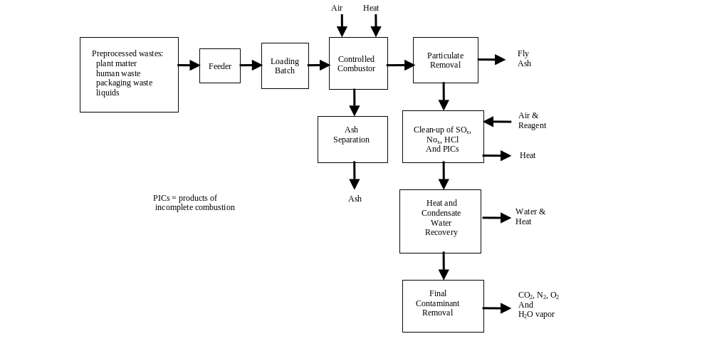

Figure 5. Incineration System

Process Description:
Incineration is a technology capable of completely converting all the waste to carbon dioxide, water, and inorganic ash. Almost any waste can be incinerated. Pretreatment is necessary to dry the waste and prepare the waste for the feed system. The incineration system includes a combustor and a contaminant cleanup system. The combustor does most of the work of oxidation, but both thermodynamics and kinetic limitations result in the formation of contaminants in the flue gas that typically include carbon monoxide, trace hydrocarbons, hydrochloric acid, sulfur dioxide, and nitrogen oxides. Catalytic systems and adsorption beds are typically used to remove the contaminants in the flue gas cleanup system. Figure 5 shows a diagram of the major components of an incinerator.

Incinerators can function in batch or continuous mode. Continuous mode means that the system holds temperature, pressure, and composition constant while continuously feeding a constant flow rate of waste and producing a continuous constant composition output. Batch operation typically means injection of a batch of material into the system with no output until some fixed period of time. During the batch cycle temperatures, pressures, and compositions vary in the system. Feed to batch systems is easier because a continuous and constant flow need not be controlled. Ash collection is also easier and cleaner in batch systems because the ash stays in the combustion chamber, does not pick up contamination while moving through a system, and does not require filtering or other special separation hardware such as a cyclone separator. The disadvantage of batch processing is that the system must be capable of handling the transient production of gases of varying compositions, and the system can be large if batch cycle times are long due to slow heating and cooling. Articles and books that discuss incineration technology are references (28 and 29).

Advantages Identified for Incineration:
- Extensive existing application and development of incineration on Earth
- High conversion rates into end-products
- Destruction of biological hazards in the waste stream
- Potential for energy production

Disadvantages:
- Need to clean up the gas phase contaminants
- Safety issues associated with high temperature
- Requirement of preprocessing, and control issues related to rapid conversion of solid wastes to gases

Microgravity (and Hypogravity) Considerations for Incineration:
Fluidized bed designs are affected but can be designed to operate over a wide range of partial gravity to microgravity. Designs other than fluidized bed might be more appropriate for microgravity. There are phase separations necessary -- vapor/solid and vapor/liquid -- that are microgravity sensitive.

Technical Readiness Level of Incineration:
The current level of development is a TRL of 4 for a continuous gravity dependent fluidized bed incinerator. Other types of batch and continuous incinerators are at TRL 3-4.

Research and Development Steps Needed to Fully Develop Incineration Technology:
- Develop combustion techniques other than fluidized bed for microgravity operation
- Develop improved catalysts for flue gas cleanup
- Integrate biological and incineration technologies. For example, pretreatment of waste using biological approaches to remove a significant amount of alkali will simplify combustion systems and improve lifetime and reliability, while the difficulties of completely and quickly processing organic components of the waste with biological techniques are avoided.
- Optimize the size, weight and power of the incinerator

4.3.2.b Electrochemical Oxidation

Process Description:
Liquid organic material can undergo oxidative degradation at low temperatures when treated in an electrochemical cell. Electrochemical oxidation may be performed directly or indirectly. In direct oxidation, the waste, usually in a soluble form, is oxidized when it comes into direct contact with an anode (positive electrode). Common anode materials include
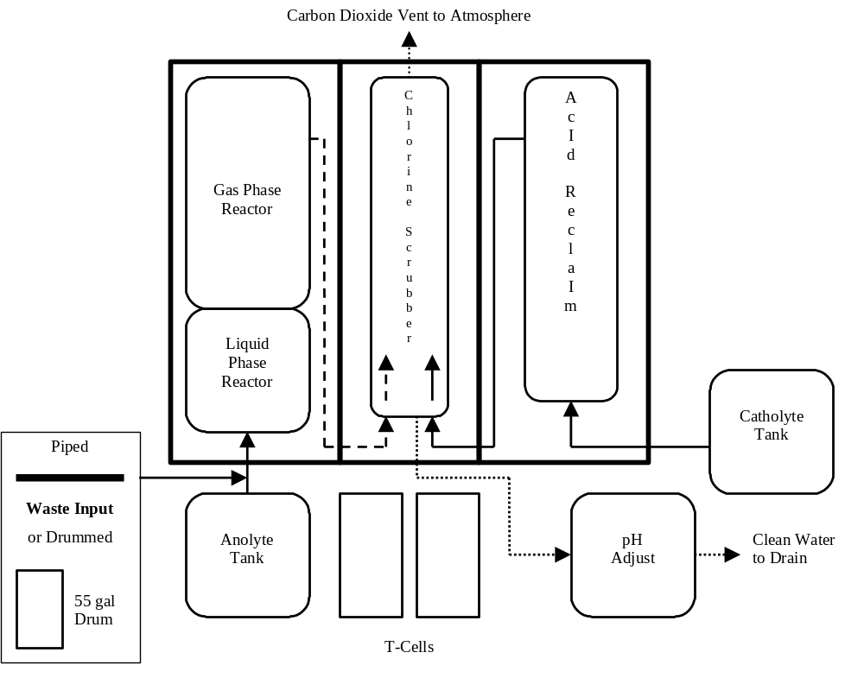

Figure 6. Indirect Electrochemical Oxidation

platinum, lead dioxide, or dimensionally stable anodes (DSAs). Organic wastes are broken down at the interface between the anode surface and the solution, i.e., the reaction is heterogeneous. Corresponding reduction reactions take place at the cathode (negative electrode) where hydrogen is usually formed. The process requires that the organic wastes be placed in an electrolyte, typically an acid or alkaline solution. The indirect process is an attempt to accelerate oxidative degradation. It differs from the direct process in that redox mediators, e.g., Ce³⁺/⁴⁺, V²⁺/³⁺, Ag⁺/²⁺, Fe²⁺/³⁺, Co²⁺/³⁺, are added to the electrolyte. The redox mediators carry out waste oxidation in the bulk electrolyte, i.e., the organic waste oxidation reactions are homogeneous. The reaction occurring at the anode is the regeneration of the redox mediator. Indirect oxidation offers greater flexibility in the types of waste slurry that can be treated. It should be noted that most of the industrial pilot plants have been designed to use the indirect oxidation method. The example given in the Figure 6 is of an indirect process using cerium as the redox couple in a nitric acid electrolyte.

Electrochemical oxidation occurs at low temperature (<100°C), producing gaseous emissions that require reduced clean up compared to thermal treatments (e.g., this method does not generate NO_{x}, SO_{x} or CO). However, emissions can include chlorine gas generated at the anode by the oxidation of chloride ions that could be present in the waste. Hydrogen generated at the cathode can be collected to provide a feedstock for other processes (e.g generate electricity in a fuel cell, etc.). The waste stream feed stock for indirect electrochemical oxidation should be in a slurry form with maximum particle sizes not exceeding 100 microns in diameter. It should be stressed, however, that the exact extent of preprocessing has yet to be determined. The direct oxidation method involves a two-step treatment, where a liquid biomass suspension is first solubilized by a high temperature process in strong alkali bath followed by electrochemical oxidation. Articles and books that discuss electrochemical oxidation technology are references (30 –34).

Advantages Identified for Electrochemical Oxidation:
- Operates at relatively low temperature and pressure
- Production of oxides of C, N, and S is minimal/ negligible
- Process is easily amenable to scale-down for a 4-6 person crew waste

Disadvantages:
- Acid/alakali requirement (expendables)
- Buildup of non-oxidizable inorganic materials
- Gaseous emissions include Cl₂
- Requires consistent and very fine particle waste

Microgravity (and Hypogravity) Considerations for Electrochemical Oxidation:
Microgravity and hypogravity concerns relate to the management of the liquid electrolyte, separation of the gases formed at the anode and cathode from the electrolyte, and gravity independent methods for feeding and distributing the waste slurry into the electrolyte bath.

Technical Readiness Level of Electrochemical Oxidation:
The technology was assessed to be at TRL 4.

Research and Development Steps Needed to Fully Develop Electrochemical Oxidation Technology:
- Develop catalytic oxidation methods and effluent treatments for combustion gases
- Optimize reactor materials, electrode materials, and membranes

4.3.2.c Pyrolysis

Process Description:
Pyrolysis is a process that breaks down wastes by heating them to high temperatures without oxygen addition. By controlling the temperature, the rate of heating, and the removal products, it is possible to obtain a variety of products. The process is outlined in Figure 7.

Pyrolysis typically produces gas, liquid, and char. The amount of liquid can be controlled from a maximum amount characteristic of the waste down to zero. The char contains carbon, nitrogen, and inorganic ash. By varying the method of pyrolysis the amounts and kinds of gaseous, liquid, and char products can be selected from the wide variety of potential products as shown in Figure 7. These products are char, hydrocarbon liquid and hydrocarbon gas.

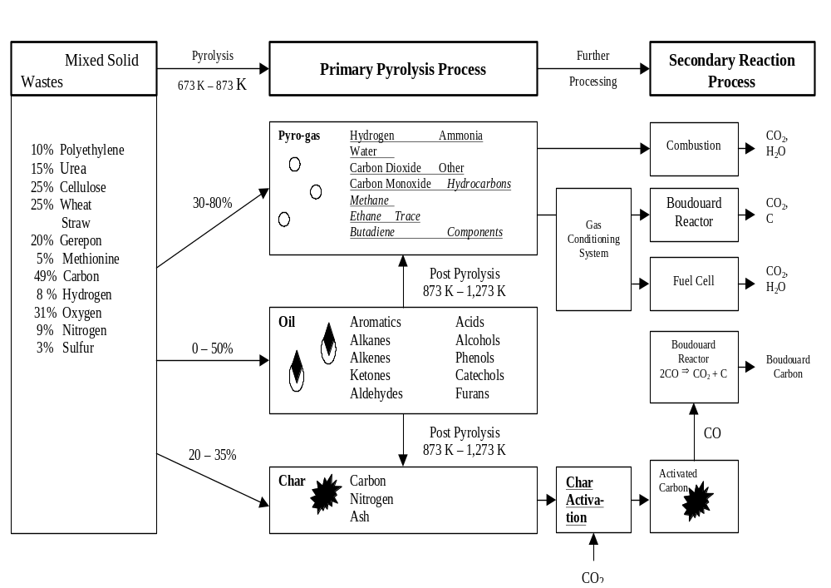
Figure 7. Pyrolysis Processing Schematic
Advantages Identified for Pyrolysis:
- Flexibility and adaptability with regard to feedstock
- Simplicity, low mass, variety of potentially useful products
- Reduction of waste volume

Disadvantages:
  - Complex product stream that may not have readily identifiable uses
  - Microgravity processing sensitivity
  - High temperature operation
  - Complex processing scheme

Microgravity (and Hypogravity) Considerations for Pyrolysis:
Solid, liquid, and gas separation steps are necessary.

Technical Readiness Level of Pyrolysis:
Currently the technology is at TRL 3. Cost is about $500,000 to get to TRL 5.

Research and Development Steps Needed to Fully Develop Pyrolysis Technology:
- Develop pyrolytic systems that are specific to biomass and feces
- Develop microgravity phase separations that are specific to the pyrolysis process
- Integrate the pyrolysis with other waste treatment technology, such as incineration if that is the appropriate overall system design

4.3.2.d Gasification

Gasifier

Energy
Converter
High
Temperature
Syn Gas
Low
Temperature
Syn Gas

Heat
Recovey
and
Purifier
Energy Recirculation (1)
Energy
Recirculation
(2)

Energy
Recirculation
(3)

Wastes
Effluents
Energy
Output
Energy
Output

Ash
and Slag

Figure 8. High Temperature Gasification

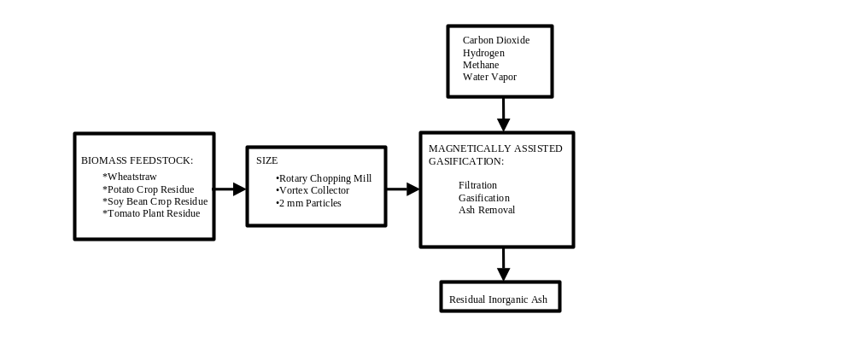
Gasification is a process that converts any carbon-containing material into a synthesis gas. Syngas is composed primarily of carbon monoxide and hydrogen. The product gases can be used as a fuel to generate electricity or steam or as a basic chemical feedstock for the petrochemical and refining industries (see Figure 8). Typical raw materials used in gasification are coal, petroleum-based materials, or materials that would otherwise be disposed of as waste. The input material is prepared and fed to the gasifier in either dry or slurried form. The feedstock reacts in the gasifier with steam and oxygen at high temperature and pressure in a reducing (oxygen starved) atmosphere. This produces synthesis gas, or syngas, made up primarily of carbon monoxide and hydrogen (more than 85% by volume) and smaller quantities of carbon dioxide and methane. The high temperature in the gasifier converts the inorganic materials in the feedstock (such as ash and metals) into a vitrified slag that is usually very safe and stable for storage. Gas treatment facilities refine the raw gas using proven commercial technologies that are an integral part of the gasification plant. Trace elements or other impurities are removed from the syngas and are either recirculated to the gasifier or recovered. Sulfur is recovered either in its elemental form or as sulfuric acid.

Figure 9. Magnetically Assisted Gasification

A specific gasification reactor design (see Figure 9) was described that addresses the needs of this system in microgravity environments and offers a way of presenting concentrated solids to the reactor. A magnetically assisted method was described which consists of three steps: (1) filtration of the suspended particulate materials from an aqueous slurry using a bed of granular ferromagnetic filtration media; (2) destruction of the entrapped particulate matter by thermal decomposition; and (3) removal and collection of the by product inorganic ash from the ferromagnetic media by fluidization in the reverse direction. A desirable feature of this design is that it enables a high solids loading to be presented to the reactor even using low solids loading streams as the input feed. This is because the filtration step concentrates the solids. Zero-g stabilization of a fluidized bed had been demonstrated in KC-135 flights. Reference (35) discusses gasification processes.

Advantages Identified for Gasification:
- Ability to treat all the waste constituents of the waste model with almost 100% conversion of waste to products
- Little size reduction or preprocessing
- Potential for the recovery of waste heat and valuable chemicals
- Compact, reliable, and safe to operate

Disadvantages:
- Although gasification is well developed commercially, it is at a low level of development for the specific NASA applications, which implies more expense to raise the TRL level.
- This is a high temperature process.
- This is a complex process.

Technical Readiness Level of Gasification:
The method was rated at TRL 1-2. Cost to TRL 5 was estimated at the workshop to be $ 0.6-1 million. Considering the low level of TRL, the cost is more likely to be on the higher end.

Research and Development Steps Needed to Fully Develop Gasification Technology:
- Gasification is a general area of technology. This technology needs to be developed to apply to a specific mission scenario.
- Breadboard prototypes need to be fabricated and tested.
- The system needs to be optimized.
- The system needs to be prepared for integration into an overall life support system.

4.3.2.d Supercritical Water Oxidation (SCWO)
Supercritical water oxidation (SCWO) is a method for oxidizing substances in water at temperatures and pressures above the critical point for water. At temperatures and pressures above the critical point, pure water exists as a single fluid phase; there are no separate liquid and vapor phases. Gases and most liquid organics (and some solid organics) are completely miscible with water above water’s critical point. As a result the mass transfer limitations on reaction rates caused by the need for oxygen to diffuse from a vapor phase to a liquid water phase do not occur in supercritical water systems. This allows for a high level of destruction of the wastes.

Figure 10 shows a diagram of a continuous SCWO processor that was built for NASA. Dual piston pumps accomplish pumping of feed. Sticky solids are handled via a two-stage reactor system. The first reactor is a vessel reactor wherein sticky solids adhere to a reactor insert and build up over time until sufficient accumulation has occurred to require reactor shutdown and cleanout. The second reactor is a tubular reactor to provide residence time for reaction completion. Energy efficiency is achieved via two external recuperative heat exchangers.

Figure 11 shows a concept for a SCWO system with a single tubular reactor. In this conceptual system accumulation of solids in the reactor would be avoided by control of conditions and flow rates in the reactor. The reactor would also be designed to achieve energy recovery via a tube in tube countercurrent flow scheme.

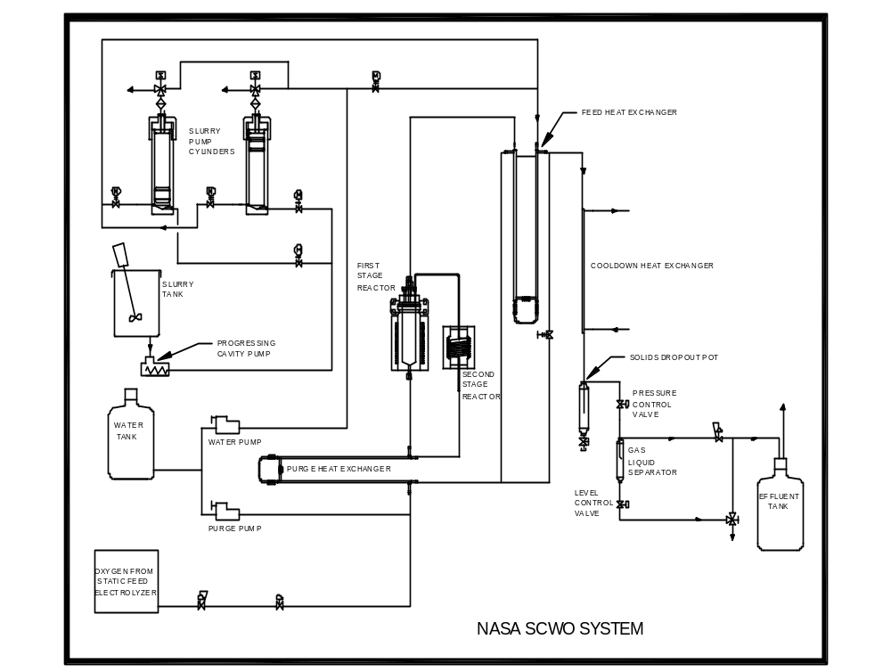

Figure 10. Diagram of Experimental NASA SCWO System
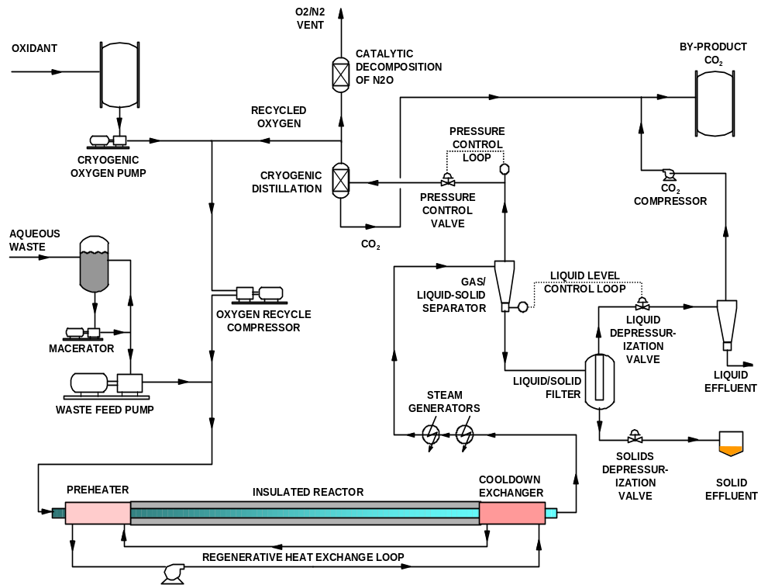

Figure 11. Concept for an Energy Recuperative SCWO Tubular Reactor System

Not all materials are miscible with water above its critical point. Solid organics such as biomass (plant/fecal material) tend to form solid residual carbonaceous particles in supercritical water, and these particles are more slowly oxidized than the dissolved organics. Pumping slurries of biomass in water into a high-pressure reactor is also a technological challenge. Inorganics such sodium chloride are not dissolved in supercritical water. Sodium chloride tends to form sticky particles that can clog tubular reactors. Pretreatment and pumping of biomass and the handling of sticky inorganic salts are some of the primary difficulties associated with SCWO. Articles and books that discuss SCWO technology are references (36-41).

Advantages Identified for Supercritical Water Oxidation:
- Complete oxidation of the carbonaceous material
- Process temperature and pressure variation could potentially yield other useful intermediate products

Disadvantages:
- High temperature and pressure of SCWO is a safety concern (the nominal operating conditions are about 870^{O}K and 24,000 kPa)
- The stored energy in the hot compressed gas can be hazardous in the case of a reactor failure
- Precautions such as pressure relief, venting, monitoring, and shielding must be taken to avoid overly rapid reactions, high temperatures, and hardware corrosion

Technical Readiness Level of Supercritical Water Oxidation:
SCWO is at about a TRL 4 level of development. Development to TRL 5 would cost about $1,000,000 to $5,000,000.

Microgravity Considerations of Supercritical Water Oxidation:
There are liquid/gas and liquid/solid phase separation that will be affected by microgravity.

Research and Development Steps Needed to Fully Develop Supercritical Water Oxidation Technology:
- Develop pretreatment systems to reliably deliver slurries to the SCWO system
- Conduct long operation reliability testing
- Develop improved methods of preventing and removing reactor scaling
- Optimize the energy consumption and rejection

4.3.2.e Lyophilization

Lyophilization (freeze drying) is a process for water recovery and stabilization of waste. Typically the waste is frozen, a high vacuum is pulled on the waste, heat energy is slowly supplied to the waste while holding vacuum, and the water vapor produced is condensed and recovered.

Figure 12 shows a concept for a lyophilization process for water recovery from feces. In this concept a tubular freeze dryer is inserted into the feces collection device of the commode, the feces are frozen, vacuum and heat are applied, and eventually the dry feces and collected water are removed separately.

Although lyophilization is a well-developed technology for commercial purposes (such as production of instant coffee), the technology has not been applied to waste treatment. Articles and books that discuss lyophylization technology are references (42-44).

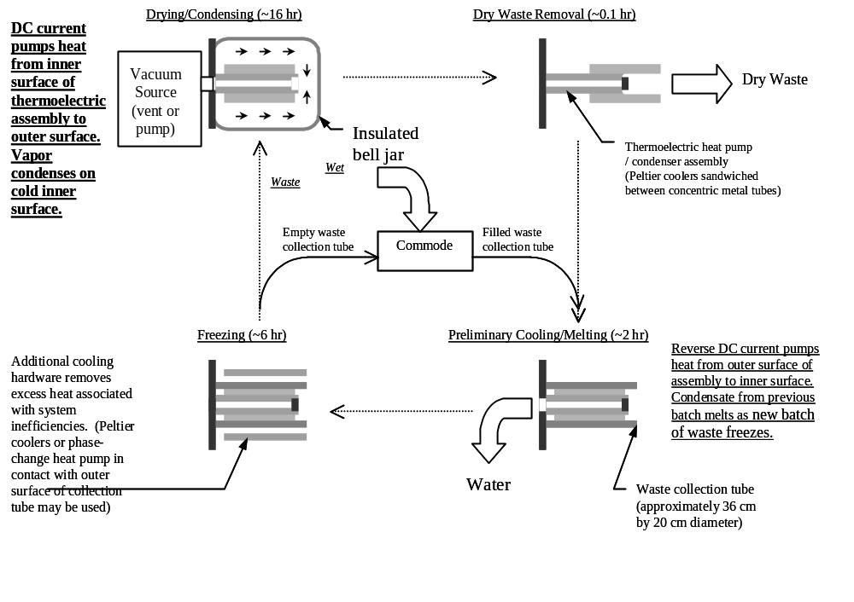

Figure 12. Lyophilization System for Freeze Drying
Advantages Identified for Lyophilization:
- Could be applied to near term missions in which the major objective of waste processing is to recover water and to stabilize waste (feces)
- Recovers water

Disadvantages:
- Dehydrated fecal material is not sterilized
- Requires energy to recover the water as compared to wet storage of feces

Microgravity Considerations for Lyophilization:
The process includes water-gas separation that may be a microgravity issue.

Technical Readiness Level of Lyophilization:
Current TRL is 2 and estimated cost to advance to TRL 5 is less than $1,000,000.

Research and Development Steps Needed to Fully Develop Lyophilization Technology:
- Develop a system that integrates with the BIO-Plex vacuum transfer of feces and centralized treatment
- Optimize the systems with respect to energy usage
- Develop a means for microgravity separation of water recovered by the system

4.3.2.f Hydrogen Peroxide Oxidation

Process Description:
Hydrogen peroxide (H₂O₂) is a chemical oxidant that is a clear liquid, slightly denser than water. It is infinitely soluble in water. Typically, it is dissolved in water for the direct oxidation of soluble organics in aqueous waste streams. Its oxidation efficiency can be enhanced when it is used in combination with an iron salt to form Fenton’s reagent. It is also used as a concentrated oxygen source. The H₂O₂ oxidation method discussed is unique because it involves peroxide for decomposition of solid materials. The method relies on a highly concentrated (i.e., 100%) H₂O₂ solution. The method depicted in Figure 13 shows concentrated peroxide being supplied from a storage tank. The concentrate is injected into a reactor vessel, where it reacts spontaneously on contact with the waste material in what is described as a “controlled burning process.” Energy released during the reaction can raise the temperatures inside the chamber to over 1300 °C. Provision is made for controlling the rate of injection, through a feedback mechanism from a pressure transducer, to prevent an overly violent reaction. The wastes themselves act to catalyze the reaction, eliminating a requirement for additional catalysts or fuels.

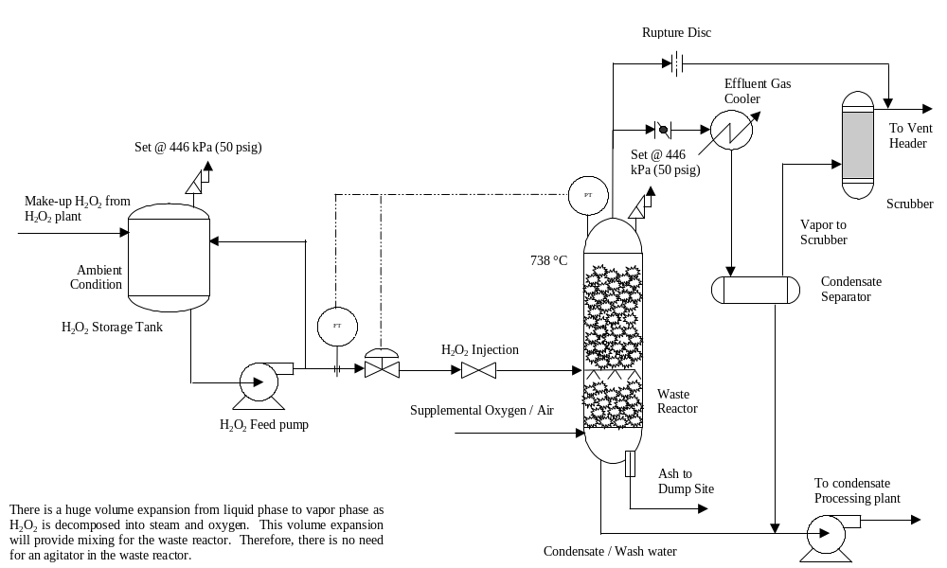
Figure 13. Hydrogen Peroxide Oxidation

Expansion of the peroxide and gases being released during the reaction provides excellent mixing so no agitator is required. A provision is made to introduce supplemental air or oxygen into the chamber to sustain combustion once it has been initiated by the peroxide injection step.

Advantages Identified for Hydrogen Peroxide Oxidation:
- Complete oxidation of organics
- Exothermic reaction (could potentially use the heat)

Disadvantages:
- Requires supply of raw materials (H₂O₂)
- Reactants are corrosive

Technical Readiness Level of Hydrogen Peroxide Oxidation:
The method was assessed as TRL 1. The basic mechanisms of controlled injection, reactor mixing, and safe operation have yet to be established in a 1 g environment. Little is known about the types of waste that could be treated by the method. The emission composition from the NASA waste feed has not been determined. Projected costs to reach a TRL of 5 are $2-3 million, spread over two years.

Research and Development Steps Needed to Fully Develop Hydrogen Peroxide Oxidation Technology:
- Develop the basic mechanisms of controlled injection, reactor mixing, and safe operation
- Design, build and test breadboard hardware for application to life support wastes
- Optimize the breadboard systems

4.3.2.g Plasma Arc Technology

Process Description:
Plasma arc incineration (Figure 14) uses extremely high temperatures in an oxygen-starved environment to completely decompose waste material into very simple molecules. The extreme heat and lack of oxygen results in pyrolysis of the input waste material. The end result is a combustible gas and an inert vitrified slag. The heat source is a plasma arc torch, a device that produces a very high temperature (between 3,000 and 8,000 °C) plasma gas. The gasification process takes place in a refractory-lined vessel, which is preheated before processing commences. Within the vessel, an optimal, high-temperature processing zone is created through which all the waste material is fed. The reactor vessel operates at normal atmospheric pressure.

The chemical composition of different input waste materials will result in different gas and slag characteristics. Waste materials such as biomass, liquid wastes, and organic wastes will produce little slag since virtually all of the waste can be gasified. Volume reduction and destruction efficiency is a significant feature of this method. For example, volume reduction in excess of 250:1 is typical for as-received municipal waste. This destruction efficiency contrasts with incineration, which can leave significant amounts of unprocessed material in the ash. The resulting slag has a leachate toxicity several orders of magnitude lower than those specified in current landfill regulations. The residual solids have safe storage characteristics.

The method’s potential to be configured for low environmental emission characteristics was recognized. The method is a batch process. The team devised an operating procedure where the waste is accumulated for two weeks, followed by a 3-5 hour period of operation. During operation, the method will be power intensive and there will be a sizeable heat load that must be rejected. The method can be operated by one person and is easy to start up and shut down. Articles and books that discuss plasma arc technology are references (45-47).

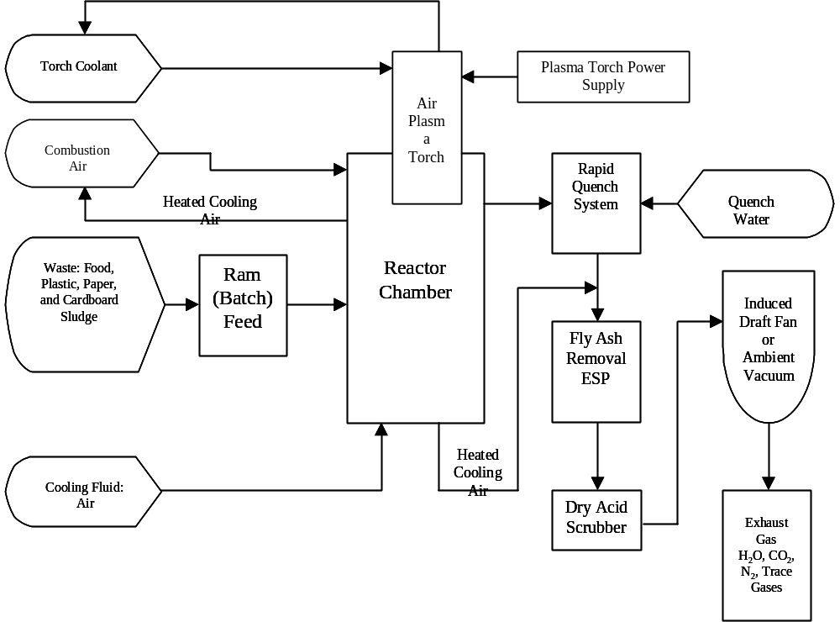

Figure 14. Plasma Arc Incineration

Advantages Identified for Plasma Arc Technology:
- Accommodates virtually any input waste material, often in an as-received condition
- Provides for virtually complete gasification of all volatiles in the source material
- Non-combustible materials, including glass and metal, are reduced to an inert slag
- Process is independent of input moisture content; therefore, there is no loss of destruction efficiency if the moisture content varies
- Product gas is high in hydrogen and carbon monoxide, with traces of methane, acetylene, and ethylene; therefore, it can be combusted very efficiently resulting in carbon dioxide, nitrogen, and water vapor as the only gaseous exhaust

Disadvantages:
- The method is untested in a space mission environment, and there is uncertainty regarding changes in heat transfer characteristics for the device
- The mechanisms for feeding waste to the high temperature reaction zone may have to be modified for microgravity operations
- Electromagnetic interference must be considered when operating the plasma
arc within a space habitat

- Scalability of the method was identified as a concern. Systems used presently are substantially larger than would be needed for space mission applications.

Technical Readiness Level of Plasma Arc Technology:
Mobile and transportable plasma systems are in use (reference) and may be adaptable to this need. A TRL of 3-4 was assigned to this method. Costs to advance to TRL 5 were estimated at $8-13 million.

Research and Development Steps Needed to Fully Develop Plasma Arc Technology:
- Scalability of the system to handle the waste stream generated as mentioned in the different mission scenarios
- Development of a Breadboard system specific to NASA requirements
- Optimization of the breadboard system
- Development and testing of an advanced system for integrated testing with other life support systems

4.3.2.h Carbon Activation

Process Description:
Waste materials do not always have to be converted to carbon dioxide and water. Biomass waste can be converted to activated carbon. Activated carbon can be used to remove contaminants from incinerator flue gas, cabin air in the trace contaminant control system, and water in the water treatment system. Although there are a number of alternative ways of converting biomass to activated carbon, the process presented at the workshop is a well-developed process.

MBR Research’s proprietary thermal rapid activation (TRAC™)* technology processes cellulose-based char pellets into activated carbon. Typical activation times are 10 minutes, compared to 6-8 hours in conventional thermal activation, and the result is a pelletized product with BET (Brunauer, Emmet, and Teller adsorption isotherm) surface area of 600 m²/g to 1,300 m²/g, with a relatively high proportion of mesopores (pore diameters between 20 and 200 Angstrom). A U.S. Patent was applied for in May 1999.

The complete processing cycle incorporates (1) feedstock pelletization, (2) charring, (3) grinding of the char, (4) extrusion of the char with a plasticizer/binder to form green pellets, (5) curing of these char pellets, and, finally, (6) thermal activation under CO₂. The process elements are at near-atmospheric pressure and elevated temperatures.

Of the foregoing processes, pelletization, grinding, and extrusion involve mechanical energy and are quite quantifiable. Pyrolysis, char pellet curing, and activation all require heat input, yet produce synthesis gas (of various composition and calorific content) with energy beyond the thermal requirements of the system. Note that processing on the order of 15 kg/day of waste by the crew, as described in NASA publication, would entail an overall batch process where the mechanical power requirements could be readily satisfied by crewmembers in exercise mode.

Figure 15 shows a diagram of the system for producing activated carbon from biomass. The diagram shows the steps, including pelletization, pyrolysis, extrusion, carbonization, and activation. Articles and books that discuss Carbon activation technology are references (48-50).

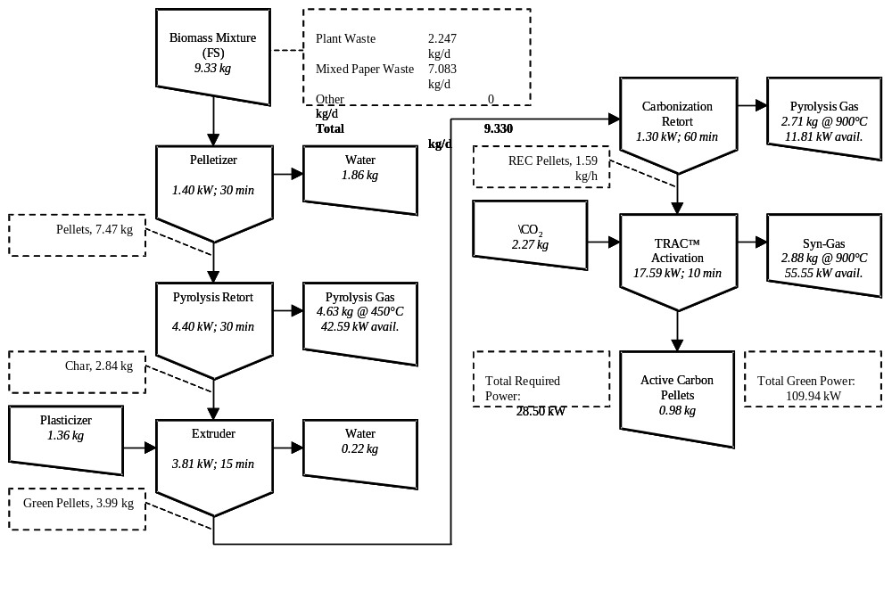
- Does not imply NASA endorsement.

Figure 15. Production of Activated Carbon from Biomass

Advantage Identified for Carbon Activation:
- Production of a useful product from the waste

Disadvantages:
- High temperatures
- Complex process
- Production of by-product gases that require combustion

Microgravity Considerations for Carbon Activation:
Solids separation can be a microgravity problem. There is a need to avoid gas condensation in order to avoid gas-liquid separations.

Technical Readiness Level of Carbon Activation:
Current TRL is 3 and cost to TRL5 is about $5 million for the process outlined above. However the process outlined above is designed to produce commercial grade activated carbon. A useful but perhaps slightly less active grade of activated carbon could be produced by a much simpler process that would cost about $1 million to develop to TRL 5.

Research and Development Steps Needed to Fully Develop Carbon Activation Technology:
- Develop a simpler process
- Optimize process to produce good quality activated carbon
- Integrate process with other life support hardware. The activated carbon can be used for incineration flue gas cleanup, trace contaminant control, and water cleanup.

4.4 Conclusions

Seven of the nine methods evaluated were thermal waste treatment processes. A significant advantage of the thermal methods is that they are very flexible in the types of input waste that they can treat. Unfavorable heat rejection characteristics are a disadvantage of each of these methods. Other than SCWO, all of the thermal methods require cleanup of the gaseous combustion byproducts. The working group recognized that considerable information on the cleanup of emissions could be available from operators of the various treatment processes both in Europe and in the United States. Many of the thermal processes evaluated by the group are used commercially for hazardous and municipal waste treatment and have had to implement techniques to meet stringent air quality regulations prior to getting a permit to operate. This database is a significant resource for future developments. The two low-temperature processes (electrochemical oxidation and lyophilization) have reduced heat rejection penalties but are limited in the types of input feed they can accommodate. For all the technologies evaluated, there was limited information available related to reliability and maintenance of systems specific to NASA applications.

5. SUMMARY ANALYSIS

5.1 Feedstock Requirements and Process Characteristics

The first series of tables presents the feedstock requirements and process characteristics for the various waste processing technologies. Specifically, these tables list the process feed rate in terms of dry waste mass per day, the process type, whether the process is batch or continuous, any associated preprocessing requirements, necessary catalysts or organisms, the composition of the waste stream, and the percentage of the input waste stream converted to final products.

Pre- and post-processing technologies, as found in Table 9, generally accept waste materials smaller than a certain size and of specified composition. Any waste stream will likely require some form of size reduction before passing to other waste processing technologies, including other pre- and post-processing technologies. Thus, to facilitate size reduction, hard and incompressible wastes, such as glass, metals, and some composite materials, should be removed from the process stream, possibly when such waste is generated. With the exception of transport by aqueous slurries, pre- and post-processing technologies require particle sizes on the order of a centimeter.

Biological processes are characterized in Table 10. Biological processes address only biodegradable waste streams and require particles diameters less than several centimeters down to less than a millimeter. All employ microbes as a processing agent, but do not require a catalyst. Finally, these microbial processes convert about a third to two-thirds of the input waste stream to gaseous products in the short term (<4 weeks) with the remaining wastes being a stabilized organic material, which biodegrades more slowly. This compost (humic material) can be recycled within in plant growing medium.

Physicochemical processes, Table 11, generally convert nearly the entire input waste stream to products. Physicochemical processes handle most waste stream components except metals and can accommodate very high feed rates. Specifically, while the biological processes will likely run continuously, most physicochemical processes are most amenable to higher feed rates with batch-mode operation for near-term missions. For larger facilities, continuous-mode operation for physicochemical technologies is likely. Finally, physicochemical technologies often use catalysts within the primary process and to clean effluent streams.
Table 9. Feedstock Requirements and Process Characteristics for Pre- and Post-Processing Waste Technologies
Name | 1App.  Acc.  No. | Solid Waste Feed Rate [kg/d] | Process Type 3 | Preprocessing  Issues | Catalyst / Organisms | Waste  Stream  Composition | Percentage of Waste Converted  [Wt%]
Collection, Transport, Vacuum Waste Collection | PPP  01 | -- | Batch | Particle diameter < 4 cm;  Feed as slurry | n/a | Human fecal material | n/a
Bulk Compaction | PPP  02 | 0.1 m³  per batch | Batch | Particle diameter < 15 cm;  No incompressible materials | n/a | Any | n/a
Dry Size Reduction and Particle Size Control | PPP  03 | Variable | Either | Remove over-sized or stringy materials; Source separate hazardous materials and metals | n/a | Any except glass and metals | n/a
Drying (Forced Air Thermal Convection, Forced Air, Thermal Vacuum, and Freeze Vacuum) | PPP  04 | Variable | Depends; Batch or Continuous | Particle size reduction is preferable | n/a | Any | n/a
Pneumatic Transport - Dry Material | PPP  05 | ~112 | Either | Particle diameter < 1 cm;  Moisture content < 60% | n/a | Any | n/a
Screw Conveyor | PPP  06 | ~11² | Either | Particle diameter < 1 cm | n/a | Any | n/a
Slurry Pumping | PPP  07 | ~11² | Either | Particle diameter < 1 mm;  Feed stream < 5 wt% solids | n/a | Any | n/a
Solid/Liquid Blending; Slurrying (50-95% Water) | PPP  08 | Variable | Either | Size reduction | n/a | Any except glass and metals | n/a

Table 9 cont. Feedstock Requirements and Process Characteristics for Pre- and Post-Processing Waste Technologies
Name | App.  Acc.  No. | Solid Waste Feed Rate [kg/d] | Process Type 3 | Preprocessing  Issues | Catalyst / Organisms | Waste  Stream  Composition | Percentage of Waste Converted  [Wt%]
Solid/Solid Blending | PPP  09 | Variable | Either | Size reduction | n/a | Any except glass and metals | n/a
Storage4 | PPP  10 | ~11 ² | Either | Biological / chemical waste stabilization | n/a | Any | n/a
Wet Size Reduction and Particle Size Control | PPP  11 | Variable | Either | Remove over-sized or stringy materials; Source separate hazardous materials and metals | n/a | Any except glass and metals | 3n/a
Table 10. Feedstock Requirements and Process Characteristics for Biological Waste Technologies
Name | App.  Acc.  No. | Solid Waste Feed Rate [kg/d] | Process Type | Preprocessing  Issues | Catalyst / Organisms | Waste  Stream  Composition | Percentage of Waste Converted  [Wt%]
Aerobic Completely Mixed (Slurry) Reactor | B01 | 8.13 | Either | Feed 40 to 70% moisture;  Particle diameter < 0.2 cm | None | Biodegradable wastes only | 25-80
Composting - Plant Nutrient Extraction Variant – 7 Day Residence Time (No Curing Stage/Biofilter) | B02 | 8.49  40.75 5 | Either | Particle diameter 0.5 to 5 cm;  Feed moisture content ~70% | Self-sustaining biological culture | Biodegradable wastes only | 35
Composting - Plant Nutrient Extraction Variant - 21 Day Residence Time | B03 | 8.49  40.75 ⁵ | Either | Particle diameter 0.5 to 5 cm;  Feed moisture content ~70% | Self-sustaining biological culture | Biodegradable wastes only | 50-60
Fixed-Film Bioreactor | B04 | 6.27 | Either | Dry feedstock;  Particle diameter < 0.2 cm;  Leach biodegradable wastes | Self-sustaining biological culture | Biodegradable soluble wastes only | 75
High-Solids Leach Bed  Anaerobic Digestion | B05 | 8.1 | Batch | Particle diameter ~2.5 cm  Feed moisture content ~70%  Remove human urine | An initial microbial culture | Biodegradable wastes only | 60-90
Paper and Biomass to Products, e.g., ethanol | B06 | 6.6 | Batch | Particle diameter < 1 cm;  Remove biotoxins and human waste products | 0.001 g of microbes per kg of waste | Biodegradable wastes only | 40
Single Cell Protein Production and Crop Nutrient Recovery | B07 | 5.5 | 5-- | Feed particle size reduction;  Remove biotoxins;  Nitrogen: Feed < 0.05 Wt% N | 0.001 g of microbes per kg of waste | Biodegradable wastes only | 33
Table 11. Feedstock Requirements and Process Characteristics for Physicochemical Waste Technologies
Name | App.  Acc.  No. | Solid Waste Feed Rate [kg/d] | Process Type | Preprocessing  Issues | Catalyst / Organisms | Waste  Stream  Composition | Percentage of Waste Converted  [Wt%]
Activated Carbon and Energy from Cellulosic Waste By-Products using the TRAC™ Process | PC01 | 9.33 ² | Batch | Particle size reduction and  waste stream dewatering | Proprietary; Not consumed | Cellulosic wastes only | --
Batch Incineration | PC02 | ~11 ² | Batch | Minimize chlorinated wastes | For oxidation & reduction 6 | Any except volatile metals | 99
Continuous Incineration | PC03 | ~11 ² | Continuous | Minimize chlorinated wastes;  Particle diameter < 1 cm for fluidized bed combustion | For oxidation & reduction 6 | Any except volatile metals | >99
High Temperature Gasification | PC04 | ~11 ² | Either | Smaller particles are preferred | None | Any | >99
Indirect Electrochemical Oxidation | PC05 | ~11 ² | Either | Waste size < 10 µm (preferred);  Feedstock in aqueous slurry | A redox couple | Any | 60-95
Lyophilization (Freeze Drying) | PC06 | 6.0 | Batch | None | None | Any moist sludge | 90 7
Magnetically Assisted Gasification (MAG) | PC07 | 12.0 | Either | Feedstock in aqueous slurry; Concentration may be dilute | -- | Any except metals | --

Table 11 cont. Feedstock Requirements and Process Characteristics for Physicochemical Waste Technologies
Name | App.  Acc.  No. | Solid Waste Feed Rate [kg/d] | Process Type | Preprocessing  Issues | Catalyst/ Organisms | Waste  Stream  Composition | Percentage of Waste Converted  [Wt%]
Plasma Arc Thermal Destruction | PC09 | ~11 ² | Batch | Dewatering of moist wastes  is preferred | None | Any except metals | 84-98
Pyrolysis in Sub-Critical Water | PC10 | ~11 ² | Continuous | Feed with 40% solid content | None | Unknown | 99
Pyrolysis | PC11 | 6-24 | Batch | None | SEROGEL | Organic waste | 100
Supercritical Water Oxidation (SCWO) | PC12 | 10.9 | Either | Particle diameter < 100 µm;  Feed stream 4-15 wt% solids; Organic chlorides < 1.5 wt% dry | Agent for N₂O decomposition | Any  (except metal) | 100

5.2 Process Parameters and Equipment Attributes

The second series of tables provides the ranges for the characteristic process parameters and overall values for the physical requirements associated with each technology. The temperature and pressure ranges refer to the range of values normally associated within any of a technology’s processors. The residence time reflects the range within the overall process as recorded on the workshop data form. Mass, power, volume, cooling and logistics values define the physical dimensions and required utilities for each technology.

Pre- and post-processing technologies, presented in Table 12, generally operate at ambient conditions with residence times of less than an hour. Generally, pre- and post-processing technologies require little power or cooling and their primary cost is mass. Unfortunately, as noted above, such technologies do not convert any waste products to useful life support system commodities but simply alter the physical size or moisture content.

Biological processes, given in Table 13, generally operate at near-ambient temperatures and pressures, although residence times are longer, often ranging from a half-week up to three weeks. Physically, biological processes require little power or cooling per processor volume. Unfortunately, biological processors are usually voluminous in order to contain the associated process streams for extended residence times. This loading in-turn, implies some unknown power consumption and heat generation. Some individual biological technologies require higher pressure and/or temperature with correspondingly greater power and thermal requirements.

Physicochemical processes, Table 14, generally employ short residence times but often operate at elevated temperatures and/or pressures. Physically, physicochemical processes generally use higher power and, correspondingly, generate higher cooling loads. Though not universal, physicochemical processing equipment can often be compact and require little mass. While the above comments are generally true, a closer examination of Table 14 reveals many technologies that operate at temperatures and pressures closer to ambient conditions.

Table 12. Process Parameters and Equipment Attributes for Pre- and Post-Processing Waste Technologies
Name | App.  Acc.  No. | Temperature Range  [K] | Pressure Range  [kPa] | Residence Time  [hr] | Total Mass  [kg] | Total Power  [kW] | Total Volume  [m³] | Total Cooling  [kW] | Logistics Mass  [kg/yr] | Logistics Volume [m³/yr]
Collection, Transport, Vacuum Waste Collection | PPP  01 | -- | -- | -- | 31.0 | 0.22 | 0.18 | -- | -- | --
Bulk Compaction | PPP  02 | n/a | n/a | n/a | 15.1 | 0.1 | 0.35 | -- | 1.8 | 1.8
Dry Size Reduction and Particle Size Control | PPP  03 | 248-348 | 76-126 | <<<1 | 100 | 2 | 3.5 | -- | 32.5 | --
Drying (Forced Air Thermal Convection, Forced Air, Thermal Vacuum, and Freeze Vacuum) | PPP  04 | <273 to 363 | < 10⁻³ to 101 | -- | -- | -- | -- | -- | -- | --
Pneumatic Transport - Dry Material | PPP  05 | -- | -- | -- | 25 | 0.2 | 0.3 | -- | -- | --
Screw Conveyor | PPP  06 | Ambient | Ambient | -- | 22 | 0.2 | 0.40 | -- | -- | --
Slurry Pumping | PPP  07 | n/a | n/a | n/a | 25 | 0.2 | 0.5 | -- | -- | --
Solid/Liquid Blending; Slurrying (50-95% Water) | PPP  08 | Ambient | Ambient | <1 | -- | -- | -- | -- | -- | --
Solid/Solid Blending | PPP  09 | Ambient | Ambient | <1 | -- | -- | -- | -- | -- | --
Storage | PPP  10 | Ambient | Ambient | n/a | <50 | n/a | 0.01-2.0 | n/a | n/a | n/a
Wet Size Reduction and Particle Size Control | PPP  11 | 278-523 | 76-740 | <1-2 | 223.5 | 16 | 5.15 | 14.4 | 45.0 | 0.9
Table 13. Process Parameters and Equipment Attributes for Biological Waste Technologies
Name | App.  Acc.  No. | Temperature Range  [K] | Pressure Range  [kPa] | Residence Time  [hr] | Total Mass  [kg] | Total Power  [kW] | Total Volume  [m³] | Total Cooling  [kW] | Logistics Mass  [kg/yr] | Logistics Volume [m³/yr]
Aerobic Completely Mixed (Slurry) Reactor | B01 | 293-313 | 20.3-1,013.3 | 24-1,152 | -- | -- | -- | -- | -- | --
Composting - Plant Nutrient Extraction Variant - 7 Day Residence Time (No Curing Stage/Biofilter) | B02 | 293-333 | 50-110 | 120-216 | 346.3 | Very Small | 1.25 | -- | None | None
Composting - Plant Nutrient Extraction Variant - 21 Day Residence Time | B03 | 293-333 | 50-110 | 456-552 | 1,001.3 | Very Small | 3.46 | -- | None | None
Fixed-Film Bioreactor | B04 | 298-318 | 101 | 1-6 | -- | -- | -- | -- | -- | --
High-Solids Leach Bed  Anaerobic Digestion | B05 | 290-356 | 85.6-104.7 | 605-740 | -- | -- | 2.6-4.2 | -- | -- | --
Paper and Biomass to Products, e.g., ethanol | B06 | 440-510 | 100-4,500 | 8-96 | -- | -- | -- | -- | -- | --
Single Cell Protein Production and Crop Nutrient Recovery | B07 | 285-320 | 50-150 | 144-360 | 80 | 0 | 1.4 | n/a | -- | --

Table 14. Process Parameters and Equipment Attributes for Physicochemical Waste Technologies
Name | App.  Acc.  No. | Temperature Range  [K] | Pressure Range  [kPa] | Residence Time  [hr] | Total Mass  [kg] | Total Power  [kW] | Total Volume  [m³] | Total Cooling  [kW] | Logistics Mass  [kg/yr] | Logistics Volume [m³/yr]
Activated Carbon and Energy from Cellulosic Waste By-Products using the TRAC™ Process | PC  01 | 300-1,200 | 100-105 8 | 1.4-3.6 | 26.7 | 31.0 | 0.116 | 110.7 | 54,728.1 | 223.2
Batch Incineration | PC  02 | 1,000-1,300 | 101 | 0-3 | -- | -- | -- | -- | -- | --
Continuous Incineration | PC  03 | 1,000-1,250 | 113-121 | <<1 | 303.0 | 6.6 | 4.53 | 7.1 | -- | --
High Temperature Gasification | PC  04 | 1,300-1,700 | 101 | <1 | -- | -- | -- | -- | -- | --
Indirect Electrochemical Oxidation | PC05 | 320-370 | 101 | -- | 3,310 | 20 | 5.1 | -- | -- | --
Lyophilization (Freeze Drying) | PC  06 | 230-298 | 0.01-101.3 | 10-40 | -- | -- | -- | -- | 7.3 | 0.004
Magnetically Assisted Gasification (MAG) | PC  07 | 400-1,000 | -- | -- | 50? | 1.0? | 2? | ? | -- | --
Peroxide Oxidation | PC  08 | 800-1,100 | 101-300 | 0.5-1.0 | -- | -- | -- | -- | -- | --
Plasma Arc Thermal Destruction | PC  09 | 1,100-1,700 9 | 101-101.3 | <<<1 | 1,150 | 34.8 | 3.9 | 38.1 | 2.74 | --
Pyrolysis in Sub-Critical Water | PC  10 | 523-573 | 10,000 | 0.2 | 6 | 2 | 0.001 | -- | -- | --
Pyrolysis | PC  11 | 900-1,300 | 500-2,000 | 0.5-2 | 25-60 | 0.6 | 0.002 | 0.4 | -- | --
Supercritical Water Oxidation (SCWO) | PC  12 | 775-973 | 23,500-26,000 | 0.01-0.03 | 613 | 0.65 | 0.289 | 1.4-3.4 | -- | --

5.3 Technology Readiness and Development Cost

Table 15, Table 16, and Table 17, provide information on technology readiness and anticipated costs associated with increasing the technology readiness to develop test articles for integrated human test scenarios. These tables provide the current technology readiness level (TRL), the cost, in millions of dollars, $M, to develop a technology to a TRL of 5 so that it is ready for testing in an integrated human test. The last two columns provide the estimated cost and time to fabricate a test article once the technology is developed to a TRL of 5.

Overall, the data in these tables is scattered and incomplete. However, from the data available, the development and fabrication costs associated with the biological technologies appear to be less expensive by a factor of two compared with the physicochemical technologies.

Table 15. Technology Readiness for Pre- and Post-Processing Waste Technologies
Name | App.  Acc.  No. | Current TRL | Cost to TRL 5  [$M] 10 | System Cost at TRL 5 [$M] | Time to TRL 5  [yr]
Collection, Transport, Vacuum Waste Collection | ¹¹PPP  01 | 4 | -- | -- | --
Bulk Compaction | PPP  02 | 4 | 0.20 | 0.06 | 1
Dry Size Reduction and Particle Size Control | PPP  03 | 3 | 0.40 | 0.50 | 1
Drying (Forced Air Thermal Convection, Forced Air, Thermal Vacuum, and Freeze Vacuum) | PPP  04 | 3-4 | -- | -- | --
Pneumatic Transport - Dry Material | PPP  05 | 4 | -- | -- | --
Screw Conveyor | PPP  06 | 4 | -- | -- | --
Slurry Pumping | PPP  07 | 4 | -- | -- | --
Solid/Liquid Blending; Slurrying (50-95% Water) | PPP  08 | 2-3 | 0.15-0.25 | -- | 1-2
Solid/Solid Blending | PPP  09 | 2-3 | 0.15-0.25 | -- | 1-2
Storage | PPP  10 | 7 | -- | -- | --
Wet Size Reduction and Particle Size Control | PPP  11 | 2-3 | 0.40 | 0.50 | 1

Table 16. Technology Readiness for Biological Waste Technologies
Name | App.  Ref. | Current TRL | Cost to TRL 5  [$M] | System Cost at TRL 5  [$M] | Time to TRL 5  [yr]
Aerobic Completely Mixed (Slurry) Reactor | B01 | 4 | -- | -- | --
Composting - Plant Nutrient Extraction Variant - 7 Day Residence Time (No Curing Stage/Biofilter) | B02 | 4 | 0.40 | -- | 2
Composting - Plant Nutrient Extraction Variant - 21 Day Residence Time | B03 | 4 | 0.50 | -- | 2-3
Fixed-Film Bioreactor | B04 | 2 | -- | 0.60 | 3-5
High-Solids Leach Bed  Anaerobic Digestion | B05 | 4 | 0.50 | -- | 0.5-1
Paper and Biomass to Products, e.g., ethanol | B06 | 2-3 | -- | -- | 2-4
Single Cell Protein Production and Crop Nutrient Recovery | B07 | 3 | -- | -- | 3

Table 17. Technology Readiness for Physicochemical Waste Technologies
Name | App.  Ref. | Current TRL | Cost to TRL 5  [$M] | System Cost at TRL 5  [$M] | Time to TRL 5  [yr]
Activated Carbon and Energy from Cellulosic Waste By-Products using the TRAC™ Process | PC01 | 3 | 0.60 | 0.35 | 0.5
Batch Incineration | PC02 | 2-3 | -- | -- | --
Continuous Incineration | PC03 | 4 | 0 | 0 | n/a
High Temperature Gasification | PC04 | 2 | -- | -- | --
Indirect Electrochemical Oxidation | PC05 | 4 | 5.00 | 2.00 | 3
Lyophilization (Freeze Drying) | PC06 | 2 | -- | -- | 3
Magnetically Assisted Gasification (MAG) | PC07 | 1-2 | 0.60 | 0.06-1.00 | 3-6
Peroxide Oxidation | PC08 | 1 | -- | -- | --
Plasma Arc Thermal Destruction | PC09 | 3-4 | -- | -- | --
Pyrolysis in Sub-Critical Water | PC10 | -- | -- | -- | --
Pyrolysis | PC11 | 3 | 0.50 | 0.60 | 2
Supercritical Water Oxidation (SCWO) | PC12 | 3-4 | 1.00-5.00 | 1.00-2.00 | 1-2

6. FUTURE DIRECTIONS

The main objective of the workshop was to assess solid waste processing technologies to develop the SWPRR strategy for NASA’s Advanced Life Support (ALS) program. The strategy will consist of a detailed technology development implementation plan that describes how the best technologies will be selected and how these technologies will be further developed for use in future human missions beyond the International Space Station. The workshop results (Volume II-Appendix) will be used to 1) develop system-level models, 2) perform analyses for determination of optimum solid waste processing systems and 3) identify research and technology development (R&TD) gaps associated with these technologies. As mentioned, the workshop results show that most of these technologies (except storage) are lower than a technology readiness level of five. The technical issues associated with bringing the SWPRR technologies to a TRL of 5 for the various mission scenarios will be described, prioritized and identified with a timeline for executing the development process in a SWPRR Implementation Plan.

The next step is to outline the implementation plan for NASA’s ALS Project solid waste processing efforts. The plan will facilitate getting from the present state of technology to determining, designing, manufacturing, and testing the solid waste processing technology necessary for future human missions. This plan will direct, focus, and map efforts among the different participants (ALS, particularly SMAP and R&TD, and test article developers).

Figure 16 outlines the priorities and development timeline over the next twenty years. This assumes an initial human mission to Mars in 2018, although this date is speculative. The integrated testing and validation of solid waste processing technologies shown in the roadmap and timeline are consistent with this date. Ground testing will be accomplished using the BIO-Plex test bed.

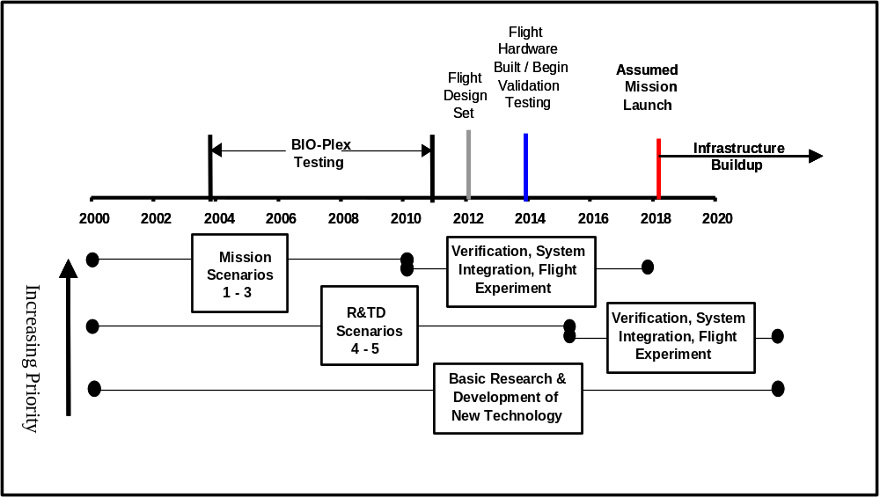
Figure 16. Timeline for Development of Life Support Technology

The implementation plan should include the following:
1.) Definition of potential future human missions beyond Space Station, emphasizing realistic missions and human-rated testing (e.g., BIO-Plex). These missions need to be defined so that we can estimate the wastes produced and the potential resources to be recovered and identify the interfaces with other systems – particularly water, air, and food.
2.) Identification of analyses to evaluate and identify the “best” technologies needed for the two major environments in which ALS systems must operate - microgravity and/or hypogravity.
3.) Map of ALS Project solid waste processing priorities and justification of these priorities based on analysis of data (e.g., identification of technology “gaps” and integration issues associated with solid waste processing).
4.) Identify how to maintain solid waste R&TD balance across TRL levels, as shown in Figure 17. This will ensure that both the basic research needed for the development of new technologies and the development of “best” technologies are represented.
5.) A timeline of solid waste project events including major and minor milestones.
6.) Relevant quantitative/qualitative data or metrics SMAP will use to analyze different scenarios.
7.) Method for incorporating updates to the implementation plan on an annual basis.
8.) Definition of the solid waste group’s roles and responsibilities.
9.) Method for updating solid waste technology assessment document as needed.

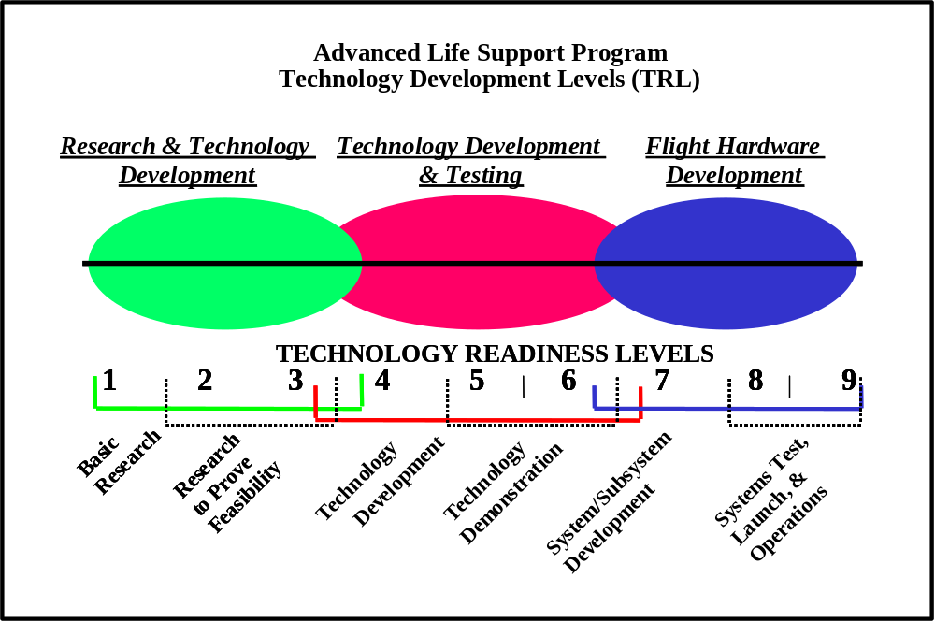
Figure 17. The ALS Project Maintains a Balance of Activities Across Technology Readiness Levels 1 Through 6.

In conclusion, the implementation plan will provide the strategy for guiding both the priorities and direction in ALS solid waste research and development by specifically charting how technologies need to be researched and developed. This plan will assist in determining the call for proposals in the NASA Research Announcement (NRA), Small Business Innovative Research (SBIR) , and Small Business Technology Transfer (STTR) proposal process. Researchers and technology developers outside of ALS will be able to determine whether their technology fits into the overall scope of the solid waste processing implementation plan.

7. ACRONYMS

ALS Advanced Life Support

App. Acc. No. Appendix Accession Number

BET Brunauer, Emmet and Teller Isotherm

Bio Biological

CSTR Continuous Stirred Tank Reactor

DSA Dimensionally Stable Anode

FFB Fixed Film Bioreactor

HRT Hydraulic Retention Time

NRA NASA Research Announcement

PC Physicochemical

PPP Pre- and Post Processing

R&TD Research and Technology Development

SBIR Small Business Innovation Research

SCP Single Cell Protein

SCWO Supercritical Water Oxidation

SEBAC Sequential Batch Anaerobic Composting

SMAP Systems Analysis Modeling Project

STTR Small Business Technology Transfer

SWPRR Solid Waste Processing Resource Recovery

TRL Technology Readiness Level

VOCs Volatile Organic Compounds

8. REFERENCES

1. Verostko, C.E, Packham, N.J.C., and Henninger, D.L., “Final Report on NASA Workshop on Resource recovery from Wastes Generated in Lunar/Mars Controlled Ecological Life Support Systems (CELSS)”, Document No. CTSD-ADV-035, August, 1992.

2. Jerng, Linda T., Drysdale, Alan E., Hanford, Anthony J., Ewert, Michael K., “Advanced Life Support Systems Modeling and Analysis Reference Missions Document, Revision A Draft, Lockheed Martin Space Operations, Houston, Texas, May 2000.

3. Diaz, L.F., G.M. Savage, and C.G. Golueke, Resource Recovery from Municipal Solid
Wastes, Volumes I and II, Primary Processing, and Volume II, Final Processing, CRC Press, Inc., 1982.

4. Taggart, A.F., Handbook of Mineral Dressing, 1954.

5. Composting and Recycling Municipal Solid Waste, L.F. Diaz, G.M. Savage, L.L. Eggerth,
and C.G. Golueke, Lewis Publishers, Inc., Boca Raton, Florida, April 1993.

6. Vesilind, P.A. and A.E. Rimer, Unit Operations in Resource Recovery Engineering,
Prentice-Hall, 1981.

7. Conveyor Equipment Manufacturers Association, Belt Conveyors for Bulk Materials, Fifth
Edition, 1998.

8. Golueke C.G. 1972 Composting. A study of the process and its principles. Rodale Press, Emmaus, PA.
- Chen, Y. and Y. Inbar. 1993. Chemical and spectroscopic analyses of organic matter transformations during composting in relation to compost maturity, p. 551-600. In: H. A. J. Hoitink and H. M. Keener (eds.) Science and engineering of composting: Design, environmental, microbiological and utilization aspects. Renaissance Publications, Worthington, OH.
- Hoitink, H.A.J., A.G. Stone, and D.Y. Han. 1997. Suppression of plant diseases by composts. HortScience 32 (2):184-187.
11. de Bertoldi, M., P. Sequi, B. Lemmes and T. Papi (eds.). 1996. The Science of Composting. Blakie Academic & Professional, London, UK.
12. Epstein, E. 1997. The science of composting. Technomic Publishing Company, Inc., Lancaster, PA

13. Haug, R.T. 1980. Compost Engineering, Principles and Practices. Ann Arbor Sciences Publishers, Inc. Ann Arbor, MI
- Haug, R.T. 1993. The Practical Handbook of Compost Engineering. Lewis Publishers, Boca Raton, FL.
- Hoitink, H.A.J., and H.M. Keener (eds.). 1993. Science and engineering of composting: design, environmental, microbiological and utilization aspects. 728 p. Renaissance Publications, Worthington, Ohio.

16. Keener, H.M., W.A. Dick and H.A.J. Hoitink. 2000. Composting and beneficial utilization of composted by-product materials. Chapter 10. pp. 315-341. In: J.F. Power et al. (eds.) Beneficial uses of agricultural, industrial and municipal by-products. Soil Science Society of America. Madison, Wisconsin.
17. Miller, F.C. 1993. Composting as a process based on the control of ecologically selective factors. p. 515-544. In F. Blaine Metting, Jr. (ed.) Soil microbial ecology-applications in agricultural and environmental management. Marcel Dekker, Inc., New York.
- Rynk, R. (ed.) 1992. On farm composting handbook. NRAES-54. Cooperative Extension Service, Northeast Regional Agricultural Engineering Service, Cornell Univ., Ithaca, NY.
- Strayer, R.F., M.P. Alazraki, N. Yorio, and B.W. Finger. Bioprocessed wheat residues to recycle plant nutrients to the JSC Variable Pressure Growth Chamber during the L/MLSTP phase III test. SAE Tech. Paper 981706. 1998.
- Garland, J.L., C.L. Mackowiak, and J.C. Sager. Hydroponic crop production using recycling nutrients from inedible crop residues. SAE Tech. Paper 932173. 1993.

- Mackowiak, C.L., J.L. Garland, R.F. Strayer, B.W. Finger, and R.M. Wheeler. Comparison of aerobically-treated and untreated crop residue as a source of recycled nutrients in a recirculating hydroponic system. Adv. Space Res. 18:281-287. 1996.

- Mackowiak, C.L., R.M. Wheeler, G.W. Stutte, N.C. Yorio, and J.C. Sager. 1997. Use of biologically reclaimed minerals for continuous hydroponic potato production in a CELSS. Adv. Space Res. 20:1815-1820.

- Nacheff-Benedict, M.S., G.H. Kumagai, G.E. Petrie, R.W. Schweickert, C.D. McFadden,N.J.C. Packham, and M.A. Edeen. 1994. An integrated approach to development of bioreactor technology for an advanced life support primary water processor. SAE Tech. Paper 941397.

- Edeen, M.A., G.H. Kumagai, L. N. Dittner, L. M. Landau, R.W. Schweickert, C.D. McFadden. 1995. Advances in development of bioreactor technology for a regenerative life support primary water processor. SAE Tech. Paper 951740

- Miller, G.P., R.J. Portier, D.P. Dickey, and H.L. Sleeper. 1991. Using biological reactors to remove trace hydrocarbon contaminants from recycled water. SAE Tech. Paper 911504.

- Strayer, R.F., B.W. Finger, and M.P. Alazraki. 1997. Evaluation of an anaerobic digestion system for processing CELSS crop residues for resource recovery. Adv. Space Res. 20: 2009 – 2015.

- Stutte, G.W. 1996. Nitrogen dynamics in the CELSS Breadboard Facility at Kennedy Space Center. J. Life Sup. Biosphere Sci. 3:67-74.

28. Fisher, J.W., Pisharody, S., Wignarajah, K., Lighty, J. S., Burton, B., Edeen, M., and Davis, K. S., “Waste Incineration for Resource Recovery in Bioregenerative Life Support Systems,” Technical Paper No. 981758, In Proceedings of the 28th International Conference on Environmental Systems (1998).

- Diemer, R. B., Ellis, T. D., Silcox, G. D., Lighty, J. S., Pershing, D. W., “Incinerators,” Encyclopedia of Chemical Technology, 4th ed., Vol.14, pp. 86-122. 1996.

- Tennakoon, C.L.K., Hitchens, G. D., Murphy, O.J., Rogers, T.D., and Verostko, C.E., “Waste Processing Using Packed Bed Electrolysis Reactor with Thermal Pretreatment at High Pressure”, ICES Paper No. 951742, Presented at the 25th International Conference on Environmental Systems San Diego, California, July 10-13, 1995.

- Rajeshwar, K., and Ibanez, J. (1997) Environmental Electrochemistry, Fundamentals and Applications in Pollution Abatement, Academic Press, San Diego, CA.

32. Sequeira, C. A. C., ed. (1994) Environmental Oriented Electrochemistry, Studies in Environmental Science 59, Elsevier, Amsterdam.

33. Tatapudi, P., and Fenton, J. (1995) “Electrolytic Processes for Pollution Treatment and Pollution Prevention,” Advances in Electrochemical Science and Engineering, Vol. 4, Gerischer, H., and Tobias, C., ed., VCH, Weinham, Germany, pp. 363-417.

34. Kaba, L., Hitchens, D., Bockris, J.O.M., “Electrochemical Incineration of Wastes,” 19th Intersociety Conference on Environmental Systems, San Diego, CA, #891510, July 1989.

35. Mahagaokar, U., Krewignhaus, A. G. “Coal conversion Processes (Gasification),” Encyclopedia of Chemical Technology, 4th ed., Vol.6, pp. 541-568. 1996.

36. Hong, G.T., Borchers, B., Pisharody, S., Fisher, J., “A Supercritical Water Oxidation Unit for Treating Waste Biomass,” Technical Paper No. 961560, In Proceedings of the 28th International Conference on Environmental Systems, Monterey, CA, 1998.

37. Pisharody, S.A., John W.Fisher, Martin Abraham., “Supercritical Water Oxidation of Solid Particulates”, Industrial & Engineering Chemistry Research (I&EC), Vol.35, Number 12, pages 4471-4478.

38. Tester, J.W., H.R. Holgate, F.J. Armellini, P.A. Webley., Killilea, G.T. Hong, H.E. Barner., “ Supercritical Water Oxidation Technology: A Review of Process Development and Fundamental Research”, 1991 ACS Symposium Series Paper on Emerging Technologies for Hazardous Waste Management, October 1-3, 1991.

39. Hong, G.T and Fowler, P.K., “Supercritical Water Oxidation of Urine and Feces”, NAS2-12176 Final Report for the period June 26,1985 to April 30, 1987.

40. Takahashi, Y., Wydeven, T., Koo, C., “Subcritical and Supercritical Water Oxidation of CELSS Model Wastes”, Adv. Space Res. 9(8), 99-110, 1989.

- Shaw, R.W., N. Dahmen., “ Destruction of Toxic Organic Materials using Supercritical Water Oxidation: Current State of the Technology”, Supercritical Fluids- Fundamentals and Applications., E.
Kiran, P.G. Debenedetti and C.J. Peters, eds., Kluwer Academis Publishers, Dordrecht, The Netherlands, 1999.

42 Liapis, A.I., Bruttini, R., “Freeze Drying,” in Handbook of Industrial Drying, A.S. Mujumdar, Editor., Marcel Dekker: New York. p. 309-343, 1995.

43. Rey, L., “Fundamental Aspects of Lyophilization,” in Aspects Theoretiques et Industriels de la Lyophilisation, L. Rey, Editor., Hermann: Paris. p. 23-43, 1964.

44. Sadikoglu, H., Liapis, A.I, “Mathematical Modelling of the Primary and Secondary Drying Stages of Bulk Solution Freeze-Drying in Trays: Parameter Estimation and Model Discrimination by Comparison of Theoretical Results With Experimental Data,” Drying Technology, 15(4): p. 791-810, 1997.

45. Peterson, S.P., Counts D.A. et al, “Current Status of Development of Plasma Arc Systems for destruction of Navy Wastes,” Proc. Int. Conf. Incin. Therm. Treatment Technol. Pp 493-498, (1999).

46. BD Sartwell, “Development of a Plasma Arc System for the Destruction of US DOD Hazardous Wastes,” Proc. Int. Conf. Incin. Therm. Treatment Technol. Pp 559-564 (1997).

- Joseph, M.F., et al “Plasma Arc Destruction of Hazardous Wastes,” Published in Electr. Power Res. Inst (EPRI) Report out of Palo Alto, (1988).

- Bansai, R. C., Donnet, J. B., and Stoeckli, F., Active Carbon, Marcel Dekker, Inc., New York, 1988.

49. Hassler, J. W., Activated Carbon, chemical Publishing Co., Inc., New Your, 1963

50. Yehaskel, A., Activated Carbon – Manufacture and Regeneration, Noyes Data Corporation, Park ridge, N.J., 1978.

- ACKNOWLEDGEMENT

The Solid Waste Processing Resource Recovery Workshop would not have been possible without the hard work and diligence of all the workshop participants. These specialists in all areas for the handling and treatment of wastes provided the necessary expertise needed to perform the technology assessments. Special appreciation is extended to all the participants. A list of the participants is in the Appendix – Volume II. Special appreciation is extended to the respective group leads that did a superb job in directing and executing the completion of the technology assessments in the allotted timeframe. They include Mr.George Savage (CalRecovery, Inc, Concord, CA), Dr. Harold Keener (Ohio Agricultural Research Development Center, Ohio State University) and Dr. Duncan Hitchens (Lynntech, Inc., College Station, TX). Thanks and recognition are given to Mr. John Keener and Anthony Hanford and Bruce Gertner (Lockheed-Martin) for their excellent work in developing the workshop assessment form and providing the technical information necessary for performing the technology assessments. The authors would like to extend their thanks and appreciation to the reviewers for all the improvements made to the preliminary draft report document. Many of the reviewers have been previously acknowledged with the exceptions of Dr. Alan Drysdale (Boeing), Dr. John Hogan (NJ-NSCORT) and Dr. Anthony Hanford (Lockheed-Martin). Finally, the authors would like to give special recognition and thanks to the following individuals for their fine support and participation at the workshop: Astronaut Shannon Lucid (JSC), Dr. Joan Vernikos (NASA Headquarters (HQ) Director of NASA Office of Life and Microgravity Science and Applications Division), Dr. Guy Fogelman (Human Support Technologies Lead at NASA HQ), Al Behrend (JSC – ALS Program Manager), Dr. Don Henninger (New ALS Program Manger), Dr. Charlie Barnes (NASA Headquarters), Mark Kliss (Ames Research Center), Richard L. Sauer (JSC), Hubert Brasseaux (JSC), Trista Wagoner (NASA-HQ), Joy King (InDyne, Inc.), Crystal Rucker (InDyne, Inc.), Rachel Miller (InDyne, Inc.) and Chantel Whatley (JSC).

1 These are the Technology Appendix Accession Numbers used as identifiers for each technology that is listed in the Appendix. 2 This feed rate is based on the waste model. If operated continuously, equipment employing this technology could process more waste per day.
3 Will this process be a batch or continuous process within a near-term life support system.
4 The information here assumes permanent storage of the waste for the duration of the mission. For temporary storage as a precursor to further processing, additional restrictions may apply as defined by the processing steps.
3
5 This technology accepts 8.49 kg/d of dry waste but the actual feed is 40.75 kg/d including moisture and recycled compost.
6 This process also requires catalysts and other agents to clean process effluent streams.
7 This is the percentage of water recovered from waste products but the waste itself is not coverted.
8 The char pelletization step operates at pressures between 2,000 and 12,000 kPa.
9 Torch temperatures are 3,000 to 7,000 K for this operating temperature range.

