APPENDIX

APPENDIX

Construction Of The Idealized COCOA Simulation Model

The choice in labeling conventions used to specify objects and parameters throughout this document is generally consistent with commonly accepted naming conventions within CMS. However, as COCOA is a geometrical simulation, the complexity of the fitting routines and modeling of complex geometries require that multiple local coordinate systems be devised for many of the components used in the simulation. Additionally, the EMU Alignment consists of several unique objects and structures that are not found elsewhere in the CMS detector. This appendix describes the labeling scheme used throughout this document as well as the construction of the Idealized EMU simulation within COCOA. It offers a very detailed examination of all components in the system as well as the precise placement of the objects in the simulation.

Definition of Chamber Labeling Scheme in CMS
As discussed previously, the Endcap Muon System is comprised of 4 Muon Endcap (ME) discs of Cathode Strip Chambers (CSCs) separated by the YE(±η) Return Field (RF) Iron disks. The RF iron acts as the principle mechanical support for the CSCs, absorber for incident particle showers, and a return for the large magnetic flux leaving the central solenoid. The CSCs on each of the ME ±2, ±3, and ±4 disks are placed into an inner ring of 18 20-degree and outer ring of 36 10-degree chambers. The ME ±1 rings 1,2, and 3 are composed of 36 10 degree chambers.

The location of a particular CSC in CMS is specified by a three digit number denoting the ME disc, whether it is in the inner or outer ring of chambers, and the chamber position on the ring. By convention, the ME discs are label in order of their placement from the interaction point, with the nearest disc in the +η Endcap designated as ME +1 and the nearest disc to the interaction point in the -η Endcap designated as ME -1. The two rings of chambers comprising a ME ±2, ±3, or ±4 disc are labeled 1 for the inner ring and 2 for the outer ring. The final number specifying the ring position of a particular chamber is determined by simply counting the number of chambers from the X(global CMS) = 0 axis as viewed from the interaction point. Counting is done in a clockwise fashion for rings in the +η Endcap and in a counter-clockwise fashion for the -η Endcap. The chamber intersecting the X (global CMS) = 0 axis is counted as the first chamber in the ring. References to specific CSCs in CMS might look like this: ME +2/2/1, ME -1/1/17, or ME 4/2/30. Figure A.1 illustrates how this labeling scheme is employed for a particular ME disc.
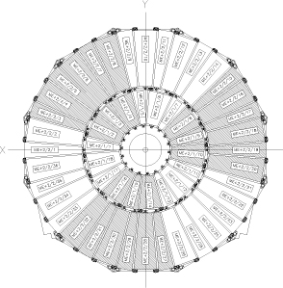
Figure A.1: Typical ME Layout. Drawing of ME2, as viewed from interaction point, with proper labeling of CSC chambers. [A.1]

Local Definition of Cathode Strip and Anode Wire Planes
The naming and numbering convention used to describe the location of cathode strips and anode wires and has been described in CMS Internal Note 2000/004. This convention has been adopted for the present simulation/reconstruction scheme.

The Cathode Strip Chambers are composed of seven trapezoidal honeycombed panels separated by small gaps. All panels except the middle panel are milled with cathode strips running the length of the panel on their inner faces while the gaps between the panels are spanned by anode wires which transverse the panel width (See Figure A.2, below).

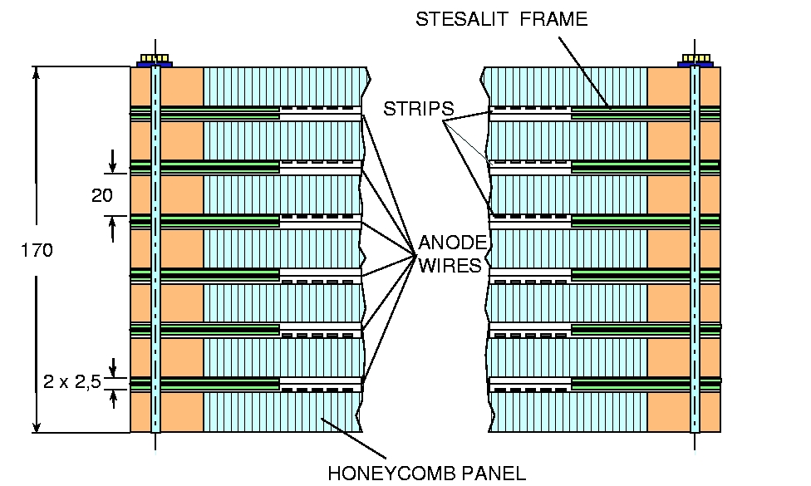
Figure A.2: Cross Section of Six Layer Cathode Strip Chamber. Dimensions in mm. [A.2]

The design of the CSC chambers calls for all cathode strip readout electronics to be mounted on the outside surface of one of the chamber faces. For a single chamber, the labeling scheme designates the chamber face on which these electronics are mounted as the top layer and the nearest cathode strip plane to this face as the first strip plane. Individual strips in the planes are number are numbered from left to right (1 to n) when the top of the chamber is viewed from the smaller to larger end of the trapezoid. Anode wire planes are designated in a manner identical to that of the cathode strip planes, while the numbering of individual anode wires in a plane increases as from the smaller to larger end of the trapezoid (1 to n). Figure A.3 illustrates the labeling scheme.

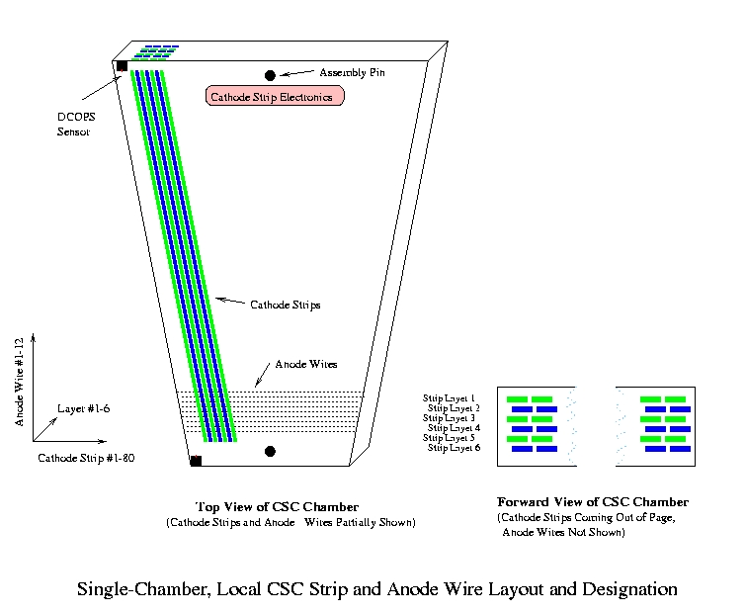
Figure A.3: Single Cathode Strip Chamber Labeling Scheme

Global Orientation of Cathode Strip and Anode Wire Planes
Chambers placed in the +η Endcap are mounted on the YE iron planes such that the first plane of cathode strips is nearest the interaction point for ME1 and ME2 chambers and furthest from the interaction point for ME3 and ME4 chambers. This arrangement means the numbering of cathode strips in the +ηEndcap increases with φ for ME1 and ME 2 while decreasing with φ for ME3 and ME4. In the -η Endcap, the positioning of the first plane of cathode strips for all chambers is identical to the +η Endcap. However, since the chambers are positioned on the opposite side of the interaction point, the numbering of cathode strips in the -ηEndcap decreases with φ in ME-1 and ME-2 while increasing with φ for ME-3 and ME-4.

Development of COCOA Simulation and Definition of Simulated Objects
To optimize the development of Endcap simulations in COCOA, it was decided to compose the simulated Endcap solely from objects arranged in a ‘parent-child’ relationship. This means that relatively simple collections of objects already defined in COCOA can be placed together to compose more complex objects. In this scheme, two DCOPS sensors can be arranged in a local coordinate system to define a CSC chamber (Figure A.3). Four CSC chambers, in turn, are arranged to form a SLM line, three SLM lines are arranged to form an Muon Endcap (ME) layer, and six ME layers are assembled to form the entire CMS Endcap Muon system. The modeling of components in this manner means that the location and orientation of all the individual components (dowel pins, chamber active reference centers, lasers, etc) does not need to be known in the general CMS coordinate system beforehand. Rather, the spatial relationships between parent and child objects can be specified directly from CMS production drawings.

This method works very well for six of the Muon Endcaps (ME±2, ±3, and ±4 Endcaps), however the unique construction of the inner most Endcaps (ME ±1) requires a somewhat less symmetric approach, as SLM lines do not traverse the ME discs and a Secondary Laser Line must be introduced. For this reason, the modeling of the ME±1 Endcaps will be addressed separately.

The extraction of the information necessary to define these relationships from CMS production drawings involved several steps and was not a simple exercise of comparing two points in a single drawing. For this reason, the assignment of errors in the simulated system will be addressed separately.

Digital CCD Optical Position Sensor (DCOPS) Sensors
The Digital CCD Optical Position Sensor (DCOPS) is composed of 4 single array CCDs arranged in an open frame and connected to a control circuit fitted with an on board ADC and DSP chip. As the beam of a cross hair laser falls incident on the DCOPS, the intersection of each leg of the laser and CCD results in the accumulation of charge across the CCD pixel array. The mean of the charge distribution on the array can be extracted with a simple fit. By knowing the size of the each pixel comprising the array, the distance between the first pixel in the array and the center of the intersecting crosshair leg (taken to be the mean of the charge distribution) is determined. The first active pixel in each CCD array is referenced to the slot base of the DCOPS mounting structure on a specially designed calibration bench. This calibration then references the CSC strips to the laser lines.

The referencing of all CCDs to a common reference point on the sensor allows for the location and orientation of the entire crosshair laser to be inferred. Alternately, if the location and orientation of the incident crosshair is already known, the charge distributions along the pixel arrays can be used to track the position of the reference point and orientation of the sensor. By monitoring two such reference points and sensor orientations on each CSC chamber, the orientation and position (transverse to the incident laser) of the chambers can be deduced.

By convention, the local coordinate system of all DCOP sensors originates at the common reference point to which the CCD pixel arrays are calibrated. The axes of the local system are orientated such that the +X axis runs away from the sensor aperture and the +Y axis runs parallel to the sensor vertical (Figure A.4). The DCOPS sensor must be carefully calibrated prior to use as a measurement device. Table A.1 shows a sample of what is required for the calibration of a typical DCOPS sensor.

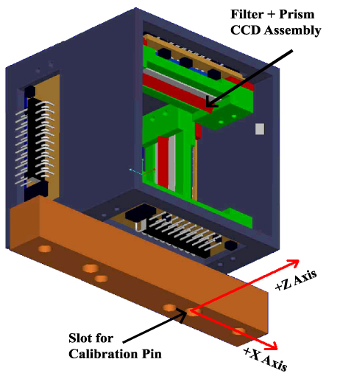
Figure A.4: 3-D View of a DCOPS Sensor. The local right handed coordinate system of the DCOPS is shown in red (Y axis runs vertically). Calibration of the sensor is done by referencing of the first active pixel in this local system. [A.3]

The initial simulation of DCOPS sensors in COCOA is based on production drawings in which the midpoint of the active pixel arrays in the CCDs are placed along the middle of the box frame.

Table A.1: Location of First Active Pixel of CCDs of a Typical DCOPS Sensor in the Local DCOPS Coordinate System as Defined by Figure A.4. Values followed by an asterisk (*) denote a dimension which will requires very precise calibration.
Component | Placement in DCOPS Reference Frame
Component | X (mm) | Y (mm) | Direction of CCD Vector
CCD 1 (Upper) | -36.829* | 65.75 | +X
CCD 2 (Right) | -8.171 | 57.579* | -Y
CCD 3 (Lower) | -36.829* | 20.75 | +X
CCD 4 (Left) | -45 | 57.579* | -Y

The CCD vector is determined to run as the direction of the increase in pixel address across each linear array. This means the CCD vectors are orientated in the DCOPS window frame to point toward the local +X and -Y DCOPS axes.

CSC Chambers
The Cathode Strip Chambers (CSC) in COCOA are defined solely in terms of the relative position and orientation of DCOPS primary calibration pin to the active center of the chamber (with the exception of ME ±1/2 CSCs, discussed later). Although determining the location and orientation of the cathode strip planes is the ultimate goal of the reconstruction and simulation, there is no need to reference the location of the strips in the fitting routine since the relationship between the active center of the chamber and the first strip position does not participate in any direct measurement. Once COCOA has been employed to determine the position and orientation of the chamber in CMS, the first strip position can be immediately specified from prior calibration.

DCOPS sensors are referenced to the cathode strips by a series of carefully constructed mounting plates and dowel pins. The definition of CSCs in COCOA must contain at least two vectors to describe the location of two DCOPS dowel pins. These vectors have been initially determined from production CSC drawings and are locally referenced to the ‘Reference Center’ of the chambers. The Reference Center of the CSCs is defined to lie on the plane of the first layer of strips and transversely positioned as the average center point of all the individual layers. Because successive layers of strips are offset by half the strip width, the average center point will not lie on the active center of the first strip layer. Figure A.5 shows a diagram of a typical CSC chamber and the relationship between the cathode strip to the geometrical and Reference center points. If the CSCs are perfectly constructed, the Reference Point will lie on along the geometrical center of each chamber and panel.
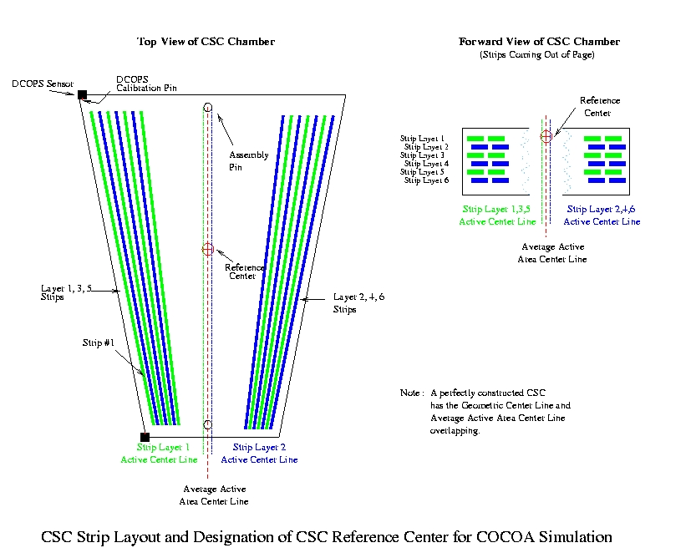
Figure A.5: Strip Layout and Reference Center Definition (definition of active center)

The active center of a CSC forms the origin of a local right handed chamber coordinate system. In this system (shown in Figure A.3 and Figure A.5), when the chamber viewed from the top, the local Z axis increases with the increase in anode wire number and the local X axis increases with the decrease in cathode strip number. The position of the primary calibration dowel pin and orientations of the CSC mounted DCOPS in this system are given below in Table A.2. The positioning of the DCOPS on the CSC chambers will fall on the left or right of the CSC geometrical center line (shown in Figure A.5), depending on the location of the chamber in CMS. Since these positions are symmetric about the chamber centerline, and the DCOPS are to be defined solely by the relative location and rotation of the primary calibration pins, it becomes necessary to place some DCOPS on the chambers with additional 180° rotations. This has the consequence of destroying any generalization of DCOPS orientations in the CMS, but it will maintain the symmetry of the CSC chambers and simplify the installation of alignment hardware by forcing the primary DCOPS alignment pin to always be positioned toward the chamber center.

Table A.2: DCOPS Primary Dowel References and Sensor Orientations for “Left Handed” CSCs. “Right Handed” CSCs differ by rotations of 180 degrees and have inverse X values. Dimensions are given with respect to the CSC Reference Center in local chamber coordinates. Coordinates have been extracted from CMS CSC production drawings (FNAL). ME ±1/2 chambers have two LINK sensors and only a single DCOPS reference sensor and are detailed in Table A.5.
Chamber | Inner DCOPS |  |  | Outer DCOPS
Chamber | X (mm) | Z (mm) | Rotation about Y (°) | X (mm) | Z (mm) | Rotation about Y (°)
ME 2/2, 3/2, 4/2 | 19.922 | 1317.833 | 180 + 5 | 280.199 | 1657.151 | 180 + 5
ME 1/3 Type 1 | 223.292 | 840.437 | 5 | 373.344 | 874.776 | 5
ME 1/3 Type 2 | 354.790 | 840.437 | 5 | 504.842 | 874.776 | 5
ME 2/1 | 272.081 | -992.094 | 10 | 13.107 | 884.330 | 180 + 10
ME 3/1 | 272.081 | -892.145 | 180 +10 | 22.158 | 776.567 | 180 + 10
ME 4/1 | 272.081 | -792.603 | 10 | 12.931 | 677.112 | 180 + 10

Aside from placement of DCOPS sensors on the left or right side of the CSC chambers, ME 2/1, 3/1, and 4/1 DCOPS placement differs slightly as these chambers are different lengths (symmetry about the geometrical center line is still maintained). The high degree of symmetry in the construction of the CSC chambers means that the entire CMS Endcap system can be modeled from four generic CSC chambers (Table A.2). Since each CSC chamber can only be “Left Handed” or “Right Handed”, there are eight unique CSC chambers in the ME ±1/3, ±2, ±3, ±4 system.

ME ±2, ±3, ±4 Straight Line Monitoring (SLM) Line Layout
Placement of DCOPS sensors on the CSC chambers has been done in a way which permits a line to be drawn parallel to a line drawn down the center of the DCOPS sensor active areas across the CMS detector. To avoid the beam pipe, the closest approach of this line to the CMS detector Z axis is made at CMS R = 300 mm. These lines are designated as Straight Line Monitor (SLM) Reference lines and denote the optimal placement of DCOPS sensors in CMS. Furthermore, the CSC chambers and DCOPS are orientated in a manner such that the CCD planes of the DCOPS sensors are exactly perpendicular to these lines.

The construction of a simulated SLM lines in COCOA is done from four CSC chambers (two left handed, two right handed), two crosshair lasers, and two reference sensors (mounted on transfer plates) placed in a local SLM coordinate system. The crosshair lasers are initially placed at opposing ends of the local SLM X axis and orientated such that the center of the crosshair beam coincides exactly with the SLM X axis. The reference sensors (on the transfer plate) are placed facing the crosshair lasers and offset so that the center of the DCOPS active area is on the SLM X= 0 axis with the DCOPS Y axis parallel to the SLM Y axis. The arrangement of CSC chambers in ME2, ME-3, and ME-4 requires the SLM lines to be constructed with left handed chambers along the +X SLM axis and right handed chambers along the -X SLM axis. ME-2, ME3, and ME4 SLM layouts have right handed chambers along the +X SLM axis and left handed chambers along the -X SLM axis.

There are only two types of SLM lines in the CMS detector. Both SLM lines have two left-handed and two right handed chambers and differ only in which side of the +X SLM axis these chambers are placed. In practice, there are also slight differences in the transfer plate assemblies due to integration issues and space constraints. However, these differences will not be important for the simulation or reconstruction of the system in COCOA though they have been incorporated into the simulation.

Table A.3: Location and Orientation of CSC Chamber Centers Along all SLM Lines in the CMS Detector. Dimensions are given with respect to the local SLM coordinate system origin. Locations and orientations of chambers in the +η and -η Endcap exhibit mirror symmetry about the CMS XY plane. Coordinates have been extracted from CMS layout drawings.
Chamber | Chamber Active Center
Chamber | X (mm) | Z (mm) | Rotation about Y (°)
ME 2/2, | ±5225.848 | 157.202 | ±85
ME 3/2, 4/2 | ±5225.848 | -157.202 | ±95
ME 2/1 | ±2371.279 | 118.164 | ±80
ME 3/1 | ±2469.704 | -135.5275 | ±100
ME 4/1 | ±2567.735 | -152.813 | ±100
ME -2/2, | ±5225.848 | -157.202 | ± 95
ME -3/2, -4/2 | ±5225.848 | 157.202 | ±85
ME -2/1 | ±2371.279 | -118.164 | ±100
ME -3/1 | ±2469.704 | 135.528 | ±80
ME -4/1 | ±2567.735 | -152.813 | ±80

The six Muon Endcap Station ±2, ±3, and ±4 (ME ±2, ±3, ±4) layouts are composed of three identical SLM lines. The endpoints of the SLM lines are designated as SLM reference points and numbered 1-6 starting with the point closest to the +X CMS axis and moving clockwise as viewed from the CMS Z = 0 interaction point (Figure A.6).

The placement of SLM lines and SLM Reference Points is the same for all ME ±2, ±3, and ±4 layers, though the orientation of chambers requires SLM lines in layers ME 2, -3, and -4 to be flipped 180 degrees from the otherwise similar ME -2, 3, and 4 SLM lines (see Table A.4). When the SLM lines on these ME layers are constructed in this manner, the final position and orientation of all CSC chambers, SLM lines, and SLM Reference Points will overlap in the global CMS XY Plane. Coverage of incident particles across RΦ in the Endcaps is not compromised in this arrangement since the overlapping of CSC chambers is accomplished within individual ME layers.

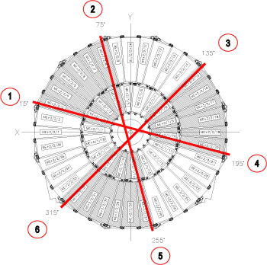
Figure A.6: Detail of SLM Lines and SLM Reference Points 1-6 for ME 2 [A.1]

Table A.4: COCOA Position and Rotation of SLM Lines For All ME Stations.
ME Layer | SLM Line | COCOA Rotation  About X (CMS) Axis | COCOA Rotation  About Z (CMS) Axis | Position
 |  |  |  | X (CMS) | Y (CMS)
ME 2  ME -3  ME -4 | 1 | +90 | 15 | -77.6457 | 289.7777
ME 2  ME -3  ME -4 | 2 | +90 | 255 | 289.7777 | -77.6457
ME 2  ME -3  ME -4 | 3 | +90 | 135 | -212.132 | -212.132
ME -2  ME 3  ME 4 | 1 | -90 | 15 | -77.6457 | 289.7777
ME -2  ME 3  ME 4 | 2 | -90 | 255 | 289.7777 | -77.6457
ME -2  ME 3  ME 4 | 3 | -90 | 135 | -212.132 | -212.132

Muon Endcap Station ±1 (ME ±1) Layout
The chambers in the ME ±1 layer are arranged into three rings rather than two rings as in the ME ±2, ±3, ±4 Endcaps. Each ring of chambers is separated along the CMS Z axis. The inner ME ±1/1 ring of chambers is not within the scope of the EMU alignment proposal, however, the EMU alignment system must reference ME ±1/2 and ±1/3 chambers to the tracker coordinate system.

In the ME ±1 Endcaps, the SLM line arrangement in ME ±2, ±3, and ±4 Endcaps cannot be duplicated due to the separation of the rings along the CMS Z axis. The large amount of Iron behind the ME ±1/1 chambers precludes SLM laser lines from traversing the ME ±1 disc. In this case, the outer reference points for the SLM laser lines are defined by transfer plates (as in the other ME layers) while inner reference points are provided by the LINK Alignment Group.

As previously discussed, the Link Alignment System is charged with transferring the tracker coordinate system to the Endcap and Barrel Alignment Systems. The transfer is accomplished by a series of laser lines that reference the tracker coordinate system to the six rigid MAB structures. The primary Link laser lines that are used in this process are split with a rhomboid prism to create a secondary Link laser line that runs parallel to the primary laser line. This Secondary Link laser line is then used to provide alignment to the ME ±1/2 ring of chambers and establish an inner reference for the ME ±1 SLM lines. Figure A.7 shows the arrangement of the ME ±1/2 and ±1/3 chambers as well as the location of the ME ±1 SLM and Secondary Link laser lines.

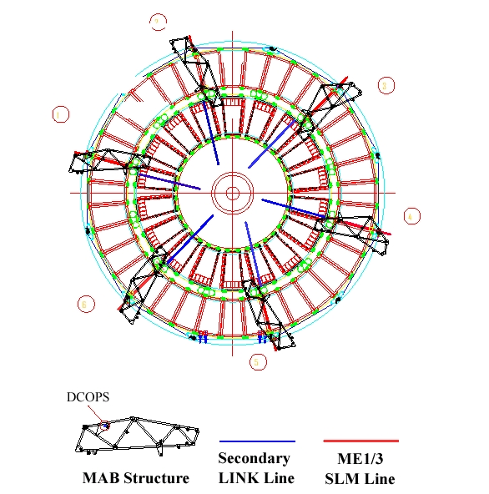
Figure A.7: ME ±1 Chamber Arrangement and Placement of SLM and Secondary Link Laser Lines. Overlap of MAB Structures is shown, though they do not touch ME±1. ME 1/1 chambers are not shown. Note SLM lines do not cross the disc, but terminate at the edge of the ME±1/2 rings. [A.1]

Since the secondary Link laser line is a beam and not a crosshair laser, DCOPS sensors cannot be used to reference this laser line to the ME ±1/2 chambers. The sensors employed to reference the secondary Link line to the ME ±1/2 chambers are two dimensional transparent sensors developed by the Link group that employ photosensitive strips etched onto a highly transparent glass substrate. Once these sensors determine the location of the ME ±1/2 chambers, a DCOPS sensor attached to the outer end of the chamber can then be used as the endpoint of the SLM crosshair laser line. Figure A.6 illustrates the arrangement of the Secondary Link laser line and the inner SLM DCOPS reference sensor. Table A.5 and Table A.6 detail the precise definition of these lines in the COCOA simulation. Table A.7 details the placement of DCOPS sensors on the ME ±1 chambers.

Table A.5: COCOA Position and Rotation of SLM Lines For ME ±1 Stations. ME ±1 SLM lines do not traverse the entire ME disc, rather they terminate at the reference DCOPS sensor placed on the ME ±1/2 frame. The SLM lines project along lines parallel to the Secondary Link Lines from (0,0, ± 6782), but offset ±66mm.
SLM Line | COCOA Rotation  About X (CMS) Axis | COCOA Rotation  About Z (CMS) Axis | Position
SLM Line | COCOA Rotation  About X (CMS) Axis | COCOA Rotation  About Z (CMS) Axis | X (CMS) | Y (CMS)
1 | -90 | 15 | -17.0821 | 63.7511
2 | -90 | 75 | 63.7511 | -17.0821
3 | -90 | 135 | 46.6690 | 46.6690

Table A.6: COCOA Position and Rotation of Secondary Link Lines In ME ±1. All Primary Link Lines project from (0, 0, ±6690). Secondary Link Lines run parallel to Primary Lines and are offset by ±66.000 mm in the CMS XY Plane.
Secondary Link Line | COCOA Rotation  About Z (CMS) Axis | Position
Secondary Link Line | COCOA Rotation  About Z (CMS) Axis | X (CMS) | Y (CMS)
1 | 15 | 12.941 | -48.296
2 | 75 | 48.296 | -12.941
3 | 135 | 35.355 | 35.355
4 | 195 | -12.941 | 48.296
5 | 255 | -48.296 | 12.941
6 | 315 | -35.355 | -35.355

Table A.7: DCOPS Primary Dowel References and Sensor Orientations for ME ±1/2 CSCs. Sensors on the ME ±1/2 chambers have rotations of -185 or 5 degrees and two possible locations for the placement of the reference DCOPS (designated as type 1 or 2), both are dictated by the projection of ideal laser lines along the ME±1 SLM lines. Dimensions are given with respect to the CSC Reference Center in local chamber coordinates. Coordinates have been extracted from CMS CSC production drawings (FNAL). ME ±1/2 chambers have two LINK sensors and only a single DCOPS reference sensor.
 | Inner Sensor |  |  | Outer Sensor
 | X (mm) | Z (mm) | Rotation about Y (°) | X (mm) | Z (mm) | Rotation about Y (°)
Link Sensors | 194.571 | 880.221 | -185 or 5 | 348.589 | 880.221 | -185 or 5
DCOPS Ref Type 1 | N/A | N/A | N/A | 498.330 | 1014.108 | -185 or 5
DCOPS Ref Type 2 | N/A | N/A | N/A | 498.330 | 1002.539 | -185 or 5

Transfer Lines
The Transfer Lines in the COCOA simulation are not modeled as distinct objects in the simulation since the placement of transfer plates at each SLM Reference Point on the individual ME layers form the bulk of the transfer system. The only additional component required to complete the system are the placement of crosshair lasers and additional Mechanical Alignment Bar (MAB) reference sensors.

The positioning of the MABs in CMS is dictated by the placement of the Barrel Muon Stations and the mounting brackets which affix the Barrel Muon Chambers to the RF iron. Since the arrangement of the Barrel Muon chambers is not symmetric in CMS Φ, the placement of the MABs and Transfer Lines cannot be symmetric in CMS.

The MAB structures are approximated as compound objects consisting of a DCOPS sensor and a proximity sensor (to provide CMS Z monitoring). In the final reconstruction of the EMU alignment system, these simulated MAB structures will have to be replaced by DCOPS sensors affixed to MABs that are interfaced to the LINK alignment group. The placement of the MAB sensors in the simulation is dictated by the predefined orientation and location of the transfer lasers (Table A.8).

Table A.8: COCOA/CMS Position of Transfer Lines and MAB Reference Sensors
Transfer Line # | Transfer Line Positions In CMS |  | MAB Sensor Positions In CMS
 | Φ (°) | R (mm) | X (mm) | Y (mm) | Z (mm)
1 | 14.052 | 7250 | 7033.049 | 1760.317 | ± 6650.000
2 | 74.099 | 7250 | 1986.326 | 6972.590 | ± 6650.000
3 | 135.901 | 7250 | -5206.504 | 5045.277 | ± 6650.000
4 | 195.948 | 7250 | -6970.958 | -1992.045 | ± 6650.000
5 | 254.052 | 7250 | -1992.045 | -6970.958 | ± 6650.000
6 | 314.099 | 7250 | 5045.277 | -5206.504 | ± 6650.000

As previously discussed, the Transfer Plates are to provide a physical coupling between the SLM and Transfer Lines. This is accomplished by constructing a mechanical assembly consisting of two DCOPS sensors (Figure A.8). These assemblies are designed to be placed along the SLM Lines such that one DCOPS sensor is centered along the SLM Line and the second DCOPS sensor is centered along the Transfer Line. The local coordinate system of the Transfer Plate is taken to be the same as the local coordinate system of the reference SLM DCOPS sensor. This means that the location of the Reference SLM DCOPS sensor will be (0,0,0) on all transfer plates with all local coordinate axes overlapping. Due the varying location of the Transfer Lines in CMS, 21 unique Transfer Plates are required to completely couple all Transfer Lines to the SLM Lines.

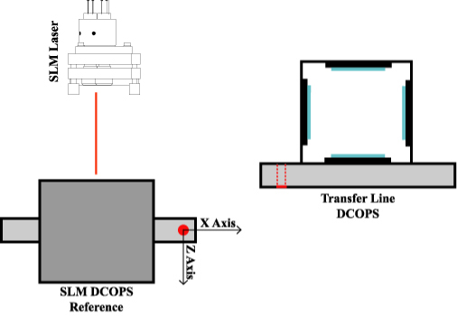
Figure A.8: Sample Layout of Transfer Plate. The figure shows the relative orientation of the two DCOPS sensors on a ME2 Point 2 transfer plate as well as the location of the SLM crosshair laser. The dashed red line on the Transfer DCOPS sensor denotes the slot assembly for the calibration pin.

Table A.9: Transfer Plate Definition. ME4 Transfer Plates are identical to those in the ME3 layer. ME-3 and ME-4 Transfer Plates are mirror symmetric to ME2 Transfer Plates with the exception of ME-3 Plate 5. ME-2 Plates are mirror symmetric to ME3 plates.
Transfer Plate # | Transfer Sensor Placement (Relative to TP Reference Point) |  |  | Transfer Sensor Rotation (Rotation about TP Axes)
 | X (mm) | Y (mm) | Z (mm) | X | Y | Z
ME1 Plate 1 | -230.950 | 19.150 | -9.350 | -90 | 180 | 0
ME1 Plate 2 | -225.000 | 19.150 | -9.350 | -90 | 180 | 0
ME1 Plate 3 | 135.000 | 19.150 | -9.350 | -90 | 180 | 0
ME1 Plate 4 | 141.000 | 19.150 | -9.350 | -90 | 180 | 0
ME1 Plate 5 | -230.950 | 19.150 | -9.350 | -90 | 180 | 0
ME1 Plate 6 | -225.000 | 19.150 | -9.350 | -90 | 180 | 0
ME2 Plate 1 | -464.951 | 84.250 | -9.350 | -90 | 180 | 0
ME2 Plate 2 | 141.000 | 84.250 | -9.350 | -90 | 180 | 0
ME2 Plate 3 | -231.000 | 84.250 | -9.350 | -90 | 180 | 0
ME2 Plate 4 | 374.951 | 84.250 | -9.350 | -90 | 180 | 0
ME2 Plate 5 | -464.951 | 84.250 | -9.350 | -90 | 180 | 0
ME2 Plate 6 | 141.000 | 84.250 | -9.350 | -90 | 180 | 0
ME3 Plate 1 | 374.951 | 84.250 | -9.350 | -90 | 180 | 0
ME3 Plate 2 | -231.000 | 84.250 | -9.350 | -90 | 180 | 0
ME3 Plate 3 | 141.000 | 84.250 | -9.350 | -90 | 180 | 0
ME3 Plate 4 | -419.951 | 84.250 | -9.350 | 90 | 0 | 0
ME3 Plate 5 | 419.951 | -302.250 | -203.350 | 90 | 0 | 0
ME3 Plate 6 | -231.000 | 84.250 | -9.350 | -90 | 180 | 0
ME-2 Plate 5 | 375.000 | 84.250 | -9.350 | -90 | 180 | 0
ME-3 Plate 5 | -419.951 | -302.250 | -203.350 | 90 | 0 | 0
Table A.10: COCOA/CMS Position of Transfer Plate. ME4 Transfer Plates locations along the SLM lines are identical to those in the ME3 layer. ME-3 and ME-4 Transfer Plate locations are mirror symmetric to ME2 Transfer Plate locations and orientations with the exception of ME-3 Plate 5. ME-2 Plates are mirror symmetric to ME3 Plates with the exception of ME-2 Plate 5.
Transfer Plate # | Transfer Plate Placement (Relative to SLM Center Point) |  |  | Transfer Plate Orientation  (Rotations About SLM Axes)
 | X (mm) | Y (mm) | Z (mm) | X | Y | Z
ME1 Plate 1 | 7282.907 | -43.25 | 22.5 | 0 | -90 | 0
ME1 Plate 2 | 7283.007 | -43.25 | 154.5 | 0 | -90 | 0
ME1 Plate 3 | 7283.004 | -43.25 | 22.5 | 0 | -90 | 0
ME1 Plate 4 | -7282.907 | -43.25 | -22.5 | 0 | 90 | 0
ME1 Plate 5 | -7282.907 | -43.25 | -22.5 | 0 | 90 | 0
ME1 Plate 6 | -7283.004 | -43.25 | -22.5 | 0 | 90 | 0
ME2 Plate 1 | 7282.907 | -43.25 | 22.5 | 0 | -90 | 0
ME2 Plate 2 | -7282.907 | -43.25 | -22.5 | 0 | 90 | 0
ME2 Plate 3 | 7282.907 | -43.25 | 22.5 | 0 | -90 | 0
ME2 Plate 4 | -7282.907 | -43.25 | -22.5 | 0 | 90 | 0
ME2 Plate 5 | 7282.907 | -43.25 | 22.5 | 0 | -90 | 0
ME2 Plate 6 | -7282.907 | -43.25 | -22.5 | 0 | 90 | 0
ME3 Plate 1 | 7282.907 | -43.25 | 22.5 | 0 | -90 | 0
ME3 Plate 2 | -7283.003 | -43.25 | -22.5 | 0 | 90 | 0
ME3 Plate 3 | 7283.007 | -43.25 | 22.5 | 0 | -90 | 0
ME3 Plate 4 | -7282.907 | -43.25 | -22.5 | 0 | 90 | 0
ME3 Plate 5 | 7088.908 | -43.25 | 22.5 | 0 | -90 | 0
ME3 Plate 6 | -7283.004 | -43.25 | -22.5 | 0 | 90 | 0
ME-2 Plate 5 | 7282.907 | -43.25 | 22.5 | 0 | -90 | 0
ME-3 Plate 5 | 7088.908 | -43.25 | 22.5 | 0 | -90 | 0

Script Labeling Conventions
Based on the COCOA scripting syntax and the parent-child relationships between components, the labeling conventions in Table A.11 have been adopted for EMU elements in COCOA Simulation Scripts.

Table A.11: Labeling of EMU Objects in COCOA Scripts.
CMS Designation | COCOA Script Designation
ME 2 SLM 1-4 | slm21
ME -2 SLM 1-4 | slm-21
ME 2 Laser 1 | las21
ME 2/2/3 | me22_3
ME 2/1/10 | me21_10
ME 2/1/10 Outer DCOPS | cops_outer21_10
ME 2/1/10 Inner DCOPS | cops_inner21_10
Transfer Line 1 | Not Needed in Script
MAB Sensor at Transfer Point 1, Z = +6500 mm | mab1
MAB Sensor at Transfer Point 1, Z = -6500 mm | mab-1
Transfer Laser 1 (located in + Endcap) | transfer1
Transfer Laser -1 (located in - Endcap) | transfer-1
ME 2 Transfer Plate 1 | transfer_plate21
ME 2 Transfer Plate 1 SLM Reference DCOPS | me2_reference1
ME 2 Transfer Plate 1 Transfer Line DCOPS | me2_transfer1

Final Scripts Compared to Theoretical Placement
The complete model of the CMS EMU Alignment System constructed with the components previously detailed show layout and placement errors in the COCOA EMU simulation components of <5 μm along the Transfer Line (average deviation of .05 μm) and 10 μm along the SLM Line (average deviation of .81 μm). The discrepancies on SLM on the order of 10 μm occur only on the placement the inner ME21/ ME-21 DCOPS sensors relative to the ME21/ME-21 CSC chamber centers. It has been decided that this error lies in the corresponding ME21/ME-21 production drawings. The decision has been made to match components in the COCOA simulation to the final production drawings rather than a perfect CMS geometry. It is expected that the tolerance on the construction of the components comprising the system will greatly exceed any of these small discrepancies in the production drawings.

