
Qualification Card / Admin Action

Error Message Overview
Valid authorizing official field for a Admin Action is required
for Qual Card position overrides…

In the past, whenever the Admin Action was turned on for a Qual Card Position, the system required the entry of a Justification, but not the entry of the Authorizing Official. Because of this, there are a number of entries with no Authorizing Official or an invalid employee ID in the Authorizing Official text box. The Change Management Board has decided that this field is now required.

Actions to correct the Authorizing Official

When opening a Qual Card page, and after clicking the “Show Qual Card Details” button, for a responder who already has Admin Action turned on for a position but no Authorizing Official, the user will see the following error message.

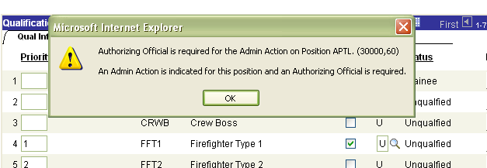

At this point, the user must go to the Justification page for that particular position and enter a valid Authorizing Official ID. Field values that are not acceptable are all 0’s or a blank field. An example is seen in the screenshot below, and must be corrected to a valid Authorizing Official. But in order to change that row of data, the user has to be in the page in “Correct History” mode.
This will cause the Qual Card screen to return you to the Show Qual Card Details page. Click Show Qual Card Details to enter back into the card in ‘Correct History’ mode. At this time please click on the justification that is identified in the error message and review the justification requirements that need to be met as described below. If you see a justification of 0’s or a blank justification, please enter a valid Employee ID and click ok. You should be able to successfully click save on the Incident Qual Card screen and the error is resolved.

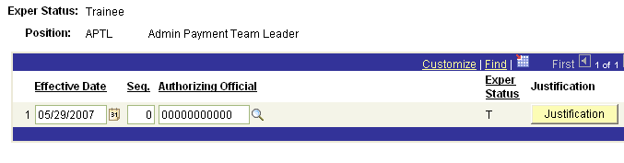

Note: The “Authorizing Official is Required” message will only occur on positions where the Admin Action is already turned on and there is no Authorizing Official, or the Authorizing Official Id is all 0’s. If the Admin Action is NOT turned on, an invalid Authorizing Official Id will not trigger the message.

If you turning on the Admin Action for the first time, the user will receive the “Authorizing Official is Required” message if they attempt to leave the justification page without entering the Authorizing Official.

Example: After turning on the Admin Action, the system will take you to the Justification page, where you can input the Authorizing Official and the Justification for the Admin Action. If the user attempts to leave the justification page without putting in an Authorizing Official, they will receive the same message as in the screenshot below.

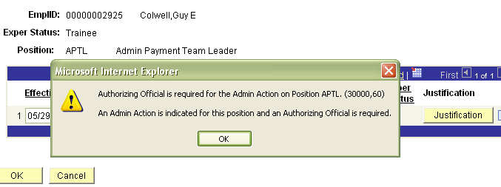

Note: At anytime, if an Admin Action occurs where the Authorizing Official is not entered, the row of data can be removed from the data base simply by clicking on the minus button for that particular row of data.


