Careering Through JPL
Alice M. Fairhurst, September 19, 2002
“Story on the Story” by Susan Hendrickson

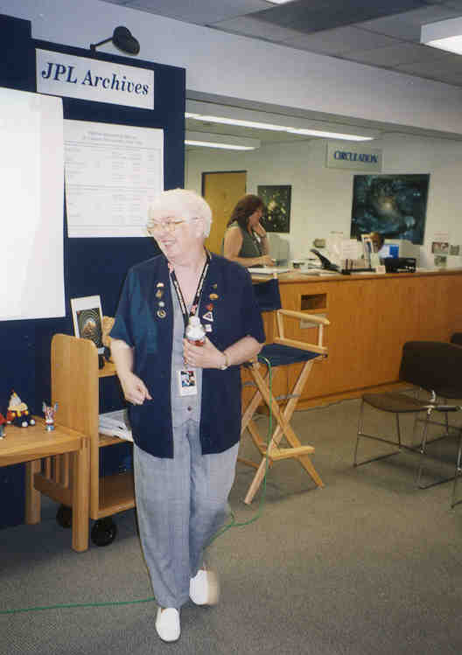

Alice Fairhurst, co-author of Effective Teaching, Effective Learning, presented an enthusiastic overview of her tenure as a JPL career development and mentoring coordinator (1991-2001). Among other things, Alice is an expert in Keirseyian Temperament and Myers-Briggs typology. The self-described “jack of all trades” offered the audience the following advice on career management:

- If one thing doesn’t work, go learn something else. Go out there and challenge yourself someplace else. Don’t stay a blacksmith when the horses are gone.
- You’ve got to have a network both inside and outside of JPL. Within JPL, network outside of your section. Outside JPL, keep up with your profession to know what skills are new. You’ve got to know what’s going on, or you’ll find yourself out-of-date.

Someone Alice had trained in “Temperament and Type” told her about a job opening at JPL that would be perfect for her. Alice was hired, and she was given the directive to involve all divisions and all job classifications in career counseling. In the past, mostly secretaries came for career development, but not enough engineers or managers. Within two years she was helping the entire Laboratory and was a key figure in JPL’s many mentoring programs.

Referring to Kenneth Brousseau and Mike Driver’s “career concepts,” Alice’s career path was partially “Spiral” because she changed at least every five to ten years (she likes growth and creativity). She also followed the “Transitory” model by making big leaps every two to four years into new fields (for variety and independence). This prepared her for what was soon to happen at JPL [downsizing]. Because JPL had been very stable, many JPL employees chose the career strategies that work best in times of stability: “Linear” (management seeker) or “Steady State”(expert) careers. Those that preferred the career strategies of change: “Spirals” and “Transitories” were few or even left JPL. When we lost the Mars Observer in 1993 and JPL began to downsize and experience high change, employees found that you can’t do a “Spiral” or “Transitory” if you don’t have a network of connections.

At the time, JPL had a paternalistic reputation, and laid-off employees were taken care of by assigning them to section 090. However, JPL is not paternalistic anymore, and you have to manage your own career. If you need career assistance, you should contact JPL’s current career counselor, Mary Ellen Derro. Alice found that employees are able to plan well for projects but not for their own careers, so she demonstrated the use of planning tools such as matrices and risk mitigation diagrams. She also found it hard to convey to employees the importance of understanding the political climate: too many had their eyes to the ground rather than finding out what was going on. She began coaching people for new positions, and she helped people understand employee and employer perspectives.

During the downsizing phase, Alice began partnering with Deanna Kramer in outplacement. People who came for counseling around this time were sad, schizophrenic about their situation, or very angry. Deanna and Alice tried to get them into their “neutral zone” by allowing them to unload, with the ultimate goal of getting them into their “happy spot” again.

Because her office was off-Lab, Alice had to work in borrowed offices, and she sometimes even counseled out of her car. At that point she even thought about quitting, but instead she stuck it out. Her efforts paid off, because JPL was recognized for excellence in career development from the California Career Development Association.

Skill development is so much faster today than it was even ten years ago. At JPL, you might find that you need to train yourself, because often the training budget is insufficient. Alice emphasized that you have to manage your own career and keep yourself up-to-date. She advised making sure you have transferable skills and joining a professional association to develop a community of support for yourself.

After the successes of Pathfinder and Sojourner, Alice became an internal organizational development consultant. She moved into her 13th office since joining JPL ten years earlier (at that point she knew she was a true JPLer!). Around that time, Alice observed a lot of cases of employee burnout. There are system archetypes on common types of problems, and one of them is found at JPL: If you put in more effort, performance goes up, but over time the system encounters a limit that causes performance to slow down, or even decline. As discussed in Tom DeMarco’s book Slack, the best way to solve this problem is to identify ahead of time the limiting factors and ease the stress. You have to ask what kinds of pressures are building up in an organization due to increased pressure on performance, and what am I going to do about it? If nothing is done, the organization’s gasket blows.

At the time, Alice asked, “What are you going to cut out?” However, this appeared to be a foreign concept at JPL. You can’t keep piling on new requirements without getting rid of things no one is willing to pay for. Alice said that when employees are overworked, there are diminishing returns on productivity, and employee health suffers. Hours worked get higher, but energy level is so low that more errors are made which puts projects at risk.

After ten years at JPL, Alice decided to retire to spend more time with her grandchildren. She now teaches a Web page design course at Cal Poly Pomona, and she continues to teach Managing Creativity with Donna Shirley at the University of Oklahoma.

