POLAR Spacecraft Status As of: Tues 5 Apr 05 16:00 EST
(changes from last week in bold border)
Subsystem/  Component | NOAA-12D  AM: 1648=AN  STIP data only | NOAA-14J  AM: 2019=AN  STIP data only | NOAA-15K  AM: 1817=AN  GAC data only | NOAA-16L  PM: 1430=AN  GAC&LAC data | NOAA-17M  AM: 2224=AN  GAC&LAC data | NOAA-N18  Planned PM  Plan AN=14:00
LAUNCHED | 05/14/91 | 12/30/94 | 05/13/98 | 09/21/00 | 6/24/02 | 11May05
CNTL OBP | OBP2 | OBP2  OBP1 inoperative | OBP2 | OBP2 | OBP2 | Dress Rehearse #1  Completed 13Jan
BUS | B-BUS  XSU-1 | B-BUS  XSU2 (XSU1 inop) | B-BUS  XSU-1 | B-BUS  XSU-1 | B-BUS  XSU-1 | Dress Rehearse #2  14Apr05
BUS VETO | NO | NO | NO | NO | NO
ADACS  X=Yaw  Y=Roll  Z=Pitch | Nominal Mode  RGmode=Monitor  Gyro chans=XYZ | Nominal Mode  Rgmode=Disabled  Gyro chans=XYZ  SS check Disabled when mode=YGC | Nominal Mode  Rgmode=Monitor  Gyro-3 Off 6/26/00 Gyro chans=AAB  N2 Low PSI invalid | Nominal Mode  Rgmode=Monitor  Gyro-3 Off 6/10/04  Gyro chans=AAA | Nominal Mode  Rgmode=Monitor  Gyro-3 Off 6/10/04  Gyro chans=AAB | New  ring laser gyro
RXO | PRI  BU random enables  daily bias+6.5 mS | PRI  BU random enables daily bias–7.0 mS | PRI  daily bias -8 mS  +100 mS 31Au04 | PRI  Daily Bias –5.5 mS  -100 mS 31Au04 | PRI  Daily Bias –3 mS
CLOCK DIV | 2 | 2 | 2 | 2 | 2
MIRP | External Synch  Rephase Enabled | External Synch  Rephase 0730 Daily | External Synch Rephase 0730 daily | External Sync  Rephase each orbit | External Sync  Rephase Enabled
TIP SIDE | 1 | 1 | 2  (since 4/23/03)  3 Channels inop | 1  Analog telem drifting  Plan swap 19Apr | 1  Analog telem drifting
DTRs | 3A, 4, 5B  Safestate 5B | 1, 2B, 5 Safestate- 1B | 1, 2, 3, 4 Safestate 1B EOT | 1,2,3,4A  Safestate 3A  4B STIP only | 1,2,3,4  Safestate=1B  DTR2-SSR | All solid state digital recorders
VTX  (APT data) | #1 ON  137.50 MHZ  Conflict starting with N15. 15 to be turned off 15 Apr | OFF  Since 8/14/02 | #1 ON  137.50 MHZ  Conflict with N12 Plan turnoff  15 Apr at 20:00z | INOP  OFF since 11/15/00 | #2 ON  137.62 MHZ | #1=137.1 MHZ #2=137.9125 MHZ
BTX | #1  136.77 MHZ | #2  137.77 MHZ | #1  137.35 MHZ | #1  137.35 MHZ | #2  137.77 MHZ
STX  #1=1698.0 mhz  #2=1702.5 mhz  #3=1707.0 mhz  #4=2247.5 mhz | 1 – HRPT;  2,3 - Playback | 3 – HRPT  2, 1 – Playback | 2-Omni HRPT  4-Playback  1,2,3-Degraded | 1 – HRPT;  2– Playback;  4 – Playback  3 low power unused | 3 – HRPT  TOAR424 low power  2 & 4 Playback  1-Standby  STX-1 output power drop TOAR 443. | STX-3 frequency drift problem caused launch slip.  Replaced at VAFB undergoing testing
POWER  (Array offset and CANT angle, charge & V/T rates, eclipse states and sun angle)  Sun-Moon  Eclipse predicted  For 8 Apr 05.  18:00-23:00Z  Minor effects on all spacecraft. | ArrayOff +50  since 8/31/04  Full Sun  Battery UVtrip 7/25/04  Sun Angle 23  Uptrend to 37 in mid-June  Batts 1&2=LRC  V/T=4  Shunt degraded  SA CANT=37 degs | Array Off -55  Since 8/21/03  Eclipse all year  Sun angle 38  up trend to 52 in June  Batts 1-3= LRC  Batts 1&3V/T=7/11  Batt2 VT=8/11  SS trigger =18.98  Shunt Degraded  SA CANT=22 degs | Array Off -45  Since 1/25/01  Full Sun  Sun Angle 12, up- trend to 32 in June  Batts 1-3= LRC  V/T=7/9  SA CANT=37 degs | Array Off -40  Since 7/16/02  Eclipse all year  Sun Angle 54  Steady trend  Batts 1-3= LRC  V/T=4/8  SA CANT=22 degs  SADPOS timer increased 5 Apr | Array Off. –40  Since 1/29/04  Eclipse all year  Sun Angle at 68  Uptrend to 72 at  the end of May  Batts 1-3= LRC  V/T= 4/8  SA CANT=37 degs  SADPOS timer increased 5 Apr
AVHRR | Nominal | INOP  Scan motor stalled  14 Apr 04 | Nominal  Rare major scan motor surges. Last  Incident 11/18/04 | Operational  TCE24 OFF 4/14/04  Occasional Image Wave patterns  Chan 3B only. | Nominal  3A-B switch enabled | New brushless scan motors
AMSU-A1 |  |  | Operational  Ch14 inoperative  Ch11 inoperative  Record low component temps reversed trend | Operational  Primary PLLO chans 9-14 bias shift.  Backup PLLO inop  Channel 9-14 noise improved since 1/19 | OFF/INOP  Since 10/30/03  Survival heat on.
AMSU-A2 |  |  | Nominal | Nominal  Space Position-2 | Nominal
AMSU-B |  |  | Operational  Bias in All Chans.  Motor surges most recent 11/14/04  IPD Reports of degraded data on Chan-3 since 4/30 | Operational  Space Position-3  IPD reports channel 8 degradation | Nominal | Replaced by MHS
HIRS | ON / INOP  Turned on 8/30/04  For power balance  Filter Wheel turned OFF 10/17/02. | NOMINAL  Operational  Occasional loss of Fwheel synch | Operational  FW mode=Hi Powr  FW Heater OFF  Frequent Filter Motor current “mini” surges  Occasional major FM current surges, most recent 12/9/04 | DEGRADED  Longwave channel imagery improved radiometric noise level is still high  TOAR 441 submitted 11 Jan05  Considering high power mode  Occasional major FM surges, most recent  12/9/04  HIRS filter heater turned OFF 1/18/05 | NOMINAL  1 Pixel cross track misalignment . | HIRS-4 replacing HIRS-3
MHS/MIU |  |  |  |  |  | Replaces AMSUB
MSU | ON / INOP  On For power balance Scan Motor OFF since 3/12/03 | Operational  Scan motor and antenna problems
SSU |  | Nominal
DCS | Nominal | Nominal | Nominal | Nominal | Nominal
SARR |  | Nominal | Operational  A-Side, AGC Mode  Intermittent failures for 243MHz A&B | Operational  A-side, AGC Mode  (B-side in FG mode)  243 MHz = INOP.  Reconfiguration planned for 6 Apr  Switch to BA mode | Nominal  A-side  All AGC Mode
SARP |  | OFF  Power Failure | Nominal  RCVR B/W = 2 | Nominal  RCVR B/W = 2 | Nominal
SEM | ON/Nominal  Turned on 8/30/04  Elec-CH-HVPS=4  Prot-CH-HVPS=0 | Operational  Elec-CH-HVPS=0  Prot-CH-HVPS=0  1 of 4 Telescopes inoperative | Nominal  E-CDEM-HVPS=2  P-CDEM-HVPS=0 | Nominal  E-CDEM-HVPS=5  P-CDEM-HVPS=4 | Nominal  E-CDEM-HVPS=2  P-CDEM-HVPS=3
SBUV |  | Degraded  Grate motor sticks  Flex memory 3 (giant step) ops suspended 12/2/03  Reduced operations |  | Operational  Degraded Ozone data  Backup Diffuser inop  Primary Diffuser deployment problem TOAR 426  AMSU EMI causing erratic Behavior in PMT cathod, range 3 | Nominal  Anode Mode
SADPOS |  |  | N/A | ON  Enabled MFactor50%  Timer changed to 12 (from 8 mins 5 APr | ON  ENABLED  Timer changed to 12 (from 8 mins 5 APr
THERMAL  Heaters, louvers  TCE’s | Nominal  TCE’s back to nominal configuration following 7/25/04 UVtrip. | Nominal | TCE26 & 15H  Telem invalid  TOAR 432  HIRS FW Heat off  TCE24L&25L (HIRS & AVHRR) failed 5/13/98  RCE thermostat failed 5/13/98 | Nominal  TCE24 OFF 4/14 (AVHRR H&L)  HIRS Filter heater turned OFF 1/18/05 | TCE3H Batt 2A heater failed ON, turned off 8/26/03 TOAR 428  CLOSED 9/14/04 no corrective action possible.  AMSU-A1 survival heaters on 10/29/03
 | N12 | N14 | N15 | N16 | N17 | NOAA-N18
COMMENTS/CHANGES:

NOAA-12 There were no changes on N12 during the past reporting period.

NOAA-14: Spacecraft is operating nominally and power subsystem remains stable and well above safe state threshold values as the long slow increase in percentage darkness time per orbit continues through mid-June 05.

NOAA-15: The N15 AVHRR was generally stable in scan motor current during the past week as component temperatures continued there uptrend (illustration 1). The synch delta was also slightly higher but is not, at the moment, something that is cause for immediate concern. The AVHRR imagery on N15 continues to be nominal.

The N15 HIRS returned back to a nominal range in the past 5 days after recovering from a filter motor current mini-surge with no reports of imagery degradation being received by EMOSS and no loss of filter wheel synch (illust 2).

The AMSU’s on N15 were all nominal during the post week as their thermal trends continued upward.

N15 is entering a RF (VTX-1) conflict period with N12 which will result in the N15 VTX-1 (APT data) being turned off at 20:00Z on 15 Apr through 07:00Z on 16 May 05. Will Chadwick is EMOSS POC for this operation.

NOAA-16 The N16 AVHRR scan motor current was slightly higher last week continuing a very slow uptrend that has generally
result in the scan motor current spending most of its time in a range that usually results in wave patterns on the imagery. In addition, the synch delta is showing sign that it may be getting ready to increase rapidly in the coming days. On the other hand, AVHRR temperatures remain very stable and well within nominal values despite TCE 24 remaining off and despite the somewhat elevated scan motor current levels, EMOSS spot checking of HRPT imagery did not find any obvious wave patterns (illustration 3 and 4). As has been the case since Nov 2004, there has still been no MIRP rephases since Nov 2004 and no bar coded imagery since last summer.

The N16 HIRS filter motor was generally stable to very slightly higher last week remaining close to but below its all
time high values (illustration 5). EMOSS continues to detect HIRS imagery degradation and also receive reports of same, while the HIRS filter wheel synch and period monitor values remain relatively nominal and stable. Discussions at the 5 April TOAR opened up the possibility that ITT would request a switch to high power mode in the hope of improving HIRS products produced by IPD which continue to be degraded. No plans for such an operation have yet been discussed beyond the conceptual stage. Sally House is EMOSS POC for this payload.

EMOSS engineers continue preparing for a TIP swap on N16 currently planned for 19 April 05. Jon Woodward and Will Chadwick are EMOSS POC’s for this operation.

EMOSS engineer Will Chadwick will be overseeing a reconfiguration of the SARR on N16 within the next several days. This reconfiguration, requested by SARSAT personnel will turn the SARR on in Mode BA by powering up the B side converter and receivers with the A side transmitter, then setting the attenuators to 5 dB (121.5 and 243 receivers and PDS channel) and 10 dB on the 406 channel.

To prevent any reasonable chance that a sun moon eclipse (predicted to occur on N16 on 8 Apr at 22:13Z) will be of a depth and duration that could result in SADPOS taking autonomous control of the solar array when it is not necessary, (as it did last October) EMOSS engineers changed the timer that implements this takeover by adding an additional 4 minutes to the previous 8 minute countdown timer. All EMOSS analysis done with its highly accurate solar eclipse model has shown that no sun-moon eclipse resulting a solar array patch current of less than 150 mAmps solar array current should ever exceed 12 minutes. Jon Woodward was EMOSS POC for this change.

NOAA-17: The N17 AVHRR scan motor current was very stable to slightly higher during the past week while synch delta and
AVHRR component temps were very stable and imagery remained nominal (illustration 6). EMOSS is continuing to monitor this payload very closely.

To prevent any reasonable chance that a sun moon eclipse (predicted to occur on N17 on 8 Apr at 19:34Z) will be of a depth and duration that could result in SADPOS taking autonomous control of the solar array when it is not necessary, EMOSS engineers changed the timer that implements this takeover by adding an additional 4 minutes to the previous 8 minute countdown timer. All EMOSS analysis done with a highly accurate solar eclipse model has shown that no sun-moon eclipse resulting a solar array patch current of less than 150 mAmps solar array current should ever exceed 12 minutes. Jon Woodward was EMOSS POC for this change.

Since 3 April, 20:20Z, the NOAA-17 Illumination Sensor Error telemetry mnemonic (BSNRDSCD), used as part of SADPOS autonomous solar array control implementation, has been miscomparing and flagging the patch current (PC) illumination sensor as in error (miscomparing with the other two illumination sensors) on every other orbit (illustration 7). In response, EMOSS engineers focused their investigation on 3 possible causes: (1) The sensor was failing,
(2) The spacecraft percent time in darkness has increased necessitating that the eclipse timer be lengthened to incorporate this increased darkness time as it did once before in Sept 2003, (3) Old ephemeris running on the spacecraft has caused the calculated darkness times to drift out of the nominal window. The most up to date analysis

N17 (cont)

has led EMOSS to the conclusion that this third possibility may be the most probable cause of this situation. N17 missed last weeks ephemeris load because the old load showed better precision than the one that was to replace it.
Therefore it was decided to leave the old load running for another week. With this coincidence coupled with additional analysis, EMOSS engineers have concluded that this old ephemeris has probably caused the eclipse timer (fix’d at 36 minutes) to “drift to the right” (illustration 8) resulting in the eclipse timer (equating to spacecraft darkness) turning on later than fresh ephemeris would otherwise determine. EMOSS is recommending that any testing or reconfiguration of N17 toward alleviating this situation await a new ephemeris load (scheduled for today; OBP=N and tomorrow; OBP=C) and additional analysis of the impact of this new ephemeris on the eclipse timer start time vs. solar array patch current comparison. If this theory holds true, the new ephemeris should push the eclipse timer back into the nominal window and all illumination sensor errors should cease within an orbit or two of the new ephemeris being activated. If this does not clear up the flag, analysis will focus back on the other two potential causes. Once all analysis has been completed, an Event Report will be distributed with highlights to be included in the next Weekly Report. Jon Woodward and Jeff Devine are EMOSS POC’s

NOAA-N: No changes since previous report. EMOSS engineers are now preparing for the second dress rehearsal scheduled for
14 Apr. The new launch support calendar has once again been made available to the general public. The new web link to review this calendar is http://sgt-mets.com/~ddipaula/poes-cal.doc

MISC: A sun-moon eclipse has been predicted by the EMOSS eclipse model. This eclipse will affect all POES spacecraft over
the course of 3 orbits from approximately 17:59 through 23:04Z on 8 Apr 05. After careful analysis (see graphs at end of this report) other than increasing the SADPOS timers (permanently) to 12 minutes on N16 and 17 EMOSS is recommending that no other reconfigurations be implemented during this event. Additional analysis will continue to be performed prior to this event to ensure the latest information has been considered. Kim Kolb, Jim Sheperd, Carl Gliniak, Jon Woodward and Jeff Devine are all involved in this analysis.

EMOSS engineer Jon Woodward will be deploying to Wallops CDA between Sunday, 10 Apr and Tues 12 Apr in a COOP exercise.

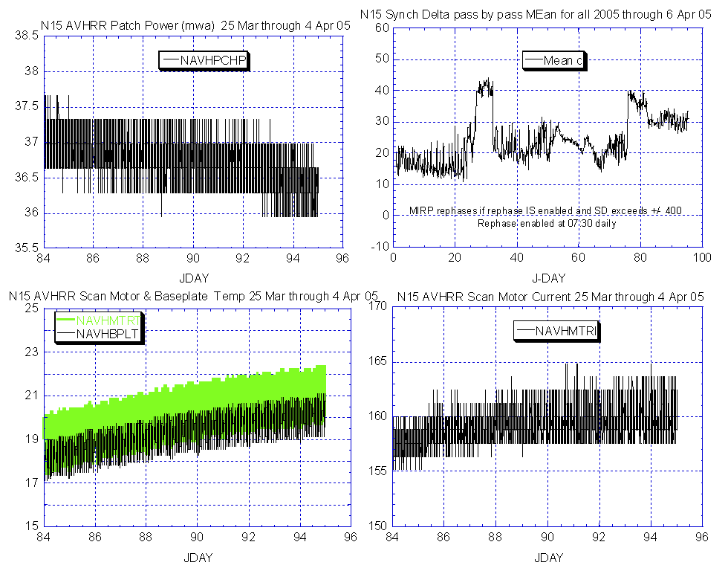

Illustration 1: N15 AVHRR Health Analysis
(Nominal and appears to have arrested the slight uptrend on scan motor current.)
.

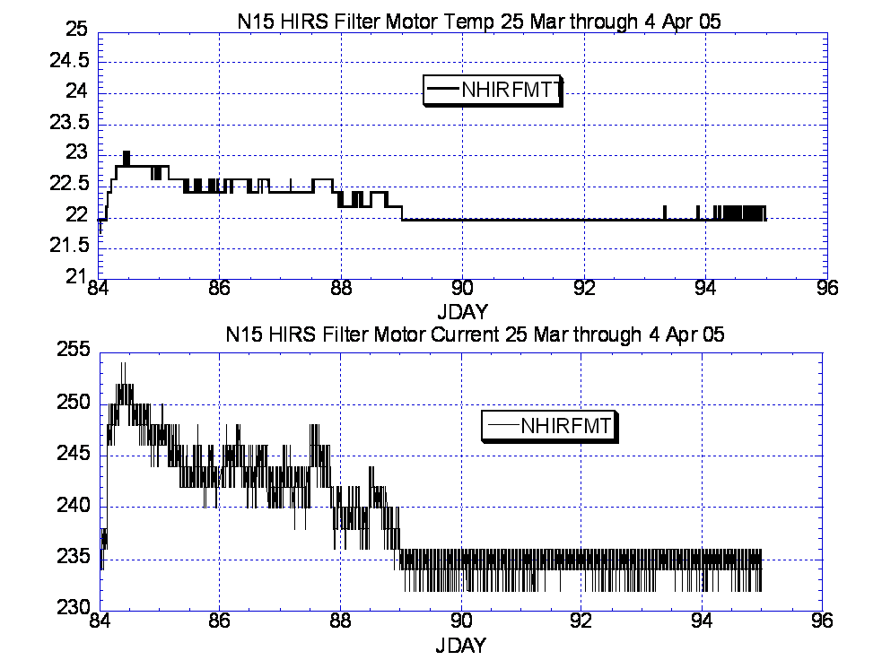

Illustration 2: N15 HIRS Health Analysis
(Looking quite nominal during the past 5 days)

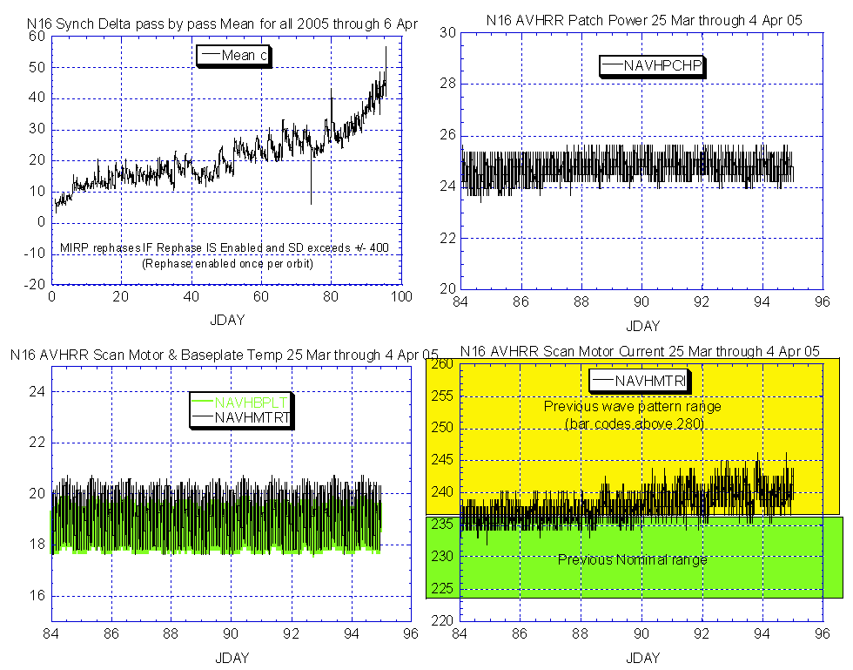

Illustration 3: 6 AVHRR Health Analysis
(Some disquieting trends but still producing nominal imagery)

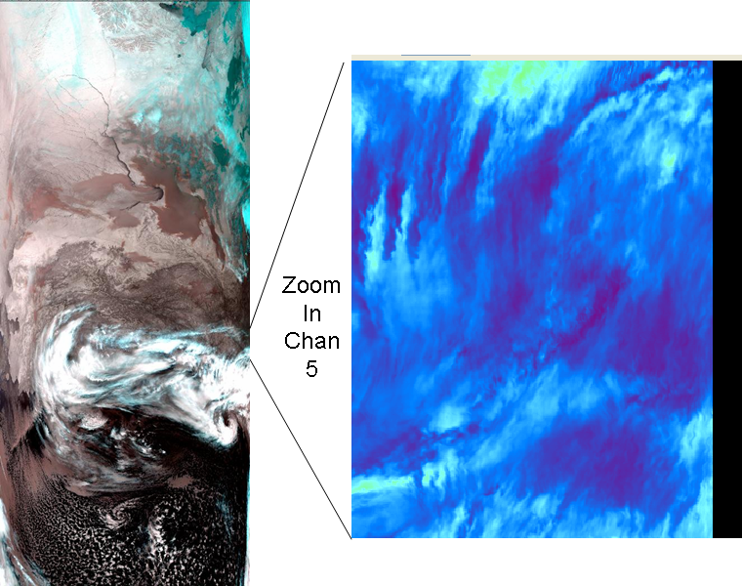

HRPT 5 Apr at 13:00Z Same image maximum zoom
(waves not readily apparent)

Illustration 4: N16 AVHRR Imagery Analysis
(Generally Nominal)

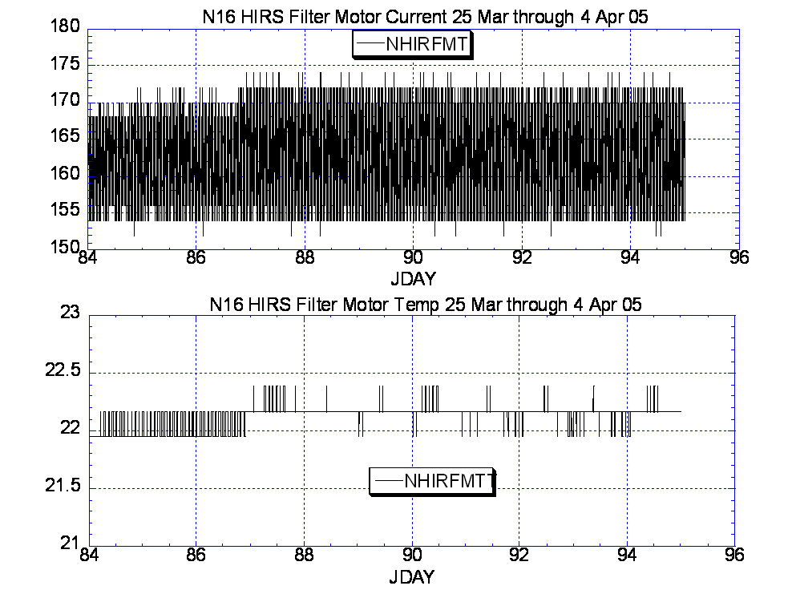

Illustration 5: N16 HIRS Health Analysis
(Generally stable although the filter motor current uptrend continues, albeit slightly. Concept discussions with ITTY and NASA have been initiated regarding the possibility of commanding the filter wheel to high power mode. No plans as yet have been formulated.)

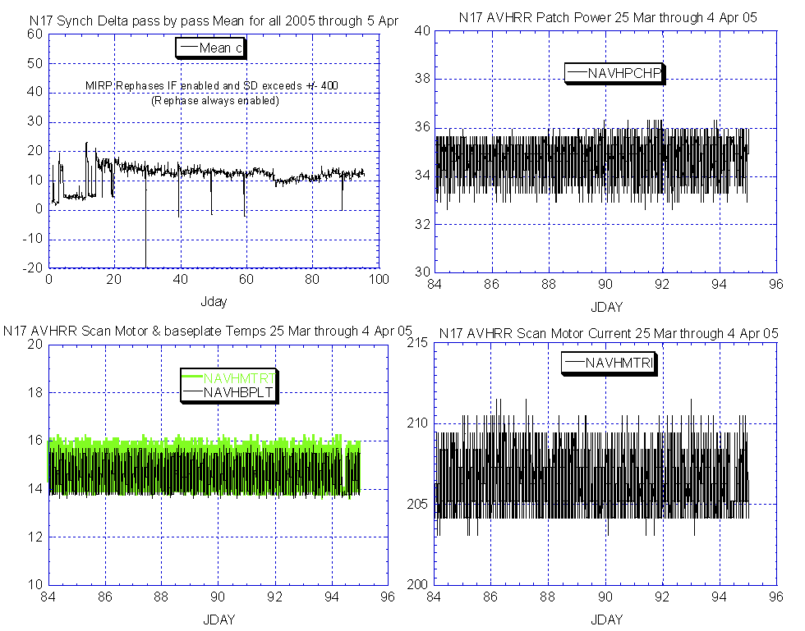

Illustration 6: N17 AVHRR Health Analysis
(Stable and nominal)

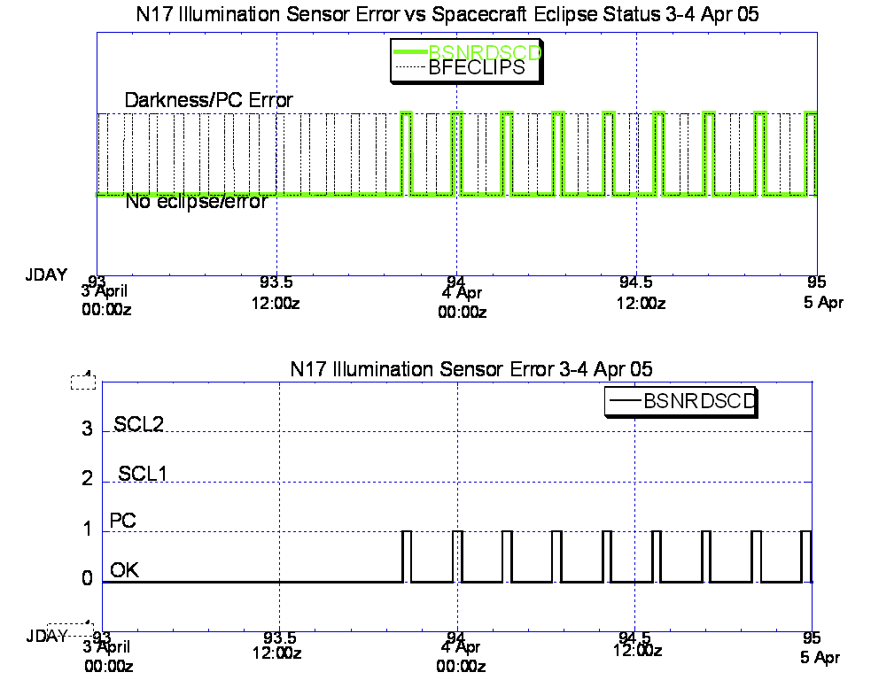

Illustration 7: N17 Illumination Sensor Error vs. Eclipse period
(Every other orbit since 3 Apr 20:20Z. Clears up after each eclipse)

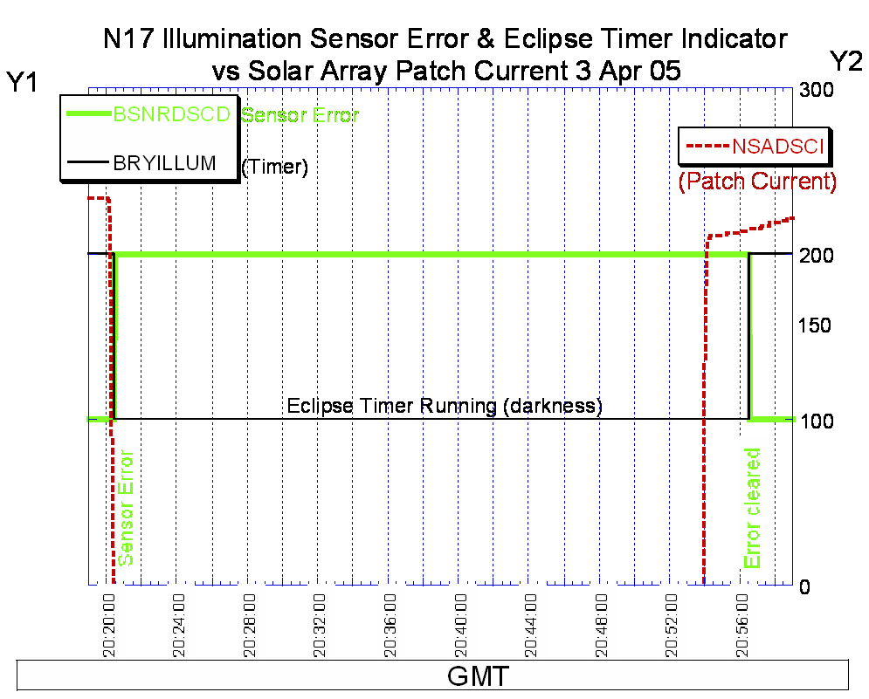

Illustration 7: N17 Illumination Sensor Error vs. Eclipse period
One full Darkness Cycle

Consider the black line FIX’d at 36 minutes per each predicted eclipse. N17 hasn’t had new ephemeris in 2 weeks. It appears that the “black line” the predicted darkness period/SADPOS timer window, may have drifted to the right, i.e. its turning on and off later than it should as evidenced by the fact that there is no time buffer on the left side of the graph when the timer starts while a 2+ minute buffer on the right side exists when the timer turns off (as depicted by the time the patch current (NSADSCI) peaks at approx 20:54 and the spacecraft “thinks” daylight (BYRILLUM) has occurred at 20:56:30. Under nominal conditions there should be about 1 minute of buffer on either side vs. the current 2 minute buffer on the right and none on the left. EMOSS is anticipating that the new ephemeris load, scheduled for 5 April for non control and 6 April for control side OBP will correct this drift by pushing the timer start time “back to the left” by approx 1 minute.

N17 MEMORY SCRUB REPORT

Last week

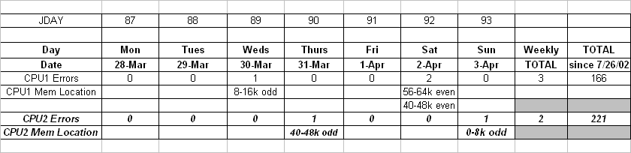

POLAR SPACECRAFT TIP CLOCK ERROR

WEEK ENDING April 1, 2005
DAY/DATE | NOAA-12 | NOAA-14 | NOAA-15 | NOAA-16 | NOAA-17
FRI. 03/25 | -186 msec | +153 msec | -123 msec | +064 msec | +021 msec
SAT. 03/26 | -187 msec | +154 msec | -122 msec | +065 msec | +020 msec
SUN. 03/27 | -187 msec | +152 msec | -123 msec | +066 msec | +021 msec
MON. 03/28 | -191 msec | +156 msec | -127 msec | +065 msec | +021 msec
TUE. 03/29 | -195 msec | +156 msec | -126 msec | +066 msec | +022 msec
WED. 03/30 | -190 msec | +157 msec | -127 msec | +065 msec | +022 msec
THU. 03/31 | -190 msec | +162 msec | -129 msec | +070 msec | +022 msec

EMOSS POC for this chart is JIM SHEPHERD

NOAA-12 *Alternating +/- 500 millisecond clock jumps will occur at 76-day intervals as long as fractional second daily ETCUP is utilized to manage clock drift. Next +500 mS jump is expected on 1/30/05.
Daily ETCUP bias of +6.5 mSec started on 12/10/03.
NOAA-14: As of 1223/03 the TIP clock is corrected daily by –7.0 msec to compensate for drift.
Subtracted 150 mSecs on 30 June
NOAA-15: As of 04/23/03 the TIP clock is corrected daily by –8 msec to compensate for drift.
Added 100 msec to spacecraft command clock on 31 Aug 04
NOAA-16: As of 12/23/03 the TIP clock is corrected daily by –5.5 msec to compensate for drift.
Subtracted 100 msec from spacecraft command clock on 31 Aug 04.
NOAA-17: As of 12/23/03 the TIP clock is corrected daily by –3 msec to compensate for drift.
Added 125 Msecs3 Feb 04.

POES Engineering Contact List

Government

Renee Smith-Dearing NOAA POES Constellation Lead 301-817-4117

Dong Han: NOAA, POES Payloads 301-817-4127

Micky Fitzmaurice: NOAA, POES Bus, IJPS 301-817-4016

Nicolaie Todirita (Todi): NOAA Ground Systems 301-817-4229

EMOSS-2 Contractor

Jeff Devine: EMOSS POES Lead 301-817-4020

Jim Walters: EMOSS, POES Payload Engineer 301-817-4033

Angelique Riley, EMOSS, POES Comm and DHS (outgoing) 301-817-4028

Carl Gliniak, EMOSS POES Power and Thermal 301-817-4207

Jim Sheperd, EMOSS POES Attitude Control 301-817-4030

Jon Woodward EMOSS, POES Flight Software C&CS 301-817-4019

Sally House EMOSS POES Payloads (in training) 301-817-4026

William Chadwick EMOSS, POES Comm and DHS (in training) 301-817-4015

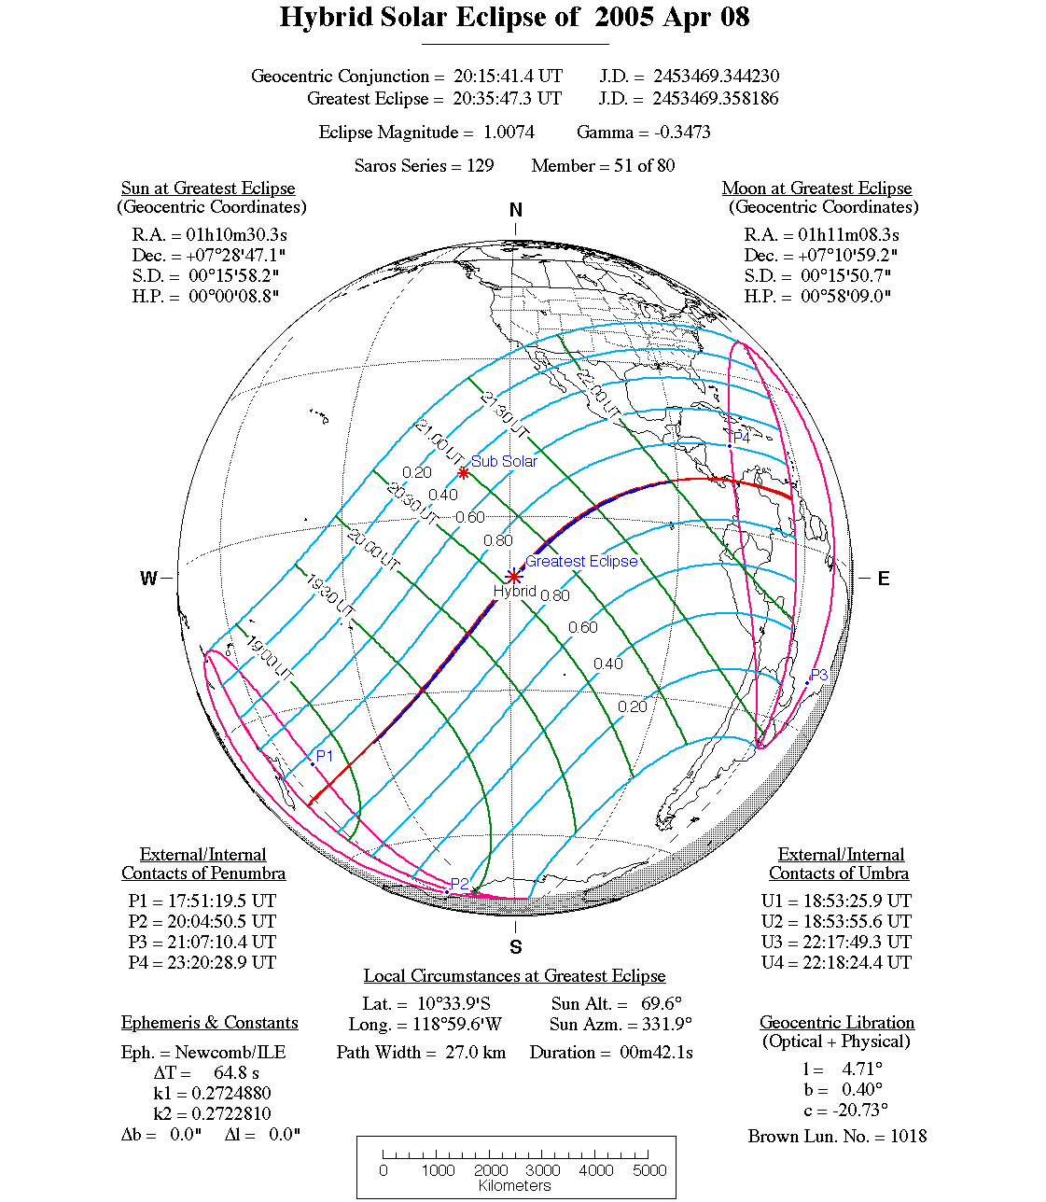

POES Eclipse Analysis for 8 April 2005 depicts the east to west movement of the solar eclipse across the earth surface. The poles are not effected by this years biannual solar event leaving all but N15 YAW updates values completely clear, reducing the number of times POES spacecraft experience this event, and allowing all spacecraft to orbit through the solar event without losing 100% sun (maximum loss 70% by N15).
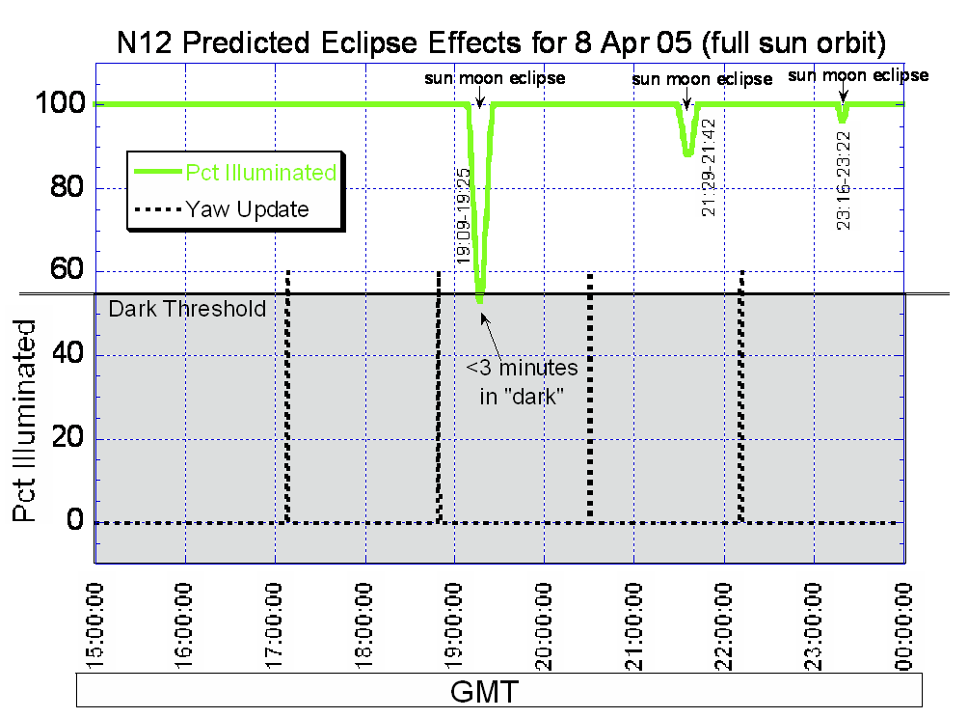

N12 Sun-Moon Eclipse Analysis for 8 Apr 05 (grey box indicates the values at which the BYRILLUM telemetry mnemonic indicates darkness.)

Effects and reconfiguration recommendations for N12 (none)

-Power balance: Eclipse effect negligible, no reconfigurations recommended

-SADPOS Takeover: Not applicable on N12, no reconfigurations possible

-Autonomous YGC Mode: No yaw updates during any reduced sun period.
No reconfigurations recommended

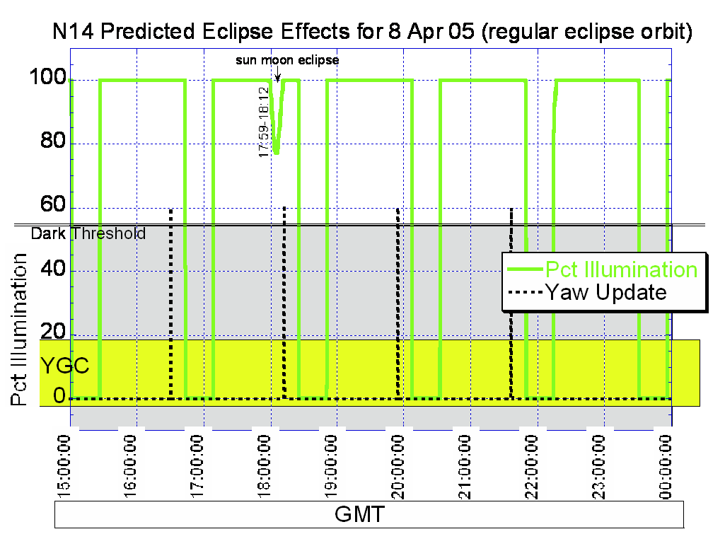

N14 Sun-Moon Eclipse Analysis for 8 Apr 05 (grey box indicates the values at which the BYRILLUM telemetry mnemonic indicates darkness. Yellow box indicates the percent illumination value threshold that would have to be reached during GEODAT predicted sunlight that could cause an autonomous switch to YGC mode during a Yaw Update)

Effects and reconfiguration recommendations for N14 (none)

-Power balance: Eclipse effect negligible, no reconfigurations recommended

-SADPOS Takeover: Not applicable on N14, no reconfigurations possible

-Autonomous YGC Mode: A yaw updates does occur at the very end of the only sun
blockage period that N14 will experience. However, the illumination value never approaches that which could threaten an autonomous switch to YGC mode.
No reconfigurations recommended

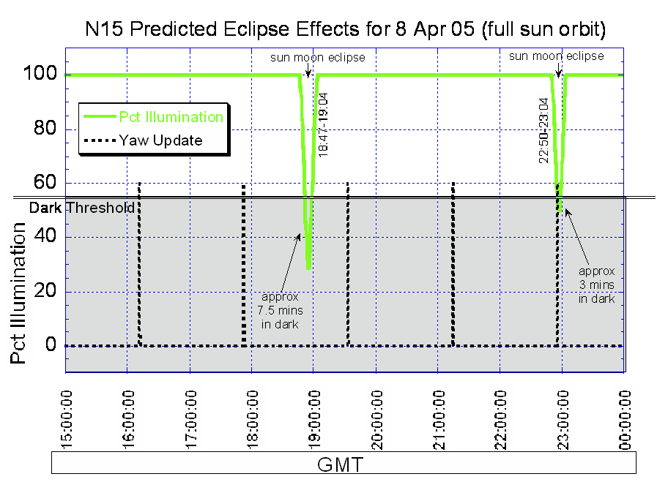

N15 Sun-Moon Eclipse Analysis for 8 Apr 05 (grey box indicates the values at which the BYRILLUM telemetry mnemonic indicates darkness.

Effects and reconfiguration recommendations for N15 (none)

-Power balance: Eclipse effect negligible on this full sun spacecraft despite the
(comparatively) “prolonged” period in BRYILLUM darkness. No reconfigurations recommended

-SADPOS Takeover: Not applicable on N15, no reconfigurations possible although the
7.5 minute “dark” period would be close to the 8 minute threshold for SADPOS takeover on N16 or N17. No reconfigurations possible

-Autonomous YGC Mode: (see next page)

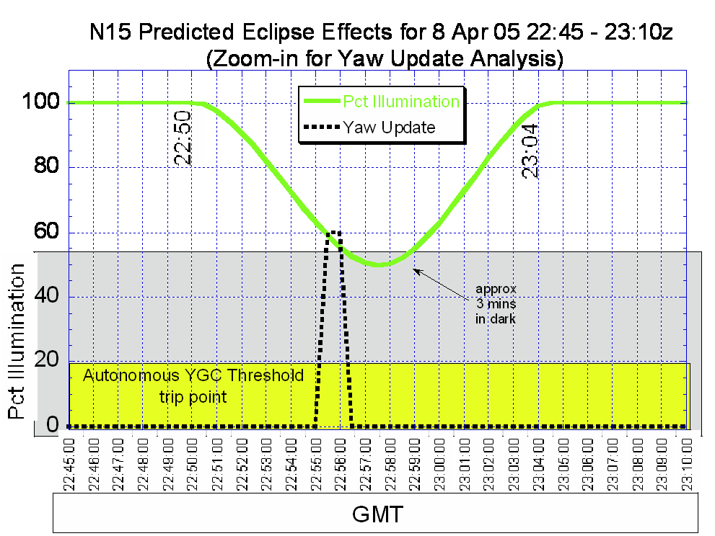

N15 Yaw Update Analysis (cont, Zoom IN from previous page)

Grey box indicates the values at which the BYRILLUM telemetry mnemonic indicates darkness. Yellow box indicates the percent illumination value threshold that would have to be reached during GEODAT predicted sunlight that could cause an autonomous switch to YGC mode during a Yaw Update)

-Autonomous YGC Mode: (from previous page) A yaw updates does occur during this
eclipse event but the predicted degree of sunlight lost (45%, equating to 55% illuminated) does not approach the value that would threaten an autonomous switch to YGC mode (80% equating to 20% illuminated). Therefore, no reconfigurations are recommended.

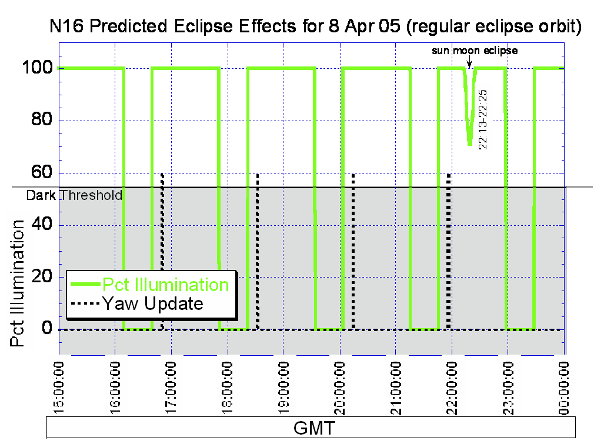

N16 Sun-Moon Eclipse Analysis for 8 Apr 05 (grey box indicates the values at which the BYRILLUM telemetry mnemonic indicates darkness.

Effects and reconfiguration recommendations for N16 (none)

-Power balance: Eclipse effect negligible; expect full charge before going back into
Earth-sun eclipse, no reconfigurations recommended

-SADPOS Takeover: SADPOS is applicable on N16. However, the darkness threshold
is never breached during this event, let alone breached for the 8 minutes that would result in SADPOS takeover. Therefore, no reconfigurations are recommended. However to be safe the SADPOS timer was permanently changed to 12 minutes as of 5 Apr 05.

-Autonomous YGC Mode: No yaw updates will occur while the sun-
moon eclipse is occurring. No reconfigurations
recommended.

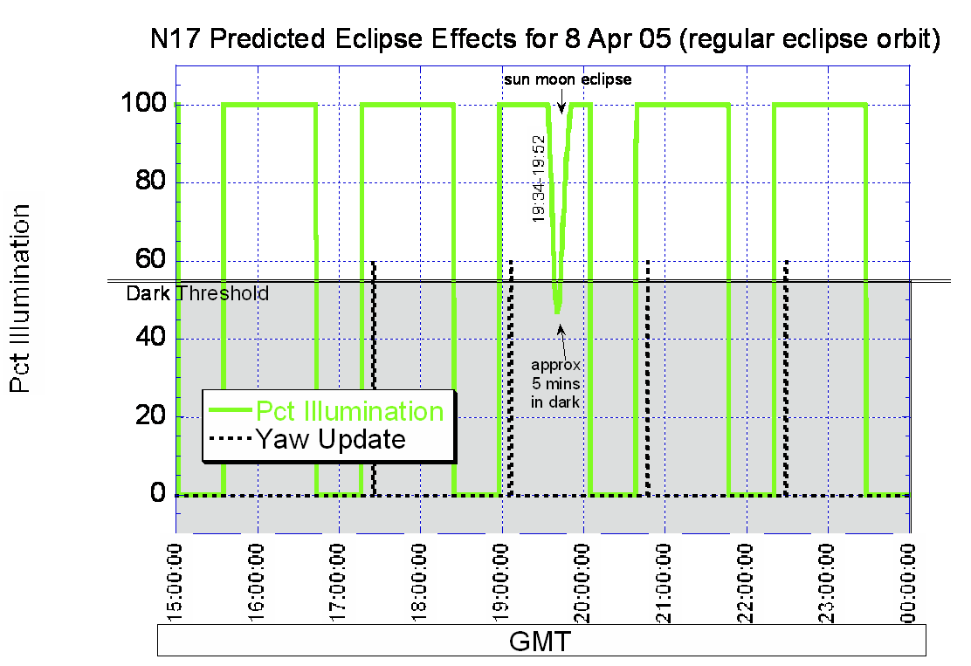

N17 Sun-Moon Eclipse Analysis for 8 Apr 05 (grey box indicates the values at which the BYRILLUM telemetry mnemonic indicates darkness.

Effects and reconfiguration recommendations for N17 (none)

-Power balance: Eclipse effect negligible; expect full charge before going back into
Earth-sun eclipse, no reconfigurations recommended.

-SADPOS Takeover: SADPOS is applicable on N17 and while the darkness threshold
is breached during this event, it is for significantly less time (5 minutes, rounded high) than the 8 minutes required for SADPOS takeover. (This analysis uses the Flight Software specs value for the BRYILLUM flag to start the 8 minute timer vs. the less conservative P&CH. Therefore, no reconfigurations are recommended. However to be safe the SADPOS timer was permanently changed to 12 minutes as of 5 Apr 05.

-Autonomous YGC Mode: No yaw updates will occur while the sun-
moon eclipse is occurring. No reconfigurations
recommended.

