Evaluation of Hyperion Performance at Australian Hyperspectral Calibration and Validation Sites
(NRA-99-0ES-01)




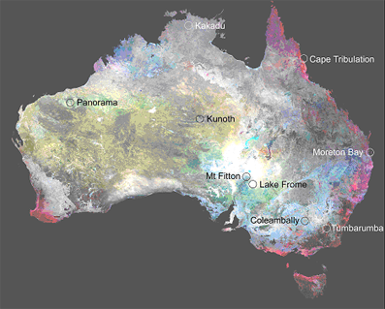

Final report to NASA

Submitted by David L. B. Jupp, PI & Bisun Datt, Co-I
CSIRO Office of Space Science and Applications
Earth Observation Centre
GPO Box 3023, Canberra, ACT 2601, Australia

On behalf of the Australian members of the Science Validation Team

Australian Principal and Co-Investigators

Person | Role | Email Address
David Jupp | Principal | David.Jupp@csiro.au
Jon Huntington | Co-Investigator | Jon.Huntington@csiro.au
Tom Cudahy | Co-Investigator | Tom.Cudahy@csiro.au
Alex Held | Co-Investigator | Alex.Held@csiro.au
Dean Graetz | Co-Investigator | Dean.Graetz@csiro.au
Craig Smith | Co-Investigator | Craig.Smith@auslig.gov.au
Terry Cocks | Co-Investigator | tdc@intspec.com
Bisun Datt | Co-Investigator | Bisun.Datt@csiro.au
Tim McVicar | Co-Investigator | Tim.McVicar@csiro.au
Fred Prata | Co-Investigator | Fred.Prata@csiro.au
Vanessa Chewings | Co-Investigator | Vanessa.Chewings@csiro.au
Cindy Ong | Co-Investigator | Cindy.Ong@csiro.au
Tom Van Niel | Co-Investigator | Tom.VanNiel@csiro.au
Arnold Dekker | Co-Investigator | Arnold.Dekker@csiro.au
Nicholas Coops | Co-Investigator | Nicholas.Coops@csiro.au
Susan Campbell | Co-Investigator | Susan.Campbell@csiro.au
Edward King | Co-Investigator | Edward.King@csiro.au
Jenny Lovell | Co-Investigator | Jenny.Lovell@csiro.au
Ross Mitchell | Co-Investigator | Ross.Mitchell@csiro.au
Denis O’Brien | Co-Investigator | Denis.Obrien@csiro.au

The Australian Sites

Site | Primary Australian Participants | US Collaborators
Lakes Frome and Argyle | Dean Graetz | Jay Pearlman, TRW
 | Susan Campbell | Pamela Barry, TRW
 | Jenny Lovell | Others at TRW
 | Edward King
Coleambally | Tim McVicar | Jay Pearlman, TRW
 | Tom Van Niel | Liang Shunlin, UM
 | Bisun Datt | Fang Hongliang, UM
 |  | Others at USDA
Tumbarumba | Nicholas Coops | Mary Martin, UNE
 | Alex Held | Marie-Louise Smith, UNE
 |  | Scott Ollinger
Moreton Bay | Arnold Dekker
 | Vittorio Brando
 | Scientists at UQ
Cairns Reef | Tiit Kutser
 | Scientists at AIMS
Mt Fitton and Panorama | Tom Cudahy | Pamela Barry TRW
 | Jon Huntington
Kunoth (Alice Springs) | Vanessa Chewings | Melba Crawford, UTA
 | Geoff Pickup
Cape Tribulation | Alex Held
 | Co-workers
Kakadu | Cindy Ong
 | Co-workers
Uardry | Fred Prata

CONTENTS

1 INTRODUCTION 1
2 PERFORMANCE AGAINST NRA PROPOSAL 2
2.1 Changes to Sites and Site outcomes 2
2.2 Data Management 4
2.2.1 Image Data 4
2.2.2 Field and Ancillary Data 5
3 APPLICATIONS SITE REPORTS 6
3.1 Tumbarumba 6
3.1.1 Site Report 6
3.1.2 Hyperion Data Processing 7
3.1.3 Conclusions 8
3.1.4 Acknowledgements 8
3.1.5 Publications 11
3.1.5.1 Journal Papers to come out of this research: 11
3.1.5.2 Conference Proceedings to come out of this research: 11
3.1.5.3 Media Reports: 11
3.2 Coleambally 12
3.2.1 Introduction 12
3.2.2 The Coleambally Site 13
3.2.3 Indices for agricultural performance 16
3.2.4 Conclusion 16
3.2.5 References 17
3.2.5.1 Journal Papers 17
3.2.5.2 Peer Reviewed Technical Reports 17
3.2.5.3 Posters 17
3.2.5.4 Media Interactions 18
3.2.5.5 Conference / Workshop Papers 18
3.3 Kunoth 19
3.3.1 Introduction 19
3.3.2 EO1 Data Processing 20
3.3.3 Conclusions 21
3.3.4 Other activities 21
3.3.5 Outcomes 21
3.3.6 Acknowledgements 22
3.4 Moreton Bay 25
3.4.1 Calibration and Validation Activities 25
3.4.2 Atmospheric Correction Procedures 25
3.4.3 Methods for Quantitative products retrieval 26
3.4.4 Quantitative products 26
3.4.5 Conclusion 27
3.4.6 Papers and presentations 28
3.4.6.1 Journal Papers 28
3.4.6.2 Conference Proceedings 28
3.4.6.3 CSIRO EOC Annual Science Meetings 28
3.4.6.4 SVT Meetings 28
3.5 Cape Tribulation – Tropical Forests & Agriculture 30
3.6 Mt Fitton 31
3.7 Panorama 32
4 CALIBRATION AND VALIDATION SITES AND FINDINGS 33
4.1 Introduction 33
4.2 Lake Frome 34
4.2.1 Introduction 34
4.2.2 Lake frome ground truth data collection 35
4.2.2.1 Reflectance Measurements 36
4.2.2.2 Navigation Measurements 37
4.2.2.3 Atmospheric Models 38
4.2.2.4 Top of the atmosphere radiance comparison 38
4.2.3 Conclusions 40
4.2.4 References 40
4.3 Uardry 42
4.4 Lake Argyle 42
5 MAJOR CONTRIBUTIONS TO MISSION AND SCIENTIFIC SUPPORT 42
5.1 ACRES data downlink, data management & outreach activities 42
5.1.1 EO 1 Mission Support 42
5.1.2 EO 1 Image data sales. 43
5.1.3 EO 1 Image Data Applications Workshop. 15 March 2002 43
5.2 HYMAP airborne Hyperspectral data base 43
6 CONCLUSIONS AND RECOMMENDATIONS 43
6.1 The Completed SVT Mission 43
6.2 The Extended Mission 44
6.3 Beyond Technology Evaluation 44
6.4 Collaboration 45
7 EO1 AND RELATED PUBLICATIONS AND PRESENTATIONS 46
7.1 Journal Papers 46
7.2 Conference Proceedings 46
7.2.1 IGARSS 2001, Sydney, Australia 46
7.2.2 IGARSS 2002, Toronto, Canada 47
7.2.3 11th ARSPC, Brisbane, Australia 47
7.2.4 SPIE Conference, Hangzhou, China 48
7.3 Technical Reports/Workshop Documents 48
7.4 Presentations at Meetings/Workshops 48
7.4.1 CSIRO EOC Annual Science Meeting, 2002 48
7.4.2 CSIRO EOC Annual Science Meeting, 2001 49
7.4.3 First SVT Meeting, NASA Goddard, February 2001 50
7.4.4 SVT Meeting, Tuscon, May 2001 50
7.4.5 SVT Meeting, Buenos Aires, November 2001 50
7.4.6 SVT Meeting, Goddard, April 2002 51
7.4.7 Final SVT Team Meeting, Hilo, Hawaii, November 2002. 51

INTRODUCTION

In 1999, a number of Australian agencies and groups made a successful application to the NASA NRA-99-0ES-01, “EO-1 Evaluation and Validation” to carry out investigations in Australia on the performance of instruments on the EO-1 Mission. The plan was to use a range of Australian sites and the capacity of the groups to deploy ground and airborne hyperspectral instruments as well as undertake detailed investigations in terms of impacts of data quality on applications as contribution to the overall evaluation and validation by the Science Validation Team (SVT) gathered together by NASA for the mission.

The EO-1 satellite was launched in November 2000 during the northern Hemisphere winter adding an increased role for the southern Hemisphere sites in the initial check-out period and early investigations of data performance. In this time, the Australian groups worked specifically with the Hyperion Instrument Team at TRW. They brought their planned field missions forward to provide support for the Instrument Team’s assessment of performance against specifications. Data from Lake Frome, Mt Fitton and the Coleambally sites were specifically used for this task.

The basic Australian activity centred around the 12 sites listed at the beginning of the document and geographically located on the image at the front of the document. The individual site reports and the outcomes from applications studied at the sites are included with this report as the Section 3.

There have been three basic phases to the Australian activity:

Phase 1: Calibration, Validation & Evaluation (year 1)

Lakes Frome and Argyle for Hyperion calibration and check-out
Coleambally for Landsat/ALI/Hyperion cross comparisons
Uardry for Hyperion check out
ACRES downlink and downlink testing

Phase 2: Applications (years 1 & 2)

Agriculture at Coleambally
Forestry at Tumbarumba
Minerals at Mt Fitton and Panorama
Water Quality at Moreton Bay
Reefs in the GBR near Cape Tribulation
Rangelands at Kakadu & Kunoth

Phase 3 (years 2 & 3)

Extended Mission – Australian bulk order
ACRES/USGS collaboration for data supply

In addition, there have been three significant activity involving international collaboration and mission support. These were:

Activity | Australian Participant | International Participant
EO-1 Data download | Ian Shepherd and Craig Smith, ACRES, Geoscience Australia | NASA Goddard, USGS
CIMEL sites (4) | Ross Mitchell, CSIRO CAR | NASA Goddard Aeronet
HYMAP Data & support | Terry Cocks, ISPL  Peter Cocks, HyVista

EO-1 data were downlinked at the TERSS X-Band station in Hobart, Tasmania and provided a means for NASA to increase acquisitions over the first year of operation. The CIMEL sites provided significant atmospheric data for a range of sites and the internationally established HYMAP instrument was used for airborne data collection at all of the Australian sites.

Working closely as part of the NASA SVT, the Australians contributed to the evaluation of the instruments, to improvements in the data processing and to development of recommendations for post-Level 1B processing that have made the data from EO-1 suitable for a range of useful applications. This led to the current Extended Mission and the semi-operational provision of EO-1 data to the world through the USGS.

Based on the improvements in Level 1 data and the recommended pathways to process Level 1 data for applications it has been found that the instruments on EO-1 and the advanced experiments have met or exceeded expectations. In the specific case of Hyperion its applications to areas such as mineral exploration and coastal waters and reefs have exceeded expectations. The instrument was, however, an experiment. It has demonstrated clearly the need for improved SNR in a future space hyperspectral instrument and it has also, through applications such as those outlined in Section 3, shown the value of developing and realising such a future mission.

PERFORMANCE AGAINST NRA PROPOSAL

The performance of the investigations making up the work plan submitted to NASA are presented on a site basis in the Section following this one. In this Section we consider more general issues and Data Management.

Changes to Sites and Site outcomes

The annual cycle of Australian southern Hemisphere summer and winter is accompanied by rains in the north in summer and generally hot and dry conditions in the south with a dry season in the north in winter and winter rains in the south. The plan presented to NASA involved eight planned sites – four in the north and four in the south.

Two of the original sites were not used for extensive EO-1 data acquisition. These were Tinga Tingana in the north of SA and Kioloa in southern NSW. The forest site at Kioloa did not have the level of ancillary data acquisition that we believed was required and it was replaced by another as described below. The Tinga Tingana site was found to have too much BRDF variation for studies with data at the resolution of EO-1 and was replaced with a salt lake (playa) nearby. However, a CIMEL located at Tinga Tingana was used effectively to provide atmospheric information to two sites, Mt Fitton and the new salt lake site (Lake Frome).

Six site activities were added to the list in the NRA proposal. The new sites and reasons for their inclusion are listed below:

Site Name | Type | Reason
Lake Frome | Summer/Winter; CalVal | Tinga Tingana was not as suitable. Lake Frome is a very bright target in the VNIR
Coleambally | Summer; Agriculture | An agricultural site was needed plus the accurate geodetic mapping provided opportunities as did the large uniform fields
Tumbarumba | Summer; Forestry site | Kioloa was not suitable and was replaced by Tumbarumba. Tumbarumba has a flux tower and extensive field data.
Moreton Bay | Winter; Water quality and coastal applications | Added when Hyperion showed better performance than expected over darker targets. Became a very significant site.
Cairns Reef | Winter; Coral reefs | Also grew in significance and is part of the same data acquisition as Cape Tribulation.
Kakadu | Winter; mine site and environment interactions | An opportunity with extensive previous data and analysis but proved difficult to acquire cloud-free images.

At the remaining initially proposed sites and the additional sites the outcomes listed in the NRA proposal were met or exceeded as described in the individual site reports. There have already been extensive reporting of the work and a wide variety of journal papers are being prepared and moved to make the results known. Of the sites the only big disappointment was Kakadu. Despite a large number of acquisitions the high cloud cover in the region and the exceptionally wet year combined to defeat us.

Briefings and press releases and articles have appeared as described in the individual site reports. In the Phase 2 of testing performance in applications there have been many excellent findings. Among these can be mentioned the better than expected performance of Hyperion for mineral mapping, the mapping of nitrogen for forestry and environmental applications, applications to coral reef mapping and water quality and the provision of time series of established hyperspectral indices for agricultural applications.

Data Management

Image Data

All EO-1 data for the Australian sites has been received and archived at the CSIRO Earth Observation Centre (EOC) in Canberra in a well-managed data storage and retrieval area. The data are managed with other EOC data holdings in stable environmental conditions. Copies of data tapes have been sent to the co-investigators upon request. The data management at the EOC consisted of entering details for each data tape into a database and sending email notification to co-investigators. ALI quick look images of the sites were also provided on the EOC website for the co-investigators to browse through before requesting copies of data tapes.

Table 1. Number of Hyperion and ALI images collected for each site.
Site | Hyperion Data (Level 1) | ALI Data (Level 1)
Cape Tribulation | 4 | 6
Kakadu | 9 | 21
Kioloa | 1 | 1
Kunoth | 13 | 20
Lake Argyle | 4 | 6
Lake Frome | 11 | 14
Mayon Volcano | 6 | 12
Moreton bay | 6 | 5
Mt Fitton | 3 | 5
Panorama | 4 | 4
Tumbarumba | 7 | 10
Uardry | 2 | 1
Coleambally | 22 | 26
TOTALS | 92 | 131

Table 1 lists the number of ALI and Hyperion images acquired for each site. The table only lists the Level 1 data available. The corresponding Level 0 ALI and Hyperion images are also archived at the EOC. We are intending to bring all of the key site and image conjunctions (such as data collected at the time of missions or special time series or applications) to a base of the Level 1B1 in the coming year. We have had significant support and help from NASA Goddard to achieve this for the most important data sites and overpasses. Since the Level 0 data are archived it would be possible to re-process any data if further developments are made to the base processing and software were available to take data from Level 0 to the new Level product.

Field and Ancillary Data

Ancillary and collateral data were collected at every site and especially for selected dates of EO-1 acquisitions. It is planned to make data available as a base for future research and teaching. The EOC web site has a collection of many electronic publications, image data, reports and information and selected site data collections. At his time base ancillary data sets have been collected and made available for:

- Lake Frome
- Coleambally
- Tumbarumba
- Kunoth

Data from other sites will be made available when it has been provided to the EOC.

At every site, HYMAP airborne Hyperspectral data has been collected and at most sites ground spectra with instruments equivalent to ASD spectral resolution have been collected. In addition, Landsat ETM data have been provided at every site when there was a successful acquisition at the same time as field work.

For the first year of the mission, due to the sensitivity of the data, the EOC EO-1 area was protected and accessed only by Co-Is with password entry. Recently, restrictions on the data in place in the initial period have been relaxed and the site has been made suitable for public access. It is hoped it will provide a resource for a growing number of studies into EO-1 data applications.

APPLICATIONS SITE REPORTS

Tumbarumba

Site P/Co-Investigator(s): Nicholas Coops / Mary Martin / Marie-Louise Smith / Alex Held
Site Name: Tumbarumba
Type of measurement: Leaf reflectances, leaf biochemistry, forest inventory data, fluxes of carbon, water and energy, plus meteorological data at time of overpass.
Measurement device: ASD FR (400 - 2500 nm)
Dates of acquisition: 25th December 2000, 1st April 2001, 19th May 2001
Latitude: S 35º 45'
Longitude: E 148º 15'
Elevation: 1200m
Surface type: Forestry (Eucalyptus, Radiata Pine, pastures, summer crops, lake, riparian vegetation)
General atmospheric conditions: Clear -to- partial clouds
Other satellite data: Landsat ETM, Limited IKONOS, CASI-2 airborne
Comments: 5m HYMAP data also available. Project is collaboration between CSIRO and Uni. New Hampshire and United States Forest Service.
Contact email: Nicholas.coops@csiro.au

Site Report

The Tumbarumba field site in South East Australia is the focus of recent studies as part of CSIRO’s ongoing soil and forest productivity project <http://www.ffp.csiro.au/nfm/mdp/>). The Tumbarumba study area is adjacent to the Snowy Mountains in southern New South Wales and covers 50,000 ha. Altitude varies from 400 m in the north-east to a maximum of 1438 m at Granite Mountain. It has a cool to cold moist sub-alpine climate with a mean annual rainfall of 680-1800 mm, with most of the area receiving approximately 1400 mm. As part of ongoing projects the area has been extensively studied and modelled using forest growth and processed based models driven in part by remote sensing inputs, to predict and assess native eucalypt forest productivity. Research has also focused on development of a GIS-based spatial soil model including development of soil fertility and soil water holding capacity indices that are integrated within 3PG-Spatial. This site is a current target of NASA’s recently launched Earth Observer-1 Hyperion instrument (http://eo1.gsfc.nasa.gov), the first space-based hyperspectral imaging spectrometer. As part of the validation of the earth observing capability of this instrument, this site has ongoing programs of research directed at the potential for remote estimation of forest canopy properties including LAI and foliar chemistry in conjunction with ongoing measurements of forest productivity. This site allowed researchers to evaluate the capacity of the Hyperion sensor on EO-1 to predict concentrations of canopy nitrogen for a range of eucalyptus species in Australia.

A total of 14 plots were located within the study area covering the full range of eucalypt species present. For determination of leaf-level foliar chemistry, leaf samples were dried and ground through a mesh sieve and wet leaf chemistry undertaken to extract nitrogen (N) and other nutrient concentrations. Plot level whole canopy biochemistry concentrations (such as N in g N of foliar biomass) were calculated as the mean of the foliar N concentration for individual species in each plot weighed by the fraction of canopy foliar mass per species. Canopy total leaf area was estimated using a camera-based point quadrat sampling technique, hemispherical photography and a LICOR 2000 instrument.

Hyperion Data Processing

A cloud free, good quality, Hyperion scene was acquired over the Tumbarumba site on the 1st April 2001. Level 1A HYPERION imagery was pre-processed within the ENVI image analysis software package using a series of pre-processing routines developed by CSIRO involving the pixel shift correction between the VNIR and SWIR spectral planes and de-streaking which involved balancing the complete image mean and standard deviation for each column and each channel. The imagery was atmospherically corrected using the ACORN Atmospheric correction and co-registered arrays were rectified to Australian Map Grid (AMG) coordinate systems to within 0.5 pixel (15 m) accuracy using 6 ground control points.

The Hyperion reflectance spectra were transformed to absorbance and a simple derivative transformation was applied. A partial least squares (PLS) regression method was used for analysis which allows the full spectrum to be reduced or represented by a series of independent variables, or latent factors, which are extracted from a spectra and leaf biochemistry matrix . From these, regression coefficients are developed for each wavelength which are directly related to the biochemical concentration of interest, while at the same time describing the spectral variation most relevant to the variation in the chemistry data.

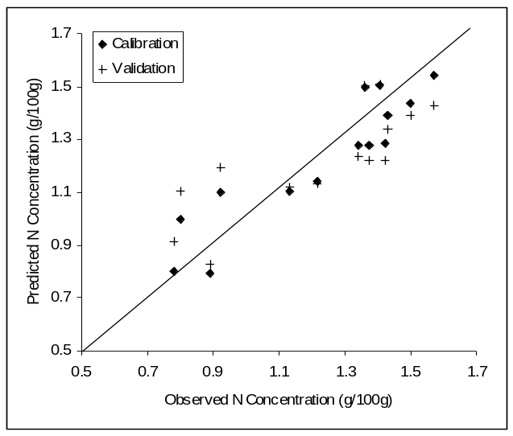
Figure ??: Predicted verus observed %N using the PLS absorbance model.

A number of models were developed from Hyperion reflectance, absorbance and derivate transformations using partial least squares regression. The most significant calibration model predicted N with a correlation coefficient (r) = 0.9 (82% variance explained) and a validation r² = 0.62 (P < 0.01). The Figure shows the predicted versus observed %N using the PLS absorbance model for both the calibration and validation values.

The standard error of the estimate of foliar N was 0.16 % equating to 13% of the mean observed %N at the site. Figure ?? shows the Earth Observer-1 Hyperion image acquired at Tumbarumba (Bago-Maragle State Forest), Australia on 1st April 2001. Image is greyscale of 803nm wavelength reflectance and ?? presents the spatial prediction of foliar % N ( 0 – 2%) based on the absorbance model.

Conclusions

The challenge to extrapolate from leaf level biochemistry, to canopy and ultimately, forest stands is an important one for the remote sensing community. The availability of eucalypt leaf chemistry, whole fresh leaf NIR, and airborne reflectance data has previously limited this application to geographically small, single scene analysis. The advent of the Hyperion sensor with its space-based platform allows imagery to be acquired and processed over much larger areas covering many different forest and vegetation communities. The application of imaging spectrometry, as detailed in this paper, indicates that estimates of canopy nitrogen concentrations over large spatial areas is possible, however the complex speciation of the eucalyptus genus can make the development of generic equations relating spectra to canopy and/or leaf biochemistry difficult. The extent to which these estimates can provide robust and accurate predictions of forest canopy condition and growth is the subject of ongoing research and similar studies worldwide will allow these findings to be placed in context with other biomes and functional types.

Acknowledgements

The Tumbarumba team acknowledges staff at the CSIRO EOC (David Jupp, Jill Huntington, Ray Merton, Bisun Datt, Jenny Lovell) as well as Steve Ungar (NASA) and Jay and Françoise Pearlman (TRW) whose efforts made this joint research program possible. In addition we acknowledge Tom Van Niel, Tim McVicar and Steve Dury for help with data processing. We also acknowledge the considerable research effort already undertaken by staff at the Tumbarumba long term forestry site. The joint Australian / US collaboration was made possible by travel grants from CSIRO EOC, CSIRO FFP and the Organisation Economic Cooperation and Development (OECD) Co-operative Research Program. We thank the directors of these programs for their interest and enthusiasm in this research.

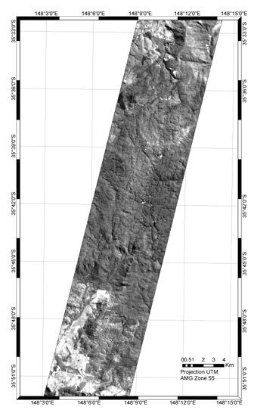

Figure ?? shows the Earth Observer-1 Hyperion image acquired at Tumbarumba (Bago-Maragle State Forest), Australia on 1st April 2001. Image is greyscale of 803nm wavelength reflectance,.
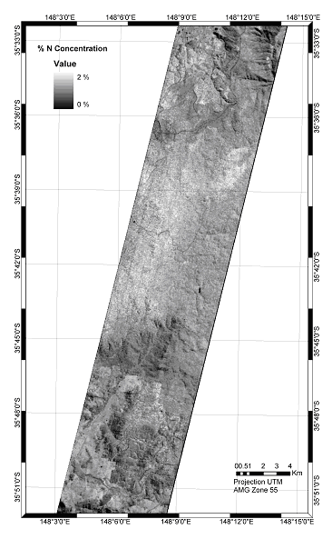

Figure ??: Spatial prediction of foliar % N ( 0 – 2%) based on the absorbance model.

Publications

Journal Papers to come out of this research:

Coops, N.C., Dury, S., Smith, M.L., Martin,. M, Ollinger, S. (2002) Comparison of Green Leaf Eucalypt Spectra using Spectral Decomposition. Australian Journal of Botany. 50: 567 – 576.

Coops, N.C., Smith, M.L., Jacobson, K. Martin,. M, Ollinger, S. (2002) Estimation of Leaf Area Index using Three techniques in a Mature Native Eucalypt Canopy. Austral Ecology. (in review).

Coops, N.C., Smith, M.L., Martin, M.M, Ollinger, S. (2002) Prediction of Eucalypt Foliage Nitrogen Content from Satellite Derived Hyperspectral Data. IEEE Transactions on Geoscience and Remote Sensing (accepted paper).

Conference Proceedings to come out of this research:

Coops, N.C., Smith, M.L., Martin, M.M., Ollinger, S.V., Held, A.H., Dury, S. (2001) Assessing the Performance of HYPERION in Relation to Eucalypt Biochemistry: Preliminary Project Design and Specifications. Proc. IGARSS'2001, Sydney, Australia, July, 2001. Paper:

Coops, N.C., Smith, M.L., Martin, M.M., Ollinger, S.V., Held, A.H., (2002) Predicting Eucalypt Biochemistry from HYPERION and HYMAP Imagery Proc. IGARSS'2002, Toronto, Canada. 24 - 29th June. Paper: 03-06-09.20

Media Reports:

Forests a blaze of colour from space Date: 03/07/01, Ref 2001/54 , http://www.csiro.au/index.asp?type=mediaRelease&id=PrsatelliteA

CSIRO Media: May 2001. A satellite eying our forests (available on CD from CSIRO National Science radio).

ABC National Radio (South Australia) 10th March 2001.

Coleambally

Coleambally.

Site P/Co-Investigator(s): Tim McVicar, Tom van Niel, Jay Pearlman, Bisun Datt & David Jupp
Site Name: Coleambally
General location: Coleambally, NSW, Australia
Type of measurement: Ground reflectance
Measurement device: ASD FR (400 - 2500 nm)
Dates of acquisition: March 7 2001
Latitude: -34.8012 (34° 48' 4.32'' S)
Longitude: 146.0136 (146° 0' 48.96'' E)
Elevation: 120 m above mean sea level, with a slope of 0° (for AT-CO CIA can be considered to be 'pan flat')
Surface type: Agriculture (irrigated) Summer Crops are rice, corn, soybeans and sorghum
General atmospheric conditions: Clear
Other satellite data: Landsat
Comments: Extensive Field Data and GIS data sets also available.
Contact email: tim.mcvicar@csiro.au

Introduction

Farmers and others engaged in agricultural management have used remote sensing products to acquire information potentially useful to them for at least the last 20 years. The type of information most useful to them, however, has been somewhat meager because of limitations of the technology, which have included the small number of fixed broad spectral bands, coarse spatial resolution, inadequate repeat cycles of data-gathering, and long delivery times for data. The EO-1 Hyperion hyperspectral spectrometer, launched in November 2000, may eliminate some of the limitations of remote sensing that agriculturalists have encountered. In particular, hyperspectral sensors can provide continuous spectral coverage through their ability to resolve the broader bands of currently operational systems such as Landsat into a large number of fine bands. The ability to provide continual spectral coverage had previously been limited to airborne systems, which experience other constraints that make it difficult or costly to acquire the most useful type of data. Airborne systems have problems relating to repeatability of data gathering, difficulty in covering large areas, and increased data processing.

The Australian CSIRO (Commonwealth Scientific and Industrial Research Organisation) has conducted a number of investigations that evaluated the EO-1 Hyperion. These investigations used existing Australian calibration and validation sites and specific hyperspectral test sites with a range of existing and ongoing data collection and analysis programs.

The Coleambally Site

One of the major investigations was conducted at the Coleambally Irrigation Area (CIA) in New South Wales, Australia. This large (95,000 hectares) agricultural area that comprises more than 500 farms, is flat and consists of large, uniform fields of varying landcover types, including a number of types of rice as well as corn, soy beans, and sorghum. The area falls entirely within two Landsat Enhanced Thematic Mapper (ETM+) scenes that make it possible to acquire both Landsat and Hyperion imagery on an eight-day repeat cycle (Figure __). In this study, a series of processing steps were taken to correct Hyperion data and reduce the effects of noise in order to produce measurements that would be valuable for farm management. The study also focused on a description of databases to be used for future instrument validation efforts and crop identification.

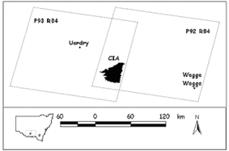
Figure __. The CIA falls completely within two Landsat ETM+ scenes, allowing for an 8-day repeat cycle

A time series of images was created by acquiring a series of 12 Hyperion images of the CIA during the 2001-2002 Southern Hemisphere summer growing season (Figure __). On-site ground sampling was also performed several times during the growing season to validate the spectral signatures received from Hyperion. In addition, scanner data from the Hymap airborne hyperspectral imaging spectrometer at 5 meters spatial resolution was acquired on January 12, 2002, to provide an accurate geographic basic image (Figure )__). (A high-resolution digital air photo mosaic is acquired over the CIA every January.)

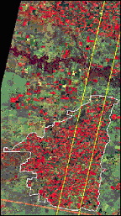
Figure __. Site of Hyperion image acquisitions

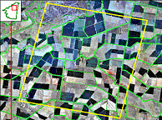
Figure __. High resolution digital air photo acquired in January 2000 to support the 2000/2001 summer (Southern Hemisphere) growing season

Geometric correction was undertaken using Hyperion images acquired in the previous growing season. The study showed that Hyperion geometry was stable. Further, two bands (Band 57 and Band 78) were compared, and results indicated that processing to Level 1B_1 had excellent VNIR and SWIR co-registration. On the basis of this study the complete time series has been registered to less than half a pixel accuracy between every image pair.

Hyperion data requires atmospheric correction, particularly in regard to atmospheric water vapor. HATCH, FLAASH, and ACORN atmospheric correction programs were used to measure the amount of water vapor. It was found that most methods of normalizing time series data were effective, but that some residual noise remained. This required that extra data cleaning and feature selection be performed. Also, a subset of 150 bands was selected from the total number of Hyperion bands in order to develop measurements from those bands considered “stable.”

Another source of noise particularly visible and most pronounced in the SWIR bands was vertical streaking. Excellent noise reduction was obtained by equalizing column means and variances. Figure __ shows MNF (Minimum Noise Fraction) Bands 1 and 15 before and after de-streaking. Figure __ shows the visual impact of de-streaking.

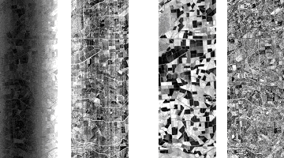
MNF 1 Radiance | MNF 15 Radiance | MNF 1 Radiance | MNF 15 Radiance
Original Data |  | De-Streaked Data
Figure __. MNF Bands 1 and 15 before and after de-streaking.

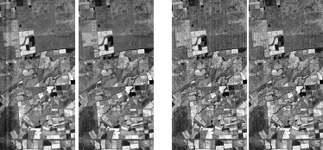
Original Data | De-Streaked Data | Original Data | De-Streaked Data
VNIR |  | SWIR
Figure __. Visual impact of de-streaking.

The time series of images produced a large volume of data that would need processing before it could be used to measure soil and crop constituents. One way to organize this data is to “bin” the 150 spectral bands into synthetic Advanced Land Imager (ALI) bands and process the data into major land cover types. Atmospheric correction would already have been applied at the fine spectral level and the final data would exhibit a high SNR. This stratification into synthetic ALI bands should allow the most effective selection of indices.

Indices for agricultural performance

The work being undertaken has made use of a range of indices that have been used at other sites and in other work at Coleambally to measure yield, stress, crop health, crop condition (such as nitrogen content), water content and cover. The value of these indices is well-established from airborne platforms and through the use of hand-help spectrometers and in laboratory studies. The capacity for Hyperion data to be used to map these from space has been assessed and it has been found that many of the indices can be successfully extracted from Hyperion data provided the data are pre-processed using the kind of methods outlined above. If the data are effectively pre-processed and atmospherically corrected then data series consistent with what can be obtained from airborne instruments can be derived (albeit with lower SNR) from the space data. However, an extensive time series such as that obtained from EO1 could not be afforded through airborne data acquisition.

Conclusion

This investigation demonstrated a way to process a time series of hyperspectral images to noise-reduced and normalized them so that they can be used to provide land use and other relevant spatial data. It has shown how time series of space data for regions anywhere in the world can be put together and how the proven benefits of hyperspectral data processing for agriculture can be applied in many cases at a broad scale and for regional surveys. Satellite data does not replace the kind of information that can be acquired from the air or on the ground but it can provide complementary world-wide regional scale information at affordable costs.

References

Journal Papers

Jupp, D.L.B., Datt, B., McVicar, T.R., Van Niel, T.G., Pearlman, J.S., Lovell, J. and King, E.G. (2002) Improving the Analysis of Hyperion Red Edge Index from an Agricultural Area. Society of Photo-Optical Instrumentation Engineers (SPIE), Journal of Optical Engineering. (Submitted).

Datt, B., McVicar, T.R., Van Niel, T.G., Jupp, D.L.B. and Pearlman, J.S. (2002) Pre-processing EO-1 Hyperion hyperspectral data to support the application of agricultural indices. Institute of Electrical and Electronics Engineers (IEEE), Transactions on Geoscience and Remote Sensing. (Accepted).

Liang, S. Fang H. L., Thorp L., Kaul, M., Van Niel, T.G., McVicar, T. R., Pearlman J. S., Walthall, C. L., Daughtry, C. S. T., and Huemmrich, F. (2002) Estimation of land surface broadband albedos and leaf area index from EO-1 ALI data and validation. Institute of Electrical and Electronics Engineers (IEEE), Transactions on Geoscience and Remote Sensing. (Accepted).

Peer Reviewed Technical Reports

McVicar, T.R., Van Niel, T.G. and Jupp, D.L.B. (2001) Geometric Validation of Hyperion Data acquired by Earth Observing 1 Satellite at Coleambally Irrigation Area. CSIRO Land and Water Technical Report 46/01.

Posters

McVicar, T.R., Van Niel, T.G. and Campbell, S.K. (2002) Coleambally Irrigation Area: A Time Series Remote Sensing Site. Presented at the 11th Australasian Remote Sensing and Photogrammetry Conference, 2-6 September, Brisbane.

Van Niel, T.G., McVicar, T.R. and Edge, F. (2002) Coleambally Irrigation Area, Riverina District, New South Wales. ACRES Update, Geoscience Australia. Issue 26, September 2002, A-3 poster.

Media Interactions

McVicar, T.R. ABC Radio Wagga Wagga NSW “NASA and Coleambally Irrigation Area” September 5, 2001.

McVicar, T.R. The Weekend Australian “NASA helps beat salinity” September 1-2, 2001, pp 22.

Conference / Workshop Papers

Jupp, D.L.B., Datt, B., McVicar, T.R., Van Niel, T.G., Pearlman, J.S., Lovell, J. and King, E.G. (2002) Improving the Analysis of Hyperion Red Edge Index. Society of Photo-Optical Instrumentation Engineers (SPIE) Third International Asia-Pacific Remote Sensing Symposium “Remote Sensing of the Atmosphere, Ocean, Environment and Space Conference”. Hangzhou, China, 23-27 October.

McVicar, T.R., Van Niel, T.G., Jupp, D.L.B. and Edge, F. (2002) Remote Sensing Research at Coleambally Irrigation Area. ACRES Update, Geoscience Australia. Issue 26, September 2002, 5-8. With accompanying A-3 poster.

Pearlman, J.S., McVicar, T.R., Van Niel, T.G., Jupp, D.L.B., Datt, B., Campbell, S.K., Lovell, J.L., Mitchell, R.M., Barry, P. and Liang, S. (2002). Assessing the Value of a Time Series of EO-1 Data for Coleambally Irrigation Area. Proceedings of the International Geoscience and Remote Sensing Symposium, Toronto, July 2002.

Van Niel, T.G., McVicar, T.R., Campbell, S.K., Liang, S., Kaul, M., Pearlman, J.S., Clancy, P., and Segal, C. (2001) The Coleambally Agricultural Component of Hyperion Instrument Validation. Proceedings of the International Geoscience and Remote Sensing Symposium, Sydney, July 2001.

Liang, S., Fang, H., Kaul, M., Van Niel, T.G., McVicar, T.R., Campbell, S.K., Walthall, C., Daughtry, C. and Pearlman, J. (2001) Land Surface Bio/Geophysical Variable Estimation for EO-1 Data and Validation. Proceedings of the International Geoscience and Remote Sensing Symposium, Sydney, July 2001.

Kunoth

Site P/Co-Investigator(s): Vanessa Chewings
Site Name: Kunoth
Type of measurement: Hyperion, ALI
Dates of acquisitions : Dec, 2000 – Oct 2001.
Type of measurement: cover
Measurement device: wheelpoint
Dates of acquisitions : May 29, 2001
Type of measurement: Airborne video transects. 4 transects at 0.2m
pixel resolution1 transect at 0.5m, 2 transects at 1.0m, 2 transects at 1.7m.
Measurement device: DMSV airborne video 450, 550, 650, 770nm
Dates of acquisitions : May 9, 2001
Type of measurement: Ground reflectance
Measurement device: GER 3700.
Dates of acquisition: October 11-16, 2000
Latitude: -23° 33'
Longitude: 133° 34'
Elevation: 700m
Surface type: semi-arid rangelands containing floodplain, open woodland, acacia shrubland.
General atmospheric conditions: Clear
Other satellite data: Multitemporal Landsat, SPOT PAN, JERS-1 prior to 2001.
Comments:
Contact email: Vanessa.Chewings@csiro.au

Report by:
Vanessa Chewings, Gary Bastin and Janine Kinloch.
CSIRO Sustainable Ecosystems, Centre for Arid Zone Research.
P.O. Box 2111, Alice Springs, NT 0871, Australia.
Tel: (08) 89 507127, Fax: (08) 89 507187, Email: Vanessa.Chewings@csiro.au

Introduction

The Kunoth arid zone application site is a complex area with high spatial variability consisting predominantly of grassland, open woodland, floodplain and Acacia shrubland (Photo 1). Our interest is in the potential of hyperspectral remote sensing to improve our understanding of ecosystem functioning in the rangelands and provide insight into where remote sensing can provide useful surrogates for monitoring components of biodiversity. Potential applications include landscape function analysis, litter and nutrient cycling and vegetation structure as an indicator of habitat quality.

A number of scenes from the Hyperion system and the ALI instrument on board the EO-1 platform were acquired over the Kunoth site in central Australia during the instrument test phase in 2001. There was an abundance of pasture growth with relatively high cover present on much of the area during this time. The passes covered periods when the vegetation was actively growing as well as when the grass and herbage layers were senescent.

EO1 Data Processing

Two main approaches are being used to explore the potential for Hyperion imagery to provide information that could be useful for biodiversity surrogates. Techniques tested include indices based on the ‘red-edge’ feature of photosynthetic vegetation (680nm to 760nm) and unmixing techniques to produce abundance fractions of components of interest.

The Hyperion imagery acquired on February 26, 2001 and August 4, 2001 was processed by TRW to Level 1 (Feb) and Level 1_A (Aug). Several pre-processing routines developed by CSIRO were applied including a ‘de-streaking’ routine. ACORN software was used by CSIRO colleagues to correct the imagery for atmospheric effects and convert to apparent surface reflectance. DMSV airborne data were acquired May 9, 2001. After preprocessing, the DMSV imagery was classified into broad components of soil, green vegetation, dry vegetation, litter and shadow to provide ground truth information to assist in validating analyses of Hyperion imagery.

Hyperion false colour imagery for the area analysed is shown in Figure 1. The darkest areas are fairly dense mulga, the bright areas scalded floodplain and the blue areas (August image) are grassland, with some open woodland. The February image has more actively growing vegetation shown in red, especially along the floodplain in the south east corner of the image. The August image represents more typical conditions as the ground layer or herbage is dry. At times such as this the photosynthetic component will consist of mainly trees and shrubs.

The spectral response of main soil and vegetation features obtained from the Hyperion instrument are shown in Figure 2. PVg refers to green grass and shrubs with green canopies such as whitewood (Atalaya hemiglauca) and PVm refers to shrubs with grey foliage such as mulga (Acacia aneura). NPV includes standing dry grass and litter while NPVs refers to sparse dry vegetation. The PV sample for the February image has much higher reflectivity in the NIR region than the August sample. We have found that vegetation indices based on red edge features such as narrow band NDVI and the slope of the red edge at the inflection point are able to separate broad groups of woody vegetation consistently.

Several approaches to spectral mixture analysis are being tested including Linear Unmixing, Match Filter and Spectral Angle Mapper procedures although as the intent of this research was to explore techniques of deriving abundance for sub pixel components, we concentrated on Linear Unmixing. Four areas were selected along the aerial video transect for evaluation of the abundance fractions. These were a floodplain site, an open woodland site, a grassland site with predominantly NPV and a mulga shrubland site.

A number of the linear unmixing and matched filtering tests yielded similar results and produced credible fraction images. An example of the August imagery unmixed with the August image spectra in Figure 1 (b) using 43 channels in the visible and near infrared range is shown in Figure 3. The component images of Soil, PV and NPV reflect the structure of the vegetation in the image very well although significant spatial structure remained after unmixing, with the highest errors on the floodplain. When values for each of the abundance images for four sites were compared with the classified aerial video imagery the open woodland, grassland and mulga shrubland sites showed reasonable consistency. However there was some confusion with soil and NPV classes, as the NPV image spectra used is a mixture of soil and NPV.

Conclusions

Our experiences show that abundance images with meaningful spatial structure can be easily produced from Hyperion imagery. However, consistently accurate results appear to require a suite of unmixing techniques that adequately cater for the inherent variability of arid zone vegetation.

As the Hyperion images were processed to Level 1, Level 1A and Level 1B, we are planning to apply recently developed CSIRO correction procedures to six of the acquisitions in order to have a consistent product for analyses. We will then be able to investigate the spectral properties of the vegetation through a phenological cycle.

Although the results are preliminary, the work has provided a valuable opportunity to evaluate data from an Earth-orbiting imaging spectrometer satellite in a semi-arid environment.

Other activities

We were pleased to be able to show several delegates following IGARSS 2001 in Sydney the Kunoth site. Visitors included Jay Pearlman (formerly TRW) and Melba Crawford (Univ of Texas).

The ALI imagery acquired during the EO-1 passes provides a valuable record of local conditions during 2001 after exceptionally good rainfall over a larger area than covered by the Hyperion imagery. Material was produced for the Alice Springs community using ALI imagery from February 2001 which showed actively growing areas of vegetation. Most of these areas represent buffel grass, an introduced grass which has an impact on the biodiversity of the area and which resulted in severe fires during 2001. The ALI images acquired throughout 2001 clearly show the extent of some of these fires.

Outcomes

Chewings, V.H., Bastin. G.N., Crawford, M. M. and Kinloch, J.E. (2002). Characterisation of Vegetation Components in the Australian Arid Zone using EO-1 Hyperion imagery. Procs.11th Australasian Remote Sensing Conference, Brisbane, 634-646.

Acknowledgements

This work was undertaken as part of a collaborative EO-1 science validation program of CSIRO EOC and NASA. David Jupp (EOC) arranged the acquisition of Hyperion imagery. Researchers from the University of Texas provided technical advice.

[Images on following pages]

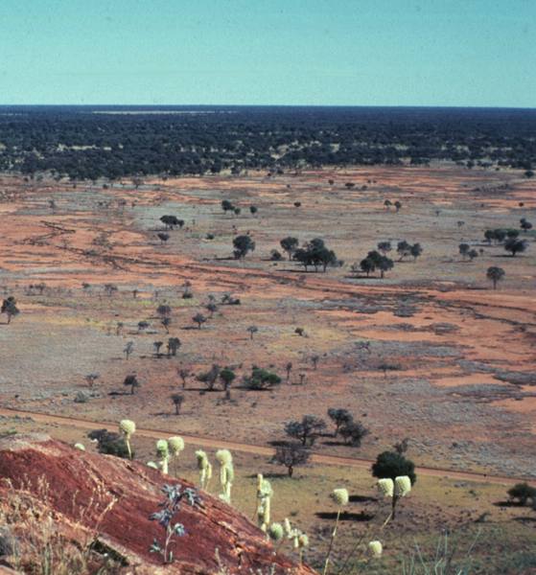
Photo 1. Kunoth Paddock, Central Australia.
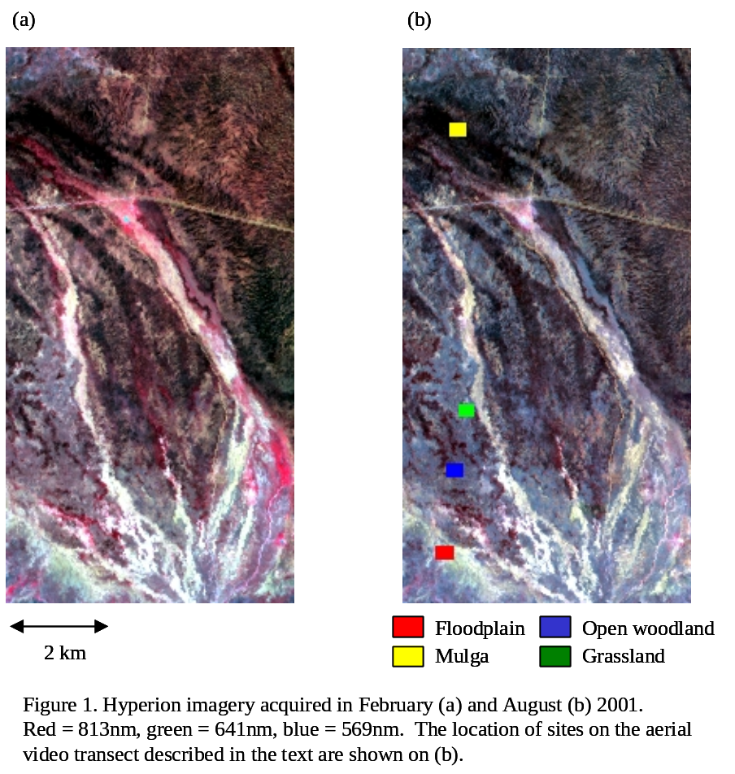
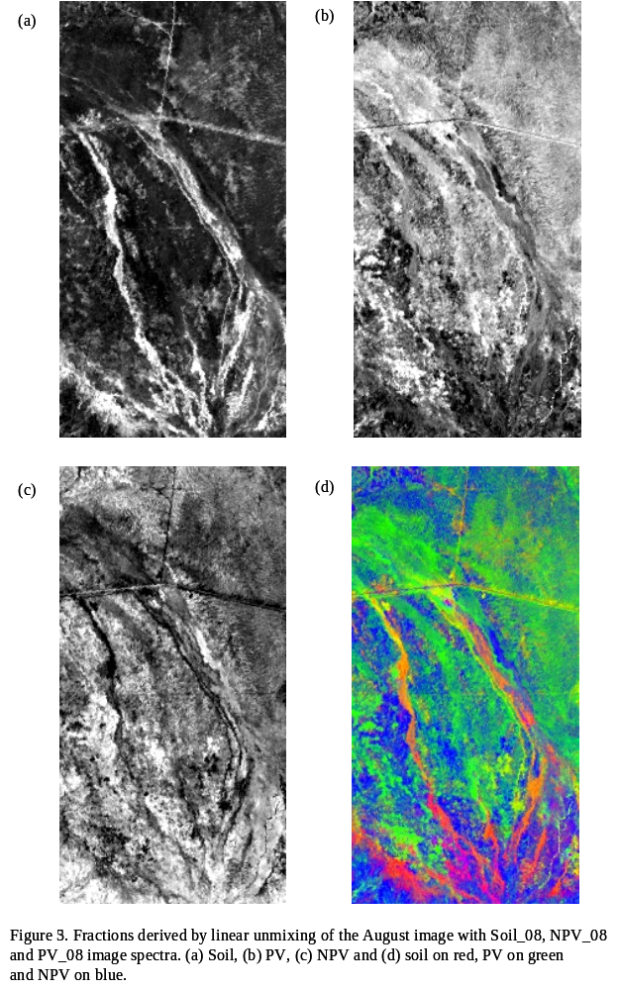
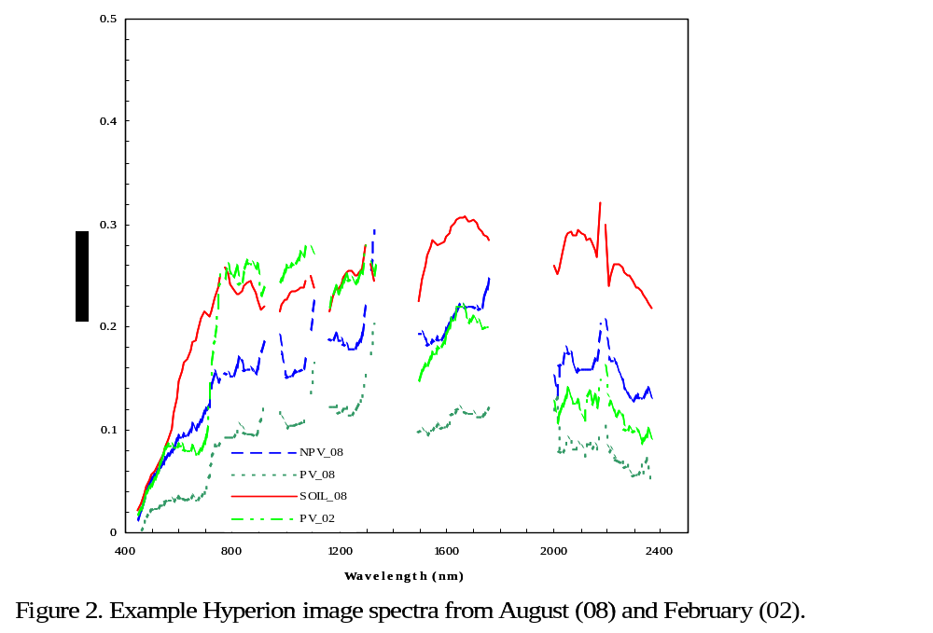

Moreton Bay

Site P/Co-Investigator(s): Vittorio Brando, Arnold Dekker
Site Name: Moreton Bay
Latitude: -27.1
Longitude: 153.133
Elevation: 0 m
Surface type: Coastal waters
General atmospheric conditions: cloud free on almost all the dates, on the exact location
Other satellite data: landsat7 ETM, Modis
Comments:
Contact email: vittorio.brando@csiro.au

Calibration and Validation Activities
During the SVT Southern Hemisphere campaign Moreton Bay Hyperion and ALI imagery was acquired six times from December 2000 to July 2001. A summer, autumn and winter image are cloud free for Deception Bay (12 January 2001, 2 April 2001, 7 July 2001).
During each Hyperion overpass a limited set of spectroradiometric measurements and in situ sampling was carried out by the University of Queensland in Deception Bay. Two extensive joint field campaigns were carried out in February 2001 and June 2001 to parameterize a bio-optical model for Moreton Bay for both optically deep and shallow waters. The field campaign collected inherent and apparent optical properties as well as concentrations of water constituents and substrate reflectances.

Dates of acquisitions | Type of measurement: | Device
12 Jan | Water leaving radiance, Downwelling Irradiance, water column profiles | ASD
1 Mar | Water leaving radiance, Downwelling Irradiance, water column profiles | ASD
2 Apr | Downwelling Irradiance | ASD, Ramses
5 Jun | -- | --
21 Jun | Water leaving radiance, Downwelling Irradiance, water column profiles | ASD, HydroRAD, RAMSES
7 Jul | -- | --

Atmospheric Correction Procedures
The dedicated a “coastal Waters and Ocean MODTRAN-4 Based ATmospheric correction” (“c-WOMBAT-c”) procedure was developed in this work to perform atmospheric and air water interface corrections to a high degree of accuracy. The “c-WOMBAT-c” procedure was implemented in IDL/ENVI® and includes an air/water interface following De Haan et al., [7, 8]. The procedure consists of: i) a three step atmospheric inversion from at-sensor-radiance to apparent reflectance [8, 9] and ii) a two step inversion of the air-water interface from apparent reflectance to subsurface irradiance reflectance [7]. “c-WOMBAT-c” applies a full MODTRAN-4 atmosphere parameterization and characterization to run the inversion. Adjacency effects in the imagery were corrected for using a spatially averaged radiance image generated by convolving the radiance imagery with a one square kilometre spatial weighting function [7, 9].
The atmospheric parameterization for the 12th January 2001 image was based on: radio-sonde data to estimate the water column contents and the actual and 24 hour average wind speed; and TOMS data for estimating ozone content. The atmospheric correction was validated by comparing the R(0−) extracted from the 12th January Hyperion imagery to the R(0−) measured in situ at the time of the overpass (see Fig. 1).

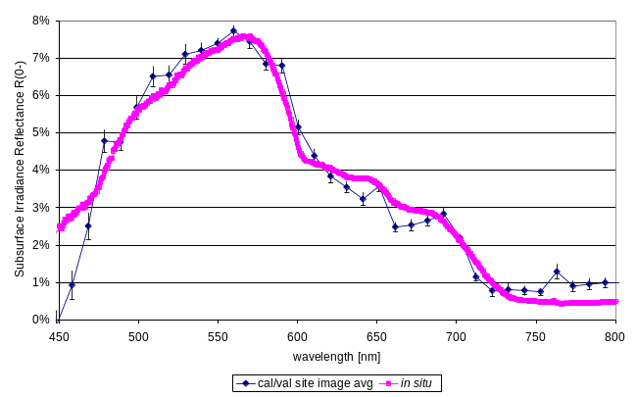
Fig. 1. Validation of atmospheric correction. Comparison of the R(0−) extracted from Hyperion imagery with the R(0−) measured in situ at the time of the overpass.

Methods for Quantitative products retrieval
Using inherent and apparent optical properties as input to an analytical optical model, it was possible to simulate the effect on R(0−) of any range of water quality variable concentrations, such as colored dissolved organic matter, chlorophyll and suspended matter present at the time of a Hyperion overpass (provided the specific inherent optical properties do not vary significantly). By inverting this analytical model it becomes possible to determine the capacity of Hyperion to estimate concentrations of water quality variables with a known degree of precision and accuracy. The precision and accuracy of these estimates are a function of the sensitivity of Hyperion, of the preprocessing and of the (inversion of the) analytical model

Quantitative products
The matrix inversion method was applied successfully for the first time to satellite hyperspectral imagery. Since the MIM encompasses the simultaneous retrieval of all constituent concentrations it automatically accounts for the complex interaction of the constituents with light in water.
Fig. 2 shows the products retrieved inverting the (5x5 low pass) filtered R(0−) Hyperion imagery of Deception Bay of January 12th 2001. The pseudo true color image (Fig. 2a), shows a resuspension eddy in the center of the bay due to the anticlockwise circulation pattern of the “rising’ tide. The water quality of the Deception Bay is determined by interaction of the open ocean waters flushing the bay (from the top right corner) with the turbid and humic Caboulture River input (off the south-west corner of the Hyperion image, but clearly visible in the Landsat 7 TM image acquired within 1 minute from Hyperion) in the lower left corner.
The chlorophyll map (Fig. 2b) shows four areas almost uniform in values while the CDOM and Tripton images (Fig. 2 c&d) show high concentration likely to be caused by sediment re-suspension due to the tidal eddy in the central part of the bay. The tripton image reaches the maximum concentration values in the lower left corner where a sediment resuspension due to the tidal pattern is visible in the pseudo true color image (Fig. 2a).

Conclusion
Hyperion imagery, after preprocessing and noise reduction strategies, can be used to map optical water quality concentrations of colored dissolved organic matter, chlorophyll and total suspended matter (as tripton) simultaneously in the complex waters of estuarine and coastal systems.

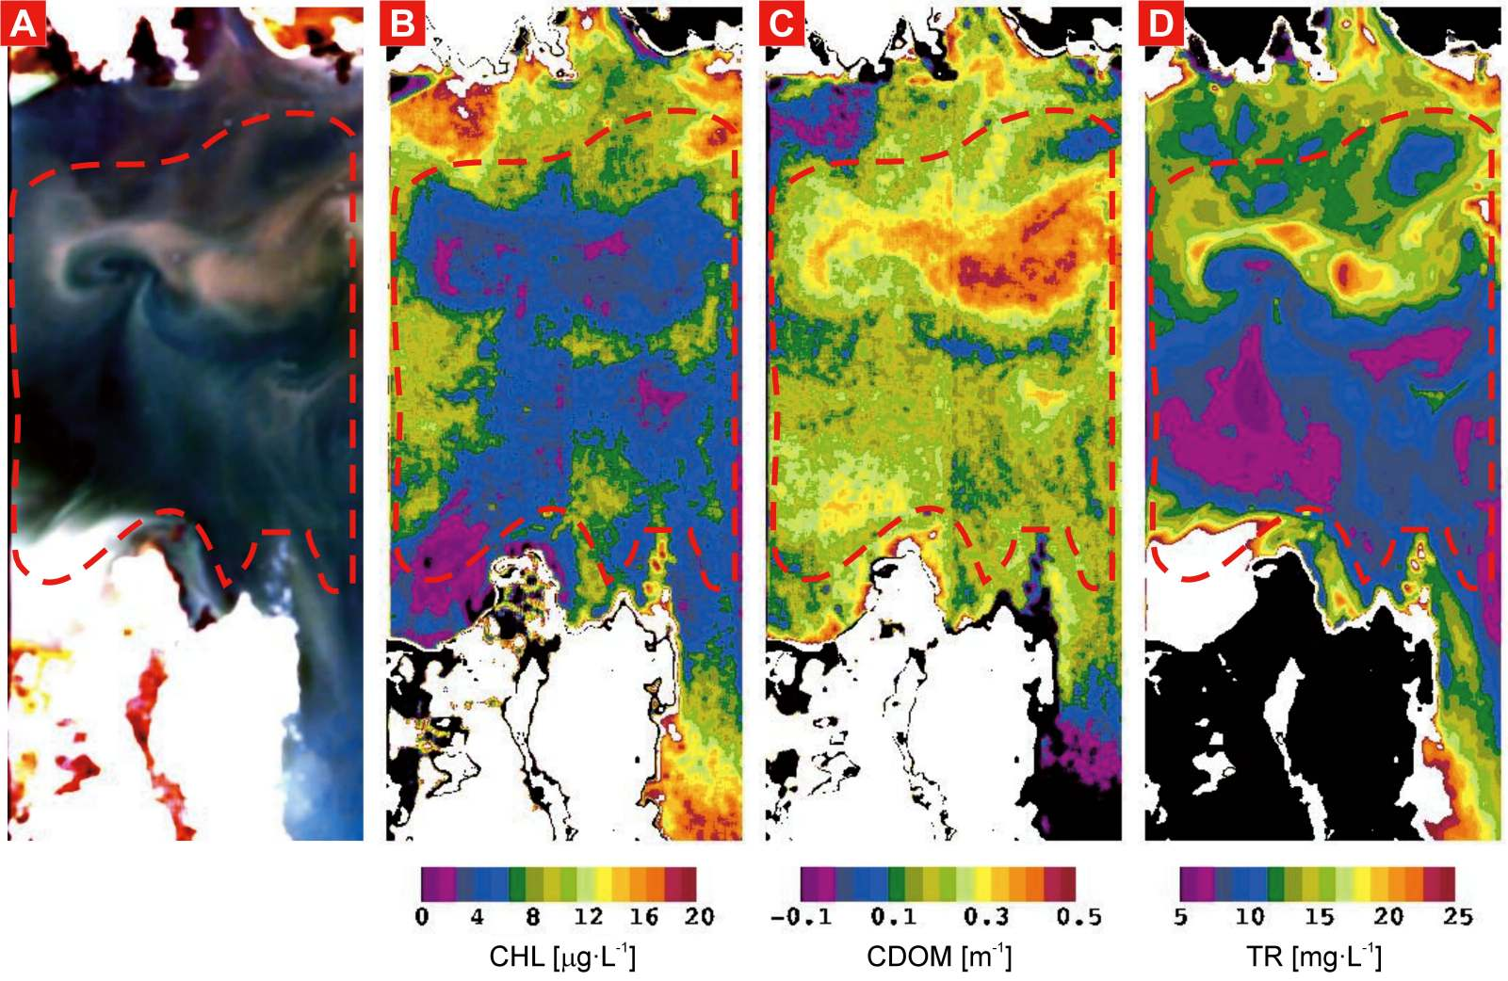
Fig. 2. a) 5x5 low pass filtered subsurface irradiance reflectance Hyperion imagery of Deception Bay January 12th 2001and the MIM retrieved concentrations for b) CHL, c) CDOM, d) TR. The dashed red line delimits the cloud free and optically deep water region.

Papers and presentations

Journal Papers
V.E. Brando and A.G. Dekker, “Satellite hyperspectral remote sensing for estimating estuarine and coastal water quality,” IEEE - Transactions on Geoscience and Remote Sensing, 2002 (accepted, Manuscript No. TGRS-00244-2002).

A.G. Dekker, V.E. Brando, N. Pinnel, A. Held, “HYPERION: the first imaging spectrometer from space: also suitable for inland and coastal water observations,” Backscatter magazine (http://www.waterobserver.org/backscatter/issue-02-winter.html), 2002.

Conference Proceedings
A.G. Dekker, V.E. Brando, J. Anstee, N. Pinnel, A. Held, “Preliminary Assessment of the performance of Hyperion in Coastal waters. Cal/Val activities in Moreton Bay, Queensland, Australia,” Proceedings of International Geoscience and Remote Sensing Symposium (IGARSS’01), Sydney, Australia, 2001.

V.E. Brando, A.G. Dekker, and J.M. Anstee, “Estuarine Hyperspectral Remote Sensing from Space: Case Study Moreton Bay,” Proceedings of the 11th Australasian Remote Sensing and Photogrammetry Conference, Brisbane, Australia, 2002.

CSIRO EOC Annual Science Meetings
A.G. Dekker, V.E. Brando, J. Anstee, N. Pinnel, A. Held, “Preliminary assessment of the performance of Hyperion in coastal waters. Cal/Val activities in Moreton Bay, Queensland, Australia,” CSIRO EOC Annual Science Meeting, Canberra, 2001.

V.E. Brando, A.G. Dekker, J.M. Anstee. “Satellite hyperspectral remote sensing for estimating estuarine and coastal water quality,” CSIRO EOC Annual Science Meeting, Canberra, 2002”

SVT Meetings
A. G. Dekker, V. E. Brando, J. Anstee, N. Pinnel, A. Held, “Preliminary assessment of the performance of Hyperion in coastal waters. Cal/ Val activities in Moreton Bay, Queensland, Australia,” EO-1 SVT Meeting, Tuscon, May 2001.

V. E. Brando, A. G. Dekker, J. Anstee, N. Pinnel, A. Held. “Preliminary multitemporal assessment of the performance of Hyperion in coastal waters. Cal/ Val activities in Moreton, Bay, Queensland, Australia,” EO-1 SVT Meeting, Buenos Aires, 6-8 November, 2001.
V.E. Brando, A.G. Dekker, J.M. Anstee. “Satellite hyperspectral remote sensing for estimating estuarine and coastal water quality. Results of the Australian Science Validation Team for assessing Hyperion for coastal remote sensing,” EO-1 SVT Meeting, Hilo, Hawaii, November, 2002

Cape Tribulation – Coral Reefs

Site P/Co-Investigator(s): Tiit Kutser, David Jupp, AIMS scientists
Site Name: Cape Tribulation
General location: North Queensland, Australia
Type of measurement: Reef substrate reflectance (under water and above the water surface), inherent optical water properties
Measurement device: HydroRad-2, Hydroscat-6, GER
Dates of acquisition: March 19, Sept. 11
Latitude: -16.11
Longitude: 145.441
Elevation:
Surface type: Coral reef
General atmospheric conditions:
Other satellite data:
Comments: The fieldwork will be carried out between 09.09.01 and 13.09.01
Contact email: David.Jupp@csiro.au

[Report still to be received]

Cape Tribulation – Tropical Forests & Agriculture

Site P/Co-Investigator(s): Alex Held
Site Name: Cape Tribulation
Type of measurement: Ground Reflectance, Spectral Irradiance
Measurement device: ASD FR (400 - 2500nm)
Dates of acquisition: Sept. 11
Latitude: S 16 deg. 06'
Longitude: E 145 deg. 26.5'
Elevation: ~20 m
Surface type: Lowland Rainforest, coral reef and tropical agriculture (sugarcane)along 180 km strip
General atmospheric conditions: Partly Cloudy?
Other satellite data: ASTER, LTM7, Modis
Comments: Hymap, casi data available, local meteorological data and access to rainforest canopy via canopy crane. Sugarcane foliar chemistry and reflectance data available.
Contact email: Alex.Held@csiro.au

[Report not received yet]

Mt Fitton

Site P/Co-Investigator(s): Tom Cudahy, Pamela Barry
Site Name: Mt Fitton
Type of measurement:
Dates of acquisition:
Latitude:
Longitude:
Elevation:
Surface type:
General atmospheric conditions:
Other satellite data:
Comments:
Contact email: Thomas.Cudahy@csiro.au

[Report still to be received]

Panorama

Site P/Co-Investigator(s): Tom Cudahy, Cindy Ong
Site Name: Panorama
Type of measurement:
Dates of acquisition:
Latitude:
Longitude:
Elevation:
Surface type:
General atmospheric conditions:
Other satellite data:
Comments:
Contact email: Thomas.Cudahy@csiro.au

[Report still to be received]

CALIBRATION AND VALIDATION SITES AND FINDINGS

Introduction

Three of the sites (Lake Frome, Uardry and Lake Argyle) were designated as Calibration and Validation sites. At these sites the emphasis was on uniform land covers and associated instrumentation and field campaigns.

Lake Frome is a large salt lake (playa) in the north of South Australia. It has ahigh visible region reflectance (about 70% when dry) with little fall-off in the blue end of the signature. It is ideal for VNIR instruments. It was found that as the year of intensive effort (2001) was a wet year, the lake surface had too much associated moisture for the SWIR region to provide effective calibration for an instrument with low SNR like Hyperion. However, Lake Frome provided a very important support function for TRW in the early phase of the Check-out which occurred in the northern hemisphere winter.

Uardry (near Hay in NSW) is a prairie site that has been used for AVHRR and MODIS calibration and validation as well as surface radiation balance studies. It is located at 14°24’S and 145°18’E. It is maintained by Fred Prata and Bob Cechet of CSIRO. Data available there as well as EO1 was from DATM and HYMAP scanners, various satellites (eg AATSR, MODIS, ASTER), Tower based SRB and meteorological data and site BRDF measurements. The site was also used in the early check-out period to refine the initial TRW calibrations.

Lake Argyle is an extensive man-made lake in norther Australia. It was planned to provide a dark target that would be used in the winter period in Australia. There is an Aeronet CIMEL (maintained by CSIRO) located there and a field campaign was carried out. Studies of the darker end of the calibration for Hyperion have been carried out but reporting has not yet been finalised.

Lake Frome

Site P/Co-Investigator(s): Dean Graetz, Susan Campbell, Edward King, Jenny Lovell, David Jupp
Site Name: Lake Frome
Type of measurement:
Measurement devices:
Dates of acquisition:
Latitude:
Longitude:
Elevation:
Surface type:
General atmospheric conditions:.
Other satellite data:
Comments:
Contact email: Susan.Campbell@csiro.au

Introduction

A ground truth campaign was carried out by CSIRO between December 17 and 20, 2000 at Lake Frome (see Figure 1) in coordination with a Hyperion mission on December 20. The day was not ideal so images were collected on January 5 and 21, 2001 to use in its place. Lake Frome is an ideal site as the Hyperion ground track aligns with a well-established and persistent salt track. Landsat 7 and Advance Landsat Imager (ALI) data collection also occurred.

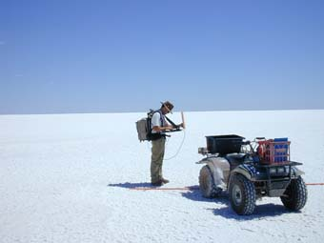
Figure 1: Field work at Lake Frome

Vicarious calibration provides a unique opportunity to investigate the characteristics of the instrument from a direction that is user oriented. The process involves extensive ground truth and coordination with spacecraft mission operations to coordinate the time of data collection of the spacecraft with the ground truth measurements. The result is a direct comparison of the top of atmosphere (TOA) measurements made by the instrument with the top of atmosphere predication based on the independently measured ground spectral reflectance measurements and propagation through a predicted atmosphere.

Using a simple but convenient model available to the group, at sensor radiances from the Lake Frome sites at the time of the overpass were estimated by the CSIRO team for January 5th . Further discussion of the Lake Frome site, the accuracy of geo-locating the instrument image with the physical site where the measurements were made and the uniformity of the site over a region comparable to the ground sample distance of the instrument during the campaign can be found in the paper by Campbell et al. (IGARSS’01).

This report reviews the ground truth campaign and presents the results of the on-orbit agreement in the predicted and measured top of the atmosphere radiances with reference to a cross-comparison with the solar calibration results. These studies were carried out soon after EO-1 launch and provided valuable support to the instrument check-out and validation prior to the release of data in early 2001.

Lake frome ground truth data collection

Lake Frome is located in the north east of South Australia (Figure 2a) and is a large, normally dry salt lake (playa). The centre of the playa is approximately at Latitude: 30º51’S and Longitude: 139º45’E. The Lake is very bright when dry with visible region reflectance being over 70%. However, moisture decreases the SWIR reflectance very significantly. Fig. 2b is an image of the Hyperion pass over the Lake Frome area showing the field sites. Notice that the sites fall on a path along the centre region of the Hyperion swath. The data collected as part of the Lake Frome vicarious calibration effort include spectral, navigation, and atmospheric data.

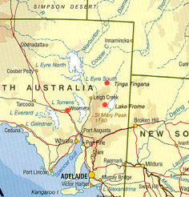  Figure 2a: Location of Lake Frome in Northern South Australia | 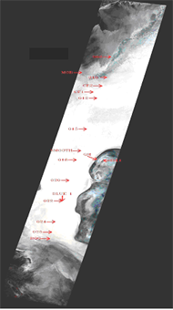
 | Fig. 2b Lake Frome image taken by Hyperion on the January 5, 2001 overpass.

Reflectance Measurements

Spectral reflectance measurements were made with an ASD Field Spec imaging spectrometer for a range of ground sites. The measurements were made over specified ground blocks to account for spatial variation and the mean signatures were established. The measurements were referenced to a standard Spectralon panel. A list of some of the sites that were measured is in Table 1; sites 018, 020, 022 and 024 were used for the comparison with Hyperion measurements.

TABLE 1:SITES CHARACTERIZED FOR COMPARISON WITH HYPERION
Name | Date | Latitude | Longitude
018 | Uniform Salt | -30.80 | 139.68
020 | Uniform Salt | -30.83 | 139.67
022 | Mixed Salt and Mottle | -30.87 | 139.66
024 | Uniform Salt | -30.90 | 139.65
008 | Salt Graded to Ooze
Island | Soil Areas

The sites were sampled in a central cluster of points and along local transects of about 100m to characterise the spatial variance and produce a mean site signature at the scale of Hyperion. Salt and mud samples were also collected for laboratory characterisation.

Fig.3 shows mean reflectance spectra for the field sites. These spectra have been linearly interpolated over the main water absorption bands as the ASD spectra are very noisy in these regions. The form of the spectrum is very similar at all the salt sites. Variation is mostly related to the thickness of the salt crust (a thin crust allows the underlying mud to influence the spectrum) and the amount of liquid water present in the salt matrix. However, the full extent of the spatial variation and its components is being studied using a range of data available for Lake Frome including Hyperion, Hymap airborne hyperspectral data and Landsat ETM data.

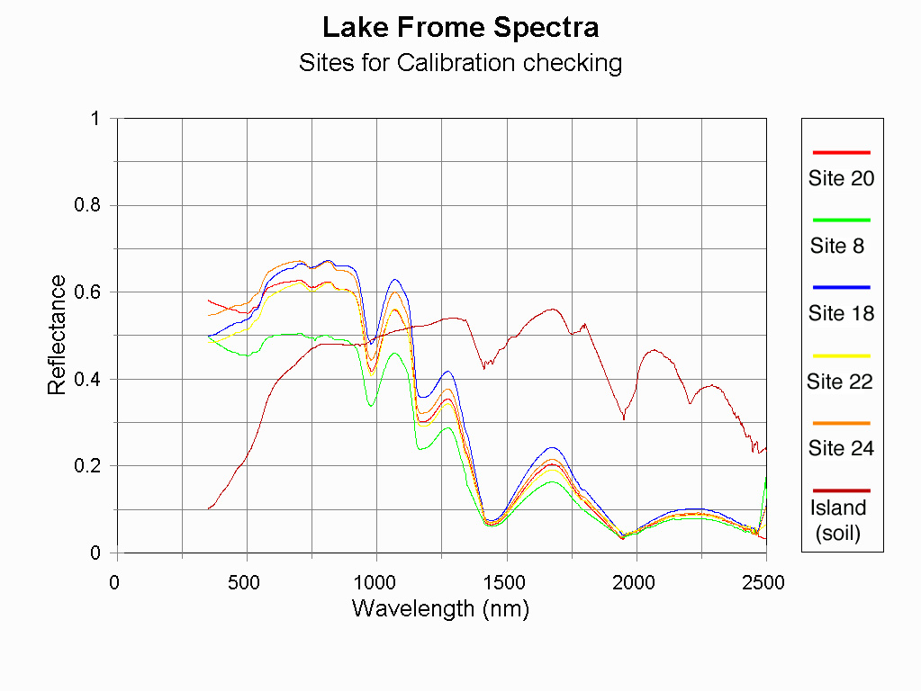
Fig 3. ASD Spectra recorded at field sites shown in Fig.2. Spectra have been linearly interpolated over regions of strong atmospheric water vapour absorption

Meteorological data were collected during the mission using a portable weather station and a Yankee Environmental Systems multi-frequency shadow-band radiometer (MFR) operating at the lakeshore. Data were also acquired from Bureau of Meteorology radiosondes launched from Woomera (250 km west of Lake Frome) and a CIMEL sun photometer located at another CSIRO field site 150 km to the north of the lake.

Navigation Measurements

The utility of the field measurements is crucially dependent on their accurate location (and re-location) on the Lake and in the image data. The GPS readings provided a very accurate base of geo-located data and so it was necessary to establish accurate image geolocation. A set of ground control points (GCPs) was identified in the image of Hyperion Band 22 (568 nm) and an accurately geo-rectified Landsat ETM image (acquired on January 21, 2001). Analysis of the data fits based on predictive error showed that a bi-linear transformation was best. This allows for x, y shifts, separate changes of scale in x and y, skew and rotation plus an xy interaction term. The statistical significance of the x-y interaction term shows there is a projective geometry in the Hyperion image on the surface. This is likely to be even more significant in other cases since Lake Frome is imaged at near nadir view. The main characteristics of the geometry can be summarised in Table 2.

TABLE 2 Hyperion Geometric Characteristics

Pixel-X | 30.646 m
Pixel-Y | 30.528 m
Rotation | -12.38°
Skew | 0.006°

EO-1 has a specific yaw to compensate for the Earth rotation skew. It seems to be very effective. The pixel shape is also very close to square. The predictive error for the VNIR sensor was 15 metres in x and 20 metres in y. This close registration and the uniformity of much of the Lake Frome site means we can identify the spectra of pixels relating to the ground sites with considerable confidence.

The GCPs were also identified in band 94 of the Hyperion image (1084 nm) to test the alignment of the two spectrometers. The data were again well-fitted by a bi-linear transformation. An offset of approximately one pixel in x and a fraction of a pixel in y was noted between the VNIR and SWIR sensors. The magnitude of the offset varied between about 1.0 and 1.2 pixels across the 256 element array. This seems to be due to slight misalignment in the two arrays and may be significant in areas with highly spatially variable spectra.

Atmospheric Models

Two sources of measured atmospheric data were available. One was CIMEL data taken at Tinga Tingana (a site established in 1998 in central Australia to study aerosols) that was used to provide estimates of aerosol optical depths and water vapor. The Woomera meteorological station is about equal distance from Tinga Tingana and provides daily radiosondes. These were used to obtain lapse rates for the pressure, temperature and water vapor profiles. These measurements were combined with historical atmospheric knowledge of the region. A simple radiative transfer model was used for the initial investigation since the necessary outputs were easy to obtain and it could be optimized to the field data.

Top of the atmosphere radiance comparison

As the mission started, CSIRO worked to provide feedback on the Hyperion calibration. Using the atmospheric model, Lake Frome data and Level 1 but uncalibrated data we obtained the following initial estimate (Figure 4) of the calibration which was then compared with the current curve by TRW:

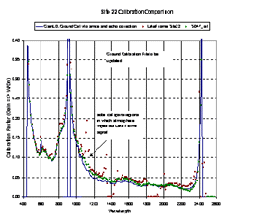
Figure 4: Initial early comparison of calibrations using Lake Frome data

This graph is largely historical as TRW and CSIRO proceeded to make considerable efforts to refine the study and look at reasons for the residual discrepancies. However, the basic result was that Hyperion was working within a close range of good calibration post-launch.

In subsequent analysis, Site 20 showed the best overall agreement between the TOA radiances calculated from ground truth and the Hyperion measurements. Fig. 5a shows the spectral radiance curves. The agreement is quite good in the visible and near IR.

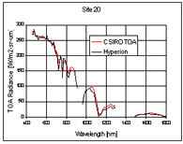 | 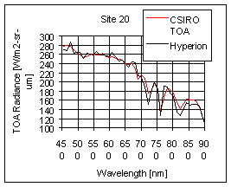
Fig.5a. Spectral radiance comparisons over the VNIR and SWIR spectral response region of Hyperion | Fig 5b. VNIR spectral radiance comparison from Fig. 2

As shown in the expanded wavelength scale in Fig. 5b, the mean difference is less than 1.5 % ± 0.5 % from 450 to 900 nm. The CSIRO TOA radiances are 16 % higher than that measured by Hyperion in the SWIR for site 020. The largest differences occur at 715, 760 and 810 nm and may be related to atmospheric correction effects at the spectral features shown in Fig. 3. Otherwise, the general difference ratio ranges from 2 to 10 % throughout the spectral region.

In the SWIR, sites 018, 020, and 024 indicate that the TOA model predictions are generally 10 to 25 % higher while site 022 data are lower as shown in Fig. 5. The gaps are where water absorption bands affect the data. Corrections for BRDF effects based on view angle and the Standard Spectralon panel SWIR performance would improve the validity of these comparisons.

Conclusions

The Lake Frome field campaign was the first time the lake had been visited for a ground based spectral measurement effort. Given the nature of the environment it was highly successful. It is planned to re-visit the site and undertake more intensive measurements and also extend the range of target sites for future EO-1 data collection. The site provides an excellent base with which to cross-compare Landsat ETM, ALI and Hyperion and compare their performance with that of other polar orbiting satellites of varying resolution and scale, such as AVHRR, ATSR2 and SPOT VGT.

While some site spectra provided a very accurate match with the Hyperion data, at others there were variations between the Hyperion data and site measurements that may have a range of causes. Among these is the surface BRDF which it was intended that we measure but is still not completely determined. The Hymap data will provide insight into this factor. Visual assessment indicates the BRDF of the lake is likely to be stable and able to be characterised.

The combination of field and laboratory measurements allowed TRW to confirm very quickly as the mission started that their calibrations were generally within about 5-10% in the VNIR and perhaps similar in the SWIR. The dark reflectance in the SWIR prevented precise conclusions. The ground reflectance measurements and atmospheric correction leading to TOA radiances were consistent with the Hyperion solar calibration where the sun is viewed by reflectance from a diffusely painted panel. The SWIR agreement is not as good as the direct Hyperion comparison with the absolute solar irradiance.

On the basis of this, TRW worked with the solar calibration to improve uniformity and absolute corrections so that the Level 1 products have been of high quality since the data were first delivered to members of the SVT. In the first year of the campaign, results from a range of sites were used and a major correction to the overall calibration made late in 2001. However, this can be seen as a refinement bringing Hyperion into alignment with standard choices of solar constant, with Landsat and ALI and provided an excellent product by the time the extended mission commenced.

References

S. Campbell, J. Lovell, D.L.B. Jupp, R.D. Graetz, P. Clancy, P. Jarecke, J. Pearlman (2001). The Lake Frome Field Campaign in support of Hyperion Instrument calibration and validation, IGARSS Special Session 40, SS40MO, paper 1675.

Graetz, R.D., Campbell, S., Lovell, J., King, E. & Byrne, G. (in preparation). Lake Frome, Australia: A site for vicarious calibration of broadband and narrow band sensors.

Barry, P.S., Jarecke, P., Pearlman, J, Jupp, D, Lovell, J, Campbell, S. (2001). Use of Lake Frome Ground Truth Campaign as a Cross-Calibration of the Hyperion Instrument. IGARSS’01 Special Session 40, paper 1780.

Uardry

Site P/Co-Investigator(s): Fred Prata
Site Name: Uardry
Type of measurement:
Measurement devices:
Dates of acquisition:
Latitude:
Longitude:
Elevation:
Surface type:
General atmospheric conditions:.
Other satellite data:
Comments:
Contact email: Fred.Prata@csiro.au

Lake Argyle

Site P/Co-Investigator(s): Edward King, Susan Campbell, Jenny Lovell, Dean Graetz
Site Name: Lake Argyle
Type of measurement:
Measurement devices:
Dates of acquisition:
Latitude:
Longitude:
Elevation:
Surface type:
General atmospheric conditions:.
Other satellite data:
Comments:
Contact email: Edward.King@csiro.au

MAJOR CONTRIBUTIONS TO MISSION AND SCIENTIFIC SUPPORT

ACRES data downlink, data management & outreach activities

EO 1 Mission Support

ACRES is recording EO-1 science data broadcast from the EO-1 on-board recorder on a daily basis at the TERSS satellite reception facility in Hobart Tasmania. This service commenced in January 2001. Approximately 600 passes of data had been recorded at the end of January 2003. The science data are sent to NASA on a daily basis for archiving and product generation.

EO 1 Image data sales.

Geoscience Australia has offered an EO-1 image product information and ordering service for most of the EO-1 mission life. This service includes offering advice on EO-1 instrument characteristics and product specifications and formats.

Data sales for: -

FY 2001-2002 are AUD$ ?
FY 2002-2003 are AUD$ ?

EO 1 Image Data Applications Workshop. 15 March 2002

ACRES/Geoscience Australia co hosted with CSIRO a one-day workshop on the applications of Hyperion data. There were presentations from CSIRO scientists on a range of applications. The workshop was a good forum to promote the value and benefits of EO-1 data to value adding remote sensing private companies.

HYMAP airborne Hyperspectral data base

CONCLUSIONS AND RECOMMENDATIONS

The Completed SVT Mission

Australian scientists have participated energetically in the EO-1 mission with its focus on new technology evaluation and inter-comparisons. The diverse sites across the continent and a solid program of field and airborne supporting data collection have led to a wide range of outcomes for Calibration & Validation studies, base data processing (including atmospheric correction) and the capability of the sensors on-board to meet the needs for a range of applications.

In addition, EO-1 has been tested against a range of applications for spectral data and found to be already a highly valuable tool for applications from the space environment. These have been described in the site reports of this document. Each site has a specific area of application to demonstrate and all have had significant success to their aims. To be effective in applications the data need, however, to be processed beyond Level 1B and the experience of the SVT and the Australian contributions has provided a processing framework on which such operational applications may be built.

The Extended Mission

Australia has also responded enthusiastically to the NASA/USGS extended mission. We have promoted and collected a significant bulk data purchase to ensure that EO-1 data reach as many new researchers and applied users of remote sensing as possible. The Australian Centre for Remote Sensing (ACRES) has worked closely with USGS and continued data acquisition when required. We have started education and outreach workshops to enable people to get to know and gain experience of both ALI and Hyperion data in their applications.

This approach recognises that for these data to impact fully on applications and become accepted beyond their use in technology evaluation we need applications results and greatly increased data access for the wider community of researchers, information suppliers and end users. The SVT has shown ALI and Hyperion to be data sets of sufficiently high quality. Now they should be put to work.

Beyond Technology Evaluation

From the proving of science point of view, there is still a gap between the demonstrated quality of the data and its base processing and its further use in applications. This gap needs energetic research and development activity to be filled.

We believe that it is possible to develop key activities on the base of the contributions of all of the scientists of the SVT to date and the outcomes of the SVT meetings and publications. These include the evaluation of time series products from the data and establishing environmental limits on applications products in others. For example in Australia:

- Continuation of the temperate Coleambally agricultural test site as a time series study for crop health evaluation and support for precision agriculture;
- Development of a complementary tropical site for time series data with agricultural, coastal and forest applications;
- Evaluation of mineral mapping tools in more complex and diverse environments;
- Proving of initial results on forest health and productivity monitoring and mapping;
- Evaluating coastal study sites in eutrophic waters;
- Assessing coral reef health and recovery from bleaching.

Due to the efforts of the SVT we can move beyond base data processing and help provide applications that build a demand for EO-1 and the coming hyperspectral and advanced multi-spectral sensor data. The need for this activity to be based on EO-1 is crucial as Hyperion is the only spaceborne hyperspectral instrument and will remain so for some time.

Collaboration

To achieve this the Australian scientists wish to build on the increased US/Australian collaboration that has developed during the SVT phase and to continue to develop the international network it has initiated. This specifically includes the potential to develop a collaborative southern hemisphere activity.

There have been important collaborations in calibration & validation, agricultural applications, forest health, mineral exploration and rangelands studies. The use of Australian sites as complementary southern hemisphere study areas will be just as important – if not more important – in the applications phase as it was in the technology evaluation phase.

We welcome the potential for NASA to build on its investment in EO-1 and in the SVT as a major resource to bring the data into operational use in applications and prepare the way for the sensors that the technology experiments will bring about. We look forward to the opportunity of being part of that activity.

EO1 AND RELATED PUBLICATIONS AND PRESENTATIONS

This section provides a complete listing of papers and presentations by the Australian EO-1 Co-Investigators arising from their work. Some of these are also listed in the individual site reports in Section 3.0.

Journal Papers

Coops, N.C., Dury, S., Smith, M.L., Martin,. M, Ollinger, S. (2002) Comparison of Green Leaf Eucalypt Spectra using Spectral Decomposition. Australian Journal of Botany. 50: 567 – 576.

Coops, N.C., Smith, M.L., Jacobson, K. Martin,. M, Ollinger, S. (2002) Estimation of Leaf Area Index using Three techniques in a Mature Native Eucalypt Canopy. Ausral Ecology. (in review).

Coops, N.C., Smith, M.L., Martin, M.M, Ollinger, S. (2002) Prediction of Eucalypt Foliage Nitrogen Content from Satellite Derived Hyperspectral Data. IEEE Transactions on Geoscience and Remote Sensing (accepted paper).

V.E. Brando and A.G. Dekker, “Satellite hyperspectral remote sensing for estimating estuarine and coastal water quality,” IEEE - Transactions on Geoscience and Remote Sensing, 2002 (accepted for publication).

A.G. Dekker, V.E. Brando, N. Pinnel, A. Held, “HYPERION: the first imaging spectrometer from space: also suitable for inland and coastal water observations,” Backscatter magazine (http://www.waterobserver.org/backscatter/issue-02-winter.html), 2002.

B. Datt, T.R. McVicar, T.G. Van Niel, D.L.B. Jupp, J.S. Pearlman, “Pre-processing EO-1 Hyperion Hyperspectral Data to Support the Application of Agricultural Indices,” IEEE - Transactions on Geoscience and Remote Sensing, 2002 (accepted for publication).

Conference Proceedings

IGARSS 2001, Sydney, Australia

T. Cudahy, R. Hewson, J. Huntington, M. Quigley, P. Barry, “The Performance of the Satellite-borne Hyperion Hyperspectral VNIR-SWIR Imaging System for Mineral Mapping at Mount Fitton, South Australia,” Proceedings of International Geoscience and Remote Sensing Symposium (IGARSS’01), Sydney, Australia, 2001.

T.G. Van Niel, T. McVicar, S. Campbell, S. Liang, M. Kaul, J. Pearlman, Clancy, C. Segal, “The Coleambally Agricultural Component of Hyperion Instrument Validation,” Proceedings of International Geoscience and Remote Sensing Symposium (IGARSS’01), Sydney, Australia, 2001.

S. Campbell, J. Lovell, D.L.B. Jupp, D. Graetz, P. Barry, P. Jarecke, J. Pearlman, “The Lake Frome Field Campaign in Support of Hyperion Instrument Calibration and Validation,” Proceedings of International Geoscience and Remote Sensing Symposium (IGARSS’01), Sydney, Australia, 2001.

N. Coops, M. Smith, M. Martin, S. Ollinger, A. Held, S. Dury, “Assessing the performance of Hyperion in Relation to Eucalypt Biochemistry: Preliminary Project Design and Specifications,” Proceedings of International Geoscience and Remote Sensing Symposium (IGARSS’01), Sydney, Australia, 2001.

A.G. Dekker, V.E. Brando, J. Anstee, N. Pinnel, A. Held, “Preliminary Assessment of the performance of Hyperion in Coastal waters. Cal/Val activities in Moreton Bay, Queensland, Australia,” Proceedings of International Geoscience and Remote Sensing Symposium (IGARSS’01), Sydney, Australia, 2001.

IGARSS 2002, Toronto, Canada

J. Pearlman, T. McVicar, T. Van Niel, D. Jupp, B. Datt, et al, “Using a Time Series of EO-1 Data for the Coleambally Irrigation Area, Australia, To Assess The Value of Co-registration, Atmospheric Correction and Multispectral Data for Agricultural Applications,” Proceedings of International Geoscience and Remote Sensing Symposium (IGARSS’02), Toronto, Canada, 2002.

T.J. Cudahy, P.S. Barry, et al, “Early Earth Magmatic-Seawater Hydrothermal Alteration Revealed through Processed Satellite-Borne Hyperion Imagery,” Proceedings of International Geoscience and Remote Sensing Symposium (IGARSS’02), Toronto, Canada, 2002.

N. Coops, M. Smith, M. Martin, S. Ollinger, A. Held, “Predicting Eucalypt Biochemistry From Hyperion and Hymap Imagery,” Proceedings of International Geoscience and Remote Sensing Symposium (IGARSS’02), Toronto, Canada, 2002.

11th ARSPC, Brisbane, Australia

V.E. Brando, A.G. Dekker, and J.M. Anstee, “Estuarine Hyperspectral Remote Sensing from Space: Case Study Moreton Bay,” Proceedings of the 11th Australasian Remote Sensing and Photogrammetry Conference, Brisbane, Australia, 2002.

B. Datt, D.L.B. Jupp, T. R. McVicar, T.G. Van Niel, J. Lovell, S. Campbell, “Spectral Feature Analysis of Crop, Soil and Stubble Using Hyperion and Hymap Data,” Proceedings of the 11th Australasian Remote Sensing and Photogrammetry Conference, Brisbane, Australia, 2002.

V. H. Chewings, G. N. Bastin, M. M. Crawford, and J. E. Kinloch, “Characterisation of Vegetation Components in the Australian Arid Zone Using EO-1 Hyperion Imagery,” Proceedings of the 11th Australasian Remote Sensing and Photogrammetry Conference, Brisbane, Australia, 2002.

A. Held, K. Powell, A. Gonzalez, S. R. Phinn, C. H. Menges, “Application of Imaging Spectroscopy to Crop Monitoring and Precision Agriculture,” Proceedings of the 11th Australasian Remote Sensing and Photogrammetry Conference, Brisbane, Australia, 2002.

SPIE Conference, Hangzhou, China

D.L.B. Jupp, B. Datt, T. R. McVicar, T. G. Van Niel, J. S. Pearlman, J. Lovell, and E. A. King, “Improving the Analysis of Hyperion Red Edge Index from an Agricultural area,” Proceedings of the SPIE Conference, Hangzhou, China, October 2002.

Technical Reports/Workshop Documents

T. R. McVicar, T. G. Van Niel, and D. L. B. Jupp, “Geometric Validation of Hyperion Data acquired by Earth Observing 1 Satellite at Coleambally Irrigation Area,” CSIRO Land and Water Technical Report 46/01, 2001.

D.L.B. Jupp et. al., “Discussions around Hyperion Data: Background Notes for the Hyperion Data Users Workshop,” CSIRO Earth Observation Centre, 2002.

B. Datt, and D.L.B Jupp, “Hyperion Data Processing Workshop: Hands-on Processing Instructions,” CSIRO Earth Observation Centre, 2002.

Presentations at Meetings/Workshops

CSIRO EOC Annual Science Meeting, 2002

B. Datt, D.L.B. Jupp, “The Hyperspectral task report,” CSIRO EOC Annual Science Meeting, Canberra, 2002.

N. Coops, M. Smith, M. Martin, S. Ollinger, A. Held, “Predicting Eucalypt Biochemistry From Hyperion and Hymap Imagery,” CSIRO EOC Annual Science Meeting, Canberra, 2002.

T. McVicar, T. Van Niel, D.L.B. Jupp, B. Datt, J. Pearlman, “Coleambally Irrigation Area (CIA) and EO-1: A Time Series Agricultural and Cal-Val Site,” CSIRO EOC Annual Science Meeting, Canberra, 2002.

V.E. Brando, A. Dekker, et al, “Satellite hyperspectral remote sensing for estimating estuarine and coastal water quality,” CSIRO EOC Annual Science Meeting, Canberra, 2002.

V.H. Chewings, G.N. Bastin, J.E. Kinloch, M.M. Crawford, “Characterisation of Vegetation Components in the Australian Arid Zone Using EO-1 Hyperion Imagery,” CSIRO EOC Annual Science Meeting, Canberra, 2002.

T.J Cudahy, P. Barry, A.P. Rodger, P. Mason, M. Quigley, M. Folkman, J. Pearlman, “Assessment of the stability of the Hyperion SWIR module for hyperspectral mineral mapping using multi-date images from Mount Fitton, Australia,” CSIRO EOC Annual Science Meeting, Canberra, 2002.

T.J. Cudahy, et al, “Hyperion Mineral Mapping Results: Panorama,” CSIRO EOC Annual Science Meeting, Canberra, 2002.

CSIRO EOC Annual Science Meeting, 2001

S. Campbell, G. Byrne, D.L.B. Jupp, E.A. King, J. Lovell, R.D. Graetz , P.S. Barry, P. Jarecke, J. Pearlman “The Lake Frome field campaign in support of Hyperion instrument calibration & Validation,” CSIRO EOC Annual Science Meeting, Canberra, 2001.

T. McVicar, T. Van Niel, “The Coleambally Agricultural Component of Hyperion Instrument Validation,” CSIRO EOC Annual Science Meeting, Canberra, 2001.

F. Prata, G. Rutter, D.L.B. Jupp, “Cal/Val Activities at the CIGSN Uardry Field Site, NSW, Australia in Support of the EO-1 Mission,” CSIRO EOC Annual Science Meeting, Canberra, 2001.

T.J Cudahy, R. Hewson, J.F. Huntington, M.A. Quigley, P.S. Barry, “The Performance of the Satellite borne Hyperion Hyperspectral VNIR-SWIR Imaging System for Mineral Mapping at Mount Fitton, South Australia,” CSIRO EOC Annual Science Meeting, Canberra, 2001.

A.G. Dekker, V.E. Brando, J. Anstee, N. Pinnel, A. Held, “Preliminary assessment of the performance of Hyperion in coastal waters. Cal/Val activities in Moreton Bay, Queensland, Australia,” CSIRO EOC Annual Science Meeting, Canberra, 2001.

N. Coops, A. Held, “EO-1 SVT Site: Tumbarumba, Australia,” CSIRO EOC Annual Science Meeting, Canberra, 2001.

First SVT Meeting, NASA Goddard, February 2001

D.L.B. Jupp et al., “Evaluation & Hyperion Performance at Australian Calibration & Validation Sites”, Goddard, February 2001.

SVT Meeting, Tuscon, May 2001

D.L.B. Jupp et al, “The Australian Summer EO-1 Southern Hemisphere (SH) Campaign,” EO-1 SVT Meeting, Tuscon, May 2001.

D.L.B. Jupp, “Lake Frome Fieldwork and Analysis Of Hyperion Data,” EO-1 SVT Meeting, Tuscon, May 2001.

T. Cudahy, J. Huntington, P. Barry, “Mount Fitton, South Australia Hyperion "SWIR - Spectral" Test Site,” EO-1 SVT Meeting, Tuscon, May 2001.

J. Pearlman, T. G. Van Niel, T. McVicar, D.L.B. Jupp, S. Liang, M. Kaul, “Agriculture in Coleambally - Imaging the growing season,” EO-1 SVT Meeting, Tuscon, May 2001.

F. Prata, D.L.B. Jupp, “Cal/ Val Activities at the CIGSN Uardry Field Site, NSW, Australia in Support of the EO- 1 Mission,” EO-1 SVT Meeting, Tuscon, May 2001.

N. Coops, “EO-1 SVT Site: Tumbarumba,” EO-1 SVT Meeting, Tuscon, May 2001.

A. G. Dekker, V. E. Brando, J. Anstee, N. Pinnel, A. Held, “Preliminary assessment of the performance of Hyperion in coastal waters. Cal/ Val activities in Moreton Bay, Queensland, Australia,” EO-1 SVT Meeting, Tuscon, May 2001.

SVT Meeting, Buenos Aires, November 2001

D. L. B. Jupp, A. Held, “Summary of Australian EO- 1 activities,” EO-1 SVT Meeting, Buenos Aires, 6-8 November, 2001.

T. R. McVicar, T. G. Van Niel, D. L. B. Jupp, J. S. Pearlman , “Assessment of Precision Agriculture in Coleambally,” EO-1 SVT Meeting, Buenos Aires, 6-8 November, 2001.

A. Held, “Summary of Australian Land and Vegetation Based EO-1 Activities,” EO-1 SVT Meeting, Buenos Aires, 6-8 November, 2001.

V. E. Brando, A. G. Dekker, J. Anstee, N. Pinnel, A. Held. “Preliminary multitemporal assessment of the performance of Hyperion in coastal waters. Cal/ Val activities in Moreton, Bay, Queensland, Australia,” EO-1 SVT Meeting, Buenos Aires, 6-8 November, 2001.

T. Cudahy, “Mineral mapping at the Australian Mount Fitton and Panorama test sites,” EO-1 SVT Meeting, Buenos Aires, 6-8 November, 2001.

T. Cudahy, “An additive SWIR instrument/ processing artifact observed in recent Hyperion data,” EO-1 SVT Meeting, Buenos Aires, 6-8 November, 2001.

SVT Meeting, Goddard, April 2002

D.L.B. Jupp, “Australian EO-1 Report: One year on – Applications and Experiences,” EO-1 SVT Meeting, Goddard Visitors Center, April 2002.

J.Pearlman, D.L.B. Jupp, T. McVicar, T. Van Niel, B. Datt, J. Lovell,” Hyperion Noise and Atmospheric Impacts on Vegetation Data,” EO-1 SVT Meeting, Goddard Visitors Center, April 2002.

D.L.B. Jupp, “Some Smiley Discussions,” EO-1 SVT Meeting, Goddard Visitors Center, April 2002.

Final SVT Team Meeting, Hilo, Hawaii, November 2002.

Bisun Datt et al. “The Australian EO-1 final Report: Activities and Outcomes from the CalVal sites”, EO-1 SVT Meeting, Hawaii, November 2002.

Alex Held, “Mapping of sugarcane biophysical variables with Hyperion imaging spectrometer on the NASA EO-1 Mission.” EO-1 SVT Meeting, Hawaii, November 2002.

