HHSIdentity Program
Software Certificate Issuance Training Materials

Department of Health & Human Services

Public Key Infrastructure (PKI)



Version 0.2
August 26, 2008
Authors
Bobby Brown, Technology Architect  BearingPoint  6564 Loisdale Court  Springfield, VA 22150  Tel: (703) 253 2598  E-mail:  bobby.brown @bearingpoint.com | Kevin Brault, Senior Manager  BearingPoint  6564 Loisdale Court  Springfield, VA 22150  Tel: (703) 747 4029  E-mail: kevin.brault@bearingpoint.com

Version History
 |  | Draft |  | Final
Description | Version | Draft Date | Author | Approval Date | Approver
Initial draft | 0.1 | 8/22/2008 | B. Brown
Submission to HHS following formatting updates | 0.2 | 8/26/2008 | J. Key

This document is protected under the copyright laws of the United States and/or other countries as an unpublished work. This document contains information that is proprietary and confidential to BearingPoint, Inc. and/or affiliates or its technical alliance partners, which shall not be duplicated, used, or disclosed in whole or in part without BearingPoint's express written permission.
© 2008 BearingPoint, Inc. and/or its affiliate(s) (Unpublished). All rights reserved.
BearingPoint® is a registered trademark of BearingPoint, LLC, or its affiliates, in the United States and other countries.
Table of Contents
1. Introduction 1
1.1 Purpose 1
1.2 Scope 1
2. Software Certificate Sponsor Training 2
2.1 Accessing the HHS Portal 2
2.1.1 Accessing the HHS Portal Using the PIV Card 2
2.1.2 Accessing the HHS Portal Using a Soft Certificate 4
2.2 Sponsoring an Employee for a Soft Certificate 5
2.2.1 Completing the “HSPD12 Sponsor an Employee” Form 6
3. Software Certificate Subscriber Training 8
3.1 Receiving Sponsorship Notification 8
3.2 Accessing the HHS Portal 9
3.3 Completing the Subscriber Request Form 10
3.3.1 Selecting a Secure Password 12
3.4 Submitting a Printed Copy of the Subscriber Request Form 13
3.4.1 Viewing the Printed Subscriber Request Form 14
3.5 Collecting the HHS Digital Certificates 17
3.5.1 Accessing the HHS Portal 18
3.5.2 Downloading the Digital Certificates 21
3.5.3 Installing the Digital Certificates 26
3.6 Ensuring Proper Collection and Installation of the HHS Digital Certificates 364. Software Certificate Registrar Training 37
4.1 Accessing the HHS Portal 37
4.1.1 Accessing the HHS Portal Using the PIV Card 37
4.1.2 Accessing the HHS Portal Using a Soft Certificate 39
4.2 Processing a Certificate Request 40

- Introduction
During Phase I of PKI Software Certificate transition (i.e., the period September 1, 2007 through March 31, 2008), an Analysis of Alternatives (AoA) document was developed to address PKI Software Certificate use cases. Upon submission of the AoA in October 2007, an additional option was requested to be investigated by the HHSIdentity Core Team members. As such, BearingPoint was asked to evaluate a possible transition of the existing SRA Software Certificate Issuance infrastructure, currently integrated with the IdenTrust Certificate Authority, to Cybertrust’s CA. A detailed analysis was completed for this option and presented to the PKI Transition Team and the Core Team. A specific set of metrics were compared in regards to maintaining the two environments (SRA Software Certificate Issuance infrastructure and the HSPD-12 infrastructure) over the life of the program. At the end of the evaluation of this new option, the groups determined that the total cost ownership was too high to continue managing both environments. The BearingPoint team was then directed to build the Software Certificate functionality into the existing PIV-II infrastructure hosted at Qwest. A detailed PKI strategy and project plan (WBS) was developed supporting the requirements gathered from the PKI stakeholders involved in the process in Phase II, which spans the period 4/1/2008-9/30/2008. This PKI strategy consists of three major stages. Stage I, as described below, is included in the current phase through 9/30/2008.
Stage I – Software Certificate Distribution
- Develop Non-PIV Software Certificate issuance that support local and antecedent enrollment process
- Develop and Implement a Helpdesk functionality that would provide the ability for the users to request and receive Software Certificates
  - Purpose
This document was created to guide Sponsors, Applicants and Registrars through the procedures that are necessary to complete the Software Certificate request and collection processes. Step-by-step instructions and relevant screenshots outline the actions that Sponsors, Applicants, and Registrars must follow to complete these processes using the HHSIdentity Portal.
  - Scope
The scope of Software Certificate training materials falls within Stage I of the PKI strategy, encompassing the period of 4/1/2008-9/30/2008. These materials support the implementation of Software Certificate distribution for Phase I by providing training materials for Software Certificate Subscribers, Sponsors, and Registrars.

- Software Certificate Sponsor Training
This guide offers step-by-step instructions on the process that a Sponsor using the Window operating system must complete in order to sponsor an Applicant for Software Certificate request and collection.

  - Accessing the HHS Portal
There are two methods the Sponsor can use to access the IDMS Portal. The Sponsor can log on to the portal by 1) using a PIV Card or 2) using a Software Certificate.
    - Accessing the HHS Portal Using the PIV Card
If accessing the Portal using the PIV Card, the Sponsor should follow the steps listed below.
- Insert the PIV Card into the card reader.
- Open a browser window.
- Type https://158.74.64.17/idms/portal into the address bar.
- At the Portal Login screen click “Portal Login” on the left side of the screen. The Portal Login screen is displayed below.
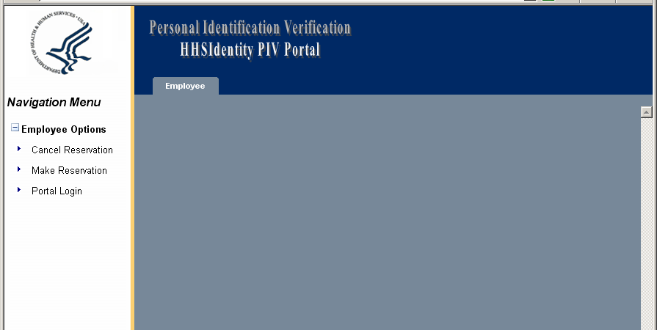

- Choose a digital certificate and then click “OK”.
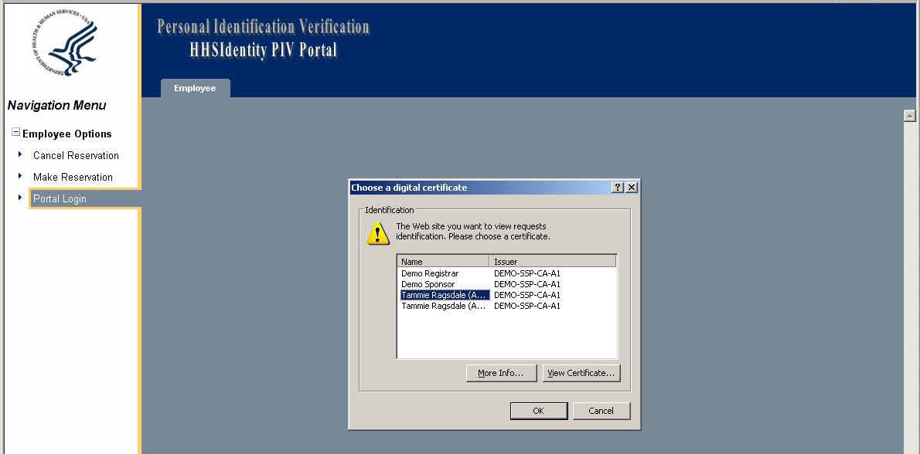
- Enter the PIN to access the PIV Card and click “OK”.
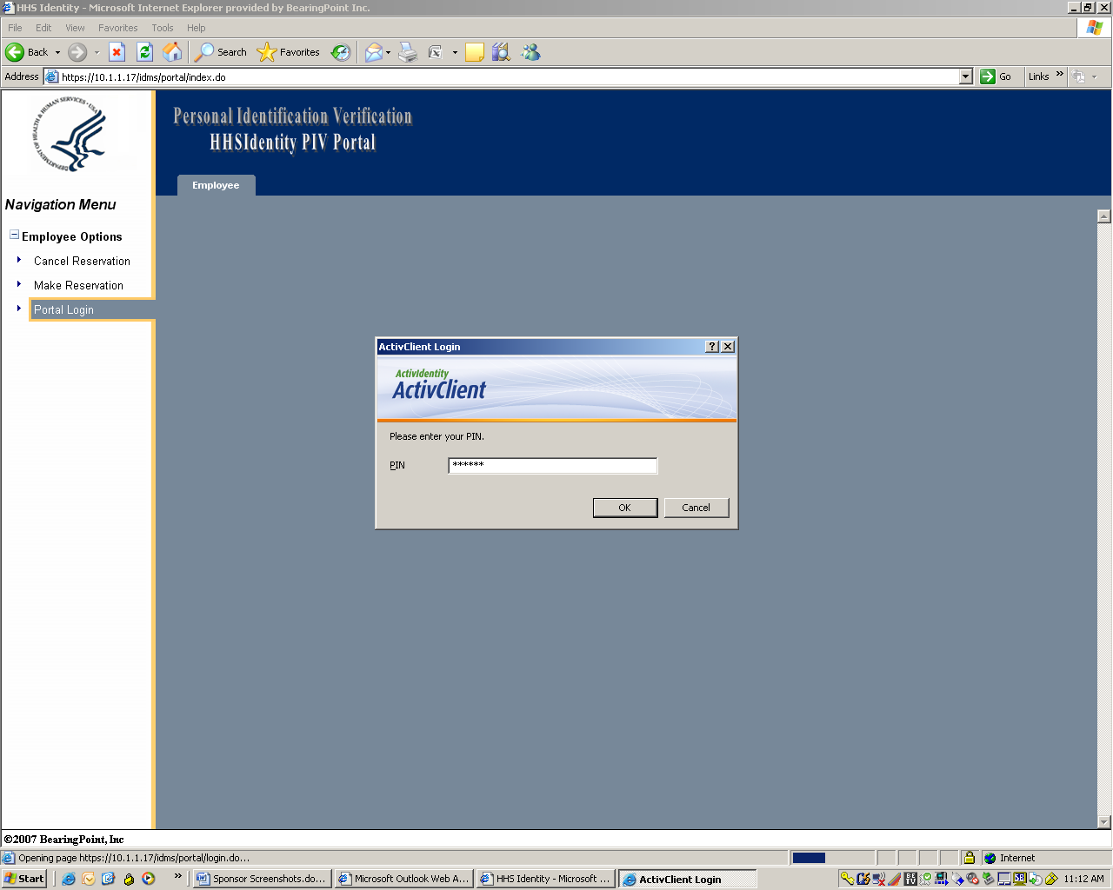

    - Accessing the HHS Portal Using a Soft Certificate
If using a Soft Certificate, the following window will be displayed. To access the HHS Portal using a Soft Certificate, enter the Password for the certificate and then click “OK”.
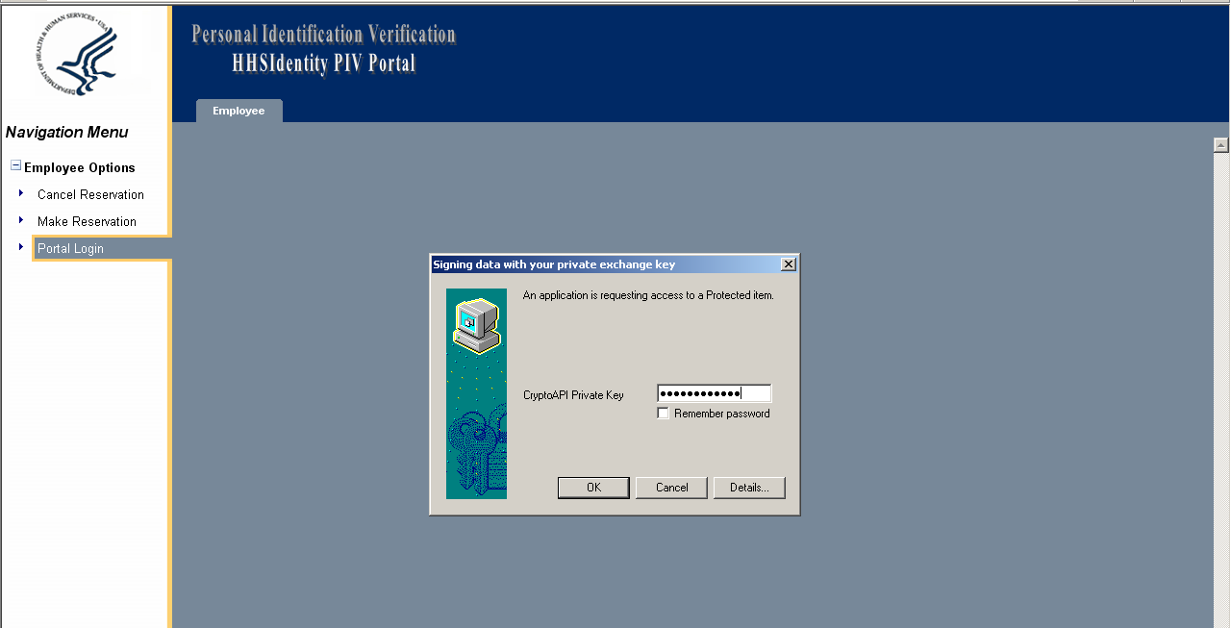

  - Sponsoring an Employee for a Soft Certificate
Once a Software Certificate or PIV card is entered, select “Sponsor Employee for Soft Cert” on the left side of the HHS Portal Screen, which is displayed in the image below.
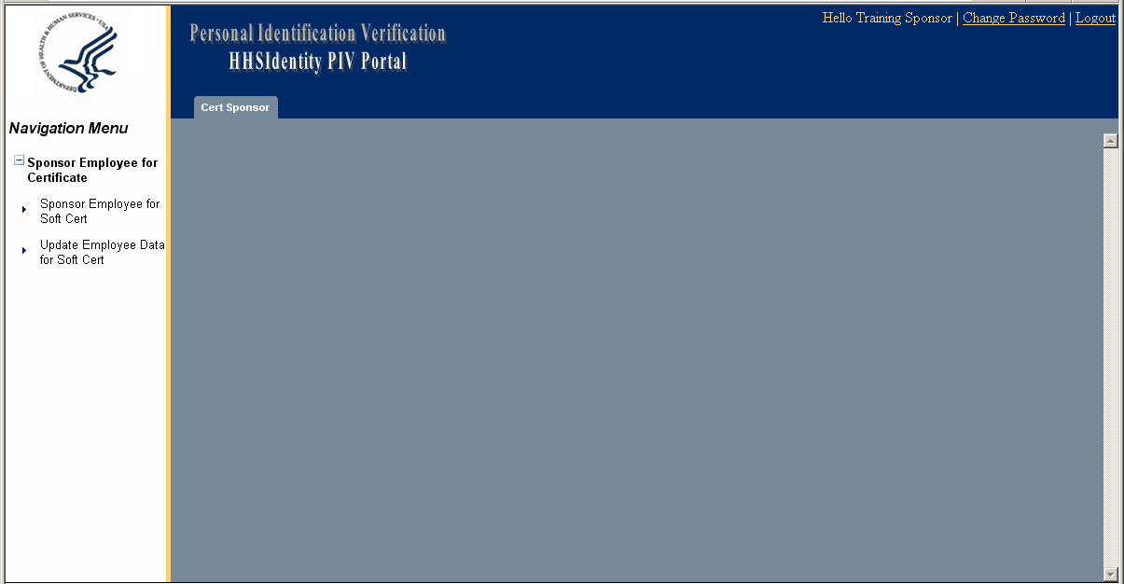

If the Sponsor receives the warning message displayed below, they have not been granted rights to the Sponsorship Portal. Contact a local helpdesk if this occurs.
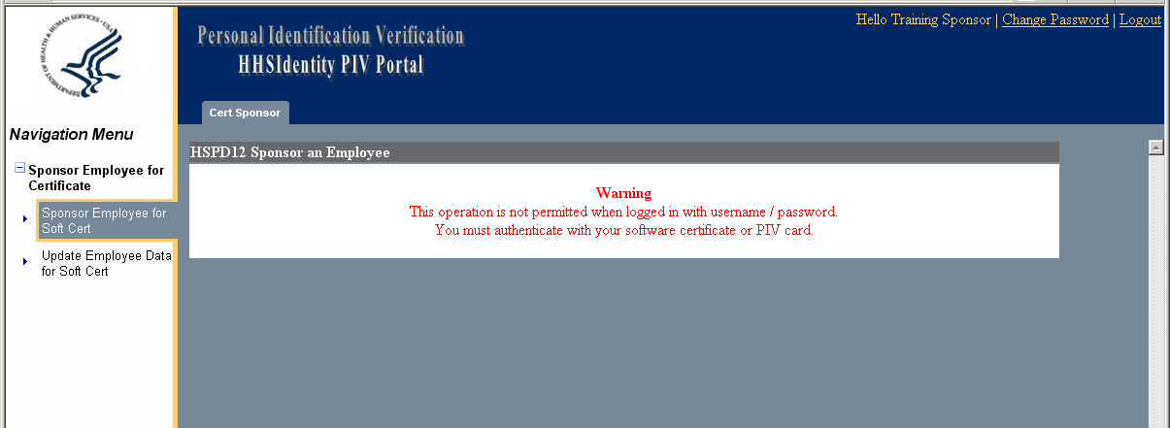

    - Completing the “HSPD12 Sponsor an Employee” Form
All fields that are labeled in red are required fields and must be filled out by the Sponsor. Once all of the required fields have been completed, click “Submit”.
NOTE: The Sponsor should validate the Applicant’s email address with the Applicant before filling out the “Primary SMTP E-Mail Address” field. It is critical that the email address is correct. The email address is used to send sponsorship information to the Applicant.
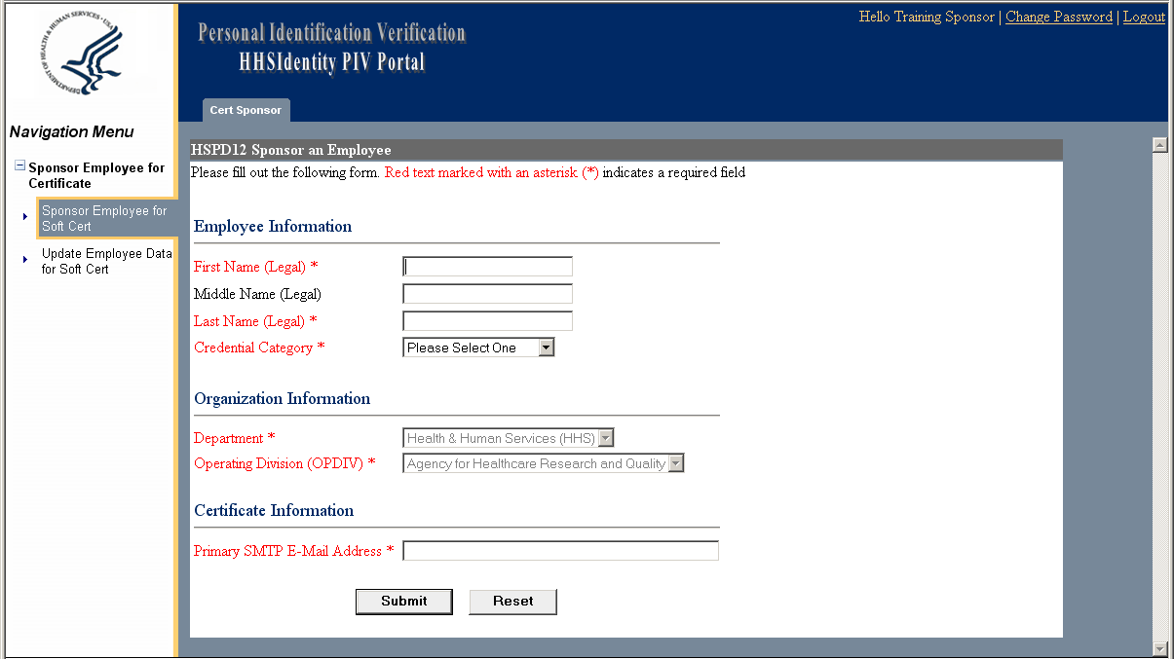

When the Sponsor has successfully submitted the Sponsor an Employee Form, they will see the screen shown below. This screen will display the message: “The Applicant’s information has been saved successfully. An email has been sent to the certificate user to review his/her information.” Click “Logout”.
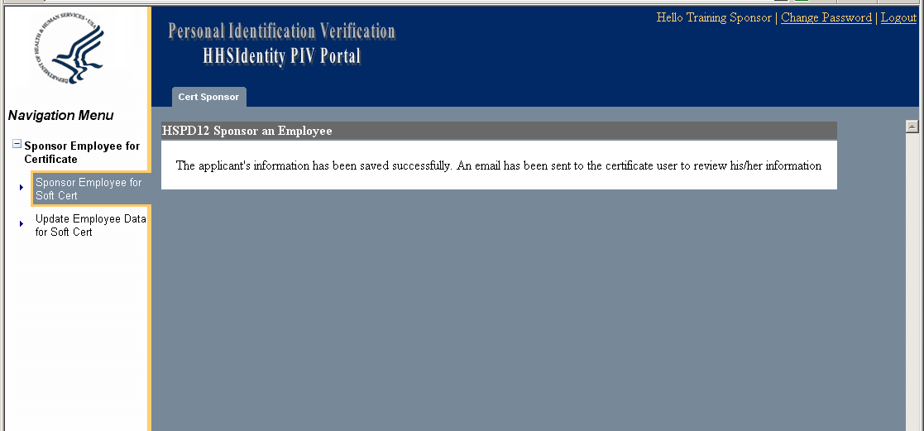
- Software Certificate Subscriber Training
This guide offers step-by-step instructions on the process that an Applicant using the Window operating system must complete in order to request and collect HSPD12 Software Certificates.

  - Receiving Sponsorship Notification
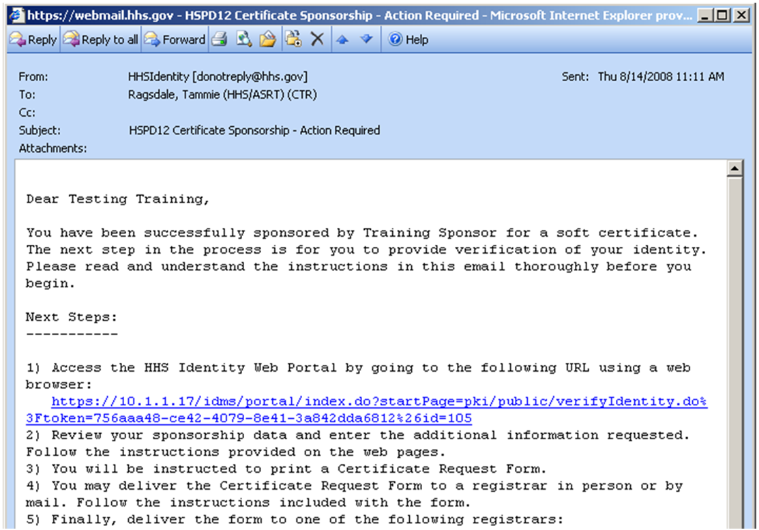
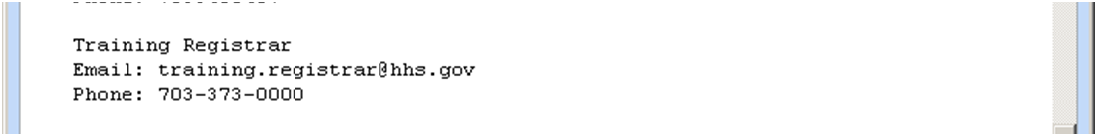
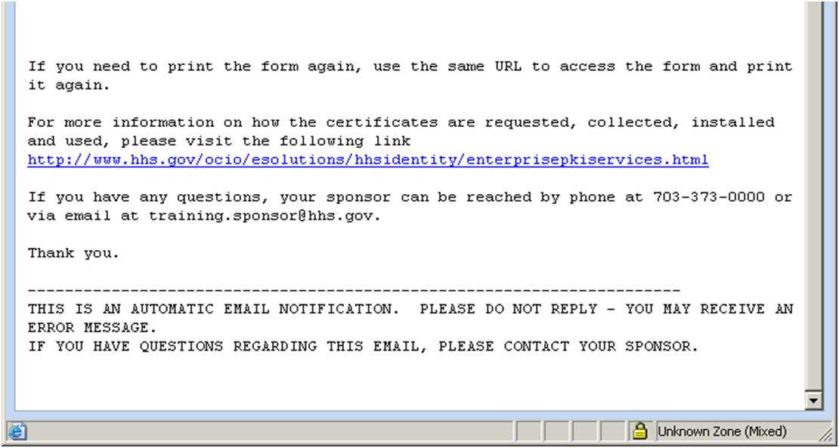
The Sponsor begins the Software Certificate Request process by accessing the HHSIdentity Portal. Once the Sponsor inputs the Applicant’s name, credential category, and email address and submits the information to the Portal, the Sponsorship process is completed and an automated email is sent to the applicant to inform them that the Sponsorship has occurred. When an Applicant receives a HSPD12 Certificate Sponsorship email, they should read and follow the instructions in the email to access the HHS Portal. The image below shows a sample HSPD12 Certificate Sponsorship email.

  - Accessing the HHS Portal
To access the HHS Portal, click the hyperlink located within the HSPD12 Certificate Sponsorship email. (https://158.74.64.17/idms/portal)
The URL provided in the email will be available for 72 hours from the time the email was sent. If the Applicant receives the message displayed in the figure below, they will have to be sponsored again.
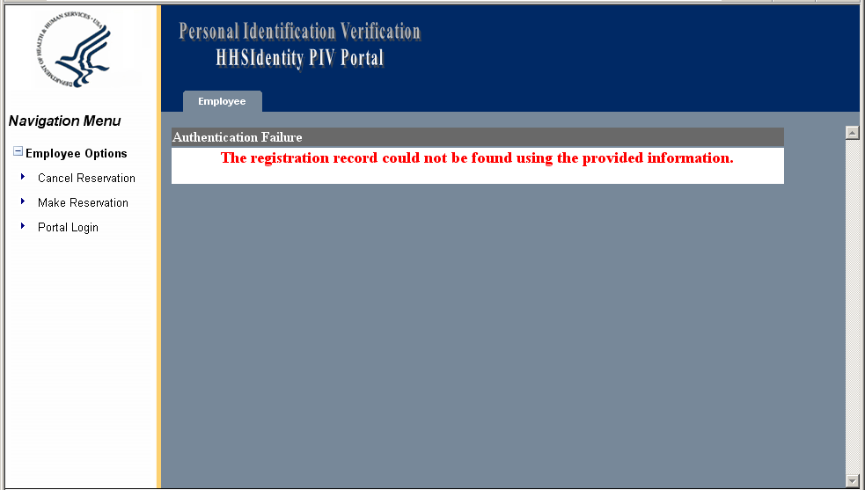

  - Completing the Subscriber Request Form
Once the Applicant clicks the link in the HSPD12 Certificate Sponsorship email, the PIV Portal opens to display the Applicant’s information that has been previously entered by the Sponsor. Below is an image of the PIV Portal screen displaying the Subscriber Request Form.
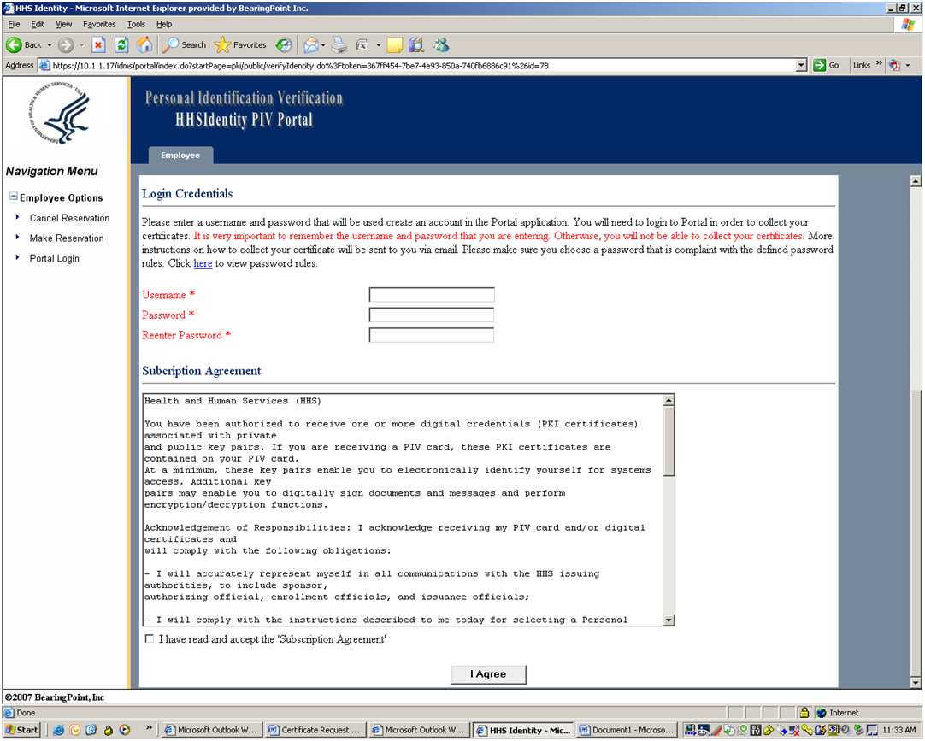
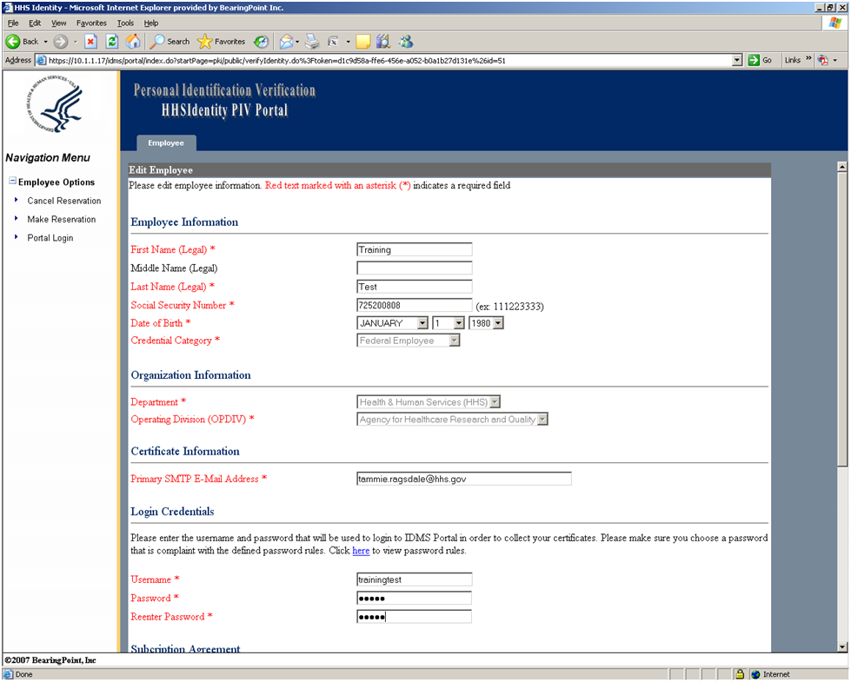

The Applicant should follow the steps outlined below to complete the Subscriber Request Form:
- The Applicant must read the Subscriber Agreement and complete all red text fields.
- Click the check box next to “I have read and accept the Subscriber Agreement”.
- Click the “I Agree” button.
- Once the Applicant has clicked the “I Agree” button on the Subscriber Agreement, the Employee Review screen is displayed. This screen allows the Applicant to check the accuracy of the information displayed on the screen. The Employee Review Screen is shown below.
- If all of the information on the Employee Review screen is correct, click “Submit”.
- If any information in the Subscriber Request Form is incorrect, correct the information and then click “Submit”. Upon review, if the Applicant notices an error in information that is grayed out, click “Cancel”. Clicking “Cancel” will return the Applicant back to the previous screen and allow them to correct the error.
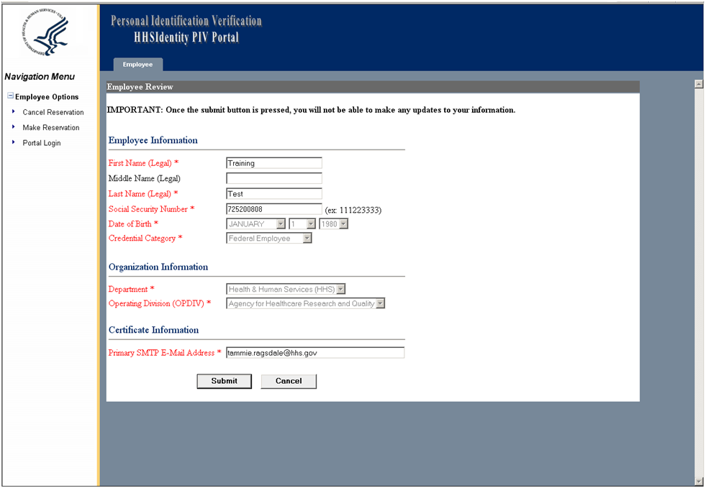

    - Selecting a Secure Password
The system will not allow the Applicant to proceed in the request process without a vaild username and a secure password.
A secure password must:
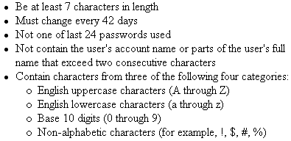
  - Submitting a Printed Copy of the Subscriber Request Form
Once the Applicant has clicked “Submit” on the Employee Review screen, the Print Request Form screen will be displayed. Below is an image of the Print Request Form screen. The Applicant should follow the steps outlined below to print and submit the Subscriber Request Form, which contains three pages: the instructions page, the Subscriber Agreement, and the Certificate Request Form.
- Click the “Click Here to View/Print Form” link.
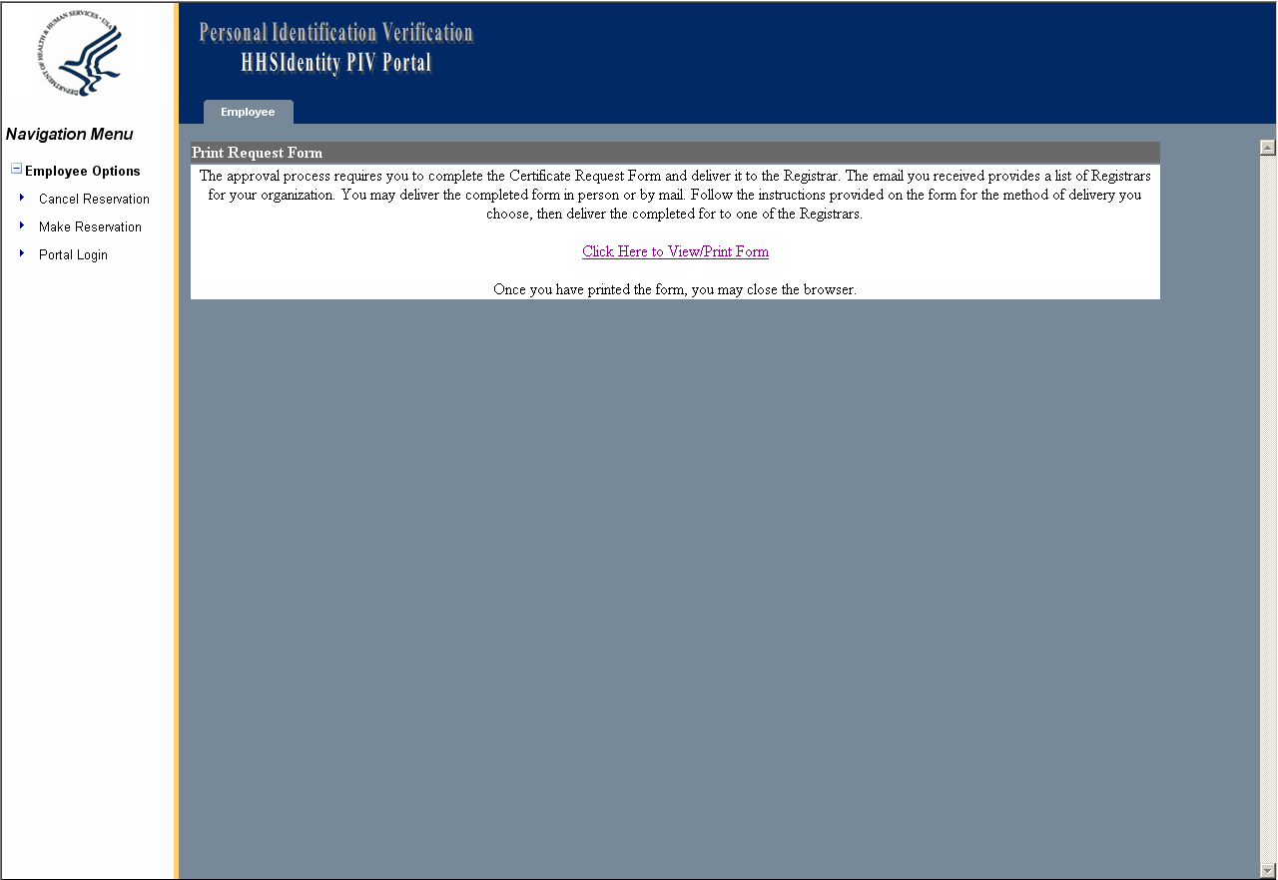

- Once the Subscriber Request Form has opened, use the menu bar at the top to print the Subscriber Request Form.
- Give the Registrar the printed copy of the Subscriber Request Form.
The instructions page is displayed below.
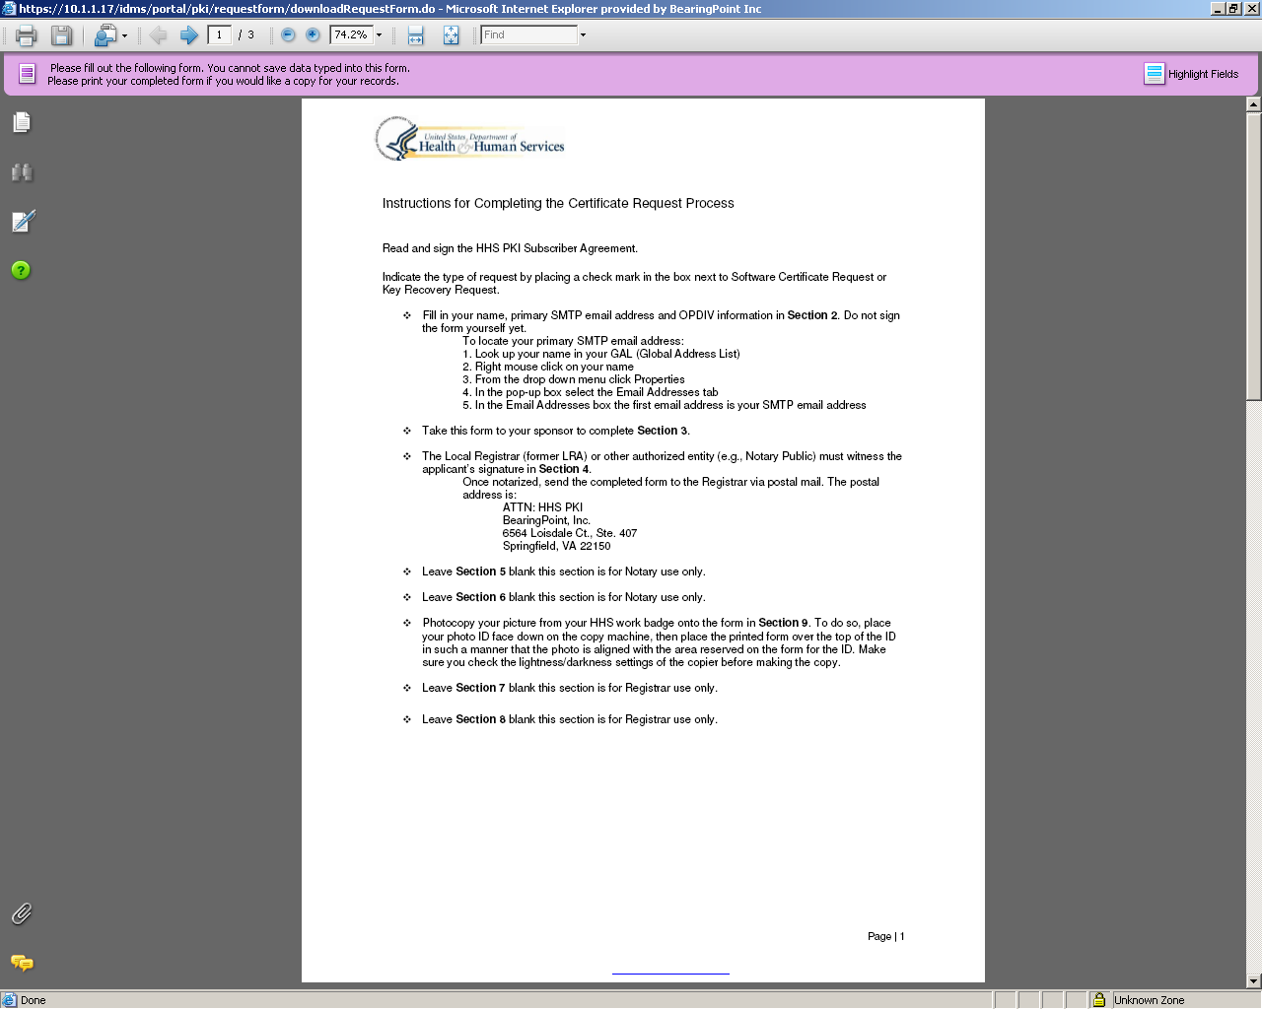

The Subscriber Agreement is displayed below.
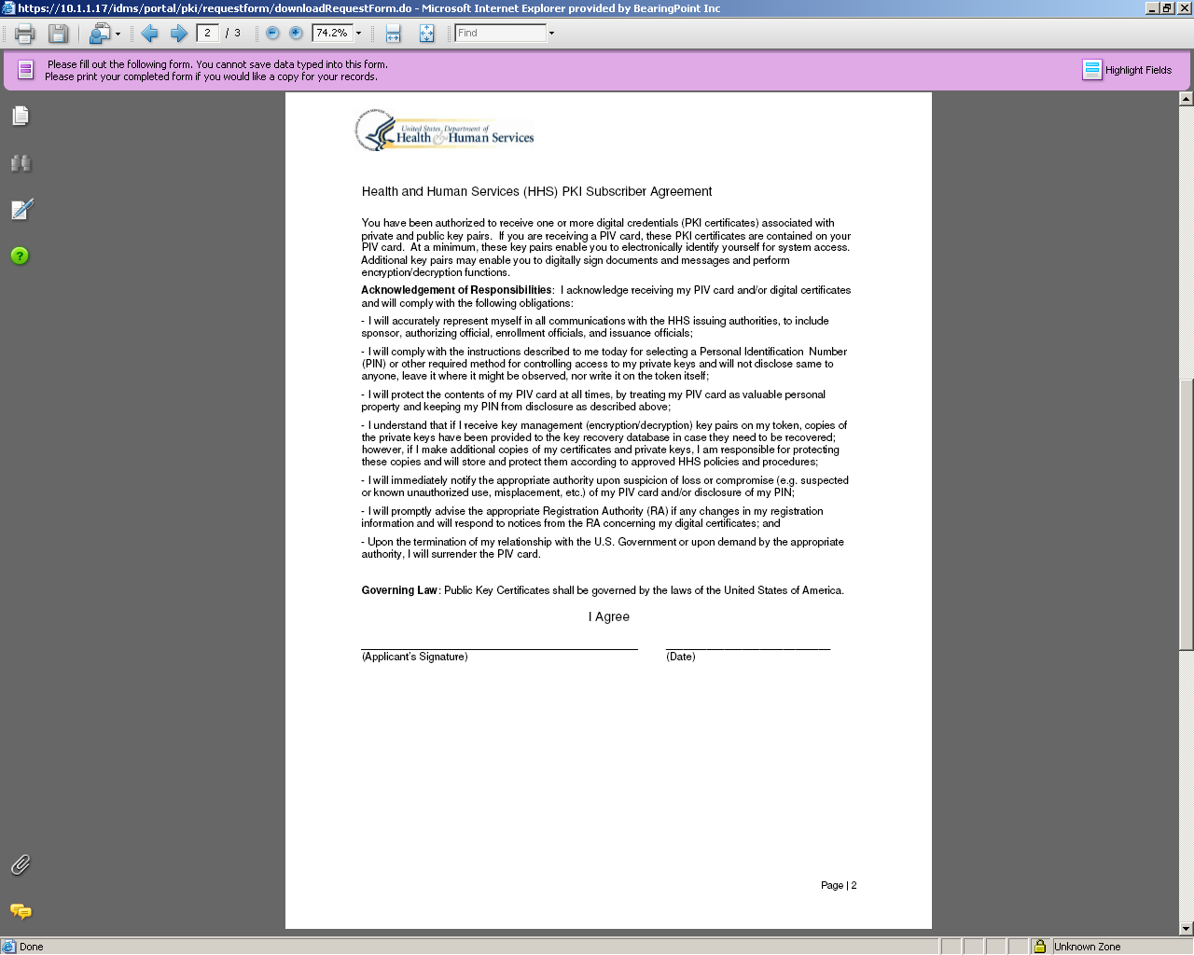

The Certificate Request Form will have the applicant’s information prepopulated. The Certificate Request Form is displayed below.
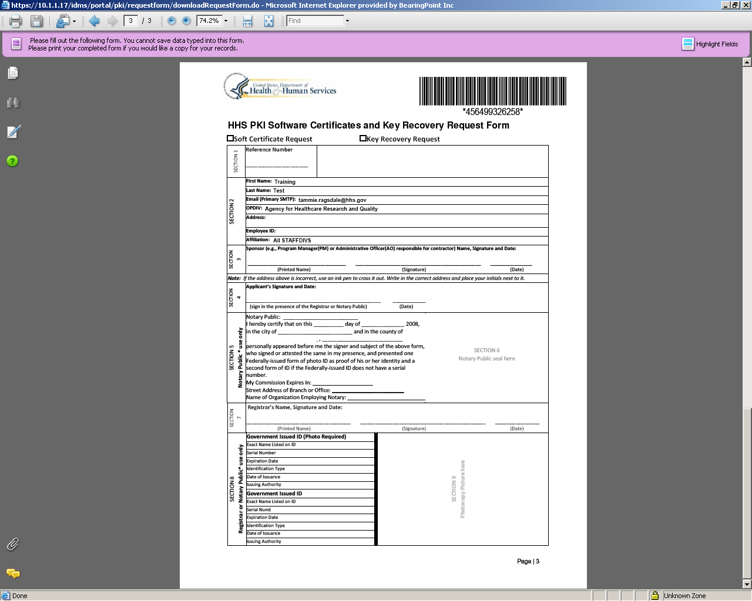
  - Collecting the HHS Digital Certificates
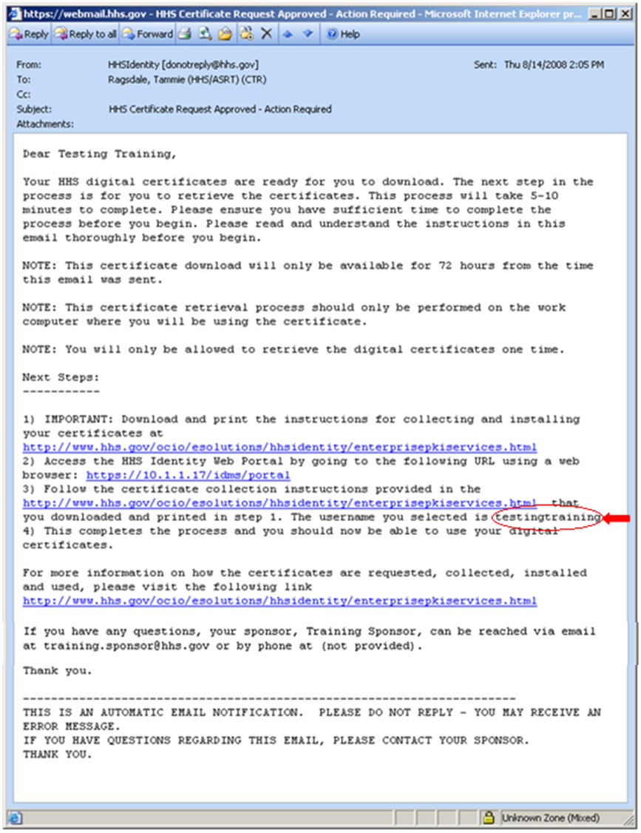
After the Registrar approves the Applicant’s certificate request, the Applicant will receive a HHS Certificate Request Approved email directing them to download their digital certificates. The Applicant should read and follow the steps described in the HHS Certificate Request Approved email. The HHS Certificate Request Approved email is shown in the image below.

The applicant should follow the steps oulined below to collect their digital certificates.
    - Accessing the HHS Portal
- Click the link for the web browser given in step #2 in the email. (https://158.74.64.17/idms/portal)
- A security alert is displayed, click “Yes”.
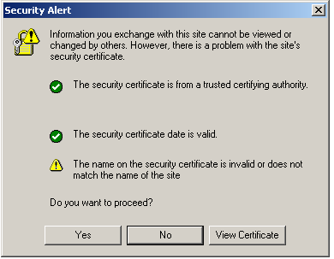

- The “Employee” tab is displayed on the navigation bar. Click “Portal Login” on the left side of the screen.
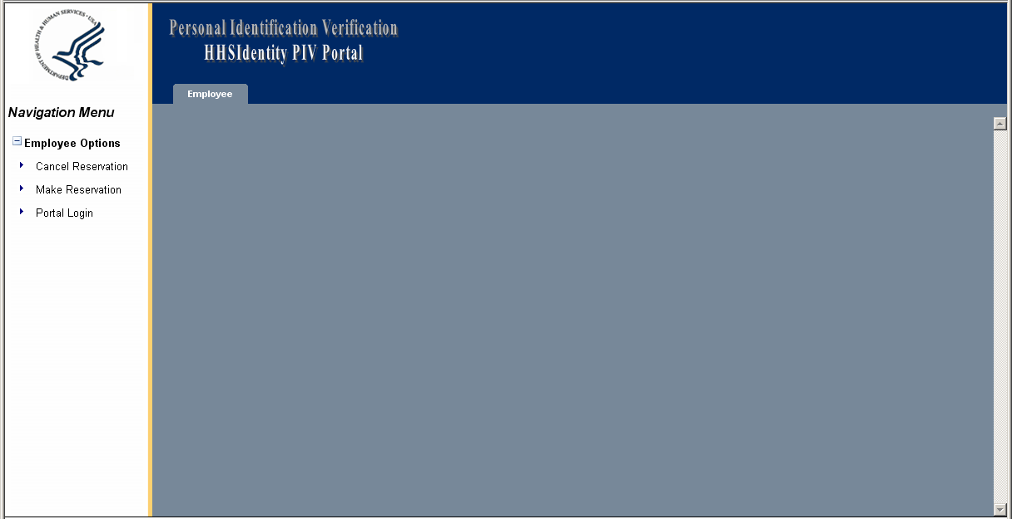

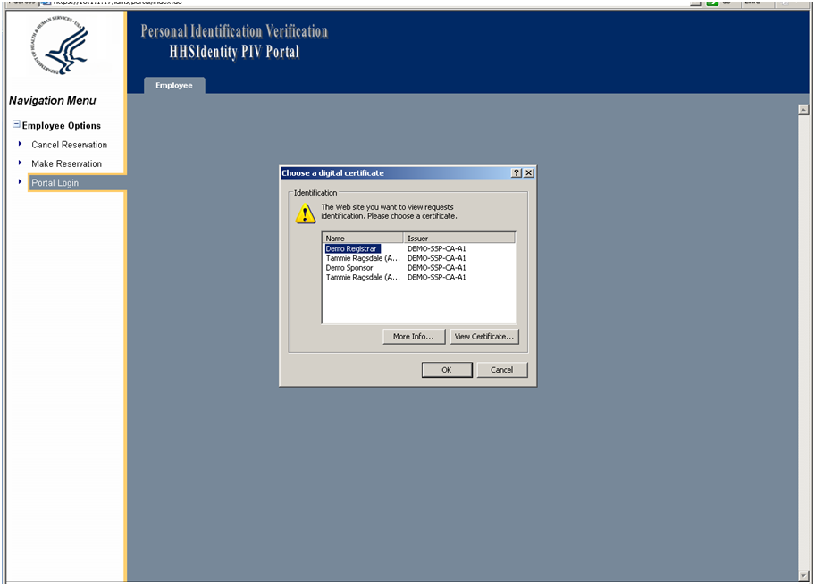
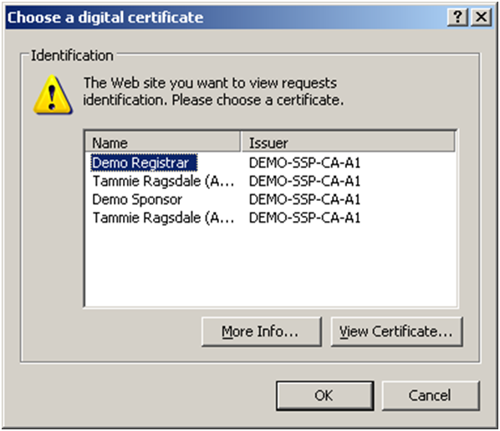
- The “Choose a digital certificate” window is displayed. Click “Cancel”.

- Enter the User ID and Password created for the Subscriber Request Form and then click “Login”. The Applicant’s user name is given in the HHS Certificate Request Approved email.
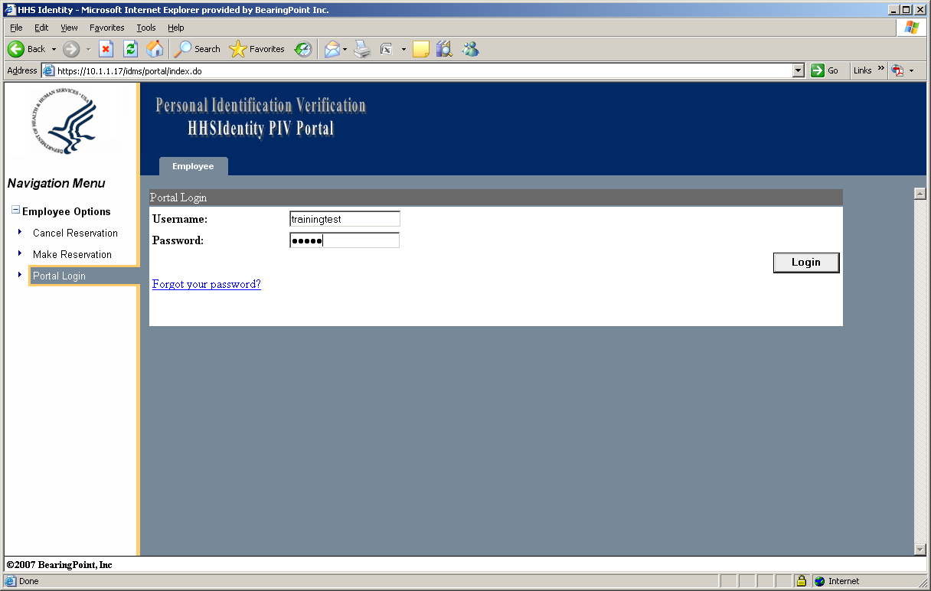

- The Applicant is prompted to enter answers for challenge questions for future access to the Portal in case they forget their password.
  - Select two challenge questions and type in answers for each question.
  - Click “Save”.
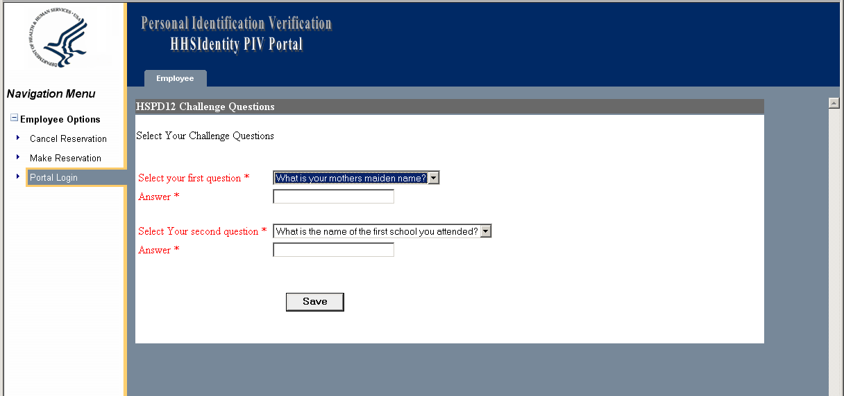

- The Applicant will receive the message “Your challenge questions and answers are saved successfully”. Click “OK”.
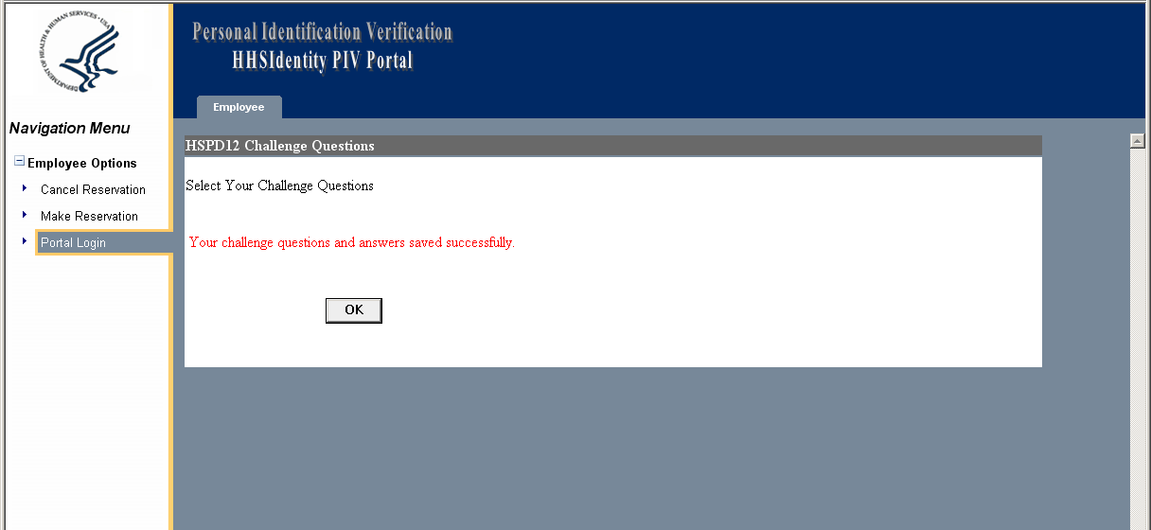
    - Downloading the Digital Certificates
- The Applicant may now proceed to collect their certificates. Click “PKI Certificate Collection” on the left side of the screen.
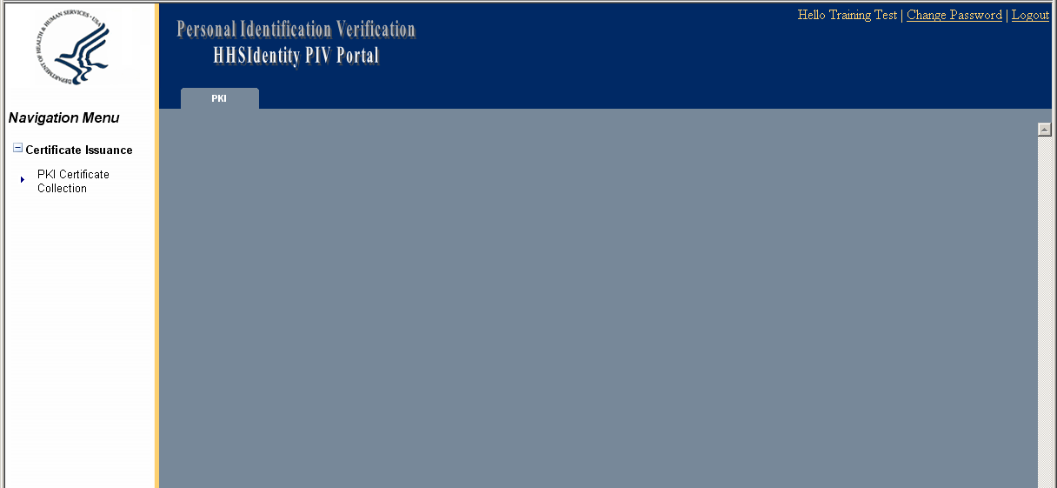
- Click “Collect Certificates” button.
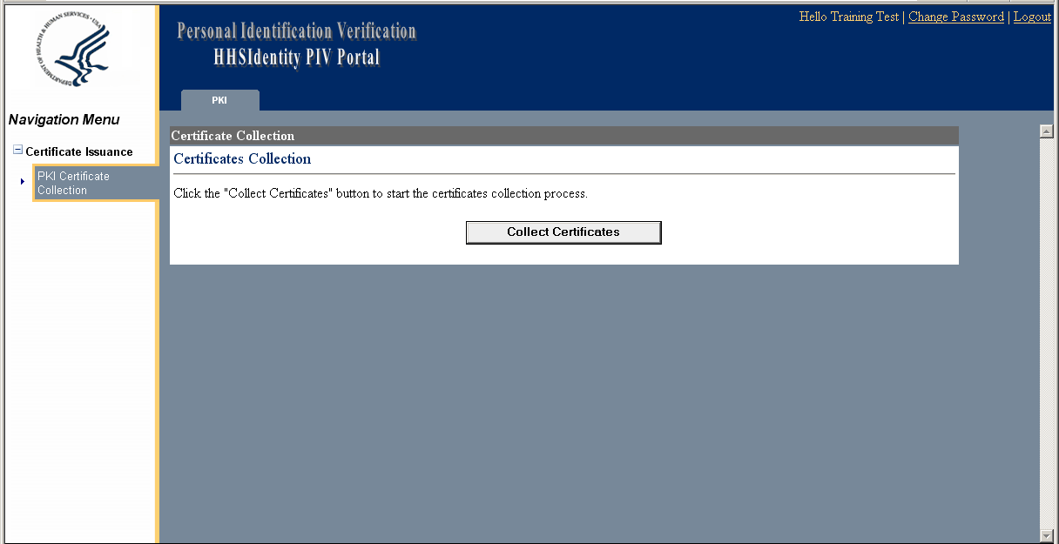

- Create and enter a passphrase to protect the Encryption Certificate in transit from the Certificate Authority (CA) to the Applicant. The Applicant will be required to enter this passphrase to retrieve their certificate. Click “Submit”.
NOTE: It is very important for the Applicant to remember their passphrase. If the Applicant forgets their passphrase, they will be required to start the process over from the beginning.
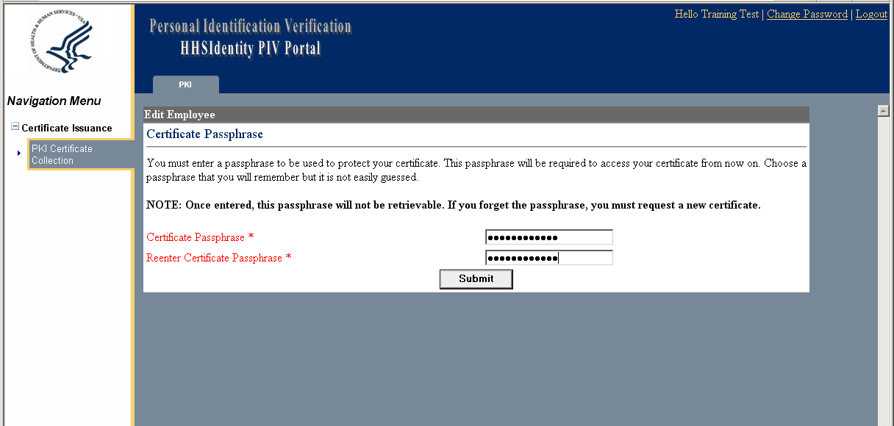
- “Generate Private Key” screen is displayed. You are now ready to generate your Digital Signing Certificate Key Pairs. Click “Submit” to generate the certificate.
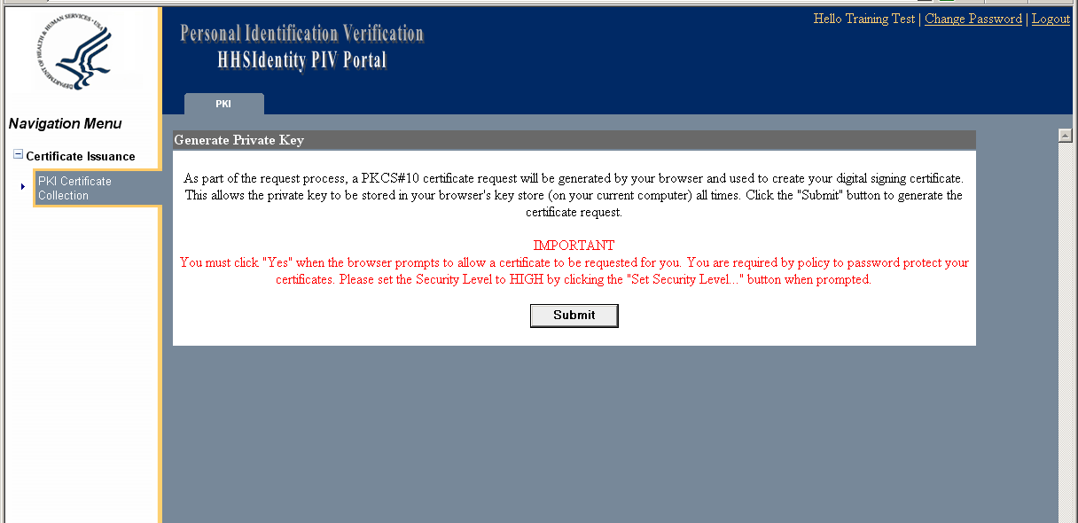
- A warning message is displayed to verify if the Applicant wants to request the certificate now. Click “Yes”.
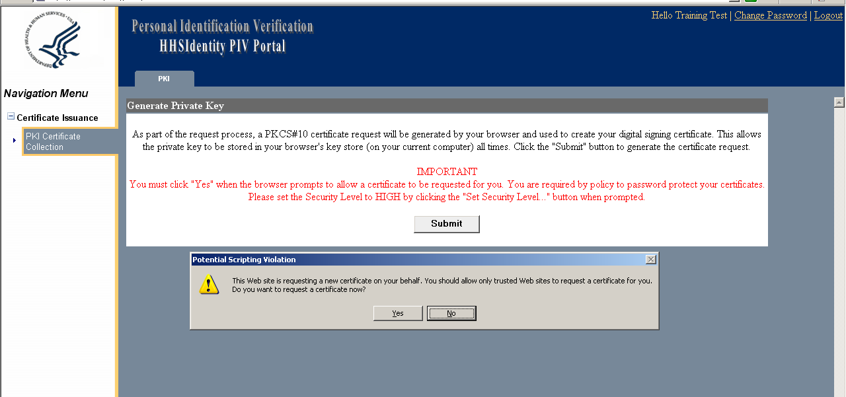
- The following screen is displayed allowing the Applicant to select the security level for the Digital Signature Certificate. Click “Set Security Level”.
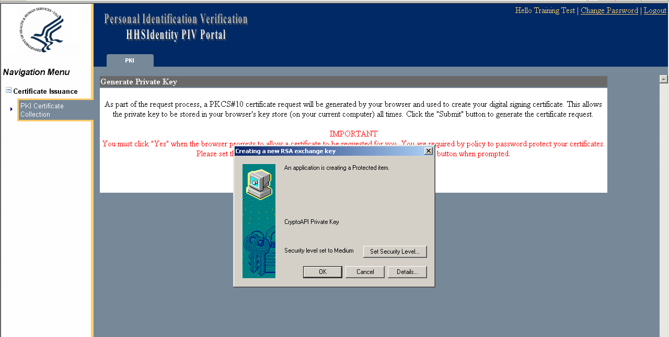

- Click “High” and then click “Next”.
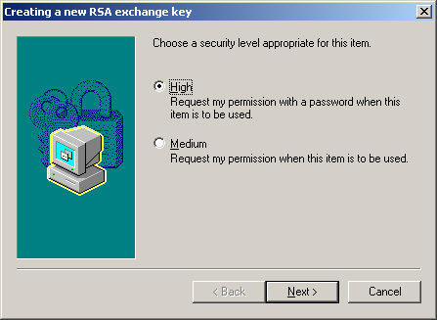
- Create and enter a password to protect the Applicant’s private key. Retype the password to confirm and then click “Finish”.
NOTE: It is very important for the Applicant to remember their password. The Applicant will be required to enter this password whenever they use the digital signing certificate in the future. The Applicant will be unable to use the digital signing certificate if they cannot remember this password.
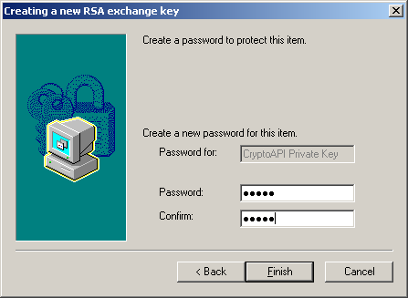
- Click “OK”.
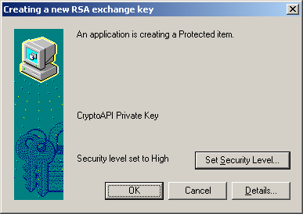
- The Applicant will now see a screen saying “Your Digital Signing Certificate is being generated. Please wait….” Wait for the Certificate Collection Screen to be displayed.
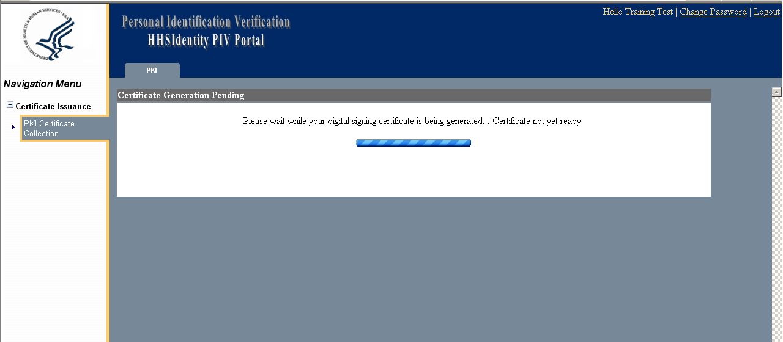

    - Installing the Digital Certificates
- Once the Certificate Collection screen is displayed, click “Click here to install your signing Certificate”.
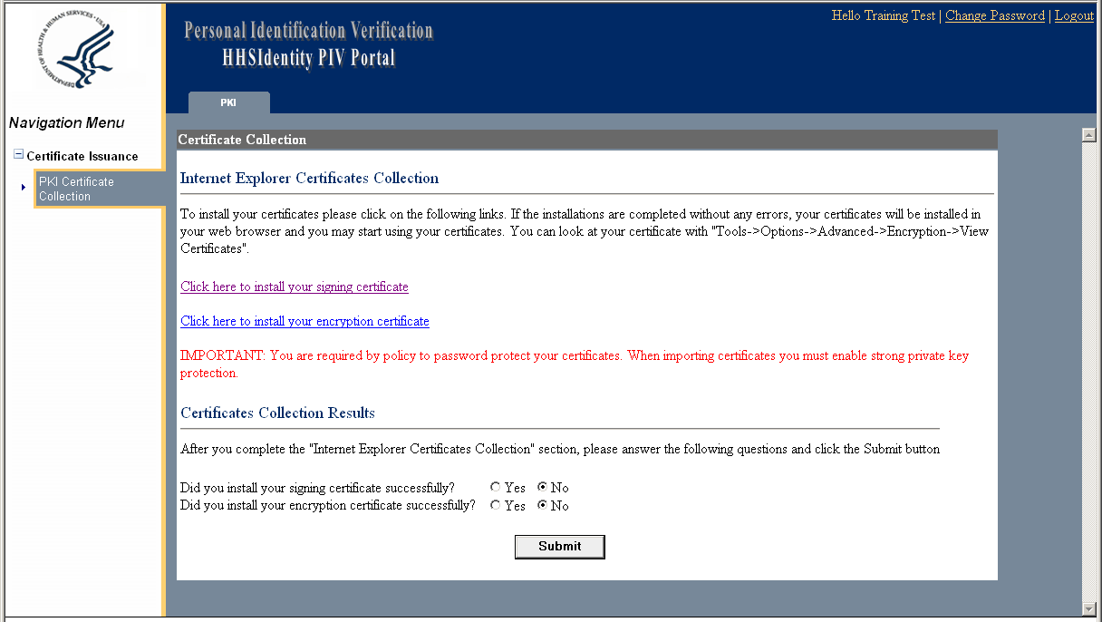

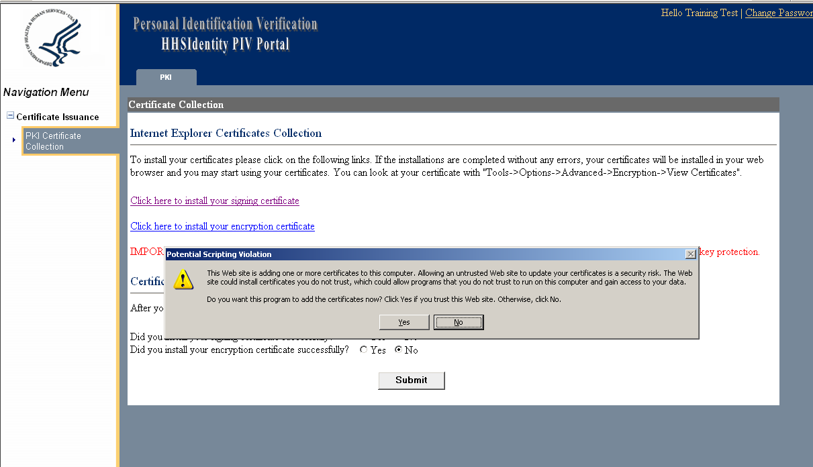
- A warning prompt is displayed to verify that the Applicant wants to add their certificate now. Click “Yes”.

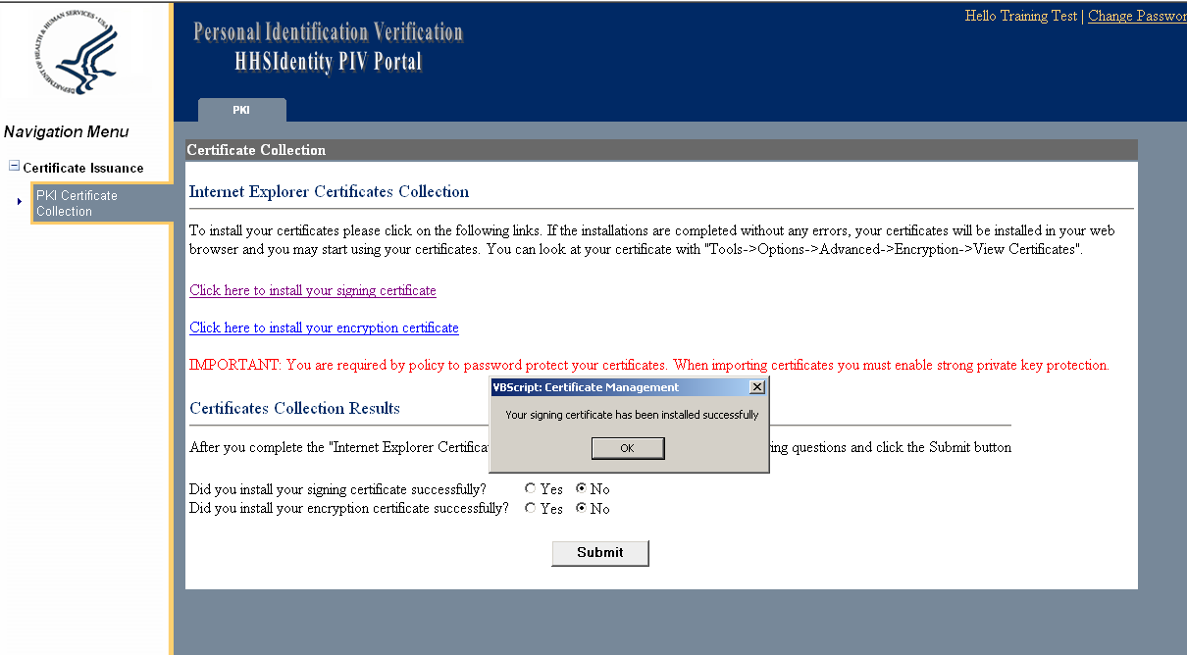
- The message “Your signing certificate has been installed successfully” is displayed. Click “OK”.
- Click “Click here to install your encryption certificate”.
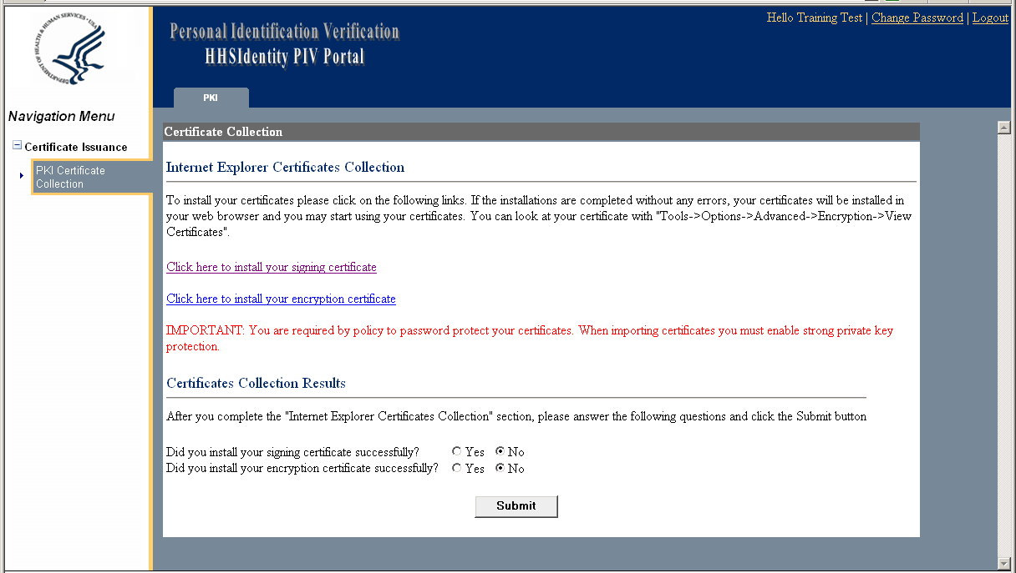
- Click “Open”.
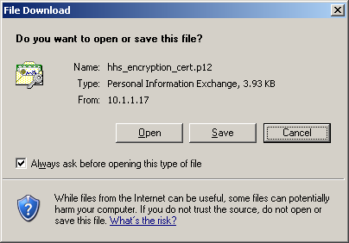

- The Certificate Import Wizard is opened. Click “Next”.
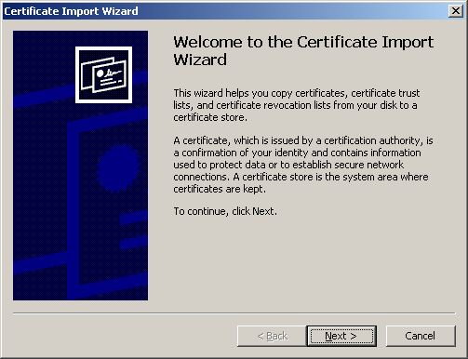

- The PKCS#12 file is already populated. Click “Next”.
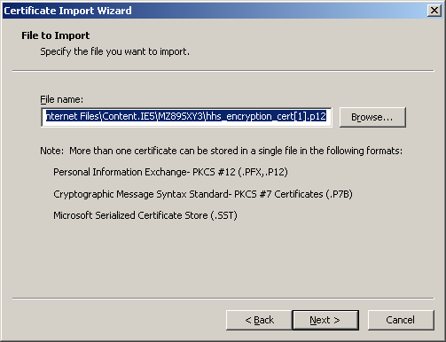
- Type the passphrase previously created to protect the Applicant’s private key in transit from the Certificate Authority (see 3.5.2 Downloading the Digital Certificates, step 3).
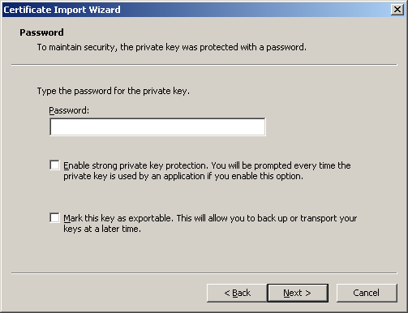
- Click both check boxes shown below and then click “Next”.
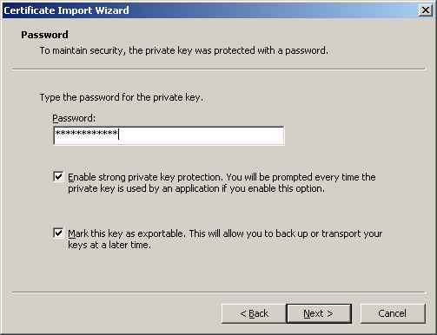
- Click “Next”.
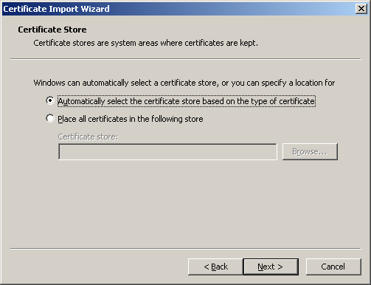

- The Certificate Import Wizard is completed. Click “Finish”.
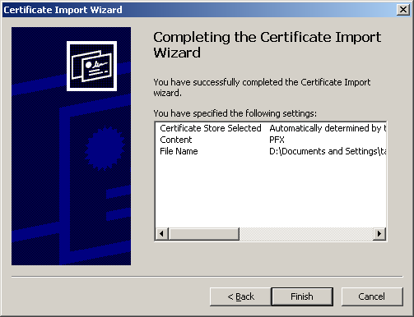
- Click “Set Security Level” to set the security level for the Encryption Certificate.
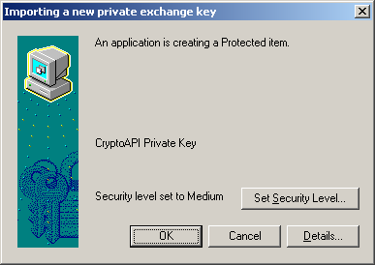
- Click “High” and then click “Next”.
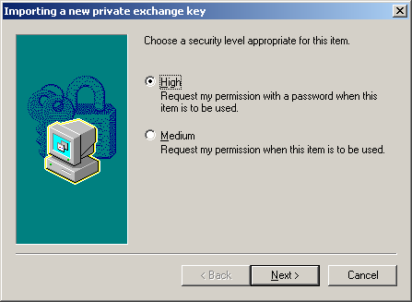

- The Applicant should follow the steps outlined below to create a password that they will use every time they use their certificate.
  - Enter the chosen password in the “Password” field
  - Retype this password in the “Confirm” field.
  - Click “Finish”.
NOTE: The Applicant will be unable to use the digital signing certificates if they cannot remember this password.
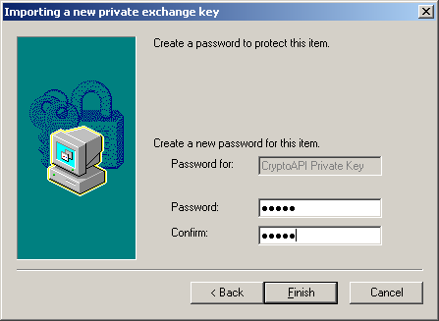

- Click “OK”.
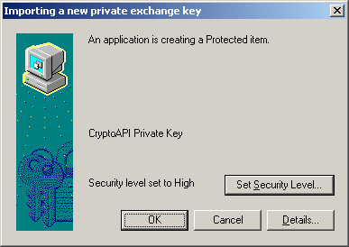
- Click “OK”.
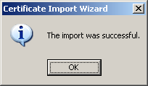

- On the Certificate Collection screen, the Applicant will see two questions under the heading “Certificates Collection Results.”
  - For both of these questions, click the button in front of the answer “Yes”.
  - Click “Submit”.
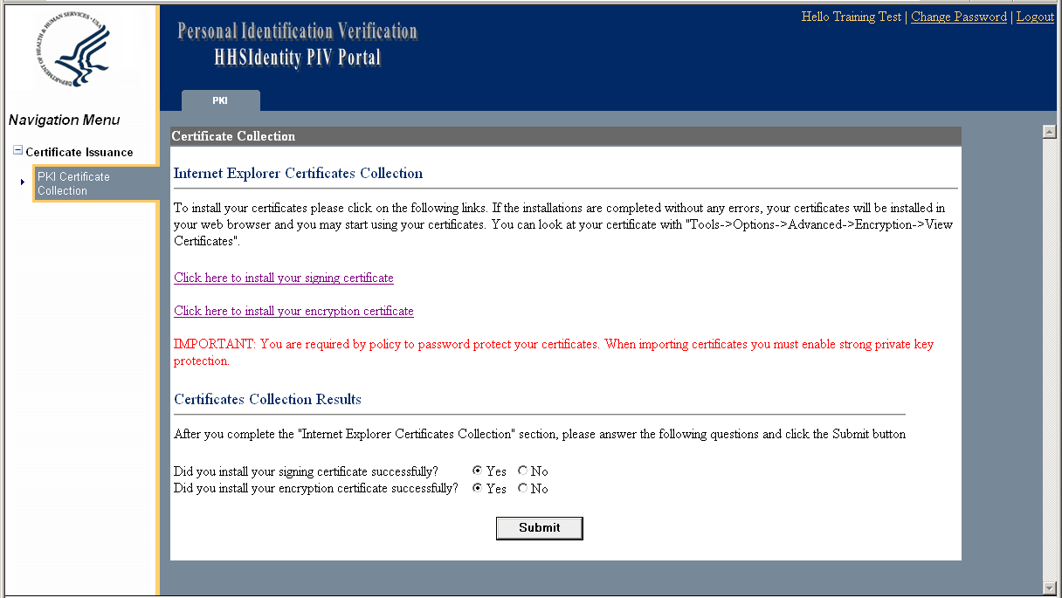
- A screen will notify the Applicant that they have successfully collected their certificates.
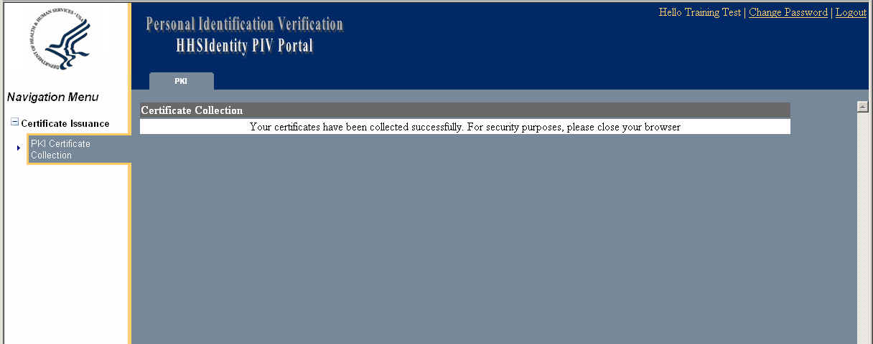
  - Ensuring Proper Collection and Installation of the HHS Digital Certificates
The Applicant should follow the steps listed below to ensure that they have properly collected and installed their certificates.
- Open an Internet Explorer Window.
- From the Internet Explorer tool bar, click Tools>Internet Options.
- Click the “Content” tab and then “Certificates”. If the Applicant’s certificates have been properly installed and collected, they should see the certificates that they have collected listed on the screen.
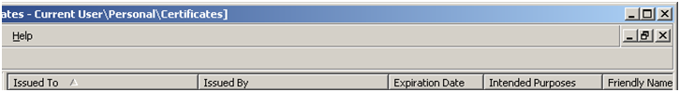
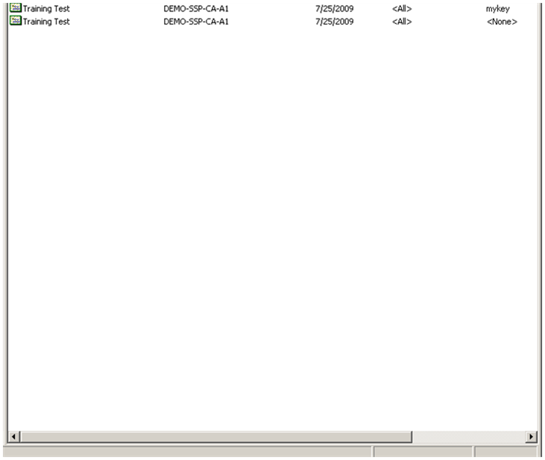

- Software Certificate Registrar Training
This guide offers step-by-step instructions on the process that a Registrar using the Window operating system must complete in order to approve an Applicant for Software Certificate request and collection.

  - Accessing the HHS Portal
There are two methods the Registrar can use to access the IDMS Portal. The Registrar can log on to the portal 1) using a PIV Card or 2) using a Software Certificate.
    - Accessing the HHS Portal Using the PIV Card
If accessing the Portal using the PIV Card, follow the steps listed below.
- Insert the PIV Card into the card reader.
- Open a browser window.
- Type https://158.74.64.17/idms/portal into the address bar.
- At the Portal Login screen, click “Portal Login” on the left side of the screen. The Portal Login screen is displayed below.
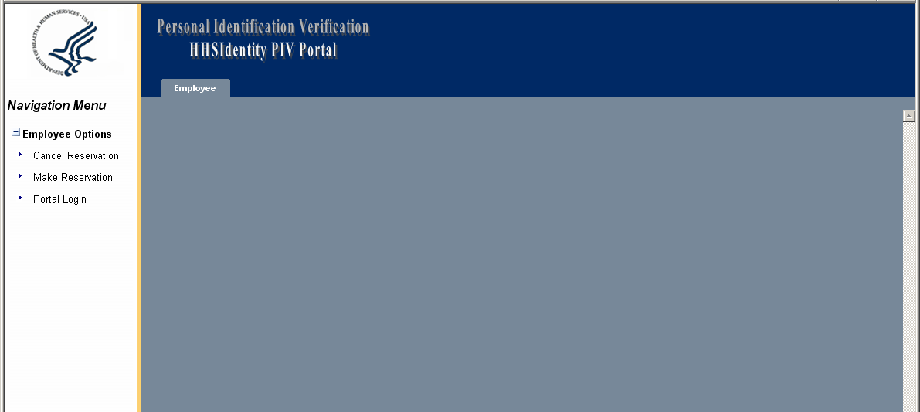

- Select the digital certificate and then click “OK”.
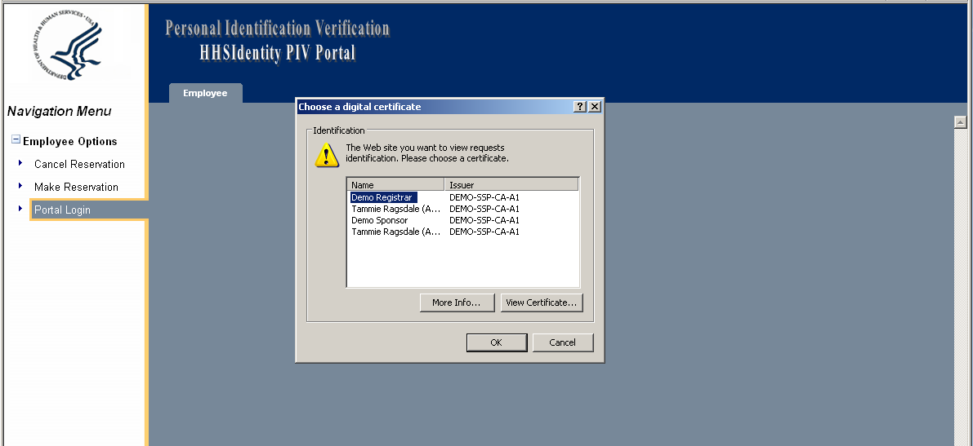

- Enter the PIN to access the PIV Card and click “OK”.

    - Accessing the HHS Portal Using a Soft Certificate
If using a Soft Certificate, the following window will be displayed. To access the HHS Portal using a Soft Certificate, enter the Password for the certificate and then click “OK”.
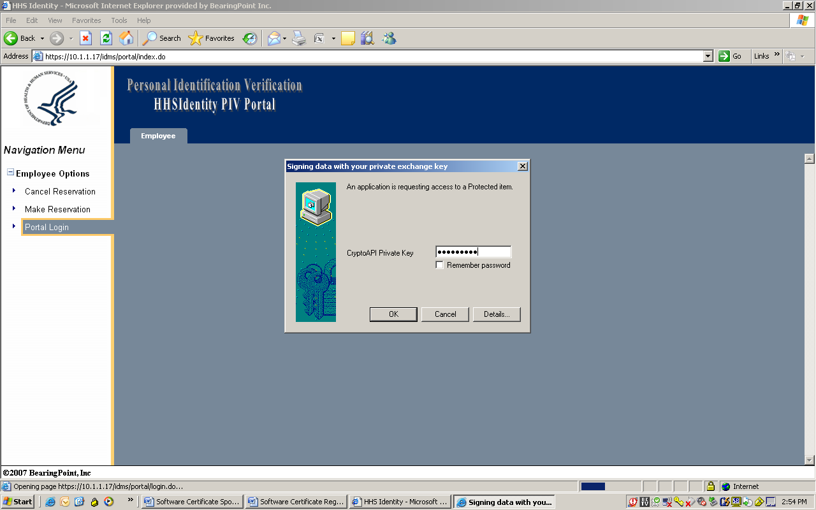

  - Processing a Certificate Request
Follow the steps outlined below to process a certificate request.
- The “Cert Registrar” tab will be displayed on the navigation bar of the HHS Portal Screen, which is displayed below. Click “Process Certificate Request” located on the left side of the screen.
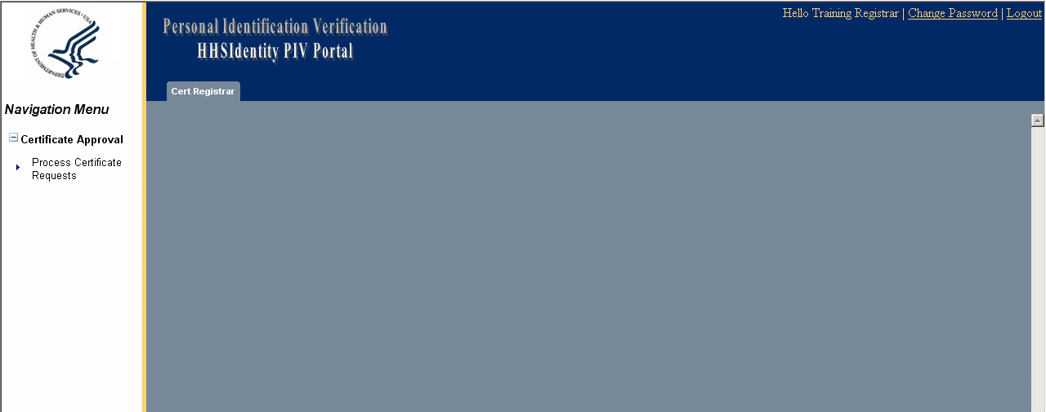
- The “Process Certificate Request” screen is displayed.
  - Enter the Barcode number. The barcode number can be found in the top right corner of the Certificate Request Form provided by the Applicant.
  - Click “Search”.
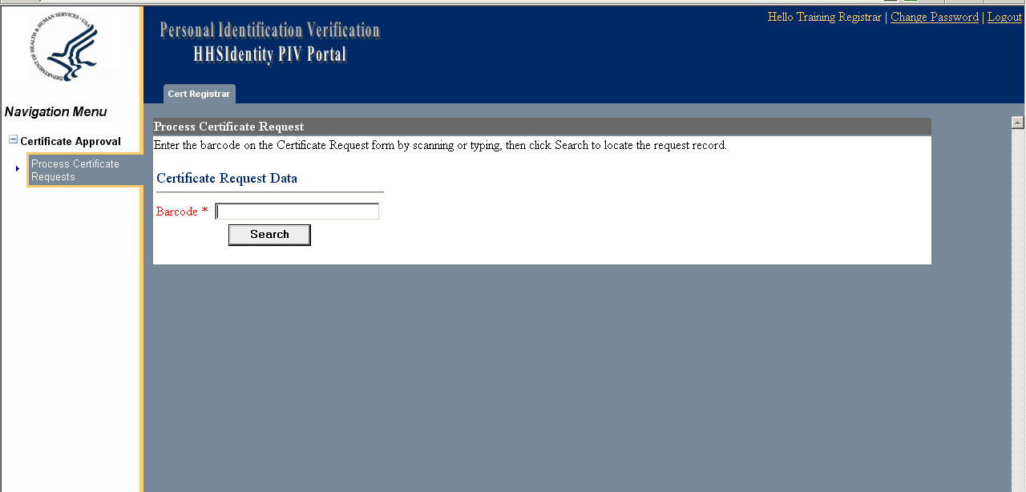
- The Applicant’s information is displayed.
  - Verify the information on the Certificate Request Form and the identity of the requestor.
  - Click “Reject” or “Approve”.
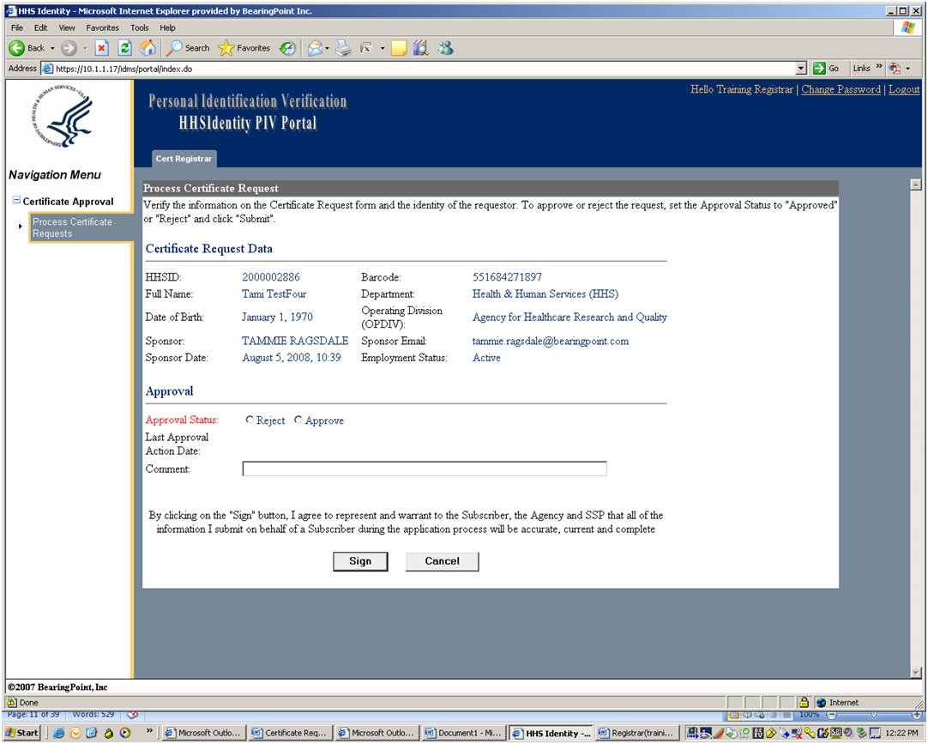
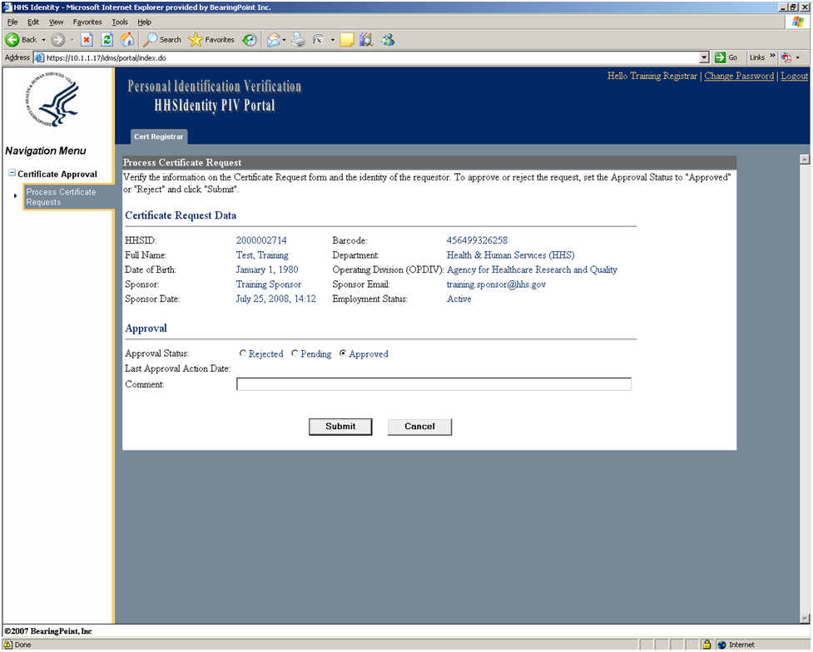
  - Click “Sign”.

- The Registrar’s digital signature is required. The Digital Signature page will indicate that the system is detecting readers, please wait.
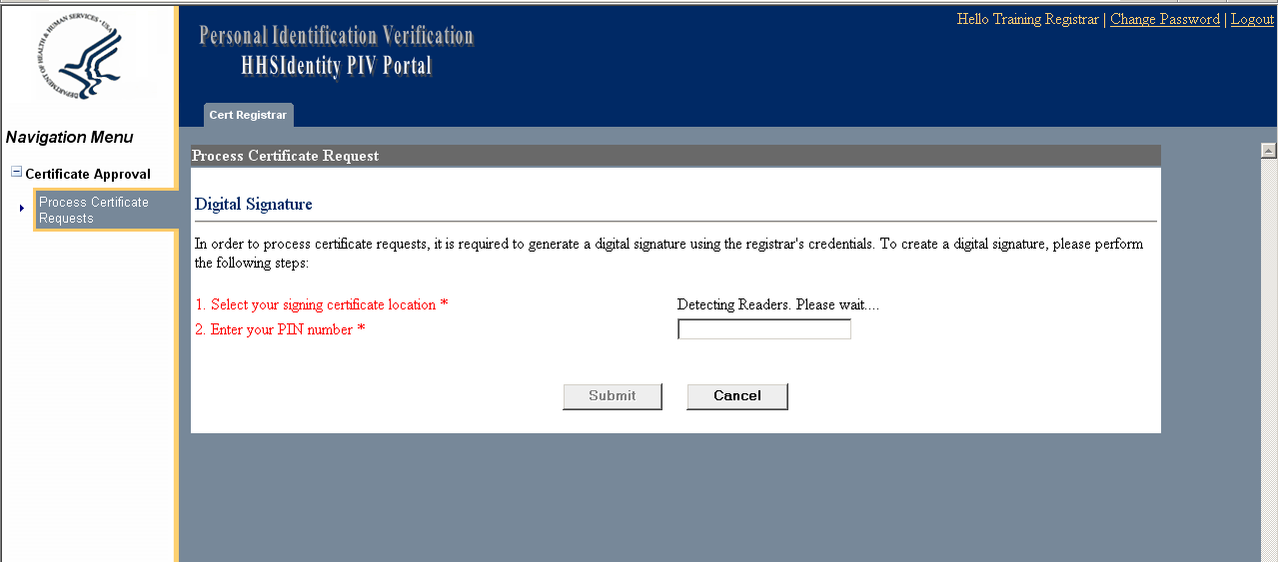
- The Registrar must now select the signing certificate location from the drop down menu in item number 1.
  - If the Registrar is using the PIV card, the PIN number must be entered in item number 2. Click “Submit”.
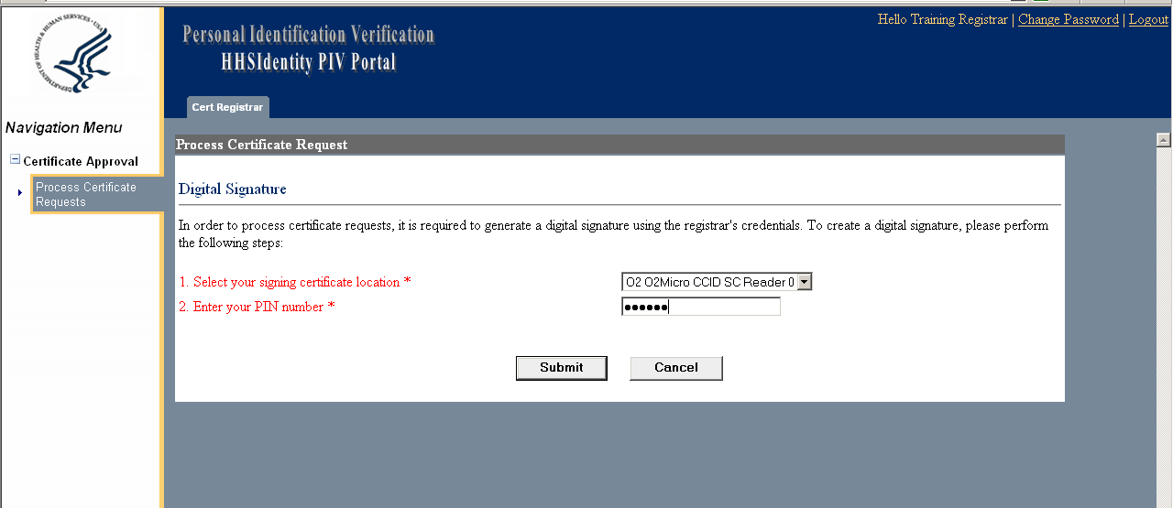

  - If the Registrar is using the Software Certificate, select “Windows Container Store” from item number 1 and then click “Submit”.
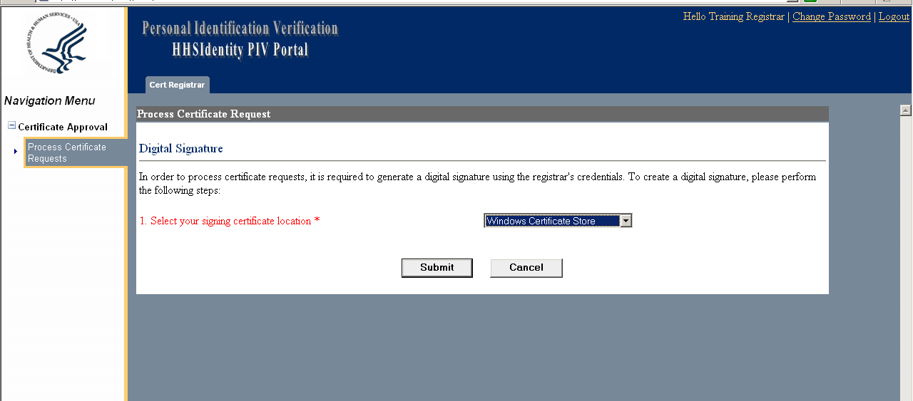
- The Registrar will receive the message “The certificate request was successfully updated.” Click “Logout” in the top right corner of the screen.


