January 14, 2007

A Temperature Sensor Using a Silicon-On-Insulator (SOI)
Timer for Very Wide Temperature Measurement

Richard Patterson, NASA Glenn Research Center

Ahmad Hammoud, ASRC Aerospace / NASA GRC

Malik Elbuluk, University of Akron

Dennis Culley, NASA Glenn Research Center

Scope

A temperature sensor based on a commercial-off-the-shelf (COTS) Silicon-On-Insulator (SOI) Timer was designed for extreme temperature applications. The sensor can operate under a wide temperature range from hot jet engine compartments to cryogenic space exploration missions. For example, in Jet Engine Distributed Control Architecture, the sensor must be able to operate at temperatures exceeding 150 °C. For space missions, extremely low cryogenic temperatures need to be measured. The output of the sensor, which consisted of a stream of digitized pulses whose period was proportional to the sensed temperature, can be interfaced with a controller or a computer. The data acquisition system would then give a direct readout of the temperature through the use of a look-up table, a built-in algorithm, or a mathematical model. Because of the wide range of temperature measurement and because the sensor is made of carefully selected COTS parts, this work is directly applicable to the NASA Fundamental Aeronautics / Subsonic Fixed Wing Program – Jet Engine Distributed Engine Control Task and to the NASA Electronic Parts and Packaging (NEPP) Program. In the past, a temperature sensor was designed and built using an SOI operational amplifier, and a report was issued [1]. This work used an SOI 555 timer as its core and is completely new work.

Temperature Sensor

A temperature-to-frequency relaxation oscillator circuit was constructed using a high temperature polyimide circuit board, Teflon wire interconnects, and high temperature lead-free solder. The circuit employed a high temperature Silicon-On-Insulator (SOI) precision timer and other specially selected, temperature-stable commercial-off-the-shelf (COTS) parts. The CHT-555-DIL14 ceramic-packaged chip was recently introduced by CISSOID Company and is specified for -30 °C to +225 °C operation [2]. The other components of the circuit included a high temperature precision, thin film platinum RTD (Resistance Temperature Detector) as the temperature-sensing element, a solid tantalum input filter capacitor, and two NPO ceramic capacitors. A schematic of the circuit is shown in Figure 1, and a photograph of the circuit board is shown in Figure 2. The circuit was evaluated at selected test temperatures between -190 °C and +210 °C. The effect of thermal cycling was also investigated by subjecting it to a total of ten cycles between +200 °C and -190 °C. A temperature rate of change of 10 °C/min and a dwell time of ten minutes at test temperature were used in these investigations. The circuit was evaluated in terms of its frequency-to-temperature conversion, period-to-temperature conversion, and variation in the output signal duty cycle and rise time with test temperature.

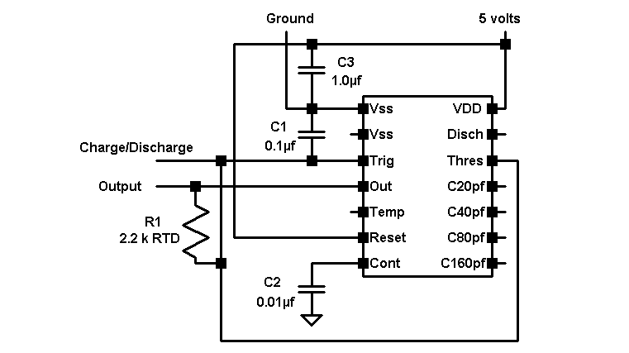

Figure 1. Schematic of the relaxation oscillator circuit.

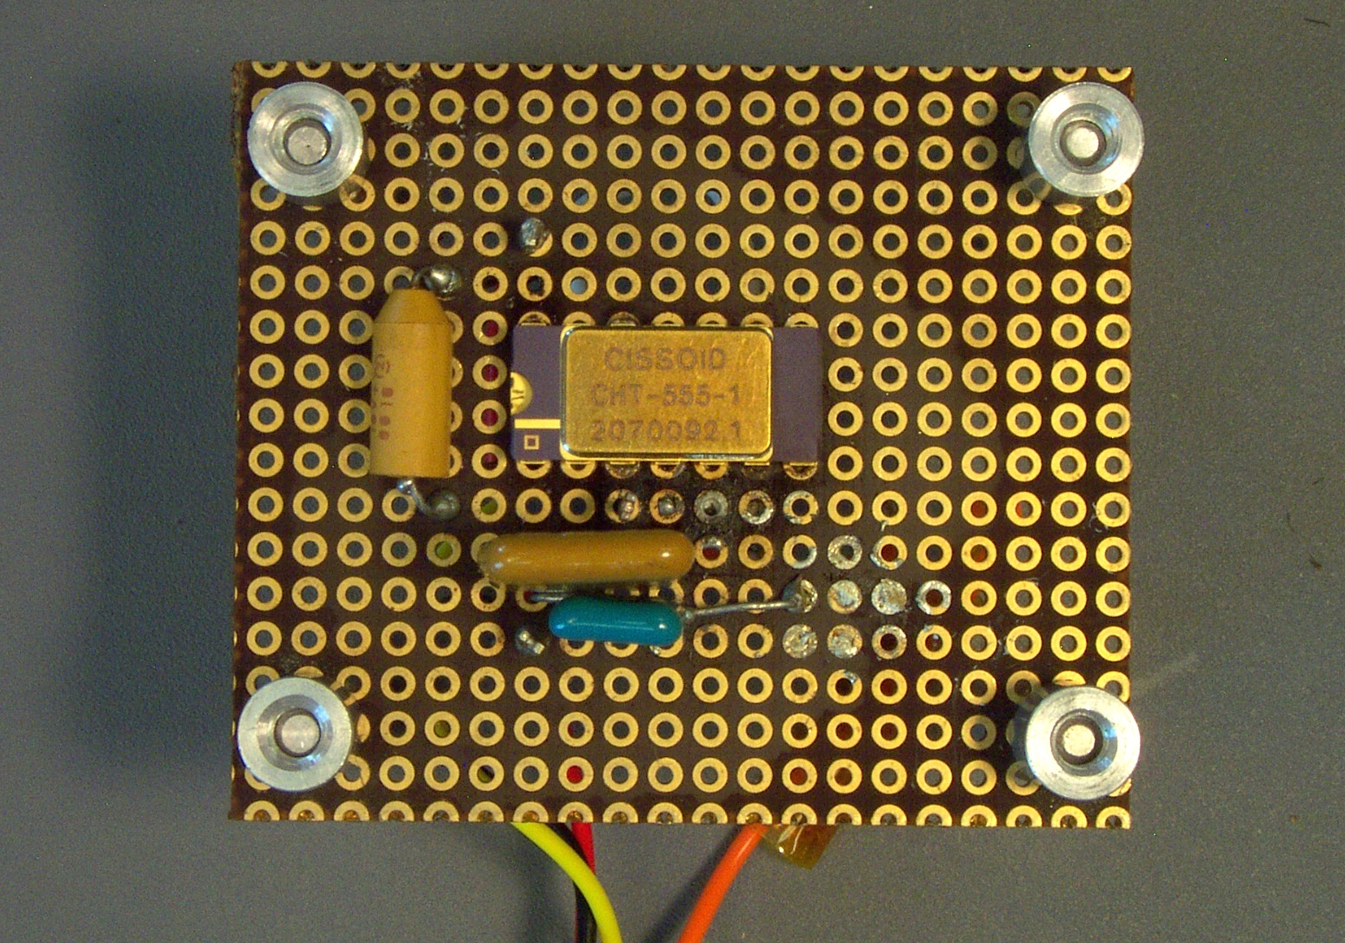

Figure 2. Relaxation oscillator circuit populated with CHT-555 timer.

Results

A typical output response of the temperature-to-frequency conversion circuit, which comprised of a rectangular pulse train (yellow signal), is shown in Figure 3 at 25 °C. The signal at the threshold pin (magenta), which governs the charge/discharge cycle of the timing capacitor C1, is also depicted in this figure as a triangular waveform. Those obtained at the high temperature of +210 °C and at the cryogenic temperature of -195 °C are shown in Figures 4 and 5, respectively. (Scale: Yellow 2V/div, Magenta 1V/div; Horizontal 0.1ms/div).

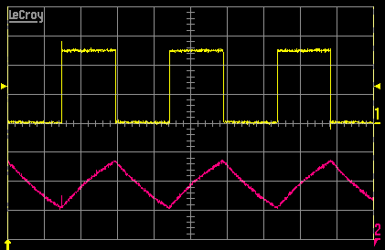

Figure 3.Output and threshold signal waveforms at 25 °C.

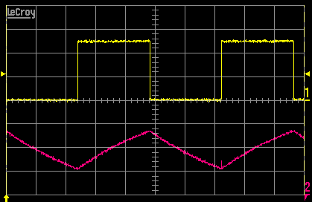

Figure 4.Output and threshold signal waveforms at +210 °C.

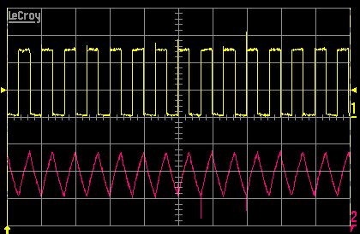

Figure 5.Output and threshold signal waveforms at -190 °C.

It can be clearly seen that the relaxation oscillator circuit performed very well throughout the temperature range between +210 °C and -190 °C as the frequency of the output signal fluctuated with variation in the sensed temperature. While the frequency of the output signal had a value of about 3.393 kHz at room temperature, it decreased to about 2.072 kHz at +210 °C and attained a frequency of 15.048 kHz when the temperature approached -190 °C. This frequency response, which took on a hyperbolic trend with temperature, is depicted in Figure 6. Plotting the period of the output signal versus temperature reveals, as expected, a linear response as shown in Figure 7. No change was experienced by either the duty cycle or the rise time of the output signal throughout the test temperature range as shown in Figures 8 and 9, respectively.

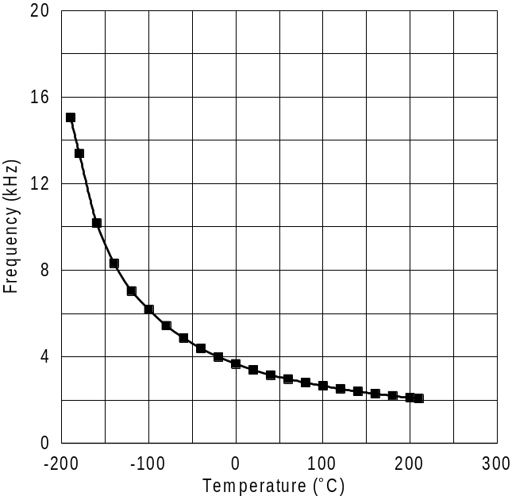

Figure 6. Output frequency versus temperature.

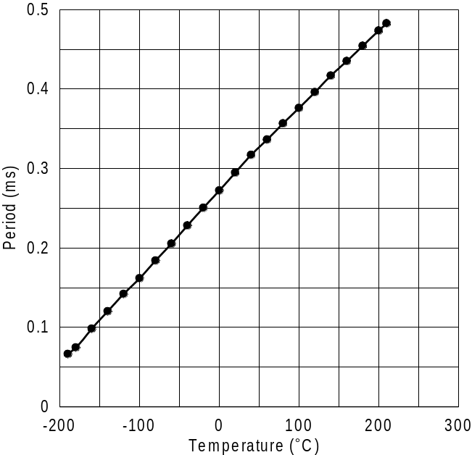

Figure 7. Period of the output signal versus temperature.

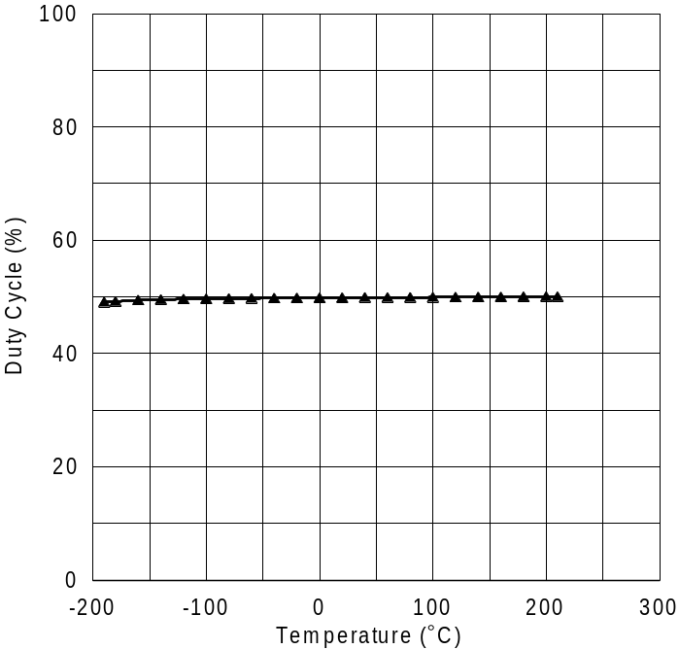

Figure 8. Duty cycle of output signal as a function of temperature.

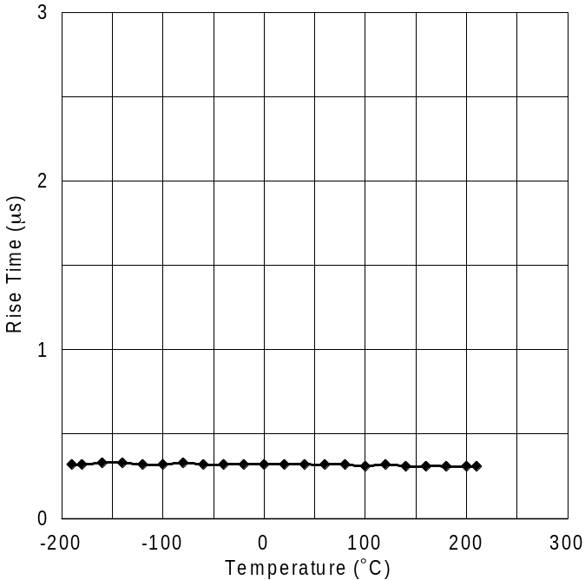

Figure 9. Rise time of output signal versus temperature.
The supply current of the circuit varied slightly with temperature as depicted in Figure 10. While the current hovered around 0.68 mA between +20 °C and +210 °C, it exhibited a slight increase with decreasing temperature reaching about 2.5 mA at the extreme cryogenic temperature of - 190 °C. This change in the circuit current with temperature is most likely attributed to the variation in the resistance value of the RTD element in the circuit as test temperature changed.

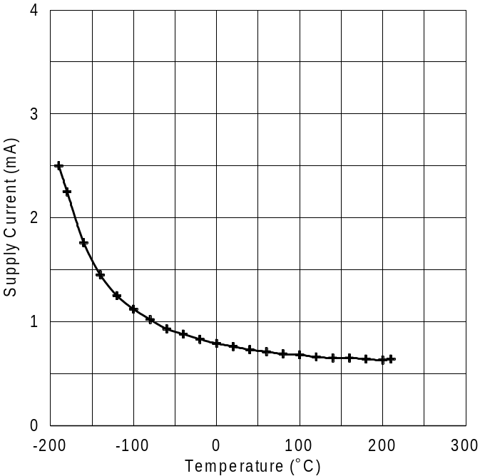

Figure 10. Circuit supply current as a function of temperature.

As was mentioned earlier, the performance of the relaxation oscillator circuit was also investigated after subjecting it to ten thermal cycles between +200 °C and -190 °C. Post-cycling measurements performed on the investigated parameters, i.e. frequency output, duty cycle, rise time, and supply current, revealed no major deviation from those obtained prior to cycling at any given test temperature. Therefore, this limited thermal cycling has had no impact on the operation of the oscillator circuit. In addition, the circuit demonstrated successful start-up operation while at the extreme temperatures, i.e. +210 °C and -190 °C.

It should be noted that this circuit design is tailored to operate into a fixed load impedance because the timing components are connected across the output. Variation in the load impedance would result in a change in the charge/discharge time constant of the circuit, and thereby the frequency of the output would change.

Conclusions

A temperature-to-frequency relaxation oscillator circuit was constructed using COTS (Commercial-Off-The-Shelf) parts for application under extreme temperatures. The circuit employed a recently-developed high temperature silicon-on-insulator CHT-555 timer, thin-film platinum RTD, and solid tantalum and ceramic capacitors. The circuit was designed mainly for hot jet engine environment but it was evaluated also for potential use under cryogenic conditions. Performance of the oscillator circuit was investigated in terms of its temperature-sensing response, output signal duty cycle and rise time, and supply current under a wide temperature range between -190 °C and +210 °C and after thermal cycling. The prototype circuit performed well throughout this temperature range in producing a pulsed output whose period was a linear function of the sensed temperature, and no major changes were observed in its characteristics, i.e. duty cycle and rise time of the output signal, as a result of change in test temperature. In addition, all of the individual parts exhibited no physical or packaging damage due to the extreme temperature exposure or cycling. It can be concluded, therefore, that all the COTS parts used in designing the circuit exhibited good performance under wide temperature swing, and these preliminary results suggest that the circuit has good potential for use in both hot and cold temperature environments. Issues such as long-term exposure to extreme temperatures, thermal cycling, and mechanical vibrations (that are typically encountered in jet engine and spacecraft environs) need to be addressed to establish reliability of the circuit and to better determine its suitability for use in hostile aerospace and space applications.

References

[1] Patterson, Richard; Hammoud, Ahmad; “Use of COTS (Commercial-Off-The-Shelf) Parts for Wide-Range Temperature Sensing from Hot Jet Engine Distributed Control Systems to Cryogenic Space Missions,” NASA Electronic Parts and Packaging Website, October 4, 2007.

[2] CISSOID Company, “CHT 555 High Temperature Precision Timer,” Datasheet Doc. DS-07006 Rev. A, March 28, 2007.

Acknowledgments

This work was performed under the NASA Glenn Research Center, GESS-2 Contract
# NNC06BA07B. Support was provided by the NASA GRC Fundamental Aeronautics / Subsonic Fixed Wing Program – Distributed Engine Control Task and by the NASA Electronic Parts and Packaging (NEPP) Program.

