The GlaxoSmithKline group of companies

FDA ADVISORY COMMITTEE Briefing Document for Use of FLOVENT DISKUS and ADVAIR DISKUS in COPD
Document Number: RM2001/00294/00

For FDA Advisory Committee Meeting - January 17, 2002

Sponsor: | GlaxoSmithKline
Date of Report: | November 20, 2001

The internal studies described herein were performed in compliance with Good Clinical Practices and Glaxo Wellcome Standard Operating Procedures for all processes involved, including the archiving of essential documents.

Copyright 2001 the GlaxoSmithKline group of companies. All rights reserved.
EXECUTIVE SUMMARY
Introduction
The contents of this briefing document review the clinical information available in support of fluticasone propionate (FLOVENT† DISKUS†) and the combination product containing fluticasone propionate (FP) and salmeterol (ADVAIR* DISKUS) for the maintenance treatment of COPD, including chronic bronchitis and emphysema. While a regulatory submission for salmeterol (SERVENT† DISKUS) in COPD was also included as part of the development program for FLOVENT and ADVAIR DISKUS, the FDA has advised that it will not be a subject for deliberation during the advisory committee meeting. Results from the SEREVENT DISKUS treatment group in this briefing document are presented for completeness and to allow for comparisons between treatments.
Salmeterol xinafoate (SAL) is a long-acting inhaled beta₂-adrenoreceptor agonist available as two formulations in the US (SEREVENT Inhalation Aerosol and SEREVENT DISKUS) for treatment of asthma. In the US, SEREVENT Inhalation Aerosol is also currently indicated for the maintenance treatment of bronchospasm associated with COPD. To complement SEREVENT Inhalation Aerosol, marketing approval is being sought for the 50mcg dose of SEREVENT DISKUS, administered twice daily for treatment of COPD. To date, SEREVENT has also been approved for the treatment of COPD in 31 countries outside the US. Worldwide, as of October 30, 2000 the exposure to salmeterol inhalation aerosol or powder was estimated to be 12.7 million patient years for treatment of asthma and COPD.
Fluticasone propionate (FP) is a synthetic, trifluorinated glucocorticoid with a high topical anti-inflammatory activity and negligible oral bioavailability. FP is indicated for the maintenance treatment of asthma as prophylactic therapy and is available as two formulations in the US (FLOVENT Inhalation Aerosol and FLOVENT ROTADISK† for Inhalation via Diskhaler). FLOVENT DISKUS, NDA 20-833, was approved in September 2000. No formulation of FLOVENT is currently approved for the treatment of COPD in the US. For treatment of COPD, marketing approval is sought for both the 250mcg and 500mcg doses of FLOVENT DISKUS, administered twice daily. To date, FLOVENT has been approved for the treatment of COPD in 67 countries outside the US. Worldwide, as of August 31, 2001 the exposure to FP inhalation aerosol or powder was estimated to be 14.4 million patient years for treatment of asthma and COPD.
ADVAIR, the combination of FP and salmeterol in a single inhaler, is indicated for the maintenance treatment of asthma as prophylactic therapy and is available as ADVAIR DISKUS in the US. No formulation of ADVAIR is currently approved for the treatment of COPD either in the US or any other country. For treatment of COPD, marketing approval is sought for both the 250/50mcg and the 500/50mcg strengths, administered twice daily. Worldwide, as of April 30, 2001, the exposure to ADVAIR DISKUS was estimated to be 1.4 million patient years for treatment of asthma and COPD.
Rationale
The rationale for the development of FLOVENT and ADVAIR DISKUS for the treatment of COPD was based on sound scientific and clinical grounds and can be summarized as follows:
- COPD is defined by the American Thoracic Society as ‘a disease state characterized by the presence of airflow obstruction due to chronic bronchitis or emphysema; the airflow obstruction is generally progressive, may be accompanied by airway hyperreactivity, and may be partially reversible.’
- Emphysema and chronic bronchitis are complex pathophysiological conditions and frequently co-exist in the same patient. While neutrophilic inflammation is characteristic of the disease, a multitude of cells, mediators, and tissues have been implicated in its pathogenesis and contribute to its clinical severity.
- COPD is a disease that exacts considerable toll on patients and society. It is currently the fourth leading cause of mortality in the US and projected to be the third by 2020. Morbidity from COPD also is rising with an estimated 668,363 hospital discharges in 1998 and estimated annual cost to the nation in 2000 of 30.4 billion dollars.
- The Confronting COPD in America Survey revealed that many patients with COPD experience substantial dyspnea, which impacts their activities of daily living and use of health care resources. About 50% of patients reported that COPD limited their ability to work, sleep, perform household chores, or participate in social activities. Forty-five percent of patients required emergency care and 14% required hospitalization for their disease within the past year.
- While smoking cessation is a primary objective of therapy, pharmacological therapy to alleviate airway obstruction, symptoms, and exacerbations is necessary for many patients even if they no longer smoke.
- No medication has shown to modify disease progression in COPD, hence current approach to treatment advocated by guidelines consists of bronchodilator medications and ICS depending on disease severity.
- Given the complexity of the disease, many patients require multiple medications to control the various pathophysiological processes responsible for the clinical manifestations of COPD.
- While bronchodilators are the only agents currently approved by the FDA for COPD treatment in the US, considerable off-label use of ICS alone or with maintenance bronchodilators is occurring. Examination of prescription activity in the US indicates that approximately 40% of COPD patients are currently receiving ICS therapy. Additionally, 46% of patients with COPD are currently receiving combination of two or more drugs of which 72% are prescribed an ICS as part of their regimen. Fifty-seven percent of these patients are being treated with maintenance bronchodilators and ICS.
- Despite the availability of medications and guidelines advocating their appropriate use in the management of COPD, the control of COPD in the US remains sub-optimal.
- For many patients, limitations such as convenience, tolerability, and effectiveness with current therapy may contribute to its under utilization leading to sub-optimal control of their disease.
- Due to limited approved treatment options, many physicians have had to use ICS off-label without full knowledge of their benefit/risk. This may lead to patients receiving higher doses than necessary and/or reliance on frequent oral corticosteroid bursts with greater safety risks.
- While many patients require treatment with multiple medications to improve clinical outcomes in COPD, this approach also increases treatment complexity contributing to patient confusion and non-adherence and may lead to greater morbidity.
- Considering the serious public health consequences associated with COPD in the US, the availability and approval of new medications for its treatment should be regarded as a medical necessity.
- Considerable scientific evidence supports the anti-inflammatory effects of ICS in the pathophysiology of COPD. Results from seven recent studies have demonstrated that ICS therapy in COPD is associated with reduction in airway inflammation (including neutrophils and CD8⁺ T-cells) as determined by lung biopsies, bronchoalveolar lavage, and sputum.
- The administration of inhaled long-acting beta₂-agonists and inhaled corticosteroids together provides broader as well as greater effects on cells, mediators, and tissues contributing to the pathophysiology of COPD than that achievable with either agent alone and provides a rationale for the clinical benefit of administering these two agents together.
- The majority of clinical evidence indicates that inhaled corticosteroids including fluticasone propionate are beneficial in the treatment of COPD. While ICS therapy may not reduce the rate of lung function decline in patients with COPD, their use has been shown to improve lung function and reduce symptoms and exacerbations which are responsible for substantial morbidity in this disease. These findings support the widespread use of ICS in the treatment of COPD by US physicians and recommendations for their use in COPD treatment guidelines.
- While clinical trial data examining concurrent therapy with inhaled long-acting beta₂-agonists and corticosteroids together in the treatment of COPD are limited, results from a recent trial indicate that the addition of fluticasone propionate to salmeterol was associated with greater benefit than use of salmeterol alone.
- The availability and approval of FLOVENT and ADVAIR DISKUS in the US will help physicians to make informed decisions regarding their use in the management of COPD and will help to address some of the limitations with current therapy. Its availability in a breath-actuated, easy to use delivery device may simplify COPD management leading to improved control of COPD for many patients.
Clinical Pharmacology
The clinical pharmacology program conducted in support of the use of FLOVENT and ADVAIR DISKUS in the treatment of COPD build on the information obtained as part of the development program for asthma. Studies in healthy volunteers and patients with asthma had shown that the pharmacokinetics and pharmacodynamic effects of administering fluticasone propionate and salmeterol as a combination product were comparable to that when these agents were administered alone. The primary aim of the current program was to characterize FP pharmacokinetics and pharmacodynamics in patients with COPD and to compare these data to the available data for patients with asthma.
- A dose-related increase in FP systemic exposure was observed in COPD subjects following an increase in dose from 250mcg to 500mcg twice daily with C_{max} averaging 53pg/mL and 84pg/mL, respectively.
- No statistically significant reduction (10%) in serum cortisol was observed with FP 250mcg compared with placebo treatment in subjects with COPD. There was a small, statistically significant reduction (21%) in serum cortisol with FP 500mcg compared to placebo; however, this difference is not considered to be clinically significant.
- Systemic exposure following inhaled administration of FP in COPD subjects was considerably lower compared to healthy subjects and similar to asthma subjects.
- Systemic exposure following inhaled administration of FP with the DISKUS was considerably lower than the currently marketed CFC MDI.
- The range of systemic exposure to FP in the COPD population was within the range observed in subjects with asthma. The range of serum cortisol values following drug administration was similar in COPD subjects and asthmatics and was generally comparable to placebo subjects.
- These findings allow the extrapolation of the long-term safety data in asthma to patients with COPD.
Design of Pivotal Studies
The design and conduct of the development program to support the efficacy and safety of FLOVENT DISKUS and ADVAIR DISKUS for treatment of patients with COPD, including emphysema and chronic bronchitis were conducted in consultation with the FDA. Three studies in 2054 subjects with COPD were performed and are summarized in the table below.
Study | Objective | Treatment  (mcg BID) | N | Duration  (weeks) | Baseline % pred FEV₁ | Primary Efficacy
FLTA3025 | Superiority of FP over placebo | FP 250  FP 500  PLA | 216  218  206 | 24 | 41.0%  39.8%  41.3% | Change from baseline at endpoint in AM pre-dose FEV₁
SFCA3006 | Superiority of combination over FP & SAL  Superiority of  FP & SAL over placebo | FSC 500/50  FP 500  SAL 50  PLA | 165  168  160  181 | 24 | 40.9%  41.4%  40.3%  41.5% | Change from baseline at endpoint in AM pre-dose FEV₁  Change from baseline at endpoint in 2h  post--dose FEV₁
SFCA3007 | Superiority of combination over FP & SAL  Superiority of  FP & SAL over placebo | FSC 250/50  FP 250  SAL 50  PLA | 178  183  177  185 | 24 | 41.4%  42.0%  41.9%  42.1% | Change from baseline at endpoint in AM pre-dose FEV₁  Change from baseline at endpoint in 2h  post-dose FEV₁

Each of the three studies was a randomized, double-blind, parallel-group, placebo-controlled, multicenter trial designed and conducted in an identical manner. Subjects were required to meet the ATS definition of COPD, be at least 40 years of age, have a current or prior history of ≥20-pack years of cigarette smoking, and have a history of cough productive of sputum on most days for at least 3 months of the year, for at least 2 years, that was not attributable to another disease process. Subjects were required to have a baseline FEV₁ <65% of predicted normal, but >0.70L or FEV₁ ≤0.70L and >40% of predicted normal with an FEV₁/FVC ratio of ≤70%. Subjects also had to be experiencing moderate dyspnea on the Modified Medical Research Council (MMRC) Dyspnea Scale at Screening and have minimal symptoms of chronic bronchitis (morning cough and sputum production) at Baseline.
Specific exclusion criteria were current diagnosis of asthma, current use of oral or high-dose inhaled corticosteroids, abnormal clinically significant ECG, need for long-term oxygen therapy, moderate or severe exacerbation during the run-in, and any significant medical disorder that would place the subject at risk, interfere with the evaluations, or influence study participation.
Subjects who met the entrance criteria began a 2-week, single-blind, run-in period with placebo treatment. All concurrent inhaled or oral sympathomimetic or anticholinergic bronchodilators and inhaled or intranasal corticosteroids were discontinued at the Screening Visit. Concurrent theophylline therapy could be continued if a stable regimen was maintained for 1 month prior to study entry and for the duration of the study. Adjustments could be made to maintain a therapeutic dose of theophylline during the study. All subjects received VENTOLIN† Inhalation Aerosol or nebules to use as needed for the duration of the trial, including the 2-week run-in period.
Subjects who successfully completed the run-in period were assigned to one double-blind treatment via the DISKUS BID for 24 weeks. Subjects were evaluated weekly for the first 4 weeks of treatment (Weeks 1, 2, 3, and 4), every 2 weeks until Week 8 (Weeks 6 and 8), and then at 4-week intervals for the remainder of the study (Weeks 12, 16, 20, and 24).
FEV₁ was chosen as the primary efficacy measure due to its wide acceptance as a reproducible and objective indicator of disease severity and prognosis in COPD. However, because beta-agonists and corticosteroids treat different aspects of the disease, two different FEV₁ endpoints were measured for assessment of treatment efficacy: pre-dose FEV₁ for ADVAIR (FSC) and for FP, and 2-hour post dose FEV₁ for FSC and for SAL. Secondary measures of efficacy included baseline and transition dyspnea index (BDI/TDI), chronic respiratory disease questionnaire (CRDQ), chronic bronchitis symptoms questionnaire (CBSQ), COPD exacerbations, morning PEF, daily VENTOLIN use, and nighttime awakenings requiring VENTOLIN.
Summary of Study Population Results
The results of the clinical trial support the following conclusions about the study populations and their disposition during the conduct of the trial.
- Most subjects completed each individual study (>60% per treatment group). The percentages of subjects prematurely discontinuing the study were similar across the treatment groups.
- Demographics, baseline characteristics, and baseline spirometry data were similar across the treatment groups in each of the three studies.
- Medication adherence was high (>95%) across the treatment groups in each of the three studies.
Efficacy Results
Efficacy results from the three pivotal studies and the integrated efficacy database for the COPD DISKUS clinical program demonstrated the efficacy of all active treatments (FSC 250/50, FSC 500/50, SAL 50, FP 250, and FP 500) following twice-daily treatment for 24 weeks in subjects with COPD.
FLOVENT DISKUS
Primary Efficacy Measure
Pre-Dose FEV₁. In all three studies, treatment with FP was associated with greater improvements in pre-dose FEV₁ compared with placebo. The estimated difference in pre-dose FEV₁ was significantly greater for FP 500 in SFCA3006 (105mL) and FP 250 in SFCA3007 (112mL) compared with placebo. In FLTA3025, a dose-related improvement in pre-dose FEV₁ was seen as FP 500 had a significantly greater improvement than placebo (estimated difference = 57mL) while FP 250 did not (estimated difference = 32mL). When data were integrated, the estimated differences from placebo for FP 250 and FP 500 were 73mL and 85mL, respectively with 95% confidence intervals of (41mL, 105mL) and (53mL, 118mL), respectively.
Key Secondary Efficacy Measures
TDI. A numerical dose response in TDI scores was demonstrated between FP 250 and FP 500. In SFCA3006 and FLTA3025, treatment with FP 500 resulted in significantly greater improvements in TDI scores when compared with PLA at Week 1 and throughout treatment; estimated differences at Endpoint = 1.1 and 0.8, respectively. No significant differences were observed for treatment with FP 250 in SFCA3007 or FLTA3025 at Endpoint.
CRDQ. In FLTA3025, increases in overall CRDQ score at Endpoint were significantly greater for both FP 250 (5.1) and FP 500 (9.1) compared with PLA (1.0) and approached the clinically meaningful threshold (≥10) in the FP 500 group. In SFCA3007, increases in FP 250 (10.4) were clinically meaningful and significantly greater compared with PLA (5.0). In SFCA3006, increases in FP 500 (4.8) were similar to increases in PLA (5.0).
CBSQ GAS. In SFCA3007, a significant difference was observed at Endpoint for treatment with FP 250 compared with PLA (estimated difference = 0.8). No other treatment differences of consequence were observed in the individual studies. These results indicate that this new instrument may not be sensitive for discerning treatment effects.
Other Secondary Efficacy Measures
Incidence of COPD Exacerbation. The incidence of COPD exacerbation (any intensity) was comparable between the FP and PLA groups in the three individual studies.
AM PEF. Increases in morning PEF for treatment with FP 250 and FP 500 were significantly greater compared with PLA in all the individual studies.
Daily VENTOLIN Use. In SFCA3006 and FLTA3025, treatment with FP 500 resulted in significantly less Overall daily VENTOLIN use when compared with PLA; the difference from PLA was only significant for FP 250 in FLTA3025.
Nighttime Awakenings Requiring VENTOLIN Use. In the three individual studies, treatment with FP 250 and FP 500 demonstrated significantly fewer awakenings per night compared with an increase with PLA.
ADVAIR DISKUS
Primary Efficacy Measures
Pre-Dose FEV₁. Treatment with FSC 250/50 and FSC 500/50 resulted in significantly greater improvements in pre-dose FEV₁ when compared with SAL 50 at Endpoint; estimated differences = 69 and 67mL, respectively. The estimated differences at Endpoint for treatment with FSC 250/50 and FSC 500/50 compared with PLA were 161 and 159mL, respectively. When data were integrated, the estimated differences at Endpoint for treatment with FSC 250/50 and FSC 500/50 compared with SAL 50 were 66 and 71mL, respectively, with 95% confidence intervals of (19mL, 113mL) and (23mL, 119mL), respectively.
Post-Dose FEV₁. Treatment with FSC 250/50 and FSC 500/50 resulted in significantly greater improvements in post-dose FEV₁ when compared with FP 250 and FP 500 at Day 1 and throughout treatment; estimated differences at Endpoint = 124 and 129mL, respectively. The estimated differences at Endpoint for treatment with FSC 250/50 and FSC 500/50 compared with PLA were 214 and 231mL, respectively. Integrated data supported the greater increases in each FSC group compared with the corresponding strength of FP and with the placebo group.
Key Secondary Efficacy Measures
TDI. Treatment with both FSC 250/50 and FSC 500/50 resulted in dose-related improvement in mean TDI scores at Endpoint that were significantly greater compared with PLA, estimated differences = 0.8 and 1.7, respectively. Treatment with FSC 500/50 also demonstrated a significantly higher mean TDI score at Endpoint compared with SAL 50 (estimated difference = 1.2) and numerically greater compared with FP (estimated difference = 0.7).
CRDQ. Treatment with both FSC 500/50 and FSC 250/50 resulted in clinically meaningful increases (i.e., ≥10.0), from Baseline in overall CRDQ score that were significantly greater compared with PLA.
CBSQ GAS. Treatment with both FSC 250/50 and FSC 500/50 demonstrated significantly greater mean change from Baseline at Endpoint in GAS compared with PLA, estimated differences = 0.6 and 0.7, respectively. No other treatment differences of consequence were observed in the individual studies.
Other Secondary Efficacy Measures
Incidence of COPD Exacerbation. The incidence of COPD exacerbations (any intensity or moderate/severe) for treatment with FSC was similar to the incidence with SAL, FP, and PLA.
AM PEF. Treatment with FSC 500/50 resulted in a significant mean increase in Overall AM PEF of 31.9L/min compared with mean increases of 16.8L/min and 12.9L/min for SAL 50 and FP 500, respectively, and compared with a mean decrease (-2.7L/min) in the PLA group. Treatment with FSC 250/50 resulted in a significant mean increase in Overall AM PEF of 30.6L/min compared with mean increases of 14.7L/min and 11.3L/min for SAL 50 and FP 250, respectively, and compared with a slight increase (0.8L/min) in the PLA group.
Daily VENTOLIN Use. Significantly less Overall VENTOLIN use was observed for treatment with FSC 250/50 and FSC 500/50 compared with PLA and compared with FP 250 and FP 500, respectively. Mean changes from Baseline in Overall VENTOLIN use were –1.0 and –1.2 puffs per day for FSC 250/50 and FSC 500/50, respectively.
Nighttime Awakenings Requiring VENTOLIN Use. The FSC 250/50 and FSC 500/50 groups had significantly fewer Overall nighttime awakenings requiring VENTOLIN use compared with PLA. Overall mean changes from Baseline were -0.12 and -0.04 awakenings per night for the FSC 250/50 and FSC 500/50 groups compared with increases of 0.02 and 0.10 awakenings per night with PLA, respectively.
Onset and Duration of Effect
Efficacy as measured by pre-dose FEV₁ for both FP 250 and FP 500 was observed as early as Week 1. At Week 1, the estimated differences from PLA for FP 250 and FP 500 were 53 and 61mL.
The bronchodilating effects of FSC 500/50 and SAL 50 were observed at Day 1, indicating an early onset of effect. Twice-daily dosing was supported by the maintenance of the effect for 12 hours.
No tolerance to the bronchodilator effect was observed over 24 weeks of treatment.
Efficacy in Population Subgroups
Subgroup analyses based on gender, age, ethnic origin, ICS use at Screening, bronchodilator response, and smoking status demonstrated similar trends to the overall population with greater benefits observed with ADVAIR vs. the individual components and with FLOVENT vs. placebo. However, the magnitude of improvement was generally greater in former vs. current smokers and reversible vs. non-reversible subjects.
Safety Results
The following conclusion points summarize the clinical safety data from the three controlled clinical studies (SFCA3006, SFCA3007, and FLTA3025).
Extent of Exposure
A total of 2054 COPD subjects were randomized to treatment in the three US controlled clinical studies and received at least one dose of study medication.
The mean extent of exposure was higher for the active drug treatment groups compared with the placebo group.
Adverse Events (AEs)
There was no evidence that the AE profile of either SAL or FP changed when the two drugs were used in combination.
The overall incidence of AEs was comparable across the treatment groups.
The most commonly reported AEs, including upper respiratory tract infection (URTI), headache, and musculoskeletal pain, were noted in similar proportions of subjects across the six treatment groups. Throat irritation, candidiasis, and hoarseness/dysphonia, all well-documented side effects of inhaled corticosteroids, occurred with a higher incidence in the FP and/or FSC groups as compared with the placebo or SAL 50 groups.
AEs Leading to Withdrawal
AEs leading to withdrawal were reported by a relatively small proportion of subjects across the treatment groups. Lower respiratory events (mainly COPD exacerbation) were the most common AEs leading to withdrawal.
Deaths and Serious Adverse Events
In the controlled clinical studies, four subjects in the placebo group died; no deaths occurred in the active drug treatment groups. None of the deaths were considered by the investigator to be related to study drug.
The incidence of SAEs was low and similar across the treatment groups. As would be expected in subjects with COPD, SAEs mainly included lower respiratory events (e.g., COPD exacerbation, pneumonia, and chest symptoms). Only one subject experienced a SAE during treatment that was considered by the investigator to be related to treatment (angina - Subject 9060, SAL 50 group, study SFCA3006); this event was also possibly attributed to a history of cardiovascular disease.
Clinical Laboratory Test Results
There were no clinically relevant treatment effects observed on clinical laboratory test results.
HPA Axis Effects
In SFCA3006 and SFCA3007, no consistent differences were noted when examining abnormalities in short ACTH stimulation at Day 1 and Endpoint across the treatment groups.
Cardiovascular Safety
Few subjects (43 of 2054, or 2%) had clinically significant changes in ECG results. Overall, the incidence of clinically significant abnormalities was lower for those treated with SAL (1%; nine of 688 subjects who received either SAL 50 or FSC 500/50; no clinically significant abnormalities were noted for subjects treated with FSC 250/50) compared with placebo (3%; 17 of 576 subjects).
There was no evidence that administration of SAL or FP alone or in combination increased the incidence of QTc prolongation.
The incidence of ventricular and supraventricular ectopic events and cardiac rates in the placebo group was similar to the active drug treatment groups at Screening and at Week 4. Only five subjects experienced a significant change from their Screening Holter at Week 4 (one subject in the placebo group, one subject in the SAL 50 group, two subjects in the FP 500 group, and one subject in the FSC 500/50 group).
Vital Signs
No effect of treatment was observed on pulse rate or on systolic and diastolic blood pressure.
Safety in Population Subgroups
No clinically relevant treatment related differences were observed in the safety profile for FSC and FP in population subgroups of gender, age, ethnic origin, smoking status, and concurrent VENTOLIN and methylxanthine use.
Bone Mineral Density
Evaluation of information on BMD with FP therapy provides reassurance that significant safety issues with the long-term use of FP in patients with COPD are unlikely and can be summarized as follows:
- Systemic corticosteroids are known to reduce BMD in areas of bone which has a high trabecular bone content such as the lumbar spine followed by femoral neck. These are the areas most prone to fractures confirming their clinical importance in assessing the impact of exogenous corticosteroid therapy.
- Bone loss following treatment with oral corticosteroids at a dose of approximately 7.5mg per day can be seen as early as the first 6 months of therapy. After 1 year of therapy with oral corticosteroids, decreases in bone mineral density of 5% have been observed.
- Although systemic exposure due to inhaled corticosteroids is much less than with oral corticosteroids, the potential for an effect on bone mineral density has been suggested. Studies examining if inhaled corticosteroid in COPD patients impacts BMD have given conflicting results. Current evidence indicates that the use of inhaled corticosteroids is unlikely to result in an increase in the incidence of fractures in patients with COPD.
- COPD patients have a number of factors which may confound the interpretation of BMD results: advanced age, smoking history, sedentary lifestyle, dietary deficiencies, potential hormonal (testosterone or estrogen) deficiencies, long-term systemic corticosteroid use, and/or use of anti-resorptive therapy. Imbalances in these variables between treatment groups and/or differences between inhaled corticosteroids in their propensity to cause systemic effects may explain some of the conflicting findings observed with trials evaluating the potential for inhaled corticosteroids to influence BMD in patients with COPD.
- While BMD results with FP treatment in COPD are currently unavailable, the similar systemic exposure seen in patients with COPD compared to that seen in patients with asthma allows extrapolation of the long-term safety data with FP in asthma to patients with COPD.
- No significant effects on BMD were seen in two separate trials comparing two years of treatment with FP 500mcg twice daily versus placebo in patients with mild asthma.
- Three-out-of-three randomized, double-blind trials, which compared FP and BDP at therapeutically comparable dosages, found significant differences favoring FP vs. BDP on BMD at doses of FP as high as 1000mcg/day for periods of up to two years. These results suggest that all inhaled corticosteroids may not have the same propensity to effect BMD.
- These results from asthma are reassuring and suggest that the long-term use of FLOVENT and ADVAIR DISKUS in the treatment of patients with COPD is unlikely to be associated with BMD reductions. A large ongoing 3-year mortality trial in patients with COPD (TORCH, SCO30003) will also evaluate the effects of FP and ADVAIR on bone mineral density in a subset of patients.
Benefit-Risk Conclusions
The results from the clinical program indicate that both FLOVENT and ADVAIR DISKUS have a favorable benefit to risk ratio for the treatment of patients with COPD and can be summarized as follows:
- The clinical program assessing FLOVENT DISKUS achieved its primary objective of demonstrating statistically significant and clinically relevant improvements in the primary measure of efficacy (pre-dose FEV₁) compared with placebo.
- The magnitude of improvements observed with FLOVENT DISKUS for the primary as well as secondary efficacy measures was comparable to that seen with salmeterol which is an approved agent for COPD indicating that fluticasone propionate provides clinically important benefits in the treatment of patients with COPD.
- The clinical program also fulfilled the regulatory requirements for combination products in the US by achieving significantly greater improvements in both of the primary efficacy measures for treatment with ADVAIR DISKUS 250/50 and ADVAIR DISKUS 500/50 compared to salmeterol and FP (pre-dose and post-dose FEV₁, respectively).
- In addition to improvements in the primary measure of efficacy, both FLOVENT DISKUS and ADVAIR DISKUS provided clinical improvements in the secondary efficacy measures compared to placebo. Most of these achieved statistical significance for FLOVENT DISKUS and almost all achieved statistical significance for ADVAIR DISKUS.
- ADVAIR DISKUS also provided significantly greater improvements for several secondary measures of efficacy compared to the individual agents (morning PEF and generally greater improvements in TDI and CRDQ) and numerical trends for other measures of efficacy. These findings suggest that treatment with both components is needed for control of the disease for many patients.
- The benefits for treatment with either FLOVENT DISKUS or ADVAIR DISKUS were not associated with any unexpected, clinically significant topical or systemic adverse effects.
- The long-term safety of FP therapy in patients with asthma is reassuring and suggests that the use of FLOVENT DISKUS and ADVAIR DISKUS in COPD is unlikely to be associated with BMD reductions.
- The absence of clinically significant differences in response between the two doses suggests that FLOVENT DISKUS 250 or ADVAIR DISKUS 250/50 twice daily serve as the recommended starting doses for each medication.
Proposed Indication and Dosage and Administration
The results from this clinical program support the following indication and recommendations for dosage and administration.
- FLOVENT DISKUS is indicated for the long-term, twice-daily maintenance treatment of COPD (including emphysema and chronic bronchitis). The proposed starting dosage for adults is 1 inhalation (250mcg) twice daily. For patients who do not respond adequately to the starting dose, increasing the dose to 500mcg twice daily may provide additional control.
- ADVAIR DISKUS is indicated for the long-term, twice-daily, maintenance treatment of COPD (including emphysema and chronic bronchitis). The proposed starting dosage for adults is 1 inhalation (250/50mcg) twice daily (morning and evening, approximately 12 hours apart). For patients who do not respond adequately to the starting dose, replacing the 250/50-strength with the 500/50-strength may provide additional control. The proposed maximum recommended dose of ADVAIR DISKUS is 500/50mcg twice daily.
Patients who may, contrary to recommended use, double their dose of FLOVENT DISKUS or ADVAIR DISKUS to treat worsening symptoms may experience an increased incidence of pharmacologically predictable adverse events associated with salmeterol or FP.
TABLE OF CONTENTS
Page
1. INTRODUCTION AND BACKGROUND 1
1.1. Purpose and Content of the Briefing Document 1
1.2. Overview of SEREVENT Development 1
1.3. Overview of FLOVENT Development 2
1.4. Overview of ADVAIR DISKUS Development 2
1.5. Overview of the DISKUS 3
1.6. Rationale Supporting the Use of FLOVENT and ADVAIR in the Treatment of COPD 3
1.6.1. Pathophysiology of COPD 3
1.6.2. Burden of Disease 4
1.6.3. Current Management of COPD 6
1.6.4. COPD Patients on Prescription Therapy 7
1.6.5. Limitations with Available Therapy 8
1.6.6. Scientific Rationale 9
1.6.7. Clinical Rationale 12
1.6.8. Summary of Rationale 16
1.7. Regulatory 18
1.7.1. Proposed Indications and Dosage and Administration 18
1.7.2. Summary of Significant FDA Interactions During the Clinical Development Program 19
1.7.3. Non-US Marketing History 20
1.7.4. Withdrawals/Rejections 21
2. CLINICAL PHARMACOLOGY AND BIOAVAILABLITY 22
2.1. Program Objectives 22
2.2. Study FLTA3025 22
2.3. Study FMS40243 23
2.4. FP Systemic Exposure 23
2.5. Serum Cortisol 24
2.6. Relationship Between FP Systemic Exposure and Serum Cortisol 25
2.7. Clinical Pharmacology Conclusions 25
3. DESIGN OF PIVOTAL STUDIES 27
3.1. Introduction 27
3.2. Study Design 27
3.3. Efficacy Measures 28
3.3.1. Primary Efficacy Measure 28
3.3.2. Key Secondary Efficacy Measures 29
3.3.3. Other Secondary Efficacy Measures 30
3.4. Safety Measures 31
3.5. Statistical Methods 31
4. STUDY POPULATION OF PIVOTAL CLINICAL STUDIES 33
4.1. Subject Accountability 33
4.2. Demographic and Baseline Characteristics 34
4.3. Spirometry and Bronchodilator Response at Screening 35
4.4. Study Medication Adherence 37
4.5. Summary of Study Population Results 37
5. EFFICACY RESULTS 38
5.1. FLOVENT DISKUS (FP) Efficacy 38
5.1.1. Primary Efficacy Measure: Pre-Dose FEV₁ 38
5.1.2. Key Secondary Efficacy Measures 42
5.1.3. Other Secondary Efficacy Measures 47
5.2. ADVAIR DISKUS (FSC) EFFICACY 53
5.2.1. Primary Efficacy Measures 53
5.2.2. Key Secondary Efficacy Measures 61
5.2.3. Other Secondary Efficacy Measures 65
5.3. Onset and Duration of Effect 69
5.3.1. FP 250 and FP 500 69
5.3.2. FSC 500/50 and SAL 50 69
5.4. Efficacy in Population Subgroups 71
5.4.1. Smoking Status 71
5.4.2. Bronchodilator Response 72
5.5. Summary of Efficacy 72
5.5.1. FP 250 and FP 500 72
5.5.2. FSC 250/50 and FSC 500/50 73
5.5.3. Onset and Duration of Effect 75
6. Safety Results 76
6.1. Introduction and Data Organization 76
6.2. Extent of Exposure 76
6.3. Adverse Event Experience in Clinical Trials 77
6.3.1. Introduction 77
6.3.2. Incidence of Adverse Events 77
6.3.3. Adverse Events of Special Interest 79
6.3.4. Withdrawals Due to Adverse Events 79
6.3.5. Deaths and Serious Adverse Events 80
6.4. Clinical Laboratory Tests 82
6.4.1. Laboratory Data Collection and Analysis 82
6.4.2. Sponsor-defined Threshold Analyses for Potassium and Glucose 82
6.5. Summary of Other Safety Assessments 83
6.5.1. Cardiovascular Monitoring 83
6.5.2. HPA Axis Effects 87
6.5.3. Safety in Population Subgroups 88
6.6. Summary of Safety from Clinical Trials 88
7. Bone Mineral Density 91
7.1.1. Introduction and Background 91
7.1.2. Inhaled Corticosteroids and BMD in patients with COPD 91
7.1.3. Inhaled Fluticasone Propionate and BMD 93
7.1.4. Conclusions 97
8. Discussion of BENEFIT/RISK 99
8.1. FLOVENT DISKUS 99
8.2. ADVAIR DISKUS 101
8.3. Conclusions 102
9. Appropriate Use of FLOVENT DISKUS and ADVAIR DISKUS in the Management of copd 104
9.1. Proposed Label: Indications, Dosage and Administration 104
9.1.1. FLOVENT DISKUS 104
9.1.2. ADVAIR DISKUS 104
9.1.3. Clinical implications of administration of more than one inhalation of FLOVENT DISKUS or ADVAIR DISKUS 105
9.2. Summary 106
10. References 107

Abbreviations Used in this Document
ACTH | adrenal corticotrophic hormone
AE | adverse event
ALA | American Lung Association
AM | morning
ANCOVA | analysis of covariance
ANOVA | analysis of variance
ATS | American Thoracic Society
AUC | area under the curve
BAL | bronchoalveolar lavage
BD | bronchodilator
BDP | beclomethasone dipropionate
BDI/TDI | Baseline Dyspnea Index/Transition Dyspnea Index
BHR | bronchial hyperresponsiveness
BID | twice daily
BMD | bone mineral density
bpm | beats per minute
BUD | budesonide
cAMP | cyclic adenosine monophosphate
CBSQ | Chronic Bronchitis Symptom Questionnaire
C_{max} | maximum concentration
C_{min} | minimum concentration
CNS | central nervous system
CO | cross over
COPD | chronic obstructive pulmonary disease
CPAP | continuous positive airway pressure
CRDQ | Chronic Respiratory Disease Questionnaire
DB | double-blind
D/C | discontinued
DEXA | dual energy x-ray absorptiometry
dL | deciliter
ECG | electrocardiogram
FDA | Food and Drug Administration
FEV₁ | forced expiratory volume in one second
FP | fluticasone propionate
FSC | fluticasone propionate and salmeterol combination product
FVC | forced vital capacity
GAS | Global Assessment Score
GI | gastrointestinal
GOLD | Global Initiative for Chronic Obstructive Lung Disease
GPRD | General Practice Research Database
GS | corticosteroid
GSK | GlaxoSmithKline
HPA | hypothalmic-adrenal axis
HPLC | high-performance liquid chromatography
ICD | International Classification of Diseases

Abbreviations Used in this Document (cont’d)
ICS | inhaled corticosteroid
ITT | Intent-to-Treat
LABA | long-acting beta₂-agonist
mcg | microgram
MCIC | minimum clinically important change
MDI | metered-dose inhaler
mL | milliliter
mmHg | millimeters of mercury
MMPs | matrix metalloproteinases
MMRC | Modified Medical Research Council
NDA | New Drug Application
NDC | National Drug Code
NHLBI | National Heart, Lung and Blood Institute
OL | open label
PC | placebo controlled
PEF | peak expiratory flow rate
PLA | placebo
QTc | corrected QT interval
QTcB | QT interval with Bazett’s correction
QTcF | QT interval with Fridericia’s correction
RIA | radioimmunoassay
RR | relative rate
SAE | serious adverse event
SAL | salmeterol
SRBI | Schulman, Ronca, and Bucuvalas, Inc.
SVE | supraventricular ectopic
t_{1/2} | half life
TIMP-1 | tissue inhibitor of metalloproteinase-1
URI | upper respiratory inflammation
URTI | upper respiratory tract infection
US | United States
VE | ventricular ectopic
WHO | World Health Organization

INTRODUCTION AND BACKGROUND

Purpose and Content of the Briefing Document
The US Food and Drug Administration (FDA) Division of Pulmonary and Allergy Drug Products has called for an Advisory Committee to meet on January 17, 2002 to consider the benefit/risk of FLOVENT† DISKUS† and ADVAIR* DISKUS for the maintenance treatment of COPD, including chronic bronchitis and emphysema. FLOVENT DISKUS is a powder inhaler that contains fluticasone propionate (FP), an inhaled corticosteroid. ADVAIR DISKUS is a new inhaled combination powder formulation that contains FP and salmeterol (SAL), a long acting beta₂-agonist. While a regulatory submission for SERVENT† DISKUS in COPD was also included as part of the development program for FLOVENT and ADVAIR DISKUS, the FDA has advised that it will not be a subject for deliberation during the advisory committee meeting. Results from the SEREVENT DISKUS treatment group in this briefing document will be presented for completeness and to allow for comparisons between treatments; however, justification for the benefit/risk of SEREVENT DISKUS in COPD will not be included.
This briefing document has been compiled by GlaxoSmithKline, Inc. to serve as a review document for the Advisory Committee members. Included are relevant clinical pharmacology, clinical efficacy and clinical safety data for FLOVENT DISKUS compared with placebo and for ADVAIR DISKUS compared with the FP, SAL and placebo. This document also provides the rationale for combining FP and SAL to treat patients with COPD and recommendations for appropriate use of each product.

Overview of SEREVENT Development
Salmeterol is available as two formulations in the US (SEREVENT Inhalation Aerosol, NDA 20-236, approved February 1994; and SEREVENT DISKUS, NDA 20-692, approved September 1997) for patients with asthma.
In the US, the aerosol formulation (MDI) of SEREVENT received approval for the maintenance treatment of bronchospasm associated with COPD, including chronic bronchitis and emphysema. To complement SEREVENT Inhalation Aerosol, marketing approval is being sought for the 50mcg dose of SEREVENT DISKUS, administered twice daily for treatment of COPD. As of May 31, 2001, SEREVENT has also been approved for the treatment of COPD in 31 countries outside the US.
Worldwide, as of October 30, 2000 the exposure to salmeterol inhalation aerosol or powder was estimated to be 12.7 million patient-years for treatment of asthma and COPD.

Overview of FLOVENT Development
Fluticasone propionate is indicated for the maintenance treatment of asthma as prophylactic therapy and is available as two formulations in the US (FLOVENT Inhalation Aerosol, NDA 20-548, approved March 1996; and FLOVENT ROTADISK† for Inhalation via DISKHALER†, NDA 20-549, approved November 1997). FLOVENT DISKUS, NDA 20-833, was approved in September 2000. Because the dose of an inhaled corticosteroid should be adjusted to the severity of the disease, approval was obtained for three strengths of FLOVENT DISKUS (50, 100 and 250mcg) to deliver the recommended doses of FP. To date, FLOVENT has been approved for the treatment of COPD in 67 countries outside the US.
No formulation of FLOVENT is currently approved for the treatment of COPD in the US. For treatment of COPD, marketing approval is sought for both the 250mcg and 500mcg doses of FLOVENT DISKUS, administered twice daily.
Worldwide, as of August 31, 2001 the exposure to FP inhalation aerosol or powder was estimated to be 14.4 million patient-years for treatment of asthma and COPD.

Overview of ADVAIR DISKUS Development
ADVAIR DISKUS (NDA 21-077) was approved for treatment of asthma in August 2000. In order to allow the dose of an inhaled corticosteroid to be adjusted to the severity of the disease, approval was obtained for three strengths of ADVAIR DISKUS (100/50mcg, 250/50mcg and 500/50mcg) to deliver recommended doses of FP in combination with 50mcg SAL.
No formulation of ADVAIR is currently approved for the treatment of COPD either in the US or any other country. For treatment of COPD, marketing approval is sought for both the 250/50mcg and the 500/50mcg strengths, administered twice daily.
Worldwide, as of April 30, 2001, the exposure to ADVAIR DISKUS was estimated to be 1.4 million patient-years for treatment of asthma and COPD.

Overview of the DISKUS
The ADVAIR, SEREVENT and FLOVENT DISKUS inhalers are the same multidose powder inhaler device consisting of molded plastic containing a foil strip with 60 regularly distributed blisters. A given device contains a small quantity of SAL (micronized) alone, FP (micronized) alone or the combination of the two, each blended with lactose. Each blister contains 50mcg of SAL and/or either 250mcg, or 500mcg of FP made up to 12.5mg with lactose. The foil strip consists of a formed base foil with a peelable lid foil. Because each dose is pre-measured, consistent dosing from the DISKUS Inhaler occurs across the range of inspiratory flows generated by most patients.
The DISKUS Inhaler is robust and easy to use, requiring three steps to take a dose; open, click, and inhale. The DISKUS device is breath-actuated, generates minimal airflow resistance and does not require special co-ordination of inhalation and actuation of the device. These characteristics make the DISKUS the ideal delivery device for treatment of COPD patients, many of whom have difficulty co-ordinating the actuation-inhalation process, as well as low inspiratory flow associated with severe COPD, i.e., FEV₁ 20-30% predicted. The DISKUS device also offers the advantage of a dose counter to improve monitoring of dosing adherence.

Rationale Supporting the Use of FLOVENT and ADVAIR in the Treatment of COPD
The rationale for the development of FLOVENT and ADVAIR DISKUS for the treatment of COPD was based on several factors including the pathophysiology of the disease, the scientific evidence of the effects of ICS and inhaled long-acting beta₂-agonists on the underlying disease process, the clinical benefits associated with taking these medications, and practical considerations related to convenience and patient adherence which may help to address some of the limitations with current therapy in the management of COPD.

Pathophysiology of COPD
COPD is defined by the American Thoracic Society as ‘a disease state characterized by the presence of airflow obstruction due to chronic bronchitis or emphysema; the airflow obstruction is generally progressive, may be accompanied by airway hyperreactivity, and may be partially reversible’. The etiology of COPD is poorly understood but there are clear genetic (α1-antitrypsin deficiency; Mahadeva, 1998) and environmental factors (cigarette smoke; Hogg, 1994) which contribute to the expression of this disease.
Emphysema and chronic bronchitis are complex pathophysiological conditions and frequently co-exist in the same patient. Emphysema is associated with the destruction of the walls of the alveoli with abnormal permanent enlargement of the airspaces distal to the terminal bronchioles and loss of alveolar attachments. As a result, elasticity of the lung tissue is lost, causing airways to collapse and obstruction of airflow. Chronic bronchitis is associated with inflammation of the respiratory bronchioles, enlargement of bronchial mucous glands accompanied by dilation of gland ducts. Goblet cell size and number are increased, and there may be both metaplasia and hypertrophy of airway smooth muscle. As a result, there is plugging of the respiratory bronchioles with muscle or mucous, and distortion due to fibrosis (ATS, 1995).
Persistent reduction in expiratory flow and a progressive deterioration in lung function despite aggressive treatment characterize COPD. Inflammation, fibrosis, goblet cell metaplasia, and smooth muscle hypertrophy in terminal bronchioles, as well as loss of alveolar attachments to bronchioles due to alveolar destruction are important causes of airflow obstruction. Although expiratory airflow may improve significantly with treatment, by definition, expiratory airflow will never normalize and will progressively worsen with time. Patients with COPD have shortness of breath, initially appearing as dyspnea on exertion and then progressing insidiously. Typically, progressively increasing productive cough and sputum production are also symptomatic manifestations of COPD. Patients most often modify their lifestyles to compensate for the dyspnea and activity limitation associated with reduced expiratory airflow (Petty, 2000). In addition to these symptoms, periods of acute deterioration due to viral or bacterial exacerbations lead to considerable morbidity and mortality from the disease.

Burden of Disease
The exact prevalence of COPD is not well characterized due to variable definitions over time and a high proportion of undiagnosed disease; however, COPD affects millions of individuals in the US and data suggest that the prevalence is rising. The reported prevalence rate for chronic bronchitis increased 58 percent between 1982 and 1996, from 33.9 per 1,000 to 53.5 per 1,000 persons (Adams, 1999). It is estimated that in 2001 as many as 21.7 million individuals in the US actually have some form of COPD; only 6.5 million have been diagnosed with COPD and as many as 15.2 million more individuals remain undiagnosed (unpublished analysis of the NHANES III data, GSK, June, 2001).
COPD exacts considerable toll on patients and society. COPD is a progressive disease and is one of the few major diseases with increasing mortality. The age-adjusted death rate from COPD-related causes increased 42 percent, from 14.0 per 100,000 in 1979 to 19.9 per 100,000 in 1998 (American Lung Association, 2001). COPD is currently the fourth-leading cause of death (National Center for Health Statistics, 2001) and is projected to be the third-leading cause of death by the year 2020 (Murray, 1996). In contrast, the age-adjusted death rate attributed to all causes decreased by 18 percent and seven of the ten leading causes of death experienced decreases in age-adjusted mortality during this time.
COPD is also associated with considerable morbidity, which is also increasing. Hospitalization for COPD-related illnesses and related costs increased significantly from 1979 to 1998. An estimated 668,362 hospital discharges due to COPD were reported in 1999, a discharge rate of 24.5 per 10,000 population (National Center for Health Statistics, 1998). According to estimates, in 1993 the annual cost to the nation for COPD was $30.4 billion (NHLBI Chart Book, 1993). This included $14.7 billion in direct health care expenditures, $6.5 billion in indirect morbidity costs and $9.2 billion in indirect mortality costs.
To better characterize the current status of COPD in the US, a national survey of public, patient and professional knowledge, attitudes and behavior regarding COPD was conducted between August and November 2000 (ALA, February 2001). The Confronting COPD in America survey was conducted by Schulman, Ronca and Bucuvalas, Inc. (SRBI), a national public-opinion research firm. Dr. Stephen Rennard of the University of Nebraska Medical Center served as an advisor. GlaxoSmithKline sponsored the survey.
Confronting COPD in America is the largest and most comprehensive survey of patients with COPD to date. Among the issues it explored were the frequency and severity of symptoms, the burden of illness, healthcare utilization, disease management and treatment, and quality of life. Telephone interviews were completed with a national sample of 573 COPD patients. The sample was identified by systematically screening a national sample of 26,880 US households to find patients 45 years and older who had been diagnosed with COPD, emphysema or chronic bronchitis, or whose symptoms matched a strict definition of chronic bronchitis. A national sample of 203 physicians - 100 primary care physicians and 103 respiratory specialists - was also interviewed as part of the survey.
The Confronting COPD in America Survey revealed that many patients with COPD are suffering from shortness of breath so severe that it interferes with even their most basic daily activities and limits their ability to work. When asked about the frequency of their symptoms during their worst 3-month period in the past year, more than three-quarters of the patients had been short of breath at least a few days a week and more than half had shortness of breath every day or had been awakened at night by coughing, wheezing or shortness of breath at least a few days a week. The impact of breathlessness on every-day activities was also striking. About three-fourths of patients were breathless when walking up only one flight of stairs with 25% experiencing difficulty breathing even when sitting or lying still and eight percent were too breathless to even leave the house. Approximately 25% of the patients consider themselves made invalids by their disease and 66% expect their condition to get worse.
The survey also indicated that COPD had a considerable impact on patients’ activities of daily living and their use of health care resources. Approximately, 50% of patients reported that COPD limited their ability to work, sleep, perform household chores, or participate in social activities. Almost three-quarters of patients see a doctor at least a few times a year and nearly a quarter at least once a month for their disease. Additionally, 14% of patients reported being hospitalized overnight and 45% of patients required emergency medical attention for their condition during the previous 12 months.
Despite the considerable functional impairment associated with COPD, many patients tended to overestimate their degree of disease control when utilizing more objective measures of assessing control. Forty-two percent of patients who reported their disease to be completely or well-controlled during the past year also reported experiencing daily shortness of breath. Additionally, less than a quarter of the patients described their disease as severe and about a third described their disease as mild. Patients’ underestimation of their disease severity and tendency to accept their condition as the best that can be expected may lead patients to seek less medical care and contribute to the morbidity and mortality from this disease (ALA, February 2001).

Current Management of COPD
Smoking tobacco is the primary contributing factor in the etiology of COPD. Smoking cessation, which has been shown to slow the rate of decline in lung function, remains a primary objective of treatment. However, even with the best current therapy, smoking cessation is only successful in less than half the smokers who attempt to stop. Additionally, for patients with more advanced COPD, prolonged smoking results in sustained damage to the lungs with persistence of clinical pathology and symptoms despite smoking cessation. Thus, for many patients, pharmacological treatment for the clinical manifestations of COPD is necessary even if they no longer smoke. Since no medication has been shown to modify progression of COPD, pharmacological therapy has focused on the treatment of airway obstruction, symptoms and exacerbations associated with COPD.
Given the complex pathophysiology of the disease, it is unlikely that a single medication can provide comprehensive control of the various factors responsible for the clinical manifestations of COPD. Indeed, multiple classes of medications are currently used in the treatment of COPD, including inhaled beta₂-agonists, anticholinergic agents, methylxanthine preparations, and inhaled corticosteroids. Many patients with COPD require more than one drug for optimal treatment (NHLBI/WHO Workshop Report, 2001).
The most recently recommended approach to treatment has been presented in evidence–based guidelines (NHLBI/WHO Workshop Report, 2001) prepared as part of the Global Initiative for Chronic Obstructive Lung Disease (GOLD). The approach recommended by the GOLD Guidelines had extensive input from US pulmonologists.
The overall approach to managing stable COPD is characterized by a stepwise increase in treatment depending on the severity of the disease. Bronchodilator medications are central to the symptomatic management of COPD (GOLD) and represent the only class of drugs with FDA approval for the treatment of COPD. Beta₂-agonists, anticholinergics, and methylxanthines are bronchodilator drugs commonly used in treating COPD. For mild disease inhaled short-acting beta₂-agonists and anticholinergics can be used on an as needed basis. However, with more persistent symptoms, they may be used as maintenance therapy. These short-acting agents need to be administered four times daily and are frequently co-administered. Salmeterol and methylxanthines have the advantage over short-acting bronchodilators of less frequent administration.
For many patients, bronchodilator therapy alone does not adequately provide relief of clinical symptoms of the disease. GOLD guidelines recommend that regular treatment with inhaled corticosteroids (ICS) is appropriate for symptomatic COPD patients with documented spirometric response to ICS or in those with an FEV₁ <80% predicted (Stage II: moderate COPD and Stage III: severe COPD) and repeated exacerbations requiring antibiotics and/or oral corticosteroids.

COPD Patients on Prescription Therapy
While inhaled corticosteroids (ICS) are not approved for the treatment of COPD, their use is supported by current treatment practices as assessed by using the NDC Health patient database. The NDCHealth patient database is a collection of prescription activity captured from more than 14,000 geographically dispersed retail pharmacies representing all 50 states. All payment types and pharmacy types are well represented in the database, therefore, these results can be generalized to the treated COPD population. International Classification of Diseases (ICD-9) codes to define patient diagnosis from NDC’s Value-Added Network Database were merged with a subset of patients from the NDCHealth patient database through the use of a unique patient identifier not provided to GSK. The NDC’s Value-Added Network ICD-9 codes are retained, up to eight diagnoses beginning in October 2000, from the patient records provided by the prescribing physicians through the third party processing and reimbursement.
Patients with ICD-9 codes of chronic bronchitis, emphysema, or chronic airways obstruction were considered to have COPD for this analysis. Patients with a co-morbidity of asthma were specifically excluded. Patients who had a prescription for a respiratory controller or a relief/rescue medication for the month of July 2001, and who had a diagnosis of COPD as defined above, were used, yielding data for approximately 1.7 million patients.
For this analysis, ICS, ADVAIR, maintenance bronchodilators (SEREVENT, FORADIL†, ipratropium, and COMBIVENT†), leukotriene modifiers, xanthines and cromolyns were considered controller medications. Because scheduled albuterol cannot be differentiated from prn use, it was not considered a controller medication for this analysis and the concurrent use of albuterol with a controller was not considered as combination therapy, thus COMBIVENT was regarded as a single controller. However, ADVAIR was considered two controllers.
A significant proportion (40%) of COPD patients was using ICS therapy (including ADVAIR). Sixteen percent of patients receiving a single controller were on an ICS alone. Forty-six percent of all COPD patients were on combination controller therapy (2 or more controllers). The majority of the patients on combination controller therapy (72%) were prescribed an ICS as part of their regimen. Additionally, more than half, (57%) were being treated with an ICS in combination with an inhaled maintenance bronchodilator (SEREVENT, FORADIL, ipratropium, or COMBIVENT). Many of these patients could therefore benefit from the convenience of a combination product containing an ICS and an inhaled bronchodilator. Seventeen percent of COPD patients on combination therapy were already using ADVAIR as shown in the figure below.
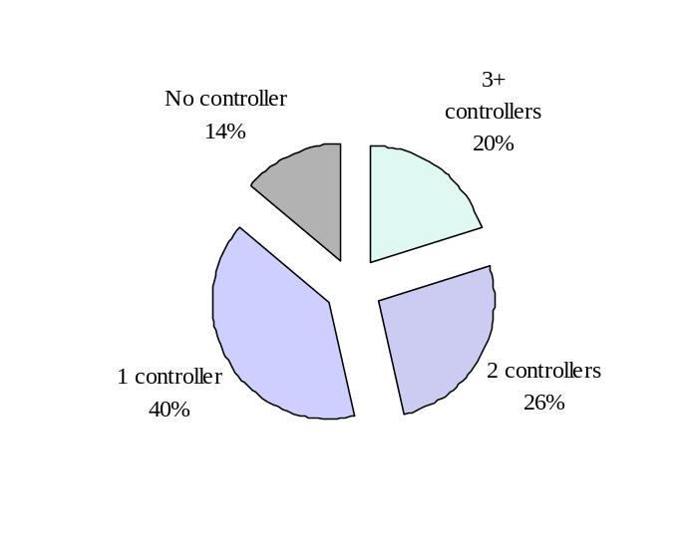COPD Patients on Prescription Therapy in July 2001
46% of COPD patients are on combination (2 or more controllers) therapy
72% of COPD patients on combination (2 or more controllers) therapy are on ICS therapy
57% of COPD patients on combination (2 or more controllers) therapy are on an ICS and a maintenance bronchodilator
17% of COPD patients on combination (2 or more controllers) therapy are already on ADVAIR

Source: NDCHealth, July 2001

Limitations with Available Therapy
The increasing morbidity and mortality from COPD in the US suggests that, for many patients, currently available therapy does not meet their needs. For some patients, limitations with current therapy may contribute to their under-utilization of healthcare resources, including available treatments, leading to sub-optimal control of patients’ disease. While bronchodilators represent the cornerstone of therapy in COPD, maintenance treatment with short-acting anticholinergics and beta₂-agonists is problematic since they require four times-a-day dosing and offer little treatment-effect during the latter hours of sleep. While a more prolonged duration of action is possible during treatment with some xanthine compounds such as sustained-release theophylline, their gastrointestinal (GI), central nervous system (CNS) and cardiovascular side effects may not be well tolerated by many patients. Additionally, concerns of drug interactions with xanthines limit their utility for patients with COPD who have considerable comorbidities also requiring pharmacological therapy.
Due to the severity of the disease, its burden on patients and the limited number of approved treatment options for COPD, many physicians have had to use ICS medications off-label for its treatment without full knowledge of their benefit/risk. This may lead to use of ICS at doses higher than necessary and/or reliance on maintenance or frequent bursts of systemic corticosteroids, which have considerable greater safety risks. Considering the serious consequences associated with COPD in the US (e.g., monetary cost, death), the availability and approval of new medications for its treatment needs to be regarded as a medical necessity.
Additionally, the complexity of COPD pathophysiology suggests that many patients will require more than one class of medication to optimally control their disease. While the use of multiple medications is likely to improve clinical outcomes in COPD, this approach also increases treatment complexity, which can contribute to patient confusion and non-adherence and lead to greater morbidity. The need to simplify medical regimens in COPD is especially critical since many patients have significant co-morbid illnesses that also require pharmacological therapy. The need for simpler treatment regimens in COPD was evident during patient interviews in the Confronting COPD in America Survey. More than half of the patients interviewed said that the necessity of taking medications so often is inconvenient and that they would be more adherent with their medication regimen if it were more convenient. A combination product containing the two most common classes of medications used in the treatment of COPD in a single inhaler will simplify therapy for many patients and may improve adherence.
For many patients, difficulties using metered-dose inhalation aerosols correctly further complicate their medical therapy and may also contribute to poor adherence. The availability of FLOVENT and ADVAIR in the DISKUS device further simplifies treatment for these patients since it does not require co-ordination of inspiration with actuation. The low inspiratory effort needed to obtain a dose should further ensure that patients with even severe lung function impairment (i.e., FEV₁ = 20-30% predicted) successfully receive treatment. The availability of a dose counter will remind patients when to refill their prescription.
Thus, the availability and approval of FLOVENT and ADVAIR DISKUS for the treatment of COPD in the US may help to address some of the limitations with current therapy. Their availability in a breath-actuated, easy to use delivery device may simplify COPD management leading to improved control of the disease for many patients. The use of these agents in the treatment of COPD is consistent with current medical practice and supported by treatment guidelines.

Scientific Rationale
COPD is a heterogeneous disease characterized by a predominantly neutrophilic inflammation, tissue remodeling with inappropriate matrix protein deposition and lung tissue destruction (Nagai & Thurlbeck, 1991) which is thought to be secondary to the release of proteases such as elastase from various inflammatory cells. These pathological features are thought to be responsible for airflow obstruction and the accelerated rate of decline of FEV₁ in patients with COPD.
Neutrophils are the most common inflammatory cell associated with COPD (Thompson, 1989; Lacoste, 1993; Pesci, 1998); however, it is clear that many other inflammatory cells are also elevated and activated in the lungs of COPD patients. These cells include lymphocytes (CD8⁺) (Saetta, 1993 & 1999), macrophages (Saetta, 1993; Grashoff, 1997) and eosinophils during exacerbations (Lacoste, 1993; Pesci, 1998; Zhu, 2001; Retamales, 2001). Influx of inflammatory cells into the lung tissue is dependent on generation of inflammatory mediators as well as upregulation of cell adhesion molecules on the vascular endothelium. Clinical studies have identified a wide range of mediators, which are elevated in the lungs in COPD and could explain many of the cellular and structural changes that are observed. Inflammatory mediators described in the sputum or bronchoalveolar lavage fluid of COPD patients include tumour necrosis factor α (TNFα), interleukin 8 (IL-8), Eotaxin, Rantes, transforming growth factor β (TGFβ)  and endothelin 1 (ET1). There is also upregulation of relevant cell adhesion molecules, which allows for the diapedeses and accumulation of inflammatory cells in the lung tissue and airway lumen (DiStefano, 1994; Gonzalez, 1996).
In addition to inflammatory cytokines, increased levels of a range of proteinases are also detected in COPD. These proteinases include matrix metalloproteinases (MMPs) such as MMP-2, MMP-9 and macrophage elastase as well as serine proteinases such as neutrophil elastase, proteinase-3 and cathepsin G. It is believed that elevation of these proteinases and a reduction in their natural inhibitors such as tissue inhibitor of metalloproteinase-1 (TIMP-1) is responsible for tissue destruction and abnormal repair in the lungs of COPD and asthma patients (Finlay, 1997; Hoshino, 1998; Ohnishi, 1998; Vignola, 1998; Shapiro, 1999, Segura-Valdez, 2000; Cataldo, 2000). Neutrophils and neutrophil elastase have been strongly implicated in the pathogenesis of COPD but it is now evident that many other cells and proteinases participate in the remodeling process that is observed in the lungs of COPD patients (Nagai & Thurlbeck, 1991; Jeffery, 1999).

For the use of ICS in the treatment of COPD
Considering that inflammation is a major hallmark of COPD and contributes to its pathophysiology and clinical manifestation, its treatment should represent a target for pharmacological therapy. Corticosteroids provide a broad range of anti-inflammatory effects which also may have clinical relevance for treatment of COPD. Corticosteroids have been shown to inhibit the in vitro release of IL-8 and TNFα from macrophages (Standiford, 1992; Larsson, 1999; Ek, 1999), two key mediators of inflammation in COPD (Keatings, 1996; Nocker, 1996).
Studies in vivo have also confirmed the anti-inflammatory effects of corticosteroid therapy in COPD. In short-term studies ICS appeared to have no significant effect on sputum neutrophil counts (Keatings, 1997; Culpitt, 1999; O’Brien, 2001). However, these studies were limited in duration, patient numbers and the range of mediators and cells that had been studied. Contradicting these findings are results from other studies, which indicate a positive outcome on a range of inflammatory indices with inhaled corticosteroids, including FP, in lung tissue biopsies, bronchoalveolar lavage (BAL) and sputum from patients with COPD. These studies are tabulated below:
Study | Endpoint/Outcome | Reference
BDP 1.5 mg/day x 6 weeks | Improved bronchial sample cell count and epithelial lining fluid, albumin, lactoferrin and lysozyme | Thompson, 1992
FP 1.5 mg/day x 8 weeks | Reduced sputum neutrophil chemotactic activity  Increased sputum anti-elastase activity | Llewellyn-Jones,1996
BDP 1.5 mg/day x 8 weeks | Reduction in sputum neutrophils | Confalonieri, 1998
FP 1 mg/day x 24 weeks | Reduction in biopsy CD8+ T cells and eosinophils | Verhoeven, 1999
FP 1 mg/day x 12 weeks | Reduction in biopsy CD8+/CD4+ T cell ratio  Reduction in biopsy mast cells | Hattotuwa, 1999  Hattotuwa, 2000
BDP 1.5 mg/day x 6 weeks | Reduction in BAL neutrophils, IL8 and MPO | Balbi, 2000
FP 1.5 mg/day x 8 weeks | Reduction in sputum neutrophils | Yildiz, 2000

Other beneficial effects of inhaled corticosteroids may be a reduction in plasma protein leakage and sputum volume in COPD (Schoonbrood, 1995). In addition, it has been reported that fluticasone propionate provides protection against bacterial and viral damage of epithelial surfaces in vitro (Dowling, 1999; Man, 2001).
The study of the actions of inhaled corticosteroids on inflammatory cells and mediators is an active field of research and many of the actions of ICS in COPD are as yet to be described.

For combining a LABA and ICS in the treatment of COPD
As with asthma therapy, the combination of a long-acting beta₂-agonist such as salmeterol and ICS may provide better control of COPD by treating airways obstruction and the underlying inflammation. Salmeterol, by virtue of elevating intracellular cyclic adenosine monophosphate (cAMP), induces a long lasting relaxation of airway smooth muscle and a range of other cAMP-mediated physiological action that may be of therapeutic relevance to COPD. Thus, salmeterol can reduce plasma protein leakage (Proud, 1998), increase ciliary beat frequency (Kanthakumar, 1994), increase mucociliary clearance (Tay, 1997; Chambers, 1999), reduce neutrophil function (Ottonello, 1996; Bloemen, 1997), reduce neutrophil numbers in airway tissue (Jeffery, 1999), and reduce cytokine secretion (Sekut, 1995; Oddera, 1997; Pang and Knox, 2001).
Recent in vitro evidence suggests that there is a mechanistic interaction at the molecular level between ICS and beta₂-agonists. On the one hand, corticosteroid can up-regulate the beta₂ receptor in the human airways (Mak, 1995; Baraniuk, 1997) which may provide more receptors for beta₂-agonists to activate. On the other hand, long-acting beta₂-adrenoceptor agonists, can facilitate the entry of glucocorticoid receptor/ligand complex into the nucleus and so improve the anti-inflammatory effect of corticosteroids (Eickelberg, 1999).
Functional studies have demonstrated that such interactions can occur in a number of cells relevant to the pathology of airway disease. Thus, chemokine and cytokine production, including IL-8, from airway smooth muscle cells (Pang & Knox, 2000; 2001) and monocytes (Oddera, 1998) can be inhibited more effectively by the combination of salmeterol and corticosteroids than by each drug alone. Furthermore, protection from the damaging actions of Pseudomonas aeruginosa on the airway epithelium can be enhanced with the combination of salmeterol and FP at concentrations which have no effect on their own (Dowling, 1999). This complementary action appears to be a class effect for both long-acting beta₂-agonists and ICS since IL1-β-induced ICAM upregulation in fibroblasts is also more effectively inhibited by the combination of formoterol and budesonide (Spoelstra, 1998).
This body of evidence suggests that the cooperativety between beta₂-agonists, particularly long-acting molecules, and ICS is a general phenomenon observed on a number of cells relevant to the pathology of airway disease. This data may provide a scientific rationale to explain the improved efficacy of ADVAIR in COPD compared with each component alone.

Clinical Rationale

For the use of ICS in the treatment of COPD
In addition to the scientific evidence, which demonstrates the anti-inflammatory effects of ICS on the cells and mediators associated with COPD, findings from several clinical studies have shown that treatment with inhaled corticosteroids improved expiratory airflow and reduced symptoms and the rate of exacerbations associated with COPD. While conflicting results have also been reported, efficacy of ICS in COPD was demonstrated in the majority of the studies. Possible explanations for studies which failed to show benefits include the studying of a small number of patients, studying patients with mild disease, use of a lower dose of ICS, short duration of treatment, and/or the exclusion of patients known to be responsive to corticosteroid and/or bronchodilator treatment. Additionally, there is evidence that response to ICS maybe related to smoking status with patients who continue to smoke experiencing lesser benefits then former smokers.
The table below illustrates the studies of short to medium duration (3 weeks to 1 year) and/or small sample size that demonstrated benefits with inhaled corticosteroid therapy.
Short–Medium Term Studies (3 weeks - 1 year Treatment Duration) Evaluating Symptoms
and Lung Function with Positive Results
Reference | Study Design | Patient Population | Treatments  (Taken BID or as stated) | Results
Auffarth, 1991 | R, DB, PG, PC  Tx: 8 wks  % predicted FEV₁:53% | 24 COPD patients smokers or  ex-smokers | Placebo  BUD 800mcg | Significant ↓ in dyspnea with BUD.  No significant differences for other symptoms between groups.  Pulmonary function changes trended in favor of BUD but were not statistically significant.
Kerstjens, 1992 | R, DB, PC, PG  Tx: Data reported at 6 months for COPD  % predicted FEV₁:64% | 39 COPD patients were evaluated at 6 months | Placebo  Terbutaline 2000mcg/day + BDP 800mcg/day  Ipratropium bromide 160mcg/day | At 6 months, mean FEV₁ ↑ with BDP compared to placebo
Weiner, 1995 | R, DB, PC, CO  Tx: 6wks each treatment  Pre BD FEV₁:1.4L | 30 stable COPD patients | Placebo  BUD 400mcg | BA responders showed significant improvement in FEV₁ following BUD as compared with placebo.  BA non-responders, demonstrates similar trends but no significant differences.
Thompson, 1989 | R, DB, PC, PG  Tx: 6 wks  % predicted FEV₁:72% | 30 patients with chronic bronchitis, current smokers | Placebo  BDP 1000mcg | BDP group showed significant improvement in FVC, FEV₁, and FEF₂₅₋₇₅. BDP significantly ↓ the bronchitis index.  BDP significantly improved parameters of airway inflammation.
Dompeling, 1992 | R, DB, PG  Tx: 1 yr  % predicted FEV₁:70% | 28 COPD pts with annual decline of FEV1 ≥80mL/yr and ≥1 EX/yr following first 2 yr of treatment with only BD (salbutamol or ipratropium bromide) | BDP 400mcg + salbutamol 1600mcg/day  BDP 400mcg + ipratropium bromide 160mcg/day | Daily inhalation of BDP during one year significantly ↓ diurnal variation of peakflow, and ↓ symptoms when added to bronchodilator treatment in COPD subjects.
Paggiaro, 1998 | R, DB, PG  Tx: 6 months  %predicted FEV₁:57% | 281 COPD patients | Placebo  FP 500mcg | Change in FEV₁ with FP was significantly ↑ compared with placebo.  An ↑ in FEV₁ was observed in the FP group, while the placebo group showed a ↓.  Bronchitic symptoms significantly improved with FP. More moderate/severe exacerbations in PLA vs. FP
R = randomized; DB = double blind; OL = open label; PG = parallel group; CO = cross over; PC = placebo controlled
Tx = treatment duration; EX = exacerbation; BDP = beclomethasone dipropionate; BUD = budesonide;
BA = beta-agonist; TAA = triamcinolone acetonide; FP = fluticasone propionate; BD = bronchodilator; PLA = placebo

Of the short-medium term studies, treatment with FP was evaluated in one 6-month study and was shown to be beneficial in the treatment of COPD (Paggiaro, 1998). Patients (n=142) treated for 6 months with FP MDI 440mcg BID (equivalent to 500mcg BID from DISKUS) demonstrated increased FEV₁ of 90mL and a reduction of cough and sputum production. In contrast, with 6 months of placebo treatment (n=139), FEV₁ decreased by 70mL and the prevalence of cough and sputum production was unchanged. A statistically significant difference between FP and placebo was observed for change in FEV₁, symptom prevalence, and moderate and severe exacerbations.
The table below illustrates the studies of short to medium duration (3 weeks to 1 year) and/or small sample size that did not demonstrate benefits with inhaled corticosteroid therapy.
Short–Medium Term Studies (3 weeks – 6 months Treatment Duration ) Evaluating Symptoms and Lung Function with Negative Results
Reference | Study Design | Patient Population | Treatments  (Taken BID) | Results
Engel, 1989 | R, DB, PC, PG  Tx: 12 wks  % predicted FEV₁:97% | 18 chronic bronchitis pts, all current smokers | Placebo  BUD 400mcg | No difference in pulmonary function or most symptoms measured.
Watson, 1992 | DB, PC, CO  Tx: 12 wk treatment periods  % predicted FEV₁:80% | 14 male smokers with measurable BHR to inhaled histamine | Placebo  BUD 600mcg | No difference in pulmonary function or most symptoms measured.
Keatings, 1997 | PC, SB, CO  Tx: 2 wk treatment periods  % predicted FEV₁:35% | 13 pts, with stable COPD, current or former smokers | Placebo  BUD 800mg | No difference in pulmonary function or markers of inflammation.
Bourbeau, 1998 | R, DB, PC, PG  Tx: 6 mos  % predicted FEV₁:36% | 79 COPD pts, current or ex-smokers that showed no response to BA or OCS | Placebo  BUD 800mcg | No difference in pulmonary function or symptoms measured.
R = randomized; DB = double blind; SB = single blind; PG = parallel group; CO = cross over; PC = placebo controlled; Tx = treatment duration; BA = beta-agonist; BUD = budesonide; OCS = oral corticosteroids;
PLA = placebo

Four large-scale, placebo-controlled, randomized, double-blind 3-year trials of the treatment of COPD with inhaled corticosteroids found no effect on the rate of decline of FEV₁, the primary endpoint in these studies. However in three of the four trials, other indications of efficacy were observed. The table below summarizes the findings of these studies.
Long-Term (3 year Treatment Duration) Studies
Reference | Study Design | Patient Population | Treatments (Taken BID) | Results
Burge, 2000  ISOLDE Trial | R, DB, PC, PG  Tx: 3 yrs  % predicted FEV₁: 50% | 751 current or former smokers with COPD | Placebo  FP 500mcg | FP ↑ mean FEV₁ but did not significantly alter rate of decline.  FP ↓ median exacerbation rate by 25%.  FP produced a slower decline in health status.  FP had fewer fractures (9, 2%) than PLA (17, 5%).
Lung Health II Study, 2000 | R, PC, DB, PG  Tx: 3 yrs.  % predicted FEV₁: 64% | 1116 mostly current smokers with COPD | Placebo  TAA 600mcg | TAA did not significantly ↓ rate of decline of pulmonary function.  TAA group had fewer respiratory symptoms.  TAA group had fewer visits to MD due to respiratory illness.  TAA group had lower airway reactivity in response to methacholine challenge.  TAA group had significantly greater changes in BMD of lumbar spine and femoral neck compared to placebo.
Vestbo, 1996  COPEHAGEN City Study | R, DB, PC, PG  Tx: 3yrs  % predicted FEV₁: 87% | 290 COPD pts unresponsive to BA or OCS.  75% current smokers | Placebo  BUD 400mcg | BUD did not alter rate of decline in FEV_{1.}
Pauwels, 1999  EUROSCOP | R, DB, PC, PG  Tx: 3 yrs  % predicted FEV₁: 76% | 1277 mild COPD pts, all current smokers | Placebo  BUD 400mcg | BUD ↑ mean FEV₁ but did not significantly alter rate of decline.  No difference in BMD except significant difference at trochanter in favor of BUD.
R = randomized; DB = double blind; PG = parallel group; PC = placebo controlled; Tx = treatment duration;
BDP = beclomethasone dipropionate; BUD = budesonide; BA = beta-agonist; OCS = oral corticosteroids;
TAA = triamcinolone acetonide; FP = fluticasone propionate; BD = bronchodilator; PLA = placebo

Other evidence for the benefit of inhaled corticosteroid therapy in COPD can be seen in the setting of treatment withdrawal. Two recently published trials have shown a deterioration of lung-function and increasing symptoms or exacerbations when maintenance inhaled corticosteroid therapy was withdrawn (O’Brien, 2001; Jarad, 1999). Additionally, patients treated with inhaled corticosteroids post-discharge from hospitalization for COPD had 24% fewer repeat hospitalizations (RR= 0.76) and a 29% reduction in mortality (RR=0.71) compared with patients not treated with inhaled corticosteroids post-discharge (Sin & Tu, 2001).
The overall findings from these trials indicate that inhaled corticosteroids, including FP are beneficial in the treatment of COPD. While ICS therapy may not reduce the rate of lung function decline in patients with COPD, their use has been shown to improve lung function and reduce symptoms and exacerbations which are responsible for substantial morbidity in this disease. These findings support the widespread use of ICS in the treatment of COPD by US physicians. Considering the importance of inflammation in the pathophysiology of COPD and lack of more specific anti-inflammatory therapy with proven clinical benefit, the availability and use of ICS in COPD provides an important treatment option for patients.

For the use of a LABA and ICS together in the treatment of COPD
Due to the complex pathophysiology of COPD, no single medication is likely to provide optimal control of the clinical manifestations of the disease. Inhaled long-acting beta₂-agonists (LABA) and inhaled corticosteroids treat different aspects of this pathophysiology and hence will provide complementary benefits in the treatment of COPD. Current clinical practice and treatment guidelines support the concomitant use of these two classes of drugs in the management of COPD.
Unlike in asthma where the combination of an inhaled corticosteroid and a long-acting beta₂-agonist has been extensively studied, limited clinical trial data is available on the use of these two classes of drugs concurrently in the treatment of COPD. Only one previous study (Cazzola, 2000) has examined the treatment of COPD with a combination of a LABA (salmeterol) and an ICS (FP) administered by separate delivery devices. Patients with moderate to severe COPD (Mean FEV₁ ≈ 1.2L) were treated for 3 months with salmeterol 50mcg BID (N=17) or salmeterol 50mcg BID together with titrated theophylline (N=16), FP 250mcg BID (N=18) or FP 500mcg BID (N=18). All treatments resulted in gradually increasing pre-dose FEV₁ as a function of time. At 3 months the only apparent difference from salmeterol 50mcg in the magnitude of increased FEV₁ (163mL) was for treatment with salmeterol + FP 500mcg (239mL). This difference was not statistically significant because of the small number of subjects. These findings suggest that it may be beneficial to combine an inhaled long-acting beta₂-agonist with an inhaled corticosteroid for the treatment of COPD.

Summary of Rationale
The rationale for the development of FLOVENT and ADVAIR DISKUS for the treatment of COPD was based on sound scientific and clinical grounds and can be summarized as follows:
- COPD is defined by the American Thoracic Society as ‘a disease state characterized by the presence of airflow obstruction due to chronic bronchitis or emphysema; the airflow obstruction is generally progressive, may be accompanied by airway hyperreactivity, and may be partially reversible.’
- Emphysema and chronic bronchitis are complex pathophysiological conditions and frequently co-exist in the same patient. While neutrophilic inflammation is characteristic of the disease, a multitude of cells, mediators, and tissues have been implicated in its pathogenesis and contribute to its clinical severity.
- COPD is a disease that exacts considerable toll on patients and society. It is currently the fourth leading cause of mortality in the US and projected to be the third by 2020. Morbidity from COPD also is rising with an estimated 668,363 hospital discharges in 1998 and estimated annual cost to the nation in 2000 of 30.4 billion dollars.
- The Confronting COPD in America Survey revealed that many patients with COPD experience substantial dyspnea, which impacts their activities of daily living and use of health care resources. About 50% of patients reported that COPD limited their ability to work, sleep, perform household chores, or participate in social activities. Forty-five percent of patients required emergency care and 14% required hospitalization for their disease within the past year.
- While smoking cessation is a primary objective of therapy, pharmacological therapy to alleviate airway obstruction, symptoms, and exacerbations is necessary for many patients even if they no longer smoke.
- No medication has shown to modify disease progression in COPD, hence current approach to treatment advocated by guidelines consists of bronchodilator medications and ICS depending on disease severity.
- Given the complexity of the disease, many patients require multiple medications to control the various pathophysiological processes responsible for the clinical manifestations of COPD.
- While bronchodilators are the only agents currently approved by the FDA for COPD treatment in the US, considerable off-label use of ICS alone or with maintenance bronchodilators is occurring. Examination of prescription activity in the US indicates that approximately 40% of COPD patients are currently receiving ICS therapy. Additionally, 46% of patients with COPD are currently receiving combination of two or more drugs of which 72% are prescribed an ICS as part of their regimen. Fifty-seven percent of these patients are being treated with maintenance bronchodilators and ICS.
- Despite the availability of medications and guidelines advocating their appropriate use in the management of COPD, the control of COPD in the US remains sub-optimal.
- For many patients, limitations such as convenience, tolerability, and effectiveness with current therapy may contribute to its under utilization leading to sub-optimal control of their disease.
- Due to limited approved treatment options, many physicians have had to use ICS off-label without full knowledge of their benefit/risk. This may lead to patients receiving higher doses than necessary and/or reliance on frequent oral corticosteroid bursts with greater safety risks.
- While many patients require treatment with multiple medications to improve clinical outcomes in COPD, this approach also increases treatment complexity contributing to patient confusion and non-adherence and may lead to greater morbidity.
- Considering the serious public health consequences associated with COPD in the US, the availability and approval of new medications for its treatment should be regarded as a medical necessity.
- Considerable scientific evidence supports the anti-inflammatory effects of ICS in the pathophysiology of COPD. Results from seven recent studies have demonstrated that ICS therapy in COPD is associated with reduction in airway inflammation (including neutrophils and CD8⁺ T-cells) as determined by lung biopsies, bronchoalveolar lavage, and sputum.
- The administration of inhaled long-acting beta₂-agonists and inhaled corticosteroids together provides broader as well as greater effects on cells, mediators, and tissues contributing to the pathophysiology of COPD than that achievable with either agent alone and provides a rationale for the clinical benefit of administering these two agents together.
- The majority of clinical evidence indicates that inhaled corticosteroids including fluticasone propionate are beneficial in the treatment of COPD. While ICS therapy may not reduce the rate of lung function decline in patients with COPD, their use has been shown to improve lung function and reduce symptoms and exacerbations which are responsible for substantial morbidity in this disease. These findings support the widespread use of ICS in the treatment of COPD by US physicians and recommendations for their use in COPD treatment guidelines.
- While clinical trial data examining concurrent therapy with inhaled long-acting beta₂-agonists and corticosteroids together in the treatment of COPD are limited, results from a recent trial indicate that the addition of fluticasone propionate to salmeterol was associated with greater benefit than use of salmeterol alone.
- The availability and approval of FLOVENT and ADVAIR DISKUS in the US will help physicians to make informed decisions regarding their use in the management of COPD and will help to address some of the limitations with current therapy. Its availability in a breath-actuated, easy to use delivery device may simplify COPD management leading to improved control of COPD for many patients.

Regulatory

Proposed Indications and Dosage and Administration
Clinical trials described in this document support the indications listed below for both FLOVENT DISKUS and ADVAIR DISKUS. The strength intended for market of the COPD indication for FLOVENT DISKUS is fluticasone propionate 250mcg/blister. The strengths intended for market of the COPD indication for ADVAIR DISKUS are fluticasone propionate 250mcg and salmeterol 50mcg/blister (250/50) and fluticasone propionate 500mcg and salmeterol 50mcg/blister (500/50).
FLOVENT DISKUS
FLOVENT DISKUS is indicated for the long-term, twice-daily maintenance treatment of COPD (including emphysema and chronic bronchitis).
The starting dosage for adults is 1 inhalation (250mcg) twice daily. For patients who do not respond adequately to the starting dose, increasing the dose to 500mcg twice daily may provide additional control.
ADVAIR DISKUS
ADVAIR DISKUS is indicated for the long-term, twice-daily maintenance treatment of COPD (including emphysema and chronic bronchitis).
The starting dosage for adults is 1 inhalation (250/50) twice daily (morning and evening, approximately 12 hours apart). For patients who do not respond adequately to the starting dose, replacing the 250/50-strength with the 500/50-strength may provide additional control.

Summary of Significant FDA Interactions During the Clinical Development Program
A meeting was held with the FDA on April 21, 1998 to discuss the clinical program for investigating the effectiveness and safety of salmeterol, fluticasone propionate, and the combination of salmeterol and fluticasone propionate via the DISKUS for the treatment of COPD, including emphysema and chronic bronchitis. The following key agreements were reached:
- The clinical trials, as described, are acceptable provided the FDA “combination policy” is met for the combination product (i.e., the contribution of both components in the combination are demonstrated).
- Replication of concept only is required for the two doses of the combination product.
- GlaxoSmithKline (GSK) will monitor 12-hour serial FEV₁ in a subset of patients in one clinical study to confirm the 12-hour duration of action of salmeterol.
- Describe the fluticasone propionate systemic exposure and effect on serum cortisol in a subset of COPD subjects in one study (FLTA3025).
- GSK will compare the safety database from the FLOVENT asthma NDA to the COPD population and also compare fluticasone propionate systemic exposure and effect on serum cortisol in the two populations.
- The use of a revised Chronic Bronchitis Symptom Questionnaire (CBSQ) is acceptable provided validation data are submitted.
- The use of the Chronic Respiratory Disease Questionnaire (CRDQ) to assess quality of life is acceptable provided the same type of assumptions/analyses are defined a priori and used as in the SEREVENT MDI COPD program.

Non-US Marketing History

Fluticasone Propionate
In markets outside the US, approval has been obtained for fluticasone propionate for COPD in the following countries as of May 31, 2001:
Country | Approval Date | Country | Approval Date | Country | Approval Date
Argentina | 01-Dec-2000 | Ghana | 04-Apr-2001 | Panama | 21-Oct-1999
Aruba | 04-Apr-2001 | Grenada | 04-Apr-2001 | Paraguay | 04-Nov-1999
Austria | 24-Nov-1997 | Guatemala | 21-Oct-1999 | Peru | Aug-1999
Bahamas | 04-Apr-2001 | Guyana | 04-Apr-2001 | Philippines | 25-Mar-2000
Bangladesh | 30-Dec-1999 | Haiti | 04-Apr-2001 | Romania | 17-Sep-1999
Barbados | 04-Apr-2001 | Holland | 21-Apr-2000 | Russia | 24-Mar-1999
Belgium | 03-Jul-2000 | Honduras | 21-Oct-1999 | Slovakia | 30-Mar-2001
Belize | 04-Apr-2001 | Iceland | * | South Africa | 31-May-2000
Bermuda | 04-Apr-2001 | Ireland | 18-Oct-1996 | Spain | 06-Nov-2000
Bolivia | 04-Apr-2001 | Israel | 11-May-2000 | Suriname | 04-Apr-2001
Botswana | 04-Apr-2001 | Jamaica | 22-Jul-1999 | Taiwan | 28-Aug-2001
Bulgaria | 31-Mar-2001 | Kenya | 04-Apr-2001 | Tanzania | 04-Apr-2001
Cambodia | 05-Apr-2001 | Latvia | 16-Jun-1999 | Thailand | 29-Apr-2001
Chile | 28-Sep-2000 | Lithuania | 11-Sep-2000 | Trinidad & Tobago | 22-Jul-1999
Columbia | 10-Jul-2000 | Luxembourg | 30-Mar-2000 | Turkey | 31-May-2000
Congo | 04-Apr-2001 | Malawi | 04-Apr-2001 | Uganda | 04-Apr-2001
Costa Rica | 21-Oct-1999 | Malta | 04-Apr-2001 | Uruguay | 16-Aug-2000
Cuba | 04-Apr-2001 | Mauritius | 04-Apr-2001 | Venezuela | 17-Jun-2000
Czech Republic | 20-Sep-2000 | Mexico | 27-Jul-1999 | Yugoslavia (Serbia) | 01-Dec-1999
Dominican Republic | 21-Oct-1999 | Myanmar | 05-Apr-2001 | Zambia | 04-Apr-2001
Ecuador | 31-Mar-2000 | Netherlands Antilles | 22-Jul-1999 | Zimbabwe | 04-Apr-2001
El Salvador | 21-Oct-1999 | Nicaragua | 21-Oct-1999
Germany | 23-Sep-1999 | Pakistan | 30-Jul-1999
*Approved with original asthma application

Salmeterol/Fluticasone Propionate Combination
The salmeterol/fluticasone propionate combination product has not received approval for COPD in any country. As of October 1, 2001 applications for COPD are pending in Canada (submitted April 30, 2001) and Europe (submitted September 28, 2001).

Withdrawals/Rejections
The applications for fluticasone propionate submitted to foreign regulatory authorities were based on different clinical studies than those supporting the current submission. Thus, the reasons for withdrawal or rejection may not be relevant to this application.
Applications for fluticasone propionate for COPD have been withdrawn by GSK or rejected by regulatory authorities in the following countries: Australia, Canada, Denmark, Estonia, Finland, Italy, New Zealand, Norway, Switzerland and the United Kingdom. The most common reason for withdrawal or rejection was inadequate efficacy to support the COPD indication. No applications have been withdrawn or rejected due to safety concerns.
No applications for the salmeterol/fluticasone propionate combination product have been withdrawn by GSK or rejected by any regulatory authority.

CLINICAL PHARMACOLOGY AND BIOAVAILABLITY

Program Objectives
The Clinical Pharmacology program for this submission builds upon the body of knowledge generated from past submissions, especially for ADVAIR DISKUS (NDA 21-077) for the treatment of asthma. In the prior submission FP and SAL systemic exposure from ADVAIR DISKUS in healthy volunteers and subjects with asthma was shown to be similar to the individual inhalers resulting in similar pharmacodynamic effects.
The primary aim of the current program was to characterize FP pharmacokinetics and pharmacodynamics in subjects with COPD and compare these data to the available data for patients with asthma. The pharmacokinetics and pharmacodynamics of FP in subjects with COPD were examined in studies FLTA3025 and FMS40243.

Study FLTA3025
The study was a randomized, double-blind, parallel-group, placebo-controlled, multicenter trial to compare the efficacy and safety of FP 250mcg and 500mcg twice daily using the 250mcg and 500mcg DISKUS strengths in subjects with COPD. After at least 4 weeks of dosing, 7 blood samples were obtained after the morning dose over a 12-hour interval from a sub-population of 86 subjects for measurements of plasma FP and serum cortisol.
A dose-related increase in the extent of systemic exposure was observed. Mean FP AUC_{last} following 500mcg twice daily (539.0pg*h/mL) was 74% greater than after 250mcg twice daily (310.6pg*h/mL). Mean C_{max} following 500mcg (83.6pg/mL) was 58% greater than after 250mcg (52.9pg/mL). The rate of absorption into the systemic circulation was similar after each dose. Median t_{max} values were 1.1h after 250mcg and 1.0h after 500mcg.
Estimates of the terminal elimination half-life were limited in many subjects because either a log-linear phase could not be identified or could only be estimated by three points. In those subjects where an estimate was made, t_{1/2} averaged 7.6h, which is consistent with previous findings (Brutsche, 2000; Mackie, 2000; Mackie, 1996).
Mean serum cortisol AUC₁₂ values following the 250mcg and 500mcg treatments were 10% and 21% lower than placebo, respectively. The difference reached statistical significance for the 500mcg dose, but not for the 250mcg dose. However, neither difference is considered to be clinically significant (Dluhy, 1998; Wilson, 1998) and the difference between the two active treatments was not significant. Mean cortisol C_{min} for placebo (123pmol/mL) and the 250mcg treatment (117pmol/mL) were similar and different from the 500mcg treatment (85pmol/mL). The lower limit of the 95% confidence interval for C_{min} for the 500mcg treatment (68.1pmol/mL) was within the normal range (Burtis & Ashwiid, 1999).

Study FMS40243
This study was a randomized, double blind, double-dummy, 2-way crossover design. Thirteen healthy subjects and 10 subjects with COPD were enrolled. Subjects were randomized to receive each of the following treatments:
- inhaled FP 500mcg twice daily from a HFA MDI with a spacer for 7 days followed by a single inhaled dose of FP 1000mcg and a placebo infusion, and
- inhaled beclomethasone dipropionate 1000mcg twice daily from a CFC MDI with a spacer for 7 days followed by a single dose of inhaled placebo and FP 1000mcg intravenous infusion.
The pharmacokinetics and pharmacodynamic effects of FP were assessed from serial plasma FP concentrations and serial serum cortisol concentrations measured over a 12 hour dosing interval after the 1000mcg FP inhaled and intravenous doses. Urinary cortisol excretion was measured over 24 hours before the start of the inhaled dosing run-in and over the 24 hours prior to the last inhaled or intravenous dose.
Systemic exposure in COPD subjects following inhalation was 35% less than the systemic exposure observed in healthy subjects. Peak concentrations in COPD subjects were 44% less than the concentrations observed in healthy subjects and occurred at 0.75h in both populations. Systemic exposure following intravenous administration was similar in both populations. Absolute bioavailability following inhaled administration in COPD subjects (13.3%, 95% CI: 8.96 – 19.83) was considerably lower compared to healthy subjects (21.2%, 95% CI: 13.4 – 33.0) (Singh, 2001) and similar to subjects with asthma (10%) (Brutsche, 2000).
The lower systemic exposure observed resulted in significantly less effect on serum cortisol, which was 83% higher in COPD subjects compared to healthy subjects.

FP Systemic Exposure
Systemic exposure data from 67 COPD subjects in FLTA3025 and FMS40243 were compared with data from 103 asthma subjects from 5 studies (FLTA3001, FLD230, FLTA2001, SFCB3019, FAS40022). Data were obtained following multiple dosing and corrected for differences in dose and assay (Daley-Yates, 2000; Falcoz, 2000). While it was not appropriate to perform statistical comparisons on the data because the populations were not matched for differences in demographics and pulmonary function, graphical comparisons and summary statistics of individual data were made. The range of systemic exposure observed in the COPD population was within the range observed in subjects with asthma.

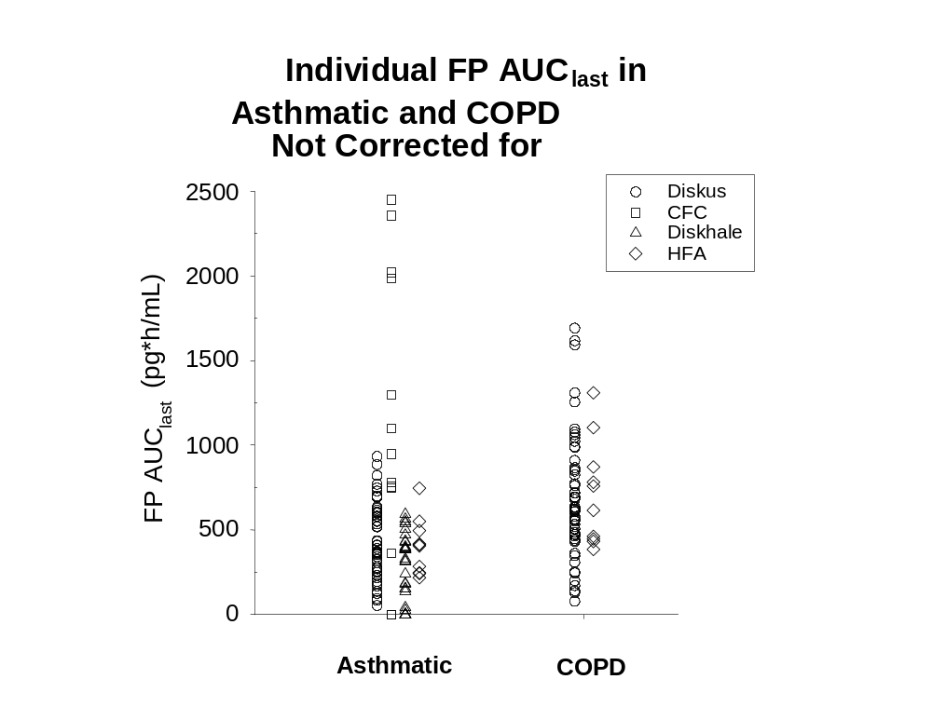

While subject numbers using the marketed MDI were limited, higher exposure following the MDI was observed when the AUC data were not corrected for device. The median and range with the MDI in asthma subjects was 950pg*h/mL (0 – 2448pg*h/mL) compared to 619pg*h/mL (79 - 1690pg*h/mL) with the DISKUS in COPD subjects. Thus, the extensive safety data generated in asthma subjects can be used to support the safety in subjects with COPD. Bone mineral density results from the MDI study (FLTA3001) are described in Section 7.

Serum Cortisol
A comparison of the effects of FP systemic exposure on serum cortisol can be compared using data from two asthma studies (FLTA2001 and SFCB3019) and one COPD study (FLTA3025). While blood-sampling regimens differed slightly, the same dose of FP from the DISKUS device was used in each study. Cortisol measurements were made after four weeks (FLTA2001 and FLTA3025) and 12 weeks (SFCB3019) of treatment.
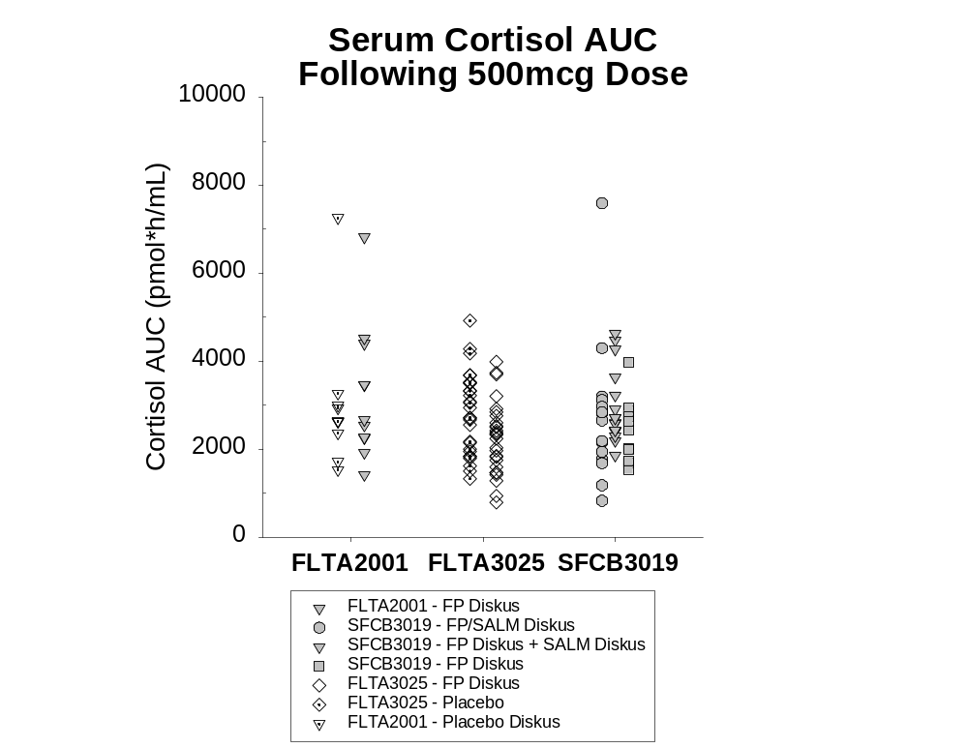

The range of serum cortisol values following drug administration was similar in COPD subjects and asthmatics and was generally comparable to placebo subjects in FLTA2001 and FLTA3025.

Relationship Between FP Systemic Exposure and Serum Cortisol
Earlier work in healthy subjects demonstrated a relationship between increases in FP systemic exposure and decreases in cortisol (Mackie & Bye, 2000). This relationship was examined using the asthma and COPD subjects in FLTA2001, SFCB3019, and FLTA3025. The relationship between FP systemic exposure and serum cortisol levels in asthma and COPD subjects were similar and differences from placebo were minimal due to low FP systemic exposure following the 500mcg dose. Most values were well within the range observed for placebo subjects.

Clinical Pharmacology Conclusions
The clinical pharmacology program conducted in support of the use of Flovent and Advair Diskus in the treatment of COPD build on the information obtained as part of the development program for asthma. Studies in healthy volunteers and patients with asthma had shown that the pharmacokinetics and pharmacodynamic effects of administering fluticasone propionate and salmeterol as a combination product were comparable to that when these agents were administered alone. The primary aim of the current program was to characterize FP pharmacokinetics and pharmacodynamics in patients with COPD and to compare these data to the available data for patients with asthma.
- A dose-related increase in FP systemic exposure was observed in COPD subjects following an increase in dose from 250mcg to 500mcg twice daily with C_{max} averaging 53pg/mL and 84pg/mL, respectively.
- No statistically significant reduction (10%) in serum cortisol was observed with FP 250mcg compared with placebo treatment in subjects with COPD. There was a small, statistically significant reduction (21%) in serum cortisol with FP 500mcg compared to placebo; however, this difference is not considered to be clinically significant.
- Systemic exposure following inhaled administration of FP in COPD subjects was considerably lower compared to healthy subjects and similar to asthma subjects.
- Systemic exposure following inhaled administration of FP with the DISKUS was considerably lower than the currently marketed CFC MDI.
- The range of systemic exposure to FP in the COPD population was within the range observed in subjects with asthma. The range of serum cortisol values following drug administration was similar in COPD subjects and asthmatics and was generally comparable to placebo subjects.
- These findings allow the extrapolation of the long-term safety data in asthma to patients with COPD.

DESIGN OF PIVOTAL STUDIES

Introduction
A major objective of the clinical development program was to show superior efficacy and comparable safety of ADVAIR DISKUS (FSC) compared to the individual components administered at the same doses in patients with COPD. An additional objective of the clinical program was to demonstrate the overall efficacy versus safety of FLOVENT, (FP), SEREVENT (SAL), and ADVAIR DISKUS versus placebo (PLA) in the treatment of COPD. A total of three studies in patients with COPD were performed in support of these objectives. Details on these studies are shown in the table below. All study medication was administered twice daily.
Study | Objective | Treatment  (mcg BID) | N | Duration  (weeks) | Baseline FEV₁ (% pred) | Primary Efficacy
FLTA3025 | Superiority of FP over placebo | FP 250  FP 500  PLA | 216  218  206 | 24 | 41.0%  39.8%  41.3% | Change from baseline at endpoint in AM pre-dose FEV₁
SFCA3006 | Superiority of combination over FP & SAL  Superiority of  FP & SAL over placebo | FSC 500/50  FP 500  SAL 50  PLA | 165  168  160  181 | 24 | 40.9%  41.4%  40.3%  41.5% | Change from baseline at endpoint in AM pre-dose FEV₁  Change from baseline at endpoint in 2h post--dose FEV₁
SFCA3007 | Superiority of combination over FP & SAL  Superiority of  FP & SAL over placebo | FSC 250/50  FP 250  SAL 50  PLA | 178  183  177  185 | 24 | 41.4%  42.0%  41.9%  42.1% | Change from baseline at endpoint in AM pre-dose FEV₁  Change from baseline at endpoint in 2h post--dose FEV₁

Study Design
Each of the three studies (SFCA3006, SFCA3007, and FLTA3025) were randomized, double-blind, parallel-group, placebo-controlled, multi-center trials designed and conducted in an identical manner.
Entry requirements were identical in the three studies. Subjects had to meet the ATS definition of COPD (ATS, 1987), be at least 40 years of age, have a current or prior history of ≥20-pack years of cigarette smoking, and have a history of cough productive of sputum on most days for at least 3 months of the year, for at least 2 years, that was not attributable to another disease process. Subjects were required to have a baseline FEV₁ <65% of predicted normal, but >0.70L or FEV₁ ≤0.70L and >40% of predicted normal with an FEV₁/FVC ratio of ≤70%. Subjects also had to achieve a score of ≥2 (moderate dyspnea) on the Modified Medical Research Council (MMRC) Dyspnea Scale (ATS News, 1982) at Screening and have minimal symptoms of chronic bronchitis (morning cough and sputum) at Baseline.
Specific exclusion criteria were current diagnosis of asthma, current use of oral or high-dose inhaled corticosteroids, abnormal clinically significant ECG, need for long-term oxygen therapy, moderate or severe exacerbation during the run-in, and any significant medical disorder that would place the subject at risk, interfere with the evaluations, or influence study participation.
Subjects who met the entrance criteria began a 2-week, single-blind, run-in period with placebo treatment. All concurrent inhaled or oral sympathomimetic or anticholinergic bronchodilators and inhaled or intranasal corticosteroids were discontinued at the Screening Visit. Concurrent theophylline therapy could be continued if a stable regimen was maintained for 1 month prior to study entry and for the duration of the study. Adjustments could be made to maintain a therapeutic dose of theophylline during the study.
All subjects received VENTOLIN Inhalation Aerosol or nebules to use as needed for the duration of the trial, including the 2-week run-in period.
Subjects who successfully completed the run-in period were assigned to one double-blind treatment via the DISKUS BID for 24 weeks. Subjects were evaluated weekly for the first 4 weeks of treatment (Weeks 1, 2, 3, and 4), every 2 weeks until Week 8 (Weeks 6 and 8), and then at 4-week intervals for the remainder of the study (Weeks 12, 16, 20, and 24).
Subjects could be discontinued from the study for AEs, lack of efficacy, use of corticosteroids or other prohibited medication, initiation of continuous positive airway pressure (CPAP), withdrawal of consent, or resumption of smoking or quitting smoking.

Efficacy Measures

Primary Efficacy Measure
FEV₁ was chosen as the primary efficacy measure due to its wide acceptance as a reproducible and objective indicator of disease severity and prognosis in COPD (ATS 1991; Crapo 1981; Kanner 1996). However, because beta-agonists and corticosteroids treat different aspects of the disease, two different FEV₁ measures were assessed: pre-dose FEV₁ for FSC and for FP, and 2-hour post dose FEV₁ for FSC and for SAL. The primary analyses were those performed at Endpoint comparing the primary measures specified above between treatment groups. The Endpoint was defined as the final evaluable measurement for the subject.
Pre-dose FEV_{1.} Differences between pre-dose FEV₁ on the first day of treatment and pre-dose FEV₁ at subsequent treatment visits were used to compare:
FSC 250/50 and FSC 500/50 with SAL (in order to assess the contribution of FP to FSC)
FSC 250/50 and FSC 500/50 with PLA
FP 250 and FP 500 with PLA
2-Hour Post-Dose FEV₁. Baseline was defined as pre-dose FEV₁ on the first day of treatment (Day 1). Change from Baseline in 2-hour post-dose FEV₁ and all subsequent treatment visits were used to compare:
FSC 250/50 and FSC 500/50 with the corresponding strength of FP, FP 250 or FP 500 (in order to assess the contribution of SAL to FSC)
FSC 250/50 and FSC 500/50 with PLA
SAL 50 with PLA

Key Secondary Efficacy Measures

Baseline/Transition Dyspnea Index (BDI/TDI)
The BDI/TDI (Mahler, 1984) was used to assess the effect of treatment on relief of dyspnea. This BDI/TDI scale was developed to provide a clinical measurement of dyspnea. The Baseline (BDI) scale administered on Treatment Day 1 rated the Baseline severity of dyspnea. Severity was rated on a graded scale from 0 to 4 where Grade 0 was most severe. The scores depended on ratings for three different categories: functional impairment, magnitude of task, and magnitude of effort. The TDI scale administered at each subsequent visit denoted changes from Baseline in functional impairment, magnitude of task, and magnitude of effort. The scale ranged from –3 to +3 where negative numbers indicated deterioration, 0 was no change, and positive numbers indicated improvement. The ratings for the 3 categories were summed to provide a Total TDI Score. A difference in TDI scores between treatment groups of 1.0 was considered clinically important (Mahler, 1999; Witek & Mahler, 2001).

Chronic Respiratory Disease Questionnaire (CRDQ)
Quality of life was assessed using the CRDQ (Guyatt, 1987) which was completed at Treatment Day 1 and Weeks 2, 4, 8, and 24 or at the Discontinuation Visit. The CRDQ is an interviewer-administered disease-specific validated 20-item questionnaire that evaluates quality of life across four domains: dyspnea (five items), fatigue (four items), emotional function (seven items) and mastery over the disease (four items). For the dyspnea domain, at first administration the subject was asked to provide five specific activities that they performed regularly which had been limited by COPD. These individualized activities were also used to evaluate the subject’s dyspnea at subsequent visits. The responses to the 20 items were summed to provide an overall assessment of quality of life. A change from Baseline in Overall CRDQ score of >10.0 is considered clinically meaningful (Jaeschke, 1989).

Chronic Bronchitis Symptoms Questionnaire (CBSQ)
A new questionnaire (CBSQ) was used to assess changes in frequency and severity of cough, chest discomfort, and sputum production. The CBSQ scale combined four selected questions taken from existing questionnaires (Petty, 1996; Rubin, 1990). The CBSQ evaluated the COPD symptoms of cough frequency and severity, chest discomfort, and sputum production on a scale of 0-4, where a rating of 0 reflected no symptoms. Subjects had to have a score of >4 out of a possible 16 at Treatment Day 1 to qualify for the study. The responses to the 4 questions were summed to provide a Global Assessment Score (GAS). Internal evaluation of unblinded data from study FLTA3025 determined that the minimum clinically important change (MCIC) from Baseline was 1.4. Test-retest reliability of the CBSQ was assessed and found to be adequate in study SFCA3007 (correlation >0.7), however, its sensitivity to detect change in clinical status was unknown.

Other Secondary Efficacy Measures
COPD Exacerbations
The occurrence of COPD exacerbations was assessed by the investigator at each clinic visit. Each COPD exacerbation was categorized as either MILD (increased use of VENTOLIN), MODERATE (use of either oral antibiotics and/or corticosteroids) or SEVERE (hospitalization). A subject was discontinued from the study after the first exacerbation requiring corticosteroids or hospitalization or the third exacerbation requiring antibiotics. The use of antibiotics for treatment of upper respiratory tract infections (URTIs) was also considered an exacerbation.
Morning Peak Expiratory Flow
Subjects measured morning peak expiratory flow (PEF) with a hand-held Mini-Wright Peak Flow Meter and recorded the L/min on their personal diary card.
Daily VENTOLIN Use
All subjects were given VENTOLIN (aerosol and/or nebules) for use as needed during the study. Subjects recorded the number of inhalations of VENTOLIN used over the past 24 hours on their personal diary cards. For data analysis, 1 nebule was equivalent to 3 puffs of aerosol.
Nighttime Awakenings Requiring VENTOLIN
Subjects also recorded the number of nighttime awakenings due to symptoms requiring the use of VENTOLIN that they experienced during the previous night on their personal diary card.

Safety Measures
The safety of the treatments in the three pivotal studies was assessed by comparing AEs, deaths, SAEs, withdrawals due to AEs, clinical laboratory tests (including hepatic function, renal function, or metabolic indices such as serum glucose), HPA axis effects in a subset of patients (12-hour serum cortisols, cosyntropin stimulation), cardiovascular measures (12-lead ECG, 24-hour ambulatory ECG in a subset of patients) and vital signs.

Statistical Methods
Study enrollment was planned for 175 to 200 per treatment group in each study. This sample size provides >90% power to detect differences between treatment groups of 100mL in both pre-dose and 2-hour post-dose FEV₁ at Endpoint. Endpoint was defined as the last on-treatment post-baseline assessment excluding any data from the discontinuation visit where additional medications could have been used.
In the individual studies, differences between treatments at Endpoint and all other time points in the change from baseline in pre-dose and post-dose FEV₁, CBSQ, and CRDQ were analyzed using contrasts from ANCOVA adjusting for baseline and investigator. Analysis of differences in BDI/TDI was performed using contrasts with ANOVA adjusting for investigator. Time to first exacerbation and time to withdrawal were analyzed using Wald Chi-square tests based on a proportional hazards model adjusting for age and baseline FEV₁. Overall average and monthly average AM PEF, nighttime awakenings, and VENTOLIN use from the diary card were analyzed using the van Elteren modification of the Wilcoxon test to adjust for investigator (van Elteren, 1958). The same analyses were performed with the integrated data with the exception of the diary data. AM PEF was analyzed using ANCOVA instead of van Elteren since the assumption that the data are normally distributed was considered to be reasonable. VENTOLIN use and nighttime awakenings were analyzed using Wilcoxon instead of van Elteren since van Elteren would not allow comparison of values not in the same protocol. Additionally for both the individual studies and integrated data, 95% confidence intervals were provided for treatment differences in pre-dose and post-dose FEV₁ and CRDQ. Baseline by treatment interactions (and protocol by treatment for the integrated data) were tested and further examined if warranted for the primary and key secondary measures (except for the treatment by Baseline interaction for TDI since baseline was not in the model).
To address multiplicity, in FLTA3025, for the primary efficacy measure (pre-dose FEV₁ at Endpoint), the comparison of high dose to placebo was made before the comparison of low dose to placebo and high dose to low dose. P-values for the second two comparisons were only interpreted inferentially if the first comparison was significant.
In SFCA3006 and SFCA3007, p-values for the three main secondary efficacy measures (overall TDI, CBSQ, and CRDQ scores at Endpoint) were only interpreted inferentially for each comparison if the corresponding comparison had a p-value < 0.05 in the analysis of its primary efficacy measure (either pre-dose FEV₁ or post-dose FEV₁ at Endpoint depending on the comparison). Additionally, the Hochberg method was used at the 0.05 level to control the type I error rate across these three secondary efficacy measures (Hochberg, 1988). Tests of comparisons at timepoints other than Endpoint were considered supportive.

STUDY POPULATION OF PIVOTAL CLINICAL STUDIES
In this section, results from the Intent-to-Treat Population are presented for the three individual studies and the integrated database. Data from Investigator 1403 in SFCA3006 (17 subjects) was excluded from all efficacy analyses as there was reason to believe the integrity of these data may have been compromised. However, these subjects are included in the safety analyses accounting for the difference in subject numbers between the safety and efficacy results. Study population summaries are provided to assist in the evaluation of treatment group comparability before study treatment.
Summaries of the study population for individual population subgroups (based on smoking status, bronchodilator response, inhaled corticosteroid use at Screening, gender, age, and race) are presented in Section 5.4.

Subject Accountability
The table below summarizes subject accountability for the ITT Population in the three pivotal studies and in the integrated data.
Subject Accountability Summary
ITT Population (excluding Investigator 1403 in SFCA3006)
 | PLA | SAL 50 | FP 250 | FP 500 | FSC  250/50 | FSC  500/50
SFCA3006 | N=181 | N=160 |  | N=168 |  | N=165
Completed (%) | 62 | 72 |  | 60 |  | 68
Discontinued (%) | 38 | 28 |  | 40 |  | 32
SFCA3007 | N=185 | N=177 | N=183 |  | N=178
Completed (%) | 68 | 68 | 73 |  | 70
Discontinued (%) | 32 | 32 | 27 |  | 30
FLTA3025 | N=206 |  | N=216 | N=218
Completed (%) | 62 |  | 65 | 67
Discontinued (%) | 38 |  | 35 | 33
Integrated | N=572 | N=337 | N=399 | N=386 | N=178 | N=165
Completed (%) | 64 | 70 | 68 | 64 | 70 | 68
Discontinued (%) | 36 | 30 | 32 | 36 | 30 | 32
Note: Ns represent the number of randomized subjects.

By the end of the study period, 28% to 40% of each treatment group in SFCA3006, 27% to 32% of each treatment group in SFCA3007, and 33% to 38% of each treatment group in FLTA3025 had prematurely discontinued the study. When study data were integrated, treatment groups were similar for total numbers of subjects who prematurely discontinued the study (30% to 36% in each group).
Across the three studies, the most common reason for premature discontinuation was COPD exacerbation, which were a similar percentage of the discontinuations across the treatment groups in SFCA3006 (21-27%) and SFCA3007 (24-30%), and were a higher percentage in the placebo group (41%) compared with the FP groups (28-29%) in FLTA3025.

Demographic and Baseline Characteristics
Subjects were required to discontinue use of inhaled corticosteroids at the Screening Visit. Subjects with a reversible bronchodilator response demonstrated a post-albuterol increase in FEV₁ of >200mL and >12% from Baseline; all other subjects were considered non-reversible.
Demographic and baseline characteristics data for the three pivotal studies and in the integrated data are summarized in the tables below.
Key Demographics and Baseline Characteristics
Pivotal Studies - ITT Population
SFCA3006  (excluding Investigator 1403) | PLA  N=181 |  | SAL 50  N=160 |  | FP 500  N=168 |  | FSC 500/50  N=165
Gender: % Female/Male | 25/75 |  | 36/64 |  | 39/61 |  | 38/62
Age (yr): Mean | 64.0 |  | 63.5 |  | 64.4 |  | 61.9
Race: % W/ B/Other | 92/6/2 |  | 95/4/1 |  | 93/5/2 |  | 95/4/1
Dyspnea Score: % with 3 or 4 | 29 |  | 44 |  | 33 |  | 34
ICS use at Screening (% Yes) | 18 |  | 31 |  | 25 |  | 28
Former/Current Smokers (%) | 46/54 |  | 54/46 |  | 54/46 |  | 54/46
# Pack-Yrs: Median | 60.0 |  | 52.5 |  | 54.0 |  | 55.0
BD Resp: % Rev/Non-Rev | 56/44 |  | 51/49 |  | 54/46 |  | 53/47
SFCA3007 | PLA  N=185 |  | SAL 50  N=177 |  | FP 250  N=183 |  | FSC 250/50  N=178
Gender: % Female/Male | 32/68 |  | 42/58 |  | 34/66 |  | 39/61
Age (yr): Mean | 64.8 |  | 64.2 |  | 63.3 |  | 63.4
Race: % W/ B/Other | 94/3/3 |  | 93/4/3 |  | 91/5/4 |  | 96/3/2
Dyspnea Score: % with 3 or 4 | 36 |  | 33 |  | 35 |  | 38
ICS use at Screening (% Yes) | 30 |  | 20 |  | 28 |  | 23
Former/Current Smokers (%) | 53/47 |  | 49/51 |  | 52/48 |  | 57/43
# Pack-Yrs: Median | 56.0 |  | 57.0 |  | 60.0 |  | 53.0
BD Resp: % Rev/Non-Rev | 55/45 |  | 55/45 |  | 55/45 |  | 56/44
FLTA3025 |  | PLA  N=206 |  | FP 250  N=216 |  | FP 500  N=218
Gender: % Female/Male |  | 32/68 |  | 28/72 |  | 34/66
Age (yr): Mean |  | 64.8 |  | 65.2 |  | 63.3
Race: % W/ B/Other |  | 93/3/2 |  | 94/4/1 |  | 94/4/1
Dyspnea Score: % with 3 or 4 |  | 33 |  | 34 |  | 36
ICS use at Screening (% Yes) |  | 31 |  | 31 |  | 31
Former/Current Smokers (%) |  | 57/43 |  | 55/45 |  | 53/47
# Pack-Yrs: Median |  | 50.0 |  | 54.5 |  | 52.3
BD Resp: % Rev/Non-Rev |  | 60/40 |  | 59/41 |  | 57/43
BD Resp=Bronchodilator response, Rev=Reversible. Percentages may not add to 100% due to missing data.

Integrated Data: Key Demographics and Baseline Characteristics
ITT Population (excluding Investigator 1403 in SFCA3006)
Integrated Data | PLA  N=572 | SAL 50  N=337 | FP 250  N=399 | FP 500  N=386 | FSC  250/50  N=178 | FSC  500/50  N=165
Gender: % Female/Male | 30/70 | 39/61 | 31/69 | 36/64 | 39/61 | 38/62
Age (yr): Mean | 64.6 | 63.9 | 64.4 | 63.8 | 63.4 | 61.9
Race: % W/ B/Other | 94/4/2 | 94/4/2 | 93/5/3 | 94/4/2 | 96/3/2 | 95/4/1
Dyspnea Score: % with 3 or 4 | 32 | 38 | 35 | 35 | 38 | 34
ICS use at Screening (% Yes) | 27 | 25 | 29 | 28 | 23 | 28
Former/Current Smokers (%) | 52/48 | 51/49 | 54/46 | 53/47 | 57/43 | 54/46
# Pack-Yrs: Median | 55 | 55 | 57 | 53 | 53 | 55
BD Resp: % Rev/Non-Rev | 57/43 | 53/47 | 57/43 | 55/44 | 56/44 | 53/47
BD Resp=Bronchodilator response, Rev=Reversible. Percentages may not add to 100% due to missing data.

Demographic and baseline characteristics for the three individual studies were similar across the treatment groups and there were no obvious differences between the three individual studies and the integrated data.

Spirometry and Bronchodilator Response at Screening
Spirometric results at Screening, including bronchodilator response, in the three individual studies and the integrated database are summarized in the tables below.
Mean Baseline Spirometry and Bronchodilator Response Results
Pivotal Studies - ITT Population
SFCA3006  (excluding Inv 1403) | PLA  N=181 |  | SAL 50  N=160 |  | FP 500  N=168 |  | FSC 500/50  N=165
Spirometry (n) | N=181 |  | n=160 |  | N=168 |  | n=165
Mean FEV₁ (mL) | 1317 |  | 1237 |  | 1233 |  | 1268
Mean FEV₁ % of Pred. | 41.5 |  | 40.3 |  | 41.4 |  | 40.9
Mean FEV₁/FVC x 100 | 49.0 |  | 48.6 |  | 47.6 |  | 49.4
BD Response (n) | N=181 |  | n=160 |  | N=168 |  | n=165
Mean % increase | 19.3 |  | 21.2 |  | 19.2 |  | 20.6
SFCA3007 | PLA  N=185 |  | SAL 50  N=177 |  | FP 250  N=183 |  | FSC 250/50  N=178
Spirometry (n) | N=185 |  | n=177 |  | N=183 |  | n=178
Mean FEV₁ (mL) | 1289 |  | 1245 |  | 1313 |  | 1252
Mean FEV₁ % of Pred. | 42.1 |  | 41.9 |  | 42.0 |  | 41.4
Mean FEV₁/FVC x 100 | 49.6 |  | 50.8 |  | 51.27 |  | 49.48
BD Response (n) | N=185 |  | n=176 |  | N=183 |  | n=178
Mean % increase | 20.2 |  | 21.3 |  | 19.5 |  | 20.1
FLTA3025 |  | PLA  N=206 |  | FP 250  N=216 |  | FP 500  N=218
Spirometry (n) |  | N=206 |  | n=216 |  | n=217
Mean FEV₁ (mL) |  | 1254 |  | 1242 |  | 1266
Mean FEV₁ % of Pred. |  | 41.0 |  | 39.8 |  | 41.3
Mean FEV₁/FVC x 100 |  | 47.2 |  | 46.6 |  | 47.8
BD Response (n) |  | N=205 |  | n=214 |  | n=216
Mean % increase |  | 22.9 |  | 22.4 |  | 23.3
Note: BD Response = bronchodilator response.
BD response was calculated as post-albuterol FEV₁ – pre-albuterol FEV₁)/pre-albuterol FEV₁

Integrated Data: Mean Baseline Spirometry and Bronchodilator Response Results
ITT Population (excluding Investigator 1403 in SFCA3006)
Integrated Data | PLA  N=572 | SAL 50  N=337 | FP 250  N=399 | FP 500  N=386 | FSC  250/50  N=178 | FSC  500/50  N=165
Spirometry (n) | n=572 | n=337 | n=399 | n=385 | n=178 | N=165
Mean FEV₁ (mL) | 1285 | 1241 | 1274 | 1252 | 1252 | 1268
Mean FEV₁ % of Pred. | 41.5 | 41.1 | 40.8 | 41.3 | 41.4 | 40.9
Mean FEV₁/FVC x 100 | 48.6 | 49.8 | 48.8 | 47.7 | 49.5 | 49.4
BD Response (n) | n=571 | n=336 | n=397 | n=384 | n=178 | N=165
Mean % increase | 20.9 | 21.3 | 21.1 | 21.5 | 20.1 | 20.6
Note: BD Response = bronchodilator response.
BD response was calculated as (post-albuterol FEV₁ – pre-albuterol FEV₁)/pre-albuterol FEV₁

Baseline spirometry and bronchodilator response data for the three individual studies were similar across the treatment groups and there were no obvious differences between the three individual studies and the integrated data.

Study Medication Adherence
The table below presents study medication adherence data (based on the dose counter) for the integrated data.
Adherence with Study Medication
ITT Population (excluding Investigator 1403 in SFCA3006)
 | PLA | SAL 50 | FP 250 | FP 500 | FSC  250/50 | FSC  500/50
SFCA3006 | N=181 | N=160 |  | N=168 |  | N=165
Median rate (%) | 95.2 | 96.4 |  | 95.9 |  | 95.8
≥90% adherence (% subjects) | 70 | 77 |  | 76 |  | 76
SFCA3007 | N=185 | N=177 | N=183 |  | N=178
Median rate (%) | 96.0 | 96.4 | 95.9 |  | 96.0
≥90% adherence (% subjects) | 79 | 82 | 77 |  | 74
FLTA3025 | N=206 |  | N=216 | N=218
Median rate (%) | 96.0 |  | 95.3 | 95.3
≥90% adherence (% subjects) | 73 |  | 79 | 72
Integrated Data | N=572 | N=337 | N=399 | N=386 | N=178 | N=165
Median rate (%) | 95.8 | 96.4 | 95.5 | 95.6 | 96.0 | 95.8
≥90% adherence (% subjects) | 74 | 80 | 78 | 73 | 74 | 76
Note: Adherence rate = (total doses from dose counter) / (2 x number of days on treatment) x 100.

Median treatment adherence was high (95.2% to 96.4%) across all treatment groups in the three individual studies and the integrated data.

Summary of Study Population Results
The results of the clinical trial support the following conclusions about the study populations and their disposition during the conduct of the trial.
- Most subjects completed each individual study (>60% per treatment group). The percentages of subjects prematurely discontinuing the study were similar across the treatment groups.
- Demographics, baseline characteristics, and baseline spirometry data were similar across the treatment groups in each of the three studies and there were no obvious differences between the three individual studies and integrated data.
- Medication adherence was high (>95%) across the treatment groups in each of the three studies.

EFFICACY RESULTS
Efficacy, including quality of life results, are presented for each of the medications of interest, i.e., FLOVENT DISKUS and ADVAIR DISKUS. For each medication, results from each of the individual studies are first presented for each efficacy measure followed by presentation of the integrated data from the three studies. The integrated data support the efficacy results from the individual studies by providing more precise estimates of the magnitude of treatment effects and increased sample sizes for examining sub-populations.
In order to account for subject withdrawals, Endpoint results are presented for primary and key secondary measures (TDI, CRDQ, and CBSQ). Endpoint was defined as the last on-treatment post-baseline assessment excluding the Discontinuation Visit. Actual mean differences from the raw data are reported in the tables. Estimated (model-adjusted) mean differences, adjusted for site and Baseline, are presented in the text. P-values in both the tables and text are for adjusted mean differences that differ slightly from the raw mean differences. Some of the Baseline sample sizes may differ from the study population data presented in Section 4 due to subjects with missing Baseline assessments.
Results of the clinical program achieved its primary objective of demonstrating greater improvements in lung function with the combination product (ADVAIR) compared with each individual component (FP and salmeterol) alone. Additionally, ADVAIR and FLOVENT were superior to placebo.

FLOVENT DISKUS (FP) Efficacy
The efficacy of FP was compared with PLA in SFCA3006 (FP 500), SFCA3007 (FP 250), and FLTA3025 (FP 500 and FP 250).

Primary Efficacy Measure: Pre-Dose FEV₁
To evaluate the efficacy of FP, the primary efficacy measure was the comparison of the mean change from Baseline in pre-dose FEV₁ for treatment with FP and PLA at Endpoint. Although the Endpoint comparison was considered primary, the mean change from Baseline in pre-dose FEV₁ for treatment with FP and PLA also was assessed at each post-Baseline treatment visit.

Individual Studies
Pre-dose FEV₁ data at Endpoint are shown in the table below for the primary comparison of FP 250 and FP 500 vs. PLA.
Primary Comparison: Mean Change (mL) from Baseline
Pre-Dose FEV₁ at Endpoint
 | PLA | SAL 50 | FP 250 | FP 500
SFCA3006
 | n=181 | n=159 |  | n=166
Baseline Mean | 1282 | 1192 |  | 1174
 | n=171 | n=158 |  | n=160
Endpoint Mean | 1292 | 1303 |  | 1298
Mean Δ | -4 | 107 ^{d} |  | 109 ^{e}
SFCA3007
 | n=185 | n=177 | n=183
Baseline Mean | 1232 | 1205 | 1236
 | n=172 | n=168 | n=175
Endpoint Mean | 1240 | 1303 | 1351
Mean Δ | 1 | 91 ^{d} | 109 e
FLTA3025
 | n=204 |  | n=215 | n=218
Baseline Mean | 1203 |  | 1207 | 1246
 | n=199 |  | n=211 | n=210
Endpoint Mean | 1221 |  | 1240 | 1301
Mean Δ | 11 |  | 38 | 61 ^{e}
d. p<0.001 for SAL compared with PLA
e. p≤0.010 for FP compared with PLA

In all three studies, treatment with FP was associated with greater improvements in pre-dose FEV₁ compared with placebo. The estimated difference in pre-dose FEV₁ for FP 500 compared with PLA was 105mL in SFCA3006 (p<0.001) and the estimated difference in pre-dose FEV₁ for FP 250 compared with PLA was 112mL in SFCA3007 (p<0.001).
In FLTA3025, a dose-related improvement in pre-dose FEV₁ compared with placebo was seen for FP 500 (estimated difference = 57mL, p=0.010) compared with FP 250 (estimated difference = 32mL, p=0.140).
Results for pre-dose FEV₁ during the treatment period for the trials are presented graphically in the figures below.

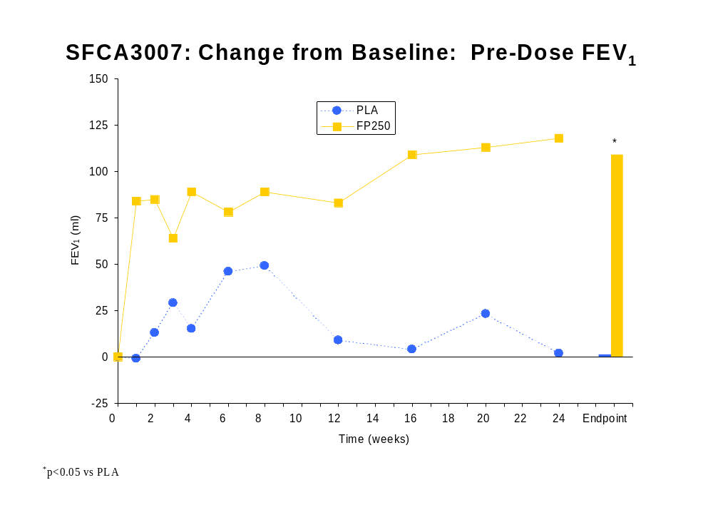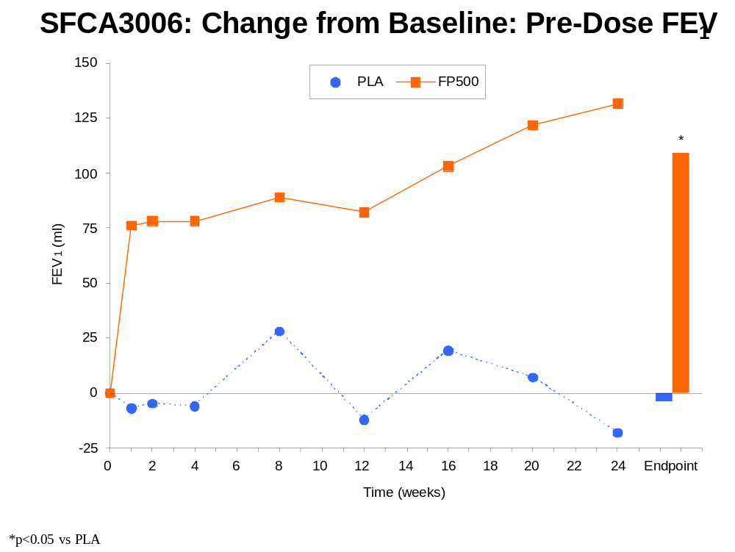

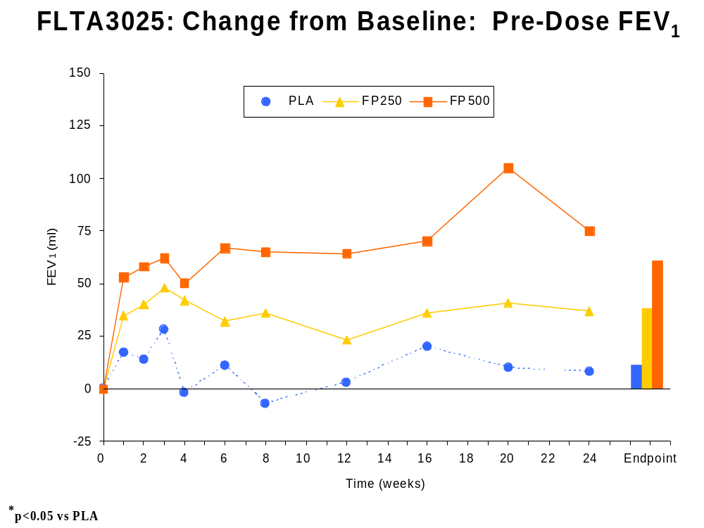
At Week 1, significantly greater increases in pre-dose FEV₁ were observed for treatment with FP 500 compared with PLA in both SFCA3006 and FLTA3025 (p≤0.017, estimated differences = 73 and 40mL) and for treatment with FP 250 compared with PLA in SFCA3007 (p<0.001, estimated difference = 84mL). At Week 24, mean changes from Baseline in pre-dose FEV₁ for the FP 500 groups in SFCA3006 and FLTA3025 were 131 and 75mL compared with -18 and 8mL for the PLA groups (p≤0.004, estimated differences = 127 and 79mL). In SFCA3007, the mean change in pre-dose FEV₁ at Week 24 for FP 250 was 118mL compared with 3mL for PLA (p<0.001, estimated difference = 116mL).

Integrated Data
The integrated results support the efficacy of both FP 500 and FP 250 on pre-dose FEV₁ by providing more precise estimates of the magnitude of the treatment differences than the individual studies. At Endpoint, the estimated difference between FP 500 and placebo was 85mL with a 95% confidence interval of (53mL, 118mL), while the estimated difference between FP 250 and placebo was 73mL with a 95% confidence interval of (41mL, 105mL). At Week 1 and throughout the study, estimated differences ranged from 50mL to 109mL between FP 500 and placebo and from 32mL to 81mL between FP 250 and placebo. The largest estimated difference from placebo for both FP 500 and FP 250 occurred at Week 24, where estimated differences were 109mL and 81mL, respectively.
The figure below shows the greater increases in pre-dose FEV₁ throughout the study for the FP treatments compared with PLA.
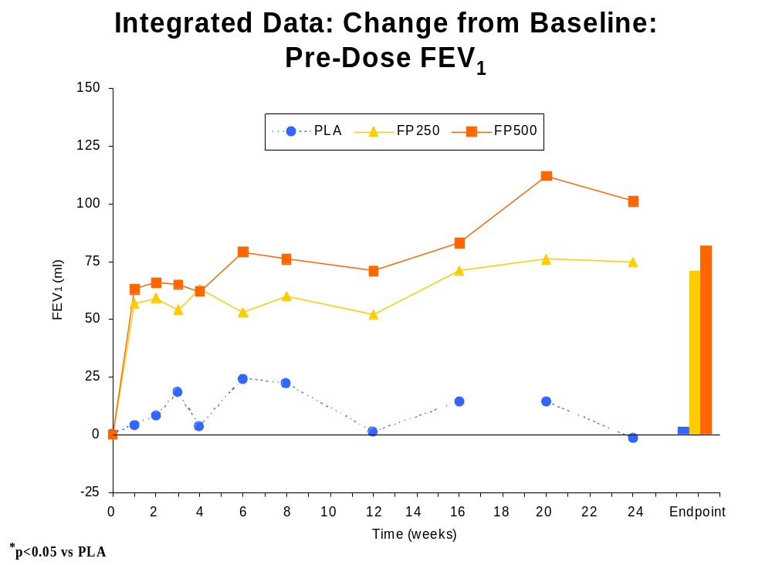

Key Secondary Efficacy Measures

Baseline/Transition Dyspnea Index (BDI/TDI)
Individual Studies
Key results for the BDI and TDI at Endpoint are presented in the table below.
Mean of Baseline/Transition Dyspnea Index (BDI/TDI)
Total TDI Score at Endpoint
 | PLA | SAL 50 | FP 250 | FP 500
SFCA3006
 | n=179 | n=154 |  | n=164
BDI Mean | 5.8 | 5.9 |  | 6.0
 | n=172 | n=158 |  | n=161
TDI Mean | 0.4 | 0.9 |  | 1.3 e
SFCA3007
 | n=183 | n=176 | n=179
BDI Mean | 5.7 | 6.1 | 6.2
 | n=172 | n=169 | n=175
TDI Mean | 1.0 | 1.6 ^{d} | 1.7
FLTA3025
 | n=204 |  | n=213 | n=216
BDI Mean | 5.8 |  | 6.3 | 5.9
 | n=199 |  | n=211 | n=211
TDI Mean | 0.5 |  | 0.9 | 1.2 ^{e}
d. p=0.043 for SAL compared with PLA
e. p≤0.010 for FP compared with PLA

The estimated differences between treatments with FP 500 and PLA were 1.1 (p=0.005) in SFCA3006 and 0.8 (p=0.010) in FLTA3025. In SFCA3006, a significant difference in TDI scores between FP 500 (0.8) and PLA (0.1, p=0.012; estimated difference = 0.6) was observed as early as Week 1. After Week 8, differences between FP 500 and PLA consistently increased at each timepoint (p≤0.049). At Week 24 in SFCA3006, the TDI score with FP 500 (1.9) was significantly greater than that with PLA (0.6, p<0.001; estimated difference = 1.5). In FLTA3025, significant differences in mean TDI total scores were also observed between FP 500 and PLA at most timepoints.
In both SFCA3007 and FLTA3025, the mean TDI scores for treatment with FP 250 were numerically greater, but not usually significantly different, from mean TDI scores for PLA. The estimated difference in SFCA3007 was 0.7 (p=0.057) at Endpoint.
Integrated Data
The integrated results support the efficacy of FP 500 on the TDI and provide positive evidence for FP 250. At Endpoint, the estimated difference between FP 500 and placebo was 0.9 for overall TDI score and ranged from 0.4 to 0.9 throughout the course of the study with the largest differences occurring at the end of the treatment period. The estimated difference between FP 250 and placebo was 0.5 at Endpoint, and ranged from 0.1 to 0.5 throughout the course of the study.
The greater increases over time in mean overall TDI score for the FP groups compared with the PLA group are depicted in the following figure:
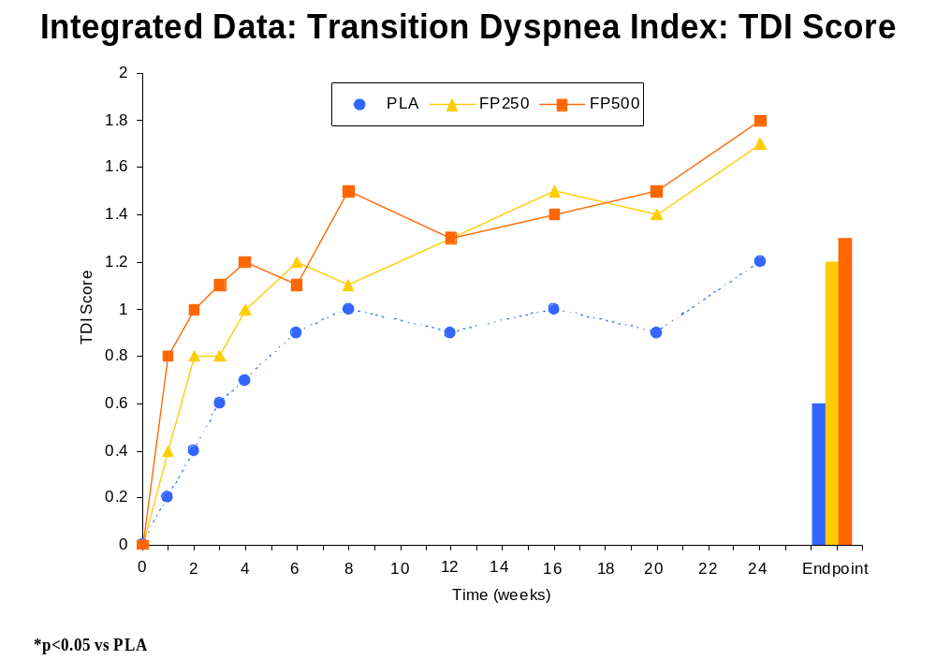

Chronic Respiratory Disease Questionnaire (CRDQ)
Individual Studies
The following table summarizes Baseline values and change from Baseline in CRDQ score for each group in the three clinical studies.
Summary of Mean Change from Baseline in CRDQ Score
 | PLA | SAL 50 | FP 250 | FP 500
SFCA3006
Baseline  Mean | n=177  86.2 | n=157  87.6 |  | n=166  88.5
Endpoint  Mean  Mean Δ | n=175  91.3  5.0 | n=155  95.8  8.0 |  | n=163  93.5  4.8
SFCA3007
Baseline  Mean | n=180  84.8 | n=173  86.3 | n=177  85.5
Endpoint  Mean  Mean Δ | n=177  89.6  5.0 | n=170  93.0  6.4 | n=170  96.4  10.4 ^{e}
FLTA3025
Baseline  Mean | n=203  87.6 |  | n=214  88.8 | n=213  83.6
Endpoint  Mean  Mean Δ | n=199  89.6  1.0 |  | n=211  94.2  5.1 ^{e} | n=210  92.8  9.1 ^{e}
e. p≤0.016 for FP compared with PLA

In FLTA3025, increases in overall CRDQ score at Endpoint were significantly greater for both FP 250 (5.1) and FP 500 (9.1) compared with PLA (1.0, p≤0.016, estimated differences=4.3 to 7.3) and approached the clinically meaningful threshold (≥10) in the FP 500 group. In SFCA3007, increases in FP 250 (10.4) were clinically meaningful and significantly greater compared with PLA (5.0, p=0.002; estimated difference=5.8). In SFCA3006, increases in FP 500 (4.8) were similar to increases in PLA (5.0, estimated difference=0.5).
Integrated Data
The integrated data support the efficacy on mean increases from Baseline in overall CRDQ score for both FP 500 and FP 250. At Endpoint, the estimated difference between FP 500 and placebo was 4.3 with a 95% confidence interval of (1.8, 6.7), while the estimated difference between FP 250 and placebo was 4.4 with a 95% confidence interval of (2.0, 6.8). Estimated differences from placebo at each treatment visit were smaller than at Endpoint and ranged from 1.5 to 3.3 for FP 500 and 1.2 to 3.8 for FP 250, achieving the largest differences at the end of the treatment period.
The figure below illustrates the greater mean change in overall CRDQ score in the FP groups compared with PLA over time.
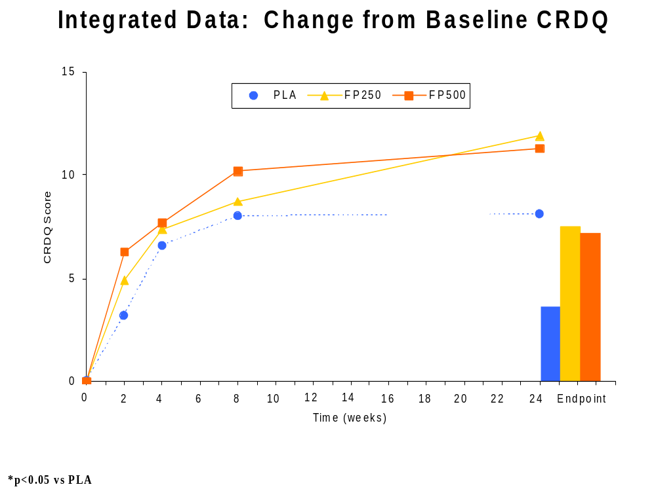

Chronic Bronchitis Symptom Questionnaire (CBSQ)
Individual Studies
The table below presents CBSQ Global Assessment Scores (CBSQ GAS) mean change from baseline for FP 250 and FP 500 compared with the PLA.
Summary of Mean Change from Baseline in CBSQ GAS
 | PLA | SAL 50 | FP 250 | FP 500
SFCA3006
Baseline | n=180 | n=159 |  | n=167
Mean | 7.3 | 7.4 |  | 7.0
Endpoint | n=172 | n=158 |  | n=161
Mean | 5.7 | 5.5 |  | 5.5
Mean Change | 1.5 | 1.9 |  | 1.6
SFCA3007
Baseline | n=185 | n=177 | n=183
Mean | 7.5 | 7.0 | 7.4
Endpoint | n=172 | n=169 | n=175
Mean | 6.1 | 5.6 | 5.2
Mean Change | 1.4 | 1.5 | 2.2 e
FLTA3025
Baseline | n=205 |  | n=215 | n=218
Mean | 7.1 |  | 7.1 | 7.4
Endpoint | n=199 |  | n=211 | n=211
Mean | 6.1 |  | 5.7 | 6.0
Mean Change | 0.9 |  | 1.4 | 1.4
e. p=0.006 for FP compared with PLA

Numerically greater increases for mean CBSQ GAS occurred with FP relative to placebo in each trial, however, significant differences between the FP and PLA groups for mean CBSQ GAS only occurred intermittently across the three studies. Only in SFCA3007, a significant difference was observed for treatment with FP 250 compared with PLA at Endpoint (p=0.006, estimated difference = 0.8).
Integrated Data
The integrated data provide estimated differences between FP 500 and placebo and between FP 250 and placebo at Endpoint on the change from Baseline in the CBSQ GAS of 0.3 and 0.6, respectively. Estimated differences from placebo ranged from 0.3 to 0.5 for FP 500 and 0.2 to 0.6 for FP 250 across the treatment visits

Other Secondary Efficacy Measures

Incidence of COPD Exacerbations
Individual Studies
The following table summarizes the results for COPD exacerbations of moderate to severe intensity.
Incidence (%) of Moderate or Severe COPD Exacerbation
Number of  Exacerbations | PLA | SAL 50 | FP 250 | FP 500
SFCA3006 | N=181 | N=160 |  | N=168
None | 65 | 63 |  | 60
At least One | 35 | 38 |  | 40
1 | 27 | 29 |  | 32
2 | 7 | 8 |  | 7
3 | 1 | 1 |  | 1
≥4 | <1 | 0 |  | 0
SFCA3007 | N=185 | N=177 | N=183
None | 66 | 69 | 62
At Least One | 34 | 31 | 38
1 | 26 | 25 | 30
2 | 6 | 5 | 8
3 | 1 | <1 | 0
≥4 | <1 | 0 | 0
FLTA3025 | N=206 |  | N=216 | N=218
None | 57 |  | 60 | 62
At Least One | 43 |  | 40 | 38
1 | 33 |  | 34 | 30
2 | 8 |  | 5 | 7
3 | <1 |  | 1 | 1
≥4 | 0 |  | <1 | 0

The incidence of moderate or severe COPD exacerbation was comparable between FP and PLA groups in all three studies.
Integrated Data
As seen with individual study results, the incidence of moderate or severe COPD exacerbation with the integrated data was comparable between each FP group and the PLA group.

Time-to-Event Analyses
Survival analyses were performed to evaluate potential treatment group differences in time to first COPD exacerbation and in time to study withdrawal for any reason), due to COPD exacerbation and due to COPD-related conditions (defined as withdrawal due to COPD exacerbation or lack of efficacy). Individual study results and integrated data all showed no significant differences among treatments for time to first COPD exacerbation of any intensity, time to first moderate or severe COPD exacerbation, and time to withdrawal, and time to withdrawal due to a moderate or severe COPD exacerbation. While no differences were observed in the individual studies, with integrated data, there was a significant difference between the FP 250 group and the PLA group for time to withdrawal for any reason. Additionally in FLTA3025 and the integrated data, there were significant differences between the FP 500 and PLA groups for time to withdrawal due to a COPD related condition.

AM PEF
Individual Studies
The table below summarizes the Baseline values and the Overall mean change from Baseline for AM PEF for the three clinical studies.
Mean Change (L/min) from Baseline: Overall PEF
 | PLA | SAL 50 | FP 250 | FP 500
SFCA3006
 | n=181 | n=158 |  | n=167
Baseline Mean | 269.5 | 252.1 |  | 243.7
 | n=179 | n=157 |  | n=166
Overall Mean | 267.1 | 268.7 |  | 256.6
Mean Change | -2.7 | 16.8 ^{d} |  | 12.9 ^{e}
SFCA3007
 | n=184 | n=176 | n=182
Baseline Mean | 220.3 | 210.3 | 220.0
 | n=183 | n=174 | n=177
Overall Mean | 220.2 | 225.3 | 230.7
Mean Change | 0.8 | 14.7 ^{d} | 11.3 e
FLTA3025
 | n=205 |  | n=213 | n=218
Baseline Mean | 249.6 |  | 254.7 | 254.2
 | n=205 |  | n=212 | n=215
Overall Mean | 247.5 |  | 263.3 | 263.8
Mean Change | -1.9 |  | 8.8 e | 9.4 e
d. p<0.001 for SAL compared with PLA
e. p≤0.003 for FP compared with PLA

In all three studies, significantly greater improvements in Overall mean change in AM PEF were seen with FP treatment relative to placebo, which confirm the improvements in FEV₁ reviewed previously. The FP 500 and FP 250 treatments demonstrated greater increases in AM PEF for each month of treatment in all three studies; treatment differences were significant at most timepoints.
Integrated Data
The integrated results for the change from Baseline in Overall AM PEF and for the change from Baseline at each treatment month support the efficacy demonstrated in the individual studies. The estimated difference in the mean change from Baseline in Overall AM PEF between FP 500 and placebo was 12.6L/min and was 11.4L/min between FP 250 and placebo. The estimated differences from placebo ranged from 10.7L/min to 14.0L/min for FP 500 and 8.9L/min to 12.3L/min for FP 250 across the 6 monthly average changes from Baseline in AM PEF.
The greater increases in AM PEF for the FP groups over time are depicted in the following figure:
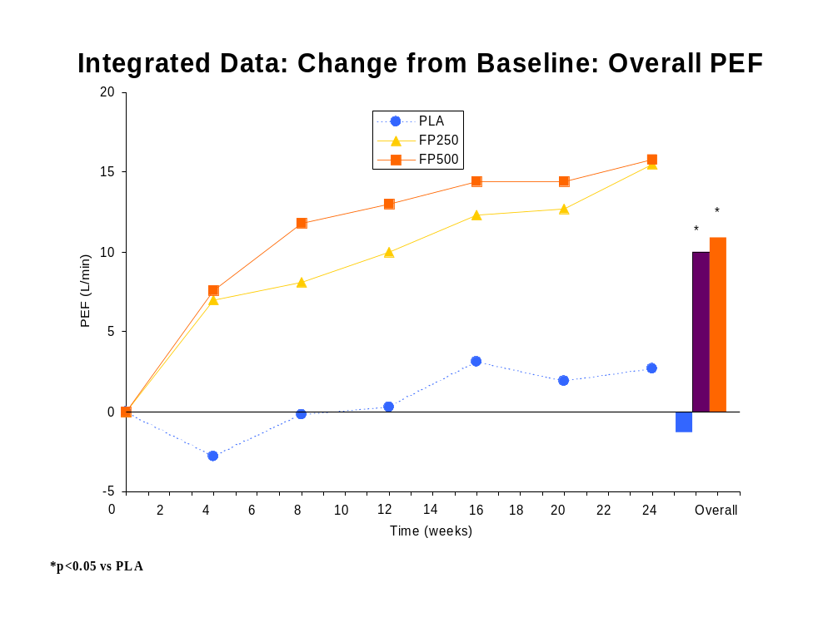

Daily VENTOLIN Use
Individual Studies
The following table summarizes Baseline values and change from Baseline in VENTOLIN use in the three clinical studies.
Mean Change from Baseline: Total Daily VENTOLIN Use
(Number of Puffs of VENTOLIN Used per Day)
 | PLA | SAL 50 | FP 250 | FP 500
SFCA3006
Baseline | n=181 | n=158 |  | n=166
Mean | 4.9 | 4.6 |  | 4.5
Overall | n=179 | n=157 |  | n=164
Mean | 5.4 | 3.6 |  | 4.1
Mean Change | 0.5 | -0.9 ^{d} |  | -0.4 e
SFCA3007
Baseline | n=184 | n=176 | n=181
Mean | 4.8 | 4.6 | 4.6
Overall | n=182 | n=174 | n=177
Mean | 5.0 | 3.9 | 4.4
Mean Change | 0.1 | -0.7 ^{d} | -0.2
FLTA3025
Baseline | n=205 |  | n=213 | n=218
Mean | 5.4 |  | 5.7 | 5.7
Overall | n=204 |  | n=212 | n=215
Mean | 6.2 |  | 5.6 | 5.5
Mean Change | 0.7 |  | -0.1 e | -0.2 e
d. p<0.044 for SAL compared with PLA
e. p<0.045 for FP compared with PLA

In all three studies, greater reduction in VENTOLIN use was observed with FP vs. placebo treatments. These differences achieved statistical significance for FP 500 in FLTA3025 and SFCA3006, but only in FLTA3025 for FP 250. Significant reductions from Baseline in VENTOLIN use were observed at most treatment months for the FP 500 treatment group compared with the PLA group in SFCA3006 and for both FP treatment groups compared with the PLA group in FLTA3025 at all timepoints (p≤0.025).
Integrated Data
Results from the integrated data support the efficacy for both FP 500 and FP 250 in the mean change from Baseline in daily VENTOLIN use in contrast to the finding in SFCA3007 for FP 250. Overall daily VENTOLIN use was less for treatments with FP 500 and FP 250 (mean changes from Baseline of -0.3 and -0.2 puffs per day, respectively) compared with PLA (mean change from Baseline of 0.5 puffs per day) (p<0.001). There were also reductions from Baseline in VENTOLIN use for each month of treatment with both FP 500 and FP 250 compared with PLA (p≤0.023).

Nighttime Awakenings Requiring VENTOLIN
Individual Studies
The following table summarizes Baseline values and change from Baseline in number of awakenings per night requiring VENTOLIN use in the three clinical studies.
Summary of Mean Change from Baseline in
Number of Awakenings per Night Requiring VENTOLIN Use
 | PLA | SAL 50 | FP 250 | FP 500
SFCA3006
Baseline | n=177 | n=156 |  | n=163
Mean | 0.27 | 0.26 |  | 0.24
Overall | n=175 | n=153 |  | n=162
Mean | 0.36 | 0.17 |  | 0.16
Mean Change | 0.10 | -0.09 ^{d} |  | -0.08 ^{e}
SFCA3007
Baseline | n=184 | n=175 | n=181
Mean | 0.23 | 0.20 | 0.24
Overall | n=181 | n=174 | n=177
Mean | 0.25 | 0.14 | 0.20
Mean Change | 0.02 | -0.06 | -0.03 ^{e}
FLTA3025
Baseline | n=202 |  | n=212 | n=217
Mean | 0.22 |  | 0.25 | 0.29
Overall | n=202 |  | n=211 | n=212
Mean | 0.33 |  | 0.20 | 0.25
Mean Change | 0.11 |  | -0.05 ^{e} | -0.05 ^{e}
d. p<0.001 for SAL compared with PLA
e. p<0.038 for FP compared with PLA

In all three studies, the FP groups showed a significantly greater Overall mean decrease in nighttime awakenings requiring VENTOLIN use (-0.03 to –0.08 awakenings per night, respectively) compared with the mean increase of the PLA groups (0.02 to 0.11 awakenings per night, respectively) (p≤0.038). During the treatment period in each study, the FP groups consistently demonstrated greater mean decreases in nighttime awakenings requiring VENTOLIN use compared with the PLA group, although treatment differences were not significant at all timepoints.
Integrated Data
Results from the integrated data support the efficacy for both FP 500 and FP 250 on nighttime awakenings requiring VENTOLIN. The FP 250 and FP 500 groups had fewer Overall nighttime awakenings requiring VENTOLIN use (mean change from Baseline of -0.04 and –0.06 awakenings per night, respectively) compared with the PLA group (mean change from Baseline of +0.08 awakenings per night) (p<0.001). Additionally, both FP treatment groups had fewer awakenings per night requiring VENTOLIN use compared with the PLA treatment group during each month of the study period (p≤0.041).

ADVAIR DISKUS (FSC) EFFICACY

Primary Efficacy Measures

Pre-Dose FEV₁
To evaluate the contribution of FP to the efficacy of FSC, the primary analyses in SFCA3006 and SFCA3007 compared the mean changes from Baseline in pre-dose FEV₁ at Endpoint between the FSC and SAL 50 treatments. Baseline was defined as the pre-dose FEV₁ on the first morning of treatment. Mean change from Baseline in pre-dose FEV₁ at Endpoint also was compared between FSC and PLA. Although the Endpoint comparison was considered primary, differences in mean changes from Baseline in pre-dose FEV₁ between FSC and both SAL 50 and PLA were assessed at each post-Baseline treatment visit.
Individual Studies
Pre-dose FEV₁ data at Endpoint are shown in the following table for the primary comparison of FSC compared with SAL 50 and FSC compared with PLA.
Primary Comparison: Mean Change (mL) from Baseline
Pre-Dose FEV₁ at Endpoint
 | PLA | SAL 50 | FP 250 | FP 500 | FSC  250/50 | FSC  500/50
SFCA3006
Baseline | n=181 | n=159 |  | n=166 |  | n=163
Mean | 1282 | 1192 |  | 1174 |  | 1254
Endpoint | n=171 | n=158 |  | n=160 |  | n=156
Mean | 1292 | 1303 |  | 1298 |  | 1410
Mean Δ | -4 | 107 |  | 109 |  | 156 ^{a,b,c}
SFCA3007
Baseline | n=185 | n=177 | n=183 |  | n=178
Mean | 1232 | 1205 | 1236 |  | 1207
Endpoint | n=172 | n=168 | n=175 |  | n=171
Mean | 1240 | 1303 | 1351 |  | 1375
Mean Δ | 1 | 91 | 109 |  | 165 ^{a,c}
a. p=0.012 for FSC compared with SAL
b. p=0.038 for FSC compared with FP
c. p<0.001 for FSC compared with PLA

The estimated difference in pre-dose FEV₁ for FSC 500/50 was 67mL compared with SAL 50 (p=0.012) and 159mL compared with PLA (p<0.001). The estimated difference in pre-dose FEV₁ for FSC 250/50 was 69mL compared with SAL 50 (p=0.012) and 161mL compared with PLA (p<0.001). Both these estimated differences and the actual increases from baseline were similar between FSC 500/50 and FSC 250/50.
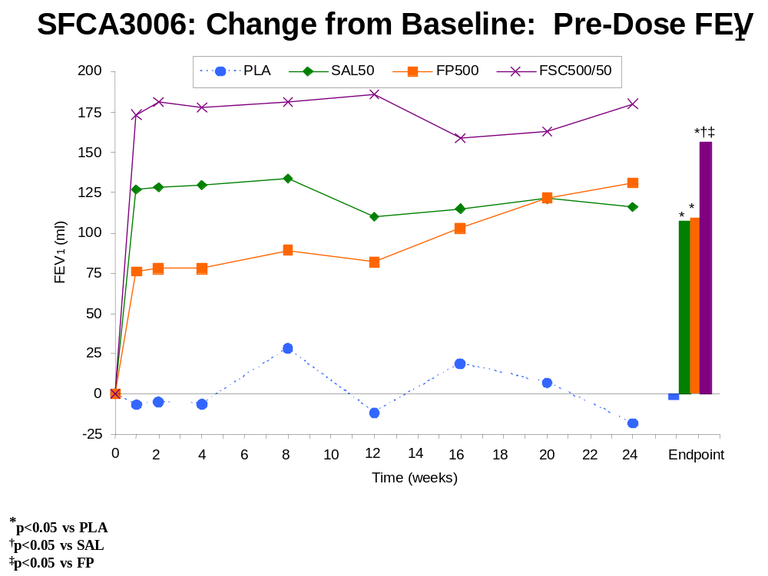
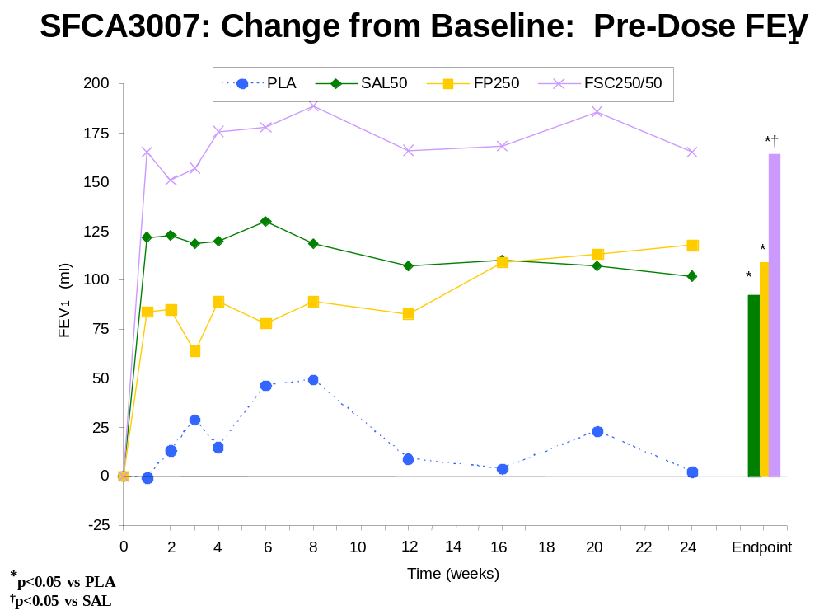
Significantly greater increases in pre-dose FEV₁ were observed at Week 1 for treatments with both FSC 500/50 and FSC 250/50 compared with SAL. This treatment difference was sustained throughout the study. Substantial increases in pre-dose FEV₁ at Week 1 with FSC treatment (165mL for the FSC 250/50 group and 173mL for the FSC 500/50 group) support an early onset of effect for FSC. Significant differences at Week 1 between FSC and SAL 50 (p≤0.032, estimated differences = 45mL and 46mL) indicate an early-onset contribution of FP to the efficacy of FSC. FSC-treated subjects who completed the entire treatment period also demonstrated substantial increases from Baseline in pre-dose FEV₁ at Week 24 (165mL for the FSC 250/50 group and 180mL for the FSC 500/50 group). In both studies, significantly greater increases in pre-dose FEV₁ were observed with FSC compared with PLA at Week 1 and at all timepoints throughout the study.
Integrated Data
The integrated data support the efficacy of FSC on pre-dose FEV₁ by providing more precise estimates of the magnitude of the treatment differences from SAL 50 than the individual studies. At Endpoint, the estimated difference between FSC 500/50 and SAL 50 was 71mL with a 95% confidence interval of (23mL, 119mL) and was 66mL with a 95% confidence interval of (19mL, 113mL) between FSC 250/50 and SAL 50. At Week 1 and throughout the study, estimated differences ranged from 52mL to 96mL between FSC 500/50 and SAL 50 and from 23mL to 56mL between FSC 250/50 and SAL 50.
The integrated data also support the efficacy of FSC on pre-dose FEV₁ by providing more precise estimates of the magnitude of the treatment differences from placebo than the individual studies. At Endpoint, the estimated difference between FSC 500/50 and placebo was 148mL with a 95% confidence interval of (102mL, 195mL) and was 143mL with a 95% confidence interval of (98mL, 188mL) between FSC 250/50 and placebo. At Week 1 and throughout the study, estimated differences ranged from 128mL to 192mL between FSC 500/50 and placebo and from 126mL to 160mL between FSC 250/50 and placebo.
The greater increases in pre-dose FEV₁ with the FSC treatments compared with SAL 50 and with placebo are illustrated in the following figure:
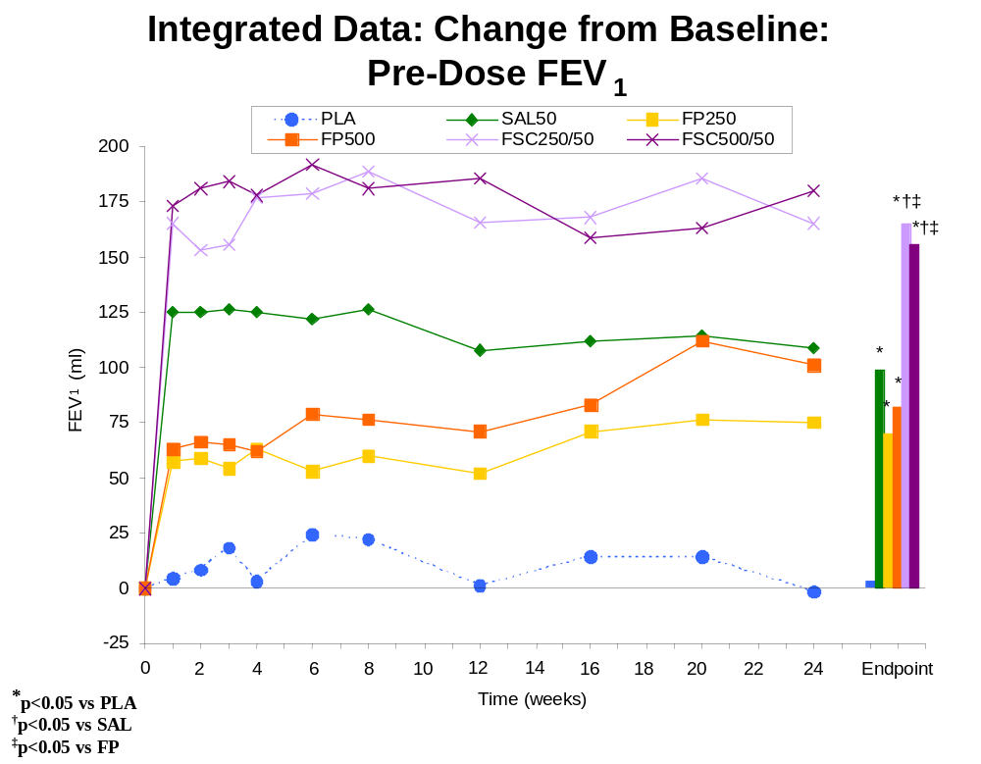

2-Hour Post-Dose FEV₁
To evaluate the contribution of SAL 50 to the efficacy of FSC, the primary analyses in SFCA3006 and SFCA3007 compared the mean change from Baseline at Endpoint in 2-hour post-dose FEV₁ between the FSC and FP treatments. Baseline was defined as the pre-dose FEV₁ on the first morning of treatment. In SFCA3006 and SFCA3007 and in integrated data, the lower strength FSC treatment was compared with the lower strength FP treatment, and the higher strength FSC treatment was compared with the higher strength FP treatment. Mean change from Baseline in 2-hour post-dose FEV₁ at Endpoint also was compared between FSC and PLA. Although the Endpoint comparison was considered primary, the mean change from Baseline in 2-hour post-dose FEV₁ also was assessed at 2 hours post-dose on Day 1 and at each subsequent treatment visit.
Individual Studies
Two-hour post-dose FEV₁ data at Endpoint are shown in the following table for the primary comparison of FSC compared with FP 250 and FP 500 and FSC compared with PLA.
Primary Comparison: Mean Change (mL) from Baseline
2-hour Post-Dose FEV₁ at Endpoint
 | PLA | SAL 50 | FP 250 | FP 500 | FSC 250/50 | FSC 500/50
SFCA3006
Baseline | n=181 | n=159 |  | n=166 |  | n=163
Mean | 1282 | 1192 |  | 1174 |  | 1254
Endpoint | n=171 | n=158 |  | n=160 |  | n=156
Mean | 1324 | 1429 |  | 1327 |  | 1515
Mean Change | 28 | 233 |  | 138 |  | 261 ^{b,c}
SFCA3007
Baseline | n=185 | n=177 | n=183 |  | n=178
Mean | 1232 | 1205 | 1236 |  | 1207
Endpoint | n=172 | n=168 | n=175 |  | n=171
Mean | 1298 | 1413 | 1389 |  | 1490
Mean Change | 58 | 200 | 147 |  | 281 ^{a,b,c}
a. p=0.010 for FSC compared with SAL
b. p<0.001 for FSC compared with FP
c. p<0.001 for FSC compared with PLA

The estimated difference in 2-hr post-dose FEV₁ for FSC 500/50 was 129 mL compared with FP 500 (p<0.001) and 231mL compared with PLA (p<0.001). The estimated difference in 2-hr post-dose FEV₁ for FSC 250/50 was 124mL compared with FP 250 (p<0.001) and 214mL compared with PLA (p<0.001). Both these estimated differences and the actual increases from baseline were similar between treatments with FSC 500/50 and FSC 250/50.
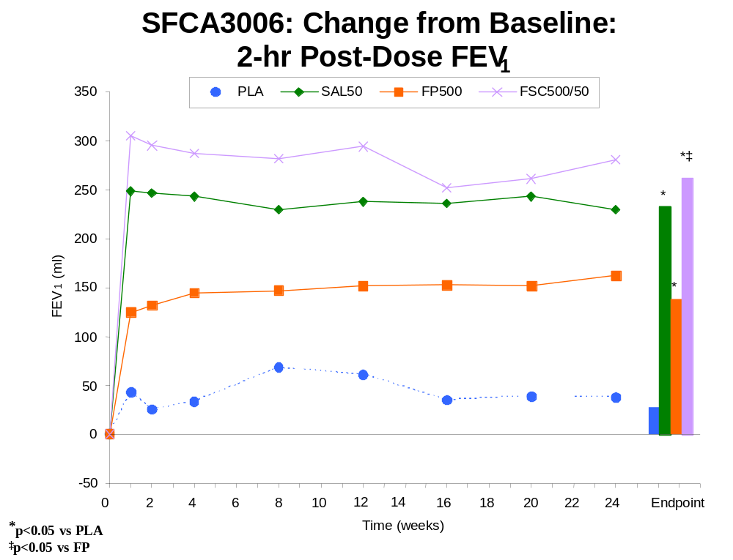
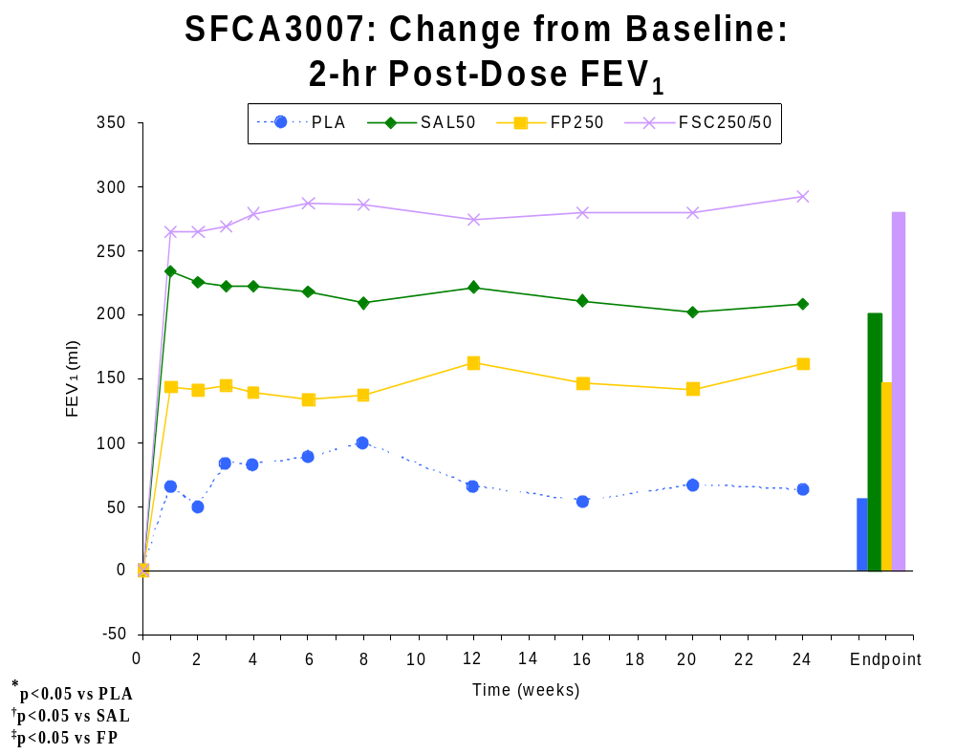
On Day 1, the FSC groups in both studies demonstrated a significantly greater change from Baseline in 2-hour post-dose FEV₁ compared with FP. This treatment difference was sustained throughout the study. The marked increase in 2-hour post-dose FEV₁ on Day 1 with FSC treatment (206mL for FSC 250/50, 186mL for FSC 500/50) supports a rapid onset of effect. At Week 24, the mean changes in 2-hour post-dose FEV₁ for the FSC 250/50 and FSC 500/50 groups (293mL and 281mL) were significantly greater than that of the corresponding strength FP group (161mL and 163mL) (p≤0.003, estimated differences = 107 and 129mL) and compared with the placebo (p<0.001, estimated differences = 203mL and 224mL), indicating sustained improvement in the FSC groups. On Day 1 and at every timepoint, the FSC treatment group in both studies demonstrated a significantly greater change from Baseline in 2-hour post-dose FEV₁ compared with PLA (p<0.001, estimated differences = 150-267mL). The sustained increase from Baseline in post-dose FEV₁ suggests a lack of tolerance to the bronchodilating effect when FSC is used for a prolonged period.
Integrated Data
FLTA3025 did not evaluate 2-hour post-dose FEV₁. Because each FSC and FP group include subjects from just one study (SFCA3006 or SFCA3007), results from the analysis of integrated data do not vary much from the individual study results for post-dose FEV₁. However, small inconsequential differences were obtained due to the integration of data from SFCA3006 and SFCA3007 into the placebo and SAL 50 treatment groups.
At Endpoint, the estimated difference between FSC 500/50 and FP 500 was 130mL with a 95% confidence interval of (73mL, 187mL) and was 125mL with a 95% confidence interval of (70mL, 179mL) between FSC 250/50 and FP 250. At Day 1 and throughout the study, estimated differences ranged from 104mL to 176mL between FSC 500/50 and FP 500 and from 96mL to 147mL between FSC 250/50 and FP 250.
At Endpoint, the estimated difference between FSC 500/50 and placebo was 218mL with a 95% confidence interval of (166mL, 271mL) and was 226mL with a 95% confidence interval of (175mL, 278mL) between FSC 250/50 and placebo. At Day 1 and throughout the study, estimated differences ranged from 138mL to 257mL between FSC 500/50 and placebo and from 163mL to 219mL between FSC 250/50 and placebo.
The greater increases in each FSC group compared with the corresponding strength of FP and with the placebo group over the course of the study period are illustrated in the following figure:
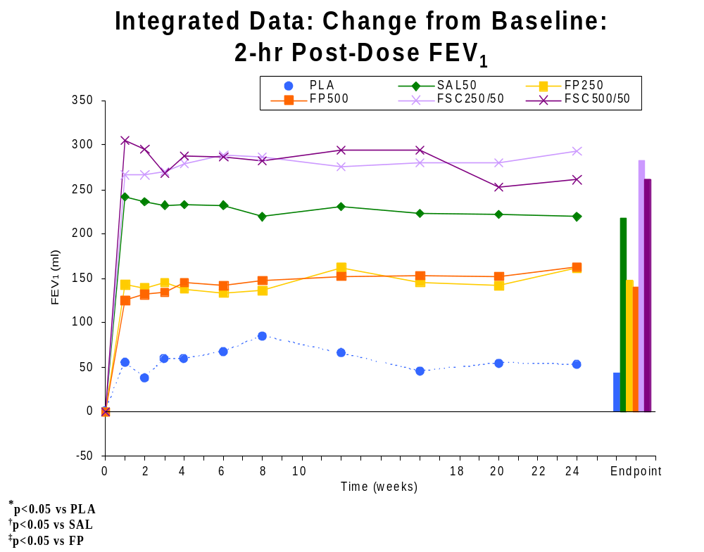

Key Secondary Efficacy Measures

Baseline/Transition Dyspnea Index (BDI/TDI)
Individual Studies
Key results for the BDI and TDI at Baseline and at Endpoint are shown in the table below.
Mean Baseline/Transition Dyspnea Index (BDI/TDI) - Total Score
 | PLA | SAL 50 | FP 250 | FP 500 | FSC 250/50 | FSC 500/50
SFCA3006
Baseline (BDI) | n=179 | n=154 |  | n=164 |  | n=160
Mean | 5.8 | 5.9 |  | 6.0 |  | 6.2
Endpoint (TDI) | n=172 | n=158 |  | n=161 |  | n=157
Mean | 0.4 | 0.9 |  | 1.3 |  | 2.1 ^{a c}
SFCA3007
Baseline (BDI) | n=183 | n=176 | n=179 |  | n=174
Mean | 5.7 | 6.1 | 6.2 |  | 6.1
Endpoint (TDI) | n=172 | n=169 | n=175 |  | n=172
Mean | 1.0 | 1.6 | 1.7 |  | 1.7 ^{c}
a. p<0.001 for FSC compared with SAL
c. p≤0.023 for FSC compared with PLA

The TDI score for treatment with FSC 500/50 was significantly greater than that for PLA (p<0.001, estimated difference = 1.7) and SAL 50 (p<0.001, estimated difference = 1.2). These estimated differences exceeded the criteria for clinical importance, predefined as a treatment difference >1.0 (Mahler, 1999; Witek & Mahler, 2001). There was also a trend for a higher TDI score compared with FP treatment (p=0.033, estimated difference = 0.7). The mean TDI score for treatment with FSC 500/50 was approximately equal to the sum of the TDI Scores with each individual component. The estimated difference in TDI Score between treatments with FSC 250/50 and PLA was 0.8 (p=0.023). Significant differences in TDI scores between FSC 500/50 and PLA were observed as early as Week 1 (p<0.001, estimated difference = 1.4) and at most time points during the 24 weeks of treatment.
Integrated Data
The integrated results support the efficacy of FSC 500/50 and provide positive evidence for FSC 250/50. At Endpoint, the estimated differences in TDI between FSC 500/50 and SAL 50, FP 500, and placebo were 1.1, 0.8, and 1.7, respectively, and were 0.1, 0.2, and 0.7 between FSC 250/50 and SAL 50, FP 250, and placebo, respectively.
Estimated differences between FSC 500/50 and placebo ranged from 0.7 to 1.9, from 0.2 to 1.4 between FSC 500/50 and SAL 50, and from 0.2 to 1.0 between FSC 500/50 and FP 500 across the treatment visits. While estimated differences between FSC 250/50 and its components were generally small, estimated differences between FSC 250/50 and placebo ranged from 0.3 to 1.1 across the treatment visits.
The greater increases over time in mean overall TDI score for the FSC groups compared with the PLA, SAL 50, and the FP groups are depicted in the following figure:
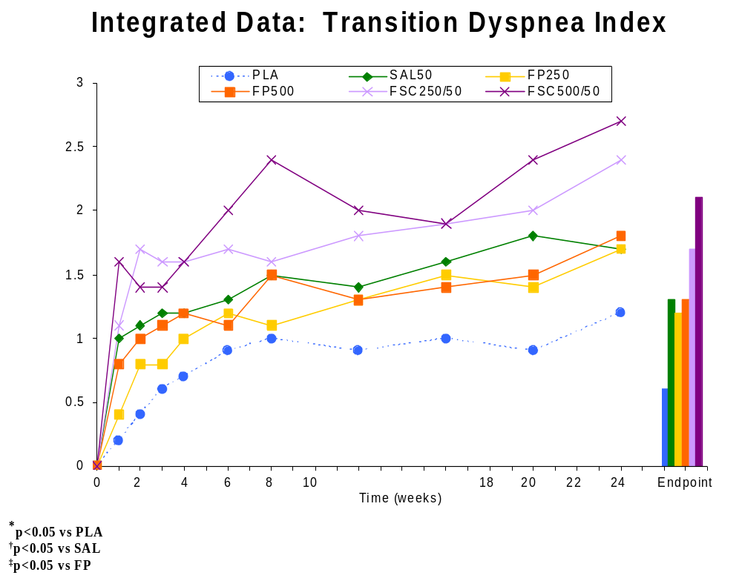

Chronic Respiratory Disease Questionnaire (CRDQ)
Individual Studies
The following table summarizes Baseline values and change from Baseline in CRDQ score for each group in the three clinical studies.
Summary of Mean Change from Baseline in CRDQ Score
 | PLA | SAL 50 | FP 250 | FP 500 | FSC  250/50 | FSC  500/50
SFCA3006
Baseline  Mean | n=177  86.2 | n=157  87.6 |  | n=166  88.5 |  | n=163  87.1
Endpoint  Mean  Mean Δ | n=175  91.3  5.0 | n=155  95.8  8.0 |  | n=163  93.5  4.8 |  | n=161  97.1  10.0 ^{b c}
SFCA3007
Baseline  Mean | n=180  84.8 | n=173  86.3 | n=177  85.5 |  | n=175  84.1
Endpoint  Mean  Mean Δ | n=178  89.6  5.0 | n=170  93.0  6.4 | n=170  96.4  10.4 |  | n=169  93.9  10.0 ^{c}
b. p=0.017 for FSC compared with FP
c. p≤0.007 for FSC compared with PLA

Treatment with both FSC 500/50 and FSC 250/50 resulted in clinically meaningful increases, i.e., ≥10.0, from Baseline in overall CRDQ score that were significantly greater compared with PLA (p≤0.007; estimated difference=5.3 and 5.2, respectively).
Integrated Data
The integrated data support the efficacy on mean increases from Baseline in overall CRDQ score for both FSC 500/50 and FSC 250/50 compared with PLA. At Endpoint, the estimated difference between FSC 500/50 and placebo was 6.5 with a 95% confidence interval of (3.0, 9.9), while the estimated difference between FSC 250/50 and placebo was 5.2 with a 95% confidence interval of (1.8, 8.6). Estimated differences between FSC and its components ranged from 0.8 to 3.1 at Endpoint with 95% confidence intervals containing zero. Estimated differences between FSC and PLA at each treatment visit were smaller than at Endpoint and ranged from 4.6 to 6.2 for FSC 500/50 and 2.0 to 4.0 for FSC 250/50.
The figure below illustrates the greater mean change in overall CRDQ score in the FSC groups compared with the FP, SAL, and PLA groups over time.
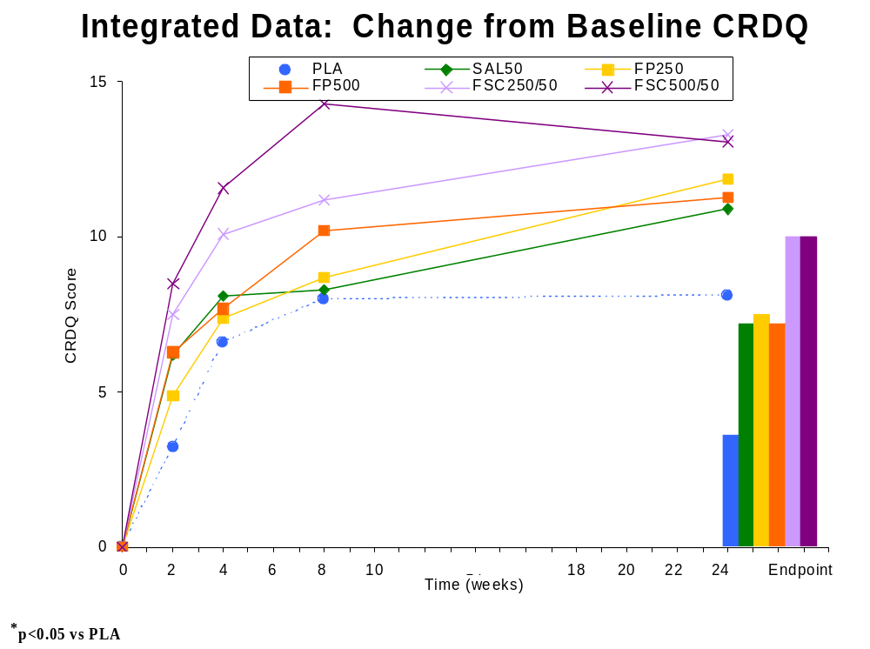

Chronic Bronchitis Symptom Questionnaire (CBSQ)
Individual Studies
The table below presents CBSQ Global Assessment Score (GAS) mean change from baseline for FSC compared with the individual components and PLA.
Mean Change from Baseline in CBSQ GAS
 | PLA | SAL 50 | FP 250 | FP 500 | FSC 250/50 | FSC 500/50
SFCA3006
Baseline | n=180 | n=159 |  | n=167 |  | n=164
Mean | 7.3 | 7.4 |  | 7.0 |  | 6.9
Endpoint | n=172 | n=158 |  | n=161 |  | n=157
Mean | 5.7 | 5.5 |  | 5.5 |  | 5.1
Mean Change | 1.5 | 1.9 |  | 1.6 |  | 1.8 ^{c}
SFCA3007
Baseline | n=185 | n=177 | n=183 |  | n=178
Mean | 7.5 | 7.0 | 7.4 |  | 7.3
Endpoint | n=172 | n=169 | n=175 |  | n=172
Mean | 6.1 | 5.6 | 5.2 |  | 5.2
Mean Change | 1.4 | 1.5 | 2.2 |  | 2.1 ^{c}
c. p≤0.047 for FSC compared with PLA

In both SFCA3006 and SFCA3007, the CBSQ GAS was not statistically different between the FSC treatment groups and the individual components and there were only small, but statistically significant, differences noted between FSC and PLA.
Integrated Data
The integrated data provide an estimated difference of 0.6 between FSC 500/50 and placebo and between FSC 250/50 and placebo at Endpoint on the change from Baseline in the CBSQ GAS. Estimated differences from placebo ranged from 0.3 to 1.0 for FSC 500/50 and 0.5 to 1.0 for FSC 250/50 across the treatment visits. Estimated differences between FSC and its components were generally small and ranged from 0.0 to 0.3 at Endpoint.

Other Secondary Efficacy Measures

Incidence of COPD Exacerbations
Individual Studies
The following table summarizes the results for COPD exacerbations of moderate to severe intensity.
Incidence (%) of Moderate or Severe COPD Exacerbation
Number of  Exacerbations | PLA | SAL 50 | FP 250 | FP 500 | FSC 250/50 | FSC 500/50
SFCA3006 | N=181 | N=160 |  | N=168 |  | N=165
None | 65 | 63 |  | 60 |  | 63
At least One | 35 | 38 |  | 40 |  | 37
1 | 27 | 29 |  | 32 |  | 27
2 | 7 | 8 |  | 7 |  | 8
3 | 1 | 1 |  | 1 |  | <1
≥4 | <1 | 0 |  | 0 |  | 1
SFCA3007 | N=185 | N=177 | N=183 |  | N=178
None | 66 | 69 | 62 |  | 66
At Least One | 34 | 31 | 38 |  | 34
1 | 26 | 25 | 30 |  | 28
2 | 6 | 5 | 8 |  | 6
3 | 1 | <1 | 0 |  | <1
≥4 | <1 | 0 | 0 |  | 0

In both SFCA3006 and SFCA3007, the incidence of moderate or severe COPD exacerbation in the FSC group was similar to the incidence in the SAL, FP, and PLA groups.
Integrated Data
As seen with individual study results, the incidence of moderate or severe COPD exacerbation with integrated data was comparable between each FSC group and the SAL, FP, and PLA groups.

Time-to-Event Analyses
Survival analyses were also performed to evaluate potential treatment group differences in time to first COPD exacerbation and study withdraw for exacerbations of any intensity or moderate/severe COPD exacerbations. No significant differences between FSC and its components were observed in the individual studies or integrated data, although using the integrated data, a difference between FSC 500/50 and placebo was significant for time to withdrawal due to a COPD-related condition (defined as COPD exacerbation or lack of efficacy), and differences between FSC 250/50 and placebo were significant for time to first COPD exacerbation of any severity, time to withdrawal, and time to withdrawal due to a COPD-related condition.

Morning PEF
Individual Studies
The table below summarizes the Baseline values and the Overall mean change from Baseline for AM PEF for the three clinical studies.
Mean Change from Baseline in AM PEF (L/min): Overall PEF
 | PLA | SAL 50 | FP 250 | FP 500 | FSC 250/50 | FSC 500/50
SFCA3006
Baseline | n=181 | n=158 |  | n=167 |  | n=162
Mean | 269.5 | 252.1 |  | 243.7 |  | 254.0 ^{f}
Overall | n=179 | n=157 |  | n=166 |  | n=162
Mean | 267.1 | 268.7 |  | 256.6 |  | 284.7
Mean Change | -2.7 | 16.8 |  | 12.9 |  | 31.9 ^{a b c}
SFCA3007
Baseline | n=184 | n=176 | n=182 |  | n=175
Mean | 220.3 | 210.3 | 220.0 |  | 206.1
Overall^{b} | n=183 | n=174 | n=177 |  | n=173
Mean | 220.2 | 225.3 | 230.7 |  | 236.3
Mean Change | 0.8 | 14.7 | 11.3 |  | 30.6 ^{a b c}
a. p<0.001 for FSC compared with SAL
b. p<0.001 for FSC compared with FP
c. p<0.001 for FSC compared with PLA

Treatment with both FSC 500/50 and FSC 250/50 resulted in significantly greater mean change from Baseline in Overall AM PEF compared with treatments with SAL, FP and PLA. In each study, the mean changes from Baseline in Overall AM PEF with FSC treatment were greater than the sum of the mean changes from Baseline observed with the SAL and FP treatments.
Integrated Data
The integrated results for the change from Baseline in Overall AM PEF and for the change from Baseline at each treatment month support the efficacy demonstrated in the individual studies. The estimated differences in the mean change from Baseline in Overall AM PEF between FSC 500/50 and SAL 50, FP 500, and placebo were 15.6L/min, 19.5L/min, and 32.0L/min, respectively, and were 13.9L/min, 18.9L/min, and 30.3L/min between FSC 250/50 and SAL 50, FP 250, and placebo, respectively.
The estimated differences between FSC 500/50 and SAL 50 ranged from 11.5L/min to 18.9L/min, from 13.9L/min to 23.2L/min between FSC 500/50 and FP 500, and from 27.2L/min to 33.9L/min between FSC 500/50 and placebo across the 6 monthly average changes from Baseline in AM PEF. For FSC 250/50, the estimated differences from SAL 50 ranged from 11.0L/min to 17.9L/min, from 18.4L/min to 22.4L/min between FSC 250/50 and FP 250, and from 28.2L/min to 32.5L/min between FSC 250/50 and placebo across the 6 monthly average changes from Baseline in AM PEF.
The figure below illustrates the greater increases in AM PEF with FSC 250/50 and FSC 500/50 treatments compared with the SAL 50, FP 250, and FP 500 treatments and compared with PLA throughout the study period.
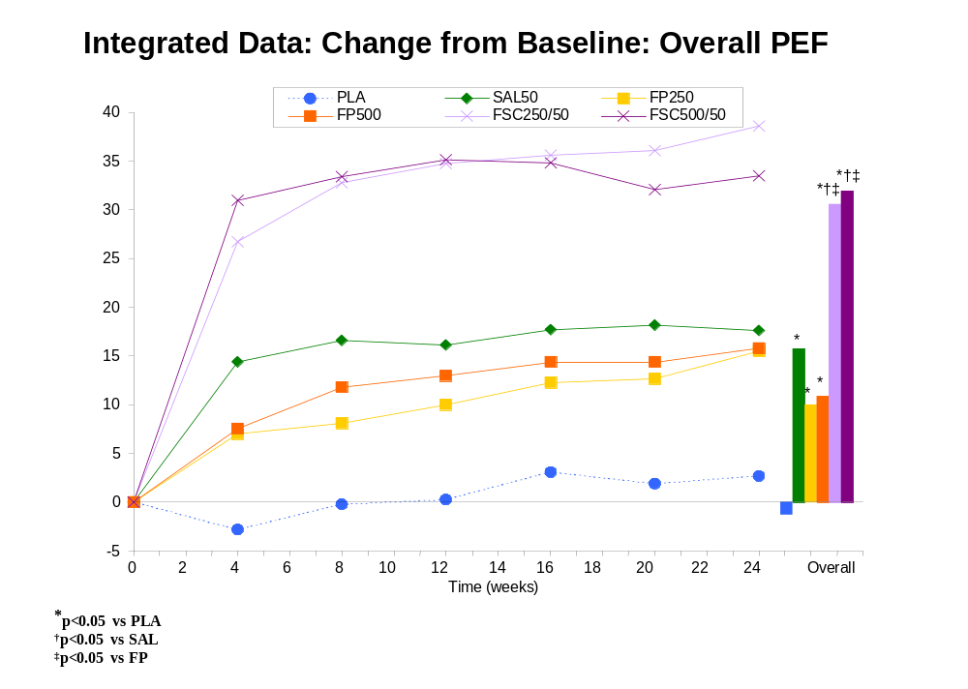

Daily VENTOLIN Use
Individual Studies
The following table summarizes Baseline values and change from Baseline in Overall VENTOLIN use in SFCA3006 and SFCA3007.
Mean Change from Baseline in Overall Daily VENTOLIN Use
(Number of Puffs of VENTOLIN Used per Day)
 | PLA | SAL 50 | FP 250 | FP 500 | FSC 250/50 | FSC 500/50
SFCA3006
Baseline | n=181 | n=158 |  | n=166 |  | n=161
Mean | 4.9 | 4.6 |  | 4.5 |  | 4.2
Overall | n=179 | n=157 |  | n=164 |  | n=161
Mean | 5.4 | 3.6 |  | 4.1 |  | 3.0
Mean Change | 0.5 | -0.9 |  | -0.4 |  | -1.2 ^{b c}
SFCA3007
Baseline | n=184 | n=176 | n=181 |  | n=174
Mean | 4.8 | 4.6 | 4.6 |  | 5.1
Overall | n=182 | n=174 | n=177 |  | n=172
Mean | 5.0 | 3.9 | 4.4 |  | 4.1
Mean Change | 0.1 | -0.7 | -0.2 |  | -1.0 ^{b c}
b. p≤ 0.036 for FSC compared with FP
c. p≤0.002 for FSC compared with PLA

The mean decrease in Overall VENTOLIN use was significantly greater for treatment with both FSC 500/50 and FSC 250/50 compared with PLA and FP.
Integrated Data
Results from the integrated data support the efficacy for both FSC 500/50 and FSC 250/50 in the mean change from Baseline in daily VENTOLIN use. Overall daily VENTOLIN use was less for treatments with FSC 500/50 and FSC 250/50 (mean changes from Baseline of -1.2 and -1.0 puffs per day, respectively) compared with PLA (mean change from Baseline of 0.5 puffs per day) and FP (mean changes from Baseline of -0.3 and -0.2 puffs per day) (p<0.001). Differences from the SAL 50 group (mean Overall change from Baseline of -0.8 puffs per day) were small. There were also reductions from Baseline in VENTOLIN use for each month of treatment with both FSC 500/50 and FSC 250/50 compared with placebo and FP (p≤0.011).

Nighttime Awakenings Requiring VENTOLIN
individual Studies
The following table summarizes Baseline values and change from Baseline in number of awakenings per night requiring VENTOLIN use in SFCA3006 and SFCA3007.
Summary of Mean Change from Baseline in Overall
Number of Awakenings per Night Requiring VENTOLIN Use
 | PLA | SAL 50 | FP 250 | FP 500 | FSC 250/50 | FSC 500/50
SFCA3006
Baseline | n=177 | n=156 |  | n=163 |  | n=157
Mean | 0.27 | 0.26 |  | 0.24 |  | 0.22
Overall | n=175 | n=153 |  | n=162 |  | n=157
Mean | 0.36 | 0.17 |  | 0.16 |  | 0.19
Mean Change | 0.10 | -0.09 |  | -0.08 |  | -0.04 ^{c}
SFCA3007
Baseline | n=184 | n=175 | n=181 |  | n=174
Mean | 0.23 | 0.20 | 0.24 |  | 0.24
Overall | n=181 | n=174 | n=177 |  | n=172
Mean | 0.25 | 0.14 | 0.20 |  | 0.12
Mean Change | 0.02 | -0.06 | -0.03 |  | -0.12 ^{c}
c. p<0.001 for FSC compared with PLA

The mean number of nighttime awakenings was significantly decreased with both FSC 500/50 and FSC 250/50 treatment compared with PLA.
Integrated Data
Results from the integrated data support the efficacy for both FSC 500/50 and FSC 250/50 on nighttime awakenings requiring VENTOLIN compared to placebo. The FSC 500/50 and FSC 250/50 groups had fewer Overall nighttime awakenings requiring VENTOLIN use (mean change from Baseline of -0.04 and –0.12 awakenings per night, respectively) compared with the PLA group (mean change from Baseline of +0.08 awakenings per night) (p<0.001). Notable differences from the individual components were generally not observed (the exception being FSC 250/50 versus FP 250).

Onset and Duration of Effect

FP 250 and FP 500
Although there was no formal a priori definition for the onset of effect for FP, the positive effect on mean change from Baseline in pre-dose FEV₁ at Week 1 in SFCA3006, SFCA3007, and FLTA3025 was indicative of an early onset of effect for FP. At Week 1, the integrated data for the FP 250 and FP 500 treatments show increases in pre-dose FEV₁ of 57 and 63mL, respectively. The estimated differences from PLA for FP 250 and FP 500 were 53 and 61mL with 95% confidence intervals of (28, 77mL) and (36, 85mL), respectively.

FSC 500/50 and SAL 50
In order to assess the onset and duration of effect of FSC and of SAL in the COPD population, 12-hour serial FEV₁ was performed in a subset of subjects (n=341) in SFCA3006. The purpose of these measurements was to demonstrate that SAL-induced increases in FEV₁ were sustained for 12 hours with the powder formulations of FSC and SAL in patients with COPD.
On Day 1, the increase in FEV₁ was ≥100mL in less than 30 minutes after treatment with both FSC 500/50 and SAL 50. At the end of the 12 hours, subjects treated with either FSC 500/50 or SAL 50 continued to have improvements from Baseline of 180mL and 145mL, respectively, as seen in the figure below.
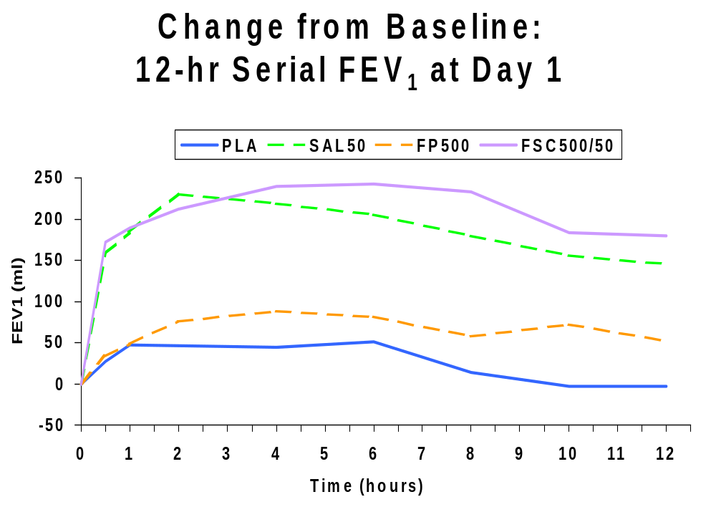
At Week 12, the mean pre-dose FEV₁ values for FSC 500/50, SAL 50 and FP 500 were greater than Day 1 baseline by 177, 120, and 77mL, respectively. At the end of the 12 hours, subjects treated with either FSC 500/50 or SAL 50 continued to have improvements from baseline of 184mL and 157mL, respectively, as seen in the figure below.
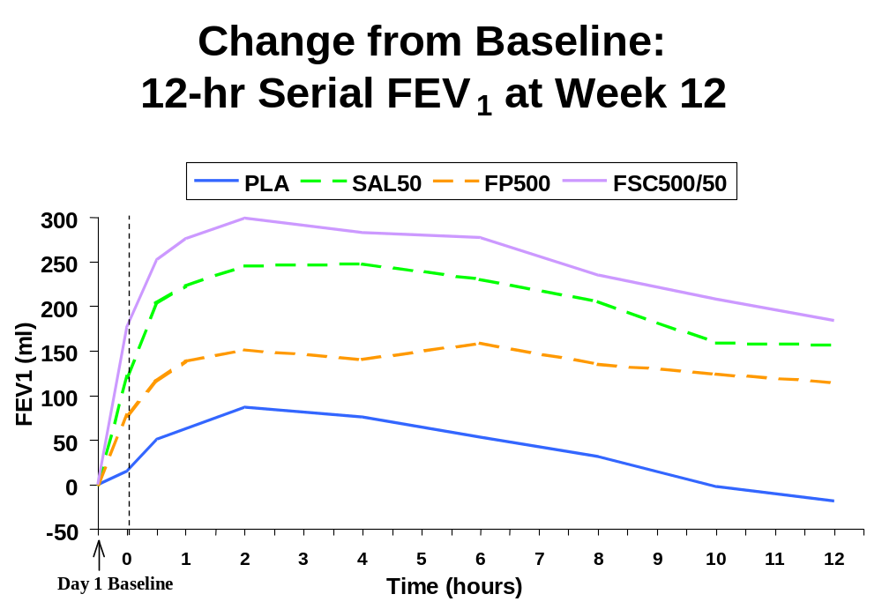

Efficacy in Population Subgroups
Efficacy results were evaluated for the following population subgroups: smoking status (current smokers, former smokers), bronchodilator response (reversible, non-reversible), ICS use (yes, no), gender (male, female), age (40-64 years, >65 years, >75 years), and ethnic origin (white, black, other). There were too few subjects in the nonWhite (Black or Other) and ≥75 years of age subgroups to determine a response to treatment. In all other population subgroups, subjects responded to treatment with FSC, SAL, and FP, although the magnitude of response sometimes differed between subgroups. Results for smoking status and bronchodilator response subgroups have been selected for presentation below since differences were seen in the magnitude of response between the two subgroups, though the trends were consistent with the results seen in all subjects (FSC > FP or SAL > PLA).

Smoking Status
Subjects were required to have >20–pack year history of smoking for study enrollment. Former smokers had discontinued cigarette smoking for at least 6 months prior to their Screening Visit. Current smokers were smoking at Screening and continued to smoke throughout the study. The major findings of this subgroup analysis are as follows:
- Compared with current smokers, former smokers were generally older, had a higher proportion of males, used more inhaled corticosteroids at the Screening Visit, and had lower percent predicted FEV₁.
- Improvements were observed in most efficacy measures for both former and current smokers treated with both FP and FSC compared with placebo. Improvements were greater for subjects treated with FSC compared with individual components or placebo.
- For mean change from Baseline in pre-dose FEV₁, all active treatment groups with an FP component had larger magnitudes of response relative to placebo within the former smoker subgroup compared with the current smoker subgroup.
- For mean change from Baseline in post-dose FEV₁, the magnitude of response between the active treatment groups and placebo for former and current smokers was similar.

Bronchodilator Response
Bronchodilator response subgroups were based on spirometric response after inhaling 4 puffs of VENTOLIN at Screening. Subjects were categorized as reversible if they demonstrated a bronchodilator response (post VENTOLIN) of >200mL and >12% improvement in FEV₁ over baseline. Subjects were categorized as non-reversible if they demonstrated a bronchodilator response (post VENTOLIN) that was either <200mL or <12% improvement in FEV₁ over baseline. The major findings of this subgroup analysis are as follows:
- Compared with non-reversible subjects, reversible subjects were generally slightly younger and had a higher proportion of males.
- Improvements were observed in most efficacy measures for both reversible and non-reversible subjects treated with both FP and FSC compared with placebo. Improvements were greater for subjects treated with FSC compared with individual components or placebo.
- All active treatments groups in the reversible subgroup had a larger magnitude of response relative to placebo compared with the non-reversible subgroup for both pre-dose FEV₁ and post-dose FEV₁, however trends were consistent with that seen in all subjects (FSC >FP or SAL >PLA).

Summary of Efficacy

FP 250 and FP 500

Primary Efficacy Measure
Pre-Dose FEV₁. In all three studies, treatment with FP was associated with greater improvements in pre-dose FEV₁ compared with placebo. The estimated difference in pre-dose FEV₁ was significantly greater for FP 500 in SFCA3006 (105mL) and FP 250 in SFCA3007 (112mL) compared with placebo. In FLTA3025, a dose-related improvement in pre-dose FEV₁ was seen as FP 500 had a significantly greater improvement than placebo (estimated difference = 57mL) while FP 250 did not (estimated difference = 32mL). When data were integrated, the estimated differences from placebo for FP 250 and FP 500 were 73mL and 85mL, respectively with 95% confidence intervals of (41mL, 105mL) and (53mL, 118mL), respectively.

Key Secondary Efficacy Measures
TDI. A numerical dose response in TDI scores was demonstrated between FP 250 and FP 500. In SFCA3006 and FLTA3025, treatment with FP 500 resulted in significantly greater improvements in TDI scores when compared with PLA at Week 1 and throughout treatment; estimated differences at Endpoint = 1.1 and 0.8, respectively. No significant differences were observed for treatment with FP 250 in SFCA3007 or FLTA3025 at Endpoint.
CRDQ. In FLTA3025, increases in overall CRDQ score at Endpoint were significantly greater for both FP 250 (5.1) and FP 500 (9.1) compared with PLA (1.0) and approached the clinically meaningful threshold (≥10) in the FP 500 group. In SFCA3007, increases in FP 250 (10.4) were clinically meaningful and significantly greater compared with PLA (5.0). In SFCA3006, increases in FP 500 (4.8) were similar to increases in PLA (5.0).
CBSQ GAS. In SFCA3007, a significant difference was observed at Endpoint for treatment with FP 250 compared with PLA (estimated difference = 0.8). No other treatment differences of consequence were observed in the individual studies. These results indicate that this new instrument may not be sensitive for discerning treatment effects.

Other Secondary Efficacy Measures
Incidence of COPD Exacerbation. The incidence of COPD exacerbation (any intensity) was comparable between the FP and PLA groups in the three individual studies.
AM PEF. Increases in morning PEF for treatment with FP 250 and FP 500 were significantly greater compared with PLA in all the individual studies.
Daily VENTOLIN Use. In SFCA3006 and FLTA3025, treatment with FP 500 resulted in significantly less Overall daily VENTOLIN use when compared with PLA; the difference from PLA was only significant for FP 250 in FLTA3025.
Nighttime Awakenings Requiring VENTOLIN Use. In the three individual studies, treatment with FP 250 and FP 500 demonstrated significantly fewer awakenings per night compared with an increase with PLA.

FSC 250/50 and FSC 500/50

Primary Efficacy Measures
Pre-Dose FEV₁. Treatment with FSC 250/50 and FSC 500/50 resulted in significantly greater improvements in pre-dose FEV₁ when compared with SAL 50 at Endpoint; estimated differences = 69 and 67mL, respectively. The estimated differences at Endpoint for treatment with FSC 250/50 and FSC 500/50 compared with PLA were 161 and 159mL, respectively. When data were integrated, the estimated differences at Endpoint for treatment with FSC 250/50 and FSC 500/50 compared with SAL 50 were 66 and 71mL, respectively, with 95% confidence intervals of (19mL, 113mL) and (23mL, 119mL), respectively.
Post-Dose FEV₁. Treatment with FSC 250/50 and FSC 500/50 resulted in significantly greater improvements in post-dose FEV₁ when compared with FP 250 and FP 500 at Day 1 and throughout treatment; estimated differences at Endpoint = 124 and 129mL, respectively. The estimated differences at Endpoint for treatment with FSC 250/50 and FSC 500/50 compared with PLA were 214 and 231mL, respectively. Integrated data supported the greater increases in each FSC group compared with the corresponding strength of FP and with the placebo group.

Key Secondary Efficacy Measures
TDI. Treatment with both FSC 250/50 and FSC 500/50 resulted in dose-related improvement in mean TDI scores at Endpoint that were significantly greater compared with PLA, estimated differences = 0.8 and 1.7, respectively. Treatment with FSC 500/50 also demonstrated a significantly higher mean TDI score at Endpoint compared with SAL 50 (estimated difference = 1.2) and numerically greater compared with FP (estimated difference = 0.7).
CRDQ. Treatment with both FSC 500/50 and FSC 250/50 resulted in clinically meaningful increases (i.e., ≥10.0), from Baseline in overall CRDQ score that were significantly greater compared with PLA.
CBSQ GAS. Treatment with both FSC 250/50 and FSC 500/50 demonstrated significantly greater mean change from Baseline at Endpoint in GAS compared with PLA, estimated differences = 0.6 and 0.7, respectively. No other treatment differences of consequence were observed in the individual studies.

Other Secondary Efficacy Measures
Incidence of COPD Exacerbation. The incidence of COPD exacerbations (any intensity or moderate/severe) for treatment with FSC was similar to the incidence with SAL, FP, and PLA.
AM PEF. Treatment with FSC 500/50 resulted in a significant mean increase in Overall AM PEF of 31.9L/min compared with mean increases of 16.8L/min and 12.9L/min for SAL 50 and FP 500, respectively, and compared with a mean decrease (-2.7L/min) in the PLA group. Treatment with FSC 250/50 resulted in a significant mean increase in Overall AM PEF of 30.6L/min compared with mean increases of 14.7L/min and 11.3L/min for SAL 50 and FP 250, respectively, and compared with a slight increase (0.8L/min) in the PLA group.
Daily VENTOLIN Use. Significantly less Overall VENTOLIN use was observed for treatment with FSC 250/50 and FSC 500/50 compared with PLA and compared with FP 250 and FP 500, respectively. Mean changes from Baseline in Overall VENTOLIN use were –1.0 and –1.2 puffs per day for FSC 250/50 and FSC 500/50, respectively.
Nighttime Awakenings Requiring VENTOLIN Use. The FSC 250/50 and FSC 500/50 groups had significantly fewer Overall nighttime awakenings requiring VENTOLIN use compared with PLA. Overall mean changes from Baseline were -0.12 and -0.04 awakenings per night for the FSC 250/50 and FSC 500/50 groups compared with increases of 0.02 and 0.10 awakenings per night with PLA, respectively.

Onset and Duration of Effect
- Efficacy for both FP 250 and FP 500 was observed as early as Week 1. At Week 1, the estimated differences from PLA for FP 250 and FP 500 were 53 and 61mL.
- The bronchodilating effects of FSC 500/50 and SAL 50 were observed at Day 1, indicating an early onset of effect. Twice-daily dosing was supported by the maintenance of the effect for 12 hours.
- No tolerance to the bronchodilator effect was observed over 24 weeks of treatment.

Safety Results

Introduction and Data Organization
The safety of SAL, FP and FSC DISKUS has been evaluated in a total of 2054 COPD subjects who were randomized and received at least one dose of study medication in the US controlled studies SFCA3006, SFCA3007 and FLTA3025. In this section, results in ITT Population are presented for the three individual studies and the integrated database. Data from Investigator 1403 in SFCA3006 was excluded from all efficacy analyses as there was reason to believe the integrity of these data may have been compromised. However, these subjects are included in the safety analyses accounting for the difference in subject numbers between the efficacy and safety results.
Safety information is reported in the following manner:
- Extent of Exposure: Section 6.2.
- Adverse Event Experience in Clinical Trials (Section 6.3): This section describes adverse events, adverse events of special interest, withdrawals due to adverse events and deaths, and serious adverse events.
- Clinical Laboratory Tests: Section 6.4.
- Summary of Other Safety Assessments (Section 6.5): This section includes electrocardiograms, 24-hour Holter monitoring, HPA axis effects, and safety in demographic subgroups.
- Summary of Safety from Clinical Trials: Section 6.6.

Extent of Exposure
The mean extent of exposure was higher for the active drug treatment groups compared with the placebo group. The table below presents exposure to study medication for the 2054 subjects in the ITT Population. This difference in exposure needs to be considered when interpreting the adverse events data since subjects with longer duration of study participation are more likely to experience adverse events than subjects with shorter duration of study participation.
Extent of Exposure to Study Medication: n (%)
(ITT Population from SFCA3006, SFCA3007 and FLTA3025 Integrated)
Subject Exposure | PLA  N=576 | SAL 50  N=341 | FP 250  N=399 | FP 500  N=391 | FSC  250/50  N=178 | FSC  500/50  N=169
Number of Weeks
0 to <4 weeks | 78 (14) | 34 (10) | 35 (9) | 36 (9) | 15 (8) | 16 (9)
4 to <8 weeks | 36 (6) | 17 (5) | 27 (7) | 27 (7) | 5 (3) | 10 (6)
8 to <12 weeks | 26 (5) | 18 (5) | 21 (5) | 24 (6) | 10 (6) | 6 (4)
12 to <16 weeks | 33 (6) | 7 (2) | 15 (4) | 28 (7) | 7 (4) | 5 (3)
16 to <20 weeks | 24 (4) | 13 (4) | 21 (5) | 19 (5) | 10 (6) | 9 (5)
20 to <24 weeks | 64 (11) | 35 (10) | 59 (15) | 38 (10) | 19 (11) | 23 (14)
≥24 weeks | 315 (55) | 217 (64) | 221 (55) | 219 (56) | 112 (63) | 100 (59)
Treatment Days
Mean | 128.9 | 138.5 | 135.6 | 131.9 | 141.3 | 137.8
Range | 1-188 | 1-189 | 1-227 | 1-192 | 1-186 | 2-191

Adverse Event Experience in Clinical Trials

Introduction
Adverse event information was obtained at each clinic visit by being spontaneously volunteered by the subject and by asking the subject general questions about medical problems and concomitant medications. Diary cards were reviewed at each visit for possible AEs. If the subject did not mention an event that was recorded, he/she was questioned for further information in order to determine if an AE occurred.
An AE was defined as any untoward medical occurrence experienced by a subject administered a pharmaceutical product that did not necessarily have a causal relationship with this treatment. Any COPD-related signs and/or symptoms (including COPD exacerbation) that caused a subject to withdraw from the study (and did not meet the definition of serious) were not considered AEs because they were symptoms of the disease being studied. However, if a COPD exacerbation did meet the definition of serious, as defined by 21 CFR 312.32, it was counted as a serious adverse event (SAE).
Without knowledge of treatment assignment of the subject, the Investigator assessed the causality of the adverse event as “yes” (there was a reasonable possibility that the adverse event may have been caused by the trial medication) or “no” (there was not a reasonable possibility).

Incidence of Adverse Events
The majority of subjects reported at least one AE. The body system with the highest incidence of AEs was ear, nose and throat.
Upper respiratory tract infection and headaches were the most commonly reported AEs. Throat irritation, candidiasis mouth/throat, and hoarseness/dysphonia, all well-documented side effects of inhaled corticosteroids, occurred with a higher incidence in treatments that contained FP as compared with the placebo or SAL 50 groups. AEs (regardless of causality) that occurred with ≥3% incidence in any treatment group are summarized in the following table.
Summary of Most Common AEs Regardless of Causal Relationship (≥ 3% incidence): n (%)
(ITT Population from SFCA3006, SFCA3007 and FLTA3025 Integrated)
Adverse Event | PLA  N=576 |  | SAL 50  N=341 |  | FP 250  N=399 |  | FP 500  N=391 |  | FSC  250/50  N=178 |  | FSC  500/50  N=169
ANY EVENT |  | 397 (69) |  | 233 (68) |  | 294 (74) |  | 312 (80) |  | 124 (70) |  | 131 (78)
URTI |  | 85 (15) |  | 36 (11) |  | 63 (16) |  | 70 (18) |  | 22 (12) |  | 28 (17)
Headaches |  | 66 (11) |  | 47 (14) |  | 51 (13) |  | 65 (17) |  | 28 (16) |  | 30 (18)
Musculoskeletal pain |  | 58 (10) |  | 42 (12) |  | 41 (10) |  | 35 (9) |  | 16 (9) |  | 20 (12)
Throat irritation |  | 36 (6) |  | 24 (7) |  | 35 (9) |  | 36 (9) |  | 15 (8) |  | 19 (11)
Viral respiratory infections |  | 23 (4) |  | 17 (5) |  | 20 (5) |  | 36 (9) |  | 10 (6) |  | 14 (8)
URI |  | 29 (5) |  | 17 (5) |  | 21 (5) |  | 26 (7) |  | 4 (2) |  | 15 (9)
Candidiasis mouth/throat |  | 4 (<1) |  | 6 (2) |  | 23 (6) |  | 46 (12) |  | 17 (10) |  | 12 (7)
Nasal congestion/ blockage |  | 19 (3) |  | 12 (4) |  | 17 (4) |  | 26 (7) |  | 5 (3) |  | 7 (4)
Cough |  | 24 (4) |  | 17 (5) |  | 18 (5) |  | 15 (4) |  | 2 (1) |  | 6 (4)
Sinusitis |  | 13 (2) |  | 15 (4) |  | 22 (6) |  | 12 (3) |  | 6 (3) |  | 5 (3)
Nausea & vomiting |  | 18 (3) |  | 11 (3) |  | 16 (4) |  | 16 (4) |  | 4 (2) |  | 6 (4)
Diarrhea |  | 28 (5) |  | 11 (3) |  | 12 (3) |  | 12 (3) |  | 3 (2) |  | 4 (2)
Chest symptoms |  | 24 (4) |  | 12 (4) |  | 9 (2) |  | 15 (4) |  | 4 (2) |  | 6 (4)
Hoarseness/dysphonia |  | 6 (1) |  | 2 (<1) |  | 18 (5) |  | 19 (5) |  | 9 (5) |  | 5 (3)
Fever |  | 18 (3) |  | 4 (1) |  | 12 (3) |  | 11 (3) |  | 8 (4) |  | 6 (4)
Malaise & fatigue |  | 17 (3) |  | 7 (2) |  | 11 (3) |  | 12 (3) |  | 6 (3) |  | 6 (4)
Muscle cramps & spasms |  | 7 (1) |  | 10 (3) |  | 9 (2) |  | 8 (2) |  | 6 (3) |  | 13 (8)
Rhinitis |  | 14 (2) |  | 12 (4) |  | 11 (3) |  | 8 (2) |  | 4 (2) |  | 3 (2)
Dizziness |  | 10 (2) |  | 12 (4) |  | 7 (2) |  | 7 (2) |  | 7 (4) |  | 5 (3)
Hypertension |  | 11 (2) |  | 12 (4) |  | 5 (1) |  | 9 (2) |  | 4 (2) |  | 5 (3)
Sinusitis/sinus infection |  | 11 (2) |  | 5 (1) |  | 8 (2) |  | 7 (2) |  | 3 (2) |  | 7 (4)
Muscle pain |  | 5 (<1) |  | 4 (1) |  | 7 (2) |  | 13 (3) |  | 0 |  | 7 (4)
Ear signs & symptoms |  | 6 (1) |  | 11 (3) |  | 6 (2) |  | 4 (1) |  | 4 (2) |  | 4 (2)
Note: Most common defined as incidence ≥3% (before rounding) in any treatment group
URTI = Upper respiratory tract infection; URI = upper respiratory inflammation
Viral respiratory infections was the preferred term for flu or flu symptoms; URI includes all AEs of ‘cold symptoms’
The preferred term “chest symptoms” includes chest pain, chest tightness, and anxiety chest pains.

Adverse Events of Special Interest
For subjects using inhaled corticosteroids, AEs of special interest include candida infection, hoarseness/dysphonia, throat irritation, evidence of bone loss, cataracts, glaucoma, and HPA axis suppression. A summary of the AEs of special interest (with the exception of HPA axis suppression; see Section 6.5.2) is provided in the following table.
AEs of Special Interest: n (%)
(ITT Population from SFCA3006, SFCA3007 and FLTA3025 Integrated)
Adverse Event | PLA  N=576 | SAL 50  N=341 | FP 250  N=399 | FP 500  N=391 | FSC  250/50  N=178 | FSC  500/50  N=169
Candidiasis | 6 (1) | 8 (2) | 29 (7) | 50 (13) | 20 (11) | 18 (11)
Throat irritation | 36 (6) | 24 (7) | 35 (9) | 36 (9) | 15 (8) | 19 (11)
Hoarseness/dysphonia | 6 (1) | 2 (<1) | 18 (5) | 19 (5) | 9 (5) | 5 (3)
Fractures | 9 (2) | 1 (<1) | 4 (1) | 4 (1) | 3 (2) | 3 (2)
Cataracts | 1 (<1) | 0 | 0 | 3 (<1) | 0 | 0
Ocular pressure disorders | 2 (<1) | 0 | 0 | 0 | 0 | 2 (1)
Note: Candidiasis includes candidiasis (mouth/throat), candidiasis unspecified, and unspecified oropharyngeal plaques

As expected, a higher incidence of total candidiasis (includes candidiasis [mouth/throat], candidiasis unspecified, and unspecified oropharyngeal plaques) occurred in the treatment groups receiving FP compared with subjects receiving placebo or SAL.
Throat irritation and hoarseness/dysphonia, well-documented side effects of inhaled corticosteroids, also occurred with a slightly higher incidence in the FP and/or FSC groups compared with the placebo or SAL 50 groups.
Few fractures were reported during the study and the incidence was comparable across the treatment groups. As expected for a 6-month trial, none of the fractures were considered treatment related.
Cataracts were reported by one subject (adverse event: bilateral cataracts) in the placebo group and three subjects (adverse events: worsening cataracts; cataract exacerbation; cataract right eye) in the FP 500 group. All three FP-treated subjects had cataracts listed as a concurrent medical condition at Screening. Ocular pressure disorders were noted in two subjects each in the placebo (adverse events: glaucoma; elevated intraocular pressure) and FSC 500/50 (adverse events: pigment dispersion syndrome; glaucoma) groups.

Withdrawals Due to Adverse Events
A total of 136 subjects (7%) were withdrawn due to AEs. With the exception of FP 500, a comparable incidence of AEs resulting in withdrawal were noted across the treatment groups.
COPD exacerbation was the most common AE leading to withdrawal. No other AE led to withdrawal in >1% of subjects. AEs that led to withdrawal in more than two subjects across the treatment groups are summarized in the following table.
Most Common AEs Leading to Study Withdrawal: n (%)
(ITT Population from SFCA3006, SFCA3007 and FLTA3025 Integrated)
AE Leading to Study Withdrawal | PLA  N=576 | SAL 50  N=341 | FP 250  N=399 | FP 500  N=391 | FSC  250/50  N=178 | FSC  500/50  N=169
ANY EVENT | 36 (6) | 15 (4) | 23 (6) | 42 (11) | 9 (5) | 11 (7)
COPD exacerbation | 8 (1) | 4 (1) | 8 (2) | 10 (3) | 0 | 2 (1)
Pneumonia | 1 (<1) | 1 (<1) | 4 (1) | 4 (1) | 0 | 2 (1)
Depressive disorders | 3 (<1) | 0 | 0 | 2 (<1) | 0 | 0
Hoarseness/dysphonia | 1 (<1) | 0 | 0 | 3 (<1) | 1 (<1) | 0
Fractures | 0 | 1 (<1) | 1 (<1) | 1 (<1) | 2 (1) | 0
Breathing disorders | 2 (<1) | 0 | 0 | 1 (<1) | 0 | 1 (<1)
URTI | 0 | 1 (<1) | 1 (<1) | 2 (<1) | 0 | 0
Candidiasis mouth/throat | 0 | 0 | 0 | 3 (<1) | 0 | 0
Viral respiratory infections | 0 | 0 | 1 (<1) | 1 (<1) | 1 (<1) | 0
Cardiovascular test findings | 2 (<1) | 1 (<1) | 0 | 0 | 0 | 0
Cerebrovascular accidents | 0 | 1 (<1) | 1 (<1) | 1 (<1) | 0 | 0
Myocardial infarction | 1 (<1) | 0 | 1 (<1) | 1 (<1) | 0 | 0
Palpitations | 2 (<1) | 0 | 0 | 1 (<1) | 0 | 0
Tachyarrhythmias | 1 (<1) | 1 (<1) | 0 | 0 | 0 | 1 (<1)
Throat irritation | 1 (<1) | 0 | 0 | 2 (<1) | 0 | 0
Chest symptoms | 1 (<1) | 0 | 0 | 1 (<1) | 0 | 2 (1)
Note: URTI = Upper respiratory tract infection
The preferred term “chest symptoms” includes chest pain, chest tightness, and anxiety chest pains.

Deaths and Serious Adverse Events
Four deaths were reported in the controlled clinical studies (one subject died after completing study FLTA3025 and SFCA3006 and two deaths occurred during SFCA3006; no subjects died in SFCA3007). All four deaths occurred in subjects treated with placebo; no deaths occurred in the active drug treatment groups. None of the deaths were considered by the investigator to be related to study drug.
- FLTA3025: Approximately 17 days after her final study visit, Subject 38176, a 72-year-old female previously treated with placebo, died due to ovarian adenocarcinoma. The subject presented to the emergency room complaining of abdominal pain. Subsequent hospitalization revealed adenocarcinoma in the ascitic fluid that was originating from the ovary. She was discharged 6 days later and her prognosis was poor. Two days after discharge, the subject died.
- SFCA3006: Seven weeks after initiating treatment with placebo, Subject 10798, a 66-year-old female, developed severe lower abdominal pain. Study drug was discontinued 8 days later. She was admitted to the hospital and was diagnosed with adenocarcinoma of the small intestines. She died as a result of the adenocarcinoma approximately 1 month after onset of abdominal pain.
- SFCA3006: Six days after initiating treatment with placebo, Subject 11283, a 60-year-old male, was admitted to the hospital due to chronic anemia. A colonoscopy revealed multiple colonic tumors and he subsequently underwent a subtotal colectomy with ileal proctostomy. Although initially stable and extubated, the subject was reintubated for aspiration pneumonia. Study drug was discontinued and the subject died approximately 2 months later due to aspiration pneumonia.
- SFCA3006: Twelve weeks after initiating treatment with placebo, Subject 11379, a 69-year-old male, experienced difficulty swallowing, dysphagia, and laryngitis. A laryngoscopy revealed bilateral vocal cord paralysis that resulted in hospitalization. Diagnostic studies revealed a recurrence of his thyroid cancer. Study drug was discontinued and the subject underwent surgical resection and a tracheostomy. He did not receive radiation or chemotherapy and his prognosis was poor. The subject died approximately 7 months later due to the thyroid cancer.
A total of 115 subjects (115/2054, 6%) experienced at least one SAE during the treatment period; of these, 75 subjects were withdrawn due to their SAEs (25 from FLTA3025, 29 from SFCA3006, and 21 from SFCA3007). A comparable proportion of SAEs were reported for subjects across the six treatment groups. SAEs that were reported for more than one subject in any treatment group are shown in the following table.
SAEs Reported by More Than One Subject in Any Treatment Group: n (%)
(ITT Population from SFCA3006, SFCA3007 and FLTA3025 Integrated)
SAE | PLA  N=576 | SAL 50  N=341 | FP 250  N=399 | FP 500  N=391 | FSC  250/50  N=178 | FSC  500/50  N=169
ANY EVENT | 34 (6) | 12 (4) | 25 (6) | 27 (7) | 8 (4) | 9 (5)
COPD exacerbation | 7 (1) | 4 (1) | 8 (2) | 11 (3) | 0 | 2 (1)
Pneumonia | 1 (<1) | 1 (<1) | 3 (<1) | 4 (1) | 0 | 2 (1)
Chest symptoms | 5 (<1) | 1 (<1) | 0 | 0 | 1 (<1) | 2 (1)
Fractures | 1 (<1) | 0 | 2 (<1) | 2 (<1) | 1 (<1) | 0
Cholelithiasis | 1 (<1) | 0 | 2 (<1) | 0 | 0 | 0
Syncope | 0 | 0 | 2 (<1) | 0 | 0 | 0
Depressive disorders | 2 (<1) | 0 | 0 | 0 | 0 | 0
Note: The preferred term “chest symptoms” includes chest pain, chest tightness, and anxiety chest pains.

As expected, the most common SAE was COPD exacerbation. COPD exacerbation was reported by <3% of subjects. Pneumonia and chest symptoms were reported as SAEs in <1% of subjects; the remaining SAEs were each reported by <1% of subjects in any treatment group. Details on the SAEs of fractures can be found in Section 6.3.3, Adverse Events of Special Interest.
Only one subject experienced a SAE during the treatment period that was considered to be drug related:
- SFCA3006: Five weeks after initiating study treatment with SAL 50, Subject 9060, a 71-year-old male with a history of angina and coronary artery disease, was hospitalized with angina and a subsequent cardiac catheterization revealed three stenotic coronary vessels with the worst being a 75% lesion. Two coronary stents were placed. The event was considered life-threatening, disabling and incapacitating. Study drug was discontinued and the event resolved 2 days after onset. In the investigator's opinion, the angina was possibly related to the use of study drug, but also possibly caused by a history of cardiovascular disease.

Clinical Laboratory Tests

Laboratory Data Collection and Analysis
Analyses of laboratory results via two different methods (shift analysis relative to the normal range and sponsor pre-defined threshold laboratory values) revealed no clinically relevant effects of active treatment on clinical chemistry and hematology analytes collected at the Screening Visit, Week 12, and Week 24 and/or the Discontinuation Visit.
Because of the known effects associated with the administration of beta₂-agonists and inhaled corticosteriods on glucose and potassium metabolism, sponsor defined threshold analyses for blood glucose and potassium are presented in this document.

Sponsor-defined Threshold Analyses for Potassium and Glucose
The following table presents the frequency of laboratory values outside the threshold values for potassium and glucose. The sponsor defined threshold values for potassium and glucose were <3Meq/L; >6Meq/L and <55mg/dL; > 175mg/dL, respectively.
Number of Subjects with Potassium and Glucose Outside Sponsor-Defined Threshold Values at Any Visit Post-Baseline: n (%)
(ITT Population from SFCA3006, SFCA3007 and FLTA3025 Integrated)
Hematology Parameter | PLA  N=576 | SAL 50  N=341 | FP 250  N=399 | FP 500  N=391 | FSC  250/50  N=178 | FSC  500/50  N=169
Potassium  > threshold range  < threshold range | n=548  2 (<1)  0 | n=325  0  0 | n=382  1 (<1)  0 | n=374  0  0 | n=169  1 (<1)  0 | n=162  0  0
Glucose  > threshold range  < threshold range | n=550  13 (2)  3 (<1) | n=326  11 (3)  5 (2) | n=382  11 (3)  2 (<1) | n=374  13 (3)  1 (<1) | n=170  3 (2)  1 (<1) | n=162  7 (4)  1 (1)

A similar percentage of subjects exhibited glucose values that exceeded the threshold limit across treatment groups. There were no subjects in any treatment group with a potassium value below the threshold limit.

Summary of Other Safety Assessments

Cardiovascular Monitoring

12-Lead Electrocardiograms (ECGs)
A 12-lead ECG was recorded at the Screening Visit, and pre-dose at Week 12, Week 24 and/or the Subject Discontinuation Visit. In addition to the initial evaluation of the ECG by the investigator, an independent electrocardiographer, blinded to treatment assignment, was responsible for providing measurements of heart rate, PR interval, QTc, QRS duration, and an overall interpretation of each ECG. For post-randomization ECGs, the independent electrocardiographer compared each ECG to the pre-randomization ECG to determine whether or not a clinically significant change had occurred. If any clinically significant worsening was noted post-randomization, the ECG was repeated and the investigator advised the subject of clinically appropriate follow-up.
An abnormal, clinically significant ECG was defined as a 12-lead tracing showing evidence of myocardial ischemia, left or right ventricular hypertrophy, clinically significant conduction abnormalities (e.g., left bundle branch block, Wolff-Parkinson-White syndrome), or clinically significant arrhythmias (e.g., atrial fibrillation, ventricular tachycardia). Subjects with a clinically significant abnormal ECG at the Screening Visit were ineligible for this study. ECG qualitative results are summarized in the following table.
ECG Qualitative Results: n (%)
(ITT Population from SFCA3006, SFCA3007 and FLTA3025 Integrated)
Timepoint | PLA  N=576 | SAL 50  N=341 | FP 250  N=399 | FP 500  N=391 | FSC  250/50  N=178 | FSC  500/50  N=169
Baseline
n | 576 | 341 | 398 | 390 | 177 | 169
Normal | 272 (47) | 185 (54) | 227 (57) | 226 (58) | 89 (50) | 94 (56)
Abnormal, not CS | 300 (52) | 155 (45) | 169 (42) | 160 (41) | 88 (50) | 75 (44)
Abnormal CS | 4 (<1) | 1 (<1) | 2 (<1) | 4 (1) | 0 | 0
Week 12
n | 418 | 265 | 307 | 289 | 140 | 133
Normal | 196 (47) | 152 (57) | 162 (53) | 160 (55) | 75 (54) | 77 (58)
Abnormal, not CS | 214 (51) | 113 (43) | 140 (46) | 128 (44) | 65 (46) | 54 (41)
Abnormal CS | 8 (2) | 0 | 5 (2) | 1 (<1) | 0 | 2 (2)
CS change from BL | 5 (1) | 0 | 3 (<1) | 0 | 0 | 1 (1)
Week 24
n | 360 | 234 | 264 | 247 | 118 | 113
Normal | 168 (47) | 117 (50) | 134 (51) | 126 (51) | 65 (55) | 60 (53)
Abnormal, not CS | 187 (52) | 117 (50) | 126 (48) | 117 (47) | 53 (45) | 53 (47)
Abnormal CS | 5 (1) | 0 | 4 (2) | 4 (2) | 0 | 0
CS change from BL | 3 (<1) | 0 | 2 (<1) | 3 (1) | 0 | 0
Discontinuation
n | 178 | 87 | 104 | 123 | 38 | 50
Normal | 87 (49) | 36 (41) | 46 (44) | 55 (45) | 19 (50) | 26 (52)
Abnormal, not CS | 84 (47) | 47 (54) | 57 (55) | 65 (53) | 19 (50) | 23 (46)
Abnormal CS | 7 (4) | 4 (5) | 1 (<1) | 3 (2) | 0 | 1 (2)
CS change from BL | 6 (3) | 2 (2) | 1 (<1) | 2 (2) | 0 | 1 (2)
Note: CS = clinically significant; BL = baseline

Few subjects had a clinically significant change in ECG results at Week 12, Week 24 or at Discontinuation. Overall, the incidence of clinically significant abnormalities was lower for those treated with SAL (1%; seven of 688 subjects who received either SAL 50 or FSC 500/50; no clinically significant abnormalities were observed in the FSC 250/50 group) compared with placebo (3%; 16 of 576 subjects).
Mean QTc intervals calculated using either Bazett’s (QTcB) or Fridericia’s (QTcF) correction were similar across the treatment groups at all time points. Mean and change from Baseline (including categorical changes) in QTcB intervals during the study are summarized in the following in-text table.
QTcB Interval Mean and Categorical Change from Baseline
(ITT Population from SFCA3006, SFCA3007 and FLTA3025 Integrated)
Timepoint | PLA  N=576 | SAL 50  N=341 | FP 250  N=399 | FP 500  N=391 | FSC  250/50  N=178 | FSC  500/50  N=169
Baseline  Mean | 415 | 417 | 415 | 417 | 417 | 418
Week 12  Mean  Change from BL  Category:  <30msec  30-50msec  50-70msec  >70msec | N=417  414  -0.1  395 (95%)  18 (4%)  3 (<1%)  1 (<1%) | N=263  414  -2.3  257 (97%)  4 (2%)  1 (<1%)  1 (<1%) | N=307  413  -2.2  297 (97%)  8 (3%)  1 (<1%)  1 (<1%) | N=289  414  -2.7  275 (95%)  11 (4%)  2 (<1%)  0 | N=140  415  -1.8  135 (96%)  3 (2%)  2 (1%)  0 | N=133  419  1.7  124 (93%)  7 (5%)  1 (1%)  1 (1%)
Week 24  Mean  Change from BL  Category:  <30msec  30-50msec  50-70msec  >70msec | N=360  412  -2.0  346 (96%)  10 (3%)  4 (1%)  0 | N=234  415  -1.9  227 (97%)  3 (1%)  3 (1%)  1 (<1%) | N=264  412  -3.1  251 (95%)  12 (5%)  0  1 (<1%) | N=248  413  -2.7  238 (96%)  8 (3%)  0  1 (<1%) | N=119  414  -2.7  117 (98%)  2 (2%)  0  0 | N=113  416  -1.1  110 (97%)  3 (3%)  0  0
Discontinuation  Mean  Change from BL  Category:  <30msec  30-50msec  50-70msec  >70msec | N=177  413  -3.9  168 (95%)  7 (4%)  2 (1%)  0 | N=87  416  -2.7  86 (99%)  1 (1%)  0  0 | N=104  414  -4.0  100 (97%)  2 (2%)  0  1 (<1%) | N=123  415  -6.3  118 (96%)  4 (3%)  1 (<1%)  0 | N=38  418  -2.1  37 (97%)  1 (3%)  0  0 | N=50  417  -1.0  46 (92%)  4 (8%)  0  0
Note: any decreases from Baseline are included in the <30msec category

Mean QTcB intervals were similar across the treatment groups at Baseline and during the study. The majority of subjects across treatment groups (>92%) had a change from Baseline of less than 30msec in QTcB intervals. Few subjects across treatment groups (<1%) had a change from Baseline in QTcB interval >70msec.

Continuous Ambulatory Electrocardiography (Holter)
Continuous ambulatory electrocardiographic (Holter) monitoring was performed on 158 subjects at 18 study centers in study SFCA3006. A baseline Holter monitoring of 24-hour duration was performed at some time during the single-blind run-in period. Subjects with clinically significant abnormal findings were not randomized into the study. Post-treatment Holter monitoring was performed at Treatment Week 4. Monitoring was initiated approximately 1 hour (+15 minutes) prior to the administration of the morning dose of study medication and continued for 24 hours.
The majority of subjects (>95% per treatment group at Screening and >89% at Week 4) had ECG data (as determined by Holter monitoring) that were within the normal limits. Five subjects experienced significant changes from Screening in Holter monitoring: one subject (3%) in the placebo group, one subject (3%) in the SAL 50 group, two subjects (6%) in the FP 500 group, and one subject (4%) in the FSC 500/50 group. One subject experienced atrial fibrillation/flutter (FP 500 group), one subject experienced heart block (FSC 500/50 group), and three subjects experienced non-sustained ventricular tachycardia (one subject in the placebo group, one subject in the SAL 50 group, one subject in the FP 500 group).
Cardiac Rhythm Abnormalities
The median number of ventricular ectopic (VE) events were comparable across the treatment groups at Screening and did not change appreciably following 4 weeks of treatment. The number of VE couplets (two ventricular ectopic beats preceded and followed by regular beats) experienced by subjects at Screening and Week 4 was similar between treatment groups. The number of VE runs (three ventricular ectopic beats preceded and followed by regular beats) experienced by subjects at Screening was less in the SAL 50 group compared with the other groups and less in the FSC 500/50 group at Week 4 compared with the other groups. The median number of supraventricular ectopic (SVE) events were comparable across the treatment groups at Screening and did not change with treatment. The median number of VE and SVE events are provided in the following in-text table.
Summary of Cardiac Rhythm Abnormalities (in 24 hours) Determined by Holter Monitoring
ITT Population from SFCA3006
 | Screening |  |  |  | Week 4
 | PLA  N=185 | SAL 50  N=164 | FP 500  N=173 | FSC 500/50  N=169 | PLA  N=185 | SAL 50  N=164 | FP 500  N=173 | FSC 500/50  N=169
n with Holters | 44 | 38 | 39 | 37 | 35 | 31 | 35 | 29
Median No. of VEs | 16.0 | 12.0 | 10.0 | 11.0 | 20.0 | 15.0 | 21.0 | 9.0
VE couplets | 9 | 8 | 8 | 8 | 5 | 8 | 8 | 5
VE runs | 7 | 3 | 8 | 10 | 7 | 7 | 10 | 3
No. of subj with  >50 VEs | 16 | 13 | 13 | 9 | 13 | 10 | 13 | 10
Median No. of SVEs | 13.5 | 11.0 | 8.0 | 14.0 | 19.0 | 11.0 | 11.0 | 8.0
No. of subj with  >50 SVEs in 24hr | 15 | 10 | 10 | 9 | 10 | 9 | 9 | 6
Note: VE = ventricular ectopic (event); SVE = supraventricular ectopic (event)
VE couplets = two ventricular ectopic beats preceded and followed by regular beats
VE runs = three or more ventricular ectopic beats preceded and followed by regular beats

Cardiac Rate
Cardiac rates overall were comparable between treatment groups at Screening and Week 4. The overall average (average of the hourly means) heart rate at Week 4 was 79.23 beats per minute (bpm) for the placebo group, 81.54bpm for the SAL 50 group, 82.98bpm for the FP 500 group, and 81.19bpm for the FSC 500/50 group. Cardiac rates overall were comparable between treatment groups at Screening (p=0.623) and Week 4 (p=0.490).

Effects on Vital Signs
Twelve-hour serial vital signs were obtained from SFCA3006 sites that participated in 12-hour serial spirometry testing. Median changes from Baseline in systolic blood pressure, diastolic blood pressure and heart rate were similar across the treatment groups and ranged from –14 to 2mmHg, –3 to 2mmHg, and –2 to 6bpm, respectively.

HPA Axis Effects
Hypothalmic-pituitary-adrenal (HPA) axis effects were evaluated in SFCA3006, SFCA3007 and FLTA3025. At a subset of sites in SFCA3006 and SFCA3007, morning plasma cortisol concentrations and short cosyntropin stimulation testing were evaluated at Treatment Day 1 (pre-treatment) and Endpoint (Treatment Week 24 or Discontinuation Visit). For cosyntropin stimulation testing, threshold values of 14.5mcg/dl and 5.6mcg/dl were used in this analysis instead of the values stated in the cosyntropin package insert (18.0 mcg/dl and 7 mcg/dl) because an HPLC assay was used. The values used in the cosyntropin package insert were based on a less specific RIA assay and need to be adjusted downward when using a more specific HPLC assay. This adjustment is consistent with previously published data (Pulmicort Package Insert, 1998; Scott, 1999). In FLTA3025, blood samples were obtained from subjects for plasma FP and serum cortisol analyses no earlier than Treatment Week 4 at eight pre-selected sites. These results are described in Section 2.2.

SFCA3006 and SFCA3007
Cortisol levels
At both Day 1 (pre-treatment) and at Endpoint, plasma cortisol concentrations were comparable across the treatment groups at both pre- and post-stimulation. The majority of subjects had normal cortisol levels at Day 1 (pre-treatment) and at Endpoint.

Abnormalities in Short ACTH stimulation
Abnormalities in Short ACTH Stimulation for All Subjects: Abnormalities in short ACTH stimulation at Day 1 (pre-treatment) and Endpoint are presented for all subjects in the following in-text table. A few subjects had abnormalities in short ACTH stimulation test results at Baseline or Endpoint with no consistent or dose-related differences observed across the treatment groups.
Number of Subjects With Abnormalities in Short ACTH Stimulation Test Results: n (%)
(ITT Population from SFCA3006 and SFCA3007 Integrated)
 | PLA  N=576 | SAL 50  N=341 | FP 250  N=399 | FP 500  N=391 | FSC  250/50  N=178 | FSC 500/50  N=169
Day 1 (Pre-treatment)
n with cortisols | 98 | 89 | 50 | 39 | 44 | 39
AM cortisol <4mcg/dL | 3 (3) | 1 (1) | 2 (4) | 0 | 0 | 1 (3)
Post-stim change <5.6mcg/dL | 5 (5) | 11 (12) | 5 (10) | 2 (5) | 4 (9) | 4 (10)
Post-stim cortisol <14.5mcg/dL | 3 (3) | 4 (4) | 3 (6) | 1 (3) | 1 (2) | 1 (3)
Post-stim change <5.6mcg/dL and  post-stim cortisol <14.5mcg/dL | 1 (1) | 3 (3) | 2 (4) | 0 | 1 (2) | 1 (3)
Endpoint
n with cortisols | 63 | 65 | 26 | 37 | 32 | 36
AM cortisol <4mcg/dL | 2 (3) | 1 (2) | 0 | 1 (3) | 1 (3) | 0
Post-stim change <5.6mcg/dL | 5 (8) | 6 (9) | 4 (15) | 6 (16) | 3 (9) | 6 (17)
Post-stim cortisol <14.5mcg/dL | 4 (6) | 3 (5) | 3 (12) | 2 (5) | 1 (3) | 2 (6)
Post-stim change <5.6mcg/dL and  post-stim cortisol <14.5mcg/dL | 3 (5) | 2 (3) | 3 (12) | 1 (3) | 0 | 1 (3)
Note: post-stim = post-stimulation; AM = morning
The Day 1 and Endpoint ‘n’ includes subjects with pre or post-stimulation cortisol <0.5mcg/dL; Endpoint is either Week 24 or Discontinuation

Safety in Population Subgroups
The safety profile of SAL, FP, FSC DISKUS in the population subgroups of gender, age, ethnic origin and smoking status were evaluated in the NDA. The age subgroups were <65, ≥65, and ≥75 years of age. The ethnic origin subgroups were White, Black and Other. The smoking status subgroups were former and current smokers. Former smokers were defined as subjects with >20 pack-year history of cigarette smoking but discontinued cigarette smoking for at least six months prior to screening and current smokers were defined as subjects with >20 pack-year history of cigarette smoking and continued to smoke at screening. Adverse event data was examined for potential drug-drug interactions in the subgroups using VENTOLIN (>6 puffs per day) and methylxanthines.
No clinically relevant treatment related differences were observed in the safety profile when examined by these subgroups. In addition, the concomitant use of VENTOLIN (≥6 puffs per day) or methylxanthines had no apparent effect on the AE profiles of the FSC 500/50, FSC 250/50, SAL 50, FP 500, or FP 250 treatment groups.

Summary of Safety from Clinical Trials
The following conclusion points summarize the clinical safety data from the three controlled clinical studies (SFCA3006, SFCA3007, and FLTA3025).
Extent of Exposure
- A total of 2054 COPD subjects were randomized to treatment in the three US controlled clinical studies and received at least one dose of study medication.
- The mean extent of exposure was higher for the active drug treatment groups compared with the placebo group.
Adverse Events (AEs)
- There was no evidence that the AE profile of either SAL or FP changed when the two drugs were used in combination.
- The overall incidence of AEs was comparable across the treatment groups.
- The most commonly reported AEs, including upper respiratory tract infection (URTI), headache, and musculoskeletal pain, were noted in similar proportions of subjects across the six treatment groups. Throat irritation, candidiasis, and hoarseness/dysphonia, all well-documented side effects of inhaled corticosteroids, occurred with a higher incidence in the FP and/or FSC groups as compared with the placebo or SAL 50 groups.
AEs Leading to Withdrawal
- AEs leading to withdrawal were reported by a relatively small proportion of subjects across the treatment groups. Lower respiratory events (mainly COPD exacerbation) were the most common AEs leading to withdrawal.
Deaths and Serious Adverse Events
- In the controlled clinical studies, four subjects in the placebo group died; no deaths occurred in the active drug treatment groups. None of the deaths were considered by the investigator to be related to study drug.
- The incidence of SAEs was low and similar across the treatment groups. As would be expected in subjects with COPD, SAEs mainly included lower respiratory events (e.g., COPD exacerbation, pneumonia, and chest symptoms). Only one subject experienced a SAE during treatment that was considered by the investigator to be related to treatment (angina in SFCA3006 Subject 9060 in the SAL 50 group); this event was also possibly attributed to a history of cardiovascular disease.
Clinical Laboratory Test Results
- There were no clinically relevant treatment effects observed on clinical laboratory test results.
HPA Axis Effects
- In SFCA3006 and SFCA3007 morning plasma cortisol concentration and short ACTH stimulation texts were performed in a subset of subjects at Baseline and the end of treatment. A few subjects had abnormalities in short ACTH stimulation test results at Baseline or Endpoint with no consistent or dose-related differences observed across the treatment groups.
Cardiovascular Safety
- ECGs were recorded for all subjects during the three trials. Few subjects (29 of 2054, or 1%) had clinically significant changes in ECG results. Overall, the incidence of clinically significant abnormalities was lower for those treated with SAL (1%; seven of 688 subjects who received either SAL 50 or FSC 500/50; no clinically significant abnormalities were noted for subjects treated with FSC 250/50) compared with placebo (3%; 16 of 576 subjects).
- There was no evidence that administration of SAL or FP alone or in combination increased the incidence of QTc prolongation.
- Holter monitoring was conducted in 158 subjects at Baseline and following 1 month of treatment in SCFA3006. The incidence of ventricular and supraventricular ectopic events and cardiac rates in the placebo group was similar to the active drug treatment groups at Screening and at Week 4. Only five subjects experienced a significant change from their Screening Holter at Week 4 (one subject in the placebo group, one subject in the SAL 50 group, two subjects in the FP 500 group, and one subject in the FSC 500/50 group).
Vital Signs
- No effect of treatment was observed for pulse or blood pressure.

Bone Mineral Density
The potential impact of inhaled corticosteroids on bone mineral density (BMD) remains a concern with long-term use. Numerous clinical studies have examined the effects of inhaled corticosteroids on BMD in subjects with asthma; however, the following sections will attempt to clarify the effect of fluticasone propionate on BMD as this is the drug under review.

Introduction and Background
In the adult skeleton, bone is composed of a dense outer layer of cortical bone surrounding a spongy latticework of trabecular bone. It is this trabecular component of bone, which is the most metabolically active. Although the entire skeleton loses bone mass with age, the distribution of bone loss is not uniform because of the different proportions of trabecular and cortical bone in the various parts of the skeleton (Erlichman, 1996). As a result, systemic corticosteroids appear to have a more prominent effect on bones with a high trabecular bone content. In a study assessing bone mineral density in subjects who had received oral corticosteroid therapy (cumulative dose up to 60 grams in less than 20 years), the greatest losses were measured in the trabecular rich lumbar spine, followed by the femoral neck (a mixture of trabecular and cortical bone), and finally the predominately cortical femoral shaft reporting the least amount of bone loss (Erlichman, 1996).
Because there is a well-established relationship between low bone mineral density and fracture (Black, 1992; Cummings, 1993; Hui, 1989), many prospective clinical drug trials have utilized bone density technology to determine treatment effects of active drug. Currently, dual energy x-ray absorptiometry (DEXA) is the favored method of detecting changes in bone mineral density given its advantages of low radiation exposure and measurement accuracy. The ideal site for such measurement has been traditionally the lumbar spine due to its high content of metabolically active trabecular bone and its propensity for fractures (Jones, 1987). The most common type of corticosteroid-induced fracture occurs at the vertebra (Sambrook, 2000; Van Staa, 2000).
Studies evaluating systemic corticosteroids have reported significant bone loss with prolonged exposure and suggest an oral prednisone dose of >7.5mg per day at which significant bone loss is observed (Erlichman, 1996; Goldstein 1999; Adachi, 2000). These effects can often be seen as rapidly as the first 6 to 12 months after initiating therapy with decreases in bone mineral density of approximately 5% observed after 12 months (Adachi, 2000). However, some recovery of bone loss may be observed in the spine when doses of prednisone are reduced below 7.5mg per day and fracture risk quickly wanes following withdrawal of corticosteroid therapy (Adachi, 2000; Van Staa, 2000).

Inhaled Corticosteroids and BMD in patients with COPD
Although systemic exposure due to inhaled corticosteroids is much less than with oral corticosteroids, the potential for an effect on bone mineral density has been suggested. However, in adult subjects with COPD, the few studies examining the association between inhaled corticosteroids and bone mineral density have given conflicting results. Currently, there are two completed long-term prospective studies reported in the literature:
The Lung Health Study II (LHS II; The Lung Health Group, 2000) was a 3-year study designed to evaluate the long-term use of inhaled triamcinolone 600mcg BID (12 inhalations/day) versus placebo in 1116 COPD subjects aged 40 to 69 (FEV₁ 30 to 90% predicted; subjects either current smokers or smokers who had quit within the past 2 years). In a subset of 412 subjects in this study, bone mineral density measurements demonstrated a small but statistically significant percent change from baseline after 36 months of inhaled triamcinolone therapy as compared to placebo at the lumbar spine (-0.35% vs. +0.98%) and femoral neck (-2.0% vs. –0.22%).
The European Respiratory Society Study on COPD (EUROSCOP; Pauwels, 1999) was a 3-year study designed to evaluate the long-term use of inhaled budesonide (BUD) 400mcg BID versus placebo in 1277 COPD subjects aged 30 to 65 (FEV₁ 50 to 100% predicted; all subjects were active smokers). In a subset of 194 subjects, BMD was measured at the lumbar spine, femoral neck, Ward’s triangle, and trochanter. Contrary to the LHS II findings, results from EUROSCOP demonstrated that there was no significant change over time and no significant effect of treatment with ICS on BMD, except for a small but significant difference at the femoral trochanter in favor of budesonide use.
There may be several reasons for these differences in BMD results with inhaled corticosteroids. First, patients with COPD are at risk for BMD loses due to a number of factors commonly found in this population: advanced age, smoking history, sedentary lifestyle, dietary deficiencies, potential hormonal (testosterone or estrogen) deficiencies and long-term systemic corticosteroid use.
These risk factors may have confounded the association made between inhaled corticosteroids and bone mineral density in these studies. In the LHS II, baseline characteristics were not provided for those patients participating in BMD assessments. Unexpectedly, during the treatment period of this study, bone mineral density of the lumbar spine increased in the placebo group but not in the active treatment group which runs contrary to what is known about the normal disposition of bone over time.
Even with normal aging, bone loss typically occurs at a rate of 0.5 to 1% per year after approximately 25 to 30 years of age at which peak bone mineral density is normally attained (Goldstein, 1999). This is potentially even more dramatic for post-menopausal women, in which bone loss usually occurs at a rate of 2-3% per year for a few years after menopause and then approximately 1% per year thereafter (Fuleihan, 1995). For that reason, the increase in bone mineral density in the placebo group is unexpected and may therefore be the result of imbalances in demographic confounders. Likewise, those small decrements in bone mineral density observed with triamcinolone over 3 years of therapy may be the result of normal age-related bone loss (i.e. a 1.5 to 3.0% decline in BMD after 3 years).
Another reason for these observed differences on BMD may lie in the fact that not all inhaled corticosteroids are the same. Triamcinolone, for example, has a higher oral bioavailability than fluticasone propionate (Derendorf, 1997). This may cause triamcinolone to have more of an impact on bone metabolism, thus having more of an effect on BMD.
Additionally, it is important to place BMD values into clinical perspective. The reason for assessing BMD is to predict fractures, and current evidence indicates that the use of inhaled corticosteroids is unlikely to result in an increase in the incidence of fractures in patients with COPD. In EUROSCOP, no difference in fracture rate was noted between active treatment and placebo. In another 3-year study of 751 subjects with COPD aged 40 to 75 (FEV₁ 50% predicted), a lower incidence of fractures was reported with FP 500mcg BID (2.4%) compared with placebo (4.6%) (Burge, 2000).
In a retrospective cohort study conducted using a large UK primary care database (the General Practice Research Database [GPRD]), use of inhaled corticosteroids in patients with predominately asthma and/or COPD did not increase the risk of vertebral or non-vertebral fractures compared with a group of bronchodilator users (Van Staa, 2001). The study included 170,818 inhaled corticosteroid users, 108,786 bronchodilator only users, and 170,818 control patients. Although the authors report higher relative risk for fracture in both the inhaled corticosteroid group and bronchodilator group as compared to the control group, the excess risk appeared to be related more to the underlying respiratory disease than to the use of inhaled corticosteroid.

Inhaled Fluticasone Propionate and BMD
Currently, there are no completed studies of FP evaluating bone mineral density in patients with COPD. For this reason, BMD is being assessed in a subset of patients with COPD from the SCO30003 study (also known as the TORCH study). This is a multi-center, randomized, double-blind, parallel-group, placebo-controlled study to investigate the long-term effects of ADVAIR DISKUS 500/50 BID, salmeterol 50mcg BID alone and fluticasone propionate 500mcg BID alone on survival of patients with COPD. Approximately 5040 eligible subjects will be randomly assigned to one of the four double-blind treatments for 156 weeks. The primary efficacy endpoint is all-cause mortality. Approximately 600 of these patients with COPD are being prospectively assessed for BMD at the total hip and L₁-L₄ regions of the spine over the 3 years of study drug treatment.
However, until the results from this study are known, there are considerable data on BMD with FP treatment in asthma.
Considering that potential effects on BMD with inhaled corticosteroid treatment are due to systemic absorption, comparison of systemic exposure information between asthma and COPD may be extrapolated to assess the relevance of the BMD data available with FP treatment in asthma to subjects with COPD. Data from several studies that are reported in Section 2 of this briefing document demonstrate a similar range of systemic FP exposure between COPD and asthma subjects. Additionally, considering that the systemic bioavailability of the FP CFC MDI was shown to be higher than that observed in patients with COPD treated with FLOVENT DISKUS, the long-term safety data with the CFC MDI can be used to conservatively characterize the long-term systemic safety of FLOVENT and ADVAIR DISKUS use in patients with COPD.
The following sections discuss the results of prospective, long-term studies of fluticasone propionate on bone mineral density in subjects with asthma to further clarify the relationship of FP and BMD.

FP versus Placebo
Two long-term studies of FP versus placebo evaluated bone mineral density over 2 years of treatment in patients aged 18 to 50 with mild to moderate asthma (FEV₁ of at least 50% predicted).
Three areas of bone mineral density were measured in each trial: lumbar spine, proximal femur, and total body. However, definitive conclusions regarding changes in BMD can only be drawn from changes in the lumbar spine, the primary safety measure of skeletal effects, since scanning of the L₁-L₄ spine was the only body site that underwent prospective quality assurance from the osteoporosis central laboratory in these trials. Results from proximal femur and total body bone mineral density were collected for observation purposes only, with no prospective quality assurance of the densitometric measurements.
Both studies demonstrated no significant differences in mean percent change from baseline in lumbar spine BMD among the treatment groups studied. Additionally, no significant changes from baseline were observed between the FP and placebo treatment groups for proximal femur and total body bone mineral density during either study. The following summarizes the lumbar spine BMD findings from these studies.
In the FP inhalation aerosol (FP 88mcg and 440 mcg CFC MDI) study (study FLTA3001, data on file), lumbar spine bone mineral density measurements demonstrated no statistically significant treatment effects across treatment groups at any time point (24, 52, 76, and 104 weeks of double-blind treatment). At Week 104, a mean percent increase from baseline in bone mineral density was observed in the placebo group (+0.21%) and FP 88mcg BID group (+0.68%) while a mean percent decrease from baseline in bone mineral density was observed in the FP 440mcg BID group (-0.28%). These differences were not statistically significant.
FP CFC MDI study (Study FLTA3001, data on file)
Lumbar spine bone mineral density (g/cm²) and mean change from baseline ± SEM
Week of Study | Placebo  (n=54) |  | FP 88mcg BID  (n=55) |  | FP 440mcg BID  (n=51)
 | N | BMD (g/cm²) | N | BMD (g/cm²) | N | BMD (g/cm²)
Screening | 54 | 1.258±0.021 | 54 | 1.247±0.018 | 51 | 1.218±0.020
Week 24 | 49 | 1.249±0.021 | 48 | 1.248±0.020 | 47 | 1.220±0.019
Δ from baseline |  | -0.006±0.003 |  | 0.002±0.005 |  | -0.002±0.004
Week 52 | 44 | 1.247±0.022 | 40 | 1.242±0.023 | 35 | 1.215±0.024
Δ from baseline |  | -0.001±0.005 |  | -0.002±0.005 |  | -0.006±0.005
Week 76 | 40 | 1.242±0.022 | 35 | 1.243±0.025 | 27 | 1.206±0.021
Δ from baseline |  | 0.003±0.005 |  | 0.002±0.007 |  | 0.003±0.006
Week 104 | 40 | 1.240±0.023 | 32 | 1.245±0.023 | 25 | 1.187±0.023
Δ from baseline |  | 0.001±0.005 |  | 0.008±0.006 |  | -0.003±0.008
No significant differences were observed across or between treatment groups

In the FP inhalation powder (FP 500mcg ROTADISK) study (Li, 1999), bone mineral density measurements demonstrated no statistically significant treatment effects at the lumbar spine across treatment groups at any time point (24, 52, 76, and 104 weeks of double-blind treatment). At Week 104, a mean percent decrease from baseline in bone mineral density was observed in the placebo group (-0.54%) and in the FP group (-0.43%).
FP ROTADISK Study (Li, 1999)
Lumbar spine bone mineral density (g/cm²) and mean change from baseline ± SEM
 | Placebo (n=54) |  |  | FP 500mcg BID (n=55)
 | N | BMD(g/cm²) | Δ from Baseline | N | BMD (g/cm²) | Δ from Baseline
Screening | 32 | 1.251±0.023 |  | 32 | 1.246±0.025
Week 24 | 28 | 1.255±0.025 | -0.001±0.005 | 29 | 1.258±0.028 | 0.003±0.007
Week 52 | 22 | 1.248±0.028 | -0.001±0.006 | 25 | 1.239±0.032 | -0.003±0.009
Week 76 | 19 | 1.244±0.032 | -0.002±0.006 | 22 | 1.234±0.034 | -0.005±0.009
Week 104 | 17 | 1.229±0.034 | -0.007±0.010 | 21 | 1.230±0.035 | -0.006±0.008
No significant differences were observed across or between treatment groups

FP versus Comparator Inhaled Corticosteroids
Several studies have specifically distinguished the effect of FP on BMD as compared to other inhaled corticosteroids in patients with asthma. Three-out-of-three randomized, double-blind trials, which compared FP and BDP at therapeutically comparable dosages, found significant differences favoring FP vs. BDP on BMD at doses of FP as high as 1000mcg/day for periods of up to two years (Pauwels, 1998; Egan, 1999; Medici, 2000). These results suggest that all inhaled corticosteroids may not have the same propensity to effect BMD and are summarized in the following table.
FP CFC MDI versus Comparator Inhaled Corticosteroid MDIs in Patients with Asthma
Ref | Study Design | Patient Pop. | BMD Results
Pauwels, 1998 | R, DB, CO study  BDP 500mcg or FP 250mcg (according to previously taken BDP 500mcg or BUD 400mcg) over 12 months with study cross-over after 6 months | 340 moderate to severe asthmatics previously treated with BDP or BUD 800-2000 mcg/day of which 207 were included in the BMD analysis | BMD ↑ with FP at all sites. Differences favoring FP versus BDP at 6 months at the spine (1.0%; p=0.05), femoral neck (1.6%; p<0.01) and Ward’s triangle (3.6%; p=0.01).
Hughes, 1999 | R, OL, PG study  FP 500mcg BID versus BUD 800mcg BID over 12 months | 59 moderate to severe asthmatics previously treated with BDP 1500-2000 mcg/day or BUD 1200-1600 mcg/day | BMD ↑ in both groups at the lumbar spine (0.49% FP and 1.59% BUD; p=0.36) and trochanter (1.77% FP and 2.95% BUD; p=0.36) at 12 months.  BMD ↓ with FP and ↑ with BUD at the femoral neck (-1.61% FP and 0.15% BUD; p=0.043) at 12 months.  When subjects receiving short courses of oral corticosteroids during the study were excluded from analysis there was no significant difference in BMD at the femoral neck between tx groups (-0.95% FP, -0.31% BUD; p=0.31). There were baseline differences between tx groups: proportion of women completing study (52% FP and 29% BUD), past oral corticosteroid use (84% FP and 65% BUD) and baseline predicted PEF (68% FP and 82% BUD)
Egan, 1999 | R, DB, PG study  FP 500mcg BID versus BDP 1000mcg BID over 24 months | 33 moderate to severe asthmatics previously on BDP or BUD 1000-2000 mcg/day for 5 yrs | Vertebral trabecular bone did not decline with FP but declined with BDP after 12 months (p=0.006) and 24 months (p=0.004).  Spine and femoral neck BMD essentially unchanged with FP and BDP at 12 months (NS) and 24 months (NS).
Medici, 2000 | R, DB, PG study  FP 400mcg/day versus BDP 800mcg/day over 12 months;  FP 750 mcg/day versus BDP 1500mcg/day over 12 months | 69 mild to moderate asthmatics previously on ICS 400-1600 mcg/day for 6 months aged 22 to 55; 67% male; all females premenopausal | No clinically significant loss of trabecular or integral (cortical and trabecular) bone in the distal radius or tibia across tx groups.  BMD ↑ from baseline with FP 400mcg/day and ↓ with BDP 800mcg/day at the lumbar spine (p=0.02) after 12 mo.  BMD ↑ from baseline with FP 750mcg/day and ↓ with BDP 1500mcg/day at the lumbar spine (NS) after 12 months.
Harmanci  1999 | FP 500mcg/day versus BUD 800mcg/day over 12 months | 30 non-smoking mild to moderate asthmatics aged 20 to 55 with no history of chronic systemic corticosteroid use | BMD absolute values of the lumbar spine, femoral neck, trochanter, intertrochanter and Ward’s triangle were essentially unchanged with BUD and FP after 12 months of treatment.
R = Randomized; DB = Double blind; OL = Open label; PG = Parallel group; CO = Cross-over; Tx = Treatment;
NS = No significant difference between treatment groups; ICS = Inhaled corticosteroids; BDP = Beclomethasone dipropionate;
BUD = Budesonide; FP = Fluticasone propionate

Conclusions
Evaluation of information on BMD with FP therapy provides reassurance that significant safety issues with the long-term use of FP in patients with COPD are unlikely and can be summarized as follows:
- Systemic corticosteroids are known to reduce BMD in areas of bone which has a high trabecular bone content such as the lumbar spine followed by femoral neck. These are the areas most prone to fractures confirming their clinical importance in assessing the impact of exogenous corticosteroid therapy.
- Bone loss following treatment with oral corticosteroids at a dose of approximately 7.5mg per day can be seen as early as the first 6 months of therapy. After 1 year of therapy with oral corticosteroids, decreases in bone mineral density of 5% have been observed.
- Although systemic exposure due to inhaled corticosteroids is much less than with oral corticosteroids, the potential for an effect on bone mineral density has been suggested. Studies examining if inhaled corticosteroid in COPD patients impacts BMD have given conflicting results. Current evidence indicates that the use of inhaled corticosteroids is unlikely to result in an increase in the incidence of fractures in patients with COPD.
- COPD patients have a number of factors which may confound the interpretation of BMD results: advanced age, smoking history, sedentary lifestyle, dietary deficiencies, potential hormonal (testosterone or estrogen) deficiencies, long-term systemic corticosteroid use, and/or use of anti-resorptive therapy. Imbalances in these variables between treatment groups and/or differences between inhaled corticosteroids in their propensity to cause systemic effects may explain some of the conflicting findings observed with trials evaluating the potential for inhaled corticosteroids to influence BMD in patients with COPD.
- While BMD results with FP treatment in COPD are currently unavailable, the similar systemic exposure seen in patients with COPD compared to that seen in patients with asthma allows extrapolation of the long-term safety data with FP in asthma to patients with COPD.
- No significant effects on BMD were seen in two separate trials comparing two years of treatment with FP 500mcg twice daily versus placebo in patients with mild asthma.
- Three-out-of-three randomized, double-blind trials, which compared FP and BDP at therapeutically comparable dosages, found significant differences favoring FP vs. BDP on BMD at doses of FP as high as 1000mcg/day for periods of up to two years. These results suggest that all inhaled corticosteroids may not have the same propensity to effect BMD.
- These results from asthma are reassuring and suggest that the long-term use of FLOVENT and ADVAIR DISKUS in the treatment of patients with COPD is unlikely to be associated with BMD reductions. A large ongoing 3-year mortality trial in patients with COPD (TORCH, SCO30003) will also evaluate the effects of FP and ADVAIR on bone mineral density in a subset of patients.

Discussion of BENEFIT/RISK

FLOVENT DISKUS
The primary efficacy measure for assessing the clinical effect of FLOVENT treatment in COPD was pre-dose FEV₁. Improvement in expiratory airflow has clinical relevance for several reasons. FEV₁ has been shown to be one of the best predictors of morbidity and mortality in patients with COPD (Postma & Sluiter 1989; ATS, 1995; Thomason & Strachan, 2000; Hansen, 1999). Additionally, PEF has also been shown to be a good predictor of overall mortality in COPD (Hansen, 2001). Since corticosteroids do not exert their treatment effects by direct bronchodilation, an improvement in pulmonary function tests represents an indirect assessment of treatment effects. The overall results from three separate clinical trials demonstrated that treatment with FLOVENT DISKUS 250mcg and 500mcg BID was associated with significant improvements in pre-dose FEV₁ relative to placebo.
These results, while important, may actually underestimate the true treatment effects since corticosteroid responsive patients may have been selectively excluded from enrolling in these trials. Since subjects were required to discontinue inhaled corticosteroid therapy during the run-in period, physicians may have been reluctant to enroll subjects who were benefiting from inhaled corticosteroid therapy into the trials. The proportion of patients who were using ICS prior to entering these trials (~25%) was considerably less than the proportion of patients with COPD who use ICS estimated from the NDCHealth database (40%) suggesting that this exclusion criteria may have impacted the types of patients enrolled in the current trials and caused a bias against FP.
Results from the secondary measures of efficacy support the benefits seen in FEV₁ with FLOVENT DISKUS treatment across the three trials. Significant improvements for both doses of FLOVENT DISKUS versus placebo were observed for morning PEF and nighttime awakenings and generally for daily VENTOLIN use and CRDQ. Improvements in dyspnea were significantly greater with the FP 500 BID dose compared with placebo. For most clinical measures, the benefits observed with FP 250 and 500mcg BID were comparable.
Unlike in previous FP trials in COPD (Paggiaro, 1998; Burge, 2000), the incidence of moderate or severe exacerbation was similar among FP and placebo treatments. This discrepancy between the current and previously reported studies may be explained by differences in study design and treatment duration. In the previous studies, larger numbers of total exacerbations for both FP and placebo treatment were likely because subjects were required to have a history of exacerbations and were also allowed to remain in the study if they experienced an exacerbation. Subjects in the current studies were not required to have a history of exacerbations and were discontinued if they experienced one exacerbation requiring treatment with a corticosteroid or a third exacerbation requiring treatment with antibiotics. Additionally, the treatment duration in one of the trials that showed a significant benefit on exacerbations with FP therapy was three years compared to six months in the current trials.
It is notable that for treatment with both FP 250 and FP 500 in SFCA3006 and SFCA3007, the improvements in morning pre-dose FEV₁ were comparable to that observed for treatment with salmeterol. For most of the secondary endpoints, the benefits of treatment with FP were also comparable to that seen with salmeterol. Salmeterol is regarded as one of the best currently approved treatments for COPD because of it’s favorable benefit/risk/convenience profile. Since FP compared favorably with salmeterol, these findings suggest that the benefits seen with FP treatment are also clinically important.
With the exception of expected topical side effects, the safety profile for patients with COPD treated with FP was comparable to that for patients treated with PLA and was consistent with findings for asthma patients. There were no unexpected or exceptional safety considerations related to the use of FP DISKUS in patients with COPD who participated in the current studies. Results of HPA axis assessments also support the safety of FP treatment in COPD. Treatment with FP 250 and 500 BID was associated with 10% and 20% lower 12-hour cortisol profiles compared to placebo, respectively. Since the HPA axis is extremely sensitive to the presence of exogenous corticosteroids, perturbation of plasma cortisol of this magnitude is considered to be clinically inconsequential. The lack of differences in the ACTH stimulation test results between FP and placebo treatment is consistent with an absence of clinically significant HPA axis suppression.
Although systemic exposure for inhaled corticosteroids is much less than with oral corticosteroids, the potential for an effect on bone mineral density (BMD) has been suggested. Recently, the results from a 3-year study of inhaled triamcinolone [600mcg BID] in patients with COPD suggested that BMD declined with long term use of ICS (Lung Health Study Group, 2000). However, it is important to recognize that not all inhaled corticosteroids are the same and that effects observed for treatment with triamcinolone may not be applicable to treatment with other inhaled corticosteroids. For example, in the EUROSCOP Study that was similar in design, treatment with inhaled budesonide [400mcg BID] for 3 years did not affect the BMD of the lumbar spine, femoral neck, or Ward’s triangle (Pauwels, 1999). While there are no completed studies that have examined the effects of FP on BMD in patients with COPD, there are considerable data on BMD in patients with asthma which are reassuring (described in Section 7). These studies suggest that not all ICS are associated with a similar risk of loss of BMD and that FP, at the doses recommended for COPD, is unlikely to be associated with significant effects on bone density. The results from a large ongoing 3-year mortality trial in patients with COPD (TORCH, SCO30003) evaluating the effects of FP 500 on bone mineral density in a subset of patients should help to confirm these findings in asthma.
In summary, FLOVENT DISKUS 250mcg and 500mcg twice daily provides clinically important and statistically significant benefits in the treatment of COPD as assessed by lung function and symptomatic measures. This benefit was not associated with clinically significant topical or systemic adverse effects.

ADVAIR DISKUS
The clinical program for approval of ADVAIR DISKUS for treatment of COPD was developed in collaboration with the FDA and fulfilled the regulatory requirements for combination products. While treatment with both doses of FP provided clinically important benefits, treatment with both ADVAIR DISKUS 250/50 and ADVAIR DISKUS 500/50 was shown to be significantly superior to its components for both primary measures of efficacy.
Since salmeterol and fluticasone propionate exert their benefits by different mechanisms of action, the primary comparison for assessing the efficacy of FSC compared with SAL was the differences in changes from Baseline in pre-dose FEV₁, while the primary comparison for assessing the efficacy of FSC compared with FP was the differences in changes from Baseline in 2-hr post-dose FEV₁. The results from the current clinical trials demonstrated that treatment with both FSC 250/50 BID and FSC 500/50 BID provided significantly greater improvements in pre-dose FEV₁ compared with both SAL 50 and PLA and significantly greater improvements in 2-hr post-dose FEV₁ compared with FP250 and FP500, respectively, and PLA. The increases in FEV₁ with both FSC 250/50 and FSC 500/50 were clinically relevant for treatment of COPD, i.e., 165mL and 156mL for pre-dose FEV₁ and 281mL and 261mL for post-dose FEV₁, respectively.
Results from the secondary measures of efficacy support the benefits seen in FEV₁ with ADVAIR DISKUS treatment. Significantly greater improvements were also observed in morning PEF, as well as TDI, daily VENTOLIN use, CBSQ, nighttime awakenings and CRDQ for treatment with both FSC 250/50 and FSC 500/50 compared with PLA. Significantly greater improvements in morning PEF and generally greater improvements in TDI and CRDQ were observed for treatment with FSC 250/50 or FSC 500/50 compared with FP and SAL. Moreover, while a clinically important improvement was not always seen with SAL or FP treatment alone, clinically important improvements were observed for many of the secondary endpoints when SAL and FP were combined as FSC. These findings suggest that treatment with both components is needed for control of the disease for many patients.
Regarding relief of dyspnea, TDI scores for treatment with both FSC 250/50 (score=1.7) and FSC 500/50 (score=2.1) were both substantial and clinically important, defined as a score ≥1.0 (Witek &Mahler, 2001). The TDI score for treatment with FSC 500/50 and its difference from placebo (Δ=1.7) were substantially greater than that previously observed in any major clinical trial. Because patients most often modify their lifestyles to compensate for the dyspnea and activity limitation associated with reduced expiratory airflow, it is important that treatment also result in improvements in the patient’s quality of life. It is therefore noteworthy that the mean change from Baseline in Overall CRDQ scores for treatment with both FSC 250/50 (10.0) and FSC 500/50 (10.0) were clinically important, defined as a change ≥10.0 (Jaeschke, 1989) in addition to being significantly greater than placebo.
The safety profile of FSC 250/50 and FSC 500/50 was consistent with that observed with the administration of both an inhaled long-acting beta₂-agonist plus an inhaled corticosteroid and was not different from the administration of the individual components alone. Additionally, no unexpected cardiovascular effects, as assessed by Holter monitoring and routine ECG, were observed in those patients receiving FSC compared to that in patients receiving FP 500, SAL 50 or PLA. Since systemic exposure to salmeterol and fluticasone propionate administered together has been shown to be similar to that of the individual agents administered alone, the long-term safety of ADVAIR DISKUS in the treatment of COPD is expected to be similar to the individual agents. As discussed in Section 7.1, the clinical data available with fluticasone propionate on BMD is reassuring, and the ongoing 3-year mortality trial in patients with COPD (TORCH, SCO30003) will also assess the effects of FSC 500/50 on bone mineral density in a subset of patients.
In summary, the addition of salmeterol to FP in both ADVAIR DISKUS 250/50 and ADVAIR DISKUS 500/50 for the treatment of COPD provided clinically important and statistically significant benefits, as assessed by lung function and symptomatic measures, superior to that provided by treatment with FP or SAL alone. These benefits were not associated with any additional clinically significant topical or systemic adverse effects.

Conclusions
The results from the clinical program indicate that both FLOVENT and ADVAIR DISKUS have a favorable benefit to risk ratio for the treatment of patients with COPD and can be summarized as follows:
- The clinical program assessing FLOVENT DISKUS achieved its primary objective of demonstrating statistically significant and clinically relevant improvements in the primary measure of efficacy (pre-dose FEV₁) compared with placebo.
- The magnitude of improvements observed with FLOVENT DISKUS for the primary as well as secondary efficacy measures was comparable to that seen with salmeterol which is an approved agent for COPD indicating that fluticasone propionate provides clinically important benefits in the treatment of patients with COPD.
- The clinical program also fulfilled the regulatory requirements for combination products in the US by achieving significantly greater improvements in both of the primary efficacy measures for treatment with ADVAIR DISKUS 250/50 and ADVAIR DISKUS 500/50 compared to salmeterol and FP (pre-dose and post-dose FEV₁, respectively).
- In addition to improvements in the primary measure of efficacy, both FLOVENT DISKUS and ADVAIR DISKUS provided clinical improvements in the secondary efficacy measures compared to placebo. Most of these achieved statistical significance for FLOVENT DISKUS and almost all achieved statistical significance for ADVAIR DISKUS.
- ADVAIR DISKUS also provided significantly greater improvements for several secondary measures of efficacy compared to the individual agents (morning PEF and generally greater improvements in TDI and CRDQ) and numerical trends for other measures of efficacy. These findings suggest that treatment with both components is needed for control of the disease for many patients.
- The benefits for treatment with either FLOVENT DISKUS or ADVAIR DISKUS were not associated with any unexpected, clinically significant topical or systemic adverse effects.
- The long-term safety of FP therapy in patients with asthma is reassuring and suggests that the use of FLOVENT DISKUS and ADVAIR DISKUS in COPD is unlikely to be associated with BMD reductions.
- The absence of clinically significant differences in response between the two doses suggests that FLOVENT DISKUS 250 or ADVAIR DISKUS 250/50 twice daily serve as the recommended starting doses for each medication.

Appropriate Use of FLOVENT DISKUS and ADVAIR DISKUS in the Management of copd

Proposed Label: Indications, Dosage and Administration
The wording for the proposed label was chosen as it is similar to the approved indication wording for other COPD maintenance medications, including salmeterol, and reflects the effect of inhaled corticosteroids on aspects of COPD other than bronchoconstriction, and is supported by results of the clinical programs with FLOVENT DISKUS, and ADVAIR DISKUS. As with salmeterol, FLOVENT DISKUS, and ADVAIR DISKUS are intended to be used regularly as maintenance therapy for COPD.
Baseline corticosteroid use and disease severity were approximately the same in all studies, so the clinical program was not designed to define a starting dose based on these baseline characteristics. Generally, the two strengths of FLOVENT DISKUS and ADVAIR DISKUS provided similar improvements in lung function and most symptom measures. Therefore, it is recommended that most patients with COPD be started on the lower dose of FLOVENT DISKUS or ADVAIR DISKUS. Since better relief of dyspnea was observed (as measured by the Transition Dyspnea Index) with the higher dose of FLOVENT DISKUS and ADVAIR DISKUS, it may be appropriate to start patients with more severe symptoms on the higher dose.

FLOVENT DISKUS
The proposed indication, dosage and administration for FLOVENT DISKUS are as follows:
“FLOVENT DISKUS is indicated for the long-term, twice-daily maintenance treatment of COPD (including emphysema and chronic bronchitis).”
“The starting dosage for adults is 1 inhalation (250 mcg) twice daily. For patients who do not respond adequately to the starting dose, increasing the dose to 500 mcg twice daily may provide additional control.”

ADVAIR DISKUS
The proposed indication, dosage and administration for ADVAIR DISKUS is as follows:
“ADVAIR DISKUS is indicated for the long-term, twice-daily, maintenance treatment of COPD (including emphysema and chronic bronchitis).”
“The starting dosage for adults is 1 inhalation (250/50 mcg) twice daily (morning and evening, approximately 12 hours apart). For patients who do not respond adequately to the starting dose, replacing the 250/50-strength with the 500/50-strength may provide additional control.”
“The maximum recommended dose is ADVAIR DISKUS 500/50 twice daily. ADVAIR DISKUS should be administered twice daily every day. More frequent administration (more than twice daily) or a higher number of inhalations (more than 1 inhalation twice daily) of the prescribed strength of ADVAIR DISKUS is not recommended as some patients are more likely to experience adverse effects with higher doses of salmeterol.”

Clinical implications of administration of more than one inhalation of FLOVENT DISKUS or ADVAIR DISKUS
As with patients with asthma, patients with COPD may take more than the prescribed dose. Although FLOVENT DISKUS and ADVAIR DISKUS labeling will specifically warn against using more than one blister twice daily, it is acknowledged that some patients may, contrary to recommended use, double the number of inhalations per dose of when they perceive a deterioration in their condition. This section will address the clinical implications of administration of double the recommended salmeterol and FP doses, as well as the results of some pharmacodynamic studies of ADVAIR DISKUS.

Effects of salmeterol
Results from seven studies (6 in patients with asthma, and one in patients with COPD) in a total of 2,608 patients have examined the safety of administering salmeterol 100mcg BID versus salmeterol 50mcg BID. In these studies, pharmacologically predictable adverse events were reported with greater frequency with salmeterol 100mcg BID compared with 50mcg BID, particularly tremor and palpitations. However, these events were generally mild or moderate and transient in nature and only occasionally led to withdrawal. No increased incidence of serious adverse events was observed with salmeterol 100mcg BID as compared to salmeterol 50mcg BID in these clinical trials.

Effects of FP
Clinical data are available to address the safety of FP at doses of greater than 500mcg twice daily, the highest recommended dose of FP contained in ADVAIR DISKUS. Both FLOVENT Inhalation Aerosol and FLOVENT ROTADISK are approved for use at doses up to 1000mcg twice daily (total daily dose 2000mcg), with doses greater than 500mcg twice daily recommended for use in patients with asthma taking oral steroids. Effects expected at higher doses of FP include effects known to occur with higher doses of inhaled corticosteroids, including topical effects (e.g., candidiasis) and effects on the HPA axis.

Effects of ADVAIR DISKUS
No clinical studies have been conducted with ADVAIR DISKUS at greater than the recommended doses. However, safety results from pharmacodynamic studies in healthy volunteers that used doses of ADVAIR DISKUS greater than the maximum dose showed no significant clinical effects other than pharmacologically predictable adverse events for FP and salmeterol that have previously been discussed.

Summary
The results from this clinical program support the following indication and recommendations for dosage and administration.
- FLOVENT DISKUS is indicated for the long-term, twice-daily maintenance treatment of COPD (including emphysema and chronic bronchitis). The proposed starting dosage for adults is 1 inhalation (250mcg) twice daily. For patients who do not respond adequately to the starting dose, increasing the dose to 500mcg twice daily may provide additional control.
- ADVAIR DISKUS is indicated for the long-term, twice-daily, maintenance treatment of COPD (including emphysema and chronic bronchitis). The proposed starting dosage for adults is 1 inhalation (250/50mcg) twice daily (morning and evening, approximately 12 hours apart). For patients who do not respond adequately to the starting dose, replacing the 250/50-strength with the 500/50-strength may provide additional control. The proposed maximum recommended dose of ADVAIR DISKUS is 500/50mcg twice daily.
Patients who may, contrary to recommended use, double their dose of FLOVENT DISKUS or ADVAIR DISKUS to treat worsening symptoms may experience an increased incidence of pharmacologically predictable adverse events associated with salmeterol or FP.

References
Adachi J, Ioannidis G. Primer on corticosteroid-induced osteoporosis. Philadelphia: Lippincott Williams & Wilkins, 2000;i-v:1-54.
Adams PF, Hendershot GE, and Marano MA. Current Estimates from the National Health Interview Survey, 1996. National Center for Health Statistics,
Vital Health Stat 1999;10(200).
American Lung Association, Epidemiology and Statistics Unit. Trends in Chronic Bronchitis and Emphysema: Morbidity and Mortality. March 2001.
American Lung Association. Confronting COPD in America Survey: Executive Summary. http://www.lungusa.org/press/lung_dis/download/exesum.pdf, February 2001.
American Thoracic Society News 1982;8:12-16.
American Thoracic Society. Lung function testing: selection of reference values and interpretative strategies. Am Rev Respir Dis 1991;144:1202-18.
American Thoracic Society. Standards for the Diagnosis and Care of Patients with Chronic Obstructive Pulmonary Disease.
Am J Respir Crit Care Medicine 1995;152:S77-S120.
Auffarth B, Postma DS, DeMonchey JGR, Van der Mark TW, Boorsma M, Koeter GH. Effects of inhaled budesonide on spirometry, reversibility, airway responsiveness and cough threshhold in smokers with COPD. Thorax 1991;46:372-377.
Balbi B. Majori M. Bertacco S. Convertino G. Cuomo A. Donner CF. Pesci A. Inhaled corticosteroids in stable COPD patients: do they have effects on cells and molecular mediators of airway inflammation? Chest 2000;117(6):1633-7.
Baraniuk JN, Ali M, Brody D, Maniscalco J, Gaumond E, Fitzgerald T, et al. Glucocorticosteroids induce beta2-adrenergic receptor function in human nasal mucosa. Am J Respir Crit Care Med 1997;155(2):704-10.
Barnes PJ. Chronic obstructive pulmonary disease. NEJM 2000;343:269-280.
Black DM, Cummings SR, Genant HK, Nevitt MC, Palermo L, and Browner W. Axial and appendicular bone density predict fractures in older women.
J Bone Miner Res 1992;7: 633-638.
Bloemen PG. van den Tweel MC. Henricks PA. Engels F. Kester MH. van de Loo PG. Blomjous FJ. Nijkamp FP. Increased cAMP levels in stimulated neutrophils inhibit their adhesion to human bronchial epithelial cells.
Am J Phys 1997;272(4 Pt 1):L580-7.
Bourbeau J, Rouleau MY, Boucher S. Randomised controlled trial of inhaled corticosteroids in patients with chronic obstructive pulmonary disease.
Thorax 1998;53:477-482
British Thoracic Society. Guidelines for the management of chronic obstructive pulmonary disease. Thorax 1997;52(suppl 5):S1-28.
Brutsche MH, Brutsche IC, Munavvar M, Langley SJ, Masterson CM, Daley-Yates PT, Brown R, Custovic A, Woodcock A. Comparison of pharmacokinetics and systemic effects of inhaled fluticasone propionate in subjects with asthma and healthy volunteers: a randomised crossover study. Lancet 2000;356:556-561.
Burge PS, Claverley PMA, Jones PW, et al. Randomised, double-blind. placebo controlled study of fluticasone propionate in patients with moderate to severe chronic obstructive pulmonary disease: the ISOLDE trial. BMJ 2000;320:1297-1303.
Burtis CA, Ashwood ER. Teitz Textbook of Clinical Chemistry, third edition. W.B. Saunders Company: Philadelphia, 1999.
Confalonieri M, Mainardi E, Della Porta R, Bernorio S, Gandola L, Beghè B, et al. Inhaled corticosteroids reduce neutrophilic bronchial inflammation in patients with chronic obstructive pulmonary disease. Thorax 1998;53:583-585.
Cataldo D. Munaut C. Noel A. Frankenne F. Bartsch P. Foidart JM. Louis R.
MMP-2- and MMP-9-linked gelatinolytic activity in the sputum from patients with asthma and chronic obstructive pulmonary disease.
International Arch Allergy & Immunol 2000;123(3):259-67.
Cazzola M, DiLorenzo G, DiPerna F, Calderaro F, Testi R, Centanni S. Additive effects of salmeterol and fluticasone or theophylline in COPD. Chest 2000;118:1576-1581.
Chambers CB. Corrigen BW. Newhouse MT. Salmeterol speeds mucociliary transport (MCT) in healthy subjects. Am J Respir Crit Care Med 1999;159:A636.
Crapo RO, Morris AH, Gardner RM. Reference spirometric values using techniques and equipment that meet ATS recommendations. Am Rev Respir Dis 1981;123:659-64.
Culpitt SV, Maziak W, Loukidis S, Nightingale JA, Matthews JL, Barnes PJ. Effect of high dose inhaled steroid on cells, cytokines, and proteases in induced sputum in chronic obstructive pulmonary disease. Am J Respir Crit Care Med 1999;160:1635-9.
Cummings SR, Black DM, Nevitt MC, Browner W, Cauley J, Ensrud K, et al. Bone density at various sites for prediction of hip fractures. Lancet 1993;341:72-5.
Daley-Yates P, Tournant J, Kunka R. Comparison of systemic availability of fluticasone propionate in healthy volunteers and subjects with asthma.
Clin Pharmacokinet 2000;39(Suppl 1):39-45.
Derendorf H. Pharmacokinetic and pharmacodynamic properties of inhaled corticosteroids in relation to efficacy and safety. Resp Med 1997;91 (Suppl A):22-28.
DiStefano A, Maestrelli P, Roggeri A, Turato G, Calabro S, Potena A, et al. Upregulation of adhesion molecules in the bronchial mucosa of subjects with chronic obstructive bronchitis. Am J Respir Crit Care Med 1994;149(3 Pt 1):803-10.
Dluhy R. Clinical relevance of inhaled corticosteroids and HPA axis suppression.
J Allergy Clin Immunol 1998;101:S447-S450.
Dompeling E, van Schayck CP, Molema J, Folgering H, van Grunswen PM, van Weel C. Inhaled beclomethasone improves the course of asthma and COPD.
Eur Respir J 1992;5:945-52.
Dowling RB, Johnson M, Cole PJ, Wilson R. Effect of fluticasone propionate and salmeterol on Pseudomonas aeruginosa infection of the respiratory mucosa in vitro.
Eur Respir J 1999;14(2):363-9.
Eickelberg O, Roth M, Lorx R, Bruce V, Rudiger J, Johnson M, et al. Ligand-independent activation of the glucocorticoid receptor by beta₂-adrenergic receptor agonists in primary human lung fibroblasts and vascular smooth muscle cells.
J Biol Chem 1999;274:1005-10.
Egan JJ, Maden C, Kalra S, Adams JE, Eastell R, Woodcook AA. A randomized double-blind study comparing the effects of beclomethasone and fluticasone on bone mineral density over two years. Eur Respir J 1999;13:1267-75.
Ek A, Larsson K, Siljerud S, Palmberg L. Fluticasone and budesonide inhibit cytokine release in human lung epithelial cells and alveolar macrophages.
Allergy 1999;54(7):691-9.
Engel T, Heinig JH, Madsen O, Hansen M, Weeke ER. A trial of inhaled budesonide on airway responsiveness in smokers with chronic bronchitis. Eur Respir J 1989;2:935-939.
Erlichman M, Holohan TV. Bone densitometry: patients receiving prolonged steroid therapy. Health Technol Assess (Rockv) 1996;(9):i-vi, 1-31.
Falcoz C, Horton J, Mackie A, et al. Bioavailability of orally administered micronised fluticasone propionate. Clin Pharmacokinet 2000;39(Suppl 1):9-15.
Finlay GA, O'Driscoll LR, Russell KJ, D'Arcy EM, Masterson JB, FitzGerald MX. et al. Matrix metalloproteinase expression and production by alveolar macrophages in emphysema. Am J Respir Crit Care Med 1997;156(1):240-7.
Fitzpatrick MF, Mackay T, Driver H, Douglas NJ. Salmeterol in nocturnal asthma: a double blind, placebo controlled trial of a long acting inhaled β₂agonist.
BMJ 1990; 301:1365-1368. (Protocol SLGH09)
Fuleihan GE, Testa MA, Angell JE, Porrino N, and Leboff MS. Reproducibility of DXA absorptiometry: a model for bone loss estimates. J Bone Miner Res 1995;10(7):1004-14.
Goldstein MF, Fallon, JJ, Harning R. Chronic glucocorticosteroid therapy-induced osteoporosis in patients with obstructive lung disease. Chest 1999;116:1733-1749.
Gonzalez S, Hards J, van Eeden S, Hogg JC. The expression of adhesion molecules in cigarette smoke-induced airways obstruction. Eur Respir J 1996;9(10):1995-2001.
Grashoff WF, Sont JK, Sterk PJ, Hiemstra PS, de Boer WI, Stolk J, et al. Chronic obstructive pulmonary disease: role of bronchiolar mast cells and macrophages.
Am J Path 1997;151(6):1785-90.
Guyatt GH, Berman LB, Townsend M, Pugsley SO, Chambers LW. A measure of quality of life for clinical trials in chronic lung diseases. Thorax 1987;42:773-8.
Hale KA, Ewing SL, Gosnell BA, Neiwoehner DE. Lung disease in long-term cigarette smokers with and without chronic airflow obstruction.
Am Rev Respir Dis 1984;130:716-721.
Hansen EF, Phanareth K, Laursen LC, Kok-Jenses A, Dirksen A. Reversible and Irreversible airflow obstruction as predictor of overall mortality in asthma and chronic obstructive pulmonary disease. Am J Respir Crit Care Med 1999;159:1267-1271.
Hansen EF, Vestbo, J, Phanareth K, Kok-Jenses A, Dirksen A. Peak Flow as predictor of overall mortality in asthma and chronic obstructive pulmonary disease.
Am J Respir Crit Care Med 2000;163: 690-693.
Harding S. The human pharmacology of fluticasone propionate.
Respir Med 1990;84(Suppl A):25-29.
Harmanci E, Ak I, Ozdemir N, Vardareli E, Elbek O, Ucgun I. The comparison of the effects of fluticasone propionate and budesonide on clinical indices and on bone mineral density in the asthmatic patients: a one year treatment study. Allergol et Immunopathol 1999;27:298-303.
Hattotuwa K, Ansari T, Gizycki M, Barnes N, Jeffery PK. A double blind placebo-controlled trial of the effect of inhaled corticosteroids on the immunopathology of COPD. Am J Respir Crit Care Med 1999;159:A523.
Hattotuwa KL, Martin D, Ansari TW, Gizycki M, Jeffery PK, Barnes NA. Inhaled steroids decreases mast cells in moderate to severe COPD.
Am J Respir Crit Care Med 2000;161:A491.
Hill AT, Bayley D, Stockley RA. The interrelationship of sputum inflammatory markers in patients with chronic bronchitis. Am J Respir Crit Care Med 1999;160:893-898.
Hochberg Y. A sharper Bonferroni procedure for multiple tests of significance. Biometrika 1988;75:800-802.
Hogg, JC, Wright JL, Wiggs BR, Coxson HO, Opazo Saez AO, Pare PD. Lung structure and function in cigarrette smokers. Thorax 1994;49:473-478.
Hoshino M, Nakamura Y, Sim J, Shimojo J, Isogai S. Bronchial subepithelial fibrosis and expression of matrix metalloproteinase-9 in asthmatic airway inflammation.
J Allergy & Clin Immunol 1998;102(5):783-8.
Hughes JA, Conry BG, Male SM, Eastell R. One year prospective open study of the effects of high dose inhaled steroids, fluticasone propionate, and budesonide on bone markers and bone mineral density. Thorax 1999;54:223-9.
Hui SL, Slemenda CW, Johnston CC. Baseline measurement of bone mass predicts fracture in white women. Ann Intern Med 1989;111:355-61.
Jaeschke R, Singer J, Guyatt GH. Measurement of health status. Ascertaining the minimal clinically important difference. Controlled Clinical Trials 1989;10(4):407-15.
Jarad NA, Wedzicha JA, Burge PS, Calverley PMA for the ISOLDE Group. An observational study of inhaled corticosteroid withdrawal in stable chronic obstructive pulmonary disease. Respir Med 1999;93:161-166.
Jeffery PK. Differences and similarities between chronic obstructive pulmonary disease and asthma. Clinical & Experimental Allergy 1999;29(Suppl 2):14-26.
Jones CD, Laval-Jeantet AM, Laval-Jeantet MH, Genant HK. Importance of measurement of spongious vertebral bone mineral density in the assessment of osteoporosis. Bone 1987;8:201-6.
Kanner R. Early intervention in chronic obstructive pulmonary disease. A review of the lung health study. Medical Clinics of North America 1996;90:523-47.
Kanthakumar K, Cundell DR, Johnson M, Wills PJ, Taylor GW, Cole PJ, et al. Effect of salmeterol on human nasal epithelial cell ciliary beating: inhibition of the ciliotoxin, pyocyanin. British J Pharm 1994;112(2):493-8.
Keatings VM, Collins PD, Scott DM, Barnes PJ. Differences in interleukin-8 and tumor necrosis factor-alpha in induced sputum from patients with chronic obstructive pulmonary disease or asthma. Am J Respir Crit Care Med 1996;153(2):530-4.
Keatings VM. Jatakanon A. Worsdell YM. Barnes PJ. Effects of inhaled and oral glucocorticoids on inflammatory indices in asthma and COPD.
Am J Respir Crit Care Med 1997;155:542-8.
Kerstjens HM, Brand PP, Hughes MD, Robinson NJ, Postma DS, Sluiter HJ, et al.
A comparison of bronchodilator therapy with or without inhaled corticosteroid therapy for obstructive airways disease. NEJM 1992;327:1413-19.
Lacoste JY. Bousquet J. Chanez P. Van Vyve T. Simony-Lafontaine J. Lequeu N. Vic P. Enander I. Godard P. Michel FB. Eosinophilic and neutrophilic inflammation in asthma, chronic bronchitis, and chronic obstructive pulmonary disease.
J Allergy Clin Immunol 1993;92(4):537-48.
Larsson S, Lofdahl CG, Linden M. IL-2 and IL-4 counteract budesonide inhibition of GM-CSF and IL-10, but not of IL-8, IL-12 or TNF-alpha production by human mononuclear blood cells. British J Pharm 1999;127(4):980-6.
Li JTC, Ford LB, Chervinsky P, Weisberg SC, Kellerman DJ, Faulkner KG, et al. Fluticasone propionate powder and lack of clinically significant effects on hypothalamic-pituitary-adrenal axis and bone mineral density over 2 years in adults with mild asthma.
J Allergy Clin Immunol 1999;103:1062-8.
Llewellyn-Jones CG, Harris AT, Stockley RA. Effect of fluticasone propionate on sputum of patients with chronic bronchitis and emphysema.
Am J Respir Crit Care Med 1996;153:616-21.
The Lung Health Group. Effect of inhaled triamcinolone on the decline in pulmonary function in chronic obstructive pulmonary disease. NEJM 2000; 343:1902-1909.
Mackie A, Bye A. The relationship of systemic exposure to fluticasone propionate and cortisol reduction in healthy volunteers. Clin Pharmacokinet 2000;39(Suppl 1):47-54.
Mackie AE, McDowall JE, Falcoz C, Ventresca P, Bye A, Daley-Yates P. Pharmacokinetics of fluticasone propionate inhaled via the Diskhaler® and Diskus® powder devices in healthy volunteers. Clin Pharmacokinet 2000;39(Suppl 1):23-30.
Mackie AE, Ventresca GP, Fuller RW, Bye A. Pharmacokinetics of intravenous fluticasone propionate in healthy subjects. Br J Clin Pharmacol 1996;41:539-542.
Mahadeva R, Lomas DA. Genetics and respiratory disease. 2. Alpha 1-antitrypsin deficiency, cirrhosis and emphysema. Thorax 1998;53(6):501-5.
Mahler DA, Weinberg DH, Wells CK, Feinstein AR. The measurement of dyspnea. Contents, interobserver agreement, and physiologic correlates of two new clinical indexes. Chest 1984;85:751-8.
Mahler DA, Donohue JF, Barbee RA, Goldman MD. Gross NJ. Wisniewski ME. et al. Efficacy of salmeterol xinafoate in the treatment of COPD. Chest 1999;115:957-65.
Mak JC, Nishikawa M, Shirasaki H, Miyayasu K, Barnes PJ. Protective effects of a glucocorticoid on downregulation of pulmonary beta 2-adrenergic receptors in vivo.
J Clin Invest 1995;96(1):99-106.
Man Y, West RM, Matthews JL, Sanjar S. Fluticasone propionate protects against viral infection of bronchial epithelial cells. Am J Respir Crit Care Med 2001;163:A737.
Medici TC, Grebski E, Hacki M, Ruegsegger P, Maden C, Efthimiou J. Effect of one year treatment with inhaled fluticasone propionate or beclomethasone dipropionate on bone density and bone metabolism: a randomised parallel group study in adult asthmatic subjects. Thorax 2000;55:375-382.
Melchor R, Biddiscombe M, Mak V, Short M, Spiro S. Lung deposition patterns of directly labelled salbutamol in normal subjects and in subjects with reversible airflow obstruction. Thorax 1993;48:506-511.
Murray CJL, Lopez AD, eds. The global burden of disease: a comprehensive assessment of mortality and disability from diseases, injuries and risk factors in 1990 and projected to 2020. Cambridge, MA. Harvard School of Public Health on behalf of WHO/World Bank (Global burden of disease and injury series, Vol 1). 1996.
NHANES III. Unpublished analysis of National Health and Nutrition Examination Survey III (1988-1994)
NHLBI Morbidity and mortality: 2000 chart book on cardiovascular, lung and blood diseases. May 2000. NIH DHHS
http://www.nhlbi.nih.gov/resources/docs/00chtbk.pdf
NHLBI/WHO Workshop Report: Global Strategy for the Diagnosis, Management, and Prevention of COPD. Scientific information and recommendations for COPD programs. NIH Publication number 2701. April 2001.
Nagai, A, Thurlbeck WM. Scanning electron microscopic observations of emphysema in humans. A descriptive study. Am Rev Respir Dis 1991;144:901-908.
National Center for Health Statistics, National Health Interview Survey, 1998. Information cited in: American Lung Association, Trends in Chronic Bronchitis and Emphysema: Morbidity and Mortality, December, 2000.
National Center for Health Statistics. Health, United States, 2001 with Urban and Rural Chartbook. Hyattsville, Maryland: 2001.
Nocker RE, Schoonbrood DFM, van de Graaf EA, Hack CE, Lutter R, Jansen HM, Out TA. Interleukin-8 in airway inflammation in patients with asthma and chronic obstructive pulmonary disease. Internat Arch Allergy Immunol 1996;109:183-191.
O'Brien A, Russo-Magno P, Karki A, Hiranniramol S, Hardin M, Kaszuba MA, et al. Effects of Withdrawal of Inhaled Steroids in Men with Severe Irreversible Airflow Obstruction. Am J Respir Crit Care Med 2001;164: 365-371.
Oddera S, Silvestri M, Scarso L, Testi R, Rossi GA. Salmeterol inhibits the allergen-induced mononuclear cell proliferation and downregulates GM-CSF release and HLA-DR expression by monocytes.
Pulmonary Pharmacology & Therapeutics 1997;10(1):43-9.
Oddera S, Silvestri M, Testi R, Rossi GA. Salmeterol enhances the inhibitory activity of dexamethasone on allergen-induced blood mononuclear cell activation.
Respiration 1998;65(3):199-204.
Ohnishi K, Takagi M, Kurokawa Y, Satomi S, Konttinen YT. Matrix metalloproteinase-mediated extracellular matrix protein degradation in human pulmonary emphysema. Laboratory Investigation 1998;78(9):1077-87.
Ottonello L, Morone P, Dapino P, Dallegri F. Inhibitory effect of salmeterol on the respiratory burst of adherent human neutrophils. Clin Exp Immunol 1996;106(1):97-102.
Paggiaro PL, Dahle R, Bakran I, Frith L, Hollingworth K, Efthimiou J. Multicentre randomized placebo-controlled trial of inhaled fluticasone propionate in patients with chronic obstructive pulmonary disease. Lancet 1998;351:773-80.
Pang L, Knox AJ. Synergistic inhibition by beta2-agonist and corticosteroids on tumor necrosis factor (TNF)-induced interlukin-8 release from cultured human airway smooth muscle cells. Am J Respir Cell Molec Bio 2000;23:79-85.
Pang L, Knox AJ. Regulation of TNF-induced eotaxin release from cultured human airway smooth muscle cells by beta2-agonist and corticosteroids.
FASEB Journal. 2001;15:261-269.
Pauwels RA, Yernault JC, Demedts MG, and Geusens P. Safety and efficacy of fluticasone and beclomethasone in moderate to severe asthma.
Am J Respir Crit Care Med 1998;157:827-832.
Pauwels RA, Lofdahl C-G, Laitinen LA, et al. Long-term treatment with inhaled budesonide in persons with mild chronic obstructive pulmonary disease who continue smoking. NEJM 1999;340:1948-1953.
Pesci A, Balbi B, Majori M, Cacciani G, Bertacco S, Alciato P, et al. Inflammatory cells and mediators in bronchial lavage of patients with chronic obstructive pulmonary disease. Eur Resp J 1998;12(2):380-6.
Petty TL. The national mucolytic study: results of a randomized, double-blind, placebo-controlled study of iodinated glycerol in chronic obstructive bronchitis.
Chest 1990;97:75-83.
Petty TL. Scope of the COPD problem in North America: early studies of prevalence and NHANES III data: basis for early identification and intervention.
Chest 2000;117 (5 Suppl 2):326S-331S
Postma DS, Sluiter HJ. Prognosis of chronic obstructive pulmonary disease: The Dutch experience. Am Rev Respir Dis 1989;140: S100-S105.
Proud D, Reynolds CJ, Lichtenstein LM, Kagey-Sobotka A, Togias A. Intranasal salmeterol inhibits allergen-induced vascular permeability but not mast cell activation or cellular infiltration. Clin Exp Allergy 1998;28(7):868-75.
Pulmicort Package Insert. Astra Inc, USA. Westborough, MA October 1998.
Rapuri PB, Gallagher JC, Balhorn KE, Ryschon KL. Smoking and bone metabolism in elderly women. Bone 2000;27(3):429-36.
Renkema TRJ, JR Schouten, GH Koester, DS Postma. Effects of long term treatment with corticosteroids in COPD. Chest 1996;199:1156-1162.
Retamales I, Elliott WM, Meshi B, Coxson HO, Pare PD, Sciurba FC, Rogers RM, Hayashi S, Hogg JC. Amplification of inflammation in emphysema and its association with latent adenoviral infection. Am J Respira Crit Care Med 2001;164: 469-473.
Roland M, Bhowmik A, Sapsford RJ, Seemungal TA, Jeffries DJ, Warner TD, et al. Sputum and plasma endothelin-1 levels in exacerbations of chronic obstructive pulmonary disease. Thorax 2001;56(1):30-5.
Rubin BK, Ramirez O, Ohar JA. Iodinated glycerol has no effect on pulmonary function, symptom score, or sputum properties in patients with stable chronic bronchitis.
Chest 1996;109:348-52.
Saetta M, Baraldo S, Corbino L, Turato G, Braccioni F, Rea F, et al. CD8+ve cells in the lungs of smokers with chronic obstructive pulmonary disease.
Am J Resp Crit Care Med 1999;160(2):711-7.
Saetta M, Di Stefano A, Maestrelli P, Ferraresso A, Drigo R, Potena A, et al. Activated T-lymphocytes and macrophages in bronchial mucosa of subjects with chronic bronchitis. Am Rev Respir Dis 1993;147(2):301-6.
Sambrook PN. Corticosteroid osteoporosis; practical implications of recent trials.
J Bone Miner Res 2000;15(9):1645-9.
Schoonbrood DF, Out TA, Lutter R, Reimert CM, van Overveld FJ, Jansen HM. Plasma protein leakage and local secretion of proteins assessed in sputum in asthma and COPD. The effect of inhaled corticosteroids. Clinica Chimica Acta 1995;240(2):163-78.
Scott MB, Skoner DP. Short term and long term safety of budesonide inhalation suspension in infants and young children with persistent asthma.
J Allergy Clin Immunol 1999;104:S200-9.
Segura-Valdez L, Pardo A, Gaxiola M, Uhal BD, Becerril C, Selman M. Upregulation of gelatinases A and B, collagenases 1 and 2, and increased parenchymal cell death in COPD. Chest 2000;117(3):684-94.
Sekut L, Champion BR, Page K, Menius JA Jr, Connolly KM. Anti-inflammatory activity of salmeterol: down-regulation of cytokine production.
Clin Exp Immunol 1995;99(3):461-6.
Shapiro SD. The macrophage in chronic obstructive pulmonary disease.
Am J Respir Crit Care Med 1999;160(5 Pt 2):S29-32.
Sin DD, Tu JV. Inhaled corticosteroid and the risk of mortality and readmission in elderly patients with chronic obstructive pulmonary disease.
Am J Respir Crit Care Med 2001;164:580-584.
Singh SD, Whale C, Hatton A, Houghton N, Raza N, Daley-Yates PT, et al. Comparison of the pharmacokinetics (PK) of inhaled fluticasone propionate (FP) in subjects with chronic obstructive pulmonary disease (COPD) and healthy subjects.
Submitted to Am J Resp Crit Care Med 2001.
Spoelstra FM, Postma DS, Hovenga H, Noordhoek JA, Kauffman HF. Budesonide and formoterol inhibit ICAM-1 and VCAM-1 expression of human lung fibroblasts.
Eur Respir J 2000;15(1):68-74.
Standiford TJ, Kunkel SL, Rolfe MW, Evanoff HL, Allen RM, Strieter RM. Regulation of human alveolar macrophage- and blood monocyte-derived interleukin-8 by prostaglandin E2 and dexamethasone. Am J Respir Cell Mol Bio 1992;6(1):75-81.
Takizawa H, Tanaka M, Takami K, Ohtoshi T, Ito K, Satoh M, et al. Increased expression of transforming growth factor-b1 in small airway epithelium from tobacco smokers and patients with chronic obstructive pulmonary disease (COPD).
Am J Respir Crit Care Med 2001;163:1476-1483.
Tay HL, Armoogum N, Tan LK. Nasal mucociliary clearance and salmeterol.
Clinical Otolaryngology & Allied Sciences 1997;22(1):68-70.
Thomason MJ, Strachan DP. Which spirometric indices best predict subsequent death from chronic obstructive pulmonary disease? Thorax 2000;55:785-788.
Thompson AB, Daughton D, Robbins RA, Ghafouri MA, Oehlerking M, Rennard SI. Intraluminal airway inflammation in chronic bronchitis. Characterization and correlation with clinical parameters. Am Rev Respir Dis 1989;140(6):1527-37.
Thompson AB, Mueller MB, Heires AJ, Bohling TL, Daughton D, Yancey SW, Sykes RS, Rennard SI. Aerosolized beclomethasone in chronic bronchitis. Rev. Respir. Dis. 1992; 146:389-95.
Thorsson L, Dahlstrom K et al. Pharmacokinetics and systemic effects of inhaled fluticasone propionate in healthy subjects. Br J Clin Pharmacol 1997;43:155-161.
Thurlbeck WM. Pathology of chronic obstructive pulmonary disease.
Clin Chest Med 1990;11:389-404.
Thurlbeck WM. Pathology of chronic airflow obstruction. In N. S. Cheriack, editor. Chronic Obstructive Pulmonary Disease. W. B. Saunders, Philadelphia. 1991;3-20.
van Elteren, PH. On the combination of independent two-sample tests of Wilcoxon. Bulletin of the International Statistical Institute 1958;37:351-361.
Van Staa TP, Leufkens HGM, Abenhaim L, Zhang B, Cooper C. Use of oral corticosteroids and risk of fractures. J Bone Miner Res 2000;15:993-1000.
Van Staa TP, Leufkens HGM, Cooper C. Use of inhaled corticosteroids and risk of fractures. J Bone Miner Res 2001;16:581-588.
Verhoeven GT, Hegmans JPJJ, Mulder PGH, Hoogsteden HC, Prins J-B. Effect on an inhaled glucocorticoid, fluticasone propionate (FP) on inflammation in bronchial biopsies of COPD patients with bronchial hyperresponsiveness (BHR).
Am J Respir Crit Care Med 1999;159:A524.
Vestbo J, Prescott E, Lange P. Association of chronic mucus hypersecretion with FEV₁ decline and chronic obstructive pulmonary disease morbidity. Copenhagen City Heart Study Group. Am J Respir Crit Care Med 1996;153:1530-1535.
Vignola AM, Riccobono L, Mirabella A, Profita M, Chanez P, Bellia V, et al. Sputum metalloproteinase-9/tissue inhibitor of metalloproteinase-1 ratio correlates with airflow obstruction in asthma and chronic bronchitis.
Am J Respir Crit Care Med 1998;158(6):1945-50.
Watson A, Lim TK, Joyce H, Pride N. Failure of inhaled corticosteroids to modify bronchoconstrictor or bronchdilator responsiveness in middle-aged smokers with mild airflow obstruction. Chest 1992;101:350-355.
Weiner P, Weiner M, Azgad Y, Zamir D. Inhaled budesonide therapy for patients with stable COPD. Chest 1995;108: 1568-1571.
Wilson AM, Sims EJ et al. Effects of intranasal corticosteroids on adrenal, bone, and blood markers of systemic activity in allergic rhinitis.
J Allergy Clin Immunol 1998;102 (4 Part 1):598-604.
Witek TJ Jr., Mahler DA. The Transition Dyspnea Index (TDI) in assessing improvements in breathlessness following tiotropium (TIO).
Am J Respir Crit Care Med 2001;163:A60 (Abstract).
Yildiz F, Kaur AC, Ilgazli A, Celikoglu M, Kacar Ozkara S, Paksoy N, et al. Inhaled corticosteroids may reduce neutrophilic inflammation in patients with stable chronic obstructive pulmonary disease. Respiration 2000;67:71-76.
Zhu J, Qiu YS, Majumdar S, Gamble E, Matin D, Turato G, et al. Exacerbations of Bronchitis: bronchial eosinophilia and gene expression for interleukin-4, interleukin-5, and eosinophil chemoattractants. Am J Respir Crit Care Med 2001;164(1):109-16.

† FLOVENT is a Trade Mark of GlaxoSmithKline group of companies. Registered in US Patent and Trademark Office.
† DISKUS is a Trade Mark of GlaxoSmithKline group of companies. Registered in US Patent and Trademark Office.
* ADVAIR is a Trade Mark of GlaxoSmithKline group of companies.
† SEREVENT is a Trade Mark of GlaxoSmithKline group of companies. Registered in US Patent and Trademark Office.
† ROTADISK is a Trade Mark of GlaxoSmithKline group of companies. Registered in US Patent and Trademark Office.
† VENTOLIN is a Trade Mark of GlaxoSmithKline group of companies. Registered in US Patent and Trademark Office.
† FLOVENT is a Trade Mark of GlaxoSmithKline group of companies. Registered in US Patent and Trademark Office.
† DISKUS is a Trade Mark of GlaxoSmithKline group of companies. Registered in US Patent and Trademark Office.
* ADVAIR is a Trade Mark of GlaxoSmithKline group of companies.
† SEREVENT is a Trade Mark of GlaxoSmithKline group of companies. Registered in US Patent and Trademark Office.
† ROTADISK is a Trade Mark of GlaxoSmithKline group of companies. Registered in US Patent and Trademark Office.
† DISKHALER is a Trade Mark of GlaxoSmithKline group of companies. Registered in US Patent and Trademark Office.
Prevalence estimates were derived based on a weighted analysis of the National Health And Nutrition Examination Survey III data (NHANES-III), a stratified multistage clustered probability survey representative of the US population (1988-1994) from the National Center for Health Statistics. The data include pulmonary function readings for all survey participants aged 45 years and older, as well as an interview regarding past and current diagnoses and current prescription drugs. The presence of airway obstruction was defined as FEV₁/FVC ratio <70% (based on GOLD guidelines.)
† FORADIL is a Trade Mark of Novartis.
† COMBIVENT is a Trade Mark of Boehringer Ingelheim.

