NRA-02-OSS-01-MIDP Mars Instrument Development Project (MIDP)

Last updated: April 25, 2002

COVER PAGE FROM WEB

Tunable Laser Spectrometer for Atmospheric and Sub-surface Gas Measurements on Mars Scout and Smart Lander Missions

Principal Investigator: Dr. Christopher R. Webster
Jet Propulsion Laboratory
California Institute of Technology

Co Investigator: Dr. Kamjou Mansour
Jet Propulsion Laboratory
California Institute of Technology

SUMMARY FOR ELECTRONIC INPUT (<2000 characters)

We propose to extend our PIDDP instrument prototyping of near-IR laser spectrometers for H2O, CO2 and their isotopomers by building and testing a Protoflight Spectrometer specifically suited for Mars Scout and Smart Lander applications. The Protoflight Spectrometer would include a redesign of our electronics board to include only flight-qualified parts, and development of a laser source at 1.87 μm from a group of 20 flight-qualified devices that we will produce. The Protoflight Spectrometer will undergo therm-vac, vibration, high-G testing to ensure its broad applicability to current and future Mars Scout and Smart Lander Missions.

The development of near-IR tunable diode laser spectrometers for measurement of H2O and CO2 and their isotopomers will enable several investigations identified in the MEPAG 2001 report (see later). This includes determining the quantity of adsorbed H2O and CO2 in Martian soil, quantifying subsurface, surface, and atmospheric water, the abundance of volatile-bearing minerals, and identifying climate records.

The laser spectrometer development is urgently needed for Mars Scout missions for 3 different applications: (i) for high-impact surface sampling probes; (ii) for balloon, lander or rover surface stations; and (iii) for sub-surface exploration such as cryobots or deep drilling probes. Because tunable laser spectrometers are so readily light weighted (200 g), with high sensitivity, fast response, low power, and minimum interference, they are accepted as the standard for water and carbon dioxide measurements on Mars. So large is the interest in the JPL laser hygrometers, for example, that this instrument is included in 6 of the current Mars Scout proposals. This number is believed to be representative of interest in these instruments for future Mars Scout and Smart Lander missions.

TABLE OF CONTENTS
Cover page/ proposal summary from web
Summary of personnel commitments and costs

SCIENTIFIC/TECHNICAL/MANAGEMENT SECTION:
1. Objectives 1
1.1. Mars Laser Spectrometer 1
1.2. Expected significance of the proposed research 1
1.3. Perceived impact 1
1.4. Relevance of proposed work to NASA OSS programs 2
2. Scientific Background 6
2.1. Water on Mars 6
2.2. Mars Climate Network 6
2.3. Volatile Reservoir Exchange 7
2.4. Mapping the Mars Temperature Record 7
2.5. Isotope Ratios 7
3. Technical Approach and Methodology 9
3.1. Near-IR Tunable laser sources 9
3.2. Tunable laser absorption spectroscopy 9
3.3. Isotope ratio measurements from laser absorption spectroscopy 10
4. Earlier PIDDP Prototyping 10
4.1. Heritage 10
4.2. The Mars Polar Lander MVACS TDL spectrometers 10
4.3. The MOD TDL spectrometer 11
4.4. The Pascal Pre-Scout Prototype Laser Hygrometer 11
4.5. The PIDDP QC Laser Spectrometer 11
5. Management Approach 12
5.1. Management 12
5.2. Organizational structure, personnel 12
5.3. Work plan 13
5.4. Facilities 15
5.5. Schedule 15
6. Cost Plan Summary 16

ANCILLARY MATERIAL:

Curriculum vitae of PI and Co-I’s

Current and Pending Support

Statement of commitments from Co-I’s

Research Budget Summary and Details

SUMMARY OF PERSONNEL COMMITMENTS AND COSTS

(RESEARCH COMPONENT: INVESTIGATORS ONLY)

FIRST YEAR (FY03)

Name Work-years Unburdened Salary Cost

Dr. Christopher R. Webster (PI)

Dr. Kamjou Mansour

SECOND YEAR (FY04)

Name Work-years Unburdened Salary Cost

Dr. Christopher R. Webster (PI)

Dr. Kamjou Mansour

THIRD YEAR (FY05)

Name Work-years Unburdened Salary Cost

Dr. Christopher R. Webster (PI)

Dr. Kamjou Mansour - -

Objectives

Mars Laser Spectrometer
We propose to extend our PIDDP instrument prototyping of near-IR laser spectrometers for H2O, CO2 and their isotopomers by building and testing a Protoflight Spectrometer specifically suited for Mars Scout and Smart Lander applications.

The Protoflight Spectrometer would incorporate a redesign of our electronics board to include only flight-qualified parts, and a laser source at 1.87 μm from a group of 20 flight-qualified devices that we will produce. The Protoflight Spectrometer will undergo therm-vac, vibration, high-G testing to ensure its broad applicability to current and future Mars Scout and Smart Lander Missions.

Expected significance of the proposed research
The development of near-IR tunable diode laser spectrometers for measurement of H2O and CO2 and their isotopomers will enable several investigations identified in the MEPAG 2001 report (see later). These includes determining the quantity of adsorbed H2O and CO2 in Martian soil, quantifying subsurface, surface, and atmospheric water, the abundance of volatile-bearing minerals, and identifying climate records.

The detection of bound water (as water of hydration or chemically/physically adsorbed) or carbonates in Martian soil or rock is extremely important for understanding the Martian climate during formation and chemical processes such as weathering. Measurements of H2O and CO2 vapor pressures evolved from heating samples will allow the identification of mineral phases (e.g. ferric carbonate (siderite), magnesium carbonate, and calcium carbonate decompose at 350, 450, and 890 ºC, respectively.

Like on Earth, Mars climate history is to some extent recorded in the delta-18 isotopic ratio in H2¹⁸O that can be measured in ice core samples, e.g. from a cryobot technique.

Perceived impact
The state of knowledge in the field of planetary measurements of atmospheric, and evolved gases and their isotope ratios rests with the significant technological advances and miniaturization efforts in two key techniques: mass spectrometry (MS), and laser absorption (LA) spectrometry.

Because tunable laser spectrometers are so readily light weighted (220 g), with high sensitivity, fast response, low power, and minimum interference, they are accepted as the standard for water and carbon dioxide measurements on Mars. So large is the interest in the Webster group laser hygrometers, for example, that this instrument is included in 6 of the current Mars Scout proposals, a number believed to be representative of interest in this instrument for future Mars Scout and Smart Lander missions.

Current (2002) Mars Scout Mission Proposals for which Webster is Instrument Provider Co-I
Mars Scout Mission | Mission PI | Laser Spectrometer Need
1. Pascal Climate Network | Robert Haberle  NASA Ames | 1.87 μm for atmospheric H₂O and CO₂
2. Artemis Multi-Scout | David Paige  UCLA | 1.87 μm for H₂O and CO₂, and 2.03 μm for isotopes of CO₂, for both atmospheric and evolved gases
3. SSTAMP Mars Balloon | Paul Mahaffy  NASA GSFC | Mid-IR QC laser spectrometer for atmospheric biogenic gases
4. Mars Cryobot | Steven Saunders JPL | 1.87 μm for H₂O and H₂¹⁸O content of ice
5. Mars Penetrator | Albert Yen  Caltech-JPL | 1.87 μm for H₂O and CO₂, and 2.03 μm for isotopes of CO₂ in evolved gases
6. Mars Lander HOMER | Pascal Lee  NASA Ames | 1.87 μm for H₂O and CO₂, and 2.03 μm for isotopes of CO₂, for both atmospheric and evolved gases

However, much work needs to be done, specifically in the instrument development work that bridges from PIDDP activities to flight, and it is in this area that we propose to focus our activities. It is anticipated that this work will lead to producing flight-qualified designs tailored to Mars Scout and Smart Lander missions that will significantly decrease the cost to mission PI’s interested in these spectrometers, while increasing the reliability and operation at the Martian extreme environmental conditions.

These laser spectrometers have a critical role to play in Human Exploration and Development of Space (HEDS) in situ resource utilization (see next section).

Relevance of proposed work to NASA OSS programs
This proposal builds on the significant accomplishments to date under the Planetary Instrument Definition and Development Program (PIDDP) in developing prototype tunable laser absorption spectrometers for planetary measurements.

The JPL Atmospheric Laser Spectroscopy Group has over the last 17 years developed laser spectrometers for Earth (aircraft and balloon), Titan (Cassini probe, not selected), and Mars (Mars98, two instruments on failed payload; Mars 2007 Mars Organic Detector TDLS). Our expertise in developing in situ laser spectrometers for Earth, Titan, and Mars provides a unique foundation for carrying out this high-TRL level instrument development program while maintaining focus on the key scientific goals.

For Earth, in over 300 aircraft and balloon flights, the group has demonstrated the high sensitivity of tunable laser absorption spectroscopy for in situ measurement of atmospheric gases in both the near-IR (1-3 μm) and the mid-IR (3-8 μm) wavelength regions. For water measurements, using 1.37 μm TDLs, we have built and flown several new laser hygrometers for measuring water vapor in the Earth's atmosphere for the aircraft ER-2, DC-8, and WB-57.

For Mars, the two miniature in situ gas spectrometers built for the Mars 98 Surveyor’s MVACS lander payload, and the Mars 2007 Mars Organic Detector (MOD) are based on room-temperature TDLs at near-IR wavelengths (1-2 μm) for measurement of atmospheric H₂O at 1.37 μm and isotopic CO₂ at 2.04 μm.

In our proposed Protoflight Spectrometer, we wish to specifically target the 1.87 μm wavelength region as more suitable for Mars application than the 1.37 μm region previously used. The laser spectrometer would provide wide-ranging and immediate application to measuring concentrations of both H2O and CO2 and its isotopomers in atmospheric, evolved gas, and ice samples.

Selected parts of the MEPAG report (March 2002) are copied below to underscore the need for in situ high-precision, accurate measurements of
H2O, CO2, and their isotopomers on Mars.

SELECTED TEXT FROM THE MARCH 2001 MEPAG REPORT UNDERSCORING THE NEED TO DEVELOP TUNABLE LASER SPECTROMETERS FOR H₂O, CO₂, THEIR ISOTOPOMERS, AND OTHER GASES

GOAL I: DETERMINE IF LIFE EVER AROSE ON MARS
[Although laser spectrometers can play an important role for achieving this goal, needs for this goal are addressed by a different NASA program].

GOAL II: DETERMINE CLIMATE ON MARS
Objective A: Characterize Mars’ present climate and climate processes (investigations in priority order)
Investigation 1: Determine the processes controlling the present distributions of water,
carbon dioxide and dust. Understanding the factors that control the annual variations of volatiles and dust is necessary to determine to what extent today’s processes have controlled climate change in the past. Requires global mapping and then landed observations on daily and seasonal time scales.
Measurements
b. Estimate water vapor flux, requiring in situ daily, diurnally resolved measurements of
near-surface water vapor concentration over (latitudinally dependent) seasonal time scales (e.g., 60 sols in polar regions; 1 Mars year at non-polar latitudes). Measurements needed at low, mid and high latitudes and in a variety of terrain (not necessarily concurrently): low and high thermal inertia regions, off and on the residual north polar cap. Measurements from a site with subliming seasonal frost also desired.
c. In situ measurements of adsorbed and solid water and carbon dioxide in the soil concurrent with the measurements described in a and b above to depths of a few cm at multiple times per day. Ice abundance measurements should cover the range from 0.01 to 1.0 g cm³ with 10% accuracy. Adsorbed H₂O measurements should cover the range from 10⁻⁴ g/g to 10⁻² g/g with 10% accuracy. Measurements of adsorbed CO₂ should cover the range from 10⁻⁵g/g to l0⁻³g/g with 20% accuracy. Measurements adsorbed H₂0 and CO2 and water ice should also be conducted to depths of ~1 meter, but do not require diurnal or even seasonal temporal resolution. Technology development needed: some.

Investigation 2: Determine the present-day stable isotopic and noble gas composition of the present-day bulk atmosphere. These provide quantitative constraints on the evolution of atmospheric composition and on the source and sinks of the major gas inventories.
Measurements
a. In situ, high-precision measurements of atmospheric isotopic composition at one site. +/- 5 per mil for 18-O/16-O, 17-O/16-O, 13-C/12-C; +/- 250 per mil for D/H, anywhere on the planet.

Investigation 3: Determine long-term trends in the present climate. This determination will test to what degree the Martian climate is changing today.
Measurements
a. Extension of the orbital and lander measurements of (A1) to multiple Mars years.

Investigation 5: Search for micro-climates. Detection of exceptionally or recently wet or warm locales and areas of significant change in surface accumulations of volatiles or dust would identify sites for in situ exploration. Requires global search for sites based on topography or changes in volatile distributions and surface properties (e.g., temperature or albedo).
Measurements
b. Detect local concentrations of water vapor, particularly within the lowest l-3 km the atmosphere at spatial resolution <100 m. Regions repeatedly surveyed during spring and summer seasons.

Investigation 6: Determine the production and reaction rates of key photochemical species (O₃, H₂O₂, CO OH etc.) and their interaction with surface materials.
Measurements
a. Measure species in the atmosphere with sensitivities of l0⁹ cm⁻³ as a function of insolation.
b. Measure and identify surface complexes or chemabsorbed species on a representative sample (sample return or in situ?) of surface materials (primary and secondary materials).

Objective B: Characterize Mars’ present climate and climate processes (investigations in priority order)
Investigation 2: Characterize history of stratigraphic records of climate change at the polar layered deposits, the residual ice caps. The polar regions suggest repeated geologically recent climate change. A key to understanding their histories is relative dating of polar layering and volatile reservoirs. Requires orbital, in situ observations and returned samples.
Measurements
c. In situ, local exploration of layered deposits in north and south polar regions t characterize the physical structure of layers, volatile content, chemical and isotopic (especially H, N, and O) variations. Measurements should be conducted at multiple stratigraphic locations at each site. Technology development needed: much.

GOAL III: DETERMINE THE EVOLUTION OF THE SURFACE AND INTERIOR OF MARS
Objective A: Determine the nature and sequence of the various geologic processes (volcanism, impact, sedimentation, alteration etc.) that have created and modified the Martian crust and surface (investigations in priority order):
Investigation 1: Determine the present state, distribution, and cycling of water on Mars. Water is arguably the most important geologic material that influences most geologic processes including the formation of sedimentary, igneous and metamorphic rocks, the weathering of geologic materials, and deformation of the lithosphere. Requires global observations using geophysical sounding and neutron spectroscopy, coupled with measurements from landers, rovers, and the subsurface.
Measurements
d. In-situ drilling to liquid water or ice to depths up to a kilometer for at least one site and to depths of several hundred m for several sites with down-hole instruments to determine elemental abundances, mineralogy of volatile and other phases, including ices.

Investigation 4: Evaluate igneous processes and their evolution through time, including the present. This study includes volcanic outgassing and volatile evolution. Volcanic processes are the primary mechanism for release of water and atmospheric gases that support potential past and present life and human exploration. Sites of present day volcanism, if any, may be prime sites for the search for life. Requires global imaging, geologic mapping, techniques for distinguishing igneous and sedimentary rocks, evaluation of current activity from seismic monitoring, and returned samples.
Measurements
b. In situ measurements from the surface for at least several volcanic sites to determine chemistry, mineralogy, and petrology. Characterization should be sufficient to identify the rock types and will require a payload with significantly more capability than Athena.
Investigation 5: Characterize surface-atmosphere interactions on Mars, including polar, eolian, chemical, weathering, and mass-wasting processes. Interest here is in processes that have operated for the last million years as recorded in the upper 1 m to 1 km of geological materials. Understanding present geologic, hydrologic, and atmospheric processes is the key to understanding past environments and possible locations for near-surface water. Knowing the chemistry and mineralogy of both near surface rocks and alteration products is essential for calibrating remote sensing data. This study also has strong implications for resources and hazards for future human exploration. Requires orbital remote sensing of surface and subsurface, and in situ measurements of sediments and atmospheric boundary layer processes.
Measurements
d. Network of at least 16 stations to monitor weather (temperature, pressure, wind velocity and strength) with concurrent visual observations from the surface and from orbit. Mission lifetime of three Mars years to determine seasonal and internal variations.

GOAL IV: PREPARE FOR HUMAN EXPLORATION
Objective A: Acquire Martian environmental data sets (priority order of investigations under review)
Investigation2: Characterize the chemical and biological properties of the soil and dust. Toxicity and reactivity needed to develop hazard mitigation strategies to ensure safety of human explorers on the Martian surface. Requires in-situ experiments.
Measurements
c. Determine the chemical reactivities with a sensitivity of ppm (of particular interest are changes in the reactivities upon heating, with exposure to humidity, and with emphasis on the identification and volatility of the gases evolved) and, up to a maximum depth of 150 cm. Understand the solubility in water of martian soil (total weight loss after water is equilibrated with the soil), the before and after composition of the soil, and the composition of the aqueous phase in equilibrium with martian soil.
d. Determine the depth of the superoxidation zone at several locations.
Investigation 3: Understand the distribution of accessible water in soils, regolith, and
Martian groundwater systems. Water is a principal resource to humans. Requires geophysical investigations and subsurface drilling and in situ sample analysis.
Measurements
b. Measure the vertical distribution (and ultimately comprehensive 3-demensional subsurface maps) of permafrost, water ice and liquid water with a vertical resolution of ~ 10 m at selected sites.
c. Determine the adsorbed and bound water content of soil samples from several provenances (air-borne dust, surface fines, sand dunes) with precision of +/- 10% down to levels of 0.1%. Determine the release temperature of water over the range 0ºC-600 ºC.
Investigation 5: Access and extract water from the atmosphere, soils, regolith, and Martian groundwater systems. Water is a principal resource. Requires in-situ operations to determine hydrologic characteristics of aquifers and aquicludes. Requires subsurface drilling.

Objective B: Conduct in situ engineering science demonstrations (priority order of investigations under review)
Investigation 4: Demonstrate in situ propellant (methane, oxygen) production (ISPP) and in situ consumables production (ISCP) (fuel cell reagents, oxygen, water, buffer gases). Components which directly interact with the Martian environment should be evaluated in a relevant environment to determine their performance. Requires process verification with in situ experiments.
Measurements
a. Demonstrate the intake and adsorption of carbon dioxide from the Martian atmosphere;
Investigation 5: Access and extract water from the atmosphere, soils, regolith, and Martian groundwater systems. Water is a principal resource. Requires in situ operations to determine hydrologic characteristics of aquifers and aquicludes. Requires subsurface drilling.
Measurements
c,d,e,f. Demonstrate extraction of water from subsurface aquifers, permafrost layers, atmosphere, and regolith.

Scientific Background

Water on Mars
The Laser Hygrometer described here directly measures the Martian water cycle. Weather controls the movement of dust around Mars, the exchange of water between the surface and atmosphere, and the seasonal cycling of CO₂ (the dominant atmospheric constituent) into and out of the polar regions.

Previous measurements of atmospheric water vapor have been made either from orbit or from Earth-based telescopes. No direct in situ measurements of water have yet been made. In situ measurements will provide information on the nature of surface-atmosphere exchange processes. Water vapor varies in space and time within the Martian atmosphere suggesting there are surface sources and sinks. However, the distribution of the sources and sinks is uncertain. This is a key element of the Martian water cycle that is best addressed by long-term, daily measurements.

Water vapor in the Martian atmosphere has been observed from orbiting spacecraft and Earth-based telescopes. The latest measurements from the MGS TES experiment show that Mars has an active hydrological cycle in which water is exchanged between the surface and atmosphere on seasonal and possibly diurnal time scales. The only known surface reservoir for water is the residual north polar ice cap that is the source of water for the north polar summertime maximum (Farmer et al., 1976; 1977; Smith et al. 2001). No such reservoir has been detected at the south pole even though a high latitude summertime maximum has been observed in the southern hemisphere. In this case, the source is likely to be water ice incorporated into the seasonal CO₂ cap, or water desorbed from the regolith as the cap retreats and the surface warms. Both hemispheres are likely to have seasonal ice deposits and/or regolith water (Jakosky and Farmer, 1982); however, aside from the north residual cap, the distribution of exchangeable surface reservoirs for water is unknown.

Water is also the key to understanding the possibility for life on Mars. Where water is and in what form are crucial data points in the search for life. Liquid water is widely believed to be required for life. Most of the water on Mars today is in the solid or gaseous form; however, it now appears that liquid water has been on the surface in the relatively recent past in the form of seepage gullies (Malin and Edgett, 2000). Models indicate that there are certain places and times on present day Mars that thin films of solar-heated liquid water could exist temporarily given the right circumstances (Haberle et al., 2001). While liquid water seems an unlikely possibility for Mars (e.g., Ingersoll, 1969), these recent observations and theoretical developments argue against ruling it out completely.

Mars Climate Network
By way of example of one application of laser hygrometers to Mars Scout missions, the Pascal Mission (PI Haberle) is directed at producing a detailed, global picture of Martian climate and weather.

Pascal will make daily measurements of near-surface atmospheric water vapor at 24 globally distributed sites for 10 Mars years. These will be the first in-situ measurements of water vapor on such a scale to determine diurnal variations in water vapor, which can be used to infer exchange between the surface and atmosphere. Numerical models of diurnal exchange predict small diurnal variations in the vapor pressure of H₂O at a specific site, but large variations according to the latitude and thermophysical characteristics of the surface (Zent et al., 1993). Pascal will allow those models to be validated, and hence sharpen our understanding of the diurnal regolith-atmosphere H₂O exchange, which ultimately controls seasonal exchange.
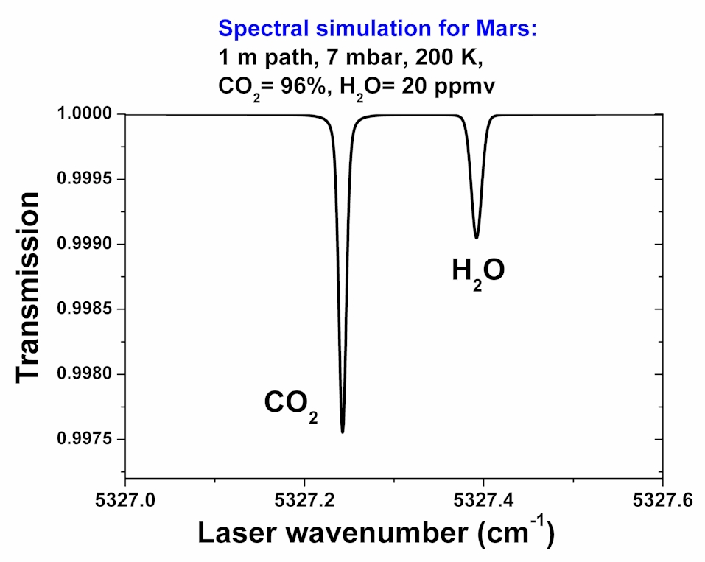

Volatile Reservoir Exchange
In addition to determining atmospheric, surface, and subsurface water, the proposed Artemis Scout Mission (PI Paige) will identify volatile reservoir exchange through additional measurements of carbon dioxide and it isotopomers (see later).

Mapping the Mars Temperature Record
Like on Earth, Mars climate history is to some extent recorded in the delta-18 isotopic ratio in H2¹⁸O that can be measured in ice core samples. Such a measurement is proposed for the Mars Scout Cryobot, in which ice core samples would be analyzed to determine their delta-18 isotopic ratio in H2¹⁸O.
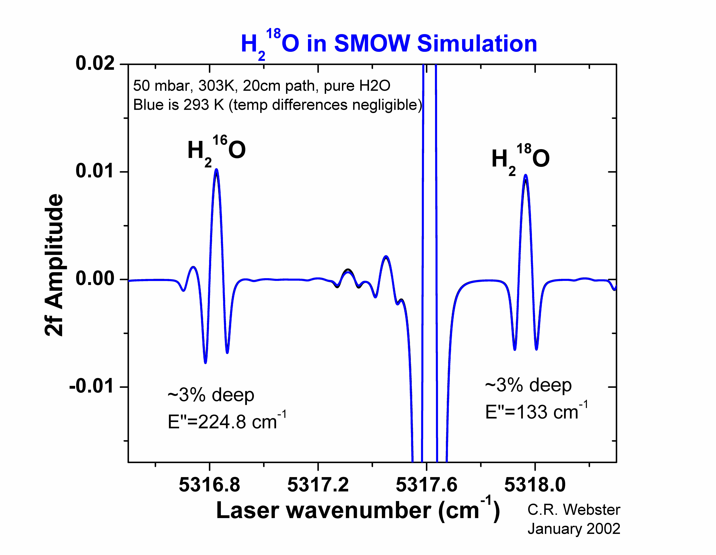

Isotope Ratios
There are numerous sources of isotopic fractionation in atmospheric gases. Isotopic fractionations in general fall into three categories: kinetic, equilibrium, and non-mass-dependent fractionation. In kinetic fractionation, discrimination between isotopomers is due to their differing rates of chemical reaction, or differing rates of diffusion to reaction sites. Kinetic fractionations are evident in reactions that never reach equilibrium partitioning, including those associated with biology, in diffusion-limited processes, and in issues involving molecular escape from the atmosphere. Equilibrium fractionation, on the other hand, refers to the equilibrium partitioning of isotopomers into different chemical constituents or phases to achieve the lowest free energy state. On the Earth, the most well-known example is the strong fractionation involved in condensing water, due to the different vapor pressures of ordinary and isotopically substituted water.

The stable isotopic compositions of low-mass (light) elements such as oxygen, hydrogen, carbon, nitrogen, and sulfur are normally reported as "delta" values in parts per thousand (denoted as ‰) enrichments or depletions relative to a standard of known composition [see http://wwwrcamnl.wr.usgs.gov/isoig/]. Delta or δ-values given in "per mil" are calculated by:

(δ‰) = (R_{sample}/R_{standard} - 1)1000

where "R" is the ratio of the heavy to light isotope in the sample or standard. For the elements sulfur, carbon, nitrogen, and oxygen, the average terrestrial abundance ratio of the heavy to the light isotope ranges from 1:22 (sulfur) to 1:500 (oxygen); the ratio D:H is 1:6410. A positive δ value means that the sample contains more of the heavy isotope than the standard; a negative δ value means that the sample contains less of the heavy isotope than the standard. A δ¹⁵N value of +30‰ means that there are 30 parts-per-thousand or 3% more ¹⁵N/¹⁴N in the sample relative to the standard.

Isotopic fractionation has long been recognized as a powerful tool for identifying chemical signatures of life. Because it is easier and faster to process lighter isotopes, biological catalysts (enzymes) exhibit a propensity for processing lighter isotopomers. Thus, the organic matter of the biomass of living organisms is generally found to be enriched with the lighter isotopes.

CARBON ISOTOPES:
Important reservoirs of carbon on Earth include biomass, atmospheric CO₂ and CH₄, soils, and dissolved carbonate in the oceans. By far the largest reservoirs of carbon are rocks like carbonate and oil shale, but they do not rapidly exchange with the atmosphere or biosphere. Dissolved carbonate in the upper ocean has a carbon isotopic composition close to 0 per mil relative to the PeeDee Belemnite (PDB) carbonate formation and appears to be in isotopic equilibrium with atmospheric CO₂ (δ¹³C = -7 per mil). Industrial CO₂ is more depleted of ¹³C (δ¹³C = -24 to -28 per mil), so fossil fuel usage is slowly reducing the δ¹³C of atmospheric CO₂. Biomass in C3 plants contains isotopically light carbon (δ¹³C = -25 per mil) relative to CO₂ due to the greater affinity of the carbon-fixing enzyme for ¹²CO₂ and its faster diffusion into plant leaves. In contrast, C4 plants are less strongly fractionated (δ¹³C = -13 to –15 per mil), and marine organic carbon has a wide range of isotopic compositions (δ¹³C = -10 to -30 per mil). Carbon isotopes are not significantly fractionated between solid and gas-phase CO₂, so sublimation and condensation processes on Mars are not expected to modify the isotopic composition of CO₂ there (except possibly due to kinetic isotope effects). Therefore, there is a better chance of finding a biological signal in δ¹³C of CO₂ in the Martian atmosphere.
Atmospheric CH₄ is strongly fractionated by its biological sources and sinks (δ¹³C ~ -46.5 per mil). Some bacteria produce CH₄ with a fractionation as large as –110 per mil (Ohmoto, 1986). Hence, CO₂ and CH₄ samples are generally suspected to be biogenic if they have a large negative δ¹³C relative to abiotic carbon reservoirs. Similarly, anomalously low δ¹³C of carbonaceous inclusions in sedimentary rocks strongly suggests that life existed on Earth more than 3.8 billion years ago (Mojzsis et al., 1996). Clearly, carbon isotopes can provide an important signature of geochemical and biological processes.

OXYGEN ISOTOPES:
On Earth, the largest reservoirs of oxygen exchangeable with the atmosphere are the crust and the hydrosphere. Biological fractionation is clearly seen in atmospheric O₂: δ¹⁸O = +23.5 per mil relative to Standard Mean Ocean Water (SMOW). Respiring organisms preferentially use light O₂, with an average fractionation of –20 per mil, leaving the atmospheric O₂ at +20 per mil. The additional +3.5 per mil enrichment comes from oxygen isotopic fractionation in leaf water. Unlike O₂, atmospheric H₂O has a large range of oxygen isotopic compositions due to Rayleigh distillation between gas-phase and condensed H₂O. The oxygen isotopic composition of precipitation ranges from close to 0 per mil in the tropics to –22 per mil in Antarctica. Atmospheric CO₂ exchanges oxygen with liquid H₂O with a fractionation that is strongly temperature-dependent. CO₂ experiences oxygen fractionation between condensed and gaseous phases. Like water, CO₂ will thus have δ¹⁸O variations from condensation, sublimation, and transport effects on Mars.

Technical Approach and Methodology

Near-IR Tunable laser sources
Room-temperature (TE cooler) tunable diode laser (TDL) sources of high spectral purity (single mode) and high output powers (5-50 mW) are now available in the near-IR region where molecules like H₂O and CO₂ have sufficiently strong IR absorption cross-sections. At wavelengths in the 1-2 μm-range, JPL’s MicroDevices Lab (MDL) have produced single-mode Distributed FeedBack (DFB) devices which have been tested and integrated into the Mars MVACS lander payload of the Mars 98 Surveyor mission: one for measurement of atmospheric H₂O at 1.37 μm and isotopic CO₂ at 2.04 μm (TDL Met); and a second as an analyzer for evolved H₂O and CO₂ from heated soil (TEGA).

However, for H2O measurements, the 1.87 μm wavelength lasers are much preferred, since they access stronger water lines, can also access isotopic H2¹⁸O lines, AND CO2 lines for pressure measurements.

Tunable laser absorption spectroscopy
Tunable laser absorption spectroscopy is widely recognized as a direct, non-invasive, simple measurement technique that is known for its high sensitivity (sub-parts-per-billion) and specificity [see review by Webster et al., 1988]. Minimum-detectable-absorptions as small as 2 parts in 10⁶ are possible, with 2 parts in 10⁵ readily achieved in flight. For reasonable pathlengths, this translates to parts-per-billion sensitivities for numerous species in the mid-infrared, and tens of ppb in the near-IR region.
Shown below are our calculations for minimum detectable amounts of H₂O and CO₂ on Mars.

MARS: NEAR-IR REGIONS FOR H₂O and CO₂
Pressure = 7 mbar (surface), T = 220 K,
path = 20 m, A_{min} = 2x10⁻⁵, 95%CO₂
Molecule | Wave-  number  (cm⁻¹) | Wave-  Length  (μm) | Expected mixing ratio | Minimum-detectable mixing ratio
H₂O |  | 1.37 | 1-500 ppm
H₂O |  | 1.87 | 1-500 ppm
CO₂  ¹³CO₂  ¹⁶O¹²C¹⁸O  ¹⁶O¹²C¹⁷O |  | 2.05 | 95.3%  1%  0.4%  0.08% | ppbv

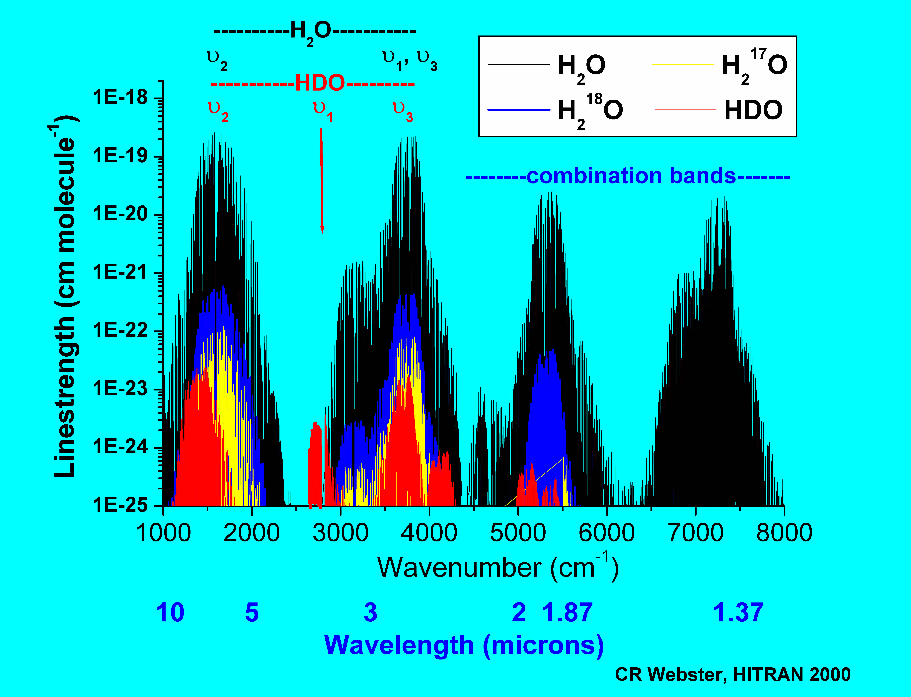
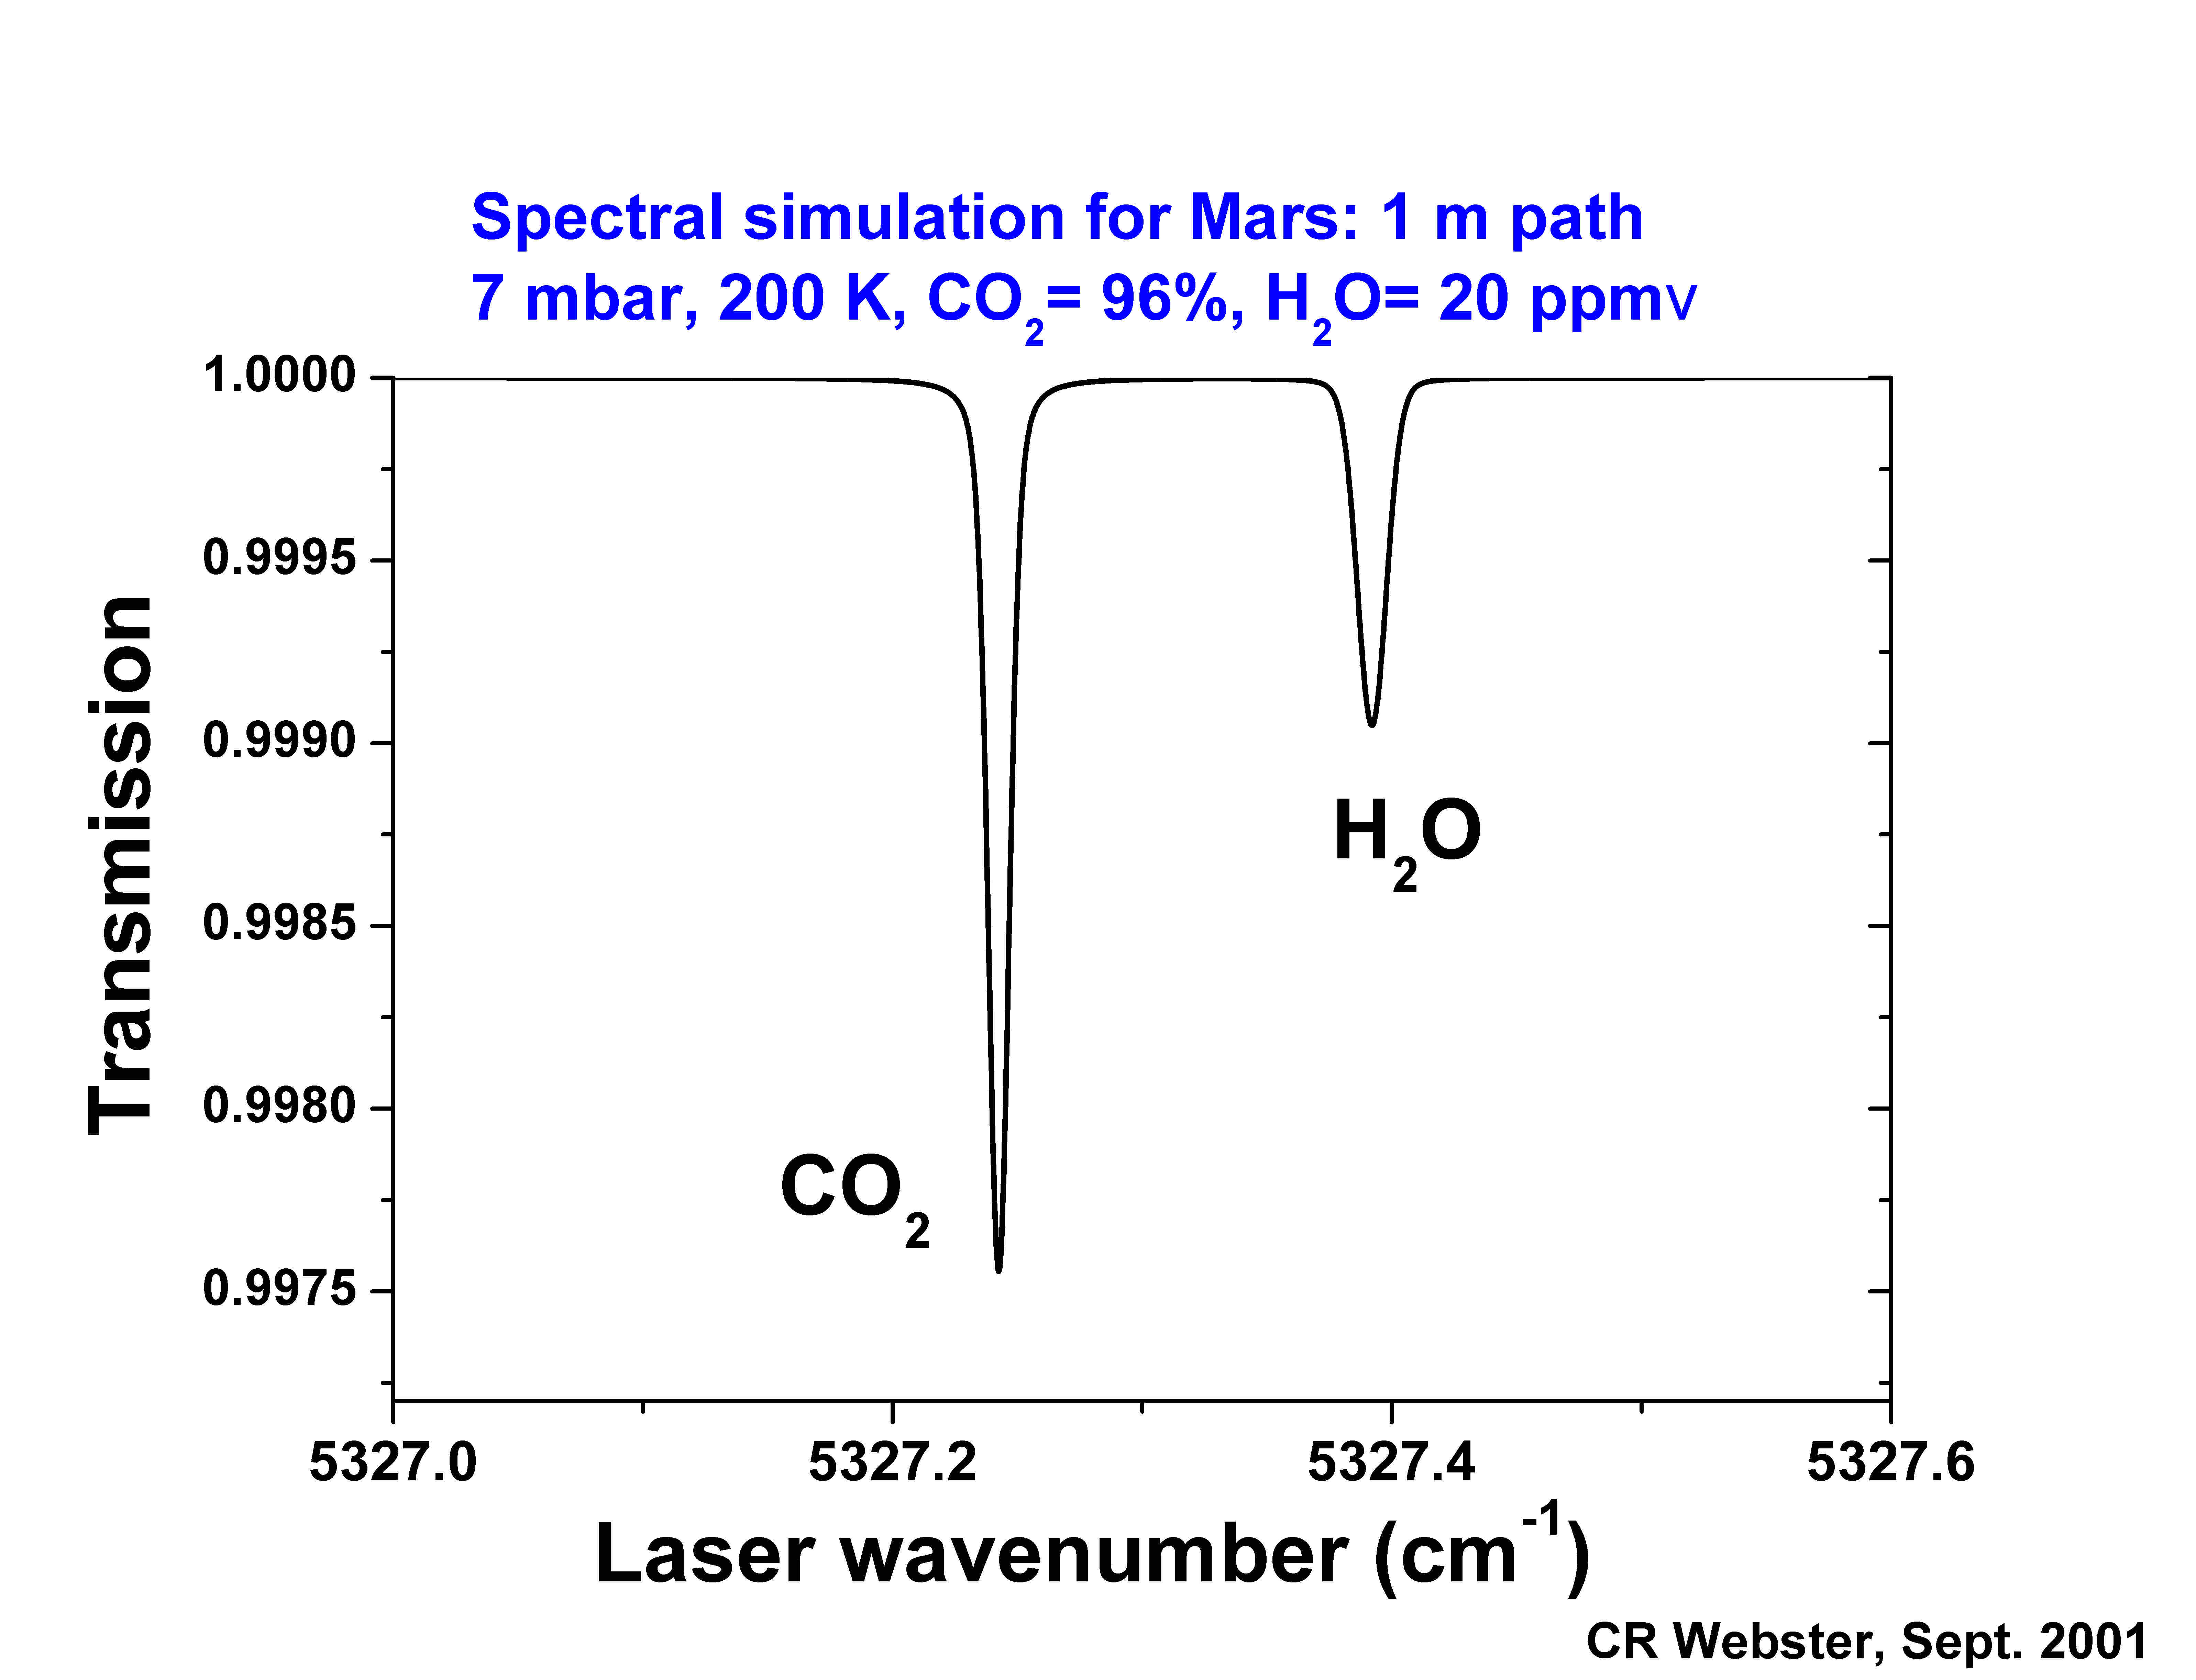
Shown below is a simulation illustrating the powerful advantage of the 1.87 μm wavelength region over the 1.37 μm region, in that a nearby CO₂ line can be used for both calibration or as a second pressure measurement (accuracy 2%). Furthermore, this region can also access a pair of suitable H₂¹⁶O/ H₂¹⁸O lines for isotopic analysis of solid, liquid, or gas phase water samples.

Isotope ratio measurements from laser absorption spectroscopy
Tunable laser spectroscopy offers a powerful means of measuring isotope ratios by selecting spectral regions where weaker features of the main isotope have similar absorptance to adjacent isotopic lines. The use of absorption lines of ¹³CO₂ and ¹²CO₂ near 4.3 μm was first proposed by Wall (1981) who found several isotopic line pairs with equal absorptance despite the 90:1 isotopic ratio.

For CO₂, isotope ratio determinations may be made using either near-IR (2.05 μm) or QC laser (4.3 μm) laser sources.

Although in principal isotope ratios may be measured down to 1 per mil using tunable laser spectroscopy, the ultimate measurement precision depends not only on spectral SNR, but also the temperature (and to a less extent, pressure) dependence of the chosen lines.

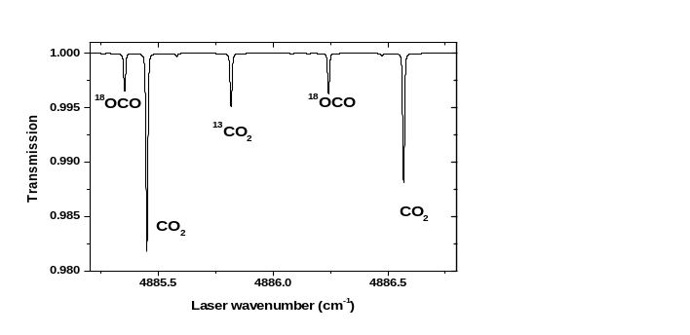
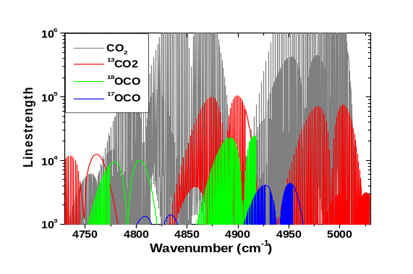
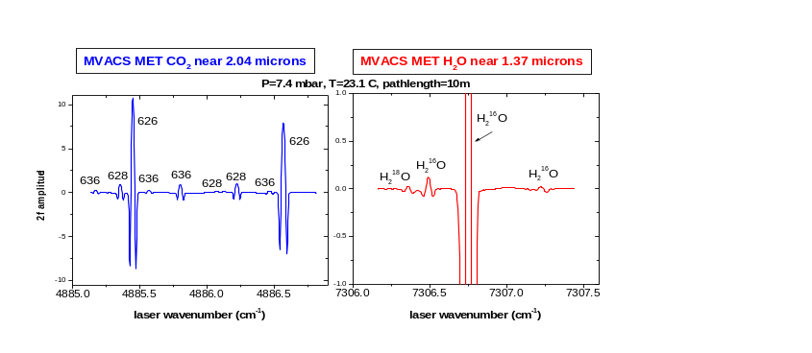
Earlier PIDDP Prototyping
Spectral simulation for CO₂ isotopes near 2.05 μm: P = 7 mbar, T = 220K, path = 1 m, 20 MHz linewidth.

Heritage
The JPL Webster group has over the last 17 years developed laser spectrometers for Earth (aircraft and balloon), Titan (Cassini probe, not selected), and Mars (Mars98, two instruments on failed payload; Mars 2007 Mars Organic Detector TDLS). In over 350 aircraft and balloon flights, the group has demonstrated the high sensitivity of tunable laser absorption spectroscopy for in situ measurement of atmospheric gases in both the near-IR (1-3 μm) and the mid-IR (3-8 μm) wavelength regions.

The Mars Polar Lander MVACS TDL spectrometers
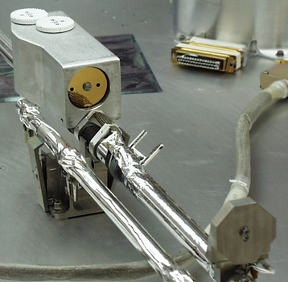
The two miniature in situ gas spectrometers built for the Mars 98 Surveyor’s MVACS lander payload, and the Mars 2007 Mars Organic Detector (MOD) are based on room-temperature TDLs at near-IR wavelengths (1-2 μm) for measurement of atmospheric H₂O at 1.37 μm and isotopic CO₂ at 2.04 μm.

The MOD TDL spectrometer
In an application similar to the MVACS MET and TEGA spectrometers, we developed a laboratory breadboard for the Mars Organic Detector that is the basis for our Mars Scout Artemis and Lander spectrometers. However, the 1.37 μm TDL for water needs to be replaced with one at 1.87 μm, and the breadboard laboratory spectrometer needs to be taken to a higher TRL level for flight consideration.

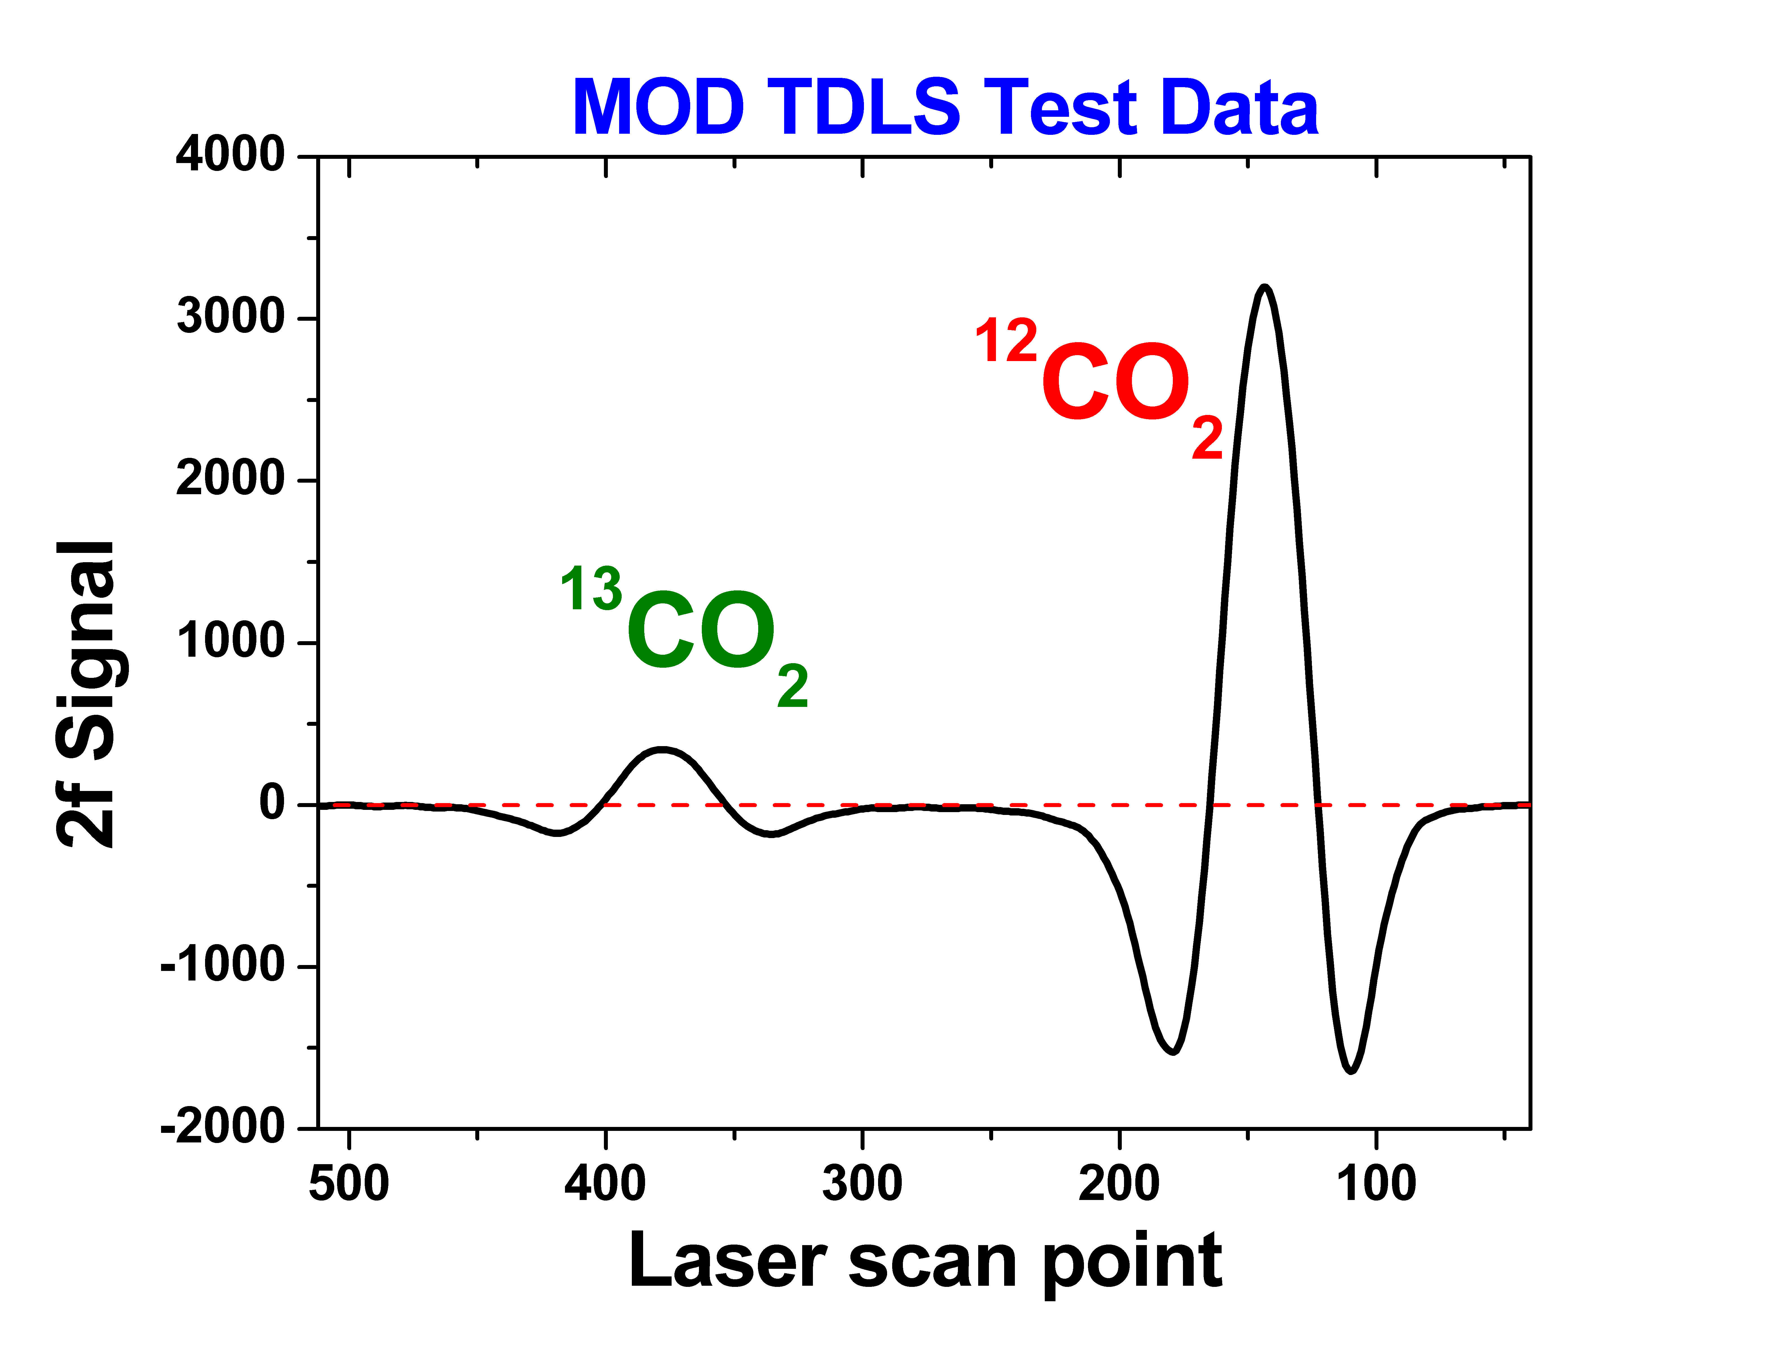

The Pascal Pre-Scout Prototype Laser Hygrometer
More recently, we have made a laboratory breadboard spectrometer version of the miniature (220 g) spectrometer that we will propose for the Mars Scout Pascal Mission. A single (unqualified) TDL at 1.87 μm was used to record the spectral region shown by way of proving sensitivities. Otherwise, much work is needed to bring this prototype to the high TRL levels.
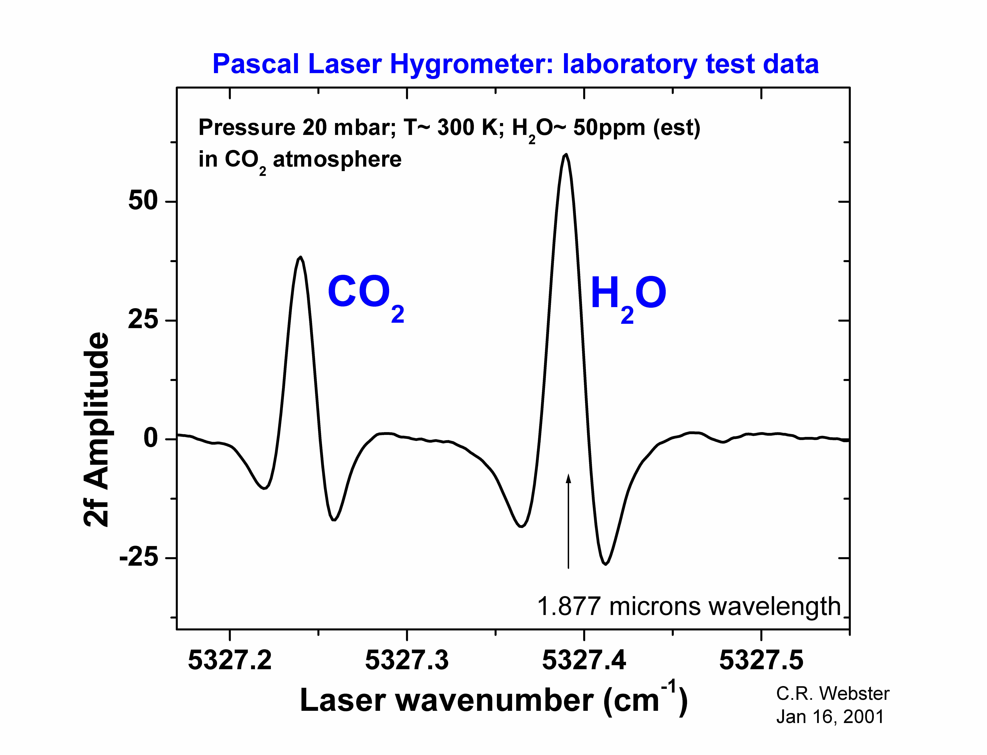
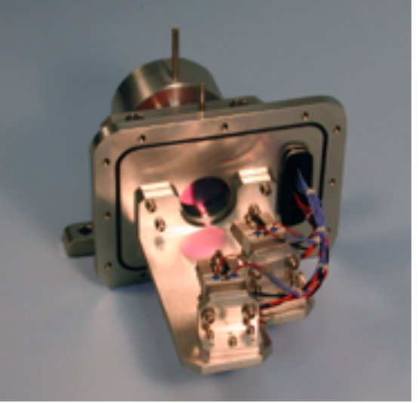
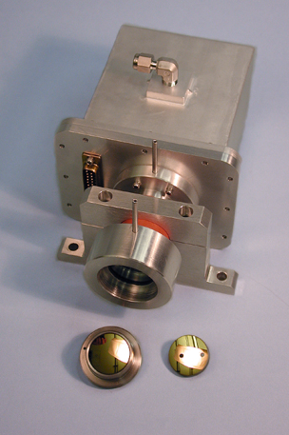
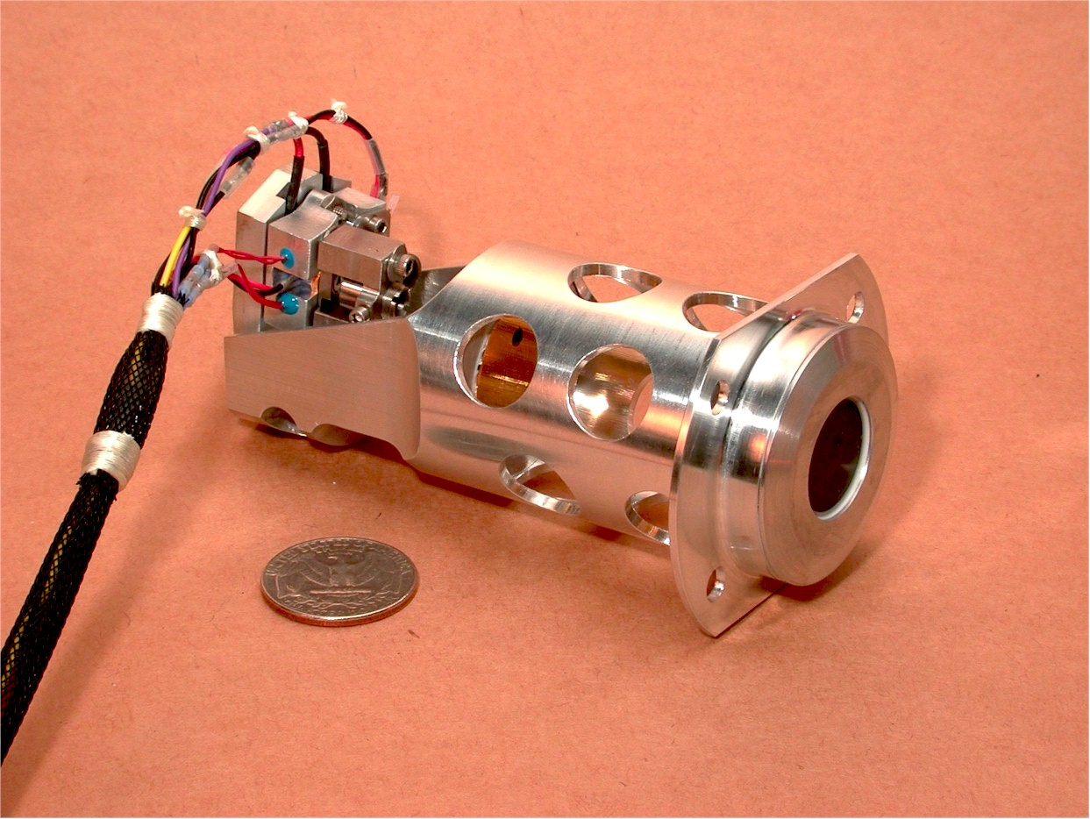
Example of optical head prototype from a near-IR , two-channel cw TDL laser spectrometer built by the PI for the Mars Organic Detector (MOD) experiment

The PIDDP QC Laser Spectrometer
Under a separate task we are also breadboarding a state-of-the-art Quantum Cascade tunable laser spectrometer for accessing a variety of gases and their isotopomers in the mid-IR region. The high-TRL level development work proposed here (e.g. of electronics) will also benefit the mid-IR spectrometer capabilities.

Management Approach

Management
The Principal Investigator, Dr. Christopher R. Webster, will manage the proposed research and have overall responsibility for all aspects of the work. As PI he will ensure that the research is completed within cost and schedule. The PI will coordinate and facilitate active communication between the team members on technical, scientific, and programmatic issues. Innovative, effective management processes and institutionally supported tools will be available to assist the research task. Critical issues and reviews will be accomplished in face-to-face meetings. The PI, whose background includes management of numerous previous JPL Earth and planetary science research, missions, and line management, is the primary leader for this instrument development research, with specific programmatic, personnel, technical, and institutional responsibilities.

Organizational structure, personnel
JPL’s Atmospheric Laser Spectroscopy Group seeks to understand the photochemistry, dynamics, and evolution of Earth and planetary atmospheres through interpretation of in situ measurements of gas, particulate, and mineral composition using state-of-the-art laser spectrometers built by the group. Over the last 17 years we have conceived, designed, and built a variety of tunable diode laser spectrometers that have flown on balloon, aircraft (ER-2, DC-8, WB57), and spacecraft (Cassini Mission, Mars Polar Lander) platforms. An active laboratory instrument miniaturization program has produced high-sensitivity spectrometers weighing less than 250 grams. A summary of the activities of our group and personnel can be found at http://laserweb.jpl.nasa.gov

Dr. Christopher R. Webster (Principal Investigator) is a Senior Research Scientist at Caltech’s Jet Propulsion Laboratory (JPL) where he has worked since 1981. He is the Group Supervisor of the Atmospheric Laser Spectroscopy Group that he formed in 1985 to study the photochemistry and dynamics of Earth and planetary atmospheres through a program of developing and flying balloon, aircraft, and spacecraft state-of-the-art laser spectrometers for gas and mineral detection analysis. In 1984 Dr. Webster pioneered the miniaturization of laser spectrometers for planetary application with the successful development of the multi-gas and particle Probe Infrared Laser Spectrometer (PIRLS) instrument for Saturn’s moon Titan, and the 1991 Mars IR Laser Spectrometer (MIRLS). He has proposed miniature laser spectrometers for biogenic gas and isotope measurements on several missions, including Mars96 Soviet Mission, the 1992 Jason Mars Discovery Mission, and more recently the Mars Organic Detector TDLS for the HEDS 2007 Mars Mission. He is also the PI for two new instrument development activities for a Quantum-cascade laser spectrometer for Mars, Titan, and Venus. He is Team Leader of the JPL Grand Challenge Initiative for identifying chemical signatures of life. Dr. Webster received a NASA Exceptional Scientific Achievement Medal (1992), 8 NASA Group Achievement Awards, and has authored >120 refereed scientific journal publications in spectroscopy, chemical physics, atmospheric science, and laser instrumentation.

Dr. Kamjou Mansour (Co-Investigator) is a senior Member of Engineering Staff in the JPL Infrared Focal Planes and Photonics Technology Group. He received his Ph.D. in quantum electronics from Center for Research and Education in Optics(CREOL) and University of North Texas in 1990 for work on optical characterization of semiconductors, dielectrics and liquid suspensions. At JPL he has been developing nanostructured materials and novel devices to demonstrate sources at new wavelengths and with ultra-narrow spectral linewidths for a wide range of sensor applications. He has been also involved in the design, fabrication and characterization of novel photonic optoelectronic circuits and high speed mode-locked semiconductor laser. Of particular importance is his experience in the development of high power, ultra narrow line width single frequency tunable diode lasers and photonic components in the 1.7-2.1 μm range for spectroscopy, LIDAR ,and optical communication applications.

Work plan
Our PIDDP and pre-Scout instrument development activities produced a working prototype laser hygrometer weighing only 220 grams that was used to demonstrate appropriate sensitivities for water at 1.87 μm. As an engineering unit (EU) the hygrometer form fit, size, mass is acceptable, but no flight parts were used, nor were this spectrometer g-force tested, vibration tested, nor therm-vac tested. Moreover, our laser sources at 1.87 μm were not flight qualified, and our EU prototype electronics board based on a Motorolla HC-12 did not incorporate flight-qualified (recommended) parts.

We propose here to conduct specific high-TRL-level activities centered on producing a Protoflight Unit (PU) that will incorporate flight-qualified lasers and electronics board. This Protoflight Unit will be tested to high-g levels, therm-vac tested, and vibration tested to flight qualification levels exceeding those of a flight unit. Our proposed work plan is therefore divided into 5 categories:
- Space qualification of 1.87 μm TDLs
- Redesign, rebuild of electronics board based on flight-qualifiable hardware.
- Modifications to instrument software based on electronics parts selected.
- Build of Protoflight Unit for testing.
- Testing of Protoflight Unit: Sensitivity analysis, Therm-vac testing, vibration and g-force testing.
- Data Analysis and Reporting.

Our work plan, schedule and costing follows these same categories detailed below:
1. Space Qualification of 1.87 μm
TDLs
For Mars applications, we first note that JPL DFB single-mode TDLs operating at both 1.37 μm and 2.03 μm (for H2O and CO2 respectively) have been previously qualified for use on the MVACS Mars Polar Lander. However, for H2O measurements, the 1.87 μm wavelength lasers are much preferred, since they access stronger water lines, can also access isotopic H2¹⁸O lines, AND CO2 lines for pressure measurements. The qualification program proposed here for the 1.87 μm devices should be achievable since the device material is the same, and the wavelength lies between that of 1.37 μm and 2.03 μm. Furthermore, JPL (Co-I Mansour) has already produced a few lasers at 1.87 μm that do scan over the required region with good single mode power, and have been used (by PI Webster) to demonstrate sensitivities for Mars applications.

We propose to produce enough single-mode DFB TDLs at 1.87 μm wavelength to conduct a rigorous flight qualification program that will leave us with 20 flight-qualified lasers for incorporation into selected Mars Scout and Smart Lander missions, thereby significantly reducing the cost to individual mission proposals.

Reliability and packaging are often pushed aside in device development despite the fact that they are crucial for mission success. The nature of failures, and the ways in which the useful service life of a device can be improved are very important. One of the objectives is to perform a coordinated series of tests on Distributed Feedback (DFB) single mode 1.87 μm wavelength lasers designed to determine the suitability of integration of these lasers diodes into the MARS space flight instruments program. JPL has extensive experience and expertise in qualifying lasers for space flights, with fully supported laboratory facilities capable of carrying out most tests listed. The table below lists some of the tests to be conducted, and the approximate number of lasers needed. We estimate that we will need to produce about 120 devices to leave 20 flight-qualified devices.
Qualification Tests #lasers Destructive (X)
Die Visual | All Devices
Internal visual inspection | All Devices
Vacuum Bake | All Devices
Electrical/optical Tests | All Devices
Temperature Cycling | All Devices
Surge current | All Devices
Thermal Impedance | All Devices
Constant Acceleration | All Devices
PIND | All Devices
High temp Reverse Bias | All Devices
Burn in | All Devices
DC Electrical /Optical Test | All Devices
Hermiticity (Gross Leak | All Devices
Radiography | All Devices
External Visual Inspection | All Devices
Temperture Charateristics | 3-5 | x
Sensitivity:optical feedback | 3-5
Relative Intensity Noise | 3-5
Output Beam requirements | 3-5
Operating Voltage | 3-5
Reverse Bias BreakD Volt. | 3-5 | x
Storage Temperature | 3-5 | x
Operating Temp Range | 5-10
Survival Temperature Range | 3-5 | x
Thermal Shock | 3-5
Accelerated Life test | 10-15 | x
Destructive Physical Analysis | 3-5 | x
Physical dimensions | 6 | x
Solderability | 3-5 | x
Resitance to solvent | 2-4 | x
Bond Strength | 3-5 | x
SEM | 3-5 | x
Die Shear | 3-5 | x
Intermittent Operation Life | 3-5 | x
Terminal Strength | 3-5 | x
Shock (Variable frequency) | 3-5
Steady State Life Test | 40-60 | x
Internal H2O Content | 3-5 | x
Neutron/ proton Irradiation | 3-5
Ionizing Radiation | 3-5

2. Redesign, rebuild of electronics board
Under PIDDP funding, we have tried various laser drive techniques for cw near-IR lasers. We have developed a laser control and signal processing circuit based on the Motorola HC12 microcontroller. This has been successfully applied to several protype instruments such as the Pascal Mars Scout prototype.

For the Mars Scout Missions, initial costing has identified an area of concern regarding the flight qualification of parts currently in our electronics board, especially the HC-12 microncontroller itself, and also the SRAM chip. An estimate to build a flight qualified board is about $500,000 (!) Rather than rely on the expensive parts screening approach, we propose to redesign our board using a parts list pre-approved as flight hardware, thus increasing reliability and greatly reducing the cost of this vital electronics board that has wide applicability to several Mars Scout and Lander missions.
3. Modifications to instrument software
Software may have to be rewritten to accommodate new hardware parts changes, since obtaining fully autonomous “on-the-fly” data processing will require the development of robust pattern matching algorithms that can identify spectral lines of interest and produce reliable, high-precision isotope ratio measurements.

4. Build of Protoflight Unit
We will build a Protoflight Unit based on the Mars Scout Pascal design shown below that would include upgrades to the optomechanical design (more rigorous design to survive high-g force and Mars environment) in preparation for the testing to be done in years 2 and 3.
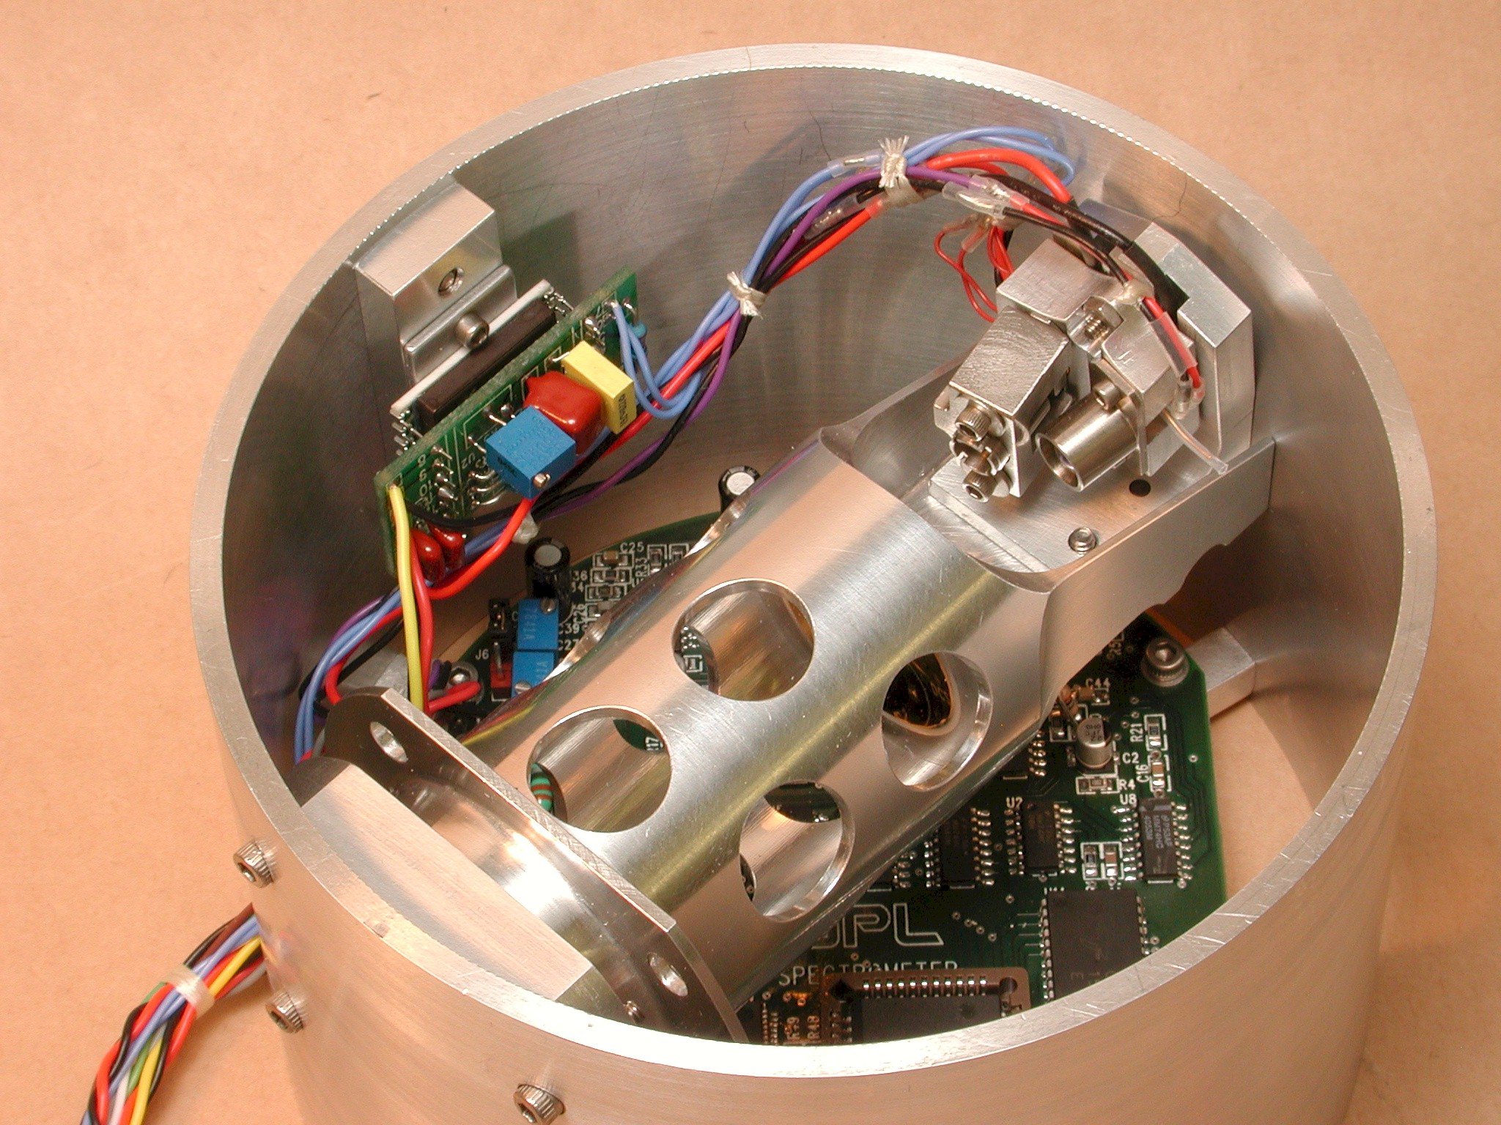
The Protoflight Unit would incorporate one of the newly-qualified 1.87 μm lasers, and the newly built electronics board and instrument software. We have much experience in building, testing, and flying laser spectrometers for Earth and planetary applications. We have learned that the instrument performance can only be fully characterized in a full-prototype end-to-end testing, in a therm-vac environment, and we propose to complete our task in this manner.

5. Testing of Protoflight Unit
The completed Protoflight Unit will be thoroughly tested for measurement sensitivity analysis, Therm-vac testing, vibration and g-force testing using existing service-facilities at JPL.

6. Data Analysis and Reporting.
We will analyze the engineering data and provide a detailed end-of-work report that would be made available for consultation by any group interested in proposing laser hygrometers for future Mars Missions.

Facilities
The instrument development will use several existing support facilities and equipment at JPL owned by Webster’s Atmospheric Laser Spectroscopy Group, including: 3 instrument and spectroscopy laboratories; turbo pumps, spectrometers, wave-meters, and vacuum equipment; computing facilities (Linux workstations, numerous PC's); computer-aided-design (CAD) for electronics and mechanical engineering. For laser production and qualification testing, extensive clean-room facilities at JPL’s MicroDevices Laboratory will be used. For thermal-vacuum testing, flight therm-vac chambers at JPL will be available for use of this project.

Schedule
The schedule is given in the schematic below, included with the cost plan information.
END OF TECHNICAL SECTION

Cost Plan Summary

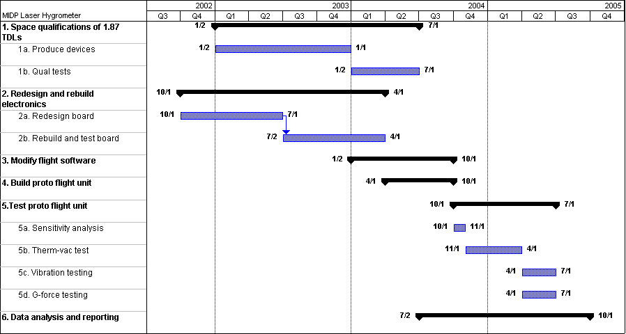

Details of the proposed costs are included in the formal mandatory material included in the appendix, and are presented here in summary for ease of presentation. Laser fabrication will be done at JPL by Mansour (Co-I) at 20% and a lab technician (50%), with $40 K wafer and material costs. The flight qualification testing will be done outside under subcontract, supervised by Mansour, and with JPL reliability planning involvement under flight instrument engineering.
BUDGET SUMMARY:
Detail | Year 1 | Year 2 | Year 3
A. Labor with benefits
PI Webster
CoI Mansour
Flight instrument Engineering
Technician
Software engineer
B. Travel
C. Services
Environmental test chamber
Fabrication, machine & glass shops
D2. Contracts, subcontracts
Flight qualification testing for lasers
D3. Procurements
Electronics parts, test equipment
Laser wafer, hardware
Optics, detector, vacuum parts, software
L. Fully-burdened total costs

References:
Altmann, J., R. Baumgart, and D.C. Weitkamp, Two-mirror multipass absorption cell, Appl. Opt., 20, 995-999, 1981.
Capasso F, Faist J, Sirtori C, and Cho AY, “Infrared (4-11 um) Quantum Cascade Lasers”, Solid State Communications, Vol. 102, No. 2-3, pp231-236, 1997.
Conrad, R., "Soil Microorganisms as controllers of atmospheric trace gases", Microbiol. Rev., 60, p609-640, 1996.
DeMore, W.B. et al, 1997, Chemical Kinetics and Photochemical Data for use in stratospheric Modeling.
Faist J, Cappasso F, Sivco DL, Sirtori C, Hutchinson AL, and Cho AY, “Quantum Cascade Laser”, Science, 264, pp 553-556, 1994.
Farmer, C.B., and P.E. Doms, Global and seasonal variations of water vapor on Mars and the implications for permafrost, J. Geophys. Res., 84, 2881-2888, 1979.
Forouhar, S., S. Keo, A. Larsson, A.Ksendzov, and H. Temkin, Low-threshold continuous operation of InGaAs/InGaAsP quantum well lasers at 2 m, Electron. Lett., 29, 574-576, 1993.
Forouhar, S., A. Ksendzov, A. Larrson, and H. Temkin, InGaAs/InGaAsP strained-layer quantum well lasers at 2 m, Electon. Lett., 28, 1431-1432, 1992.
Fung, I.W., et al., 1997, Carbon 13 exchanges between the atmosphere and biosphere, Global Biogeochemical Cycles, 11, 507-533.
Gmachl C, et al, “Tunable Distributed-Feedback Quantum-Cascade Lasers for Gas Sensing Applications”, SPIE vol. 3285, p 144.
Herriott, D.R., H. Kogelnik, and R. Kompfner, Off-axis paths in spherical mirror resonators, Appl. Opt., 3, 523-526, 1964.
-Ivanov, M.V., and A.Y. Lein, "Changes in the stable isotope composition of gases and minerals as a result of microbial activity", SPIE Vol. 3111, 1997.
Kim, K.R. and H. Craig. (1993). Science, 262, 1855.
Krajick, K. "To Hell and Back", Discover Magazine, pp. 76-81, July 1999.
Lara-LM, Lellouch-E, Lopezmoreno-JJ, and Rodrigo-R, “Vertical distribution of Titan’s Atmospheric Neutral Constituents”, J. Geophys. Res., (Planets) 101(E10) 23261-23283, 1996.
Lovelock, J. E., and Margulis, L., 1974, Atmospheric homeostasis, by and for the biosphere: The Gaia hypothesis Tellus 26, 1
Maguire, W.C., "Martian isotope ratios and upper limits for possible minor constituents as derived from Mariner 9 IR spectrometer data", Icarus, 32, p85-97, 1997.
May, R.D., and C.R. Webster, Data processing and calibration for tunable diode laser harmonic absorption spectrometers, J. Quant. Spectrosc. Radiat. Transfer, 49, 335-347, 1993.
May, R.D., Open-path near-infrared tunable diode laser spectrometer for atmospheric measurements of H₂O, J. Geophys. Res., 19,161-19,172, 1998.
Mojzsis, S.J., G. Arrhenius, K.D. McKeegan, T.M. Harrison, A.P. Nutman, and C.R.L. Friend, Evidence for life on Earth before 3,800 million years ago, Nature, 384, 55-9, 1996.
Nair et al, 1994, Icarus, 111, 124-150.
Namjou K, Cai S, Whittaker EA, Faist J, Gmachl C, Cappasso F, Sivco DL, and Cho AY, “Sensitive Absorption Spectroscopy with a Room-Temperature Distributed-Feedback Quantum-Cascade Laser”, Optics Letters Vol. 23, No. 3, pp. 219, February 1,1998.
Ohmoto, Hiroshi, in Stable Isotopes in High Temperature Geological Processes, J.W. Valley, H.P. Taylor, Jr., and J.R. O’Neil, eds., Min. Soc. Amer., Washington DC, p. 491-560, 1986.
Orient, O.J., A. Chutjian, and V. Garkanian, "Miniature High-Resolution Quadrupole Mass Spectrometer Array", Rev. Sci. Instr. 68, 1393-1397, 1997.
Owen, T., “Titan”, in The New Solar System, by Beatty and Chaikin (Eds), 189-194, Cambridge University Press, (1990).
Rahn, T. and M. Wahlen. (1997). Science, 278, 1776.
Rahn, T., Zhang, H., Wahlen, M. and Blake, G.A. (1998), Geophys. Res. Lett., 25, 4489.
Rothman, L.S., C.P. Rinsland, A. Goldman, S.T. Massie, D.P. Edwards, J.-M. Flaud, A. Perrin, C. Camy-Peyret, V. Dana, J.-Y. Mandin, J. Schroeder, A. McCann, R.R. Gamache, R.B. Wattson, K. Yoshino, K.V. Chance, K.W. Jucks, L.R. Brown, V. Nemtchinov, and P. Varanasi, The HITRAN molecular spectroscopic database and HAWKS (HITRAN Atmospheric Workstation): 1996 edition, J. Quant. Spectrosc. Radiat. Transfer, 60, 665-710, 1998.
Samuelson, R.E., W.C. Maguire, R.A. Hanel, V.G. Kunde, D.E. Jennings, Y.L. Yung, and A.C. Aikin, 1983, CO₂ on Titan. J. Geophys. Res., 88, 8709-8715.
Scott, D.C., R.H. Herman, C.R. Webster, R.D. May, G. Flesch, and W.S. Woodward, Aircraft Laser Infrared Absorption Spectrometer II (ALIAS-II) for in-situ atmospheric measurements of N₂O and CH₄, Appl. Opt., (in press, 1999).
Solderblom LA, Chapter 17 “The Composition and Mineralogy of Martian Surface from Spectroscopic Observations”, in Mars, H.H. Kieffer et al., eds., University of Arizona, Tucson, 1992.
Tacke M, “New Developments and Applications of Tunable IR Lead Salt Lasers”, Infrared Phys. Technol., Vol. 36, No.1, pp 447-463,1995.
Toth, R.A., Extensive measurements of H₂¹⁶O line frequencies and strengths: 5750 to 7965 cm-1, Appl. Opt., 33, 4851-4867, 1994.
Webster, C.R. and R.D. May, Simultaneous in situ measurements and diurnal variations of NO, NO₂, O₃, jNO₂, CH₄, H₂O, and CO₂ in the 40 to 26 km region using an open path tunable diode laser spectrometer, J. Geophys. Res., 92, 11931-11950, 1987.
Webster, C.R., R.T. Menzies, and E.D. Hinkley, Infrared laser absorption: theory and applications, in Laser Remote Chemical Analysis, Chapter 3, edited by R.M. Measures, John Wiley, New York, 1988.
Webster, C.R., S.P. Sander, R, Beer, R.D. May, R.G. Knollenberg, D.M. Hunten, and J. Ballard, Tunable diode laser IR spectrometer for in situ measurements of the gas phase composition and particle size distribution of Titan's atmosphere, Appl. Opt. 29, 907-917, 1990.
Webster, C.R., R.D. May, R. Toumi, and J.A. Pyle, Active nitrogen partitioning and the nighttime formation of N₂O₅ in the stratosphere: simultaneous in situ measurements of NO, NO₂, HNO₃, O₃, and N₂O using the BLISS diode laser spectrometer, J. Geophys. Res., 95, 13851-13866, 1990.
Webster, C.R., R.D. May, C.A. Trimble, R.A. Chave, and J. Kendall, Aircraft (ER-2) laser infrared absorption spectrometer (ALIAS) for in-situ stratospheric measurements of HCl, N₂O, CH₄, NO₂, and HNO₃, Appl. Optics, 33, 454-472, 1994.
Webster CR, G.J. Flesch, D.C. Scott, J. Swanson, R.D. May, W. S. Woodward, C. Gmachl, F. Capasso, D.L. Sivco, J.N. Baillargeon, A.L. Hutchinson, A.Y. Cho, “Quantum Cascade Laser Measurements of Stratospheric Methane and Nitrous Oxide”, Applied Optics, January 20 issue, 2001.
Webster CR, Sander SP, Beer R, May RD, Knollenberg RG,Hunten DM, Ballard J,“Tunable Diode Laser IR Spectrometer for In Situ Measurements of the Gas Phase Composition and Particle Size Distribution of Titan’s Atmosphere”, Applied Optics 29, 907-917, 1990.
Wennberg, P.O., R.C. Cohen, N.L. Hazen, L.B. Lapson, N.T. Allen, T.F. Hamisco, J.F. Oliver, N.W. Lamham, J.N. Demusz, and J.G. Anderson (1994), Rev. Sci. Instrum., 65, 1858-1876.
Woodward, W.S., and R.D. May, Flash-ROM-based multichannel arbitrary-waveform generator, Electronic Design, April 19, 1999, pp. 86-88.
Yung YL, Allen M, and Pinto JP, “Photochemistry of the Atmosphere of Titan: Comparison Between Model and Observations”, The Astrophysical Journal of Supplement Series, 55:465-506, 1984.
Yung, Y.L., and W.B. DeMore, “Photochemistry of the stratosphere of Venus: Implications for atmospheric evolution”, Icarus, 51, 199-247 (1982).
Yung, Y.L., & W.B. DeMore, 1999, Photochemistry of Planetary Atmospheres, Oxford University Press.
Yung, Y.L. and C.E. Miller. (1997), Science, 278, 1778.

ANCILLARY INFORMATION

ONE-PAGE RESUME
DR. CHRISTOPHER R. WEBSTER
Senior Research Scientist, Jet Propulsion Laboratory, Pasadena, California 91109-8099
Tel: (818) 354-7478 Email: Chris.R.Webster@jpl.nasa.gov
EDUCATION:
Ph.D. Molecular Spectroscopy, University of Bristol (UK), 1977, Prof. RN Dixon, F.R.S.
B.Sc. (Hons) Chemical Physics, University of Reading (UK), 1974, Prof. IM Mills.

PROFESSIONAL EXPERIENCE:
2000-Present Lead Scientist, Atmospheric Chemistry Research Element, JPL-Caltech
1990-Present Senior Research Scientist, JPL-Caltech
1992-93 Visiting Full Professor, Geological and Planetary Sciences, Caltech
1988-90 Section Manager, Atmospheric and Oceanographic Sciences, JPL-Caltech
1986-Present Group Supervisor, Atmospheric Laser Spectroscopy Group, JPL-Caltech
1984-86 Deputy Leader, Laser Monitoring Group, JPL-Caltech
1981-84 Senior Scientist at Jet Propulsion Lab (JPL), California
1979-81 Postdoc with Prof. Richard N. Zare, Chemistry Department, Stanford University, CA
1977-79 Postdoc with Dr. F Rostas, Royal Society Fellowship, Paris-Observatory, France
1974-77 Graduate Fellow/ Teaching Assistant/ Math Tutor, University of Bristol

TEACHING EXPERIENCE:
1992-93 Spectroscopy and atmospheric chemistry: Caltech, CA
1980 Freshman Chemistry, Stanford University, CA
1974-77 TA in theoretical chemistry and mathematics, Bristol University, England
Graduate Student Advisor to: Lyatt Jaegle (Ph.D.), Robert Herman (Ph.D.), Elisabeth J. Moyer (Ph.D.)

PROFESSIONAL ACTIVITIES:
- Principal Investigator (2002-Present) (Code S) ASTID Laser Spectrometer for Biogenic Gases& Isotopes
- Co-Investigator (2002-03) (Code S) Mars Scout Mission Laser Spectrometers (6)
- Co-Investigator (2001-04) Code Y IIP CO₂ Laser Absorption Spectrometer
- Principal Investigator (2001) JPL (DRDF) Miniature CO₂ Airborne Laser Isotope Spectrometer (ALIS)
- Co-Investigator (1999-2000) (Code U/HEDS) Mars Organic Detector (MOD)
- Team Leader (1999-2001) (DRDF) Grand Challenge Biogenic Gases & Isotope Ratios for Detection of Life
- Principal Investigator (1998-Present) JPL/NASA (Code S) Quantum-Cascade Laser Spectrometer for in situ measurement of atmospheric and evolved gases on Mars, Titan, Venus, & Europa.
- Principal Investigator (1991-Present) NASA (Code Y) Aircraft Laser Infrared Absorption Spectrometer (ALIAS-II) for aircraft and balloon measurements of trace gases.
- Member, NASA Aircraft Payloads Panel (Code Y) (1991-Present).
- Principal Investigator (1988-Present) NASA (Code Y) Aircraft ER-2 Laser Infrared Absorption Spectrometer (ALIAS) for polar ozone depletion studies.
- Principal Investigator (1997-99) JPL/NASA (Code S) CLARIS Absorption& Raman Mars Spectrometer.
- Principal Investigator (1981-92) NASA (Code Y) Balloon-borne Laser In-Situ Sensor (BLISS) experiment for testing models of stratospheric photochemistry
- Principal Investigator (1984-90) NASA/ESA/DRDF Titan Probe Infrared Laser Spectrometer
- Member, NASA Balloon Working Group (1985-1988), Instrument Incubator Program (IIP) panel (1999)
- Principal Investigator (1981-84), Co-Investigator (1984-Present) NASA Code Y Laser Laboratory spectroscopy Program.
- Technical Monitor, several NASA-JPL SBIR technology developments.
- Reviewer for NASA, NSF, NOAA, EPA, JGR, GRL, CPL, Phys Rev.

PUBLICATIONS, AWARDS, PATENTS:
- Refereed scientific journal publications (126)
- NASA Certificates of Recognition; Tech Briefs (12); Patents (2)
- NASA Exceptional Scientific Achievement Medal (1992)
- NASA Group Achievement Award (1993-2001): AASE-II, SPADE, ASHOE, POLARIS, SOLVE
- NASA Group Achievement Award (2000) Quantum Cascade Laser measurements
- NASA Group Achievement Award (1997) Balloon/UAV Laser Spectrometer
- NASA Group Achievement Award (1992) Aircraft Laser Infrared Absorption Spectrometer
- NASA Group Achievement Award (1989) Balloon-borne Laser In-Situ Sensor
- Royal Society of London Fellowship (1978-79).

SELECTED JOURNAL PUBLICATIONS OF CHRISTOPHER R. WEBSTER

l. "Single Vibronic Level Fluorescence of CrO₂Cl₂ Excited by a Tunable cw Dye Laser," R.N. Dixon and C.R. Webster, J. Mol. Spec. 62, 27l-282 (l976).

2. "Lasers for Listening to Molecules," C.R. Webster, New Scientist, 73, 383-385 (l977).

3. "Optoacoustic Spectroscopy with a Tunable cw Dye Laser: Forbidden Transitions in Some Unstable Sulphur Compounds," R.N. Dixon, C.R. Webster, and D.A. Haner, Chem. Phys. 22, l99-206 (l977).

6. "The Determination of the Electric Dipole Moment of H₂CS in its A,¹A₂ Excited State Using Dye Laser Electric Field Spectroscopy," R.N. Dixon and C.R. Webster, J. Mol. Spectros. 70, 3l4-322 (l978).

7. "The Dye Laser-Induced Fluorescence and Emission Spectrum of the KXe Molecule," C.R. Webster and F. Rostas, Chem. Phys. Lett. 59, 57-61 (l978).

9. "Generation of UV Radiation from Intracavity Doubling of a Single-Mode Ring Dye Laser," C.R. Webster, L. Woste and R.N. Zare, Springer Series in Optical Sciences 26, l63-172 (l98l).

11. "Time-Resolved Spectroscopy of RbXe Excimers Populated by Superradiant Transitions," C.R. Webster and F. Rostas, J. Phys. B 14, 4497-4512 (1981).

12. "Narrow-Band UV Radiation (250-260 nm) by Intracavity Doubling a Single-Mode Ring Dye Laser," C.R. Webster, L. Woste and R.N. Zare, Opt. Comm. 35, 435-440 (1980).

13. "Photochemical Isotope Separation of Hg-l96 by Reaction with Hydrogen Halides," C.R. Webster and R.N. Zare, J. Phys. Chem. 35, l302-1305 (l98l).

14. "Laser Optogalvanic Effect in a Pure Iodine Discharge," C.T. Rettner, C.R. Webster and R.N. Zare, J. Phys. Chem. 85, ll05-1107 (l98l).

16. "Determination of the Electric Dipole Moment of the HSO Radical in its X²A"(000) and A²A'(003) Electronic States," C.R. Webster, P.J. Brucat and R.N. Zare, J. Mol. Spectros. 92, 184-202 (l982).

17. "Optogalvanic Wavelength Calibration for Laser Monitoring of Reactive Atmospheric Species," C.R. Webster, Appl. Opt. 21, 2298-2300 (1982).

18. "Laser Optogalvanic Photodetachment Spectroscopy: A New Technique for Studying Photodetachment Thresholds with Application to I⁻", C.R. Webster, I.S. McDermid and C.T. Rettner, J. Chem Phys. 78, 646-651 (1983).

19. "Infrared Laser Optogalvanic Spectroscopy of Molecules", C.R. Webster and R.T. Menzies, J. Chem. Phys. 78, 2121-2128 (1983).

20. "Laboratory Simulation of Tunable Diode Laser Remote Measurement of Atmospheric Gases Using Topographic Targets", C.R. Webster and W.B. Grant, Apple. Opt. 22, 1952-1954 (1983).

21. "Laser Optogalvanic Spectroscopy of Molecules," C.R. Webster and C.T. Rettner, Laser Focus 19, 41-48 (1983).

23. "Balloon-borne Diode Laser Absorption Spectrometer for Measurements of Stratospheric Trace Species," R.T. Menzies, C.R. Webster and E.D. Hinkley, Appl. Opt. 22, 2655-2664 (1983).

25. "Optogalvanic Photodetachment Spectroscopy," I.S. McDermid and C.R. Webster, J. de Physique 44, C7-461-466 (1983).

26. "Infrared Optogalvanic Spectroscopy of NH₃ and NO₂," C.R. Webster and
R.T. Menzies, J. de Physique 44, C7-429-437 (1983).

28. "Microprocessor-Controlled Laser Tracker for Atmospheric Sensing," R.A. Johnson, C.R. Webster, and R.T. Menzies," Rev. Sci. Instr. 56, 547-556 (1985).

30. "Tunable Diode Laser Stark Modulation Spectroscopy for Rotational Assignment of the HNO₃ 7.5 μm Band," C.R. Webster, R.D. May, and M.R. Gunson, Chem. Phys. Lett. 121, 429-436 (1985).

31. "Infrared Laser Absorption: Theory and Applications", C.R. Webster, R.T. Menzies, E.D. Hinkley, Laser Remote Chemical Analysis, Ch. 3, Ed. R. M. Measures, (1988).

34. "Stratospheric Composition Measurements of Earth and Titan Using High- Resolution Tunable Diode Laser Spectroscopy", C.R. Webster, J. Quant. Spectros. Radiat. Trans. 40, 239-248, (1988).

41. "Tunable Diode Laser Infrared Spectrometer for In-situ Measurements of the Gas Phase Composition and Particle Size Distribution of Titan's Atmosphere", C.R. Webster, S.P. Sander, R. Beer, R.D. May, R.G. Knollenberg, D.M. Hunten, and J. Ballard, Appl. Opt. 29, 907-917, (1990).

42. "Active Nitrogen Partitioning and the Nighttime Formation of N₂O₅ in the Stratosphere: Simultaneous In-situ Measurements of NO, NO₂, HNO₃, O₃, N₂O, and jNO₂ Using the BLISS Diode Laser Spectrometer", C. R. Webster, R. D. May, R. Toumi, and J. Pyle, J. Geophys. Res. 95, 13,851-13,866, (1990).

48. "In-Situ Stratospheric Measurements of CH₄, ¹³CH₄, N₂O, and OC¹⁸O Using the BLISS Tunable Diode Laser Spectrometer", C.R. Webster and R.D. May, Geophys. Res. Letters 19, 45-48, (1992).

49. "Aircraft (ER-2) Laser Infrared Absorption Spectrometer (ALIAS) for In-situ Stratospheric Measurements of HCl, N₂O, CH₄, NO₂, and HNO₃", C.R. Webster, R.D. May, C.A. Trimble, R.G. Chave and J. Kendall, Applied Optics, 33, 454-472, 1994.

51. "Chlorine Chemistry on Polar Stratospheric Cloud Particles in the Arctic Winter", C.R. Webster, R.D. May, D.W. Toohey, L.M. Avallone, J.G. Anderson, P. Newman, L. Lait, M.R. Schoeberl, J.W. Elkins and K.R. Chan, Science 261, 1130-1134 (1993).

58. "Balloon Profiles of Stratospheric NO₂ and HNO₃ for Testing the Heterogeneous Hydrolysis of N₂O₅ on Sulfate Aerosols", C.R. Webster, R.D. May, M. Allen, L. Jaeglé, Geophys. Res. Letters 21, 53-56, 1994.

81. “Evolution of HCl Concentrations in the Lower Stratosphere from 1991 to 1996 Following the Eruption of Mt. Pinatubo”, C.R. Webster, R.D. May, H.A. Michelsen, D.C. Scott, J.C. Wilson, H.H. Jonsson, C.A. Brock, J.E. Dye, D. Baumgardner, R.M. Stimpfle, J.P. Koplow, J.J. Margitan, M.H. Proffitt, L. Jaeglé, R.L. Herman, H. Hu, G.J. Flesch, M Loewenstein, accepted, Geophys. Res. Lett., 1998.

- "In situ measurements of CO in the upper troposphere and lower stratosphere from the ER-2 aircraft”, R.L. Herman, C.R. Webster, R.D. May, D.C. Scott, H. Hu, P.O Wennberg, E.J. Hintsa, T.P. Bui, and Y.L. Yung, in preparation for J. Geophys. Res., 1998.

107. “Quantum cascade laser measurements of stratospheric methane (CH₄) and nitrous oxide (N₂O)”, C.R. Webster, G.J. Flesch, D.C. Scott, J. Swanson, R.D. May, W.S. Woodward, C. Gmachl, F. Capasso, D.L. Sivco, J.N. Baillargeon, A.L. Hutchinson, A.Y. Cho, submitted to Appl. Opt., December 1999.

RESUME Dr. Kamjou Mansour

EDUCATION Ph.D. in Quantum Electronics (1990), Center for Res.& Educ. in Optics(CREOL), Orlando, FL
M.Sc. in Physics (1986), Center for Applied Quantum Electronics (CAQE) UNT, Denton,TX
M.S. in Electrical Engineering (1984) Southern Methodist University, Dallas, TX.
B.S. in Electrical Engineering and Physics (1983), Southern Methodist University , Dallas, TX.

EXPERIENCE
2001- Present, Senior Member of engineering Staff in Infrared Focal Planes and Photonic Technologies, microDevices Laboratory, Jet Propulsion Laboratory, Pasadena, CA.
Developing nanostructured materials and novel devices to demonstrate sources at new wavelengths and with ultra-narrow spectral linewidths for a wide range of sensor and remote sensing applications. Developing advanced electron beam lithography techniques to improve the grating design of near-IR (1-2µm) distributed feedback (DFB) lasers for more precise tuning to molecular absorption lines and to reduce spectral linewidths to below 100kHz for LIDAR and interferometric space science applications. Developing microcavity structures based on high-Q ring and two dimensional (2D) photonic bandgap structures,with the goal of producing improved chemical and biological sensors for life support and planetary science. Developing advanced photonics and integrated opto-electronics components for different NASA and DOD applications.

1999- 2001, Member of Technical Staff, Photonic Technology Group, Jet Propulsion Laboratory, Pasadena, CA.
Designed and developed high power, single frequency InGaAs strained layer tunable semiconductor laser in the 1.8-2.1 µm range. Worked extensively on design and fabrication of high speed transmitters (mode-locked lasers) for high speed bit parallel dense division multiplexing links. Fabricated and characterized low loss InP passive waveguides for optoelectronic applications. Worked on design and integration of high performance EO-polymers as passive and active elements onto III-V semiconductor devices for optoelectronic applications. In charge of testing and characterization of optoelectronic components for JPL’s photonic group

1997 – 1999, Associate Scientist, California Institute of Technology, Pasadena, CA
Performed research and development on polymeric thin films of newly developed two-photon absorbing molecules and conjugated planar macrocyclic molecules for photonic applications.

1995 – 1997, Visiting Assistant Research Faculty, CREOL (center for Research and Education in Optics and Lasers), Orlando, FL
Conducted research on the optical characteristics of liquid crystaline fibers arrays doped with organic molecules for photonic switching applications. Participated in the development of a beam propagation program. Used to simulate the photonic switching and limiting processes in reverse saturable absorbing molecules for optical limiting devices

1991-1995, Member of Technical Staff (Post-doctoral Position), California Institute of Technology, Jet Propulsion Laboratory, Pasadena, CA
Designed, fabricated and demonstrated the first multi-plate solid state optical switching/limiting devices for senors and eye protection based on strongly saturated excited state absortption in conjugated planar macrocyclic molecules. Participated in the development of of thin-film ferroelectric memory chips. Participated in the development of two dimensional micro-lense array for flat docking target assembly for space applications.
Demonstrated that HIFS is an excellent tool for assessing the elemental composition of meterorites and planets.

1990-1991, Post-doctoral Research Scientist, CREOL, Orlando, FL
Performed research on nonlinear optical and ultra-fast electronic properties of semiconductor materials.

PUBLICATIONS Publications include over 38 journal and refereed and proceedings.

CURRENT AND PENDING RESEARCH SUPPORT
Dr. Christopher R. Webster
Jet Propulsion Laboratory (JPL)

A. CURRENT SUPPORT :
1. Source of Support: NASA’s Upper Atmospheric Research Program (UARP)
2. Project Title Aircraft measurements of the ALIAS instrument: PI Webster
3. Award Amount
4. Period of Award ongoing
5. Person-months 6.0 (50%)

1. Source of Support: NASA’s Radiation Sciences Program (RSP)
2. Project Title Aircraft measurements for CRYSTAL-FACE: PI Webster
3. Award Amount
4. Period of Award ongoing
5. Person-months 1.2 (10%)

1. Source of Support: NASA’s Planetary Instrument Definition and Development Program (PIDDP)
2. Project Title Tunable QC Laser Spectrometer : PI Webster
3. Award Amount
4. Period of Award FY01-FY02
5. Person-months 2.4 (20%)

1. Source of support: NASA Astrobiology Science and Technology Instrument Development (ASTID) Program: PI Webster
2. Project Title: Identifying Chemical Signatures of Life from in situ Laser Spectroscopy of Biogenic Gases and Isotope Ratios on Mars, Titan, and Europa
PI Webster
3. Award Amount
4. Period of Award FY02-FY03
5. Person-months 1.2 (10%)

B. PENDING PROPOSALS:
This one.

CURRENT AND PENDING RESEARCH SUPPORT
Dr. Kamjou Mansour
Jet Propulsion Laboratory (JPL)

A. CURRENT SUPPORT :
1. Source of Support: NASA Code R
2. Project Title Advanced Semiconductor Lasers and Photonic Integrated Circuits:
PI Mansour
3. Award Amount
4. Period of Award 9/01/1999-9/01/2002, Last year
5. Person-months 4 (35%)

1. Source of Support: NASA Code Y
2. Project Title Advanced optical heterodyne receiver development for Coherent Doppler Wind Lidar:PI Tratt
3. Award Amount
4. Period of Award
5. Person-months 4 (35%)

1. Source of Support: NASA-JPL Director’s Research and Development Fund
Title Single mode semiconductor lasers for LIDAR and other NASA Applications:
PI Mansour
3. Award Amount
4. Period of Award 3/02/02-9/02/03
5. Person-months 1.2 (10%)

Source of support: Army Research Laboratory Collaborative Technology Alliance Program (ARL-ASCTA)
2. Project Title: 2-5 μm Mid-Infrared Laser Development: PI Mansour
3. Award Amount
4. Period of Award 6/01/2001-6/01/2007
5. Person-months 2 (15%)

B. PENDING PROPOSALS:
none

CO-INVESTIGATOR/COLLABORATOR COMMITMENT

Tunable Laser Spectrometers for Atmospheric and Sub-surface Gas Measurements on Mars Scout and Smart Lander Missions

Principal Investigator: Dr. Christopher R. Webster
Jet Propulsion Laboratory
California Institute of Technology

Co-Investigator: _____________________
Dr. Kamjou Mansour
Jet Propulsion Laboratory
California Institute of Technology

We acknowledge that we are identified by name as Co-Investigators to the investigation entitled “Tunable Laser Spectrometers for Atmospheric and Sub-surface Gas Measurements on Mars Scout and Smart Lander Missions”. This proposal is submitted by Dr. C.R. Webster as Principal Investigator to the NRA-02-OSS-01-MIDP Mars Instrument Development Project (MIDP), and we intend to carry out all responsibilities identified for us in the proposal. We understand that the extent and justification of our participation as stated in this proposal will be evaluated during peer review in determining the merits of this proposal.

