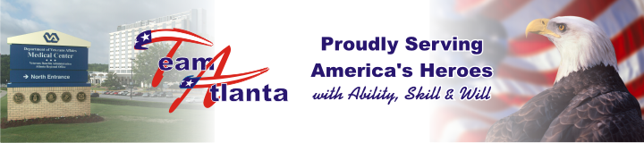
December 26, 2007
Director’s Holiday Open House spreads Yuletide Cheer 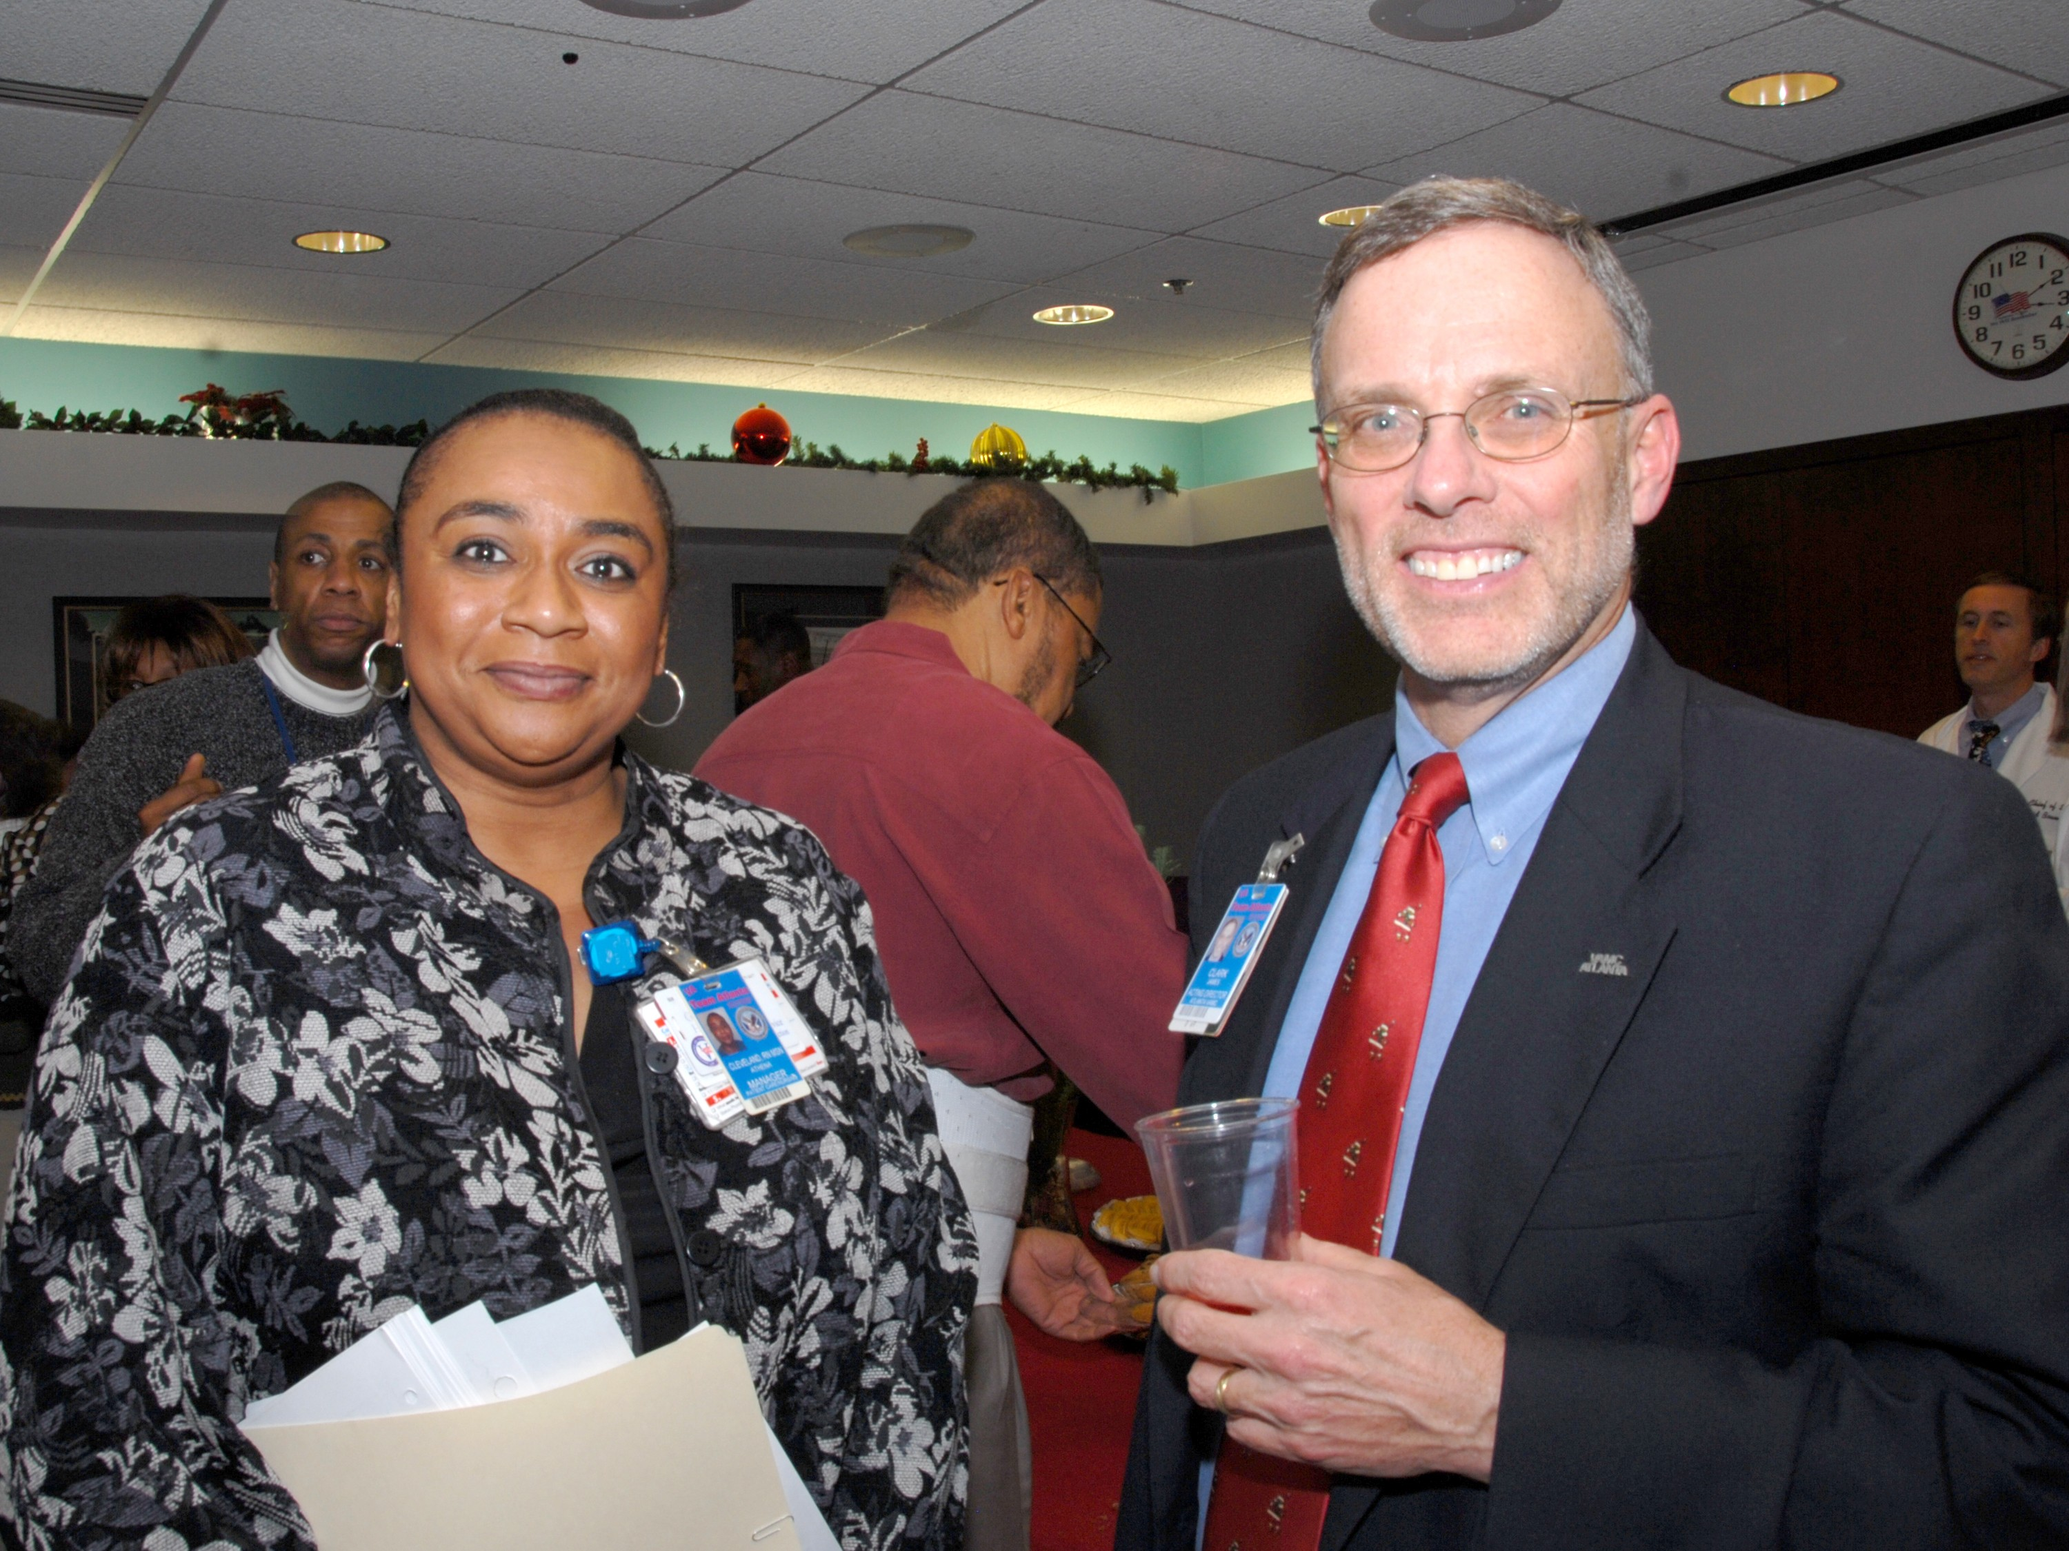
Acting Director James Clark and Nurse Manager Athena Cleveland take part in the festivities.

Some VAMC employees began their Yuletide
celebrations early this year by attending the Director’s annual Holiday Open House on Dec 19.
For one newly arrived nurse, it was a heartwarming gesture that left a lasting impression.
“This is my first month and my first Christmas here at the VA, and I’m pleased to say that the event was a great success and I am looking forward to next year's event,” said nurse Carolyn Robinson.
Nurse Manager Athena Cleveland added that celebrations like the Director’s Holiday Open House go a long way in building employee morale.
“Every staff member is an important part of the organization and this reception is a wonderful way to show that each person is a valued member of Team Atlanta.”
News Briefs

What is Integrated Ethics? A national education and organizational change initiative that provides a comprehensive approach to ethics in health care. Integrated Ethics is designed to improve ethics quality across VHA.
Integrated Ethics addresses ethics quality at all levels—at the level of decisions and actions, at the level of the systems and processes that drive decision making, and at the level of the values, environment, and culture that shape ethical practices overall.
What is an Integrated Ethics program? Effective ethics programs must do three things well: respond to ethics concerns on a case by case basis, address ethics issues on a systems level, and foster an environment and culture that is conducive to ethical practice.
Local Integrated Ethics programs achieve these goals through three core functions:
- ethics consultation
- preventive ethics
- ethical leadership
In addition to ethics consultation, preventive ethics, and ethical leadership coordinators, in each facility an Integrated Ethics Program Officer is responsible for day-to-day operations and an Integrated Ethics Council coordinates ethics-related activities across the organization. Facility Points of Contact:
- Ethical Leadership – Dr. David Bower, Chief of Staff, x-7604
- Integrated Ethics Program Officer – Kevin Hayes, AA/COS, X-1540
- Ethics Consultant – Dr. Mark Shumate, X-7860
- Preventive Ethics – Cindy Siegler, Compliance and Business Integrity Officer, X-2297
Joint Commission- For patient safety concerns, contact
Quality Management at ext. 6243; to file a complaint, contact the Office of Inspector General at (800) 488-8244 or VA IG at 53E/P.O. Box 50410, Washington, DC 20091 or contact Joint Commission at (800) 994-6610 or email complaint@jointcommission.org. No adverse action will be taken against those who report safety or quality of care concerns.
Dial-A-Prayer- VAMC’s Chaplain Service is now offering a Dial-A-Prayer service/ministry. Dial-A-Prayer is available all day and every day. If you are calling from an outside telephone, dial 404-321-6111, ext 4161.

Radiology Department gifts patient in time of need

examination. During the pre-exam interview,
the patient shared with technologist Lisa
Baptiste the struggles and misfortune that he and his family had encountered. This patient, while undergoing diagnostic testing for his personal health, expressed much more
concern about the welfare of his family than himself.
To make the holiday a little less stressful, the Radiology Department contacted the patient and inquired as to how they could best help his family. The patient stated that his greatest need was to pay a much overdue electricity bill totaling $480.00. In the spirit of the season, the radiology staff contacted the Georgia Power Company and paid the bill in full and continued spreading holiday cheer by sending the family a gift card.

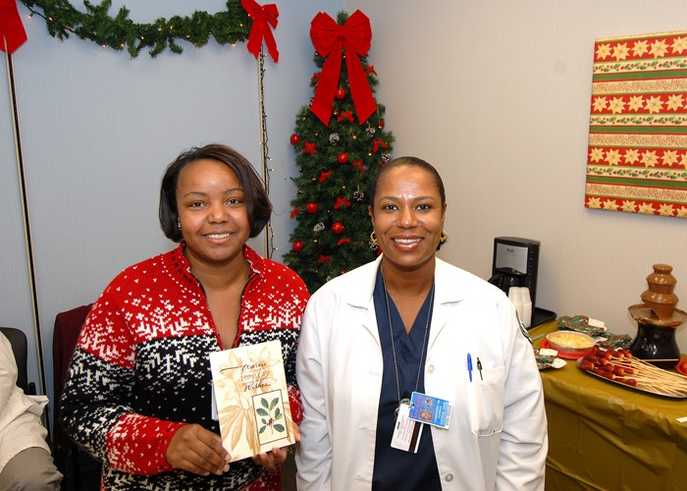
Radiology Department’s Erica Hall (left) and Florence Longchamp display gift card for the patient the department rallied to assist.

On Dec 1, 2007, a patient visited the Atlanta VA Medical Center for a scheduled radiology

Eagle’s Nest receives holiday gift from Vulcan Materials
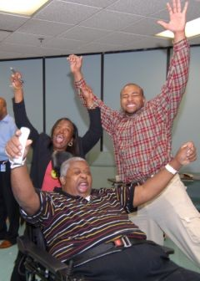
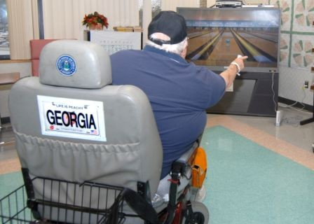
Carol Landrum of Vulcan Materials and one of her associates presented the Wii game to the NHCU residents during the Resident Council meeting. The Wii game is one of the most popular interactive video games, requiring upper limb strength (arms and hands) and concentration. Ms Landrum and her associate loaded the second floor dayroom television with the game and then walked the residents through it.



