USDA Foreign Agricultural Service
GAIN Report

Template Version 2.09

Global Agriculture Information Network

Required Report - public distribution
Date: 9/6/2005
GAIN Report Number: KS5045
KS5045
Korea, Republic of
Livestock and Products
Annual
2005

Approved by:
Stan Phillips
U.S. Embassy
Prepared by:
Yong Keun Ban

Report Highlights:

The continuing ban on U.S. and Canadian beef is driving prices for pork and Hanwoo beef higher. Consumers are searching for alternatives while Korean cattle and swine producers are enjoying firm prices. Hanwoo beef producers reacted by increasing cattle inventories. Strong pork prices combined with constraints to expansion of swine inventories are expected to lead to continued robust imports of pork in 2006. Government policy toward beef and pork production is increasingly emphasizing quality, safety and providing information to consumers.

Includes PSD Changes: Yes
Includes Trade Matrix: Yes
Annual Report
Seoul [KS1]
[KS]
Table of Contents
Section I: Situation and Outlook 3
Section II: Cattle, Beef, and Veal 5
Section III: Swine and Pork 10
Section IV: Statistical Tables: Cattle and Beef 14
PS&D Table for Cattle 14
PS&D Table for Beef 15
Cattle and Beef Tables 16
Section V: Statistical Tables: Swine and Pork 23
PS&D Table for Swine 23
PS& Table for Pork 24
Swine and Pork Tables 25

Section I: Situation and Outlook

Korea is currently maintaining bans on both U.S. and Canadian beef. In June 2005, Korean officials traveled to the United States to conduct technical talks with U.S. officials and review additional BSE protection measures put into place in the United States since May 2004. However, news that a second case of BSE had been detected in Texas caused Korean officials to defer release of their findings from the trip pending review of the final epidemiological report on the Texas BSE case. The epidemiological investigation report was provided to the Korean government at the end of August. The Korean government will review the report and convene a meeting of the Animal Health Committee to evaluate all the information obtained from three rounds of Korea-U.S. technical talks, site visits made by Korean officials in the United States and other sources of information such as the epidemiological report. The Animal Health Committee will advise the Minister of Agriculture of its findings and recommendations. The Minister will review the report from the Animal Health Committee and decide whether to allow for high-level policy negotiations on setting the conditions for import resumption of U.S. beef. Post will adjust the estimates in this report if Korea changes its policy and allows beef to enter from the United States.

In part as a result of heightened concerns about food safety, the Korean government introduced a pilot traceability system in some discount stores in 2005. The system is designed to enhance consumer confidence in locally produced Hanwoo beef and is expected to increase beef consumption in 2005 and 2006. The regional elections in April 2006 will also help boost beef consumption. Frozen U.S. beef that cleared quarantine inspection prior to the import ban in December 2003 was reaching the end of its shelf life and has now been used up.

Lucrative Hanwoo fed cattle prices and, in turn, increased demand for Hanwoo feeder calves have encouraged farmers to expand their herds. Cow inventories (over 2 years old) increased from 617,000 head in December 2004 to 647,000 head in June 2005. Another round of herd contraction could occur if Hanwoo beef prices subside after U.S. beef returns to the market. However, inventory adjustments would likely be relatively small compared to the contraction that occurred in late 2000 and early 2001 when the beef market was liberalized.

Government policies have focused less on stimulating Hanwoo production and more on emphasizing enhancements to the food safety system for domestic beef. Among other aspects, the new focus includes development of a traceability program and environment friendly livestock production policies.

Despite significant increases in the Hanwoo inventory and a sluggish economy, Hanwoo beef retail prices remain twice as high as imported Australian beef. Hanwoo products target the high-income consumer market. However, the majority of Korean beef consumers who focused formerly on reasonably priced but high quality imported beef have now shifted to other substitute products, such as pork and fish. Because most Koreans prefer highly marbled beef over lean meat, many consumers have opted to switch to pork rather than Australian beef which is leaner than Hanwoo or U.S. beef. This shift has caused pork prices to rise.

Korean government’s efforts to resume fresh/chilled/frozen pork exports to Japan has been hampered by Japan’s prohibition on imports for one year after the last vaccination against classical swine fever. Korea continued to vaccinate its swine in 2005. Agreement was reached with Japan in August 2005 to export heat-treated pork. However, the domestic pork industry is unlikely to view the agreement as attractive at present, given the lucrative domestic pork prices. Pork production continues to drop in 2005 as more environmental restrictions eliminate farms that cannot afford required pollution control equipment. However, strong pork demand as people continue to substitute pork for beef will likely forestall a large shakeout among hog producers until consumers shift back to imported beef.

Korea has a positive list of approved veterinary drugs (antibiotics, growth hormones, feed additives, etc.). Veterinary drugs that are not on Korea’s positive list should not be detected in any meat product. Some of the approved veterinary drugs are allowed to be administered through compound feed. However, the total number of veterinary drugs approved for use in compound feed was reduced from 53 to 25 items on December 10, 2004. This measure went into effect on May 1, 2005.

The maximum residue level of antibiotics and pesticides permitted in meat products can be found by visiting the Korea Food & Drug website at www.kfda.go.kr.

Section II: Cattle, Beef, and Veal

Production

The Korean Hanwoo cattle inventory continues to increase in 2005. This trend is projected to continue into 2006. The ongoing import ban on U.S. and Canadian beef and ensuing record level farm gate prices for Hanwoo cattle and calves in 2005 have caused farmers to expand their herds. Also, the introduction of programs to enhance consumer confidence in Hanwoo beef and provide assurance of its authenticity appear to be buttressing demand for Hanwoo beef against future resumption of imports from the United States and Canada.. The import ban on U.S. beef has been in place since December 2003. Accordingly, most of the U.S. beef that had entered Korea prior to the ban has now been consumed since it was approaching the end of its shelf life which is less than 2 years under Korea regulations.

Reflecting Hanwoo producers’ optimism, beef cow inventories have increased from 617,000 head at the beginning of 2005 to 647,000 heads as of July 1, 2005. Some of the increase in cow numbers is due to increased feeder calve prices which jumped 361,000 won per head (about US$350) during the first 6 months of 2005. Fed cattle prices increased only 106,000 won (about US$103) per head during the same period perhaps reflecting speculation that prices will peak in 2006. The number of farm households involved in Hanwoo beef production increased from 189,000 to 192,000 during the first half of 2005.

In June 2005, news of the second case of BSE in the United States created optimism among local producers that imports of U.S. beef would not resume in 2005. The United States provided the epidemiological investigation results on the second BSE case at the end of August. The Korean government will review this report and add it to the body of information on measures to safeguard U.S. beef that will be provided to the Animal Health Committee (an advisory group comprised of public and private sector experts). The Committee will review the information and provide the Minister of Agriculture with its advice and recommendations. The Minister will review the Committee’s input and decide whether to begin negotiations for trade resumption. If trade does resume after such negotiations, there is a possibility of another round of herd contraction if Hanwoo beef prices subside after U.S. beef returns to the market. However, inventory adjustments are not expected to be as significant as those which occurred at the end of 2000 and early 2001 when the beef market was liberalized.

If U.S. beef trade resumes in 2006, Hanwoo calf production will contract as producers readjust to the presence of high quality grain-fed U.S. beef on the market. In turn, total slaughter numbers will increase. However, because of the high calf production in 2005, the overall ending inventory in 2006 is expected to remain stable.

The Korean government introduced a pilot beef traceability system in some of the discount stores to increase consumer confidence in the authenticity of Hanwoo beef. Based on preliminary indications, the traceability system is expected to increase beef consumption in 2005. In its first year of implementation in 2005, a total of 53,000 head are participating in the program. The Korean government’s goal is to apply the system to all Hanwoo cattle by 2009.

In general, the basic policy for the beef industry is aimed at providing higher-quality, safe livestock products that will meet the consumer demand in contrast to past emphasis on production-related support.

On May 7, 2005, a shipment of feeder calves (851 head) was imported from Australia for the first time in 14 months. Local producers did not protest as they did when previous cattle imports occurred. However, producer group representatives vowed to track the animals and make sure that they are not marketed falsely as domestic Hanwoo beef after slaughter.

MAF has implemented the following initiatives to provide higher-quality, safe livestock products that will meet the demand of consumers in 2005:

Cash Incentives for Quality Improvement: Castrated Hanwoo steers that receive “Grade A+” after slaughter qualify for a cash premium of 200,000 won/head and those that receive “Grade A” receive 100,000 won/head. The total number of animals expected to receive this cash incentive in 2005 is targeted at 61,000 head, compared to 17,000 head in 2004. The government has budgeted 8.48 billion won (US$8.2 million) for 2005. Only cattle that were born in Korea are eligible for the incentive payment. Audits of the program indicate some payments under the program may have gone to ineligible recipients in 2004 and 2005. As a result, it is possible that funding for the program may be reduced in 2006.

Mandatory Livestock Registration: The Ministry of Agriculture & Forestry is implementing its plan to require livestock farmers to register with the municipal/provincial government. To comply with registration requirements, farmers must maintain a minimum farm space per animal and undergo education on environmentally friendly agriculture once a year. Hanwoo farms larger than 300 square meters and swine farms larger than 50 square meters are required to register by the end of 2005. When the registration is completed, the government will have a better database for controlling livestock diseases, targeting support and enforcing prerequisites for obtaining support. The government has budgeted 18.79 billion won (US$18.2 million) in 2005 for this project.

Improvement of BSE Monitoring System: Korea randomly tests 1000 head of cattle per year under a BSE monitoring program. Cattle tested under the monitoring program are allowed to move into the market before the test results become available. In addition to the animals tested for BSE on a monitoring basis, all cattle exhibiting suspicious signs are required to undergo testing for BSE. The animals subject to the mandatory test are not allowed to enter the market until the test result becomes available.

Beef Traceability System: Korea plans to introduce a beef traceability system on a trial basis from October 2004 to 2008. When implemented, it will provide information for beef by each stage of production, from the cattle farm, slaughter plant, processing facility to marketing channels. The tracebility system will target 9 brands in 2005, which will cover around 45,000 head of Hanwoo cattle. Total budget for this project is set at 367 million won ($356,000) in 2005 to provide support for procurement of ear tags, setting up the computer system, purchase of code scanners, printers, etc. The government will also test a traceability system for imported beef in 2005 by selecting 2 importing companies, 1 processing plant, 2 retail stores and 2 quarantine facilities. Radio Frequency ID (RFID) Chips will be used to conduct the trial traceability program for imported beef. Pending the results of the trial, the government plans to implement this program for all Hanwoo cattle in 2009.

Hanwoo Cattle Check-Off Program: Hanwoo producers have agreed to implement a mandatory check-off program to secure funding for promotion of Hanwoo beef. As of May 1, 2005, slaughter plants began collecting 20,000 won/head (US$19.4) when Hanwoo cattle are delivered at the slaughter plant. The check-off funds, less 3 percent provided as an administrative fee for slaughter plants, will be deposited in a central fund. The government plans to provide matching funds up to the amount contributed by the producers. The check-off funds and the government’s matching funds are expected to amount to a total of 5.2 billion won (US$5 million) in 2005, among which half will be used for promoting Hanwoo beef in 2005 and the remainder will be held in reserve for future activities.

Facilitation of Livestock Packing Centers (LPC): On August 24, 2005, the Ministry of Agriculture & Forestry announced a plan to facilitate improvement of the LPCs. The program is intended to enhance operations and competitiveness of the seven LPCs that are currently in operation by providing incentives to produce more sanitary meat. After evaluating the HACCP operation level and management level, the government will provide a zero-interest loan to the top one-third of the LPCs, a low interest loan of 3 percent to the middle-third, and no support to the LPCs that fall into the bottom third. The Ministry will also extend the loan period for the existing government loans for 2 years. The government hopes to expand LPC marketing opportunities by allowing the LPCs to conduct wholesale business and also promote the marketing of boxed meat. Currently, most of the meat that is slaughtered in 108 slaughter plants is marketed in the form of whole and half carcasses. The government will also stop giving business permits for new slaughter plants.

Beef Imports

The import statistics used in this report reflect shipments that have officially cleared customs. Therefore, the import numbers in the PS&D and trade matrix from United States and Canada are actually products that had cleared quarantine inspection prior to the BSE outbreak (December 23, 2003 for the United States and May 2003 for Canada) but cleared customs in 2004 and 2005.

Initial concerns among Korean consumers have faded as more information has become available. Reports of market opening in other countries, continued strong beef consumption in the United States and activities to educate consumer representatives and the media in Korea have all contributed to easing consumer concerns. As a result, consumption of beef has gradually increased. Local producers captured some of the market but the bulk of the increase in consumption was filled by imports from Australia and New Zealand. Also, U.S. frozen beef that had cleared quarantine inspection prior to December 2003 continued to be supplied through the first half of 2005. Beef imports are expected to increase during the second half of 2005 as imported U.S. beef in the warehouses has been used up and demand continues to improve. Koreans’ preference for highly marbled grain-fed beef is a constraint on Australia and New Zealand’s promotional efforts to capture the market supplied by U.S. and Canadian beef in the past. Australia has reportedly increased its supply of grain-fed beef. However, increased exportable supplies of grain-fed Australian beef still fall far from meeting the demand that existed prior to the ban for highly marbled U.S. beef.

Korean quarantine officials are currently conducting a survey to see if importers would prefer to grant priority to quarantine inspection of chilled meat over frozen meat. Currently, all meat that must undergo laboratory inspection is inspection on a first-come-first-serve basis whether it is chilled or frozen. As a result, importers of chilled meat can face delays in inspection which create difficulty in selling chilled meat within the shelf life. If the government’s plan to prioritize the inspection of chilled meat is realized, it would allow importers to have more time to market chilled meat products and likely expand imports of chilled meat.

The government also is trying to pass a law that would mandate country of origin labeling for beef on restaurant menus. Such efforts are designed to address complaints from Hanwoo beef producers that roughly 30 percent of restaurants market dishes made from imported beef as Hanwoo beef dishes. A DNA test conducted by Seoul YWCA showed that 12 out of 41 restaurants were found to be selling imported beef or dairy cow beef as Hanwoo beef. The government is providing a reward of 50,000 – 1,000,000 won (US$48 - $965) to people that report false labeling of country of origin of beef.

The Korean government has also agreed to conduct an import risk assessment of Argentine beef. Currently, beef imports from Argentina are prohibited due to concerns over foot-and-mouth disease.

The U.S. Meat Export Federation (USMEF) continues to conduct promotional activities to educate consumers and restore consumer confidence in consumption of beef. Such activities have served a vital role in providing factual information about BSE to the public to counter inaccurate information reported in the media. USMEF escorted a team composed of consumer groups and scholars to the United States in May 2005 to show them the measures in place to secure the safety of U.S. beef against BSE. USMEF plans to continue to promote the safety of U.S. beef among consumers during the second half of 2005.

Australia is aggressively promoting its beef in the Korean market during the absence of U.S. beef, under the slogan of “Clean and Safe” Australian beef. To commemorate its third year of the promotional campaign, it conducted a special “333 Festival” during the period April 28 – May 15, 2005, where it offered free round-trip tickets to Australia for 100 people as well as free steak dinners for 999 couples, etc. The key message that Australia emphasized during this campaign was “Safe, delicious and nutritious.”

Canada, whose beef imports are also currently banned, continues to promote the safety of its beef in Korea, under the slogan of “Beef at its Best from Canada.” The key message that Canada is also focusing on is the fact that Canadian beef is safe by promoting traceability since 2001, separate control of cattle older than 30 months, SRM removal, feed ban, and that Canadian beef originates largely from cattle that were born after the feed ban went into effect.

Consumption/Utilization/Stocks

As can be seen from the promotional efforts by beef exporting nations as well as some of the Korean government policies, restoring consumer confidence in the safety of beef is the key to increasing beef consumption. Increased understanding of measures to protect consumers among consumer representatives and media appears to have resulted in a reduction in reporting on BSE in the local media. Accordingly, consumer confidence is gradually improving and restoring normal consumption patterns. Also, the major election for electing municipal/provincial government officers and representatives scheduled for April 2006 may boost the economy to some extent and will help increase beef consumption.

Imported stocks of U.S. beef have run out. Beef restaurants are having trouble securing beef that meets the quality level of U.S. beef but is still less expensive than Hanwoo beef. This is because consumers prefer the taste of grain fed U.S. beef which cannot be found among the suppliers of imported beef that are currently in the market. The gap created by the absence of U.S. and Canadian beef has left the market divided into distinct high and low-end categories. Within the high-end market consumers continue to purchase prime quality Hanwoo beef even though the price is about 4,000 won (US$3.9)/kg more expensive than select quality Hanwoo beef. The lower end category is comprise of imported beef or beef produced from local dairy cattle or imported cattle.
Korean language web sites of interest (some contain limited information in English):

Ministry of Agriculture & Forestry: www.maf.go.kr
National Agricultural Products Quality Service: www.naqs.go.kr
National Agricultural Cooperatives Federation: www.nacf.co.kr
Korea Rural Economic Institute www.krei.re.kr
Korea Swine Association: www.koreapork.or.kr

The conversion factor used for converting carcass to boneless weight is 1.25 for pork and 1.36 for beef.

Section III: Swine and Pork

The swine industry has been enjoying historically high swine prices due to a decline in swine inventory and increased pork consumption since cases of BSE were detected in North America. Substitution of pork for poultry meat following outbreaks of avian influenza (AI) in countries that were major poultry meat suppliers to Korea has also contributed to strong demand for pork. Initial concerns regarding BSE and AI have eased and consumers are, to a degree, increasing consumption of beef and poultry meat.

Despite the signs that pork demand may have peaked, pork prices remain high as increases in domestic swine inventories have been hampered by continuing problems with swine disease outbreaks in Korea and implementation of strict environmental regulations. Swine inventory levels have consequently contracted significantly in 2005 and have offset reduced pork demand to keep swine prices high. Various environmental restrictions will continue to tighten the supply of swine production in 2006. Also, if U.S. beef imports are resumed, ending swine inventories in 2006 may contract to levels below 2005.

The Korean swine industry has suffered from three major porcine diseases that have caused the overall inventory to drop. The so called “three P’s,” are Post-weaning Multi-systemic Wasting Syndrome (PMWS), Porcine Reproductive & Respiratory Syndrome (PRRS), and Porcine Epidemic Diarrhea (PED). The disease problems have resulted in high losses of weaning pigs.

The Korean government’s requirement to register all swine farms that have over 50 square meters of livestock growing facilities by the end of 2005 is another factor limiting herd expansion. Farms subject to registration must be equipped with pollution control facilities and meet certain minimum space requirements per animal. Due to the costs associated with complying with the regulations, only 72.7 percent of the farms subject to registration requirements had registered as of August 12, 2005.

The increased fee for disposal of swine excrements is another negative factor that is limiting increases in swine inventories. The fee increased from 16,000 won/MT (US$15.5) in 2004 to 20,000 won/MT (US$19.4) in 2005. There are rumors that the fee may go up another 20 percent.

Another environmental-related law that went into effect as of February 2005 is called the Act on Prevention of Offensive Odor. This Act requires the control of 12 different types of odor, including ammonia in 2005. In 2006, 5 other types of odor, including toluene will be added onto the list and 5 more types of odor, including propionic acid, will be added to the list again in 2007. The Korean government distributed 11,000 copies of handbook on controlling odor in swine farms. If the government receives a complaint from a neighbor about odor, it will conduct an investigation and will give out a warning notice for the first violation. The second violation will be subject to a fine and the third violation will mean the closure of the farm. Such strict measures have forced smaller farms that cannot afford to purchase pollution control equipment to exit from swine production. Large farms that have more than 1,000 head accounted for 77 percent of swine production in Korea as of June 2005. The decision by the Korean government on when to lift the import ban placed on U.S. beef will also influence pork and, in turn, swine production levels.

Despite the constraints to increasing swine inventory, producers who are able to raise swine are enjoying a lucrative year. The average production cost of a hog is 179,000 won/head (US$173). With farm gate prices reaching 277,000 won/per head (US$268), farmers are earning roughly US$95 per head. Such high domestic swine prices have increased pork imports in 2005. Also, limitations to increasing the herd size due to strict environmental restrictions will inhibit domestic production from capturing a greater share of consumption in 2006 and will result in higher import volumes.

High domestic swine prices are creating other problems. As farm gate prices surge, farmers are less concerned about quality and are sending hogs to the slaughter plants before they are over 110 kg resulting in reduced quality pork. The average slaughter weight dropped from 110 kg during the first quarter of 2005 to 108 kg during the second quarter of 2005. Because of the unstable quality of domestic pork, imported frozen pork of consistent quality has commanded a price premium over domestic frozen pork.

According to a survey conducted by the National Agricultural Cooperatives Federation (NACF) in 2005, consumers cited their reasons for eating pork as:

- because of its good taste (54.3 percent);
- because other family members like pork (21.2 percent);
- because of the low price (10.7 percent).

When NACF marketed the first organic pork on August 12, 2005, it was quickly sold out despite prices that were three times higher than non-organic pork. Organic pork bellies, the most popular cut, sold for 42,900/kg (US$41.55/kg). Organic Boston butts sold for 32,100 won/kg (US$31.1/kg). The prices for organic pork exceeded prices for low-priced Hanwoo beef cuts such as rounds, which sold for 25,800 won/kg (US$24.99/kg).

The Japanese government requires exporting countries to be free from classical swine fever (CSF) for one year from the last vaccination. Therefore, as Korea continued to vaccinate against CSF in 2005, prospects for exporting fresh/chilled/frozen pork to Japan, once Korea’s largest export market, seem unlikely for the near future. Korea and Japan reached an agreement in August 2005 to allow for Korean heat-treated pork to be exported to Japan. However, because of high pork prices in Korea, there is not much incentive to export heat-treated pork to Japan at the moment. Small amounts of Korean pork continue to be exported to the Philippines but exports to Russia have ceased because domestic prices are more attractive.

Government negotiations on a breeding hog export protocol to the Philippines are not progressing as expected. Korean breeding farms are also not eager to export hogs to the Philippines because there is a high demand from the local swine industry. Korean exporters are looking forward to the FTA agreement with ASEAN, which is composed of ten South East Asian nations. The Korean government hopes to sign an agreement by 2006 with implementation in 2007.

The Korean Swine Association plans to spend 7.9 billion won (about US$7.67 million) in 2005 on promotional activities to increase the consumption of unpopular cuts by airing ads on television and radio programs. This is a significant increase from the 2.6 billion won (about US$2.25 million) expended on such activities in 2004. Over 81.5 percent of the consumers were aware of the promotion and 55 percent of the surveyed consumers replied that their perception towards unpopular lean pork cuts had improved favorably. As with beef promotion, pork exporters are also focusing on food safety as a major component in promotional activities. Similarly, Danish pork promotions are focusing on the safety. The U.S. Meat Export Federation has actively promoted U.S. pork in major discount stores in Korea along with private U.S. pork export companies who have featured promotions of ‘chilled’ U.S. pork.

Selected support programs for the swine sector in 2005, some of which also encompass the cattle sector, follow:

Support for Branded Pork: The government plans to provide 163 billion won ($158 million) to enhance the total amount of pork marketed under brand names. It will provide loans under the program at an interest rate of 3 percent per annum, with a 3-year grace period and full repayment at the end of the loan period. In 2005, there are 207 registered brands (including beef and chicken). The Korean government’s goal is to focus the program on active brand names and reduce the total number of brands participating in the program to 80 or 90 by 2007.

Mandatory Livestock Registration: See details in Section II.

The Korea Chile Free Trade Agreement (FTA) went into effect April 1, 2004. One result of the FTA has been that Korea has increased duty-free quota access for Chilean pork and reduced duties on out-of-quota pork imports from Chile. Pork imports from Chile are projected to rise from 23,203 MT in 2004 to 33,600 MT in 2005. Chilean pork exporters will have tariff-free access to Korea for most cuts after the Chile-Korea FTA has been in effect for 10 years. Korea and Chile will negotiate the tariff treatment for carcasses and half-carcasses under the FTA after the end of the Doha Development Agenda negotiations.

Korea-Chile Free Trade Agreement: Impact on Pork Trade
HS Heading | Description | Category 1/
0203 | Meat of swine, fresh, chilled or frozen.
02031 | Fresh or chilled:
0203110000 | Carcasses and half-carcasses | Year 10
0203120000 | Hams, shoulders and cuts thereof, with bone in | Year 10
020319 | Other
0203191000 | Belly | Year 10
0203199000 | Other | Year 10
02032 | Frozen:
0203210000 | Carcasses and half-carcasses | Doha Development Agenda 2/
0203220000 | Hams, shoulders and cuts thereof, with bone in | Year 10
020329 | Other
0203291000 | Belly | Year 10
0203299000 | Other | Year 10
1/ Chilean pork exporters will have tariff-free access to Korea for most cuts after the Chile-Korea FTA has been in effect for 10 years.
2/ Korea and Chile will negotiate the tariff treatment for carcasses and half-carcasses under the FTA after the end of the Doha Development Agenda negotiations.

Customs duties on imports into Korea originating in Chile under category "Year 10" shall be eliminated in accordance with the following timetable.

Korea-Chile Free Trade Agreement: Tariff Staging for Product in Year 10 Category
“Year 10” Category | 2004 |  | 2005 | 2006 | 2007 | 2008 | 2009 | 2010 | 2011 | 2012 | 2013 | 2014
“Year 10” Category | Before Apr 1 | After Apr 1
Percentages of annual tariff reduction | 0 | 9.1 | 18.2 | 27.3 | 36.4 | 45.5 | 54.5 | 63.6 | 72.7 | 81.8 | 90.9 | 100
Example:  Tariffs (%) for Frozen Bellies  From Chile  0203.29.1000 | 25 | 22.7 | 20.5 | 18.2 | 15.9 | 13.6 | 11.4 | 9.1 | 6.8 | 4.6 | 2.3 | 0

Korean language web sites of interest (some contain limited information in English):

Ministry of Agriculture & Forestry: www.maf.go.kr
National Agricultural Products Quality Service: www.naqs.go.kr
National Agricultural Cooperatives Federation: www.nacf.co.kr
Korea Rural Economic Institute www.krei.re.kr
Korea Swine Association: www.koreapork.or.kr

The conversion factors used for converting a carcass to a boneless weight are 1.25 for pork, 1.36 for beef.

Section IV: Statistical Tables: Cattle and Beef

PS&D Table for Cattle

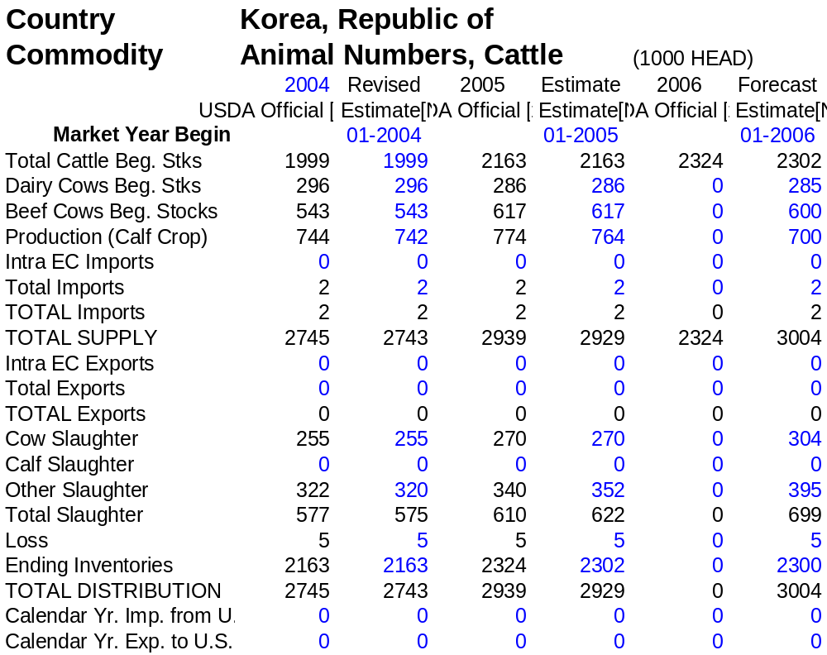

PS&D Table for Beef

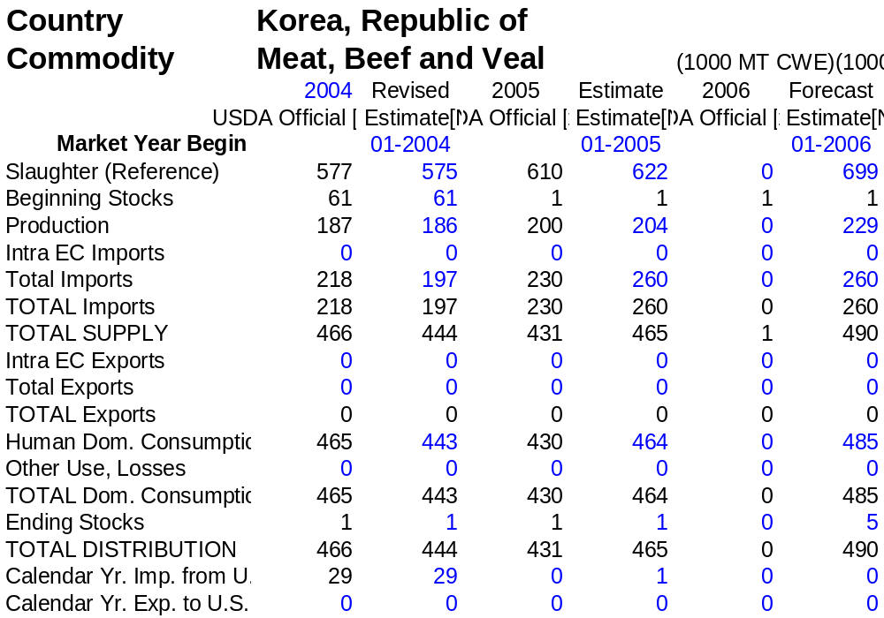

Cattle and Beef Tables

Korea: Beef Imports (2004 – 2005)

Country | 2004 | 2005
Country | Revised | Preliminary
Country | (In metric tons, product weight equivalent)
U.S.A. | 25,427 | 800
Australia | 88,719 | 94,600
New Zealand | 44,881 | 42,300
Mexico | 769 | 1,800
Canada | 261 | 10
Others | 69 | 490
TOTAL | 106,126 | 140,000
Source: Korea Customs Service, Office of Ag. Affairs
Product Weight Equivalent

Korea: Beef Imports (Annual 2004, First Six Months of 2004 and 2005)
(Unit: Metric tons and $000)
Country | Annual 2004 |  | Jan. – Jun., 2004 |  | Jan. – Jun., 2005
Country | Volume | Value | Volume | Value | Volume | Value
U.S.A. | 25,427 | 95,403 | 18,405 | 65,948 | 719 | 3,795
Australia | 88,719 | 315,794 | 38,435 | 131,424 | 55,582 | 216,486
New Zealand | 44,881 | 130,486 | 21,326 | 59,219 | 24,835 | 88,130
Mexico | 769 | 1,976 | 266 | 607 | 1,036 | 4,020
Canada | 261 | 209 | 261 | 209 | 1 | 8
Others | 69 | 402 | 56 | 115 | 118 | 320
TOTAL | 160,126 | 544,270 | 78,749 | 257,522 | 82,291 | 312,759
Source: Korea Customs Service, Office of Ag. Affairs
Product Weight Equivalent

Korea: Processed Beef Imports (Annual 2004, First Six Months of 2004 and 2005)
(Unit: Metric tons and $000)
Country | Annual 2004 |  | Jan. – Jun., 2004 |  | Jan. – Jun., 2005
Country | Volume | Value | Volume | Value | Volume | Value
U.S.A. | 1 | 12 | 1 | 12 | 0 | 0
Mongolia | 29 | 32 | 29 | 32 | 27 | 18
Brazil | 18 | 17 | 0 | 0 | 0 | 0
PRC | 17 | 7 | 17 | 7 | 16 | 23
Australia | 16 | 175 | 9 | 84 | 2 | 38
Philippine | 12 | 25 | 6 | 13 | 4 | 8
Other | 0 | 0 | 0 | 0 | 0 | 0
TOTAL | 93 | 268 | 62 | 148 | 49 | 87
Source: Korea Customs Service, Office of Ag. Affairs
Product Weight Equivalent (HS 021020 and 160250)

Korea: Processed Beef Exports: Exports of processed beef products were minimal. Korea exported a total of 4.8 MT in 2004, compared to 7 MT in 2003. There were no exports during the first six months of 2005.

Korea: Cattle Slaughter Trend

Month | Total | Cows | Steers
Month | (Heads Slaughtered)
Total 1997 | 1,125,281 | 573,954 | 551,327
Total 1998 | 1,282,290 | 643,266 | 639,024
Total 1999 | 1,096,207 | 614,325 | 481,882
Total 2000 | 997,331 | 547,745 | 449,586
Total 2001 | 729,245 | 369,039 | 360,206
Total 2002 | 633,024 | 313,466 | 319,558
Total 2003 | 583,799 | 268,986 | 314,813
Total 2004 | 574,426 | 254,761 | 319,665
January, 2004 | 51,733 | 21,662 | 30,071
February, 2004 | 21,932 | 11,160 | 10,772
March, 2004 | 34,746 | 16,903 | 17,843
April, 2004 | 45,603 | 20,959 | 24,644
May, 2004 | 47,426 | 21,672 | 25,754
June, 2004 | 48,940 | 20,781 | 28,159
July, 2004 | 47,583 | 21,958 | 25,625
August, 2004 | 48,616 | 21,058 | 27,558
September, 2004 | 78,393 | 33,012 | 45,381
October, 2004 | 42,975 | 19,151 | 23,824
November, 2004 | 50,952 | 21,837 | 29,115
December, 2004 | 55,527 | 24,608 | 30,919
January, 2005 | 73,666 | 29,417 | 44,249
February, 2005 | 51,342 | 23,818 | 27,524
March, 2005 | 43,620 | 16,538 | 27,082
April, 2005 | 43,115 | 18,484 | 24,631
May, 2005 | 44,449 | 19,157 | 25,292
June, 2005 | 41,423 | 18,093 | 23,330
Source: Ministry of Agriculture & Forestry

Korea: Live Hanwoo Beef Cattle Prices

(Won per head, Exchange rate is US$1=1,030 won)
Month/Year | Calf |  | 500 Kg.
Month/Year | Female | Male | Female | Male *
1999 Average | 774,000 | 1,024,000 | 2,401,000 | 2,488,000
2000 Average | 1,103,000 | 1,294,000 | 2,872,000 | 2,752,000
2001 Average | 1,729,000 | 1,785,000 | 3,514,000 | 3,245,000
2002 Average | 2,306,000 | 2,288,000 | 4,236,000 | 3,927,000
2003 Average | 3,242,000 | 2,610,000 | 4,849,000 | 3,907,000
2004 Average | 3,226,000 | 2,246,000 | 4,339,000 | 3,512,000
January, 2004 | 3,792,000 | 2,731,000 | 5,119,000 | 3,955,000
February, 2004 | 3,601,000 | 2,573,000 | 4,858,000 | 3,625,000
March, 2004 | 3,487,000 | 2,427,000 | 4,690,000 | 3,452,000
April, 2004 | 3,264,000 | 2,250,000 | 4,445,000 | 3,177,000
May, 2004 | 2,751,000 | 1,998,000 | 4,087,000 | 2,925,000
June, 2004 | 2,874,000 | 2,068,000 | 3,944,000 | 2,917,000
July, 2004 | 3,168,000 | 2,205,000 | 4,114,000 | 3,374,000
August, 2004 | 3,192,000 | 2,165,000 | 4,181,000 | 3,567,000
September, 2004 | 3,202,000 | 2,167,000 | 4,155,000 | 3,659,000
October, 2004 | 3,181,000 | 2,178,000 | 4,198,000 | 3,872,000
November, 2004 | 3,165,000 | 2,133,000 | 4,169,000 | 3,877,000
December, 2004 | 3,033,000 | 2,059,000 | 4,106,000 | 3,740,000
January, 2005 | 2,877,000 | 2,037,000 | 4,022,000 | 3,520,000
February, 2005 | 2,920,000 | 2,131,000 | 4,036,000 | 3,563,000
March, 2005 | 3,037,000 | 2,216,000 | 4,175,000 | 3,605,000
April, 2005 | 3,219,000 | 2,316,000 | 4,215,000 | 3,634,000
May, 2005 | 3,294,000 | 2,343,000 | 4,220,000 | 3,648,000
June, 2005 | 3,372,000 | 2,409,000 | 4,223,000 | 3,695,000
July, 2005 | 3,414,000 | 2,410,000 | 4,259,000 | 3,799,000
Source: Ministry of Agriculture & Forestry
National Agricultural Cooperatives Federation

* These are average prices of non-castrated bulls, which are very price elastic to demand. Castrated steers are less price elastic to demand but, as they go directly to the slaughter plants without going through the livestock market, they are not included in these figures and represents about 10 percent of the slaughter numbers. After the year-end and New Year, the demand for beef drops significantly.

Korea: Monthly Beef Import Prices (CIF)
Unit: Dollars per Metric Ton
Month | 2004 | 2005
January | 3,399 | 3,682
February | 3,010 | 3,888
March | 3,128 | 3,837
April | 3,274 | 3,974
May | 3,389 | 3,727
June | 3,364 | 3,756
July | 3,564 | 3,670
August | 3,514
September | 3,597
October | 3,383
November | 3,541
December | 3,543
Source: Korea International Trade Association
Note: Prices are average of all cuts, regardless of country of origin, whether chilled/frozen or bone-in or boneless.

Korea: Per Capita Consumption of Livestock Products
Unit: Kilogram, boneless basis
Year | Total Meat | Beef | Pork | Chicken | Egg
1995 | 27.5 | 6.7 | 14.8 | 6.0 | 10.1
1997 | 29.3 | 7.9 | 15.3 | 6.1 | 10.4
1999 | 30.6 | 8.4 | 16.1 | 6.1 | 9.9
2000 | 32.0 | 8.5 | 16.5 | 7.0 | 10.3
2001 | 32.2 | 8.1 | 16.8 | 7.3 | 11.1
2002 | 33.5 | 8.5 | 17.0 | 8.0 | 11.3
2003 | 33.3 | 8.1 | 17.3 | 7.9 | 10.5
2004 | 31.3 | 6.8 | 17.9 | 6.6 | 10.6
Source: National Agricultural Cooperatives Federation
Korea Rural Economic Institute
Ministry of Agriculture & Forestry

Korea: Hanwoo Cattle Inventory
(1,000 Household, 1,000 Head)
Month / Year | House-hold | Total Stock | By Age |  |  | Cow
Month / Year | House-hold | Total Stock | Under 1 year old | 1-2 year old | Over 2 year old | 1-2 year old | Over 2 year old
Sep., 1997 | 482 | 2,880 | 1,191 | 528 | 1,161 | 277 | 1,146
Dec., 1997 | 465 | 2,735 | 1,102 | 535 | 1,098 | 275 | 1,082
Mar., 1998 | 474 | 2,762 | 1,043 | 580 | 1,139 | 300 | 1,118
Jun., 1998 | 466 | 2,750 | 1,058 | 588 | 1,104 | 305 | 1,082
Sep., 1998 | 450 | 2,633 | 1,015 | 585 | 1,033 | 306 | 1,013
Dec., 1998 | 427 | 2,383 | 895 | 556 | 932 | 296 | 913
Mar., 1999 | 413 | 2,198 | 812 | 503 | 883 | 276 | 862
Jun., 1999 | 399 | 2,167 | 801 | 512 | 854 | 280 | 834
Sep., 1999 | 372 | 2,094 | 758 | 520 | 816 | 272 | 794
Dec., 1999 | 350 | 1,952 | 717 | 489 | 746 | 256 | 726
Mar., 2000 | 336 | 1,819 | 646 | 461 | 712 | 239 | 690
Jun., 2000 | 326 | 1,801 | 666 | 434 | 701 | 215 | 678
Sep., 2000 | 305 | 1,713 | 642 | 412 | 659 | 199 | 639
Dec., 2000 | 290 | 1,590 | 589 | 390 | 611 | 188 | 593
Mar., 2001 | 267 | 1,476 | 540 | 361 | 575 | 172 | 556
Jun., 2001 | 260 | 1,507 | 544 | 383 | 580 | 178 | 562
Sep., 2001 | 247 | 1,485 | 544 | 370 | 571 | 171 | 552
Dec., 2001 | 235 | 1,406 | 506 | 351 | 549 | 163 | 532
Mar., 2002 | 227 | 1,371 | 499 | 328 | 544 | 149 | 525
Jun., 2002 | 224 | 1,448 | 558 | 324 | 566 | 146 | 546
Sep., 2002 | 218 | 1,461 | 557 | 335 | 569 | 144 | 546
Dec., 2002 | 212 | 1,410 | 521 | 335 | 554 | 146 | 532
Mar., 2003 | 191 | 1,337 | 484 | 325 | 528 | 141 | 504
Jun., 2003 | 190 | 1,423 | 529 | 349 | 545 | 152 | 521
Sep., 2003 | 189 | 1,464 | 551 | 355 | 558 | 156 | 533
Dec., 2003 | 188 | 1,480 | 546 | 366 | 568 | 157 | 543
Mar., 2004 | 189 | 1,521 | 536 | 389 | 596 | 163 | 569
Jun., 2004 | 189 | 1,627 | 586 | 409 | 632 | 172 | 600
Sep., 2004 | 189 | 1,667 | 602 | 416 | 649 | 176 | 617
Dec., 2004 | 189 | 1,666 | 609 | 409 | 648 | 177 | 617
Mar., 2005 | 191 | 1,654 | 603 | 397 | 654 | 184 | 622
Jun., 2005 | 192 | 1,757 | 646 | 427 | 684 | 192 | 647
Source: National Agricultural Products Quality Management Service
Note: Total animal numbers may not add up, due to rounding.
Korea: Hanwoo Cattle – Cow/Calf Ratio
(1,000 Head)
Month/Year | Calf  (Under 1 year) | Cow  (Over 1 year) | Ratio (%)
Sep., 1997 | 1,191 | 1,423 | 83.7
Dec., 1997 | 1,102 | 1,357 | 81.2
Mar., 1998 | 1,043 | 1,418 | 73.6
Jun., 1998 | 1,058 | 1,387 | 76.3
Sep., 1998 | 1,015 | 1,319 | 77.0
Dec., 1998 | 895 | 1,209 | 74.0
Mar., 1999 | 812 | 1,138 | 71.4
Jun., 1999 | 801 | 1,114 | 71.9
Sep., 1999 | 758 | 1,066 | 71.1
Dec., 1999 | 717 | 982 | 73.0
Mar., 2000 | 646 | 929 | 69.5
Jun., 2000 | 666 | 893 | 74.6
Sep., 2000 | 642 | 838 | 76.6
Dec., 2000 | 589 | 781 | 75.4
Mar., 2001 | 540 | 728 | 74.2
Jun., 2001 | 544 | 740 | 73.5
Sep., 2001 | 544 | 723 | 75.2
Dec., 2001 | 506 | 695 | 72.8
Mar., 2002 | 499 | 674 | 74.0
Jun., 2002 | 558 | 692 | 80.6
Sep., 2002 | 557 | 690 | 80.7
Dec., 2002 | 521 | 678 | 76.8
Mar., 2003 | 484 | 645 | 75.0
Jun., 2003 | 529 | 673 | 78.6
Sep., 2003 | 551 | 689 | 80.0
Dec., 2003 | 546 | 700 | 78.0
Mar., 2004 | 536 | 732 | 73.2
Jun., 2004 | 586 | 772 | 75.9
Sep., 2004 | 602 | 793 | 75.9
Dec., 2004 | 609 | 794 | 76.7
Mar., 2005 | 603 | 806 | 74.8
Jun., 2005 | 646 | 839 | 77.0
Source: National Agricultural Products Quality Management Service

Korea: Cattle/Beef Tariff Table for CY2005

(N: In-quota / M: Out-of-quota)
Tariff Number | Product Description | WTO Bound Rate | Current Applied Rate | Other Information
0102.10.1000 | Pure-bred breeding milk cow | N: 0  M: 89.1% | N: 0  M: 89.1% | Total in-quota amounts for these three HS numbers are 1,067 heads.
0102.10.2000 | Pure-bred breeding beef cattle | N: 0  M: 89.1% | N: 0  M: 89.1%
0102.10.9000 | Pure-bred breeding - other | N: 0  M: 89.1% | N: 0  M: 89.1%
0102.90.1000 | Other milk cow | 40.0% | 40.0% | Import was liberalized on Jan. 1, 2001.
0102.90.2000 | Other beef cattle | 40.0% | 40.0% | Import was liberalized on Jan. 1, 2001.
0102.90.9000 | Other | 0 | 0
0201.00.0000 | Beef (fresh or chilled)
0201.10.0000 | Carcass and half-carcass | 40.0% | 40.0% | Import was liberalized on Jan. 1, 2001.
0201.20.0000 | Other cuts with bone-in | 40.0% | 40.0% | Import was liberalized on Jan. 1, 2001.
0201.30.0000 | Boneless | 40.0% | 40.0% | Import was liberalized on Jan. 1, 2001.
0202.00.0000 | Beef (Frozen)
0202.10.0000 | Carcass and half-carcass | 40.0% | 40.0% | Import was liberalized on Jan. 1, 2001.
0202.20.0000 | Other cuts with bone-in | 40.0% | 40.0% | Import was liberalized on Jan. 1, 2001.
0202.30.0000 | Boneless | 40.0% | 40.0% | Import was liberalized on Jan. 1, 2001.
0206.10.0000 | Beef offal (fresh or chilled) | 18.0% | 18.0%
0206.20.0000 | Beef offal (frozen)
0206.21.0000 | Tongues | 18.0% | 18.0%
0206.22.0000 | Livers | 18.0% | 18.0%
0206.29.0000 | Other
0206.29.1000 | Tails | 18.0% | 18.0%
0206.29.2000 | Feet | 18.0% | 18.0%
0206.29.9000 | Other | 18.0% | 18.0%
0210.20.0000 | Meat and edible meat offal of bovine animals, salted, in brine, dried or smoked; edible flours and meals of meat or meat offal of bovine animals.
0210.20.1000 | Dried or smoked | 27.0% | 27.0%
0210.20.9000 | Other | 27.0% | 27.0%
1602.50.0000 | Other prepared or preserved meat, meat offal or blood, of bovine animals
1602.50.1000 | In airtight containers | 72.0% | 72.0%
1602.50.9000 | Other | 72.0% | 72.0%
Source: Korea Customs and Trade Institute
N: in-quota rate; M: out-of-quota rate

Section V: Statistical Tables: Swine and Pork

PS&D Table for Swine

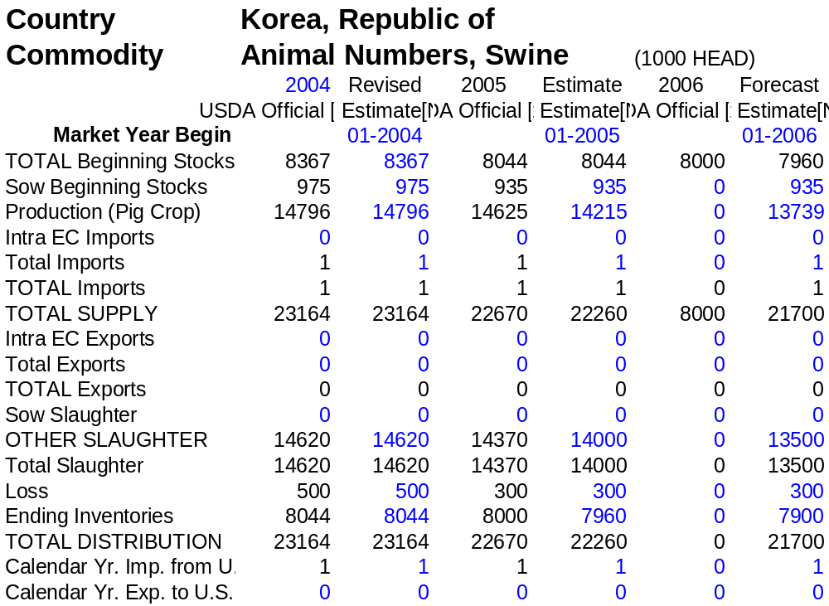

PS& Table for Pork

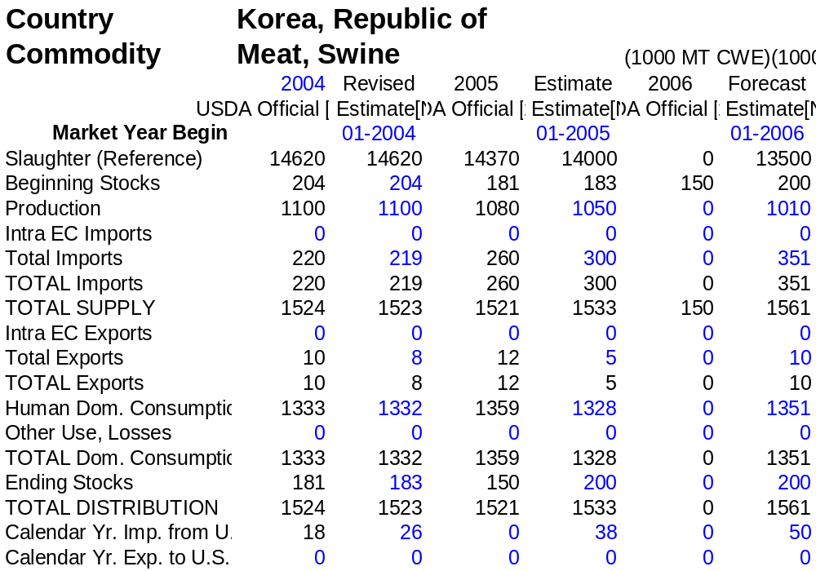

Swine and Pork Tables

Korea: Pork Imports (2004 – 2005)

Country | 2004 | 2005
Country | Revised | Preliminary
Country | (In metric tons, product weight equivalent)
U.S.A. | 20,931 | 30,400
Canada | 39,609 | 53,100
Chile | 23,203 | 33,600
Denmark | 22,345 | 32,400
Belgium | 19,649 | 28,500
France | 13,781 | 20,000
Netherlands | 8,748 | 12,700
Hungary | 7,951 | 11,500
Austria | 6,470 | 9,400
Poland | 4,442 | 6,400
Spain | 2,054 | 3,000
Sweden | 1,689 | 2,500
Finland | 1,581 | 2,200
Australia | 1,506 | 2,100
Mexico | 285 | 400
United Kingdom | 185 | 300
Other | 854 | 1,500
TOTAL | 175,283 | 250,000
Source: Korea Customs Service, Office of Ag. Affairs
Product Weight Equivalent
Korea: Pork Imports (Annual 2004, First Six Months of 2004 and 2005)
(Unit: MT & $000)
Country | Annual 2004 |  | Jan. – Jun., 2004 |  | Jan. – Jun., 2005
Country | Volume | Value | Volume | Value | Volume | Value
U.S.A. | 20,931 | 38,347 | 9,638 | 16,241 | 29,262 | 67,830
Canada | 39,609 | 37,970 | 18,863 | 14,941 | 27,381 | 39,212
Chile | 23,203 | 54,625 | 10,925 | 24,321 | 14,677 | 37,270
Denmark | 22,345 | 27,661 | 11,122 | 12,814 | 11,515 | 19,979
Belgium | 19,649 | 51,913 | 11,322 | 27,012 | 8,553 | 27,272
France | 13,781 | 39,003 | 6,698 | 16,986 | 9,670 | 32,319
Netherlands | 8,748 | 23,888 | 4,476 | 10,967 | 4,854 | 16,515
Hungary | 7,951 | 16,780 | 3,947 | 6,901 | 4,122 | 11,703
Austria | 6,470 | 17,104 | 2,579 | 6,181 | 4,636 | 13,120
Poland | 4,442 | 9,259 | 1,591 | 2,922 | 2,799 | 7,410
Spain | 2,054 | 4,768 | 0 | 0 | 4,657 | 9,439
Sweden | 1,689 | 2,666 | 636 | 834 | 883 | 1,318
Finland | 1,581 | 2,953 | 819 | 1,516 | 766 | 1,558
Australia | 1,506 | 3,601 | 676 | 1,493 | 1,165 | 2,588
Mexico | 285 | 910 | 45 | 131 | 1,343 | 4,495
United Kingdom | 185 | 584 | 0 | 0 | 1,047 | 2,060
Other | 854 | 1,579 | 634 | 882 | 668 | 1,314
TOTAL | 175,283 | 333,611 | 83,971 | 144,142 | 127,998 | 295,402
Source: Korea Customs Service
Product Weight Equivalent (HS Code: 0203)

Korea: Pork Exports (2004 – 2005)

Country | 2004 | 2005
Country | Revised | Preliminary
Country | (In metric tons, product weight equivalent)
U.S.A. | 0 | 0
Philippine | 4,440 | 3,500
Russia | 1,683 | 400
Japan | 811 | 100
Mongolia | 114 | 0
Others | 42 | 0
TOTAL | 7,090 | 4,000
Source: Korea Customs Service, Office of Agricultural Affairs
Korea: Processed Pork Imports (Annual 2004, First Six Months of 2004 and 2005)
(Unit: (MT & $000)
Country | Annual 2004 |  | Jan. – Jun., 2004 |  | Jan. – Jun., 2005
Country | Volume | Value | Volume | Value | Volume | Value
U.S.A. | 432 | 1,888 | 220 | 894 | 252 | 1,042
PRC | 151 | 229 | 83 | 126 | 103 | 140
Denmark | 24 | 87 | 15 | 53 | 6 | 24
Spain | 4 | 44 | 1 | 16 | 2 | 18
Australia | 3 | 59 | 2 | 36 | 1 | 26
Poland | 3 | 19 | 0 | 0 | 27 | 120
Canada | 1 | 17 | 1 | 8 | 1 | 8
Other | 1 | 8 | 1 | 7 | 1 | 9
TOTAL | 619 | 2,351 | 323 | 1,140 | 393 | 1,387
Source: Korea Customs Service
Product Weight Equivalent (HS 0210.1, 1602.41, 1602.42)

Korea: Processed Pork Exports (Annual 2004, First Six Months of 2004 and 2005)
(Unit: MT & $000)
Country | Annual 2004 |  | Jan. – Jun., 2004 |  | Jan. – Jun., 2005
Country | Volume | Value | Volume | Value | Volume | Value
U.S.A. | 0 | 0 | 0 | 0 | 0 | 0
Germany | 312 | 801 | 208 | 380 | 21 | 94
Philippine | 168 | 64 | 168 | 64 | 0 | 0
Japan | 72 | 655 | 59 | 527 | 4 | 27
PRC | 0 | 0 | 0 | 0 | 2 | 13
TOTAL | 552 | 1,520 | 435 | 971 | 27 | 134
Source: Korea Customs Service
Product Weight Equivalent (HS 0210.1, 1602.41, 1602.42)

Korea: Pork Exports (Annual 2004, First Six Months of 2004 and 2005)
(Unit: MT & $000)
Country | Annual 2004 |  | Jan. – Jun., 2004 |  | Jan. – Jun., 2005
Country | Volume | Value | Volume | Value | Volume | Value
U.S.A. | 0 | 0 | 0 | 0 | 0 | 0
Philippine | 4,440 | 3,986 | 2,522 | 2,564 | 1,745 | 1,211
Russia | 1,683 | 2,471 | 1,515 | 2,008 | 0 | 0
Japan | 811 | 3,659 | 145 | 624 | 5 | 54
Mongolia | 114 | 42 | 114 | 42 | 0 | 0
Other | 42 | 120 | 24 | 56 | 0 | 0
Total | 7,090 | 10,278 | 4,320 | 5,294 | 1,750 | 1,265
Source: Korea Customs Service
Product Weight Equivalent (HS 0203)

Korea: Swine Slaughter Trend
(Heads slaughtered)
Month | 2003 | 2004 | 2005
January | 1,396,954 | 1,242,284 | 1,204,480
February | 1,177,307 | 1,169,628 | 1,021,101
March | 1,277,202 | 1,293,279 | 1,206,810
April | 1,287,346 | 1,254,620 | 1,150,498
May | 1,224,233 | 1,157,302 | 1,060,529
June | 1,146,264 | 1,119,480 | 1,025,568
July | 1,192,283 | 1,122,453
August | 1,233,340 | 1,124,036
September | 1,214,569 | 1,135,975
October | 1,412,825 | 1,347,396
November | 1,273,525 | 1,347,639
December | 1,450,768 | 1,306,154
TOTAL | 15,286,616 | 14,620,246
Ministry of Agriculture & Forestry

Korea: Live Swine Prices

(Won per head, Exchange rate is US$1=1,030 won)
Annual Live Swine Prices
Year | Piglet |  | Swine (100 Kg)
1995 | 49,000 |  | 155,000
1996 | 48,000 |  | 171,000
1997 | 53,000 |  | 171,000
1998 | 50,000 |  | 179,000
1999 | 59,000 |  | 199,000
2000 | 54,000 |  | 166,000
2001 | 55,000 |  | 174,000
2002 | 59,000 |  | 178,000
2003 | 53,000 |  | 164,000
2004 | 64,000 |  | 235,000
Monthly Live Swine Prices
Month / Year | Piglet |  | Swine (100 Kg)
Month / Year | 2004 | 2005 | 2004 | 2005
January | 57,000 | 68,000 | 189,000 | 258,000
February | 61,000 | 87,000 | 214,000 | 261,000
March | 65,000 | 93,000 | 228,000 | 254,000
April | 66,000 | 94,000 | 234,000 | 247,000
May | 68,000 | 94,000 | 252,000 | 269,000
June | 68,000 | 100,000 | 261,000 | 294,000
July | 67,000 | 100,000 | 259,000 | 277,000
August | 65,000 |  | 265,000
September | 64,000 |  | 249,000
October | 62,000 |  | 196,000
November | 62,000 |  | 216,000
December | 65,000 |  | 251,000
Source: Ministry of Agriculture & Forestry
National Agricultural Cooperatives Federation

Korea: Swine/Pork Tariff Table for CY2005

Tariff Number | Product Description | WTO Bound Rate | Current Applied Rate | Other Information
0103.10.0000 | Pure-bred breeding swine | N: 0  M: 18.0% | N: 0  M: 18.0% | In-quota amount is 1,850 heads.
0103.90.0000 | Other swine
0103.91.0000 | Weighing, less than 50 Kg. | 18.0% | 18.0%
0103.92.0000 | Weighing, 50 Kg. or more | 18.0% | 18.0%
0203.10.0000 | Pork (Fresh or chilled)
0203.11.0000 | Carcass and half-carcass | 22.5% | 22.5%
0203.12.0000 | Hams, shoulder and cuts, with bone-in | 22.5% | 22.5%
0203.19.1000 | Belly | 22.5% | 22.5%
0203.19.9000 | Others | 22.5% | 22.5%
0203.20.0000 | Pork (Frozen)
0203.21.0000 | Carcass and half-carcass | 25.0% | 25.0%
0203.22.0000 | Hams, shoulder and cuts, with bone-in | 25.0% | 25.0%
0203.29.1000 | Belly | 25.0% | 25.0%
0203.29.9000 | Others | 25.0% | 25.0%
0206.30.0000 | Pork offal (Fresh or chilled) | 18.0% | 18.0%
0206.40.0000 | Pork offal (Frozen)
0206.41.0000 | Liver | 18.0% | 18.0%
0206.49.1000 | Feet | 18.0% | 18.0%
0206.49.9000 | Others | 18.0% | 18.0%
0206.80.0000 | Other offal (Fresh /chilled) | 18.0% | 18.0%
0206.90.0000 | Other offal (Frozen) | 18.0% | 18.0%
0210.10.0000 | Meat & edible meat offal of swine, salted, in brine, dried or smoked; edible flours and meals of meat or meat offal of swine
0210.11.0000 | Hams, shoulders and cuts thereof, with bone-in | 25.0% | 25.0%
0210.12.0000 | Bellies (streaky) and cuts thereof | 31.5% | 31.5%
0210.19.0000 | Other | 25.0% | 25.0%
1602.40.0000 | Other prepared or preserved meat, meat offal or blood, of swine
1602.41.1000 | Hams and cuts thereof in airtight containers | 54.0% | 54.0%
1602.41.9000 | Hams and cuts thereof, other | 27.0% | 27.0%
1602.42.1000 | Shoulders and cuts thereof in airtight containers | 54.0% | 54.0%
1602.42.9000 | Shoulders and cuts thereof, other | 27.0% | 27.0%
Source: Korea Customs and Trade Institute
N: in-quota rate; M: out-of-quota rate.

