Science of Science Management
October 2-3, 2008

Work Group Breakout Summaries

Priority Questions for Breakout Discussion Groups

A core element of the meeting was four simultaneous, closed session breakout discussions, which align with the conceptual model of the meeting. The four constructs are:

- Current State of Knowledge Assessment
- Knowledge Generation/Advancement
- Knowledge Utilization/Dissemination/Diffusion
- Public Health Impact

Figure 1. Conceptual Model
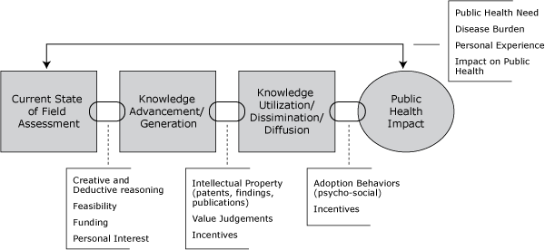

Each breakout discussion focused on a single priority question in order to create a feasible cross-disciplinary assessment model. The discussions were led by NIH Institute Directors with the participation of invited experts and a cross-section of key NIH staff. This collaborative effort was aimed to result in a proposed assessment model that can be tested. The results can provide evidence-based information for decisionmakers to plan or to create policy. Introductions to the four concept areas were provided, as follows. The four groups approached their tasks in slightly different ways. Summaries of their discussions follow.

Current State of Knowledge Assessment Work Group

Participants

- Lawrence Tabak, Director, NIDCR, Chair
- David Wilson, Associate Professor, Dept of Public and International Affairs, George Mason University
- Mary Kane, President, Concept Systems Incorporated
- Adam Jaffe, Dean of Arts and Sciences and Fred C. Hecht Professor in Economics, Brandeis University
- Michael Darby, Professor of Money and Financial Markets, University of California-Los Angeles
- James Wong, Senior Product Strategist, Hitachi Global Storage Technologies
- Lenworth Johnson, Professor of Ophthalmology and Neurology, University of Missouri
- Kathie Reed, NIA, Director, Office of Planning, Analysis, and Evaluation
- Alan Koretsky, NINDS, Senior Investigator, Laboratory of Functional and Molecular Imaging
- Robert Star, NIDDK, Director, Division of Kidney, Urologic and Hematologic Diseases
- Richard Suzman, NIA, Director, Division of Behavioral and Social Research
- Christie Drew, NIEHS, Health Scientist Administrator, Program Analysis Branch
- Luci Roberts, OPASI

Charge

The group was asked to focus on how existing knowledge and needs can be assessed to identify possible gap areas and research opportunities.

Overarching Guiding Question: What components should be included in a comprehensive framework of processes, analytic tools and methods that can be used to assess and prioritize the state of knowledge in a basic, clinical, or population-based research field to encourage innovation and advancement?

Priority Question: How can the current state of knowledge be assessed to identify science opportunity for innovative research?

Themes

Key questions raised include:

- At what points in the process is research enhanced?
- Does funding individuals versus projects lead to better research?
- How do program directors make prioritization decisions?
- How is a decision reached that the science is ready?
- How is innovation sensed? What criteria can identify innovation?
- Is there a technological opportunity to replace what is there and is it appropriate?
- Should a database tool be created to investigate science-of-science-management questions?
- Which funding schemes produce the most innovative research and how is innovation measured?

The group identified four elements that drive all scientific endeavors: people, data, decisions and decision frameworks, and scientific or theoretical frameworks. These elements could provide an organizing framework on which to identify gaps.

Identifying Stars. Who are the star scientists? They write frequently cited papers, but are papers cited because they are “classic”, methods papers or review articles, or because they present a new area of research which could flag opportunities? Frequently cited papers are not always innovative; thus, paper citations might identify an area but not a star scientist. And, “just because it’s hot doesn’t mean it’s a spark.” Part of defining the current state of science is identifying star scientists and the qualities that make them so. The goal is to be better able to identify stars and recruit them at the an early stage of their careers.

Discerning “Mediocre” and “Bad” Science and Scientists. The “charlatans and crooks” must be identified because they can point to systemic problems that need to be fixed, and they consume resources that could be used productively. The mediocre also must be better identified. Although there will never be a system where every researcher is 100% productive; knowledge is cumulative and everything builds on increments of knowledge, no matter how miniscule. The challenge to evaluation is in knowing that a path is leading nowhere.

Counting Citations. One must be able to read a paper critically to evaluate bibliometric data and assess why people might cite it. Citation research may only reveal what is already known. Innovative research is not always recognized by the number of times an article is cited.

Identifying Gaps. Literature review often reveals gaps, but not all gaps are worth filling. The challenge is to determine the reason for the gaps and to decide which gaps need to be filled. One gap that must be filled is the reporting of negative research results (methodologies and robustness).

Disclosing Serendipity. Most innovation occurs through serendipity; yet scientists rarely report this phenomenon. A database could capture this, or case studies of innovative products could be conducted (e.g., CAT scan preceding MRI) to better understand the factors influencing their development. It is important to remember, however, that “Chance favors the prepared mind.” (Pasteur)

Creating Databases to Study Productivity. There are few analyses of productivity. A reliable and valid searchable NIH database containing common longitudinal data on the careers of people and their ideas, funding (or funding rejections), institutions, and products would assist research in this area. Similarly, an analysis of 500 cases of innovation might shed light on “where the breaks came.”

Factors to Consider in Studying and Measuring Constructs

- The more general a model, the better. But different approaches may be needed depending on whether one is assessing basic, clinical, or population science.
- Common definitions of terms are needed.
- Identify areas where control can be influenced over a structure and where it cannot.
- Work from the current state to the desired state and define the components that would comprise a framework for assessment.
- Some assessment tools are available, but knowing how to apply them to all areas is challenging.
- What sort of processing systems are needed? Decisions have to be focused on knowledge, prioritization, and connection to decisions that NIH has the power to make (i.e., what NIH is authorized to fund?).
- Recognize that change may influence the incentive system under which researchers function.
- Recognizing opportunity and where scientists direct resources may be very different from doing innovative work. Scientists follow the money. It is not possible to assess where science is going; only where it has been.
- Scientists may avoid research pathways with substantial regulatory / IRB requirements, complex patient recruitment or special collection.
- It is critical to get input from all stakeholders.
- It is important to recognize the phenomenon of simultaneous innovation.
- How much do NIH funding decisions influence the model and how is it assessed?
- Develop a method for scientists to record how they make decisions and set priorities.
- Define the horizon for assessment and determining success—30 to 40 years or 1 or 2 years?
- Are new investigators, in fact, more innovative?

Proposed Model for Study

- Define current status (using bibliometrics, wiki, expert opinion).
- Identify gaps and prioritize those that should be pursued (involving all stakeholders).
- Identify areas or people who can pursue filling those gaps.
- Determine whether the science is ready.

Inherent in each step is a series of questions amenable to research. Stakeholders should have input into prioritization.

Relationships among the Constructs Depicting the Components of the Priority Question

How do we assess the current state of knowledge to identify science opportunity?
for innovative research?
Gaps
Innovative
research
Define
current state
of research
and
investigator quality
Wiki
Bibliometrics
Expert
Opinion
Areas/people
that are
not worthy
Decisions:

Is the
science ready?
Scientists
Other
Stakeholders
Pursue
Not pursue
Prioritization

Factors Needed to Study and Measure Constructs

Construct/Component | Ways To Measure | Source
Define current state of research | Create a database tool that is reliable, valid, and available for investigating SoS management questions?  Unfunded applications: fate of applicants? (not publicly available) | - Data NIH develops internally  - Data NIH can mandate from PIs  - External data (e.g., bibliometrics)
Define investigator quality | Whether funding individuals or funding projects yields more innovation?
Gaps—go / no-go | How is the current state of knowledge assessed at NIH?  Develop criteria by using the characteristic elements of the actors (i.e., new PIs more innovative?) | - Ask program directors and PIs (new and senior)
Decisions | How do different people approach prioritization and how does it relate to success?  Is the science ready? | - Domain scores  - Priority scores  - Percentiles  - Other inputs into funding decisions

Current State of Knowledge Assessment Work Group

Participants

- Nora Volkow, Director, NIDA, Chair
- Scott Stern, Associate Professor, Kellogg School of Management Northwestern University
- Katy Börner, Associate Professor of Information Science and Informatics, Indiana University
- Susan Cozzens, Director Technology Policy and Assessment Center, Georgia Institute of Technology
- Edward Roberts, Professor of Management of Technology/Founder and Chair MIT Entrepreneurship Center, Massachusetts Institute of Technology
- Gilbert Omenn, Professor of Internal Medicine, Human Genetics and Public Health, University of Michigan
- Arthur Kleinman, Professor of Medical Anthropology Harvard University
- Kevin Callahan, NIAID, Director, Office of Strategic Planning and Financial Management
- Susan Gottesman, NCI, Senior Investigator, Biochemical Genetics
- Mark Guyer, NHGRI, Director, Division of Extramural Research
- Richard Fabsitz, NHLBI, Deputy Chief, Epidemiology Branch
- Nancy Jones, NIAID, Planning and Evaluation Specialist, Strategic Planning and Evaluation Branch
- Joni Rutter, NIDA
- Kerry Goetz, OPASI

Charge

The group was charged to address the need to develop more appropriate methodologies for assessing the products of scientific research, and for understanding the types of knowledge generated (in addition to publication) especially discovery, innovation, and across large systems.

Overarching Guiding Question: What is needed for a comprehensive assessment of NIH knowledge generation and advancement?

Priority Question: What is needed for the assessment of NIH knowledge generation?

Themes

Terminology, Assumptions, and Goals: Should we be focused on the “science of science” or on the “science of science management”? Is it correct to assume that better science management will mean better and more useful science? What are the untoward effects of science management? Is it possible that it will create an “iron cage” or bureaucracy that leads to worse outcomes? On the other hand, we cannot continue to manage science based merely on hunches and anecdotes. Perhaps we need a better definition of “knowledge” and an appreciation of the many types of knowledge generated in addition to the accumulation of research findings (e.g., skills, experience, wisdom). Ideas are not the same as knowledge. Do we care about ideas as much we care about knowledge? Should we focus on processes and metrics as part of science management?

What We Don’t Know: We don’t understand scientific creativity, that is, how do important ideas come about? Better understanding of what constitutes scientific creativity would allow us to design research to increase and foster idea development.

Ways of Knowing: How can we better recognize new ideas and/or stimulate them, beyond the typical program announcements? We need more real-time measures of science as it is being conducted and knowledge is being generated instead of always looking back (e.g., through publications). We need better tools to capture knowledge that is being generated, in addition to bibliometrics, e.g., serendipitous results, unanticipated results, and knowledge of how to manage science. We need to expand our concept of knowledge outputs, e.g., education of other scientists, better processes (new methods and tools), research/scientific expertise and competencies, hypotheses confirmed, refuted, or shown inappropriate negative results (alternative knowledge), , ideas that stimulate more research/research questions, patents, productive workshops.

Approaches to Knowledge Generation: Science can come from individuals or collaborations. How do we weigh individual creativity versus team approaches? What techniques encourage “out of the box” cross-stimulation? Research on entrepreneurs has shown that the most successful ones work in teams—productivity is related to size and time together of the founding team. Research questions to be answered include: 1) what kinds of teams and what kinds of teamwork are most likely to generate different types of knowledge; 2) what is the productivity of teams, and 3) can program management influence the productivity of teams? How are answers influenced by the nature of the question or problem? How do managers identify which projects require interdisciplinary approaches, ideas, tools/platforms, so that a higher weight can be given to teamwork?

The Limits of Current Tools: Old bibliometric models do not reflect the aggregate, dynamic, transient, and collective efforts of teams of scientists. They do not capture streaming data. The paradigm of knowledge generation has changed yet the metrics have not (e.g., insufficient focus on interactions, collaborations).

Factors to Consider in Studying and Measuring Constructs

- The assessment process should be connected to the mission—to advance human health.
- What rewards can be developed to encourage the translation of highly specialized science advances into advances in health care and public health?
- There is a gap between the knowledge that gets produced in the conduct of science and what gets reported. We don’t disclose failure, which dramatically inhibits the productivity of future generations of scientists.
- How do we know what knowledge is valid? Within a field people sense what is valid but this is poorly captured by metrics.
- How does “conventional wisdom” inhibit innovative ideas?
- How much redundancy is needed in science, and how can appropriate replication be managed?
- Publications are still the central reward structure. This has to be recognized and more effort should be focused on more insightful and innovative use of bibliometrics. For example, using publications to capture hypotheses confirmed, refuted, modified, or discarded, as well as new methods and concepts, etc.

Proposed Models for Study

- Study management and organizational models across NIH, looking at organizational range of management and organizational styles and structures.
- Study review process to identify patterns associated with innovative ideas
- Conduct case studies of different management and organizational styles.
- Conduct natural experiments.
- Create models of how science and science management currently function to assist in hypothesis development and testing
- Study individual versus group science.
- Develop infrastructure to allow and facilitate fast access to information (e.g., searchable databases, scholarly marketplace).
- Study how NIH funding mechanisms and NIH policies (e.g. conflicts of interest reporting, data base sharing etc.) affect science conduct/practice (demographics of scientists, teams versus individuals or research types) and productivity such as knowledge generation.
- Clinicaltrials.gov is a model of recorded results, whether successes or failures. Start asking grantees to report on three things learned but not published.
Relationships among the Constructs Depicting the Components of the Priority Question
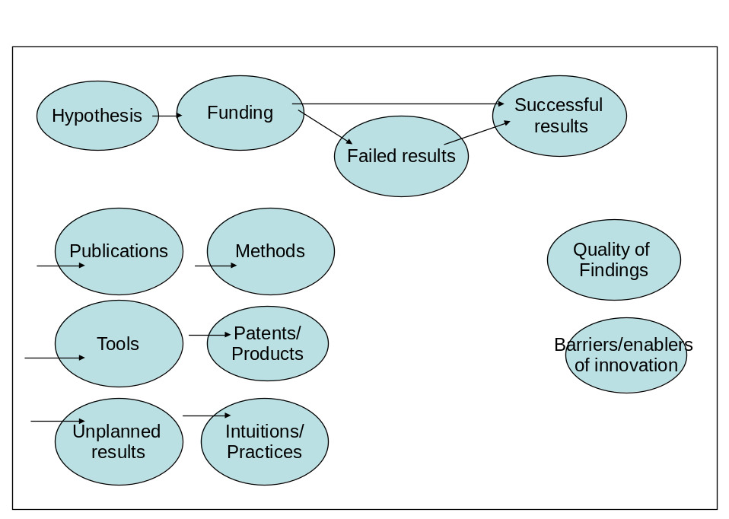

Factors Needed to Study and Measure Constructs
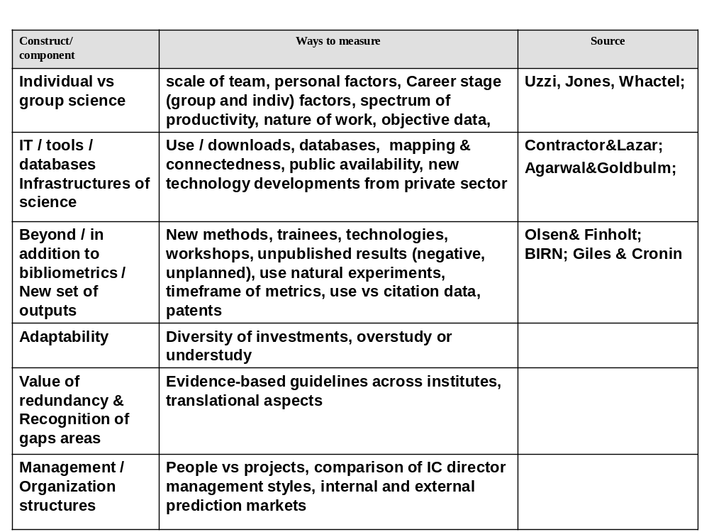

Knowledge Utilization/Dissemination/Diffusion Working Group

Participants

- Thomas Insel, Director, NIMH, Chair
- William Trochim, Professor, Department of Policy Analysis and Management, Cornell University
- Jason Owen-Smith, Assistant Professor, Sociology and Organizational Studies, University of Michigan
- Lynne Zucker, Professor of Sociology and Policy Studies, University of California-Los Angeles
- Fiona Murray, Associate Professor, Management of Technological Innovation and Entrepreneurship, Massachusetts Institute of Technology
- Michelle McMurry, Director, Health, Biomedical Science and Society Initiative, Aspen Institute
- Edwin Flores, Founder, Chalker Flores LLP
- Della Hann, NIMH, Director, Office of Science Policy and Program Planning
- David Lipman, NLM, Director, NCBI; Senior Investigator
- Anita Linde, NIAMS, Director, Office of Science Policy and Planning
- Stephen Marcus, NCI, Scientist, Tobacco Control Research Branch
- Patty Mabry, OD, Office of Behavioral and Social Sciences Research
- Christina Clark, COPR
- Evelyn Botchway, OPASI

Charge

The group was asked to focus on how to assess how knowledge and resources generated from research results are communicated, distributed, utilized, and adopted into behaviors, standards of care, science policies, and the next generation of research.

Overarching Guiding Question: How can social networks and collaborations among constituents/stakeholders facilitate the exchange and use of relevant knowledge to enhance learning and innovation and to facilitate the utilization of the information in practical applications and at key decision points?

Priority Question: How can we best leverage social networks to facilitate information utilization?

Themes

Key questions raised include:
- How do we understand the formation and dissolution of social/knowledge relationships?
- What is the landscape of all the social networks? Who are the players, and what differing activities do they engage in together?
- Where is the research knowledge being disseminated, and who are the final users within and outside of NIH?
- How do biomedical and behavioral research breakthroughs ultimately get disseminated/go viral?
- How does NIH and biomedical science find new ways to disseminate information in a Facebook-influenced society? What matrix should be created to crystallize NIH’s role in this process?
- What kind of information do stakeholders need for different purposes? How can NIH focus the public health community to use information dissemination to promote healthy choices?
- How is the effectiveness of information dissemination measured? What metrics exist to measure “downstream” applications / translation of science findings to public health?
Social Networks—How They Develop and Function: Discussion involved the various players and members of social networks, including the producers and consumers of biomedical research, how they are identified, and what promotes these relationships. There is a need to define the landscape of all social networks related to biomedical science and what an optimized product would look like. However, a range of different pressures, constraints, and opportunities for forming different types of interactions are in play involving a number of factors, including shared materials and reagents, co-authorship, and licensing.

How Relationships Could Develop in Science: In social network terms, one could envision relationships that can change fluidly—for example, for two groups that simultaneously publish on reprogramming stem cells, the acknowledgments and supplemental materials can help identify nodes and connections (such as cited papers and shared materials) that can delineate how each led to those outcomes. The evaluation of collaborations in biotechnology and nanotechnology suggests that the greater the number of articles published that list industry and academic partners, the greater the success of the collaboration, although the effect is greater with bigger “name” researchers than with lesser-known colleagues. Commercialization is important, but it is not the sole or even most important factor. Information flow is crucial to ensure that state-of-the-art treatment guidelines are implemented, and a feedback loop is important in identifying remaining barriers and deficiencies at each phase of translation.

Barriers to Social Networking in Biomedicine: For the general U.S. population, websites such as Amazon.com offer informal rating systems, and Facebook promotes social networking. However, in biomedicine, such web-based networking is unpopular because it does not offer standard incentives, such as the “point system” of publishing and presenting that is used in academia and at NIH. Other reasons social network systems are not used include intellectual property/commercial concerns and delays in the acquisition of relevant information.

Regarding barriers, put simply, the culture of traditional biomedical science tends to impede the rapid communication of research results. Intellectual property and patent issues also serve to undermine information access. In addition, the broader public often has less access to information than researchers do, even though the public/consumer is often motivated and willing to do the necessary background work to be able to understand most of this information. However, different actors will need different kinds of information and the methods of transmitting that information will vary.

The conduct of biomedical and behavioral research in the United States is still “a proprietary enterprise” that rewards the individual and inhibits broad collaboration. One result is the resistance to “big science” and a preference for R01-oriented projects. It also is based on a culture of single-person entrepreneurship that impedes broad collaboration. The jargon and culture of differing branches of science lead to difficulties between both individuals and groups of scientists (i.e., basic versus clinical scientists, principal investigators versus postdoctoral students). Other barriers include time, money, the political environment, and disciplinary egocentrism. Also, different standards of responsibility can create dampers on the flow of information. NIH rightly takes responsibility for the research it supports, but other players may not have the same standards. That may be one reason why NIH and senior researchers have hesitated to embrace such a completely open tool, but may be more willing to use semi-open, controlled systems.

Progress in Breaking Through Some Barriers: However, there are exceptions. Howard Hughes Medical Institute and the Wellcome Trust want to develop an invitation-only web system to create a “rating and commenting service” to rank scientific papers. This may represent a good “middle ground” between the use of a completely open networking system and the use of the current information dissemination method of journals and scientific meetings. Also, some website/listservs for targeted groups of researchers have started posting key papers as they are published and are encouraging comments and discussions. They have grown to include presentations and are being archived. As another example, PubMed policy is to maximize access to information rapidly.

The focus in overcoming these barriers, it was agreed, should be on creating a testable model of social networks, with practical measures of those interactions.

Conceptual Framework for Developing a Model. The questions involved in developing such a model include the following:

- What kinds of knowledge are needed?
- Who and what kinds of players want that knowledge?
- For what purposes do they want that knowledge?
- From whom do they want the knowledge?
- What are the facilitating and impeding factors?
- Through what kinds of channels can/should knowledge be disseminated?
- Can this knowledge be tapped to help promote the marketing of healthy choices?
- Once the communications networks are identified, how does one measure change and the impact of that change?

Vectors of Dissemination. These include publishing, both traditional print and web based; online search engines; listservs; training; gatekeepers—scientific, financial, legal, and journalistic; integration through meta-analysis, review articles, and guidelines that translate disparate information into useable formats; conferences and presentations; informal face-to-face communications; community and personal relationships; and disease groups.

Sources of Public Input Back to Scientists. These include legislative bodies; funding priorities; patients and healthcare providers; and NIH, industry, and clinical trial advisory bodies at various levels.

Measuring Transactions. Various transactions can be measured, such as when an investigator acknowledges others in a paper; time from publication to first other use; and facilitators and barriers in each interaction.

Metrics: The Rate of Flow from A to B. The best collaborations occur when there is a high degree of openness and confidence in the other partner; however, this also might produce the least amount of documentation (e.g., conversations, sharing of materials, reagents). The best records may, in fact, reflect an unwillingness to work with others, or grudging collaboration. Citation measures do not work very well, and there is a need to distinguish between citations within the research niche and across disciplines and to distinguish between process measures that tell how well the intermediate markers may function and the long-term effect.

Research Measures and Questions. These include looking at sources of variation across rows and down columns in the matrix; how producer-to-producer outputs become the inputs to producer-to-user ties; how outcomes of producer-to-user ties get bled into user-to-user ties; when new information becomes integrated into classroom settings; the extent of mechanisms by which researchers gather feedback, such as community advisory groups, as part of their studies; organized feedback from disease/consumer groups on how responsiveness has changed over time; the impact of FDA regulatory approaches: strict on drugs and biologics, nonexistent on surgical procedures; measurement of the quality and context of information sharing; and negative and positive framing of feedback.

Participants decided that the best way to understand the opportunities and challenges in these research utilization and dissemination efforts would be through a systems approach, using a matrix of producers and users in which each relationship (producer to producer etc.) has the potential for bidirectional interactions (see below). The group explored the four possible interactions in the matrix and for each sought to identify key partners in utilization and dissemination, the information and other types of knowledge they share, methods of communication, impediments to their communication and knowledge utilization, and, ultimately, methods of measuring the effectiveness of dissemination.

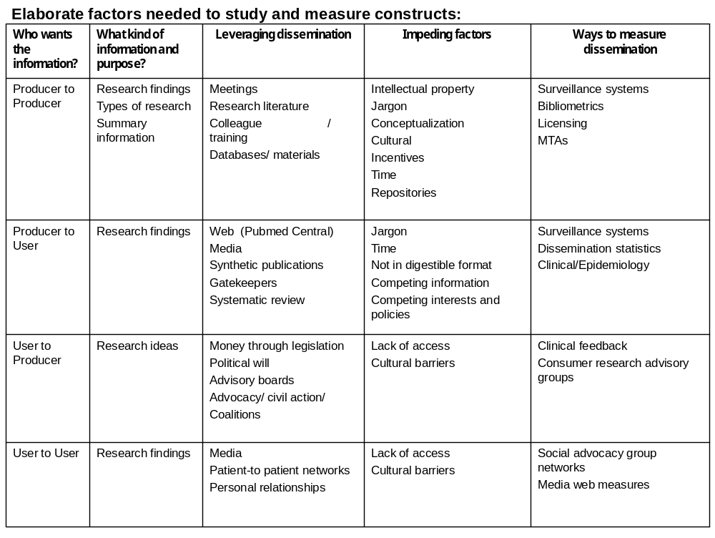

General precepts:

- Nothing in this matrix is prescriptive.
- All matrix rows can be drilled down and particular columns can be compared across rows
- The outputs of one row often are the inputs of another.
- What makes this a system are the interactions among rows.

Issues/measures that are generic and cut across all categories include:

- Time to use or adoption.
- Rates of use or saturation.
- Established infrastructure so that outcomes can be studied.

All players/stakeholders can be both producers and consumers of information. Key players include:

- Researchers—basic, translational, clinical.
- Healthcare practitioners.
- Patients and families.
- Policy makers.
- Congress and staff.
- Federal agencies.
- Advocates.
- Disease advocacy groups.
- High-income individuals—through direct funding and impact on policy makers.
- Foundations.
- Communications mediators such as health, science, and policy journalists.

Public Health Impact Working Group

Participants

- Paul Sieving, Director, NEI, Chair
- Doris Rubio, Associate Professor of Medicine, Biostatistics, and Nursing, University of Pittsburgh
- Nate Osgood, Assistant Professor, Department of Computer Science, University of Saskatchewan
- Daniel Sarewitz, Director of the Consortium for Science, Policy and Outcomes, Arizona State University
- Harold Pincus, Professor, Department of Psychiatry, Columbia University
- Ernst Berndt, Professor of Applied Economics, Massachusetts Institute of Technology
- Phyllis Wise, Provost and Executive Vice President, University of Washington
Lori Mulligan, NCRR, Director, Office of Science Policy
- Ronald Germain, NIAID, Senior Investigator, Immunology
- Clifford Lane, NIAID, Senior Investigator, Division of Clinical Research
- Richard Fisher, NEI, Associate Director for Science Policy and Legislation
- Susan Daniels, NIAID, Health Scientist Administrator, Office of Scientific Coordination and Program Operations
- Genevieve deAlmeida-Morris, NIDA
- Kathryn Law, OPASI

Charge

The group was asked to focus on how public health impact can be assessed to identify possible relationships with biomedical research.

Overarching Guiding Question: What systemic models for improved public health, including pathways and contexts, could be useful for informing multiple NIH decision making processes?

Priority Question: How do we measure the impact of NIH research on public health?

Themes

Key questions raised include:

  - What is the actual "product" of NIH research?
  - What are the facilitators and barriers to success in research?
  - What should be assessed?
  - Should NIH influence the research process and extrapolate forward in an attempt to reach for goals OR focus on assessing what is currently available?
  - Should NIH identify a need, and then address how it would organize to address the need?
  - Should the burden of disease be linked with NIH expenditures?
  - How can NIH maximize its impact on public health?
  - How can we better advocate to stakeholders?

Factors to Consider in Studying and Measuring Constructs. Three concepts underlie the priority question: It would be useful to know what percentage of NIH research could be converted to research on public health; NIH could take more of a microview or a macroview in evaluation—in other words, tracking could be accomplished by individual project or by research area; and useful models and metrics would then give rise to questions related to the impact of NIH research on public health that could be incorporated into an RFA.

Approaches to Creating a Model as a Starting Point. NIH directors' congressional testimonies could be reviewed to correlate the goals that were delineated in such testimony with the actual accomplishments. In addition, retrospective analysis could be conducted by selecting major clinical advances in the last two decades and assessing NIH’s role in their development. There was discussion about how it may be advantageous to project both backward and forward to identify the facilitators and barriers to success in public health research. By way of a biological science analogy, such approaches could to be likened to starting at the receptor, at the surface of the cell, and then moving to the gene of interest OR starting at the gene of interest and working backward.

Assessment. Maintaining a degree of sophistication about the complexity of the system that is the subject of the research is essential. For example, clinical research in HIV started with the premise that a vaccine approach would be faster and easier than a pharmaceutical approach, and investment in vaccines—in terms of infrastructure and funding—was made before there was a vaccine candidate. This approach differed from the one that was taken to microbicide development. Also, the change in treatment guidelines was driven by research and drug discovery. There is a need for systems-based mapping of the complex phenomena that influence improvements in public health, as well as a need for comparative assessments of both successes and failures. Needed are appropriate surrogate markers, as well as exploration of how the surrogate markers will be perceived by stakeholders and the public. Using the war on cancer as an example, it would be helpful to know how much of discovery has addressed the goal, given the decades-long investment in this effort.

Multiple-Phase Model. To design a theoretical model and incorporate specific cases into that model, one must begin with the input of all variables—that is, the indicators of public health.

"Things should be as simple as possible, but not simpler." Albert Einstein

Because of the timeframe that can be involved in discovery, which can range from 10 to 30 years from the time a research finding is made to the development and implementation of public health treatments and cures from that finding, a truly useful model will incorporate the appropriate phases. Such a model also should enable researchers to perform experiments that might lead to an increased public health impact, and it should lead to definable improvements in public health, such as innovations that may be associated with improvement of cardiovascular health.

Strategies. Measure the state of public health—both morbidity and mortality. Gather input from the public to help determine goals, and identify which aspects of these goals require NIH funding. Assess what should be considered long-term efforts that may involve research that could cross over a number of diseases and look at what funding would be required to fund this research, recognizing that it these may represent high-risk efforts that may not ultimately result in the finding answers that are needed. Work toward flexible investment that will provide the ability to pursue a direction of research that might fall under the high-risk category, with the recognition that different levels risk-aversion will influence choices.

Model Implementation. The theoretical model needs to be applied differently to basic versus clinical/translational research, because qualitatively they are different and serendipity plays a variable role in each. A flexible and more sensitive model would better address the balance in the NIH research portfolio, recognizing, for example, that some research is observational. The model should recognize variability across different fields of research, because not all research takes three decades to transition to clinical application. The model should take into account that it must function within a particular social and political environment, and such factors should be taken into account.

Key Players: Mediators and Modulators. Identify the impediments to translating research into practice that are not within NIH’s purview; these include various social, political, and economic forces and factors, and work to accommodate these factors (modulators) into models, some of which may include new legislation, political changes, changes in immigration patterns, economic changes, and changes in global public health status. Recognize the importance of mediators and the many variables that are involve in the healthcare system, such as the varying levels of quality among physicians, patients’ access to healthcare services, and changes that may occur involving new discoveries and disease outbreaks.

Constructs. These include decreasing mortality; reductions in hospitalization; extended lifespan of people with AIDS; reduction in dialysis; and reduction in the costs associated with managing diseases.

Descending Objectives for Proposed Model(s)

- Create a model of the impact of NIH research on public health.
- Find qualitative ways to assess the impact of research on public health.
- Create methods to measure the impact of NIH research on public health.
- Improve the tools that enable decision-makers to make public health assessments.
- Use the SF-36 as a way to measure quality, cost, and health outcomes across all diseases AND track funding outcomes.
- Design strategies that serve the public's interests.
- Decide what NIH should be focusing on in the future, then assess available resources and determine what is needed in order to reach research goals.
- Create a taxonomy regarding the decision-making pathways at NIH.

Conceptual Schema: Relationships among the Constructs Depicting the Components of the Priority Question



