 |  |  |  |  | Proposal Cover Page  Date: 6/12/2007 |  |  |  |  |  |  |  | NNH07ZDA001N-ARCTAS  Proposal Number:  (Leave blank for NASA use)
Name of Submitting Institution: |  |  |  |  |  | Bay Area Environmental Research Institute |  |  |  |  |  | Congressional District: |  |  | California #1
Proposal Title: | Airborne sunphotometer measurements of aerosols and water vapor to study aerosol radiative forcing and boreal forest fires in ARCTAS
Certification of Compliance with Applicable Executive Orders and US Code
By submitting the proposal identified in this Cover Sheet/Proposal Summary in response to this Research Announcement, the Authorizing Official of the proposing institution (or the individual proposer if there is no proposing institution) as identified below:
- certifies that the statements made in this proposal are true and complete to the best of his/her knowledge;
- agrees to accept the obligations to comply with NASA award terms and conditions if an award is made as a result of this proposal; and
- confirms compliance with all provisions, rules, and stipulations set forth in the two Certifications contained in this NRA [namely, (i) Assurance of Compliance with the NASA Regulations Pursuant to Nondiscrimination in Federally Assisted Programs, and (ii) Certifications, Disclosures, And Assurances Regarding Lobbying and Debarment & Suspension].
Willful provision of false information in this proposal and/or its supporting documents, or in reports required under an ensuing award, is a criminal offense (U.S. Code, Title 18, Section 1001).

NASA PROCEDURE FOR HANDLING PROPOSALS

This proposal shall be used and disclosed for evaluation purposes only, and a copy of this Government notice shall be applied to any reproduction or abstract thereof. Any authorized restrictive notices that the submitter places on this proposal shall also be strictly complied with. Disclosure of this proposal for any reason outside the Government evaluation purposes shall be made only to the extent authorized by the Government.

Principal Investigator Name: |  |  |  | Jens Redemann |  |  |  |  | Authorized Institutional Official Name: |  |  |  | Mark T. Sittloh
Organization: |  |  |  | Bay Area Environmental Research (BAER) Institute |  |  |  |  | Organization: |  |  |  | Bay Area Environmental Research Institute
Mailing Address: |  |  |  | 4742 Suffolk Ct. |  |  |  |  | Mailing Address |  |  |  | 560 3rd St. West
City, State Zip: |  |  |  | Ventura, CA 93003 |  |  |  |  | City, State Zip: |  |  |  | Sonoma, CA 95476-6502
Telephone Number: |  |  |  | (805) 658-2637 |  |  |  |  | Telephone Number: |  |  |  | (707) 938-9387
Fax Number: |  |  |  | (805) 658-2637 |  |  |  |  | Fax Number: |  |  |  | (707) 938-3984
Email Address: |  |  |  | jredemann@mail.arc.nasa.gov |  |  |  |  | Email Address: |  |  |  | msittloh@baeri.org
Principal Investigator Signature: |  |  |  |  |  |  |  |  | Authorized Institutional Official Signature:
Date: |  |  |  |  |  |  |  |  | Date:
Co-Investigators:
Name |  | Telephone |  |  |  |  | Email |  |  |  | Institution |  | Address
Philip B. Russell |  | 650-604-5404 |  |  |  |  | Philip.B.Russell@nasa.gov |  |  |  | NASA Ames |  |  | Moffett Field, CA 94035
Budget: |  |  |  |  |  |  |  | BAER |  | NASA Ames |  |  |  |  |  | Total
Year 1 (Oct. 2007 – Sep. 2008):
Year 2 (Oct. 2008 – Sep. 2009):
Year 3 (Oct. 2009 – Sep. 2010):
Total:

TABLE OF CONTENTS

ACRONYMS iii
1 ABSTRACT / EXECUTIVE SUMMARY 2
2 BACKGROUND AND RATIONALE 3
2.1 AATS-14 capabilities relevant to this proposal 3
2.2 Aerosol Radiative Forcing Studies in previous field campaigns 4
2.3 Comparisons of AATS measurements to satellite, in situ, and other aircraft observations in previous field campaigns 5
2.3.1 Comparisons to satellite observations 5
2.3.2 Comparisons to in situ observations 9
2.3.3 Comparisons to lidar measurements and synergy with other airborne radiation sensors 12
2.4 Spatial variability of AOD based on AATS-14 measurements in previous studies 12
3 Detailed description of proposed work 13
3.1 AATS-14 instrument calibration, measurements, data reduction, and archival for ARCTAS (April/July 2008) 14
3.1.1 Calibration 14
3.1.2 Measurements 14
3.1.3 Data reduction and archival 15
3.2 Integrated analyses for ARCTAS aerosol radiative effect studies 15
3.3 Integrated analyses for ARCTAS satellite validation studies 15
4 SUMMARY OF PLANNED ACTIVITIES LISTED BY YEAR 17
4.1 Year 1 (FY08) 17
4.2 Year 2 (FY09) 17
4.3 Year 3 (FY10) 17
5 REFERENCES 17
6 MANAGEMENT PLAN 21
6.1 Roles of Co-PIs and Co-I’s 21
7 CURRENT AND PENDING SUPPORT OF PI J. Redemann 21
8 BUDGET 22
8.1 Budget Justification: Narrative 22
8.2 Budget Justification: Details 23
8.3 Total Budget 23
8.4 Travel budget 24
9 Biographical Sketches 25
10 STATEMENTS OF COMMITMENT 28
10.1 Co-Investigator 28
10.2 Collaborators 29
10.2.1 Prof. Peter Pilewskie, Univ. of Colorado 29
10.2.2 Dr. Ralph Kahn, JPL 30

ACRONYMS

AATS | Ames Airborne Tracking Sunphotometer(s)
ACE | Aerosol Characterization Experiment
AERONET | Aerosol Robotic Network
AOD | Aerosol Optical Depth
ARM | Atmospheric Radiation Measurement
AVHRR | Advanced Very High Resolution Radiometer
BRDF | Bidirectional Reflectance Distribution Function
CALIOP | Cloud-Aerosol LIdar with Orthogonal Polarization
CALIPSO | Cloud-Aerosol Lidar and Infrared Pathfinder Satellite Observations
CAR | Cloud Absorption Radiometer
CCSP | Climate Change Science Program
CIRPAS | Center for Interdisciplinary Remotely Piloted Aircraft Studies
CLAMS | Chesapeake Lighthouse & Aircraft Measurements for Satellites
COZ | Columnar Ozone
CWV | Columnar Water Vapor
DIAL | Differential Absorption Lidar
DOE | Department of Energy
DU | Dobson Unit (10⁻³ atm-cm)
EOS | Earth Observation System
ESE | Earth Science Enterprise
EVE | Extended-MODIS-λ Validation Experiment
HIRDLS | High Resolution Dynamics Limb Sounder
HSRL | High Spectral Resolution Lidar
IGAC | International Global Atmospheric Chemistry
INTEX or  INTEX-NA | Intercontinental Chemical Transport Experiment-North America
INTEX-A or -B | Phase A or B of INTEX-NA
IOP | Intensive Observation Period
IR | Infrared
ITCT | Intercontinental Transport and Chemical Transformation
MAS | MODIS Airborne Simulator
MASTER | MODIS/ASTER Airborne Sensors
MISR | Multi-Angle Imaging Spectroradiometer
MODIS | Moderate-resolution Imaging Spectroradiometer
OCO | Orbiting Carbon Observatory
OMI | Ozone Monitoring Instrument
PARASOL | Polarization and Anisotropy of Reflectances for Atmospheric Sciences coupled with Observations from a Lidar
POLDER | Polarization and Directionality of the Earth’s Reflectances
PRIDE | Puerto Rico Dust Experiment
PSAP | Particle Soot Absorption Photometer
RSP | Research Scanning Polarimeter
SAFARI | Southern African Regional Science Initiative
SGP | Southern Great Plains
SOLVE II | SAGE III Ozone Loss and Validation Experiment II
SSA | Single Scattering Albedo
SSFR | Solar Spectral Flux Radiometer
SZA | Solar Zenith Angle
TARFOX | Tropospheric Aerosol Radiative Forcing Observational Experiment
TC⁴ | Tropical Composition, Cloud and Climate Coupling
TCSP | Tropical Cloud Systems and Processes
TES | Tropospheric Emission Spectrometer
TOMS | Total Ozone Mapping Spectrometer
UV | Ultraviolet

ABSTRACT / EXECUTIVE SUMMARY
We propose airborne sunphotometer measurements and their combined analysis with Terra and A-Train satellite aerosol data, and other airborne observations to address the ARCTAS scientific objectives regarding the spatial distribution and radiative impact of Arctic Haze and biomass burning aerosol. Measurements will be made by the NASA Ames Airborne Tracking Sunphotometer (AATS-14) on a profiling aircraft. In particular, we plan to collect AATS-14 measurements of aerosol optical depth (AOD), aerosol extinction, water vapor column content, and water vapor concentration in two 4-week deployment periods in April and July of 2008. The goals of our proposed work are:

1) the preparation, calibration and field deployment of AATS-14 on a profiling aircraft in two 4-week periods in ARCTAS;
2) the processing and archival of AATS-14 data collected in ARCTAS;
3) an integrated analysis of the horizontal and vertical distribution of Arctic Haze aerosols and the emissions from boreal forest fires, with an emphasis on the immediate vicinity of clouds;
4) the combination of AATS-14 AOD measurements with solar irradiance measurements on the same aircraft to determine aerosol direct radiative effects; and
5) the use and validation of aerosol observations from MODIS, MISR, OMI, POLDER and CALIPSO in conjunction with AATS-14 measurements to address ARCTAS science objectives.

The work proposed will build on the successful deployment of our group’s sunphotometers on a variety of aircraft in a large number of field campaigns, including TARFOX (1996), ACE-2 (1997), SAFARI-2000 (2000), PRiDE (2000), ACE-Asia (2001), CLAMS (2001), EVE (2004), INTEX-A (2004), and INTEX-B (2006). Our proposed integrated analyses will build on the experience gathered in these field campaigns, which have provided important aerosol information used in the improvement of retrieval algorithms for the MISR and MODIS sensors among others.

The combination of AATS-14 measurements of AOD with solar spectral irradiance measurements from the Solar Spectral Flux Radiometers (SSFR, PI: Peter Pilewskie, proposed separately) have resulted in the development of techniques to study aerosol radiative forcing efficiency and aerosol absorption. We plan to utilize these techniques to study aerosol radiative effects in ARCTAS, thereby providing observationally-based estimates of the aerosol radiative forcing of climate by Arctic aerosols. If the aircraft that AATS-14 and SSFR are deployed on also carries a suitable in situ instrumentation package, comparisons and closure studies between the aerosol radiative properties and the in situ measured optical and microphysical properties will be carried out.

The research proposed here supports the strategic sub-goal 3A of the NASA ROSES 2007 call, i.e., to “study Earth from space to advance scientific understanding and meet societal needs”. The scientific question we seek to answer are those regarding changes in the global Earth system, the primary causes for those changes, and how the Earth system will change and respond to these changes in the future. Our work will be responsive to the NASA research objectives loosely paraphrased here: 3A.1 “Understand climate forcing associated with changes in atmospheric composition”; 3A.5 “Understand the role of oceans, atmosphere, and ice in the climate system and improve predictive capability for its future evolution”.

Because of our experience in the synergistic use of suborbital and satellite aerosol observations, and because of the membership of the PI of this proposal on the MODIS and CALIPSO science teams, we feel uniquely qualified to perform the work proposed in response to this NRA.

BACKGROUND AND RATIONALE
Aerosols introduce major uncertainty into predictions of Earth’s climate. Atmospheric aerosols exert a direct effect on the Earth’s radiation balance by scattering and absorbing solar and longwave radiation and an indirect effect through the modification of cloud radiative properties, as well as cloud formation and maintenance. Both effects can be studied using in situ [e.g., Redemann et al., 2000, 2006; Fiebig et al., 2002], satellite [e.g., Zhang et al., 2005; Coakley et al., 2002] or suborbital remote sensing data [e.g., Hignett et al., 1999; Russell et al., 1999; Kim et al., 2005], with advantages and drawbacks to each method. Satellite observations of aerosols and their radiative effects in the Arctic are extremely important due to the paucity of suborbital observations. At the same time, these satellite observations are hampered by the vast spatial extent of cloud cover, the lack of contrast between clouds and highly reflective surfaces, as well as the persistently low sun angles and long seasonal lack of solar illumination during NH winter.
The ARCTAS white paper [Jacob et al., 2007] identifies four scientific themes: long-range transport of pollution to the Arctic, boreal forest fires, aerosol radiative forcing and chemical processes. Out of those scientific themes, the NASA Ames Airborne Tracking Sunphotometer (AATS-14) is uniquely suited to contribute to at least two areas, namely boreal forest fires and direct aerosol radiative forcing of climate, including the proven ability to support satellite-based observations for similar scientific objectives.
At the time this proposal is being prepared, the migration of radiation sensors previously flown on the contracted J-31 aircraft in INTEX-A and INTEX-B has commenced. The platform now designated for these sensors is the NASA P-3. We assume here that at least the AATS-14, CAR and SSFR sensors will be successfully installed on the NASA P-3 by the start of the ARCTAS deployment. With the exception of instrument re-installation, no costs for integrating AATS-14 on the P-3 platform are included here.
The research proposed here supports the strategic sub-goal 3A of the NASA ROSES 2007 call, i.e., to “study Earth from space to advance scientific understanding and meet societal needs”. The scientific question we seek to answer are those regarding changes in the global Earth system, the primary causes for those changes, and how the Earth system will change and respond to these changes in the future. Our work will be responsive to the NASA research objectives loosely paraphrased here: 3A.1 “Understand climate forcing associated with changes in atmospheric composition”; 3A.5 “Understand the role of oceans, atmosphere, and ice in the climate system and improve predictive capability for its future evolution”. As noted by the ROSES 2007 Summary of Solicitation, NASA addresses these questions and objectives by using an integrated observational strategy that combines observations from space with suborbital and ground-based measurements.
In this proposal, we seek funding to carry out airborne sunphotometer measurements of aerosol properties in ARCTAS to support aerosol radiative forcing studies and to aid in the interpretations and validation of measurements acquired with aerosol sensors aboard Terra and the A-Train satellites, while addressing scientific goals of ARCTAS. The following sections provide a summary of the capabilities of the NASA Ames Airborne Tracking Sunphotometer (AATS-14), a brief description of the relevant satellite sensors, their data products and validation needs, a summary of ARCTAS, and some examples of previous AATS measurements in relevant experiments.

AATS-14 capabilities relevant to this proposal
The deployments of the NASA Ames Airborne Tracking Sunphotometers (AATS-6 and AATS-14) in previous field campaigns have made significant contributions to the airborne study of atmospheric aerosols. In addition to the successful deployment of AATS-14 in the INTEX-A and INTEX-B field campaigns, the fully analyzed AATS measurements from SAFARI (2000), PRiDE (2000), ACE-Asia (2001), and CLAMS (2001), EVE (2004) and previous experiments have been used extensively in radiative forcing assessments and for the augmentation and validation of satellite sensors aboard the NASA EOS platforms and other spacecraft.
AATS-14 measures direct solar beam transmission in 14 narrow channels using detectors in a tracking head that rotates in two axes. Azimuth and elevation motors controlled by differential sun sensors rotate the tracking head, keeping detectors normal to the solar beam. The tracking head mounts outside the aircraft skin to minimize blockage by aircraft structures and also to avoid data contamination by aircraft-window effects. From the transmission measurements we derive AOD at 13 wavelengths (354, 380, 453, 499, 519, 604, 675, 778, 865, 1019, 1241, 1558, 2139 nm) and columnar water vapor (CWV). Under suitable conditions (see below) we also derive columnar ozone (COZ). Vertical differentiation of AOD and CWV data in suitable flight patterns yields aerosol extinction spectra and water vapor concentration. In previous field campaigns, the AATS-14 AOD measurements in the UV, visible, and near IR (out to 1 μm) have been extensively compared to ground-based AERONET measurements, yielding very strong correlations (r²>0.99) and rms-differences generally less than 10% (e.g., Schmid et al., 2003a; Livingston et al., 2003, Redemann et al., 2005). Measurements of AATS CWV agreed with other CWV measurements at least to within 10% [Schmid et al., 2001; Livingston et al., 2007, see also below].
For COZ the accuracy of AATS retrievals depends critically on two factors: (1) the relative magnitudes of the overlying AOD and ozone optical depth, both near 600 nm (the peak of the Chappuis ozone absorption band) and (2) solar zenith angle (SZA). For AATS-14 data acquired at aircraft altitudes near 10 km during the SOLVE II mission, COZ retrievals to better than 3% accuracy (~10 DU) were achieved because AOD at 600 nm was less than or comparable to the ozone OD there (~0.04), and because the instrument calibration uncertainty was minimized by large airmass values due to SZAs >83° (Livingston et al., 2005). For the proposed AATS measurements in ARCTAS, data will usually be taken at smaller SZAs from an aircraft often flying near the surface, and with overlying AOD likely to exceed overlying ozone optical depth significantly. Thus, it is unrealistic to expect AATS COZ retrieval accuracies of better than 10% (~30 DU), except when the AATS aircraft flies at higher altitudes (i.e., above most AOD) and SZA is large.

Aerosol Radiative Forcing Studies in previous field campaigns
For the study of aerosol–climate interactions, we are mainly interested in aerosol effects on the atmospheric radiation balance. Hence, an actual measurement of atmospheric irradiance is preferable to methods which require the deduction of the aerosol effect on irradiance based on in situ aerosol properties or measurements of satellite radiances. The preferred way to study the aerosol radiative forcing of climate uses simultaneous measurements of the aerosol amount and the affected radiation field. In several recent field campaigns, AATS-14 derived AOD has been used in conjunction with measurements of the spectral irradiance by SSFR (Pilewskie et al., 2000) to determine the direct impact of aerosols on the radiation balance. For example, Redemann et al. [2006a] used the aerosol gradient method to derive the direct aerosol radiative forcing efficiency in 10 case studies during flights conducted as part of the INTEX-A and ITCT field studies in 2004. This method requires the determination of the change in AOD and the associated change in net spectral irradiance (see Figure 1). The combination of coincident AATS-14 and SSFR measurements yielded plots of net (downwelling minus upwelling) spectral irradiance as a function of aerosol optical depth (AOD) as measured along horizontal flight legs. By definition, the slope of these plots yields the instantaneous change in net irradiance per unit AOD change and is referred to as the instantaneous spectral aerosol radiative forcing efficiency, E_{i}, [W m⁻² nm⁻¹]. Numerical integration over a given spectral range yields the instantaneous broadband aerosol radiative forcing efficiency [W m⁻²]. This technique for deriving E_{i} is called the aerosol gradient method because it actually requires gradients in AOD and net irradiance.
Within 10 case studies considered suitable for their analysis, Redemann et al. [2006a] found a high variability in the derived instantaneous aerosol forcing efficiencies for the visible wavelength range (350-700 nm), with a mean of -79.6 W m⁻² and a standard deviation of 21.8 W m⁻²(27%). Redemann et al. [2006a] further presented spectrally resolved aerosol forcing efficiencies between 350 and 1670 nm, estimates of the midvisible aerosol single scattering albedo (SSA) and a comparison of observed broadband forcing efficiencies to previously reported values. Their estimates of aerosol SSA showed that aerosol absorption was larger early in the 12 July-8 August 2006 period than later, consistent with independent trajectory analyses and satellite imagery that showed the stronger influence of smoke aerosols from Alaska fires during the early period.
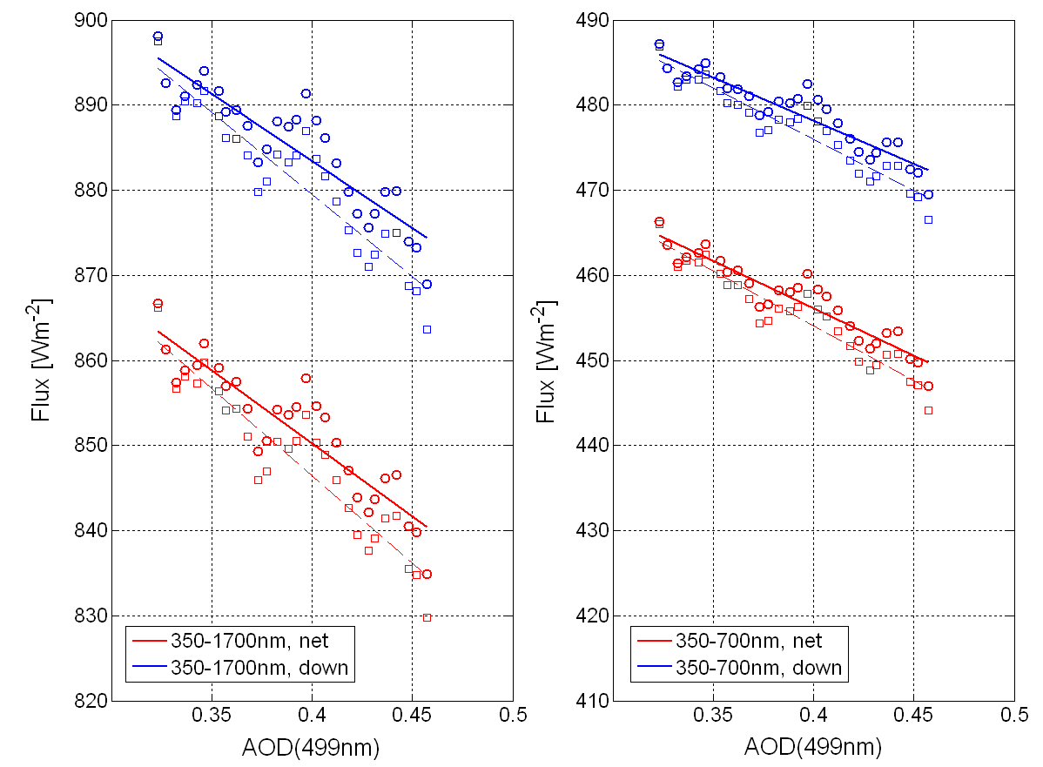
Figure 1. a) Regression plot of binned broadband visible net irradiance shown in versus midvisible aerosol optical depth for a case study (July 21, 2004) in INTEX-A and two spectral ranges (350-1700nm and 250-700nm, respectively). The slope of the regression line yields the instantaneous aerosol radiative forcing efficiency, Δ_{i}E.

Comparisons of AATS measurements to satellite, in situ, and other aircraft observations in previous field campaigns

Comparisons to satellite observations
Satellite sensors of aerosols [Kaufman et al., 2002; Ramanathan et al., 2002] are essential to developing an accurate description of the regional and global distribution of aerosols and their variability. Spaceborne aerosol sensors launched in the past few years, such as MODIS, MISR, POLDER, OMI and CALIOP, have the potential to advance our understanding of aerosol processes at global and regional scales alike. However, for these satellite aerosol observations to be most useful for the study of climate, an extensive validation effort is required to ensure their continuous reliability and assess their accuracy.
AATS measurements of aerosol optical depth and water vapor have been used extensively in the interpretation and validation of satellite-based observations. The notable advantages of the AATS-14 instrument for this purpose include its deployment on airborne platforms (which allows the validation of satellite observations over dark water), a well-documented instrument calibration record, and extensive coverage of the spectral range of current satellite sensors. Note that the AATS-14 spectral range extends to the MODIS channel at 2.1 μm, a channel that carries abundant information on aerosol particle size. AATS-14 is one of the very few sensors that can measure AOD at 2.1 μm, and the only airborne one [e.g., Levy et al., 2005, Redemann et al., 2005]. Table 1 summarizes satellite aerosol validation studies that have used an AATS instrument. To date, nine published studies have compared AATS measurements to retrievals by MODIS or MISR aboard the EOS Terra and Aqua satellites, and two publications led by the AATS team included validation of TOMS-derived AOD. In addition, a publication dealing with the validation of two distinct OMI aerosol retrieval algorithms (see below) in the context of INTEX-B [Livingston et al., 2007] is in preparation.
Table 1. Validation of satellite derived aerosol properties published by the proposing team.
Sensor | Campaign | Region | Surface | Period | Publication
AVHRR | TARFOX | US East Coast | Ocean | July 1996 | Veefkind et al., 1999
AVHRR | ACE 2 | Canary Islands | Ocean | June/July 1997 | Durkee et al., 2000  Livingston et al., 2000  Schmid et al., 2000
ATSR-2 | TARFOX | US East Coast | Ocean | July 1996 | Veefkind et al., 1999
ATSR-2 | SAFARI 2000 | Namibian Coast | Ocean | September 2000 | Schmid et al., 2003b
GMS-5 | ACE-Asia | Eastern Asia | Ocean | April 2001 | Wang et al, 2003b
GOES-8 | PRIDE | Puerto Rico | Ocean | June/July 2000 | Livingston et al., 2003  Wang et al., 2003a
MAS | TARFOX | US East Coast | Ocean | July 1996 | Tanré et al. 1999
MISR | SAFARI-2000 | Southern Africa | Ocean & Land | September 2000 | Schmid et al., 2003b
MISR | ACE-Asia | Eastern Asia | Ocean | April 2001 | Kahn et al., 2004
MISR | CLAMS | US East Coast | Ocean | July/Aug. 2001 | Redemann et al., 2005
MISR | INTEX-A | US East Coast | Ocean | July 2004 | Russell et al., 2007
MODIS | PRIDE | Puerto Rico | Ocean | June/July 2000 | Livingston et al., 2003  Levy et al., 2003
MODIS | SAFARI-2000 | Southern Africa | Ocean & Land | September 2000 | Schmid et al., 2003b
MODIS | CLAMS | US East Coast | Ocean | July/August 2001 | Levy et al., 2005 Redemann et al., 2005
MODIS | ACE-Asia | Eastern Asia | Ocean | April 2001 | Chu et al., 2004
MODIS | ACE-Asia | Eastern Asia | Ocean | April 2001 | Anderson et al., 2006
MODIS | EVE | US CA Coast | Ocean | April 2004 | Redemann et al., 2006
MODIS | INTEX-A | US East Coast | Ocean | July 2004 | Russell et al., 2007
POAM | SOLVE-2 | Arctic | Ocean & Land | Jan/Feb 2003 | Russell et al., 2005
SAGE 3 | SOLVE-2 | Arctic | Ocean & Land | Jan/Feb 2003 | Russell et al., 2005
SeaWiFS | ACE-Asia | Eastern Asia | Ocean | April 2001 | Hsu et al., 2002
TOMS | PRIDE | Puerto Rico | Ocean | June/July 2000 | Livingston et al., 2003
TOMS | SAFARI-2000 | Southern Africa | Land | September 2000 | Schmid et al., 2003b

These AATS results have provided important aerosol information used in the improvement of retrieval algorithms for MISR [Kahn et al., 2001, Martonchik et al., 1998] and MODIS [Martins et al., 2002, Levy et al., 2005; Chu et al., 2005]. Additional examples of AATS measurements are given in Russell et al., 1999, Schmid et al., 2000, 2003a, Livingston et al., 2003, and Redemann et al., 2006b.
The A-Train constellation includes six satellites, all with equator crossing times within a 30 minute time frame. The six satellites are Aqua, CloudSat, CALIPSO, PARASOL, Aura and OCO. Aboard these six satellites are at least four instruments with a key goal of measuring aerosols: the MODIS instrument on Aqua, CALIOP on CALIPSO, POLDER on PARASOL, and OMI on Aura. Many A-Train instruments also measure water vapor, including TES, HIRDLS, and MLS on Aura, and AIRS and MODIS on Aqua. Table 2 contains a list of the Terra and A-Train satellite instruments and derived data products especially relevant to this proposal. The following paragraphs give more information on specific instruments targeted by this proposal.

Table 2. Satellite sensors relevant to this proposal
Satellite | Instrument | Data products | Coverage / Resolution / Comments
Aqua+Terra | MODIS | AOD (ocean - 7λ, 470-2130 nm, land - 2λ, 470 + 660 nm), column H₂O | 10x10km, nadir
CALIPSO | CALIOP | Aerosol extinction profiles (2λ, 532 + 1064 nm)  AOD (2λ, 532 + 1064 nm) | 333 / 30 m (horiz./vert.), Level-2 profile/curtain with 40km horiz.
Terra | MISR | AOD, aerosol type, particle shape indication (ocean and land - 4λ, 470-865 nm) | 17.6km, operational, 1km research mode
PARASOL | POLDER | AOD (2λ, 670 + 865 nm) | 20x20km
Aura | OMI | AOD + ssa (17λ, 330-500 nm), column O₃ | 13x24 km, 13x12km (zoom mode)
Aura | TES | Water vapor profiles, surface to 33 km | 0.5x5 km / 4 to5 km (horizontal / vertical), nadir mode
Aqua+Terra | CERES | Broadband solar and terrestrial radiative fluxes in three channels | 20km, nadir horizontal, and flux profiles
Aqua | AIRS | Water vapor profiles, surface to 100 mb  Column water vapor, troposphere | 50 km / 2km (horizontal / vertical)

OMI is a hyperspectral imager that measures UV and visible radiation scattered back by the Earth-atmosphere system. A major OMI advantage is its ability to derive aerosol optical depth and single scattering albedo over land, by using the small land surface reflectivity in the UV. This technique, developed by Herman et al. [1997] and Torres et al. [1998], is sensitive to aerosols that absorb in the near-UV, such as mineral dust, volcanic ash and carbonaceous particles. Whereas measurements of AOD and SSA by OMI’s predecessor, TOMS, were limited to a few bands in the near UV, OMI measures radiances from 270 to 500 nm, with resolution ~0.5 nm. Because of strong absorption below 330 nm by ozone, OMI-derived aerosol properties range from the near-UV to the mid-visible (330-500 nm) at 17 discrete wavelengths [Torres et al., 2002], chosen in part to match wavelength bands of other satellite sensors such as MODIS. By incorporating wavelengths longer than TOMS, OMI bridges the gap to retrievals by MODIS, MISR and AVHRR. OMI also has finer spatial resolution than TOMS, aiding in cloud-screening. Operationally, OMI AOD and SSA are derived by two methods, a multi-wavelength method and the aforementioned near UV-technique. One of the main purposes of this proposal is the validation of OMI AOD from both techniques, by using AATS-14 in ARCTAS, similar to our efforts in INTEX-B (see also Figure 2).
MODIS is one of four Earth-observing satellites aboard the Terra satellite and one of six aboard the Aqua satellite. MODIS views the entire Earth's surface every 2 days, acquiring data in 36 spectral bands. The MODIS aerosol product (MOD04_L2) is derived from radiance measurements in channels 1-7 and 20 of the 36 MODIS bands. Over the ocean the measured radiances are inverted into the aerosol optical depths at 466, 553, 644, 855, 1243, 1632 and 2119 nm and volume distribution (in the range of 0.08-5 µm radius). In the inversion, it is assumed that the aerosol size distribution is bi-modal log-normal [Remer et al., 2005]. AOD, fine mode fraction and other aerosol data are retrieved and stored at a resolution of nominally 10x10km at nadir [Kaufman et al., 1997].
MISR produces 36 simultaneous views of Earth, in a combination of nine angles varying from +70° to –70° in the along-track direction, in four spectral bands centered at 446, 558, 672 and 867 nm [Diner et al., 1998]. It takes seven minutes for all nine MISR cameras to view a fixed line on the surface, which sets the effective temporal resolution for coincident observations. At midlatitudes, a given location is imaged about once per week in Global Mode, providing 275 m resolution data in all four nadir channels, and in the red channels of the other eight cameras. The remaining 24 channels of data are averaged on board the spacecraft to 1.1 km resolution. During major field campaigns locations in the MISR swath can be designated “MISR Local Mode sites”, 300 km along-track by 360 km cross-track, over which data are acquired at 275 m resolution in all 36 channels. Due to the wide range of scattering angles sampled (about 50° to 160° at midlatitudes), MISR offers tight constraints on AOD, particle shape, size distribution, and single scattering albedo, particularly over dark, uniform ocean surfaces [Kahn et al., 2001; Martonchik et al., 1998].
Within the A-Train, the CALIPSO satellite carries an aerosol-cloud lidar (CALIOP), a three-channel imaging infrared radiometer (IIR) and a wide-field camera (WFC). The CALIPSO suite of instruments is designed to provide a global set of data on aerosol and cloud properties, enabling new observationally-constrained estimates of the radiative effects of aerosols and clouds on climate. The key instrument for this proposal is CALIOP, a two-wavelength (532 and 1064nm), polarization-sensitive lidar that produces profiles of aerosol extinction and backscattering with a single-shot vertical and horizontal resolution of 30 and 333 m, respectively. The CALIPSO aerosol algorithm selects a “best-match” lidar ratio (i.e., the ratio of aerosol extinction to aerosol backscatter, Klett [1985]) based on optical characteristics, geolocation and season from a look-up table that is based on a cluster analysis of AERONET data and in situ observations, respectively [Vaughan et al., 2004, Omar et al., 2005]. To fulfill feature finding and layer classification requirements, the current CALIPSO level-2 algorithm yields an aerosol layer product at a horizontal resolution of 5 km and an aerosol profile product at a horizontal resolution of 40 km.
As an example of previous, multi-grid cell validation studies with AATS-14, Figure 2 shows the comparison of spectral AOD by two different OMI retrieval algorithms (“MW”: using radiances of 17 channels from UV to vis.; “UV”: using only UV radiances) and by the standard MODIS aerosol retrieval algorithm to an average AATS-14 spectral AOD during a low-level flight leg on March 10, 2006, over the Gulf of Mexico in INTEX-B. There is good agreement between AATS-14 and MODIS-derived spectral AOD and less good agreement between AATS-14 and the two OMI retrievals. The exact causes of this disagreement are being studied; indeed, the resolution of individual retrieval grid cells allows a much closer investigation of the exact causes for potential disagreement of satellite and suborbital AOD measurements (e.g., surface characteristics, cloud contamination, etc.) than the comparison of temporally-averaged ground-based observations to spatially-averaged satellite observations affords.

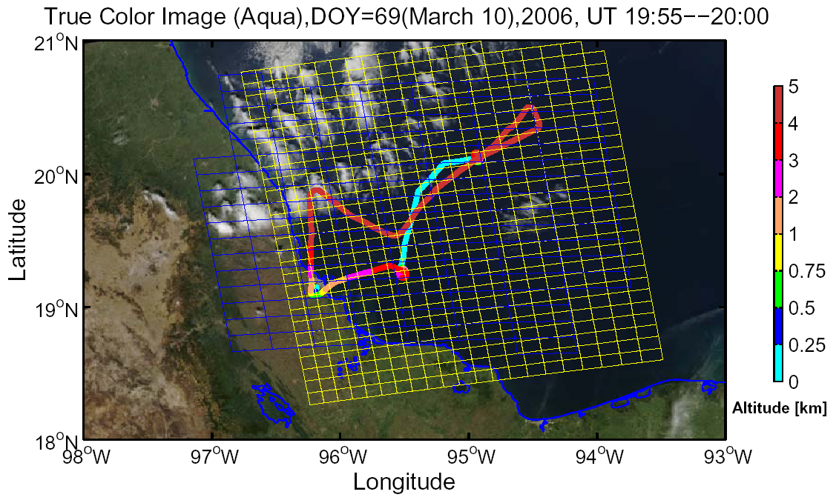
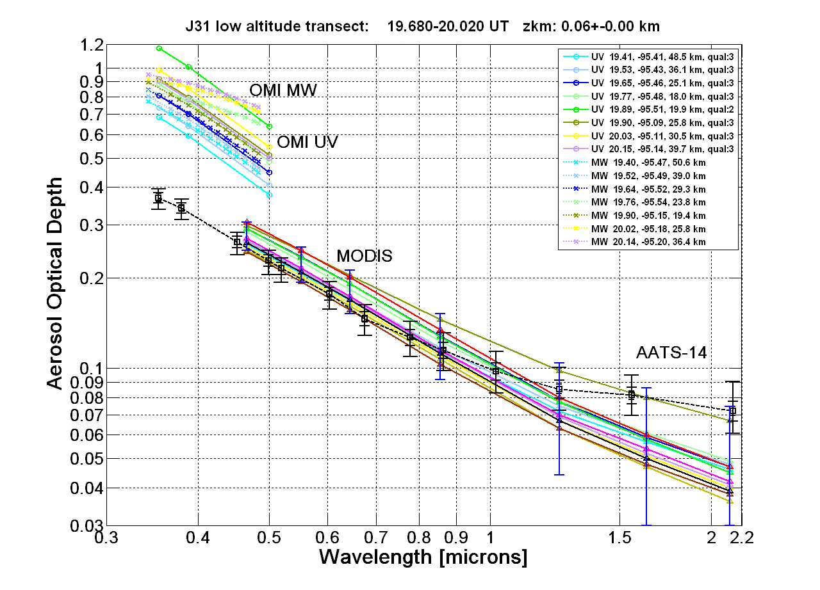
Figure 2: Comparisons of multi-grid cell retrievals of spectral AOD by two different OMI retrieval algorithms (“MW”: using radiances of 17 channels from UV to vis.; “UV”: using only UV radiances) and by the standard MODIS aerosol retrieval algorithm to AATS-14 measurements during a low-level flight leg on March 10, 2006, over the Gulf of Mexico in INTEX-B.

Comparisons to in situ observations
Aerosol closure studies test the consistency of different measurements that are linked by one or more models. Because the linking models (e.g., of aerosol growth in humidity, of light scattering by mixed aerosols) are often used as components of the chemical transport models or general circulation models that predict aerosol effects on climate, closure studies provide important assessments of both the measurements and the models that undergird our current understanding of aerosol effects on climate.
Aerosol extinction closure studies have revealed important insights about aerosol sampling and inadvertent modification in such previous experiments as TARFOX (Hegg et al., 1997; Hartley et al. 2000), ACE-2 (Collins et al., 2000; Schmid et al., 2000), SAFARI 2000 (Magi et al., 2003), ACE-Asia (Schmid et al., 2003a, Redemann et al., 2003) and CLAMS (Magi et al., 2005).
The basis for these studies is the measurement of aerosol optical depth and columnar water vapor with an Ames Airborne Tracking Sunphotometer (AATS-14 or AATS-6), because inlet effects (e.g., loss or enhancement of large particles, shrinkage by evaporation of water, organics, or nitrates) and filter effects that may decrease the quality of in situ measurements are not present in the sunphotometer observations. As pointed out above, the differentiation of AOD vertical profiles yields profiles of spectral aerosol extinction (see Figure 3) and water vapor density. Measuring solar beam attenuation by an AATS on the same aircraft as in situ sensors allows a close match in the aerosol layers described by the attenuation and in situ measurements. Such a match allows the best-defined comparison between attenuation and in situ results. It avoids the ambiguity that occurred in previous experiments when the sunphotometer measurements were taken from the ground and thus provided no information on what fraction of column optical depth was above the aircraft’s maximum sampling height.
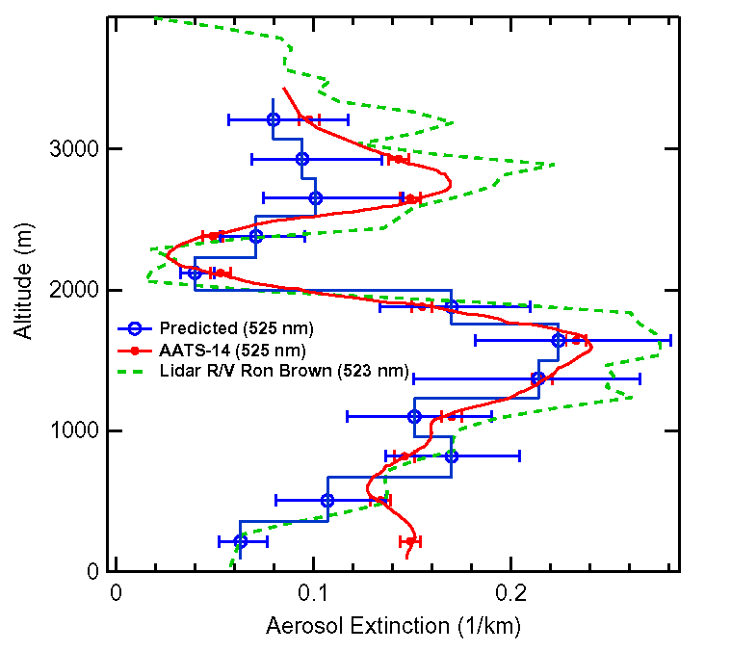
Figure 3. Comparison of aerosol extinction derived from AATS-14 measurement, aerosol size distributions, and lidar measurements on R/V Ron Brown (Wang et al., 2003b).

An example from ACE-Asia where the in situ extinction is computed from in situ size distribution and chemical composition measurements is shown in Figure 3 [Wang et al., 2003b]. In the uppermost layer, the underestimate of Mie-predicted extinction compared to the AATS-14 result is attributed to nonspherical dust particles there, which are undersized by the in situ mobility analyzer (Wang et al., 2003b). In addition to the AATS-14 and in situ derived extinction, Figure 3 further shows a lidar-derived profile of midvisible aerosol extinction, which reproduces the AATS and in situ derived aerosol layer structure well.In a recent study, Schmid et al. [2006] compared a variety of ways to derive aerosol extinction, including in situ, airborne sunphotmeter and lidar observations. They concluded that even well proven measurement techniques produce bias differences in midvisible aerosol extinction of 15-20%, with potentially larger differences in the UV and SWIR. Because the observational circumstances are different for every aircraft, it is particularly important for airborne platforms that are newly equipped with in situ aerosol instrumentation to devote a significant portion of flights towards flight patterns suitable for assessing the consistency of the in situ measurements and the date from the available radiation sensors, such as AATS-14, SSFR, and RSP. Since the P-3 platform to be used in ARCTAS is a new platform for the radiation sensors and some of the in situ instrumentation, we propose to carry out closure studies between AATS-14 and the relevant in situ sensors.
Figure 4. Comparison of water vapor measurements on the Twin Otter in ACE-Asia by AATS-14 and in situ sensors. (i-l) Examples of vertical profiles. (m) Comparison of layer water vapor for 26 profiles. Error bars are based on horizontal distance spanned by a profile, combined with average horizontal variability of CWV in ACE-Asia flights. (n) Comparison of water vapor density for the 26 profiles. (Schmid et al., 2003b).

In addition to spectral AOD, AATS-14 measures the overlying column water vapor (CWV) using a channel in the 940-nm water vapor absorption band [e.g., Schmid et al., 2000, 2001, Livingston et al., 2007]. Vertical differentiation of AATS CWV profiles in aircraft ascents or descents yields profiles of water vapor concentration. Our previous closure studies have included many comparisons between the AATS water vapor results and those from a variety of other measurement techniques (e.g., Schmid et al., 2000, 2001). Fig. 4 shows examples for AATS-14 in ACE-Asia. In addition to the satellite validation work proposed here, the continuously measured CWV results are useful in radiative transfer calculations and in assessing any CWV changes associated with measured AOD changes aloft.

Comparisons to lidar measurements and synergy with other airborne radiation sensors
In addition to the in situ closure studies mentioned in the previous section, AATS-14 results have been compared abundantly to, and used synergistically with, lidar aerosol observations. These studies include the investigation of massive aerosol layers in SAFARI-2000 [Schmid et al., 2003], the combined use of lidar, sunphotometer and in situ size distribution data to estimate aerosol refractive indices in TARFOX [Redemann et al., 2000a,b], and the validation of the Raman lidar at the ARM Southern Great Plains Site [Ferrare et al., 2006]. In ARCTAS, the investigation of the vertical distribution of Arctic haze aerosols and aerosol emissions from boreal forest fires will benefit greatly from the availability of the CALIOP lidar measurements aboard the CALIPSO satellite and from the planned deployment of the HSRL (High Spectral Resolution Lidar) aboard the Langley King Air B-200 aircraft. We propose to support the cross-validation of the CALIOP and HSRL measurements through the measurements of vertical profiles of aerosol extinction obtained from AATS-14.
Besides the potential in situ observation aboard the P-3 itself, the lidar measurements on other aircraft, and the satellite observations, a fourth class of sensors that will benefit from the deployment of AATS-14 on the P-3 are the other radiation sensors flown aboard the P-3. At the time this proposal is being written, efforst are beoing made to integrate the GSFC Cloud Absorption Radiometer (CAR) on the P-3; there is also a possibility that one of the Research Scanning Polarimeters (RSP) will be available to fly aboard the P-3. In previous deployments, most notably SAFARI, CLAMS, INTEX-A and INTEX-B, the RSP and the CAR teams have used AATS-14 measurements to constrain [Chowdhary et al., 2005] and to validate their own retrievals of aerosol properties [Gatebe et al., 2005].

Spatial variability of AOD based on AATS-14 measurements in previous studies
Spatial variability in radiance fields observed by passive satellite sensors is frequently used in the separation of cloud and aerosol signals, under the assumption that most clouds exhibit larger spatial variability than aerosols. In clear regions, AOD spatial variability contributes significantly to the variability in the satellite-observed radiance field. AOD variability can only be assessed on the relevant scales (of a few hundred meters, comparable to the satellite sensor resolution) from suborbital platforms that move fast by comparison to wind speeds and only with instruments that provide data at appropriate rates (1 Hz being equivalent to a spatial resolution of ~100m at an aircraft speed of 200 knots). AATS-14 samples at 3 Hz and typically averages 9 samples, recording a 3-second average every 4 seconds. Because AATS-14 measures the direct solar beam transmission (unaffected by surface properties), and because it is deployed on relatively fast-moving platforms, it is well suited for studies of AOD spatial variability.
For example, the cloud mask used in the MODIS aerosol retrieval algorithm computes the standard deviation of 553 nm reflectances in every group of 3 by 3 pixels within a box [Martins et al., 2002]. If any group of 9 contiguous pixels has a standard deviation greater than 0.0025, the center pixel is labeled as 'cloudy' and discarded. This test separates aerosol from most cloud types, but may fail at the centers of large, thick clouds and with cirrus, both of which can be spatially homogeneous. An example of the cloud mask thus derived is shown in the lower right hand panel of Figure 5 for a scene sampled on April 30, 2004, off the California coast (the 500m pixels that exhibit variability with respect to their neighbors in excess of the criterion above have white borders). The question arises whether the variability in the vicinity of clouds could be due to 3-D radiative effects or even the variability in aerosol properties rather than actual cloud contamination. To answer this question, we have started to apply the MODIS standard aerosol retrieval algorithm, usually applied only to MODIS radiance spectra averaged over 10x10km, to the individual 500m pixel radiances shown in the upper left panel of Figure 5 [Redemann et al., 2007] to produce fine-scale maps of aerosol retrievals (see lower left panel of Figure 5). We expect to compare these fine-scale aerosol retrievals to the AATS-14 measurements obtained along the colored flight path also shown in Figure 5 to elucidate whether a less stringent cloud screening, for example the standard MODIS cloud mask shown in the upper right panel of Figure 5, would produce a cloud filter that would not suppress aerosol information in the immediate vicinity of clouds. We propose similar studies in ARCTAS as outlined in section 3.3 below.
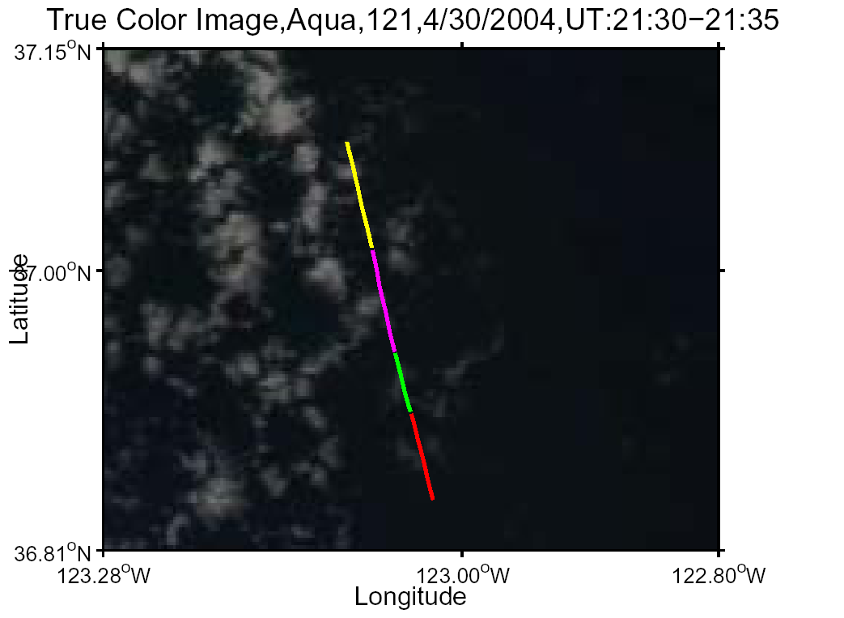 | 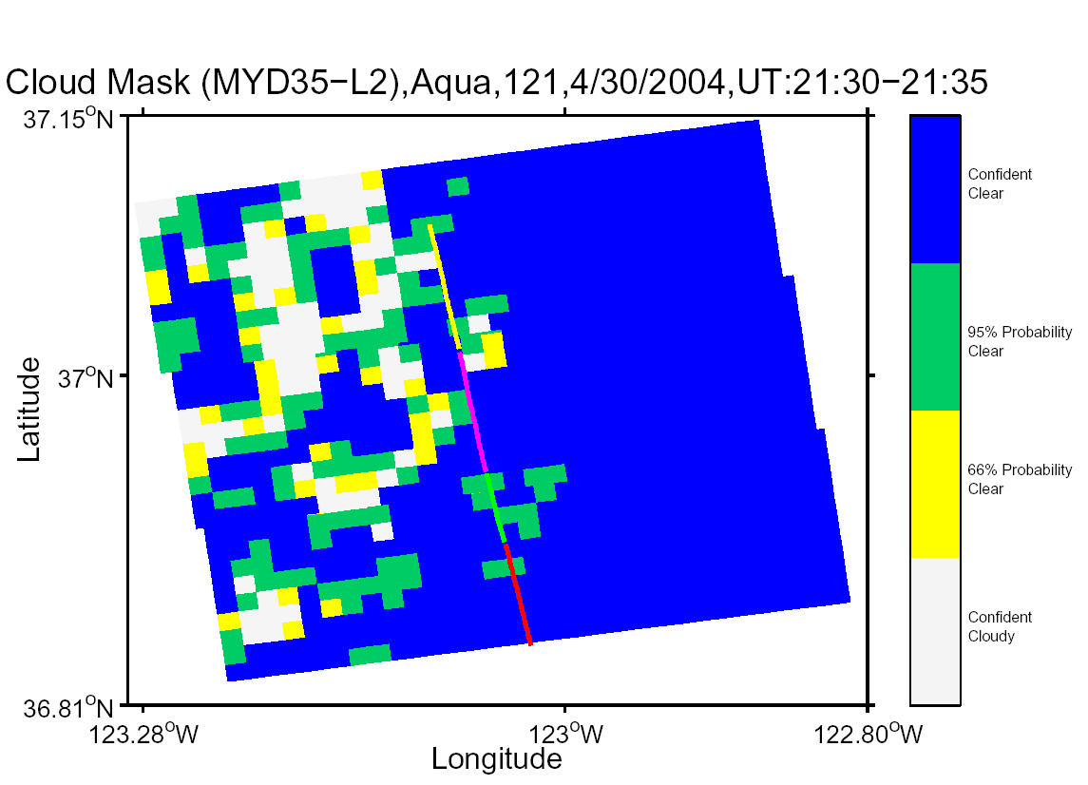
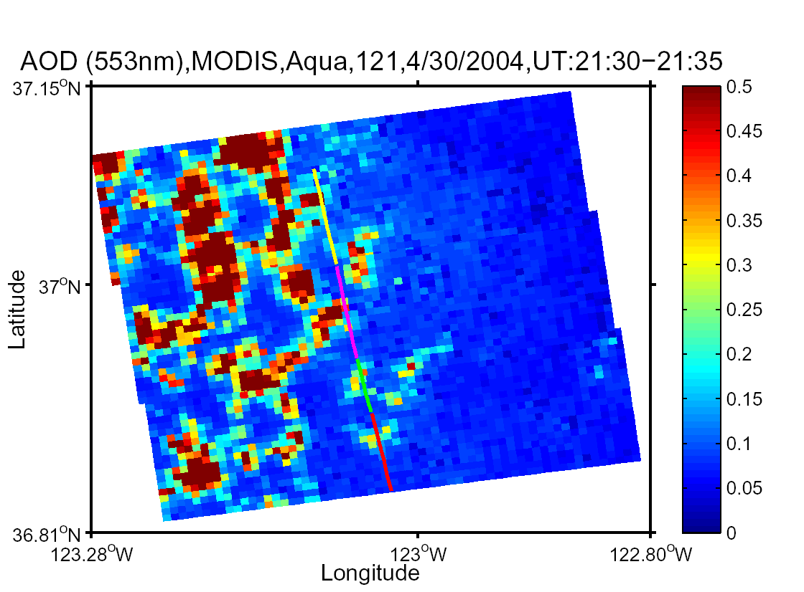 | 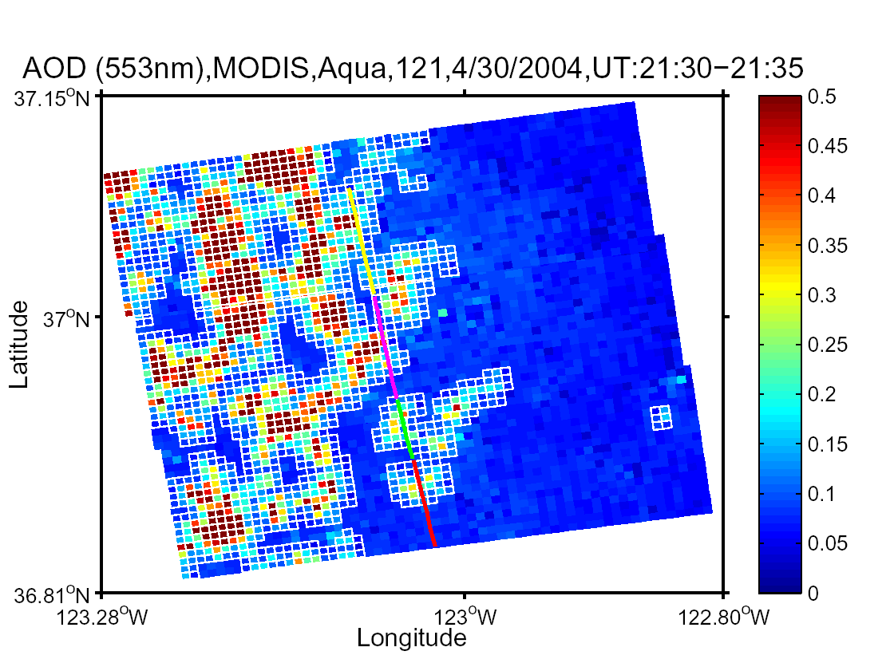
Figure 5. Upper Left - Flight track of EVE flight CIR06 (red), April 30, 2004, superimposed on MODIS-Aqua true color image. Upper Right – Standard MODIS cloud mask, MYD35. Lower left – AOD (553nm) computed by applying the MODIS standard algorithm to 500m pixel radiances. Lower right – same as lower left, but with MODIS 500m pixels that would be sorted out by variability criterion outlined with white borders.

Detailed description of proposed work
For the reasons given in the preceding sections, we propose to make measurements with AATS-14 on the NASA P-3 aircraft in ARCTAS and to perform integrated analyses that address ARCTAS science goals. The following subsections provide more specifics on the proposed measurements and analyses.

AATS-14 instrument calibration, measurements, data reduction, and archival for ARCTAS (April/July 2008)

Calibration
Standard procedure for the preparation of AATS-14 for field deployment is the pre- and post-mission calibration of the instrument at Mauna Loa Observatory. These calibration trips are usually scheduled for a 10-day span in an attempt to obtain a minimum of 5 suitable Langley plots per trip. Because the ARCTAS deployment schedule calls for two 4-week deployments (currently P-3 operations in Phase-A assumed to be from Fairbanks, AK and Phase-B from Alberta, Canada) we will schedule three calibration trips, with the second calibration trip serving as the post-mission calibration for the Phase-A deployment and as the pre-mission calibration for the Phase-B deployment. Previous calibrations have shown very good stability of AATS-14 calibration on time scales of a few months and therefore three calibration trips should suffice.

Measurements
Our proposed AATS-14 experimental work will emphasize measurements of: (a) AOD spectra (354-2139 nm) and CWV on horizontal transects, (b) aerosol extinction spectra and water vapor density in vertical profiles, and (c) when conditions are appropriate, column ozone. Flights will be coordinated with overpasses of A-Train satellites, as well as with other ARCTAS platforms, so as to best address the combined science goals (see below). Our ARCTAS flights will also include underflights of Terra, permitting a renewal of our previous correlative measurements for MISR aerosol validation, which have been very fruitful.
P-3
King Air B-200

Fig. 6. Illustration of the low-altitude aircraft flight patterns proposed for AATS measurements in ARCTAS to support combined suborbital and satellite aerosol radiative effect studies. (1) Survey Vertical Profile. (2) Minimum-Altitude Transect. (3) Parking Garage. (4) Above-Cloud Transect.

Our experience from INTEX-A&B and many previous experiments has shown that success in accomplishing the dual goals of satellite validation and radiative effect science is critically dependent on flying the necessary aircraft flight patterns. Fig. 6 shows the types of flight patterns flown in INTEX-A&B, which we also propose to fly in ARCTAS. More detailed flight patterns are proposed to be developed in a companion proposal led by Dr. Russell, submitted separately to this NRA.
Brief descriptions and rationales for the four patterns shown in Figure 6 are as follows: (1) Survey Vertical Profile, often flown when first arriving at a measurement site, provides profiles of AOD, aerosol extinction, CWV, and water vapor density, often used for determining aerosol and water vapor layer heights for further measurements in subsequent patterns. (2) Minimum Altitude Transect, usually flown at or near satellite overpass time, provides AOD and CWV measurements of the full column viewed by the satellite. Long transects can measure gradients and other spatial structure in the satellite scene. (3) Parking Garage, or stepped profile, includes horizontal legs and linking ramps. The horizontal legs permit measurements of radiative fluxes and/or collection of long-duration samples, at altitudes chosen on the basis of the Survey Vertical Profile. (4) Above-Cloud Transect provides measurements of AOD spectra and CWV above cloud. Such measurements contribute to studies of aerosol indirect (i.e., cloud-mediated) effects. For example, above-cloud AOD spectra are difficult to determine from space, but they affect satellite retrievals of cloud OD and droplet effective radius—two important measures of aerosol indirect effects. Radiative flux spectra from above-cloud transects also permit retrievals of cloud OD and droplet effective radius from SSFR and RSP measurements.

Data reduction and archival
We will reduce the AATS-14 data in the field and provide it to the project archive on project schedules as we did in INTEX-A&B (see the data archived at http://www-air.larc.nasa.gov/cgi-bin/arcstat.). Our experience has shown that our initial data reduction in the field produces data that is within a few percent of final data processing, with the exception of rare changes in the calibration of select channels, which can only be detected during the post-mission calibration trip and therefore need to be included in later processing.

Integrated analyses for ARCTAS aerosol radiative effect studies
The range of integrated analyses possible with the ARCTAS AATS-14 data set will depend somewhat on whether and which other instruments fly on the P-3 aircraft with AATS-14. As pointed out above, the inclusion of an in situ aerosol instrumentation package on the P-3 would necessitate a focus on aerosol closure studies, such as those described in section 2.3.2 above.
The radiative impacts of Arctic Haze aerosol and boreal forest fire smoke depend critically on their vertical distributions and on the albedo of the underlying surface. Therefore, as a first step to the radiative effects studies proposed here, we plan to assess the vertical structure of aerosol optical properties during aircraft profiles. Depending on the observational circumstances, we propose to then either make measurements conducive to the aerosol gradient method for the assessment of aerosol radiative forcing efficiency or to fly stacked parking garage patterns to allow the derivation of aerosol absorption from the measurement of layer AOD from AATS and flux divergence from the SSFR (see above).

Integrated analyses for ARCTAS satellite validation studies
Satellite sensors of aerosols [Kaufman et al., 2002; Ramanathan et al., 2002] are essential for developing an accurate description of their regional and global distribution and variability. In particular in the Arctic, spaceborne aerosol sensors launched in the past few years, such as MODIS, MISR, POLDER, OMI and CALIOP, have the potential to advance our understanding of aerosol processes in an environment that is otherwise difficult to access. Together the new sensors are beginning to advance our understanding of aerosol-climate interactions.
It is noteworthy that the ARCTAS white paper [Jacob et al., 2007] contains a detailed vision for the synergy of satellite and suborbital observations of Arctic haze and boreal forest fires. The suborbital platforms need the satellite-based measurements to assess the spatial context of their detailed observations, while the satellite measurements require the suborbital measurements for validation purposes and to provide the satellite studies with aerosol information not currently accessible from space.
Of particular interest to the validation of OMI data products are observations that include information on aerosol absorbing properties, because aerosol single scattering albedo (SSA) is one of the data products to be derived from OMI radiances. In the past, observations of AOD by AATS-14 were successfully combined with measurements of spectrally resolved total irradiances by the NASA Ames SSFR (Solar Spectral Flux Radiometer) to derive the spectral aerosol single scattering albedo [e.g., Bergstrom et al., 2003]. In INTEX-A, the AATS and SSFR measurements were combined to estimate aerosol radiative forcing from an aerosol gradient method - as shown in Fig. 1. In this proposal we only request funding to support the deployment of the NASA AATS-14 instrument and associated analyses. However, the addition of SSFR to measure upwelling and downwelling, spectrally resolved total irradiances will enable the validation of OMI-derived SSA.
The particular interests of the MISR aerosol team in ARCTAS are (i) to study Boreal Fire Plume Height, Optical Depth, and Smoke Type, (ii) to quantify MISR's ability to retrieve Aerosol Optical Depth Over Snow and Ice, (iii) to contribute MISR maps of high-latitude Aerosol Optical Depth, Air Mass Type & Extent, as much as possible, (iv) to contribute MISR multi-angle maps of high-latitude Surface Structure, and (v) to work collaboratively to realize the aerosol transport and aerosol forcing campaign goals.
The ARCTAS goals of the MODIS aerosol team led by Dr. Lorraine Remer are (i) to study emission sources and transport of aerosols (dust, pollution, smoke) and CO to the Arctic region, (ii) inter-compare/validate aerosols and CO between GOCART model outputs, satellite retrievals, and aircraft measurements to assess influxes of aerosol and CO to the Arctic region in a global perspective, (iii) advance satellite retrievals over snow/ice/cloud surface using airborne measurements of aerosol chemical compositions and CO vertical distributions currently unavailable or less accurate, and (iv) to evaluate aerosol radiative effects in the complex environments (snow/ice/clouds) using GOCART model simulations and MODIS satellite measurements on Terra and Aqua.

As described in section 2, the observations of aerosols and their radiative effects by MODIS, MISR and OMI in the Arctic are extremely important due to the paucity of suborbital observations. At the same time, these satellite observations are hampered by the vast spatial extent of cloud cover, the lack of contrast between clouds and highly reflective surfaces, as well as the persistently low sun angles and long seasonal lack of solar illumination. We propose here to fly low-level horizontal transects over the Arctic snow- and ice-cover to measure spectral AOD with AATS-14 for a validation of the retrievals by the passive aerosol remote sensors.

Among the challenges for the passive remote sensors described above, only the persistence of low cloud cover in the Arctic presents an observational challenge to CALIPSO. Because of the relatively higher frequency of CALIPSO overpasses in the Arctic (by comparison to lower latitudes), we expect to have ample opportunities for the comparison of AATS-14 derived aerosol extinction profiles to the extinction profiles derived from the CALIOP lidar. Even when low clouds are present, AATS-measured AODs and extinction profiles above the clouds can be compared to corresponding CALIPSO results. Both the above-cloud and cloud-free comparisons of AATS and CALIPSO should be useful for the investigation of the spatial distribution of Arctic haze and boreal forest fires, which in turn is important for assessing the transport of pollutants to the Arctic.

Finally, we propose to use the AATS-14 observations of AOD near clouds in partly cloudy satellite scenes to study the spatial variability of AOD as a function of distance from cloud edges. We plan to use these observations to study the effectiveness with which the passive remote sensors separate aerosols from clouds and we plan to incorporate both satellite (CALIOP) and suborbital (HSRL) data to investigate where changes in full column AOD as seen by AATS occurred in the vertical column relative to the vertical extent of clouds.

SUMMARY OF PLANNED ACTIVITIES LISTED BY YEAR

Year 1 (FY08)
- Preparation for participation of AATS-14 in ARCTAS including replacement of deteriorated filters, installation of AATS on P-3 (assuming that initial integration, funded by other sources, is successful), participation in pre-deployment test flights, coordination of deployment schedule, flight planning, etc.;
- Participation of AATS-14 in two ARCTAS deployments(April and July 2008);
- Pre-, between-, and post-mission calibration of AATS-14 at MLO (March, June, August 2008);
- Preliminary analysis and archival of AOD, CWV and COZ data collected in ARCTAS on ARCTAS website by Sept. 30, 2008;

Year 2 (FY09)
- Final archival of data collected in ARCTAS, based on post-mission calibration;
- Detailed validation studies for MODIS, MISR and OMI based on AATS-14 data collected in ARCTAS; publication of validation results.
- Collaborative studies to test closure among suborbital sensors and chemical transport models using AATS multi-wavelength extinction profiles. Derivation of CALIOP validation profiles from the extinction closure study cases. Publication of results.

Year 3 (FY10)
- Integrated analyses of data collected during ARCTAS, including comparison of coincident data products from various Terra and A-Train sensors in the context of collocated suborbital measurements, and assessment of regional aerosol radiative effects. Publication of results.
- Studies of the spatial distribution of Arctic haze aerosols and emissions from boreal forest fires, based on the combined use of suborbital in situ and remote sensing data with satellite aerosol retrieval maps to provide the scene context of the suborbital measurements. Publication of results.

REFERENCES
Anderson T. L., Y. Wu, D. A. Chu, B. Schmid, J. Redemann, O. Dubovik. Testing the MODIS satellite retrieval of aerosol fine mode fraction, J. Geophys. Res., 110 , D18204, doi:10.1029/2005JD005978, 2005.
Bergstrom, R. W., P. Pilewskie, B. Schmid, and P. B. Russell, Estimates of the spectral aerosol single scattering albedo and aerosol radiative effects during SAFARI 2000, J. Geophys. Res., 108(D13), 8474, doi:10.1029/2002JD002435, 2003.
Chu D. A., L. A. Remer, Y. J. Kaufman, B. Schmid, J. Redemann, K. Knobelspiesse, J.-D. Chern, R.-R. Li, F.-L. Chang, J. Livingston, P. Russell, Characterization of Aerosol Properties by MODIS during ACE-Asia Experiment. J. Geophys. Res., 110, D07308, doi:10.1029/2004JD005208, 2005.
Chowdhary, J., B. Cairns, M.I. Mishchenko, P.V. Hobbs, G. Cota, J. Redemann, K. Rutledge, B.N. Holben, and E. Russell, Retrieval of aerosol scattering and absorption properties from photopolarimetric observations over the ocean during the Chesapeake Lighthouse and Aircraft Measurements for Satellite (CLAMS) experiment, J. Atmos. Sci., Vol. 62, No. 4, pp. 1093–1117, 2005.
Coakley, J. A., Jr., W. R. Tahnk, A. Jayaraman, P. K. Quinn, C. Devaux, and D. Tanré, Aerosol optical depths and direct radiative forcing for INDOEX derived from AVHRR: Theory, J. Geophys. Res., 107(D19), 8009, doi:10.1029/2000JD000182, 2002.
Collins, D. R., Jonsson, H. H., Seinfeld, J. H., Flagan, R. C., Gassó, S., Hegg, D., Russell, P. B., Livingston, J. M., Schmid, B., Öström, E., Noone, K. J., and Russell, L. M. In situ aerosol size distributions and clear column radiative closure during ACE 2. Tellus B 52, 498-525, 2000.
Diner, D.J. W.A. Abdou, J.E. Conel, K.A. Crean, B.J. Gaitley, M.Helmlinger, R.A. Kahn, J.V. Martonchik, and S.H. Pilorz, MISR aerosol retrievals over southern Africa during the SAFARI-2000 dry season campaign, Geophys. Res. Lett.28, 3127-3130, 2001.
Durkee, P. A., K. E. Nielsen, P. J. Smith, P. B. Russell, B. Schmid, J. M. Livingston, B. N. Holben, D. R. Collins, R. C. Flagan, J. H. Seinfeld, K. J. Noone, E. Öström, S. Gassó, D. A. Hegg, L. M. Russell, T. S. Bates, and P. K. Quinn. Regional aerosol properties from satellite observations: ACE-1, TARFOX and ACE-2 results. Tellus, B 52, 484-497, 2000.
Ferrare R., D. Turner, M. Clayton, B. Schmid, J. Redemann, D. Covert, R. Elleman, J. Ogren, E. Andrews, J. Goldsmith, H. Jonsson, Evaluation of Daytime Measurements of Aerosols and Water Vapor made by an Operational Raman Lidar over the Southern Great Plains, J. Geophys. Res., 1111, D05S08, doi:10.1029/2005JD005836, 2006.
Fiebig, M., A. Petzold, U. Wandinger, M. Wendisch, C. Kiemle, A. Stifter, M. Ebert, T. Rother, and U. Leiterer, Optical closure for an aerosol column: Method, accuracy, and inferable properties applied to a biomass-burning aerosol and its radiative forcing, J. Geophys. Res., 107(D21), 8130, doi:10.1029/2000JD000192, 2002.
Gatebe, C.K., M.D. King, A.I. Lyapustin, G.T. Arnold and J. Redemann, Airborne Spectral Measurements of Ocean Directional Reflectance, J. Atmos.c Sci., Vol. 62, No. 4, pp. 1072–1092., 2005.
Hartley, W. S., P. V. Hobbs, J. L. Ross, P. B. Russell and J. M. Livingston, Properties of aerosols aloft relevant to direct radiative forcing off the mid-Atlantic coast of the United States, J. Geophys. Res. 105, 9859-9886, 2000.
Hegg, D. A., J. Livingston, P. V. Hobbs, T. Novakov, and P. B. Russell, Chemical apportionment of aerosol column optical depth off the Mid-Atlantic coast of the United States, J. Geophys. Res, 102, 25,293-25,303, 1997.
Herman, J.R., P.K. Bhartia, O. Torres, C. Hsu, C. Seftor, E. Celarier, Global Distribution of UV Absorbing Aerosols From Nimbus-7/TOMS Data, J. Geophys. Res., 102, 16,911-16,922,1997.
Hignett, P., J. P. Taylor, P. N. Francis, and M. D. Glew, Comparison of observed and modeled direct aerosol forcing during TARFOX, J. Geophys. Res., 104(D2), 2279–2288, 1999.
Hsu, N. C., Tsay, S, Herman, J Holben, B, Comparisons of satellite retrieval of aerosol properties from SeaWiFS and TOMS to the AERONET measurements, EOS Trans. AGU, 82 (47), Spring Meet. Suppl., Abstract A51B-03, 2002.
Jacob, D. J., P.K. Bhartia, W. H. Brune, B. Cairns, K. V. Chance, J. H. Crawford, Jack E. Dibb (UNH), John C. Gille, D.B.A. Jones, R. Kahn, Q. Li, W. McMillan, B. Pierce, L. A. Remer, P. B. Russell, H. B. Singh, A. Stohl, C. R. Trepte, and J. Worden, Arctic Research of the Composition of the Troposphere from Aircraft and Satellites (ARCTAS), A NASA contribution to the International IGAC/POLARCAT Experiment for the International Polar Year 2007-8, White paper dated 7 Feb 2007, http://cloud1.arc.nasa.gov/arctas/.
Kahn, R., P. Banerjee, and D. McDonald, The sensitivity of multiangle imaging to natural mixtures of aerosols over ocean, J. Geophys. Res., 106, 18,219-18,238, 2001.
Kahn, R., et al., incl. J. Redemann, Environmental snapshots from ACE-Asia, J. Geophys. Res., 109, D19S14, doi:10.1029/2003JD004339, 2004.
Kaufman, Y.J., D. Tanré, L.A. Remer, E. Vermote, A. Chu and B.N. Holben, Operational remote sensing of tropospheric aerosol over land from EOS moderate resolution imaging spectroradiometer. J. Geophys. Res., 102, 17051-17067, 1997.
Kaufman, Y., D. Tanré, and O. Boucher, A satellite view of aerosols in the climate system, Nature, 419, 215-223, 2002.
Kim, D.-H., B. J. Sohn, T. Nakajima, and T. Takamura, Aerosol radiative forcing over east Asia determined from ground-based solar radiation measurements, J. Geophys. Res., 110, D10S22, doi:10.1029/2004JD004678, 2005.
Klett, J. D., Lidar inversion with variable backscatter/extinction ratios, Appl.Opt., 24, 1638-1643, 1985.
Levy, R. C., L. A. Remer, J. V. Martins, A. Plana-Fattori, B. N. Holben, J. Redemann, P. Russell, G. L. Schuster, W. J. Rodriquez, K. Rutledge, R. Kleidman, Y. J. Kaufman, Validation of MODIS Aerosol Retrieval over the Ocean during CLAMS, EOS Transactions, Vol. 83, no. 19, pp. S36, 2002.
Levy, R. C., L. A. Remer, D. Tanré, Y. J. Kaufman, C. Ichoku, B. N. Holben, J. M. Livingston, P. B. Russell, H. Maring, Evaluation of the MODIS retrievals of dust aerosol over the ocean during PRIDE. J. Geophys. Res., Vol. 108, No. D19, 8594 10.1029/2002JD002460, 23 July 2003.
Levy, R.C., L.A. Remer, J.V. Martins, Y.J. Kaufman, A. Plana-Fattori, J. Redemann, B. Wenny, Evaluation of the MODIS aerosol retrievals over ocean and land during CLAMS, J. Atmos. Sci., Vol. 62, No. 4, pp. 974–992, 2005.
Livingston, J. M., V. Kapustin, B. Schmid, P. B. Russell, P. K. Quinn, T. S. Bates, P. A. Durkee, P. J. Smith, V. Freudenthaler, D. S. Covert, S. Gassó, D. A. Hegg, D. R. Collins, R. C. Flagan, J. H. Seinfeld, V. Vitale, and C. Tomasi, Shipboard sunphotometer measurements of aerosol optical depth spectra and columnar water vapor during ACE 2 and comparison to selected land, ship, aircraft, and satellite measurements. Tellus, B 52, 594-619, 2000.
Livingston, J. M., et al., Airborne sunphotometer measurements of aerosol optical depth and columnar water vapor during the Puerto Rico Dust Experiment, and comparison with land, aircraft, and satellite measurements, J. Geophys. Res., 108 (D19), 8588, doi:10.1029/2002JD002520, 2003.
Livingston J. M., B. Schmid, P. B. Russell, J. A. Eilers, R. W. Kolyer, J. Redemann, S. A. Ramirez, J-H. Yee, W. H. Swartz, C. R. Trepte, L. W. Thomason, M. C. Pitts, M. A. Avery, C. E. Randall, J. D. Lumpe, R. M. Bevilacqua, M. Bittner, T. Erbertseder, R. D. McPeters, R. E. Shetter, E. V. Browell, J. B. Kerr, K. Lamb. Retrieval of ozone column content from airborne Sun photometer measurements during SOLVE II: Comparison with coincident satellite and aircraft measurements Atmospheric Chemistry and Physics Special Issue on the SOLVE II/VINTERSOL campaign. Atmos. Chem. Phys., 5, 2035-2054, 2005 SRef-ID:1680-7324/acp/2005-5-2035, 2005.
Livingston, J., B. Schmid, J. Redemann, P. B. Russell, S. A. Ramirez, J. Eilers, W. Gore, S. Howard, J. Pommier, E. J. Fetzer, S. W. Seemann, E. Borbas, D. Wolfe, Comparison of Water Vapor Measurements by Airborne Sunphotometer and Near-Coincident In Situ and Satellite Sensors during INTEX-ITCT 2004, J. Geophys. Res., accepted January 29, 2007.
Magi, B. I., P. V. Hobbs, B. Schmid , and J. Redemann, Vertical profiles of light scattering, light absorption and single scattering albedo during the dry, biomass burning season in southern Africa and comparisons of in situ and remote sensing measurements of aerosol optical depths, J. Geophys. Res. , 108(D13), 8504, doi:10.1029/2002JD002361, 2003.
Magi, B.I., P.V. Hobbs, T.W. Kirchstetter, T. Novakov, D.A. Hegg, S. Gao, J. Redemann, and B. Schmid, Aerosol Properties and Chemical Apportionment of Aerosol Optical Depth at Locations off the United States East Coast in July and August 2001, J. Atmos. Sci. doi: 10.1175/JAS3263.1, Vol. 62, No. 4, pp. 919–933, 2005.
Martins, J.V., D. Tanré, L.A. Remer, Y.J. Kaufman, S. Mattoo and R. Levy, MODIS Cloud screening for remote sensing of aerosol over oceans using spatial variability. Geophys. Res. Lett., 29, 10.1029/2001GL013252, 2002.
Martonchik, J. V., D. J. Diner, R. Kahn, T. P. Ackerman, M. M. Verstraete, B. Pinty, and H. R. Gordon, Techniques for the retrieval of aerosol properties over land and ocean using multiangle imaging. IEEE Trans. Geosci. Rem. Sens., 36, 1212-1227, 1998.
Omar, A. H., J. Won, D. M. Winker, S. Yoon, O. Dubovik, and M. P. McCormick, Development of global aerosol models using cluster analysis of Aerosol Robotic Network (AERONET) measurements, J. Geophys. Res., 110, D10S14, doi:10.1029/2004JD004874, 2005.
Pilewskie P, et al. incl. B. Schmid, P. Russell, The discrepancy between measured and modeled downwelling solar irradiance at the ground: Dependence on water vapor, Geophys. Res. Lett., 27, 137-140, 2000.
Pilewskie, P., R. Bergstrom, et al. incl. J. Livingston, P. Russell, Solar radiative forcing by Saharan dust during the Puerto Rico Dust Experiment. Fall Meeting, Amer. Geophys. Union, December 2002.
Pilewskie, P., J. Pommier, R. Bergstrom, et al., incl. B. Schmid, Solar spectral radiative forcing during the Southern African Regional Science Initiative, J. Geophys. Res., 108(D13), 8486, doi:10.1029/2002JD002411, 2003.
Ramanathan, V., T. S. Bates, J. E. Hansen, D. J. Jacob, Y. J. Kaufman, J. E. Penner, M. J. Prather, S. E. Schwartz, and J. H. Seinfeld, National Aerosol-Climate Interactions Program (NACIP), A National Research Imperative, White Paper, http://www-NACIP/ucsd.edu, 2002.
Redemann, J., R.P. Turco, K.N. Liou, P.B. Russell, R.W. Bergstrom, B. Schmid, J.M. Livingston, P.V. Hobbs, W.S. Hartley, S. Ismail, R.A Ferrare, E.V. Browell, Retrieving the vertical structure of the effective aerosol complex index of refraction from a combination of aerosol in situ and remote sensing measurements during TARFOX, J. Geophys. Res., 105, 9949-9970, 2000a.
Redemann, J., R.P. Turco, K.N. Liou, P.V. Hobbs, W.S. Hartley, R.W. Bergstrom, E.V. Browell, and P.B. Russell, Case studies of the vertical structure of the direct shortwave aerosol radiative forcing during TARFOX, J. Geophys. Res., 105, 9971-9979, 2000b.
Redemann, J., S. Masonis, B. Schmid, T. Anderson, P. Russell, J. Livingston, O. Dubovik, A. Clarke, Clear-column closure studies of aerosols and water vapor aboard the NCAR C-130 in ACE-Asia, 2001, J. Geophys. Res. 108(D23), 8655, doi:10.1029/2003JD003442, 2003.
Redemann, J., B. Schmid , J. A. Eilers, R.A. Kahn, R. C. Levy, P. B. Russell, J. M. Livingston, P. V. Hobbs, W. L. Smith Jr., B. N. Holben, Suborbital measurements of spectral aerosol optical depth and its variability at sub-satellite grid scales in support of CLAMS, 2001, J. Atmos. Sci. , doi:10.1175/JAS3387.1,Vol. 62, No. 4, pp. 993-1007, 2005.
Redemann, J., Q. Zhang, B. Schmid, P. B. Russell, J. M. Livingston, H. Jonsson, and L. A. Remer (2006), Assessment of MODIS-derived visible and near-IR aerosol optical properties and their spatial variability in the presence of mineral dust, Geophys. Res. Lett., 33, L18814, doi:10.1029/2006GL026626, 2006a.
Redemann, J., P. Pilewskie, P. B. Russell, J. M. Livingston, S. Howard, B. Schmid, J. Pommier, W. Gore, J. Eilers, and M. Wendisch (2006), Airborne measurements of spectral direct aerosol radiative forcing in the Intercontinental chemical Transport Experiment/Intercontinental Transport and Chemical Transformation of anthropogenic pollution, 2004, J. Geophys. Res., 111, D14210, doi:10.1029/2005JD006812, 2006b.
Redemann , J., Q. Zhang, P. Russell, P. Pilewskie, J. Livingston, B. Schmid, L. Remer, R. Kahn, Remote Sesning of the aerosol-cloud boundary, AMS Annual Meeting, Jan. 16-19, San Antonio, TX, 2007.
Remer, L. A., et al., The MODIS aerosol algorithm, products and validation. J. Atmos. Sci., 62, 947-973, 2005.
Russell, P. B., J. M. Livingston, P. Hignett, S. Kinne, J. Wong, and P. V. Hobbs, Aerosol-induced radiative flux changes off the United States Mid-Atlantic coast: Comparison of values calculated from sunphotometer and in situ data with those measured by airborne pyranometer, J. Geophys. Res., 104, 2289-2307, 1999.
Russell, P. B., and J. Heintzenberg, An Overview of the ACE 2 Clear Sky Column Closure Experiment (CLEARCOLUMN), Tellus B 52, 463-483, 2000.
Russell, P.B., J.M. Livingston, J. Redemann, B. Schmid, S.A. Ramirez, J. Eilers, R. Khan, A. Chu, L. Remer, P.K. Quinn, M.J. Rood, W. Wang, Multi-Grid-Cell Validation of Satellite Aerosol Property Retrievals in INTEX/ITCT/ICARTT 2004, J. Geophys. Res., 112, D12S09, doi:10.1029/2006JD007606, 2007.
Schmid, B., J. M. Livingston, P. B. Russell, P. A. Durkee, H. H. Jonsson, D. R. Collins, R. C. Flagan, J. H. Seinfeld, S. Gassó, D. A. Hegg, E. Öström, K. J. Noone, E. J. Welton, K. J. Voss, H. R. Gordon, P. Formenti, and M. O. Andreae, Clear sky closure studies of lower tropospheric aerosol and water vapor during ACE 2 using airborne sunphotometer, airborne in-situ, space-borne, and ground-based measurements, Tellus, B 52, 568-593, 2000.
Schmid B., J.J. Michalsky, D.W. Slater, J.C. Barnard, R.N. Halthore, J.C. Liljegren, B.N. Holben, T.F. Eck, J.M. Livingston, P.B. Russell, T. Ingold, and I. Slutsker. Comparison of columnar water-vapor measurements from solar transmittance methods. Applied Optics, Vol. 40, No. 12, 1886-1896, 2001.
Schmid, B., D. A. Hegg, J. Wang, D. Bates, J. Redemann, P. B. Russell, J. M. Livingston, H. H. Jonsson, E. J. Welton, J. H. Seinfeld, R. C. Flagan, D. S. Covert, O. Dubovik, A. Jefferson, Column closure studies of lower tropospheric aerosol and water vapor during ACE-Asia using airborne sunphotometer, airborne in-situ and ship-based lidar measurements, J. Geophys. Res., Vol. 108 D23, doi:10.1029/2002JD003361, 2003a.
Schmid B., J. Redemann, P. B. Russell, P. V. Hobbs, D. L. Hlavka, M. J. McGill, B. N. Holben, E. J. Welton, J. Campbell, O. Torres, R. A. Kahn, D. J. Diner, M. C. Helmlinger, D. A. Chu, C. Robles Gonzalez, and G. de Leeuw, Coordinated airborne, spaceborne, and ground-based measurements of massive, thick aerosol layers during the dry season in Southern Africa, J. Geophys. Res, 108, doi:10.1029/2002JD002297, 2003b.
Schmid B., R. Ferrare, C. Flynn, R. Elleman, D. Covert, A. Strawa, E. Welton, D. Turner, H. Jonsson, J. Redemann, J. Eilers, K. Ricci, A. G. Hallar, M. Clayton, J. Michalsky, A. Smirnov, B. Holben, J. Barnard. How well can we measure the vertical profile of tropospheric aerosol extinction?, J. Geophys. Res. Vol. 111, D05S07 doi:10.1029/2005JD005837, 2006.
Tanré, D., Remer, L. A., Kaufman, Y. J.; Mattoo, S.; Hobbs, P. V.; Livingston, J. M.; Russell, P. B.; Smirnov, A. Retrieval of aerosol optical thickness and size distribution over ocean from the MODIS airborne simulator during TARFOX. J. Geophys. Res. 104 (D2) 2261-2278, 1999.
Torres, O., P.K. Bhartia, J.R. Herman, Z. Ahmad and J. Gleason, Derivation of aerosol properties from satellite measurements of backscattered ultraviolet radiation, Theoretical Basis, J. Geophys. Res.,103, 17099-17110, 1998.
Torres, O., Decae, R., Veefkind, P., de Leeuw, G., OMI Aerosol Retrieval Algorithm, ATBD-OMI-03, Version 2.0, August, 2002.
Vaughan, M. et al., Fully automated analysis of space-based lidar data: an overview of the CALIPSO retrieval algorithms and data products, in “Laser Radar Techniques for Atmospheric Sensing”, U. N. Singh (ed.), Proc. SPIE, Vol. 5575, doi: 10.1117/12.572024, 2004.
Veefkind J. P., G. de Leeuw, P. A. Durkee, P. B. Russell, P. V. Hobbs, and J. M. Livingston, Aerosol optical depth retrieval using ATSR-2 and AVHRR data during TARFOX, J. Geophys. Res., 104, 2253-2260, 1999.
Wang, J., S. A. Christopher, J. S. Reid, H. B. Maring , D. L. Savoie , B. N. Holben, J. M. Livingston, P. B. Russell and S-K. Yang, GOES-8 retrieval of dust aerosol optical thickness over the Atlantic Ocean during PRIDE, J. Geophys. Res. , 108 D19, doi: 10.1029/2002JD002494, 2003.a.
Wang, J., S.A. Christopher, F. Brechtel, J. Kim, B. Schmid, J. Redemann, P.B. Russell, P. Quinn, and B.N. Holben, Geostationary Satellite Retrievals of Aerosol Optical Thickness during ACE-Asia, J. Geophys. Res., 108, doi:10.1029/2003JD003580, 2003b.
Zhang, J., S.A. Christopher, L.A. Remer and Y.J. Kaufman, Shortwave Aerosol Cloud-Free Radiative Forcing from Terra, II: Global and Seasonal Distributions, J. Geophys. Res., D10, S24, doi:10.1029/2004jd005009, 2005.

MANAGEMENT PLAN

Roles of Co-PIs and Co-I’s
Dr. Jens Redemann will be Principal Investigator. He will be responsible for the overall scientific direction, project management, administration, and communications with NASA HQ. He will be responsible for completing the work on time and within budget. Dr. Philip Russell will be Co-Investigator. He will be responsible for the project management on the NASA Ames part of this proposal, and he will participate scientifically. Mr. Roy Johnson, the AATS engineer, will prepare AATS-14 for deployment and provide engineering support in the field. Mr. John Livingston has been a member of the NASA Ames Sunphotometer Group for more than two decades and will assist in the deployment of AATS-14 and in the detailed analysis of its data. Mrs. Ramirez and Mrs. Zhang will aid in the analysis of AATS-14 and satellite data during and after the ARCTAS deployments.
NASA Ames Research Center and BAER Institute will furnish additional personnel necessary to accomplish the research.

CURRENT AND PENDING SUPPORT OF PI J. Redemann
Short Title | Agency/Task No.  Total award | Duration / WY for J. Redemann
Current:
NASA EOS Program:  “Spatial variability of MODIS and MISR derived data products”. | NASA HQ / NNG04GM63G  $340.7k (Co-PI) | 7/2004–8/2007 /  0.2 WY
NASA INTEX-B:  “Airborne Sunphotometry in INTEX-B: Measurements and Analyses…” | NASA AURA/04-0000-0297  $1106.4k (Co-I) | 10/2005-9/2008  0.15 WY
A combination of mesoscale aerosol transport modeling, suborbital data, CALIPSO and other A-Train aerosol observations to study the vertical structure of aerosol radiative effects | NNH05ZDA001N-CCST  $TBD (PI) | 10/2006-9/2009  0.2-0.35 WY (est.)
Pending:
Using MODIS, MISR and suborbital aerosol products in the vicinity of clouds and in clear skies to assess aerosol radiative effects | NNH06ZDA001N-EOS  $554.8k (PI) | 10/2006-9/2009  0.30 WY
Supplemental Analyses of INTEX-B J31 Sunphotometry: Collaborative Studies of Aerosol, Cloud and Surface Radiative Properties and Effects | NNH06ZDA001N-ACRM  $950.0k (Co-I) | 10/2006-9/2009  0.25 WY

BUDGET

Budget Justification: Narrative
As specified by Section IV of the ROSES 2007 NRA, this section includes the Table of Proposed Work Effort and the description of facilities and equipment, as well as the rationale and basis of estimate for all components of cost including procurements, travel, publication costs, and all subawards/subcontracts. The Table of Proposed Work Effort includes the names and/or titles of all personnel necessary to perform the proposed investigation. The number of person-months each person is expected to devote to the project must be given for each year.

Table of Proposed Work Effort

The work commitments shown in this section for the PI, Co-I and other investigators are based on our best estimate of the work required to conduct the proposed work and bring the effort to a successful conclusion via flights, data archival, presentations and publications.
The trips shown (below) are to ARCTAS planning meetings, ARCTAS deployment sites, data workshops, and open scientific conferences, where the named investigators will need to attend to confer on plans and to present interim and final results.
Justification for the other costs (listed in Section 3.2, Budget Justification: Details per the ROSES 2007 call) is as follows:

Network and computer support: This is an allocation to the proposed project of a share of charges billed to Dr. Russell’s group for maintaining the network and system administration in Ames Building 245. These costs are not covered by Ames G&A or Allocated Service Pools but are billed to research tasks.
Publications: This is our best estimate of the journal page charges and conference abstract fees required to describe the research results at conferences and in the peer-reviewed literature. Other included support costs identified are for Directorate and Division operating accounts.

Budget Justification: Details

As specified by Section IV of the ROSES 2007 NRA, this section includes the detailed proposed budget including all of the Other Direct Costs and Other Applicable Costs specified in the NASA Guidebook for Proposers. As required for this NRA, the Budget Justification: Narrative and the Budget Justification: Details do not specify the Total Estimated Cost, the cost of Direct Labor, or any Administrative Costs
(e.g., overhead).

Total Budget
As specified by Section IV of the ROSES 2007 NRA, the Total Budget file, which specifies the complete set of cost components including all costs discussed in the Budget Narrative and Budget Details, as well as the Total Estimated Cost, cost of Direct Labor, and Administrative Costs (overhead), is provided in a file called “totalbudget.pdf,” which is uploaded as a separate attachment in NSPIRES.

Travel budget

Biographical Sketches

(a) Jens Redemann, PI
Abbreviated Curriculum Vitae

Professional Experience
Senior Research Scientist, Group Leader | BAERI, Sonoma, CA | Sept. 006 to present
Senior Research Scientist | BAERI, Sonoma, CA | April 1999 to Sept. 2006
Research Assistant | UCLA, CA | May 1995 to March 1999
Lecturer | UCLA, CA | Jan. 1999 to present
Research Assistant | FU Berlin, Germany | June 1994 to April 1995

Education
Ph.D. in Atmospheric Sciences, UCLA. | 1999
M.S. in Atmospheric Sciences, UCLA. | 1997
M.S. in Physics, FU Berlin, Germany. | 1995

Relevant Research Experience
- PI for a grant to study the vertical distribution of aerosol radiative effects from a combination of CALIPSO, MODIS and MISR data. CALIPSO and MODIS science team member.
- Co-Principal Investigator for the study of the spatial variability of aerosol products in the vicinity of clouds from MODIS and MISR. MODIS science team member.
- Mission Principal Investigator and Mission Scientist for the Extended-MODIS-λ Validation Experiment (EVE) in 2004, an airborne field campaign to validate MODIS near-IR AOD measurements of Asian dust transported across the Pacific basin.
- PI, NASA New Investigator Program (NIP), 2003-2005.
- PI for the participation of AATS-14 (an airborne sunphotometer) in the CLAMS satellite validation study (July 2001). Responsible for proposal writing and experiment design, instrument integration, as well as scheduling and supervision of three group members. Member of the CLAMS science team.
- Related airborne sunphotometer, lidar and spectral solar flux radiometer measurements to in situ measurements of atmospheric aerosols and gases to model and derive the vertical structure of aerosol-induced radiative flux changes in Earth’s atmosphere.
- Participated in the SAFARI-2000, ACE-Asia, PRIDE, CLAMS, ADAM , ARM Aerosol IOP, EVE and INTEX-A&B field experiments aimed at investigating atmospheric aerosols. Responsible for daily flight planning and platform coordination in CLAMS, INTEX and EVE.
- Utilized satellite derived aerosol optical depth fields and aerosol properties from the ACE-Asia campaign to determine the aerosol radiative forcing of climate in the Pacific Basin troposphere.
- Developed a coupled aerosol microphysics and chemistry model to study the dependence of the aerosol single scattering albedo on ambient relative humidity.

Honors / Organizations
AGU Fall meeting invited presentation | 2005
NASA Group Achievement Awards – INTEX-A Science Team | 2005
Member of technical committee: NASA Earth System Scholars Network | June 2004 -
NASA Group Achievement Awards - SOLVE II Science Team | 2004
Invited Presentation at the 5th International APEX workshop, Miyazaki, Japan. | July 2002
Invited Presentation at the Atmospheric Chemistry Colloquium for Emerging Senior Scientists (ACCESS V). | 1999
Outstanding Student Paper Award, AGU Fall meeting. | 1998
NASA Global Change Research Fellowship Awards. | 1995-1998
UCLA Neiburger Award for excellence in teaching of the atmospheric sciences. | 1997

Summary of bibliography: 40 peer-reviewed journal articles (10 first-authored), 100+ conference presentations (50+ first-authored).

Publications relevant to this NRA are listed in section 6 of this proposal. A complete list of publications can be found at http://geo.arc.nasa.gov/sgg/AATS-website/CV_info/redemann.html.

(b) Philip B. Russell
Abbreviated Curriculum Vitae

Scientific Contributions

Leadership of many studies of atmospheric aerosol and trace gas effects on radiation and climate, using remote and in situ measurements from space, air, ground, and ship platforms.
Development of the NASA Ames Airborne Tracking Sunphotometers (AATS, U.S. Patent 4,710,618) and leadership of their worldwide, diverse uses ranging from validation of satellites and models through studies of aerosol radiative forcing of climate.
Membership on many satellite science teams, including Earth Observing System Inter-Disciplinary Science (EOS-IDS), Solar Occultation Satellites (SOSST), Stratospheric Aerosol and Gas Experiment (SAGE), and Stratospheric Aerosol Measurement (SAM) II.

Professional Experience

NASA Ames Research Center: Research Scientist (1995-present); Chief, Atmospheric Chemistry and Dynamics Branch (1989-95); Acting Chief, Earth System Science Division (1988-89); Chief, Atmospheric Experiments Branch (1982-89). Project Manager, Stratosphere-Troposphere Exchange Project (STEP, 1982-93).
SRI International (1972-82): Physicist to Senior Physicist, Atmospheric Science Center.
National Center for Atmospheric Research (1971-72, at University of Chicago and NCAR): Postdoctoral Appointee.

Education

Ph.D. and M.S., Physics, Stanford University (1971 and 1967, Atomic Energy Commission Fellow).
M.S., Management, Stanford University (1990, NASA Sloan Fellow).
B.A., Physics, Wesleyan University (1965, Magna cum Laude; Highest Honors).

Honors and Awards

NASA Ames Honor Award (2002, for excellence in scientific research). NASA Ames Associate Fellow (1995, for excellence in atmospheric research; Ames’s highest annual award). NASA Exceptional Service Medal (1988, for managing Stratosphere-Troposphere Exchange Project). NASA Space Act Award (1989, for inventing Airborne Autotracking Sunphotometer). NASA Group Achievement Awards (1989-2006).
Member, Phi Beta Kappa and Sigma Xi.

Scientific Societies/Committees

Fellow, American Association for the Advancement of Science (elected 2005 for “pioneering work and scientific leadership in the measurement of aerosol properties and the effects of haze on the Earth’s energy budget and climate”). Editor-in-Chief (1994-95) and Editor (1993, 1996), Geophysical Research Letters; Member, Board of Editors and Atmospheric Science Executive Committee, American Geophysical Union. Guest Editor, Journal of Geophysical Research Special Issues (1988-1993). Chair, American Meteorological Society International Committee on Laser Atmospheric Studies (1979-82, Member, 1978-82). Member, National Research Council Committee on Army Basic Research (1979-81). Member, American Meteorological Society Committee on Radiation Energy (1979-81).
1987)

Publications
Over 125 peer-reviewed publications. Selected publications relevant to this NRA are listed below.

Russell, P. B., et al., Multi-grid-cell validation of satellite aerosol property retrievals in INTEX/ITCT/ICARTT 2004, J. Geophys. Res., 112, D12S09, doi:10.1029/2006JD007606, 2007
Russell, P., et al., Aerosol optical depth measurements by airborne Sun photometer in SOLVE II: Comparisons to SAGE III, POAM III and airborne spectrometer measurements, Atmos. Chem. Phys., 5, 1311–1339, 2005 (SRef-ID: 1680-7324/acp/2005-5-1311, www.atmos-chem-phys.org/acp/5/1311/).
Russell, P. B., et al, Sunlight transmission through desert dust and marine aerosols: Diffuse light corrections to Sun photometry and pyrheliometry, J. Geophys. Res., 109, D08207, doi:10.1029/2003JD004292, 2004.
Schmid B., J. Redemann, P. B. Russell, et al., Coordinated airborne, spaceborne, and ground-based measurements of massive, thick aerosol layers during the dry season in Southern Africa, J. Geophys. Res., 108(D13)8496, doi:10.1029/2002JD002297, 2003.
Russell, P. B., et al., Comparison of aerosol single scattering albedos derived by diverse techniques in two North Atlantic experiments, J. Atmos. Sci., 59, 609-619, 2002.
Redemann, J., P. B. Russell, and P. Hamill, Dependence of aerosol light absorption and single scattering albedo on ambient relative humidity for sulfate aerosols with black carbon cores, J. Geophys. Res., 106, 27,485-27,495, 2001.
Russell, P. B., and J. Heintzenberg, An overview of the ACE-2 Clear Sky Column Closure Experiment (CLEARCOLUMN), Tellus B 52, 463-483, 2000.
Schmid, B., Livingston, J. M., Russell, P. B., et al. Clear sky closure studies of lower tropospheric aerosol and water vapor during ACE 2 using airborne sunphotometer, airborne in-situ, space-borne, and ground-based measurements. Tellus B 52, 568-593, 2000.
Bergstrom, R. W., and P. B. Russell, Estimation of aerosol radiative effects over the mid-latitude North Atlantic region from satellite and in situ measurements. Geophys. Res. Lett., 26, 1731-1734, 1999.
Russell, P. B., P. V. Hobbs, and L. L. Stowe, Aerosol properties and radiative effects in the United States Mid-Atlantic haze plume: An overview of the Tropospheric Aerosol Radiative Forcing Observational Experiment (TARFOX), J. Geophys. Res., 104, 2213-2222, 1999a.
Russell, P. B., et al., Aerosol-induced radiative flux changes off the United States Mid-Atlantic coast: Comparison of values calculated from sunphotometer and in situ data with those measured by airborne pyranometer, J. Geophys. Res., 104, 2289-2307, 1999b.
Russell, P. B., S. Kinne and R. Bergstrom, Aerosol climate effects: Local radiative forcing and column closure experiments, J. Geophys. Res., 102, 9397-9407, 1997.
Russell, P. B., et al., Global to microscale evolution of the Pinatubo volcanic aerosol, derived from diverse measurements and analyses. J. Geophys. Res., 101, 18,745-18,763, 1996a.
Russell, P.B., et al., The tropical experiment of the Stratosphere-Troposphere Exchange Project (STEP): Science objectives, operations, and summary findings. J. Geophys. Res., 98, 8563-8589, 1993.
Russell, P.B., et al., Post-Pinatubo optical depth spectra vs. latitude and vortex structure: Airborne tracking sunphotometer measurements in AASE II. Geophys. Res. Lett., 20, 2571-2574, 1993.
Russell, P.B., and M.P. McCormick. SAGE II aerosol data validation and initial data use: An introduction and overview. J. Geophys. Res., 94, 8335-8338, 1989.
Russell, P.B., et al. Satellite and correlative measurements of the stratospheric aerosol: III. Comparison of measurements by SAM II, SAGE, dustsondes, filters, impactors, and lidar." J. Atmos. Sci., 41, 1791-1800, 1984.
Russell, P.B., and B.M. Morley, 1982: "Orbiting Lidar Simulations: II. Density, Temperature, Aerosol and Cloud Measurements by a Wavelength-Combining Technique," Applied Optics, 21, 1554-1563.
Russell, P.B., et al. "Satellite and correlative measurements of the stratospheric aerosol: I. An optical model for data conversions." J. Atmos. Sci., 38, 1270-1294, 1981.
Russell, P.B., J.M. Livingston, and E.E. Uthe. "Aerosol-induced albedo change: measurement and modeling of an incident." J. Atmos. Sci., 36, 1587-1608, 1979.
Russell, P.B., and G.W. Grams, 1975: Application of soil dust optical properties in analytical models of climate change, J. Appl. Meteorol., 14, 1037-1043.

STATEMENTS OF COMMITMENT

Co-Investigator

TO: Jens Redemann

FROM: Philip Russell

I acknowledge that I am identified by name as Co-Investigator to the investigation entitled “Airborne
sunphotometer measurements of aerosols and water vapor to study aerosol radiative forcing and boreal forest fires in ARCTAS”, that is submitted by Dr. Jens Redemann to the NASA Research Announcement NNH07ZDA001N-ARCTYAS, and that I intend to carry out all responsibilities identified for me in this proposal. I understand that the extent and justification of my participation as stated in this proposal will be considered during peer review in determining in part the merits of this proposal.

Signed:

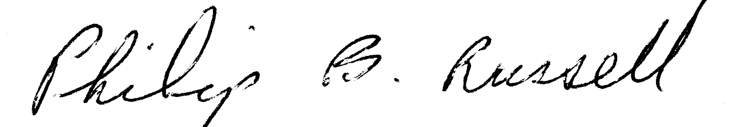
Philip Russell
Date:

Collaborators

Prof. Peter Pilewskie, Univ. of Colorado

Subject: Letter of support for ARCTAS collaboration
From: Peter Pilewskie <Peter.Pilewskie@lasp.colorado.edu>
Date: Tue, 05 Jun 2007 13:26:33 -0600
To: Jens Redemann jredemann@mail.arc.nasa.gov

Dear Jens,
I acknowledge that I am identified by name as a Collaborator to the investigation entitled “Airborne
sunphotometer measurements of aerosols and water vapor to study aerosol radiative forcing and boreal forest fires in ARCTAS”, that is submitted by Dr. Jens Redemann to the NASA Research Announcement NNH07ZDA001-N-ARCTAS, and that I intend to carry out all responsibilities identified for me in this proposal. I understand that the extent and justification of my participation as stated in this proposal will be considered during peer review in determining in part the merits of this proposal.

Sincerely,

Peter Pilewskie
--
Peter Pilewskie
Laboratory for Atmospheric and Space Physics
Department of Atmospheric and Oceanic Sciences
Duane Physics, Rm D-317
Campus Box 311
University of Colorado
Boulder, CO 80309-0311
303 492 5724
peter.pilewskie@lasp.colorado.edu

Dr. Ralph Kahn, JPL
