Progress report on development of the COsmic Foreground Explorer (COFE)
Philip Lubin, Principal Investigator
January 29, 2007

Summary
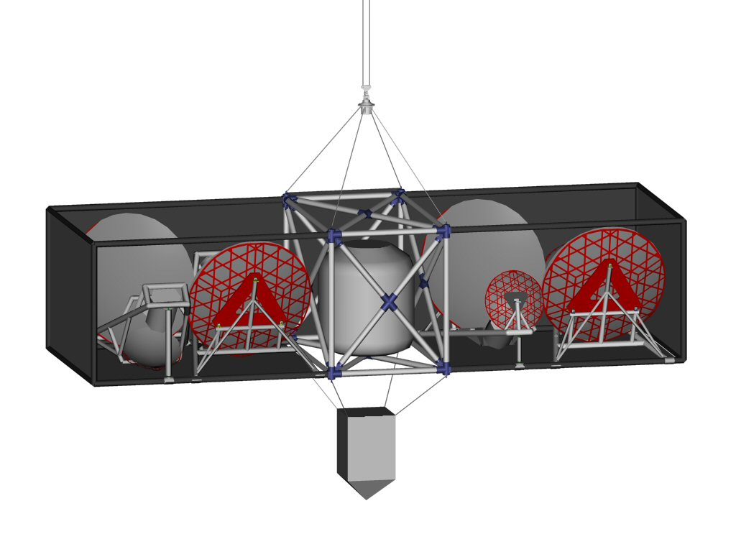
COFE is a balloon borne centimeter wave survey instrument being built at the University of California at Santa Barbara. The system consists of multiple identical off axis telescopes mounted to a single balloon platform with cryogenic detector arrays operating at 10 15 and 20 GHz. The primary goal of COFE is a (nearly) all sky measurement of the polarized foregrounds for measurements of the CMB polarization. This will likely be a rich data set, of particular interest will be a strong ability to identify and characterize (or set limits on) possible ‘spinning dust’. A rendering of the current system design is shown below. For scale note that the major axis of the primary mirrors is 2.2 meters.

Work in the past year has focused on 3 main elements: detailed testing of the modulator concept and systematics with a realistic full scale prototype at 40 Ghz (Bmachine); Development and structural analysis of telescope and gondola frames; Development of final design and research into possible manufacturing techniques for primary and secondary reflectors as well as feeds.

Bmachine Testing
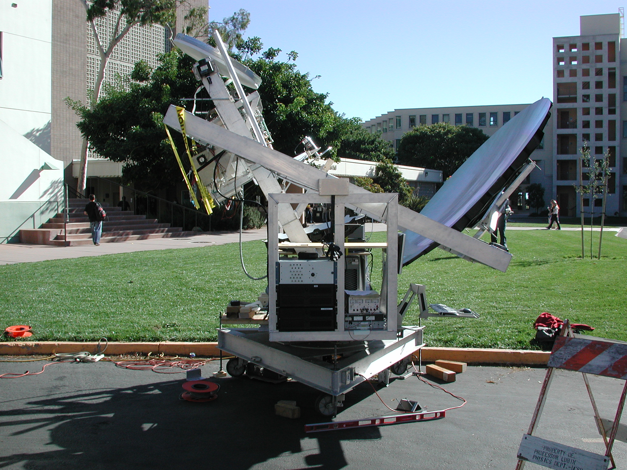
The Bmachine prototype is shown here during optical testing at UCSB. The system uses the baseline optical configuration of COFE, which employs a reflection half wave plate at the confocal point of the telescope to modulate the polarization of the telescope at 120 Hz. The COFE mirrors will be laid up on the same mold as the Bmachine mirrors pictured. Primary goals for Bmachine prototype testing this year have been to develop robust wiregrids of high enough quality for the modulator, and to validate the optical performance with the polarization modulator in the complete optical system. Plots below show some of the principal results to date:

1/f noise reduction
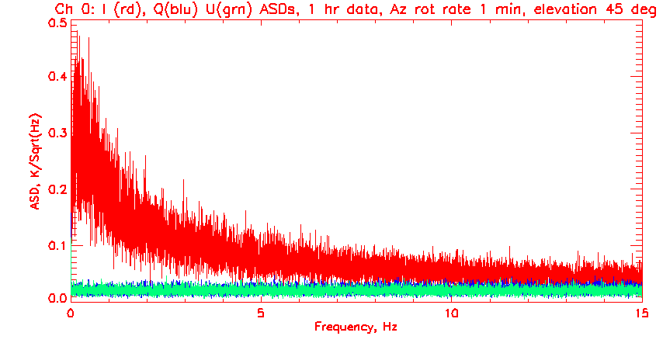
The optical modulator/demodulation effectively removes the significant 1/f noise of the HEMT radiometer.
Sample Amplitude Spectral Densities while running the telescope in nominal mapping mode. Note the removal of nearly all 1/f noise in the Q and U demodulated timstreams compared with the DC temperature measurement.
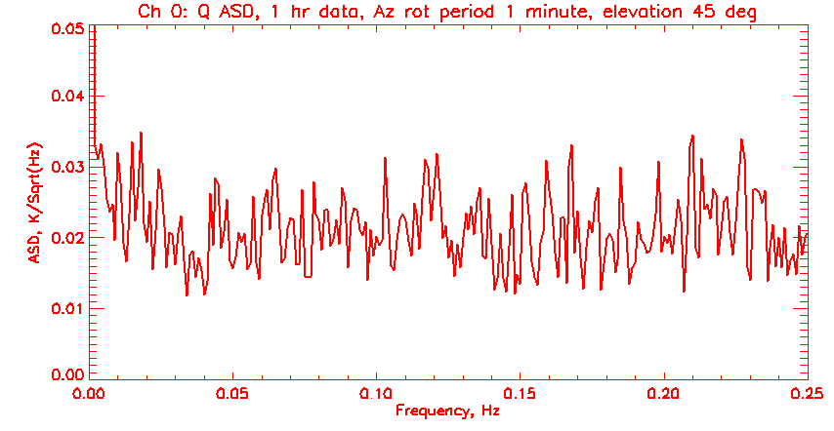
Expanded view of the demodulated ‘Q’ data above, showing the 1/f knee around 10 mHz or below. Note these data cover an hours worth of scanning and would show any gross scan synchronous effects.

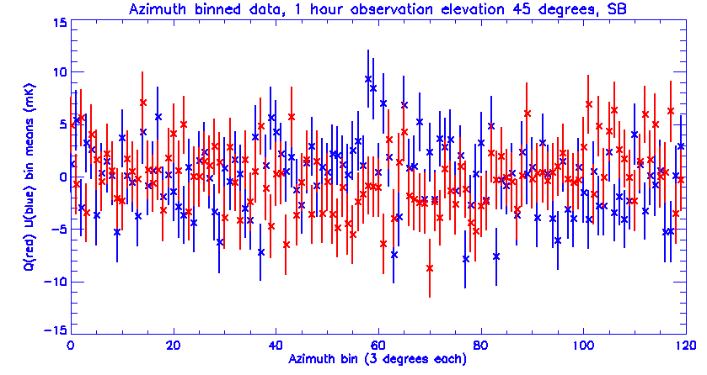
Scan synchronous artifacts
Data from 1 hours observation binned in azimuth to emphasize any scan synchronous signals. System is remarkably clean without ground shields or any sophisticate data massaging.

Optical testing
Optical tests of the Bmachine prototype are crucial for validating the COFE optical designa and modulation technique.
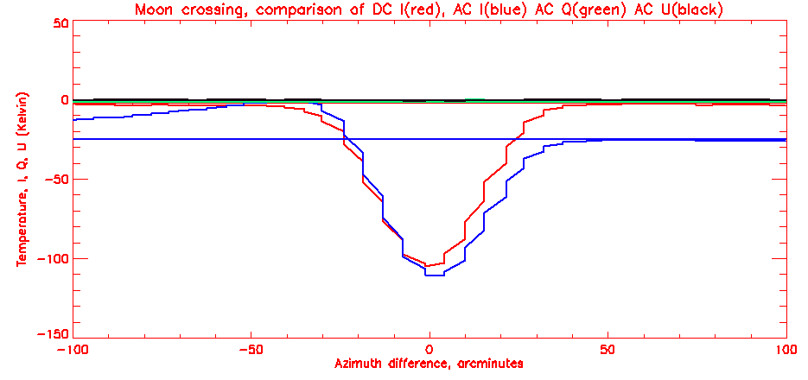
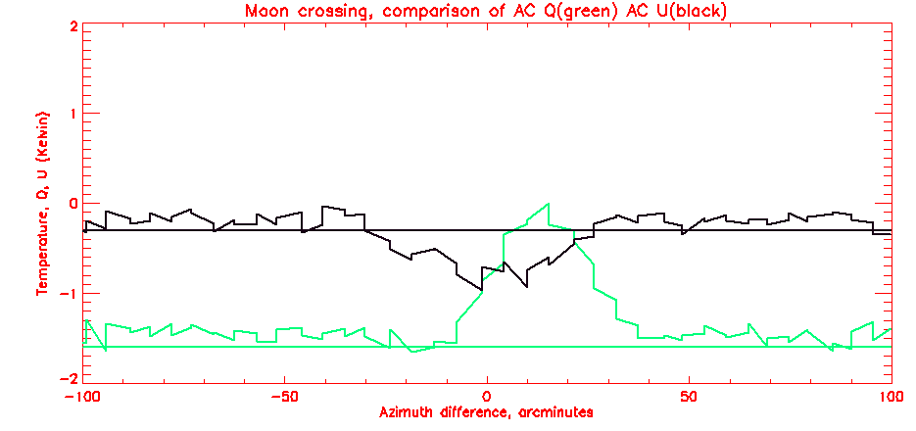
Scan of the moon taken during nominal operations. The top figure shows the DC and AC total power response in Red and Blue respectively. Q and U demodulations are shown in Green and Black. Note the coupling from I to Q and U is minimal. The lower plot is an expansion of the scale to show the coupling, which is about 1 percent. Much more detailed tests are underway.

Modulator Validation
Extensive testing has been done on many wire grid candidates to validate the operation and efficiency of the polarization modulator. Two representative plots below demonstrate efficiency of at least 95% and the orthogonality of the demodulated phase states.
Polarization Modulator: A little hard to interpret, the top graph compares the radiometer output with no modulator (thick blue line) to the radiometer output for a single phase angle including the spinning wave plate (black line). Both times viewing our full beam polarized calibrator as it rotates through several revolutions.
The lower graph compares the Q and U demodulated outputs to their quadrature sum as the calibrator is rotated.
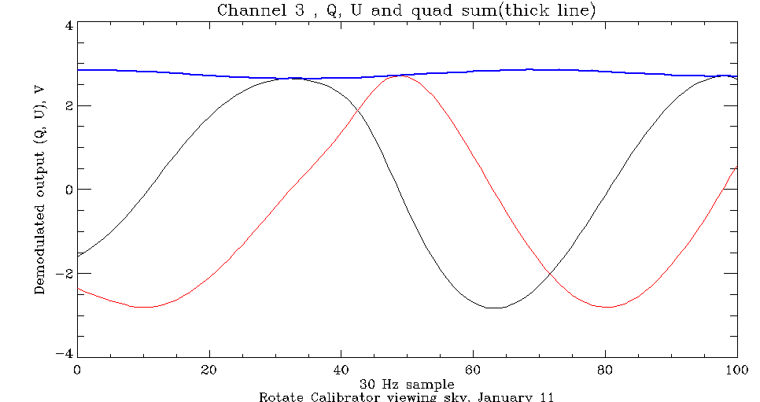
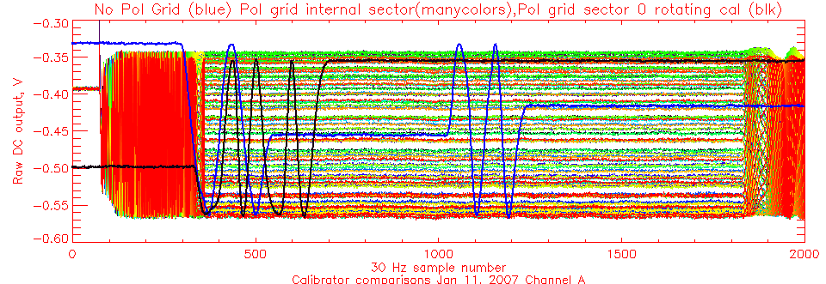

Gondola and Telescope structural design
Two different optical layouts are being built, one based on the waveplate modulator, one based on internal switches. COFE may include both designs, split by frequency, which determines the performance available in cryogenic switching. Renderings and pictures below depict the designs.

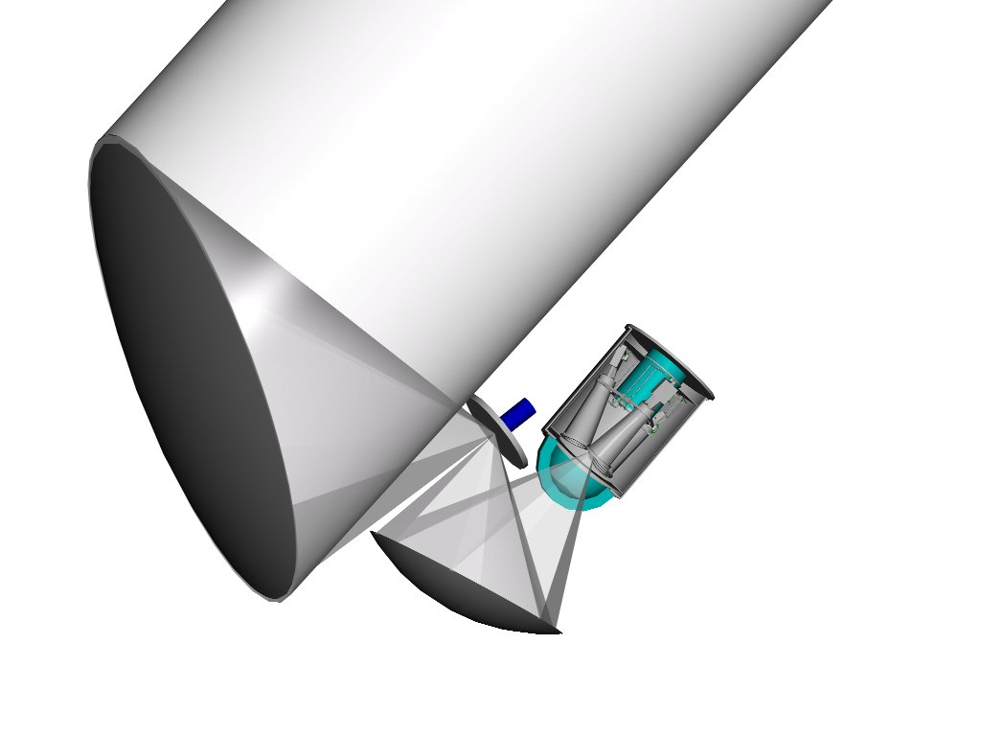
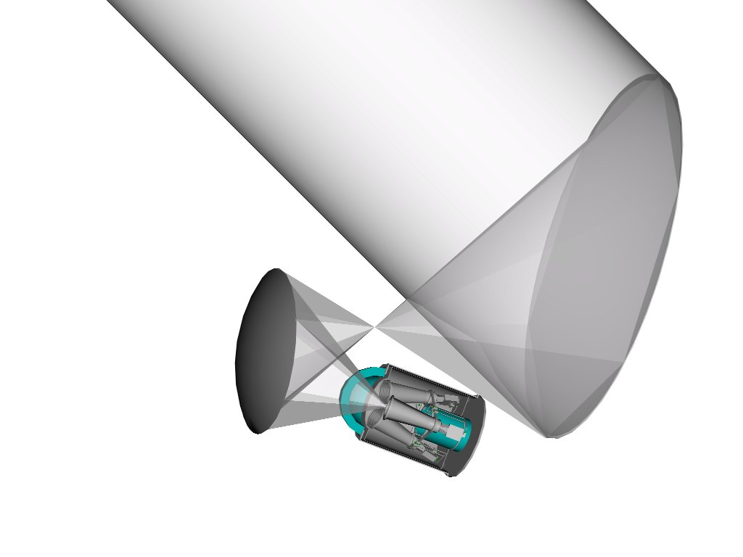
Optical Layout

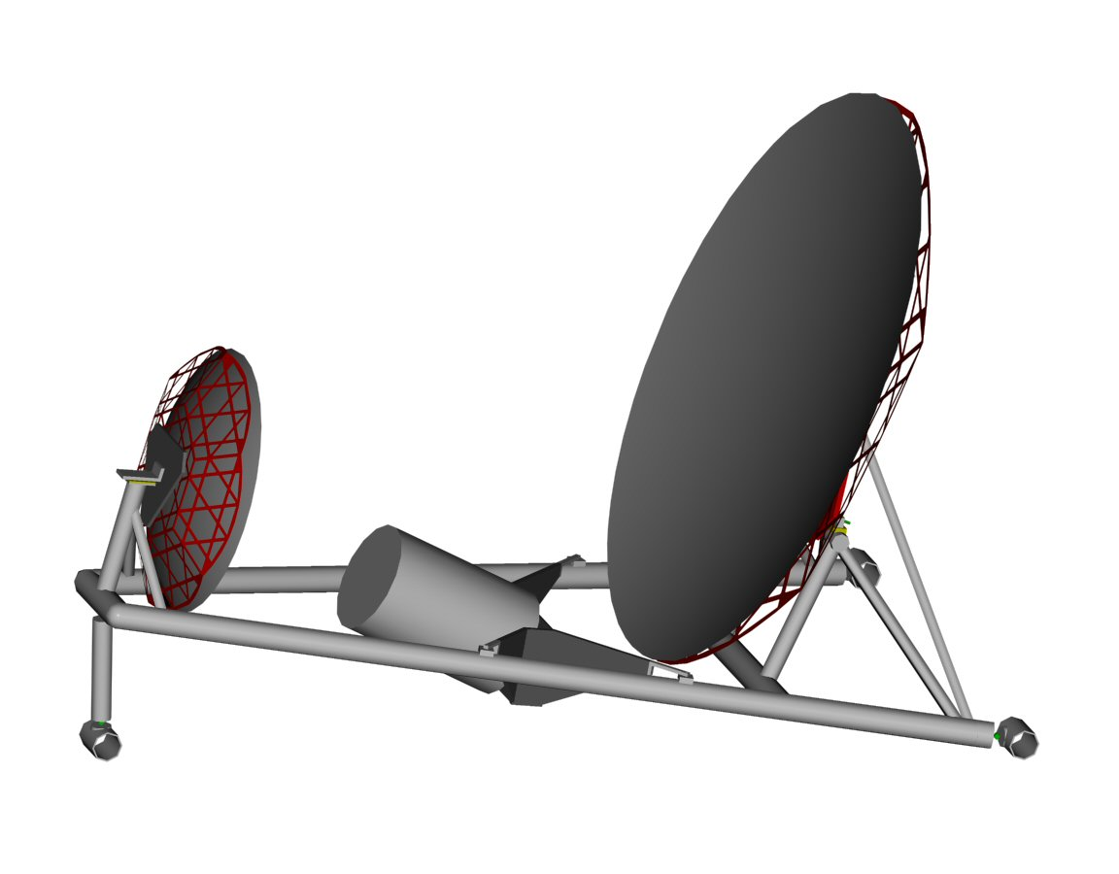
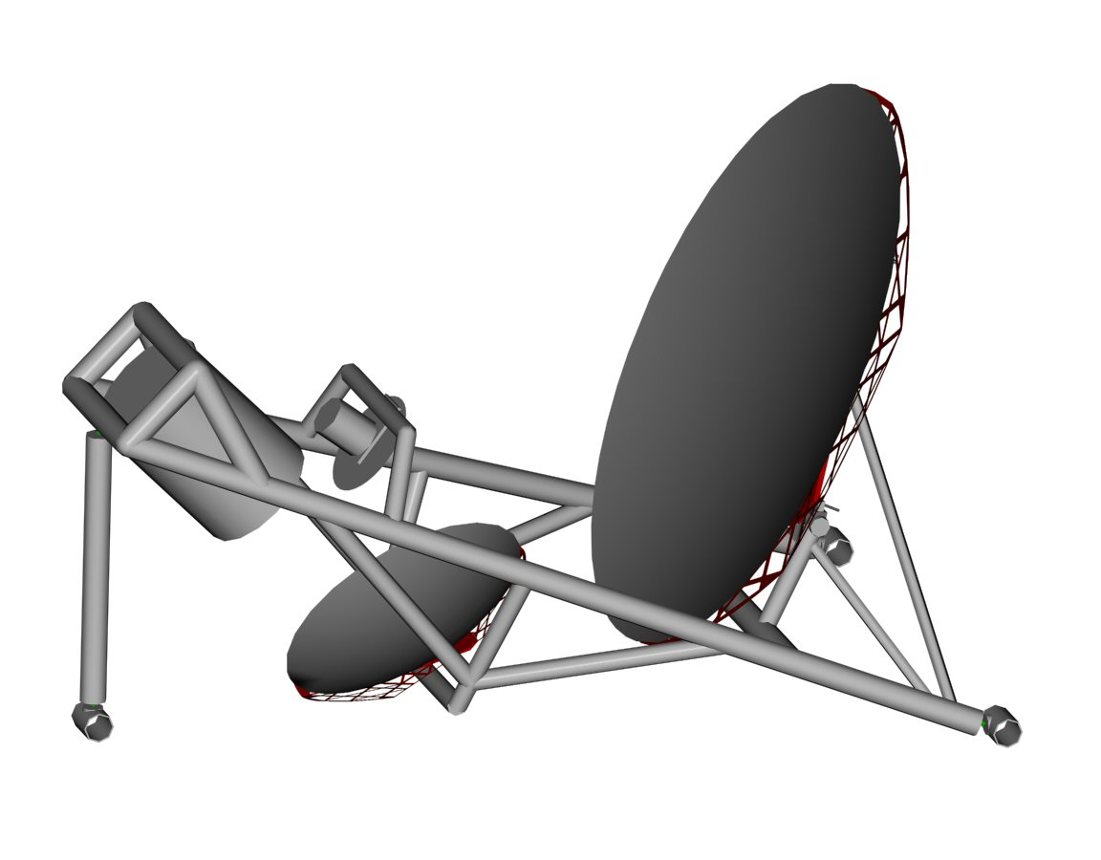
Frame Design

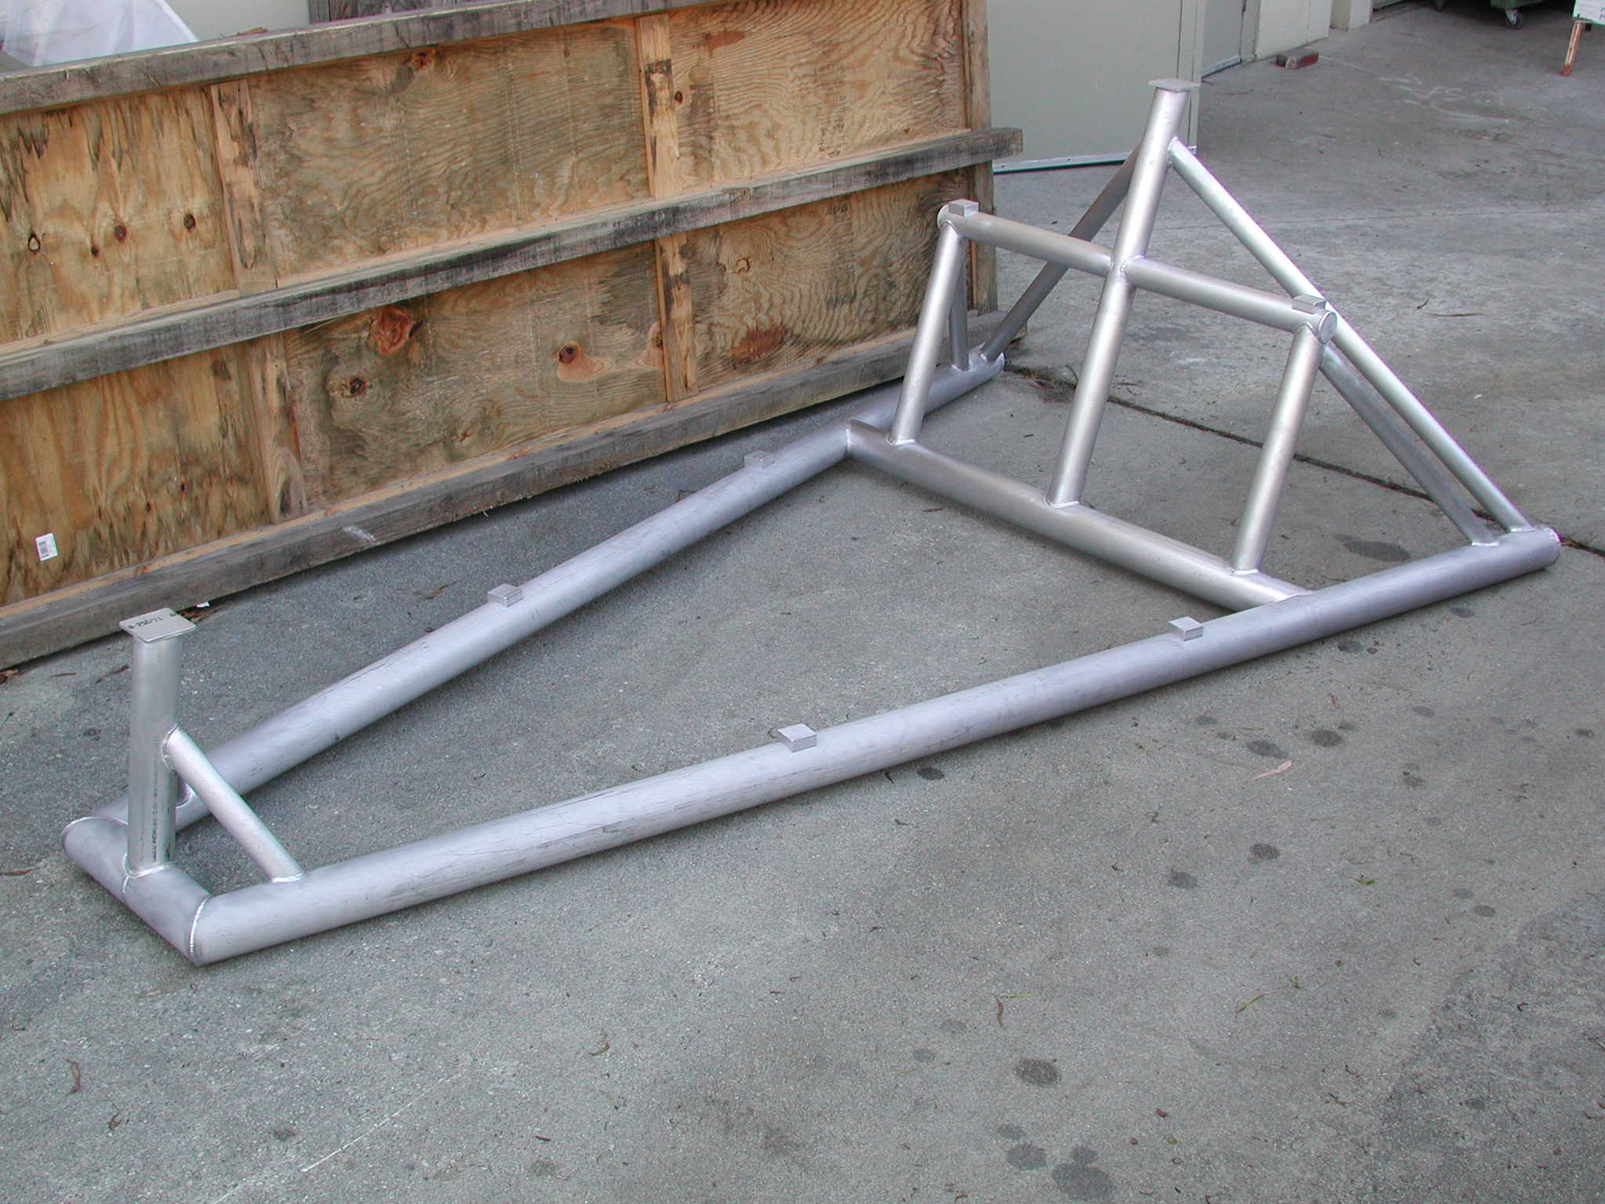
Metal
Telescope frame designs. The second optical frame is under construction. These frames are both very stiff and very light. The gondola design requirements have been minimized by relying on these stiff independent telescope frames to hold optical accuracy and by decoupling these frames from overall gondola stresses. Both frames will be used in coming months to test the new reflectors.

Reflectors and feeds

Reflectors
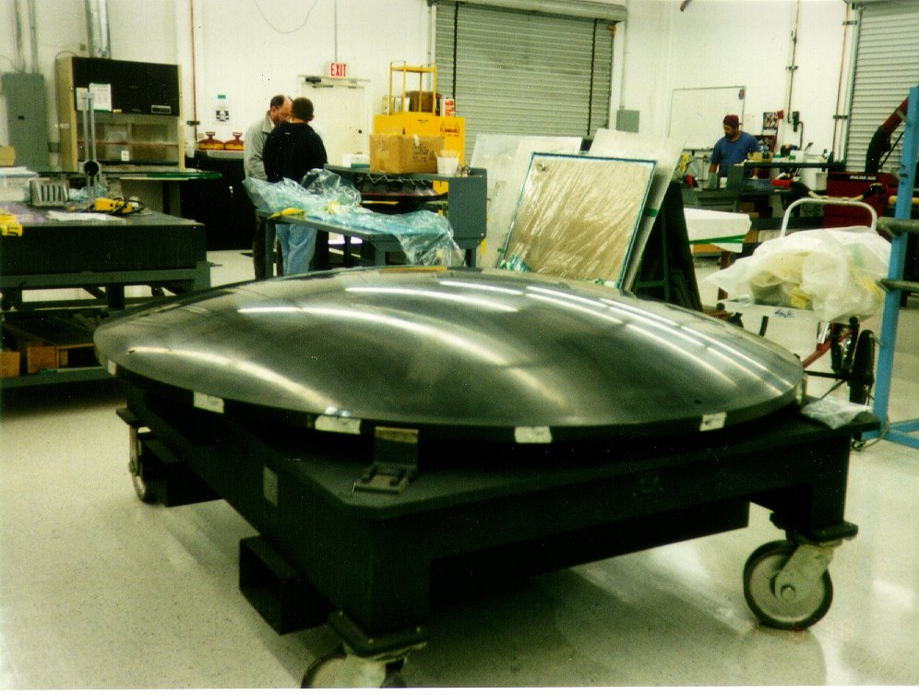
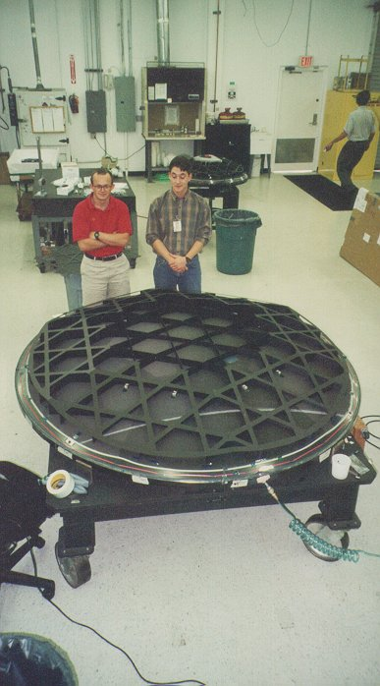
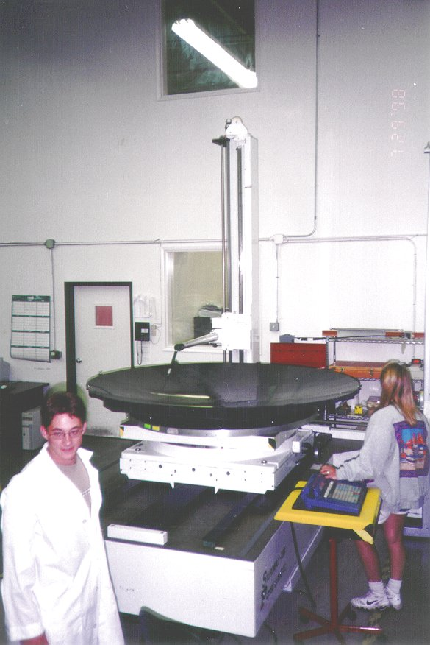
COFE will have 4 independent telescopes as a baseline. We are using our existing molds, built to make the BEAST reflectors in 1998-1999, to make the reflectors for COFE. A contract for the first two sets is already underway with ATK (formerly Composite Optics Incorporated) who made the original mirrors. ATK will use standard CFRP layup techniques to reproduce our mirrors. We are also pursuing more forward looking techniques to produce mirrors at hopefully 1/5 the cost of the traditional ones. Our strategy is to complete two new sets with ATK, which will give us a total of 4 full mirror systems, and then to do a demonstration set for validation with a different company, A2ZFX, where the goal will be to produce mirrors with reflective coatings already applied for around $5K per set. This would be a major advance for mmwave suborbital and flight systems, and would provide us with our backup optics.
2.4 Meter mold, First mirror during layup, computer measurement at Able Engineering (Santa Barbara).

Schedule
- 2006-Funding begins- Finalize optical frame, gondola and Polarization Modulator Prototype
- 2007-Assemble first telescope system and perform ground tests
- 2008-Two Ft Sumner flights (25 h nominal)
- 2009-Analysis of flight data and preparation for Southern Hemisphere flights.

