Environmental, Safety & Health
314.554.2388 (Phone)
314.554.4182 (Facsimile)
ppike@ameren.com

July 31, 2026

Mark Friedrichs, PI-40
Office of Policy and International Affairs
U.S. Department of Energy
Forrestal Building
1000 Independence Avenue, S.W.
Washington, D.C. 20585

By email: 1605bguidelines.comments@hq.doe.gov

Re: Comments on RIN 1901-AB23, Interim Final Rule Corrections and Updates to Technical Guidelines for Voluntary Greenhouse Gas Reporting. 72 Fed. Reg. 4411 (January 31, 2007)

Dear Mr. Friedrichs:

Ameren is pleased to submit comments on the Department of Energy Office of Policy and International Affairs’ (“OPIA’s”), January 31, 2007, Federal Register (“FR”) notices on the interim final rule Corrections and Updates to Technical Guidelines for Voluntary Greenhouse Gas Reporting for filing voluntary reports of greenhouse gas emissions and reductions.

Ameren provides energy services to approximately 2.4 million electric and 1 million natural gas customers over nearly 64,000 square miles in Illinois and Missouri. We have participated in the voluntary reporting of greenhouse gases since 1995. Ameren is a member of the Edison Electric Institute (“EEI”), and as a member of this group, we support the comments that they are submitting on the proposal.

We appreciate the opportunity to submit comments and have no significant comments to include other than those developed by EEI; however, we are concerned about the precedent that is being set by establishing such a short comment period. Normally, Federal Agencies allow at least 30 days of comment period on program changes and due to the importance of this program we are concerned that the comment period has been shortened to 20 days. The reason for haste is not explained, but is further exemplified by the presumed effective date only 10 days after the deadline for comments to be received. It can only be hoped that DOE’s rush to finalize the Technical Guidelines does not result in undue program limitations.

We appreciate the opportunity to provide these comments. If you have any questions, please contact me at (314) 554-2388.

Sincerely,
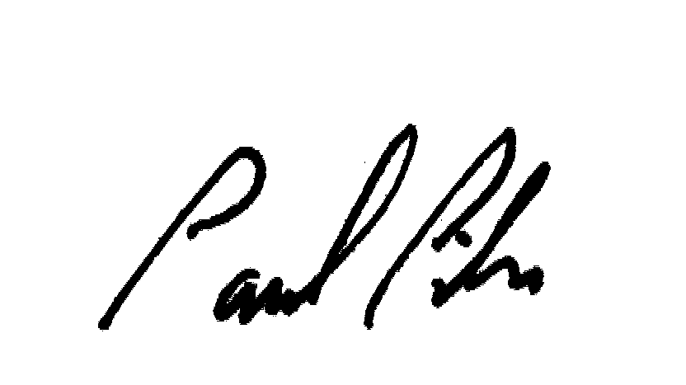
Paul R. Pike
Strategic Analyst

