Chapter 2 Machine Layouts

2.1 The Staged Approach and Footprint Description

The staged approach to the VLHC described in this feasibility study requires placing two collider rings in a common tunnel. This requirement imposes constraints on the lattices of the rings as well as on the civil construction parameters. In this report we describe the design, construction, installation and maintenance of these two proton-proton colliders. The first of these, called Stage 1, with a nominal 40 TeV cm energy uses relatively low-field superferric magnets and use NbTi conductor. The Stage 1 ring has as its injector the currently operating ~ 1 TeV Tevatron. The Stage 1 VLHC will operate at an initial luminosity of 1 × 10³⁴ cm^{–2}sec^{–1}.
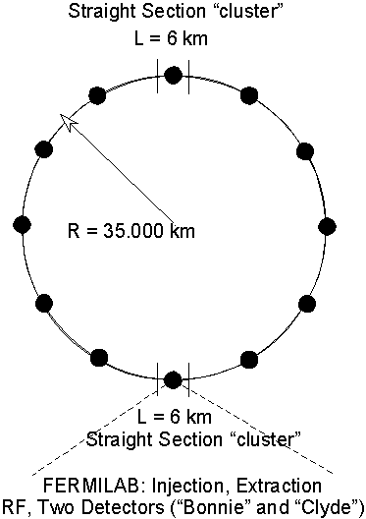
After Stage 1 has been in operation for several years carrying out a frontier physics program the Stage 2 ring will be added and a bypass for the Stage 1 ring constructed. Stage 2 will have a nominal cm energy of 175 TeV and use the Stage 1 ring operating at 10 TeV as its injector. The Stage 2 magnets will have an operating field of ~10 T and use Nb₃Sn superconductor. The Stage 2 VLHC will have a peak luminosity of 2 × 10³⁴ cm^{–2}sec^{–1}.

One anticipates that the multi-billion dollar investment in the conventional facility described will serve the world high-energy physics program over many decades. Therefore the tunnel should be designed to allow adding as yet unspecified other future collider rings to the complex.

2.2 Geometry
Figure 2.1. Ring Geometry with arbitrary orientation

The circumference of the collider is 232 km. The protons take ~78 msec to circle the ring and their revolution frequency is 1290 Hz. A ring of this size with arbitrary orientation is shown in Figure 2.1. The overall footprint is a racetrack. An approximate description is two half circles of radius = 35 km joined by two long straight sections, each 6 km long. A more precise description of the proposed footprint is the major arcs bend the beams 174º and the remaining 6º of bending occurs in the 6 km, which is a cluster of 5 straight sections separated by four bends. These clustered straight sections are for injection, abort, rf cavities, interaction regions for two experiments, and for the transfers between Stage 1 and Stage 2.

Several possible orientations allowing injection from the Tevatron are discussed in Chapter 4 and several possible geographical sitings based on geological considerations are shown in Chapter 7. Fermilab is an excellent site for constructing this frontier physics facility due to the existence of an injector chain having the required beam characteristics and the excellent geology of the region. An important design goal is to put as much as possible on the site especially the beam dumps for ES&H and public relations reasons.

Grouped below or nearly below the existing Fermilab site are the underground injection and extraction (abort) beam lines, the abort beam dump, and the rf acceleration stations. In the long “on-site” straight section is room for two detectors, separated sufficiently to avoid muon background from one detector to the other. In this study, it is assumed that the long straight opposite the Fermilab site is “passive” although a “far” campus could be developed there.

The depth below surface depends on the specific orientation of the collider tunnel. The relative merits of three configurations are discussed in Chapter 5: These are
- 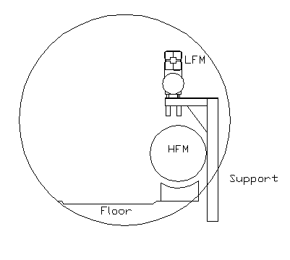South Ring with 0.08% incline and depth at Fermilab of 235 feet
- North Ring, no incline and depth at Fermilab of 330 feet
- North Ring with 0.20% incline and depth at Fermilab of 501 feet

The size of most of the tunnel is 12-foot clear diameter with a 10-foot wide invert (floor) as shown in Figure 2.2. The Stage 1 collider ring is placed directly over the high-field ring.

This diameter should be regarded as a minimum. A larger tunnel might be preferred for reasons of economy, i.e. it might be cheaper to build. A larger tunnel eases the alignment tolerance and provides more room for multiple activities during installation. The Civil Construction required to accommodate the technical components that make up the Stage 1 collider, in addition to the main tunnel will have many wider portions for special purposes, injection and extraction beam line tunnels, access shafts, and a large number of caverns of varying sizes. These caverns will accommodate the beam stop, rf klystrons, kicker magnet power supplies, groundwater collection caverns and pumping stations, ac power distribution alcoves, cryo valve alcoves, quench resistor caverns, cryo systems caverns, and a large number of electronics drawers. These latter are 5-foot deep by 1-foot in diameter bored into the aisle side of the tunnel wall to house a variety of power supplies, instrumentation and controls.

When Stage 2 is implemented additional civil construction will be required for the bypass around the near side cluster only.

Spaced around the circumference are twelve surface facilities that during civil construction are used for spoils removal and then serve to house cryogenics plants and other required machine functions.

Paragraph: Describe footprint of a “typical” surface facility. A few sentences about utilities, how many MW installed, water pumping … etc. Figure.

Both low field and high field ring lattices are constructed from optical modules placed end to end like Lego blocks. Each optical module — an arc, dispersion suppressor, or interaction region straight — has an overall length which is an integer multiple of L_{hc}, the arc half-cell length. Low and high field modules with the same function are quite different in implementation. The low field modules use combined function magnets, while high field modules always use separated function magnets. For example, the low-field arc half-cell contains two combined function bending magnets, while the high field arc half cell contains seven “pure” dipoles. Nonetheless, optical modules in both low-field and high-field rings always have the same overall length and the same net bending angle. Another example is the dispersion suppressor modules. In both low and high field rings a Dispersion Suppressor module is 3 × L_{hc} long, constructed from 4 dispersions suppressor half cells of length 3/4 × L_{hc} each with 2/3 of the bending of a regular arc half cell.

Table 2.1 lists the fundamental parameters of the VLHC footprint that are common to both low and high field rings. Table 2.2 lists the sequence of optical modules for half the ring — one arc and the utility region on the Fermilab site —in mnemonic form. IR stands for Interaction Region modules; DM for Dispersion Suppressor modules, and IA for the Injection/Abort straight section. The footprint geometry for the far off-site utility region, half way around the VLHC, is identical. The two utility regions are separated by identical arcs. Table 2.3 lists the sequence of optical modules in the on-site utility region in greater detail, including the key for the mnemonics.

Table 2.1. Fundamental lattice parameters common to both low and high field rings
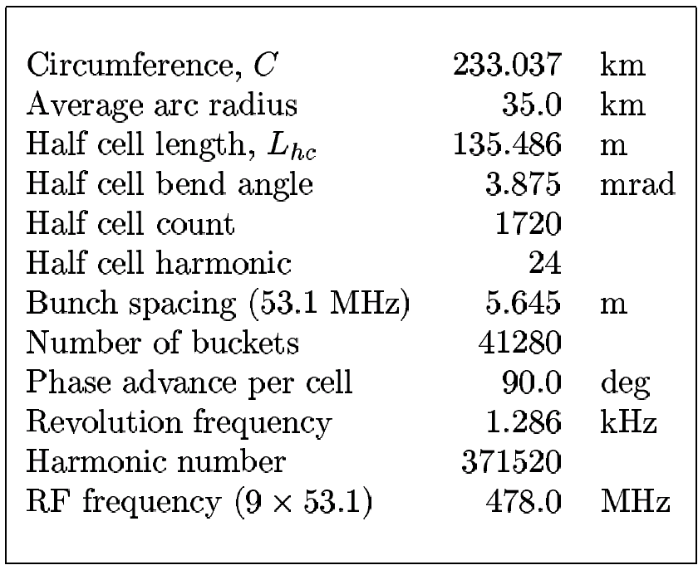

Table 2.2. Sequence of optical modules around half of the VLHC

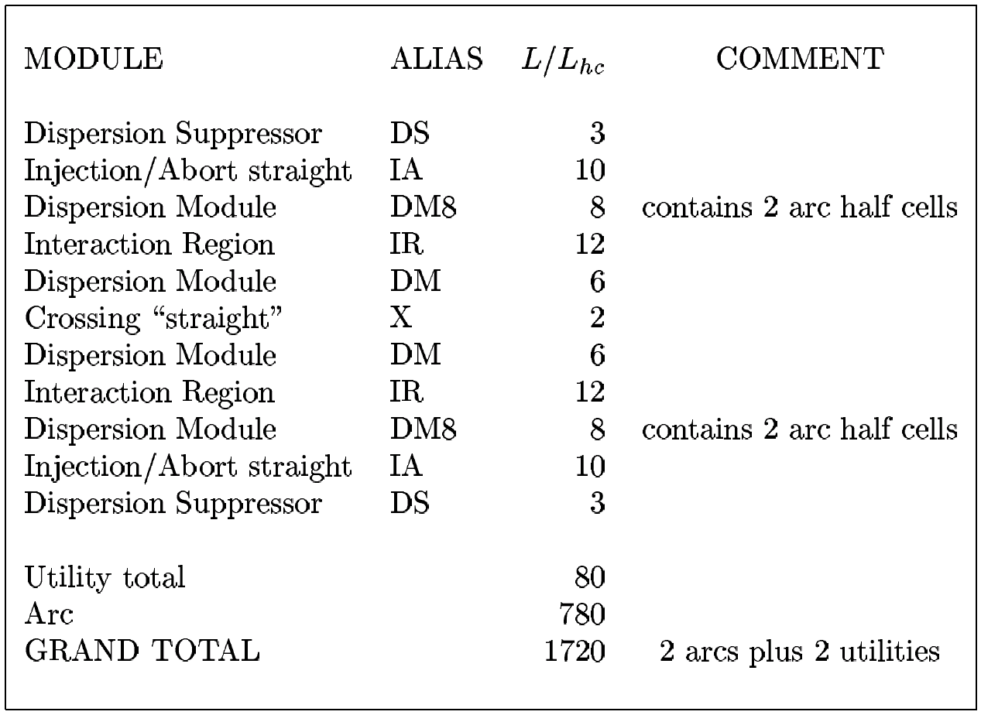
Table 2.3. Sequence of optical modules in the on-site utility region of the VLHC

Figure 2.3 shows a scale layout of the optical modules in the on-site utility region, including two interaction points (IPs). Injection from the Tevatron is naturally away from the two IPs, since the VLHC is about 100 meters below the ground at Fermilab. One of the two abort lines per ring is shown, missing the neighboring IP by about 40 meters. A common abort dump area is possible for the four beams, approximately 100 meters from the horizontal crossing point “X” of the low-field ring.
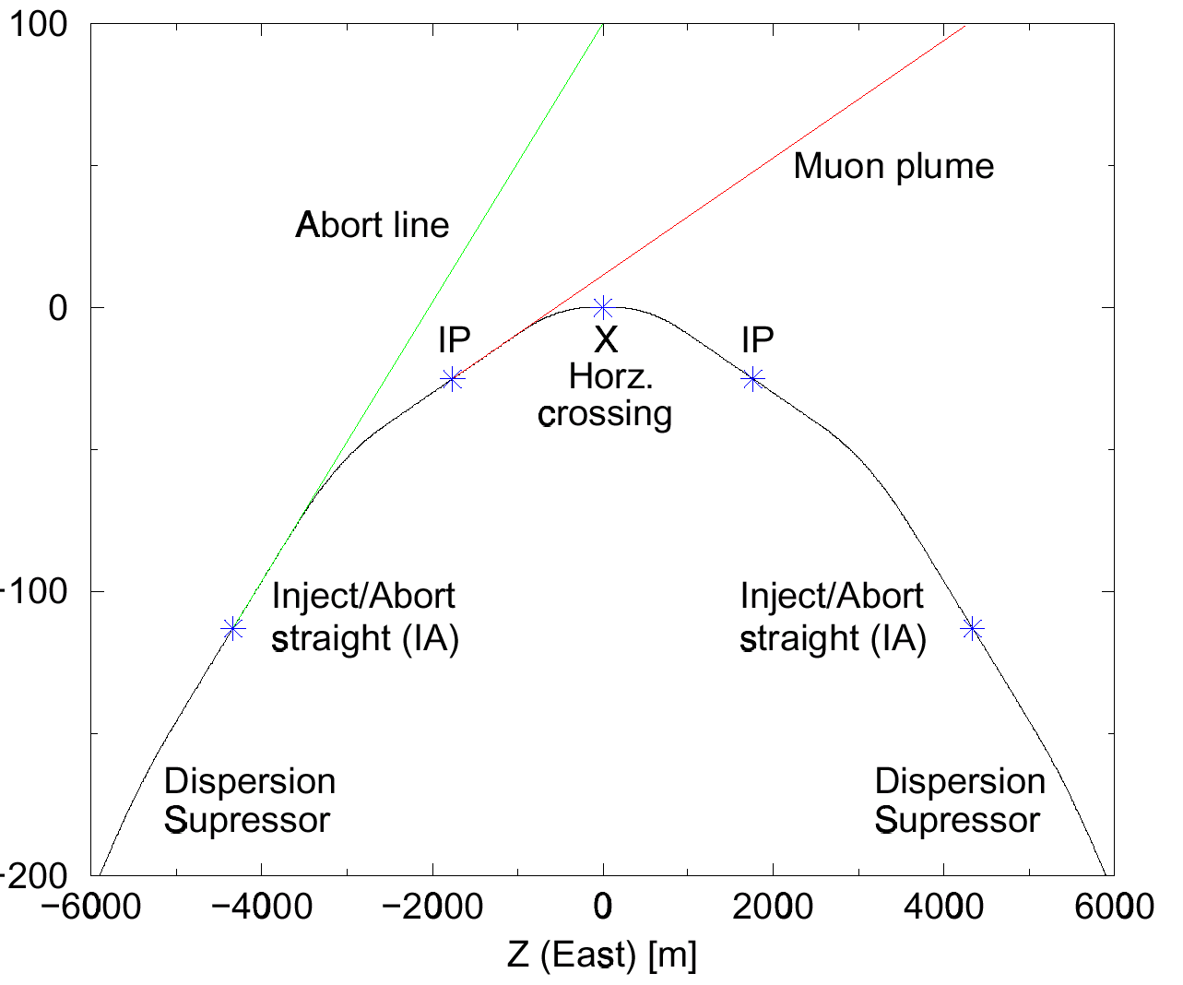
Figure 2.3. Layout of the on-site utility region of the VLHC, showing the clearance of the abort lines and muon plumes from the experiments.

Comment: I suggest that here the muon plume is dropped from the figure but a similar figure with the muon plume is shown in section 2.5 Experimental Areas.

This arrangement suggests the possibility of a common abort dump area as shown in Figure 2.4. Also shown are the beam crossovers. An even number of crossovers are required to keep the circumference of the two counter rotating beams equal. Since the near and far utility straight sections have the same lattice structure there are six crossovers around the circumference.

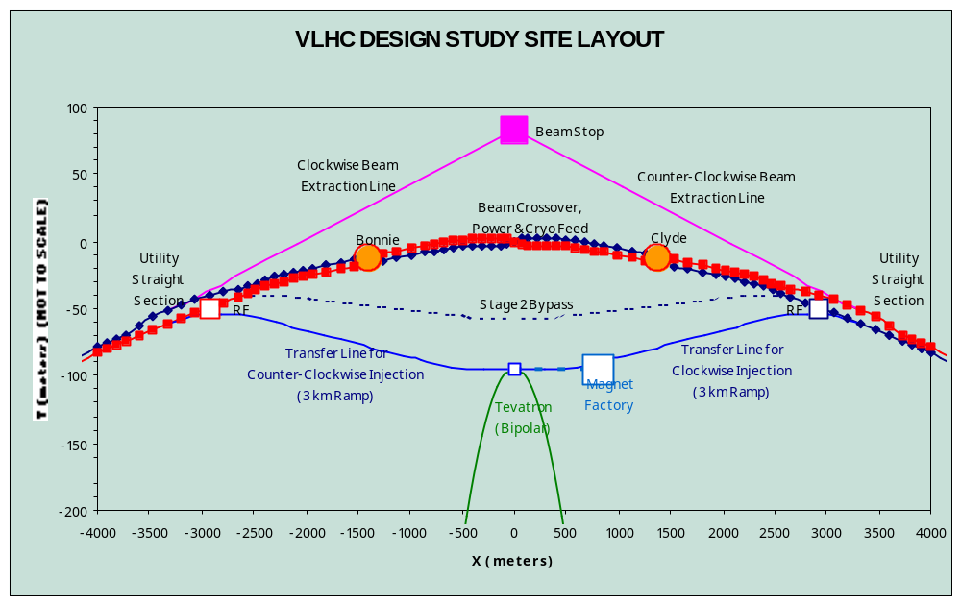Figure 2.4. Single On-site Beam Stop Beam Stop (not to scale)

Comment: I’d like a version of Figure 2.3 without the Stage 2 bypass.

One advantage of modular construction is that low and high field lattices are guaranteed to have almost identical footprints, and therefore to fit in the same tunnel, so long as corresponding low and high field modules are placed on top of each other. The maximum transverse offset of the high field ring relative to the low field ring is only about 6 mm, easily allowing one ring to be placed on top of the other at all locations in the VLHC tunnel.

Another advantage of modular construction is the ability to independently modify one particular module — for example, to increase a module length in units of L_{hc} — without adjusting any other modules. This is only possible if the arc half cell length is an integer times the bunch spacing, because only then is the total circumference guaranteed to correspond to an integer number of evenly spaced bunches.

Paragraph: magnet counts, lengths, dipole, and for Stage 2, quad strengths, packing (or filling?) factors (or fractions?).

Paragraph: what’s in the gaps; descriptive. Figure showing a straight section with joints, pumps, correction elements.

The (minimum) bunch spacing is taken to be one 53.1 MHz rf wavelength in the Tevatron. This guarantees a relatively simple filling scheme from the Tevatron, with a bunch time spacing of 18.8 ns, a value not unreasonably challenging to the experiments. Thus the half cell length is 135.486 m. The value chosen is to make the half cell length to be as long as possible, without leaving both rings too vulnerable to systematic field harmonic errors, and without increasing too much the equilibrium emittance in the high field ring due to synchrotron radiation. It is quite probable that the current value of L_{hc} is not optimal, since we do not yet fully understand what are realistic values systematic magnet harmonics.

Paragraph: general discussion of rf parameters and rf systems. Choice of f_{rf} = 477.938 MHz, superconducting cavities. Flat beams in Stage 2.

Synchrotron radiation is a major issue in Stage 2. It limits E and L and damps the beam. There is a tradeoff between E and L imposed by a total power limit. The optimum choice will not be determined until the physics case is developed.

Add to above paragraph: numbers of L at 150, 175, 200 TeV, maximum magnetic field in Stage 2; also synchrotron power.

Question: should this chapter also describe vacuum systems and beam screen?

2.3 Injection Lines

Figure 2.5. Injection Lines. (redo figure)

Various suggestions for transporting the 900 GeV protons from the Tevatron to the Stage 1 ring are described in Chapter 4. In one of these schemes, shown in Figure 2.5, with the Tevatron operating as a bipolar proton accelerator, two 3.2 km long beam lines transfer the 900 GeV extracted beams from the Tevatron to the VLHC ring. The lines drop 120 m in vertical height at a 4% grade, permitting their use for equipment transport during magnet installation and tunnel construction. Since the beam lines are long and the magnets sparse, permanent magnets are used wherever possible to eliminate cable, cooling water, power supply, and safety system costs associated with conventional magnets. Focusing and optical matching is performed with adjustable strength (± 20%) permanent magnet quadrupoles similar to those developed for NLC work at Fermilab. The beam vacuum is a conventional stainless steel/ion pump system.

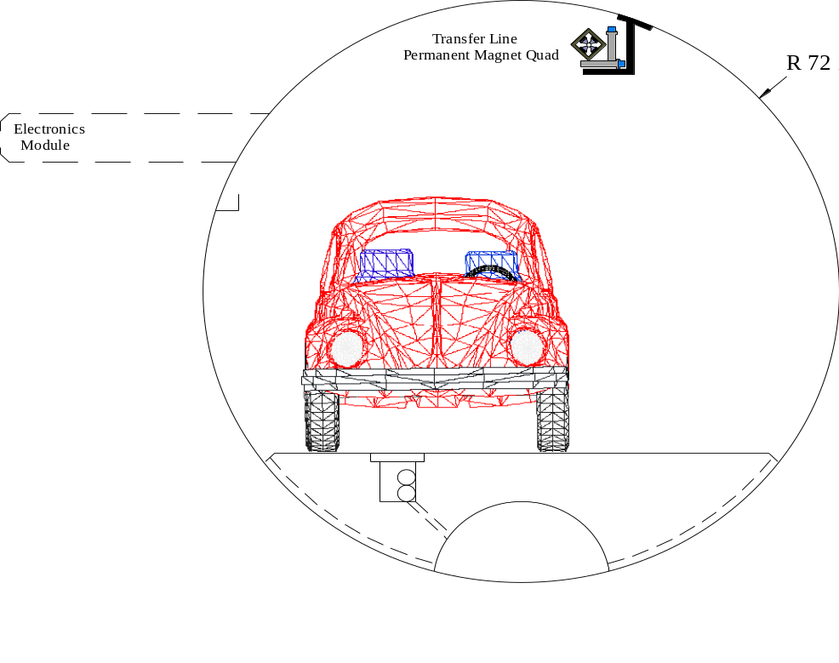

Figure 2.6. Transfer Line Tunnel

Most of the transfer line is a sparse quadrupole channel as shown in Figure 2.6. The beam line is placed near the ceiling to keep the tunnel clear for installation and access. Figure 2.7 shows a possible transfer line module. Stepping-motor controlled stands are used to eliminate orbit correctors, power supplies, and corrector magnet cables. Multiplexed electronics in modules similar to the arcs provide instrumentation and ion pump power and control functions without a significant cable plant. Dog-leg bellows provide flexibility for a ±1 cm range of motion. Figure 2.8 shows permanent magnet dipole (0.8 Tesla) and Quadrupole (60 T/m) beam line elements.

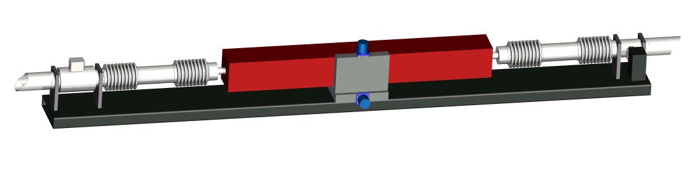
Figure 2.7. Girder with Permanent Magnet Quad, X-Y stage, Ion Pump, and BPMs

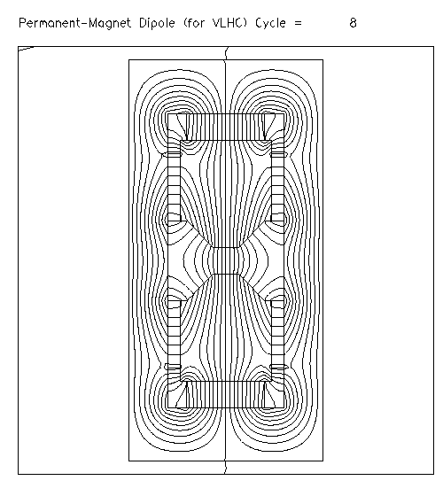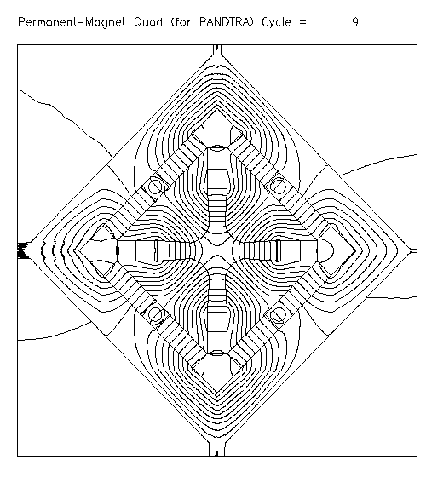
Figure 2.8. Permanent Magnet elements used for transfer line

The exact design of the transfer line optics depends on VLHC ring orientation and site considerations. The example beamline shown in Figure 2.9 and described below has most of the essential characteristics of a workable solution.
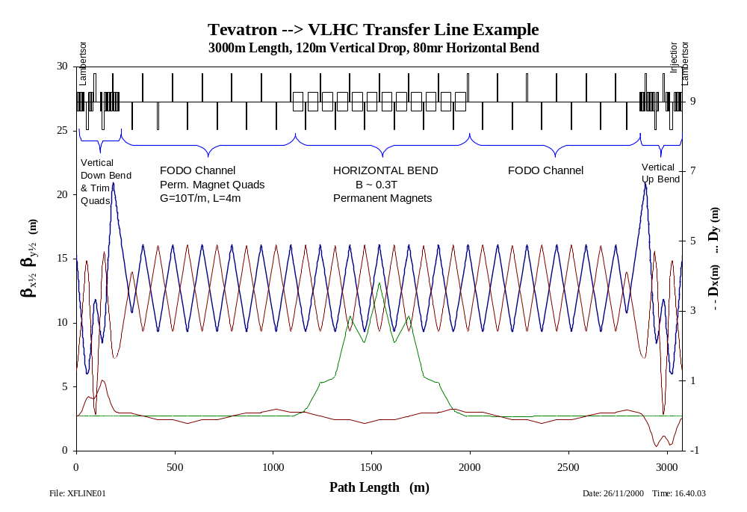
Figure 2.9 Example of possible optics for Tevatron-to-VLHC transfer line

The Lambertson magnets totaling 45 m length and operating at 1.1 Tesla bend the extracted beam downward at 17 mrad. The remaining 23 mrad of down bend is completed in the next 200 m using 0.8 T permanent magnet dipoles with trim dipoles. The length of the down bend is not set by magnet bend strength but by the requirement of generating sufficient phase advance to cancel the vertical dispersion caused by the Lambertson. Site-specific transverse bending may also be required.

The 2.8 km main body of each line is a FODO channel consisting of permanent magnet quads. The small horizontal bends which may be needed can be provided by permanent magnet dipoles. The bends are configured to maintain zero horizontal dispersion in the straight sections between bends. In the example lattice shown above, a single non-dispersive horizontal bend of 80 mrad is placed at the center of the transport line.

At the VLHC end of the line an up bend is required. This section is mirror image of the down bend. Permanent magnets provide 23 mrad of vertical bend and the injection Lambertson completes the bend and kills the vertical dispersion at the injection point. Matching (adjustable) quadrupoles in the last few cells adjust the transfer line lattice functions to match the ~250 m cells of the main collider.

Steering trims are desirable not only to establish an initial orbit centered on each quadrupole, but also for aperture scans to verify a clear aperture in the vicinity of the design orbit. This is accomplished with mechanical quad movers (a step motor/lead screw stage in both the X or Y direction) for each permanent magnet quad. In a FODO channel with 60-degree phase advance, there is a 2:1 ratio between the downstream orbit deflection and the quad motion necessary to produce that deflection. Thus quad movers with a ±1 cm range of motion will be able to produce a ±2 cm “two-bump” (or a ±4 cm “four-bump”), sufficient to probe the full aperture of the beam line.

It is desirable to have some degree of momentum adjustability in the transport line. Depending on operational experience and cryogenic upgrades, it may be best to inject at the highest possible energy (up to 1 TeV). Conversely, performance may prove optimal to cycle the Tevatron as rapidly as possible at a lower energy of 800 GeV to minimize dwell time at injection. This is an issue for permanent magnets.

The quadrupole FODO channel will operate over a range of energy. The phase advance per cell is ~65/60/55 degrees at 800/900/1000 GeV. As discussed previously, adjustable permanent magnet matching quadrupoles will be placed at each end of the line. The Lambertson will be powered in series with the Tevatron bus so their bend scales automatically with energy. The required energy adjustability to the dipole bends can be accomplished with either a limited number of electromagnets, or mechanically adjustable permanent magnet dipoles similar to those described in ref. [1].

The extracted beam size in the transfer line is a couple of mm, so that the aperture requirements will be set by estimates of misalignments and vacuum considerations. In the long straight FODO channels we propose a 4-inch beam pipe between quadrupoles to maximize vacuum conductance and minimize pipe alignment requirements. The integrated gradient of the quads in the FODO channel is 40 T-m/m. This can be attained with rare-earth permanent magnets. The weight (and approximate cost) of permanent magnet quadrupoles scale as the cube of the aperture. At present we consider a 33 mm elliptical beam pipe (corresponding to 25.4 mm pole tip diameter).
  - Extraction (abort system)

2.5 Stage 1 to Stage 2 transfer and bypass

Add: description of the Stage 1 to Stage 2 transfer.

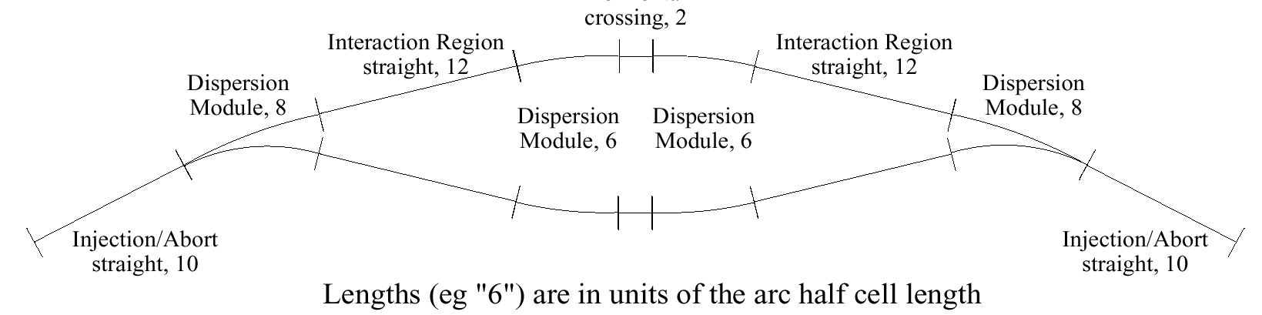
In the transition from Stage 1 to Stage 2 operation, the experiments will remain centered on the same interaction points. At the same time it is envisaged that they will be upgraded to take up more space along the beam line, increasing the distance from the IP to the first magnet, L*, from 20 m to 30 m. It is therefore necessary to add a bypass to keep the low field ring beams well clear of the experiments. This must be done without changing the total low-field ring circumference. Figure 2.10 is a cartoon of a “proof-of-principle’ by pass which will work, but which has not been design in detail. The total length of the bypass is approximately 8 km.

Figure 2.10. Cartoon of a bypass to transport low-field ring beams past the experiments in Stage 2 operation

  - Experimental Area(s)

Discussion of Experimental caverns. Brief summary of what is in chapters 7 and 8. Figure?
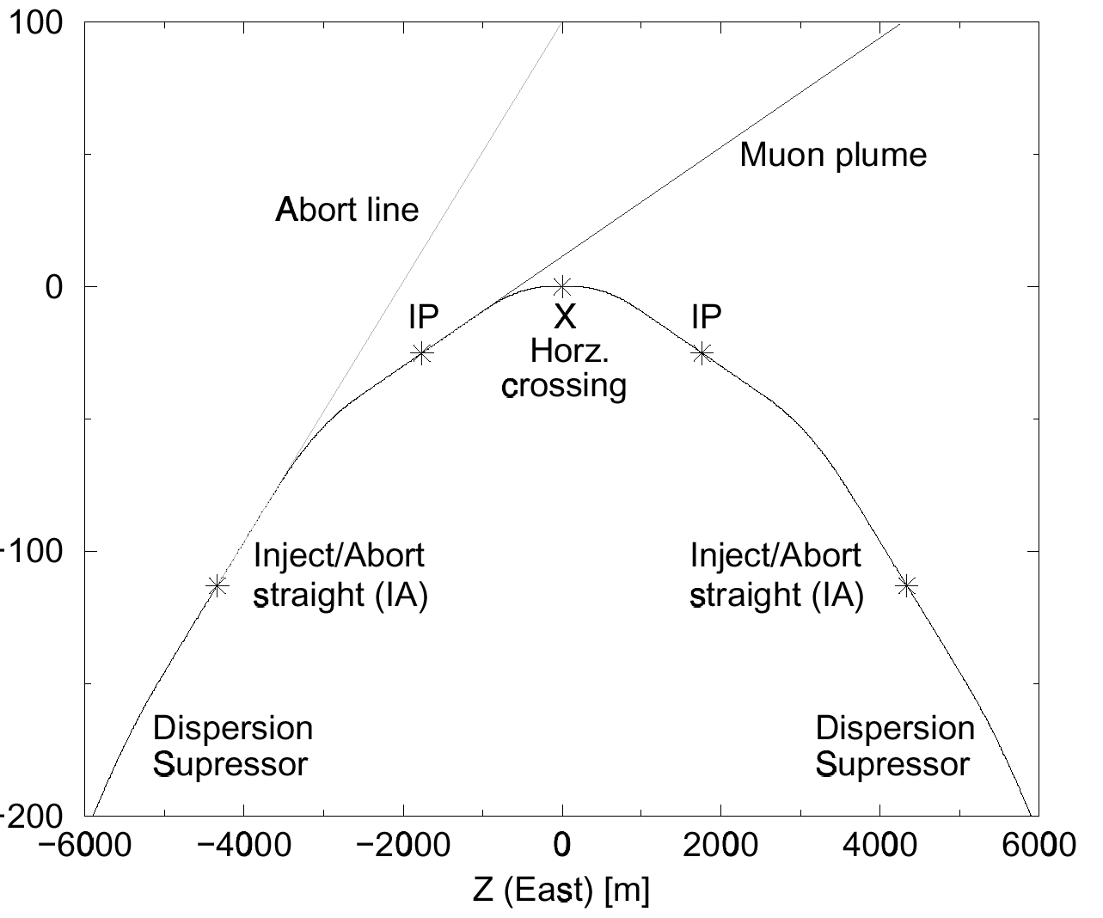
Figure 2.11 Shows that the muon plume emanating from one IP misses the other experiment by approximately 70 meters

Figure 2.12. Shows Bonnie and Clyde. Another version of Bill’s drawing.

Paragraph: Stage 1 operating scenario, time line for injection, acceleration

Paragraph: Stage 2 operating scenario, time line for injection, acceleration; mention a few of the basic parameters, proton burnoff time, IBS time, damping time.

References

[1] KEK paper

