IN-HOSPITAL RESPONSE TO EXTERNAL
CHEMICAL EMERGENCIES:
PERSONAL PROTECTIVE EQUIPMENT, TRAINING,
SITE OPERATIONS PLANNING, AND MEDICAL PROGRAMS

Technical Report – Final Draft

by
Paul Fedele, PhD*,
Panos Georgopoulos, PhD†, Pamela Shade†, Paul Lioy PhD†,
Michael Hodgson, MD, MPH**, Mark A. Brown, PhD**

*U.S. Army Soldier and Biological Chemical Command (SBCCOM)
†Environmental and Occupational Health Sciences Institute (EOHSI)
**Veterans Health Administration (VHA)

April 15, 2003

TABLE OF CONTENTS
TABLE OF CONTENTS i
LIST OF TABLES ii
LIST OF FIGURES iii
ACKNOWLEDGEMENTS v
1. SUMMARY 1
2. INTRODUCTION 2
3. HAZARD AND EXPOSURE ASSESSMENT: METHODS, ANALYSIS AND RESULTS 6
3.1. Site Operations Planning 7
3.2. Background and Motivation for Hazard Assessment 8
3.3. Purpose of Hazard Assessment 9
3.4. Realistic Maximum Hazard Levels 9
3.5. Evaporation Process 11
3.6. Evaporation Rate and Adsorption/Desorption 11
3.7. Vapor Generation at the Decontamination Site 12
3.8. Constant Flow, Uniform Mixing Approximation 13
3.9. Exposure Modeling 14
3.10. Discussion of Modeling Results 17
4. TRAINING NEEDS 34
5. MEDICAL SURVEILLANCE 35
6. CONCLUSION 36
6.1. Local: facility level 36
6.2. Local: Area Emergency Planning Committees 36
6.3. National Level 36
REFERENCES 37
APPENDIX: ACRONYMS AND SYMBOLS 44

LIST OF TABLES
Table 1. Description of the levels of Personal Protective Equipment (PPE) as well as any inherent limitations. 4
Table 2. Summary of the properties of chemical warfare agents (CWA) and selected toxic industrial chemicals. The volatility and time constant (τ) for the evaporation process determine how quickly an agent will evaporate upon dissemination. The concentration of the CWA that is lethal to 50% of the population after a one-minute exposure (LCt₅₀) is provided as well as the dose that is lethal to 50% of the population (LD₅₀). The 100 g deposition of agent is an upper bound release from typical dissemination devices. The larger number of lethal doses per 100 g of CWA indicate increased potential harm to those exposed. 19
Table 3. Number of lethal doses resulting from a 100 g deposition of a chemical warfare agent. The 100 g deposition of agent is an upper bound release from typical dissemination devices. The larger number of lethal doses per 100 g of CWA indicate increased potential harm to those exposed. 20
Table 4. Percentiles of the Monte Carlo forecasted total integrated exposure concentration (CT) of sarin. The concentration is the predicted exposure of medical personnel as victims present themselves to the medical treatment facility for decontamination and triage. The Monte Carlo trials represent the initial mass deposition (m_{o}) with an appropriate beta distribution (shown in Figure 4). 21
Table 5. Percentiles of the Monte Carlo forecasted total integrated exposure concentration (CT) of sarin. The concentration is the predicted exposure of medical personnel as victims present themselves to the medical treatment facility for decontamination and triage. The Monte Carlo trials represent the initial mass deposition (m_{o}) with a triangular distribution with a maximum value of 100 g and a likeliest value of 10 g. 22
Table 6. Percentiles of the Monte Carlo forecasted total integrated exposure concentration (CT) of sarin. The concentration is the predicted exposure of medical personnel as victims present themselves to the medical treatment facility for decontamination and triage. The Monte Carlo trials represent the initial mass deposition (m_{o}) with a triangular distribution with a maximum value of 100 g and a likeliest value of 10 g. The evaporation rate of sarin (ν_{evap}) is described by an exponential distribution as a realistic estimate of the desorptive evaporation rate. 23
Table 7. Percentiles of the Monte Carlo forecasted total integrated exposure concentration (CT) of sarin. The concentration is the predicted exposure of medical personnel as victims present themselves to the medical treatment facility for decontamination and triage. The Monte Carlo trials represent the initial mass deposition (m_{o}) with a triangular distribution with a maximum value of 100 g and a likeliest value of 10 g. In this scenario the contaminated body surface area is assumed to be 20%, which represents the potential exposure to healthcare workers when victims immediately disrobe. 24
LIST OF FIGURES
Figure 1. Depiction of the presence of a secondary source of exposure to healthcare workers (decon staff) that are downwind of arriving victims. Exposure would arise from evaporation of agent from victims’ clothing prior to disrobing and showering. Worst-case conditions are used to estimate an upper bound of exposure; if recommended decontamination procedures are followed, this scenario would be highly unlikely. 5
Figure 2. Schematic depiction of free-surface evaporation process of a liquid agent. The evaporative flux is the rate of change of surface-deposited mass with time. It depends on the volatility and an evaporation rate of the liquid. 25
Figure 3. Total integrated exposure concentration (CT) of CWA for medical personnel as a function of the evaporation time constant (τ). The time interval begins after a 10-minute lag time during which some material has evaporated; the evaporation will continue as decontamination proceeds. The time-integrated exposure concentration is then the sum of exposure concentration as contaminated patients file past the medical personnel. This concentration is dependent upon the evaporation time constant (τ) which is the characteristic time for volatilization of the liquid agent. When τ is small the majority of the agent evaporates prior to arrival at the medical treatment facility; for agents with a larger τ, little agent will evaporate not only during transport to the medical facility, but throughout the decontamination process. 26
Figure 4. Frequency density of initial mass deposition (m_{o}) of sarin which describes the frequency with which victims will be contaminated with a specific amount of sarin. This density is based on the assumption of a two-dimensional Gaussian distribution that represents a uniform density of people and the likely mass deposition of the CWA as the radial distance increases from the dissemination device. 27
Figure 5. Beta distribution with α=0.52 and β=1.20 representing the initial mass deposition (m_{o}) of sarin. The distribution was chosen as an appropriate fit corresponding to the frequency density shown in Figure 3 and is used in subsequent Monte Carlo simulations to determine the total exposure to sarin received by medical personnel. 28
Figure 6. Monte Carlo forecast of total integrated exposure concentration (CT) of sarin when the mass deposition (m_{o}) is represented by the beta distribution presented in Figure 4. The time-integrated exposure concentration is then the sum of exposure concentration as contaminated patients file past the medical personnel. The integration begins after a 10-minute lag time which represents transport time to the facility; the integration is stopped when the decontamination process ends. 29
Figure 7. Monte Carlo forecast of total integrated exposure concentration (CT) of sarin when the mass deposition (m_{o}) is represented by a triangular distribution with a maximum value of 100 g and a likeliest value of 10 g. The time-integrated exposure concentration is then the sum of exposure concentration as contaminated patients file past the medical personnel. The integration begins after a 10-minute lag time which represents transport time to the facility; the integration is stopped when the decontamination process ends. 30
Figure 8. Monte Carlo forecast of total integrated exposure concentration (CT) of sarin when the evaporation rate of sarin (ν_{evap}) is described by an exponential distribution as a realistic estimate of the desorptive evaporate rate. The mass deposition (m_{o}) is represented by a triangular distribution with a maximum value of 100 g and a likeliest value of 10 g. The time-integrated exposure concentration is then the sum of exposure concentration as contaminated patients file past the medical personnel. The integration begins after a 10-minute lag time which represents transport time to the facility; the integration is stopped when the decontamination process ends. 31
Figure 9. Monte Carlo forecast of total integrated exposure concentration (CT) of sarin when the mass deposition (m_{o}) is represented by a triangular distribution with a maximum value of 100 g and a likeliest value of 10 g. The time-integrated exposure concentration is then the sum of exposure concentration as contaminated patients file past the medical personnel. The integration begins after a 10-minute lag time which represents transport time to the facility; the integration is stopped when the decontamination process ends. In this scenario the contaminated body surface area is assumed to be 20%, which represents the potential exposure to healthcare workers when victims immediately disrobe. 32
Figure 10. Emergency response steps for survivors of chemical attack seeking medical attention at hospital ER. The “hot” zone represents the site of the CWA release, while the “cold” zone is the area with no expected contamination. The “warm” zone denotes areas where contaminated victims present themselves for decontamination. As the contaminated patients arrive at the medical treatment facility, they become sources of contamination for the medical personnel who must adhere to the recommended steps to minimize exposure. Health care workers in each zone also limit exposure when covered by the appropriate level of personal protective equipment. 33

ACKNOWLEDGEMENTS
This work originated in several overlapping committees convened to plan an agency-wide response to the possibility of chemical terrorism and the role of hospitals supporting decontamination. The authors wish to acknowledge the thoughtful and important support of James Genovese of SBCCOM; Art Stuempfle, Ph.D. of OptiMetrics; Jim Farsetta, Edward Thorsland, Craig Hyams, M.D., M.P.H., Susan Mather, M.D., M.P.H., John Beatty, Margie Scott, M.D., and Vernon Wilkes of VHA; Scott Deitchmann, M.D. of NIOSH; Melody Sands and Atkinson Longmire, M.D., M.P.H. of OSHA; and Linda Everett of EOHSI.

SUMMARY
Hospitals removed from the immediate site of an incident involving the release of hazardous materials, including chemical warfare agents, must develop emergency response plans to receive victims and simultaneously protect healthcare professionals from toxic chemicals, including weapons of mass destruction. This paper reviews four technical issues essential to the success of these plans.
- Hospital personnel who work with contaminated individuals should receive at least eight hours of training on personal protective equipment and decontamination and be retrained at least annually to work safely; more frequent equipment practice is strongly recommended.
- Development and coordination of protocols must include the local emergency planning committee, with clear assignment of tasks and locations, such as clothing removal for primary decontamination. Failure to plan this single most important contribution to exposure reduction through systematic local coordination puts hospital personnel at grave risk of adverse effects.
- Site operations planning must address decontamination runoff and contaminated clothing control, as these are both potential sources of secondary exposure. Failure to control them increases risk for staff.
- Level C personal protective equipment, though not appropriate for work at the site of the hazardous materials releases, is adequate to protect hospital staff away from the site of release despite off-gassing of agents that have been identified as possible causes of incidents. This conclusion is based on the development of worst-case evolution of scenarios for which none of the identified or planned exposure control strategies are actually implemented. Preventing exposures to healthcare workers does require that plans and procedures are in place, coordinated, and trained for.

INTRODUCTION
The Nunn-Lugar Act, first approved in 1991 in response to the disintegration of the Soviet Union (Reaves, 2001) was designed to limit the threat of terrorism; this act increased in relevance after September 11, 2001. The status of research and development to ensure and improve proper civilian medical response to chemical and biological terrorism was assessed by the Institute of Medicine/National Research Council in 1999 (IOM/NRC, 1999). Ongoing terrorist threats have generated far more widespread civilian emergency response planning and development. These include the formation of Metropolitan Medical Response Teams (MMRTs), the promulgation of new standards demanded by the Joint Commission on Accreditation of Healthcare Organizations (JCAHO) (JCAHO, 2003), and the development of standards for personal protective equipment (PPE) (NIOSH, 2001) in “hot” and “warm” zones (see Page 7 and Figure 10 for detailed explanation of zones). PPE comes in various “levels,” (OSHA, 1995a), described in Table 1 (see also Lindsay, 1999a, 1999b, 2001; Foust, 1999). The appropriate level of protection and victim decontamination for healthcare remains to be defined (Fairfax, 1992, 1999, 2002a, 2002b; Arnold & Lavonas, 2003; ATSDR, 2001b), especially in the case of the appearance of victims of attacks at the front door of an emergency room.

Chemical incidents are thought to be possible through several different scenarios. These possibilities include the release of chemical warfare agents, such as nerve gases (e.g. sarin, VX) or blister agents (e.g. mustard), with detailed information on appropriate responses available (see e.g. two SBCCOM reports: Lake et al., 2000, SBCCOM, 2002; also ATSDR, 2002, and Sidell et al., 2002). Another possibility of accidental harmful chemical release may involve adverse transportation events (USAF, 1990). The Centers for Disease Control and Prevention (CDC) has developed a list of agents and clinical implications (CDC, 2003), including those most likely released through the opportunistic use of weapons of mass destruction or chemical transportation accidents (i.e., tanker trucks and railcars) by terrorists. However, this is not an all inclusive list for the types of situations that may yield the instantaneous or continuous release of toxic chemicals. Standard protocols provide appropriate response to such events; one such publication (Bronstein & Currance, 1994) advocates the use of high level PPE.

Emergency planning has led many hospitals to develop chemical hazard plans for emergencies arising within hospitals and in the community, such as may occur from terrorist attacks (Kirk et al., 1994; Huff, 1991; Brennan et al., 1999). Much discussion has focused on the appropriate level of PPE needed to protect healthcare workers as they address the health needs of contaminated patients (CDC, 1997). Many hospitals have expressed concern about the widespread expectation for level A or level B PPE. Although highly trained response teams, with monthly practice, may feel comfortable intubating patients and performing triage (Stopford, 2001), many hospitals consider the use of level C PPE at the top end of their reasonable range (MacIntyre et al., 2000). Standards promulgated by the Occupational Safety and Health Administration (OSHA) on hazardous waste operations (OSHA, 1995a) and respiratory protection (OSHA, 1995b; NIOSH, 2001) require a hazard analysis to justify selection of specific equipment. In addition, hospitals must train employees adequately to an appropriate level of skill in the use of personal protective equipment and in decontamination procedures. As part of such programs, they must include medical testing and surveillance under the same two OSHA standards (Levitin & Siegelson, 1996). All of these issues must be examined in order to achieve an effective plan that both protects healthcare workers, and allows for the decontamination of victims prior to triage and treatment.

The Veterans Health Administration (VHA) consists of 142 hospital systems (many with multiple campuses), 800 clinics, and 200 nursing homes around the United States, with approximately 210,000 healthcare workers. As a large integrated healthcare system, it must provide a certain level of central policy guidance for facilities. In an effort to identify and define needed resources, the VHA convened groups to develop a hazard and exposure assessment, identify needed actions for compliance with OSHA standards, review site and operational planning issues, and resolve medical testing issues.

This report develops a hazard and exposure assessment to identify an adequate level of PPE and defines the associated local emergency planning, medical surveillance, and training elements needed to meet OSHA, EPA, and JCAHO requirements. To that end, it uses worst-case conditions to estimate an upper bound of exposure, as illustrated in Figure 1.

Table 1. Description of the levels of Personal Protective Equipment (PPE) as well as any inherent limitations.
Level | Elements | Protects against | Usual time required to put on and remove PPE | Maximal period available to work | Constraints
A | Fully encapsulating for vapor barriers  Self-contained breathing apparatus | All unknown agents | 15 minutes | approximately 60 minutes in two periods (two 60 minute, “featherweight” bottles, with bottle replacement time needs) | Cardiovascular risk; exercise limitations; heat stress  Visibility constraints in face shields (fogging; perimeter vision)  Glove use (palpation, fine motor manipulation)
B | Encapsulating suits  Self-contained breathing apparatus | Splash protection  Airborne hazards | 15 minutes | approximately 60 minutes in two periods (two 60 minute, “featherweight” bottles, with bottle replacement time needs) | Cardiovascular risk; exercise limitations; heat stress  Visibility constraints in face shields (fogging; perimeter vision)  Glove use (palpation, fine motor manipulation)
C | Negative pressure respirator  Splash-protecting suits | Splash protection  Some airborne hazards | 1-5 minutes | 8 hour shift with rest breaks for heat illness management | Heat illness
D | No respirator

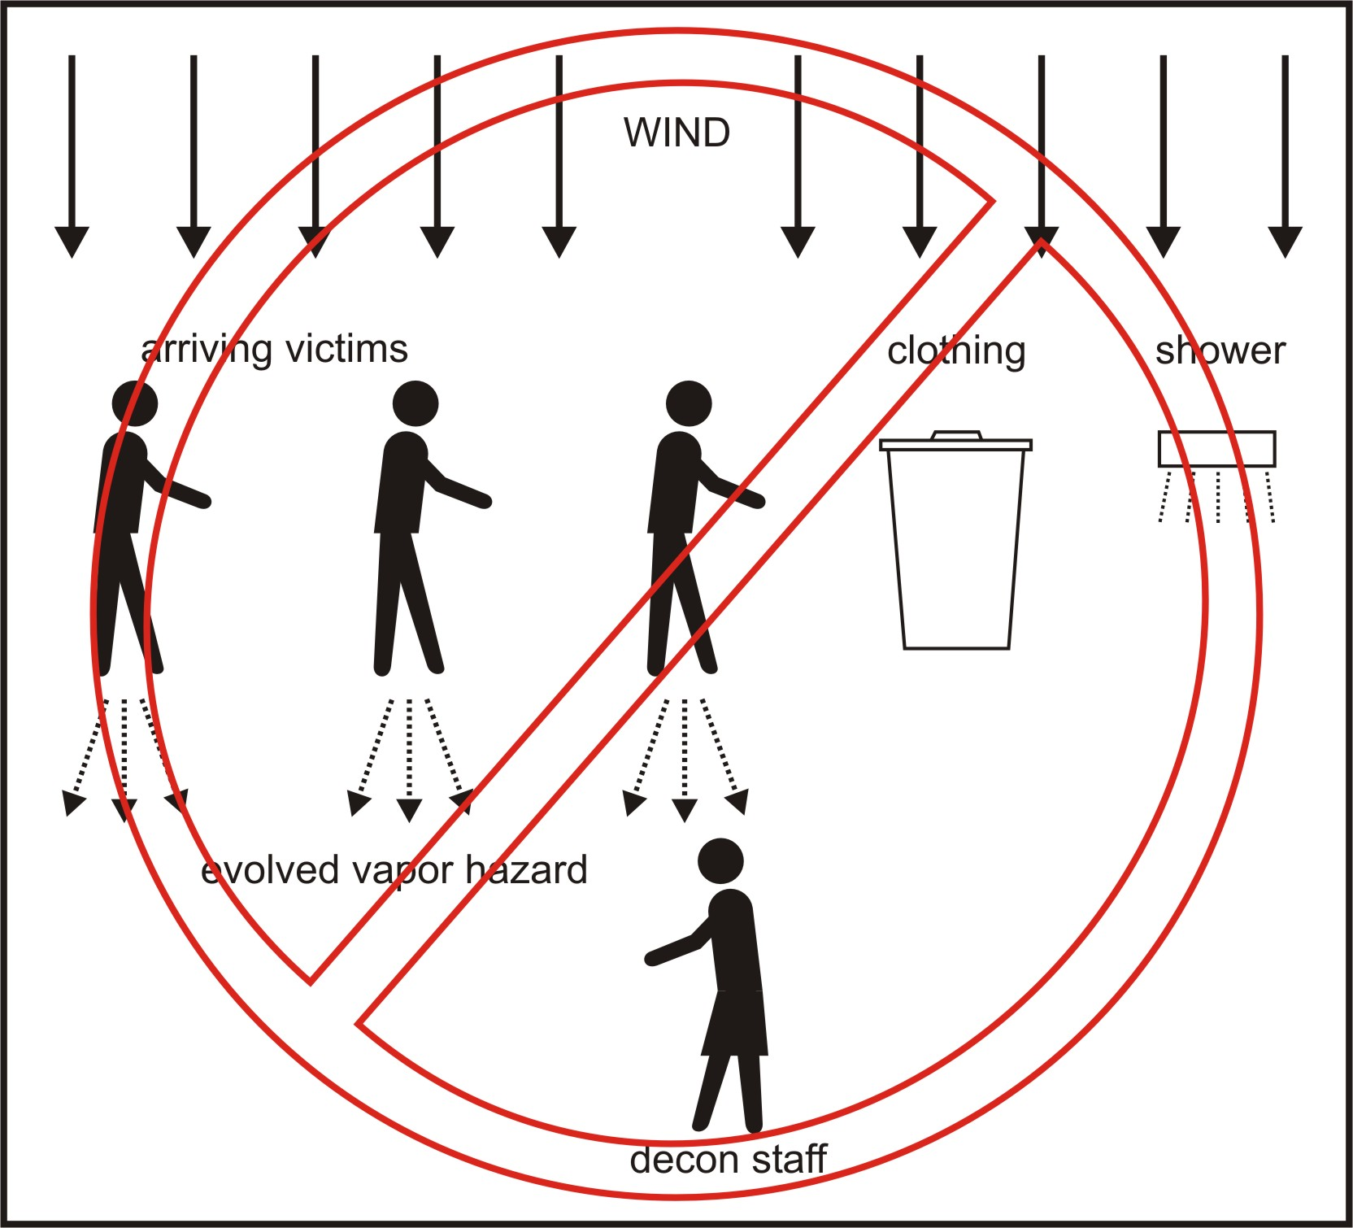
Figure 1. Depiction of the presence of a secondary source of exposure to healthcare workers (decon staff) that are downwind of arriving victims. Exposure would arise from evaporation of agent from victims’ clothing prior to disrobing and showering. Worst-case conditions are used to estimate an upper bound of exposure; if recommended decontamination procedures are followed, this scenario would be highly unlikely.

HAZARD AND EXPOSURE ASSESSMENT: METHODS, ANALYSIS AND RESULTS
To understand the required level of PPE and associated operational strategies, specific actions were taken for the current study:
- Discussions to define issues, tasks, and responsibilities: Three overlapping groups discussed hospital planning in face-to-face, electronic (email), and telephone communications. Group members included clinical and clinical administrative staff (medical center directors, regional corporate directors), toxicology and occupational medicine, industrial hygiene and safety, physics, exposure assessment, chemical engineering, public health, safety regulation, and computer modeling. The initial starting point for these discussions was the Chemical Stockpile Emergency Preparedness Program (CSEPP) (FEMA, 2003). These discussions outlined likely scenarios, defined roles, tasks, and responsibilities and considered site consequences, in part based on national discussions and resources.
- Theoretical work to assemble equations and derive important constraints: A first step was to develop relevant conceptual models and to assemble equations for chacterizing estimates of source attributes for the chemical vapor hazards produced by contaminated patients. These equations could then be used to derive relationships between operational parameters (time and distance from sites and sources) and exposures generated by the patients acting as sources of contamination.
- Dissemination of materials and identified problems: Written materials, i.e., text, equations, modeling spreadsheets, and visual presentations were circulated for the solicitation of comments and suggestions for refining the issues. Individual participants reviewed and used the various materials to identify weaknesses, missing critical information, and faulty assumptions.
- Face-to-face meeting to develop scenarios, refine questions, and define likely important modeling parameters: A face-to-face meeting was held to review concerns and walk through the assumptions and scenarios, to identify weaknesses and omissions, and to define the release, exposure, decontamination and triage scenarios to be modeled.
- Identify model parameters for range finding: Modeling experts identified appropriate models, used an existing array of models in the laboratory, and compared the results from these with available pertinent published data.
- Review model assumptions and operational implications: These results were reviewed in a face-to-face meeting to define weaknesses and the resulting operational needs.
- Refine needed model inputs and operational consequences: An updated set of models was developed based on refinements with operational recommendations.

OSHA Standards, interpretations, and letters were reviewed to determine what level of skill, training, and response is expected of healthcare facilities (Fairfax, 1992, 1999, 2002a, 2002b). Finally, medical program content was defined by reviewing the pertinent standards, considering the levels of protection and decontamination required to provide effective medical care, and reviewing the scientific literature on appropriate medical surveillance.

A large hospital system, such as VHA, has facilities in a variety of settings vulnerable to an equally broad range of hazards and exposures to weapons of mass destruction, based on local differences in targets and parallel resources. For example, in some densely populated urban areas, the VA hospital is adjacent to a modern university hospital. In some relatively rural areas, and mid size cities, the VA hospital is the single largest healthcare facility. Consequently, a national plan would be both inadequate and inappropriate. Locally appropriate emergency planning can be more effectively accomplished at the local (municipal) level.

Hazards broadly covered under this assessment initially included the traditional weapons of mass destruction identified as likely agents in the US Army Chemical Casualty Care Handbook (USAMRICD, 2000). Subsequent discussions suggested that industrial chemicals, that are commonly transported, might also be used as weapons. Several lists of such agents are available, including one posted on the website of the Agency for Toxic Substances and Disease Registry (ATSDR), identifying approximately 140 such agents (ATSDR, 2001a) and one in the Army Field Manual 3-9, Potential Military Chemical/ Biological Agents and Compounds (US Army, 1990). Discussions identified agents with a broad range of physical characteristics (vapor pressure), toxicology (dermal, systemic, respiratory effects), and exposure routes (dermal, inhalation). Table 2 presents example agents in the broad spectrum of potential CWAs, with corresponding critical physical, chemical, and toxicological characteristics. Water is also included in this table, for comparison purposes.

Site Operations Planning
The National Institute for Standards and Technology (NIST) is leading the development of standards for personal protective equipment for “hot” and “warm” zone work, i.e., in sites with active release of and potential exposure to chemical agents (NIST, 2002). The implicit assumption has been that such areas are geographically distinct from hospital emergency departments. Protection needs for healthcare workers might therefore be less stringent for two reasons. First, the active primary source of chemical agent, whether from a terrorist device or from a transportation accident, will no longer contribute to exposures. Second, the time since exposure will have led to a reduction in agent left to be released, due to evaporation (or off-gassing from the contaminated patient) (Westin et al., 1998).

Tasks for healthcare workers and others include decontamination, triage, and treatment in various settings. Clinical treatment guidelines after diagnoses are clear. No clinical algorithms have been published to guide non-clinicians (technicians), but specific treatment is needed only for chemical asphyxiants (cyanide) and cholinesterase inhibitors (nerve agents) (ATSDR, 2001c). Discussions revealed the presence of some confusion regarding planning for decontamination, triage, and treatment at the local level. In many settings, clothing removal, where much of the chemical contamination resides, was not considered to be an essential first step. This oversight may lead to unnecessary and preventable exposure to emergency transport personnel due to the continued presence of the secondary source (Torngren et al., 1998). Additionally, site operations planning must address decontamination runoff and contaminated clothing control, as these are both potential sources of secondary exposure (USEPA, 2000).

A roundtable of experts reviewed known terrorist devices and the possible delivered doses. In addition, assumptions about battlefield exposure/dose delivery from chemical warfare agents were reviewed and considered (Fulco et al., 2000). Agent exposures might occur through aerosol spray or vapor generation (US Army, 1990; Winters & Chenoweth, 2002). Both condensation and evaporation may modify the dispersion of the airborne agents. An assumed reasonable upper bound of agent deposition on individuals is 100 g, if the individual is in the direct line of dissemination. In general, much lower exposure would be expected as most of the deposited agent will be on clothing (Jenkins et al., 1992).

Background and Motivation for Hazard Assessment
The event of 20 March 1995 in Tokyo was used as an example scenario of what could take place in a chemical terrorism event. In that case, members of a Japan-based cult, Aum Shinrikyo, placed eleven bags containing a dilute mixture of sarin on five subway cars in the Tokyo subway system. Some of these bags were punctured, dilute agent mixture spread across the floor of the subway cars, and some people were overcome by the sarin. The mixture was about 30% sarin; it also contained other compounds that gave it a strong, irritating odor. This odor alerted people to the presence of a chemical hazard, whether or not they had received a significant exposure to sarin. The overall result was that thousands of people, considered the “worried well”, sought immediate medical attention (Nakajima et al., 1997; Ogawa et al., 2000; Ohbu et al., 1997).

Many people who suspected that they had been exposed to a dangerous chemical went directly to various Tokyo medical facilities. Self-referred patients arrived at medical facilities without undergoing any decontamination process. Actions as simple as removing one’s shoes, were not implemented; this oversight was significant, due to the nature of the spill. (After leaking from the punctured bags, the sarin presumably spread over the floor and could be most easily picked up on shoes.) Under these conditions, victims brought contamination into medical facilities capable of producing sarin vapor exposures sufficient to cause noticeable effects among medical staff, even though the arriving patients were not overcome by their own contamination. Since the affected medical staff did not necessarily touch victims, the presence of a vapor hazard can be inferred.

In the event of terrorism involving chemical warfare agents, it is anticipated that some self-referred patients, who have not experienced any decontamination process, will seek medical aid wherever the public perceives aid to be available. Such locations include Veteran’s Administration Medical Centers. The arrival of these contaminated persons would present a hazard to the personnel at the medical facility and would threaten the ability of medical personnel to continue providing necessary medical care (Nozaki et al., 1995; Okumura et al., 1998; Ohbu et al., 1997). Should a medical facility become contaminated with a Chemical Warfare Agent (CWA) and should the medical center personnel begin to exhibit chemical exposure effects, the facility would be effectively shut down.

To help reduce hazards to medical facility personnel, and to avert a shutdown of medical facilities, it is important that all medical treatment facilities develop the capability to remove and safely store contaminated clothing, and then decontaminate persons who can be expected to seek medical attention at the facility, after a potential exposure to a CWA. The appropriate number of personnel will depend on the situation of the facility; it will vary with the community and with the facility’s medical role in the community.

Purpose of Hazard Assessment
The goal of efforts by the VHA and the US Army Soldier and Biological Chemical Command (SBCCOM) is to identify the amount of vapor protection needed by personnel at a medical facility, who may be called upon to eliminate the “personal” secondary source of chemical agent on the victim, and decontaminate self-referred or Emergency Medical Technician (EMT) transported victims of a CWA incident. To support this effort, vapor sources must be identified and quantified. Vapor sources determine the rate and amount of vapor generated by a contaminated individual. These terms support the overall estimate of the vapor hazards produced by a group of contaminated victims (Hartmann, 2001; Thornton, 1990; Crosier & Sommerville, 2002).

Realistic Maximum Hazard Levels
The maximum vapor concentration of a chemical compound that can exist in air is known as its saturation level. While saturated vapor levels can be produced in the laboratory, it is not reasonable to expect that vapor saturation would be achieved in a real-world terrorist incident. Estimation of a reasonable potential maximum vapor exposure (time-integrated vapor concentration) is needed to determine necessary protection levels.

A reasonable maximum vapor concentration was needed for establishing a standard for Self-Contained Respiratory Protection against Chemical, Biological, Radiological Nuclear and Explosive (CBRNE) Materials (Arnold & Lavonas, 2003). In creating such a standard, The National Institute for Occupational Safety and Health (NIOSH) chose a range of dissemination devices that represent possible terrorist devices. Dissemination from these devices was modeled by SBCCOM (Fulco et al., 2000; NIOSH, 2001) and the maximum vapor concentration produced by each device was determined. A reasonable maximum vapor concentration was determined as the average of all device maximum concentrations, but only from those which produced exposures above the 50% lethality level. The resulting vapor concentration was applied as the vapor concentration against which Self Contained Breathing Apparatus (SCBA) protective performance standards were written. For sarin, which has a saturation concentration of over 20,000 mg/m³ at 25°C, a reasonable vapor concentration is 2,000 mg/m³ or less than one tenth of saturation (Mioduszewski et al., 1998). The reasonable maximum concentration is not the absolute maximum that is physically possible, but rather a maximum that can be reasonably expected in a terrorist incident.

The amount of vapor generated by contaminated individuals primarily depends on the amount of contamination that a self-referred person, or EMT forwarded person, will likely bring to a medical facility. In determining the vapor source on the victim’s body and clothing, it is necessary to determine the maximum reasonable amount of contamination that individuals might bring to a medical facility. To determine this value, the same procedures are followed that were used to establish the NIOSH SCBA standard vapor challenge concentration (NIOSH, 2001).

This evaluation commenced with consideration of the same set of terrorist devices that were used to establish the reasonable maximum vapor concentration in the NIOSH SCBA standard. In order to ensure a conservative starting estimate, rather than characterizing the dissemination of a volatile agent, such as sarin, the dissemination of a non-volatile agent, such as VX, was considered. The amount of agent deposited on victims and their clothing was determined, without any evaporation occurring during the dissemination process. Allowing no evaporation during the dissemination process will maximize the liquid deposited on people. Evaporation is only considered once the CWA has deposited.

The amount of contamination on people will depend on the amount of material in the dissemination device, where the individual is located with respect to the dissemination device, and what they are wearing at the time of contact. Using SBCCOM expertise in liquid dissemination processes, the radius of liquid dissemination and amount of liquid per unit area, within the dissemination radius (Fulco et al., 2000) was determined. Assuming that this total amount is deposited on a person, the amount of contamination expected was estimated to be 100 g of agent per individual.

Chemical warfare agents are designed to be lethal. By official Department of Defense (DOD) cutaneous toxicity estimates, given by Grotte & Yang, (1998), 100 g yields the number of lethal doses for the indicated CWA, as shown in Table 3.

People who receive such high numbers of lethal doses will not survive long enough to get to a medical facility on their own (Moore, 1998b; Moore, 1998a). Thus, there is a practical upper limit to the amount of contamination that a self-referred victim can be expected to bring to a medical facility (Neumann & Kimmel, 1998). However, because it is desirable to ensure that the vapor hazard levels are reasonable maximum values, the influence of the agent on the individual victims is ignored and it is assumed that all contaminated victims are capable of getting to the medical facility. Thus it is considered that individuals who come to the medical facility receive 100 g of contamination on (surface) and in (inhaled) their body and their clothing at the inception of the incident.

The scenario of interest does not include an attack on the medical facility; victims are assumed to arrive at the medical facility at some reasonable time after the dissemination occurs. The focus of this study is not to prepare medical facilities so that they can continue to function during a CWA attack at the facility itself, but rather to ensure that the facility and its associated personnel are capable of dealing with a number of victims arriving by foot, car or EMT transport, as a result of a chemical release, which occurred outside the immediate vicinity of the medical facility (Broadwater, 1999).

So, ten minutes are allowed between the dissemination of the agent and the arrival of self-referred, contaminated victims at the medical facility, which is consistent with the arrival times that occurred in the Tokyo sarin incident (Ohbu et al., 1997). Emergency medical personnel also consider this to be a reasonable time between incident inception and arrival at a medical facility.

During this time, the evaporation of the agent will not be ignored (Topp et al., 1997). Evaporation is assumed to begin after the conclusion of the dissemination and deposition processes. The agent continues to evaporate as victims travel to the medical facility and once they arrive at the medical facility, prior to decontamination. Evaporation before arrival at the facility will limit the vapor hazards created by extremely volatile, quickly evaporating, materials such as phosgene, chlorine, and hydrogen cyanide, all of which are gases at standard conditions (Kukkonen et al., 2001).

Evaporation Process
To determine how much vapor will be generated at a hospital decontamination site, the evaporation rate must also be determined (Topp et al., 1997). Evaporation from free liquid surfaces is first considered. Transport models typically deal with evaporation from free liquid surfaces by applying a finite, constant, evaporation rate until the liquid is completely gone. (The U.S. Army Personal Computer Program for Chemical Hazard Prediction or D2PC (Rogers et al., 1990) is the transport and diffusion model used for hazard estimation in CSEPP). The rate of change of surface-deposited mass is given by the evaporative flux of material (mass per unit area per unit time, ) from the liquid free surface, or

,
mg/m²), C_{Vol} is the volatility of the liquid (mg/m³), and ν_{evap} is an empirically determined evaporation transfer rate (m/min). The evaporation transfer rate is technically a vector taken to be away from and normal to the liquid surface. The evaporation transfer rate is the quantity which specifies the finite, constant, evaporation rate. The evaporation process is schematically illustrated in Figure 2.

Since sarin has about the same volatility as water, this evaporation time has been verified by observing the evaporation of water on a low-humidity day. Water and sarin have very similar volatilities: 22,900 versus 22,000 mg/m³, at 25°C (Mioduszewski et al., 1998). However, while the air may hold a substantial level of water vapor at normal relative humidity, the air seldom holds any ambient level of sarin. Thus, sarin can generally be expected to evaporate from a liquid free surface somewhat faster than water, on most days.

A typical evaporation transfer rate of water (ν_{evap}) is approximately 10 cm/min, or 0.10 m/min. (Of course, in reality, this value will vary with temperature and other ambient conditions.) This value applies to molecules with volatilities in the range of most CWAs. With a volatility of about 20 g/m³, and an evaporation rate of 0.10 m/min, 100 g of sarin/m² will completely evaporate in 50 minutes (Ellison, 1999; Munro et al., 1999; Rosenblatt et al., 1995).

Evaporation Rate and Adsorption/Desorption
Free-surface evaporation does not consider evaporation from an adsorbed state. As the depth of the liquid becomes small, the remaining liquid can adhere to surfaces and the rate of evaporation will decrease (Hatch et al., 1987). As the free liquid surface vanishes and the molecules desorb from the surface itself, the mass evaporation process can be characterized by an evaporation rate that is proportional to the amount of mass per unit area remaining on the surface. This scenario is particularly true of evaporation from porous surfaces, such as represented by clothing (Karlsson & Huber, 1996; Kukkonen et al., 2001). Under these conditions, the evaporation process is better described as

where m₀ is the amount of mass per unit area at which desorption begins to effect the evaporation rate, and τ is the time constant of the evaporation process for the remaining mass. The time constant, τ , is not the time required for complete evaporation, but rather the time for about 63% of the current amount of material to leave the surface. This evaporation process is called desorptive evaporation.

For the conditions considered, a deposition of 100 g/m² corresponds to a depth of 1 mm of liquid. This depth is sufficient to completely cover many surfaces, such as fabrics. The dividing point between free-surface evaporation, with the finite constant evaporation rate, and desorptive evaporation, with a mass-dependent evaporation rate, is 100 g/m². In our vapor source, m₀ = 100 g/m².

By equating the mass evaporation rate at the transition from free-surface evaporation to desorption evaporation, the desorptive evaporation time constant can be estimated. Equating these rates when the mass deposition is m₀, a relation is obtained specifying the desorptive evaporation time constant in terms of the mass-deposition, the agent volatility, and the free-surface evaporation transport rate. The desorptive evaporation time constant, τ , is

.

From the volatility of the CWA, the mass transfer rate for free-surface evaporation, and the mass per unit area at the start of desorptive evaporation, the time constant for desorptive evaporation is estimated. From the volatilities of various chemical warfare agents, values for evaporation time constants, τ, in minutes and in hours are obtained. Table 2 illustrates the range of τ values that apply to CWAs and some selected toxic industrial compounds. Note that compounds such as phosgene, which is a gas under standard conditions, are expected to evaporate from a liquid state in less than a minute, water is expected to completely evaporate in times of about the order of hours, sulfur mustard would take days to evaporate, while VX would take years. Recall, the time constant, τ , is time for approximately 63% of the current amount of material to leave the surface. In other words, the amount of material on the surface decreases by about 63%, every τ minutes, until the amount of material remaining becomes negligible (Welty et al., 1984).

Vapor Generation at the Decontamination Site
As agent desorbs from a contaminated individual, it is mixed into the passing air and is a secondary source to decontamination personnel who are standing near the contaminated individual. With agent desorbing at a rate given by

the concentration of agent downwind of a patient can be estimated. The resulting concentration will depend on how this evaporating mass is mixed into the air.

Constant Flow, Uniform Mixing Approximation
A simple conceptual model was used to account for the above mentioned mixing, in order to evaluate the time-dependent concentration close to an individual with off-gassing vapor. A separation distance of about 1 m between contaminated persons was assumed.

Downwind, the evaporating agent is assumed to be uniformly mixed within a column of air that has a cross-sectional area (A_{w}) of about 1 m². This ideal situation will never precisely occur, but the vapor plume may travel over an area of the order of 1 m², and the resulting time-integrated concentration at a point in this square meter should be close to the value obtained from a uniform concentration distribution.

An area, A_{P}, (also equal to about 1 m²) of the patient surface is assumed to be contaminated with 100 g of CWA. For outdoor conditions, a low wind (or local air flow) speed (u_{W}) is 1 m/s, or 60 m/min (NOAO, 2002; NCDC, 1998). The vapor concentration downwind of the contaminated individual is then

Spreading 100 cm³ of liquid (about 100 g) over 1 m², corresponds to a liquid depth of 0.01 cm, which represents the initial deposition of agent received at the CWA incident site.

The victims are assumed to arrive at the medical facility and the medical facility personnel to guide them in removing residual source material (such as clothing and other personal belongings) and then decontaminate the victims beginning at a time, t_{s}, (equal to 10 minutes) after the victims are first splashed with agent (Nakajima et al., 1997; Ogawa et al., 2000; Ohbu et al., 1997; Zhu et al., 1992; Larson & Odoni, 1981). The exposure that medical personnel will receive will also begin after this ten minute interval. Agent deposited on these victims will however begin evaporating as soon as deposition has occurred. Thus, some of the agent will actually have evaporated during that ten minutes.

To determine the exposure that medical personnel will experience in dealing with these victims, integration of concentration begins at time, t_{s} and ends once the decontamination process is completed. The decontamination process may continue for 6 hours, or 360 minutes, quite a conservative assumption for dealing with persons critically exposed to weapons of mass destruction (SBCCOM, 2002; Lake et al., 2000). The integrated total potential concentration is given by the integral

; τ in minutes

Integrating over the specified duration gives the final expression for the integrated total exposure concentration.

This total concentration depends on τ ; if τ is very small, the agent mainly evaporates from the skin and clothing before the victims can get to the medical facility and the potential exposure remains low. If τ is large, the amount of agent that evaporates from skin or clothing before the victims arrive at the facility is small, but the amount that evaporates during the decontamination process will also be small.

The total concentration as a function of τ is shown in Figure 3, with the previously indicated values for m₀, A_{P}, A_{W}, u_{W}, and t_{s}.

Exposure Modeling
The goal of the hazard and exposure assessment was to develop a maximum upper bound under worst-case conditions, i.e., if none of the planned protective measures were implemented and if health care workers worked for six direct contact hours with contaminated patients who continued to arrive after an initial well-defined event with a point source (bomb, terrorist dispersal device, etc). Chemical warfare nerve agents have been designed to be very toxic and fast acting. When an individual receives multiple lethal doses of nerve agent, unconsciousness and death follow within seconds to minutes. We do not anticipate that individuals who become contaminated with multiple lethal doses of sarin, or other nerve agent, will self-refer to any medical treatment facility, requiring even as little as ten minutes travel time. The lethality of chemical warfare nerve agents will itself limit the amount of contamination that self-referred victims will bring to the medical treatment facility.

Many of the parameters involved in the calculation of the total exposure are actually probabilistic rather than deterministic in character. Therefore, to model likely exposure patterns, Monte Carlo simulations were performed using Design Engineering’s Crystal Ball 2000 Professional, a macro package for Microsoft Excel (Werckman et al., 2000). Probability distributions were assigned to specific parameters to account for both uncertainty and variability in their values. These simulations were used to derive distributions of the potential exposure to decontamination staff.

As a first step in developing a probabilistic assessment of potential exposures, a likely distribution of the secondary “source” term, i.e. the amount of contaminant on the victims, based on reasonable assumptions, must be defined.

To determine the mass deposition, a bivariate Gaussian distribution was first used to describe a uniform density of people within an area of agent deposition. This distribution represents a radial situation, where the greatest potential for a significant amount of contamination would exist at the center. As the distance from the center increases, the likelihood of receiving significant contamination decreases. This arrangement means that more and more people will receive lower and lower deposition of agent. The final distribution results in approximately 20-30% of victims being significantly contaminated. Specifically, the standard deviation (σ) was chosen such that 1 of every 4 or 5 persons becomes contaminated with a significant amount of agent.

The maximum deposition level is established as 100 g/m² (based on the assumptions previously outlined); one person occupies 1 m² of area. Single-sided contamination is assumed over 1 m² of clothing/body surface which means that the amount of contamination per square meter is the amount of contamination per person. The levels for maximum deposition and “significant contamination” are based on knowledge of typical dissemination devices. In this manner, the probability of a particular mass deposition rate (in g/m²) was determined. These probabilities were then used to generate a frequency distribution for mass deposition, as shown in Figure 4.

Additional distributions were also used to describe the mass deposition. First, ranking from a Chi-Square test was employed to determine an appropriate fit to the above frequency distribution. The “goodness-of-fit” was then evaluated from the results of Kolmogorov-Smirnov and Anderson-Darling tests. The resulting beta distribution (pictured in Figure 5) appropriately places the highest probability with the range of lower mass deposition of agent.

As an alternative, a triangular distribution was also used to represent mass deposition, with a maximum value of 100 g of agent and a likeliest value of 10 g.

The evaporation transfer rate (ν_{evap}) value of 0.1 m/min, which was used in the analysis presented in the earlier sections, was derived based on the transport of mass via molecular diffusion in air. In reality, evaporation is a process controlled not only by molecular diffusion, but by various additional macroscopic factors such as local air flows, temperature differences between the contaminated individual and the surrounding air, and proximity of other individuals (Bjorn & Nielsen, 1996; Bjorn & Nielsen, 2002; Brohus, 1997; Fan, 1995; Chen & Xu, 1998; Yokoyama et al., 2002). Since these factors would increase the transfer rate of mass, the fixed value employed in the deterministic analysis presented earlier, corresponds to a conservative approach. Therefore, subsequent simulations incorporated the variability and uncertainty in transfer values by assigning a probability distribution to the evaporation rate with the value 0.1 m/min as a lower bound.

Distributions were also chosen to represent other parameters as well. The exposed surface area of the patient (A_{p}) is assumed to be one-half of the total body surface area. The normal distribution used to describe average body surface area (with mean of 2 m²) is based on the EPA’s Exposure Factors Handbook (USEPA, 1997). This distribution accounts for the variability in body surface area due to age, gender, and race. A normal distribution was also used to represent the wind (or air flow) velocity (u_{W}) where the mean is 60 m/min (Karayannis et al., 1997). This is an approximation of the hypergeometric distribution (Ayyub & McCuen, 2002) typically associated with ambient wind speeds (NOAO, 2002; NCDC, 1998).

The lag time from the initial dissemination of agent to the arrival time of the patient at the medical facility is also variable. A normal distribution about a mean of 10 minutes was used initially. Ambulance arrival times can be also be represented by an exponential distribution (Ayyub & McCuen, 2002; Zhu et al., 1992; Larson & Odoni, 1981) so this assumption was also incorporated in a set of simulations.

The column of air into which the agent is mixed (A_{w}) is defined as 1 m² and was treated as a fixed value. The volatility of sarin (C_{vol}) was also held constant during the Monte Carlo runs. The 6-hour length of the decontamination process is based on the steps in the decontamination procedure and was held at this value as a conservative estimate (Hurst, 1997; Brockman, 1998; Cox, 1994; Raber et al., 2001).

Monte Carlo simulations were then performed using the above defined parameters with the maximum number of trials set to 25,000. The percentiles and total concentration forecast, resulting from mass deposition that is represented by the beta distribution is shown in Table 4 and Figure 6.

Alternatively, a triangular distribution of mass deposition was used in another Monte Carlo simulation with all other parameters identical to the previous simulation. As mentioned earlier, the triangular distribution was arranged with a maximum value of 100 g of agent and a likeliest value of 10 g. The results of this simulation are presented in Table 5 and Figure 7.

According to the above simulation results, medical personnel in level C PPE with a respiration protection factor of 1,000 working for 6 hours (i.e. length of the decontamination process) would receive a dose significantly less than the NIOSH CBRNE SCBA standard of 2.1 mg-min/m³ (NIOSH, 2001). The results of both simulations show that less than 2% of healthcare workers would be exposed to levels of sarin that could not be protected against with level C PPE, even if victims’ clothing remained as an ongoing source of contamination. As previously mentioned, several runs were used to compare different distributions for parameters such as evaporation rate and lag time. When more realistic distributions for evaporation transfer rate are incorporated, this percentage is reduced further, as shown in Table 6 and Figure 8.

As previously stated, approximately 80% of the contamination resides on victims’ clothing which leads to the recommended decontamination process that requires disrobing as a first step. In order to illustrate the significant reduction in exposure that results from the immediate disrobing of contaminated patients, a final Monte Carlo simulation was assembled. A triangular distribution was again used to describe the deposited mass, but the exposed surface area was reduced from 50% to 20%. The percentiles shown in Table 7 and corresponding results in Figure 9 show that the potential exposure to healthcare workers has been significantly reduced. In the prior conservative model, i.e. the worst-cast scenario, less than 2% of the Monte Carlo trials resulted in an exposure that could not be protected against with level C PPE. This final simulation demonstrates that when the contaminated clothing is immediately removed upon arrival at the health care facility, the level of sarin exposure to a healthcare worker would be negligible.

Discussion of Modeling Results
The above modeling outcomes suggest several items with important operational implications. First, as expected, the major predictors of exposure to healthcare personnel are time since exposure in “hot” zone and the amount of material remaining on the person. For all agents except sarin, doses delivered through airborne routes (i.e., off-gassing), five minutes after leaving the scene should be negligible if clothing was removed (see Table 2). Recognition of an event, identification of transportation means, and transportation to a healthcare facility are not expected to take less than five minutes under even the most ideal circumstances. Only agents with a vapor pressure similar to water, such as sarin, might still volatilize enough from the skin and clothing to place healthcare workers at risk, even after relatively short periods of time (Mioduszewski et al., 1998). Thus, source material needs to be removed from the victim as soon as possible, and the source material must be safely stored away from healthcare workers.

In mass casualty settings, many survivors have appeared in healthcare facilities through non-standard routes, bypassing the planned transportation pathways. It is likely that “contaminated” patients, whether minimally exposed and healthy, or heavily exposed and acutely ill, will arrive in healthcare settings without clothing removal. Facilities must plan for such unexpected arrivals.

Second, as clothing is likely to contain a large percentage of the delivered dose, the clothing is the next most important predictor of dose. If clothing is removed in the “hot” or “warm” zone, exposures are obviously substantially lower. If not, clothing actually functions as a secondary source in the decontamination zone and requires an explicit exposure control strategy. This possibility requires a focus on clothing removal and control immediately upon arrival at the decontamination scene (for example, through the preparation of explicit instructions and through planning an efficient delivery system). Some personal items, such as wallets, photographs, plastic glasses frames, etc. may absorb agents in a way that prevent decontamination. Valuables, such as wedding rings and precious stones, can likely be contaminated. Facilities must plan to distinguish between decontaminable and discardable belongings. Clothing must be stored in controlled settings away from people during activities. Plastic bags (3 or 6 ml) are likely to provide adequate protection for transport to storage but should not be relied upon for containment of agent. Therefore there must be a centralized HAZMAT storage container available near (but at a safe distance from) the actual decontamination and triage area, in which to deposit all bagged materials. Finally, formal removal must follow strict hazardous waste operations protocols.

Third, during the actual decontamination, both showering and effluent runoff may function as secondary sources of exposure; both may require control. EPA mandates planning for runoff control. Containment, rather than relying on evaporation of the CWA, is necessary if real contamination is expected. Similarly, if serious contamination is expected, some approach to ventilation of the decontamination facility is necessary. Where such facilities are permanent, built into a hospital infrastructure, great care must be taken to assure that no cross-contamination allows entry into other parts of the facility, through drift from positive pressure, re-entrainment into air intakes, or planned recirculation (possible if decontamination areas are built into hallways). Portable units, including tents, have substantial advantages for terrorist events using weapons of mass destruction as such cross-contamination is less likely. A schematic of the recommended approach to patient receipt, clothing removal, decontamination and triage is shown in Figure 10.

Understanding exposures requires the use of “near field” microscale models, as the majority of current regulatory models (for atmospheric dispersion modeling) are valid only for very simple configurations of source and receptor settings (OFCM, 1999; Bacon, 2000; Fernando et al., 2001; Georgopoulos, 2002; ORD, 2002; Kukkonen et al., 2001). There are no existing simple/regulatory models valid down to the 1 m scale in a realistic setting, i.e. near buildings, with moving vehicles, people, etc.. In fact, understanding the dynamic patterns of sources and resulting concentrations in complex outdoor and indoor microenvironmental settings requires Computational Fluid Dynamics (CFD) techniques that account for local mechanical and convection effects on the transport and deposition of contaminants (Bennett et al., 2000; Winters & Chenoweth, 2002; Hayashi et al., 2002). Not only site operations planning and layout affects exposures, but also human movement and posture will affect contaminant transport patterns. For example, the “human plume” resulting from a thermal gradient producing convective turbulence, would likely enhance the release agent and move it along the body at about 50 L/s with a vertical speed of about 0.25 m/s (Settles et al., 1996; Settles et al., 2001) for a standing person.

So, several aspects of local site layout affect predicted exposures. Orientation of the patient, i.e., lying vs standing, affects concentrations in that upright patients release concentrations along a longer pathway, with potentially higher concentrations to healthcare workers. The closeness of patients to each other and competing up- and down-drafts caused by convection patterns will considerably influence exposure. The chaotic nature of emergencies would most likely prevent the control of exposure via proper placement of stretchers and patients.

Monte Carlo simulations based on conservative assumptions about the amount of mass deposited to the victims’ bodies, suggest that the probability of levels of exposure exceeding the capability of level C PPE would be less than 2%.

Table 2. Summary of the properties of chemical warfare agents (CWA) and selected toxic industrial chemicals. The volatility and time constant (τ) for the evaporation process determine how quickly an agent will evaporate upon dissemination. The concentration of the CWA that is lethal to 50% of the population after a one-minute exposure (LCt₅₀) is provided as well as the dose that is lethal to 50% of the population (LD₅₀). The 100 g deposition of agent is an upper bound release from typical dissemination devices. The larger number of lethal doses per 100 g of CWA indicate increased potential harm to those exposed.
Agent Symbol | Agent | C_{vol} (25°C) (mg/m³) | MW (g/mol) | τ* (min) | τ * (hr) | LCt₅₀  (mg • min)/m³ | LD₅₀ (mg) | LD₅₀/100g
Cl | Chlorine | 25000000 | 71 | 0.04 | 0.000667 | 19000
CG | Phosgene | 10000000 | 99 | 0.1 | 0.001667 | 3200
AC | Hydrogen Cyanide | 1080000 | 27 | 0.925926 | 0.015432 | 2000
-- | Water | 22900 | 18 | 43.66812 | 0.727802
GB | Sarin | 22000 | 140 | 45.45455 | 0.757576 | 35 | 1700 | 59
GD | Soman | 3900 | 182 | 256.4103 | 4.273504 | 35 | 350 | 286
HD | Sulfur Mustard | 920 | 159 | 1086.957 | 18.11594 | 1000 | 1400 | 71
GA | Tabun | 610 | 162 | 1639.344 | 27.3224 | 70 | 1500 | 67
GF | GF | 581 | 180 | 1721.17 | 28.68617 | 35 | 350 | 286
VX | VX | 10 | 267 | 100000 | 1666.667 | 15 | 5 | 20000
*

Table 3. Number of lethal doses resulting from a 100 g deposition of a chemical warfare agent. The 100 g deposition of agent is an upper bound release from typical dissemination devices. The larger number of lethal doses per 100 g of CWA indicate increased potential harm to those exposed.
Agent | Name | LD₅₀ (mg) | LD₅₀/100g of agent
GB | Sarin | 1700 | 59
GD | Soman | 350 | 286
HD | Sulfur Mustard | 1400 | 71
GA | Tabun | 1500 | 67
GF | GF | 350 | 286
VX | VX | 5 | 20000

Table 4. Percentiles of the Monte Carlo forecasted total integrated exposure concentration (CT) of sarin. The concentration is the predicted exposure of medical personnel as victims present themselves to the medical treatment facility for decontamination and triage. The Monte Carlo trials represent the initial mass deposition (m_{o}) with an appropriate beta distribution (shown in Figure 4).
Percentile | CT  mg-min/m³
0% | 0.00
5% | 0.00
10% | 0.00
15% | 0.00
20% | 0.10
25% | 1.11
30% | 5.02
35% | 13.44
40% | 27.44
45% | 47.18
50% | 71.65
55% | 101.57
60% | 138.19
65% | 178.36
70% | 225.89
75% | 283.86
80% | 353.97
85% | 445.37
90% | 576.87
95% | 831.21
100% | 5,953.16

Table 5. Percentiles of the Monte Carlo forecasted total integrated exposure concentration (CT) of sarin. The concentration is the predicted exposure of medical personnel as victims present themselves to the medical treatment facility for decontamination and triage. The Monte Carlo trials represent the initial mass deposition (m_{o}) with a triangular distribution with a maximum value of 100 g and a likeliest value of 10 g.
Percentile | CT  mg-min/m³
0% | 0.00
5% | 2.70
10% | 9.29
15% | 18.43
20% | 30.32
25% | 44.46
30% | 60.09
35% | 78.12
40% | 98.51
45% | 120.26
50% | 143.35
55% | 168.78
60% | 199.13
65% | 233.76
70% | 272.44
75% | 321.49
80% | 382.47
85% | 459.27
90% | 592.98
95% | 819.10
100% | 3,768.36

Table 6. Percentiles of the Monte Carlo forecasted total integrated exposure concentration (CT) of sarin. The concentration is the predicted exposure of medical personnel as victims present themselves to the medical treatment facility for decontamination and triage. The Monte Carlo trials represent the initial mass deposition (m_{o}) with a triangular distribution with a maximum value of 100 g and a likeliest value of 10 g. The evaporation rate of sarin (ν_{evap}) is described by an exponential distribution as a realistic estimate of the desorptive evaporation rate.
Percentile | CT  mg-min/m³
0% | 0.00
5% | 1.56
10% | 9.04
15% | 20.97
20% | 35.20
25% | 51.72
30% | 68.90
35% | 87.81
40% | 108.73
45% | 132.05
50% | 157.36
55% | 185.97
60% | 217.81
65% | 252.05
70% | 292.62
75% | 345.77
80% | 412.97
85% | 507.40
90% | 651.13
95% | 950.04
100% | 20,813.34

Table 7. Percentiles of the Monte Carlo forecasted total integrated exposure concentration (CT) of sarin. The concentration is the predicted exposure of medical personnel as victims present themselves to the medical treatment facility for decontamination and triage. The Monte Carlo trials represent the initial mass deposition (m_{o}) with a triangular distribution with a maximum value of 100 g and a likeliest value of 10 g. In this scenario the contaminated body surface area is assumed to be 20%, which represents the potential exposure to healthcare workers when victims immediately disrobe.
Percentile | CT  mg-min/m³
0% | 0.00
5% | 0.53
10% | 1.98
15% | 4.03
20% | 6.48
25% | 9.37
30% | 12.65
35% | 16.40
40% | 20.55
45% | 25.07
50% | 29.99
55% | 35.30
60% | 41.34
65% | 48.00
70% | 56.05
75% | 65.45
80% | 77.21
85% | 93.05
90% | 117.48
95% | 162.09
100% | 935.75

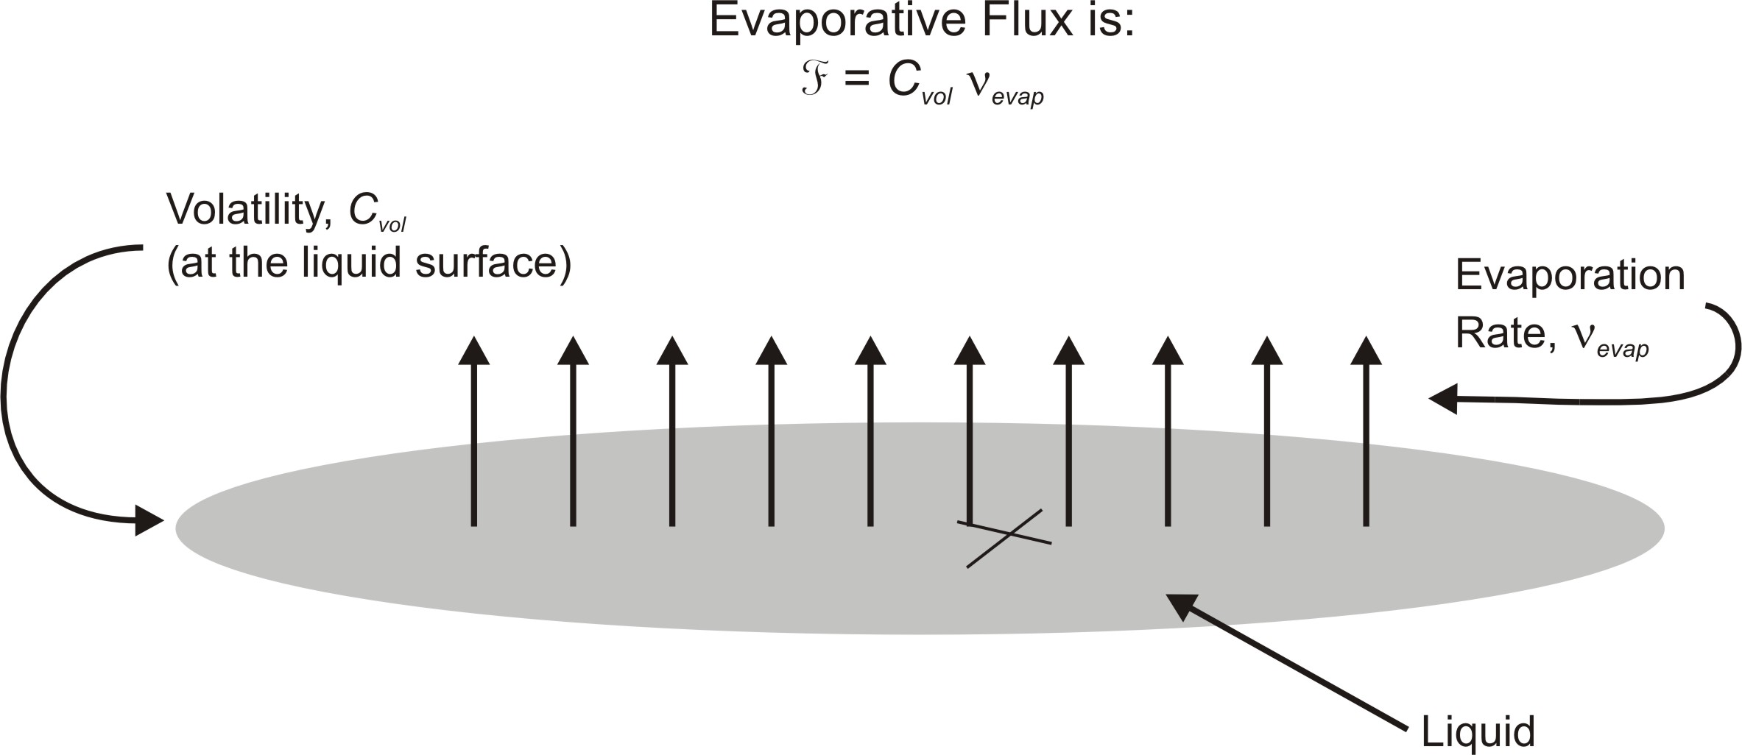
Figure 2. Schematic depiction of free-surface evaporation process of a liquid agent. The evaporative flux is the rate of change of surface-deposited mass with time. It depends on the volatility and an evaporation rate of the liquid.

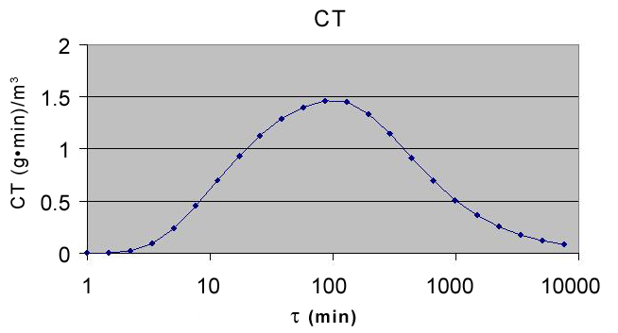
Figure 3. Total integrated exposure concentration (CT) of CWA for medical personnel as a function of the evaporation time constant (τ). The time interval begins after a 10-minute lag time during which some material has evaporated; the evaporation will continue as decontamination proceeds. The time-integrated exposure concentration is then the sum of exposure concentration as contaminated patients file past the medical personnel. This concentration is dependent upon the evaporation time constant (τ) which is the characteristic time for volatilization of the liquid agent. When τ is small the majority of the agent evaporates prior to arrival at the medical treatment facility; for agents with a larger τ, little agent will evaporate not only during transport to the medical facility, but throughout the decontamination process.

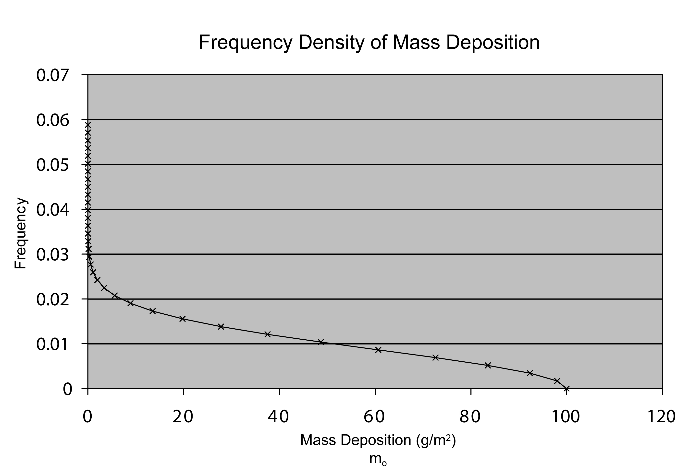
Figure 4. Frequency density of initial mass deposition (m_{o}) of sarin which describes the frequency with which victims will be contaminated with a specific amount of sarin. This density is based on the assumption of a two-dimensional Gaussian distribution that represents a uniform density of people and the likely mass deposition of the CWA as the radial distance increases from the dissemination device.

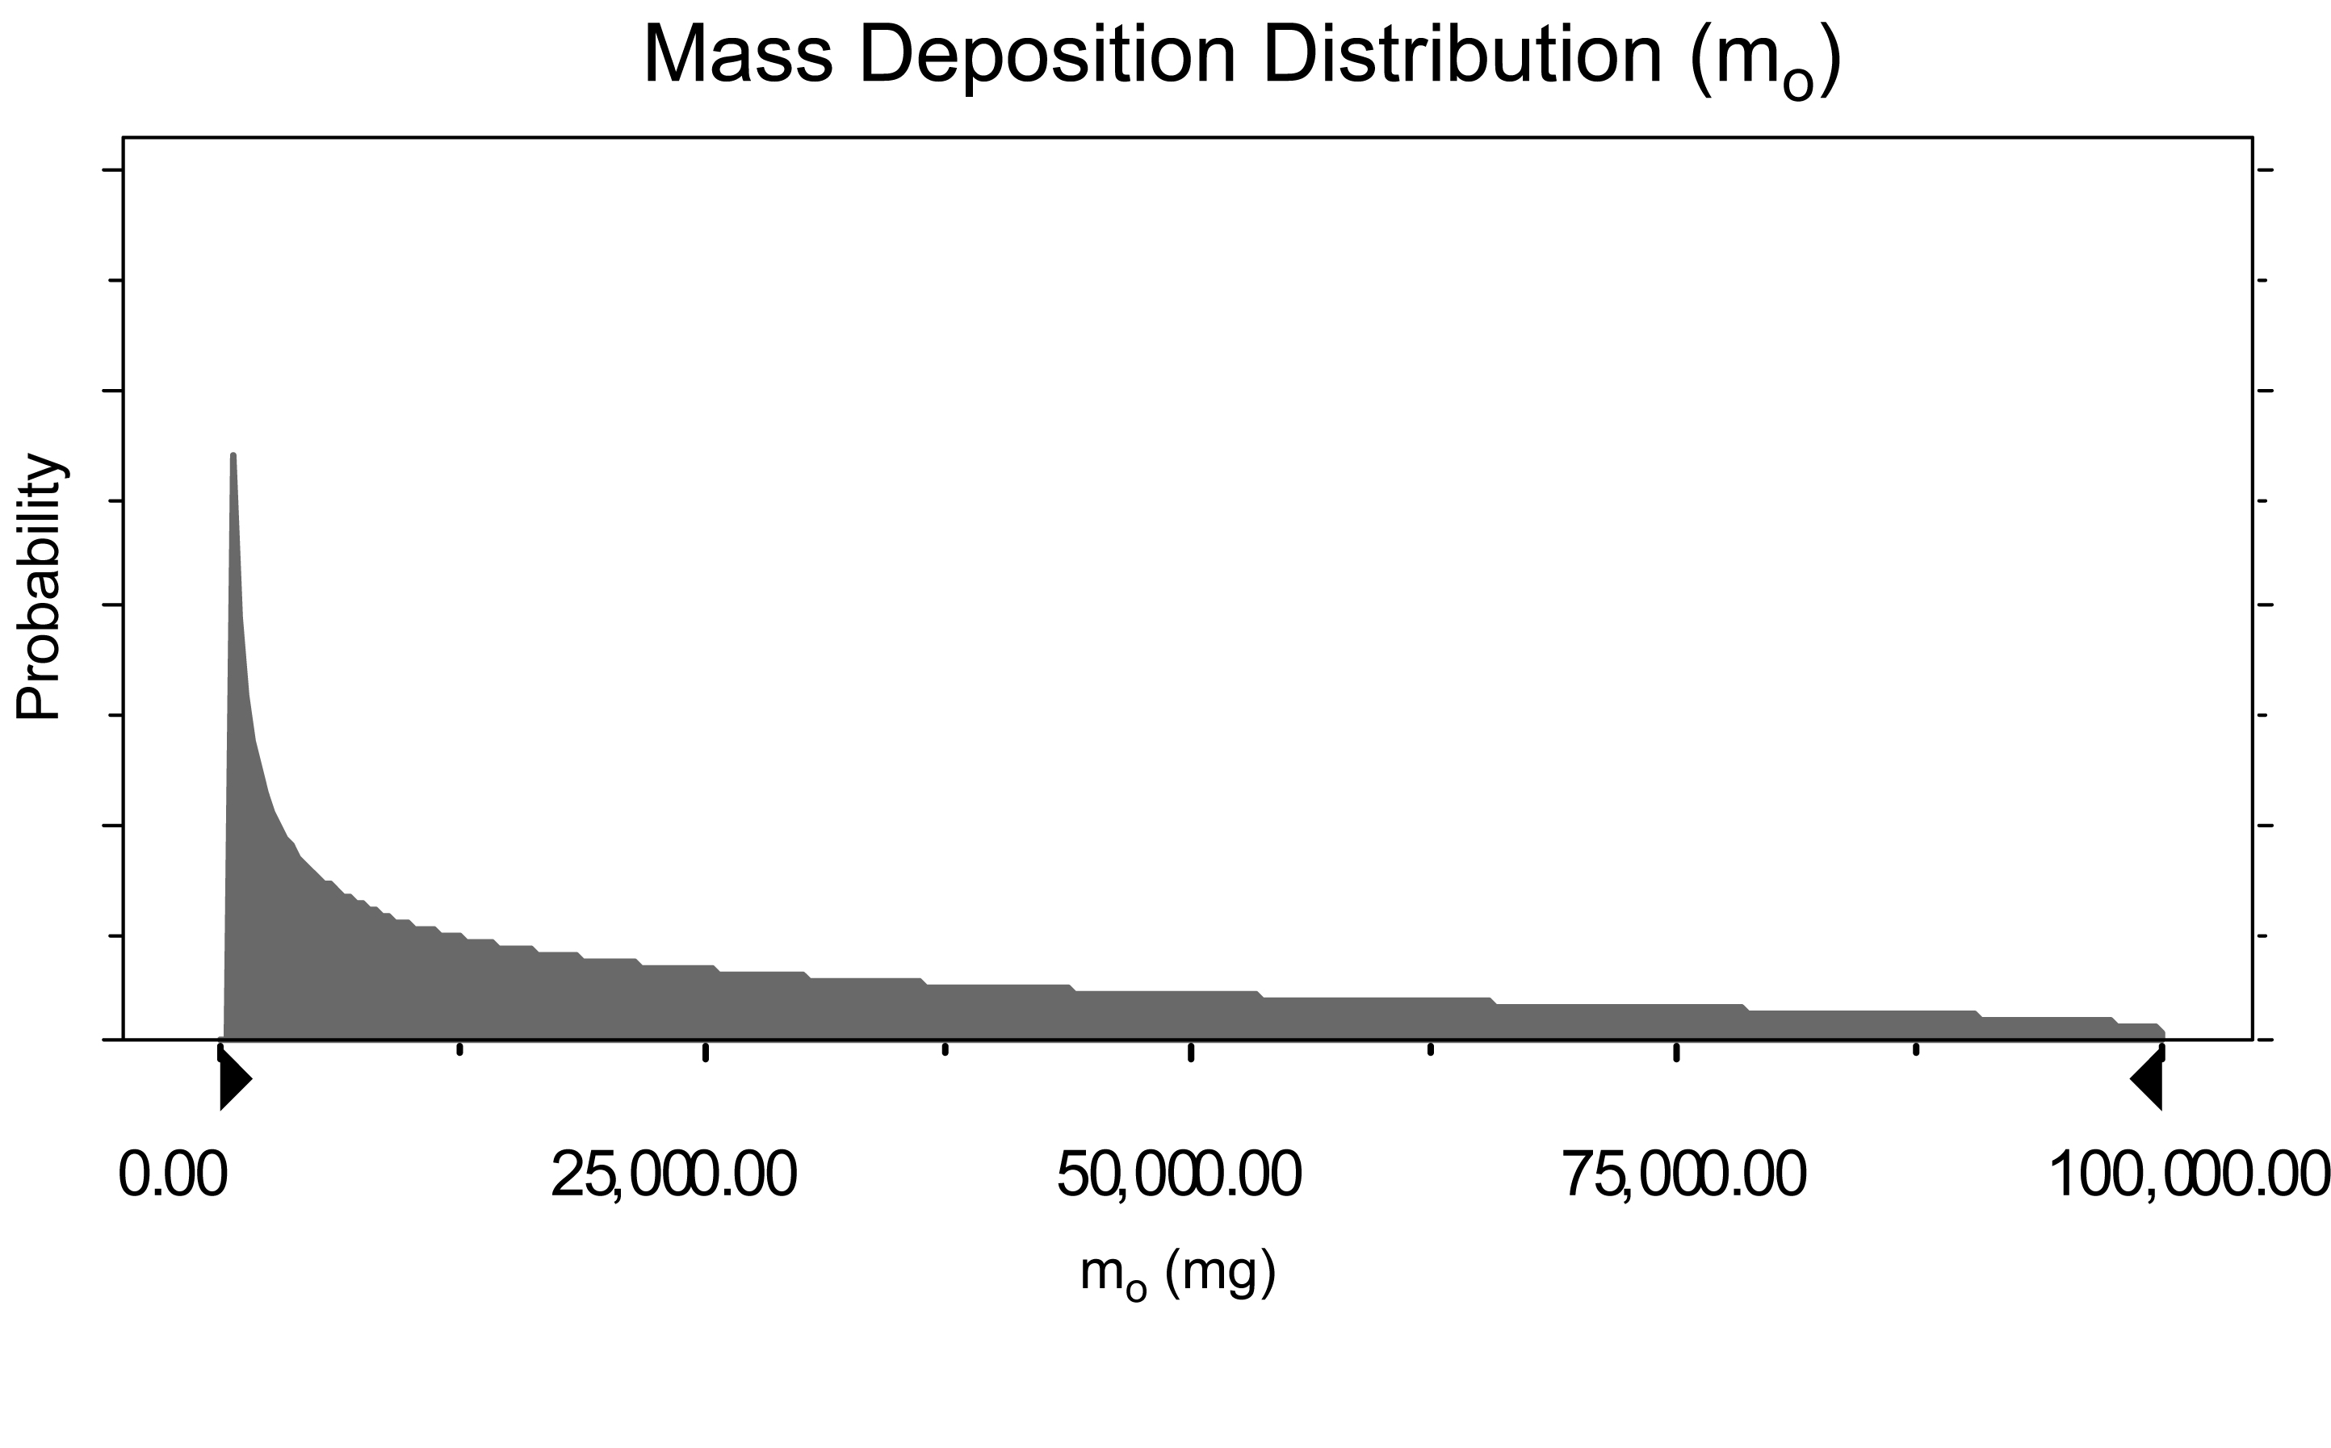
Figure 5. Beta distribution with α=0.52 and β=1.20 representing the initial mass deposition (m_{o}) of sarin. The distribution was chosen as an appropriate fit corresponding to the frequency density shown in Figure 3 and is used in subsequent Monte Carlo simulations to determine the total exposure to sarin received by medical personnel.

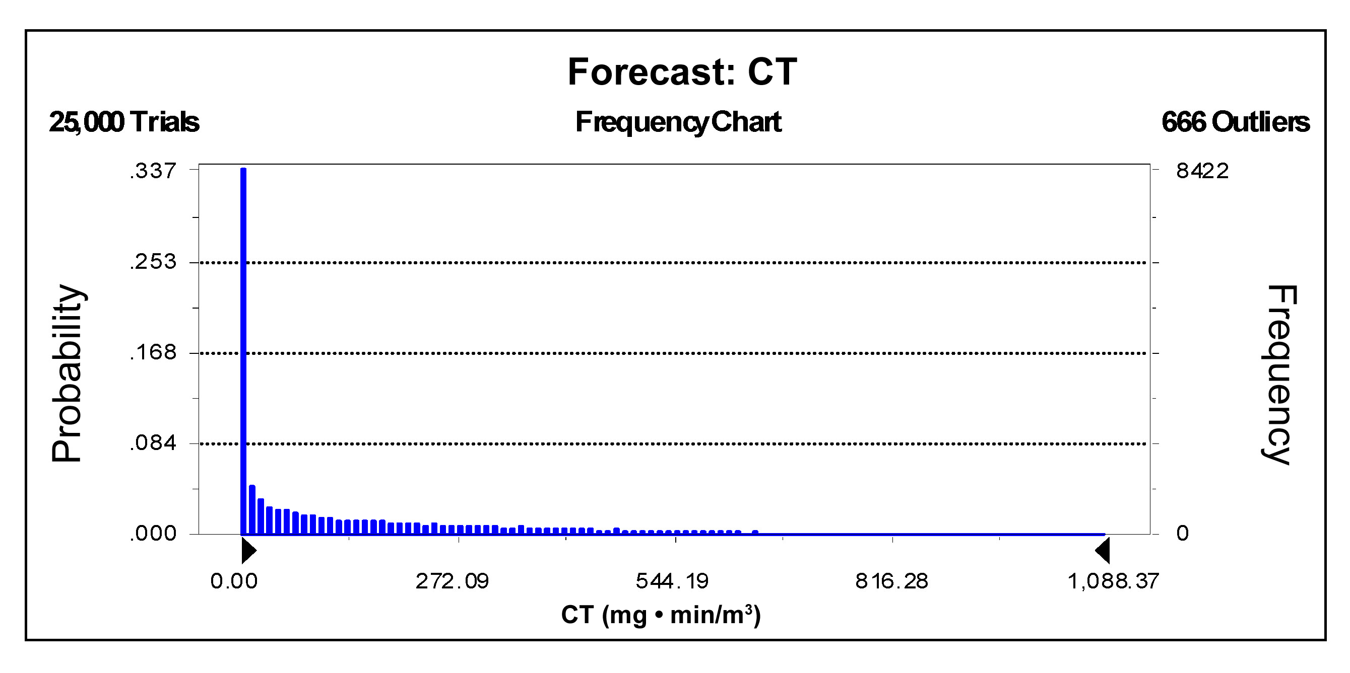
Figure 6. Monte Carlo forecast of total integrated exposure concentration (CT) of sarin when the mass deposition (m_{o}) is represented by the beta distribution presented in Figure 4. The time-integrated exposure concentration is then the sum of exposure concentration as contaminated patients file past the medical personnel. The integration begins after a 10-minute lag time which represents transport time to the facility; the integration is stopped when the decontamination process ends.

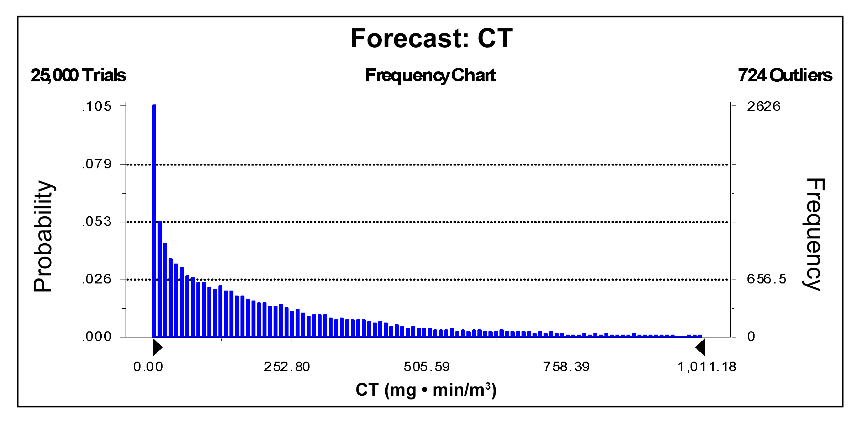
Figure 7. Monte Carlo forecast of total integrated exposure concentration (CT) of sarin when the mass deposition (m_{o}) is represented by a triangular distribution with a maximum value of 100 g and a likeliest value of 10 g. The time-integrated exposure concentration is then the sum of exposure concentration as contaminated patients file past the medical personnel. The integration begins after a 10-minute lag time which represents transport time to the facility; the integration is stopped when the decontamination process ends.

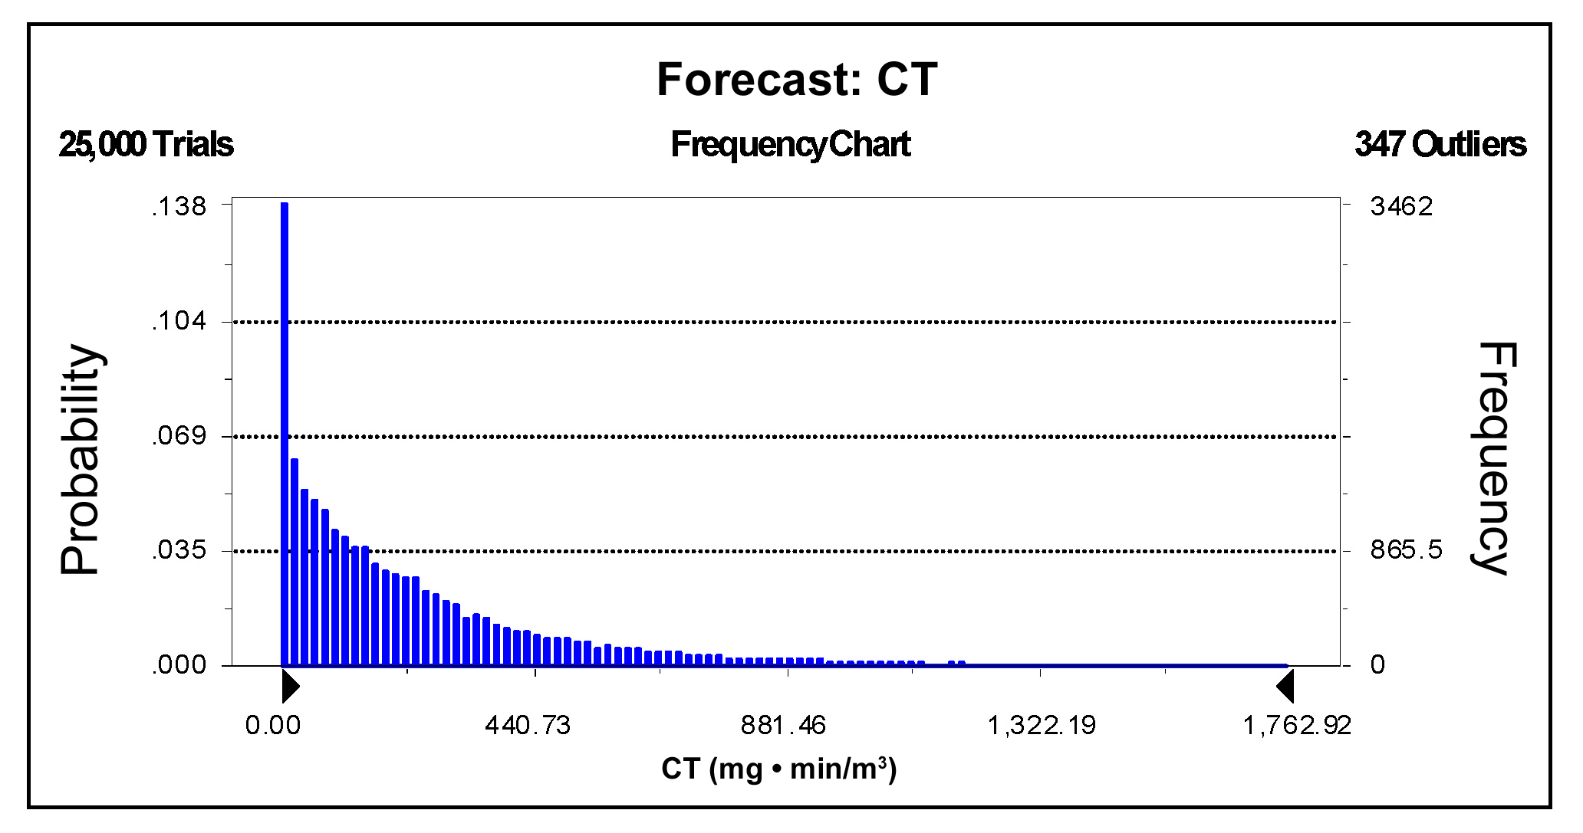
Figure 8. Monte Carlo forecast of total integrated exposure concentration (CT) of sarin when the evaporation rate of sarin (ν_{evap}) is described by an exponential distribution as a realistic estimate of the desorptive evaporate rate. The mass deposition (m_{o}) is represented by a triangular distribution with a maximum value of 100 g and a likeliest value of 10 g. The time-integrated exposure concentration is then the sum of exposure concentration as contaminated patients file past the medical personnel. The integration begins after a 10-minute lag time which represents transport time to the facility; the integration is stopped when the decontamination process ends.

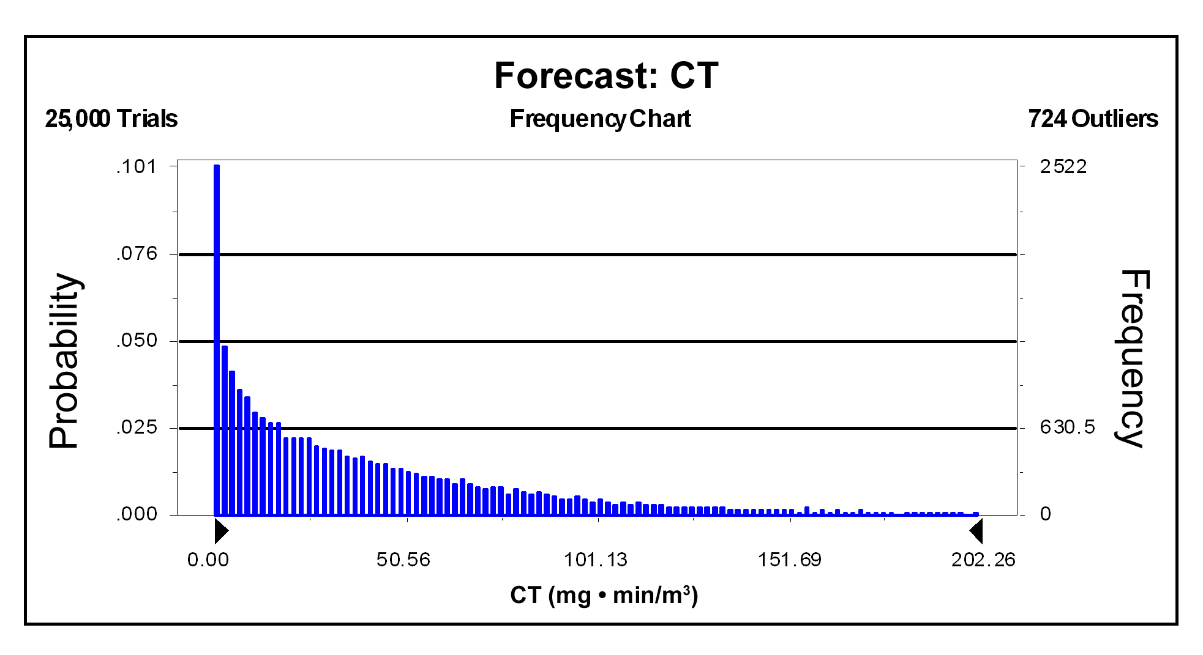
Figure 9. Monte Carlo forecast of total integrated exposure concentration (CT) of sarin when the mass deposition (m_{o}) is represented by a triangular distribution with a maximum value of 100 g and a likeliest value of 10 g. The time-integrated exposure concentration is then the sum of exposure concentration as contaminated patients file past the medical personnel. The integration begins after a 10-minute lag time which represents transport time to the facility; the integration is stopped when the decontamination process ends. In this scenario the contaminated body surface area is assumed to be 20%, which represents the potential exposure to healthcare workers when victims immediately disrobe.

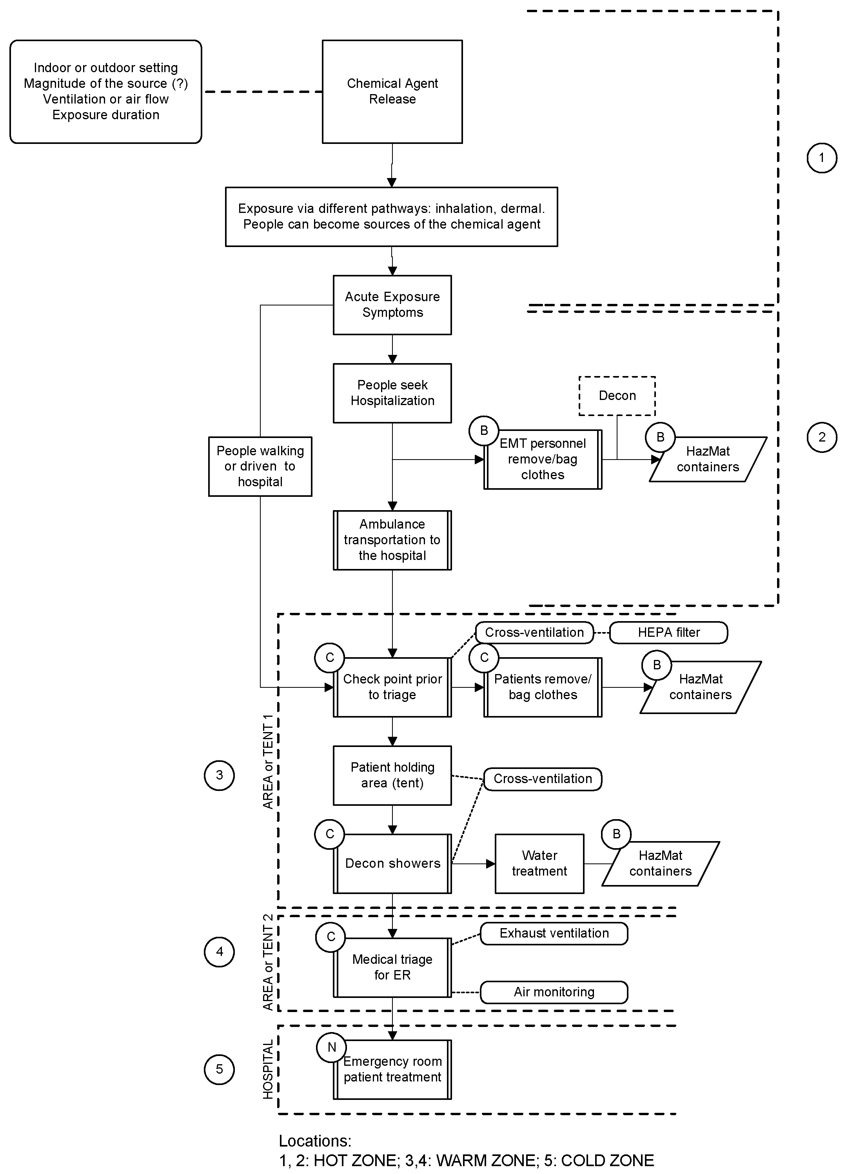
Figure 10. Emergency response steps for survivors of chemical attack seeking medical attention at hospital ER. The “hot” zone represents the site of the CWA release, while the “cold” zone is the area with no expected contamination. The “warm” zone denotes areas where contaminated victims present themselves for decontamination. As the contaminated patients arrive at the medical treatment facility, they become sources of contamination for the medical personnel who must adhere to the recommended steps to minimize exposure. Health care workers in each zone also limit exposure when covered by the appropriate level of personal protective equipment.

TRAINING NEEDS

Does OSHA require level B personal protective equipment for hospital workers?
The Hazardous Wastes Operations and Emergency Response (HAZWOPER) Standard (29 CFR 1910.120(q)(3)(iv)) applies to employees under the site specific Incident Command System who are engaged in emergency response with the intent of handling or controlling the release. For these employees, possible close approach to the point of release and exposure to inhalation hazards is anticipated, and for them, the highest level of respiratory protection is required. However, some facilities have interpreted this to mean that all hospitals involved in chemical incidents, especially involving WMD agents, must be prepared for responses using level B PPE.

By contrast, hospital personnel expected to decontaminate a chemically contaminated patient who had been involved in a release of a hazardous substance are removed from the site of the emergency and the point of release. Such personnel do not need to be trained or equipped as would a person participating on HAZMAT team. Their potential exposures would result from proximity to or contact with a patient who may have been chemically contaminated. Such hospital personnel would need be trained to the first responder operations level (1910.120(q)(6)(ii))(Fairfax, 1999; Fairfax, 1992). Health care workers' primary activities in such a situation would be clinical care and the resultant decontamination. Their exposure to inhalation and dermal hazards is likely to be substantially lower than those actively participating at the site of chemical release. OSHA cannot define how contaminated patient(s) will be, who are presented at hospitals post-release, and whether level A, B, or C are the most appropriate level of protection (Fairfax, 2002a). OSHA does not assume that level B or A (self-contained breathing apparatus) are necessary (Fairfax, 2002b) although this is one way of addressing a hazard assessment. On the other hand, on-site responding personnel at active release sites with the potential for exposure from ongoing release of agents, are at much higher risk of adverse effects than in-hospital staff. OSHA does require hospitals to conduct a risk assessment that identifies types and levels of exposures that employees can reasonably anticipate (Fairfax, 2002a). If personnel are exposed to residual off-gassing from patients rather than to an active chemical agent dispersal device, the risk assessment should focus on the actual likely exposures.

Is level C adequate for “self-referrals”?

Where the types of substances are known and worst-case scenarios can be constructed, likely exposures can be estimated. Scrutiny of evaporation rates suggests that only sarin, or other agents with vapor pressures similar to water, could still generate hazardous vapor exposures during decontamination. For sarin, levels of 100 g of agent on individuals are likely to generate doses well above the lethal concentration for 50% of the population (IOM, 1997). Such levels are incapacitating, so that patients with such concentrations can arrive only after passive transport. Such patients must be brought either by ambulance, where they will likely have been decontaminated, or by private vehicle, via which only limited numbers (far less than the 50% mentioned above) would actually appear. So, exposures to hospital personnel would remain well below the threshold required for level B.

MEDICAL SURVEILLANCE
Workers in hazardous operations have undergone medical surveillance examinations since several environmental disasters in the early 1980s. The practices evolved from an early document (NIOSH/OSHA/USCG/EPA, 1985) and were codified in a 1986 OSHA standard, HAZWOPER standard (Melius, 1986). Practices have evolved since then and have been codified for a program to manage demilitarization of chemical warfare agents, namely the Chemical Stockpile Emergency Preparedness Program (CSEPP) (FEMA, 2003). Medical programs for hazardous materials handling serve two purposes: (a) fitness to work and (b) adverse health effect monitoring (Melius, 1986; Gochfeld & Favata, 1990; Favata & Gochfeld, 1989; Udasin et al., 1991).

Working in chemical protective suits with powered air-purifying respirators (PAPRs) generates the usual consideration of work capabilities. Three specific concerns arise: first, individuals working in chemical protective clothing appear to be at increased risk of heat illness, especially in hot climates. Physical conditioning and acclimatization appear to have few documented benefits (McLellan & Frim, 1994) and are not likely to serve as a useful element to a hospital response program. Hospitals should address this with monitoring and control programs (Tan & Fitzgerald, 2002) such as contained in CSEPP. Second, chronic diseases associated with impaired autonomic sensitivity warrant scrutiny (Beckett et al., 1986). Third, PAPRs, by themselves, really have no physiological contraindications, as there is no added resistance such as described for negative pressure respirators (Hodous et al., 1986). However, discomfort from air streams passing the face may be severe enough to prevent effective work. This represents a psychological response that, together with claustrophobia, may preclude participation in a program. The weight of equipment is negligible, so that the cardiovascular concerns arising with the use of self-contained breathing apparatus are insignificant for level C PPE. In general, therefore, neither pulmonary nor cardiac contraindications should preclude wearing level C PPE, but heat illness monitoring programs are necessary.

Equally important is surveillance of health endpoints. Routine screening for pulmonary, dermal, neurological, and gastrointestinal effects represents important baseline documentation. Routine blood testing for such programs generally aims to define hematologic and hepatic functioning. Body-mass index, as a major contributor to liver test abnormalities, must be recorded. Biological monitoring for the many potential agents is impossible. After the fact, documentation of exposure, particularly for individuals who develop symptoms, should be an integral part of the incident resolution. For many, serial laboratory determinations, such as used for the documentation of cholinesterase inhibition and recovery (Coye et al., 1987) are appropriate. Comparison of levels obtained immediately after exposure with those obtained later may serve to document markers of exposure or effect with subsequent resolution. In general, as sequential determination and comparison with the initial levels provides evidence of changes in body burden or recovery, serum banking is unnecessary.

CONCLUSION
Based on considerations discussed in the previous section, the authors believe level C PPE is possible under well-defined conditions and assumptions that pertain to hospitals. Still, use of level C requires prior planning and protocols at the facility and the following constraints:

Local: facility level
- Staff involved in the response to such events must have a clear understanding of the hazards of agents, of the broad syndromes associated with exposure, and of the treatment implications (pocket cards, emergency responders’ guides). They must have training in PPE and the local plans.
- Local plans must focus on site layout and operational strategies integrated with the local community. A decontamination plan requires site layout that identifies a receiving area before the hospital that focuses on rapid disrobing and decontamination, and local storage of bagged source material. Prior consideration of the location of staging and holding areas, their relationship to the emergency room/ambulatory care access site, and the intricacies of security and crowd control are essential to the success of such decontamination. Clear and simple instructions by megaphone, to individuals or groups, are essential and should happen quickly.
- Facilities must provide fans for air movement across disrobing / holding areas and in decontamination tents.
- Clothing, etc. can be transported in plastic bags to the designated HAZMAT container, but handling this material will require level B or higher PPE (done by national operations).
- Bleach decontamination of corpses is likely to allow the deceased to be handled in a normal manner.

Local: Area Emergency Planning Committees
It is essential that local committees agree on protocols that require the removal of clothing prior to transport to healthcare facilities. This exposure reduction will benefit emergency medical technicians and ambulance drivers and the receiving healthcare workers. This is the single most important control strategy. All responders must be trained to recognize that prompt removal of contaminated clothing is essential once victims have been removed from the site of ongoing release and before transport to a healthcare facility.

National Level
EMT triage algorithms should exist for the clinical presentations, to be used by front-line workers. This is crucial for rapidly-acting nerve gases and chemical asphyxiants like cyanide. In general, other agents require decontamination and supportive treatment but do not clearly benefit from additional pharmacologically justified treatment. Once detection equipment exists that is sensitive and reliable enough to guide exposure assessment and management, such front-line algorithms may be less important. First responders should distinguish basic syndromes (hypercholinergic, chemical anoxia, mucosal irritants) and relay critical information on likely agents to the receiving healthcare facility.

REFERENCES

APPENDIX: ACRONYMS AND SYMBOLS

List of Acronyms
ATSDR Agency for Toxic Substances and Disease Registry
CBRNE Chemical Biological, Radiological Nuclear and Explosive Materials
CSEPP Chemical Stockpile Emergency Preparedness Program
CWA Chemical Warfare Agent
D2PC U.S. Army Personal Computer Program for Chemical Hazard Prediction
DOD Department of Defense
EMT Emergency Medical Technician
EOHSI Environmental and Occupational Health Sciences Institute
HAZWOPER Hazardous Wastes Operations and Emergency Response
JCAHO Joint Commission on Accreditation of Health Care Facilities
MMRT Metropolitan Medical Response Team
NIOSH National Institute of Occupational Safety and Health
NIST National Institute for Standards & Technology
OSHA Occupational Safety and Health Administration
PPE Personal Protective Equipment
SBCCOM US Army Soldier and Biological Chemical Command
SCBA Self Contained Breathing Apparatus
USAF United States Air Force
VHA Veterans Health Administration

List of Symbols
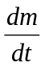 evaporative flux of chemical agent [mg/m²-min]
C_{vol} volatility of chemical agent [mg/m³]
ν_{evap} evaporation transfer rate [m/min]
m_{o} mass deposition [g/m²]
τ time constant of evaporation process [min]
A_{w} area of column of air [m²]
A_{p} surface area of patient contaminated with agent [m²]
u_{W} wind velocity [m/min]
C vapor concentration downwind of contaminated patient [mg/m³]
CT integrated exposure concentration [mg-min/m³]
t_{s} start time for integration [min]
LD₅₀ dose lethal to 50% of exposed population [mg]
LCt₅₀ concentration lethal to 50% of exposed population after 1min exposure [mg-min/m³]

2% is a very conservative estimate because removal of clothing and decontamination should occur immediately (as subsequently discussed).

