The Muon Storage Ring

Introduction
The 50-GeV storage ring for neutrino production has been designed using a racetrack configuration. A racetrack is the optimal geometry for maximizing the proportional length of a single straight section to circumference, hence maximizing the number of muons converted into a neutrino beam. Although this particular ring was designed to meet limitations and target physics detectors specific to the Fermilab site, its design concepts, parameters, components, and dynamics are generally applicable. The racetrack design is simple, containing a downward straight, called the production straight, a return straight pointed towards the surface and two arcs with their associated matching and dispersion suppression sections.

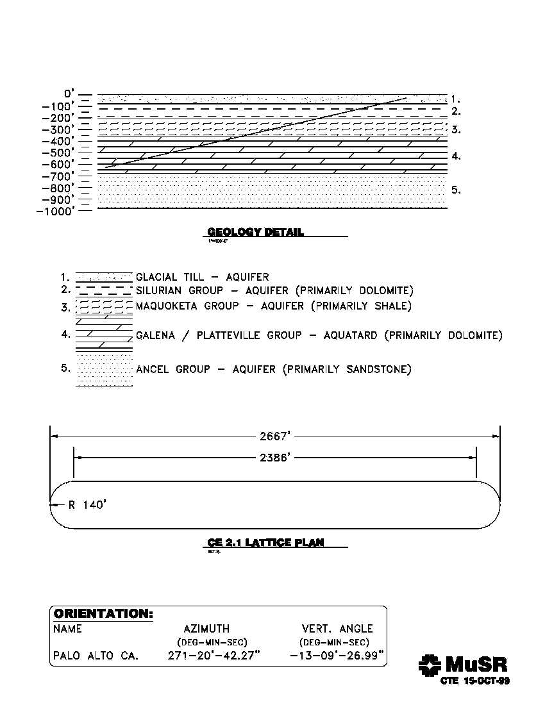

Figure 1: Constraints on the storage ring due to the geology under the Fermilab site. The 2667’ (or 813 meter) limit on the cross-section profile of the ring shown in the lower drawing is given by the 600 foot available for the ring’s vertical drop the and 13 degree angle between Fermilab and the West Coast.

One of the parameter constraints of the design arises from the underlying geology of the site as shown in Figure 1. The vertical distance between the surface of the site and the bottom of the Galena Platteville rock layer is approximately 680 feet. Below this dolomite layer is a sandstone layer, which must be avoided because it is a poor substrate for tunnel construction and it contains the water supply for the municipalities surrounding Fermilab. Of the 680 feet, 600 have been allocated to the ring for its vertical drop (Table 1). The “vertical drop” is the vertical distance between two parallel planes: one plane through the topmost part of the ring and a second plane through the bottommost part of the ring.

This vertical constraint is a limitation because at least part of the ring must be tilted at a vertical angle to direct the neutrino beam through the earth to a long-baseline detector. Tilting the entire ring obviates the need for additional, “out-of-plane” bending. For a significant angle of declination and vertical height restriction, tilting increases the relative arc length and matching and dispersion suppression sections, thereby decreasing the relative length of the production straight and the fraction of decays occurring in this straight.

An assumption used in designing this ring is the choice of the angle at which the ring must direct the neutrinos to illuminate the long-baseline physics detector. For directing the neutrino beam to the West Coast (including SLAC, LBNL, etc.), the downward angle corresponds to about 13°. This 13-degree angle combined with the vertical drop limit of 600 feet (183 meters) gives a cross-sectional profile of the ring (shown in the top part of Figure 1) of 813 meters. The “cross sectional profile” is the distance between the uppermost point of the ring and the bottommost point of the ring.
600 | Feet | Ring Vertical Drop
10 | Feet | Tunnel ceiling to floor
10 | Feet | Shielding above ring
50 | Feet | Undisturbed bottom layer of Galena Platteville
10 | Feet | For uncertainties in the above three numbers
680 | Feet | Total from Surface to Bottom of Galena Platteville
Table 1: Allocation of vertical distances under the Fermilab site.

The cross-sectional profile constraint, when combined with a dipole field of 6T and muon beam energy of 50 GeV, provides a straight section for neutrino production which is about 39% of the entire ring circumference. This is to be compared to a mathematical maximum possible value of 50%. The choice of 6T is based on Figure 2 which shows the production straight length divided by the circumference as a function of dipole bend field. The ratio is calculated based the 813 meter cross-sectional profile constraint and, thus, is specific to the geology under the Fermilab site. Releasing this constraint would allow one to increase the circumference. If, for example, one chooses to keep the arcs the same and increase the straight sections by a large factor, the ratio approaches the mathematical limit. On the other hand, one could use lower field magnets in larger arcs along with larger straight sections and still maintain a large decay fraction.
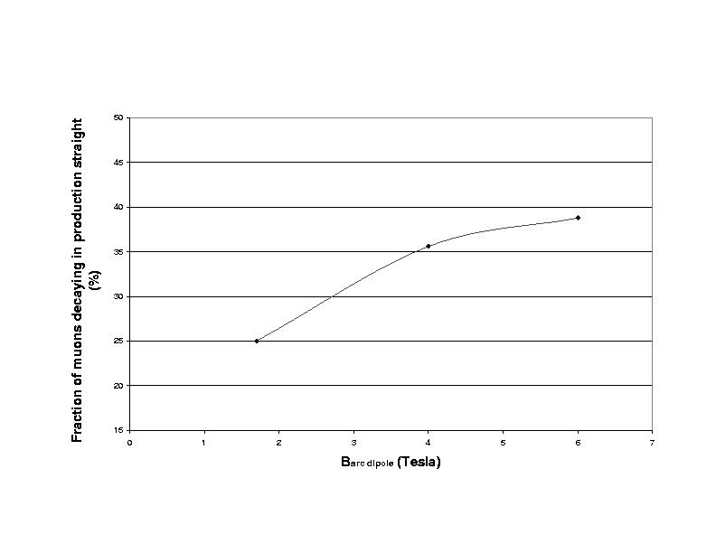

Figure 2: Fraction of muons decaying in straight section as function of dipole bend field.
In terms of the optics design, achieving a large admittance competes with the need to form a collinear neutrino beam—collinear, at least, to within limits set by the decay kinematics. To prevent the dynamics of the parent muon beam from contributing significantly to the angular spread of the secondary neutrino beam, the divergence of the muon beam in the production straight must be much less than the mean decay angle, which is 2 mr at 50 GeV. A straight with high-beta functions (implying large transverse beam sizes) is required. The challenge, then, in the design of the storage ring is to preserve the exceptionally large emittance transmission of the arc design through a transition to a high-beta region. The betatron function values are primarily determined by the transverse emittance combined with a user-defined limit that the divergence in the high-beta straight be equal to or less than one tenth the rms decay angle, or 0.2 mr. In terms of the unnormalized emittance and the betatron functions, the angular divergence is given by:
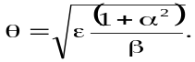
The design conditions are summarized in Table 2. In the following paragraphs, details of the design are described.

The Lattice
Storage Ring Geometry | Unit | racetrack
Storage Ring Energy | GeV | 50
Vertical Descent Limit | m | ≈183
Declination Angle | Degrees | ≈13
Cross-sectional Profile | m | 813
ε(rms, normalized) | mm-rad | 3.2π
dp/p(rms) | % | 1.0
Maximum Poletip Field | T | 6.0
Arc Cell Phase Advance | Degrees | 90
Table 2: Muon Storage Ring Design Parameters and Constraints

The Arcs
Strong focussing FODO cells were chosen for the arcs to achieve a large momentum acceptance as compared with more complicated focussing structures. To shorten the arc lengths, high-field superconducting dipoles with 6T fields are assumed. Since strong gradients and large apertures are needed to accommodate and contain the large transverse emittance and the large displacement of off-momentum orbits, superconducting quadrupoles are also used.

The parameters of the magnets in the arc cells are listed in Table 3 along with calculated beam sizes based on the emittances in Table 2. The dimensions of the magnet apertures also include a 1-cm beam-stay-clear and a 1-cm thick tungsten liner for shielding. A 90° phase advance per cell was chosen so as to support strong sextupole correction of linear chromaticity while simultaneously maintaining an acceptable level of transverse acceptance. This phase advance is also the best choice to minimize transverse beam sizes both vertically and horizontally. The sextupole field has been superimposed on the quadrupole field (at the peak of the dispersion and betatron function) to minimize both the strength needed as well as the tune shift with amplitude aberration. Superconducting quadrupoles have been designed with a sextupole field component added. Each arc contains 31 half-cells, giving a total of 62 arc dipoles and 62 arc quadrupoles for the entire ring. For control purposes the defocusing and focusing quadrupoles are on separate buses. The arc lattice functions are plotted in Figure 3.
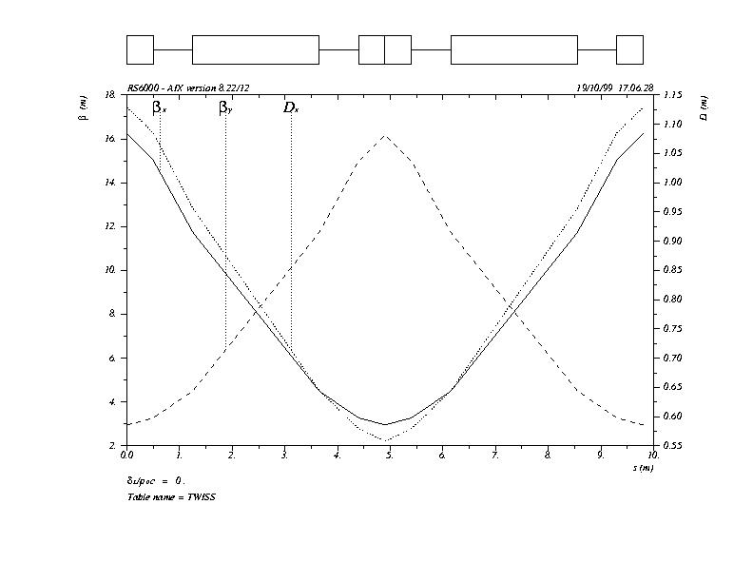

Figure 3: Lattice functions in the arcs of the storage ring.

Production Straight
General
Tungsten shield thickness | cm | 1.0
Beam-stay-clear | cm | 1.0
Inter magnet spacing | m | 0.75
Dipoles
Dipole length | m | 2.4
Dipole bend | rad | 0.0859
Dipole field | T | 6.0
Beam size (6σ) WxH | cm | 8.0x5.3
Dipole full aperture, WxH | cm | 12x9.3
Sagitta | cm | 2.67
Quadrupoles
Quadrupole length | m | 1.0
Quadrupole strength | m-2 | 0.31
Quadrupole poletip field | T | 3.6
Beam size (6σ) WxH:
F quad | cm | 9.2x2.6
D quad | cm | 4.2x6.2
Quadrupole bore | cm | 14
Sextupoles (overlay on quad field)
Horiz. Sextupole strength | m-3 | 0.64
Vert. Sextupole strength | m-3 | 1.26
Horiz. Sextupole field | T | 0.52
Vert. Sextupole field | T | 1.03
Arc FODO cell parameters
Cell length | m | 9.8
Cell phase advance | deg | 90
β(max) | m | 16.2
Dx(max) | m | 1.3
Total number of arc cells |  | 31
Table 3: Parameters of the large-momentum acceptance arc cells for a 50-GeV muon storage ring.
The neutrino production straight, in contrast to the arcs, is a high-beta function, weak focussing structure. This production straight is matched to the arcs using a quadrupole doublet, and it has been designed to transmit a large momentum range in addition to forming a near parallel beam of muons. To form the insert, the short FODO cells of the arcs are matched into much longer, high-beta FODO cells that are the building blocks of the production straight. Use of a periodic unit allowed flexibility in the length of this region. The production straight represents about 39% of the 1.75-km ring circumference.

Table 5 gives the parameters of these production straight cells. The very low field gradient required by the quadrupoles in this region offers the possibility of using permanent magnets. The lattice functions for the production straight are shown in Figure 4.

Return Straight
The return straight is approximately equal in length and opposite to the production straight. It has been simply designed using 90° cells, 50-m long. The parameters of the return straight cells are shown in Table 4, and the lattice functions are shown in Figure 5. It cannot be identical to the production straight because of the anticipated need for higher order corrections for the ring. Tuneshift with amplitude corrections are planned using octupoles and /or sextupoles inserted in this straight. The cell parameters in the return straight will then be adjusted to enhance the dynamic aperture of the ring. It is planned that not only tuneshift-with-amplitude terms from the arc sextupoles will be corrected, but also those arising from the strong fringe fields associated with the unusually large bore of the quadrupoles.
Cell length | m | 50.78
Quadrupole length | m | 1
Quadrupole strength | m-2 | 0.056
Quadrupole poletip field | T | 0.84
Quadrupole bore | cm | 18
Cell phase advance | deg | 90
β(max) | m | 86.3
Rms divergence | mr | 0.73
Number of cells |  | 12
Table 4: Parameters of the FODO cells in the return straight of a 50-GeV muon storage ring.

Cell length | m | 137.6
Quadrupole length | m | 3
Quadrupole strength | m-2 | 0.0019
Quadrupole poletip field | T | 0.05
Quadrupole bore | cm | 33
Cell phase advance | deg | ≈22
β(max) | m | 436.0
rms divergence | mr | 0.20
Number of cells |  | 5
Table 5: Parameters of the high-beta FODO cells for the neutrino production straight section in the 50-GeV muon storage ring

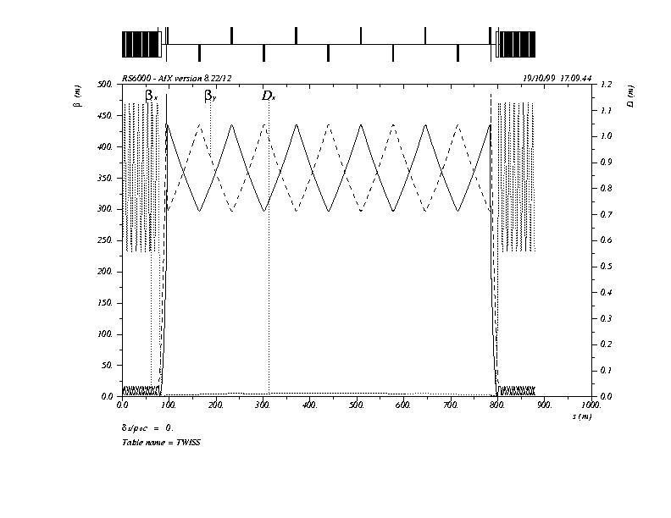

Figure 4: Lattice functions in the production straight.

Matching and Utility Sections
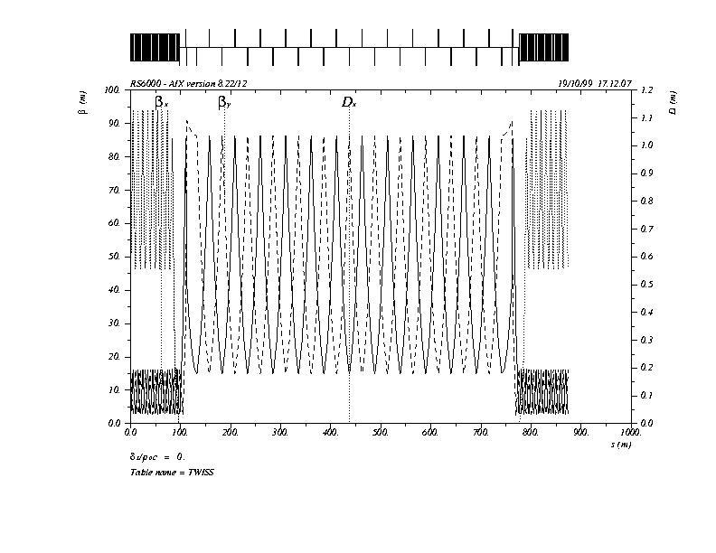

Figure 5: Lattice functions in the return straight.
A combined matching section and dispersion suppressor was placed at each end of the arcs for efficient transition into the high-beta straight. A conventional two-cell dispersion suppressor was utilized for the return straight. Four more dipoles and sixteen quadrupoles are contained in the four matching/dispersion suppression sections. If conventional dispersion suppression is used for the high-beta straight, the length of the straight is reduced by about 4% of the total circumference, from 39% to about 35%.

Injection
The Muon Storage Ring has need of an injection kicker system that will deflect the incoming beam on orbit. The injection kickers are placed in the downward (or production) straight in order to inject into the ring at the top near the surface. Injection kickers with large apertures [2] will be needed for this purpose. The main parameters for the kicker system are given in Table 6.
Type |  | Horizontal
Clear Gap WxH | mm | 308x246
Integral BL | Tesla-meter | 0.6
Field Flattop | μsec | 2.0
Field Fall | μsec | 4.0
Field Variation | % | 10
Rep Rate | Hz | 15
Table 6: Injection kicker specifications.

The required total field integral is given by 24 magnets of length 1 meter and with a field of about 300 Gauss. This choice is based on two engineer-defined limits that were design constraints. Experience has suggested that the maximum system voltage should be limited to 50 kV and the maximum switch tube current should be limited to 5 k Amps. These two requirements imply a system impedance of 5 ohms.

In Figure 6 we show a proposal for the cross section of the magnet. The mechanical design for the support structure and vacuum vessel is non-existent and will need to be addressed for the next level design. The actual magnet length and number of pulsers will need to be nailed down at that time.

The above constraints are such that the peak field will be: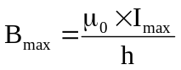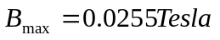
And the total length of the magnet system will be:
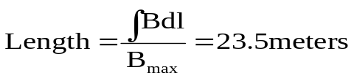
On a per meter basis the inductance, capacitance and the field drift time of the magnet are: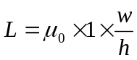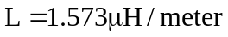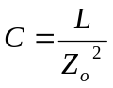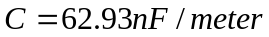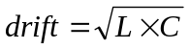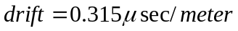

Figure 6: Proposed kicker magnet cross section. The dimensions are in inches [mm].
Ferrite

The PFN that will be used to drive each magnet will have an impedance of 5 ohms and a pulse length of 2.25 μsec. A SPICE simulation of both the PFN and magnet has been completed.

Superconducting Magnets for the Arcs
The two arcs of the Muon Storage Ring will be composed of superconducting magnets. The 31 identical arc-cells include 62 dipoles and 62 quadrupoles, with sextupoles combined with the quadrupole coils. All the magnets are designed to work at 4.5 K in one-phase liquid helium flow, and are also designed to work under the quite high beam losses heating of about 5 W/meter on average, with a peak value twice as high. The highest operating field for these magnets is 6 T, which allows the use of NbTi superconductor. Critical current data for the inner coil strands of the SSC 50 mm dipole were used as a reference for estimating the coil geometry and the superconductor volume. This critical current was ~ 340 Amps at 7 T and 4.2 K for the strands with 0.84 mm diameter. The average current density for the cable with insulation inside the coil was assumed to be 500 Amps/mm². The basic conceptual designs for all magnets use the single layer cosθ coil geometry and RHIC type mechanical structure for the cold mass design.

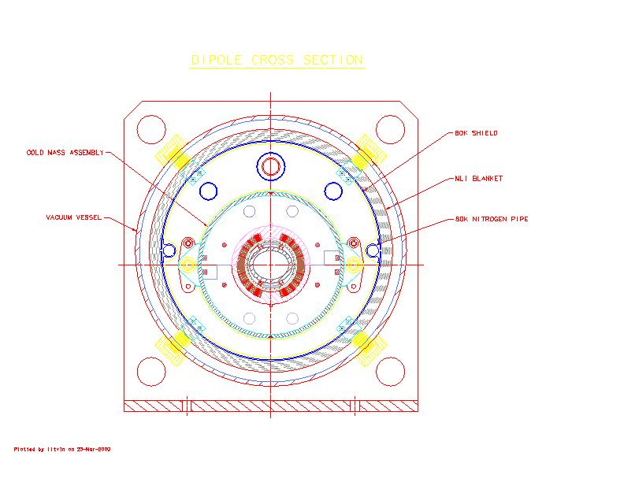

Figure 7: Arc Dipole Cross Section
The basic parameters of the magnets for the arcs of the storage ring are presented in Table 7.

A cross-section of the dipole cold mass inside the cryostat is shown in Figure 7. Here one sees the single layer superconductor coil surrounded by plastic spacers and collared by iron yoke laminations. Stainless steel shells that are welded around the yoke complete the cold mass assembly. The cold mass has two connections to the “spider” type suspension in the middle plane. This assembly is fixed to the vacuum vessel by four bolts. The thermo-shields that are placed around the cold mass will have a temperature of about 80 K and could be cooled by liquid nitrogen. Multi-layer insulation blankets are used to reduce the heating of the thermo-shields from the vacuum vessel. The vacuum vessel has reinforcement in the areas of the magnet suspensions.

The quadrupole and sextupole coils will be assembled like spool-pieces: that is, the sextupole coils will be placed around the quadrupole coils and will be collared together by iron yoke laminations. Stainless steel shells will be welded around the yoke. The complete cold mass assembly of the spool-piece and the dipole magnet assembly will be welded together in a common helium vessel. This vessel forms the basic half-cell unit of the arc. The longitudinal view of this arc half-cell cryostat is shown in Figure 8.

The cryostat has two suspensions along the length of the magnets. One is placed in the middle of the quadrupole and is an anchor point to keep the center point of the quadrupole in place during cool-down of the magnets. As shown in the top view of Figure 8, the dipole magnet has significant bending of the cold mass in the horizontal plane with a sagitta of about 68 mm. This bending should be done for the beam tube as well to preserve beam aperture. The superconductor coil must be protected from the electrons coming from muon decay, and is provided by a 10 mm cylindrical wall of tungsten as shown in Figure 7. As shown in section 8.4.1 below, the heat load on the tungsten will be about 50 W/meter on the average, with a peak value about twice as large. Cooling could be provided by two flattened tubes with liquid nitrogen flow or cold helium gas. Some additional tubes come through the suspension and are used for bus-bar returns and as a heat exchanger for the helium flow.
Dipole
Operating field | Tesla | 6
Magnetic length | meter | 2.4
Operating current | kA | 15
Stored energy | MJ | 1.4
Beam aperture (HxW) | mm | 80x100
Tungsten beam tube thickness | mm | 10
Cold mass diameter | mm | 410
Length of cold mass | meter | 3
Weight of cold mass | tons | 3
Quadrupole
Gradient | T/m | 51.4
Magnetic length | meter | 1.0
Operating current | kA | 10
Coil inner diameter | mm | 160
Beam aperture | mm | 120
Sextupole coil
Coil inner diameter | mm | 220
Horizontal poletip field | T | 0.52
Vertical poletip field | T | 1.03
Magnetic length | meter | 1.0
Common cold mass diameter | mm | 410
Length of cold mass | meter | 1.5
Weight of cold mass Quad+Sextupole | tons | 1.5
Table 7: Arc magnet specifications
A summary of the mechanical dimensions and cryogenic loads of the arc-half cell are shown in Table 8.
Half-cell assembly
Cold mass diameter | mm | 410
Total length of cold mass | meter | 4.6
Beam tube length | meter | 4.9
Total weight of the common cold mass | tons | 4.5
Outer diameter of cryostat | Mm | 800
Total weight of arc half-cell assembly | Tons | 5.5
Cryo loads
to He level, at 4.5 K | W/cryostat | 5
to N2 level, at 77 K | W/cryostat | 30
Dynamic heat losses (including average beam losses)
to He level, at 4.5 K | W/meter | 7
to N2 level, at 77 K | W/meter | 70
Table 8: Mechanical and cryogenic parameters of the arc half-cell.

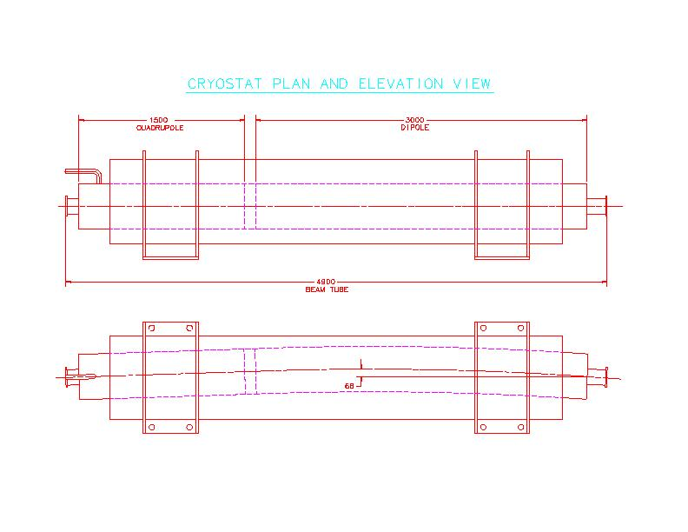

Figure 8: Cryostat Plan and Elevation Views. A half-cell is shown with a quadrupole and a dipole. The dimensions are in mm.

Power Supplies for the Muon Storage Ring
Schematics for the power supplies for the arcs of the storage ring are shown Figure 9. The power supply design assumes the dipole circuit requires 15 kAmp DC and each quadrupole (focusing and defocusing) circuit requires 10 kAmp DC. Since all circuits are superconducting, the resistance of the warm bus connecting the power supplies to the load and an acceptable ramp rate sets the voltage requirement. For the purposes of this study, the supplies were designed in units of 150 kWatt modules each capable of 30 volts and 5000 amps. Such supplies are common around Fermilab and have well known costs and operating characteristics. The dipole bus would require 3 of these supplies operating in parallel while the quad buses would each need 2. Assuming an 0.4 henry dipole circuit inductance yields a ramp rate of 75 Amps/sec (200 sec to ramp to 15 kAmp).
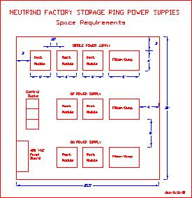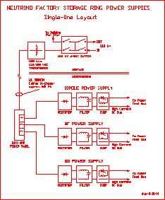

Figure 9: Schematics of Power Supplies for the Muon Storage Ring.
Since it is quite costly to transport 15 kAmp, the power supplies should be located near the feed cans in the beam enclosure. This should be no problem at the near-surface end of the ring, but requires some consideration for the deep end. The present plan is to locate the power supplies at the tunnel level and provide the 480 VAC power from the surface. The exceptionally high cost of a 15 kAmp, 800-foot long vertical DC bus system drove this decision. The cryogenic problems with operating a long vertical superconducting power transmission line ruled out the possibility of a superconducting feed from the surface. Further optimization studies may indicate additional cost or performance savings by installing the 13.8KV/480VAC transformer at the tunnel level. Presently, it is planned to use passive filters to smooth the output of the power supplies. This is the common practice at Fermilab for storage ring systems.

Quench Protection Dumps
This study assumes the quench protection dump switches and resistors will be integrated with the power supply filter. The switch itself will be similar to the 15 kAmp dump presently operating at the Fermilab magnet test facility. The resistors could be water-cooled stainless steal elements or air-cooled elements mounted to the wall of the vertical access shaft. The present plan does not include backup DC breakers in the dump switch because of the high cost of such devices. In the event that the dump switch fails, the Quench Protection Monitoring system would protect the magnets by firing all the magnet heaters in the string.

Muon Storage Ring Quench Detection & Protection
The MµSR will consist of 6 separately excited superconducting magnet strings. Each of the two arcs will have a dipole, and two quad circuits. The dipole circuits will store much more energy (45 MJ each) than the quad circuits, but quench protection will be implemented in the same manner for each. One embedded Quench Protection Monitor (QPM) will be needed in the “Power Supply Room” at each arc.

For quench detection, one voltage tap from each magnet will need to be connected with a coax to the QPM. VFC or ∆∑ technology can be used for data acquisition. For quench protection, each magnet will need an embedded heater connected to a capacitive discharge Heater Firing Unit located in the PS room. Also located in the PS room, will be the dump, dump switch, and two Quench Bypass Switches (QBS), as shown in Figure 10. Only one safety lead is needed in the center of each arc.

Lattice Performance and Tracking

Figure 10: Dipole Quench Protection

Power
Supply
Dump
45 MJ
15KA
Safety
Lead
Power
Lead
Power
Lead
Heater
QBS
QBS
Dipole
String .2 H
Dipole String .2 H
Dump
Switch
Overall physical characteristics of the storage ring are summarized in Table 9. The dynamic aperture and momentum performance of the ring lattice has been studied by tracking for 1000 turns to high order including not only full kinematical effects but also fringe field characterization of the large-bore quadrupoles [3].
This is a very conservative number of turns to track since the intensity of 50 GeV muons decays by 1/e in only 178 turns. Tracking plots are shown in Figure 11 in steps of 0.5 σ as given by a normalized emittance (rms) of 3200 π mm-mr. The top plots show the dynamic aperture of the storage ring with fringe fields of all quadrupoles included. Further study showed that only the fringe fields from four strong quadrupoles in the matching/dispersion suppression sections about the production straight caused a deterioration in dynamic aperture. Turning the fringe fields off in these four quadrupoles improved the dynamic aperture considerably as can be seen in the lower plots. Since fringe fields depend strongly on poletip field, the simplest solution is to lengthen these quadrupoles and reduce their poletip field correspondingly. To date, tracking has not included field and alignment errors. Given the relatively short lifetime of the beam, <1% field errors and all but the lowest-order resonances are not expected to be important.
Circumference | m | 1752.8
Neutrino decay fraction | % | 39.2
Production region
Matching and dispersion suppression | m | 44.1
High-beta FODO straight | m | 688
General
βx(max)/βy(max) |  | 90
νx/νy |  | 86.3
Natural chromaticity |  | 12
Table 9: Overall parameters of the storage ring.

Beam Induced Energy Deposition And Radiation Fields
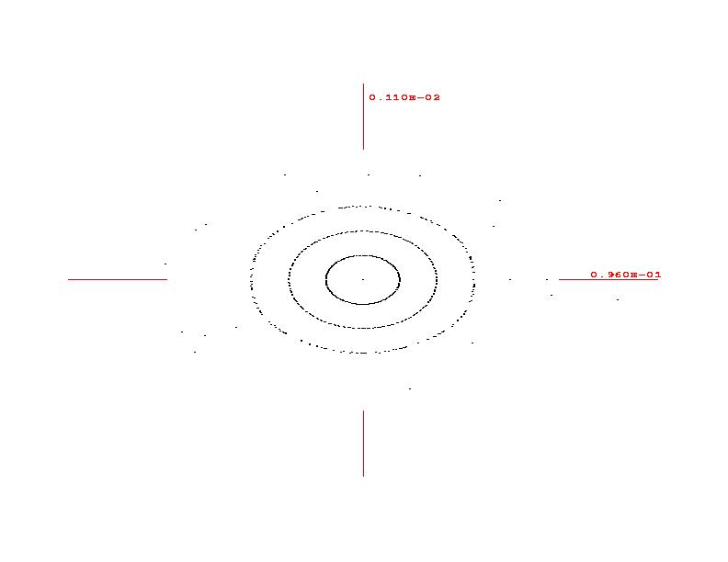
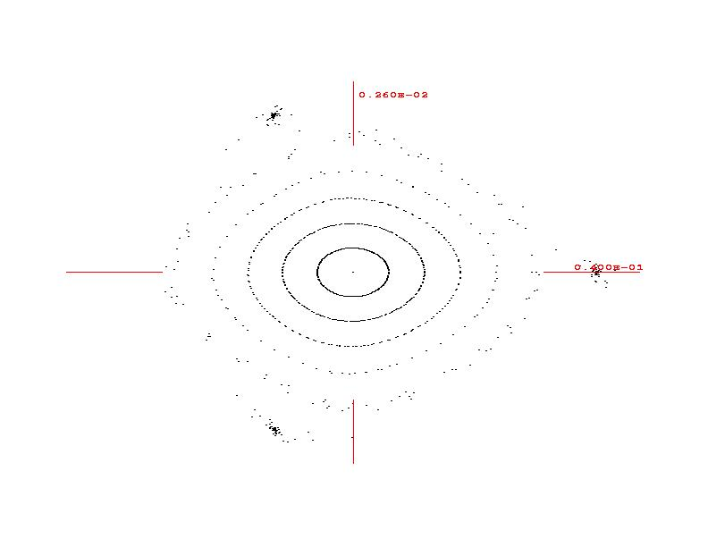

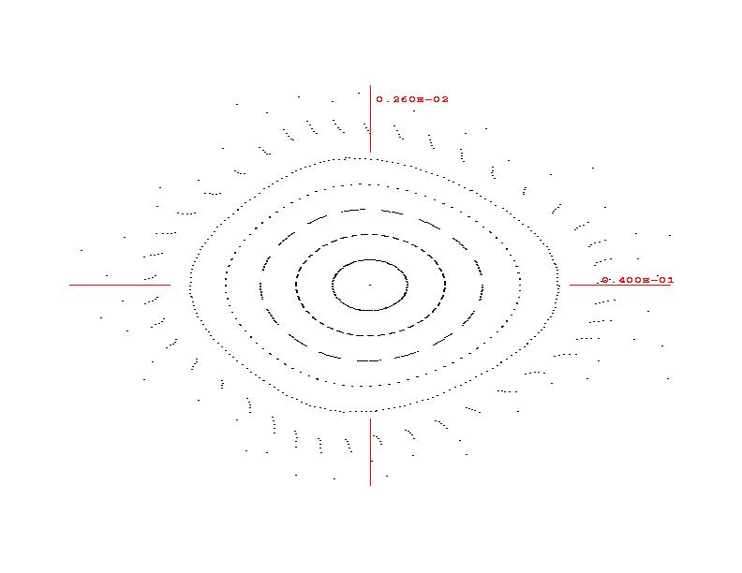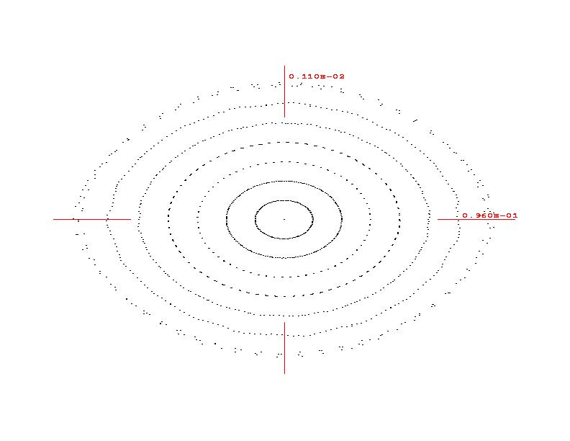

Figure 11: Top: Horizontal (left) and vertical (right) accepted phase space plots obtained by 9th order tracking through the full muon storage ring, including chromatic correction sextupoles and quadrupole fringe fields. Tracking is plotted in steps of 0.5 σ for an normalized emittance (rms) of 3200 π mm-mr. Bottom: Same as top plots but with quadrupole fringe fields in the matching sections to the production straight turned off.
Realistic Monte Carlo simulations have been performed with the MARS14(2000) code [1] for the arcs and straight sections of a muon storage ring using the above lattice for 30 and 50 GeV muon beams. Detailed analysis of radiation levels inside the magnets, around the arc tunnel and at large distances from the ring (neutrino hazard) is done.
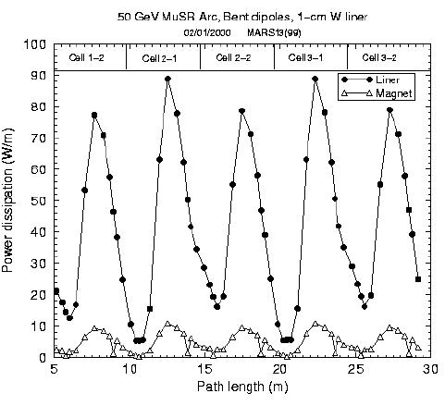

Figure 12: Longitudinal distribution of power dissipation in the arc magnets with 1 cm thick tungsten bore tubes.

Arc Magnets
Forced muon decays and shower simulation with MARS are done in the arc FODO cells. The cells are 9.8 m long each and made of 45 T/m 1-m quads and 6 T 2.4-m dipoles. At 50 GeV, the muon decay rate is 1.6x10¹⁰ decays/m/s. For a 240 kW beam, there is 84 kW power dissipation in the 1750 m storage ring, or 47.8 Watts per meter on average. A thick bore tube made - as calculations show - of tungsten must intercept most of this power. The longitudinal distributions of both power density and power dissipation oscillate in the arc cells (see Figure 12), with about 10% of power dissipated in the SC coils and 90% in the protective bore tube. The power density peaks in the orbit plane with a strong azimuthal variation (see Figure 13).
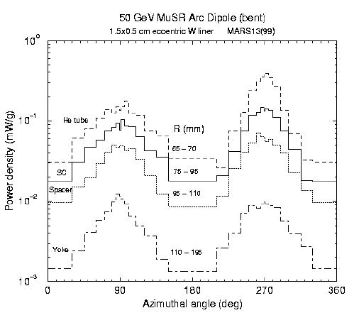

Figure 13: Power density in the bent arc dipole.

As a result of thorough optimizations, it was found that the radiation load to the superconducting coils of the arc magnets due to 50 GeV muon beam decays is reduced to tolerable levels if the dipole is bent and there is a tungsten eccentric bore tube. The latter can be made of a 1-mm thick SS pipe (100x80 mm elliptical aperture) and a 1-mm thick SS pipe (122x102 mm elliptical aperture) shifted inward by 5 mm with the space between filled with tungsten. With such a tube the peak power density in the coil is 0.15 mW/g and the peak power dissipation in the bore tube (at nitrogen temperature) and in the rest of the magnet (at helium temperature) is about 90 and 9 W/m, respectively. Averaged over the arc length values are about two times lower. Residual dose rates on the magnets are quite acceptable.

Radiation Around The Arc Tunnel And Downstream Of The Straight Sections
Full-scale MARS calculations have shown that the normal occupancy limit of 0.25 mR/hr is provided by 2 meters of dolomite type shielding below, above and radially inward from the arc tunnel enclosure walls. Six meters of such shielding is needed to provide that limit radially outward (see Figure 14). Power supply rooms and other underground enclosures should be placed inward from the arc tunnel.
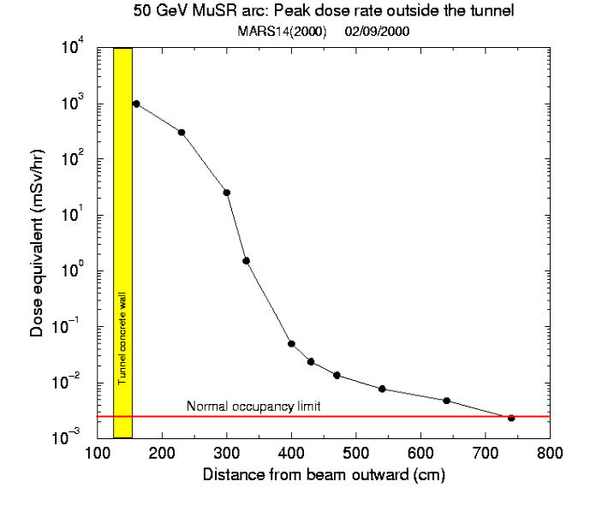

Figure 14: Dose distribution radially outward from the arc tunnel enclosure.
The off-site limit of 10 mR/yr due to neutrino-induced radiation in the arcs is reached at 50 meters radially outward from the beam orbit. The height of such a controlled disk is only +-10 cm from the orbit plane.

Neutrino-induced radiation downstream of the straight sections is more severe. The off-site limit of 10 mR/yr is met at 4.2 km for a 50 GeV MuSR and at 1.8 km for a 30 GeV MuSR. The maximum half-width of a tolerable isocontour is 4.3 m and 2.7 m at 50 and 30 GeV, respectively.

REFRENCES

- N.V. Mokhov, “The MARS Code System User Guide, Version 13(95)”, Fermilab-FN-628 (1995); N.V. Mokhov et al., Fermilab-Conf-98/379 (1998); LANL Report LA-UR-98-5716 (1998); nucl-th/9812038 v2 16 Dec 1998; http://www-ap.fnal.gov/MARS/.
- E. Keil, Muon Storage Ring Design with Simple Mathematica Packages, CERN-SL-99-053-AP, August 31, 1999.
- F. Zimmerman et al, MUCOOL Note 95, March 3, 2000

