Couples HIV Counseling and Testing

Module Five: Providing Concordant Positive Results
____________________________________________________________________

Module Perspective
This module will begin with a morning review of previous work covered, followed by a review of the second session of the Couples HIV Counseling and Testing (CHCT) Protocol. Participants will learn how to provide concordant positive results to couples using the CHCT Protocol (Components V-B through XI-B).

The trainer will lead participants in a values clarification exercise before reviewing component X-B. The component focuses on children, family planning, and prevention of mother-to-child transmission (PMTCT) treatment options. The values clarification exercise is intended to help counselors understand their values surrounding certain issues relating to HIV while giving each participant an opportunity to explore different points of view.

After lunch this module will cover potential benefits of disclosure in the disclosure benefits and basics section. The last component in this section (Component XI-B: Disclosure and Getting Support for Concordant Positive Couples) provides a review. After counseling skills are briefly reviewed, a role play exercise will allow participants to practice providing a concordant positive result to a couple.

This module will conclude after role play number three is processed.

Objectives for Module Five:

- Learn the procedure for providing HIV-positive results for couples.
- Identify care for HIV-infected persons.
- Address family planning and reproductive health issues for HIV-positive couples.
- Discuss the benefits of disclosure.
- Practice all skills covered so far.

Advance Preparation

Gather Materials

- Prepare Overheads 5-1 through 5-23

5-1: Components I through VI-A
5-2: Component V-B: Provide Concordant Positive Test Results
5-3: Component V-B (Continued)
5-4: Component VI-B: Discuss Coping and Mutual Support
5-5: Component VI-B (Continued)
5-6: Component VII-B: Discuss Positive Living and HIV Care and Treatment
5-7: Component VIII-B: Discuss Things to Do at Home to Keep Healthy
5-8: Component IX-B: Discuss Risk Reduction
5-9: Component X-B: Discuss Children, Family Planning, and PMTCT Options
5-10: Component X-B (Continued)
5-11: Basic Information about PMTCT
5-12: Component XI-B: Discuss Disclosure and Getting Support
5-13: Disclosure Basics (Continued)
5-14: Disclosure Basics (Continued)
5-15: Disclosure Basics (Continued)
5-16: Benefits of Disclosing to Children
5-17: Considerations for Disclosing to Children
5-18: Considerations for Disclosing to Children (Continued)
5-19: Component XI-B (Continued)
5-20: Review of Counseling Skills
5-21: Review of Counseling Skills (Continued)
5-22: Review of Counseling Skills (Continued)
5-23: Review of Counseling Skills (Continued)

- Make Copies of Handouts

Values Clarification Exercise (H5-1)
Role Play Character Description—Husband (H5-2)
Role Play Character Description—Wife (H5-3)
Universal PMTCT Messages (H5-4)
Providing Concordant Positive Results Script (If possible, print this on blue paper)

- Write the Following on Separate Newsprint

Morning Review
Potential Benefits of Disclosure for the HIV-Infected Person
Potential Benefits of Disclosure to Sex Partners
Potential Benefits of Disclosure to Family and Community

- Make Sure You Understand the Participant Coding Sheet

Day Three
Module 5: Topics/Activities Schedule
Start time: 8:30am
Activity Time

Morning Review 25 Minutes

Second Session—Concordant Positive 20 Minutes
(Component V-B: Providing Results )

Second Session—Concordant Positive 25 Minutes
(Component VI-B: Coping and Mutual Support)

Second Session—Concordant Positive 40 Minutes
(Component VII-B: Positive Living and Care and Treatment )

Morning Break 20 Minutes

Second Session—Concordant Positive 20 Minutes
(Component VIII-B: Keeping Healthy)

Second Session—Concordant Positive 20 Minutes
(Component IX-B : Risk Reduction)

Values Clarification Exercise 30 Minutes

Second Session—Concordant Positive 40 Minutes
(Component X-B: Children, Family, PMTCT )

Lunch 60 Minutes

Disclosure Benefits/Basics 40 Minutes

Second Session—Concordant Positive 35 Minutes
(Component XI-B: Disclosure and Support)

Review Counseling Skills 20 Minutes

Role Play #3 (Components I–XI-B) 60 Minutes

Afternoon Break 20 Minutes

Processing of Role Play 30 Minutes

Wrap-Up/Adjourn for the Day 5 Minutes
End time 5:00 pm

Morning Review

Welcome participants to the third day of the training. Begin the morning with a quick review of the material you have covered so far. Before starting the morning review, it will be necessary to cover up any protocol posters (if being used) in preparation for a review exercise. Ask for different volunteers to name and quickly describe each of the components you have discussed.

As the participants respond, write their answers on newsprint.

Morning Review

List responses here.

Let’s start the morning with a review of the components of the CHCT intervention that we have discussed up to this point. We have discussed Components I through VI-A. Are there volunteers to describe each component we have discussed so far, starting with Component I?

Listen for:

Initial Session:
Component I: Introduce the Couple to CHCT and Obtain Concurrence to Receive Couple Services
Component II: Explore the Couple’s Relationship and Reason for Seeking CHCT Services
Component III: Discuss the Couple’s HIV Risk Concerns
Component IV: Prepare for Testing and Discuss Possible Results

Rapid Test Performed

Second Session:
Component V-A: Provide Concordant Negative Test Results
Component VI-A: Discuss Risk Reduction

Once Components I through VI-A have been described and listed, hang the newsprint in a visible place to act as a reminder for the participants. Thank everyone for participating.

Display Overhead 5-1. This chart can be found in the Participant’s Manual.

Briefly review the steps of CHCT that you have covered thus far. Make sure there are no questions before you move on.

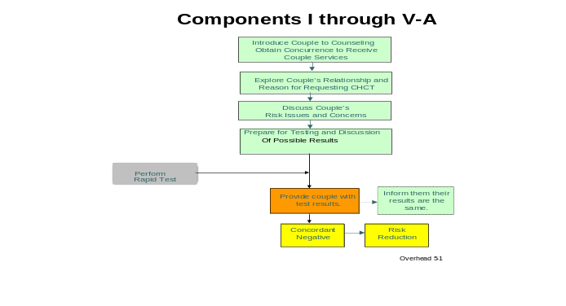

Please look at this chart in your manuals.

So far we have discussed the initial session and Components I through IV, which include the procedure for introducing a couple to CHCT and obtaining concurrence to receive CHCT services; exploring the couple’s relationship and reason for seeking CHCT services; discussing the couple’s HIV risk concerns; and preparing the couple for testing and discussing possible results.

The first component of the initial session, in which you introduce the couple to CHCT and obtain concurrence to receive couple services, is the most appropriate place for a couple to decide not to receive CHCT services.

Yesterday we discussed the second session for a couple with concordant negative results, Components V-A and VI-A. The couple is informed that their results are the same and that they are concordant negative. The remainder of the session includes a discussion of risk reduction to ensure that the couple remains HIV-negative.

Today we are going to discuss how to provide a couple with a concordant positive HIV test result; how to identify care for living positively with HIV; ARV treatment; family planning and PMTCT issues; and disclosure. We will finish today with a role play of all the skills we have discussed so far.

Before we get started, are there any questions or comments about the material we have covered so far?

Component V-B: Provide Concordant Positive Results

Go through the tasks and objectives one at a time using the overheads and the script. After you have gone through the material, give the participants a moment to look over the background information, tasks, and objectives for Component V-B. These can be found in the Participant’s Manual.

The second session of CHCT refers to the counseling that takes place after the couple has received their rapid HIV test. There are three possible test outcomes:

1. The couple is concordant negative, which we discussed
yesterday
2. The couple is concordant positive
3. The couple is discordant

The components we will cover today discuss how to inform a couple that their results are the same and that they are concordant positive.

As we review Component V-B, reflect back on the couple counseling skills that we have discussed and practiced. These techniques and strategies will continue to be important.

Display Overhead 5-2.

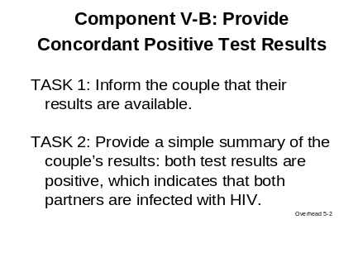

Component V-B covers how to inform a couple that their results are concordant positive.

Task 1: Inform the couple that their results are available
The counselor should inform the couple that their results are available. The counselor’s objective is to transition into the session and notify the couple that they will be receiving their results.

Task 2: Provide a simple summary of the couple’s results: both test results are positive, which indicates that both partners are infected with HIV
The counselor’s objective is to reaffirm that the couple as a unit is receiving their test results and they will deal with the outcome together.

Display Overhead 5-3.

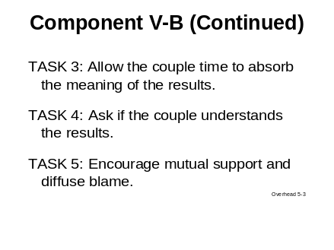

Task 3: Allow the couple time to absorb the meaning of the results
Provide a moment for each of the individuals and the couple together to consider the information they have been given. This allows them to collect their thoughts and emotions.

Task 4: Ask if the couple understand the results
The counselor’s objective is to check in with the couple to make sure they understand what their test results mean and the implications. For example, couples may need to be reassured that a positive test result does not necessarily mean that they have AIDS or that they will soon become sick and die.

Task 5: Encourage mutual support and diffuse blame
The counselor’s objective is to focus the couple on coping with the results. The counselor should diffuse any discussion about one partner infecting the other or bringing HIV into the relationship. The counselor may need to rely on his or her counseling skills, such as easing tension and diffusing blame, to help the couple to understand that it is impossible to determine when or by whom either partner became infected.

In reality, this information is neither relevant nor helpful. Instead, the couple should try to focus on coping with the results and supporting each other.

Give the participants a moment to reflect on this information and to review the tasks and objectives in their manuals.

Before we move on, take a moment to review the information in Component V-B in your manuals.

Component VI-B: Discuss Coping and Mutual Support

Move on to the next component. Read the material on the overheads out loud. Also be sure to mention the points in the script.

The next component, Component VI-B, deals with helping couples cope and support each other. During this component, the counselor must delicately balance the couple’s expression of feelings with supportive encouragement. The counselor’s demeanor should be somber but supportive. Let’s look at the tasks that will guide the counselor through Component VI-B.

Display Overhead 5-4.

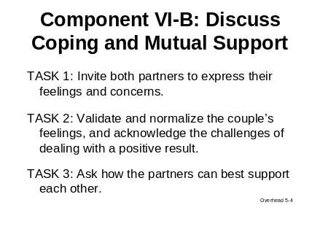

Task 1: Invite both partners to express their feelings and concerns
The objective of this task is for the counselor to understand how receiving positive results is affecting the couple. The counselor should provide each individual with an opportunity to identify and voice emotions and reactions.

The counselor should avoid labeling the couple’s feelings for them. For example, the counselor should avoid saying, “You must be upset” or “This must be difficult for you.” The counselor’s objective is to hear the couple verbalize how they are feeling and to convey understanding and support. The counselor can do this by saying, “Tell me how each of you is feeling about your result.”

Task 2: Validate and normalize the couple’s feelings and acknowledge the challenges of dealing with a positive result
The counselor should provide genuine empathy and offer support and understanding.

Task 3: Ask how the partners can best support each other
The counselor should focus the partners on generating ideas of how they will support each other.

Display Overhead 5-5.
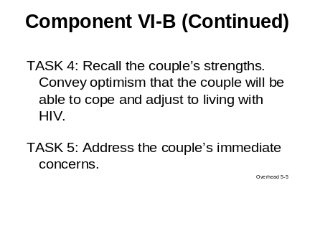

Task 4: Recall the couple’s strengths. Convey optimism that the couple will be able to cope and adjust to living with HIV.
The counselor’s objective is to help the couple recognize and build on their skills and resources, both individually and as a couple.

Task 5: Address the couple’s immediate concerns
Determine if there are critical issues that must be addressed so the couple can listen, focus, and participate in the remainder of the session.

Give the participants a moment to review the background and tasks for Component VI-B in their manuals.

Clarify any questions the participants may have.

Take a moment to review the tasks and objectives of Component VI-B in your manuals. We will have a chance to practice these tasks later on today when we do our role play.

Are there any questions?

Component VII-B: Discuss Positive Living and HIV Care and Treatment

During this component, the counselor gently transitions the session away from addressing the couple’s feelings and emotions associated with dealing with HIV and toward the clinical care, treatment, and preventive services required to manage HIV infection. It’s important to emphasize that there are many preventive treatments that can enhance the quality of life for individuals with HIV. The goal of this component is to motivate and empower the couple to seek needed care and treatment services and to care for themselves and each other. To do this, the counselor provides information about the essentials of HIV care and treatment that is adapted to the couple’s level of understanding.

Display Overhead 5-6.

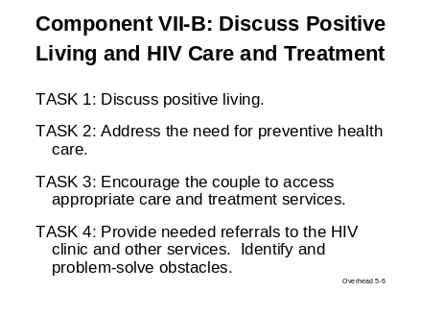

Task 1: Discuss positive living
The counselor’s objective is to encourage the partners to focus on their ability to enhance their health and well-being.

What do we mean when we say “positive living”?

Acknowledge responses.

Responses may include:
- Obtaining medical care
- Good nutrition
- Maintaining psychological health

Task 2: Address the need for preventive health care
The counselor’s objective is to encourage an immediate visit to the HIV clinic.

Task 3: Encourage the couple to access appropriate care and treatment services
The counselor’s objective is to motivate the couple to obtain the essential clinical care for their HIV infection.

Task 4: Provide needed referrals to the HIV clinic and other services. Identify and problem-solve obstacles.
The counselor should link the couple to care and services available.

During this component, the counselor’s goal is to motivate the couple to seek needed care and treatment. The counselor should discuss how to access treatment and be able to make appropriate referrals. One treatment option that may come up is the use of antiretroviral drugs, or ARVs.
Fundamentals of ARV Treatment for HIV Infection

Counselors should generally understand the fundamentals of ARV treatment, which we are about to discuss. However, counselors need to be mindful not to act as the “expert” on ARV treatment to clients. Counselors who are not clinicians should especially use caution and should not answer complicated questions.

Read through the fundamentals of ARV treatment listed below. Have the participants follow along in their manuals.

            - Antiretroviral treatments are medications used to treat HIV. “ARV” is the abbreviation commonly used to refer to these drugs.
            - ARVs help infected persons feel better and delay the effects of HIV on their health. ARVs can prolong life.
            - ARVs do not cure HIV or AIDS.
            - ARVs must be taken for life.

            - ARVs lower the level of virus in the blood if taken (as directed) without missing doses. However, it is still possible to transmit the virus.

            - Not everyone infected with HIV needs ARVs right away.

            - Another treatment is often given before ARVs are needed. This is called cotrimozaxole (or Cotrim).
Counselors should understand this critical information so they can discuss it with couples clearly and simply. The counselor must make the couple aware that ARV medications help manage HIV infection.

Do you have any questions about this?

Are there other obstacles to accessing treatment that you think your clients might face?

Acknowledge responses.

Let the group know that it is time to take a break. Be sure to let them know what time to return. During break, arrange the room for the next exercise by placing three large signs on opposite sides of the room that say, “AGREE,” “DISAGREE,” and “MIDDLE OF THE ROAD.”

Now let’s take a 20-minute break. When we return, we will review Component VIII-B: Discuss Things to do at Home to Keep Healthy. Please return by (state time).
Morning Break

Component VIII-B: Discuss Things to Do at Home to Keep Healthy

Welcome the group back from break.

Move on to the next component. Read the material on the overheads out loud. Also be sure to mention the points in the script.

Welcome back.

During this component, Component VIII-B, the counselor will discuss things the couple can do at home to keep healthy, including preventing diarrhea and malaria. The counselor will also discuss the importance of good nutrition.

The goal of this component is to empower the couple to take action at home to remain healthy and to prevent other infections and illnesses.

Display Overhead 5-7.

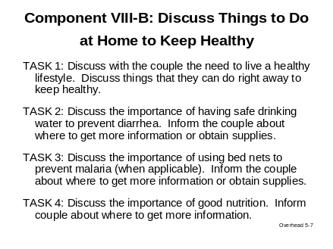

Task 1: Discuss with the couple the need to live a healthy lifestyle. Discuss things that they can do right away to keep healthy.
The counselor’s objective is to reinforce that the couple will need to play an active role in maintaining and preserving their own health.

Task 2: Discuss the importance of having safe drinking water to prevent diarrhea. Inform the couple about where to get more information or obtain supplies.
The counselor’s role is to provide information that will help the couple to keep their drinking water supply safe in an effort to prevent diarrhea.
Task 3: Discuss the importance of using bed nets to prevent malaria (when applicable). Inform the couple about where to get more information or obtain supplies.
The counselor’s role is to make the couple aware that sleeping under a bed net will help to prevent malaria. The counselor will also provide information to the couple on where they can obtain bed nets.

Task 4: Discuss the importance of good nutrition. Inform the couple about where to get more information.
The counselor’s role is to reinforce the importance of good nutrition while providing assistance in obtaining nutritional information.

It’s important to remember that inexpensive, effective, accessible, and feasible things can be done to prolong life.

Positive living and taking steps to stay healthy at home not only help people with HIV to live longer but also improve the quality of life. It can mean the difference between leaving a 5-year-old child an orphan versus living 10 extra years and being able to nurture that 5-year-old into a 15-year-old.

As counselors, we need to support and advocate these interventions that keep people well.

So far we have discussed:

            - Component V-B: Provide Concordant Positive Test Results
            - Component VI-B: Discuss Coping and Mutual Support
            - Component VII-B: Discuss Positive Living and HIV Care and Treatment
            - Component VIII-B: Discuss Things to Do at Home to Keep Healthy

Are there any questions before we move on?

Component IX-B: Discuss Risk Reduction

Now let’s discuss Component IX-B: Discuss Risk Reduction.

Display Overhead 5-8.

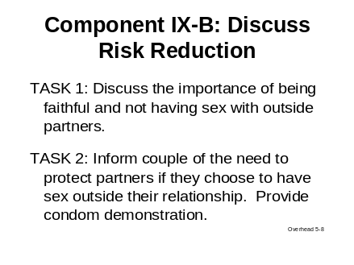

The discussion of HIV transmission to partners outside of the relationship should be handled diplomatically and in general terms.

Why should the counselor talk about outside partners?

Listen for:

- Because discordance is possible, outside partners could be HIV-negative.
- Outside partners could have STIs that would make the couple sicker.
- Individuals in a couple are HIV-positive and need to use condoms with outside partners.

Acknowledge responses.

The counselor should explain that condoms must be used with any partners outside the relationship because condoms both protect the couple from other STIs that could make them sick and protect other partners from HIV.

Task 1: Discuss the importance of being faithful and not having sex with outside partners
The counselor’s objective is to reinforce the importance of being faithful to protect the partners from getting other infections that could make their HIV disease worse.

Task 2: Inform couple of the need to protect partners if they choose to have sex outside their relationship. Provide condom demonstration.
The counselor’s objective is to reinforce the importance of encouraging other sex partners to go for HIV testing and of using condoms with any outside partners.

Again, the best way for the partners to protect their health is to be faithful to each other. But if either partner chooses to have sex outside the relationship, they must ALWAYS USE A CONDOM so that they do not give HIV to others and do not get any infections that could make them sicker.

Allow a moment for participants to look over the material you just covered. Answer any questions they may have.

Please take a moment to review the background information, tasks, and objectives for Component IX-B in your manuals.

Next we have a values clarification exercise.

Values Clarification Exercise
The goal of this exercise is to show the participants that each person has values and opinions about HIV-related issues. Also, counselors need to remain neutral during the counseling session and not let their values influence the discussion.

The room should be arranged so that the signs, “AGREE,” “DISAGREE,” and “MIDDLE OF THE ROAD,” are hanging on different sides of the room. Distribute the handout titled Values Clarification Exercise. Ask participants to complete the short handout but NOT to write their names on the handout. Then collect and redistribute the handouts so that each participant receives an unknown person’s responses. Introduce the exercise. Then read the first statement that appears on the handout. Ask participants to move and stand by the sign that corresponds with the response on the handout that they have been given. Allow a few minutes for each group to discuss an argument to defend the response that is on the handout they have been given. Then ask volunteers from each group to explain why they agree, disagree, or are in the middle of the road with the statement. This may not be what that person really believes; instead, it represents an argument for that position. Each group should have no more than 4 or 5 minutes for their response. Facilitate a short discussion about each position before moving on to the next question.

As facilitator of the exercise, you should not choose a side. It’s important for the safety of the exercise that you remain neutral. However, if at some point there are no participants to represent one of the viewpoints, you may stand in. If a response is not marked on someone’s handout, have that person join the group in the middle of the road.

Distribute the Handout: Values Clarification Exercise.

We are now going to do an exercise to help us understand and explore how we feel about several HIV-related issues. I am distributing a handout. Read the statements listed and circle your view on the issue—agree, disagree, or middle of the road. Please circle the response that describes your honest feelings about each statement listed in the handout. Please do NOT write your name on this handout because when you are done, I am going to collect the handouts and then randomly redistribute them. By not writing your names, your personal responses will be kept private during the exercise.

Allow some time for participants to circle their responses. Then collect and redistribute the handout.

If you happen to receive your own handout, please keep this to yourself.

Take a moment to look at the responses for each question on the handout you have been given. Think about possible reasons for feeling that way, even if it is not your personal view.

Now I am going to read the first statement, and I want you to gather by the sign that matches the response on your handout. Please act as though what is written on the sheet of paper that I’ve given you is your stance, even if it is not how you really feel. In this exercise, there are no right or wrong answers.

Read the first statement. Ask participants to go to the sign that represents the response on the handout they were given.

- Couples who test HIV-positive should not become pregnant and have children.

Allow each group no more than 3 minutes to defend their response to the statement. Facilitate a short discussion among participants about the responses.

Now each group should discuss its stance and choose a spokesperson to share and explain why that group agrees or disagrees with the statement. For those standing “in the middle of the road,” listen to both sides of each issue and think about why you remain neutral.

Let’s hear from those who agree. Why might someone agree with this statement?

Let’s hear from those who disagree. Why might someone disagree with this statement?

Now, let’s hear from those in the middle. Why did you remain neutral?

Move on to the next statement. Use the same format for discussion.

- ARV treatment should be withheld from patients who do not take their medicine like the doctors tell them.

Move on to the third and final statement. Use the same format for discussion.

- Pregnant women infected with HIV should be required to take ARVs to reduce the risk of transmission to their infants.

In debriefing the exercise, be sure to highlight the importance of CHCT counselors remaining neutral and practicing self-awareness.

This exercise was designed to help you as counselors understand your values about certain issues relating to HIV. We also wanted all of you to explore different points of view.

This exercise shows we all have opinions and values, but it is important for counselors to remain neutral. We need to remember to be self-aware and not to let our personal opinions impact the CHCT session.

As we move on to review family planning and PMTCT treatment options, remember the importance of counselor self-awareness of any biases about the reproductive options and decisions of HIV-infected couples. Counselors must be sure to give the couple the facts and not convey their personal biases.

Before we move on, are there any questions or comments about this exercise?

Component X-B: Discuss Children, Family Planning, and PMTCT Options

When both partners are infected with HIV, a number of issues related to the couple’s family planning and reproductive choices and decisions will need to be addressed.

In terms of public health, the objective is to prevent unintended pregnancies and to reduce the risk of HIV transmission to infants born to infected mothers. The most effective way to prevent HIV transmission to an infant is for the couple not to have additional children and to have protected sex only. However, in terms of human rights, the couple should be supported to make informed reproductive choices and then their choices should be respected.

The counselor should always approach the couple’s issues with a full understanding of their own self-awareness issues. This includes the self-awareness issues we discussed on the first day of this training and the issues we discussed during the values clarification exercise.

Will someone describe how a counselor with self-awareness can better assist in counseling couples?
Self-Awareness Review

Acknowledge responses.

This question is designed to help participants remember the couple counseling skills—particularly self-awareness—that were addressed in Module Two. You may want to display Overheads 2-2 and 2-3 as a reminder.

Responses should include:

- Self-awareness reduces the potential for the counselor to bias the couple’s decisions.
- Self-awareness helps the counselor understand that he or she is not responsible for the couple’s decisions or the couple’s relationship.

As we go through the tasks and objectives in this component, remember that children, family planning, and PMTCT may not be addressed in depth. The counselor should aim at least to address the essential information and to provide appropriate referrals.
Discussing Children, Family Planning, and PMTCT

If the couple is interested and time permits, the counselor can discuss their choices more fully.

When discussing family planning and reproductive health issues with the couple, the counselor’s aim is to make sure that the couple understands PMTCT, has access to family planning services, and understands the importance of accessing PMTCT services if the woman is pregnant or if the couple conceives in the future.

Display Overhead 5-9.

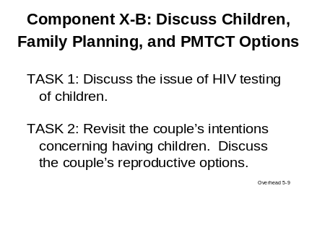

Task 1: Discuss the issue of HIV testing of children
Because both partners are HIV-positive, there is a possibility that young children may have become HIV infected through their mother. The counselor should encourage the couple to bring their children for HIV testing so that, if the children are positive, they can get the care and treatment they need.

Task 2: Revisit the couple’s intentions concerning having children. Discuss the couple’s reproductive options.
The counselor will have two objectives. The first is to review the couple’s reproductive intentions in light of their HIV test results.

The counselor’s second objective is to address options for limiting the risk of mother-to-child-transmission of HIV while respecting the couple’s reproductive choices.

Options that should be discussed include:

- Choosing not to have additional children
- Preventing unintended pregnancies
- Using dual contraception: using condoms and one other method to prevent pregnancy
- Accessing PMTCT antenatal services

For each of these options, the counselor should be prepared to provide referrals.

In your community, what outside factors may influence a couple’s decision to have children?

Responses may include:

- Having children is highly valued by society.
- Extended family may play an important role in influencing a couple’s decision to have children.

Acknowledge responses and discuss the reality of family planning pressures.

Display Overhead 5-10.

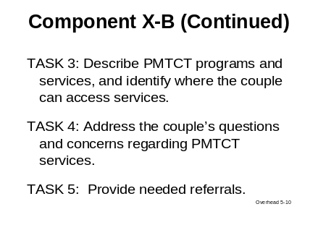

Task 3: Describe PMTCT programs and services and identify where the couple can access services
The counselor should identify where the couple can obtain PMTCT services, such as antenatal care (ANC) facilities. Any HIV positive pregnant woman must be referred to ANC and PMTCT.

Task 4: Address the couple’s questions and concerns regarding PMTCT services
The counselor’s objective is to identify the couple’s reservations, myths, or misconceptions about PMTCT services.

Counselors should have a general understanding of how to prevent mother-to-child transmission of HIV. This is especially important when counseling couples in which the woman is currently pregnant.

HIV can be transmitted from mother to child during pregnancy, during labor and delivery, or while breastfeeding. However, PMTCT interventions can greatly reduce this risk.

Display Overhead 5-11.

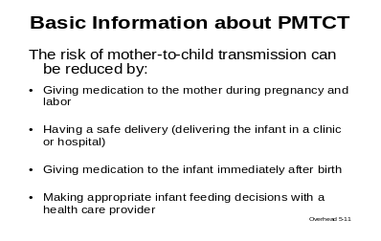

The risk of mother-to-child transmission can be reduced by:

- Giving medication to the mother during pregnancy and labor
- Having a safe delivery (delivering the infant in a clinic or hospital)
- Giving medication to the infant immediately after birth
- Making appropriate infant feeding decisions with the assistance of a health care provider

Task 5: Provide needed referrals
The last task is to link the couple to locally accessible family planning and PMTCT services.

Counselors should be prepared to cover the family planning and reproductive health issues we have discussed. However, sometimes couples may not be ready to address these issues fully, as they have just learned their test results and there are many things to discuss during the post-test session.

What should you do if during the CHCT session the couple is not prepared to discuss family planning and prevention of mother-to-child transmission of HIV issues?

Acknowledge responses and facilitate brief discussion.

Listen for:

- Counselor should cover the essential information.
- Counselor should refer any pregnant woman who is HIV positive to ANC and PMTCT.
- Counselor should provide referrals to family planning and PMTCT programs that are available to the couple.
      - Counselor should provide printed information (if available and appropriate).

Even if the couple is not ready to address these issues fully, it is important for the counselor to convey the essential information and then to make appropriate referrals for follow-up.

When addressing family planning and reproductive health options with concordant positive and discordant couples, it is important for the counselor to remember what we discussed during the values clarification exercise. Counselors must remain self-aware when helping couples with family planning and PMTCT issues. Any pregnant woman who is HIV-positive must be referred to ANC and PMTCT services.

Are there any questions about this material?

Allow a moment for participants to look over the material you just covered. Note that Universal PMTCT Messages can also be found at the end of the handout section in this module.

Answer any questions they may have.

Please take a moment to review the background information, tasks, and objectives for Component X-B in your manuals. Also, please quickly review Basic and Universal PMTCT Messages found after Component X-B in your manual. Note that the page titled Universal PMTCT Messages contains a website link to the Testing and Counseling for PMTCT Support Tool Package developed by International Agencies (i.e., CDC, WHO, UNICEF, USAID, and OGAC) for additional information.

Next we will take a one-hour lunch break. When we return from lunch, we will review Component XI: Discuss Disclosure and Getting Support, including a review of the benefits and considerations of disclosing to children. Then we will have a chance to practice providing concordant positive results in a role play exercise.

Confirm with participants the time they should return from lunch.
Lunch Break

Please return by (state time).

Disclosure Benefits and Basics
Have three blank newsprints prepared. They should be titled Potential Benefits of Disclosure to the HIV-Infected Person, Potential Benefits of Disclosure to Sex Partners, and Potential Benefits of Disclosure to Family and Community.

Show blank newsprint entitled Potential Benefits of Disclosure to the HIV-Infected Person. Ask participants to name all the benefits of disclosure they can think of for the HIV-infected person. List them on the newsprint.

Then show the next newsprint, Potential Benefits of Disclosure to Sex Partners. Again, ask participants to brainstorm and name the benefits they can think of for the sex partner or partners, and write their responses.

Show the final newsprint entitled Potential Benefits of Disclosure to Family and Community. Ask participants to list benefits of disclosing HIV status to family and community. Write their comments on newsprint.

Post the newsprints around the room.

Begin by displaying the first newsprint.

Potential Benefits of Disclosure for the HIV-Infected Person

List responses here.

Before we continue with our review of Component XI-B: Discuss Disclosure and Getting Support, let’s talk more about potential benefits of disclosing one’s HIV status.

What benefits of disclosure can you think of for the HIV-infected person?

List responses.

Show the next newsprint.

Potential Benefits of Disclosure to Sex Partners

List responses here.

Now think about the potential benefits of disclosure for sex partners. What benefits can you think of?

List answers.

Show final newsprint.

Potential Benefits of Disclosure to Family and Community

List responses here.

Finally, consider the benefits of disclosure for one’s family and community. What benefits can you think of?

List responses and thank participants.

Thank you for your comments. Your lists include benefits that counselors should help their clients to identify.

Turn to your manuals. Let’s take another look at the potential benefits of disclosure.

As you continue to go through the benefits, be sure to highlight responses from the group that match the responses in their manuals.

Benefits of disclosure for the HIV-infected person:

- May build a network of social and emotional support. This helps reduce the sense of isolation and anxiety.
- May enhance opportunities for those with HIV to receive support in obtaining proper medical care and treatment.
- Disclosure helps HIV-infected individuals take medication properly by:
- Allowing the individual to take medication openly
- Allowing the individual to acknowledge HIV status
- Allowing the individual to receive support during treatment

Benefits of disclosure for outside sex partner or partners:

- Allows sex partner or partners to know of exposure risk.
- Allows sex partner or partners to seek testing and to reduce the likelihood of acquiring or transmitting HIV.
- Enhances the ability of the sex partner or partners to understand and support behavior changes needed to reduce risk.

Benefits of disclosure for family and community:

- Disclosure helps infected individuals, couples, and families prepare for the future.
- It gives an opportunity to address children’s fears and anxieties.
- It provides a role model to friends, families, and the community.
- It allows health care providers to take appropriate precautions.

The potential benefits of knowing and disclosing one’s HIV status include those you came up with and those listed in your manuals.

Are there any possible downsides of disclosing results?

Acknowledge responses.

As you finalize this section, remind participants that while there may be potential downsides of disclosure (e.g. being discriminated against at work) there are also many benefits of disclosure.

Component XI-B: Discuss Disclosure and Getting Support

Try to bring points from the previous exercise into the discussion of Component XI-B: Discuss Disclosure and Getting Support.
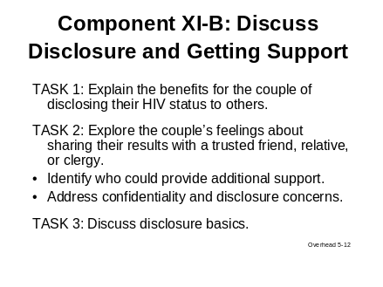

Task 1: Explain the benefits for the couple to disclose their HIV status to others
The counselor’s role is to help the couple to understand how disclosing their HIV test results to trusted friends or relatives can help them to receive additional support that they will need both individually and as a couple.

Task 2: Explore the couple’s feelings about sharing their results with a trusted friend, relative, or clergy
The counselor’s objective is to assess the couple’s level of comfort about disclosing their test results to someone within their family or social network in order to receive additional support.
- Identify who could provide additional support.
- Address confidentiality and disclosure concerns.

Task 3: Discuss disclosure basics
The counselor’s role is to provide the couple with disclosure basics to help them mentally frame how they will disclose.
As counselors, it is important to remember that disclosure to people and partners outside of the couple relationship is an issue that must be approached with sensitivity. Therefore, there are some disclosure basics I want to review with you.

Disclosure Basics

Display Overhead 5-13.
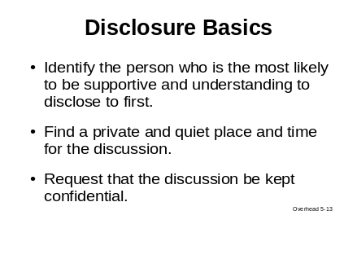

- Identify the person who is the most likely to be supportive and understanding to disclose to first.
- Find a private and quiet place and time for the discussion.
- Request that the discussion be kept confidential.

Display Overhead 5-14.

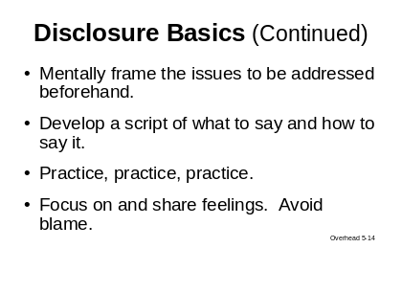

- Mentally frame the issues to be addressed beforehand.
- Develop a script of what to say and how and when to say it.

- Practice
  - Anticipate both supportive and non-supportive responses and how the responses may make the couple feel
  - Imagine possible counter-responses

It’s important for the couple to think carefully about, mentally frame, and practice how they will approach disclosing their HIV status and related issues.

- Focus on and share feelings. Avoid blame.

Display Overhead 5-15.

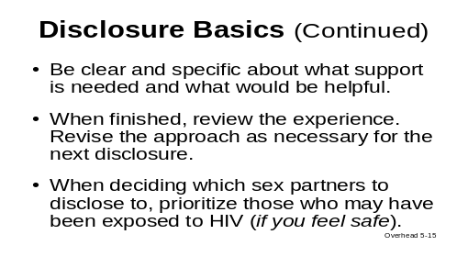

- Be clear and specific about what support is needed and what would be helpful.
- When finished, review the experience. Revise the approach as necessary for disclosure to the next person.
- When deciding which outside sex partners to disclose to, prioritize those who may have been exposed to HIV (disclose your HIV status if you feel it is safe to do so).

Once couples and individuals decide to disclose and to whom they want to disclose, practicing the disclosure is a useful way to develop strategies to make the process easier.

Now let’s go over some information on the benefits of and considerations for disclosing to children. This information is for your general knowledge as a counselor in case the couple would like to discuss these issues. This material can be found on page __ in your manuals.
Disclosing to Children: Benefits and Considerations

Display Overhead 5-16.

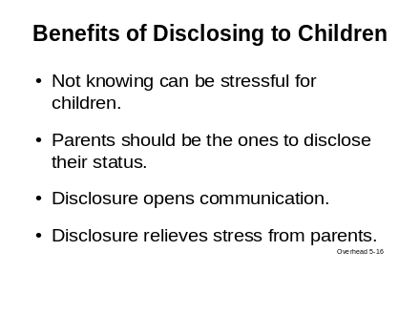

Parental disclosure to children: benefits of disclosure

- Not knowing can be stressful for children.
  - Children can be highly perceptive. Children (especially older ones) often know something is wrong even if the parent has not disclosed.
  - Parents can relieve the stress of uncertainty as well as communicate trust and openness by talking about their status.

    - Parents should be the ones to disclose their status. It’s best for children to learn about their parents’ HIV status from the parents themselves.
    - Disclosure opens communication between the parents and children and allows the parents to address the children’s fears and misperceptions.
    - Disclosure lowers parents’ stress.

    - Parents who have shared their HIV status with their children tend to experience less depression than those who do not.

Display Overhead 5-17.

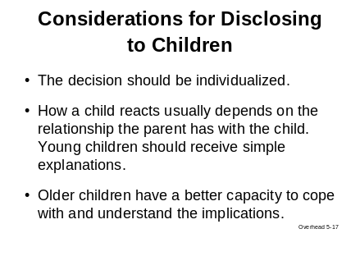

- The decision to tell a child that a parent or parents are HIV-infected should be individualized to the child’s age, maturity, family dynamics, social circumstances, and health status of the parent.
- How a child reacts to learning one parent or both parents have HIV usually depends on the relationship the parents have with the child.
- Young children should receive simple explanations about what to expect with their parent’s HIV status. The focus should be on the immediate future and addressing fears and misperceptions.
- Older children have a better capacity to cope with their parent’s status and to understand the implications of being HIV-positive.

Display Overhead 5-18.

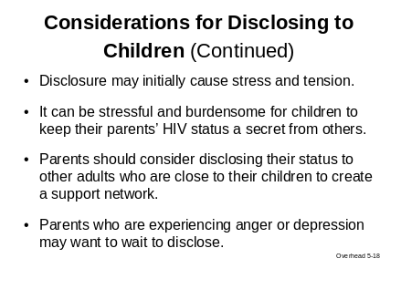

- It is possible that in some cases, disclosure may initially cause stress and tension. Parents should anticipate that their children might need time to adjust to and accept their parents’ HIV status.
- It can be stressful and burdensome for children when a parent discloses his or her HIV status and then requires them to keep it a secret from others.
- Parents should consider disclosing their status to other adults who are close to their children. This can create a support network of adults who can help the children cope with and process their feelings.
- Parents who are experiencing intense feelings of anger or severe depression about their HIV infection may want to wait to disclose to their children until after they have learned to cope with their status.

(Sources: American Academy of Pediatrics 1999, Armistead 1997, Armistead 1995, Lee 2002, Wiener 1998)

HIV-affected children and families need ongoing support beyond disclosure for coping with HIV and planning for the future. This is addressed in more detail in Module Seven: Support Services.

What questions or comments do you have?

Let’s continue with Tasks 4, 5, and 6.

Display Overhead 5-19.
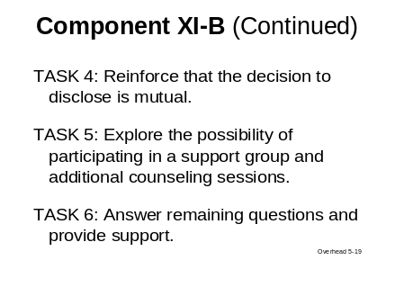

Task 4: Reinforce that the decision to disclose is mutual
The counselor should ensure that both partners are comfortable with the decision to share their results and with the person or people with whom they intend to confide their test results.

Task 5: Explore the possibility of participating in a support group and additional counseling sessions
The counselor should determine if the couple would be receptive to accessing other support resources. Specify the types of support that would be acceptable to the couple.

Task 6: Answer remaining questions and provide support
The counselor should bring closure to the session and provide appropriate reassurance and encouragement.

Take a moment to read over these tasks in your manuals.

Are there any questions?

Review Counseling Skills

Display Overheads 5-20 through 5-23.

Before we divide into small groups to do a role play, let’s quickly review essential counselor skills for effectively delivering services.

Quickly display overheads 5-20 through 5-23 and review essential counselor skills for effectively delivering CHCT services.

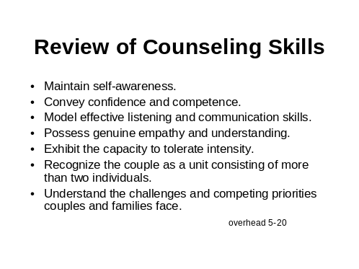

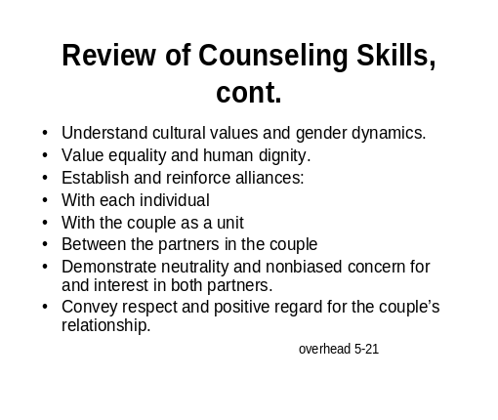

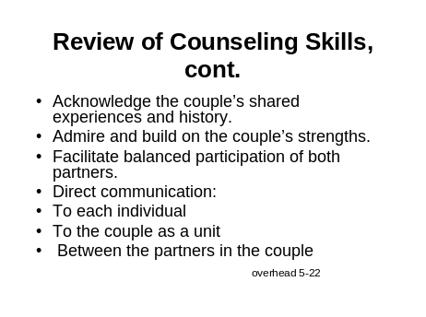

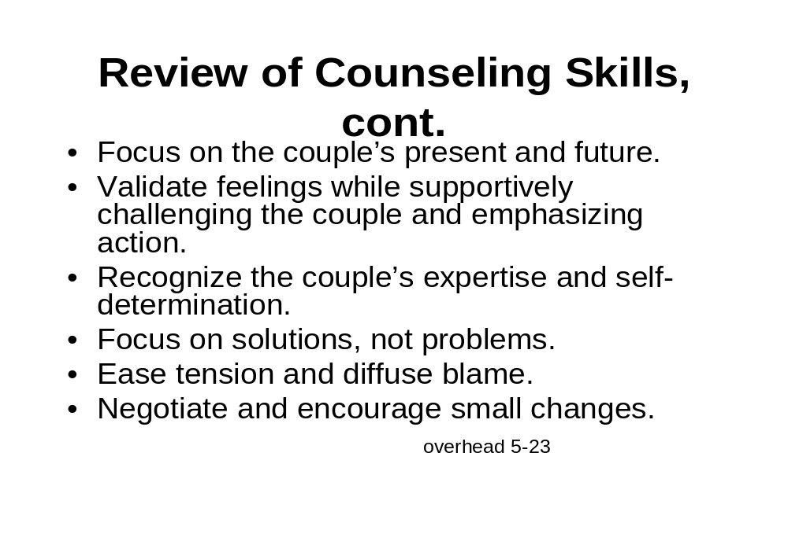

These counselor skills can be found in your manuals.
To maintain the quality of your future sessions, please refer to these skills to guide you as you deliver CHCT services.

Are there any comments before we move on to the role play?

Role Play: Post-Test Session, Concordant Positive Couple
In preparation for this role play, divide the participants into groups of three according to the Participant Coding Sheet. Be sure to identify clearly who will play the counselor and who will play the couple.

Distribute the background descriptions for each role, including the script for the counselor. Let the groups know that they will have 20 minutes for the pre-test initial session counseling. The groups will have 25 minutes for the second session of post-test counseling. After the role play is over, small groups will have 8 minutes to debrief. Keep track of time throughout the role play and give the groups updates of how much time is left.

Introduce the role play.

I will divide you into groups of threes for this role play.

- As before, the individuals in the couple will receive character descriptions to follow, and the counselor should follow the script.
- Each group will start the role play from the beginning of a CHCT session.
- You will have 20 minutes for the initial session, which is the counseling that takes place before the rapid HIV test.

I will help you keep track of time.

- You will have 25 minutes for the second session—the counseling that takes place after the HIV test has been performed.
- The counselor will provide the couple with the test results and proceed with Components V through XI.
- After you are finished with the role play, you will have 8 minutes to debrief in your small groups.

Are there any questions so far?

Divide the participants into groups of threes. Designate each group a place in the room.

Distribute the background descriptions to those playing the couple. Ask that they each read only their sheet. Distribute scripts to the counselors.

Give the counselors some time to review the components and objectives for this role play, and allow those in the couple to think about their characters.

You will have 45 minutes to conduct this role play.

Counselors should remember to meet the objectives in all of the components for conducting the initial session of a CHCT session and for the second session when providing concordant positive results. As counselors cover the essential information and provide referrals to family planning and PMTCT programs, please assume that all programs are accessible to your couple.

Are there any questions before we begin?

I will call time in 20 minutes, at which point the counselors should wrap up the initial session. Then you will have 25 minutes for the second session when the couple receives their concordant positive results. Please begin.

During the role play, the trainer should walk around the room and check in with the groups as they conduct the role plays. Answer questions and make sure the groups are staying on track.

Time is up. For the next 8 minutes, please provide feedback to your counselors in your small groups. Feedback should be from the client’s viewpoint on how effective your couple counselor was in providing your concordant positive result. I will call time after 8 minutes, and we will take a 20-minute break before returning to process this role play all together.

Let participants know that they can take a 20-minute break. Be sure to let them know what time to return to process the role play. Allow participants to remain in their groups if they choose to continue their discussion during break time.
Afternoon Break

Processing the Role Play

Welcome the participants back from break, and ask all participants to reconvene as one large group.

As you facilitate the processing of the role play, stress that couple counselors need to gauge how much they were able to get into each of the intervention topics based on how the couple responded or reacted to receiving a concordant positive result. What topics were important to them at that time, and what topics are most important to discuss?

Facilitate a group discussion by asking the following questions.

Questions for the counselors:

- How did you feel when providing the couple with a summary of their results, stating that their test results were HIV-positive and that this indicated that both of them were infected with HIV?
- How easy was it to transition away from addressing the couple’s feelings and emotions toward clinical care, treatment, and preventive services required to manage HIV infection?
- How challenging was it to address disclosure and risk reduction issues?

Questions for the couple:

- How did the counselor’s demeanor affect receiving a positive result?
- Did your counselor cover essential information and provide referral to family planning and other appropriate programs for a couple in your situation?
- Was the discussion of risk transmission to partners outside of the relationship handled diplomatically and in general terms?
- Did you leave your session fully understanding the value and importance of accessing appropriate care? If so, what was good about your counselor’s approach? If not, what could have been done differently?

Finish by summarizing the discussion and thanking participants for their input. When the discussion is over, distribute all the handouts from the role play to the participants. This includes the scripts for the concordant positive session and the character descriptions.

Wrap-Up
Tomorrow we will review the protocol for providing discordant results and related issues.

Thank the participants for their work and energy. Remind them what time you will be starting tomorrow.

References

American Academy of Pediatrics Committee on Pediatric AIDS. Disclosure of illness status to children and adolescents with HIV infection. Pediatrics 1999; 103(1):164-166.
Armistead L, Forehand R. For whom the bell tolls: parenting decisions and challenges faced by mothers who are HIV seropositive. Clinical Psychology: Science and Practice 1995; 2(3):239-250.
Armistead L, Klein K, Forehand R, Wierson M. Disclosure of parental HIV infection to children in the families of men with hemophilia: description, outcomes, and the role of family processes. Journal of Family Psychology 1997; 11(1):49-61.
Lee MB, Rotheram-Borus MJ. Parents’ disclosure of HIV to their children. AIDS 2002; 16(16):2201-2207.
Weiner LS, Battles HB, Hellman NE. Factors associated with parents’ decision to disclose their HIV diagnosis to their children. Child Welfare 1998; 77(2):115-135.
World Health Organization and Centers for Disease Control and Prevention. Prevention of mother-to-child transmission of HIV (PMTCT) training manual Atlanta, Georgia, 2004. WHO/CDC PMTCT training materials can be obtained at: http://www.cdc.gov/nchstp/od/gap/pmtct/

Handouts

Module Five: Providing Concordant Positive Results

Counselor’s Script: Providing Concordant Positive Results

Component V-B: Provide Concordant Positive Test Results

Task | Script
- Inform the couple that their results are available. | Your test results are now ready.
- Provide a simple summary of the couple’s results: both test results are positive, which indicates that both partners are infected with HIV. | Both of your test results are positive. This means that you both have HIV.
- Allow the couple time to absorb the meaning of the results. | Take your time. We have plenty of time to talk about these test results.
- Ask if the couple understands the results. | I want to be sure you understand the results. Do you understand these results?  What do these results mean to you?
- Encourage mutual support and diffuse blame. | HIV is common, and we do not know how long each of you has had HIV. I encourage you to deal with this together and to support each other.

Component VI-B: Discuss Coping and Mutual Support

Task |  | Script
- Invite both partners to express their feelings and concerns. |  | Could each of you tell me how you are feeling?  What questions do you have?
- Validate and normalize the couple’s feelings and acknowledge the challenges of dealing with a positive result. |  | These feelings are a normal part of hearing your positive HIV test results. I encourage you to focus on how best to support each other now rather than blame each other.  It can be stressful at first to hear that you have HIV. You will probably have many strong feelings about your status and each other. It is normal to feel upset or angry but also feel love and concern for your partner.  Many couples with HIV-positive results express similar feelings.  Let’s take this one step at a time.
- Ask how the partners can best support each other. |  | You came here today to deal with HIV as a couple. Now, how can you best support each other through this?
- Recall the couple’s strengths. Convey optimism that the couple will be able to cope and adjust to living with HIV. |  | You may need some time to adjust to this, but in time and with each other’s support, you will have a better chance of coping and continuing with your life together.  You have dealt before with difficult and rough times in your lives, and remembering this will help you get through this.
- Address the couple’s immediate concerns. |  | There is a lot we need to talk about. But first, do you have any questions?

Component VII-B: Discuss Positive Living and HIV Care and Treatment

Task | Script
- Discuss positive living. | Positive living means taking care of yourself in order to improve the quality of your life and to stay well longer.  There are many people who have HIV and are living well. There is hope for you and your family. You will need to take several steps, however, to stay healthy. I will give you information about the HIV clinic where you can go to get help.  Paying attention to your medical care is an important part of living positively. Let’s talk about this.
- Address the need for preventive health care.  - Encourage immediate visit to the HIV clinic | It is very important that you get medical care as soon as possible. You will need to go to a clinic that treats HIV. We will give you a referral letter to take with you when you seek care and treatment.  Effective treatment for HIV is becoming more available in our community, and you may be eligible for this treatment. You need to be evaluated to determine what the best treatment is for you.  The medical provider at the HIV clinic will examine you and do tests to determine what drugs, if any, you need at this time.
- Encourage the couple to access appropriate care and treatment services. | I encourage you both to get medical care as soon as possible. HIV care and treatment can keep you from getting sick and protect you from other illnesses. It will make a big difference in how you feel.
- Provide needed referrals to the HIV clinic and other services. Identify and problem-solve obstacles. | Here is a list of the HIV care and treatment services we have discussed and the locations where you can receive these services.  Do you have concerns about going to the HIV clinic?  Here is your referral letter to give to the clinic medical providers.
Component VIII-B: Discuss Things to Do at Home to Keep Healthy

Task |  |  | Script
- Discuss with the couple the need to live a healthy lifestyle. Discuss things that they can do right away to keep healthy. |  |  | In addition to seeking care at the clinic, there are several important things you need to do at home to keep healthy.
- Discuss the importance of having safe drinking water to prevent diarrhea. Inform the couple about where to get more information or obtain supplies. |  |  | To prevent diarrhea, you should boil drinking water or use a safe water vessel with [name of bleach solution] added to the vessel. Here is some information about keeping your drinking water supply safe for you.
- Discuss the importance of using bed nets to prevent malaria (when applicable). Inform couple about where to get more information or obtain supplies. |  |  | You should sleep under a bed net to keep mosquitoes from biting you at night. This will prevent malaria. Here is some information about where you can obtain a bed net.
- Discuss the importance of good nutrition. Inform couple about where to get more information. |  |  | Good nutrition is also very important. Here is some nutritional information (and if applicable, how to obtain food supplements).

Component IX-B: Discuss Risk Reduction

Task | Script
- Discuss the importance of being faithful and not having sex with outside partners. | Since you both have HIV, we need to talk about how you can protect each other from other illnesses.  You can best protect each other by having sex only with each other and not having sex with other partners. If you have sex with others, you can get other infections from them that can make you sick and could make your HIV disease worse. You could give these infections to your partner who could get sick as well.
- Inform couple of the need to protect partners if they choose to have sex outside their relationship. Provide condom demonstration. | In addition to making you and your partner sick, you could give HIV to these outside partners.  If either of you has sex with other partners, these partners should also be tested for HIV. Just because you are positive does not mean they are infected. I encourage you to refer any other partners to a clinic or VCT site for HIV testing.  Again, the most effective way to protect yourselves is to be faithful to each other. But if you choose to have sex outside your relationship, YOU MUST ALWAYS USE A CONDOM, so that you do not give HIV to others and so you do not get any infections from them that could make you sicker.  Now I will demonstrate for you how to use a condom correctly.

Component X-B: Discuss Children, Family Planning, and PMTCT Options

Task | Script
- Discuss the issue of HIV testing of children. | In addition to staying healthy for you and your family, there are things you need to do to be sure your children stay healthy.  If you have young children, they should be tested to see if they have HIV so they can also get the care they need. You need to have your children tested for HIV here or at a Maternal Child Heath (MCH) clinic.
- Revisit the couple’s intentions concerning having children.  Discuss the couple’s reproductive options. | You may be planning to have more children. You should know that HIV can be transmitted to your baby. Therefore, you should think about whether you still want to have more children now that you know you have HIV.  The most effective way to prevent transmission of HIV is to choose not to have additional children. There are many family planning methods that you can use to prevent pregnancy—condoms, pills, and injectables for example. Address the benefits and issues associated with the use of multiple contraceptive methods, such as condoms and oral contraceptives, to reduce the risk of unintended pregnancy and STD/HIV transmission. I will give you a referral to a family planning clinic before you leave today.  What are your thoughts about getting pregnant in the future?  How would you choose to prevent pregnancy if you decide not to have more children?

- Describe PMTCT programs and services and identify where the couple can access services.  - Any HIV positive pregnant woman must be referred to ANC and PMTCT | If you do get pregnant, it is important that you get care during your pregnancy because there are important steps you can take to decrease the chances of transmitting HIV to your baby. Currently, ___________________ (name of clinic) offers services to HIV-infected women who become pregnant.
- Address the couple’s questions and concerns regarding PMTCT services. | What questions do you have?
- Provide needed referrals.  Family planning  ANC clinics (if woman is pregnant)  MCH clinic (if woman has young children and/or if she is breastfeeding) | Here is a list of family planning clinics and clinics where you can get care during pregnancy.

Component XI-B: Discuss Disclosure and Getting Support

Task | Script
- Explain the benefits for the couple to disclose their HIV status to others. | As we have discussed, it is very important for you to support each other. However, there are a lot of issues to deal with. It may be helpful to have someone other than each other to give you support and help you make decisions.  Trusted friends or family can support you in dealing with HIV and can also help you get HIV care and treatment.
- Explore the couple’s feelings about sharing their results with a trusted friend, relative, or clergy.  - Identify who could provide additional support.  - Address confidentiality and disclosure concerns. | How do you feel about sharing your HIV test results with someone you trust?  Who do you feel could best support the two of you as you cope and adjust to living with HIV?  What concerns do you have about having someone know you have HIV?  I would like to hear from each of you about your feelings on this.
- Discuss disclosure basics. | After you identify someone with whom you would like to talk about your HIV status, think about what you would like to say to that person.  Think of a private place and time to talk, and ask them to keep the discussion confidential and not to tell anyone else. Sometimes it is helpful to practice what you would like to say ahead of time and imagine how this person will react.  Who do you think you might want to tell about your HIV status? How do you think you would like to tell this person? When would you talk with them? What would you say? How do you think he or she would react?  Let’s imagine I’m that person. Tell me about your results and I’ll respond.
- Reinforce that the decision to disclose is mutual. | As we discussed, your decisions about sharing your HIV results have to be made together.
- Explore the possibility of participating in a support group and additional counseling sessions. | There is also support available in the community. Would you be interested in talking with other couples in your situation?  Here is a list of post-test clubs, support groups for couples, and resources for additional counseling.
- Answer remaining questions and provide support.  Summarize. | We have talked about a lot today. Let’s review the important steps you need to take:  - Go to the HIV clinic and give the referral letter to the provider.  - Be sure to drink water that is safe.  - Be sure to eat healthy.  - Use a bed net to prevent malaria.  - Bring your children in for testing.  - Talk with each other about whether you want to use family planning methods.  - Protect yourselves and others by only having sex with each other.  - Wear condoms if you choose to have sex outside the relationship.  - Seek out support from friends, family, and support groups within your community.  Please share with me any remaining questions you may have.  It is a challenge to deal with having HIV. However, with time and mutual support, you will have a better chance of adjusting and living positively.

Values Clarification Exercise

- Couples who test HIV-positive should not become pregnant (i.e., have children).

Agree Middle of the Road Disagree

- ARVs should be withheld from non-compliant patients (i.e., patients not taking their medication according to doctor’s orders) in order to protect against the development of resistant strains of HIV.

Agree Middle of the Road Disagree

- Pregnant women infected with HIV should be required to take ARVs to minimize the risk of transmission to their infants.

Agree Middle of the Road Disagree

Handout 5-1
Role Play - Concordant Positive

Husband: Elias age 31, driver for an aid organization
Wife: Jane age 28, sells fruits, vegetables, and other staples at a roadside vending stand
Marriage: 5 years
Children: 5-year-old son, 2-year-old daughter

Jane and Elias are a very close couple and after years of hard work they feel like their life is going pretty well. Jane met Elias at a friend’s wedding. He was very charming and she liked him immediately. He seemed to be a good man. He had a good job and was building a house for his mother. Elias and Jane never talked in detail about their past relationships. Jane is aware that prior to the time they met, Elias drove a truck for another aid organization and delivered supplies to programs in various neighboring countries. He was away for weeks at a time and she imagines he may have met girls along the way. Elias knows that for a brief time Jane had a boyfriend who she was serious about but the relationship ended long before they met. Since they married they have built a nice home for their family. Elias’s mother lives close by and helps to take care of the children when Jane is working.

Elias and Jane are considering having another child. Elias, in particular, would like another son. The nurse midwife, a family friend, who delivered their youngest daughter, recommended to Jane that the couple receive CHCT service prior to adding another child to their family. Elias has a coworker who has been ill and Elias is concerned that this friend may have AIDS. Elias’ concern about his coworker has caused him to talk to Jane a little more about his worries about HIV. The youngest child of Elias and Jane has had some minor health problems and this has added to their worries. As a result, they decided to go together to receive couple HIV testing.

You are Elias:

Prior to his current position Elias delivered construction and food commodity supplies for another aid organization. He would be gone for several weeks at a time. This was a lonely time for Elias and he would sometimes go to the local bars in the evenings. Occasionally he would meet a girl and have sex with her. He would usually use condoms but not always. For awhile he had a steady girlfriend in the northern part of the country. He was fairly serious about her and thought they might marry. Initially he used condoms with this girl to prevent pregnancy but eventually they stopped. This relationship ended when the girl moved to the city to live with her sister to find a better job. Not long after that Elias met Jane and they later married. Elias is very happy with his life. He is dedicated to his wife and children. Elias feels that he and Jane have a strong bond and have worked together toward building a better future for their family. Although Elias is worried about going for an HIV test, he feels a bit reassured that his employer is scaling-up a program to provide access drugs to treat HIV as part of the employee health package. He doesn’t know a lot about these drugs but thinks they may offer some hope.

Handout 5-2
Role Play - Concordant Positive

Husband: Elias age 31, driver for an aid organization
Wife: Jane age 28, sells fruits, vegetables, and other staples at a roadside vending stand
Marriage: 5 years
Children: 5-year-old son, 2-year-old daughter

Jane and Elias are a very close couple and after years of hard work they feel like their life is going pretty well. Jane met Elias at a friend’s wedding. He was very charming and she liked him immediately. He seemed to be a good man. He had a good job and was building a house for his mother. Elias and Jane never talked in detail about their past relationships. Jane is aware that prior to the time they met, Elias drove a truck for another aid organization and delivered supplies to programs in various neighboring countries. He was away for weeks at a time and she imagines he may have met girls along the way. Elias knows that for a brief time Jane had a boyfriend who she was serious about but the relationship ended long before they met. Since they married they have built a nice home for their family. Elias’s mother lives close by and helps to take care of the children when Jane is working.

Elisa and Jane are considering having another child. Elias, in particular, would like another son. The nurse midwife, a family friend, who delivered their youngest daughter, recommended to Jane that the couple receive CHCT service prior to adding another child to their family. Elias has a coworker who has been ill and Elias is concerned that this friend may have AIDS. Elias’ concern about his coworker has caused him to talk to Jane a little more about his worries about HIV. The youngest child of Elias and Jane has had some minor health problems and this has added to their worries. As a result, they decided to go together to receive couple HIV testing.

You are Jane:

While in secondary school Jane had a boyfriend. This boy really pressured her to have sex with him. Jane only had sex with this boy twice. Later, Jane met a boy from her village and was involved with him for awhile. He ended their relationship when he got the opportunity to go away to a technical school for training. She was hurt and disappointed when this young man left. About a year later she met Elias and finally found the relationship she was looking for. Jane feels that she and Elias have a strong bond. Elias is a responsible and kind husband, a good father, and works hard to provide for the family.

Handout 5-3

Universal PMTCT Messages:

- HIV transmission from mother to child during pregnancy, labor, delivery, or breastfeeding is called vertical transmission, perinatal transmission, or mother-to-child HIV transmission (MTCT).

- Prevention of mother-to-child HIV transmission is called “PMTCT.”

- MTCT accounts for nearly 90% of the more than 600,000 estimated new HIV infections that occur in children worldwide each year.¹

- Without any intervention (antiretroviral [ARV] prophylaxis or treatment) up to 35-40% of infants born to mothers infected with HIV who breastfeed can become HIV-infected.^{2,3.}
- 5-10% transmission risk during pregnancy
- ~15% during labor and delivery
- ~ 15% during the breastfeeding period

- Research published in 1994 showed that zidovudine (ZDV or “AZT”) given to pregnant HIV-infected women reduced the risk of MTCT.⁴ Since then, the testing of women and provision of ARVs for those who are pregnant and HIV-positive have resulted in a dramatic decline in the number of children perinatally infected with HIV in developed countries.⁵

- Simple, effective interventions also make preventing MTCT in resource-limited settings an obtainable goal.^{2,6} Most countries are now supporting national PMTCT programs. The key PMTCT interventions include:
  - Provider-initiated routine opt-out testing and counseling in the context of pregnancy (e.g., during antenatal, labor and delivery, and immediate post-delivery periods) to enable women to learn their HIV status.
  - Short-course antiretroviral prophylaxis (ARVs), which can be given during pregnancy, during labor, and to the baby after birth to reduce the chance of transmission, and to improve the mother’s health.
  - Modified infant feeding practices, which could be either exclusive breastfeeding or replacement feeding but no mixed feeding.

- For individual women participating in PMTCT programs and receiving these interventions, the risk of transmission can be reduced to 10% or even as low as 5%, even in resource-limited countries.

- Further, new global initiatives to support ARV therapy and widespread prevention, care, and treatment programs have created important opportunities to support PMTCT; integrate PMTCT into maternal-child health programs; introduce more effective ARV interventions; and provide linkages to care and treatment for mothers, infants, and family members (“PMTCT-plus”).⁵

- The best way to manage HIV in pregnancy, and to prevent infants from getting HIV, is for all pregnant women to attend antenatal care as early as possible in pregnancy and to deliver in a health facility.
- Providers should routinely recommend HIV counseling and testing with same day results.
- Pregnant HIV-infected women who need treatment for their health as well as for PMTCT should receive highly active antiretroviral therapy (HAART).⁷

- Pregnant HIV-infected women who do not yet need treatment for their health should receive the most effective and accessible ARV prophylaxis regimen for PMTCT. The regimens for ARV prophylaxis recommended by WHO⁷ include:
- AZT from 28 weeks of pregnancy plus single dose NVP + 3TC at onset of labor, and AZT + 3TC for 1 week after delivery; and for the infant single dose NVP (SDNVP) soon after birth plus AZT for 7 days. This is the most effective regimen.
- Alternative prophylactic regimens include single dose Nevirapine (SDNVP) for both the mother at labor and the baby immediately after birth.
- Infants born to HIV-positive women who had not received any ARVs should be given single dose NVP at birth plus AZT for 4 weeks. SDNVP has the advantages of feasibility and cost as well as being accessible for women presenting late in pregnancy.⁸

- HIV-infected women, including those on HAART, should avoid breastfeeding only if replacement feeding is acceptable, feasible, affordable, sustainable, and safe. If not, HIV-positive mothers should exclusively breastfeed their baby for the first few months of life and there should be no mixed feeding (i.e. combining breast milk with bottle-feeding, water, or formula feeding).

- Women attending ANC should also be encouraged to bring their partner for HIV testing. All HIV-infected mothers, infant and family members should be referred to treatment, care and support services, to ensure care for the entire family.

References

1. UNAIDS 2006 Report on the Global AIDS Epidemic, The Joint United Nations Programme on HIV/AIDS, 2006.

2. De Cock KM, Fowler MG, Mercier E, de Vincenzi I, Saba J, Hoff E, et.al. Prevention of mother-to-child transmission of HIV-1 in resource poor countries: translating research into policy and practice. JAMA 2000; (283):1175-1182.

3. Nolan ML, Greenberg AE, Fowler MG. A Review of Clinical Trials to Prevent Mother-to-Child HIV-1 transmission in Africa and inform rational intervention strategies. AIDS 2002; 16(15):1991-1999.

4. Conner EM, Sperling RS, Gelber R, Kiseley P, Scott G, O’Sullivan MJ, et al. Reduction of maternal-infant transmission of human immunodeficiency virus type 1 with zidovudine treatment. N Eng J Med 1994; 331(18):1173-1180.

5. http://www.cdc.gov/hiv/resources/factsheets/perinatl.htm

6.http://www.cdc.gov/nchstp/od/gap/docs/program_areas/About%20Our%20Work_PMTCT.01.05.pdf

7. WHO/ What’s new in the PMTCT guidelines?
http://www.who.int/hiv/mediacentre/fs_2006guidelines_pmtct/en/

8. Marseille E, Kahn JG, Mmiro F, Guay P, Musoke P, Fowler M, et al. Cost effectiveness of a single dose nevirapine regimen to mother and infant to reduce vertical HIV transmission in sub-Saharan Africa. Lancet 1999; 354(9181):803-809.

Additional PMTCT Information

Testing and Counseling for PMTCT Support Tool Package can be obtained at:
http://www.womenchildrenhiv.org/wchiv?page=vc-10-00
Developed by the following international agencies: CDC, WHO, UNICEF, USAID, and OGAC

Handout 5-4

Overheads

Module Five: Providing Concordant Positive Results



