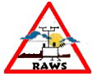
NCDFR Fire Staff Study
Remote Automated Weather Stations

Prepared by: Gary M. Curcio

Date: July 1993

- Assignment.

The assignment was to investigate the Division’s minimum needs for Remote Automated Weather Stations (RAWS).

- Assumptions.

In order to proceed with this assignment several assumptions were used:

- The acquisition of additional RAWS units would in effect create a RAWS network.
- The information or data obtained from this network would be equally important to the Forest Protection and the Forest Development Programs.
- Each District would require an individual review with recommendations integrated into a statewide network. During the review process the following points were considered wildfire occurrence (historical and present), forest management activities and unique local weather patterns and/or influences.
- National Weather Service (NWS) forecast zones were reviewed and the minimum standard of the least one RAWS unit per weather zone was adopted. This would facilitate better forecasting services and provide a reference check of the accuracy and reliability of zone and spot forecasting.
- RAWS site locations would be selected on the basis of program needs, the tracking of major weather movements across the state, the ability to secure the site, and its position of existing and accessible RAWS units (i.e., US Forest Service (USFS), US Fish and Wildlife (USFW) and Division of Forest Resources (NCFS).

- Facts relating to the Matter.

The NCFS currently owns and operates 6 RAWS units. Three are manufactured by Handar Inc., and are located in the Whiteville, Rockingham and Sylva Districts. Of special note the Sylva unit is subject to be moved. The USFS has agreed to replace this RAWS with one of their newly purchased units. The Division’s three other units are manufactured by Forest Technology Systems (FTS) and are located in the Lenoir, New Bern and Fairfield Districts. These stations are simple but high tech instrumentation, which requires annual preventative checks and refurbishment. These critical areas are often overlooked as a sustained requirement. The Handar units are currently under a maintenance agreement but the FTS units are not. Regardless of the manufacturer these automated stations require quarterly spot inspections. During these inspections cleaning, fuel bed refurbishment and minor preventative maintenance repairs are performed.

There are other agencies in NC that has weather requirements that are similarly to the NCFS. These include but are not limited the NWS, USFS, USFW and the NC Agricultural Research Farms (NCARF / State Climate Office). The present and projected capabilities of each agency are presented below.

IN-SERVICE STATIONS

AGENCY SYSTEM NAME PRESENT PROJECTED
NWS ASOS 7 29
AWOS 7 7
USFS RAWS 6 9
USFW RAWS 2 4
NCFS RAWS 6 ? (22)
NCARF WDAS 14 14

TOTAL 42 79

There was an initial attempt to organize the various agencies into an interagency group where cooperation and compatibility would be promoted. However, priorities, time, money and commitment have stalled any progress to this goal. Because of wildfire suppression and prescribe burning responsibilities, the USFS, USFW and NCFS can effectively network their stations. This is facilitated by computer and software capabilities (PC’s, WIMS and Fire Weather +) as well as weather collecting platforms (Handar and FTS). In NC these three natural resource agencies posses 14 stations with a growth potential to 35 stations.

Advancements are progressing across Region 8 and the nation as each state develops their respective RAWS networks and the NWS upgrades to NEXTRAD or Doppler Radar. These two advancements will greatly enhance forecasting predictability and accuracy. However, as important as weather is to natural resource agencies in NC, we as a group still lack year round NWS forecasting services. Of special note, computer hardware and software enhancements are planned during this fiscal year at the NWS.

- Discussion.

As we move to the future, resource managers require timely, accessible, local site specific weather readings. Their need is becoming increasingly important. Whether it is for wildfire suppression or prescribed burns, reliable and accurate readings are essential for making sound management decisions. The acquisition of 16 additional RAWS stations and their subsequent strategically placement would be the core ingredient towards the creation of a minimal statewide interagency RAWS network. Region II would acquire 8 units, while Region I and III would acquire 5 and 3 units respectively.

This RAWS network is certainly feasible and its expense can certainly be justified. This is presuming that field personnel (District and Counties) and the NWS initiate proper and maximum utilization. When making professional decisions ease of access and timely access to RAWS date are essential. The way business is conducted by the NCFS field units; the Handar units are the user-friendliest stations available, while FTS units require a more extensive communication link to use the system. (i.e., PC’s software package, telephone modem, and NCFS radio communications). This type of communication link has a one-time cost of $3,500.

At the present RAWS stations are being under utilized. This can be attributed to the following reasons:

- The initial learning curve that accompanied Handar Stations created a negative image for RAWS.
- The inability of the field units to easily access the FTS stations is an inherent hindrance.
- The decreased fire activity and the chaotic state of NFDRS have diminished the observed need for reliable weather.
- NWS forecasts have been on occasions less than true and the forecasts are seasonal not year round.
- And the non-use of the stations for prescribed burning activities.

- Conclusion.

The Division of Forest Resources will benefit from a RAWS network. It’s installation, use and, maintenance is all key ingredients for this initiative’s success.

- Recommendations.

It is recommended that the Division start the process to create this network. Upon acceptance of the proposed county locations (review exhibits), purchasing needs to be stared immediately as funds become available. Districts already possessing stations need to be informed on how field personnel (District and County) can use the RAWS data. This would integrate the uses for Forest Protection and the Forest Management’s Programs, and may serve to eliminate most reasons for under utilization of RAWS. The cost for the proposed RAWS network is estimated at (1999 fiscal prices $13,500 per station) . The cost is basically the same whether considering a Handar or FTS station network. A cost, which is not to be overlooked, is the annual preventative cost for 22 stations. The cost is estimate at (1999 fiscal price $625 per station).

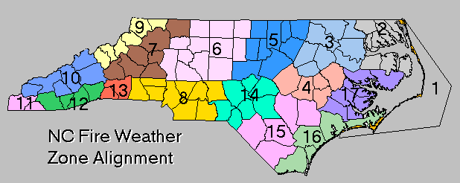EXHIBIT 1 NATIONAL WEATHER SERVICE FORECAST ZONES

EXHIBIT 2 STATE CLIMATE OFFICE WEATHER STATIONS

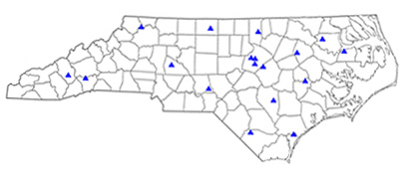

EXHIBIT 3 NCFS PROPOSED RAWS ACQUISITIONS & THEIR SITE
LOCATIONS



