Regional Residential Heating Oil Model
Draft April 13, 2005

Table of Contents

1. Overview of Regional Residential Heating Oil Model 2
2. Data Sources 4
3. Residential Heating Oil Demand 5
A. Introduction 5
B. Regional Demand Equations 7
1. Residential Heating Oil Price 7
2. Weather 8
3. Number of Homes with Heating Oil for Space Heating 11
4. Dummy Variables 14
4. Heating Oil Prices 15
A. Introduction 15
B. Distillate Wholesale Price 16
1. Crude Oil Price Change 16
2. Inventories 17
3. Total U.S. Distillate Demand 17
5. Dummy Variables 17
C. Residential Heating Oil Prices Before State Taxes 19
1. Wholesale Distillate Price Change 19
2. Weather 20
3. Inventories 20
4. Dummy Variables 21
D. Residential Heating Oil Prices After State Taxes 22
5. Inventories 24
A. Introduction 24
B. Regional Inventory Equations 24
1. Distillate to Crude Oil Price Differential 25
2. Beginning Stocks 25
3. Weather 25
4. Dummy Variables 26
Appendix A. Detailed Tables 27
Appendix B. Variable Definitions 33
Appendix C. EViews Model Program File 36
Appendix D. Regression Results 37
Appendix D. Regression Results 37

1. Overview of Regional Residential Heating Oil Model

Distillate fuel oil is consumed in several different sectors, including on-highway transportation, residential, commercial, industrial, and agricultural (Figure 1). Other applications include off-highway diesel, railroad, vessel bunkering, electric power, and oil company use.

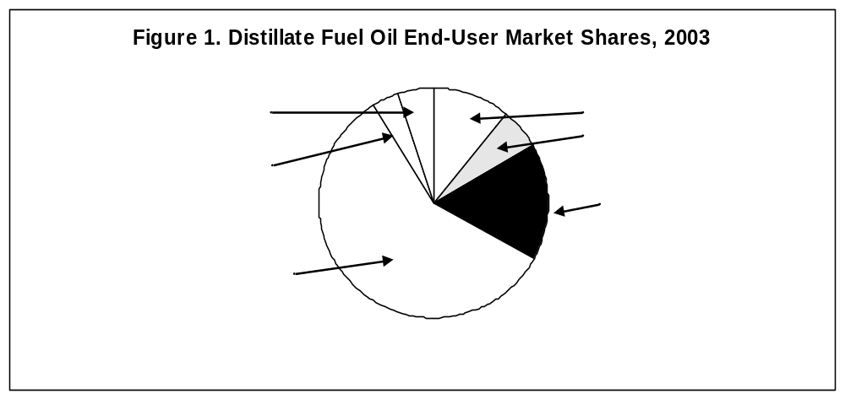

Distillate fuel oil is a general classification for one of the petroleum fractions produced in crude oil distillation operations. First, distillate fuel is classified as No. 1, No. 2, or No. 4 fuel oil where the higher number denotes a heavier or more viscous liquid. Heating oil used in the residential sector is primarily No. 2 distillate fuel oil (about 1.5 percent is No. 1 fuel oil). Second, distillate fuel is classified as diesel fuel or fuel oil. The most significant distinction between diesel fuel and fuel oil is that diesel fuel has a maximum allowed sulfur level of 500 parts per million or lower while fuel oil has a 5,000 parts per million maximum. Consequently, diesel fuel can be used as fuel oil but fuel oil generally cannot be used as diesel fuel. Heating oil used in the residential sector is fuel oil that has the higher sulfur limit.

Heating oil ranks as the third most important source of residential energy in the Nation, with nearly 8 percent of all households using heating oil as their primary space heating fuel (Energy Information Administration, 2001 Residential Energy Consumption Survey, Table HC1-9a). Heating oil is also used by households for water heating.

The objective of the regional short-term residential heating oil model is to generate residential price forecasts for the four census districts: Northeast, South, Midwest, and West (see Appendix A1 for map). Regional residential heating oil prices are estimated as a function of the wholesale distillate fuel price, regional stocks, and weather (Figure 2). Regional residential heating oil prices are then aggregated to the U.S. level by weighting regional prices by estimated regional demands.

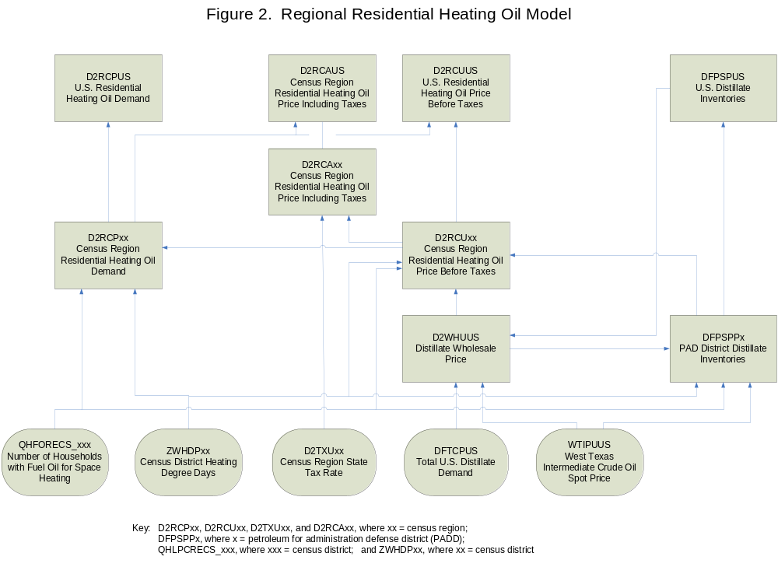

2. Data Sources

The monthly volume and price data used in the regional heating oil model appear in two EIA publications: the Petroleum Supply Monthly (PSM) and Petroleum Marketing Monthly (PMM) (Figure 3). Weekly regional inventory data published in the Weekly Petroleum Status Report (WPSR) are used for the most recent two months where monthly data is not yet available. A monthly time series of the number of homes with heating oil as the main space heating fuel is derived by linear interpolation from the quadrennial Residential Energy Consumption Survey (RECS).

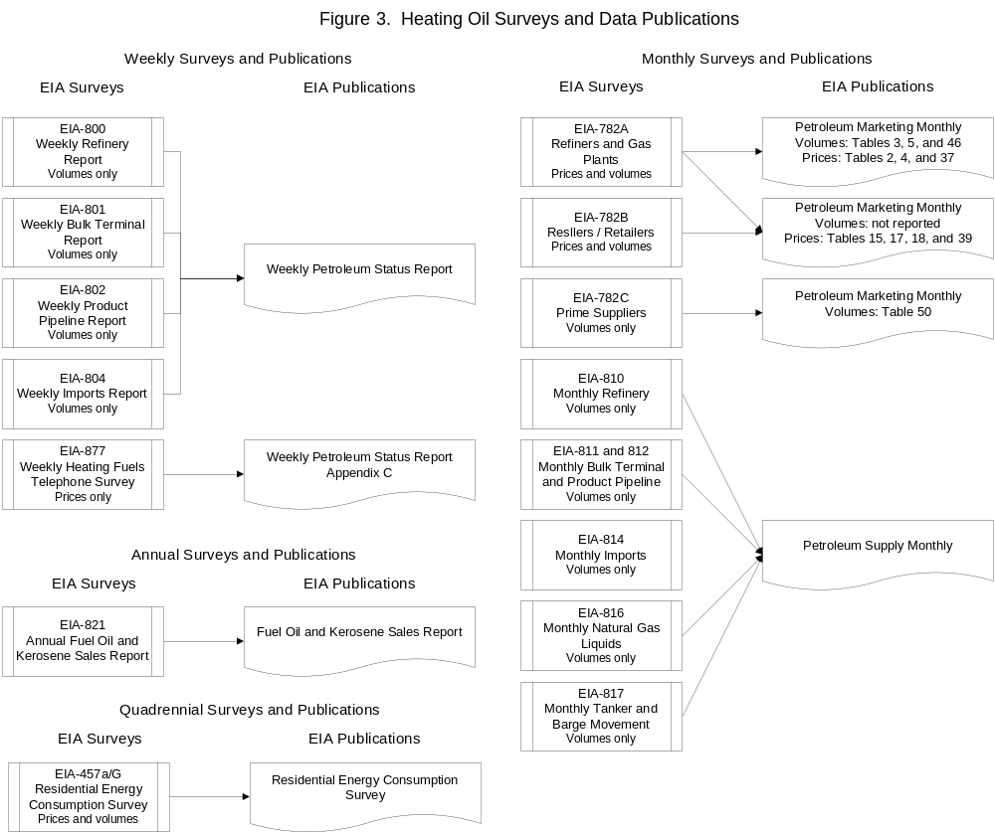

The PSM includes volume data from surveys of primary suppliers such as refineries, pipelines, and bulk terminals. The PMM includes volume and price data from the primary suppliers as well as other wholesale and retail suppliers. Because PSM surveys do not classify products by end use it is not possible to produce a complete regional supply and demand balance for residential heating oil. A U.S. supply-demand balance for distillate fuel is produced separately in the Short-Term Energy Outlook model.

3. Residential Heating Oil Demand

A. Introduction

Heating oil has two primary uses in the residential sector: space heating and water heating. Space heating makes up about 81% of total residential heating oil demand (Figure 4).

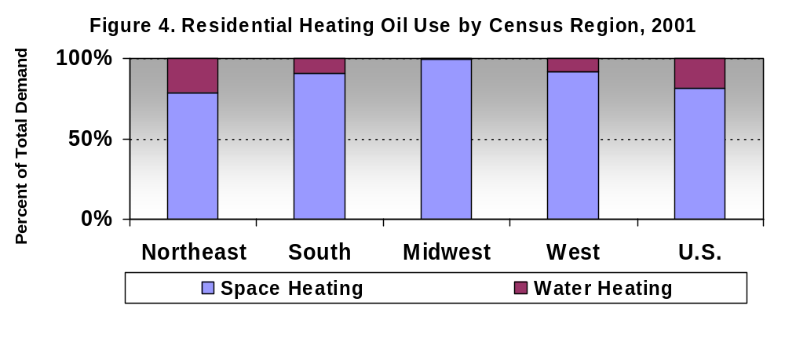

Heating oil has the largest share of the space heating fuel market in the Northeast with 6.24 million homes representing almost 31 percent of all homes in the region using heating oil as their primary space heating fuel and an additional 0.18 million that use heating oil as a secondary fuel (Figure 5). Market shares in the other regions are much smaller, ranging from 3.2 percent in the Midwest down to 0.7 percent in the West.

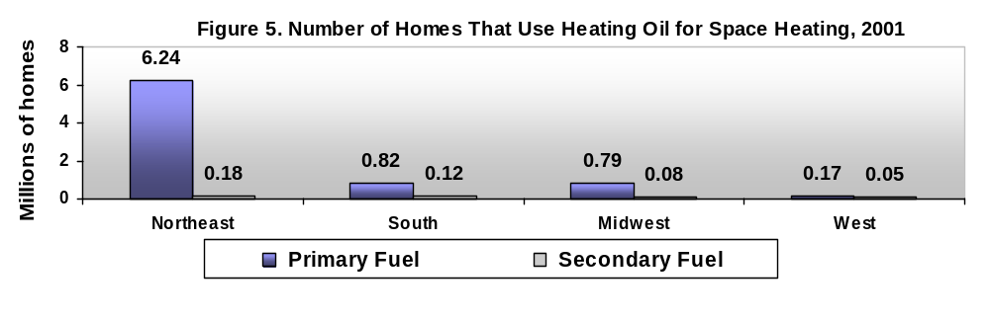
Heating oil consumption per household is greatest for space heating (Figure 6).

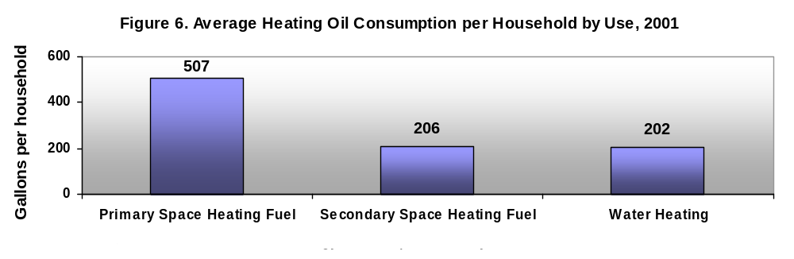
Average total annual average residential sector heating oil consumption is greatest in the Northeast because of the greater number of homes using heating oil for space heating and colder weather (Figure 7).

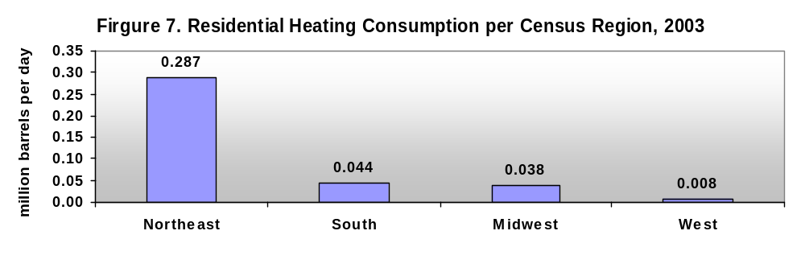

B. Regional Demand Equations

The Regional Short-Term Energy Model for residential heating oil includes residential sector heating oil demand for the four census regions. Estimates of regional residential heating oil demand are used to weight regional heating oil prices to calculate an average U.S. residential heating oil price.

The census region residential heating oil demand equations include the following four groups of explanatory variables:

Residential Heating Oil Price | The average real residential heating oil price in the census region.
Weather | Census division heating degree day deviations from normal weighted to the census region level based on the number of homes in each census division that use heating oil as their primary space heating fuel.
Number of Homes | The number of homes in each census region that use heating oil as their primary space heating fuel.
Dummy Variables | Dummy variables are included to capture the seasonality in heating oil consumption and to eliminate the effects of certain events that are considered outliers in the data series.

1. Residential Heating Oil Price

The average real census region residential heating oil price (nominal price divided by the consumer price index) is included to capture the expected small negative elasticity of demand with respect to price.

Because heating oil demand is highly seasonal we include two price variables, one for November through March and one for April through October. A given change in price is expected to have a larger affect on demand in the winter than in the summer. For example, the Northeast region heating oil demand model includes the following two independent variables:

(d2rcune / cicpius) * (nov+dec+jan+feb+mar)
(d2rcune / cicpius) * (apr+may+jun+jul+aug+sep+oct)

where,
d2rcune = Northeast residential heating oil price
cicpius = Consumer price index

The regression results generally confirm that negative relationships between demand and price are present in all four census regions and the price effect is larger in the winter than in the summer (Table 1). Residential demand declines as the real residential heating oil price in each census region rises with all other variables held constant. Exceptions are the Northeast during the summer months and the West during the winter (although these results are not statistically significant).

We can calculate an approximate price elasticity of demand based on the estimated regression coefficients in the residential price equations using the average residential demands and prices over the regression equation estimation period (Jan. 1995 – Dec. 2004), which are reported in Table 1. For example, the average winter residential demand and price for the Northeast region were 442 thousand barrels per day and 111.9 cents per gallon, respectively. An estimated price coefficient of -0.002172 (with heating oil demand in millions of barrels per day) implies a 10 percent increase in price, from 111.9 to 123.1 cents per gallon, reduces residential demand from 442 to 418 thousand barrels per day, or 5.5 percent. This price elasticity of demand is -0.55 (the 5.5 percent reduction in demand divided by the 10% increase in price).

Table 1. Calculated elasticities of residential heating oil demand with respect to residential heating oil price by census region.
 | Northeast | South | Midwest | West
Winter (November – March):
Average demand, million bpd | 0.442 | 0.068 | 0.055 |  | 0.014
Average price, cents/gal | 111.9 | 111.8 | 101.7 |  | 112.4
Estimated coefficient | -0.002172 | -0.000302 | -0.000443 |  | +0.000019*
Calculated price elasticity | -0.55 | -0.50 | -0.82 |  | +0.15
Summer (April – October):
Average demand, million bpd | 0.132 | 0.021 | 0.021 |  | 0.005
Average price, cents/gal | 107.1 | 105.6 | 100.7 |  | 116.1
Estimated coefficient | +0.000039* | -0.000054* | -0.000095 |  | -0.000036
Calculated price elasticity | +0.03 | -0.27 | -0.45 |  | -0.83
Elasticities are calculated based on simple demand and price averages over the regression equation estimation period (Jan. 1995 – Dec. 2004).
* Estimated coefficient not statistically significant at the 90% confidence interval.

2. Weather

Heating oil demand in the residential sector is highly seasonal because of the weather-related space heating demand. Fuel consumption for space heating rises during the winter months and falls during the spring and summer.

Heating degree days is a useful indicator of the energy required for space heating. When the daily mean temperature is below 65 degrees F, most buildings require heat to maintain inside temperatures of 70 degrees. Heating degree days are calculated by subtracting the daily mean temperature (the average of the day’s high and low temperatures) from 65 degrees F. Each degree below 65 degrees is one degree day. The daily totals are summed for each month.

Heating degree days for each census region are calculated by weighting the heating degree days for each census district within the region by the number of homes with heating oil as the primary space heating fuel in each district. An example calculation of the heating oil-weighted heating degree days for the Northeast region is shown in Table 2. Heating degrees days by month for each census region are shown in Figure 8.

Table 2. Calculation of Northeast Census Region Heating Degree Days, January 2004.
Census District | Heating degree days |  | Number of homes with heating oil space heat
New England | 1,474 | x | 2.700 | = | 3,989.8
Middle Atlantic | 1,348 | x | 3.572 | = | 4,815.1
 |  |  | 6.272 |  | 8,794.9
Divided by total number of homes |  |  |  | ÷ | 6.272
Northeast census region heating degree days |  |  |  | = | 1,402

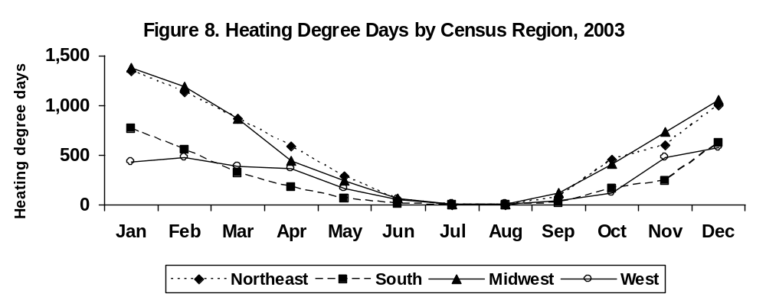

Because space heating represents the largest share of residential heating oil demand, total residential heating oil demand is also strongly seasonal as shown in Figure 9. The Northeast region with more homes using heating oil for space heating exhibited the greatest seasonality in demand in 2003 with monthly demand ranging from a low of 85 thousand barrels per day in July to a high of 655 thousand barrels per day in January.

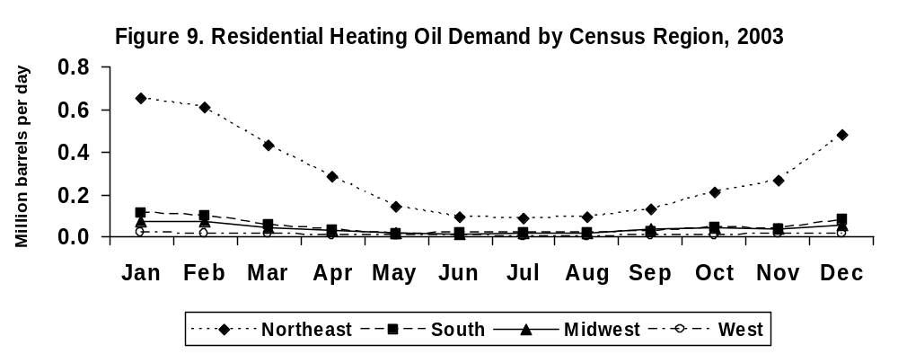

We can also illustrate the cold weather impact on demand by comparing per household demand with heating degree days as shown in Figures 10A through 10D. One additional heating degree day in the census regions increases per household daily demand between 0.0013 barrels (0.05 gallons) to 0.0033 barrels (0.14 gallons).

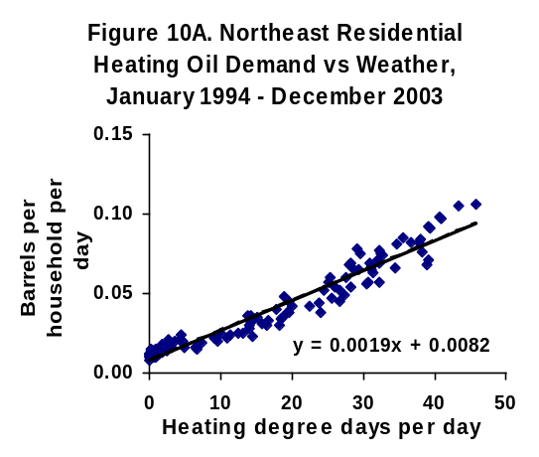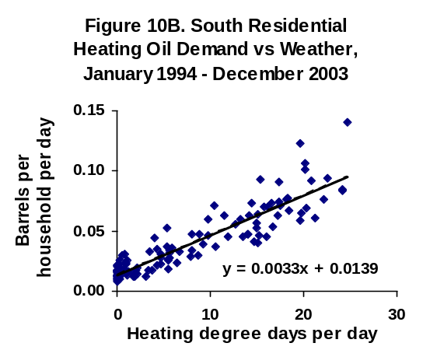
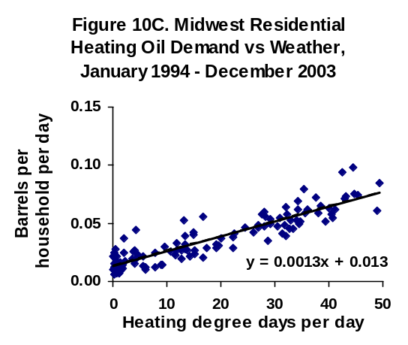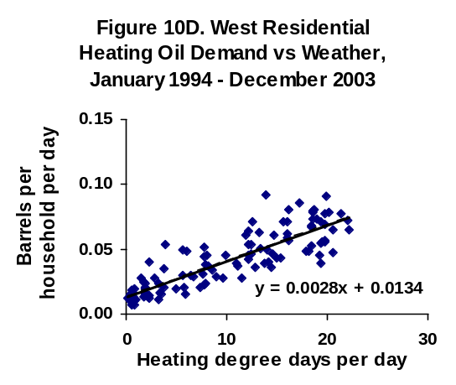

The residential heating oil demand equations include heating degree day deviations from normal for both the current month and the previous month. For example, some of the residential demand impact of a cold January may not show up until February as residences get their heating oil tanks refilled. The regression results indicate that in the Northeast, South and Midwest regions about 81 percent of the demand impact occurs immediately while 89 percent of the cold weather impact on demand in the West occurs during the first month.

A rule-of-thumb is that a 10 percent increase in heating degree days increases fuel required for space heating by 10 percent. The effects of a 10 percent increase in heating degree days for 2005 on residential heating oil demand based on the estimated regression equations are reported in Table 3.

Table 3. Estimated effect of cold weather on residential heating oil demand by census region, 2005.
(percent change in residential sector demand)
 | Northeast | South | Midwest | West | U.S.
Jan | 10.5 % | 7.6 % | 13.4 % | 2.4 % | 10.2 %
Feb | 10.6 % | 7.4 % | 11.5 % | 2.6 % | 10.2 %
Mar | 12.1 % | 7.8 % | 12.4 % | 2.5 % | 11.4 %
Apr | 11.3 % | 8.0 % | 9.8 % | 3.1 % | 10.7 %
May | 10.3 % | 5.6 % | 7.9 % | 3.2 % | 9.5 %
Jun | 4.4 % | 1.2 % | 3.0 % | 3.0 % | 3.9 %
Jul | 1.1 % | 0.2 % | 0.8 % | 2.1 % | 1.0 %
Aug | 0.9 % | 0.1 % | 0.8 % | 0.9 % | 0.8 %
Sep | 3.6 % | 0.8 % | 2.2 % | 1.1 % | 3.0 %
Oct | 8.8 % | 4.1 % | 5.7% | 1.6 % | 7.6 %
Nov | 12.3 % | 8.0 % | 11.0 % | 2.4 % | 11.3 %
Dec | 11.0 % | 7.5 % | 11.6 % | 2.7 % | 10.4 %
Average | 9.8 % | 6.4 % | 9.2 % | 2.4 % | 9.2 %
Alternative cold weather scenario assumes 10% more heating degree days in each census region beginning January 2005.

The results in Table 3 are consistent with the rule-of-thumb for the Northeast and Midwest. The West census district has a small response to cold weather but the small sample population yields less reliable results.

3. Number of Homes with Heating Oil for Space Heating

Heating oil demand is expected to be positively related to the number of the homes that use heating oil as the main heating fuel. The EIA Residential Energy Consumption Survey (RECS) reports the number of homes and volume of heating oil consumed by census division for the following categories of use:

- Any use
- Space heating primary fuel
- Space heating secondary fuel
- Water heating

The largest volume of use is as the primary fuel for space heating, which represents about 80 percent of total residential heating oil demand in the Nation (detailed tables with the number of homes and heating oil consumption by census region are available in Appendix A). Heating oil use as the secondary fuel for space heating represents about 2 percent of total residential demand, with water heating making up the remaining 18 percent of demand.

The regional heating oil residential demand regression equations include the number of homes that use heating oil as the primary space heating fuel. The total number of homes with heating oil as the primary space heating fuel in each census region is calculated by adding the number of homes in each corresponding census division. For example, the Northeast census region includes the Middle Atlantic and New England census divisions:

Total number of homes in Northeast census region with heating oil space heating | = qhfohrecs_mac + qhfohrecs_nec

where,
ghfohrecs_mac = RECS estimate of homes using heating oil as the primary heating fuel in the Middle Atlantic census division
qhfohrecs_nec = RECS estimate of homes using heating oil as the primary heating fuel in the New England census division

The RECS surveys are conducted every four years (1989, 1993, 1997, and 2001). A monthly time series is created by linear interpolation between the RECS survey points (Figure 11). A forecast of the number of homes is created by multiplying the share of total homes reported in the 2001 RECS survey by regional population forecasts published by the U.S. Census Bureau.

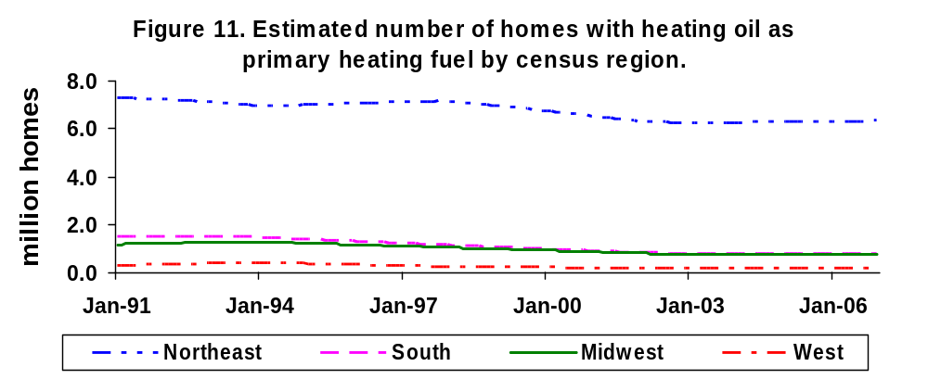
Sources: Linear interpolation and extrapolation of EIA Residential Energy Consumption Survey data.

The relationship between heating oil demand and the number of houses with heating oil as the main space heating fuel should be seasonal. In other words, a doubling of homes using heating oil for space heating will have a much larger effect on demand in January than in July. Because of this expected seasonal relationship the number of homes with heating oil heat is separated into two seasons: one series includes the number of homes in November through March (0 otherwise) and a second series includes the number of homes in April through October (0 otherwise). For example, the Northeast region heating oil demand model includes the following two independent variables:

(qhfohrecs_mac + qhfohrecs_nec) * (nov+dec+jan+feb+mar)
(qhfohrecs_mac + qhfohrecs_nec) * (apr+may+jun+jul+aug+sep+oct)

We can see the effect of a change in the number of homes on heating oil demand by comparing an estimated average seasonal demand per house for space heating derived from the 2001 RECS with the estimated regression coefficients for the number of houses per season in Table 4. For example, the estimated coefficient on the number of houses with heating oil as the primary space heating fuel for the Northeast implies that each additional house will increase winter heating oil consumption by about 0.019 barrels per day per house, which is less than the estimated average 0.057 barrels per house per day from RECS.

Table 4. Residential heating oil demand and number of houses with heating oil space heating
 | Estimated average heating oil demand as primary space heating fuel per house from RECS,  (barrels per house per day) | Estimated coefficient on number of houses with heating oil as primary space heating fuel,  (barrels per house per day)
Northeast:
April - October | 0.017 | 0.0009*
November - March | 0.057 | 0.019*
South:
April - October | 0.015 | 0.0004*
November - March | 0.050 | - 0.016
Midwest:
April - October | 0.021 | - 0.016
November - March | 0.051 | 0.037
West:
April - October | 0.015 | 0.006
November - March | 0.038 | 0.012
Notes: Not statistically significant at the 90% confidence level.
Estimated average heating oil demand as primary space heating fuel based on the 2001 Residential Energy Consumption Survey (RECS) average household heating oil demand with a correction for seasonality derived from 5-year averages (1998-2003) of total heating oil residential demand. For example, estimated winter demand = 2001 RECS average heating oil space heating demand per household x average winter heating oil demand / average annual heating oil demand.

The regression coefficients are directionally consistent with the estimated average seasonal space-heating demand per house except in the South. There are two primary characteristics of the number of homes with heating oil heat data series that reduces their efficiency as explanatory variables. The first problem is that the Residential Energy Consumption Survey only occurs every four years. The monthly historical household data series used in the regional heating oil model are generated by simple linear interpolation between surveys.

The second problem with RECS household data for heating oil is that the share of total households with heating oil heat is small. The 95% confidence interval around the estimated number of homes in a census region with heating oil space heating ranges from plus or minus 24 percent (Northeast) to 52 percent (West). This combination of low frequency and low precision of measurement will significantly affect the reliability of the estimated regression model coefficients.

4. Dummy Variables

Dummy variables are included to reflect the seasonality in heating oil consumption not captured by seasonality in prices and to eliminate the effects of certain events that are considered outliers in the data series.

First, we have dummy variables for each individual month except December. For example, JAN equals 1 for every January in the time series and is equal to 0 in every other month. These individual monthly dummy variables are intended to capture normal demand seasonality as deviations from December demand. In other words, if the coefficient for JAN is 0.05, then demand in January is expected to be 50,000 barrels per day higher than in December. The regression results for the monthly dummy variables generally reveal lower demand in the summer with demand peaking in January.

The second group of dummy variables control for nonrecurring events. The EIA monthly residential heating oil demand survey covers only a sample rather than universe of all retail suppliers. Every few years the sample is rebased, which can lead to shifts in demand in certain States. The most significant shift appears to have occurred recently in the Northeast and Midwest census regions. This apparent shift is captured by a dummy variables that account for a demand shift in the coldest winter months:

(D0212 + D03on) * (nov+dec+jan+feb+mar) | = 1, if December 2002, or December, January, or February in 2003 and later years,
 | = 0, otherwise

4. Heating Oil Prices

A. Introduction

Residential heating oil prices are variable within and across regions (Figures 12A – 12D).

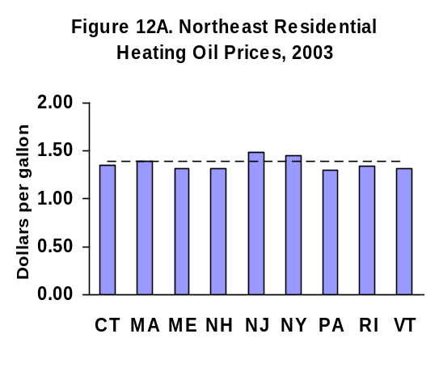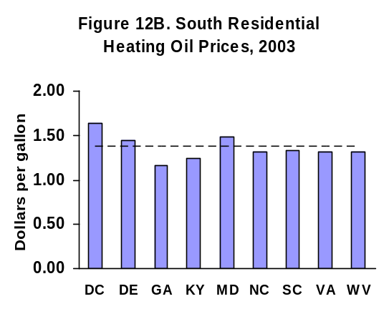
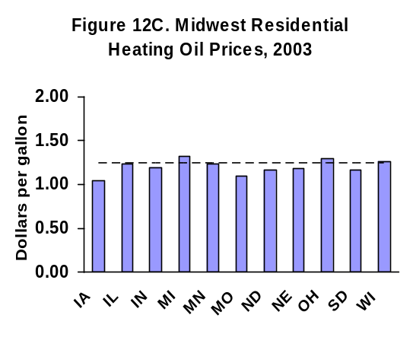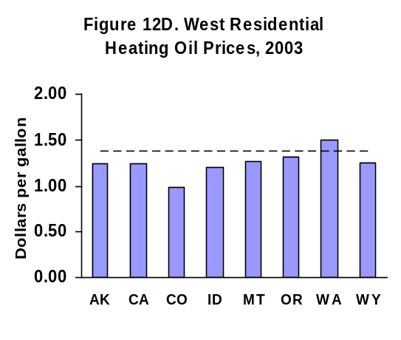
The heating oil price model begins with an estimate of the average U.S. distillate wholesale price. This wholesale price is used as a proxy for the heating oil wholesale price to each regional residential sector. Residential heating oil prices excluding State taxes are modeled as a function of the wholesale price and other variables that may affect the markup of retail prices over the wholesale price.

Wholesale distillate and retail heating oil prices are modeled as price spreads rather than price levels. For example, the left-hand side (dependent) variable in the wholesale distillate price equation is the difference between the average U.S. distillate wholesale price and the spot price of WTI crude oil (in cents per gallon). For regional retail prices the dependent variable is the difference between the census region residential heating oil retail price and the average U.S. distillate wholesale price.

B. Distillate Wholesale Price

Since heating oil is a product of crude oil refining we assume the wholesale price is directly related to the spot price of crude oil. There are many measures of crude oil prices because of the many different grades of crude oil. The spot price of West Texas Intermediate (WTI) was selected as the representative crude oil that is most closely related to distillate prices.

The difference between the average U.S. distillate wholesale price and the spot price of WTI crude oil (converted from dollars per barrel to cents per gallon) is estimated as a function of the following explanatory variables plus a first-order autoregressive error correction term:

Crude Oil Price Change | The change in the current month spot West Texas Intermediate (WTI) crude oil price from the prior month.
U.S. Inventories | Deviation in prior month ending U.S. total primary stocks from the prior four-year average for that month.
U.S. Distillate Demand | Deviation in total distillate demand from prior three-year average
Dummy Variables | Dummy variables are included to capture seasonality and to eliminate the effects of certain events that are considered outliers in the data series.

1. Crude Oil Price Change

A change in the crude oil price is expected to feed forward to wholesale distillate prices, possibly with a short lag. Including the difference in the current and prior-month crude oil price as an explanatory variable allows for some delay in the price pass through.

The structure of the estimated regression equation:

D2WHUUS(t) – 100*WTIPUUS(t)/42
= a0 + a1 * (100/42) * [WTIPUUS (t) – WTIPUUS (t-1)]...

where, D2WHUUS(t) = average U.S. wholesale distillate price in month t
WTIPUUS (t) = West Texas Intermediate (WTI) spot price in month t
a0, a1 = estimated regression coefficients

is equivalent to the following equation:

D2WHUUS (t) = a0 + (1 + a1) * (100/42) * (WTIPUUS (t)
– a1 * (100/42) * WTIPUUS (t-1)...

with the coefficients on the current and lagged WTI prices constrained to add to 1.0.

The estimated negative coefficient for a1 of -0.18 suggests that about 82 percent of a crude oil price increase shows up in the current month with the remaining 18 percent in the following month.

2. Inventories

The beginning of month (end of prior month) total U.S. distillate inventory as a deviation from the prior four year average for that month is included as a right-hand side variable. Higher than historical average U.S. inventory levels are expected to lower the wholesale distillate price. The estimated regression equation coefficient is negative as expected. Wholesale distillate prices are up to 2.3 cents per gallon higher (the greatest price impact occurs during the winter months) when inventories are 1 standard deviation lower than the last five year average (2000 – 2004).

3. Total U.S. Distillate Demand

The deviation in total distillate demand from the previous three year average is a mechanism for recognizing the price impact of demand shocks such as from cold weather. The estimated coefficient is positive as expected. Wholesale distillate prices are up to 1.2 cents per gallon higher (the greatest price impact occurs during the winter months) when total distillate demand is 1 standard deviation higher than the last five year average (2000 – 2004).

5. Dummy Variables

Dummy variables are included to reflect the seasonality in wholesale distillate prices not captured by seasonality in the other variables and to eliminate the effects of certain events that are considered outliers in the data series.

First, we have dummy variables for each individual month except December. For example, JAN equals 1 for every January in the time series and is equal to 0 in every other month. These individual monthly dummy variables are intended to capture normal wholesale price seasonality as deviations from the December price. In other words, if the coefficient for JAN is 1.00, then the wholesale price in January is expected to be 1.0 cent per gallon higher than in December with all other variables constant.

The regression results for the monthly dummy variables conform to expectations with the wholesale price lowest in May and peaks just before the start of the heating season in September. The observed seasonality in price provides an incentive for firms to build and hold heating oil inventories during the summer months for delivery during the winter heating season.

The second group of dummy variables control for nonrecurring events that are considered outliers in the data series. These dummy variables shown in Table 6 identify months when the wholesale price was significantly higher than expected.

Table 6. Wholesale distillate price equation dummy variables.
Variable | Description | Estimated Coefficient | Explanation
d0001 + d0002 | Jan + Feb, 2000 | 10.7
d0302 + d0303 | Feb + Mar, 2003 | 8.7 | Cold Jan and Feb with natural gas price spike

C. Residential Heating Oil Prices Before State Taxes

The Regional Short-Term Energy Model for residential heating oil includes residential sector heating oil retail prices for the four census regions. The difference between the census region residential heating oil retail price and the wholesale distillate price is estimated as a function of the following explanatory variables plus a first-order autoregressive error correction term:

Wholesale Distillate Price Change | The change in the current month wholesale distillate price from the prior month
Regional Weather | Census division heating degree day deviations from normal weighted to the census region level using the number of homes in each census division that use heating oil as their primary space heating fuel.
Regional Inventories | Deviation in prior end-of-month Petroleum Administration for Defense District (PADD) stocks from the prior four-year average for that month.
Dummy Variables | Dummy variables are included to capture the seasonality in heating oil prices and to eliminate the effects of certain events that are considered outliers in the data series.

1. Wholesale Distillate Price Change

The residential heating oil price is directly related to the wholesale price. A change in the wholesale price is expected to feed forward to residential prices, possibly with a short lag. Including the difference in the current and prior-month wholesale distillate price as an explanatory variable allows for some delay in the price pass through.

The structure of the estimated regression equation:

D2RCUxx(t) – D2WHUUS(t) = a0 + a1 * [D2WHUUS(t) – D2WHUUS(t-1)]...

where, D2RCUxx(t) = residential heating oil retail price in region xx in month t
D2WHUUS(t) = wholesale distillate price in month t
a0, a1 = estimated regression coefficients

is equivalent to the following equation:

D2RCUxx(t) = a0 + (1 + a1) * (D2WHUUS(t) – a1 *D2WHUUS(t-1)]...

with the coefficients on the current and lagged wholesale prices constrained to add to 1.0.

The estimated values of the a1 coefficients for the different regional equations suggests that from 47 percent (West) to 63 percent (Midwest) of a change in the wholesale price shows up in the current month residential price with the remainder in the following month.

2. Weather

Regional heating degree day deviations from normal are included to capture the possible impact of cold weather on retail prices. Surprisingly the estimated coefficients on the regional weather variable for all regions except the South are negative. Colder-than-normal weather lowers the residential heating oil price with all other variables held constant. However, none of the weather variables are statistically significant at the 90 percent confidence interval. The impact of the negative weather coefficient is small. For example, if heating degree days are 10% greater than normal, the retail price effect is less than one-half cent per gallon in the Northeast region.

3. Inventories

While total U.S. inventories are included in the wholesale distillate price regression equation, regional inventory levels are included in the residential price equations. Inventories are entered as the difference in beginning-of-month stocks from the prior four year average.

Inventory data are not available by census region. Inventories by Petroleum Administration for Defense (PAD) District are used for census regions as shown below. A more detailed description of the correspondence between census regions and PAD Districts is provided in Appendix A.

Census Region | PAD District
Northeast | 1
South | 1
Midwest | 2
West | 5

The estimated coefficients on inventories are negative as expected only in the Midwest and West. The greatest impact occurs in the West. When West region stocks are 1 standard deviation lower than the average over the last five years (2000 - 2004), residential prices are higher by about 1.7 cents per gallon. Residential heating oil prices in the South region would be 0.7 cents lower. The price impact is close to zero in the Northeast where the estimated coefficient was not statistically significant.

4. Dummy Variables

Dummy variables are again included to reflect the seasonality in residential heating oil prices (or the markup over the wholesale price) not captured by seasonality in the wholesale price and inventory variables and to eliminate the effects of certain events that are considered outliers in the data series.

The regression results for the monthly dummy variables conform to expectations with the residential price lowest at the end of summer and peaking during the winter. The observed seasonality in price reflects the seasonality in demand and provides an incentive for firms to build and hold distillate inventories during the summer months for delivery during the winter heating season.

The second group of dummy variables control for nonrecurring events that are considered outliers in the data series.

Table 8. Residential price equation dummy variables.
 |  | Estimated Coefficients
Variable | Description | Northeast | South | Midwest | West | Explanation
d9612 | Dec 1996 | n.a. | n.a. | 7.7 | n.a.
d00 | Year 2000 | 7.0 | n.a. | n.a. | n.a.
d0001 | Jan 2000 | -6.9 | n.a. | n.a. | n.a.
d0012 | Dec 2000 | n.a. | 14.5 | 6.8 | 10.1
d0101 | Jan 2001 | n.a. | 19.2 | n.a. | n.a.
d01on | Jan 2001 and later | 12.5 | 13.3 | 9.7 | 17.6
d0202 | Feb 2002 | n.a. | n.a. | n.a. | 7.8
d0303 | Mar 2003 | 9.0 | n.a. | n.a. | n.a.

D. Residential Heating Oil Prices After State Taxes

The Regional Short-Term Energy Model for residential heating oil includes residential sector heating oil prices including State taxes for the four census regions. The heating oil price including State taxes is calculated by multiplying each region’s heating oil price ex tax by a regional sales tax factor. For example, the Northeast region heating oil price including State taxes is calculated by:

D2RCANE = D2TXUNE * D2RCUNE

where,
D2RCANE = Residential heating oil price after taxes, Northeast region
D2TXUNE = Region State sales tax factor (e.g., 1.05 = 5% tax rate)
D2RCUNE = Residential heating oil price before taxes, Northeast region

The regional sales tax factors used in the model are approximations of the actual average sales tax. We apply the same State tax rates used in EIA’s estimation of State residential petroleum product prices including taxes published in the annual State Expenditure and Price Reports (http://www.eia.doe.gov/emeu/states/_price_multistate.html). The State tax rate includes the State’s portion of the sales tax and excludes any local options for additional sales tax. The census region tax rate is calculated by weighting each State’s tax rate by the volume of residential heating oil sales in that State for each month.

We can check the efficacy of this method by comparing the difference between other published after-tax residential heating oil prices and out before-tax price. The are two surveys of after-tax residential heating oil prices:

- EIA publishes the State Heating Oil and Propane Program (SHOPP) weekly survey of after-tax residential heating oil prices conducted by State energy offices. The SHOPP surveys are conducted only during the winter months (beginning of October through mid-March).

- The U.S. Bureau of Labor Statistics reports residential heating oil prices including taxes for the U.S. and census regions as part of the monthly Consumer Price Index.

Figure 13 compares the percent differences between the after-tax and before-tax prices for the SHOPP price and the BLS price. These price differences are compared with the estimates State tax rate. The winter-only SHOPP price has averaged 7.7 percent higher than the before-tax price and the BLS price has averaged 5.6 percent higher than the before tax price (4.4 percent higher during the same winter months covered by the SHOPP price) over the last 10 years. The estimated State tax rate has averaged 4.9 percent (the State tax rate could be as high as 6.4 percent if the local sales tax option were included at the maximum level allowed.)
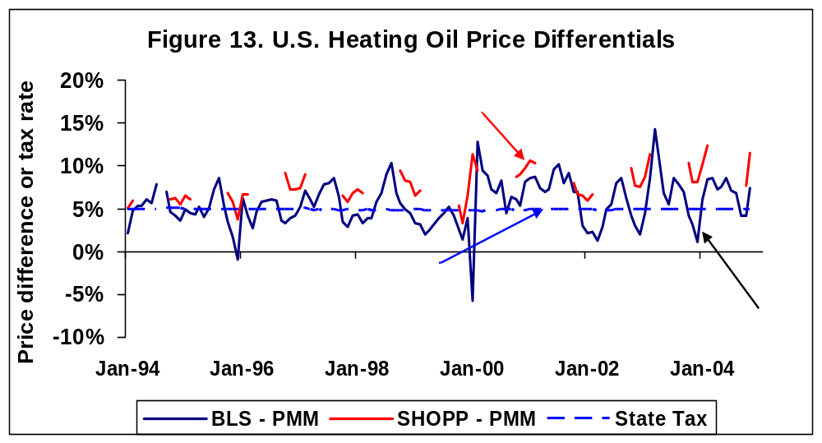
Notes: BLS: Bureau of Labor Statistics, consumer price index survey after tax residential heating oil price
SHOPP: EIA, State Heating Oil and Propane Program after tax residential heating oil price (winter only).
PMM: Energy information Administration, Petroleum Marketing Monthly, before tax residential heating oil price.

The average difference between the BLS after tax price and the before-tax price is closer to the estimated State tax rate in the Northeast. The BLS price averaged 5.0 percent higher than the before-tax price and the estimated State tax rate averaged 4.9 percent over the last 10 years. SHOPP prices are not available for census regions.

While the average after- and before-tax heating oil price differences are very close to the calculated State tax rate, there can be large deviations in any one month. One fundamental difference between the two series that leads to the large variations is that the BLS and SHOPP residential prices are spot (or will-call) price while the before-tax price represents an actual price paid by households. The actual household price may be higher or lower than the spot price because many households lock in winter prices during the summer months. Consequently, during unexpected price increases during the winter, the average price actually paid by households may be significantly lower than the spot price. If spot prices fall then households could pay more. Because the objective of the Regional Short-Term Energy Model is to forecast average prices households actually pay we do not attempt to model spot residential prices. Consequently, some households may pay significantly more or less than regional prices estimated in this model not only because of price differences across States and regions but also because of the market pricing structure.

5. Inventories

A. Introduction

Distillate inventory withdrawals provide the second largest source of heating oil during the winter heating season. During the peak demand months of December, January, and February, distillate inventories supply over 20 percent of total distillate demand on average. Inventories are built up during the spring and summer months, and typically peak by the end of September or October and reach their lowest point in March.

Distillate storage consists of three types: primary, secondary, and tertiary. Primary storage consists of refinery, pipeline, and bulk terminal stocks. Secondary storage consists primarily of large above-ground tanks owned by heating oil retail distributors, while tertiary storage consists mainly of residential and commercial customers. Inventory survey data are available only at the primary storage level.

B. Regional Inventory Equations

The Regional Short-Term Energy Model for residential heating oil includes inventories for the five Petroleum Administration for Defense Districts (PADD). Inventory data for census region districts are not available.

Inventories are modeled as first difference stock changes rather than as stock levels. The reason for modeling stocks as changes rather than levels is that this method can provide a smoother transition from the historical data into the forecast.

The PADD stock change equations include the following explanatory variables:

Wholesale Distillate – Crude Oil Price Differential | Prior month difference between the distillate wholesale price and the average acquisition cost of crude oil to U.S. refineries.
Beginning Stocks | Deviation in prior month ending U.S. total primary stocks from the prior four-year average for that month.
Weather | Census division heating degree days weighted to the census region level using the number of homes in each census division that use heating oil as their primary space heating fuel.
Dummy Variables | Dummy variables are included to capture the seasonality in distillate inventories and to eliminate the effects of certain events that are considered outliers in the data series.

1. Distillate to Crude Oil Price Differential

An increase in the wholesale distillate price relative to the price of crude oil is expected have a positive impact on stock changes. Stock builds should be larger than normal or stock draws smaller with a higher distillate wholesale price. The higher distillate price should motivate suppliers to increase output and consumers to reduce demand.

The distillate-to-crude oil price differential is calculated based on the spot price of West Texas Intermediate (WTI) crude oil. The crude oil price in dollars per barrel is divided by 42 to convert it to a per gallon basis.

The estimated coefficients are negative as expected in PADDs 1, 4, and 5, but positive in PADDs 2 and 3. However, the coefficients are statistically significant (at the 90 percent confidence level) only in PADD 2.

2. Beginning Stocks

The beginning of month (end of prior month) PADD inventory as a deviation from the prior four year average for that month is included as a right-hand side variable. Higher than historical average inventory levels are expected to reduce stock builds or increase stock draws. The estimated coefficients for all PADDs were negative as expected and statistically significant in all PADDs except PADD 1. In PADDs 2 through 5 a beginning-of-month inventory that is 1 million barrels above the previous four-year average reduces the month’s normal stock change by 0.3 to 0.4 million barrels.

3. Weather

The distillate stock change equations include heating degree day deviations from normal for selected census divisions as shown below. A more detailed description of the correspondence between census divisions and PAD Districts is provided in Appendix A.

PAD District | Census Division
1 | New England, Middle Atlantic, and South Atlantic
2 | East and West North Central
3 | East and West South Central
4 | Mountain
5 | Pacific

The census division heating degree days are weighted by the number of households within each division that uses heating oil as the primary space heating fuel to arrive at the PADD heating degree days.

Weather that is colder than normal should lead to smaller stock builds or larger stock draws because of the increase in demand, at least in PADD 1 (the Northeast). Cold weather may not be expected to have significant effects outside the Northeast because of the small market shares for space heating. The estimated coefficients are negative as expected but statistically significant only in PADDs 1 and 2..

4. Dummy Variables

Dummy variables are again included to reflect the seasonality in stock changes not captured by seasonality in weather. The regression results for the monthly dummy variables conform to expectations that stock builds occur during the spring and summer months and stock draws during the winter in PADDs 1, 2, and 3, but not PADDs 4 and 5.

Appendix A. Detailed Tables

Appendix A1. Heating Oil Primary Stocks, Residential Consumption, and Residential Prices by Census Region

Appendix A2. Correspondence Between Census Divisions and Petroleum Administration for Defense Districts.

Appendix A3. Residential Sector Use of Heating Oil, 2001

Appendix A4. Residential Sector Use of Heating Oil, 1997

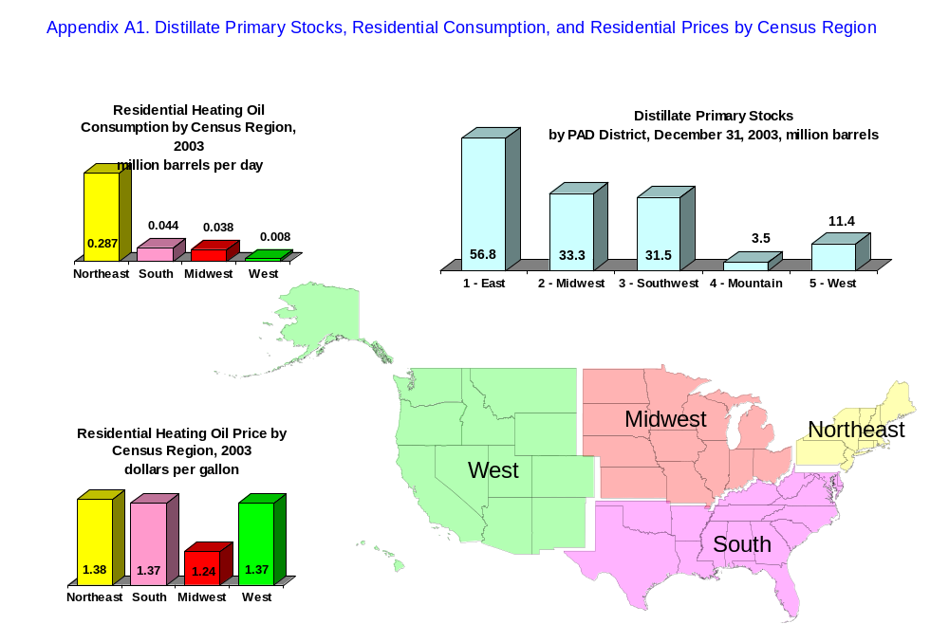

Appendix A2. Correspondence Between Census Divisions and Petroleum Administration for Defense Districts.
Census  Region | Census  Division |  | Petroleum Administration for Defense District (PADD) |  |  |  |  | Households with Heating Oil Space Heating, 2001 (mllions)
Census  Region | Census  Division |  | 1 | 2 | 3 | 4 | 5 | Total | Primary Fuel
Northeast | New England | CT | X |  |  |  |  | 2.7 | 2.7
 |  | ME | X
 |  | MA | X
 |  | NH | X
 |  | RI | X
 |  | VT | X
 | Middle Atlantic | NJ | X |  |  |  |  | 3.7 | 3.6
 |  | NY | X
 |  | PA | X
South | South Atlantic | DE | X |  |  |  |  | 0.9 | 0.8
 |  | DC | X
 |  | FL | X
 |  | GA | X
 |  | MD | X
 |  | NC | X
 |  | SC | X
 |  | VA | X
 |  | WV | X
 | East South Central | AL |  |  | X |  |  | Q | Q
 |  | KY |  | X
 |  | MS |  |  | X
 |  | TN |  | X
 | West South Central | AK |  |  | X |  |  | Q | Q.
 |  | LA |  |  | X
 |  | OK |  | X
 |  | TX |  |  | X
Midwest | East North Central | IL |  | X |  |  |  | 0.5 | 0.4
 |  | IN |  | X
 |  | MI |  | X
 |  | OH |  | X
 |  | WI |  | X
 | West North Central | IA |  | X |  |  |  | 0.4 | 0.4
 |  | KS |  | X
 |  | MN |  | X
 |  | MO |  | X
 |  | NE |  | X
 |  | ND |  | X
 |  | SD |  | X
West | Mountain | AZ |  |  |  |  | X | Q. | Q.
 |  | CO |  |  |  | X
 |  | ID |  |  |  | X
 |  | MT |  |  |  | X
 |  | NV |  |  |  |  | X
 |  | NM |  |  | X
 |  | UT |  |  |  | X
 |  | WY |  |  |  | X
 | Pacific | AK |  |  |  |  | X | 0.2 | Q.
 |  | CA |  |  |  |  | X
 |  | HI |  |  |  |  | X
 |  | OR |  |  |  |  | X
 |  | WA |  |  |  |  | X
Notes:
Q = Data withheld either because the Relative Standard Error (RSE) was greater than 50 percent or fewer than 10 households were sampled.
Source households with heating oil space heating: Energy Information Administration, Residential Energy Consumption Survey, 2001; Consumption and Expenditure Data Tables; Tables CE2-9c, CE2-10c, CE2-11c, and CE2-12c; accessed January 10, 2005 (http://www.eia.doe.gov/emeu/recs/).

Appendix A3. Residential Sector Use of Heating Oil, 2001
 | Census Region
 | Northeast | South | Midwest | West | U.S.
Number of homes that used Heating Oil (millions)
Any use (1) | 6.613 | 0.942 | 0.885 | 0.220 | 8.667
Space heating (1) | 6.416 | 0.943 | 0.886 | 0.218 | 8.462
Primary fuel | 6.240 | 0.820 | 0.790 | 0.170 | 8.020
Secondary fuel (2) | 0.176 | 0.123 | 0.076 | 0.048 | 0.442
Water Heating (1) | 4.455 | Q | Q | Q | 4.703
Total volume of Heating Oil used (million gallons)
Any use | 4,166 | 419 | 437 | 84 | 5,105
Space heating | 3,266 | 379 | 434 | 77 | 4,155
Primary fuel | 3,226 | 369 | 405 | 64 | 4,064
Secondary fuel | 40 | 10 | 29 | 13 | 91
Water Heating | 900 | 40 | 3 | 7 | 950
Heating Oil consumption per household (gallons)
Any use | 630 | 445 | 494 | 381 | 589
Space heating | 509 | 402 | 490 | 353 | 491
Primary fuel | 517 | 450 | 513 | 378 | 507
Secondary fuel | 227 | 81 | 382 | 271 | 206
Water Heating | 202 | Q | Q | Q | 202
Notes:
Q = Data withheld either because the Relative Standard Error (RSE) was greater than 50 percent or fewer than 10 households were sampled.
Regions may not add to U.S. total because of rounding errors.
(1) Calculated from total volumes and volumes per household reported by the EIA Residential Energy Consumption Survey
(2) Calculated by difference between total and primary space heating.
Sources:
Energy Information Administration, Residential Energy Consumption Survey, 2001; Consumption and Expenditure Data Tables; Tables 2, CE2-9c, CE2-10c, CE2-11c, and CE2-12c; accessed January 10, 2005 (http://www.eia.doe.gov/emeu/recs/).

Appendix A4. Residential Sector Use of Heating Oil, 1997
 | Census Region
 | Northeast | South | Midwest | West | U.S.
Number of homes that used heating oil (millions)
Any use (1) | 7.466 | 1.161 | 1.052 | 0.280 | 9.963
Space heating (1) | 7.343 | 1.138 | 1.052 | 0.280 | 9.813
Primary fuel | 7.080 | 1.110 | 1.030 | 0.230 | 9.450
Secondary fuel (2) | 0.263 | 0.028 | 0.022 | 0.050 | 0.363
Water Heating (1) | 4.946 | Q | Q | Q | 1.560
Total volume of heating oil used (million gallons)
Any use | 5,816 | 555 | 752 | 151 | 7,273
Space heating | 4,722 | 526 | 734 | 151 | 6,133
Primary fuel | 4,630 | 520 | 719 | 137 | 6,006
Secondary fuel | 92 | 6 | 15 | 14 | 127
Water Heating | 1,093 | 29 | 18 | 0 | 1,139
Heating oil consumption per household (gallons)
Any use | 779 | 478 | 715 | 540 | 730
Space heating | 643 | 462 | 698 | 540 | 625
Primary fuel | 654 | 469 | 698 | 595 | 636
Secondary fuel | 350 | 214 | 682 | 280 | 350
Water Heating | 221 | Q | Q | Q | 219
Notes:
Q = Data withheld either because the Relative Standard Error (RSE) was greater than 50 percent or fewer than 10 households were sampled.
Regions may not add to U.S. total because of rounding errors.
(1) Calculated from total volumes and volumes per household reported by the EIA Residential Energy Consumption Survey
(2) Calculated by difference between total and primary space heating.
Sources:
Energy Information Administration, Residential Energy Consumption Survey, 2001; Consumption and Expenditure Data Tables; Tables 2, CE2-9c, CE2-10c, CE2-11c, and CE2-12c; accessed January 10, 2005 (http://www.eia.doe.gov/emeu/recs/).

Appendix B. Variable Definitions

Table B1. Variable Definitions
 |  |  | Sources
Variable Name | Units | Definition | History | Forecast
APR | Integer | = 1 if April, 0 otherwise
AUG | Integer | = 1 if August, 0 otherwise
CICPIUS | Index | Consumer price index | BLS | DRI
D00 | Integer | = 1 if 2000, 0 otherwise
D0001 | Integer | = 1 if January 2000, 0 otherwise
D0002 | Integer | = 1 if February 2000, 0 otherwise
D0003 | Integer | = 1 if March 2000, 0 otherwise
D0009 | Integer | = 1 if September 2000, 0 otherwise
D01 | Integer | = 1 if 2001, 0 otherwise
D0101 | Integer | = 1 if January 2001, 0 otherwise
D0102 | Integer | = 1 if February 2001, 0 otherwise
D0103 | Integer | = 1 if March 2001, 0 otherwise
D0112 | Integer | = 1 if December 2001, 0 otherwise
D0201 | Integer | = 1 if January 2002, 0 otherwise
D0202 | Integer | = 1 if February 2002, 0 otherwise
D0212 | Integer | = 1 if December 2002, 0 otherwise
D03ON | Integer | = 1 if January 2003 or later, 0 otherwise
D0403 | Integer | = 1 if March 2004, 0 otherwise
D2RCAMW | CPG | Heating oil residential price after taxes, Midwest census region, all sellers | STF | STF
D2RCANE | CPG | Heating oil residential price after taxes, Northeast census region, all sellers | STF | STF
D2RCASO | CPG | Heating oil residential price after taxes, South census region, all sellers | STF | STF
D2RCAUS | CPG | Heating oil residential price after taxes, U.S., all sellers | STF | STF
D2RCAWE | CPG | Heating oil residential price after taxes, West census region, all sellers | STF | STF
D2RCPMW | MMBD | Heating oil residential deliveries, Midwest census region, all sellers | PMM | STF
D2RCPNE | MMBD | Heating oil residential deliveries, Northeast census region, all sellers | PMM | STF
D2RCPSO | MMBD | Heating oil residential deliveries, South census region, all sellers | PMM | STF
D2RCPUS | MMBD | Heating oil residential deliveries, U.S., all sellers | PMM | STF
D2RCPWE | MMBD | Heating oil residential deliveries, West census region, all sellers | PMM | STF
D2RCUMW | CPG | Heating oil residential price before taxes, Midwest census region, all sellers | PMM | STF
D2RCUNE | CPG | Heating oil residential price before taxes, Northeast census region, all sellers | PMM | STF
D2RCUSO | CPG | Heating oil residential price before taxes, South census region, all sellers | PMM | STF
D2RCUUS | CPG | Heating oil residential price before taxes, U.S., all sellers | PMM | STF
D2RCUWE | CPG | Heating oil residential price before taxes, West census region, all sellers | PMM | STF
D2TXUMW | Index | Heating oil State sales tax factor, Midwest census region | STF | ROT
D2TXUNE | Index | Heating oil State sales tax factor, Northeast census region | STF | ROT
D2TXUSO | Index | Heating oil State sales tax factor, South census region | STF | ROT
D2TXUWE | Index | Heating oil State sales tax factor, West census region | STF | ROT
D9602 | Integer | = 1 if February 1996, 0 otherwise
D98 | Integer | = 1 if 1998, 0 otherwise
D99 | Integer | = 1 if 1999, 0 otherwise
D9912 | Integer | = 1 if December 1999, 0 otherwise
DEC | Integer | = 1 if December, 0 otherwise
DFPSPP1BLD | MMB | Distillate stock change, PADD 1 | PSM | STF
DFPSPP2BLD | MMB | Distillate stock change, PADD 2 | PSM | STF
DFPSPP3BLD | MMB | Distillate stock change, PADD 3 | PSM | STF
DFPSPP4BLD | MMB | Distillate stock change, PADD 4 | PSM | STF
DFPSPP5BLD | MMB | Distillate stock change, PADD 5 | PSM | STF
DFPSPP1 | MMB | Distillate end-of-month stocks, PADD 1 | PSM | STF
DFPSPP2 | MMB | Distillate end-of-month stocks, PADD 2 | PSM | STF
DFPSPP3 | MMB | Distillate end-of-month stocks, PADD 3 | PSM | STF
DFPSPP4 | MMB | Distillate end-of-month stocks, PADD 4 | PSM | STF
DFPSPP5 | MMB | Distillate end-of-month stocks, PADD 5 | PSM | STF
DFPSPUS | MMB | Distillate end-of-month stocks, U.S. | PSM | STF
FEB | Integer | = 1 if February, 0 otherwise
JAN | Integer | = 1 if January, 0 otherwise
JUL | Integer | = 1 if July, 0 otherwise
JUN | Integer | = 1 if June, 0 otherwise
MAR | Integer | = 1 if March, 0 otherwise
MAY | Integer | = 1 if May, 0 otherwise
NOV | Integer | = 1 if November, 0 otherwise
OCT | Integer | = 1 if October, 0 otherwise
QHFORECS_ESC | MM | Number of homes with heating oil as primary space heating fuel, E. South Central census div. | RECS | ROT
QHFORECS_ENC | MM | Number of homes with heating oil as primary space heating fuel, E. North Central census div. | RECS | ROT
QHFORECS_MAC | MM | Number of homes with heating oil as primary space heating fuel, Middle Atlantic census div. | RECS | ROT
QHFORECS_MTN | MM | Number of homes with heating oil as primary space heating fuel, Mountain census div. | RECS | ROT
QHFORECS_NEC | MM | Number of homes with heating oil as primary space heating fuel, New England census div. | RECS | ROT
QHFORECS_PAC | MM | Number of homes with heating oil as primary space heating fuel, Pacific census div. | RECS | ROT
QHFORECS_SAC | MM | Number of homes with heating oil as primary space heating fuel, South Atlantic census div. | RECS | ROT
QHFORECS_WNC | MM | Number of homes with heating oil as primary space heating fuel, W. North Central census div. | RECS | ROT
QHFORECS_WSC | MM | Number of homes with heating oil as primary space heating fuel, W. South Central census div. | RECS | ROT
SEP | Integer | = 1 if September, 0 otherwise
TIME | Integer | = 1 to n, where n = number of observation
WTIPUUS | DBBL | Spot price WTI crude oil | PMM | EXO
ZWHDENC | HDD | Heating degree-days, East North Central census division | NOAA | NOAA
ZWHDESC | HDD | Heating degree-days, East South Central census division | NOAA | NOAA
ZWHDMTN | HDD | Heating degree-days, Mountain census division | NOAA | NOAA
ZWHDPAC | HDD | Heating degree-days, Pacific census division | NOAA | NOAA
ZWHDPMA | HDD | Heating degree-days, Middle Atlantic census division | NOAA | NOAA
ZWHDPNE | HDD | Heating degree-days, New England census division | NOAA | NOAA
ZWHDSAC | HDD | Heating degree-days, South Atlantic census division | NOAA | NOAA
ZWHDWNC | HDD | Heating degree-days, West. North Central census division | NOAA | NOAA
ZWHDWSC | HDD | Heating degree-days, West South Central census division | NOAA | NOAA
ZWHNENC | HDD | Heating degree-days normal, East North Central census division | NOAA | NOAA
ZWHNESC | HDD | Heating degree-days normal, East South Central census division | NOAA | NOAA
ZWHNMTN | HDD | Heating degree-days normal, Mountain census division | NOAA | NOAA
ZWHNPAC | HDD | Heating degree-days normal, Pacific census division | NOAA | NOAA
ZWHNPMA | HDD | Heating degree-days normal, Middle Atlantic census division | NOAA | NOAA
ZWHNPNE | HDD | Heating degree-days normal, New England census division | NOAA | NOAA
ZWHNSAC | HDD | Heating degree-days normal, South Atlantic census division | NOAA | NOAA
ZWHNWNC | HDD | Heating degree-days normal, West. North Central census division | NOAA | NOAA
ZWHNWSC | HDD | Heating degree-days normal, West South Central census division | NOAA | NOAA

Table B2. Units Key |  |  | Table B3. Sources Key
CPG | Cents per gallon |  | BLS | Bureau of Labor Statistics
DBBL | Dollars per barrel |  | DRI | Global Insight DRI-WEFA
DMMB | Dollars per million Btu |  | EXO | Exogenous
HDD | Heating degree-days |  | NGM | Natural Gas Monthly
Index | Index value |  | NOAA | National Oceanic and Atmospheric Organization
MM | Millions |  | PMM | Petroleum Marketing Monthly
MMB | Million barrels |  | PSM | Petroleum Supply Monthly
MMBD | Million barrels per day |  | RECS | Residential Energy Consumption Survey
 |  |  | ROT | Rule-of-thumb
 |  |  | STF | STIFS Model

Appendix C. EViews Model Program File

'--------- Residential heating oil consumption ---------

:EQ_D2RCPNE
:EQ_D2RCPSO
:EQ_D2RCPMW
:EQ_D2RCPWE

@IDENTITY d2rcpus = d2rcpne + d2rcpso + d2rcpmw + d2rcpwe

' -------- Residential Heating Oil Prices ---------

:EQ_D2RCUNE
:EQ_D2RCUSO
:EQ_D2RCUMW
:EQ_D2RCUWE

@IDENTITY d2rcuus = (d2rcpne * d2rcune + d2rcpso * d2rcuso + d2rcpmw * d2rcumw + d2rcpwe * d2rcuwe) / d2rcpus

' ---------- Add state sales taxes to PMM price series ----------

@IDENTITY d2rcane = d2rcune * d2txune
@IDENTITY d2rcaso = d2rcuso * d2txuso
@IDENTITY d2rcamw = d2rcumw * d2txumw
@IDENTITY d2rcawe = d2rcuwe * d2txuwe

@IDENTITY d2rcaus = (d2rcpne * d2rcane + d2rcpso * d2rcaso + d2rcpmw * d2rcamw + d2rcpwe * d2rcawe) / d2rcpus

' -------- Distillate Stocks ---------

:EQ_DFPSP1BLD
:EQ_DFPSP2BLD
:EQ_DFPSP3BLD
:EQ_DFPSP4BLD
:EQ_DFPSP5BLD

@IDENTITY dfpspp1 = dfpspp1(-1) + dfpsp1bld
@IDENTITY dfpspp2 = dfpspp2(-1) + dfpsp2bld
@IDENTITY dfpspp3 = dfpspp3(-1) + dfpsp3bld
@IDENTITY dfpspp4 = dfpspp4(-1) + dfpsp4bld
@IDENTITY dfpspp5 = dfpspp5(-1) + dfpsp5bld

@IDENTITY dfpspus = dfpspp1 + dfpspp2 + dfpspp3 + dfpspp4 + dfpspp5

Appendix D. Regression Results

D2RCPNE, Residential Heating Oil Demand Northeast Census Region
D2RCPSO, Residential Heating Oil Demand South Census Region
D2RCPMW, Residential Heating Oil Demand Midwest Census Region
D2RCPWE, Residential Heating Oil Demand West Census Region
D2WHUUS, Distillate Wholesale Price
D2RCUNE, Heating Oil Retail Residential Price excluding taxes, Northeast Census Region
D2RCUSO, Heating Oil Retail Residential Price excluding taxes, South Census Region
D2RCUMW, Heating Oil Retail Residential Price excluding taxes, Midwest Census Region
D2RCUWE, Heating Oil Retail Residential Price excluding taxes, West Census Region
DFPSP1BLD, Distillate Stock Build (Draw) PADD 1
DFPSP2BLD, Distillate Stock Build (Draw) PADD 2
DFPSP3BLD, Distillate Stock Build (Draw) PADD 3
DFPSP4BLD, Distillate Stock Build (Draw) PADD 4
DFPSP5BLD, Distillate Stock Build (Draw) PADD 5

Dependent Variable: D2RCPNE
Method: Least Squares
Date: 02/08/05 Time: 13:27
Sample: 1995M01 2004M10
Included observations: 118
Variable | Coefficient | Std. Error | t-Statistic | Prob.
C | 0.673806 | 0.262166 | 2.570149 | 0.0117
(D2RCUNE/CICPIUS)*(NOV+DEC+JAN+FEB+MAR) | -0.002172 | 0.000389 | -5.585599 | 0.0000
(D2RCUNE/CICPIUS)*(APR+MAY+JUN+JUL+AUG+SEP+OCT) | 3.85E-05 | 0.000312 | 0.123402 | 0.9020
((QHFOHRECS_MAC*(ZWHDPMA-ZWHNPMA)/ZSAJQUS)+(QHFOHRECS_NEC*(ZWHDPNE-ZWHNPNE)/ZSAJQUS))/(QHFOHRECS_MAC+QHFOHRECS_NEC) | 0.011937 | 0.000779 | 15.32149 | 0.0000
((QHFOHRECS_MAC(-1)*(ZWHDPMA(-1)-ZWHNPMA(-1))/ZSAJQUS(-1))+(QHFOHRECS_NEC(-1)*(ZWHDPNE(-1)-ZWHNPNE(-1))/ZSAJQUS(-1)))/(QHFOHRECS_MAC(-1)+QHFOHRECS_NEC(-1)) | 0.002752 | 0.000808 | 3.406135 | 0.0010
(QHFOHRECS_MAC+QHFOHRECS_NEC)*(NOV+DEC+JAN+FEB+MAR) | 0.018699 | 0.026349 | 0.709654 | 0.4796
(QHFOHRECS_MAC+QHFOHRECS_NEC)*(APR+MAY+JUN+JUL+AUG+SEP+OCT) | 0.000946 | 0.008915 | 0.106159 | 0.9157
TIME*(NOV+DEC+JAN+FEB+MAR) | -0.000690 | 0.000298 | -2.317811 | 0.0226
D99+D00+D01 | -0.020101 | 0.004196 | -4.789838 | 0.0000
D0202 | -0.074884 | 0.021289 | -3.517561 | 0.0007
(D0212+D03ON)*(NOV+DEC+JAN+FEB+MAR) | 0.077695 | 0.011872 | 6.544312 | 0.0000
JAN | 0.099329 | 0.008553 | 11.61358 | 0.0000
FEB | 0.084143 | 0.008922 | 9.430877 | 0.0000
MAR | -0.056617 | 0.008587 | -6.593536 | 0.0000
APR | -0.432486 | 0.273475 | -1.581449 | 0.1171
MAY | -0.544798 | 0.273382 | -1.992811 | 0.0491
JUN | -0.591072 | 0.273239 | -2.163204 | 0.0330
JUL | -0.603631 | 0.273063 | -2.210596 | 0.0294
AUG | -0.584555 | 0.273080 | -2.140597 | 0.0348
SEP | -0.538940 | 0.273347 | -1.971634 | 0.0515
OCT | -0.484139 | 0.273498 | -1.770176 | 0.0799
NOV | -0.161173 | 0.008762 | -18.39377 | 0.0000
R-squared | 0.991113 | Mean dependent var |  | 0.258277
Adjusted R-squared | 0.989169 | S.D. dependent var |  | 0.175750
S.E. of regression | 0.018291 | Akaike info criterion |  | -4.998274
Sum squared resid | 0.032118 | Schwarz criterion |  | -4.481705
Log likelihood | 316.8981 | F-statistic |  | 509.8090
Durbin-Watson stat | 2.239524 | Prob(F-statistic) |  | 0.000000

Dependent Variable: D2RCPSO
Method: Least Squares
Date: 02/08/05 Time: 13:44
Sample: 1995M01 2004M10
Included observations: 118
Variable | Coefficient | Std. Error | t-Statistic | Prob.
C | 0.108626 | 0.010405 | 10.43966 | 0.0000
(D2RCUSO/CICPIUS)*(NOV+DEC+JAN+FEB+MAR) | -0.000302 | 0.000101 | -2.999208 | 0.0034
(D2RCUSO/CICPIUS)*(APR+MAY+JUN+JUL+AUG+SEP+OCT) | -5.39E-05 | 7.94E-05 | -0.678948 | 0.4988
((QHFOHRECS_ESC*(ZWHDESC-ZWHNESC)/ZSAJQUS+QHFOHRECS_WSC*(ZWHDWSC-ZWHNWSC)/ZSAJQUS+QHFOHRECS_SAC*(ZWHDPSA-ZWHNPSA)/ZSAJQUS))/(QHFOHRECS_ESC+QHFOHRECS_WSC+QHFOHRECS_SAC) | 0.002536 | 0.000285 | 8.905017 | 0.0000
((QHFOHRECS_ESC(-1)*(ZWHDESC(-1)-ZWHNESC(-1))/ZSAJQUS(-1)+QHFOHRECS_WSC(-1)*(ZWHDWSC(-1)-ZWHNWSC(-1))/ZSAJQUS(-1)+QHFOHRECS_SAC(-1)*(ZWHDPSA(-1)-ZWHNPSA(-1))/ZSAJQUS(-1)))/(QHFOHRECS_ESC(-1)+QHFOHRECS_WSC(-1)+QHFOHRECS_SAC(-1)) | 0.000558 | 0.000307 | 1.819683 | 0.0719
(QHFOHRECS_ESC+QHFOHRECS_WSC+QHFOHRECS_SAC)*(NOV+DEC+JAN+FEB+MAR) | -0.015625 | 0.004989 | -3.132117 | 0.0023
(QHFOHRECS_ESC+QHFOHRECS_WSC+QHFOHRECS_SAC)*(APR+MAY+JUN+JUL+AUG+SEP+OCT) | 0.000433 | 0.003962 | 0.109330 | 0.9132
D0101+D0102+D0103 | -0.018030 | 0.003066 | -5.879569 | 0.0000
D0112+D0201+D0202 | -0.029830 | 0.003331 | -8.954669 | 0.0000
JAN | 0.021426 | 0.002250 | 9.523603 | 0.0000
FEB | 0.013843 | 0.002307 | 5.999421 | 0.0000
MAR | -0.014409 | 0.002292 | -6.286787 | 0.0000
APR | -0.076558 | 0.013148 | -5.822653 | 0.0000
MAY | -0.089531 | 0.012998 | -6.888277 | 0.0000
JUN | -0.091690 | 0.012907 | -7.103700 | 0.0000
JUL | -0.092406 | 0.012884 | -7.171967 | 0.0000
AUG | -0.088848 | 0.012911 | -6.881758 | 0.0000
SEP | -0.081657 | 0.013009 | -6.276702 | 0.0000
OCT | -0.071190 | 0.013102 | -5.433628 | 0.0000
NOV | -0.028744 | 0.002286 | -12.57103 | 0.0000
R-squared | 0.974768 | Mean dependent var |  | 0.040121
Adjusted R-squared | 0.969876 | S.D. dependent var |  | 0.027375
S.E. of regression | 0.004751 | Akaike info criterion |  | -7.707506
Sum squared resid | 0.002212 | Schwarz criterion |  | -7.237898
Log likelihood | 474.7428 | F-statistic |  | 199.2580
Durbin-Watson stat | 1.754904 | Prob(F-statistic) |  | 0.000000

Dependent Variable: D2RCPMW
Method: Least Squares
Date: 02/08/05 Time: 13:36
Sample: 1995M01 2004M10
Included observations: 118
Variable | Coefficient | Std. Error | t-Statistic | Prob.
C | 0.049376 | 0.009020 | 5.474281 | 0.0000
(D2RCUMW/CICPIUS)*(NOV+DEC+JAN+FEB+MAR) | -0.000443 | 8.88E-05 | -4.994500 | 0.0000
(D2RCUMW/CICPIUS)*(APR+MAY+JUN+JUL+AUG+SEP+OCT) | -9.48E-05 | 5.59E-05 | -1.694802 | 0.0933
((QHFOHRECS_ENC*(ZWHDENC-ZWHNENC)/ZSAJQUS)+(QHFOHRECS_WNC*(ZWHDWNC-ZWHNWNC)/ZSAJQUS))/(QHFOHRECS_ENC+QHFOHRECS_WNC) | 0.001414 | 0.000134 | 10.51765 | 0.0000
((QHFOHRECS_ENC(-1)*(ZWHDENC(-1)-ZWHNENC(-1))/ZSAJQUS(-1))+(QHFOHRECS_WNC(-1)*(ZWHDWNC(-1)-ZWHNWNC(-1))/ZSAJQUS(-1)))/(QHFOHRECS_ENC(-1)+QHFOHRECS_WNC(-1)) | 0.000307 | 0.000136 | 2.259744 | 0.0261
(QHFOHRECS_ENC+QHFOHRECS_WNC)*(NOV+DEC+JAN+FEB+MAR) | 0.037238 | 0.005528 | 6.736209 | 0.0000
(QHFOHRECS_ENC+QHFOHRECS_WNC)*(APR+MAY+JUN+JUL+AUG+SEP+OCT) | -0.016043 | 0.003756 | -4.271162 | 0.0000
D99+D00+D01 | -0.007579 | 0.000869 | -8.725147 | 0.0000
D0202 | -0.017877 | 0.004225 | -4.231725 | 0.0001
(D0212+D03ON)*(NOV+DEC+JAN+FEB+MAR) | 0.012108 | 0.001955 | 6.192882 | 0.0000
JAN | 0.010830 | 0.001717 | 6.307180 | 0.0000
FEB | 0.007419 | 0.001797 | 4.127618 | 0.0001
MAR | -0.011106 | 0.001733 | -6.407548 | 0.0000
APR | 0.003153 | 0.010428 | 0.302370 | 0.7630
MAY | -0.009611 | 0.010382 | -0.925681 | 0.3569
JUN | -0.014417 | 0.010338 | -1.394508 | 0.1663
JUL | -0.014649 | 0.010307 | -1.421208 | 0.1585
AUG | -0.010353 | 0.010331 | -1.002202 | 0.3187
SEP | -0.000354 | 0.010386 | -0.034109 | 0.9729
OCT | 0.007336 | 0.010415 | 0.704376 | 0.4829
NOV | -0.015074 | 0.001762 | -8.553469 | 0.0000
R-squared | 0.973651 | Mean dependent var |  | 0.034405
Adjusted R-squared | 0.968219 | S.D. dependent var |  | 0.020814
S.E. of regression | 0.003711 | Akaike info criterion |  | -8.195326
Sum squared resid | 0.001335 | Schwarz criterion |  | -7.702238
Log likelihood | 504.5243 | F-statistic |  | 179.2212
Durbin-Watson stat | 1.849846 | Prob(F-statistic) |  | 0.000000

Dependent Variable: D2RCPWE
Method: Least Squares
Date: 02/08/05 Time: 13:52
Sample: 1995M01 2004M10
Included observations: 118
Variable | Coefficient | Std. Error | t-Statistic | Prob.
C | 0.010867 | 0.001191 | 9.127418 | 0.0000
(D2RCUWE/CICPIUS)*(NOV+DEC+JAN+FEB+MAR) | 1.92E-05 | 1.36E-05 | 1.416925 | 0.1597
(D2RCUWE/CICPIUS)*(APR+MAY+JUN+JUL+AUG+SEP+OCT) | -3.58E-05 | 1.03E-05 | -3.470437 | 0.0008
((QHFOHRECS_MTN*(ZWHDMTN-ZWHNMTN)/ZSAJQUS)+(QHFOHRECS_PAC*(ZWHDPAC-ZWHNPAC)/ZSAJQUS))/(QHFOHRECS_MTN+QHFOHRECS_PAC) | 0.000182 | 4.63E-05 | 3.930532 | 0.0002
((QHFOHRECS_MTN(-1)*(ZWHDMTN(-1)-ZWHNMTN(-1))/ZSAJQUS(-1))+(QHFOHRECS_PAC(-1)*(ZWHDPAC(-1)-ZWHNPAC(-1))/ZSAJQUS(-1)))/(QHFOHRECS_MTN(-1)+QHFOHRECS_PAC(-1)) | 2.33E-05 | 4.59E-05 | 0.507941 | 0.6127
(QHFOHRECS_MTN+QHFOHRECS_PAC)*(NOV+DEC+JAN+FEB+MAR) | 0.011597 | 0.002182 | 5.313798 | 0.0000
(QHFOHRECS_MTN+QHFOHRECS_PAC)*(APR+MAY+JUN+JUL+AUG+SEP+OCT) | 0.006089 | 0.001943 | 3.133233 | 0.0023
D9602 | 0.003720 | 0.000816 | 4.560793 | 0.0000
D98 | -0.001059 | 0.000260 | -4.074952 | 0.0001
D0009 | 0.003049 | 0.000802 | 3.801798 | 0.0003
D0101 | -0.002569 | 0.000827 | -3.107868 | 0.0025
JAN | 0.001910 | 0.000357 | 5.356693 | 0.0000
FEB | -0.000921 | 0.000359 | -2.562156 | 0.0120
MAR | -0.002812 | 0.000351 | -8.016880 | 0.0000
APR | -0.001380 | 0.001508 | -0.915417 | 0.3623
MAY | -0.004316 | 0.001509 | -2.860669 | 0.0052
JUN | -0.006501 | 0.001499 | -4.336597 | 0.0000
JUL | -0.007410 | 0.001492 | -4.966065 | 0.0000
AUG | -0.006644 | 0.001486 | -4.470296 | 0.0000
SEP | -0.004641 | 0.001491 | -3.112015 | 0.0024
OCT | -0.000399 | 0.001510 | -0.264294 | 0.7921
NOV | -0.003182 | 0.000355 | -8.968769 | 0.0000
R-squared | 0.979685 | Mean dependent var |  | 0.008601
Adjusted R-squared | 0.975241 | S.D. dependent var |  | 0.004766
S.E. of regression | 0.000750 | Akaike info criterion |  | -11.38654
Sum squared resid | 5.40E-05 | Schwarz criterion |  | -10.86997
Log likelihood | 693.8058 | F-statistic |  | 220.4541
Durbin-Watson stat | 1.491237 | Prob(F-statistic) |  | 0.000000

Dependent Variable: D2WHUUS-(100*WTIPUUS/42)
Method: Least Squares
Date: 04/12/05 Time: 13:12
Sample: 1993M01 2004M12
Included observations: 144
Convergence achieved after 6 iterations
Variable | Coefficient | Std. Error | t-Statistic | Prob.
C | 11.13267 | 1.133403 | 9.822337 | 0.0000
(100/42)*(WTIPUUS-WTIPUUS(-1)) | -0.174984 | 0.031289 | -5.592541 | 0.0000
DFTCPUS-(DFTCPUS(-12)+DFTCPUS(-24)+DFTCPUS(-36))/3 | 4.423446 | 1.050675 | 4.210099 | 0.0000
DFPSPUS(-1)-(DFPSPUS(-13)+DFPSPUS(-25)+DFPSPUS(-37)+DFPSPUS(-49))/4 | -0.219731 | 0.037377 | -5.878742 | 0.0000
D0001+D0002 | 10.69974 | 1.675403 | 6.386365 | 0.0000
D0302+D0303 | 8.679723 | 1.685867 | 5.148523 | 0.0000
JAN | 0.447500 | 0.632246 | 0.707794 | 0.4804
FEB | -0.380240 | 0.836826 | -0.454383 | 0.6503
MAR | -1.686276 | 0.944460 | -1.785439 | 0.0766
APR | -1.442302 | 1.005085 | -1.435004 | 0.1538
MAY | -3.042389 | 1.049655 | -2.898465 | 0.0044
JUN | -4.607060 | 1.060133 | -4.345738 | 0.0000
JUL | -4.178776 | 1.048637 | -3.984960 | 0.0001
AUG | -2.750446 | 1.007258 | -2.730627 | 0.0072
SEP | -0.547539 | 0.929968 | -0.588773 | 0.5571
OCT | 0.414402 | 0.806644 | 0.513736 | 0.6083
NOV | -0.120740 | 0.602313 | -0.200460 | 0.8414
AR(1) | 0.818278 | 0.059365 | 13.78385 | 0.0000
R-squared | 0.855357 | Mean dependent var |  | 10.19028
Adjusted R-squared | 0.835841 | S.D. dependent var |  | 4.963084
S.E. of regression | 2.010868 | Akaike info criterion |  | 4.351478
Sum squared resid | 509.4923 | Schwarz criterion |  | 4.722705
Log likelihood | -295.3064 | F-statistic |  | 43.82991
Durbin-Watson stat | 1.878661 | Prob(F-statistic) |  | 0.000000
Inverted AR Roots | .82

Dependent Variable: D2RCUNE-D2WHUUS
Method: Least Squares
Date: 04/12/05 Time: 13:58
Sample: 1995M01 2004M12
Included observations: 120
Convergence achieved after 18 iterations
Variable | Coefficient | Std. Error | t-Statistic | Prob.
C | 41.38390 | 1.573120 | 26.30689 | 0.0000
D2WHUUS-D2WHUUS(-1) | -0.346061 | 0.024348 | -14.21322 | 0.0000
DFPSPP1(-1)-(DFPSPP1(-13)+DFPSPP1(-25)+DFPSPP1(-37)+DFPSPP1(-49))/4 | 0.044958 | 0.041261 | 1.089595 | 0.2785
((QHFOHRECS_MAC*(ZWHDPMA-ZWHNPMA)/ZSAJQUS)+(QHFOHRECS_NEC*(ZWHDPNE-ZWHDPNE)/ZSAJQUS))/(QHFOHRECS_MAC+QHFOHRECS_NEC) | -0.050790 | 0.086307 | -0.588476 | 0.5575
D0001 | 8.157912 | 1.929766 | 4.227409 | 0.0001
D0002 | 15.74686 | 1.649178 | 9.548310 | 0.0000
D0305+D0306 | 6.886998 | 1.241416 | 5.547696 | 0.0000
D00ON | 4.596363 | 1.880788 | 2.443849 | 0.0163
JAN | 1.634237 | 0.525465 | 3.110080 | 0.0024
FEB | 2.334782 | 0.709326 | 3.291553 | 0.0014
MAR | 1.915262 | 0.792653 | 2.416268 | 0.0175
APR | -0.181620 | 0.851126 | -0.213388 | 0.8315
MAY | -2.414157 | 0.896099 | -2.694073 | 0.0083
JUN | -3.979434 | 0.905171 | -4.396332 | 0.0000
JUL | -6.677332 | 0.880078 | -7.587205 | 0.0000
AUG | -9.277763 | 0.846477 | -10.96044 | 0.0000
SEP | -8.214147 | 0.780038 | -10.53044 | 0.0000
OCT | -5.867529 | 0.668303 | -8.779751 | 0.0000
NOV | -3.245099 | 0.494535 | -6.561925 | 0.0000
AR(1) | 0.874059 | 0.051378 | 17.01217 | 0.0000
R-squared | 0.956658 | Mean dependent var |  | 40.55577
Adjusted R-squared | 0.948423 | S.D. dependent var |  | 6.773976
S.E. of regression | 1.538411 | Akaike info criterion |  | 3.850390
Sum squared resid | 236.6710 | Schwarz criterion |  | 4.314972
Log likelihood | -211.0234 | F-statistic |  | 116.1695
Durbin-Watson stat | 1.816469 | Prob(F-statistic) |  | 0.000000
Inverted AR Roots | .87

Dependent Variable: D2RCUSO-D2WHUUS
Method: Least Squares
Date: 04/12/05 Time: 14:01
Sample: 1995M01 2004M12
Included observations: 120
Convergence achieved after 9 iterations
Variable | Coefficient | Std. Error | t-Statistic | Prob.
C | 41.09855 | 1.499891 | 27.40103 | 0.0000
D2WHUUS-D2WHUUS(-1) | -0.345449 | 0.030892 | -11.18264 | 0.0000
DFPSPP1(-1)-(DFPSPP1(-13)+DFPSPP1(-25)+DFPSPP1(-37)+DFPSPP1(-49))/4 | 0.068549 | 0.050871 | 1.347522 | 0.1808
((QHFOHRECS_ESC*(ZWHDESC-ZWHNESC)/ZSAJQUS+QHFOHRECS_WSC*(ZWHDWSC-ZWHNWSC)/ZSAJQUS+QHFOHRECS_SAC*(ZWHDPSA-ZWHNPSA)/ZSAJQUS))/(QHFOHRECS_ESC+QHFOHRECS_WSC+QHFOHRECS_SAC) | 0.016413 | 0.100196 | 0.163806 | 0.8702
D0002 | 7.190610 | 1.737181 | 4.139241 | 0.0001
D0305+D0306 | 6.276471 | 1.646747 | 3.811436 | 0.0002
D00ON | 5.517045 | 1.650458 | 3.342735 | 0.0012
JAN | 2.645483 | 0.686784 | 3.851986 | 0.0002
FEB | 2.713969 | 0.931497 | 2.913555 | 0.0044
MAR | 1.816744 | 1.034518 | 1.756126 | 0.0821
APR | -0.394414 | 1.111851 | -0.354736 | 0.7235
MAY | -5.888747 | 1.170362 | -5.031559 | 0.0000
JUN | -7.825581 | 1.181619 | -6.622759 | 0.0000
JUL | -8.316177 | 1.150511 | -7.228249 | 0.0000
AUG | -9.801331 | 1.109703 | -8.832392 | 0.0000
SEP | -9.078106 | 1.026372 | -8.844851 | 0.0000
OCT | -6.866880 | 0.889741 | -7.717843 | 0.0000
NOV | -3.527988 | 0.661458 | -5.333654 | 0.0000
AR(1) | 0.827870 | 0.059778 | 13.84912 | 0.0000
R-squared | 0.929752 | Mean dependent var |  | 39.70183
Adjusted R-squared | 0.917233 | S.D. dependent var |  | 6.981993
S.E. of regression | 2.008671 | Akaike info criterion |  | 4.377119
Sum squared resid | 407.5105 | Schwarz criterion |  | 4.818471
Log likelihood | -243.6271 | F-statistic |  | 74.26481
Durbin-Watson stat | 1.683643 | Prob(F-statistic) |  | 0.000000
Inverted AR Roots | .83

Dependent Variable: D2RCUMW-D2WHUUS
Method: Least Squares
Date: 04/12/05 Time: 14:04
Sample: 1995M01 2004M12
Included observations: 120
Convergence achieved after 8 iterations
Variable | Coefficient | Std. Error | t-Statistic | Prob.
C | 32.85678 | 1.285685 | 25.55585 | 0.0000
D2WHUUS-D2WHUUS(-1) | -0.202869 | 0.029699 | -6.830837 | 0.0000
DFPSPP2(-1)-(DFPSPP2(-13)+DFPSPP2(-25)+DFPSPP2(-37)+DFPSPP2(-49))/4 | -0.165132 | 0.101774 | -1.622539 | 0.1078
((QHFOHRECS_ENC*(ZWHDENC-ZWHNENC)/ZSAJQUS)+(QHFOHRECS_WNC*(ZWHDWNC-ZWHNWNC)/ZSAJQUS))/(QHFOHRECS_ENC+QHFOHRECS_WNC) | -0.009824 | 0.054975 | -0.178702 | 0.8585
D0001 | -6.691290 | 1.829220 | -3.658002 | 0.0004
D0002 | -9.570955 | 1.820329 | -5.257816 | 0.0000
D01ON | 3.106688 | 1.498248 | 2.073548 | 0.0407
JAN | 0.086232 | 0.657588 | 0.131134 | 0.8959
FEB | 1.049892 | 0.843092 | 1.245288 | 0.2159
MAR | 0.695360 | 0.948818 | 0.732870 | 0.4653
APR | 0.153108 | 1.015043 | 0.150839 | 0.8804
MAY | -0.991546 | 1.056576 | -0.938452 | 0.3503
JUN | -1.824729 | 1.073492 | -1.699806 | 0.0922
JUL | -3.926477 | 1.061783 | -3.698002 | 0.0004
AUG | -4.895339 | 1.021992 | -4.789998 | 0.0000
SEP | -2.882694 | 0.950828 | -3.031771 | 0.0031
OCT | -1.531153 | 0.823812 | -1.858621 | 0.0660
NOV | -0.516497 | 0.609845 | -0.846931 | 0.3990
AR(1) | 0.821673 | 0.057229 | 14.35751 | 0.0000
R-squared | 0.855969 | Mean dependent var |  | 32.62004
Adjusted R-squared | 0.830300 | S.D. dependent var |  | 4.515709
S.E. of regression | 1.860231 | Akaike info criterion |  | 4.223574
Sum squared resid | 349.5064 | Schwarz criterion |  | 4.664927
Log likelihood | -234.4144 | F-statistic |  | 33.34651
Durbin-Watson stat | 1.630191 | Prob(F-statistic) |  | 0.000000
Inverted AR Roots | .82

Dependent Variable: D2RCUWE-D2WHUUS
Method: Least Squares
Date: 04/12/05 Time: 13:16
Sample: 1995M01 2004M12
Included observations: 120
Convergence achieved after 8 iterations
Variable | Coefficient | Std. Error | t-Statistic | Prob.
C | 43.66335 | 2.540452 | 17.18724 | 0.0000
D2WHUUS-D2WHUUS(-1) | -0.478106 | 0.056261 | -8.498067 | 0.0000
DFPSPP5(-1)-(DFPSPP5(-13)+DFPSPP5(-25)+DFPSPP5(-37)+DFPSPP5(-49))/4 | -1.545688 | 0.403968 | -3.826259 | 0.0002
((QHFOHRECS_MTN*(ZWHDMTN-ZWHNMTN)/ZSAJQUS+QHFOHRECS_PAC*(ZWHDPAC-ZWHNPAC)/ZSAJQUS))/(QHFOHRECS_MTN+QHFOHRECS_PAC) | -0.003799 | 0.202598 | -0.018753 | 0.9851
JAN | -1.378379 | 1.243021 | -1.108894 | 0.2700
FEB | 0.044998 | 1.654409 | 0.027199 | 0.9784
MAR | 5.380943 | 1.886169 | 2.852843 | 0.0052
APR | 6.566783 | 2.053559 | 3.197757 | 0.0018
MAY | 6.640555 | 2.133635 | 3.112320 | 0.0024
JUN | 5.904505 | 2.160541 | 2.732882 | 0.0074
JUL | 4.767943 | 2.139431 | 2.228603 | 0.0280
AUG | 0.860757 | 2.071924 | 0.415439 | 0.6787
SEP | 1.338924 | 1.927310 | 0.694711 | 0.4888
OCT | 1.853229 | 1.666609 | 1.111976 | 0.2687
NOV | 1.654230 | 1.234337 | 1.340177 | 0.1831
AR(1) | 0.843476 | 0.052821 | 15.96849 | 0.0000
R-squared | 0.818465 | Mean dependent var |  | 46.00331
Adjusted R-squared | 0.792282 | S.D. dependent var |  | 8.272987
S.E. of regression | 3.770507 | Akaike info criterion |  | 5.615862
Sum squared resid | 1478.540 | Schwarz criterion |  | 5.987528
Log likelihood | -320.9517 | F-statistic |  | 31.25940
Durbin-Watson stat | 2.152979 | Prob(F-statistic) |  | 0.000000
Inverted AR Roots | .84

Dependent Variable: DFPSP1BLD
Method: Least Squares
Date: 03/04/05 Time: 13:08
Sample: 1995M01 2004M10
Included observations: 118
Variable | Coefficient | Std. Error | t-Statistic | Prob.
C | -3.914451 | 1.284944 | -3.046397 | 0.0030
(QHFOHRECS_NEC*(ZWHDPNE-ZWHNPNE)/ZSAJQUS+QHFOHRECS_MAC*(ZWHDPMA-ZWHNPMA)/ZSAJQUS+QHFOHRECS_SAC*(ZWHDPSA-ZWHNPSA)/ZSAJQUS)/(QHFOHRECS_NEC+QHFOHRECS_MAC+QHFOHRECS_SAC) | -0.588092 | 0.112583 | -5.223652 | 0.0000
D2WHUUS-100*WTIPUUS/42 | 0.109496 | 0.078420 | 1.396277 | 0.1657
DFPSPP1(-1)-((DFPSPP1(-13)+DFPSPP1(-25)+DFPSPP1(-37)+DFPSPP1(-49))/4) | -0.047413 | 0.031409 | -1.509503 | 0.1343
D9912+D0001 | -11.19501 | 2.050907 | -5.458566 | 0.0000
D0101 | 11.65834 | 2.933670 | 3.973977 | 0.0001
D0403 | -9.279368 | 2.889905 | -3.210960 | 0.0018
JAN | -6.014468 | 1.290463 | -4.660705 | 0.0000
FEB | -3.885763 | 1.283475 | -3.027533 | 0.0031
MAR | -2.963090 | 1.315271 | -2.252836 | 0.0265
APR | 2.562363 | 1.285106 | 1.993892 | 0.0489
MAY | 7.127677 | 1.304249 | 5.464966 | 0.0000
JUN | 6.983214 | 1.325690 | 5.267608 | 0.0000
JUL | 8.962513 | 1.319985 | 6.789859 | 0.0000
AUG | 6.755870 | 1.296618 | 5.210380 | 0.0000
SEP | 3.673321 | 1.276561 | 2.877514 | 0.0049
OCT | 3.534851 | 1.277317 | 2.767403 | 0.0067
NOV | 3.412772 | 1.310116 | 2.604938 | 0.0106
R-squared | 0.803901 | Mean dependent var |  | -0.152008
Adjusted R-squared | 0.770565 | S.D. dependent var |  | 5.704439
S.E. of regression | 2.732392 | Akaike info criterion |  | 4.987802
Sum squared resid | 746.5968 | Schwarz criterion |  | 5.410449
Log likelihood | -276.2803 | F-statistic |  | 24.11457
Durbin-Watson stat | 1.865065 | Prob(F-statistic) |  | 0.000000

Dependent Variable: DFPSP2BLD
Method: Least Squares
Date: 03/04/05 Time: 13:09
Sample: 1995M01 2004M10
Included observations: 118
Variable | Coefficient | Std. Error | t-Statistic | Prob.
C | 2.247631 | 0.592508 | 3.793423 | 0.0003
((QHFOHRECS_ENC*(ZWHDENC-ZWHNENC)/ZSAJQUS)+(QHFOHRECS_WNC*(ZWHDWNC-ZWHNWNC)/ZSAJQUS))/(QHFOHRECS_ENC+QHFOHRECS_WNC) | -0.149711 | 0.044396 | -3.372169 | 0.0011
D2WHUUS-100*WTIPUUS/42 | -0.064760 | 0.032769 | -1.976281 | 0.0508
DFPSPP2(-1)-((DFPSPP2(-13)+DFPSPP2(-25)+DFPSPP2(-37)+DFPSPP2(-49))/4) | -0.347769 | 0.065745 | -5.289691 | 0.0000
JAN | -2.902909 | 0.638210 | -4.548514 | 0.0000
FEB | -2.629973 | 0.640199 | -4.108054 | 0.0001
MAR | -3.255152 | 0.643807 | -5.056101 | 0.0000
APR | -1.112803 | 0.639720 | -1.739515 | 0.0849
MAY | -1.148256 | 0.648412 | -1.770873 | 0.0795
JUN | -1.605125 | 0.655945 | -2.447041 | 0.0161
JUL | -1.226719 | 0.652699 | -1.879455 | 0.0630
AUG | -1.537953 | 0.643854 | -2.388667 | 0.0187
SEP | -1.896048 | 0.638174 | -2.971054 | 0.0037
OCT | -4.893741 | 0.638906 | -7.659563 | 0.0000
NOV | 0.711292 | 0.651619 | 1.091577 | 0.2776
R-squared | 0.634277 | Mean dependent var |  | -0.069890
Adjusted R-squared | 0.584567 | S.D. dependent var |  | 2.144460
S.E. of regression | 1.382193 | Akaike info criterion |  | 3.603501
Sum squared resid | 196.7771 | Schwarz criterion |  | 3.955707
Log likelihood | -197.6066 | F-statistic |  | 12.75955
Durbin-Watson stat | 2.059011 | Prob(F-statistic) |  | 0.000000

Dependent Variable: DFPSP3BLD
Method: Least Squares
Date: 03/04/05 Time: 13:10
Sample: 1995M01 2004M10
Included observations: 118
Variable | Coefficient | Std. Error | t-Statistic | Prob.
C | 0.420274 | 0.626466 | 0.670865 | 0.5038
((QHFOHRECS_ESC*(ZWHDESC-ZWHNESC)/ZSAJQUS)+(QHFOHRECS_WSC*(ZWHDWSC-ZWHNWSC)/ZSAJQUS))/(QHFOHRECS_ESC+QHFOHRECS_WSC) | -0.047351 | 0.064813 | -0.730583 | 0.4667
D2WHUUS-100*WTIPUUS/42 | -0.032486 | 0.033128 | -0.980593 | 0.3291
DFPSPP3(-1)-((DFPSPP3(-13)+DFPSPP3(-25)+DFPSPP3(-37)+DFPSPP3(-49))/4) | -0.307164 | 0.069365 | -4.428200 | 0.0000
JAN | -1.964362 | 0.694228 | -2.829561 | 0.0056
FEB | -1.265637 | 0.697269 | -1.815135 | 0.0724
MAR | 0.530943 | 0.688942 | 0.770664 | 0.4427
APR | 0.112539 | 0.689892 | 0.163126 | 0.8707
MAY | 1.246573 | 0.697545 | 1.787087 | 0.0769
JUN | 0.365202 | 0.702070 | 0.520179 | 0.6041
JUL | 1.067372 | 0.699036 | 1.526919 | 0.1298
AUG | -0.117275 | 0.691811 | -0.169519 | 0.8657
SEP | 0.515311 | 0.687056 | 0.750027 | 0.4549
OCT | -0.260876 | 0.694592 | -0.375581 | 0.7080
NOV | 0.715921 | 0.703436 | 1.017748 | 0.3112
R-squared | 0.372281 | Mean dependent var |  | -0.000144
Adjusted R-squared | 0.286960 | S.D. dependent var |  | 1.762274
S.E. of regression | 1.488094 | Akaike info criterion |  | 3.751151
Sum squared resid | 228.0857 | Schwarz criterion |  | 4.103357
Log likelihood | -206.3179 | F-statistic |  | 4.363292
Durbin-Watson stat | 2.105765 | Prob(F-statistic) |  | 0.000005

Dependent Variable: DFPSP4BLD
Method: Least Squares
Date: 03/04/05 Time: 13:12
Sample: 1995M01 2004M10
Included observations: 118
Variable | Coefficient | Std. Error | t-Statistic | Prob.
C | 0.299666 | 0.092707 | 3.232398 | 0.0016
(ZWHDMTN-ZWHNMTN)/ZSAJQUS | -0.006084 | 0.010254 | -0.593302 | 0.5543
D2WHUUS-100*WTIPUUS/42 | 0.000686 | 0.004575 | 0.149982 | 0.8811
DFPSPP4(-1)-((DFPSPP4(-13)+DFPSPP4(-25)+DFPSPP4(-37)+DFPSPP4(-49))/4) | -0.402844 | 0.074263 | -5.424583 | 0.0000
JAN | -0.328174 | 0.101411 | -3.236074 | 0.0016
FEB | -0.456198 | 0.101154 | -4.509951 | 0.0000
MAR | -0.413176 | 0.101754 | -4.060547 | 0.0001
APR | -0.542954 | 0.101764 | -5.335403 | 0.0000
MAY | 0.087368 | 0.102794 | 0.849937 | 0.3973
JUN | -0.099759 | 0.104778 | -0.952098 | 0.3433
JUL | -0.386202 | 0.103840 | -3.719215 | 0.0003
AUG | -0.653875 | 0.102618 | -6.371944 | 0.0000
SEP | -0.223575 | 0.101124 | -2.210898 | 0.0293
OCT | -0.256147 | 0.100958 | -2.537170 | 0.0127
NOV | 0.161679 | 0.103517 | 1.561866 | 0.1214
R-squared | 0.620916 | Mean dependent var |  | -0.004246
Adjusted R-squared | 0.569390 | S.D. dependent var |  | 0.334522
S.E. of regression | 0.219516 | Akaike info criterion |  | -0.076498
Sum squared resid | 4.963307 | Schwarz criterion |  | 0.275708
Log likelihood | 19.51338 | F-statistic |  | 12.05052
Durbin-Watson stat | 2.095271 | Prob(F-statistic) |  | 0.000000

Dependent Variable: DFPSP5BLD
Method: Least Squares
Date: 03/04/05 Time: 13:13
Sample: 1995M01 2004M10
Included observations: 118
Variable | Coefficient | Std. Error | t-Statistic | Prob.
C | 0.326230 | 0.314954 | 1.035802 | 0.3027
(ZWHDPAC-ZWHNPAC)/ZSAJQUS | -0.035119 | 0.049709 | -0.706493 | 0.4815
D2WHUUS-100*WTIPUUS/42 | 0.012257 | 0.015842 | 0.773669 | 0.4409
DFPSPP5(-1)-((DFPSPP5(-13)+DFPSPP5(-25)+DFPSPP5(-37)+DFPSPP5(-49))/4) | -0.408989 | 0.077418 | -5.282861 | 0.0000
JAN | -0.849506 | 0.347694 | -2.443256 | 0.0163
FEB | -0.994810 | 0.354123 | -2.809220 | 0.0059
MAR | -0.582874 | 0.349641 | -1.667064 | 0.0985
APR | 0.133777 | 0.353363 | 0.378584 | 0.7058
MAY | -0.159763 | 0.354806 | -0.450283 | 0.6535
JUN | -0.953231 | 0.358000 | -2.662654 | 0.0090
JUL | -0.725404 | 0.356657 | -2.033901 | 0.0445
AUG | -0.459536 | 0.353040 | -1.301652 | 0.1959
SEP | -0.161993 | 0.351955 | -0.460267 | 0.6463
OCT | -0.272402 | 0.352375 | -0.773046 | 0.4413
NOV | 0.017192 | 0.357471 | 0.048093 | 0.9617
R-squared | 0.378365 | Mean dependent var |  | -0.005534
Adjusted R-squared | 0.293871 | S.D. dependent var |  | 0.897649
S.E. of regression | 0.754307 | Akaike info criterion |  | 2.392248
Sum squared resid | 58.60490 | Schwarz criterion |  | 2.744454
Log likelihood | -126.1426 | F-statistic |  | 4.478010
Durbin-Watson stat | 2.136394 | Prob(F-statistic) |  | 0.000003

These assumptions were tested in estimation of alternative models with different model structural specifications and different crude oil prices, such as the U.S. refinery average acquisition cost.

