 | Module 11  Use and Care of Equipment At the HIV Rapid Testing Site

Purpose | To help you understand exactly what is expected of you concerning the care and use of equipment at the HIV rapid test site and to equip you with the necessary skills
Pre-requisite  Modules | Module 5: Assuring the Quality of HIV Rapid Testing
Learning Objectives | At the end of this module, you will be able to:  - Specify their responsibilities related to equipment at the HIV rapid test site  - Routinely monitor the temperatures of refrigerators or freezers  - Confirm auto pipettes deliver specified volumes  - Properly use and maintain centrifuges
Content Outline | Rationale for using properly maintained equipment  Your responsibilities for equipment  Use and care of equipment at the HIV rapid testing site  - Refrigerator and Freezer  - Pipette  - Centrifuge
Handouts | Daily Temperature Check Chart  Generic Maintenance Form
  Notes on Customization | Modify this module based on the equipment used at the test sites and participants’ jobs and responsibilities.

The Lab Quality System | Equipment is a component of the Lab Quality System. This component addresses:  - Equipment selection  - Equipment acquisition  - Equipment installation and initial calibration/validation  - Maintenance service and repair  - Troubleshooting  - Retiring equipment and disposition
Functioning Equipment is Vital to Quality Service | Produces  reliable  test results  Lowers  repair costs  Prevents  delays in  testing  Maintains  productivity  Total  Quality  Functioning  Equipment
 | Why is it important to properly maintain equipment? Reliable results aid clinical diagnosis. Unreliable results may result in incorrect diagnosis and treatment of the patient. If equipment is properly maintained, it is less likely to breakdown before its next service and is less likely to perform inadequately due to lack of maintenance.
Equipment at HIV Rapid Testing Site | HIV Rapid Testing can be performed with minimal equipment. At a minimum, there are 4 pieces of equipment that may be used at the rapid testing site.  - Refrigerators store reagents, kits, and quality control materials requiring refrigerator storage (such as Capillus).  - Freezers store specimens collected for EQA purposes prior to transport to a reference laboratory. Quality control specimens may also be stored in a freezer.  - Pipettes collect or transfer specimen to test device.  - Centrifuges separate cells from serum/plasma  All equipment used at the testing site must be properly maintained. Using equipment that has not been properly maintained may compromise the quality of test results.
Management Responsibilities: Ensure Test Site Readiness | Lab management is responsible for making sure the test site is ready to receive and install a new piece of equipment. This includes:  - Assigning responsibilities for oversight of all lab equipment.  - Establishing inventory record – Each piece of equipment must have an inventory record. This record contains pertinent information such as manufacturer and name of equipment, maintenance and service record, and manufacturer contact information.  - Establishing maintenance program, including routine function checks, trouble-shooting, and maintenance log  - Developing and implementing written protocols for operating procedures  - Training the operators – Everyone using any piece of laboratory equipment must be properly trained. Training must include troubleshooting.
Your Responsibilities: Execute at Test Site | Once a piece of equipment is installed at your site, your job is to:  - Follow written operational procedures  - Conduct routine maintenance, including function checks  - Take corrective actions  - Keep records  Do not use malfunctioning equipment.
Function Checks Verify that Equipment is Working Properly | Function checks are activities performed periodically to ensure that equipment is working properly before use and appropriately maintained for peek performance.  Function checks should be performed routinely such as daily, weekly, monthly, and after adjustment or repair. Examples of function checks include monitoring refrigerator temperatures, verifying pipette accuracy and checking centrifuge speed.
Refrigerator and Freezer: Use and Care | What you need to do:  - Keep organized  - Periodically clean inside and outside  - Ensure door is completed sealed when closing  CAUTION! – DO NOT store food items or beverages in laboratory refrigerator or freezer
Refrigerator & Freezer: Temperature Checks | Monitor your refrigerator and freezer daily and make sure they are within the acceptable temperature ranges:  - Refrigerator: 2ºC to 8ºC  - Freezer: -20ºC, -40ºC, or -80ºCs | 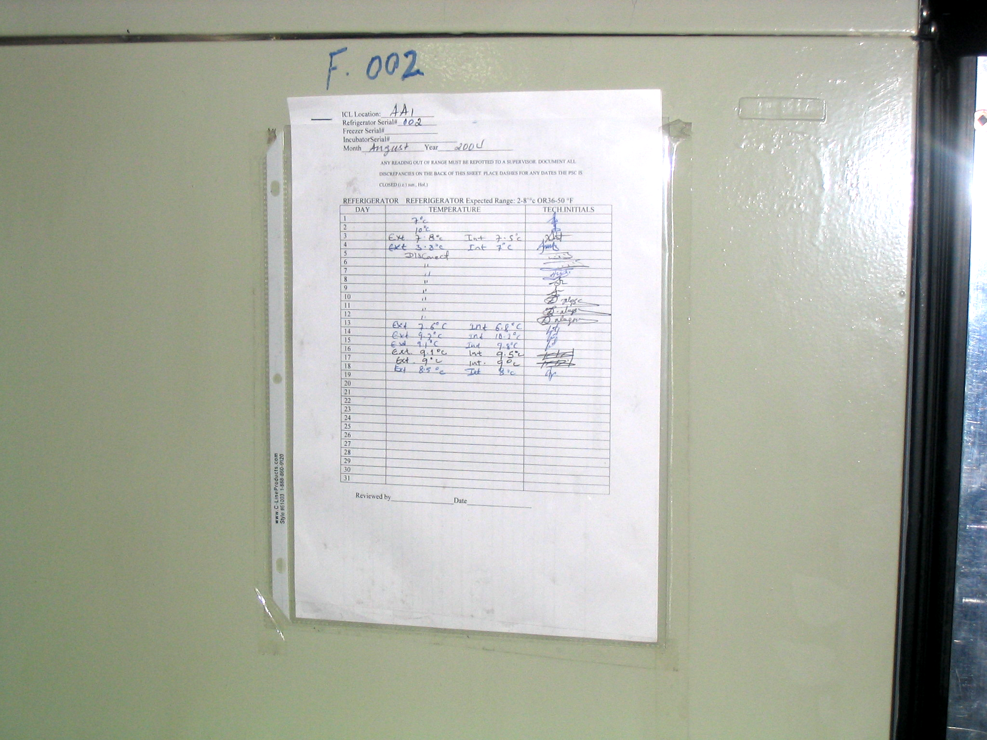
 | This photo illustrates routine monitoring of temperatures of this refrigerator. It is a good practice to attach the form for recording temperatures directly on the front of the refrigerator for easy access. Inserting it into a protector page will guard against tearing of paper.
Refrigerator & Freezer: Temperature Log | At the end of this module you will find a sample temperature log for your reference.
Types of Pipettes | 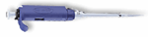  Precision Pipette | 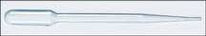  Graduated plastic bulb pipette
There are two types of pipettes: precision pipettes and graduated plastic bulb pipettes.
Precision pipettes dispense precise and accurate volumes (e.g., 50 µl for Determine). They are not disposable, but use disposable, single-use, pipette tips.
Graduated plastic bulb pipettes, on the other hand, dispense approximate volume, are easy to use, and are disposable.
Remember, never re-use disposable items. Doing so will cause cross contamination.

Pipette: Use and Care | What you need to do:  - Select the appropriate pipette for the volume required (for example, if 50 micro liters (µl) of specimen is required, use a 100 µl pipette)  - Ensure that the pipettor, tips, and specimen are at the same temperature  - Firmly attach tip  - Hold the pipette vertically when aspirating –  - Place tip just below the sample  - Avoid air bubbles  - Discard contaminated tips in appropriate container after completion of task
Never lay the pipette on its side when liquid is in the tip – doing so will cause the specimen to flow into to the pipette shaft and damage the pipette.
Air bubbles in the tip can greatly reduce pipetting accuracy. If an air bubble is trapped within the tip during intake, do the following:
- Dispense the sample into the original vessel
- Check the tip immersion depth
- Pipette more slowly
- If an air bubble appears a second time, discard the tip and use a new one.
Remember these safety practices:
- Carefully discard pipette tips in the appropriate container. Used pipette tips should not be found on the floor, as this poses a safety hazard.
- Never re-use a pipette tip, which causes cross contamination and will compromise patient results. A fresh tip should be used for each sample.
Precision Pipettes Require Performance Checks | Precision pipettes should be checked periodically for performance. You will need the following supplies: pipette, pipette tips, analytical balance, weigh boats, and distilled or deionzed water. The analytical balance should have a scale of 0.1 to 0.0001 mg.
Pipette: Steps for Checking Reproducibility | Performance checks include reproducibility and calibration. The procedures for checking reproducibility are described below:  - Pipette a series of 10 samples into a weigh boat on an analytical scale  - Record weight of each sample to calculate calibration results  - Verify calculated results are within limits  - If the results are not within limits, remove from service until appropriate adjustment can be made  - Decontaminate pipette and scale after use
  Range | Max/Min | Accuracy
  10 µl | + 1.0 µl | 10%
  100 µl | + 10.0 µl | 10%
  200 µl | + 20.0 µl | 10%
Pipette: Troubleshooting | See the following troubleshooting chart.
  Problem | Potential Cause | Action
  Leakage | Tip(s) incorrectly attached  Foreign articles between the tip and cone  O-ring damaged | Attach firmly  Clean tip cones  Change the O-ring
  Inaccurate dispensing | Incorrect operation  Tip incorrectly attached | Follow manufacturer’s instructions carefully  Firmly attach tip
Centrifuge: Use and Care | What you need to do:  - Always operate with the lids closed – Operating a centrifuge without the lid closed poses an unnecessary safety hazard.  - Balance contents before turning on. – For example, if there is only one sample to be centrifuged, a tube identical in size and volume must be placed in the rotor opposite the tube. Note: The rotor is the part of the centrifuge that holds the tubes and rotates during operation.  - Check for vibration – There may be several reasons why a centrifuge vibrates. When vibration occurs, you’ll need to:  - Stop operation of the centrifuge.  - Determine the cause of the noise or vibration.  - Correct immediately to prevent severe damage to the centrifuge or injury to the worker. Refer to the owner’s manual for possible causes aside from improper balancing  - Do not open the lid until the rotor has come to a complete stop  - Keep lids on tubes when spinning – Do not take the tops off the tubes before spinning. Doing so will cause splashing and creating of aerosols from potentially infectious material
Centrifuges: Function Checks | Separation activity is a function of both centrifugal force and timing. Proper balance, lubrication and rotor function are essential for proper centrifugation to occur. | 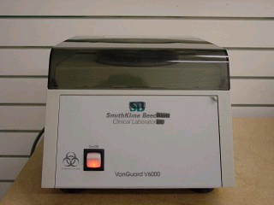
Centrifuge: Routine Maintenance | When cleaning the centrifuge:  - Clean interior daily with soap and water, wipe with a disinfectant  - Wipe spills using 10% bleach solution  - After cleaning, run the centrifuge at varying RPMs to check the braking mechanism and ensure a smooth gradual stop  When noticing unusual noises or vibrations:  - Stop operation of the centrifuge  - Follow manufacturer’s recommendation on activation and release of brakes  - Correct immediately to prevent severe damage to the centrifuge or injury to the worker  Inspect for evidence of wear, cracks in fitting, corrosion, uneven wear, or signs of fatigue by checking:  - Head, shaft head and coupling  - Rotor  - Brushes and bearings  - Power supply  - Motor and lubricant  - Gaskets, seals, mounts and lubricants  Brushes need to be inspected every 3-6 months and replaced according to manufacturer specifications.
Centrifuge Safety | Follow these safety rules when operating a centrifuge:  - Increase the speed slowly until optimal speed is reached  - Disconnect the centrifuge from the electrical source before preventive maintenance, cleaning or inspection  - Take caution when removing spills and broken specimen tubes after a run  - If tubes are broken, keep the door closed and allow to sit undisturbed for 30 minutes before attempting to clean  - Use tweezers to remove broken glass  Simply turning the power off does not remove power to the centrifuge.
Keep a Log for All Maintenance Activities | It is a good practice to keep a log to document problems, corrective action, preventive maintenance, cleaning, and inspections. At the end of the module, you will find a sample, generic maintenance log for your reference.
Exercise: Create a Maintenance Activity Log | Use what you have learned in this module and create a maintenance checklist specific to your test site.  Create a list of maintenance activities on a daily, weekly, monthly, and yearly basis

Key message | - Functioning equipment is vital to quality service  - DO NOT use malfunctioning equipment  - DO NOT store food items or beverages in laboratory refrigerator or freezer  - DO NOT re-use pipette tips or graduated plastic bulb pipettes

 | Module Review
Find out how much you have learned by answering these questions.
Why is it important to keep equipment in optimal condition?

Describe proper use and care for:
- Refrigerator and freezer
__________________________________________________________________ - Pipettes
__________________________________________________________________ - Centrifuges
__________________________________________________________________

What are some routine maintenance activities performed on:
- Refrigerator and freezer?
__________________________________________________________________ - Pipettes?
__________________________________________________________________ - Centrifuges?
__________________________________________________________________
Describe your responsibilities for equipment at the test site.
______________________________________________________________________________________________________________________________________________________________________________________________________

DAILY TEMPERATURE CHECK CHART FOR REFRIGERATOR/FREEZER/INCUBATOR # Thermometer # Temp set:
 | Month |  |  | Year
Date | Temp Observed |  | Initials |  | Comments
1
2
3
4
5
6
7
8
9
10
11
12
13
14
15
16
17
18
19
20
21
22
23
24
25
26
27
28
29
30
31
 |  |  | Supervisor: |  | (Initials)
 |  |  | Name:
 |  |  | Date:
 |  |  | Binder #
 |  |  | Storage Location
 |  | Document control No.

Generic Maintenance Form
Model no._____________ |  |  |  |  |  | Serial no.______
MONTH: | YEAR:
Daily Maintenance (Activity) | 1 | 2 | 3 | 4 | 5 | 6 | 7 | 8 | 9 | 10 | 11 | 12 | 13 | 14 | 15 | 16 | 17 | 18 | 19 | 20 | 21 | 22 | 23 | 24 | 25 | 26 | 27 | 28 | 29 | 30 | 31
Weekly Maintenance (Activity) | 1 | 2 | 3 | 4 | 5 | 6 | 7 | 8 | 9 | 10 | 11 | 12 | 13 | 14 | 15 | 16 | 17 | 18 | 19 | 20 | 21 | 22 | 23 | 24 | 25 | 26 | 27 | 28 | 29 | 30 | 31
Monthly Maintenance (Activity) | 1 | 2 | 3 | 4 | 5 | 6 | 7 | 8 | 9 | 10 | 11 | 12 | 13 | 14 | 15 | 16 | 17 | 18 | 19 | 20 | 21 | 22 | 23 | 24 | 25 | 26 | 27 | 28 | 29 | 30 | 31

