The Performance Management Toolkit

A Guide to Developing and Implementing
Performance Management Plans

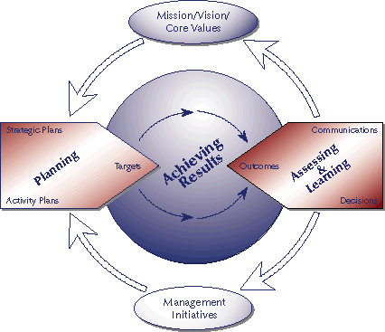

Policy and Program Coordination Bureau
Contract Number: AEP-C-00-99-00034-00
Last Revised: April 2003

Foreword

This Toolkit was originally developed in the summer and fall of 2000 to accompany the one-week USAID "Performance Management Workshop". To date, this workshop has been held over 30 times in Washington and all of the USAID regions and over 900 Agency staff have been trained. This version of the Toolkit was produced in April 2003 to reflect the changes in ADS Chapters 200-203 that went into effect on January 31, 2003.

We would like to acknowledge the technical and administrative support provided by the staff of the USAID Bureau for Policy and Program Coordination, especially Dan Blumhagen and John Haecker of the Center for Development Information and Experience.

We would also like to thank the staff of the USAID/Africa Bureau, particularly Kathie Keel and Ruth Buckley from the Office of Development Planning, Shirley Erves from the Regional Economic Development Support Office and Dana Ott from the Office of Sustainable Development. Their contributions, during various iterations of the Toolkit and its implementation during the pilot workshop, have been significant. In addition, the participants of the pilot workshop provided valuable insights and comments that contributed to the overall effectiveness of this Toolkit.

Also, we would like to thank Rita Owen and her colleagues from the Office of Human Resources/Learning Services for their cooperation and support. They have contributed significantly to the dissemination of these materials to hundreds of USAID staff.

And lastly, our sincere thanks to all of the Operating Units in the field and in Washington who shared their knowledge and experience with us during the development of their Performance Management Plans.

To all those who have contributed to this effort, we hope that this Toolkit will further the Agency's Managing for Results efforts and lead to more sustainable and effective programs that improve the lives of the people that USAID staff work so hard to serve.

Integrated Managing for Results Team
IBM Business Consulting Services
January 10, 2003

For more information about the Integrated Managing for
Results Contract, AEP-C-00-99-00034-00, contact: (1/10/03)
Dan Blumhagen, M.D., Ph.D., M.P.H.  Cognizant Technical Officer  USAID  1300 Pennsylvania Ave. NW  Washington, DC 20523  Office: 202-712-5816  dblumhagen@usaid.gov | Perry Pockros, Shiro Gnanaselvam  Program Managers  IBM Business Consulting Services  1616 North Fort Myer Drive  Arlington, VA 22209  Office: 703-741-1000  perry.pockros@us.ibm.com  shiranthi.gnanaselvam@us.ibm.com

FACING PAGE: This Toolkit is organized around a three-part process for developing and implementing PMPs. Each task is fully detailed with supporting materials, tools, and resources.

PMP Development and Implementation Process
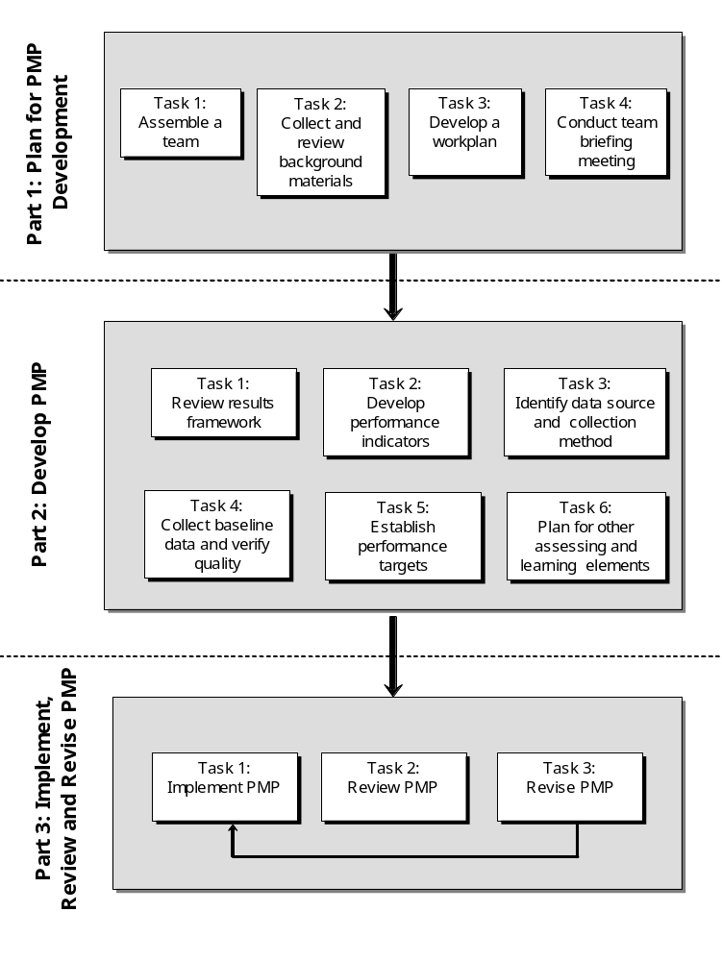
Table of Contents
Foreword iii
PMP Development and Implementation Process iv
Toolkit Quick Reference Guide viii
List of Acronyms x
Overview 11
Introduction to the Performance Management Plan (PMP) 11
How to Use This Toolkit 13
Part 1: Plan for PMP Development 15
Task 1 – Assemble a PMP development team 15
Task 2 – Collect and review background materials 16
Task 3 – Develop a workplan 17
Task 4 – Conduct team briefing meeting 18
Part 2: Develop the PMP 19
Task 1 - Review Results Framework 21
Key Definitions, ADS Guidance and Helpful Resources 21
1.1 Assess quality of results statements 23
1.2 Validate logic 24
1.3 Verify results are within USAID’s manageable interest 27
1.4 Ensure critical assumptions are identified 27
Task 2 – Develop Performance Indicators 29
Key Definitions, ADS Guidance and Helpful Resources 29
2.1 Develop list of potential indicators 30
2.2 Assess potential indicators 31
2.3 Select best indicators 38
2.4 Document indicators in the PMP 38
Task 3 – Identify Data Source and Collection Method 40
ADS Guidance and Helpful Resources 40
3.1 Identify potential data sources 41
3.2 Generate data collection options 42
3.3 Select data collection option 43
3.4 Develop data collection tools 45
3.4 Develop data collection tools 46
Task 4 – Collect Baseline Data and Verify Quality 47
Key Definitions, ADS Guidance and Helpful Resources 47
4.1 Collect baseline data 49
4.2 Conduct a data quality assessment 50
4.3 Build commitment to and capacity for quality 54
Task 5 – Establish Performance Targets 57
Key Definitions, ADS Guidance and Helpful Resources 57
5.1 Establish indicator targets 58
5.2 Input baselines and targets into performance data tables 59
Task 6 – Plan for Other Assessing and Learning Activities 61
Key Definitions, ADS Guidance and Helpful Resources 61
6.1 Plan for data analysis and use 67
6.2 Plan for performance reviews 68
6.3 Plan for evaluations and special studies 70
6.4 Plan for performance reporting 73
Conclusion 76
Part 3: Use, Review and Revise the PMP 78
Task 1 – Use the PMP 78
Task 2 – Review the PMP 79
Task 3 – Revise the PMP 80
Appendix A: Worksheets 81
Worksheet 1: PMP Development Team Skills Matrix 82
Worksheet 2: PMP Development Workplan 83
Worksheet 3: Results Statement Assessment 84
Worksheet 4: Results Framework Assessment 85
Worksheet 5: Performance Indicator Quality Assessment 86
Worksheet 6: Performance Indicator Reference Sheet 88
Worksheet 7: Data Quality Assessment Checklist 91
Worksheet 8: Summary Performance Data Table 97
Worksheet 9: Performance Management Task Schedule 98
Worksheet 10: Evaluations and Special Studies Planning 100
Worksheet 11: Evaluation Scope of Work (SOW) Planning 101
Appendix B: Helpful Hints 102
Helpful Hint 1: Facilitating Group Discussions and Decision-Making 103
Helpful Hint 2: Indicators for Hard-to-Measure Results 104
Helpful Hint 3: Performance Indicator Brainstorming Session 105
Helpful Hint 4: Rapid Low-Cost Data Collection Methods 106
Helpful Hint 5: Information Systems for Data Collection and Performance Monitoring 108
Helpful Hint 6: Key Features of Quality Data Sources 110
Helpful Hint 7: Tips to Minimize Bias 112
Helpful Hint 8: Tips for Communicating Performance Information in Reports 113
Helpful Hint 9: Questions to Guide Portfolio Reviews 114
Helpful Hint 10: Maintaining Official SO Team Files 116
Appendix C: Helpful Resources 117
Resources available on the Internet 117
USAID Economic and Social Data Service (ESDS) 121
Research and Reference Services (R&RS) 121
USAID Library and Learning Resources Center 121
Development Experience Clearinghouse 122
Appendix D: ADS 201.3.7.6 and ADS Chapter 203 123

Toolkit Quick Reference Guide
Use this guide to quickly identify key worksheets, techniques, and helpful hints.

Part 1: Plan for PMP Development

Tasks | Worksheets, Techniques, Helpful Hints
Assemble a PMP development team | Worksheet 1: PMP Development Team Skills Matrix
Collect and review background materials
Develop a workplan | Worksheet 2: PMP Development Workplan
Conduct a team briefing meeting

Part 2: Develop PMP

Task 1: Review Results Framework

Sub-tasks | Worksheets, Techniques, Helpful Hints
Assess quality of results statements | Worksheet 3: Results Statement Assessment  Worksheet 4: Results Framework Assessment  Technique: Assess Framework in a Facilitated Session  Helpful Hint 1: Facilitating Group Discussions and Decision-Making
Validate logic
Verify USAID's manageable interest
Ensure critical assumptions are identified

Task 2: Develop Performance Indicators

Sub-tasks | Worksheets, Techniques, Helpful Hints
Develop list of potential indicators | Technique: Use Current Resources to Identify Potential Indicators  Technique and Helpful Hint 2: Indicators for Hard-to-Measure Results
Assess potential Indicators | Worksheet 5: Performance Indicator Quality Assessment
Select best indicators | Technique and Helpful Hint 3: Performance Indicator Brainstorming Session
Document indicators in the PMP | Worksheet 6: Performance Indicator Reference Sheet

Task 3: Identify Data Sources and Collection Methods

Sub-tasks | Worksheets, Techniques, Helpful Hints
Identify potential data sources | Technique: Assess Results Framework in a Facilitated Session (also Helpful Hint 1)
Generate data collection options | Helpful Hint 4: Rapid Low-Cost Data Collection Methods
Select data collection option | Technique: Use Decision Chart to Select Best Data Collection Option  Worksheet 6: Performance Indicator Reference Sheet
Develop data collection tools
Task 4: Collect Baseline Data and Verify Quality

Sub-tasks | Worksheets, Techniques, Helpful Hints
Collect data | Technique: Storing Data in an Information Database, and Helpful Hint 5
Conduct a data quality assessment | Technique: Plan Data Quality Assessments  Worksheet 7: Data Quality Assessment Checklist  Technique: Assess Data from Data Sources, and Helpful Hint 6  Helpful Hint 7: Tips to Minimize Bias  Worksheet 6: Performance Indicator Reference Sheet
Build commitment to and capacity for quality | Technique: Foster Organizational Commitment

Task 5: Establish Performance Targets

Sub-tasks | Worksheets, Techniques, Helpful Hints
Establish baselines | Technique: How to Establish Baselines when Information is Inadequate
Establish indicators | Technique: Conduct a Target Setting Meeting  Helpful Hint 1: Facilitating Group Discussions and Decision-Making  Technique: Approaches to Target Setting
Input baselines and targets into performance data table | Worksheet 8: Performance Data Table

Task 6: Plan for Other Assessing and Learning Elements

Sub-tasks | Worksheets, Techniques, Helpful Hints
Plan for data analysis and use | Worksheet 9: Performance Management Task Schedule  Worksheet 6: Performance Indicator Reference Sheet  Helpful Hint 8: Tips for Communicating Performance Information in Reports  Technique: Chart Book Analysis Presentation Approach
Plan for performance reviews | Technique: Portfolio Review Approaches  Helpful Hint 9: Questions to Guide Portfolio Reviews
Plan for evaluations and special studies | Technique: Planning for Evaluations (also Helpful Hint 4)  Worksheet 10: Evaluations and Special Studies Planning  Worksheet 11: Evaluation Scope of Work Planning
Plan for performance reporting | Technique: Plan for Annual Report Reporting
Plan for ongoing data quality assessments | Technique: On-going Data Quality Assessments  Worksheet 7: Data Quality Assessment Checklist

Part 3: Use, Review and Revise PMP

Tasks | Worksheets, Techniques, Helpful Hints
Implement PMP | Helpful Hint 10: List of Official SO Team Files
Review PMP | Helpful Hint 9: Questions to Guide Portfolio Reviews
Revise PMP

List of Acronyms

ADS Automated Directives System

CDIE USAID Center for Development Information & Evaluations

CSP Country Strategic Plan

CTO Cognizant Technical Officer

DHS Demographic & Health Survey

GAO U.S. General Accounting Office

GIS Geographic Information System

IR Intermediate Result

M&E Monitoring and Evaluation

MFR Managing for Results

NGO Non-Governmental Organization

OMB Office of Management and Budget

PMP Performance Management Plan

PPC USAID Bureau for Policy and Program Coordination

PVO Private Voluntary Organization

SO Strategic Objective

TLA Three-Letter Acronym!

Overview

The purpose of this Toolkit is to provide USAID staff and partners with practical resources for a critical aspect of managing for results – developing and implementing a performance management plan (PMP). The emphasis of this Toolkit is on the how to of developing a PMP rather than a discussion of what is performance management, which is contained in the official programming policies—the USAID Automated Directives System Chapters 200-203.

The primary target audience for this Toolkit is the Strategic Objective (SO) teams who are responsible for developing the PMP. The objectives of this Toolkit are to help you (the team):

- Understand the purpose of a PMP
- Carry out preparations to develop a PMP
- Review results statements
- Develop performance indicators
- Collect performance data
- Verify performance data quality
- Analyze, evaluate and use performance information
- Implement and continuously improve the PMP

The Toolkit describes key performance management processes and provides tools and techniques that can be used to implement them. It provides examples to illustrate key points and identifies reference sources where additional information can be sought. Lastly, the Toolkit emphasizes the importance of documenting performance data and analysis. Documentation helps you:

- Ensure the availability of information you need to analyze and improve program performance
- Tell your story with confidence in the information you provide
- Explain your procedures to stakeholders who seek assurance that quality standards are being maintained in the collection and reporting of performance data.

Introduction to the Performance Management Plan (PMP)

What is a PMP?

A PMP is a performance management tool used by an Operating Unit and Strategic Objective (SO) team to help plan and manage the process of assessing and reporting progress towards achieving a Strategic Objective. It is a critical tool for planning, managing, and documenting how performance data is collected and used. A PMP serves to:
- Define specific performance indicators for each SO and IR, determine baselines and set targets
- Plan and manage the Annual Report data collection process to meet quality standards
- Incorporate relevant data collection requirements into activities and obligation agreements
- Plan potential related evaluative work to supplement Annual Report indicator data
- Estimate costs related to data collection and plan how these will be financed
- Communicate expectations to partner institutions responsible for producing the outputs intended to cause measurable changes in performance

A PMP contributes to the effectiveness of the performance monitoring system by assuring that comparable data will be collected on a regular and timely basis. Using the PMP to sufficiently document indicator definitions, sources, and methods of data collection increases the likelihood that you will collect comparable data over time - even when key personnel change. PMPs also support reliable data collection by documenting the frequency and schedule of data collection and assigning responsibilities.

What is contained in a PMP?

A PMP contains full documentation of the indicators used to track progress toward the Strategic Objective, their data sources, the quality of data available and responsibilities for collection and analysis of the data. There is no standard PMP format, however, you are encouraged to develop a comprehensive PMP that goes beyond the one-page matrix often encountered. Your PMP should help the team establish systems to monitor, evaluate, analyze, review, and report performance data. Agency guidance identifies required and recommended PMP elements.

ADS Guidance on PMP Elements

Contents of a Preliminary PMP (ADS 201.3.7.6)
- Propose performance indicators for the Strategic Objective-level result (with baseline data and ultimate targets).
- If possible, include performance indicators for the Intermediate Results (with baseline data and ultimate targets).

Mandatory Elements of a Complete PMP (ADS 203.3.3.1)
- At least one indicator to measure progress at the SO level with baseline data and performance targets
- At least one indicator to measure progress towards each IR with baseline data and performance targets

Additional Contents of a Complete PMP (ADS 203.3.3.1)
- Calendar of performance management tasks
- Statement of all performance indicators that will be used to assess progress over the life of the SO
- Baseline values and performance targets for each indicator
- Specification of the data source and collection method
- Specification of the schedule for data collection
- Description of known data limitations
- Description of the data quality assessment procedures that will be used to verify data quality

NOTE: More specific guidance applies to indicators that are reported to Washington

When is a PMP prepared?

You should begin planning for performance management early in the strategic planning process. ADS 201.3.7.6 provides that Operating Units must include a preliminary PMP when submitting a Strategic Plan or new Strategic Objective for approval. A complete PMP is required within one year of approving a Strategic Plan or new Strategic Objective. The PMP may be reviewed and approved by the Operating Unit director. You should review and update your PMP at least annually as part of the Portfolio Review and Annual Report preparation.

Usually, Operating Units and SO teams develop the PMP in three main stages as strategic planning and implementation proceed. Figure 0-1 illustrates the relationship between PMP development and the strategic planning process.
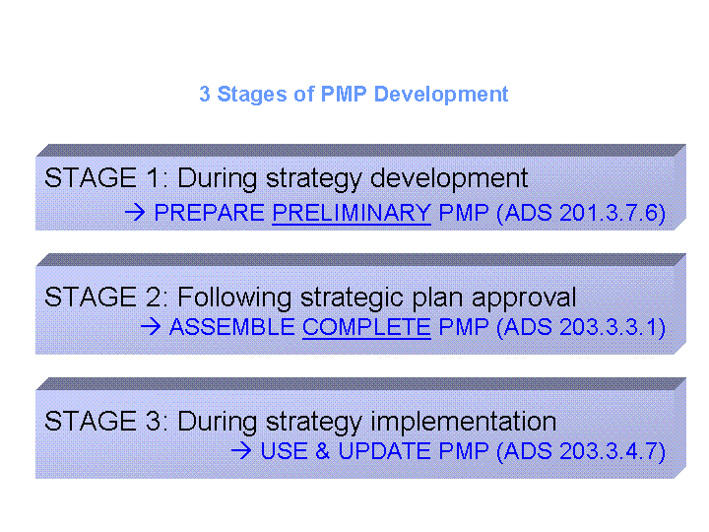

How to Use This Toolkit
The Toolkit is divided into three parts.
- Part 1 focuses on how to begin preparing for PMP development
- Part 2 focuses on how to develop a comprehensive PMP
- Part 3 focuses on how to implement and continually improve the PMP.

Each part includes information essential for establishing a system of using performance information to make program decisions. These icons can help you quickly navigate through the Toolkit:


KEY DEFINITIONS: Indicates key definitions for the relevant PMP development
phase.


WORKSHEET: Indicates that a tool is available to help you document PMP elements and analysis throughout the PMP development process. Examples of completed worksheets are frequently presented in the text. Blank copies of the worksheets can be found in the WORKSHEET appendix of the Toolkit.


TECHNIQUE: Indicates a technique (e.g., facilitating a brainstorming session, questions to ask) that you might consider using in order to complete a performance management process. Some of these techniques will refer you to additional information in the HELPFUL HINTS appendix.



CONSIDER THIS: Indicates questions or principles that you should consider in developing the PMP.


INFORMATION SERVICE: Indicates a contracted service available to USAID employees for procuring and analyzing data and information. More information about these resources, and others, are contained in the RESOURCES appendix.

The Toolkit also contains ADS EXCERPTS from relevant sections of the ADS, lists of helpful resources, and practical examples. The tools, techniques, and tips in this Toolkit provide a general approach to PMP development and implementation. You can and should consider tailoring Toolkit elements to meet the specific needs of the your program.

Part 1: Plan for PMP Development

Developing a useful PMP requires the time and attention of the entire SO team and many of your partners. Because it is a team effort, you will save time and effort during the development process by first conducting these four key preparation tasks:

Task 1: Assemble a team
Task 2:
Collect and review background materials
Task 3: Develop a workplan

Task 4: Conduct team briefing meeting

Task 1 – Assemble a PMP development team

A team approach to PMP development will help facilitate a shared sense of ownership among those who use the PMP, and bring creativity and innovation to developing each PMP element. The first step in the process is to designate a team leader. Designate leadership to one, or at most two, team members. The team leader will ensure the coordination of team meetings, collection and distribution of background materials, facilitation of discussions, and documentation of the PMP.

Once the team leader is identified, assemble the PMP development team. An effective team will have a balanced set of skills that include:
- Knowledge of USAID “managing for results” approach
- Experience in the relevant sector/sub-sector
- Educational background/training in the relevant sector/sub-sector
- In-depth knowledge of the target country and understanding of local conditions
- General knowledge of USAID structures, processes and culture
- Knowledge of performance measurement methodologies and best practices
- Strong facilitation, analytical and report writing skills

In most cases, these skills will be available within the SO team. In other cases, external help from another Operating Unit or contractor will supplement the existing skill sets. When you bring in external help, it is critical to maintain a team approach to PMP development. This means that external team members help fill in gaps in the PMP development team skill set, rather than duplicate skills that already exist on the SO team. This will ensure that the best possible PMP is produced at the conclusion of the exercise.

WORKSHEET 1 - PMP Development Team Skills Matrix: Use Worksheet 1 to help assemble the PMP development team. Table 1-1 presents a sample matrix to help you assess if you have assembled the team that you need.

Table 1-1. PMP Development Teams Skills Matrix

Name | Role | Knows USAID MFR approach | Has sector experience | Has sector training or education | Knows local conditions in-depth | Knows USAID structure, processes, culture | Knows PM methods and best practices | Has facilitation, analytical and report writing skills
1. Jane Smith | Team Leader |  |  |  |  |  |  | 
2. Sara Jones | Data collection |  |  |  |  |  |  | 
3. Fred Wilson | Data collection |  |  |  |  |  | 
4. Kate Thomas | Data analysis |  |  |  |  |  | 
5. T. Consultant | Data analysis |  |  |  |  |  |  | 

Task 2 – Collect and review background materials

You may want to gather and review some of the materials listed in Table 1-2. Having these materials available from the beginning will save time during the PMP development process.

Table 1-2. Other Resources for PMP Preparation (See Helpful Resources appendix for resource locations)
Agency Guidance | Operating Unit Specific Materials | Background Materials
- ADS Chapters 200-203  - TIPS Series (titles abbreviated):  6: Performance Indicators  7: The PMP  8: Performance Targets  12: Indicator and Data Quality  13: Results Framework | - Most recent Country Strategic Plan (CSP)  - Most recent Annual Report  - Relevant diagnostic studies, assessments or evaluations relating to the SO  - Preliminary PMP or Draft PMP  - Information/reports prepared by partners  - Strategic Plan approval cable from USAID/W  - Background information on likely data sources  - Other performance management information, e.g., IG reports, data quality assessments, guidance specific to the Operating Unit. | - Lists of indicators from Annual Report data base or SO-relevant handbook  - GAO, 1998, The Results Act – An Evaluator’s Guide to Assessing Agency Annual Performance Plans  - Harry Hatry, 1999, Performance Measurement – Getting Results

If your SO contains elements of policy reform or institutional capacity building, you may want to include TIPS 14: Monitoring the Policy Reform Process or TIPS 15: Building Institutional Capacity, with your background materials. (RESOURCES provides their location).
INFORMATION SERVICES:

- Economic and Social Data Service (ESDS): ESDS staff specialize in selecting the most appropriate quantitative data for specific research purposes. Access ESDS via CDIE Online at http://cdie.usaid.gov (accessible only within the USAID firewall; click 'Statistics' at the top of the homepage)
- Research and Reference Services (R&RS): R&RS staff help development practitioners clarify their information needs after which they identify, analyze and deliver appropriate information in a useful form. R&RS also manages the USAID Library and Learning Resources Center. Access R&RS via CDIE Online at http://cdie.usaid.gov (available only within the USAID firewall; click 'Research' or 'Library' at the top of the homepage)

Task 3 – Develop a workplan
WORKSHEET 2 – PMP Development Workplan: As you read through this task, refer to Worksheet 2 to help assemble the PMP development workplan. Project management software, such as MS Project, can also be used to develop the PMP workplan.

A workplan will help guide the team through the PMP development process. The workplan should document what needs to be done, due dates, and persons responsible for achieving each task. It is usually prepared by the team leader and one/two other team members. Developing a detailed work plan involves the following steps:

- Identify the major PMP development tasks: Often, the tasks of PMP development are defined by major deliverables that you will produce or major tasks that contribute to a deliverable. For example, major tasks may include:

- Review Results Framework
- Develop indicators and collection methods
- Collect data and verify quality
- Establish baselines and targets
- Plan for other assessing and learning elements
- Assemble draft PMP
- Review and revise the PMP
- Identify the sub-tasks: For each major task, identify the sub-tasks you will need to accomplish. For example, within "Plan for other assessing and learning elements" the sub-tasks may be:

- Plan for data analysis and use
- Plan for performance reviews,
- Plan for evaluations and special studies, etc.

- Estimate the time duration and the appropriate timing of each task or sub-task: Determine how long each sub-task will take to complete and when the task should commence. Base the projected duration of that task on reasonable expectations, weighing the workload and other responsibilities of the team against the need to assemble the plan in a reasonable timeframe. Make sure to leave adequate time for management reviews and check to be sure that outside reviewers are available during the time you want them to review the document. Also plan for the time needed to handle administrative matters such as contracting for services, etc.
Note, too, that in most cases developing a PMP from start to finish may not be possible over a period of consecutive days, and thus may have to be done in phases. For example, you may decide to proceed with reviewing the Results Framework and developing the performance indicators soon after the Strategic Plan has been approved. However, you may recognize that it would be better to collect baseline data and establish targets once a new contractor is in place in a couple of months. In this case the timing of these events should be reflected in the workplan.

- Assign resources to each sub-task: Identify which team members will work on each sub-task and any financial resources that will be needed to complete it.

- Validate the workplan with the SO team: Usually the workplan is developed by the team leader and one/two other team members. At this point, review the workplan informally with all SO team members to verify that the assumptions regarding tasks, timing and responsibilities are reasonable. Revise the workplan as needed.
- Complete any contracting plans as needed: Lastly, if you need to contract out for services to help develop the PMP, prepare a detailed scope of work specifying the final product, schedule, skill needs and expectations. Complete the contracting process in time for additional team members to be present at the Team Briefing Meeting (see Task 4).

Task 4 – Conduct team briefing meeting

Once the first three steps are completed, the team leader usually conducts a team briefing meeting to get the team on the same page, particularly in terms of the final product, the workplan, and assigned responsibilities. Focus on explaining the team leader’s expectations and clarifying team members concerns and questions. Also take the opportunity to introduce team members not familiar with one another. The team leader should bring copies of the materials to be discussed at the meeting. Figure 1-1 presents elements of a meeting agenda.
Figure 1-1. Briefing Meeting Agenda

- Purpose of the meeting
- Introductions
- Review and agree on the workplan
- Discuss expectations
- Agree on roles and responsibilities
- Questions and answers

Part 2: Develop the PMP

Part 2 of the Toolkit focuses on how to develop a comprehensive PMP. Each of the six tasks below have a number of sub-tasks associated with them. These will be explored in detail in the following pages.
Task 1:
Review results framework
Task 2:
Develop performance
indicators
Task 3:
Identify data source and collection method
Task 4:
Collect baseline data and verify data quality
Task 5:
Establish performance targets
Task 6:
Plan for other assessing and learning elements

Before discussing the PMP development process in detail, keep in mind some guiding principles for PMP development.
CONSIDER THIS – Guiding Principles of PMP Development:

- The PMP is the foundation for a sound performance management system. A good PMP is a useful tool for management and organizational learning - it provides intelligence for decision-makers, and thus serves as a constant desk reference to guide the assessment of results. A good PMP is updated annually to ensure maximum use for decision-making. The PMP is NOT something developed only to satisfy Washington and then left to collect dust.

- An effective monitoring system yields performance information that helps “tell your story” better. Your ability to communicate the achievement of development results and share lessons learned is dependent on your ability to collect useful performance information.

- Performance indicators are the basis of the PMP. Effective performance monitoring starts with indicators that are direct, objective, practical, and adequate. Indicators are useful for timely management decisions and credibly reflect the actual performance of USAID-sponsored activities.

- Performance monitoring is based on access to and use of data that is of reasonable quality given the reality of the situation. Your team’s management decisions should be based on data that is reasonably valid, reliable, and timely. Good performance monitoring systems include regular data quality assessments.

- A good PMP helps the SO team focus on what's important. The PMP provides the conceptual framework around which the SO team prioritizes and carries out its work. A PMP helps clearly assign accountability for results. It also outlines the mechanisms through which these results are shared both internally with employees and externally with partners and other stakeholders.
- Effective leadership makes for a smoother process. Every SO team member is responsible for the success of the SO. However, teams who work in Operating Units where the leaders of the unit (e.g., mission directors, SO team leaders, program officers) agree on the importance of a sound performance management system, and demonstrate its value by using it, will generally be more enthusiastic about participating in the process and using the information that results from it. Effective leadership also means creating a learning environment for results reporting that is seen by the staff as positive, not punitive.

CONSIDER THIS – Involve Customers, Partners and Stakeholders: Your customers, stakeholders, and partners will play an important role in performance management. As such, their participation deserves special mention as a guiding principal. Where appropriate, you should:

- Include stakeholders when developing Performance Management Plans and collecting, interpreting, and sharing information and experience

- Communicate Results Framework indicators to implementing partners and explain how their performance data feeds into the goals and objectives of the Operating Unit.

- Encourage implementing partners to use common definitions and descriptors of performance indicators

- Consider the special information needs of partners. Wherever feasible, integrate your performance monitoring and evaluation activities with similar processes of your partners

- Help partners develop their own performance monitoring and evaluation capacity

- Consider the financial and technical assistance resources needed to ensure stakeholder participation in performance monitoring and evaluation

Task 1 - Review Results Framework

The purpose of this task is not to develop a Results Framework from scratch. This would already have been done during the development of the Strategic Plan. In preparation for a PMP, however, it is often useful to conduct a quick review of Results Framework to validate the implied cause-effect relationships and ensure that all results are within USAID’s manageable interest. The process of reviewing results statements can be broken down into four sub-steps.

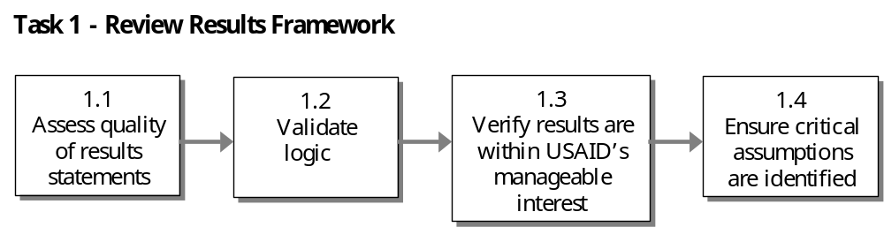

Key Definitions, ADS Guidance and Helpful Resources

KEY DEFINITIONS: The following definitions are relevant to this PMP development task:

- Result: A significant, intended, and measurable change in the condition of a customer, or a change in the host country, institutions or other entities that will affect the customer directly or indirectly. Results are typically broader than USAID-funded outputs, and required support from other donors and partners not within USAID’s control.

- Results Framework: A planning, communications and management tool, which conveys the development hypothesis implicit in the strategy and the cause-effect linkages between the Intermediate Results (IR) and the Strategic Objective (SO). A Results Framework includes the SO and the IRs necessary to achieve the SO, whether funded by USAID or its partners. It includes any critical assumptions that should hold for the development hypothesis to lead to achieving the relevant objective. Typically, it is laid out in graphic form supplemented by a narrative.

- Strategic Objective (SO): The most ambitious result that a USAID Operating Unit, along with its partners, can materially affect, and for which it is willing to be held accountable within the time period of the Strategic Objective. SOs can be designed for an Operating Unit to provide analytic, technical, logistical, or other types of support to the SOs of other Operating Units (whether bilateral, multi-country, or global in nature)

- Intermediate Result (IR): An important result that is seen as an essential step to achieving a Strategic Objective. IRs are measurable results that may capture a number of discrete and more specific results.

- Development Hypothesis: A narrative description of the specific causal linkages between IRs and a SO that are expected to lead to the achievement of the SO. They hypothesis is based on sound development theory, knowledge and experience within the context of a specific SO. Generally, the term refers to plausible linkages and not statistically accurate relationships

- Manageable Interest: The concept of manageable interest recognizes that achievement of results requires joint action on the part of many other actors such as host country governments, institutions, other donors, civil society, and the private sector. When an objective is within USAID’s manageable interest, it means we have reason to believe that our ability to influence, organize, and support others around commonly shared goals can lead to the achievement of desired results, and that the probability of success is high enough to warrant expending program and staff resources. A result is within an entity’s manageable interest when there is sufficient reason to believe that its achievement can be significantly and critically influenced by interventions of that entity.

ADS Guidance for Results Frameworks (ADS 201.3.7.3)

A Results Framework should:

- Succinctly capture the key elements of the development hypothesis for achieving a SO (program intent and content)
- Clearly state results at SO and IR levels
- Provide sufficient detail and causal linkages to diagram the development hypothesis
- Use results statements that are measurable and feasible during the planned life of the SO given anticipated resource levels
- Propose a preliminary PMP
- Incorporate critical assumptions
- Identify any results to be achieved through other SOs that would significantly support achievement of IRs in the Results Framework.

Helpful Resources to Learn More about Reviewing Results Frameworks

- ADS Chapter 201 - Planning (www.usaid.gov/pubs/ads/200/)
- TIPS13: Building a Results Framework (www.dec.org/pdf_docs/PNACA947.pdf)
- Handbook of Democracy and Governance Program Indicators (www.dec.org/pdf_docs/PNACC390.pdf)

Ideally, all of the tasks below can be best accomplished through a facilitated session of your entire SO team. The techniques and tools to help guide you through this process are:


TECHNIQUE – Assess Results Framework in a Facilitated Session: Conducting the quality assessment of a Results Framework in a facilitated session of your entire team ensures that all team members understand the logic and reasoning behind each result statement. Helpful Hint 1: Facilitating Group Discussions and Decision-Making provides some tips and techniques for facilitating group sessions.

WORKSHEETS 3 and 4– Results Statements Assessment and Results Framework Assessment: Refer to Worksheets 3 and 4 as you read through each of the tasks below. These worksheets can be useful for guiding the team through the facilitated discussion of each Results Framework element.

1.1 Assess quality of results statements

Good performance indicators start with good results statements that people can understand and agree on. Therefore, begin the PMP development process by reviewing SOs and IRs to make sure that each individual results statement is of good quality. Using Worksheet 3, you can determine if your results statement is:

- Measurable and objectively verifiable
- Meaningful and realistic
- Focused on USAID’s strategic commitments
- Customer or stakeholder driven
- Can be materially affected by the Operating Unit and its partners (within manageable interest)
- Statement of results – not an activity, process or output
- Uni-dimensional – not a combination of results

CONSIDER THIS – Rules of Thumb for Results Statement Review: Some rules of thumb to keep in mind when reviewing results statements are:

- Avoid overly broad statements. Which specific aspects of the result will program activities emphasize?

- State results as future completed actions. The statement should describe the end state that is desired as result of the activity.

- Use strong action verbs. This makes results easier to implement. Examples of strong action verbs are: constructed, eradicated, or reduced. Examples of weak action verbs are: enhanced, liaised, or coordinated.

- Be clear about what type of change is implied. What is expected to change -- a situation, a condition, the level of knowledge, an attitude, or a behavior? Is the expected change an absolute change, relative change, or no change?

- Identify more precisely the specific targets for change. Who or what are the specific targets for the change? Is change expected to occur among individuals, families, groups, communities, regions?

- Study the activities and strategies directed at achieving change. Is the expected relationship between activities and their intended results direct or indirect?

1.2 Validate logic

Causality

The linkages up the Results Framework should be causal -- achievement of one result is necessary for, and contributes to, achievement of the other. The causal connection between two IRs or between an IR and a SO in a Results Framework should also be direct. You should not need to infer additional IRs to understand the linkage between two results, or accept many or broad assumptions to move from a “lower” result to a “higher” result or SO.

Figure 2-1 illustrates this requirement for causal linkages within the Results Framework.
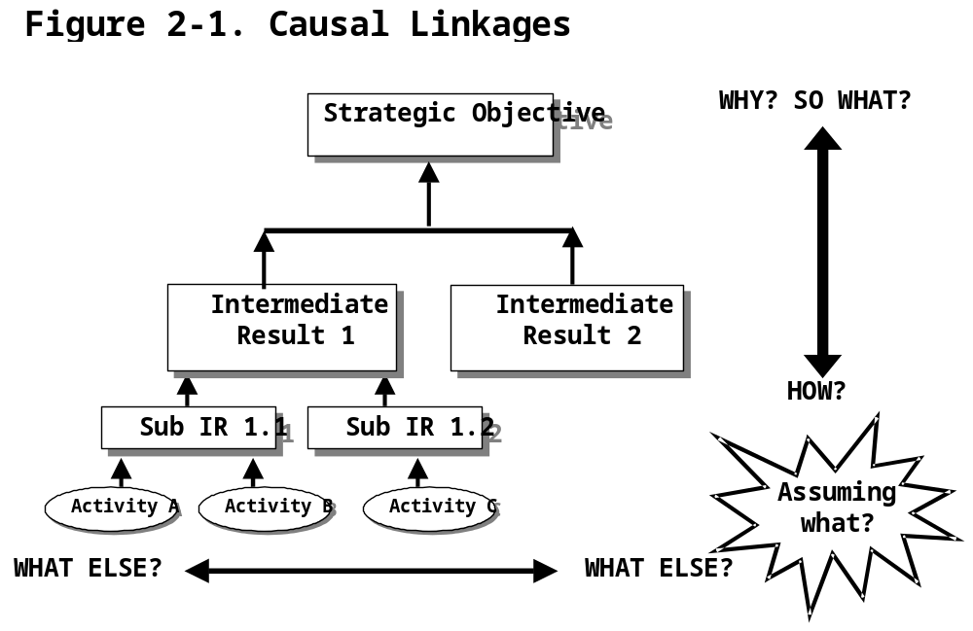

As you move up the framework, you should be able to answer the questions “why does this matter?” and “So what if we do this?” The result that emerges in response to those questions is the SO statement.

As you move down the framework, you should be able to answer the question “how do we cause this effect?” This question does not refer to the activities needed to achieve the result but to other Intermediate Results needed to achieve the higher-level result.

A problem that occurs commonly in results frameworks is that they are not set up with a causal logic. Instead, the relationship between the results is set up to be categorical, definitional or chronological. The next few paragraphs illustrate these three common logical flaws with examples and shows how they can be rectified.

In the first example, below, what is the difference between the SO-level result and the Intermediate Result? If your IR is a restatement or a clarification of your SO, then your IR is probably acting as a definition of another level. Instead, you want the lower level result(s) to cause the achievement of the higher-level result.

In the second example, below, the Intermediate Results are sub-categories of the SO-level result. As yourself how you would measure each of the four results statements on the left side. For each result statement, you would be measuring an aspect of “effective management”, but with a different kind of organization. If it sounds like the same indicator (just disaggregated for each result), then the levels of your results frameworks are probably categories of the same result. Instead, you want the lower levels of the results framework to cause the achievement of a higher-level result.

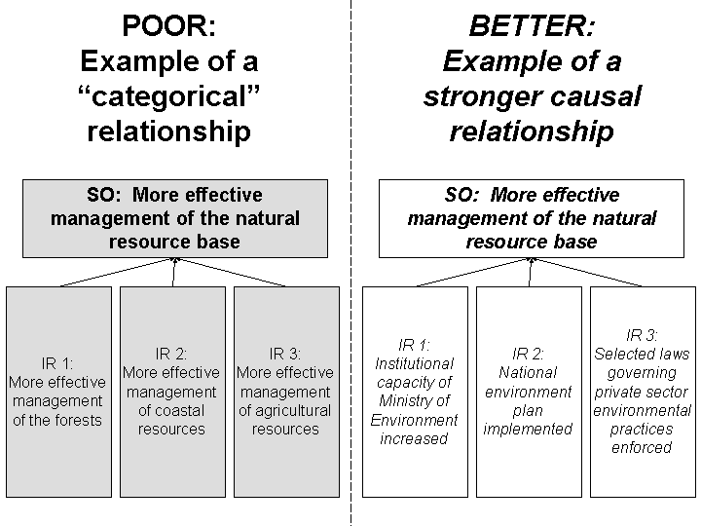
The third example, below, does not make it clear what specific problems or constraints the planners are trying to address to get to the key IR. The two sub-IRs are important steps in the process of arriving at IR 1, but they do not describe results that cause the IR 1. Although the lower level results may be more linked to specific activities, be careful that your results framework does not represent a chronological workplan of activities (first do step one, then do step two, then…). Instead, you want the lower levels of the results framework to cause the achievement of a higher-level result.

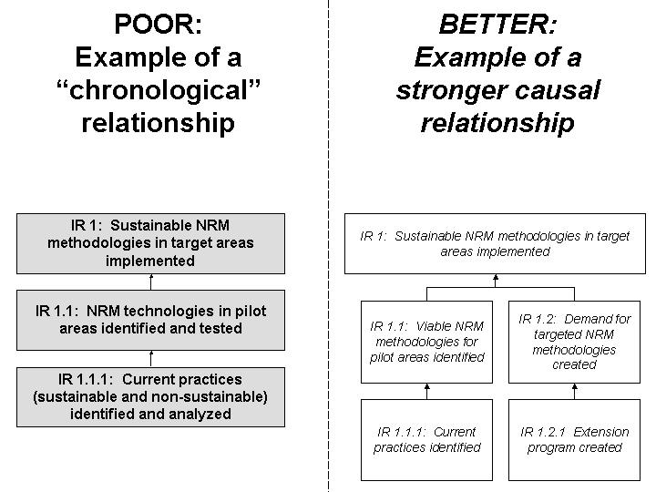

USAID partner results

As one moves across the IRs and sub-IRs of the framework, one should be able to answer the question “what else is required to achieve the above result?” The logic of the development hypothesis is strengthened when the Intermediate Results of other USAID partners have been considered. However, while it is essential to consider USAID partner results, it is not necessary that all of the Intermediate Results be reflected in the Results Framework itself. In fact, only the results that are most relevant and critical to achieving the SO may be included.

However, since SO teams are encouraged to document USAID partner results in the accompanying narrative to the Results Framework, you may want to refer to this documentation if there are any questions as to whether all of the critical results have been considered. In general, the more thoroughly and specifically the contributing Intermediate Results are determined, the stronger the logic of the hypothesis and the greater the chances of being able to manage activities for the achievement of the Strategic Objective.

1.3 Verify results are within USAID’s manageable interest

The ADS list of definitions (200.6.B) states that a result is within an entity’s manageable interest “when there is sufficient reason to believe that its achievement can be significantly and critically influenced by interventions of that entity.” Even though USAID recognizes that development outcomes require joint action on the part of many other actors than itself (e.g., host country governments, other donors, civil society), the Agency seeks to ensure that the objectives it sets for itself are within its own manageable interest. Manageable interest gives USAID reason to believe that its ability to influence, organize, and support others around commonly shared goals can lead to the achievement of desired results, and that the probability of success is high enough to warrant expending program and staff resources.

Verifying that all results within an Operating Unit’s Results Framework are within the Agency’s manageable interest holds managers accountable for the results stated in the Results Framework. Good results statements will reflect a realistic level of accountability. The SO is the highest result that the Operating Unit, working with its partners, can expect to materially affect and for which it is willing to be held accountable.

Poor Examples | Good Examples
SO: Broad-based sustainable economic growth | SO: Increased employment in the formal, off-farm private sector
SO: Reduced population growth | SO: Reduced fertility

As earlier discussed, the causal connections between the IRs and SO should also be reasonable.

Poor Examples | Good Examples
SO: Increased use of modern contraception  IR: Improved training of health care providers | SO: Increased use of modern contraception  IR: Increased availability of contraceptive services and commodities
SO: Increased off-farm employment  IR: Increased citizen’s skills for private sector development | SO: Increased-off farm employment  IR: Increased number of formal private sector enterprises

1.4 Ensure critical assumptions are identified

Every result involves risks (e.g., events, conditions, or decisions) that could cause it to fail. Risks outside the direct control of the SO team are called assumptions.

A critical assumption is defined as a general condition under which the development hypothesis or strategy for achieving the objective will hold true. Assumptions complete the “if/then” logic (describing the necessary conditions between each level) by adding the “if/AND/then” logic (describing the necessary and sufficient conditions between each level). You can determine the assumptions by asking the question “what conditions should exist in addition to my objectives in order to achieve the next level?’

CONSIDER THIS – Importance of Clarifying Critical Assumptions: As you identify critical assumptions that underpin your development hypothesis, keep in mind why clarifying critical assumptions is important to the PMP development process:

- Identifies what is beyond the program/activity manager’s control
- Provides shared judgment of the probability of success
- Promotes realistic program and activity design
- Improves communication between the program/activity manager and the SO team

At the planning stage, assumptions help identify risks that can be avoided by incorporating additional components into the Results Framework itself. In activity execution, assumptions indicate the factors that SO teams should anticipate, try to influence, and develop contingency plans for in case things go wrong.

Do not confuse critical assumptions that are outside the control of USAID and its partners, with results. Critical assumptions reflect conditions likely to affect the achievement of results in the Results Framework - such as the level of political commitment to women’s empowerment or the openness of export markets. A critical assumption differs from an IR in that the IR represents a focused and discrete outcome that specifically contributes to the achievement of the SO.

Be realistic when identifying critical assumptions and avoid defining critical assumptions that have a comparatively low chance of holding over the duration of the Strategic Plan. For example, an assumption such as no outbreak of war is surely an important condition, however, it does not help the design of the Results Framework. If a war were to occur, it is probably self evident that the program would suffer.

Finally, recognize that critical assumptions can be found at every level within the Results Framework. And remember that they should be continuously monitored to ensure that development hypothesis is built around valid assumptions.

Task 2 – Develop Performance Indicators

To manage for results, you need reliable and timely data. Performance indicators specify the data that the SO team will collect in order to measure program progress and compare actual results over time against what was planned. Performance indicators can also be used to:

- Orient and motivate operating unit staff toward achieving results
- Better communicate USAID achievements to host country counterparts, other partners and customers
- Clearly and consistently report results achieved to USAID stakeholders, including Congress, Office of Management and Budget, and citizens.

The process of developing performance indicators can be broken down into four sub-steps.
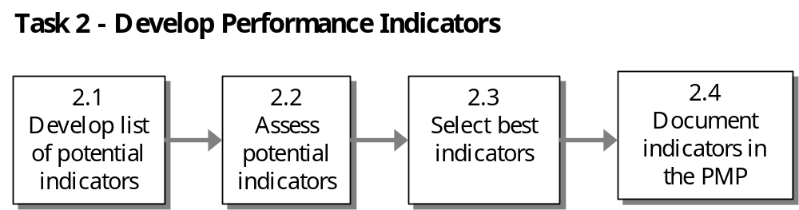

Key Definitions, ADS Guidance and Helpful Resources

KEY DEFINITIONS: The following definitions are relevant to this PMP task:

- Performance Indicator: A particular characteristic or dimension used to measure intended changes defined by a Results Framework. Performance indicators are used to observe progress and to measure actual results compared to expected results. Performance indicators help to answer “how” and “if” an Operating Unit or SO team is progressing towards its objective, rather than “why” such progress is or is not being made. Performance indicators may measure performance at any level of a Results Framework.

- Outcome: A result sought by USAID. In ADS Chapters 200-203, the term “outcome” is equivalent to “result”

- Output: A tangible, immediate and intended product or consequence of an activity within USAID’s control. Examples of outputs include people fed, personnel trained, better technologies developed and new construction. Deliverables included in contracts will generally be considered outputs, as will tangible products and consequences of USAID grantees.

Characteristics of Good Performance Indicators (ADS203.3.4.2)

Good performance indicators generally exhibit the following characteristics:

- Direct: An indicator should closely track the result it is intended to measure. When direct indicators cannot be used because of costs or other factors, a reasonable proxy indicator maybe used.
- Objective: Objective indicators are operationally precise and uni-dimensional. They should be unambiguous about what is being measured and what data are being collected.

- Useful for Management: Indicators should be useful for management purposes at relevant levels of decision making

- Practical: An indicator is practical if data can be obtained in a timely way and at reasonable cost.

- Attributable to USAID: Performance indicators should measure change that is clearly and reasonably attributable, at least in part, to the efforts of USAID. That is, indicators should credibly reflect the actual performance of the Strategic Plan.
- Timely: Performance data should be available when they are needed to make decisions.

- Adequate: Taken as a group, a performance indicator and its companion indicators should be the minimum necessary to ensure that progress toward the given results is sufficiently captured.

Helpful Resources to Learn More about Developing Performance Indicators

- ADS Chapter 203, www.usaid.gov/pubs/ads/200/200.pdf
- TIPS 6: Selecting Performance Indicators, www.dec.org/pdf_docs/pnaby214.pdf
- TIPS 12: Guidelines for Indicator and Data Quality, www.dec.org/pdf_docs/pnaca927.pdf
- TIPS 14: Monitoring the Policy Reform Process, www.dec.org/pdf_docs/pnaca949.pdf
- TIPS 15: Measuring Institutional Capacity, www.dec.org/pdf_docs/pnacn612.pdf and www.dec.org/pdf_docs/pnacg624.pdf
- Handbook of Democracy and Governance Program Indicators, www.dec.org/pdf_docs/PNACC390.pdf

2.1 Develop list of potential indicators

Each result usually has many possible indicators, some of which will be more appropriate and useful than others. Start with a list of potential indicators and then narrow down the list to a final set based on a set of criteria.

TECHNIQUE – Use Current Resources to Identify Potential Indicators: Tap information from some of these resources to help identify potential indicators.

- Your portfolio of activities
- USAID Annual Report Database (www.dec.org/partners/ardb/)
- USAID sector expertise (Pillar and Regional Bureaus; other Operating Units)
- Internal brainstorming by SO team
- Experience of other Operating Units with similar indicators
- External sector/regional experts
- Handbooks of sector indicators
- The Internet (for indicators used by other organizations)

The key to creating a useful list of potential indicators is to view the desired result in all its aspects and from all perspectives. Another best practice is to use a participatory approach in selecting performance indicators. Collaborating closely with development partners, host country counterparts, and customers at each step of the indicator selection process has many benefits. It makes good sense to draw on the experience of others and obtain their consensus throughout the process.

2.2 Assess potential indicators

Once the list of potential indicators is developed, assess each potential indicator. The quality of a potential indicator can be assessed to determine if it is:

- Direct
- Objective
- Useful for Management
- Practical
- Attributable to USAID and its partners
- Timely
- Adequate

WORKSHEET 5 – Performance Indicator Quality Assessment: In the following discussion, use Worksheet 5 to help document your assessment of each potential indicator.

DIRECT: The performance indicator should closely track the result it is intended to measure.

Poor Example (Direct) | Good Example (Direct)
Result: Increased conservation of natural habitats  Indicator: Number of park visitors | Result: Increased transfer of environmentally sustainable farming practices  Indicator: Number of farmers using X number of specific environmentally sustainable practices

If direct indicators are not feasible, then use credible proxy measures. Proxy indicators are an indirect measure of a given result.

Poor Example (Proxy Indicator) | Good Example (Proxy Indicator)
Result: Increased conservation of natural habitats  Direct Indicator: Number of park visitors  Proxy Indicator: Percent of park costs met from private sources | Result: Increased transfer of environmentally sustainable farming practices  Direct Indicator: Percent of farmers using X number of specific environmentally sustainable practices  Proxy Indicator: Number of farmers trained to use X number of specific environmentally sustainable practices.

OBJECTIVE: Performance indicators should be unambiguous about what is being measured. Thus, it should be uni-dimensional (should measure only one phenomenon at a time) and be precisely defined in the PMP.

Example (Precisely Defined) | Example (Uni-dimensional)
Result: Improved performance of export firms  Precise Indicator: % of export firms experiencing an annual increase in revenues of at least 5%  Imprecise Indicator: Number of successful export firms | Result: Improved access to basic education  Uni-dimensional Indicator: Primary school enrollment  Multi-dimensional Indicator: Primary school enrollment and literacy rates

USEFUL FOR MANAGEMENT: Performance indicators should be useful for the relevant level of decision-making (at the SO team, Operating Unit or Agency level). Avoid collecting and reporting information that is not used to support program management decisions. As discussed in ADS 203.3.2, Operating Units usually have varying information needs for decision-making depending on where the Operating Unit is in implanting the SO.

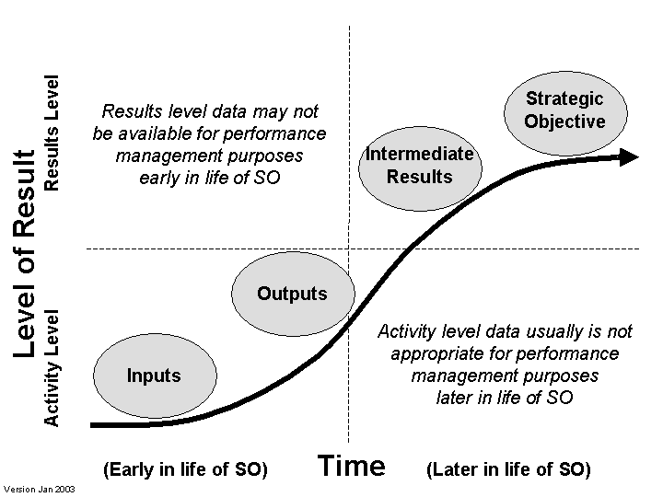

PRACTICAL: Operating Units should select performance indicators for which data can be obtained at reasonable cost and in a timely fashion. Data that are very costly to procure are of limited use. Data collection costs, in terms of both human and financial resources, is an important consideration. In general, the cost of collecting data for an indicator should not exceed the management utility of the data. A good rule of thumb is that costs to an Operating Unit for performance monitoring and evaluations should normally range between three to ten percent of the total budget for the Strategic Objective (see ADS 203.3.2.2).

ATTRIBUTABLE TO USAID AND ITS DEVELOPMENT PARTNERS: Performance indicators included in the PMP should measure changes that are clearly and reasonably attributable, at least in part, to USAID efforts. Attribution exists when the outputs produced by USAID financed activities have a logical and causal effect on the results being measured by the performance indicator. Attribution is based upon a solid and credible development hypothesis that is reflected in the Results Framework, combined with a strong causal link between outputs of activities and the Intermediate Results measured.

Indicators Attributable to USAID
A simple way to assess attribution is to ask the question:
- If there had been no USAID activity, would the result have been different?

If the answer is “no,” then there is likely an attribution issue and a more suitable indicator should be sought.

TIMELY: Performance information should be available when it is needed to make management decisions.

The necessary timeliness of the data really depends upon the nature of the decision to be made though experience suggests that information for managing activities should be available on a quarterly basis.

In some cases—humanitarian crises, for example—daily information may be required. For most routine SO team level decisions, however, data should be regularly available from performance monitoring systems. Even data that are available on an annual basis may not be as useful for addressing routine management issues as data that are available more frequently.

Data that are collected infrequently (every 2-5 years), or with a substantial lag time (longer than a year), may be useful for tracking long-term trends and confirming the accuracy of lower-level data. Such indicators should be supplemented with other performance indicators (direct or proxy), which are able to reflect program performance on a more frequent basis.

ADEQUATE: The PMP should contain only as many indicators as are necessary and cost effective for management and reporting purposes.

Strike a balance between having too many indicators, which can increase the cost of collecting, and analyzing the data, and too few indicators, which could be insufficient to assess progress. The general rule of thumb is two to three indicators per result, but this may differ depending on the:

- Complexity of the result being measured
- Level of resources available for monitoring performance
- Amount of information needed to make reasonably confident decisions

Poor Example (Adequate) | Good Example (Adequate)
Result: Increased use of child survival services  Indicator: DPT3 vaccination rate | Result: Increased use of child survival services  Indicator: DPT3 vaccination rate  Indicator: Oral rehydration therapy use rate  Indicator: Acute respiratory infection case management rate

CONSIDER THIS: Reflecting Gender Considerations in Performance Indicators

Men and women have different access to development programs and are affected differently by USAID activities. USAID seeks to understand these differences, to improve the efficiency and overall impact of its programs, and to ensure that both women and men have equitable access to development activities and their benefits.

Agency guidance (ADS 203.3.4.3) provides that performance management systems and evaluations at the SO and IR levels SHOULD include gender-sensitive indicators and sex-disaggregated data when the technical analyses supporting the SO, the IRs or the activities demonstrate that:

- The activities or their anticipated results involve or affect women and men differently
- This difference is potentially significant for managing towards sustainable program impact.

Poor Example (Disaggregated) | Good Example (Disaggregated)
SO: Increase foreign exchange revenues  IR: Increased tourism receipts  - Number of male tourists  - Number of female tourists | SO: Increased agricultural production  IR: Increased adoption of improved production technologies  - Number or % of male-headed farm households adopting improved technology  - Number or % of female-headed farm household adopting improved technologies

If it is too difficult to track and report sex-disaggregated data, the Agency encourages Operating Units to use performance indicators that may assess gender impact indirectly.

Operating units should also consider gender when determining how data will be collected. For example, using only men to collect data may not yield an accurate data set if societal norms restrict social relations between the sexes.

Table 2-1 demonstrates how indicator data can be disaggregated.

Table 2-1. Data Disaggregation and Analysis, by Indicator

Performance Indicator: | Analyze by: |  |  |  | Additional Analysis by:
Performance Indicator: | Aggregate | Activity | Gender | Youth / Adult | Additional Analysis by:
IR 3.1.1 Vulnerable Communities Better Able to Meet Their Own Needs
- Value of external contributions to community development projects, by source | ✓ | ✓ |  |  | Cash, Material, Labor, Source
- Number of community development projects completed | ✓ | ✓ |  |  | Project Type, Region
- Number of direct beneficiaries under IR 3.1.1 | ✓ | ✓ | ✓ | ✓ | Intervention Type

CONSIDER THIS – Quantitative versus Qualitative Indicators: The concept of quantitative versus qualitative indicators has been a subject of frequent discussion over the past few years. New Agency guidance indicates a shift away from the approach that indicators should be quantitative rather than qualitative. Because quantitative indicators are numerical (e.g., number or percentage of dollar value, tonnage) versus the descriptive, qualitative indicators (e.g., description of the status of an intended result, analysis of documents, documented observations, representative case descriptions), their numerical precision tends to lead to more agreement on the interpretation of results. However, qualitative indicators can supplement the numbers and percentages with a richness of information that brings a program’s results to life.

Agency guidance (ADS 203.3.4.1) states that indicators may be quantitative or qualitative. You are expected to select the type of indicator that is most appropriate for the result being measured. If a qualitative indicator is determined to be most appropriate, you should:
- Clearly define each term used in the measure
- Make sure to document all definitions
- Find other ways (such as using rating scales) to minimize subjectivity

Quantitative vs. Qualitative Indicators
When selecting indicators, ask yourself:

- Can we get meaningful information by using quantitative indicators?
- Can we get objective, convincing information by using qualitative indicators?
- Can we quantify our qualitative indicators without losing important information?
- Do we need a mix of the two?

TECHNIQUE – Use Scales, Indexes, and Scorecards for Hard-to-Measure Results: Helpful Hint 2: Indicators for Hard-to-Measure Results describes several methods that can be used to develop indicators that quantify complex results. The methods are: rating scales, milestone scales, indexes, and scorecards. These tools help to introduce a measure of objectivity to inherently subjective measures. When using scales, indexes, and scorecards, keep in mind validity and reliability. Figure 2.3 presents an example of rating system that converts a qualitative assessment to a quantitative indicator.

Figure 2-3. Transforming Qualitative Data into Quantitative Performance Measures

To measure an IR that emphasizes improvements in quality of maternal and child health services, USAID/Yemen devised a scale that transforms qualitative information about services into a rating system against which targets can be set:

0 points = Service not offered
1 point = Offers routine antenatal care
1 point = Offers recognition and appropriate management of high risk pregnancies
1 point = Offers routine deliveries
1 point = Offers appropriate management of complicated deliveries
1 point = Offers post-partum care
1 point = Offers neonatal care

Score: Total actual service delivery points
Total possible service delivery points

(Adapted from TIPS 8 – Establishing Performance Targets)

Another interesting example of how to document progress towards results is the approach used by USAID/Mozambique in the early 1990's. This approach is presented in Figure 2.4.

Lastly, TIPS 14: Monitoring the Policy Reform Process (www.dec.org/pdf_docs/pnaca949.pdf) and TIPS 15: Measuring Institutional Capacity (www.dec.org/pdf_docs/pnacn612.pdf) provide detailed guidance for selecting indicators that measure progress in the areas of policy reform and institutional capacity building.

Figure 2.4 Performance Monitoring Challenge: War-to-Peace Transition
USAID/Mozambique, 1992-1995
Our Problem
How to monitor an array of people-level changes across a vast territory, in the absence of transport and communications infrastructure, data sources, and security?

Our Solution
- Select a small number of sites that can be visited safely
(we chose six providing a range of “baseline” conditions: north/center/south; isolated/accessible; more or less affected by war/drought)
- Mobilize existing staff to form a small team for each site that crosses all technical/ sectoral lines; schedule regular visits; arrange logistics so trips are short and easy as possible
(3-person teams worked well; only 2 of the 3 ever needed to travel at one time; Americans were balanced with FSN/TCN staff; tried not to put two agriculture or two health staff on the same team; quarterly visits worked best)
- Develop a simple site visit guide, covering all topics of interest, to be used systematically by teams visiting all sites to “tell the story”
(ours included (i) questions to ask a key informant about the overall situation in the site, (ii) questions to ask a “typical” person about his own circumstances/perceptions, and (iii) observations for the monitors to make during each visit; together these addressed food security, health and nutrition, crops, access/transport, water, resettlement of displaced persons, perceptions of security, openness of political activity, schools, market development, land mines, demobilization/reintegration of combatants, intention to vote, etc.)
- Take lots of photographs -- gave each team an easy-to-use camera and lots of film/data disks; gave monitors ideas of what to photograph - encouraged them not to be shy; developed film/downloaded images and captioned them immediately after the trip; used pictures in as many ways as possible
(“before and after” times series proved extremely important to our tracking, e.g. in one site a crossroads sign photographed quarterly was isolated and overgrown at the first visit but the center of a bustling truck/bus stop 18 months later, and our photographs showed every phase in this transformation; anything that strikes the monitor’s eye should be snapped, our high-impact images included beaming women showing off voter registration cards, food-for-work crews clearing 15-year-old trees from the middle of long-disused roads, etc.)
- Insist on prompt reports on each visit, but allow lots of latitude for report format
(ours ranged from 12-page narratives to bulleted phrases in an email, but all were useful; the key is to get the report within a day of the team’s return and circulate it widely; encourage monitors to report statistics when they find them, but also to report and use qualitative information, since “the plural of anecdote is data”)
- Organize occasional “all-Mission” meetings to talk about the trends and implications of what the teams are reporting from the different sites
(such sessions proved crucial as the transition period advanced and decisions needed to be made about moving from emergency relief approaches to “development” approaches; they also gave us a head start on developing our post-transition Strategic Plan)

The photographs and qualitative information we collected proved useful well beyond our Mission-level program management and results reporting. CDIE and other Agency units used our photographs and anecdotes to illustrate reports, evaluations, etc. We’ve now digitized the 1400-images and created a set of three CDs, retiring the photos while still accessing the images easily.

It didn’t work perfectly. Some monitoring teams fell apart at various points, especially as staff changed. Their performance varied considerably over the three years. It was difficult to shift gears from this approach to the formal “statistical” PMPs as we began our post-transition Strategic Plan in 1996. An investment in costly household surveys was needed to establish baselines. But overall this proved to be a richly rewarding approach to monitoring.

Prepared 3 October 2000; for more information contact Juliet Born at USAID/Mozambique (juborn@usaid.gov)

2.3 Select best indicators

The next step is to narrow the list to the final indicators that will be used in the performance monitoring system. They should be the optimum set that meets the need for management-useful information at a reasonable cost.

TECHNIQUE – Select Best Indicators in a Brainstorming Session: Involve all SO team members in selecting indicators using a facilitated approach. Helpful Hint 3: Performance Indicator Brainstorming Session has tips on facilitating the performance indicator selection session. Use your completed copies of Worksheet 4 to guide the team’s discussions. Continue to use a collaborative approach when selecting the best indicators. Obtain input from all members of the SO team, your partners, sector experts and data collection experts.

Be selective. Remember the costs associated with data collection and analysis. Limit the number of indicators used to track each objective or result to a few (two or three). Select only those that represent the most basic and important dimensions of project aims.

If you find that a performance indicator does not meet all the criteria earlier discussed, you may revisit the indicator and revise it to meet the criteria. Otherwise, you will need to identify alternative indicators.

2.4 Document indicators in the PMP

Proper documentation will facilitate the maintenance of quality performance indicators and data.

WORKSHEET 6 – Performance Indicator Reference Sheet: Use Worksheet 6 to complete the SO/IR/Indicator section and the "Description" section. Note that Worksheet 6 behind the “Worksheets” tab, also includes detailed instructions for filling out the indicator reference sheet. By the end of Part 2 you will have completed the remaining sections of the worksheet. Table 2-2 presents an example of a completed performance indicator reference sheet.

Table 2-2: Example of a completed Performance Indicator Reference Sheet (Worksheet 6)
Strategic Objective 5: Increased Opportunities for Domestic and Foreign Investment
Intermediate Result 5.2: Strengthened capacity of selected institutions to foster private enterprise
Indicator 5.2c: Revenue generated by fee-based services at targeted associations
DESCRIPTION
Precise Definitions:
Revenue means income from fee-based services. General membership fees cannot be counted. Fee-based services mean any training, workshop, publication, or internet based service that is offered to the association’s entire membership (or segments of its membership) and for which a fee is levied. Targeted associations are AAA, BBB, and CCC. Members can be individuals and/or associations (and their members) that are members of the targeted association.
Unit of Measure: peso
Disaggregated by: Name of each association
Justification/Management Utility: An increase in revenues from services to members is a direct measure of improved capability of the association to offer services that are valued (demonstrated by willingness of members to pay for the service) by its membership.
PLAN FOR DATA ACQUISITION BY USAID
Data Collection Method: Implementing partner conducts document review of internal records of targeted associations
Data Source(s): Implementing partners XXX and YYY
Method of Acquisition by USAID: Semi-annual monitoring reports from implementing partners submitted to USAID activity manager, with the above information, brief analysis, and detailed back up.
Frequency & Timing of Data Acquisition: Semi-annually, January 31 and July 31.
Estimated Cost of Data Acquisition: Low cost – part of data collection by targeted associations & implementing partners
Individual(s) responsible at USAID: Jane Doe, Activity Manager
Individual responsible for providing data to USAID: Raj Patel, Project M&E specialist
Location of data storage: MS Excel File (S:\SO2\EG PMP\EG Performance data table.xls)
DATA QUALITY ISSUES
Date of Initial Data Quality Assessment: See Assessment Report “Data Quality Assessments for Annual Report Indicators,” for details.
Known Data Limitations and Significance (if any): For association BBB, initial data quality assessment revealed that revenue from services had been erroneously included with fee revenue in the baseline data. Transcription error was not material but was corrected immediately.
Actions Taken or Planned to Address Data Limitations: Error in data was corrected.
Date of Future Data Quality Assessments: Q2 FY 2003
Procedures for Future Data Quality Assessments: Incorporate into normal activity monitoring; schedule with activity monitoring field visit; review partner back-up data; interview responsible individuals in targeted associations.
PLAN FOR DATA ANALYSIS, REVIEW, & REPORTING
Data Analysis: Summary data for all associations analyzed and summarized by USAID
Presentation of Data: Bar or line graphs showing targets and actuals as well as disaggregation as noted above.
Review of Data: Annual review of data by EG SO team during Portfolio Review; annual review by …..(insert name of activity manager) with target associations.
Reporting of Data: Annual Report data tables and narrative; Activity Implementation Reviews (AIRs), Annual Portfolio Review.
OTHER NOTES
Note on Baselines/Targets: Original baseline collected was not for entire CY2000. Recommend baseline data be collected in Jan 2001 and replace data collected in Nov 2000. (Note: Done in Jan 01). Targets will need to be set with partners.
Other Notes: None.
PERFORMANCE INDICATOR VALUES
Year | Target | Actual | Notes
2000 |  | Peso 400,000 | Covers full CY 00. Collected Jan 01.
2001 | Peso 600,000 | Peso 565,000
2002 | Peso 1,000,000 | Peso 980,000
THIS SHEET LAST UPDATED ON: 4/08/03

Task 3 – Identify Data Source and Collection Method

Data can be gathered and collected from a variety of sources using a variety of methods. Some methods are hands-on and highly participatory, while others are more exclusive and rely on the opinion of one or two specialists. In most cases, it is best to use more than one data collection method per SO. The process of identifying quality data sources and developing data collection methods can be broken down into four sub-steps (see Task 3).
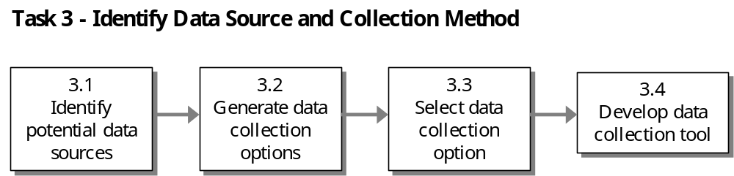

ADS Guidance and Helpful Resources

Good Practices in Data Collection (ADS 203.3.5.3c)

- Data are collected using methods to address and minimize sampling and non-sampling errors
- Written procedures are in place for data collection
- Data are collected by qualified personnel, and personnel are properly supervised
- Data are collected using a consistent collection process from year to year
- Safeguards are in place to prevent unauthorized changes to the data
- Source documents are maintained and readily available
- Duplicate data are detected

Helpful Resources to Learn More about Data Collection

- ADS Chapter 203, www.usaid.gov/pubs/ads/200/203.pdf
- TIPS 1: Conducting a Participatory Evaluation, www.dec.org/pdf_docs/pnabs539.pdf
- TIPS 2: Conducting Key Informant Interviews, www.dec.org/pdf_docs/pnabs541.pdf
- TIPS 3: Preparing an Evaluation Scope of Work, www.dec.org/pdf_docs/pnaby207.pdf
- TIPS 4: Using Direct Observation Techniques, www.dec.org/pdf_docs/pnaby208.pdf
- TIPS 5: Using Rapid Appraisal Methods, www.dec.org/pdf_docs/pnaby209.pdf
- TIPS 10: Conducting Focus Group Interviews, www.dec.org/pdf_docs/pnaby233.pdf
- TIPS 11: The Role of Evaluation in USAID, www.dec.org/pdf_docs/pnaby239.pdf
- TIPS 12: Guidelines for Indicator and Data Quality, www.dec.org/pdf_docs/pnaca927.pdf
- Department of Energy, “The Performance-Based Management Handbook, Volume 4: Collecting Data to Assess Performance”, www.orau.gov/pbm/pbmhandbook/pbmhandbook.html
- Kumar, Krishna, “Rapid, Low-Cost Data Collection Methods for USAID,” December 1987, www.dec.org/pdf_docs/PNAAL100.pdf
- CDIE Resource Book on Strategic Planning and Performance Monitoring Under Re-engineering, “Common Problems/Issues with Using Secondary Data,” April 1997, [DEXS Document #PN-ACH-632]

3.1 Identify potential data sources

For each selected performance indicator, SO teams should explore what data sources are available (or might be available if the indicators are conceptualized in different ways). Only indicators for which it is feasible to collect data in a given country should be used.

TECHNIQUE – Identify Potential Data Sources in a Facilitated Session: Facilitate a brainstorming session (see Helpful Hint 1: Facilitating Group Discussions and Decision-Making) or hold individual discussions with the following resources in order to help identify potential data sources:

- USAID: Use primary data collected by the SO team or through independent entities contracted for this purpose.
- Implementing partners: Data often come from management information such as periodic reports, service statistics, etc.
- Secondary sources: Includes government ministries, the United Nations, and international agencies, and are usually not under USAID control. This means that USAID does not have the right to audit the data or investigate data quality in depth.

INFORMATION SERVICES: The following services may be useful for identifying potential secondary sources of data.

- Economic and Social Data Service (ESDS): ESDS staff specialize in selecting the most appropriate quantitative data for specific research purposes. Access ESDS via CDIE Online at http://cdie.usaid.gov (available only within the USAID firewall; click 'Statistics' at the top of the homepage)
- Research and Reference Services (R&RS): R&RS staff help development practitioners clarify their information needs after which they identify, analyze and deliver appropriate information in a useful form. R&RS also manages the USAID Library and Learning Resources Center. Access R&RS via CDIE Online at http://cdie.usaid.gov (available only within the USAID firewall; click 'Research' or 'Library' at the top of the homepage)

SO teams often rely on data collected by implementing partners and secondary sources. Figure 2-5 illustrates these three sources of performance data and their relationships to cost and USAID control over quality.

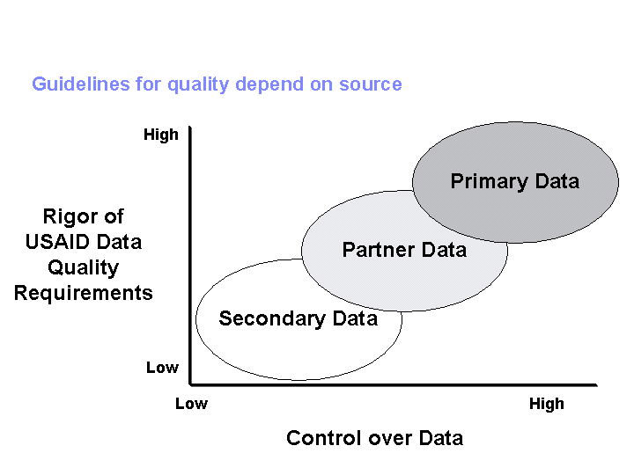

Determining appropriate potential sources of data will require conversations with people knowledgeable about various data sources (partners, government statistical or service agencies, public opinion survey organizations, university social science research centers, etc.). These contacts will help you to understand:

- What data are already being collected
- Whether existing data would be appropriate for a candidate indicator
- Whether the candidate indicators are relevant and feasible for the situation
- What alternatives may work

Grantee and contractor programs often also include data collection to monitor their activities, which may provide potential data sources for the result’s indicators. If there are no feasible or reliable sources available, then consider proxy indicators for which good data will be available.

3.2 Generate data collection options

There are a number of data collection methods available. Some of the most commonly used methods are known as Rapid Low-Cost Data Collection Methods. These methods are often the preferred choice for SO teams when cost and timeliness are important. These methods are usually conducted by third party interviewers and/or observers who are skilled in conducting and facilitating various types of interviews and meetings. These methods include:

- Focus group interviews: Small-group, facilitated session designed to quickly gather in-depth information while offering stakeholders a forum for direct participation.

- Key informant interviews: In-depth discussions with person(s) who are knowledgeable on a specific topic.
- Community interviews: Meetings conducted on a specific topic that are open to all members of a village/community.
- Direct observations: Intensive and systematic observations of a phenomenon or process in its natural setting. May also include interviews with key informants.
- Informal surveys: Informal surveys differ from formal, or sample, surveys in that they: focus on few variables, use a small sample size, use non-probability sampling, and thus typically permit more flexibility to interviewers in the field.

Helpful Hint 4: Rapid Low-Cost Data Collection Methods provides some additional insights into these data collection methods.

Other data collection methods you may want to consider are:

- File review: Reviewing data that has been previously collected and is present in the program files, or other program documentation. This type of review offers a relatively quick method to discover what data has already been collected with an eye toward minimizing the need for additional data collection and the costs associated with that data collection effort.

- Case study: A research method that uses extensive description and analysis of a complex situation studied in its context to answer questions about the efficiency and effectiveness of current programs.

- Content analysis: Refers to the codification and analysis of qualitative data. By coding and classifying qualitative information, this method attempts to develop an understanding of the larger volumes of qualitative analysis.

- Peer review/expert panel: Involves review and assessment of program results by those with expertise in the field.

- Survey: Provides a rigorous and detailed sample survey method of gathering information from stakeholders and others by directly questioning them.

3.3 Select data collection option

The best data collection systems are designed to be as simple as possible – not too time-consuming, not unreasonably costly, but able to provide you with good information at a frequency that meets your management needs.

Therefore, take practicality into account when selecting a data collection tool. Consider the level of effort and resources required to develop the data collection tool and analyze the data. Also think about how often and at what point during the management cycle the data will be available for use, and the conditions in the country environment in which you operate.

For example, if data of adequate quality are already collected routinely by a secondary source, costs may be minimal. If primary data have to be collected at your expense, costs will be higher – how much higher will depend on the scope, method, and frequency of the data collection. A survey, for example, may cost several hundred thousand dollars, whereas a rapid appraisal would be much less expensive. Table 2.3 lists some of the factors and related questions to consider in selecting an appropriate method.

Table 2.3 Factors to Consider in Selecting a Data Collection Method

Factor | Questions to Consider
Cost | What is a reasonable cost for the team to incur for collecting the data? Some low-cost data collection methods limit the type of information that can be collected
Speed | How much time is available and reasonable for data collection and processing? How will shorter collection times impact other data characteristics - accuracy/level of detail?
Geographic Diversity | What is the geographic area impacted by the program? How can data be effectively collected in hard-to-reach or widely-dispersed geographic areas?
Demographic Diversity | How much diversity is present in the target audience (e.g., income, size of organization, ethnicity)? A diverse population whose target audience is non-homogeneous on one or more factors may require a bigger sample size to capture impact accurately.
Level of Accuracy | How accurate should the data be? How accurate are the local government statistics? How do you balance level of accuracy against the cost of collecting data?
Reliability | Can comparable data be collected using this same method in the future?
Frequency | How often are the data to be collected? How does this impact data collection in terms of staff/partner resources and costs associated with collecting the data?

CONSIDER THIS – Limitations to Collecting Data: Your ability to use certain data collection methods will vary by:

- Data collection capacity and tradition in the host country
- Access to government information
- Local government unit capacity
- Capacity of implementing partners, think tanks and academic institutions
- Public attitudes toward social data and surveys
- Available data documentation
- Sector and sub-sector
- USAID resources
- Confidentiality and requirements such as parental consent to survey their children. Such requirements can add considerably to the effort required to obtain the data
TECHNIQUE – Use a Decision Chart to Select Best Data Collection Option: Figure 2-6 presents a sample decision flow that SO teams can also use to guide selection of data collection methods for indicators.

WORKSHEET 6 – Performance Indicator Reference Sheet: Once you've completed Tasks 3.1-3.3, refer to the copies of Worksheet 6 that you completed in Task 2. Update the section called "Plan for Data Acquisition by USAID."

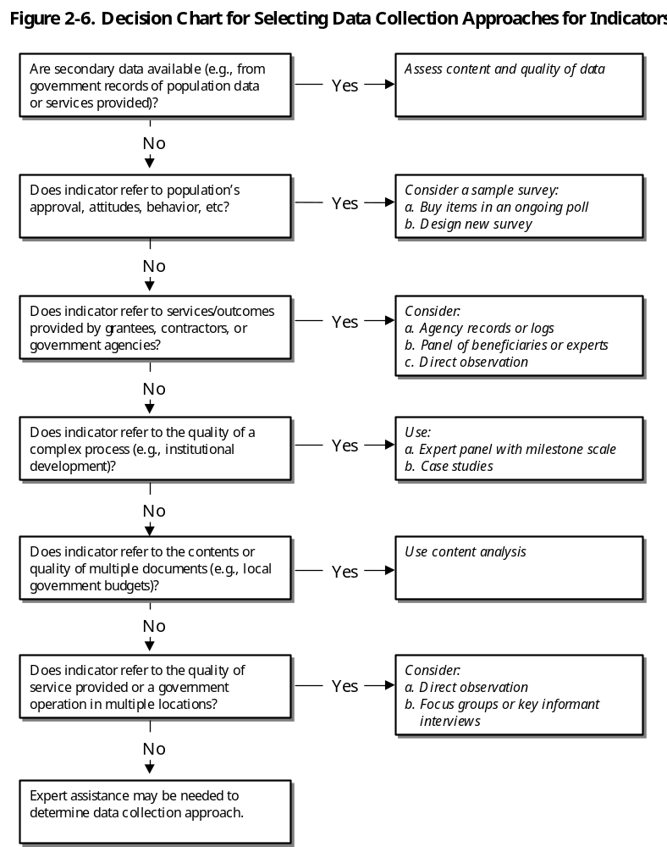

3.4 Develop data collection tools

Once data collection methods are chosen, you may need to develop tools to collect the data. Table 2-4 presents some guidelines for developing and using several of these tools.

Table 2-4. Guidelines for Developing and Using Data Collection Tools

Collection Method | Guidelines
Rapid Low-Cost (focus groups, community interviews, informal surveys, etc) | - Define the problem and formulate the research question  - Identify the sample population for the study  - Carefully choose a facilitator  - Generate and pre-test the interview guide  - Recruit the sample  - Conduct the interviews, meetings, focus groups, survey, etc.  - Analyze data and share the results with stakeholders
Case study | - Define the problem and formulate the scope and objective of the query with specific attention toward the nature and context of subject  - Identify samples to be used in the study. They should address the representational needs of the range of data being evaluated and show the relevance of the study  - Select the type of case most appropriate to the needs of the program  - Collect the data to be analyzed through a combination of sources  - Analyze the data, accounting for rival explanations, reproduction of findings, internal validity, plausibility, ability to generalize, and overall coherence  - Evaluate the results regarding ability to generalize and internal data validity  - Write the report and share the findings
Content analysis | - Determine the data source  - Establish the coding categories and code the text  - Analyze category frequencies, correlation, and patterns  - Write the report
Peer review/  expert panel evaluation | - Use peer review in conjunction with other evaluation techniques  - Use peer review for research and development activities that are public domain  - Peers should be readily identifiable  - Avoid internal peers  - Guard against dysfunctional group dynamics  - If scales are used, test the validity and reliability of those scales  - Provide a bias statement for reviewers
File review in evaluation | - Review authorizing legislation, congressional testimony, and comments from legislators  - Review documents related to the regulatory implementation of the legislation  - Review budget documents, administrative documents, and meeting minutes  - Review program participant data collected as part of their interaction with the program
Surveys | - Define the areas of evaluation and develop applicable questions  - Establish a survey plan  - Develop a sampling protocol that includes a well thought out method of data collection, sampling techniques and method of analysis  - Develop the questionnaire  - Field test the questionnaire, individual questions and the time it takes to administer the test  - Distribute the questionnaire to respondents with a return date.  - Provide a follow-up contact with non-respondents  - Analyze data and share the results with stakeholders

Task 4 – Collect Baseline Data and Verify Quality

In order to manage for results, you need to gather and analyze data that meets the Agency’s data quality standards. Poor quality data can lead to incorrect inferences, e.g., USAID interventions had a given impact when they did not or vice versa. You should take steps to understand the appropriateness and use of different kinds of data collected, understand data limitations, correct these limitations where cost effective, and learn to manage for results when data are known to be imperfect.

In addition, the public is carefully scrutinizing the performance of government agencies. With the advent of the Government Performance Results Act and other government requirements, agencies are moving from accountability for inputs to accountability for results. The public, Congress, and OMB are increasingly taking a more “results oriented” and "cost-effective" look at agency programs. In an era of shrinking Federal budgets, demonstrating effective performance and sustainable program impacts helps justify programs and their costs.

Knowing that demonstrating performance rests on the quality of performance data, you can act effectively to improve activity design and performance and revise strategies appropriately. The process of verifying performance data quality can be broken down into three sub-steps.

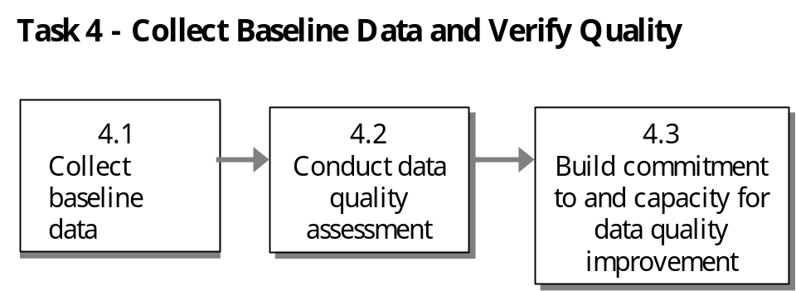

Key Definitions, ADS Guidance and Helpful Resources

KEY DEFINITIONS: The following definitions are relevant to this task:

- Performance Baseline: The value of a performance indicator before the implementation of a USAID-supported activity that contributes to the achievement of the relevant result.

- Verification: Checking performance data against data quality standards to reduce the risk of using data that contain significant errors.

- Bias: Refers to the likelihood that data collected may reflect only a portion of the spectrum of relevant opinion. Bias often occurs as the result of the collection of an incomplete or inaccurately weighted sample of data.

- Significant error (including bias): An error that affects conclusions about the extent to which performance goals have been achieved.

- Measurement error: Results primarily from weaknesses in design of a data collection instrument; inadequate controls for biases in responses or reporting; or inadequately trained or supervised enumerators.

ADS Requirements for Data Quality (ADS 203.3.5.1)

Performance data should be as complete, accurate, and consistent as management needs and resources permit. To be useful in managing for results and credible for reporting, performance data should meet reasonable standards of validity, integrity, precision, reliability, timeliness.

- Validity. Data should clearly and adequately represent the intended result. While proxy data may be used, the Operating Unit should consider how well the data measure the intended result. Another key issue is whether data reflect a bias such as interviewer bias, unrepresentative sampling, or transcription bias.

- Integrity. Data that are collected, analyzed, and reported should have established mechanisms in place to reduce the possibility that they are intentionally manipulated for political or personal reasons. Data integrity is at greatest risk of being compromised during collection and analysis.

- Precision. Data should be sufficiently precise to present a fair picture of performance and enable management decision-making at the appropriate levels. One key issue is whether data are at an appropriate level of detail to influence related management decisions. A second key issue is what margin of error (the amount of variation normally expected from a given data collection process) is acceptable given the management decisions likely to be affected. In all cases, the margin of error should be less than the intended change; if the margin of error is 10 percent and the data show a change of 5 percent, the Operating Unit will have difficulty determining whether the change was due to the USAID activity or due to variation in the data collection process. Operating Units should be aware that improving the precision of data usually increases the cost of collection and analysis.

- Reliability. Data should reflect stable and consistent data collection processes and analysis methods from over time. The key issue is whether analysts and managers would come to the same conclusions if the data collection and analysis process were repeated. Operating Units should be confident that progress toward performance targets reflects real changes rather than variations in data collection methods. When data collection and analysis methods change, the PMP should be updated.

- Timeliness. Data should be timely enough to influence management decision-making at the appropriate levels. One key issue is whether the data are available frequently enough to influence the appropriate level of management decisions. A second key issue is whether data are current enough when they are available.

Helpful Resources to Learn More about Data Quality

- ADS Chapter 203 – Assessing and Learning, www.usaid.gov/pubs/ads/200/203.pdf
- TIPS 12: Guidelines for Indicator and Data Quality, www.dec.org/pdf_docs/pnaca927.pdf
- Handbook of Democracy and Governance Program Indicators, www.dec.org/pdf_docs/PNACC390.pdf
- U.S. General Accounting Office, “The Results Act: An Evaluator’s Guide to Assessing Agency Performance Plans”, www.whitehouse.gov/OMB/mgmt-gpra/gplaw2m.html
- U.S. General Accounting Office, “Performance Plans: Selected Approaches for Verification and Validation of Agency Performance Information”
- U.S. General Accounting Office, Standards for Internal Controls, www.gao.gov/

4.1 Collect baseline data

Completing Task 3 led your team through the process of determining what data to collect and the method and tools that should be used to collect data. Now is the time to execute your data collection plan and begin collecting the initial data for each indicator.

The baseline measure establishes the reference point for the start of the program period. In some cases, planners may want to go back several years to correctly portray the context in which progress will be made. It is preferable if the baseline immediately precedes the start of a new Strategic Plan because we are trying to gauge the progress of a particular Strategic Plan. It will not always be possible to secure baseline data for the chosen year. In that instance, the baseline may be the most recent past year for which the relevant information exists or can be acquired.
CONSIDER THIS – Examine the Performance Trend line: When selecting a baseline year or years, examine the trend line of past performance. There could be unexpected spikes or dips in the trend and a year in which one or the other occurs would be a poor year to select as the baseline year.

TECHNIQUE – How to Establish Baseline When Information is Inadequate: Where baseline information is inadequate, many USAID Operating Units initiate a data collection effort as soon as their Strategic Plan is approved and the performance indicators they will use to judge progress are selected. The first set of data collected on these indicators becomes the formal baseline against which targets are set and future progress is assessed. For people-specific indicators, baselines should disaggregate data by gender and/or other relevant customer groups.

As you start collecting data, you may find that you're amassing a pile of forms, papers and other documents that should be organized and compiled before any real analysis can begin. When this scenario is multiplied by all the SO teams in an Operating Unit, many units begin to consider the use of an information database as a more effective way to store and analyze data. The technique below addresses the database issue.

TECHNIQUE – Storing Data in an Information Database: Traditional data collection involves manually collecting performance data on forms, looking for trends in the data, and summarizing the results in a printed management report. However, this traditional method of reporting is rapidly being replaced by automated software systems that rely on a computer’s processing power to help analyze, process, and communicate information in real-time and in both visual and printed form. As data is collected, you may want to use an information database to store performance data.

Before jumping into a discussion of the pros and cons of certain databases, it may be useful to figure out if a database is needed by asking some basic questions:

- How many people will need to work with the database at the same time? Are they in the same building and/or are they on the same computer system?
- Does the data currently exist in any system?
- Does data exist in well-organized hard-copy reports?
- If the data does not exist in a centralized location, designing a database is only half the job; the other half is determining the process for identifying and entering data into the database. NOTE: Many database projects fail not because of the design of the database but because the organization using it has no established process for putting information into it.

The sophistication of the data collection system should be matched to the needs of the Operating Unit. The investment in technology should return benefits to the organization that exceeds the costs. These benefits will typically accrue in terms of improved information accuracy, security, accessibility, timeliness, and cost-effectiveness.

Helpful Hint 5: Information Systems for Data Collection and Performance Monitoring provides additional information on data collection and performance monitoring systems.

4.2 Conduct a data quality assessment

You need to know if you can trust your data to use it for making decisions. Performance data should be as complete, accurate and consistent as management needs and resources permit. A data quality assessment of each selected performance indicator will help you validate the usefulness of your data. ADS 203.3.6.6 states that when conducting these assessments, you should:

- Verify that data are of reasonable quality based on the five data quality standards provided in ADS 203.3.5.1
- Review data collection, maintenance, and processing procedures to ensure consistent application. Take steps to address identified data quality limitations.
- Retain documentation (whether as simple as a memoranda or a detailed report).
- Disclose limitations for data reported in some sections of the Annual Report (see ADS 203.3.8.3)
MANDATORY: Data reported to USAID/Washington for Government Performance and Results Act (GPRA) reporting purposes or for reporting externally on Agency performance must have had a data quality assessment at some time within the three years before submission. (ADS 203.3.5.2)

Recognize that no data are perfect, but they should be good enough to document performance and support decision-making. Use your professional judgment, and back it up by documenting your decisions and supporting information. Judgments about sufficient quality levels should reflect:

- Uses of the data
- Management judgments about what level of quality is needed for confident decisions.
- Technical assessments about what degree of quality is possible (e.g., professional judgment about acceptable levels of error; implications of data collection methodology, sampling strategy)
- Practical considerations. Trade-off between accuracy and cost or between dimensions of quality (e.g., timeliness and completeness).

TECHNIQUE – Plan Data Quality Assessments: A practical approach to planning data quality assessments includes the following:

- Develop and implement in overall data quality assurance plan that includes initial data quality assessment periodic quality reviews, partner and USAID capacity development
- Maintain written policies and procedures for data collection, maintenance, and process
- Maintain an audit trail – document the assessment, decisions concerning data quality problems, and the steps taken to address them
- Decide who should be involved in the data quality assessment (SO team members, partners, sector specialists, specialists in data quality)
- Decide when data quality assessments will be done

WORKSHEET 7: Data Quality Assessment Checklist: Table 2-5 identifies five criteria for assessing the performance data quality. These five criteria are covered in more detail in Worksheet 7, which you can use to assess the quality of your selected performance data:

Table 2-5. Key Criteria for Assessing Performance Data Quality

Criteria | Answers the question: | Affected by:
Validity | - Do data clearly and directly measure what we intend to measure? | Measurement error. Can result from weak design of data collection instrument, inadequate control for biases in responses or reporting, or inadequately trained or supervised enumerators.  Sampling error. Sample may not be representative, too small for statistical extrapolation or contain sample units based on supposition rather than statistical representation.  Transcription error. Data entries may occur when transcribing data from one source to another. Formulae should be applied consistently, and final numbers reported accurately.
Reliability | - Would you come to the same findings if the data collection and analytical process were repeated? | Changes in the data collection process. Ensuring that data are reliable requires that the collection process be consistent from year to year.
Timeliness | - Are data available frequently enough to inform?  - Are data current enough when they are available? | Frequency. Performance data are available on a frequent enough basis to regularly inform program management decisions  Currency. Data are sufficiently up to date to guide decision-making (e.g., quarterly). Data collected infrequently (every 2-5 years), or with a substantial lag time (>1 year), can help track long-term trends and confirm lower level data accuracy.
Precision | - Are data at the appropriate level of detail?  - What margin of error is acceptable given the management decisions to be affected? | Acceptable margin of error. The expected change being measured should be greater than the margin of error
Integrity | - Are mechanisms in place to reduce the possibility that data are manipulated for political or personal reasons? | Risk. Data is at greatest risk during data collection and analysis  Objectivity and independence. Needed in key data collection, management, and assessment procedures.  Confidence in data. Need for confidence in data from secondary sources. May require an independent review of secondary source data.

Before you begin assessing all of the data, take into consideration the source of the data, and the impact this might have on the assessment process.

TECHNIQUE – Assess Data from Different Sources: The rigor to which a data quality assessment is applied to a data source (i.e., USAID, implementing partner, secondary source) will differ for each source. The goal to assessing data from implementing partners and secondary sources is for you to be aware of data strengths and weaknesses and the extent to which data can be trusted when making management decisions and reporting. Table 2-6 presents a practical approach for assessing data from different data sources. Helpful Hint 6: Key Features of Quality Data Sources provides some additional insight.

Table 2-6. Tips for Assessing Data from Different Sources

Data Source | Tips for Conducting a Data Quality Assessment (DQA)
USAID | - Focus the DQA on the written procedures and training for sampling, data collection, transcription and analysis and determine if they are rigorous enough to produce data that meet the five data quality standards. Specifically focus on whether:  - Written procedures are in place for data collection  - The data collection process is consistent from year to year  - Data are collected using methods to address and minimize sampling and non-sampling errors  - Data are collected by qualified personnel and personnel are properly supervised  - Duplicate data are detected  - Safeguards are in place too prevent unauthorized changes to the data; and  - Source documents are maintained and readily available  - Ensure that data quality requirements are written into any solicitations (SOW, RFP, RFA) for data collection  - Conduct spot checks to ensure that quality assurance mechanisms are being used
Implementing partner | - Periodically sample and review data for completeness, accuracy and consistency. This includes making sure that the indicator definitions being used by the partner are consistent with the definitions contained in your PMP.  - Review partner reports to determine if they are sufficiently consistent to be reliable  - Conduct field visits to compare central office records with field site records; try to visit a broad range of sites.  - Audit financial information when performance indicators use financial information
Secondary source | - Periodically sample and review data for completeness, accuracy and consistency  - Review the data with other development partners to gain an appreciation of accuracy and credibility  - Request a briefing to gain a better understanding of the data collection and analysis process. This should help you determine whether the data can be trusted or not.  Some special considerations:  - USAID does not have the right to audit or investigate data quality in depth  - If USAID provides technical assistance to a government ministry to improve data collection and analysis, you maybe in a very good position to assess the quality of the data

While conducting the assessment, you may find evidence that points to bias in the data collection process that is affecting the quality of the data. Bias can come in many forms.

CONSIDER THIS – Types of Data Bias:

- Interviewer bias: Interviewers who gather program performance data through surveys or focus groups (for example) with program beneficiaries may inject their own bias, either intentionally or not, into the way they conduct the interviews. Likewise, different interviewers may not ask questions in the same way.

- Instrument or measurement bias: Instruments can be biased, for example, if a different instrument is used for the beneficiaries and for the control group. Also, instruments may be written in a way that sways people to give one response over another.

- Response bias: For example, if a sufficiently large group of beneficiaries who share common characteristics or opinions choose not to answer a survey question, they can bias the results by not having their responses included.

- Recall bias: For instance, respondents to data collection instruments are asked to respond to questions that require them to think back and comment on conditions they lived in several years ago. The passing of time may lead people to recall the conditions differently from the reality of the time.

- Time or seasonal bias: Some data may be biased if they are collected at different times of the day or different seasons of the year.

Helpful Hint 7: Tips to Minimize Bias presents some helpful hints to reduce bias.

The assessment process is not over when the worksheet has been completed. The results may indicate that you need to develop and implement a plan that will improve the quality of the data and your ability to use it for performance management. The steps in your plan may include:
- Ensure transparency – report data limitations and their implications for assessing performance
- Improve an indicator by using another source or new methods of measurement
- Adjust, supplement, or replace problematic data
- Triangulate – use multiple data sources with offsetting strengths and limitations.

4.3 Build commitment to and capacity for quality

Management needs to create a climate that encourages coordination, resource allocation, and attention to data quality issues that enable improvements in data quality. The following techniques may help encourage organizational commitment. Figure 2-7 describes the data quality assessment used by the USAID/Bangladesh mission.

TECHNIQUE – Foster Organizational Commitment: Some approaches that can be used to foster organizational commitment to and capacity for quality include:

- Have Agency executives provide confidence that they value and use good quality data by communicating its importance, making data quality an organizational goal, creating a climate of managing for results, and providing technical and financial support.
- Review organizational capacities and procedures for data collection and use. Review the designation of responsibilities for integrating and coordinating data; sufficient staff and expertise to fulfill responsibilities, appropriate hardware and software, and resources for building, upgrading, and maintaining data systems.
- Assign clear responsibilities for data creation and maintenance, training and supervision of those who enter data, transferring data from initial to final formats, and appropriately analyzing and reporting performance measures.
- Adopt audit and independence review mechanisms that encourage objectivity and independence in collecting and managing data
- Provide responsible staff with training and guidance for needed skills and knowledge in performance management
- Share Agency data quality standards with partners (including need for baselines, targets, and disaggregated data)
- Support partners in the development of written activity-level PMPs

Figure 2-7. Data Quality Improvement in Action: USAID/Bangladesh Democracy Partnership
Data Quality Challenges:
- Indicator definitions, measurement criteria and data collection methods were not uniformly understood
- Data collection process was time consuming, decreasing time available to implement program activities
- Data collection and use were not well matched
- Insufficient clarity concerning roles and responsibilities among the Partners for data design, collection, analysis and reporting
- Defining target populations and maintaining baseline values for indicators had become problematic
- Qualitative data did not complement the other data provided
- Intended comprehensive picture was not clearly drawn

Actions Taken:
- Conducted a data quality review in a fully collaborative fashion
--Active participation by the implementing NGOs in each critical step along the way
--Three complementary forums: meetings of three partner institutions, consultative sessions with partner organizations and implementing NGOs, plenary workshops
--Decisions were obtained by consensus at these sessions
- Took a fresh look at the Results Framework, including indicators
--Clarified indicator definitions, approaches to data collection for these indicators and roles of the various partners and the NGOs in data collection
- Drafted a new Performance Management Plan to communicate adjustments
- Made improvements in clarity of measurement
--Efficiency of data collection and usefulness of performance reporting were key priorities
- Developed a “Data Collection and Reporting Funnel”
--Information needs begin with the grassroots NGOs (broad array/relatively frequent)
--Subset needed by TAF to synthesize results of NGO efforts and to report periodically to USAID/Bangladesh
--Subset needed by USAID/Bangladesh to meet its own program management and reporting needs
--Helped to clarify the commonalties and differences in data needs among various data users

Lessons Learned:
- Plenty of experience with largely uninformative numerical data
- High level of need for NGOs to report on the substance of their activities and accomplishments
- A mix of data collection approaches: formal surveys, community interviews and NGO-based counts accompanied by interpretive narratives.
- Performance monitoring system
--Training plan for NGOs in data collection and reporting
--Data collection instruments have been designed and are being pre-tested in the field
- Bangladesh consulting firm has been contracted to collect, analyze and report data for a few selected indicators through probability surveys
- The demand for data use should determine the frequency of reporting
- The more “internal” the expected use of the data, the more frequently we expect reporting to take place
- Data collection activities are the minimum necessary to support managing for results at all levels
--Annual for USAID/W, via the Annual Report
--DP has needs for more frequent reporting (The Asia Foundation needs NGO reports on a semi-annual basis for its program management and reporting purposes.)
- NGOs are likely to analyze their own data on approximately a monthly basis

Task 5 – Establish Performance Targets

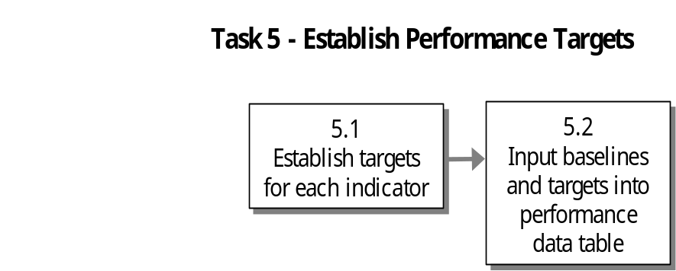Baseline data and performance targets are critical to managing for results because they are key reference points for assessing program performance. Baseline data establishes a reference point for the start of the program period. When the team establishes performance targets, it commits itself to specific intended results to be achieved within explicit timeframes. Each year, the team assesses its performance by comparing actual results against these targets. The process of establishing baselines and targets can be broken down into two sub-steps.

Key Definitions, ADS Guidance and Helpful Resources
KEY DEFINITIONS: The following definitions are relevant to this PMP task:

- Performance Targets: Specific, planned level of result to be achieved within an explicit time frame.

- Interim Target: Targets set for years in between the baseline and final target year (e.g., for years in which change is expected and data collection is possible).

- Ultimate, or Final, Target: The planned value of a performance indicator at the end of the planning period. For SOs, final targets are often set at five to eight years away. For IRs, final targets are usually set three to five years away.

Helpful Resources to Learn More about Establishing Targets

- TIPS 8, “Establishing Performance Targets”, www.dec.org/pdf_docs/pnaby226.pdf
- Handbook of Democracy and Governance Program Indicators, www.dec.org/pdf_docs/PNACC390.pdf

5.1 Establish indicator targets

Once performance indicators have been developed and baseline data collected, establish final (usually end of SO date) and interim (usually annual) performance targets. Targets should be optimistic, but realistic. A common practice is to set targets that will force you to “stretch” to exceed your past performance. However, special care should be taken not to set the target outside of reasonable expectations. Setting a target too high, or allowing zero tolerance for human error, undermines morale and makes targets appear unattainable. Instead, set targets that excite team members’ and partners’ interest and elicit commitment.

TECHNIQUE – Conduct a Target Setting Meeting: Conduct a target setting meeting to identify potential performance targets. Helpful Hint 1: Facilitating Group Discussions and Decision-Making has tips on facilitating decision-making meetings. Have at least one target setting session for each indicator. Involve your implementing partners in the meetings, whenever possible. Collaborating with others who are knowledgeable about the local situation and about reasonable expectations for accomplishments is key to target setting. Other USAID Operating Units, other development agencies, host country counterparts, partners, customers and experts can all be invaluable in helping to determine the progress that might be expected.
TECHNIQUE – Approaches to Target Setting: Determining appropriate targets for each indicator can be accomplished in several ways. Much will depend on the information available or readily gathered. Target setting approaches include:

- Project future trend, then add the “value added” by USAID activities. This approach involves estimating the future trend without USAID’s program, and then adding whatever gains can be expected as a result of USAID’s efforts. Projecting the future can be very difficult, but can be made somewhat easier if historical data are available to establish a trend line.

- Establish a final performance target for the end of the planning period, then plan progress from the baseline level. This approach involves deciding on the program’s performance target for the final year, and then defining a path of progress for the years in between. Final targets may be based on benchmarking techniques or on judgments of experts, program staff, customers or partners.

- Set annual performance targets. This approach is based on judgments about what can be achieved each year, instead of starting with a final performance level and working backwards.

- Benchmarking. Look at other organizations or institutions that use the same types of indicators to demonstrate progress and set targets accordingly. For example, if you are tracking the number of days for an institution to register new enterprises, research the length of time it takes for other countries and use those data points as benchmarks for setting your indicator targets.

CONSIDER THIS – Principles of Target Setting: As you apply the target setting approaches described above, keep in mind some basic principles for setting targets.

- Think about what the trend has been in the past for any given indicator
- Consider parallel experience from other countries
- Think through when program activities will have an impact on indicator values
- Think about external conditions which may affect indicator values over time
- Consider setting a target range rather than a single numerical target
- Consider how clearly the target or the actual will communicate and how the trend line will move when deciding on an indicator’s unit of measurement
- When indicators are disaggregated, targets should be disaggregated as well

5.2 Input baselines and targets into performance data tables

WORKSHEET 6 – Performance Indicator Reference Sheet: Input baseline data and targets into the data table in each indicator reference sheet.

WORKSHEET 8 – Summary Performance Data Table: You may also want to use Worksheet 8 to consolidate all your performance data into a summary table. Table 2-7 is an example of a completed summary data table.

Table 2-7. Example of Worksheet 8: Summary Performance Data Table

SO or IR | Results Statement | Indicator | Unit of Measure | Disaggregation | Baseline Year | Baseline Value | 2001 Target | 2001 Actual | 2002 Target | 2002 Actual | 2003 Target | 2003 Actual
IR  3.1.1 | Vulnerable communities better able to meet own needs | Number of community groups organized | # groups |  | May-Nov 2000 | 0 | 12 |  | 36 |  | 48
 |  | Value and percent of community contributions to community projects | - Dollars  - % per project | Source of contribution | May-Nov 2000 | a) 0  b) 0 | a) $5K  b) 5% | a)  b) | a) $20K  b) 10% | a)  b) | a) $40K  b) 20% | a)  b)
IR  3.1.1.1 | Increased access to economic opportunities and support services | Number of loans disbursed | # loans | Recipients:  Male  Female | May-Nov 2000 | M 15  F 10 | M 25  F 20 | M  F | M 30  F 30 | M  F | M 35  F 40 | M  F
 |  | Number of jobs created | # jobs | Male  Female | May-Nov 2000 | M 75  F 50 | M 125  F 100 | M  F | M 150  F 150 | M  F | M 175  F 200 | M  F
IR  3.1.1.2 | Communities organized to address self-defined needs | Number of community development projects developed | # projects | Project Type | May-Nov 2000 | 0 | 6 |  | 18 |  | 24

Task 6 – Plan for Other Assessing and Learning Activities

Assessing and learning is the process of systematically obtaining useful feedback and applying it to move programs forward and report progress to others. Therefore, think about supplementing performance monitoring with planned evaluations, special studies, and other formal and informal information sources as needed. This comprehensive approach to planning for assessment and learning will yield useful performance information that will help you:

- Make informed management decisions regarding the best use of resources to achieve desired objectives over time
- Improve the performance, effectiveness, and design of existing development assistance
- Document findings on the impact of development assistance

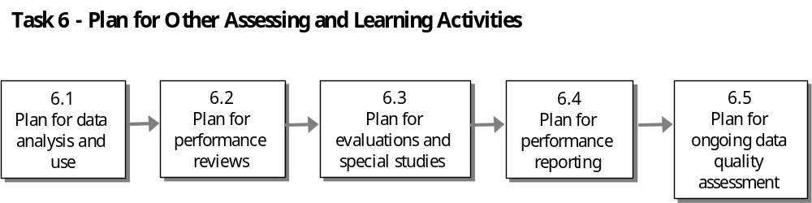The process of planning for these other elements can be broken down into five sub-tasks.

Key Definitions, ADS Guidance and Helpful Resources
KEY DEFINITIONS: The following definitions are relevant to this PMP development task:
- Evaluation: A relatively structured, analytical effort undertaken to answer specific program management questions. An evaluation can provide a systematic way to gain insights and reach judgments about the effectiveness of specific activities, validity of a development hypothesis, utility of performance monitoring efforts, or impact of other changes in the development setting on achievement of results.

- Portfolio Review: A required periodic review of all aspects of an Operating Unit or SO team’s programs. It focuses on both strategic and operational issues and examines the robustness of the underlying development hypothesis and the impact of activities on results. It is often held in preparation for submission of the Annual Report.

- Intensive Program Review: A program review that is required at least once every three years. Intensive program reviews are conducted by regional and pillar bureaus for each operating unit/program under its responsibility. The purpose of the review is to provide an opportunity for Washington offices to examine planned and actual progress toward results set forth in the Results Framework and Performance Management Plan and to review future resource requirements for each SO.

- Annual Report: An annual document produced by each Operating Unit and submitted to the responsible Bureau to report on past performance, future resources needed, and data needed for Agency-wide management, budget decisions, and external reporting. Annual Reports began in 2001 and replaced the Results Review and Resource Request (R4).

Keys to Effective Performance Management (ADS 203.3.2.1)

- Actively Plan for Performance Management: Operating Units should plan for performance management while developing Strategic Objectives and designing activities. Starting early is key because assembling the various elements of the system takes time. When trying to develop preliminary Performance Management Plans (PMP), some Operating Units may discover that the proposed Strategic Objectives or Results Frameworks need revision, which may require additional time.

- Make Decisions on the Basis of Performance Data: Operating Units should use performance information systematically to assess progress in achieving results and to make management decisions. In terms of the supply of performance information, it is important that information be available when required for decision-making. On the demand side, decision-makers at all levels should use performance information to influence decision-making processes and encourage partners to do likewise.

- Seek participation: Operating Units can strengthen performance management by involving customers, partners, stakeholders, and other USAID and USG entities in the process of performance management. Operating Units can promote participation by (1) including customers, partners, and stakeholders when developing PMPs; (2) including partners when collecting, interpreting, and sharing performance information and experience; (3) integrating USAID performance management efforts with similar processes of partners; and (4) assisting partners in developing their own performance management and evaluation capacity.

- Streamline the process: Operating Units should only collect and report on the information that is most directly useful for performance management. More information is not necessarily better because it markedly increases the management burden and cost to collect and analyze. Operating Units should also seek to align their performance information needs with those of their partners, thereby lessening the reporting burden for partner organizations. Examples include jointly defining a critical set of performance indicators or incorporating data collection directly into assistance and acquisition mechanisms. Operating Units should ensure that reporting requirements are included in acquisition and assistance instruments, and that partner reporting schedules provide information at the appropriate times for Agency reporting.

- Be transparent: Operating Units should share information widely and be candid in reporting. Transparency involves (1) communicating any limitations in data quality so that achievements can be honestly assessed; (2) conveying clearly and accurately the problems that impede progress and steps that are being taken to address them; and (3) avoiding the appearance of claiming jointly-achieved results as solely USAID results.

Helpful Resources to Learn More about Analysis and Evaluation

- ADS Chapter 203, www.usaid.gov/pubs/ads/200/203.pdf
- TIPS 1: Conducting a Participatory Evaluation, www.dec.org/pdf_docs/pnabs539.pdf
- TIPS 2: Conducting Key Informant Interviews, www.dec.org/pdf_docs/pnabs541.pdf
- TIPS 3: Preparing an Evaluation Scope of Work, www.dec.org/pdf_docs/pnaby207.pdf
- TIPS 4: Using Direct Observation Techniques, www.dec.org/pdf_docs/pnaby208.pdf
- TIPS 5: Using Rapid Appraisal Methods, www.dec.org/pdf_docs/pnaby209.pdf
- TIPS 10: Conducting Focus Group Interviews, www.dec.org/pdf_docs/pnaby233.pdf
- TIPS 11: The Role of Evaluation in USAID, www.dec.org/pdf_docs/pnaby239.pdf

Figure 2-8 presents a summary of the assessing and learning practices for USAID/Mali.

Figure 2-8. Assessing and Learning Put into Practice: USAID/Mali’s Experience

USAID/Mali has developed an extensive system for measuring programmatic performance and for monitoring/evaluating that performance. The following is a summary of the key documents that are generated and the mechanisms through which data are collected and analyzed.

Key Documents:
- Results Frameworks and Performance Indicator Table: A separate table for each SO serves as the core instruments for documenting performance.
- System of Performance Measurement: A data set which contains all the detailed information that goes into the Results Frameworks and Performance Indicators tables. The SP contains additional “lower level” results data on individual activities, generates various reports, and tabulates information through a customized ACCESS-based management information system.
- Annual Report: An Operating Unit’s major reporting document, which also can provide information for the program reviews.
- Policy Agenda Matrix: Consolidates, in summary form, all the major policy agenda items being tackled through SO programs and quantifies progress to date.
- Contractor and PVO progress reports: Contain basic data and performance indicators submitted by contractors and are incorporated into the system and Results Frameworks.
- Government of Mali (GM) national statistics: Statistics collected and compiled by GM are used to measure progress
- Geographic Information System (GIS): An Arc/View software used to show the geographic location of different activities/facilities of interest.

Key Monitoring and Evaluation Mechanisms:
- Contractor, PVO and GM data collection systems: USAID/Mali specifies appropriate measures of performance, benchmarks/targets for achievement at various stages or dates, and the system for reporting accomplishments with contractors and PVO partners.
- Surveys and field visits: Numerous surveys/studies are done annually to either collect or verify information provided by partners
- Program Implementation Reviews (PIR): Bi-annual sessions used to review progress activity-by-activity, not just overall SO or program.
- PVO Continuation Application Reviews: Formal, annual reviews held with partner PVOs to assess progress, plans for the next phase, and financial requirements
- Retreats for the Operating Unit or partners: Use retreats as a mechanism to look at overall performance – for both staff of the Operating Unit and its partners

CONSIDER THIS – Budget for Performance Monitoring: As you plan to assess and use performance data, consider the costs of collecting, analyzing and using that data. Sufficient funding and personnel resources should be made available for performance monitoring work. ADS 203.3.2.2 provides that three to ten percent of total program resources should be allocated in most cases, though factors unique to each activity or strategic element will influence this decision. Strive for cost-effective performance monitoring. If anticipated costs appear prohibitive, consider:

- Modifying performance indicators to permit less expensive approaches to regular data collection
- Modifying the approach/design of evaluative activities, considering rapid, low cost alternatives
- Modifying the relevant Strategic Objective or Intermediate Result, since it is not possible otherwise to judge progress at reasonable costs

WORKSHEET 9 – Performance Management Task Schedule: As you go through Task 6, use Worksheet 9 to schedule all your team's assessing and learning activities—data acquisition and analysis, Portfolio Reviews performance reporting, data quality assessment, evaluation plans, etc.

Table 2-8 is an excerpt from a performance management task schedule completed for one USAID Operating Unit in the field.

Table 2-8. Example of Worksheet 9: Performance Management Task Schedule

PERFORMANCE MANAGEMENT TASKS | FY 2004 |  |  |  | FY 2005 |  |  |  | FY 2006 |  |  |  | FY2007 |  |  |  | Notes
PERFORMANCE MANAGEMENT TASKS | Q1 | Q2 | Q1 | Q2 | Q3 | Q4 | Q3 | Q4 | Q1 | Q2 | Q3 | Q4 | Q1 | Q2 | Q3 | Q4 | Notes
COLLECT CONTEXT-LEVEL DATA
Gather data on macroeconomic situation (Inflation rates, poverty, exchange rates) |  |  |  | X |  |  |  | X |  |  |  | X |  |  |  | X | Before Annual Report
Summarize IMF country report |  |  |  | X |  |  |  | X |  |  |  | X |  |  |  | X | Before Annual Report
COLLECT SO-LEVEL PERFORMANCE DATA
SO Indicator #1: Number of micro-loans by USAID-assisted micro-finance intermediaries | X | X | X | X | X | X | X | X | X | X | X | X | X | X | X | X
SO indicator #2: Loan approval rate for USAID-assisted micro-finance intermediaries |  |  |  |  |  | X |  | X |  |  |  | X |  |  |  | X
COLLECT IR-LEVEL PERFORMANCE DATA
Indicator #1.1: Milestone score rating of progress reengineering selected administrative processes |  | X |  | X |  |  |  |  |  | X |  |  |  | X
Indicator #3.2: Number of loan applications in region XYZ | X |  | X |  | X |  | X |  | X |  | X |  | X |  | X
Etc.
Etc.
COLLECT ACTIVITY-LEVEL DATA
Gather partner progress reports from Partner XXX | X | X | X | X | X | X | X |  |  |  |  |  |  |  |  |  | Project with Partner XXX currently ends in third year
Gather partner progress reports from Partner YYY | X | X | X | X | X | X | X | X | X | X | X | X | X | X | X | X
Gather partner progress reports from Partner ZZZ |  |  |  | X | X | X | X | X | X | X | X | X | X | X | X | X | Project with Partner ZZZ scheduled to begin in second year
CONDUCT EVALUATIONS & SPECIAL STUDIES
Report on administrative reengineering at ABC government agency |  | X |  |  |  |  | X
Mid-strategy review |  |  |  |  |  |  |  |  |  |  | X | X |  |  |  |  | Specific assessments TBD
Estimate increased investment attributable to reengineering of key business processes |  |  |  |  |  |  |  |  |  |  |  |  |  | X | X
REVIEW PERFORMANCE INFORMATION
Review partner activity progress reports | X | X | X | X | X | X | X | X | X | X | X | X | X | X | X | X | Informal review of partner reports
Portfolio Review with Mission Director |  |  | X |  |  |  | X |  |  |  | X |  |  |  | X |  | Operational-level review
Review in preparation for Annual Report | X |  |  |  | X |  |  |  | X |  |  |  | X
REPORT PERFORMANCE RESULTS
Submit Annual Report |  | X |  |  |  | X |  |  |  | X |  |  |  | X
ASSESS DATA QUALITY
Asses data from partner XXX |  |  |  |  |  |  | X |  |  |  |  |  |  |  |  |  | Coincides with assessment of ABC government agency
Asses data from partner YYY |  |  |  | X |  |  |  | X |  |  |  | X |  |  |  | X | IR 3 leader responsible
Asses data from partner ZZZ |  |  |  |  |  |  |  | X |  |  |  |  |  |  |  | X | IR 2 leader responsible
REVIEW & UPDATE PMP
IR Managers update indicator sheets on shared drive | X | X | X | X | X | X | X | X | X | X | X | X | X | X | X | X
Complete PMP in binder printed and updated |  |  |  | X |  |  |  | X |  |  |  | X |  |  |  | X

6.1 Plan for data analysis and use

Everyone needs information, but not everyone knows what to do with raw data. Data should be processed and synthesized before reporting and using. Sound analysis of performance data will provide you with useful information about what happened (against expected results) and why progress is or is not on track. Properly planning how performance data will be analyzed, used and presented is at the heart of performance management. To plan for this, ask these key questions:

- How will the data be analyzed?
- Who will be involved in the analysis?
- Who will use the data and for what purpose?
- How will the data be presented?

Table 2-9 presents some approaches to apply in planning for performance data analysis and use:
Table 2-9. Data Analysis Approaches

Analysis Approach | Analysis Technique | Questions to Consider
Analyze data for a single result | - Compare actual performance against targets  - Compare current performance to prior year  - Compare current performance to baseline  - Analyze trends in performance | - Did we meet our targets? Why or why not?  - How does this period’s performance compare to last period? Are we on track for our ultimate target?  - Did our critical assumptions hold during the performance period?  - What happened that we did not expect?  - What improvements are needed?  - Are new results statements, indicators, or targets needed?
Analyze data across the Results Framework | - Examine performance of lower results in relation to higher results  - Examine data from critical assumptions to help interpret results
Analyze the contribution of USAID’s activities to the achievement of results | - Examine timing of results in relation to timing of USAID program efforts  - Compare movement in results trends to movement in level of USAID program efforts  - Compare performance to control group in similar environment

WORKSHEET 6 – Performance Indicator Reference Sheet: Once you have determined your data analysis approach, refer to your completed indicator worksheets and input your plan for each indicator.

The key to presenting data analysis is to tell a compelling story. Be candid. Users of performance information will want to know how you plan to address performance problems and limitations. Visual displays such as tables, boxes, and figures can condense information, present it in a clear format, and highlight underlying relationships and trends. This helps communicate findings to decision-makers more clearly and quickly. Helpful Hint 8: Tips for Communicating Performance Information in Reports will provide you with some guidelines in presenting data analysis in report format.

TECHNIQUE – Chart Book Analysis Presentation Approach: Figure 2-9 provides an example of a creative storyboard technique for presenting performance data analysis. The slides in the presentation are designed in such a way that the audience can clearly understand how the data are supporting the program results. The presenter is telling a story that is easy to follow without getting lost in all the data contained in the graphics. Presentations that simply show one complicated graphic after another, with little/no text to make the points that should be taken from the analysis, have less impact on the audience. The same can also be said about the opposite approach – avoid reports with overly long text and too few graphic presentations that could help the reader easily understand program results.
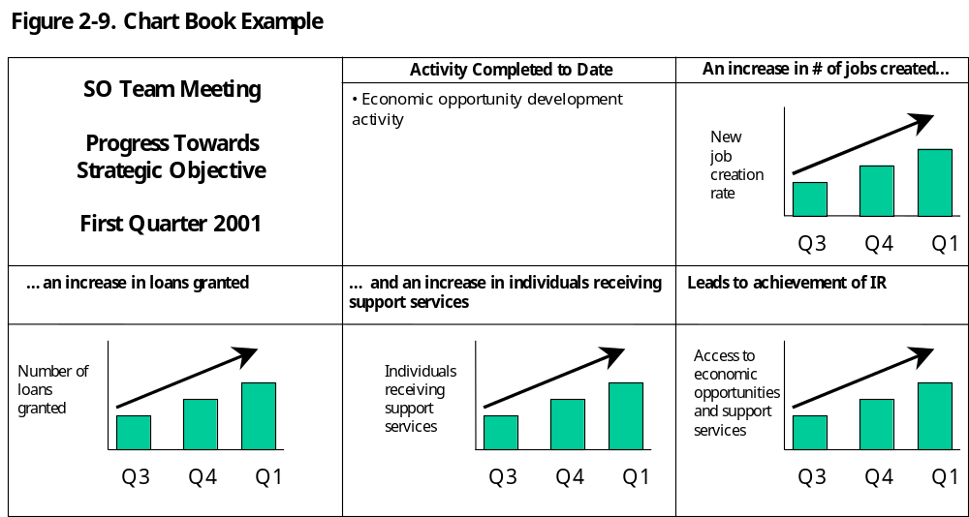

6.2 Plan for performance reviews

ADS Chapter 203 requires two types of performance reviews of Operating Unit performance – the Portfolio Review which as an annual exercise conducted by the operating unit and the Intensive Program Review which is a triennial exercise led by the responsible bureau.

Portfolio Reviews: The portfolio review is a required annual review conducted by the operating unit. Its purpose is to systematically analyze the progress of each SO examining both strategic and operational issues. It is intended to bring together various expertise and points of view to determine whether a program is “on track” or if new actions are needed to improve the chance of achieving results. Portfolio reviews should lead to management decisions about program implementation and feedback into planning and achieving processes. Specific guidance on conducting Portfolio Reviews can be found in ADS 203.3.7. The guidance states that the structure, process and timing of a Portfolio Review is left up to you, but requires that, during the course of the fiscal year, you review:

- Progress towards the achievement of the SO during the past year and expectations regarding future results achievement
- Evidence that outputs of activities are adequately supporting the relevant IRs and ultimately contributing to the achievement of the SO
- Adequacy of inputs for producing planned outputs
- Adequacy of performance indicators selected in the PMP
- Status and timeliness of input mobilization efforts
- Progress on the annual procurement plan
- Status of critical assumptions and causal relationships defined in the Results Framework along with the related implications for performance
- Status of cross-cutting themes and/or synergies between Strategic Objectives
- Status of related partner efforts that contribute to the achievement of IRs and SOs
- Status of the Operating Unit's management agreement and need for any changes to the approved Strategic Plan
- Pipeline levels and future resource requirements
- SO team effectiveness and adequacy of staffing
- Vulnerability issues, related corrective efforts and their costs.

You should use information from the reviews to identify and analyze the implications for the achievement of results. When you identify significant deficiencies or problems, you may need to alter, increase, or discontinue activities, or rethink the logic behind the original expectations.

TECHNIQUE – Portfolio Review Approach: There is no one prescribed structure or process for conducting Portfolio Reviews. One of the most common approaches is for designated staff to analyze a variety of program-related information and prepare issues for discussion in a larger group forum that may include SO team members, other members of the Operating Unit, and partners. Operating Units may choose to define standard procedures that are judged useful for their programs. Many units will find it particularly useful to conduct a Portfolio Review as part of the preparation process for Annual Reports. Some operating units choose to conduct the portfolio review in two parts with each part having a different focus. For example, one part might be focused on program results such as progress towards SOs, status of cross-cutting themes and status of critical assumptions while the other is focused on internal mission management issues such as procurement, pipeline and staffing.

HELPFUL HINT 9: Questions to Guide Portfolio Reviews: Use Helpful Hint 9 to help plan and carry out Portfolio Reviews. The questions listed will help you to address key issues that affect the management of your portfolio. These issues can be categorized into three broad areas as follows:

- Strategy and activity issues: results, outputs, inputs, development hypothesis, critical assumptions, non-USAID circumstances, and interface between tactics and strategy
- Process issues: indicators and targets, evaluations, teamwork, and customer/partner perceptions
- Vulnerability issues: financial vulnerability, other vulnerability, and audit readiness

Intensive Program Reviews: Intensive program reviews are mandatory reviews conducted every three years by pillar or regional bureaus of each operating unit or program. The purpose of the review is to provide Washington Offices the opportunity to examine thoroughly how each program is proceeding relative to the results framework and performance management plan for each SO, and to review resource requirements.

Procedures for conducting an intensive program review is left up to each Bureau but the process must include other bureaus and offices.

As part of your performance management planning effort, you should consult with your Bureau about if and when an intensive program review of your OU will be conducted, so that you can schedule the review appropriately.

6.3 Plan for evaluations and special studies

Evaluation is a relatively structured analytical effort undertaken selectively to answer specific management questions regarding USAID-funded assistance programs or activities. Evaluation is also a management tool that plays a vital role in Agency decision-making, accountability reporting, and learning. It is an important source of information about the performance of USAID activities, programs and strategies.

Determine in advance if special studies can be identified (e.g., DHS, intermittent surveys) or if evaluation issues can be predicted. Plan to determine, at the time of the Portfolio Review, if there are performance deviations (positive or negative) that show need for evaluations or studies. Near the end of the SO life, plan to determine if something happened that requires a study to better document the results.

INFORMATION SERVICES:

Research and Reference Services (R&RS): R&RS staff can help you determine if other evaluations or special studies have been conducted on similar topics. Access R&RS via CDIE Online at http://cdie.usaid.gov (available only within the USAID firewall; click 'Research' or 'Library' at the top of the homepage)

CONSIDER THIS – Situations that Prompt a Need for Evaluation: To complement ongoing performance monitoring, consider planning an evaluation when there is a distinct and clear management need, as in the following situations:

- A key management decision should be made and there is inadequate information
- Performance information indicates an unexpected result (positive or negative) that should be explained
- Customer, partner, or other informed feedback suggests that there are implementation problems, unmet needs, or unintended consequences or impacts
- Issues of sustainability, cost-effectiveness, or relevance arise
- Validity of Results Framework hypotheses or critical assumptions is questioned
- Periodic Portfolio Reviews have identified key questions that need to be answered or on which consensus should be developed
- Extracting lessons is important for the benefit of other Operating Units or future programming
TECHNIQUE – Planning for Evaluations: Take into account the following key steps and questions, as listed in Table 2-11, when planning evaluations and special studies.

Table 2-11. Key Steps and Questions for Planning Evaluations
KEY STEPS | KEY QUESTIONS
- Decide if and when to evaluate  - Clarify the evaluation purpose  - Use R&RS for research support  - Identify the research questions  - Select appropriate evaluation methods  - Plan for data collection and analysis  - Form an evaluation team  - Plan procedures (e.g., schedule, logistics, reporting needs, budget) | - Who is likely to need information from or about the program?  - What do they need to know?  - How would they use the information if they had it?  - When do they need it?  - How accurate should it be?  - When and how should the data be collected and analyzed?  - Who is responsible for data collection and analysis?

If an evaluation is likely, plan to select an evaluation method from among several options. Table 2-12 presents some evaluation method options. Helpful Hint 4: Rapid Low-Cost Data Collection Methods provides supplemental information on the appropriateness, advantages, and limitations of rapid appraisal techniques.

Table 2-12. Evaluation Methods and Key Considerations

EVALUATION METHOD
- Short workshops to reflect on whether the development hypothesis is valid
- Community interview or customer focus groups
- Large scale surveys
- Rapid appraisal or participatory techniques
- Traditional, formal impact evaluations
KEY CONSIDERATIONS
- Nature of the information, analysis, or feedback needed
- Trade-off between quality/validity and cost
- Cultural considerations
- Time-frame of the management need for information
- Time and resources available
- Level of accuracy required

CONSIDER THIS – Special Studies: In some cases, you may need to conduct special studies that go beyond the scope of program monitoring or evaluation. One example is the Demographic and Health Surveys (DHS) that are conducted approximately every five years to inform health sector programming.

As discussed in ADS 203.3.6.1, an important role of special studies is to examine whether the needs of vulnerable groups are being met. Special studies need to be designed with the same care as evaluations. When collecting data for analysis, take particular care to design and implement the study in order to minimize error and ensure good data quality.

WORKSHEET 10 – Evaluations and Special Studies Planning: Use Worksheet 10 to help document the possible evaluations and special studies identified to complement performance monitoring. This worksheet will help you identify the subject, timing, and any special research considerations. Table 2-13 presents an example of how an evaluation or special study may be planned.

Table 2-13. Evaluations and Special Studies Planning

Evaluation/Study Subject | When | Key Research Question(s)
Reproductive Health Survey | On-going | What is the status of reproductive health in the country?  What is the nature of citizen’s knowledge, attitudes, behaviors, and practices?
Community Assessment for the Social Development Fund | April – May, 2000 | Which communities should be targeted?  How should funds be programmed?
World Vision Feeding Program | April – May, 2000 | How effective and efficient has the program been?  What are the opportunities for improvement?
Community Development Approaches | April – May, 2000 | What are the merits of various approaches?  What lessons can be learned from community development efforts in the country?  How can sustainability be ensured?
Mission’s Value-Added in the Health Sector | June – Sept, 2000 | Should USAID continue to fund these programs?

Although the timing of the PMP development process may be such that the evaluation will not take place in the immediate future, you may want to consider the types of questions found in Worksheet 11 when the time comes to develop the evaluation scope of work.
WORKSHEET 11 – Evaluation Scope of Work Planning: Use Worksheet 11 to help develop the scope of work for planned evaluations. An evaluation scope of work (SOW) is a plan for conducting evaluations or special studies. It conveys clear directions to the evaluation team. A good SOW usually:

- Identifies the activity, Intermediate Results, or Strategic Plan to be evaluated
- Provides a brief background on implementation
- Identifies existing performance information sources
- States the purpose, audience and use of the evaluation
- Identifies the evaluation method to answer the questions
- Clarifies the evaluation questions
- Identifies the evaluation method(s) to answer the questions
- Discusses evaluation team composition and participation of customers, partners and stakeholders
- Covers procedures such as schedule and logistics
- Clarifies requirements for reporting and dissemination
- Includes a budget

6.4 Plan for performance reporting

To enhance learning opportunities within the Agency and among partners and other stakeholders, plan to report and share progress toward expected results. Base your reporting upon quantitative and qualitative performance information gathered through your performance monitoring systems, evaluations, and other relevant sources. Make every effort to be open and direct and to share both successes and failures.

To support the Agency in its learning processes, share copies of annual performance reports, evaluation reports, and other useful information that may be of broad interest to other teams and units. Furthermore, copies of these reports are required to be sent to the DEC in electronic format for uploading onto their web site (see Resources appendix).

The Annual Report will serve as the primary document for reporting performance information. You may also want to develop your own internal reports to guide management decisions. For example, consider a periodic Activity Manager’s Monitoring Report, which can be revised to be more clearly linked with performance indicators at the SO and IR levels.
TECHNIQUE – Plan for Annual Reports: At the end of each calendar year, Operating Units must submit an Annual Report to Washington that complies with the annual guidance cable. The annual Portfolio Review can provide much of the analytical basis for this report. In the Annual Report, plan to discuss:

- Progress towards the achievement of the SO over the past fiscal year, as well as expectations for future results
- Evidence that activities are supporting the relevant Intermediate Result(s), and ultimately contributing to the achievement of the SO
- Status of critical assumptions (i.e. whether they continue to hold) and causal relationships defined in the Results Framework, and the related implications for performance towards the SO and IRs
- Future resource requirements

- HELPFUL HINT 8 – Tips for Communicating Performance Information in Reports: Use Helpful Hint 8 to plan for more effectively reporting performance information. Such reports include Annual Reports, but may also include other reports internal or external to the Operating Unit or Agency.

6.5 Plan for on-going data quality assessments

Do not stop reviewing data quality once the performance data is reported in the Annual Report. Plan to regularly review data quality to ensure that it continues to support the needs of the SO and IRs in performance monitoring.
TECHNIQUE – On-going Data Quality Assurance: Over the course of implementing a Strategic Plan, prepare to:

- Build data quality assessment into normal work processes, including ongoing reviews and site visits
- Use software checks and edits of data on computer systems and review their implementation
- Use feedback from data users and other stakeholders
- Compare performance information with other sources of similar data or program evaluation
- Obtain verification by independent parties, including other donors and the Office of the Inspector General

For each indicator reported in the Annual Report, reassess data quality as necessary, but at intervals of no greater than three years. These assessments will ensure that performance information is sufficiently complete, accurate, and consistent. Conduct these assessments consistent with Agency and external guidance. In particular:
- Verify and validate performance information to ensure that data are of reasonable quality
- Review data collection, maintenance, and processing procedures to ensure that they are consistently applied and continue to be adequate
- Document this assessment in the Annual Report, and keep a complete report on file

WORKSHEET 7 – Data Quality Assessment Checklist: As you did during the initial data quality assessment, use Worksheet 7 to conduct periodic or on-going assessments of reported performance data.

TECHNIQUE – Set up a “data quality file”: A good way to maintain adequate documentation of data quality and assessment is to set up a simple data quality file. Use this file to store copies of data collection instruments, source documents, raw figures or worksheets used to calculate indicators, data quality assessment memos and reports, etc. Refer to Helpful Hint 10: Maintaining Official SO Team Files for additional ideas.

CONSIDER THIS – Collection of Other Useful Data: In addition to collecting data on performance, consider seeking out other useful data to track goal-level progress or illustrate the development context or environment, status of critical assumptions, and validity of the development hypothesis.

- Aspirations, or “goal-level” indicators: An SO team may wish to track progress toward results that are beyond USAID’s manageable interest, or results that are of a higher level than the Strategic Objective. For example, a hypothetical USAID economic growth program may aspire to achieve significant macro or national-level results within, say, twenty years. However, within the five year timeframe of the current Strategic Plan, such results may be beyond what the Operating Unit and its partners are willing to be held accountable for achieving. In this case, the SO team may choose to informally track such aspirational indicators in order to keep the team aware of progress toward long-term, sustainable development.

- Development context/environment: Information about trends within the larger context of the current environment may be useful in understanding the progress of the SO. Many factors affect progress, not the least of which are the national social, health, and economic conditions. Consider taking these factors into account when analyzing and reporting data on performance indicators. Examples of context indicators relevant to the health sector, for instance, include poverty rates (aggregate and by region) and mortality rates (maternal, infant, child, and gross). These and other relevant macro or research-driven statistics can be tracked informally. Several data sources may be helpful in this larger analysis, including studies by UNICEF, the World Bank, national health and economic statistics, and reviews of current social, business, and government trends.

- Status of critical assumptions: Gather data informally to test critical assumptions. Data sources may include studies, reports, conferences, and other communications from government institutions, other donors, NGOs and PVOs, and other key stakeholders. Review critical assumptions regularly and as part of the annual Portfolio Review to determine whether they continue to hold and their implications for adjusting the approach.

- Validity of the development hypothesis: Validate and reassess the development hypothesis as activities progress and the environment evolves. Key tools for this assessment can include: empirical evidence of the development context and validity of critical assumptions, evaluations, special studies, and other information sources to include reports of activity impact.

INFORMATION SERVICES:

- Economic and Social Data Service (ESDS): ESDS can help identify and deliver relevant contextual data. Access ESDS via CDIE Online at http://cdie.usaid.gov (available only within the USAID firewall; click 'Statistics' at the top of the homepage)
- Research and Reference Services (R&RS): R&RS staff can help identify, analyze and deliver relevant contextual data, evaluations, studies, reports, conferences, and other communications from government institutions, other donors, NGOs and PVOs, and other key stakeholders. Access R&RS via CDIE Online at http://cdie.usaid.gov (available only within the USAID firewall; click 'Research' or 'Library' at the top of the homepage)

Conclusion
Congratulations! By completing Tasks in Parts 1 and 2 of the Toolkit, you have addressed all of the required and recommended elements listed in ADS 203.3.3 and referenced in the Overview of this Toolkit. If you were to compile three of the Toolkit worksheets into your PMP, you will have documented all of the required and most of the recommended PMP elements. Table 2.14 shows the elements covered in each of the Toolkit worksheets.

Table 2.14 PMP Elements By Toolkit Worksheet | Worksheet 6: Performance Indicator Reference Sheet | Worksheet 8: Performance Data Table | Worksheet 9: Performance Management Task Schedule
PMP must include:
- At least one performance indicator at the SO level, with baseline and ultimate target levels | √ | √
- At least one performance indicators for each IR, with baseline and ultimate target levels | √ | √
PMP should include:
- Calendar of performance management tasks |  |  | √
- Statement of the set of performance indicators to be used over the life of the SO | √
- Baseline values and targeted values for all indicators in the PMP | √ | √
- Source of data and method for data collection | √
- Schedule for data collection |  |  | √
- Known data limitations | √
- Data quality assessment procedures | √
- Baselines and targets by indicator | √ | √
PMP may include:
- Description of plans for data analysis, report, review and use | √
- Estimated costs of collecting, analyzing and reporting performance data | √
- Possible evaluation efforts identified to complement the performance management effort and circumstances that require evaluations or other special studies |  |  | √
- Plans for monitoring the underlying development hypothesis, critical assumptions and context affecting the Results Framework | √

While ADS Chapter 203 does contain a list of PMP requirements, it does not go so far as to prescribe the contents or organization of a PMP. In general, these are left to the discretion of the SO team and the approval of the Operating Unit Director. Refer to Helpful Hint 10: Maintaining Official SO Team Files for additional information.

Once you have assembled the initial PMP, communicate the assembled plan to all relevant stakeholders and begin implementation.

Part 3: Use, Review and Revise the PMP

Once developed, your Performance Management Plan serves as a living document that you can use to manage your program for results. As emphasized at the beginning of this Toolkit, one of the key guiding principles of the PMP is:

The PMP is the foundation for a sound performance management system. A good PMP is a useful tool for management and organizational learning - it provides intelligence for decision-makers, and thus serves as a constant desk reference to guide the assessment of results. A good PMP is updated annually to ensure maximum use for decision-making. The PMP should NOT be developed only to satisfy Washington reporting needs and then left to collect dust.

Use the PMP continuously to make informed management decisions, improve tactics and organizational processes, identify performance gaps, and set goals for improvements.
Task 1:
Use the PMP

Task 3:
Revise PMP

Task 2:
Review PMP

CONSIDER THIS – Create a Results-Oriented Culture: Planning for performance data analysis and use will not, by itself, create a result-oriented culture. If you do not actually use the data, no one will take performance measurement seriously. SO teams and operating unit leadership should strive to:

- Encourage and emphasize activities that contribute to results
- Continually assess activities to improve performance
- Use a mix of measures – consider effectiveness and efficiency
- Display current performance information and targets in the work environment
- Hold individuals and teams responsible for managing for results – link SO performance to staff work objectives and performance ratings

Task 1 – Use the PMP

Once you have developed your PMP, you must start using it in order to derive the benefits that the PMP can provide. This involves executing tasks such the following that you laid out in your PMP:
- Collect performance data
- Review performance data and implementing partner reports
- Conduct evaluations and specials studies
- Conduct performance reviews (portfolio reviews and intensive program reviews)
- Report performance results
- Conduct data quality assessments

Remember, any data that is reported to Washington must have had a data quality assessment within the last three years.
REMINDER!!! Data reported to Washington for GPRA reporting purposes or for reporting externally on Agency performance MUST have had a data quality assessment within the last three years before submission. ADS 203.3.5.2

Implementing the tasks mentioned above will allow you to:
- Determine whether your development hypothesis is valid
- Determine whether the critical assumptions continue to hold
- Make informed decisions on whether to abandon or modify Agency programs, Strategic Objectives, or activities that are not achieving intended results
- Plan new programs, Strategic Objectives, and/or activities
- Communicate progress to USAID/Washington, the U.S Congress and other stakeholders

As you begin the implementation process, you may also want to ensure that the team is maintaining adequate documentation to support the performance management process. Helpful Hint 10: Maintaining Official SO Team Files provides guidance in this area.

Task 2 – Review the PMP

Plan to review and revise the PMP at least annually and more often if necessary. This can be done during the Portfolio Review or Annual Report preparation. Consider the following questions:

- Are our indicators working?
- Are we getting the information that we need?
- How can we improve the PMP?

During the different phases of implementing a Strategic Plan, occasionally take a critical look at performance indicators and data sources to make sure the indicators are still measuring what they were intended to measure and that data are being collected. Include an assessment of all performance indicators (at both SO and IR levels) and cover each data source.

Through the review of PMP data, you may find that you need make changes to your PMP. For example you may realize that you need to disaggregate data differently or that you need to collect data more or less frequently. Or, you may find that you need to understand a particular trend in the data in more depth, possibly through an evaluation. If you need to conduct an evaluation, this will be a new performance management task that you will have to add to your calendar of tasks and plan for at the appropriate time. In any event, your review of the PMP may result in your having to update your PMP to accurately reflect current needs.

Task 3 – Revise the PMP

If upon review, PMP elements such as indicator definition or responsible individual need to be changed, the PMP should be updated to reflect those changes. More significant changes such as changing, adding or dropping an indicator should only be done if there is a compelling need. When considering a change like this, Operating Units need to weigh the advantages of making the change against problems that could occur as a result of the change. For example, data collected before an indicator or data collection method was changed may not be comparable to data collected after the change.

Usually, operating units have the authority to approve changes to performance indicators without Bureau or Agency approval. If, however, the change in the indicator reflects a “significant” modification to a previously approved SO, then approval to change the indicator has to be sought. ADS 203.3.4.7 provides detailed guidance on changing indicators.

In addition to updating indicator reference sheets, also remember to update your performance management task schedule. This calendar of tasks is likely to change regularly based on evolving circumstances. Maintaining an up-to-date calendar will be critical to ensuring effective performance management.

When you make any change to your PMP (particularly to indicator reference sheets), make sure that the rationale for the change is documented. This is critical if the PMP is to be a useful management tool to all who use it, including those who may succeed you in your job. In addition, this prepares the team to answer questions from other stakeholders who want to know why changes were made and to what degree performance indicators and data were reviewed.

Appendix A: Worksheets

Worksheet 1: PMP Development Team Skills Matrix
Worksheet 2: PMP Development Workplan
Worksheet 3: Results Statement Assessment
Worksheet 4: Results Framework Assessment
Worksheet 5: Performance Indicator Quality Assessment
Worksheet 6: Performance Indicator Reference Sheet
Worksheet 7: Data Quality Assessment Checklist
Worksheet 8: Summary Performance Data Table
Worksheet 9: Performance Management Task Schedule
Worksheet 10: Evaluations and Special Studies Planning
Worksheet 11: Evaluation Scope of Work (SOW) Planning

Worksheet 1: PMP Development Team Skills Matrix

Use this worksheet to list all of the proposed team members of the PMP development team and their proposed roles. Check-mark each skill that the team members have. Use this worksheet to ensure that you have a good cross-section of skills represented on the team. An example of the completed matrix can be found in Part 1, Task 1 of the Toolkit.

Name | Role | Knows USAID MFR approach | Has sector experience | Has sector training or education | Knows local conditions in-depth | Knows USAID structure, processes, culture | Knows PM methods and best practices | Has facilitation, analytical and report writing skills
1.

2.

3.

4.

5.

Worksheet 2: PMP Development Workplan
Use this worksheet to list all of the major tasks and sub-tasks needed to prepare the PMP. Expand the worksheet by including additional rows in the table as needed. Another approach would be to use Microsoft Project to develop the workplan if someone on the team is familiar with it.

DESCRIPTION | START DATE | END DATE | LEVEL OF EFFORT | STAFF
Phase 1:

Task 1:

Sub-task 1:

Sub-task 2:

Task 2:

Sub-task 1:
Sub-task 2:

Phase 2:

Task 1:

Sub-task 1:

Sub-task 2:

Task 2:

Sub-task 1:
Sub-task 2:

Worksheet 3: Results Statement Assessment

Sector:

Strategic Objective:

Results Statement (Name/Number):

CRITERIA FOR ASSESSING THE RESULTS STATEMENT | Yes | No | Un-sure | COMMENTS
Is the results statement MEASURABLE? | ❑ | ❑ | ❑
Is the results statement MEANINGFUL? | ❑ | ❑ | ❑
Is the results statement REALISTIC? | ❑ | ❑ | ❑
Is the results statement focused on USAID STRATEGIC COMMITMENTS? | ❑ | ❑ | ❑
Is the results statement CUSTOMER or STAKEHOLDER DRIVEN? | ❑ | ❑ | ❑
Is the results statement within the MANAGEABLE INTEREST of the Operating Unit and its development partners? | ❑ | ❑ | ❑
Is the results statement focused on RESULTS or outcomes of activities (such as impact, quality, cost/efficiency, timeliness) rather than a description of activities themselves? | ❑ | ❑ | ❑
Is the statement UNI-DIMENSIONAL (focused on one result rather than a combination of results)? | ❑ | ❑ | ❑

OTHER COMMENTS: | RECOMMENDATION:  ___ Accept results statement  ___ Revise results statement and then accept  ___ Reject results statement

Worksheet 4: Results Framework Assessment

Sector:

Name of Strategic Objective:

CRITERIA FOR ASSESSING THE RESULTS FRAMEWORK | Yes | No | Un-sure | COMMENTS
CAUSAL LINKAGE: At each level of the results framework, does achievement of one result cause the achievement of the other? Is the linkage direct? | ❑ | ❑ | ❑
CONTRIBUTIONS OF USAID PARTNERS: At each level of the results framework, have activities been identified (regardless of whether they will be conducted by USAID or its partners) to cause the result at the next level? [Note: not all results from USAID partners need to be identified in the framework but there may at least be mention of them in the narrative that accompanies the framework.] | ❑ | ❑ | ❑
MANAGEABLE INTEREST (A): Is the SO level result one that the team, working with its partners, can materially affect? | ❑ | ❑ | ❑
MANAGEABLE INTEREST (B): Is the team willing to be held accountable for all results within the results framework, including the SO level result? | ❑ | ❑ | ❑
CRITICAL ASSUMPTIONS: Have all the critical assumptions been identified at each level of the results framework? | ❑ | ❑ | ❑

OTHER COMMENTS: | RECOMMENDATION:  ___ Accept results framework  ___ Revise results framework and then accept  ___ Reject results framework

NOTE: Refer to TIPS 13: Building a Results Framework for additional information and examples of quality results frameworks.

Worksheet 5: Performance Indicator Quality Assessment

Name of Indicator:

Name of Relevant Result:

CRITERIA | COMMENTS
Is the indicator DIRECT?

▪ Does it closely measure the result it is intended to measure?
▪ Is it grounded in theory and practice?
▪ Does it represent an acceptable measure to both proponents and skeptics?
▪ If it is a proxy, is it as directly related to the relevant result as possible?
Is the indicator OBJECTIVE?

▪ Is it unambiguous about what is being measured?
▪ Is there general agreement over the interpretation of the results?
▪ Is it unidimensional (i.e., does it measure only one phenomenon at a time)?
▪ Is it operationally precise (i.e., is there no ambiguity over what kind of data should be collected)?
Is the indicator USEFUL for management?

- Useful at what level? (SO? Project? Agency?)
- How will it be used?

Is the indicator PRACTICAL?

▪ Are timely data available (i.e., is data current and available on regular basis)?
▪ Can the data be collected frequently enough to inform management decisions?
▪ Are data valid and reliable?
▪ Are the costs of data collection reasonable?

Is the indicator ATTRIBUTABLE to USAID effort?
- Are the links between USAID supported activities and the result being measured clear and significant?
- Can the result be attributed, at least in part, to USAID efforts?
Is the indicator TIMELY?
- Are data available when needed for decision making?
- Are data available frequently enough for decision making
Is the indicator ADEQUATE?

▪ Does it merely indicate progress rather than attempt to fully describe everything an activity accomplishes?
- Taken as a group, are the indicator and its companion indicators the minimum necessary to ensure that progress toward the given result is sufficiently captured?
Should the indicator be DISAGGREGATED?
- Is dissaggregation necessary/appropriate?

Does the indicator reflect GENDER CONSIDERATIONS? (if technical analysis demonstrates the need for this)

OTHER COMMENTS:

RECOMMENDATION:

Worksheet 6: Performance Indicator Reference Sheet
Use this comprehensive reference sheet to record and update all relevant specifications and details for a particular indicator. Imagine that you are providing a new staff member with a quick but complete overview of this performance indicator, including where the raw data comes from and how it can be analyzed. Edit the headings to make them more relevant to your situation, or modify the sheet to meet Operating Unit requirements as needed. For suggestions on how to complete this form, see following page. Also, an example of a completed performance indicator reference sheet can be found in Part 2, Task 2.4 of the Toolkit.
Performance Indicator Reference Sheet
Name of Strategic Objective:
Name of Intermediate Result:
Name of Indicator:
Is this an Annual Report indicator? No ___ Yes ____, for Reporting Year(s) _________
DESCRIPTION (Refer to Toolkit Part 2, Task 2)
Precise Definition(s):
Unit of Measure:
Disaggregated by:
Justification & Management Utility:
PLAN FOR DATA ACQUISITION BY USAID (Refer to Toolkit Part 2, Task 3)
Data collection method:
Data Source:
Method of data acquisition by USAID:
Frequency and timing of data acquisition by USAID:
Estimated Cost of Data Acquisition:
Individual responsible at USAID:
Individual responsible for providing data to USAID:
Location of Data Storage:
DATA QUALITY ISSUES (Refer to Toolkit Part 2, Task 4)
Date of Initial Data Quality Assessment:
Known Data Limitations and Significance (if any):
Actions Taken or Planned to Address Data Limitations:
Date of Future Data Quality Assessments:
Procedures for Future Data Quality Assessments:
PLAN FOR DATA ANALYSIS, REVIEW, & REPORTING (Refer to Toolkit Part 2, Task 6)
Data Analysis:
Presentation of Data:
Review of Data:
Reporting of Data:
OTHER NOTES (Refer to Toolkit Part 2, Tasks 4 & 5)
Notes on Baselines/Targets:
Other Notes:
PERFORMANCE INDICATOR VALUES
Year | Target | Actual | Notes
THIS SHEET LAST UPDATED ON:

Instructions for Completing the Performance Indicator Reference Sheet
Name of Strategic Objective: Enter the number and full name of the SO.
Name of Intermediate Result: Enter the number and full name of the IR, if applicable
Name of Indicator: Enter the full title of the indicator.
Is this an Annual Report indicator? Enter yes or no, and clarify which reporting years(s).
DESCRIPTION (Refer to Toolkit Part 2, Task 2)
Precise Definition(s): Define the specific words or elements used in the indicator.
Unit of Measure: Enter the unit of measure (number of…, percent of…, or US dollars). Clarify the minimum or maximum values if needed (minimum score is 1.0 and maximum score is 5.0). Clarify if the number is cumulative or specific to the year. Clarify numerator and denominator if applicable.
Disaggregated by: List any planned ways of disaggregating the data (male/female, youth/adult, urban/rural, region, etc.) and justify why useful.
Justification & Management Utility: Briefly describe why this particular indicator was selected and how it will be useful for managing performance of the SO team’s portfolio? If the value of this indicator changes, what does this indicate about the program?
PLAN FOR DATA ACQUISITION BY USAID (Refer to Toolkit Part 2, Task 3)
Data collection method: Describe the tools and methods for collecting the raw data. Examples include: ledger of patient names, document review, structured interviews, focus group interviews, written survey, direct observation, self-reported information, and so on. Who collects the raw data and where is it stored before it gets to USAID?
Data Source: Identify the source of data (e.g., DHS survey; ministry data; partner records)
Method of data acquisition by USAID: How does USAID acquire the data or report? Describe the form in which the SO team will receive the data (such as periodic monitoring report, or compiled survey analysis report).
Frequency and timing of data acquisition: Describe how often data will be received by the SO Team or Operating Unit, and when.
Estimated cost of data acquisition: Estimate the cost (in dollars and/or level of effort) of collecting, analyzing and providing the data to USAID. Clarify if there are any direct costs to USAID for collecting this data, or if the costs are included in an existing activity or contract.
Individual(s) responsible at USAID: Identify the specific SO team member who will be directly responsible for acquiring the data.
Individual(s) responsible for providing data to USAID: Identify who is responsible for providing the data to USAID.
Location of Data Storage: Identify where the data will be maintained in the Operating Unit (e.g., specific file cabinet, or specific folder on shared computer).
DATA QUALITY ISSUES (Refer to Toolkit Part 2, Task 4)
Date of Initial Data Quality Assessment: Enter the date of initial data quality assessment and the responsible party.
Known Data Limitations and Significance (if any): Describe any data limitations discovered during the initial data quality assessment. Discuss the significance of any data weakness that may affect conclusions about the extent to which performance goals have been achieved.
Actions Taken or Planned to Address Data Limitations: Describe how you have or will take corrective action, if possible, to address data quality issues.
Date of Future Data Quality Assessments: Enter the planned date for subsequent data quality assessments.
Procedures for Future Data Quality Assessments: Describe how the data will be assessed in the future (e.g., spot checks of partner data, financial audit, site visits, or software edit check).
PLAN FOR DATA ANALYSIS, REVIEW, & REPORTING (Refer to Toolkit Part 2, Task 6)
Data Analysis: Describe how the raw data will be analyzed, who will do it, and when.
Presentation of Data: Describe how tables, charts, graphs, or other devices will be used to present data, either internally within the SO team or Operating Unit, or externally to Washington or other audiences.
Review of Data: Describe when and how the SO team or Operating Unit will review the data and analysis (e.g., during portfolio review, mission internal review, or activity-level reviews with implementing partners).
Reporting of Data: List any internal or external reports that will feature the data and/or analysis of this indicator (e.g., Annual Report data tables, Annual Report narrative, Budget Justification, report to Ambassador, or activity manager’s report).
OTHER NOTES (Refer to Toolkit Part 2, Task 5)
Notes on Baselines/Targets: Explain how the baselines and targets were set and identify any assumptions made. If baselines and targets have not been set, identify when and how this will be done.
Other Notes: Use this space as needed.
PERFORMANCE INDICATOR VALUES
Year | Target | Actual | Notes
THIS SHEET LAST UPDATED ON: mm/dd/yy
To avoid version control problems, type the date of most recent revision or update to this reference sheet.

Worksheet 7: Data Quality Assessment Checklist

Refer to this checklist when the SO team conducts both initial and periodic data quality assessments. The full list does not have to be completed—the SO team may wish to identify the most critical data quality issues for formal or informal assessment.

Name of Strategic Objective:
Name of Intermediate Result (if applicable):
Name of Performance indicator:
Data source(s):
Partner or contractor who provided the data (if applicable):
Year or period for which the data are being reported:
Is this indicator reported in the Annual Report? (circle one) YES NO
Date(s) of assessment:
Location(s) of assessment:
Assessment team members:

For Office Use Only

SO team leader approval: X________________________________________Date______________

Mission director or delegate approval: X________________________________________Date______________

Copies to:

Comments

1. VALIDITY—Do the data adequately represent performance?
 | Yes | No | Comments
Face Validity
- Is there a solid, logical relation between the activity or program and what is being measured, or are there significant uncontrollable factors? | ❑ | ❑
Measurement Error
Sampling Error (only applies when the data source is a survey)
- Were samples representative? | ❑ | ❑
- Were the questions in the survey/questionnaire clear, direct, easy to understand? | ❑ | ❑
- If the instrument was self-reporting were adequate instructions provided? | ❑ | ❑
- Were response rates sufficiently large? | ❑ | ❑
- Has non-response rate been followed up? | ❑ | ❑
Non Sampling Error
- Is the data collection instrument well designed? | ❑ | ❑
- Were there incentives for respondents to give incomplete or untruthful information? | ❑ | ❑
- Are definitions for data to be collected operationally precise? | ❑ | ❑
- Are enumerators well trained? How were they trained? Were they insiders or outsiders? Was there any quality control in the selection process? | ❑ | ❑
- Were there efforts to reduce the potential for personal bias by enumerators? | ❑ | ❑
Transcription Error
- What is the data transcription process? Is there potential for error? | ❑ | ❑
- Are steps being taken to limit transcription error? (e.g., double keying of data for large surveys, electronic edit checking program to clean data, random checks of partner data entered by supervisors) | ❑ | ❑
- Have data errors been tracked to their original source and mistakes corrected? | ❑ | ❑
- If raw data need to be manipulated to produce the data required for the indicator: | ❑ | ❑
- Are the correct formulae being applied? | ❑ | ❑
- Are the same formulae applied consistently from year to year, site to site, data source to data source (if data from multiple sources need to be aggregated)? | ❑ | ❑
- Have procedures for dealing with missing data been correctly applied? | ❑ | ❑
- Are final numbers reported accurate? (E.g., does a number reported as a “total” actually add up?) | ❑ | ❑
Representativeness of Data
- Is the sample from which the data are drawn representative of the population served by the activity? | ❑ | ❑
- Did all units of the population have an equal chance of being selected for the sample? | ❑ | ❑
- Is the sampling frame (i.e., the list of units in the target population) up to date? Comprehensive? Mutually exclusive (for geographic frames) | ❑ | ❑
- Is the sample of adequate size? | ❑ | ❑
- Are the data complete? (i.e., have all data points been recorded?) | ❑ | ❑
Recommendations for improvement:

2. RELIABILITY—Are data collection processes stable and consistent over time?
 | Yes | No | Comments
Consistency
- Is a consistent data collection process used from year to year, location to location, data source to data source (if data come from different sources)? | ❑ | ❑
- Is the same instrument used to collect data from year to year, location to location? If data come from different sources are the instruments similar enough that the reliability of the data are not compromised? | ❑ | ❑
- Is the same sampling method used from year to year, location to location, data source to data source? | ❑ | ❑
Internal quality control
- Are there procedures to ensure that data are free of significant error and that bias is not introduced? | ❑ | ❑
- Are there procedures in place for periodic review of data collection, maintenance, and processing? | ❑ | ❑
- Do these procedures provide for periodic sampling and quality assessment of data? | ❑ | ❑
Transparency
- Are data collection, cleaning, analysis, reporting, and quality assessment procedures documented in writing? | ❑ | ❑
- Are data problems at each level reported to the next level? | ❑ | ❑
- Are data quality problems clearly described in final reports? | ❑ | ❑
Recommendations for improvement:

3. TIMELINESS—Are data collected frequently and are they current?
 | Yes | No | Comments
Frequency
- Are data available on a frequent enough basis to inform program management decisions? | ❑ | ❑
- Is a regularized schedule of data collection in place to meet program management needs? | ❑ | ❑
Currency
- Are the data reported in a given timeframe the most current practically available? | ❑ | ❑
- Are data from within the policy period of interest? (i.e., are data from a point in time after intervention has begun?) | ❑ | ❑
- Are the data reported as soon as possible after collection? | ❑ | ❑
- Is the date of collection clearly identified in the report? | ❑ | ❑
Recommendations for improvement:

4. PRECISION—Do the data have an acceptable margin of error?
 | Yes | No | Comments
- Is the margin of error less than the expected change being measured? | ❑ | ❑
- Is the margin of error is acceptable given the likely management decisions to be affected? (consider the consequences of the program or policy decisions based on the data) | ❑ | ❑
- Have targets been set for the acceptable margin of error? | ❑ | ❑
- Has the margin of error been reported along with the data? | ❑ | ❑
- Would an increase in the degree of accuracy be more costly than the increased value of the information? | ❑ | ❑
Recommendations for improvement:

5. INTEGRITY—Are data are free of manipulation?
 | Yes | No | Comments
- Are mechanisms in place to reduce the possibility that data are manipulated for political or personal reasons? | ❑ | ❑
- Is there objectivity and independence in key data collection, management, and assessment procedures? | ❑ | ❑
- Has there been independent review? | ❑ | ❑
- If data is from a secondary source, is USAID management confident in the credibility of the data? | ❑ | ❑
Recommendations for improvement:

For indicators for which no recent relevant data are available

If no recent relevant data are available for this indicator, why not?

What concrete actions are now being undertaken to collect and report this data as soon as possible?

On what date will data be reported?

Worksheet 8: Summary Performance Data Table

Use this worksheet to keep track of baseline values and target values for the life of the SO for each SO and IR indicator. Some Operating Units prefer to consolidate baseline and target data values for all indicators into one table (and other prefer to keep the data on the lower section of Worksheet 6). Modify the table to include additional indicators and years as needed. An excerpt from a completed table can be found in the Toolkit in Part 2, Task 5.3.

SO or IR | Results Statement | Indicator | Unit of Measure | Disaggregation | Baseline Year | Baseline Value | 2005 Target | 2005 Actual | 2006 Target | 2006 Actual | 2007 Target | 2007 Actual
SO

IR

Sub-IR

Worksheet 9: Performance Management Task Schedule

Use this worksheet to schedule all of the SO team's monitoring and reporting activities over the life of the SO. Modify the table to include additional indicators and years as needed. An excerpt from a completed schedule can be found in Part 2, Task 6.1 of the Toolkit.

PERFORMANCE MANAGEMENT TASKS | FY 2004 |  |  |  | FY 2005 |  |  |  | FY 2006 |  |  |  | FY2007 |  |  |  | Notes
PERFORMANCE MANAGEMENT TASKS | Q1 | Q2 | Q1 | Q2 | Q3 | Q4 | Q3 | Q4 | Q1 | Q2 | Q3 | Q4 | Q1 | Q2 | Q3 | Q4 | Notes
COLLECT CONTEXT-LEVEL DATA
COLLECT SO-LEVEL PERFORMANCE DATA
COLLECT IR-LEVEL PERFORMANCE DATA
COLLECT ACTIVITY-LEVEL DATA
CONDUCT EVALUATIONS & SPECIAL STUDIES
REVIEW PERFORMANCE INFORMATION
REPORT PERFORMANCE RESULTS
ASSESS DATA QUALITY
REVIEW & UPDATE PMP

Worksheet 10: Evaluations and Special Studies Planning

Use this worksheet during a facilitated discussion with the PMP development team to determine whether and when evaluations and special studies might be conducted during the life of the SO. A completed version of this worksheet can be found in Part 2, Task 6.3 of the Toolkit.

Evaluation/Study Subject | When | Key Research Question(s)

Worksheet 11: Evaluation Scope of Work (SOW) Planning

Use this worksheet as soon as the SO team has determined that an evaluation should take place in the near future. Reviewing this list of questions will help formulate a well-developed SOW.

PLANNING ELEMENTS | DESCRIPTION
What is the activity, or strategy being evaluated?
Provide a brief background on the implementation.
What are existing performance information sources?
What is the purpose of the evaluation?

Who is the audience for the evaluation?
How will the evaluation be used?

What are the key evaluation questions
What evaluation methods will be used to answer the evaluation questions?
What is the proposed composition of the evaluation team?
What customers, partners, or stakeholders will participate in the evaluation?
What is the schedule for the evaluation?
What logistics are necessary for the evaluation?
What are requirements for reporting and dissemination of the evaluation?
What is the budget for the evaluation?

Appendix B: Helpful Hints

Helpful Hint 1: Facilitating Group Discussions and Decision-Making
Helpful Hint 2: Indicators for Hard-to-Measure Results
Helpful Hint 3: Performance Indicator Brainstorming Session
Helpful Hint 4: Rapid Low-Cost Data Collection Methods
Helpful Hint 5: Information Systems for Data Collection and Performance Monitoring
Helpful Hint 6: Key Features of Quality Data Sources
Helpful Hint 7: Tips to Minimize Bias
Helpful Hint 8: Tips for Communicating Performance Information in Reports
Helpful Hint 9: Questions to Guide Portfolio Reviews
Helpful Hint 10: Maintaining Official SO Team Files

Helpful Hint 1: Facilitating Group Discussions and Decision-Making

There are two critical dimensions of an effective group discussion: “what” is discussed, and “how” the discussion takes place. The latter focuses on the process of the meeting – how decisions are made, how problems are resolved, how group members interact and is often where problems arise. Facilitators are especially helpful with managing the “how” aspects a meeting. However, they also sometimes assist with the “what” aspects as well.

Hints for Facilitators

- Encourage a creative environment
- Warm up
- Break the ice
- Review ground rules
- Introduce problem statement/discussion objective
- Manage flow of ideas/discussion
- Listen actively
- Solicit clarification by asking questions
- Provide feedback
- Record ideas/discussion on flip charts
- Facilitate decision-making. Consider consensus-building, multi-voting, pair-wise ranking, polling, or other techniques.

Ground Rules for Brainstorming

When used skillfully, brainstorming is a great technique to help people get involved in the process of generating creative ideas. A facilitator writes the topic or question to be brainstormed at the top of a large sheet of paper, then asks the group to call out their ideas in short phrases that can be written down quickly. In order to set a creative, high energy atmosphere, the following guidelines should be stated to the group at the outset:

- Everyone participates—no one dominates. Have each person share at least one idea before opening the floor for free flow.
- Record every idea in full view to prevents misunderstandings and reminds others of ideas.
- Go for quantity. The more ideas the better.
- Don’t criticize or evaluate ideas. This is a key rule, and is often forgotten! Premature judgment will curb the essential creative flow. The time to evaluate is after you have created a large list of possibilities.
- Encourage creative, free-wheeling ideas. Wild ideas can lead to innovative approaches.
- Ideas may be “piggy-backed.” One person may build upon another’s idea.
- Seek to combine ideas in creative ways.

Do it quickly—5-15 minutes works well. After brainstorming, focus the group’s thinking by jointly identifying the most promising ideas or combinations of ideas. Consider waiting a day before making a final decision in order to allow your sub-conscious mind to continue to work on it. Select the best idea based on agreed-upon criteria.

Helpful Hint 2: Indicators for Hard-to-Measure Results

Here are some key points to consider when using scales, indexes, and scorecards for hard-to-
measure results.

Method | Definition | Strengths | Weaknesses
Rating Scales | A rating device that presents a range of responses of a single issue or a single dimension of an issue. The rating is done by trained observers or experts. There are three major types of rating systems: written descriptions, photographs, and other visual scales | - Facilitates data collection on “soft” dimensions of development  - Enables transformation of “subjective” information into numbers | - Derived numbers can be misleading if underlying data are invalid or unreliable
Indexes | A combination of multiple ratings to assess an overall concept or issue | - A weighting system can be applied to assign greater or lesser value to each item in the index  - Useful for measuring progress in areas where complex, qualitative judgments are required | - Incorrect weighting can lead to erroneous conclusions  - Combining too many elements into a single number has limited management utility
Scorecards | A simple index that is based on yes/no responses | - Useful in determining whether certain characteristics are present  - Most useful for straightforward judgments | - May oversimplify complex information to the extent that scores lack meaning

Some points to note regarding rating scales and indices:
- Different people use scales differently
- You need to determine how many values the scale should have
- Raters should be trained
- Consistency in ratings is key
- Using the same team of raters helps standardize ratings
- Weights should be assigned with care

Refer to the Democracy and Governance Handbook’s annex on using scales, indexes, and scorecards for performance measurement for additional examples.

Helpful Hint 3: Performance Indicator Brainstorming Session

Your SO team can use the following interactive technique to brainstorm indicators for your results framework. Adapt the process to your needs and the resources available.

1. Set Up
On a large piece of newsprint, draw out the results framework for the SO. Under each results statement box, arrange the following:

- Blue Post-Its for each of the performance indicators initially proposed by the mission

- Mini Post-Its labeled with the name of each program under the result. Include the names of implementing partners and collaborating NGOs on each program Post-It

- Large Post-Its for general notes and comments

2. Discuss Initial or Existing Indicators

Discuss each of the initial indicators based upon your detailed quality assessment and notes from the review by the entire SO team. On each indicator Post-It, use Post-It “flags” or colored markers to record initial thoughts as follows:

- “Note!” flags for each indicator that the mission had previously proposed to report in the Annual Report

- Green flags for each indicator that was outstanding or needed minimal improvement

- Yellow flags for each indicator that could be considered if it were significantly improved

- Red flags for each indicator that was completely unacceptable

- Blue flags for each red-flagged indicator that was not an acceptable performance indicator, but was a good indicator of context and that the mission should track

3. Brainstorm for New Indicators

Based upon discussions with partners, stakeholders, and others, brainstorm for additional indicators, with an eye for “adequacy” (including “balance”), using:

- Yellow Post-Its for each potential indicator

- For the new indicators, follow a rating process using flags as above.

- Engage in an iterative process of improvement, rating, and selection among all indicators

Helpful Hint 4: Rapid Low-Cost Data Collection Methods

Key Informant Interviews: In-depth discussions on a specific topic with a knowledgeable person.

When Appropriate | Advantages | Limitations | Skills Required
- General information is sufficient for decision-making  - An understanding is required of the motivations and attitudes that direct behavior  - Available quantitative data needs to be interpreted  - Primary purpose of the study is to generate suggestions and recommendations  - The need is to develop questions, hypotheses, and propositions for further testing and refinement. | - Provides in-depth, inside information because it comes from knowledgeable persons.  - Provides flexibility to explore new idea & issues that had not been anticipated during planning  - Easy to find people with right skills to conduct these interviews  - Can be completed quickly. | - Does not provide quantitative data  - Findings are susceptible to interviewer biases | - Interviewer must have:  - Substantial knowledge of the subject and practical experience  - Exposure to techniques of conducting qualitative interviews  - Knowledge of local language

Focus Group Interviews: Participants discuss ideas, issues, and information among themselves under general supervision of a moderator

When Appropriate | Advantages | Limitations | Skills Required
- Ideas and hypotheses for designing a development intervention are needed  - Reactions to the recommended innovations need to be determined  - Responses of the local populations need to be determined  - Major implementation problems, whose nature and implications are not clear, are to be examined and analyzed  - Recommendations and suggestions are needed | - Enable information to be gathered rapidly  - Are economical-do not require large sample surveys, etc.  - Individual inhibitions are often reduced  - Generate fresh ideas | - Susceptible to same moderator biases as are key informant interviews  - Discussions can be dominated by a few articulate people  - Cannot provide quantifiable information | Interviewer must have  - Understanding of the subject  - Local language proficiency  - Training/ experience in conducting group discussions

Community Interviews: Community/village meetings open to all members

When Appropriate | Advantages | Limitations | Skills Required
- Village/Community-level data are required  - Support for a specific initiative needs to be assessed  - An assessment of the needs of communities is to be made in order to develop suitable programs  - An evaluation is to be conducted of the development initiative affecting a majority of the community members. | - Permit direct interactions between the investigator and a large number of local population  - Generate quantitative data  - Built-in mechanism for correcting inaccurate information  - Data can be collected quickly and can be cost effective | - Can be easily manipulated by community elite  - Can be monopolized by articulate participants  - Many issues cannot be discussed in group encounters | - Interviewer must have:  - Understanding of the subject  - Local language proficiency  - Training/ experience in conducting group discussions

Direct Observation: Intensive and systematic observation of a phenomenon or process in is natural setting. May involve interviews of key informants.

When Appropriate | Advantages | Limitations | Skills Required
- When trying to understand on-going behavior or an unfolding event  - Information about physical infrastructure is required  - Delivery systems or the services offered by public and private agencies are to be examined  - Preliminary information is required | - Enables investigator to study a phenomenon in its natural setting  - May reveal social and economic conditions and problems of which the informants are unaware  - Rapid and economical | - Susceptible to observer bias  - Units under observation must represent the population  - Observation affects people's behavior | - Observers must have:  - Specialized subject knowledge  - Experience in field observation  - Knowledge of local language

Informal Surveys: Differ from samples surveys in that they: focus on few variables, use a small sample size, use non-probability sampling, and permit more flexibility to interviewers in the field.

When Appropriate | Advantages | Limitations | Skills Required
- When quantitative information is needed about a homogeneous population  - Difficult to construct a probability sample without major investment  - Some qualitative information is already available  - Quantitative data about attitudes, beliefs and responses of target population are required immediately | - Can generate quantitative data when sample surveys are difficult  - Non-random sampling errors are low  - Provide relevant quantitative data in short time with limited personnel. | - Not good for collecting in-depth information  - Susceptible to sampling biases  - Complex statistical analyses are not always feasible | - Investigator must have:  - Strong knowledge of survey topic  - Formal training/ experience in conducting informal surveys  - Familiarity with local socioeconomic conditions

Helpful Hint 5: Information Systems for Data Collection and Performance Monitoring

Operating Units have a variety of options to choose from when it comes to selecting an information system to manage the performance monitoring and reporting process. In order to decide what system is right for you, conduct a simple needs analysis by asking:

- How much will data collection and processing cost?
- What is the value of the information to decision-making?
- What level of data quality to decision-makers need?
- Who needs access to the data and when?
- What are the needs for security/control of data?
- What is the appropriate frequency of data collection and reporting?
- Are quality vendors/contractors available locally?

Microsoft Excel

Using a well-thought out spreadsheet, such as Microsoft Excel, may accomplish the mission’s goals and be a more effective system than more complicated computer programs. In Microsoft Excel, Workbooks (files) can be used to work and store your data. Because each workbook can contain many worksheets, you can organize various kinds of related information into a single spreadsheet file. You can enter and edit data on several worksheets simultaneously and perform calculations based on data from multiple worksheets. When you create a chart, you can place the chart on the worksheet with its related data or on a separate chart sheet.

If using an Excel spreadsheet, take time to determine:
- How many fields of data (pieces of information) do you want to store?
- How many columns (in a database, a “field”) and rows (in a database, a “record”) would you need?

“Strengths” depend on a lot of things but could include:
- Relatively low cost to buy program (already included on many computers as part of the Microsoft Office suite)
- Relatively user-friendly
- Ability to generate graphs and charts based on data entered into the worksheet
- Help for users and developers is available within the program or from the Microsoft help centers in various countries and on the internet

“Weaknesses” include:
- Not robust/large enough for integration with enterprise-wide computer systems like Oracle
- Cannot provide meaningful analysis if data set is incomplete

Microsoft Access

Microsoft Access is a database program. You may need a programmer, although many non-IT specialists can learn Access fairly easily (the fact that the screens look similar to other Microsoft products helps). An average computer, or even a laptop, can run Access. Access is appropriate for a “mid-sized” database (“Large” would be Oracle). Access is often used by missions and other offices as their first database, when they are unlikely to need a large or complex database.

“Strengths” depend on a lot of things but could include:
- Relatively low cost to buy program (already included on many computers as part of the Microsoft Office suite)
- Relatively low cost of programmers (it is not a difficult programming language)
- Relatively user-friendly
- Help for users and developers is available within the program or from the Microsoft help centers in various countries and on the internet

“Weaknesses” include:
- Not robust/large enough for integration with enterprise-wide computer systems like Oracle
- Cannot provide meaningful analysis if data set is incomplete
- Fails when the data is too large (too many records) or there are too many relationships in the database

Geographic Information Systems (GIS)

GIS is the general term used for applications that allow you to demonstrate the analysis of data in a map form; all GIS systems have a database inside. Although many GIS applications are available (do a search on the web to see some brand names) they require more expense and more development time than simple databases. GIS systems need a programmer, and the programmers are harder to find. It may be necessary to have a larger and/or dedicated computer to run a GIS system.

But ask questions first to determine if GIS is even needed. Why/how do you want the data to be linked to a map? Would it be enough just to have a chart showing the number of kids in each province or is it really important to show that information on a map? Although GIS systems are very powerful, especially for presenting uneven distributions of social indicators across geography, the cost of developing a system may not be justifiable.

“Strengths” depend on a lot of things but could:
- Can present data analysis linked to geography

“Weaknesses”:
- Expense
- Less powerful analysis and results if you have an incomplete or small data set

Here are some examples of companies who sell GIS applications. On each of these web pages, there are descriptions of how GIS analysis was used in various sectors.

ESRI (http://www.esri.com/industries/index.html)
ArcInfo (http://www.esri.com/software/arcinfo/index.html)
ArcView (http://www.esri.com/software/arcview/index.html)
Atlas GIS (http://www.esri.com/software/atlas/index.html).
Clarklabs (http://www.clarklabs.org/03prod/gallery/imgalfrm.htm)
MapInfo (http://www.mapinfo.com/solutions_and_services/interest_areas/government/government_solutions.html)
GRASS GIS (http://www.baylor.edu/~grass/links.html)

Helpful Hint 6: Key Features of Quality Data Sources

Primary Data Sources

You may occasionally use primary data collected on your own or through independent entities that you engage for this purpose. For example, you may require primary data to be collected scientifically to serve as a baseline, interim, or final evaluation of SO achievement.

In these settings, you should ensure that the contractor doing the data collection and analysis follows good statistical and operational methodology, as outlined in TIPS No. 12 and ADS 203.3.5. These requirements should be written into the contracts so they become enforceable if and when necessary. As part of data quality assessments, look for and document evidence of the following key features:

- Are there written descriptions of the data verification and validation procedures to be used to minimize the chance that significant error, including bias, are not added during collection, maintenance or processing of data?
- Are general procedures in place to control data quality, such as supervision of data collection?
- Are sufficient descriptions available of the instruments and procedures to be used to ensure that data are collected consistently over the course of the activity?
- Do mechanisms exist to ensure timely availability of data for management purposes?
- Is source documentation readily available?

Partner Data

Much of the data that you will collect will come from implementing partners, including contractors, cooperating agencies, and grantees. This data is typically derived from partners’ ongoing performance monitoring systems. To assess the quality of partner data, you may:

- Periodically sample and review the partner data to ensure completeness, accuracy and consistency
- Use independent audits or other procedures for ensuring quality financial information when financial data is used for performance measurement
- Determine whether the partner appropriately addressed known data quality problems

As you seek to monitor whether implementation is on track towards expected results, you may want to use field visits, data from other sources, and independent surveys or evaluations to ensure quality data. All assessments should be documented and available. In particular, look for and document evidence of the following:

- Does the partner have procedures for data collection, maintenance and processing that are consistently applied and continue to be adequate?
- Does the partner continue to utilize these procedures to ensure a consistent flow of quality data?

Secondary Data Sources

Occasionally, you may rely on secondary data sources over which the Agency has no control. These may include government ministries or other bilateral donors or development agencies.

When such data are the only, or best, source of performance information, obtain as much information as possible as to how the data are collected and analyzed, and what quality control mechanisms exist. To perform data assessments, you may want to:

- Interview managers responsible for data collection within the source agency, and report findings in a memorandum of conversation.
- Discuss the quality of data—often off the record—with counterparts in other agencies. These discussions will be documented and summarized in memoranda that assess everything that is known about the reliability of such data.
- Share data collection experiences with secondary sources, and discuss how reliable they feel their information is. This information should be documented in trip reports.

When performing data quality assessments of secondary sources, you might choose to seek evidence of the following:

- Does the secondary source have procedures that periodically review data collection, maintenance and processing to ensure that these procedures are consistently applied and continue to be adequate?
- Were independent audits or other independent evaluations of the data available to ensure that quality data are available? This applies particularly to financial data, but may apply to other data if another donor or independent body assesses the adequacy of the data collection, analysis and reporting system.
- Does the secondary source address known data quality problems?
- Are there independent sources that confirm that secondary source data are accurate?

If the data from secondary sources turn out to be reliable, they can serve as an inexpensive, easily accessible source of performance information. If not, develop other data sources that can be used to monitor performance.

Helpful Hint 7: Tips to Minimize Bias

Bias Type | Tips to Minimize Bias
Interviewer bias | - Train interviewers thoroughly  - Standardize the interview protocol  - Use highly objective, closed ended questions  - Have each collector or team gather information from different areas, both in baseline and subsequent evaluation surveys  - For longitudinal surveys, the same data collector (or team) should collect information for the same individuals throughout the duration of the evaluation
Instrument or measurement bias | - Pilot test the instrument and revise accordingly  - Standardize measurement instruments and procedures  - Calibrate instruments frequently
Response bias | - Train interviewers thoroughly on how to probe for information  - Use highly objective, closed ended questions
Recall bias | - Train interviewers thoroughly on how to probe for information and how to help respondents remember past events  - Use specific and meaningful reference/recall period
Time or seasonal bias | - Standardize the time of day or season of data collection so information on treatment groups and controls is collected during the same period

Helpful Hint 8: Tips for Communicating Performance Information in Reports

- Begin reports with a brief executive summary

- Include a table of contents and list of acronyms, if applicable

- Keep reports concise

- Use simple, clear language

- Use tables, charts, and graphs to summarize results

- Use simple, eye catching graphics to support text

- Synthesize available findings

- Use real examples

- Make concrete recommendations

- List “lessons learned”

- Provide references for additional sources of information

Helpful Hint 9: Questions to Guide Portfolio Reviews

The following tables (excerpted from ADS 203.3.7) provide a list of questions that can be used to plan and carry out portfolio reviews. Other questions may be relevant and useful to address. For those questions answered in the negative, the SO team should seek to understand the reason behind the answer and what corrective actions, if any, might be necessary.

Strategy and Activity Issues to Address during Portfolio Reviews

Area of Concern | Suggested Questions
Results | - Are the desired results being achieved?  - Are the results within USAID’s manageable interest?  - Will planned targets set in the previous Annual Report be met?  - Is the performance management system in place adequate to capture data on the achievement of results?
Outputs | - Are planned outputs being completed on schedule?  - Are the outputs leading to the achievement of the desired results as anticipated?
Inputs | - Are the necessary inputs being provided on schedule by USAID and/or its customers/partners?  - Are inputs effective in producing the desired outputs?  - Are funding pipelines adequate to finance activities until new funds become available for obligation?  - If there are significant differences between planned and actual expenditures, do these point to potentially problematic delays or cost overruns ?
Development hypothesis | - Has the logic identified in the development hypothesis in the Results Framework been found to hold true?  - If not, what adjustments, if any, are needed to the strategy?
Critical assumptions inherent in results framework | - Do the assumptions stated in the Results Framework still hold true?  - If not, what effect does this have on the SO activities and expected results?
Non-USAID circumstances | - Are situations or circumstances beyond USAID control and influence, other than the identified critical assumptions, affecting USAID activities?  - If so, what are they, and what are the effects on USAID activities?
Interface between tactics and strategy | - At the current rate of progress, is USAID on track to achieve the results that have been targeted in the future?  - Have significant problems or issues been identified in their early stages in order to take corrective action, or are they dealt with after major problems have occurred?

Process Issues to Address during Portfolio Reviews

Area of Concern | Suggested Questions
Indicators and targets | - Are the performance indicators appropriate for management needs?  - Are the established indicators being monitored regularly?  - Will USAID be able to attribute progress in the indicator to USAID?  - Were the set targets realistic?  - If not, what targets are more appropriate?  - Do performance data meet quality standards for reporting?
Evaluations | - Have any evaluations been completed to fill performance information gaps?  - Is the information from prior evaluations informing decisions and action on relevant activities?  - Are new evaluations needed to inform future decisions?
Teamwork | - Do team members have clear roles and responsibilities and adequate authority for implementing activities?  - Is the team receiving adequate support from other units in the Mission, Operating Unit or Bureau?  - Is the team regularly involving non-USAID members in information sharing and decision-making?  - Is staffing of the team adequate?  - Are any changes to roles or new team members needed?  - Are sub-teams (if any) functioning adequately?
Customer/partner perceptions | - Are customer/partner expectations and needs being regularly assessed?  - Are customers/partners involved in performance management and assessing effort?  - Are gender concerns being addressed, and are there new gender issues that the SO team needs to take into account?  - What opportunities do customers have to obtain information and to provide ongoing feedback to USAID on priorities and activity implementation?

Vulnerability Issues to Address during Portfolio Reviews

Area of Concern | Suggested Questions
Financial vulnerability | - Do recipient institutions meet financial management and accountability standards?  - Are the funds received from USAID being handled properly?  - Are previously identified problem areas being corrected?
Other vulnerability | - Are activities in compliance with any applicable legal or legislative restrictions?  - Are potential conflict of interest or procurement integrity issues being adequately managed?  - Are activities in compliance with the environmental impact mitigation provisions of the 22 CFR environmental determination? (see ADS 204 and ADS 201.3.4.11b)
Audit readiness | - Are filing systems and documentation adequate to establish an audit trail?  - Are approval authorities and procedures clear and being followed?  - Has the necessary post-obligation documentation been developed (e.g., financial and substantive tracking)?  - Are the performance indicators supported by documentation that show reported data accurately represent real progress?

Helpful Hint 10: Maintaining Official SO Team Files

Each SO Team is responsible for ensuring there is official documentation to support the SO team's performance management and reporting activities. ADS 203.3.3 provides the guidance about what is mandatory and what is suggested in a performance management plan (this information is also summarized in Table 2.14 of the Toolkit).

As you begin implementing the PMP you should organize and maintain a set of performance management files that document your performance management activities. Here are some suggestions that you should consider maintaining to support the PMP:

Recommended Documentation for Performance Management Files
- Data tables with targets and actual data for all indicators in PMP
- Source documents/supporting documentation for all data recorded in data tables
- Calculations to support data recorded in performance data tables
- Documentation of data quality assessments
- Documentation of indicator assessments
- Justification for any changes to Annual Report indicators
- Copies of all special studies and/or evaluations
- Copies of all surveys and other instruments used to collect performance data
- Reports of site visits by USAID staff to monitor activities
- Activity progress reports from partners
- Summary of outcomes of annual portfolio review process and activity implementation review if any

Also see ADS 202.3.4.6 and ADS 502 about maintaining official SO Team files.

Appendix C: Helpful Resources

Resources available on the Internet

Description | Location
General USAID Resources
- ADS 200 | www.usaid.gov/pubs/ads/200/200.pdf
- ADS 201 | www.usaid.gov/pubs/ads/200/201.pdf
- ADS 202 | www.usaid.gov/pubs/ads/200/202.pdf
- ADS 203 | www.usaid.gov/pubs/ads/200/203.pdf
- Dialogue about ADS Programming Policies | www.USAIDResults.org (click on Town Hall)
- Economic and Social Data Services | http://cdie.usaid.gov (internal USAID only)
- Research and Reference Services | http://cdie.usaid.gov (internal USAID only)
- Performance Management Toolkit (including worksheets) | www.USAIDResults.org (click on Tools)
- “Legal and Policy Considerations when involving partners and customers on Strategic Objective Teams and other consultations” | www.usaid.gov/pubs/ads/200/2016s1.doc
- Database of R4s and Annual Reports | www.dec.org/partners/pmdb/
- Database of “Development Experience” | www.dec.org
TIPS Series
- TIPS No. 1: Conducting a Participatory Evaluation (1996) | www.dec.org/pdf_docs/PNABS539.pdf
- TIPS No. 2: Conducting Key Informant Interviews | www.dec.org/pdf_docs/PNABS541.pdf
- TIPS No. 3: Preparing an Evaluation Scope of Work (1996) | www.dec.org/pdf_docs/PNABY207.pdf
- TIPS No. 4: Using Direct Observation Techniques | www.dec.org/pdf_docs/PNABY208.pdf
- TIPS No. 5: Using Rapid Appraisal Methods (1996) | www.dec.org/pdf_docs/PNABY209.pdf
- TIPS No. 6: Selecting Performance Indicators (1996) | www.dec.org/pdf_docs/PNABY214.pdf
- TIPS No. 7: Preparing a Performance Monitoring Plan (1996) | www.dec.org/pdf_docs/PNABY215.pdf
- TIPS No. 8: Establishing Performance Targets (1996) | www.dec.org/pdf_docs/PNABY226.pdf
- TIPS No. 9: Conducting Customer Service Assessments (1996) | www.dec.org/pdf_docs/PNABY227.pdf
- TIPS No. 10: Conducting Focus Group Interviews (1996) | www.dec.org/pdf_docs/PNABY233.pdf
- TIPS No. 11: Role of Evaluation in USAID (1997) | www.dec.org/pdf_docs/PNABY239.pdf
- TIPS No. 12: Guidelines for Indicator and Data Quality (1998) | www.dec.org/pdf_docs/PNACA927.pdf
- TIPS No. 13: Building a Results Framework (2000) | www.dec.org/pdf_docs/PNACA947.pdf
- TIPS No. 14: Monitoring the Policy Reform Process (2000) | www.dec.org/pdf_docs/PNACA949.pdf
- TIPS No. 15: Measuring Institutional Capacity (2000) | www.dec.org/pdf_docs/PNACG612.pdf; Annex available at www.dec.org/pdf_docs/PNACG624.pdf
Selected Sector-Specific Resources
- Food Security Indicators and Framework for Use in the Monitoring and Evaluation of Food Aid Programs | www.dec.org/pdf_docs/PNACG170.pdf
- Handbook of Democracy and Governance Program Indicators | www.dec.org/pdf_docs/PNACC390.pdf
- “Synthesis of Democracy and Governance Cross Sectoral Case Studies” | www.dec.org/pdf_docs/PNACJ950.pdf or www.usaid.gov/regions/afr/pubs/democracy.html
- Kumar, Krishna, “Rapid Low Cost Data Collection Methods for AID.” | www.dec.org/pdf_docs/PNAAL100.pdf
- “Pocketbook of Family Planning and Reproductive Health Indicators for Program Design and Evaluation” | www.dec.org/pdf_docs/PNACG519.pdf
- “Health and family planning indicators: a tools for results frameworks, Volume I” | www.dec.org/pdf_docs/PNACM806.pdf
- “Health and family planning indicators: measuring sustainability, Volume II” | www.dec.org/pdf_docs/PNACE795.pdf
- “Measuring results of health sector reform for system performance: a handbook of indicators” | www.dec.org/pdf_docs/PNACH329.pdf
- “Indicators for monitoring and evaluation of AIDS programs” | www.dec.org/pdf_docs/PNACN335.pdf
- “Handbook of indicators for HIV/AIDS/STI programs” | www.dec.org/pdf_docs/PNACK416.pdf
- “Expanded response guide to core indicators for monitoring and reporting HIV/AIDS programs” | www.dec.org/pdf_docs/PNACS452.pdf
- “Developing survey-based indicators for national AIDS programs” | www.dec.org/pdf_docs/PNACM547.pdf
- “A framework to identify gender indicators for reproductive health and nutrition programming” | www.dec.org/pdf_docs/PNACR626.pdf
Other Donors
- CIDA: Results Based Management Handbook | www.acdi-cida.gc.ca/cida_ind.nsf/vLUallDocByIDEn/98D3AA0A746EECF0852569840046FA4D?OpenDocument
- ADB: Handbook for the Economic Analysis of Health Sector Projects | www.adb.org/Documents/Handbooks/Health_Sector_Projects/default.asp
- World Bank: Performance Monitoring Indicators (1996, based on logical frameworks) | www.worldbank.org/html/opr/pmi/pmi.pdf
- OECD Public Management and Governance | www.oecd.org/puma/
General Accounting Office | www.gao.gov/
- GAO Guide to Implementing GPRA | www.gao.gov/special.pubs/gpra.htm
- Government Performance and Results Act | www.whitehouse.gov/OMB/mgmt-gpra/gplaw2m.html
- GAO Results Act Evaluation Guide | www.gao.gov/
- GAO, "Performance Plans: Selected Approaches for Verification and Validation of Agency Performance Information" | www.gao.gov/
- GAO Quantitative Data Analysis | www.gao.gov/
- GAO, Standards for Internal Controls | www.gao.gov/
Department of Energy | www.orau.gov
- Department of Energy, "Guidelines for Performance Measurement" | http:// www.orau.gov/pbm/documents/g1201-5.pdf
- Department of Energy, "The Performance-Based Management Handbook, Volumes 1-6 | www.orau.gov/pbm/pbmhandbook/pbmhandbook.html
- DOE Performance-Based Management Special Interest Group | www.orau.gov/pbm/
Other
- Hatry, Harry P. and Joseph S. Wholey. Performance Measurement: Getting Results, 1999 | None available

USAID Economic and Social Data Service (ESDS)

The Economic and Social Data Service (ESDS) is managed by DevTech Systems, Inc., under contract with the U.S. Agency for International Development. ESDS staff provide economic analysts and policy makers with access to social and economic statistics on the developing countries of Asia, Africa, Latin America and the emerging market economies of Eastern Europe and the former Soviet republics. The ESDS project serves as a focal point for collecting, analyzing and disseminating a wide range of data in support of the analysis, planning, management, and monitoring of programs and projects conducted by USAID and its development partners. You can access ESDS via CDIE Online at http://cdie.usaid.gov (The link is 'Statistics' at the top of the homepage.).

Research and Reference Services (R&RS)

R&RS is a research and reference service project designed to support USAID's development assistance programs, by providing relevant and timely information and analysis to USAID field and Washington staff, as well as USAID contractors and development partners. The project serves to link those who need information with the essential literature and resources.

R&RS staff assist development practitioners in clarifying their information needs, and respond by identifying, analyzing and disseminating appropriate information in a useful form. Products and services include analytical memoranda and papers, lessons learned analyses, reference, computerized database searches, bibliographies, interlibrary loans, tailored information packages, referrals, a current awareness update service, and several regular publications. Technical assistance and training is available to USAID mission libraries and other USAID units concerned with the Management of development information resources.

USAID Library and Learning Resources Center

The R&RS project also staffs and manages the USAID Library and Learning Resources Center, the heart of the R&RS reference service, specializing in providing ready reference responses, ready access to information resources, and USAID database search service for USAID patrons, development partners and the public. The collection comprises USAID reports and serials, World Bank publications, commercially published books and journals, reference materials, newspapers, and CD-ROMs. The library's online catalogue is located at http://library.info.usaid.gov/ (available only within the USAID firewall). The telephone number is 202-712-0579.

You can access R&RS via CDIE Online at http://cdie.usaid.gov (available only within the USAID firewall). Follow the links for 'Research' and 'Library' at the top of the homepage.

Development Experience Clearinghouse

As part of PPC’s development information services team, the USAID Development Experience Clearinghouse (DEC) collects information that describes USAID's own development assistance activities. These materials include: evaluations, research studies, contracts and grant agreements, technical assessments, and deliverables such as annual and final reports, training materials, conference proceedings, videotapes, and computer software.

The Development Experience Clearinghouse has created an electronic library catalogue, the Development Experience System (DEXS), which contains citations for over 100,000 documents. The DEXS also contains a growing collection of complete, full-text publications saved in Adobe Acrobat that can be downloaded to your computer. To search the DEXS, visit the Clearinghouse's website at http://www.dec.org/partners/ (public website). Agency personnel may access the DEXS through CDIE Online at http://cdie.usaid.gov (availably only within the USAID firewall). The DEX is also available on CD-ROM (CD-DEXS).

PPC also manages the R4 and Annual Report database, which is available through the internal USAID intranet at http://cdie.usaid.gov/r4/ (available only within the USAID firewall) and the public USAID internet at http://www.dec.org/partners/ardb/.

Appendix D: ADS 201.3.7.6 and ADS Chapter 203

