UNITED STATES DEPARTMENT OF EDUCATION
OFFICE OF SPECIAL EDUCATION AND
REHABILITATIVE SERVICES
REHABILITATION SERVICES ADMINISTRATION
WASHINGTON, DC 20202

INFORMATION MEMORANDUM
RSA-IM-04-15
DATE: August 27, 2004

ADDRESSEES: STATE VOCATIONAL REHABILITATION AGENCIES
(GENERAL)
STATE VOCATIONAL REHABILITATION AGENCIES (BLIND)
CLIENT ASSISTANCE PROGRAMS
PROTECTION AND ADVOCACY OF INDIVIDUAL RIGHTS
PROGRAMS
REGIONAL REHABILITATION CONTINUING EDUCATION
PROGRAMS
RSA SENIOR MANAGEMENT TEAM
STATE TITLE VII CHAPTER 2 PROGRAM MANAGERS
REGIONAL REHABILITATION SERVICES ADMINISTRATION
INDEPENDENT LIVING REPRESENTATIVES

SUBJECT: INDEPENDENT LIVING OLDER BLIND PROGRAM ANNUAL REPORT

CONTENT: Pursuant to Title VII, Chapter 2 of the Rehabilitation Act of 1973, as amended (Act), the Rehabilitation Services Administration (RSA) administers formula grant programs which deliver independent living services to older individuals who are blind. The attached Annual
Report, prepared by the Rehabilitation Research and Training Center
on Blindness and Low Vision at Mississippi State University, provides
a compilation of data for fiscal year (FY) 2002. The statistical information contained in the report is derived from data submitted by
each program on RSA Form 7-OB through the RSA management information system. The Annual Report is designed to support
program evaluation efforts made pursuant to Section 12 (Evaluation)
of the Act, and the Government Performance and Results Act of 1993 (GPRA).

In addition, this Annual Report includes an appendix that presents the following data and information in a table format:

Sources of Funding
Funding Allocations
State Agency Total FTE
Total Agency Staff FTE

Page 2 – Independent Living Services for Older Individuals who are Blind, FY 2002
Annual Report

Total FTE for Contractor
Total FTE by State
Total FTEs with Disabilities by State
Total FTEs who are Racial/Ethnic Minorities
Total FTEs who are Racial/Ethnic Minorities with Disabilities
Total Minorities with Disability
Services Provided by Level of Vision
Services Provided by Age Grouping

These data are designed to aid policy makers and program administrators in shaping future services for older individuals who are blind.

INQUIRIES: Suzanne Mitchell, Director
Blind & Visually Impaired Division (BVID)
(202) 245-7454

___________________________
Joanne Wilson
Commissioner

cc: Council of State Administrators of Vocational Rehabilitation
National Organization of Rehabilitation Partners
National Council of State Agencies for the Blind
National Council for Independent Living
National Rehabilitation Facilities Coalition
National Association of Protection and Advocacy Systems

Rehabilitation Services Administration

Independent Living Services for Older Individuals
Who are Blind

Title VII-Chapter 2
Annual Report for FY 2002

Compiled by:

J. Elton Moore, Ed.D., CRC
William Sansing, M.S., CRC

April, 2004

Rehabilitation Research and Training Center
on
Blindness and Low Vision

Mississippi State University

Copyright 8 2004
All Rights Reserved

Mississippi State University
Rehabilitation Research and Training Center
on Blindness and Low Vision
P.O. Box 6189, Mississippi State, MS 39762
Voice: (662) 325-2001
TDD: (662) 325-8693
Fax: (662) 325-8989

Development of this document was supported in part by the National Institute on Disability and Rehabilitation Research, U.S. Department of Education, Washington, DC. Opinions expressed herein do not necessarily reflect those of the granting agency, and no official endorsement should be inferred.

Mississippi State University does not discriminate on the basis of sex, age, race, color, religion, national origin, veteran’s status, or disability.

Rehabilitation Services Administration

Independent Living Services for
Older Individuals Who are Blind

Title VII-Chapter 2
Annual Report for FY 2002

Background

Section 752 of the Rehabilitation Act of 1973, as amended (PL 105-220), authorizes formula grants to state vocational rehabilitation agencies for programs to provide independent living services for significantly visually impaired individuals who are 55 years of age or older. These programs are referred to in Title VII-Chapter 2 (VII-2) of the Rehabilitation Act as Independent Living Services For Older Individuals Who Are Blind.

Among many older adults, vocational goals may be inappropriate and significant visual impairments often interfere with normal activities of daily living. Services provided by the VII-2 Programs are targeted to those age 55 or older whose significant visual impairment makes gainful employment extremely difficult to obtain, but for whom independent living goals are feasible. The targeted outcome of these independent living services is to enhance a consumer's ability to maintain their desired level of personal independence. The outcome for society at large may be the avoidance or delay of costly long-term care options.

The VII-2 Program is administered by the Independent Living Branch of the Rehabilitation Services Administration (RSA) under the Office of Special Education and Rehabilitative Services of the U.S. Department of Education. This report is compiled as a part of RSA=s management information system and is designed to support program evaluation efforts made pursuant to Section 12 (Evaluation) of the Rehabilitation Act of 1973, as amended, and the Government Performance and Results Act of 1993 (GPRA).

RSA guidelines emphasize several specific core services that are ordinarily considered essential in the rehabilitation process for individuals who are blind. As a result, the core services most commonly provided by VII-2 Programs are related to (a) purchase of adaptive aids, devices, or equipment (e.g., low vision aids and appliances, communication aids); (b) training (e.g., orientation and mobility (O&M) skills; communication skills; daily living skills; adaptive aids, devices, and equipment; advocacy; management of secondary disabilities); (c) other individual services (e.g., low
vision screening/services, counseling, transportation, readers and guides, restorative services, referral to other agencies, support groups, community integration); (d) outreach services; (e) community awareness; and (f) community capacity.

Prior to FY 1995, states competed against each other every 3 years for limited VII-2 grant awards averaging approximately $200,000 annually per program. Because all states competed for a limited number of awards at the existing level of funding, only one-half to two-thirds were accommodated during each 3-year cycle. There was no assurance which states would be funded from one cycle to the next. Program staff were unable to predict the likelihood of continuing services beyond the existing award cycle. This precipitated a great deal of instability in program services and program staffing.

At the urging of the National Council of State Agencies for the Blind (NCSAB) and many state VII-2 program administrators, a major change occurred in the VII-2 funding allocations in FY 1995. RSA agreed to consider funding a larger number of programs (at a reduced rate), in order to create a more equitable situation among states and to eliminate wasteful elements that resulted from beginning and ending programs every 3 years. It was determined that all viable applications would be funded. RSA also increased the funding cycle from 3 to 5 years, greatly increasing stability within the programs. The program was converted from a discretionary grant program to a formula grant when the $13 million "trigger" was reached in FY2000. For a historical review of the VII-2 program, see Moore (2003), Moore & Stephens (1994), Orr & Rogers (2001) and Rogers & Orr (1999).

Federal Program Funding

The Congressional appropriation for FY 2002 was $24,750,000, a 24% increase over the FY 2001 funding level of $20,000,000. All 50 states, plus the District of Columbia, the Virgin Islands, Puerto Rico, Guam, Northern Mariana Islands, and American Samoa were funded by the VII-2 Program in FY 2002. Reporting forms were received from all programs except the Virgin Islands and Guam. These 54 agencies reported in Part I, section (A):1, $25,771,758, ( it is assumed this included carry-over funds due to total funding reported exceeding the appropriation). This reported total represents an increase of 18% over the 56 programs funded in FY 2001.

Reported funding levels ranged from $40,000 to $2,879,647 per year (see Appendix for individual states and sources of funding). The average amount of Title VII Chapter 2 federal funding [as reported in Part I, section (A)] per funded program was $460,210 ($25,771,75856). This average per program allotment was increased by $68,817 (18%) from FY 2001 to FY 2002.

The following table outlines the funding history of the VII-2 Program from its beginning 15 years ago. The federal funding average per program presented in the
table is based on total federal dollars appropriated, divided by the number of programs funded in a particular year. The federal funding average per program may vary slightly from figures published in previous reports which aggregated the amount of federal funding as reported by each program, as opposed to a calculated average.

Because some of the VII-2 allotment is expended by the federal government prior to distribution to states, the calculated per program average (total federal dollars divided by the number of funded programs) is slightly higher than the actual amount allotted.

FEDERAL FUNDING HISTORY

Fiscal  Year | Total Federal  Dollars Appropriated | Number of  Programs Funded | Average Funding  Per Program
1987 | 4,785,000 | 25 | 191,400
1988 | 5,290,000 | 28 | 188,929
1989 | 5,600,000 | 28 | 200,000
1990 | 5,700,000 | 28 | 203,571
1991 | 5,827,000 | 28 | 208,107
1992 | 5,914,000 | 28 | 211,214
1993 | 6,505,000 | 31 | 209,839
1994 | 6,944,000 | 33 | 210,424
1995 | 8,131,000 | 48 | 169,396
1996 | 8,952,000 | 52 | 172,154
1997 | 9,852,480 | 55 | 179,136
1998 | 10,950,000 | 55 | 199,090
1999 | 11,169,000 | 55 | 203,073
2000 | 15,000,000 | 55 | 272727
2001 | 20,000,000 | 56 | 357,143
2002 | 24,750,000 | 56 | 441,964

Program Data Collection

From 1987 until 1993, the Rehabilitation Research and Training Center (RRTC) on Blindness and Low Vision at Mississippi State University, and NCSAB collaboratively solicited data from programs for program evaluation purposes. During this time-frame, program directors from each state receiving VII-2 funds voluntarily submitted data on an annual basis in order to construct a profile of these programs throughout the country. This collection of data allowed the RRTC and NCSAB to generate a profile of older Americans who are participants in programs supported by VII-2 funds. These program data have been published and disseminated annually.

In FY 1994, RSA began to require states that are funded under VII-2 to provide a minimum data set similar to that previously collected by the RRTC. Since that time, the RRTC has written, and RSA has published, a report based upon the data collected from all programs that receive VII-2 funds. The data reported herein were collected from all 50 states, the District of Columbia, Puerto Rico, the Northern Mariana Islands, and American Samoa. Reporting forms were not received from Guam or the Virgin Islands. This report, compiled by the RRTC on Blindness and Low Vision, covers data related to program activities in FY 2002 based upon the information submitted by the programs on Form 7-OB to RSA. FY 2002 encompasses the time period October 1, 2001 to September 30, 2002.

Each program was provided a reporting form along with instructions at the beginning of the fiscal year to facilitate adequate data collection throughout the year. All program directors were asked to submit their data to RSA for the fiscal year by December 31, 2002. In addition, an electronic copy of each form was sent to the RRTC.

The data reporting instrument (ED (RSA)-7-OB Form) was expanded for FY 2001 to collect more information related to staff, consumer demographics, cost of services, and services provided. Section I, sources and amounts of funding, on the new form remained the same as the previous form. Section II expanded the staffing information to include the number of staff who were racial/ethnic minorities with a disability. Section III records individual client data and included the most new information. The new information included: cause of visual impairment, onset of significant vision loss, highest level of education completed, type of living arrangement, setting of residence at time of intake, and source of referral. Section IV recorded the number of clients receiving one or more services under the Title VII-Chapter 2 Program, listed the types of services provided and resources allocated. This section was changed to separate cost information from Title VII-2 funds and costs from other funds. Also, there were several changes in the Aservices provided@ parts of Section VI. These sections are designed to collect information related to the core services outlined in the grant regulations, as well as other demographic and program data that are germane in developing an aggregate profile of program participants and program activities. Most information is presented in aggregate form; however, at the request of RSA, individual programs are identified within portions of the data set (see Appendix). Additionally, each program retains its own database and can compare its particular profile and performance with other programs.

Sources of Funding

Programs supported with VII-2 funds were asked to report the amount of federal (VII-2), other federal, state, third party, and in-kind contributions received during the fiscal year. Based on the programs= reported funded dollar amount, including carry-over ($25,771,758), the average total cost per program was $460,210. Other sources of federal funds could include Social Security reimbursement funds and Title VII, Part B funds.

Seventeen states expended other federal dollars; average per program (as calculated by averaging among all 56 programs) was $86,885, a 7.2% decrease from the $93,580 reported in 2001. Cost-sharing is required of all states, and the number of states reporting a state dollar contribution decreased from 45 in FY 2001 to 43 in FY 2002. The average amount of state funding provided per program was $149,287, a 39.6% increase from the $106,946 reported in FY 2001. The average total cost per program for FY2002 was $799,287 ($44,600,07356). This average reflects a 14.4% increase over the $672,942 average for FY2001. The FY2002 average cost per program includes administration and overhead costs, and costs for direct services. The average administration and overhead costs, for all programs, was $137,416, a 63% increase from the $84,124 reported in FY 2001. Also, the average total cost per program for direct services increased 28% from $588,818 in FY 2001 to $661,870 in FY 2002.

AVERAGE FUNDING PER PROGRAM BY SOURCE*

Source | Number of Programs  Reporting | Average Total Cost  Per Program*
VII-2 | 54 | $460,210
Other Federal | 17 | $86,885
State | 43 | $149,287
Third Party | 17 | $49,279
In-Kind | 19 | $53,626
Total reported from each funding source | 54 | $799,287
* Averages are for all 56 programs, regardless of the number of programs actually reporting.

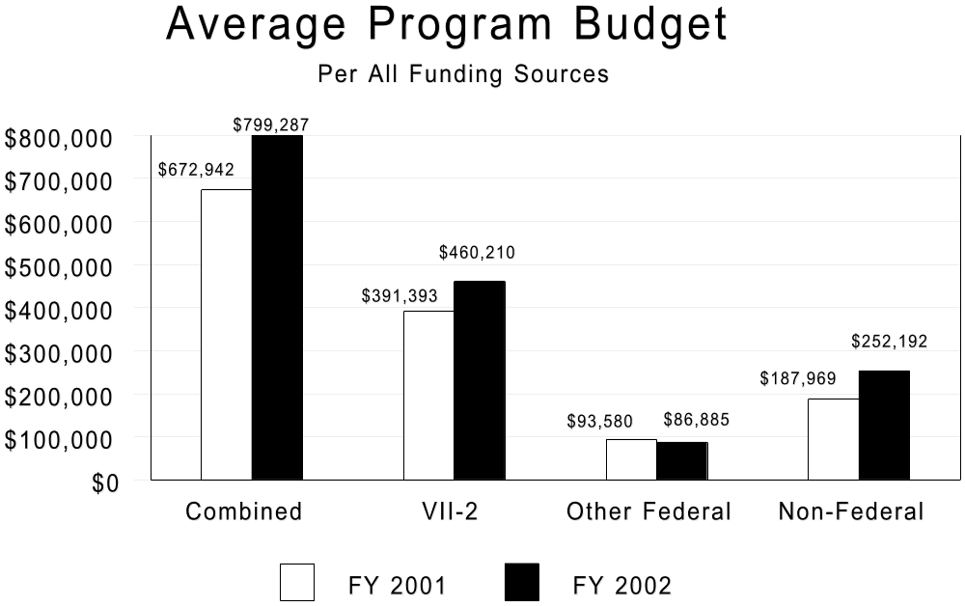

The average overall non-federal support per program increased from $187,969 to $252,192, a 34% increase. The overall average funding per program was $799,287, a 18.8% increase over the calculated $672,942 in FY 2001. These data reveal that 58% of all program funds continue to be federal VII-2 dollars. In addition,11% are other federal dollars, and 31% are from non-federal sources (state dollars, in-kind contributions, and third-party contributions). The overall ratio of the VII-2 portion of the funding pie was unchanged from FY 2001.
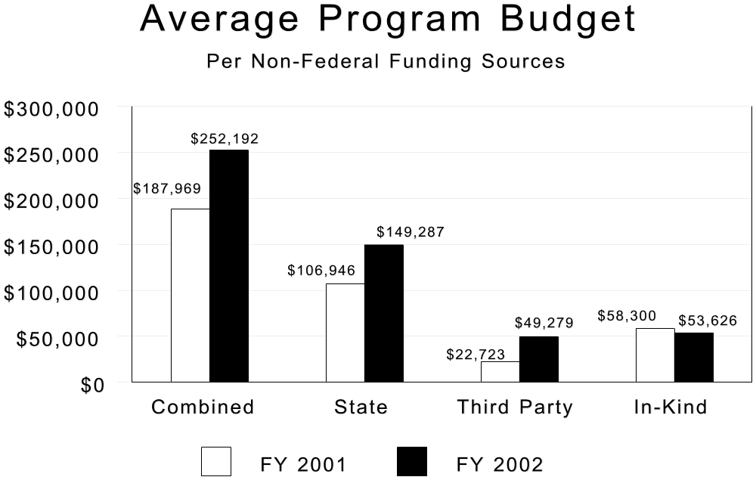

Third party contributions were reported by 17 programs, up from the 15 reported in FY 2001. The overall average of third party contributions per program increased from $22,723 to $49,279, a 117% increase. In-kind contributions were reported by 19 states, which is identical to the number reported in FY:2001. The overall average for in-kind contributions in FY 2002 was $53,626, compared to the previous year=s $58,300, an 8% decrease. (See Appendix for individual states, sources of funding, and type of expenditures.)

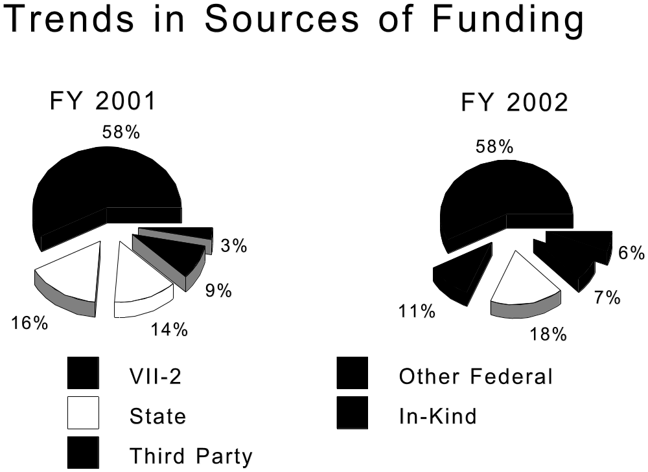

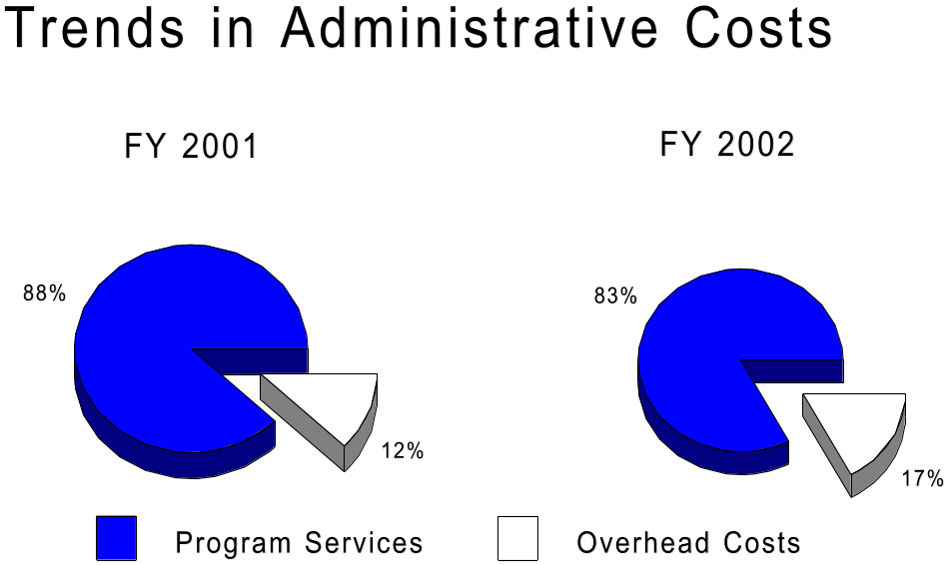

Program services consume the bulk of all program expenditures (83%). During the past several years administrative costs trended lower to a FY2001 level of 12%. However, FY2002 data reveal an increase to 17%. These overhead and administrative costs, as a percent of total costs, represent a ratio not experienced since FY1995 Some state agencies are experiencing tremendous financial pressures from budget shortfalls; therefore, these data may indicate a return to higher percentages of funding directed toward administrative costs.

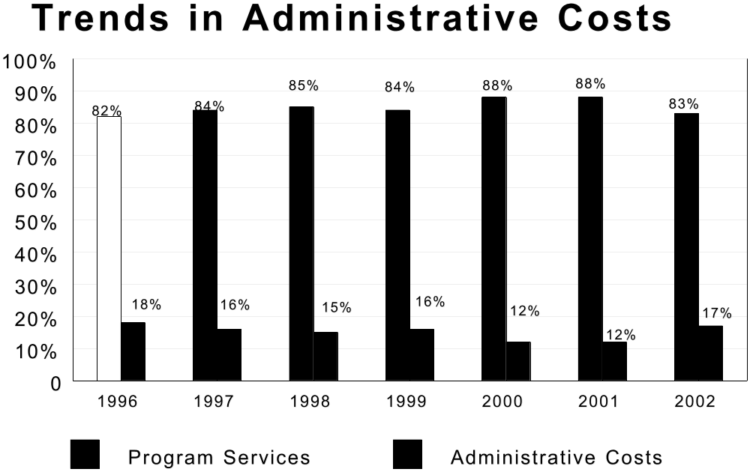

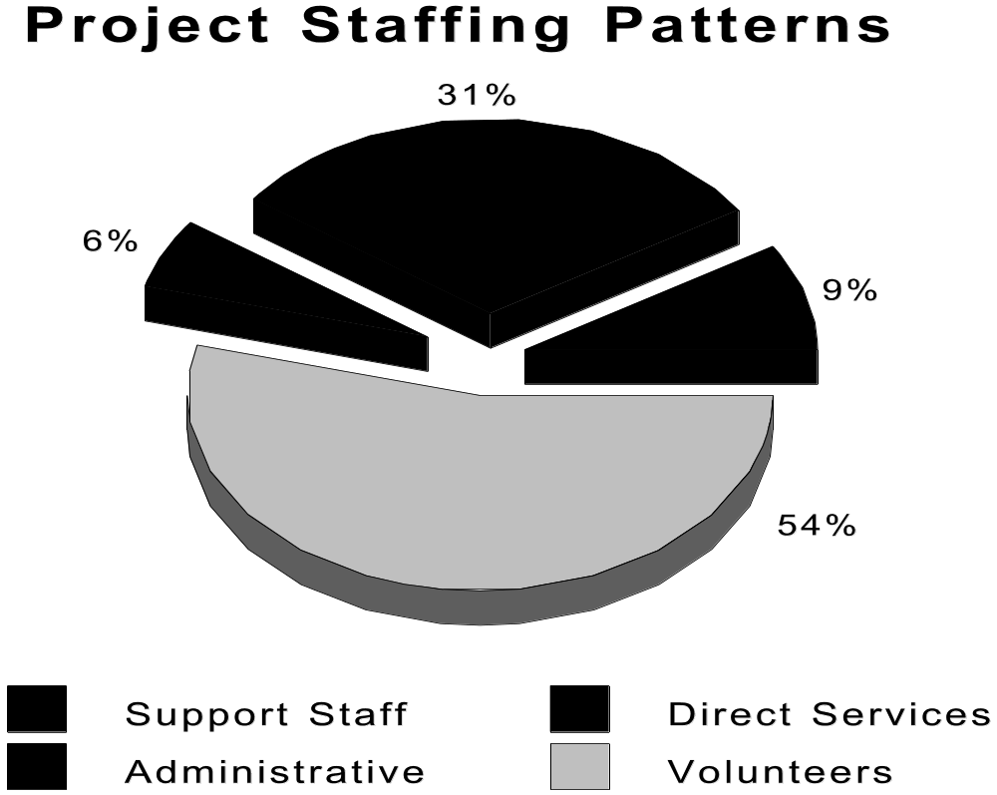

Program Staffing

Six percent of all program staff are classified as administrative, 2% less than the previous year. Staff who provide direct services was 31%, 9% lower than the previous year. Volunteers increased from 50% to 54%, and due to changes in the reporting form, consultants were no longer reported by the states. The new form separated staff into two categories, state agency staff and contractor staff. This information indicated state agency staff comprised 25.5% of the total staff and 74.5% were contractors. There was an overall increase in the total FTE (full-time equivalent) positions (from 1852 to 2487.36). Also, the average FTE per program increased (from 31 to 44.43). The form also captures the number of staff that considered themselves Bilingual as well as what additional languages were spoken. This item indicated 183.74 (7.4%) staff FTEs considered themselves to be Bilingual with Spanish or Spanish accompanied with another language being the most common other language spoken. However, this information should be utilized with caution because the form only allows for a simple listing of the other languages spoken. This listing included Spanish, Spanish and other, Japanese, French, Other, and Sign Language. However, there is no definitive way to report the exact number of staff that speak any specific other language.

Program Staffing Profile
Staffing  Category | Total FTE  State Agency* | Total FTE  Contractor | Total FTE  with a Disability | Total FTE  as a Minority | Total FTE Minority with Disability
Administration | 54.09 | 89.40 | 35.4  9% | 21.01  8% | 6.65  7%
Direct Service | 328.79 | 433.33 | 240.57  58% | 158.75  57% | 53.69  55%
Support | 126.33 | 104.63 | 41.36  10% | 48.05  17% | 11.50  12%
Volunteer | 125.59 | 1225.20 | 97.85  23% | 50.99  18% | 24.78  26%
All Categories | 634.80 | 1852.56 | 415.18  17% | 278.80  11% | 96.62  4%

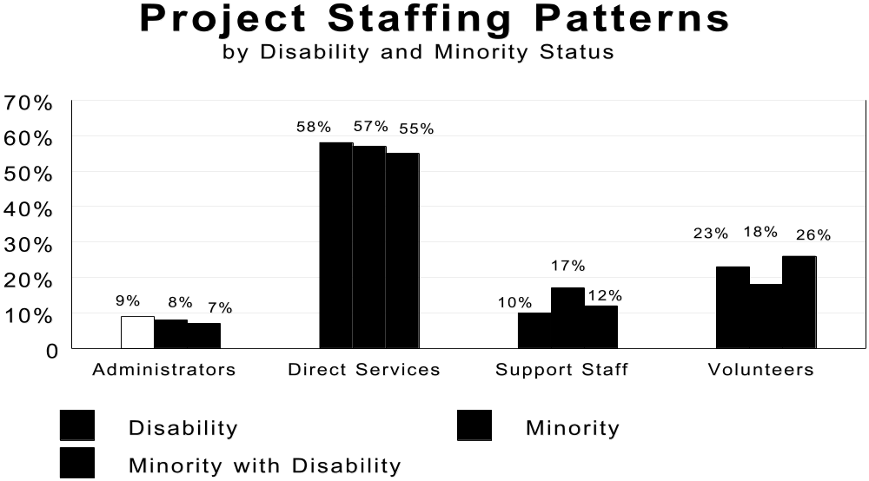

Among all staff, including volunteers, 17% have some type of disability compared to 22% in the previous fiscal year. The number of all staff reflecting minority status decreased from 12% to 11%. The highest ratios of persons with disabilities in descending order are direct service staff, 58%; volunteers, 23%; support staff, 10%; administrative staff, 9%. The highest ratios of persons of minority status compared to the total FTEs in that specific category, in descending order are direct service staff, 57%; volunteers, 18%; support staff, 17%; and administration, 8%. (See Appendix for individual states and staffing.)

Participant Characteristics

As reported earlier, the annual reporting form was revised in FY 2001. During the first year the new form included large amounts of missing data in all of the new and many of the old categories of participant characteristics, The amount of missing data decreased during FY2002; however, missing data still represent a substantial percentage of consumers in certain categories. These missing data are not included in any of the percentage calculations of participant characteristics provided in this report; however, the missing data are stated for each section, either in the narrative or as an accompanying explanation for any charts or tables. Continuing to minimize the amount of missing data will increase the reliability of the aggregated results included in this report and allow more accurate interpretations of the data.

Gender. Of those reporting gender, more than 7 out of 10 consumers (71%) are female and 29% of program participants are male. The gender ratio of 70% females served is typical among this population due to variations in life expectancy between genders.

Race/Ethnicity. Past reports have compared the race/ethnicity percentages of consumers served by the IL program with national race/ethnicity estimates; however, new census data allow comparisons with national race/ethnicity estimates for only people over 55 years of age. The following table indicates that on a national level the IL program is doing very well serving minorities; nevertheless, considerable research is needed to examine individual states to determine if some states skew the aggregate data. In addition, it should be noted that 13% of consumers receiving one or more services were not reported in the race/ethnicity section of the reporting form.
Race/Ethnicity of IL Consumers
Race/Ethnicity*  (*non-Hispanic) | Total U.S. Population** | U.S. Population  Age 55 & Above** | Race/Ethnicity of  IL Consumers
White* | 69% | 81.6% | 85%
African American* | 12% | 8.6% | 8.3%
Hispanic | 12.5% | 5.7% | 4.5%
Asian/Pacific Islander* | 3.8% | 2.6% | 1.4%
Native American* | .7% | .5% | .8%
Another Race/Ethnicity* | 2% | 1% | 0%
** Data from IPUMS Census data. (Sansing, 2004).[Analysis of IPUMS Data. Steven Ruggles and Matthew Sobek et al. Integrated Public Use Microdata Series: Version 3.0. Minneapolis: Historical Census Projects, University of Minnesota, 2003.
Retrieved June 26, 2003 from: http://www.ipums.org.] Unpublished raw data.
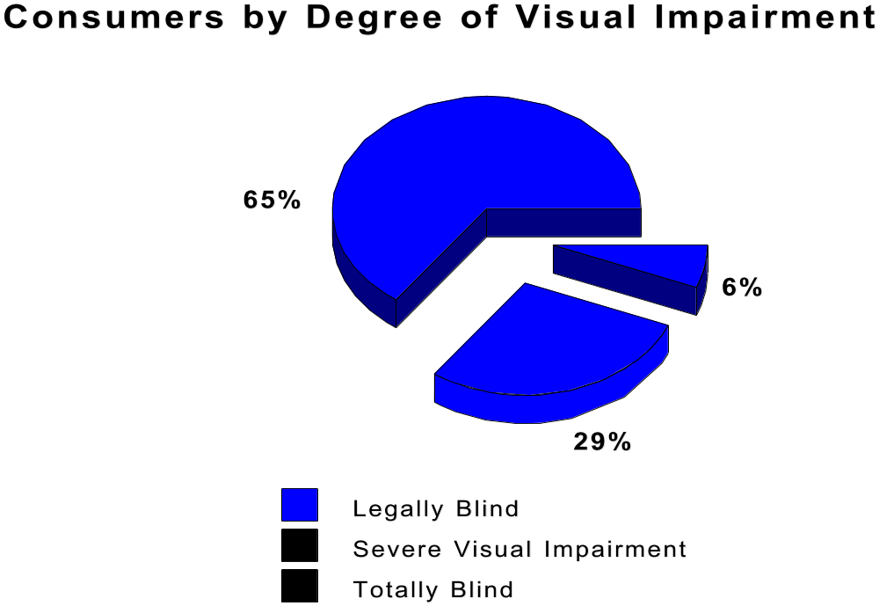

Of those reporting degree of visual impairment, over 6 out of 10 consumers (65%) were legally blind and 29% were classified as having a severe visual impairment that impacted upon their ability to function independently. In addition, 6% of consumers reported they were totally blind. It should be noted that degree of visual impairment was not collected from 16% of consumers that received one or more services and these missing data are not included in the previous percentage calculations. (See Appendix for individual states and data on individuals served.)

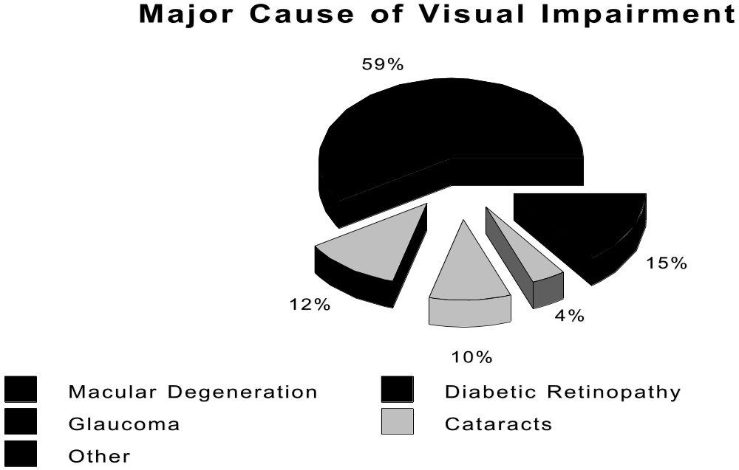

As reported earlier, FY2001 marked the addition of several new reporting elements within many sections of the annual reporting form. One of these elements was the nature of condition resulting in a consumer=s visual impairment. Of those reporting the major cause of visual impairment, almost 6 out of 10 consumers (59%) listed macular degeneration as their major cause of visual impairment; 12% listed diabetic retinopathy, 10% listed glaucoma, 4% listed cataracts, and 15% reported other causes of visual impairment. It should be noted that cause of visual impairment was not collected from 20% of consumers that received one or more services and these missing data are not included in the percentage calculations.

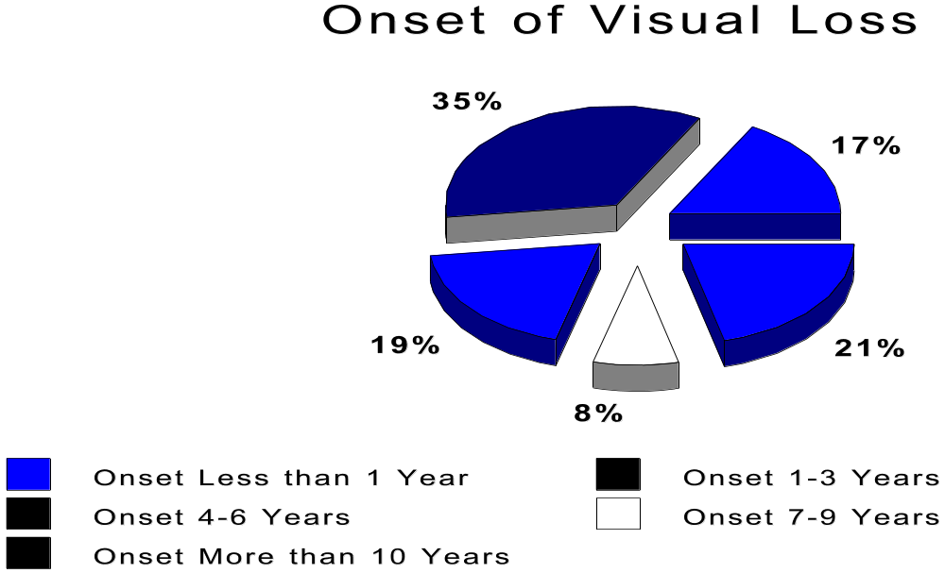

The revised form also included a new data element related to onset of visual impairment. Of those reporting onset of visual impairment, 35% reported their vision loss began 1 to 3 years prior to receiving services from a Title-VII program. Also, 17% reported their vision loss began less than 1 year prior; 19% 4 to 6 years prior; 21%, 10 years or more prior; and 8% reported their vision loss began 7-9 years prior. It should be noted that onset of visual loss was not collected from 36% of consumers that received one or more services and these missing data are not included in the percentage calculations
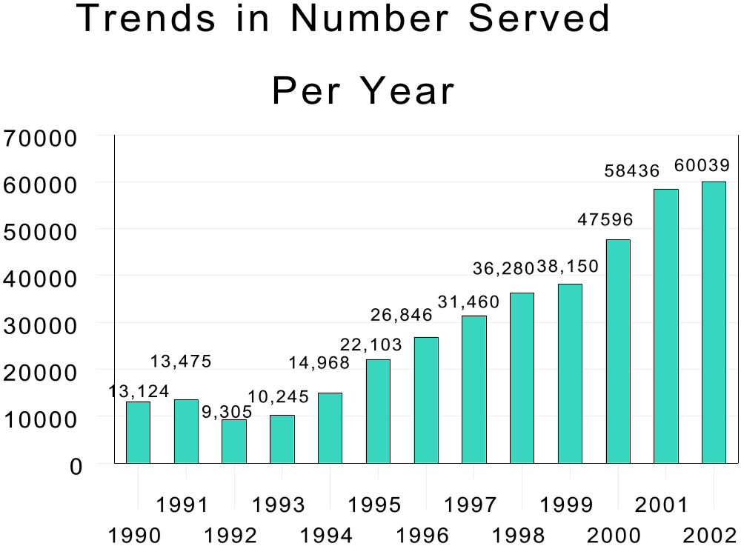

The total number of consumers served in FY 2002 (as reported within Part IV) was 60,039 compared to 58,436 in FY 2001. However, this number exceeds the 55,421 (4,618 missing data/not recorded) cases reported in Part III under Age categories. The number served in FY 2002 reflects a 2.7% increase in the individuals served compared to the previous year. These programs appear to be making judicious use of limited federal funds. The average direct expenditure per consumer was $617 (an increase of $53 from last year). Unfortunately, despite the increase in the number of individuals served, this is a very small percentage of the estimated number of those who might benefit from such a program.

States vary in the way they collect data on non-visual disabilities. Some states only account for the first non-visual disability, while others record more than one. Also, the new form included the item Data not recorded in the non-visual impairment section. Data were not recorded for 19% of the consumers receiving one or more services from the Title-VII program. Therefore, the reported percentages are based only on those consumers for which a non-visual impairment was recorded. Additionally, because some states report more than one non-visual disability, the percentages sum to more than 100%.

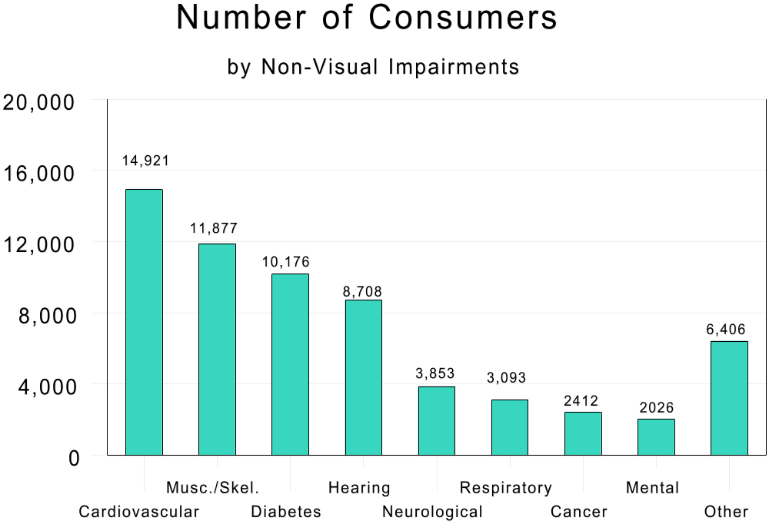

The most prevalent non-visual disability reported among consumers reporting a non-visual impairment were cardiovascular disease, 32%; musculoskeletal disorders, 26%; diabetes, 22%; and hearing impairment, 19%. Other impairments were neurological changes, 8%; respiratory or lung conditions, 7%; cancer, 5%; alterations in mental functioning, 4%; and other, 14% (includes kidney failure).

More than seven out of 10 consumers (71%) were 75 years of age or older. Fifty-three percent were age 80 or older, and more than 3 out of 10 (31%) were age 85 years or older. During the past 10 years, the average number of consumers age 80 and older has been trending toward half of the total number served and last year marked the first time persons age 80 and over comprised over half (53%) of persons receiving at least one service provided by the Title VII-Chapter 2 Program. It is notable that this trend was continued this year with 54% of consumers age 80 or above.

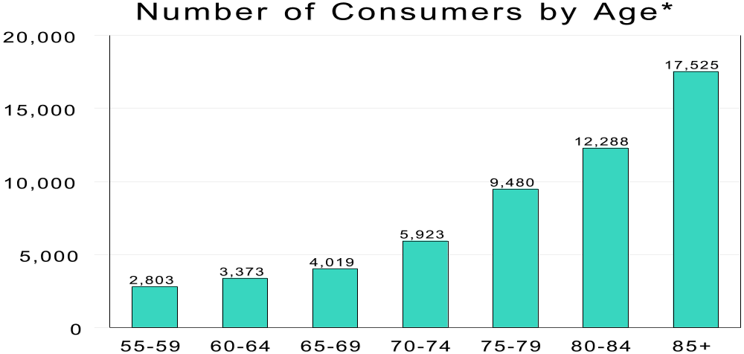
*4618 missing data/data not recorded in age of consumer served

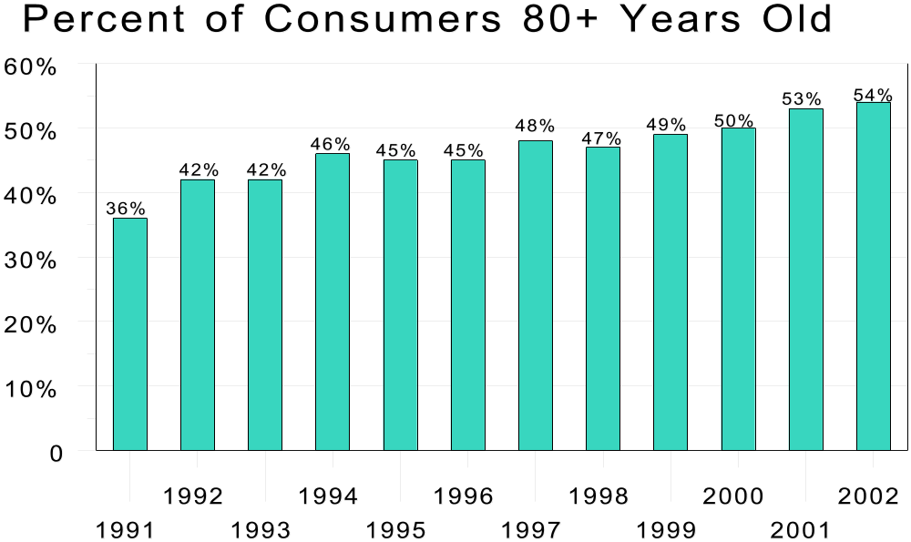
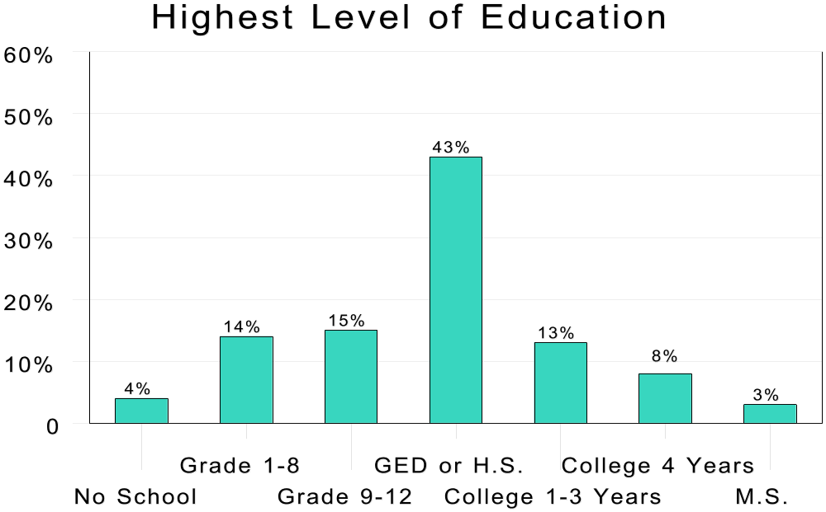

The Highest Level of Education Completed was added to the revised form. Of those reporting educational level, 43% of consumers receiving one or more services had completed high school and 24% had received some education beyond high school. Only 33% had completed less than a high school education. It should be noted that highest level of education was not collected from 31% of consumers that received one or more services and these missing data are not included in the percentage calculations

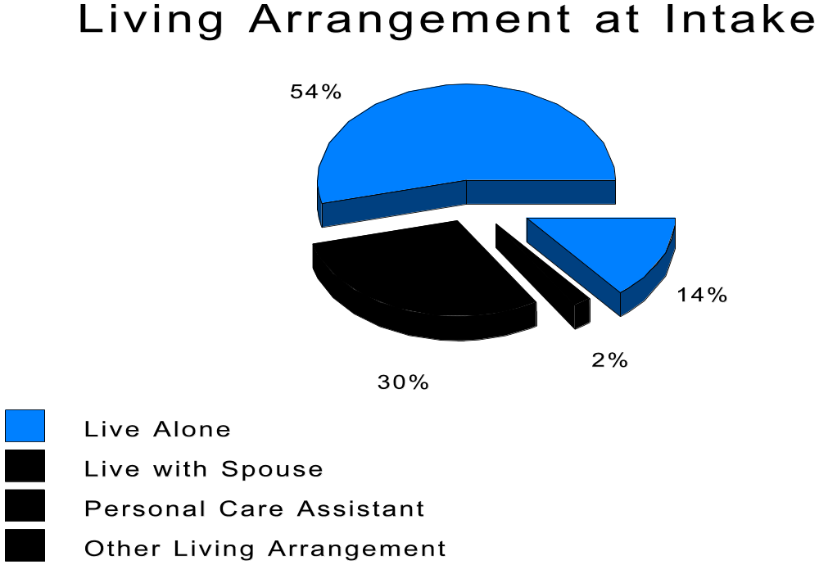

Each consumer=s Living Arrangement at Time of Intake was another new item included on the revised form. This item indicated 54% of consumers receiving at least one service lived alone at the time of intake. Additionally, 30% lived with their spouse, 2% lived with a personal care assistant, and 14% reported other types of living arrangement at intake. It should be noted that living arrangement at the time of intake was not collected from 21% of consumers that received one or more services and these missing data are not included in the percentage calculations.

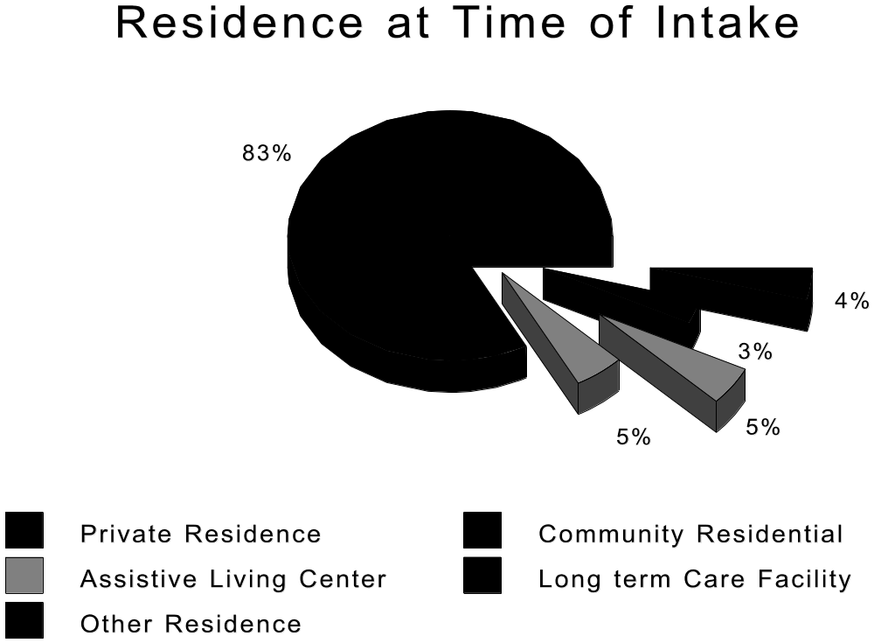

Each consumer=s Setting of Residence at Time of Intake was another item added to the new form. This item indicated 83% of consumers receiving at least one service lived in a private residence, apartment, or home at the time of their intake. Additionally, 5% lived in an Assisted Living Center, 5% lived in a community center, 3% lived in a long-tern care facility, and 4% indicated some other type of living arrangement at intake. It should be noted that type of residence at the time of intake was not collected from 23% of consumers that received one or more services and these missing data are not included in the percentage calculations.

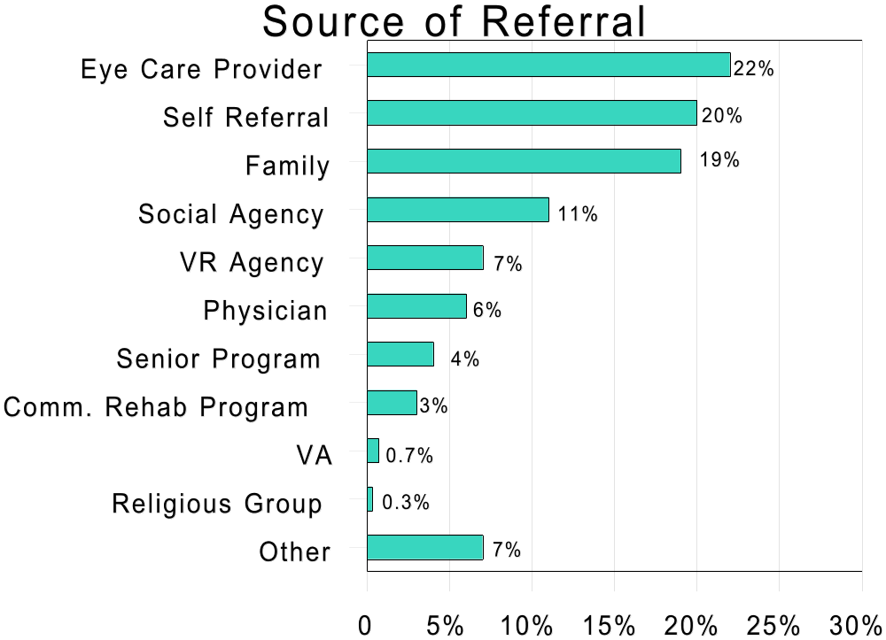

The Source of Each Consumer=s Referral to the Title VII Program was another new item on the revised form. This item indicated 22% of consumers were referred by their eye care provider, 20% by self-referral, 19% by a family member or friend, 11% by a social service agency, 7% by a vocational rehabilitation agency, 6% by a general practitioner or related medical personnel, 4% by a senior program, and 11% by some other type of referral. This information was not collected from 16% of the consumers receiving at least one service and these missing data are not included in the percentage calculations.

Services and Outcomes

The number of consumers served annually by VII-2 programs appeared to correlate with the funding cycles designated by RSA. In the past, the initial year of the 3-year funding cycle yielded the lowest number of participants, while the final year netted the highest. This phenomenon may have been attributable to predictable new program start-up delays, such as those often encountered in recruiting, hiring, and training new staff. The average number of persons served per program followed this same pattern; however, the overall number of persons served has increased notably over the past several fiscal years due to the increase in the number of programs funded and increased funding. The average number of persons served per program continued to increase from the previous year with 1,072 (60,03956) or 1112 persons served per program for the 54 reporting agencies.

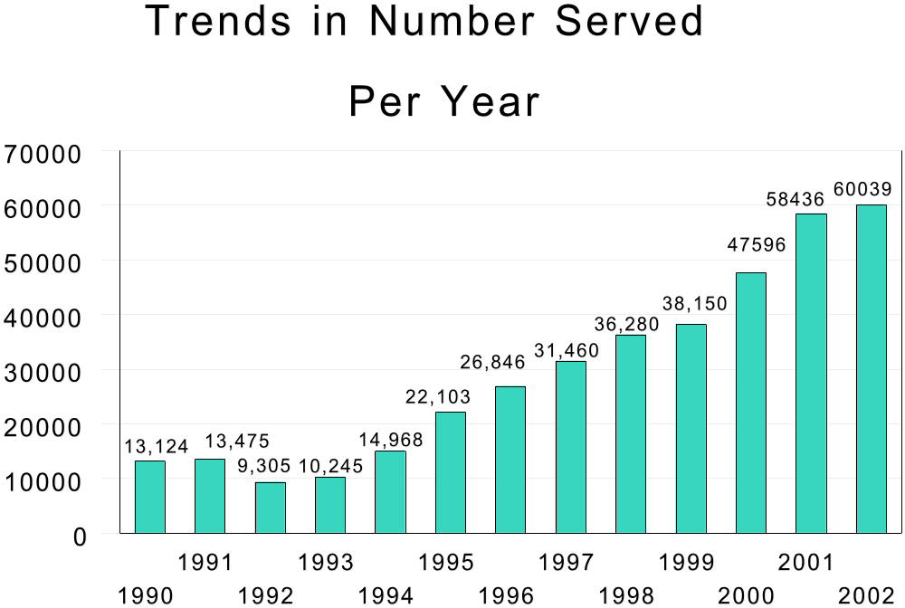

Perhaps one of the better ways of observing the depths of services provided among programs is to determine the ratio of those served who actually receive training for the development of skills related to Activities of Daily Living (ADL). Consider that the average number of consumers served per program in the initial 3-year funding cycle (FY1989-1991) was 501, compared to 397 in the second funding cycle
(FY1992-1994), a 21% decrease. It rose to 516 in the third funding cycle (FY 1995-1997), a 30% increase. This year=s average number of consumers served per program was 1,072, a 2.7% increase from the previous year=s average and has more than doubled the average of the third funding cycle (FY 1995-1997). In addition, the average number of persons who actually received training in ADL skills throughout the past 3 funding cycles increased from 210 to 283 to 367. The average number of persons per program receiving training in ADL skills in FY 2002 was 529. This number of consumers receiving training in daily living skills increased from 505 in FY 2001. This indicates an increase from the previous year in the ratio of those receiving ADL skills training to the total number served. The ratio in FY2002 was 49.4% compared to 48% for FY 2001.

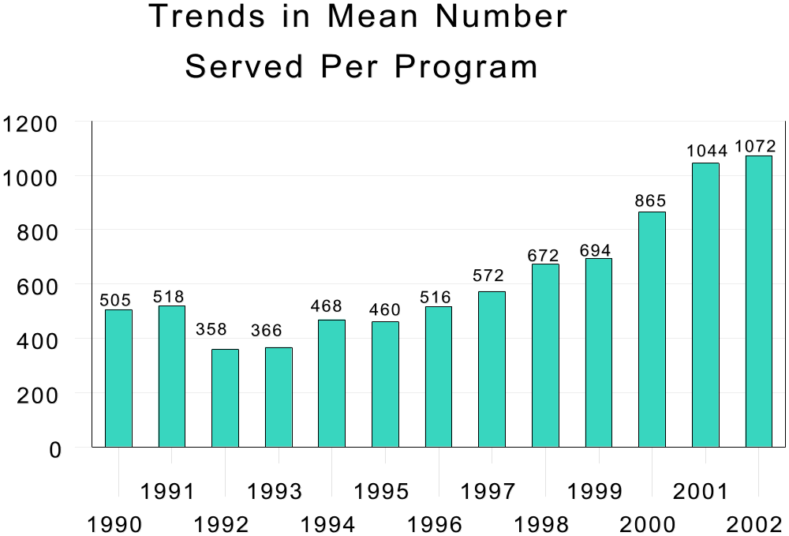

Skills training in orientation & mobility, communication, activities of daily living, advocacy, management of secondary disabilities, and low vision training comprised the primary categories of training services among these programs in FY 2002. Additional categories of services provided included low vision exams/screening/services, family counseling, transportation, readers or sighted guides, physical restoration, referral to vocational rehabilitation, referral to other agencies, PEER or support groups, and community integration. More than 21,527 consumers were referred to other agencies (including vocational rehabilitation) for services, at no cost to the VII-2 program. This is an increase of 3,767 from the previous year.

There has been an increase since last year in the average number of participants per program receiving each service except community integration (-23), restoration (-22), referrals to support groups (B18), and readers (-18). The greatest increase was found in low vision training (average increase of 97 participants). Other notable increases included O&M Training (+61), communication (+61), low vision screening (+55), referral to VR (+52), ADL (+24), and other referrals (+14). The average number of consumers receiving low vision training increased to 403 consumers. This training allows consumers to maximize their residual vision.

The revised form for FY 2001 included cost of services provided (reported in Part VI). The revised form separated federal funds from other sources of service funds. On average, programs spent $213,704 ($140,690 federal and $73,014 other source of funds) for training, $123,255 ($79,164 federal and $44,091 other source of funds) for individual services, and $124,959 ($104,596 federal and $20,363 other source of funds) for the purchase of adaptive aids, devices, or equipment. This total ($461,918) is substantially less than the average cost of direct services reported ($661,870).

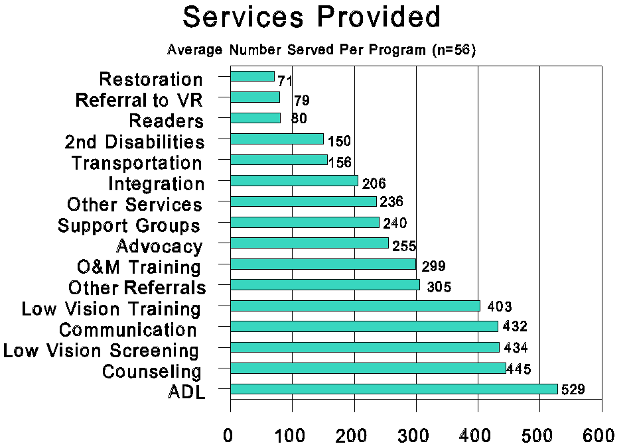

Consumer Comments

Several of the 7-OB forms contained consumer comments in response to the question, AWhat was the greatest difference this program made in your life?@ While it was not possible to summarize the results of the Program Participant Survey instrument, the following comments were typical of those mentioned most frequently by elders throughout the country (a special effort was made to capture participant comments verbatim; therefore, some deficiencies in grammar, syntax, and clarity of expression may be noted):

- AIt gave me more independence.@
- AIt taught me how to use a cane, mark items.@
- AGave me more confidence in myself and provided help with things I could not do myself.@
- AIt helped me compensate for my disability.@
- AHelped me to be able to see better.@
- AIt enabled me to be more confident in my life.@
- AIt has made it easier to shop.@
- ANow I can get out some as I don=t have a car.@
- ACan do more things for myself.@
- AI=m seeing better with magnifiers and the black lines for check writing.@
- ATelephone and magnifiers make life easier; able to sew again.@
- AGave me hope when I felt helpless.@
- ABeing able to read oven/microwave without digital outputs-got rid of my anger.@
- AEverything helped (wide-line paper, address book, magnifier.@
- ATelling time, talking books.@
- ANot depressed anymore.@
- AExplaining how to tell money.@
- AReading books on tape.@
- ALoved the visits.@
- AKnowing that there is help out there.@
- AGet around pretty good. Confidence in doing things that I couldn=t do. I=m still a person. Hosted Thanksgiving at my house.@
- AActivity with family and around house.@
- AOvercame fear of being alone!@
- AThe program gave me hope and self-confidence.@
- APhone, clock, timer made my life easier and less frustrating.@
- AScanner for reading on television and being able to read-I enjoy reading.@
- ATalking and working with people who help the visually impaired every day, knowing they understand the frustrations and problems of everyday living.@
- AMakes life worth living again. Your program is wonderful and I thank you.@
- AThey gave me the will to live and hope again. Without the program I never would have gotten over being so depressed.@
- AGood counselor support.@
- AI would hate to do without the services I received.@
- AProgram needs more workers and more money so more people can benefit.@
- AKnowing there are other people who had macular degeneration and there is help.@

Summary

Collection and compilation of these data have helped profile Title VII-Chapter 2 programs over the past 12 years. These profiles are one of several ways of viewing the benefits and outcomes of these less visible, yet critically important programs. These data should aid policy makers and program administrators alike in shaping the future of services for individuals who are older and visually impaired.

Increases in funding and implementation of a formula grant have strengthened and added stability to the program. The net results as reflected in this document are as follows: (a) more people continue to be served, (b) a larger ratio of those being served are receiving ADL skills training and other core services, (c) more programs are increasing the level of local resources contributed, (d) program stability and efficacy have increased, and (e) substantially more consumers are being referred to other agencies for services at no cost to the VII-2 program.

It is apparent that programs such as those funded under Title VII-Chapter 2 of the Rehabilitation Act are frugal, yet cost effective. Although these programs have generally maintained their level of service provision despite minimal increases in funding allotments, the number of persons served remains limited to a very small percentage of those who are thought eligible to benefit from these services. Federal and state policy makers and administrators might view the funding of these programs as an investment because it is arguable that in many instances, these programs prevent and/or delay the need for high-cost institutional or supported living care by extending active life expectancy.

The leaders of the NCSAB and the RRTC on Blindness and Low Vision who initially defined and began this process of data collection are to be commended. The leadership within the Rehabilitation Services Administration are to be commended for their resolve to continually expand and improve the VII-2 programs, in part via an annual analysis of what has become a minimum data set.

Recommendations

Program administrators should always be mindful of ways to improve the effectiveness and efficiency of programs serving individuals who are blind or severely visually impaired. For the most part, the clearer the picture one gleans from program data, the more objective the planning and service delivery process becomes. Thus, it is important that program administrators continually strive to improve their data collection instruments and procedures.

Upon viewing the data set from fiscal year 2002, the following recommendations are made in the spirit of improving the program:

- RSA should develop and implement strategies, in collaboration with the VR agency grantees and contractors, to reduce the amount of not-reported or missing data, especially in areas that should routinely be captured (e.g., age of consumers, degree of visual impairment, cause of visual impairment, etc.).

Rational: While the amount of missing data has been reduced from FY2001, large portions of key data elements remain unreported (e.g., degree of visual impairment [i.e. legally blind, totally blind, or severe visual impairment] was not collected for 16% of consumers served; cause of visual impairment [i.e. macular degeneration, diabetic retinopathy, glaucoma, cataracts, etc.] was not collected from 20% of the consumers served).

- RSA should provide technical assistance to Guam and the Virgin Islands relative to the completion of their annual Form 7OB data report.

Rational: Form 7OB program data have not been reported for the past two consecutive fiscal years as required by 34 CFR 367.11(d).

- All VR agency grantees and contractors should be encouraged to increase the utilization of In-Kind contributions as permitted under the statute and federal regulating guidelines.

Rational: Only 19 states reported use of In-Kind contributions in FY2002 (same as in FY2001). Use of In-Kind contributions are acceptable as a match/cost sharing mechanism and extend the use of limited state dollars: and

- RSA should ensure that all grantees make available and report minimal non-federal contributions (match/cost-sharing) as required in Section 752 (f)(1) of the Rehabilitation Act of 1973, as amended.

Rational: Several states reported expenditures less than $1 for each $9 of Federal Funds provided in the grant as required in 34 CFR 367-11 (b).

For More Information, Contact:

Ms. Suzanne Mitchell, Special Assistant
to the Commissioner
Rehabilitation Services Administration
U.S. Department of Education
330 C Street SW
Washington, DC 20202-2741
Phone (202) 205-9312

References

Moore, J.E. (2003). Using program evaluation to improve service delivery for older individuals who are blind. Journal of Visual Impairment and Blindness, 97, 42-45.

Moore, J.E. & Stephens, B.C. (1994). Independent living services for older individuals who are blind: Issues and practices. American Rehabilitation, 20(1), 30-34

Orr, A.L. & Rogers, P. (2001) Development of vision services for older people who are visually impaired: A historical perspective. Journal of Visual Impairment and Blindness, 95, 669-689.

Rogers, P. & Orr, A.L. (1999). Establishing a national service delivery program for older people who are blind or visually impaired. Re:view, 31, 103-112.

Sansing, (2004).[Analysis of IPUMS Data. Steven Ruggles and Matthew Sobek et al. Integrated Public Use Microdata Series: Version 3.0. Minneapolis: Historical Census Projects, University of Minnesota, 2003.
Retrieved June 26, 2003 from: http://www.ipums.org.] Unpublished raw data.

United States Census Bureau. (2003). Overview of Hispanic and racial make-up of total United States Population. Retrieved January 21, 2003., from factfinder.census.gov/servlet/DDTable?_ts.

Appendix

Sources of Funding
State* | VII-2 $ | Other Federal $ | State $ | 3rd party $ | In kind $ | Total $
Alabama | 378437 | 0 | 40793 | 0 | 0 | 419230
Alaska | 304179 | 1645 | 0 | 0 | 2771 | 308595
Arizona | 364115 | 0 | 198700 | 36410 | 0 | 599225
Arkansas | 232675 | 0 | 172756 | 0 | 0 | 405431
California | 2879647 | 0 | 0 | 0 | 414650 | 3294297
Colorado | 278626 | 7550 | 1987 | 800 | 8608 | 297571
Connecticut | 253341 | 57418 | 1149069 | 152044 | 0 | 1611872
Delaware | 294909 | 30927 | 321737 | 1606 | 41663 | 690842
D.C. | 213882 | 0 | 25000 | 13285 | 0 | 252167
Florida | 2200686 | 1349657 | 300138 | 2001967 | 623429 | 6475877
Georgia | 463322 | 12000 | 39944 | 14050 | 23146 | 552462
Hawaii | 219216 | 0 | 42506 | 0 | 0 | 261722
Idaho | 225000 | 40377 | 25000 | 0 | 0 | 290377
Illinois | 937136 | 225492 | 106868 | 3591 | 661947 | 1935034
Indiana | 349451 | 0 | 0 | 2174 | 75930 | 427555
Iowa | 315251 | 0 | 64552 | 0 | 0 | 379803
Kansas | 225000 | 0 | 25000 | 0 | 0 | 250000
Kentucky | 323630 | 0 | 35955 | 0 | 0 | 359585
Louisiana | 330486 | 0 | 36721 | 5091 | 0 | 372298
Maine | 267000 | 0 | 0 | 0 | 300000 | 567000
Maryland | 394359 | 0 | 43818 | 0 | 257134 | 695311
Massachusetts | 443099 | 0 | 49500 | 0 | 26210 | 518809
Michigan | 767979 | 288638 | 85331 | 0 | 0 | 1141948
Minnesota | 368537 | 0 | 1091749 | 0 | 0 | 1460286
Mississippi | 225000 | 85408 | 25000 | 0 | 0 | 335408
Missouri | 465782 | 0 | 369258 | 0 | 0 | 835040
Montana | 304959 | 0 | 25320 | 1956 | 0 | 332235
Nebraska | 225000 | 0 | 17001 | 7999 | 0 | 250000
Nevada | 320416 | 0 | 35507 | 0 | 0 | 355923
New Hampshire | 220644 | 0 | 0 | 0 | 42724 | 263368
New Jersey | 688698 | 427880 | 240413 | 0 | 0 | 1356991
New Mexico | 225000 | 0 | 476300 | 0 | 0 | 701300
New York | 1615627 | 0 | 169524 | 0 | 0 | 1785151
North Carolina | 398333 | 20918 | 2615 | 10000 | 56333 | 488199
North Dakota | 191269 | 0 | 58712 | 0 | 0 | 249981
Ohio | 928285 | 1409187 | 103143 | 148208 | 0 | 2588823
Oklahoma | 284859 | 198356 | 265034 | 0 | 0 | 748249
Oregon | 273899 | 0 | 30433 | 0 | 0 | 304332
Pennsylvania | 1125301 | 277962 | 1640080 | 0 | 0 | 3043343
Rhode Island | 303101 | 0 | 81740 | 0 | 0 | 384841
South Carolina | 316568 | 0 | 16195 | 0 | 117138 | 449901
South Dakota | 277109 | 0 | 30790 | 0 | 0 | 307899
Tennessee | 325220 | 0 | 36136 | 0 | 0 | 361356
Texas | 1353967 | 372431 | 443350 | 0 | 0 | 2169748
Utah | 225000 | 0 | 27157 | 0 | 0 | 252157
Vermont | 225000 | 0 | 275000 | 44992 | 0 | 544992
Virginia | 456018 | 0 | 0 | 0 | 217344 | 673362
Washington | 481507 | 59732 | 132115 | 310001 | 0 | 983355
West Virginia | 225000 | 0 | 0 | 0 | 36666 | 261666
Wisconsin | 427898 | 0 | 0 | 0 | 42790 | 470688
Wyoming | 225000 | 0 | 2157 | 5390 | 22843 | 255390
Puerto Rico | 285710 | 0 | 0 | 0 | 31745 | 317455
American Samoa  American Samoa | 40000 | 0 | 0 | 0 | 0 | 40000
Mariana Islands | 81625 | 0 | 0 | 0 | 0 | 81625
Total Funding | 25,771,758 | 4,865,578 | 8,360,104 | 2,759,564 | 3,003,071 | 44,760,073
*A reporting form was not received from Guam or the Virgin Islands

Funding Allocations
State* | Overhead $ | Direct Service $ | Total $
Alabama | 93547 | 325683 | 419230
Alaska | 58679 | 249916 | 308595
Arizona | 122800 | 476425 | 599225
Arkansas | 10066 | 395365 | 405431
California | 586439 | 2707858 | 3294297
Colorado | 65594 | 231977 | 297571
Connecticut | 472574 | 1139298 | 1611872
Delaware | 151436 | 539406 | 690842
D.C. | 122252 | 129915 | 252167
Florida | 2279888 | 4195989 | 6475877
Georgia | 26390 | 526071 | 552461
Hawaii | 73852 | 187870 | 261722
Idaho | 89756 | 200621 | 290377
Illinois | 252150 | 1682884 | 1935034
Indiana | 0 | 427555 | 427555
Iowa | 76560 | 303243 | 379803
Kansas | 10243 | 239757 | 250000
Kentucky | 37500 | 322085 | 359585
Louisiana | 5880 | 366418 | 372298
Maine | 93750 | 473250 | 567000
Maryland | 5031 | 690280 | 695311
Massachusetts | 136911 | 381898 | 518809
Michigan | 195004 | 946944 | 1141948
Minnesota | 608975 | 851311 | 1460286
Mississippi | 7648 | 327760 | 335408
Missouri | 140125 | 694915 | 835040
Montana | 9394 | 322841 | 332235
Nebraska | 49169 | 200831 | 250000
Nevada | 30742 | 325181 | 355923
New Hampshire | 89687 | 173681 | 263368
New Jersey | 94258 | 1262733 | 1356991
New Mexico | 76000 | 625300 | 701300
New York | 0 | 1785151 | 1785151
North Carolina | 0 | 488199 | 488199
North Dakota | 345 | 249636 | 249981
Ohio | 167558 | 2421265 | 2588823
Oklahoma | 126392 | 621857 | 748249
Oregon | 0 | 304332 | 304332
Pennsylvania | 432594 | 2610749 | 3043343
Rhode Island | 22051 | 362790 | 384841
South Carolina | 20000 | 429901 | 449901
South Dakota | 16359 | 291540 | 307899
Tennessee | 0 | 361355 | 361355
Texas | 179818 | 1989930 | 2169748
Utah | 42541 | 209616 | 252157
Vermont | 59149 | 485843 | 544992
Virginia | 29859 | 643503 | 673362
Washington | 168484 | 814871 | 983355
West Virginia | 52643 | 209023 | 261666
Wisconsin | 148754 | 321934 | 470688
Wyoming | 116647 | 138743 | 255390
Puerto Rico | 31745 | 285710 | 317455
American Samoa | 0 | 40000 | 40000
Mariana Islands | 8067 | 73558 | 81625
Total Allocation | 7,695,306 | 37,064,767 | 44,760,073
*A reporting form was not received from Guam or the Virgin Islands

State Agency Total FTE
State* | Administrators | Direct service | Direct Support | Consultants | Volunteers | Total FTE for State Agency
Alabama | 1.25 | 6.0 | 12.75 | 0 | 4.0 | 23.75
Alaska | 0 | 0 | 0 | 0 | 0 | 0
Arizona | .36 | 2.0 | 0 | 0 | 0 | 2.36
Arkansas | 1.0 | 7.0 | 6.5 | 0 | 0 | 14.50
California | 1.5 | 0 | 0 | 0 | 0 | 1.50
Colorado | 1.25 | 0 | 0 | 0 | 0 | 1.25
Connecticut | .81 | 10.0 | 3.6 | 0 | 31 | 45.41
Delaware | 1.4 | 6.0 | 1.4 | 0 | 0 | 8.80
D.C. | .75 | .75 | .25 | 0 | 0 | 1.75
Florida | 0 | 0 | 0 | 0 | 0 | 0
Georgia | .10 | 0 | 0 | 0 | 0 | .10
Hawaii | .10 | .835 | 0 | 0 | 0 | .94
Idaho | 1.0 | 5.5 | 3.5 | 0 | .25 | 10.25
Illinois | 2.5 | 5.95 | 3.4 | 0 | 0 | 11.85
Indiana | 5.1 | 6.4 | 3.5 | 0 | 1.55 | 16.55
Iowa | .52 | 5.04 | .82 | 0 | 0 | 6.38
Kansas | .95 | 4.1 | 3.3 | 0 | 0 | 8.35
Kentucky | .50 | 4.5 | 1.0 | 0 | .10 | 6.10
Louisiana | .10 | 0 | 0 | 0 | 0 | .10
Maine | .80 | 4.35 | .15 | 0 | 0 | 5.30
Maryland | 1.0 | 5.4 | .5 | 0 | 0 | 6.90
Massachusetts | 1.0 | 1.7 | 0 | 0 | 0 | 2.70
Michigan | 1.0 | 4.0 | 1.0 | 0 | 0 | 6.00
Minnesota | 3.6 | 8.48 | 5.2 | 0 | 0 | 17.28
Mississippi | 1.0 | 6.0 | 1.0 | 0 | 15.0 | 23.00
Missouri | 1.0 | 5.0 | 5.0 | 0 | 0 | 11.00
Montana | 1.5 | 8.0 | 0 | 0 | 0 | 9.50
Nebraska | .96 | 4.2 | 1.8 | 0 | 0 | 6.96
Nevada | .10 | 3.4 | 0 | 0 | 0 | 3.50
New  Hampshire | 1.0 | 1.0 | 1.0 | 0 | 2.0 | 5.00
New Jersey | 0 | 0 | 0 | 0 | 0 | 0
New Mexico | .50 | 8.0 | 1.0 | 0 | 0 | 9.50
New York | .25 | 0 | .10 | 0 | 0 | .35
North Carolina | 1.1 | 12.0 | 12.6 | 0 | 0 | 25.70
North Dakota | .50 | 3.19 | .24 | 0 | 0 | 3.93
Ohio | .48 | 3.5 | 3.3 | 0 | 0 | 7.28
Oklahoma | 2.5 | 23.0 | 9.5 | 0 | 20.0 | 55.00
Oregon | 1.0 | 4.0 | 1.5 | 0 | 0 | 6.50
Pennsylvania | 3.09 | 17.97 | 5.0 | 0 | 0 | 26.06
Rhode Island | .40 | 4.35 | .35 | 0 | 0 | 5.10
South Carolina | 1.0 | 10.0 | 11.0 | 0 | 0 | 22.00
South Dakota | 1.0 | 7.0 | 0 | 0 | 0 | 8.00
Tennessee | 1.5 | 23.0 | 3.5 | 0 | 0 | 28.00
Texas | 1.6 | 28.5 | 11.25 | 0 | 0 | 41.35
Utah | .10 | .40 | 0 | 0 | 0 | .50
Vermont | .290 | 7.05 | 5.08 | 0 | 1.0 | 13.42
Virginia | .32 | 41.0 | .10 | 0 | 50.0 | 91.42
Washington | 1.3 | .60 | .50 | 0 | 0 | 2.40
West Virginia | .25 | 0 | .25 | 0 | 0 | .50
Wisconsin | .87 | 5.44 | .50 | 0 | .60 | 7.41
Wyoming | .39 | 6.38 | .64 | 0 | .092 | 7.50
Puerto Rico | 2.0 | 6.0 | 2.0 | 0 | 0 | 10.00
American Samoa | 1.0 | 1.0 | 1.0 | 0 | 0 | 3.00
Mariana Islands | .50 | .80 | 1.25 | 0 | 0 | 2.55
Total Agency Staff FTE | 54.09 | 328.79 | 126.33 | 0 | 125.59 | 634.8
*A reporting form was not received from Guam or the Virgin Islands

Total FTE for Contractors
State* | Administrators | Direct service | Direct Support | Consultants | Volunteers | Total FTE for  Contractors
Alabama | 0 | 0 | 0 | 0 | 0 | 0
Alaska | 2.31 | 5.56 | 4.19 | 0 | .525 | 12.59
Arizona | 0 | 7.0 | 1.6 | 0 | 0 | 8.60
Arkansas | 0 | 0 | 0 | 0 | 0 | 0
California | 8.23 | 40.37 | 6.18 | 0 | 5.27 | 60.05
Colorado | 2.06 | 6.4 | .28 | 0 | .88 | 9.62
Connecticut | .50 | 1.75 | 0 | 0 | 0 | 2.25
Delaware | 0 | 0 | 0 | 0 | 0 | 0
D.C. | .78 | 2.0 | 1.7 | 0 | .55 | 5.03
Florida | 29.5 | 126.5 | 38.0 | 0 | 95.0 | 289.00
Georgia | 3.67 | 13.43 | 5.36 | 0 | 5.0 | 27.46
Hawaii | 1.0 | 3.75 | 1.0 | 0 | 0 | 5.75
Idaho | 0 | 0 | 0 | 0 | 22.0 | 22.00
Illinois | 3.0 | 17.0 | 4.0 | 0 | .65 | 24.65
Indiana | .53 | 4.95 | 2.25 | 0 | 961.0 | 968.73
Iowa | 0 | 0 | 0 | 0 | 0 | 0
Kansas | 0 | 0 | 0 | 0 | 0 | 0
Kentucky | 0 | 0 | 0 | 0 | 0 | 0
Louisiana | .25 | 3.71 | .05 | 0 | .05 | 4.06
Maine | .75 | 4.5 | .50 | 0 | 1.5 | 7.25
Maryland | 0 | 0 | 0 | 0 | 0 | 0
Massachusetts0 | 0 | .50 | 0 | 0 | 0 | .50
Michigan | 0 | 4.0 | .50 | 0 | 0 | 4.50
Minnesota | 0 | 0 | 0 | 0 | 0 | 0
Mississippi | 0 | 0 | 0 | 0 | 0 | 0
Missouri | 0 | 0 | 0 | 0 | 0 | 0
Montana | 0 | 1.0 | 0 | 0 | 6.4 | 7.40
Nebraska | 0 | 0 | 0 | 0 | 0 | 0
Nevada | 0 | 0 | 0 | 0 | 0 | 0
New  Hampshire | .75 | 0 | 0 | 0 | 0 | .75
New Jersey | 8.66 | 10.92 | 3.4 | 0 | 61.57 | 84.55
New Mexico | 0 | 0 | 0 | 0 | 0 | 0
New York | 20.98 | 118.94 | 27.1 | 0 | 47.0 | 214.02
North Carolina | 0 | 0 | 0 | 0 | 0 | 0
North Dakota | 0 | 0 | 0 | 0 | 0 | 0
Ohio | 4.3 | 27.4 | 7.3 | 0 | .80 | 39.80
Oklahoma | 0 | 0 | 0 | 0 | 0 | 0
Oregon | 0 | 0 | 0 | 0 | 0 | 0
Pennsylvania | 0 | 0 | 0 | 0 | 0 | 0
Rhode Island | 0 | 0 | 0 | 0 | 0 | 0
South Carolina | 0 | 0 | 0 | 0 | 0 | 0
South Dakota | .50 | 3.0 | 0 | 0 | 15.0 | 18.50
Tennessee | 0 | 0 | 0 | 0 | 0 | 0
Texas | 0 | 8.0 | 0 | 0 | 0 | 8.00
Utah | .38 | 3.15 | .47 | 0 | 0 | 4.00
Vermont | 0 | 0 | 0 | 0 | 0 | 0
Virginia | 0 | 0 | 0 | 0 | 0 | 0
Washington | 0 | 13 | 0 | 0 | 0 | 13.00
West Virginia | 1.25 | 6.0 | .75 | 0 | 2.0 | 10.00
Wisconsin | 0 | .50 | 0 | 0 | 0 | .50
Wyoming | 0 | 0 | 0 | 0 | 0 | 0
Puerto Rico | 0 | 0 | 0 | 0 | 0 | 0
American Samoa | 0 | 0 | 0 | 0 | 0 | 0
Mariana Islands | 0 | 0 | 0 | 0 | 0 | 0
Total FTE Contractor | 89.4 | 433.33 | 104.63 | 0 | 1225.20 | 1852.56
*A reporting form was not received from Guam or the Virgin Islands

Total FTE by State
State* | Total Administrators | Total Direct service | Total Direct Support | Total Consultants | Total Volunteers | Total FTE All  Sources
Alabama | 1.25 | 6.0 | 12.75 | 0 | 4.0 | 23.75
Alaska | 2.31 | 5.56 | 4.19 | 0 | .53 | 12.59
Arizona | .36 | 9.0 | 1.6 | 0 | 0 | 10.96
Arkansas | 1.0 | 7.0 | 6.5 | 0 | 0 | 14.50
California | 9.73 | 40.37 | 6.18 | 0 | 5.27 | 61.55
Colorado | 3.31 | 6.40 | .28 | 0 | .88 | 10.87
Connecticut | 1.31 | 11.75 | 3.6 | 0 | 31.0 | 47.66
Delaware | 1.4 | 6.0 | 1.4 | 0 | 0 | 8.80
D.C. | 1.53 | 2.75 | 1.95 | 0 | .55 | 6.78
Florida | 29.5 | 126.5 | 38.0 | 0 | 95.0 | 289.00
Georgia | 3.77 | 13.43 | 5.36 | 0 | 5.0 | 27.56
Hawaii | 1.1 | 4.59 | 1.0 | 0 | 0 | 6.69
Idaho | 1.0 | 5.5 | 3.5 | 0 | 22.25 | 32.25
Illinois | 5.5 | 22.95 | 7.4 | 0 | .65 | 36.50
Indiana | 5.63 | 11.35 | 5.75 | 0 | 962.55 | 985.28
Iowa | .52 | 5.04 | .82 | 0 | 0 | 6.38
Kansas | .95 | 4.1 | 3.3 | 0 | 0 | 8.35
Kentucky | .50 | 4.5 | 1.0 | 0 | .10 | 6.10
Louisiana | .35 | 3.71 | .05 | 0 | .05 | 4.16
Maine | 1.55 | 8.85 | .65 | 0 | 1.5 | 12.55
Maryland | 1.0 | 5.40 | .50 | 0 | 0 | 6.90
Massachusetts | 1.0 | 2.2 | 0 | 0 | 0 | 3.20
Michigan | 1.0 | 8.0 | 1.5 | 0 | 0 | 10.50
Minnesota | 3.6 | 8.48 | 5.2 | 0 | 0 | 17.28
Mississippi | 1.0 | 6.0 | 1.0 | 0 | 15.0 | 23.00
Missouri | 1.0 | 5.0 | 5.0 | 0 | 0 | 11.00
Montana | 1.5 | 9.0 | 0 | 0 | 6.4 | 16.90
Nebraska | .96 | 4.2 | 1.8 | 0 | 0 | 6.96
Nevada | .10 | 3.4 | 0 | 0 | 0 | 3.5
New  Hampshire | 1.75 | 1.0 | 1.0 | 0 | 2.0 | 5.75
New Jersey | 8.66 | 10.92 | 3.4 | 0 | 61.57 | 84.55
New Mexico | .50 | 8.0 | 1.0 | 0 | 0 | 9.50
New York | 21.23 | 118.94 | 27.20 | 0 | 47.0 | 214.37
North Carolina | 1.10 | 12.0 | 12.6 | 0 | 0 | 25.70
North Dakota | .50 | 3.19 | .24 | 0 | 0 | 3.93
Ohio | 4.78 | 30.90 | 10.60 | 0 | .80 | 47.08
Oklahoma | 2.50 | 23.0 | 9.5 | 0 | 20.0 | 55.00
Oregon | 1.0 | 4.0 | 1.5 | 0 | 0 | 6.50
Pennsylvania | 3.09 | 17.97 | 5.0 | 0 | 0 | 26.06
Rhode Island | .40 | 4.35 | .35 | 0 | 0 | 5.10
South Carolina | 1.0 | 10.0 | 11.0 | 0 | 0 | 22.00
South Dakota | 1.5 | 10.0 | 0 | 0 | 15.0 | 26.50
Tennessee | 1.5 | 23.0 | 3.5 | 0 | 0 | 28.00
Texas | 1.6 | 36.5 | 11.25 | 0 | 0 | 49.35
Utah | .48 | 3.55 | .47 | 0 | 0 | 4.50
Vermont | .29 | 7.05 | 5.08 | 0 | 1.0 | 13.42
Virginia | .32 | 41.0 | .10 | 0 | 50.0 | 91.42
Washington | 1.3 | 13.6 | .50 | 0 | 0 | 15.40
West Virginia | 1.5 | 6.0 | 1.0 | 0 | 2.0 | 10.50
Wisconsin | .87 | 5.94 | .50 | 0 | .60 | 7.91
Wyoming | .39 | 6.38 | .64 | 0 | .092 | 7.50
Puerto Rico | 2.0 | 6.0 | 2.0 | 0 | 0 | 10.00
American Samoa | 1.0 | 1.0 | 1.0 | 0 | 0 | 3.00
Mariana Islands | .50 | .80 | 1.25 | 0 | 0 | 2.55
Total FTE | 143.49 | 762.12 | 230.96 | 0 | 1350.79 | 2487.36
*A reporting form was not received from Guam or the Virgin Islands

Total FTEs with Disabilities by State
State* | Total Administrators | Total Direct service | Total Direct Support | Total Consultants | Total Volunteers | Total FTE All  Sources
Alabama | 0 | 2.5 | 3.0 | 0 | 3.65 | 9.15
Alaska | 2.1 | 2.7 | .93 | 0 | .275 | 6.01
Arizona | 0 | 0 | 0 | 0 | 0 | 0
Arkansas | 1.0 | 2.0 | 0 | 0 | 0 | 3.00
California | 1.84 | 15.97 | .47 | 0 | .69 | 18.97
Colorado | 1.11 | 5.4 | .18 | 0 | .58 | 7.27
Connecticut | .51 | 3.4 | 0 | 0 | .02 | 3.93
Delaware | 0 | 0 | 1.4 | 0 | 0 | 1.40
D.C. | 1.25 | 2.0 | 1.3 | 0 | .40 | 4.95
Florida | 2.5 | 41.0 | 3.0 | 0 | 34.0 | 80.50
Georgia | .10 | 6.0 | 2.0 | 0 | 5.0 | 13.10
Hawaii | 0 | 1.0 | 0 | 0 | 0 | 1.00
Idaho | 0 | 3.0 | .50 | 0 | 18.0 | 21.50
Illinois | 1.0 | 13.4 | 1.85 | 0 | 0 | 16.25
Indiana | 4.0 | 5.25 | 3.0 | 0 | 1.0 | 13.25
Iowa | 0 | 2.52 | .40 | 0 | 0 | 2.92
Kansas | .95 | 0 | 2.2 | 0 | 0 | 3.15
Kentucky | 0 | 2.0 | 1.0 | 0 | .10 | 3.10
Louisiana | .15 | .61 | .0 | 0 | .04 | .80
Maine | 0 | 1.3 | 0 | 0 | 0 | 1.30
Maryland | 1.0 | 3.0 | 0 | 0 | 0 | 4.00
Massachusetts | 0 | 0 | 0 | 0 | 0 | 0
Michigan | 0 | 5.0 | 0 | 0 | 0 | 5.00
Minnesota | 0 | 2.0 | 0 | 0 | 0 | 2.00
Mississippi | 0 | 2.0 | 0 | 0 | 0 | 2.00
Missouri | 1.0 | 5.0 | 5.0 | 0 | 0 | 11.00
Montana | 1.0 | 2.0 | 0 | 0 | 0 | 3.00
Nebraska | .96 | 1.0 | .20 | 0 | 0 | 2.16
Nevada | 0 | 2.0 | 0 | 0 | 0 | 2.00
New  Hampshire | 1.0 | 1.0 | 0 | 0 | 2.0 | 4.00
New Jersey | 1.0 | 0 | 0 | 0 | 0 | 1.00
New Mexico | .50 | 3.0 | 0 | 0 | 0 | 3.50
New York | 1.6 | 14.4 | 4.1 | 0 | 11.0 | 31.10
North Carolina | 0 | 3.0 | 5.2 | 0 | 0 | 8.20
North Dakota | 0 | 1.2 | 0 | 0 | 0 | 1.20
Ohio | .30 | 3.7 | .90 | 0 | .50 | 5.40
Oklahoma | 2.0 | 13.0 | .50 | 0 | 3.0 | 18.50
Oregon | 1.0 | 4.0 | 0 | 0 | 0 | 5.00
Pennsylvania | .26 | 3.29 | .50 | 0 | 0 | 4.05
Rhode Island | 0 | 1.4 | 0 | 0 | 0 | 1.40
South Carolina | 0 | 1.0 | 0 | 0 | 0 | 1.00
South Dakota | 0 | 4.5 | 0 | 0 | 15.0 | 19.50
Tennessee | .50 | 5.0 | 0 | 0 | 0 | 5.50
Texas | 2.0 | 20.0 | 1.0 | 0 | 0 | 23.00
Utah | .48 | 1.25 | .33 | 0 | 0 | 2.06
Vermont | 0 | 2.1 | .40 | 0 | 0.5 | 3.00
Virginia | 1.0 | 10.0 | 0 | 0 | 0 | 11.00
Washington | 1.3 | 5.6 | .50 | 0 | 0 | 7.40
West Virginia | 1.25 | 5.0 | 1.0 | 0 | 2.0 | 9.25
Wisconsin | .38 | .70 | 0 | 0 | 0 | 1.08
Wyoming | .39 | 4.38 | 0 | 0 | .092 | 4.86
Puerto Rico | 0 | 1.0 | 0 | 0 | 0 | 1.00
American Samoa | 0 | 0 | 0 | 0 | 0 | 0
Mariana Islands | 0 | 0 | .50 | 0 | 0 | .50
Total FTE Disability | 35.43 | 240.57 | 41.36 | 0 | 97.85 | 415.21
*A reporting form was not received from Guam or the Virgin Islands

Total FTEs who are Racial/Ethnic Minorities
State* | Total Administrators | Total Direct service | Total Direct Support | Total Consultants | Total Volunteers | Total Minority  FTE
Alabama | .25 | 2.0 | 0 | 0 | 2.0 | 4.25
Alaska | 0 | .77 | 0 | 0 | 0 | .77
Arizona | 0 | .80 | 0 | 0 | 0 | .80
Arkansas | 1.0 | 1.0 | 4.0 | 0 | 0 | 6.00
California | 2.08 | 12.56 | 2.27 | 0 | .06 | 16.97
Colorado | .10 | 1.0 | 0 | 0 | .15 | 1.25
Connecticut | 0 | 2.0 | .60 | 0 | 3.41 | 6.01
Delaware | .90 | 0 | .70 | 0 | 0 | 1.60
D.C. | 1.53 | 2.0 | 1.95 | 0 | .55 | 6.03
Florida | 2.0 | 31.0 | 10.0 | 0 | 1.0 | 44.00
Georgia | .10 | 3.07 | 2.45 | 0 | 0 | 5.62
Hawaii | 0 | 3.59 | 1.0 | 0 | 0 | 4.59
Idaho | 0 | 0 | 0 | 0 | 0 | 0
Illinois | .15 | 3.85 | 1.10 | 0 | 0 | 5.10
Indiana | 2.0 | 2.5 | 1.0 | 0 | 2.0 | 7.50
Iowa | 0 | 0 | 0 | 0 | 0 | 0
Kansas | 0 | 1.0 | .10 | 0 | 0 | 1.10
Kentucky | 0 | 0 | 0 | 0 | 0 | 0
Louisiana | 0 | 1.1 | 0 | 0 | .02 | 1.12
Maine | 0 | .50 | 0 | 0 | 0 | .50
Maryland | 0 | 0 | 1.0 | 0 | 0 | 1.00
Massachusetts | 0 | 0 | 0 | 0 | 0 | 0
Michigan | 0 | 2.0 | 0 | 0 | 0 | 2.00
Minnesota | 0 | 0 | 0 | 0 | 0 | 0
Mississippi | 0 | 2.0 | 1.0 | 0 | 5.0 | 8.00
Missouri | 1.0 | 2.0 | 2.0 | 0 | 0 | 5.00
Montana | 0 | 0 | 0 | 0 | 0 | 0
Nebraska | 0 | 0 | .20 | 0 | 0 | .20
Nevada | 0 | .10 | 0 | 0 | 0 | .10
New  Hampshire | 0 | 0 | 0 | 0 | 0 | 0
New Jersey | 0 | 7.4 | 3.0 | 0 | 34.8 | 45.20
New Mexico | .50 | 6.0 | 1.0 | 0 | 0 | 7.50
New York | 1.4 | 30.3 | 4.35 | 0 | 2.0 | 38.05
North Carolina | 1.0 | 2.0 | .80 | 0 | 0 | 3.80
North Dakota | 0 | 0 | 0 | 0 | 0 | 0
Ohio | 0 | 3.7 | .80 | 0 | 0 | 4.50
Oklahoma | 0 | 1.0 | 0 | 0 | 0 | 1.00
Oregon | 0 | 0 | 0 | 0 | 0 | 0
Pennsylvania | .50 | .73 | .48 | 0 | 0 | 1.71
Rhode Island | 0 | 1.25 | 0 | 0 | 0 | 1.25
South Carolina | 0 | 4.0 | 5.0 | 0 | 0 | 9.00
South Dakota | 0 | 1.0 | 0 | 0 | 0 | 1.0
Tennessee | 0 | 1.0 | 0 | 0 | 0 | 1.0
Texas | 3.0 | 13.0 | 0 | 0 | 0 | 16.0
Utah | 0 | .40 | 0 | 0 | 0 | .40
Vermont | 0 | 1.0 | 0 | 0 | 0 | 1.00
Virginia | 0 | 4.0 | 0 | 0 | 0 | 4.00
Washington | 0 | 0 | 0 | 0 | 0 | 0
West Virginia | 0 | 0 | 0 | 0 | 0 | 0
Wisconsin | 0 | .60 | 0 | 0 | 0 | .60
Wyoming | 0 | .13 | 0 | 0 | 0 | .13
Puerto Rico | 2.0 | 6.0 | 2.0 | 0 | 0 | 10.00
American Samoa | 1.0 | 0 | 0 | 0 | 0 | 1.00
Mariana Islands | .50 | .40 | 1.25 | 0 | 0 | 2.15
Total | 21.01 | 158.75 | 48.05 | 0 | 50.99 | 278.8
*A reporting form was not received from Guam or the Virgin Islands

Total FTE Who are Racial/Ethnic Minorities with Disabilities
State* | Total Administrators | Total Direct service | Total Direct Support | Total Consultants | Total Volunteers | Total Minorities with  Disabilities
Alabama | 0 | 1.0 | 0 | 0 | 2.0 | 3
Alaska | 0 | .77 | 0 | 0 | 0 | .77
Arizona | 0 | 0 | 0 | 0 | 0 | 0
Arkansas | 0 | 0 | 0 | 0 | 0 | 0
California | .55 | 7.26 | .05 | 0 | .01 | 7.87
Colorado | .25 | .75 | 0 | 0 | .15 | 1.15
Connecticut | 0 | 1.35 | 0 | 0 | 0 | 1
Delaware | 0 | 0 | .70 | 0 | 0 | 1
D.C. | 1.25 | 2.0 | 1.3 | 0 | .40 | 5
Florida | 0 | 13.0 | 1.0 | 0 | 3.0 | 17
Georgia | .10 | 1.02 | 1.0 | 0 | 1.0 | 3
Hawaii | 0 | 1.0 | 1.0 | 0 | 0 | 2
Idaho | 0 | 0 | 0 | 0 | 0 | 0
Illinois | 0 | 2.8 | .50 | 0 | 0 | 3
Indiana | 2.0 | 1.5 | 1.0 | 0 | 2.0 | 7
Iowa | 0 | 0 | 0 | 0 | 0 | 0
Kansas | 0 | 1.0 | .10 | 0 | 0 | 1
Kentucky | 0 | 0 | 0 | 0 | 0 | 0
Louisiana | 0 | .32 | 0 | 0 | .02 | .34
Maine | 0 | .25 | 0 | 0 | 0 | 0
Maryland | 1.0 | 0 | 0 | 0 | 0 | 1
Massachusetts | 0 | 1.0 | 0 | 0 | 0 | 1
Michigan | 0 | 0 | 0 | 0 | 0 | 0
Minnesota | 0 | 0 | 0 | 0 | 0 | 0
Mississippi | 0 | 0 | 0 | 0 | 12.0 | 12
Missouri | 1.0 | 1.0 | 0 | 0 | 0 | 2
Montana | 0 | 0 | 0 | 0 | 0 | 0
Nebraska | 0 | 0 | 0 | 0 | 0 | 0
Nevada | 0 | 0 | 0 | 0 | 0 | 0
New  Hampshire | 0 | 0 | 0 | 0 | 0 | 0
New Jersey | 0 | 0 | 0 | 0 | 4.2 | 4
New Mexico | .50 | 3.0 | 0 | 0 | 0 | 4
New York | 0 | 1.0 | 1.05 | 0 | 0 | 2
North Carolina | 0 | 2.0 | .80 | 0 | 0 | 3
North Dakota | 0 | 0 | 0 | 0 | 0 | 0
Ohio | 0 | 0 | 0 | 0 | 0 | 0
Oklahoma | 0 | 1.0 | 0 | 0 | 0 | 1
Oregon | 0 | 0 | 0 | 0 | 0 | 0
Pennsylvania | 0 | .27 | 0 | 0 | 0 | 0
Rhode Island | 0 | 1.0 | 0 | 0 | 0 | 1
South Carolina | 0 | 0 | 0 | 0 | 0 | 0
South Dakota | 0 | 1.0 | 0 | 0 | 0 | 1
Tennessee | 0 | 0 | 0 | 0 | 0 | 0
Texas | 0 | 4.0 | 2.0 | 0 | 0 | 6
Utah | 0 | .40 | 0 | 0 | 0 | 0
Vermont | 0 | 1.0 | 0 | 0 | 0 | 1
Virginia | 0 | 1.0 | 0 | 0 | 0 | 1
Washington | 0 | 0 | 0 | 0 | 0 | 0
West Virginia | 0 | 0 | 0 | 0 | 0 | 0
Wisconsin | 0 | 0 | 0 | 0 | 0 | 0
Wyoming | 0 | 0 | 0 | 0 | 0 | 0
Puerto Rico | 0 | 1.0 | 0 | 0 | 0 | 1
American Samoa | 0 | 1.0 | 0 | 0 | 0 | 1
Mariana Islands | 0 | 0 | 1.0 | 0 | 0 | 1
Total Minority with Disability | 6.65 | 53.69 | 11.5 | 0 | 24.78 | 96.62
*A reporting form was not received from Guam or the Virgin Islands

Services Provided by Level of Vision**
State* | Total # Served | Totally Blind | Legally Blind | Severe Visual Impairment | Missing Data
Alabama | 1097 | 107 | 846 | 142 | 2
Alaska | 280 | 16 | 193 | 71 | 0
Arizona | 858 | 40 | 377 | 385 | 56
Arkansas | 955 | 61 | 700 | 194 | 56
California | 2332 | 168 | 1365 | 771 | 28
Colorado | 376 | 20 | 157 | 91 | 108
Connecticut | 1814 | 28 | 1695 | 2 | 89
Delaware | 733 | 16 | 520 | 196 | 1
D.C. | 85 | 10 | 75 | 0 | 0
Florida | 2973 | 214 | 2166 | 371 | 222
Georgia | 739 | 26 | 446 | 213 | 54
Hawaii | 343 | 17 | 296 | 30 | 0
Idaho | 3763 | 11 | 100 | 100 | 3552
Illinois | 2180 | 94 | 1093 | 569 | 424
Indiana | 451 | 12 | 313 | 72 | 54
Iowa | 1243 | 70 | 741 | 283 | 149
Kansas | 360 | 9 | 106 | 242 | 3
Kentucky | 839 | 32 | 583 | 224 | 0
Louisiana | 1108 | 166 | 850 | 76 | 16
Maine | 315 | 2 | 151 | 102 | 60
Maryland | 704 | 354 | 39 | 152 | 159
Massachusetts | 809 | 27 | 782 | 0 | 0
Michigan | 1101 | 64 | 920 | 112 | 5
Minnesota | 2019 | 20 | 1091 | 908 | 0
Mississippi | 593 | 140 | 453 | 0 | 0
Missouri | 1582 | 72 | 718 | 723 | 69
Montana | 636 | 6 | 181 | 357 | 92
Nebraska | 373 | 7 | 121 | 133 | 112
Nevada | 489 | 15 | 348 | 126 | 0
New Hampshire | 669 | 5 | 365 | 299 | 0
New Jersey | 772 | 90 | 311 | 369 | 2
New Mexico | 192 | 0 | 181 | 0 | 11
New York | 2844 | 202 | 1813 | 7 | 822
North Carolina | 876 | 37 | 559 | 280 | 0
North Dakota | 904 | 6 | 296 | 418 | 184
Ohio | 3483 | 160 | 1298 | 1185 | 840
Oklahoma | 1203 | 40 | 1040 | 87 | 36
Oregon | 669 | 11 | 358 | 210 | 90
Pennsylvania | 3420 | 147 | 2275 | 998 | 0
Rhode Island | 670 | 15 | 542 | 113 | 0
South Carolina | 944 | 22 | 580 | 149 | 193
South Dakota | 465 | 7 | 180 | 278 | 0
Tennessee | 645 | 15 | 490 | 140 | 0
Texas | 2881 | 80 | 2055 | 469 | 277
Utah | 949 | 49 | 506 | 362 | 32
Vermont | 964 | 13 | 221 | 326 | 404
Virginia | 2740 | 75 | 872 | 301 | 1492
Washington | 1649 | 11 | 628 | 849 | 161
West Virginia | 487 | 31 | 294 | 155 | 7
Wisconsin | 545 | 6 | 164 | 367 | 8
Wyoming | 490 | 6 | 231 | 226 | 27
Puerto Rico | 280 | 56 | 122 | 101 | 1
American Samoa | 60 | 14 | 2 | 44 | 0
Mariana Islands | 88 | 0 | 3 | 85 | 0
Total Services and Level of Vision | 60,039 | 2,922 | 32,812 | 14,463 | 9,842
*A reporting form was not received from Guam or the Virgin Islands
** The data reported under Total # Served should match the reported totals for visual disability. A number of states only reported Closed Cases in Total # Served (Part IV), when these totals were less than number reporting Level of Vision or within Part IV , the higher number was included in Total # Served for this report. When totals did not match, the discrepancies were included as Missing Data.

Services Provided by Age Grouping**
State* | Total # Served | 55 to 64 | 65 to 74 | 75 to 84 | 85 + | Missing Data
Alabama | 1097 | 102 | 207 | 437 | 347 | 4
Alaska | 280 | 61 | 57 | 107 | 55 | 0
Arizona | 858 | 88 | 120 | 367 | 283 | 0
Arkansas | 955 | 131 | 199 | 355 | 270 | 0
California | 2332 | 428 | 520 | 828 | 547 | 9
Colorado | 376 | 39 | 69 | 110 | 150 | 8
Connecticut | 1814 | 113 | 243 | 625 | 833 | 0
Delaware | 733 | 87 | 124 | 266 | 256 | 0
D.C. | 85 | 33 | 30 | 19 | 3 | 0
Florida | 2973 | 327 | 433 | 1125 | 836 | 252
Georgia | 739 | 85 | 157 | 276 | 193 | 28
Hawaii | 343 | 28 | 76 | 128 | 111 | 0
Idaho | 3763 | 31 | 45 | 116 | 60 | 3511
Illinois | 2180 | 177 | 343 | 871 | 559 | 230
Indiana | 451 | 52 | 52 | 172 | 131 | 44
Iowa | 1243 | 54 | 161 | 469 | 559 | 0
Kansas | 360 | 46 | 64 | 152 | 92 | 6
Kentucky | 839 | 134 | 174 | 311 | 220 | 0
Louisiana | 1108 | 325 | 356 | 325 | 82 | 20
Maine | 315 | 23 | 48 | 114 | 125 | 5
Maryland | 704 | 99 | 119 | 206 | 121 | 159
Massachusetts | 809 | 44 | 79 | 429 | 257 | 0
Michigan | 1101 | 89 | 208 | 488 | 296 | 20
Minnesota | 2019 | 87 | 197 | 802 | 933 | 0
Mississippi | 593 | 53 | 103 | 246 | 191 | 0
Missouri | 1582 | 215 | 316 | 628 | 423 | 0
Montana | 636 | 35 | 86 | 272 | 243 | 0
Nebraska | 373 | 30 | 48 | 170 | 125 | 0
Nevada | 489 | 28 | 86 | 218 | 157 | 0
New Hampshire | 669 | 37 | 91 | 288 | 253 | 0
New Jersey | 772 | 164 | 241 | 234 | 130 | 3
New Mexico | 192 | 31 | 44 | 68 | 49 | 0
New York | 2844 | 200 | 428 | 1091 | 1117 | 8
North Carolina | 876 | 148 | 195 | 353 | 180 | 0
North Dakota | 904 | 38 | 83 | 368 | 415 | 0
Ohio | 3483 | 327 | 613 | 1420 | 1094 | 29
Oklahoma | 1203 | 125 | 268 | 432 | 377 | 1
Oregon | 669 | 42 | 82 | 253 | 278 | 14
Pennsylvania | 3420 | 389 | 652 | 1393 | 986 | 0
Rhode Island | 670 | 31 | 78 | 288 | 273 | 0
South Carolina | 944 | 161 | 209 | 349 | 158 | 67
South Dakota | 465 | 30 | 55 | 195 | 185 | 0
Tennessee | 645 | 64 | 109 | 266 | 206 | 0
Texas | 2881 | 503 | 682 | 1026 | 670 | 0
Utah | 949 | 75 | 134 | 330 | 403 | 7
Vermont | 964 | 49 | 141 | 350 | 416 | 8
Virginia | 2740 | 346 | 471 | 1089 | 834 | 0
Washington | 1649 | 151 | 280 | 688 | 530 | 0
West Virginia | 487 | 58 | 92 | 208 | 129 | 0
Wisconsin | 545 | 16 | 47 | 151 | 177 | 154
Wyoming | 490 | 31 | 71 | 182 | 175 | 31
Puerto Rico | 280 | 76 | 96 | 85 | 23 | 0
American Samoa | 60 | 8 | 25 | 19 | 8 | 0
Mariana Islands | 88 | 32 | 35 | 20 | 1 | 0
Total Services by Age Group | 60,039 | 6,176 | 9,942 | 21,778 | 17,525 | 4,618

*A reporting form was not received from Guam or the Virgin Islands

** The data reported under Total # Served should match the reported totals for visual disability. A number of states only reported Closed Cases in Total # Served (Part IV); when these totals were less than number reporting Level of Vision or within Part IV; the higher number was included in Total # Served for this report. When totals did not match, the discrepancies were included as Missing Data.

