Techniques for Modeling Human Intestinal Cancer in Mice

October 22-26, 2000

Presented by

The Jackson Laboratory

Faculty: Catherine Booth, William F. Dove, Jeffrey I. Gordon, Richard B. Halberg, Julie Ann O'Shea, Thaddeus S. Stappenbeck, and Robert H. Whitehead

Edited by: W. F. Dove, R. B. Halberg, L. Clipson,
and I. L. Riegel

The McArdle Laboratory for Cancer Research
University of Wisconsin-Madison

Send any corrections or additions to dove@oncology.wisc.edu
- Tissue Preparation

  - Dissection Equipment
  - Fixation, Embedding, and Staining
  - Formaldehyde and Fixation
  - Formol Saline Fixative
  - Carnoy’s Fixative
  - Hematoxylin and Eosin Staining
  - Wholemount of Intestines
  - Chelating Agent Isolations

Dissection equipment
One set per pair of investigators unless specified otherwise

On bench, in sequence:
- Bibulous paper, Fisher 11-998
- Two pairs veterinary scissors, Sontec 110-2075
- Two dosing needles, 18 gauge, 2-inch, 2.4 mm, Sontec 1103-754
- Curved low-resolution scissors, Sontec #__________
- Two pairs dressing forceps, delicate straight (blue tip cap), Sontec 14-4300
- Jeweler's forceps, extra delicate #5, Sontec 14-6850
- Two pairs eye scissors, round tips (lime green tip cap), Sontec 13-7700
- Two pairs eye scissors, straight delicate tip (forest green tip cap), Sontec 13-7500

Above bench surface:
- Vannes capsulotomy scissors, straight tip, Sontec 13-5300 (one per bench)
- Two knife handles, Sontec 1100-742
- Box of surgical blades, Sontec 117-722
- Squeeze bottle, 70% ethanol

Footnote:
Members of the Dove laboratory prefer Roboz surgical equipment over Sontec.

Tissue Processing

Catherine Booth
Paterson Institute

Fixation

The purposes of fixation can generally be considered to be threefold: to stabilize the tissue constituents, to harden the tissue to allow sectioning, and to kill any infective agents in the tissue.

Generally speaking, the smaller the piece of tissue the better the fixation owing to penetration effects. The most commonly used fixative is formalin, which is available commercially as a 37% solution (Fisher); this is then diluted in a solution of PBS 10x to an approximately 4% working concentration. The tissue is generally fixed for 24 hr in the 4% solution and then changed to 70% ethanol. This tends to be the preferred fixative for processing tissue that is to undergo immunohistochemistry.

Other fixatives that are commonly used are Carnoy’s and Bouin's fixative. Carnoy’s fixative is the preferred fixative for examining cellular structure, such as apoptotic cells, or for bromodeoxyuridine labeling. It is a solution of ethanol, chloroform, and propionic acid in the following proportions; 6:3:1. This fixative is highly efficient at penetrating tissue and therefore usually requires no more than 30-60 minute fixation time. The sample should then be transferred to 70% alcohol. Bouin's fixative is used to examine cytoplasmic staining; the fixative contains picric acid and preserves glycogen, thereby giving impressive cytoplasmic staining. Samples should be fixed for 6-24 hr and then transferred to 70% ethanol.

Formaldehyde and Fixation

M. Bromley
Paterson Institute

Formaldehyde is a gas!

Names like formalin and formol originate from trade names, but now they are often used for the aqueous solution of formaldehyde we use as a fixative. Manufacturers pass formaldehyde (HCHO) through water to produce a saturated solution of approximately 40% (grams per cm³) or 37% (grams per 100 g of solution). The formaldehyde in this concentrated solution will rapidly polymerize, and so normally at least 10% methanol (or another additive) is added to prevent the condensation reaction. Formic acid can also develop, but this can be neutralized to formate by buffering. The concentrate is normally diluted 1 + 9 with PBS for histological use – this is a 4% solution (or 10% in older textbooks whose authors considered the 40% concentrate to be "pure").

Formaldehyde in aqueous solution exists mainly as methylene glycol:

⎯⎯⎯⎯→
HCHO + H₂O ←⎯ CH₂ (OH)₂

methylene glycol

The formaldehyde molecule is the crosslinking fixative; however, the equilibrium is far in favor of methylene glycol, so even though formaldehyde and methylene glycol penetrate tissue quickly, fixation is relatively slow. Physical chemists call this a clock reaction; it takes hours for formaldehyde used up in the fixation process to be replaced from methylene glycol. The process of fixation can be speeded up by low pH, high concentration, and elevated temperatures. BUT BEWARE! This is how leather is made, so don't try it for histology!

Paraformaldehyde is a solid made by polymerizing the gas formaldehyde. The term paraformaldehyde is now used in histology to signify the aqueous solution of formaldehyde prepared from solid paraformaldehyde. Paraformaldehyde fixative is often quoted as the fixative of choice. The method of preparing, say, a 4% solution of formaldehyde means that there is not the 1% methanol and very little formate present, which would be there from a commercial concentration.

However, formate will develop slowly on storage, so if you want very little formate, use fresh paraformaldehyde solution and store it at 4ºC to slow down this process. Some workers store a frozen aliquot of paraformaldehyde for emergencies, but I don't know how effective this is.

SAFETY

Formaldehyde is a noxious gas, and the fixative should be used only in a fume cupboard. Solutions of formaldehyde must not come into contact with hydrochloric acid or bleach because a carcinogen is produced.

Formol Saline Fixative

This fixative is suitable for use on tissue prior to embedding in a methacrylate-type resin. It may also be the fixative of choice for certain immunohistochemical and histological staining methods.

Recipe for formol saline:

50 ml – 37-41% formaldehyde solution
450 ml – phosphate-buffered saline (from PBS tablets)

Formaldehyde solution has short-term (10 minutes) and long-term (8 hours) maximum exposure limits of 2 parts per million. Formaldehyde is a COSHH (Control of Substances with Health Hazard; UK) level 2 substance, is toxic, and should be kept locked away in the poisons cupboard when not in use. Solutions containing formaldehyde should always be handled in the fume cupboard. It has been found to cause cancer in laboratory animals, and there is evidence of reproductive effects. You should also ensure that you are on the list of registered users of formaldehyde, which is held in the COSHH Guidance Folder. Remember to fill out the poisons usage book when using any formaldehyde (or any poison!).

Carnoy’s Fixative

Carnoy's fixative is used to fix most tissues for routine sectioning and is the most commonly used fixative in this department. Unfortunately, however, it poses the greatest risk to persons being exposed to hazardous substances!

Carnoy's fixative penetrates tissues well and is rapidly acting. Most tissues, therefore, require only 20-30 minutes' fixation in Carnoy's, but this depends on the size of the specimen.

The recipe for Carnoy's fixative is:
600 ml Absolute Alcohol
300 ml Chloroform (Trichloromethane)
100 ml Propionic Acid
It should be stored in the silver sparkproof refrigerator.

Ethanol (absolute alcohol) has a long-term (8 hours) occupational exposure standard of 1000 parts per million, and so one should avoid breathing the vapor whenever necessary. It is also irritating to the eyes.
Propionic Acid has short-term (10 minutes) and long-term (8 hours) occupation exposure standards of 10 and 15 parts per million, respectively. It is corrosive to the skin and eyes, and is harmful if taken internally.
Chloroform, however, poses the greatest risk to health – it has short-term (10 minutes) and long-term (8 hours) occupational exposure standards of 10 and 50 parts per million, respectively. It is also under review by the relevant authorities as to whether or not its use will be further restricted. It has been found to cause cancer in laboratory animals, and may be teratogenic and mutagenic. It is irritating to eyes and skin, and is very toxic by inhalation. Chloroform is a COSHH level 2 substance, and so you should ensure that you are on the list of registered users, held in the COSHH Guidance Folder.
Therefore, Carnoy's fixative must always be used in the fume cupboard and must never be poured down the drain – one should use the waste Carnoy's bottle in the fume cupboard.

We, the undersigned, have read and understood this protocol and its associated health and safety information:

Hematoxylin and Eosin Staining of Paraffin Sections

Catherine Booth
Paterson Institute

Method

1. Dewax slides in xylene for 1 hr.

2. Take the slides through graded alcohols from absolute to 95%, 90% ,70%, 40%, and then into water, allowing 10 minutes in each.

3. Place slides in Gill's hematoxylin for 3 min.

4. Wash in running water for 1 min.

5. Dip into alkaline water 3 times and wash in running water for 1 min.

6. Place in eosin for 1 min.

7. Wash in running water for 1 min.

8. Dehydrate through the alcohols: 40%, 70%, 90%, 95% and absolute.

9. Place in xylene for 30 min, mount, and cover slip.

Wholemount of Intestines

Thad Stappenbeck
Washington University, St. Louis

1) Excise bowel en bloc from stomach to ano-rectal junction and place in cold PBS. Tease away mesentery and pancreas.

2) Flush gut with cold PBS (use a 12-cc syringe fitted with a blunt-ended 18-gauge needle).

3) Flush gut with fixative to expand the gut (for easier pinning).

4) Open gut by cutting lengthwise along mesenteric side using blunt-ended scissors. In a "pinning tray" (a square tissue culture dish with hardened black wax in it), submerge the opened intestine in 10 ml of fixative and pin the gut from proximal to distal, mucosal side up on the black wax.

5) Fix while shaking on a rotating platform, at room temperature. **Pin the intestine taut in order to decrease background and ensure penetration of fixative.

6) Wash with three washes of 70% ethanol and embed

Entomological pins: Carolina Biological (1 800-334-5551) #F6-65-4370
Black wax: Carolina Biological #F6-62-9100
Dental wax: Thau Nolde Inc. (298-3700) #93152, 5# box (store pins)

To embed guts for routine paraffin sections:

1) Remove gut from pinning tray (remove pins!!!), blot dry, and place mucosal side up on a cutting board. Overlay with 55ºC 2% agar (made up in water) and let harden

2) Bisect the gut with a fresh razor blade, cutting along anti-mesenteric axis (whole length of the gut)

3) Make perpendicular cuts every 2 cm along the length of the gut (this will yield 15-20 segments times two sides)

4) Trim pieces of excess agar

5) Place individual segments on the cutting board so that crypt-villus axis is perpendicular to cutting surface

6) Five to eight segments can be placed parallel to each other and overlaid with agar

7) Trim and place in a cassette

8) A small intestine from an adult mouse yields 4-6 blocks/gut

Chelating Agent Isolations

Catherine Booth
Paterson Institute

Dissociation of crypts

Various approaches have been used to release intestinal crypts, usually involving mechanical or enzymatic digestion or the use of chelating agents. As a general rule, enzymatic digestion appears to be the best for maintaining the viability of isolated crypts, aided in part by some form of mechanical disruption, e.g., chopping tissue to produce small pieces for the enzyme to act upon. Crypts isolated in this manner appear to maintain their functional stem cell viability and crypt structure, but are not isolated at a maximal yield.

In contrast, the use of chelating agents appears to be an efficient way of isolating many intact crypts, but with a decreased viability. However, despite this, the isolation of crypt and villi with this approach may provide a useful tool for examining their three-dimensional structure and for short-term functional and positional studies, e.g., tissue may be fixed in 4% formal saline and examined via immunohistochemistry and confocal microscopy to examine the three-dimensional distribution of proliferation markers. The most widely used technique uses EGTA/EDTA, first described by Weiser (1973), which has since been adapted by Flint et al. (1991,1994), allowing separate crypt and villus fractions to be obtained for the measurement of mRNA or protein expression levels.

Weiser Solution: Generally a 5X or 10X stock solution can be prepared and stored at 4°C. This can then be diluted in double-distilled H₂O when required. The recipe for a 5X stock is shown below:

1 L double distilled water
3.95 g disodium hydrogen orthophosphate (BDH 102494)
5.45 g potassium dihydrogen orthophosphate(BDH 10203)
28.1 g NaCl (Sigma S7653)
0.6 g KCl
75 g sucrose (Sigma S9378)
50 g D-sorbitol (Sigma S1876)
0.4 g Dl-dithiothreitol (Sigma D0632)

Once diluted to a 1X solution, 2.26 g EDTA (BDH 280263e) and 1.9 g EGTA (Sigma E0396) should be added, and the solution pH adjusted to 7.3.

Method

1. The small intestine or colon is removed and the luminal contents removed via flushing with HBSS by using a needle and syringe.

2. The tissue is then sliced down the center longitudinally and opened up to expose the luminal surface or, alternatively, cut into smaller lengths and inverted. The tissue is most easily inverted by threading either the inside of a ballpoint (mouse) or a knitting needle (rat) through the lumen. One end of the intestine can then be secured in place with a piece of cotton thread, and the remaining intestine can then be eased over the secured site so that it becomes inverted. The inverted tissue can then be eased off the support.

3. The material is then washed in 2 changes of HBSS and placed in a T25 cm² flask with chelating solution at 4°C for a period of 1 hr.

4. The chelating solution is then removed and replaced with fresh and the flask shaken; the contents of the flask is then examined under an inverted microscope to see whether any crypts/villus have been liberated. Generally this will take between 1-2 hr incubation time; if you do not see any free crypts, continue to incubate your sample at 4ºC , checking at 30-minute intervals. Villi will be released prior to the crypts, with adenomatous tissue being released last. If separate fractions are required, then the tissue should be incubated in the solution for just 30 minutes at 4°C. Any loosened material will be released via shaking, although the first stage usually contains only debris. The solution should then be replaced every 10 minutes, the solution shaken vigorously, and the fractions collected; this will provide a series of fractions containing villi, then villi with crypts attached, then crypts, and finally the adenomatous tissue.

5. If large sheets of intact epithelium are required this can be attained by incubating the tissue for longer periods, i.e., 2-3 hr without shaking the material during the incubation time. The solution is agitated at the end of this period, thereby releasing larger intact sheets of material.

6. Once released, the isolates must be removed from the chelating solution to prevent further disruption into a single cell form. This can be done by centrifuging the solution in a refrigerated centrifuge at the lowest speed possible, discarding the supernatant, and then resuspending the pellet in the required media/fixative.

Figure 1 illustrates a crypt/villus obtained from a Weiser isolation; Figures 2 and 3 demonstrate adenomatous tissue.
Figure 1: Crypt/villus
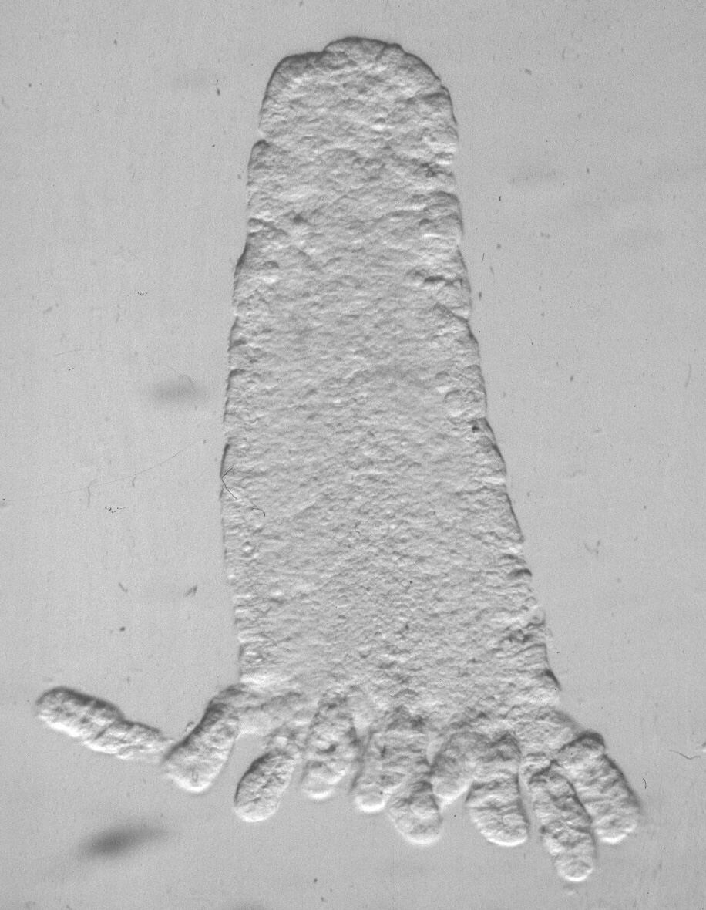
Figure 2: Adenomatous tissue
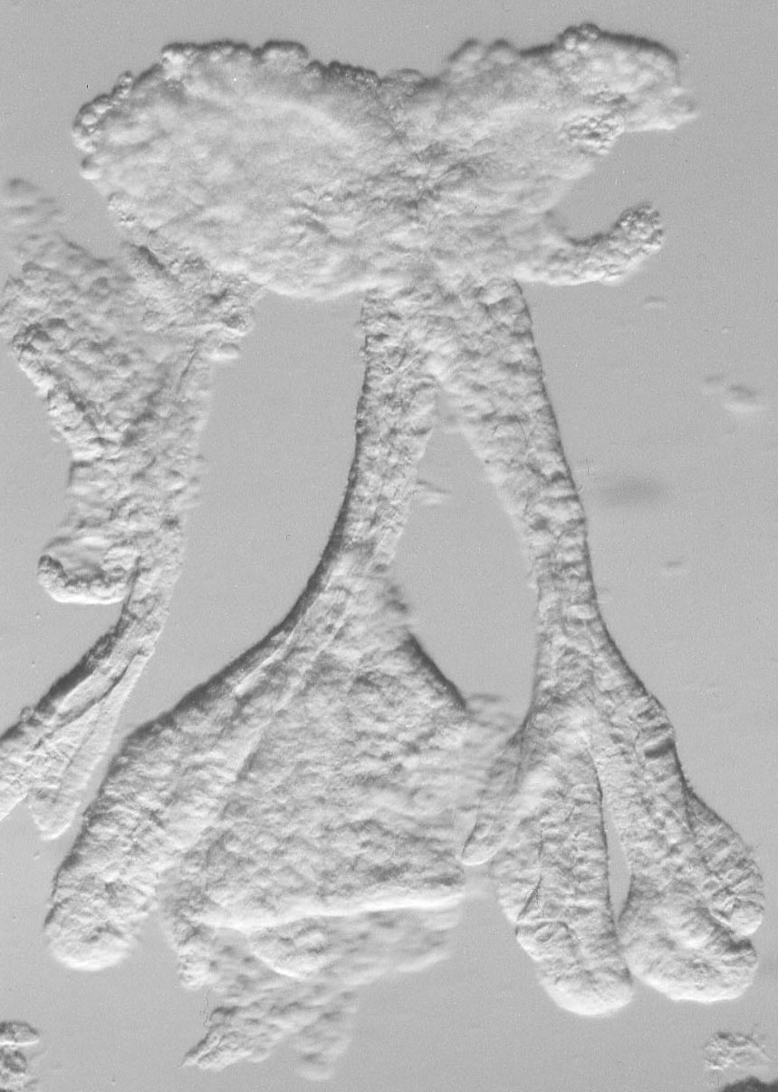
Figure 3: Adenomatous tissue


