POLAR Spacecraft Status As of: Tues 14 Aug 07, 12:00 EST
(Changes from last week in bold border)
Subsystem/  Component | NOAA-12D  AM 16:59=AN  STIP data only  No IPD processing | NOAA-15K  AM: 17:49=AN  GAC data only | NOAA-16L  PM: 15:04=AN  GAC&LAC data | NOAA-17M  AM: 22:23=AN  GAC&LAC data | NOAA-18N  PM 13:49=AN  GAC & LAC data
LAUNCHED | 05/14/91 | 05/13/98 | 09/21/00 | 6/24/02 | 5/20/05
CNTL OBP | OBP2  Recursive SCT | OBP2 | OBP2 | OBP2 | OBP2
BUS | B-BUS  XSU-1 | B-BUS  XSU-1 | B-BUS  XSU-1: TOAR444 | B-BUS  XSU-1 | B-BUS  XSU-1
BUS VETO | NO | NO | NO | NO | NO
ADACS | Nominal Mode  Autonomous swap to YGC 30 Aug 06, commanded back to nominal 31 Aug  RGmode=Monitor  Gyro chans=XYZ | Nominal Mode  Rgmode=Monitor  Gyro-3 Off 6/26/00 Gyro chans=AAB  N2 Low PSI invalid | RGYRO Mode  Estimate Y-ROLL  Rgmode=PASSIVE  Gyros-1 & 3 Inop/Off  Gyro chans XA-ZB  Pitch wheel bias 2400  *Z gas unload = 145  Gyro2 safe macro | Nominal Mode  Rgmode=Monitor  Gyro-3 Off 6/10/04  Gyro chans=AAB GAS Enabled Dec 05  *Z Gas unload =45 | Nominal Mode  Gyro-A MIMU-2  Z-wheel -Pitch  TOAR 447  Z-momentum transition complete  Pitch Torquer again active
RXO | PRI  BU random enables  daily bias+6.5 mS | PRI  daily bias -8 mS  -500 mS 12/31/05 | PRI  Daily Bias –5.5 mS  -1500 mS 31Dec05 | PRI  Daily Bias –3 mS  -1500 mS 31Dec05 | PRI  No daily bias  -1500 mS 31Dec05
CLOCK DIV | 2 | 2 | 2 | 2 | 2
MIRP | External Synch  Rephase Enabled | External Synch Rephase 0730 daily | External Sync  Rephase each orbit | External Sync  Rephase Enabled | External Synch  Rephase Enabled
TIP SIDE | 1 | 2  (since 4/3/03)  3 channels inop | 2  since 4/18/05  (analog drifting?) | 2  Swapped 9/20/06 | 1  Analog telem drifting
Recorders  (DTR, SSR) | DTRs 3A, 4, 5B  Safestate 5B  4b low pressure | DTRs 1, 2, 3, 4 Safestate 1B EOT | DTRs 1, 2, 3, 4A  Safestate 3A  4B STIP only | DTR 1,3,4 / SSR 2  Safestate=SSR 2B  4A Pressure leak | SSRs 1,2,3,4,5  Safestate=5B  Current spikes
VTX  (APT data) | #1 ON  137.50 MHZ | #1 ON  As of 19 June 07 | OFF / INOP  since 11/15/00 | #2 ON  137.62 MHZ | #2 ON  137.9125 MHZ
BTX | #1  136.77 MHZ | #1  137.35 MHZ | #2  137.77 MHZ | #2  137.77 MHZ | #1  137.35 MHZ
STX  1 = rcp 1698.0 mhz  2 = lcp 1702.5 mhz  3= rcp 1707.0 mhz  4= rcp 2247.5 mhz | 1 – HRPT;  2,3 - Playback | 2-Omni HRPT  2 Omni=rcp  Power TOAR 446  4-Playback  1,2,3-Degraded | 2 – HRPT  1– Playback  4 off INOP-10 Aug 2007  3 low power INOP -10 Aug 2007 | 3 – HRPT  TOAR424 low power  2 & 1 Playback  STX-1 Power drop  STX-4 no modulation | 1 - HRPT  3 - Playback  2-Playback  4-Test & Standby
POWER  (Array offset and CANT angle, eclipse states and sun angle) | ArrayOff +90  since 8/8/07  Full Sun  Sun Angle 16 uptrend to 20 in early Jan 07  Shunts severely degraded  SA CANT=37 degs  PSSS trigger =18.5  BVR & PSE to Back-up 8/7/07 | Array Off -45  Since 1/25/01  Full Sun  Sun Angle 13  Uptrend to 18 early Jan 07  SA CANT=37 degs | Array Off -40  Since 7/16/02  Eclipse all year  Sun Angle 34  Steady trend  SA CANT=22 degs  Transitioning to full sun S/C in Sept 07  BVR Phase Control auton swap 7/19/07 | Array Off. –40  Since 1/29/04  Eclipse all year  Sun Angle at 66  Steady trend  SA CANT=37 degs | Array Off. -40  Since 6/6/05  Eclipse all year  Sun Angle 63 uptrend to 65 on  1 Jan 07  SA CANT=22  BVR Phase Control auton swap 3/29/06 & 1/4/07
AVHRR | Nominal  HRPT and APT data only | Nominal  Channel 3B only  Occasional minor scan motor instabilities | Nominal  Recent SM current increases  TCE24 OFF 4/14/04  Channel 3B only | Nominal  3A-B switch enabled  Previous scan motor current mini surges | Nominal  Channel 3B only  Scan motor current drop 29 Aug 06
AMSU-A1 |  | Operational  Ch14 inoperative  Ch11 inoperative | Operational  Primary PLLO chans 9-14 bias shift.  Backup PLLO inop.  Channel 9-14 noise | OFF/INOP  Since 10/30/03  Survival heat on. | Nominal  Full Scan mode
`AMSU-A2 |  | Nominal | Nominal | Nominal | Nominal
AMSU-B |  | Operational  Bias in All Chans.  Degraded Chan-3 | Operational  Space Position-3  Chan-8 degradation | Nominal | Replaced by MHS
HIRS | ON/Inop  Turned On 4/30/05  for power balance  Filter Wheel OFF  Outgas & Filter Wheel Htrs On 8/6/07, Pwr Bal | NOMINAL  FW Abrupt return to nominal 7/12/05  After years of minor and major current surges  FW mode=Hi Powr | NOMINAL  New all time high filter motor current reached 9/17/06.  Imagery occasionally exhibits high levels of radiometric noise | NOMINAL  1 Pixel cross-track misalignment. | Operational  Filter Heat OFF.  LW channel 1-12 noise TOAR 448 Loose LWIR lens.  LW imagery erratic.
MHS/MIU |  |  |  |  | Nominal  Fly Wheel Motor Current Spiking but not alarming since 27 Dec 06  Entered Motor Spin State on 27 March 07
MSU | ON/Inop  Turn on 7/9/07 for power balance
SSU
DCS  RFI investigation | Nominal | Nominal | Nominal  Pseudo message turned on 1/5/06 | Nominal | Nominal  DRU’s 1-7 On  DRU8 inop/off
SARR |  | Operational  A-Side, AGC Mode  Intermittent failures for 243MHz A&B | Operational  Mode =AA  A-side, AGC Mode  (B-side in FG mode)  243 MHz = INOP. | Nominal  A-side  All AGC Mode | Nominal  A-Side  All AGC Mode  Since 15 Aug 05
SARP |  | Nominal  RCVR B/W = 2 | Nominal  RCVR B/W = 2 | Nominal | Nominal  A-side 23 May05
SEM | ON/Nominal  Autonomous reset  8 Jun 06, back to nominal 10 June  Turned on 8/30/04  Elec-CH-HVPS=4  Prot-CH-HVPS=0  TED level=3 | Nominal  E-CDEM-HVPS=2  P-CDEM-HVPS=0 | Nominal  E-CDEM-HVPS=6  P-CDEM-HVPS=5  27 Jun 0615:30z | Nominal  E-CDEM-HVPS=2  P-CDEM-HVPS=4  27 June 06 16:00z | Nominal  Elec-CH-HVPS=1  27 June 06 17:00z  Prot-CH-HVPS=0
SBUV |  |  | Operational  Degraded Ozone data  Backup Diffuser inop  Primary Diffuser deployment problem TOAR 426  AMSU EMI causing erratic Behavior in PMT cathod, range 3 | Nominal  Anode Mode  Plan sweep mode  Standard Ops  TOAR 463 sun glint  IBSL test performed 12 Sept 06  Grating motor investigation | Nominal  Anode mode  since 6 July 05 13:30z  Electronics turnoff taken out of STESM safestate table  TOAR 462 sun glint
SADPOS |  |  | ON  Enabled MFactor50%  Timer = 12 mins | ON  ENABLED  Timer = 12mins | ON  Enabled  Timer =12 mins
THERMAL  Heaters, louvers  TCE’s | Nominal  TCE’s back to nominal configuration following 7/25/04 UVtrip. | TCE26 & 15H  Telem valid  TOAR 432 closed  TCE24L&25L (HIRS & AVHRR) failed 5/13/98  RCE thermostat failed 5/13/98  Spacecraft in thermal uptrend | Nominal  TCE24 OFF 4/14/05  (AVHRR H&L)  HIRS Filter heater turned OFF 1/18/05 | TCE3H Batt 2A heater failed ON, turned off 8/26/03  AMSU-A1 survival heaters on 10/29/03 | All TCE’s active  HIRS filter heater turned OFF 9/28/06

COMMENTS/CHANGES:

MISC: Planning for a partial solar eclipse on 11 Sep 2007 is being planned.

NOAA-12: After spending many days attempting to power balance NOAA-12, it was decided to decommission the spacecraft. It was decommissioned on 10 August 2007 at 17:18:38z

There were relatively no changes to the rest of the NOAA-12 health situation during the past week. MSU power balance appears to continue to hold stable at the motor's turn on temperature of 70 C.

NOAA-12’s power balance situation continued to degrade significantly. There were been numerous SAD Bias responses to the Filtered Bus Voltage exceeding 28.5V. Once the SA was moved to +90 º, for part of the orbit the bus was stealing the charge current from the batteries. The discharge rate was 0 but the charge rate was not at its nominal levels of 1.7 or .75 amps. This led us to believe that we could not achieve a power neutral situation during a full sun orbit. (See Figure 1)

During the depletion of the fuel it was noted that the N2 low pressure (the regulator pressure) was decreasing where it should have bounced back to 500psi after the thruster firings to close the regulator until the high pressure was equal to 500psi (see Figure 2). Also noted as more fuel was the attitude response was weakening. After discussions with NASA/GSFC personnel and EMOSS investigating the OV report for NOAA-12, it was discovered that at handover to NOAA the N2 high pressure in the tank was ~900psi. This high pressure was now reading ~2800psi. The high pressure transducer did have a problem quickly after launch where its reading went to 0 for ~20 min and then returned to a nominal value. When EMOSS investigated the pressure reading, it was noticed that it was rising slowly for the past 10 years or so. Therefore there was not as much N2 fuel left then believed, thus the regulator pressure dropping was indicative of the amount of pressure left in the tank. We actually were below the blow-down threshold. After this discovery we proceeded with the deactivation.

A change to this deactivation from NOAA-14’s was the addition of firing only the N2 thruster for 25.5 seconds and opening all thruster valves (including hydrazine) to deplete all possible fuel. Very little attitude disturbance was noted, thus proving as much of the fuel as possible was depleted.

For Battery Information see Figure 2, note that since the Solar Array offset of +95º, NOAA-12 has been going power negative every orbit.

Below is the list of actions taken:

8 August 2007
- 16:20z
  - Slewed the Solar Array to a +95º offset from +90º.
- 19:40z
  - Thrusters were fired (4 yaw/roll thrusters) for 1 second to test the depletion of the fuel
10 August 2007
- 15:30z
  - Thrusters were fired (4 yaw/roll thrusters) for 5 second to test the depletion of the fuel; this was done numerous times during the pass.
- 17:40z
  - NOAA-12 was decommissioned

NOAA-15: There were relatively no changes to the NOAA-15 payload health situation during the past week. N-15 has come out of summer eclipse season. EPS in nominal

The Z RWA has completed its migration to negative RPM. No impact on operations. The #2 gyro is still unstable since about July 24th. This has affected yaw control (yaw updates as high as 0.7 degrees). The trend is not evident in gyro motor current or thermal data.

NOAA-16: There was relatively no change in the performance of the NOAA-16 payload subsystems during the past week and the rest of the spacecraft subsystems were also nominal during this time.

On 10 August 2007 at 08:01z, the AET was not able to achieve bit sync or frame sync lock on STX-4. The CDA noticed that there was an RF carrier with no modulation; very similar to the NOAA-17 STX-4 anomaly. STX-4 is currently unusable. The schedules were updated to use STX-3 which is known to have a lower output power of ~1 watt but thought to be usable. After 2 uses of STX-3, it became too noisy to retrieve the data. It is also considered unusable at this time. The schedules were again updated to reflect the 2 unusable STXs.

A request from NASA has been made to move the SA from -40 to -35 so the shunts are always on to possibly avoid the spikes on the recorders. An evaluation and a date for move is TBD. NOAA-16 will be in full sunlight beginning in mid-September. This is the first time ever it will not be eclipsing.

NOAA-17: There was relatively no change in the performance of the NOAA-17 payload subsystems during the past week. The HIRS filter wheel period noise calmed down this week.

No updates or conclusion were reached about the Attitude disturbance on 17 July 2007. The investigation continues.

NOAA-18: There were relatively no changes to the NOAA-18 health situation during the past week.

On 13 August 2007 at 05:11z the following mnemonics flagged and have remained out of limits: MSPH4VAL (YL), MSPH3VAL (YL), MSPDCOFV (YL), MSPDCOFE (YH), MHKDCOFE (YH), QSPPRFLT (YH). These are indications that the DC offsets for channels H3 and H4 have moved out of the optimum range. The instrument data is degraded, but there is no health and safety risk.

The VTX will be switched from side 2 to 1 on 16 Aug 2007 at 14:43.

MetOp A: No significant changes reported on the NOAA instruments on MetOp. The HRPT transmitter failure investigation continues.

Trend Observations (NOAA Instruments)
· AMSU-A1 Dig A temperatures dropped steadily by approximately 0.5 deg C over the course of the week. This trend has also been observed over the past month, where the average drop in temperature has been approximately 1 deg C. AMSU-A2 temperatures have remained stable during the same period.
· With one exception (refer to AR8360, described below under “Anomalies”), all other housekeeping telemetry and science data were stable during this reporting period.
· EUMETSAT confirmed an error in their NEdN calculation method for the CVF HIRS Daily Report. This was corrected on August 8 and now the NEdN values are very stable.
· HIRS Filter Wheel resyncs have remained at the same approximate rate as reported last week (approximately once every 93 seconds).

Anomalies
· AR8360, “HIRS Scan Mirror Temperature Out-of-Limits”: Anomalous temperature telemetry was observed between August 6-8, but has returned to nominal since then. There was also a correlation observed between jumps in the Scan Mirror Temperature telemetry and slight drops in the Patch Power. This is currently under investigation by ITT.
· Investigations continued on trying to isolate the cause of the HRPT SSPA failure.

Operations Performed
· The SEM IFCs were run on Tuesday, August 7, with the TED IFC starting at 08:53:03 UTC and the MEPED IFC starting at 08:54:23 UTC.

Operations Planned
· The SEM IFCs will be run again on their weekly schedule (Tuesday, Aug 14).

NOTES: Figures 3 – 5 have been omitted for web listing.

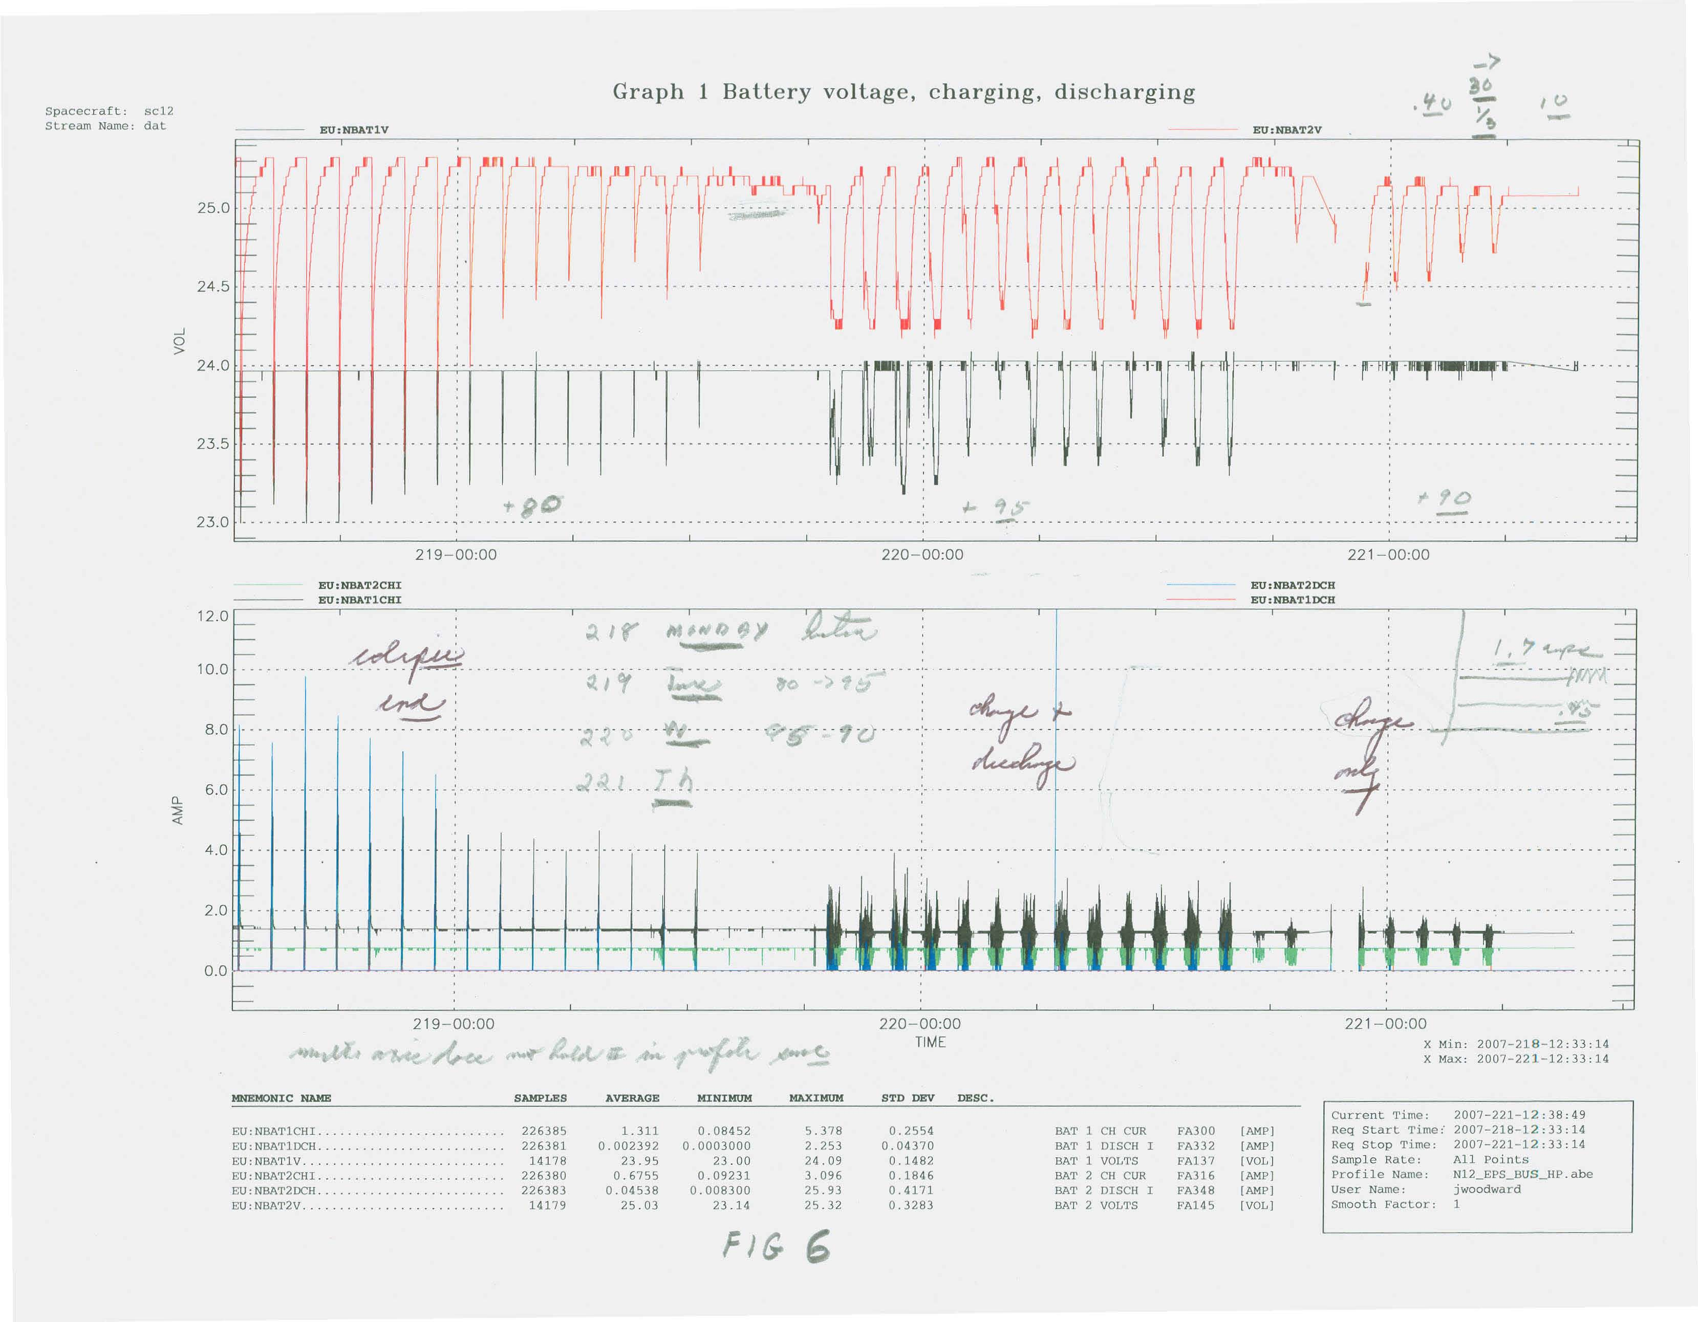
Figure 1 NOAA-12 EPS (2007/218-221)
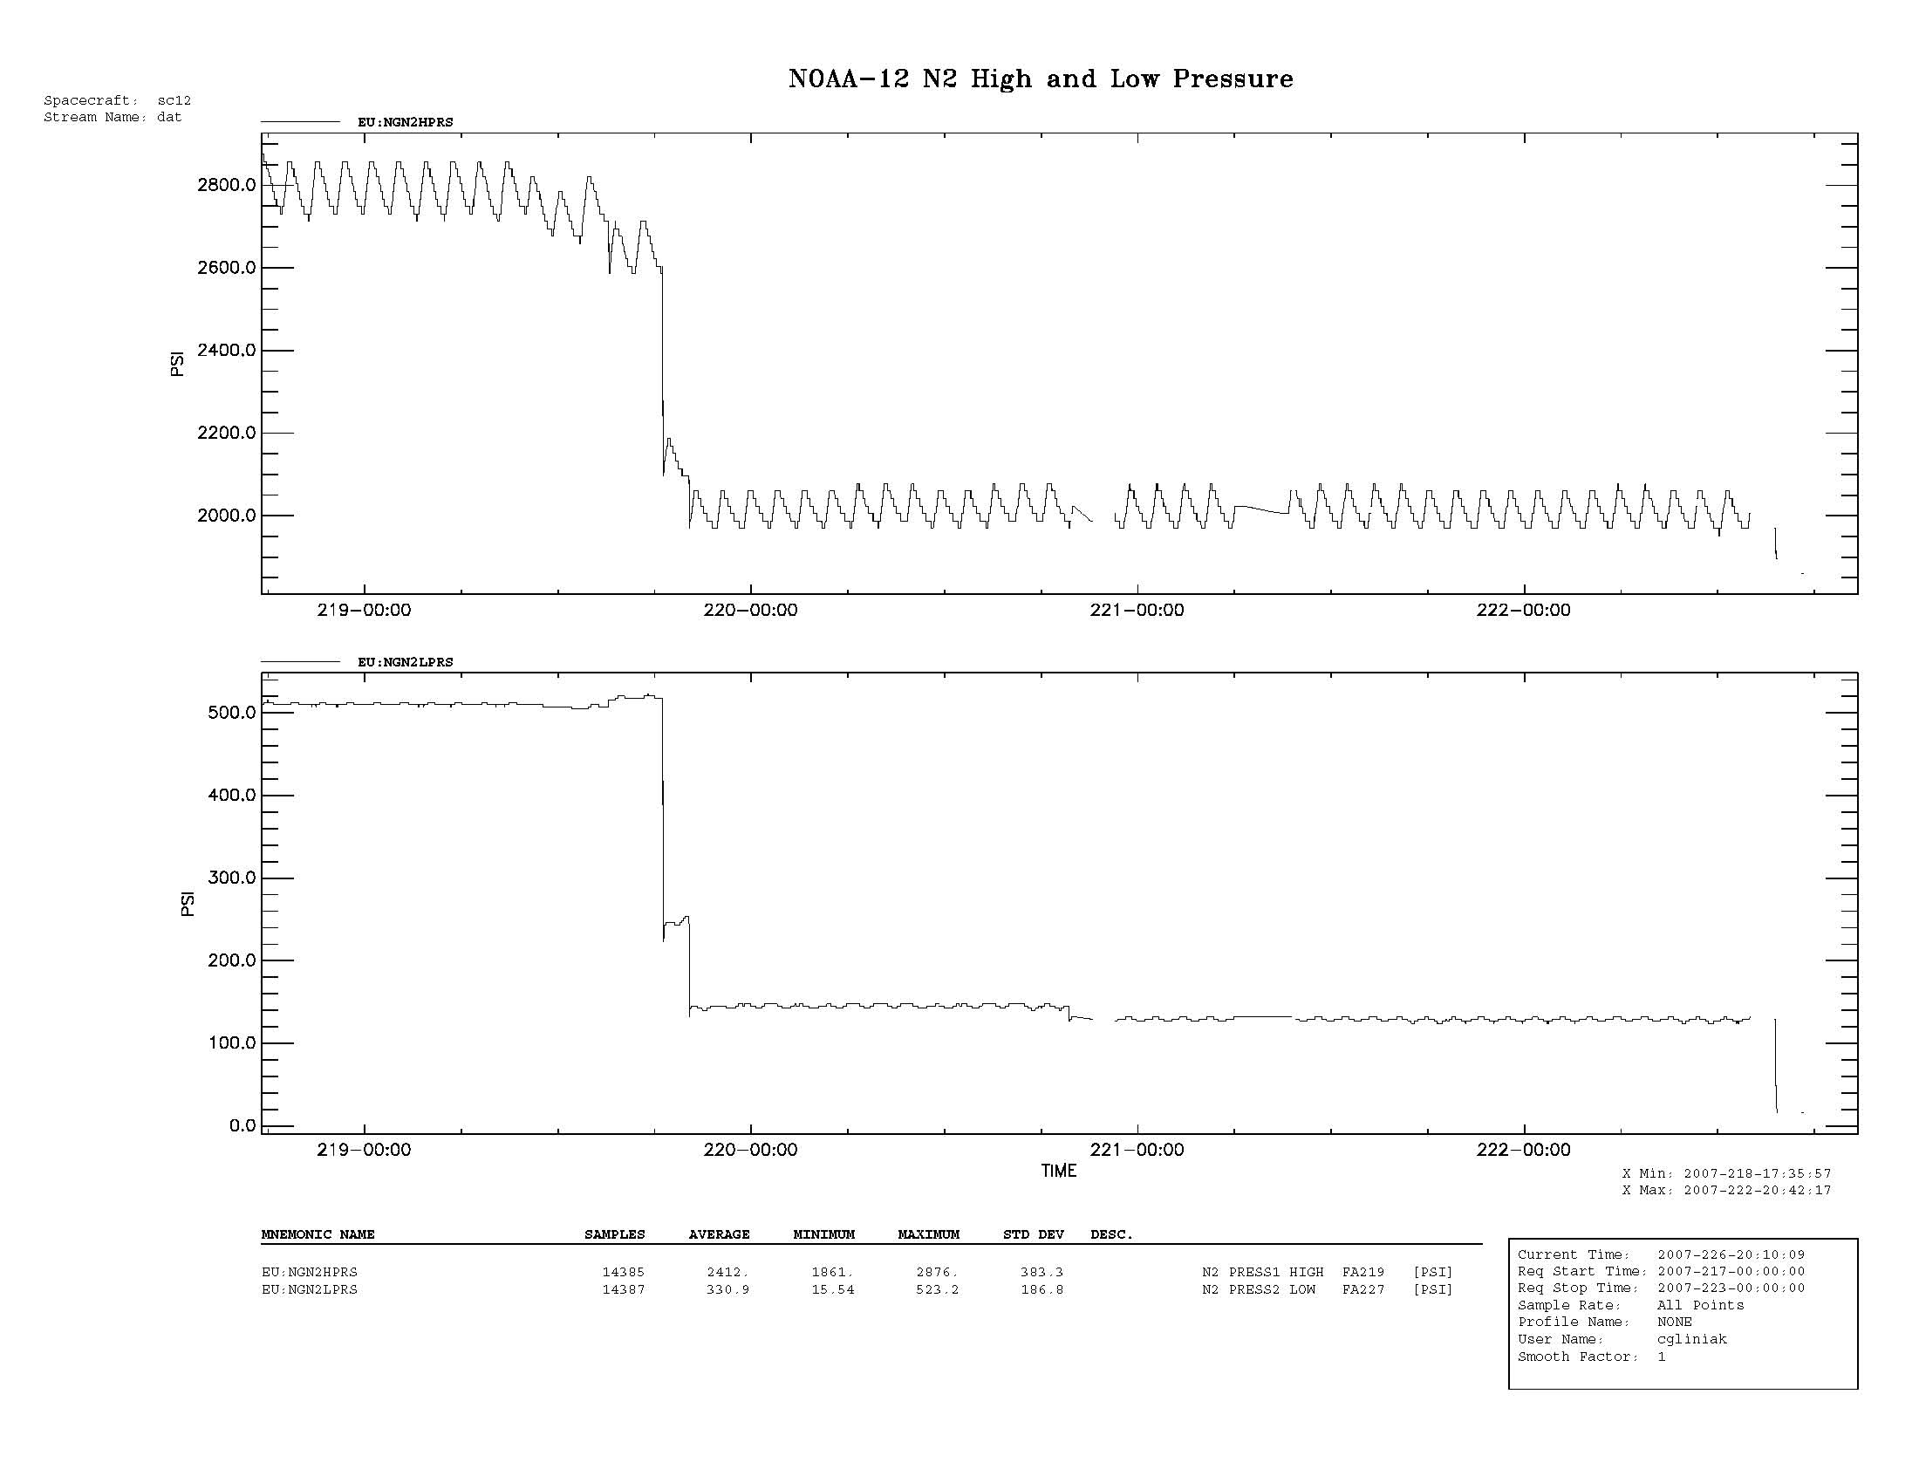
Figure 2 NOAA-12 RCE (2007/217-223) 30-226)
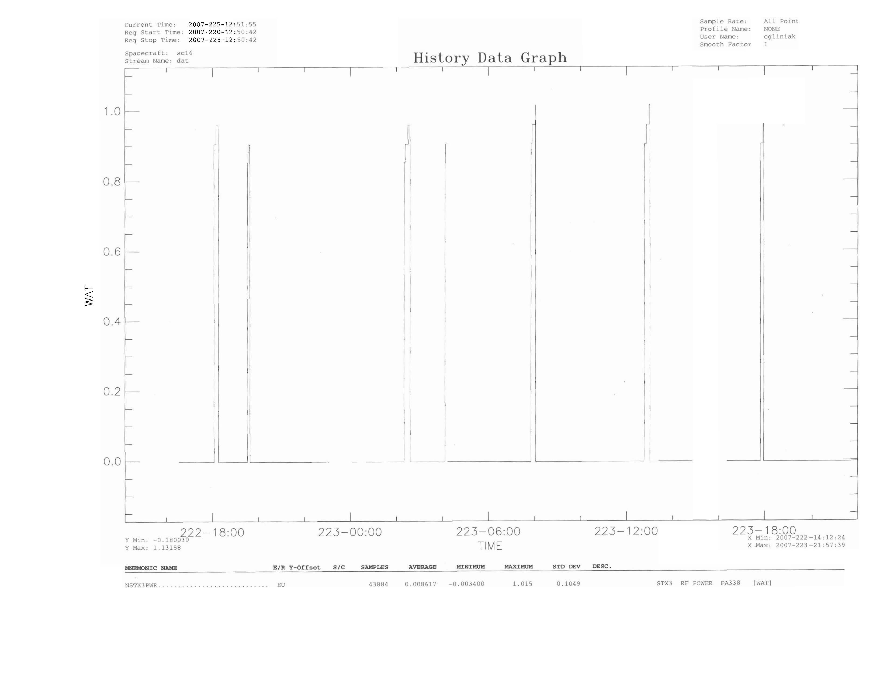
Figure 6 NOAA-16 STX-3 Output Power (2007/222-223)
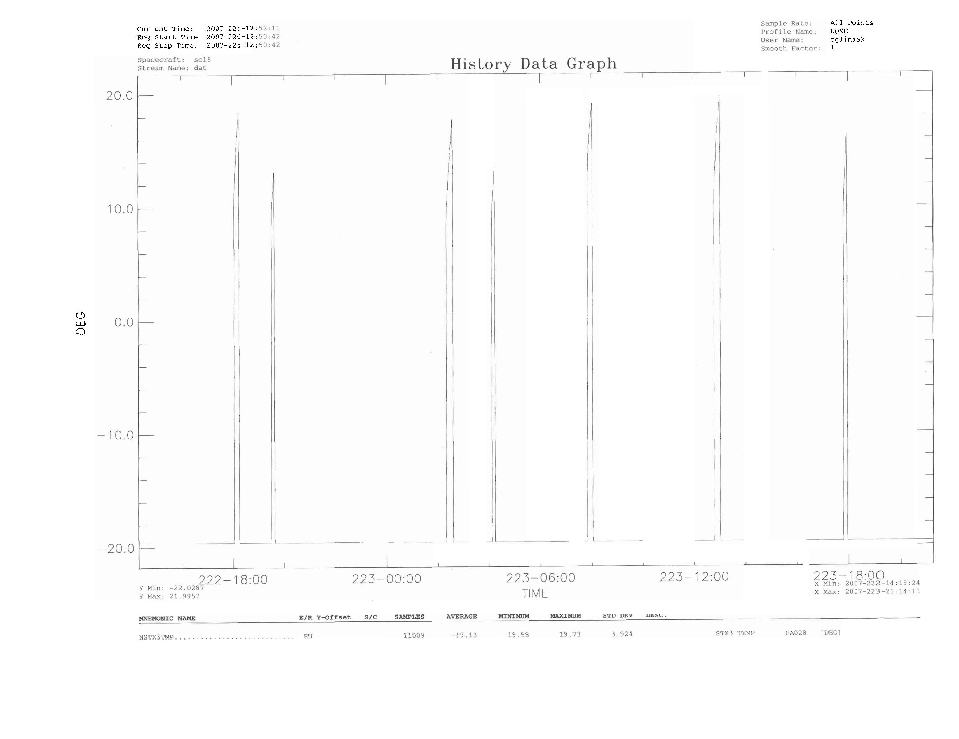
Figure 7 NOAA-16 STX-3 Temperature (2007/222-223)
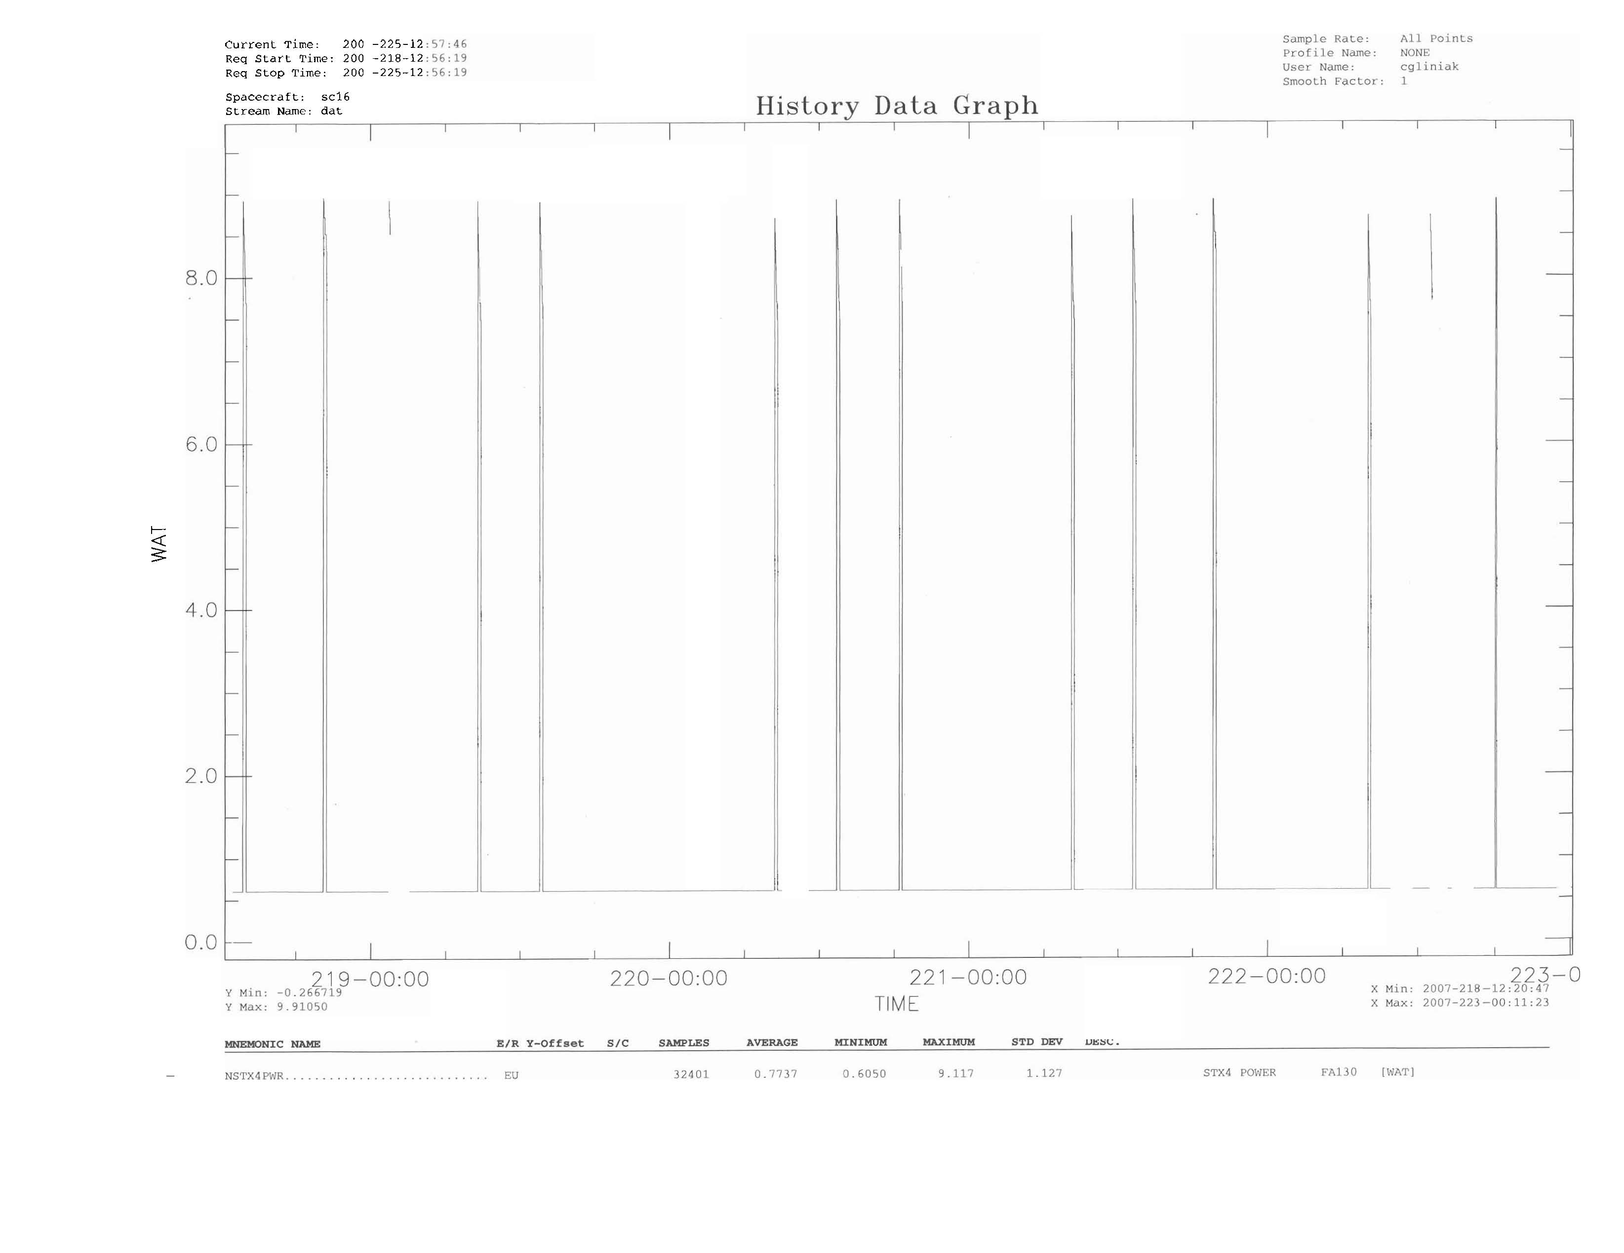
Figure 8 NOAA-16 STX-4 Output Power (2007/218-222)
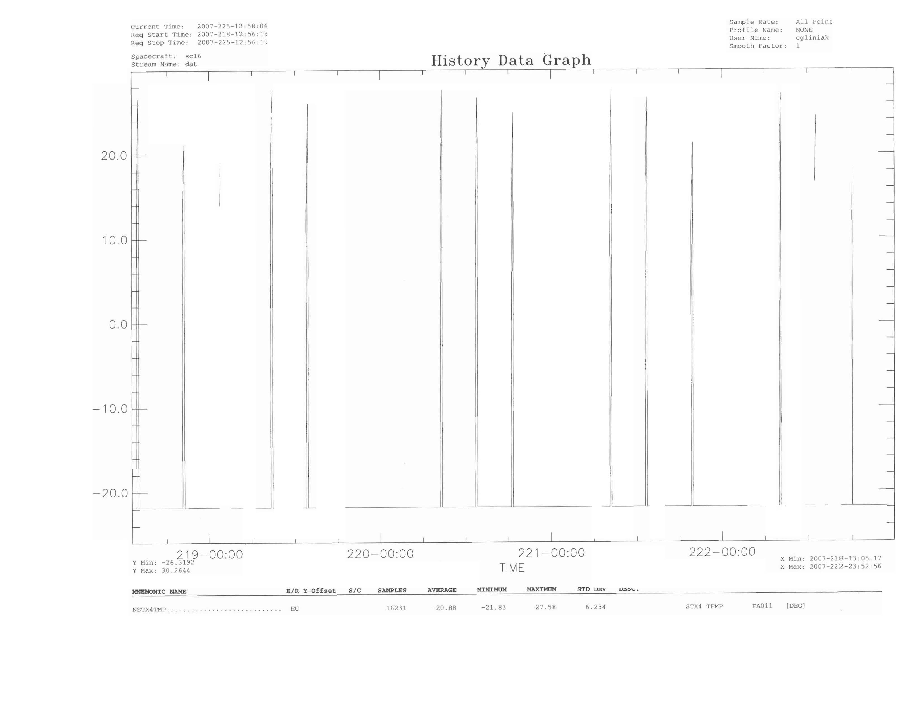
Figure 9 NOAA-16 STX-4 Temperature (2007/218-222)

