SNAP Reaction Wheel Size
Patrick Jelinsky
12/20/2004

Introduction
The size of the reaction wheels on a spacecraft is determined by three criteria. The reaction-wheel torque must equal the worst case anticipated disturbance torque. The reaction-wheel must have sufficient torque to perform the fastest slew maneuvers. Finally, the reaction-wheels must have sufficient momentum storage.

Wheel Coordinate System
There is planned to be 4 reaction-wheels on SNAP on the axes of a tetrahedral. Only three are needed for control of the observatory, but there is an extra one for redundancy. A schematic of the wheel coordinate system is shown in Figure 1. The dot product between any two wheels is the same, –1/3, or and angle of ~109.5°.

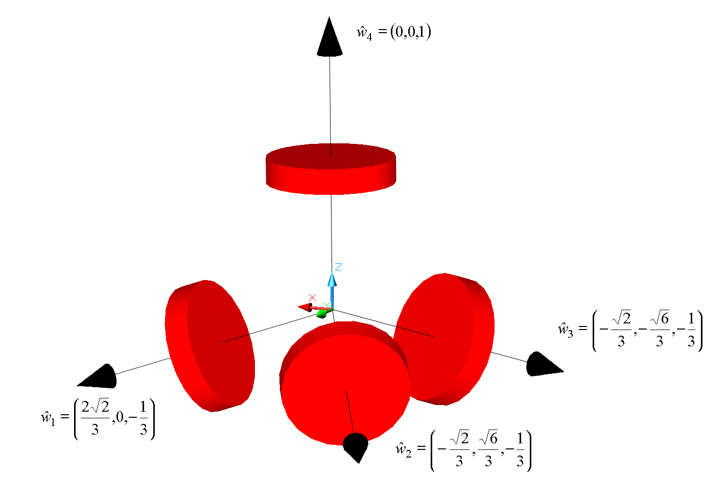

Figure 1Reaction-wheel coordinate system.
Since there are 4 wheels and they are not orthogonal, any momentum or torque will be shared between the wheels. A study was done to determine the maximum momentum or torque that a wheel would have. Two scenarios were analyzed. The first was with all 4 wheels working and sharing the momentum/torque, and the second was with one of the wheels off (failed). The first case had an angular momentum vector in the X-Y plane. Figure 2 shows the maximum fraction of momentum or torque any one wheel would have with a vector in the X-Y plane. Figure 3 shows the maximum fraction of momentum or torque any one wheel would have with a vector out of the X-Y plane. The worst case is 0.62 and 1.23 for all wheels and one failed wheel respectively.
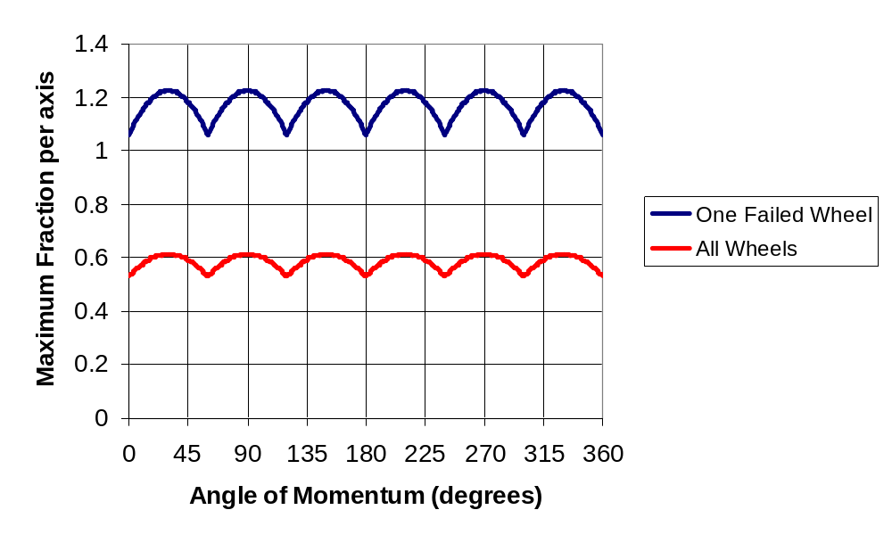
Figure 2 Maximum fraction of momenum in one wheel with the vector in the X-Y plane. The red curve is with all 4 wheels working, the blue curve is with one failed wheel.
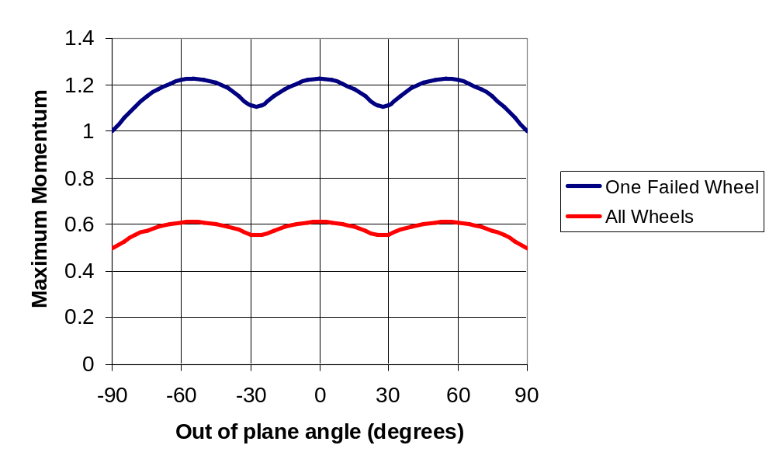
Figure 3 Maximum fraction of momentum in one wheel with the vector out of the X-Y plane. The red curve is with all 4 wheels working, the blue curve is with one failed wheel.

Observing Strategy
The observing strategy for SNAP is to perform science observations for 21.5 hours per day and then point the high gain antenna at earth and download the data for 2 hours per day. Since the high gain antenna is fixed, this gives 15 minutes to slew from the science orientation to the communications orientation and back. During the science observations very small slews will be done.

Disturbance Torque
There are four types of disturbance torques that can affect a spacecraft, gravity gradient, solar radiation, magnetic field, and aerodynamic. SNAP will be at the earth-sun L2 point so the only disturbance torque with an appreciable magnitude is due to solar radiation.
The torque from solar radiation pressure is given by:
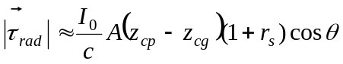
where τ_{rad} is the torque due to solar radiation pressure, I₀ is the solar constant (1290 – 1380 W/m² at L2), c is the speed of light, A is the area of the spacecraft, z_{cp} is the location of the center of pressure, z_{cg} is the location of the center of mass, r_{s} is the specular reflectance, and θ is the angle of incidence to the Sun.

The solar radiation torque was calculated using the simplified model of SNAP shown in Figure 4. In addition, the radius of the solar array is 1.34 m with an angle subtended of 120°. The center of mass of the observatory is 2.07 m above the bottom of the observatory. The optical data for the different materials is shown in Table 1.

Table 1 Optical Properties of Various Coverings
Material | r_{s}
Multi Layer Insulation (MLI) | 0.1 – 0.6
Optical Solar Reflector (OSR) | 0.07
Solar Cell | 0.08

For the values given in Table 1 and Figure 4 the solar radiation torque varies from (1.5-2.0)x10⁻⁴ N-m for the maximum solar flux of 1380 W/m^2. If the optical properties are varied to maximize the torque the value becomes 2.4x10⁻⁴ N-m. So any momentum wheel must have a torque of at least 2.4x10⁻⁴*1.23 N-m = 2.95x10⁻⁴ N-m. This should be easy.
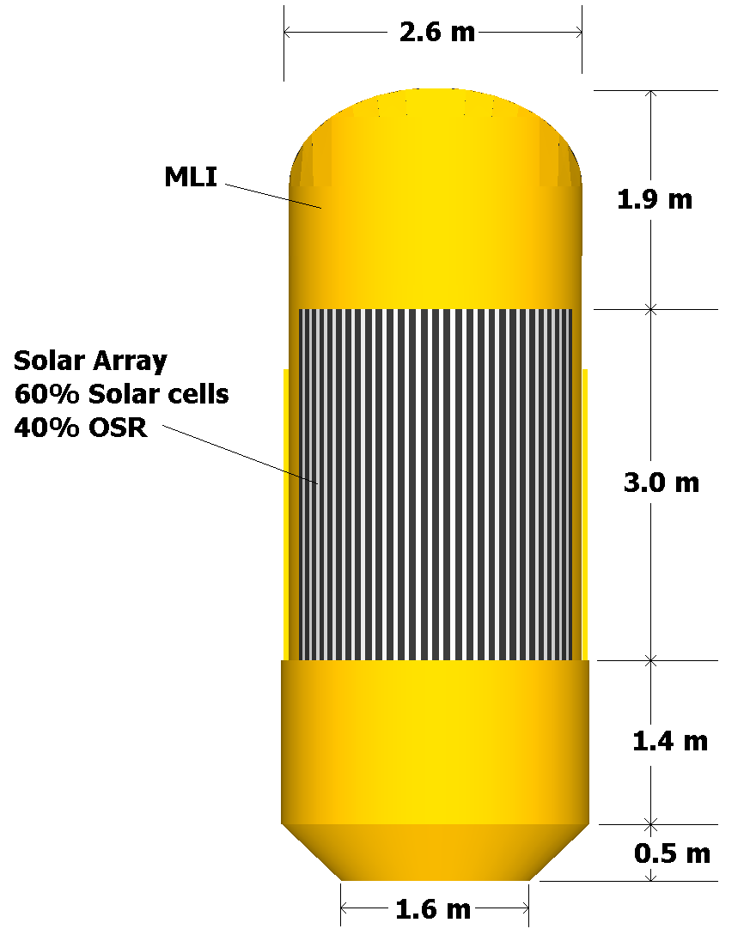
Figure 4 Simplified drawing of SNAP used for solar radiation torque calculations.

Stored Momentum
The angular momentum from the solar radiation pressure should be stored in the wheels for at least 24 hours so it only must be dumped once per day. Therefore the wheels must have a capacity of at least 2.4x10⁻⁴ N-m*1.23*24h*3600s/h = 25.5 N-m-s. Many wheels can meet this requirement.

Slew Rate
The maximum slew from science to communications is about 82°. The slew must be completed in 15 minutes. Assume that it accelerates for ½ the time and decelerates for the rest of the time. The maximum required torque is
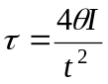
where θ is the angle of the slew, τ is the required torque, I is the moment of inertial, and t is the time for the slew. The maximum stored angular momentum in the wheels is
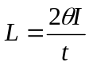
where L is the stored angular momentum. I is about 3500 kg m² (if the slew about the worst axis). The torque required is 2.5x10⁻² N-m*1.23 = 3.0x10⁻²N-m. The angular momentum stored in this slew is 11.1 N-m-s. This is smaller than the solar radiation angular momentum stored in 24 hours. If the slew rate is specified to be 6°/min, then any length slew will require a wheel with 12.2 N-m-s of capacity.

Possible Wheels
A list of some known reaction wheels are shown in Table 2. All of these reaction wheels meet the capacity and torque requirements for SNAP with all four wheels working (> 12.9 N-m-s capacity, > 0.015 N-m torque). Several of the wheels meet the capacity and torque requirements for SNAP with only 3 wheels running (> 25.5 N-m-s capacity, > 0.03 N-m torque). The smaller capacity wheels have a big advantage of less jitter on the spacecraft.
Table 2 Various Reaction Wheel Specifications
Wheel | Capacity  (N-m-s) | Maximum Torque  (N-m) | Speed  (RPM)
L3 Comm RWA15 | 20 | 0.75 | ±2200
Ithaco E | 26 | 0.3 | ±2000
Ithaco B | 14 | 0.05 | ±4500
Explorer | 30 | 0.05 | ?
Honeywell HR12 | 25 | 0.2 | ±6000
Honeywell HR16 | 150 | 0.2 | ±6000

Momentum Dumping
Thrusters must be fired to dump the momentum. The amount of fuel mass needed to dump the momentum is:
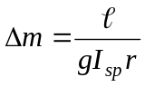
where Δm is the mass of fuel, l is the stored angular momentum, g is gravity on earth, I_{sp} is the specific impulse of the fuel, and r is the distance between the thruster and the center of mass. For and I_{sp} of 220 seconds and r of 1.5 meters, SNAP will need 2.3 kg of hydrazine per year. If SNAP uses 1 N thrusters to dump the momentum, each day about a 14 second burn will be needed to dump the momentum.

The observatory will move during momentum dumping thrusts if the torque from the wheel is less than the toque from the thruster. Figure 5 shows the position versus time for a 10 second thruster burn. The reaction wheel was assumed to have a maximum torque of 0.05 N-m and the thruster was assumed to be a 1 N thruster placed 1.5 meters from the C.G. of the observatory. The observatory moves over 35° from the original direction before recovery.
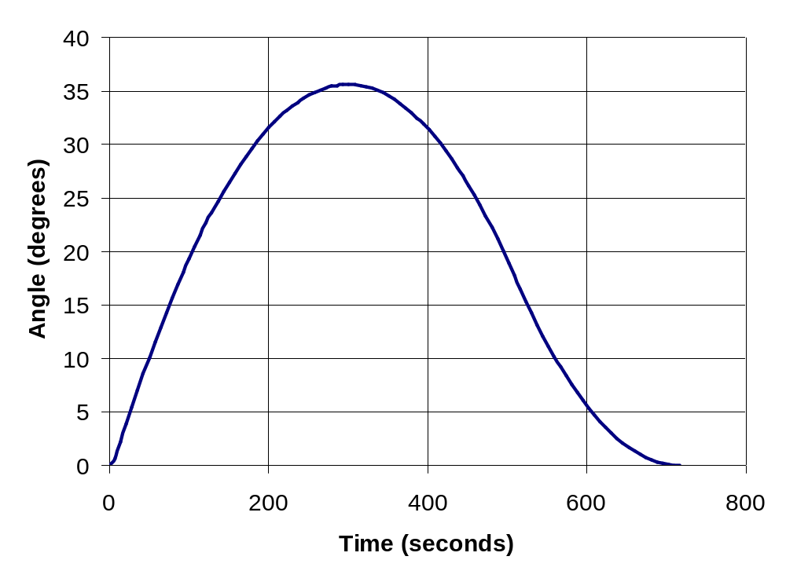
Figure 5 Angular Motion due to a 10 second thruster burn, assuming a wheel torque of 0.05 N-m, and a 1 N thruster, 1.5 meters from the C.G.
The length of the slew produced by a 1 N thruster placed 1.5 meters from the C.G. versus length of the thruster burn is shown in Figure 6. If one 14 second burn is done at a time to dump the total daily momentum the observatory will slew 70°, 16°, 10°, and 2° for momentum wheel torques of 0.05 N-m, 0.2 N-m, 0.3 N-m and 0.75 N-m respectively.

The time for the ACS system to settle the pointing to the science requirements will be dependant on the length of the slew. If the slew is less than the size of the fine guidance sensor field of view, the settling time will be very small since it will never lose “lock”. If the slew is larger than new fields of stars must be analyzed before the stars can be identified. For this analysis, it is assumed that for slews less than the settling time will be 30 seconds, for any slew larger than 2’ the settling time is assumed to be 120 seconds. Figure 7 shows the total recovery time, slew time plus settling time, versus the length of the thruster burn for various wheel torques. For a 14 second thruster burn the recovery time is 19, 6, 5 and 3 minutes for 0.05, 0.2, 0.3 and 0.75 N-m wheels respectively. For a 1 second thruster burn the recovery time is 3.2, 2.3, 2.2 and 0.6 minutes for 0.05, 0.2, 0.3 and 0.75 N-m wheels respectively. For a 100 ms burn the recovery time is 37, 32, 31, and 30 seconds for 0.05, 0.2, 0.3 and 0.75 N-m wheels respectively. Small momentum dump burns could probably be done during the 30 second science readout time or larger slews during the 21.5 hours of the day allocated to science if necessary. A 100 ms burn would have to be done every 10 minutes to keep up with the radiation pressure. A 1 second burn would need to be done every 1.7 hours.

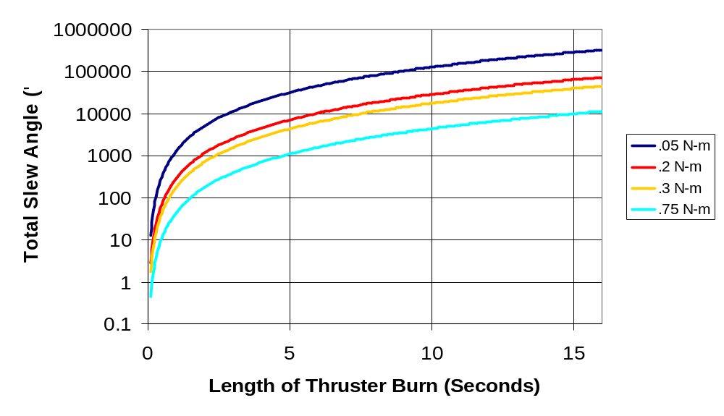
Figure 6 Observatory Motion versus length of thruster burn for various wheel torques. The thruster was assumed to be a 1 N thruster 1.5 meters from the C.G.

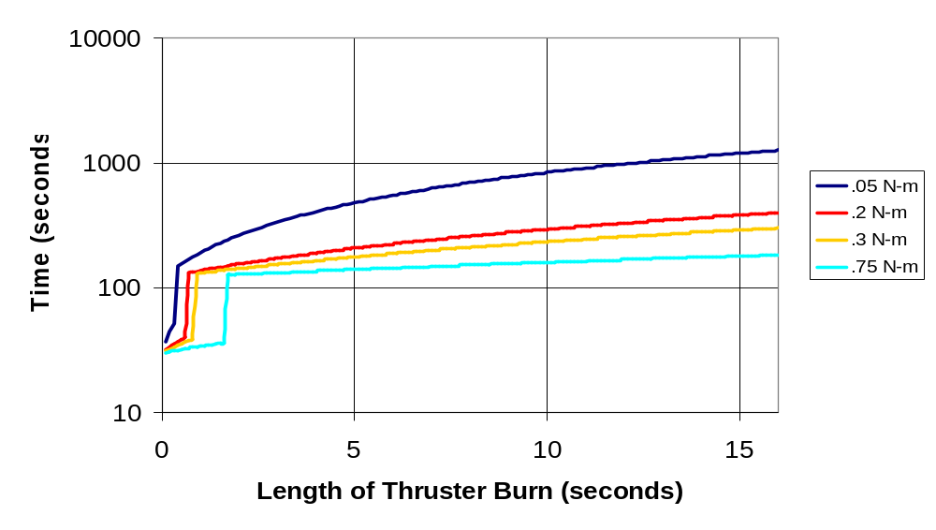
Figure 7 Recovery time versus length of thruster burn for various size reaction wheels.

Conclusion
The wheels on SNAP must have a capacity of 25.5 N-m-s if only three wheels are running and a capacity of 12.9 N-m-s if all four wheels are running. They must have a maximum torque of at least 0.015 N-m with all four wheels running and 0.03 N-m if only three wheels are running.

SNAP will require about 2.3 kg of hydrazine per year to dump the momentum from the solar radiation pressure. Every day one 14 second burn is required to dump the momentum. If smaller wheels are needed to meet the jitter requirements, then more frequent burns during the “dead-time” of the science observations could be done. A 1 second burn would need to be done every 1.7 hours, or a 100 ms burn would need to be done every 10 minutes. A 1 second burn requires from 34 second to 3.2 minutes to recover the pointing. A 100 ms burn requires between 30 and 37 seconds to recover the pointing.

