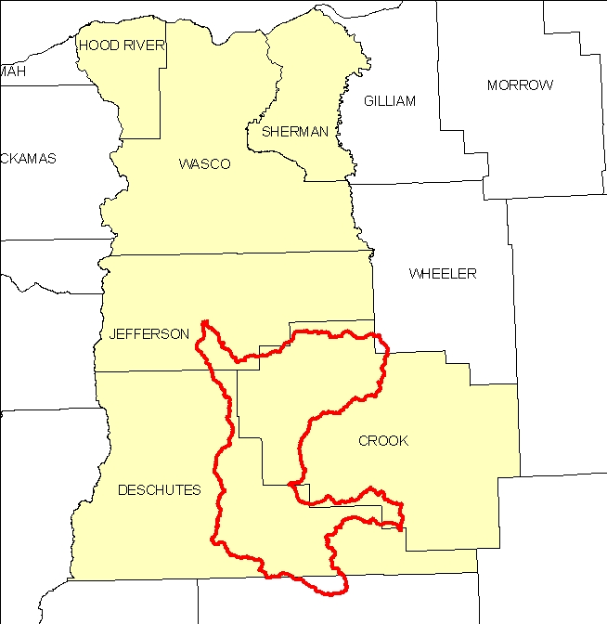
Introduction
The Lower Crooked 8-Digit Hydrologic Unit Code (HUC) subbasin is comprised of 1.2 million acres. Most of the subbasin is located in Crook and Deschutes Counties. Sixty percent is public land, and the remainder is under private ownership. There are 1,106 farms and 1,800 farmers and ranchers in the subbasin. Notably, two-thirds of the farms in the subbasin are less than 50 acres in size and nearly all of these are operated by individuals who work off the farm and are relatively new to agriculture and resource management.

Located in central Oregon, the Lower Crooked subbasin is largely rangeland and forest land. Approximately half of the forest land is under private industrial ownership, and the other half is under private, non-industrial ownership. Overstocked lodgepole pine and ponderosa pine and invasive weeds restrict the productivity for timber, grazing, and wildlife habitat. Juniper is encroaching onto rangeland and ponderosa pine sites.

Conservation assistance is provided by three NRCS service centers, one soil survey office, one resource conservation and development (RC&D) office, and two satellite field offices (Warm Springs Indian Reservation and Hood River).

Profile Contents

Introduction
Physical Description
Land Use Map & Precipitation Map
Common Resource Area
Resource Concerns
Census and Social Data
Progress/Status
Footnotes/Bibliography

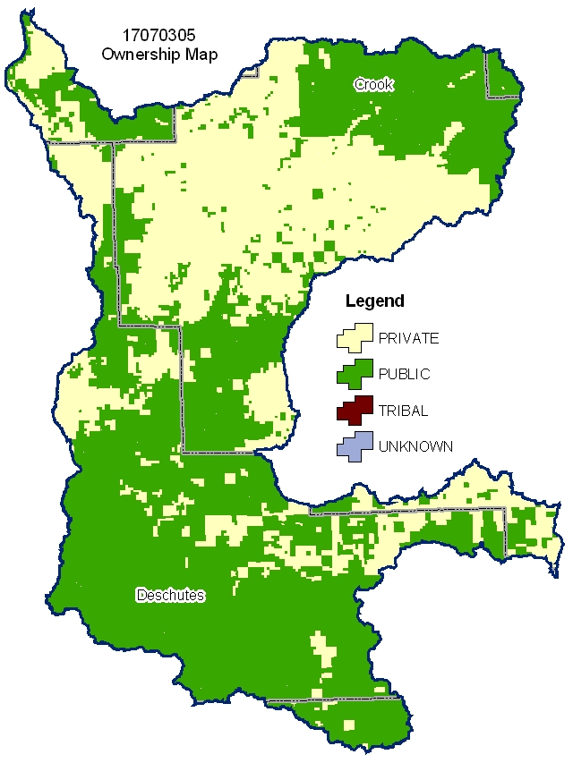
Relief Map
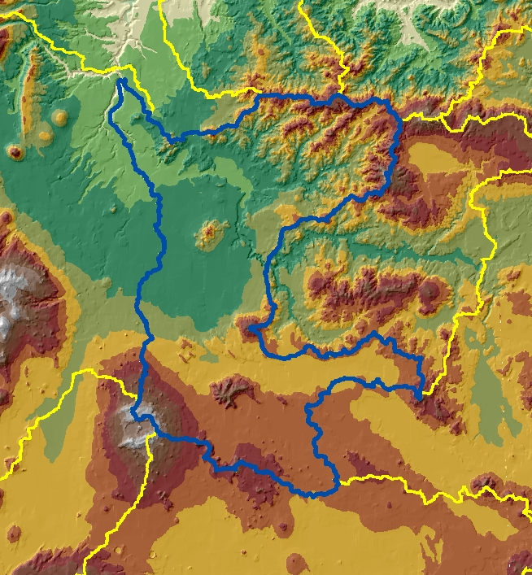

Produced by the Water Resources Planning Team Portland, OR
The United States Department of Agriculture (USDA) prohibits discrimination in all its programs and activities on the basis of race, color, national origin, sex, religion, age, disability, political beliefs, sexual orientation, and marital or family status. (Not all prohibited bases apply to all programs.) Persons with disabilities who require alternative means for communication of program information (Braille, large print, audiotape, etc.) should contact USDA’s TARGET Center at 202-720-2600 (voice and TDD).
To file a complaint of discrimination, write USDA, Director, Office of Civil Rights, Room 326W, Whitten Building, 14th and Independence Avenue, SW, Washington DC 20250-9410, or call (202) 720-5964 (voice and TDD). USDA is an equal opportunity provider and employer.

Physical Description Back to Contents
ALL NUMBERS IN THIS PROFILE ARE FOR OREGON ONLY
Land Cover/Land Use  (NLCD^{/2}) | Ownership - (2003 Draft BLM Surface Map Set^{/1})
Land Cover/Land Use  (NLCD^{/2}) | Public |  | Private |  | Tribal |  | Totals | %
Land Cover/Land Use  (NLCD^{/2}) | Acres | % | Acres | % | Acres | % | Totals | %
Forest | 285,900 | 24% | 134,200 | 11% | 0 | 0% | 420,100 | 35%
Grain Crops | * | --- | * | --- | 0 | 0% | * | ---
Conservation Reserve Program Land ª | 0 | 0% | * | --- | 0 | 0% | * | ---
Grass/Pasture/Hay | 35,800 | 3% | 89,900 | 7% | 0 | 0% | 125,700 | 10%
Orchards/Vineyards | 0 | 0% | 0 | 0% | 0 | 0% | 0 | 0%
Row Crops | 0 | 0% | * | --- | 0 | 0% | * | ---
Shrub/Rangelands | 393,200 | 33% | 245,600 | 20% | 0 | 0% | 638,800 | 53%
Water/Wetlands/Developed/Barren | * | --- | * | --- | 0 | 0% | 11,000 | 1%
Oregon HUC Totals b | 720,100 | 60% | 484,000 | 40% | 0 | 0% | 1,204,100 | 100%
*: Less than one percent of total acres. See below for special considerations.
a: Estimate from Farm Service Agency records and includes CRP/CREP.
b: Totals are approximate due to rounding and small unknown acreages.
Special Considerations for This 8-Digit HUC:

- Approximately fifty percent of private forest land is under industrial forest ownership.

- Pasture and hay is associated with both ranch and small farm operations.

- Row crops and other specialty crops include potatoes, vegetable seed, garlic, mint, and nursery crops.

Irrigated Lands  (1997 NRI^{/3} Estimates for Non-Federal Lands Only) | Type of Land | ACRES | % of  Irrigated Lands | % of  HUC
 | Cultivated Cropland | 20,200 | 19% | 2%
 | Uncultivated Cropland | 38,400 | 35% | 3%
 | Pastureland | 50,200 | 46% | 4%
 | Total Irrigated Lands | 108,800 | 100% | 9%
(Continued on the following pages)

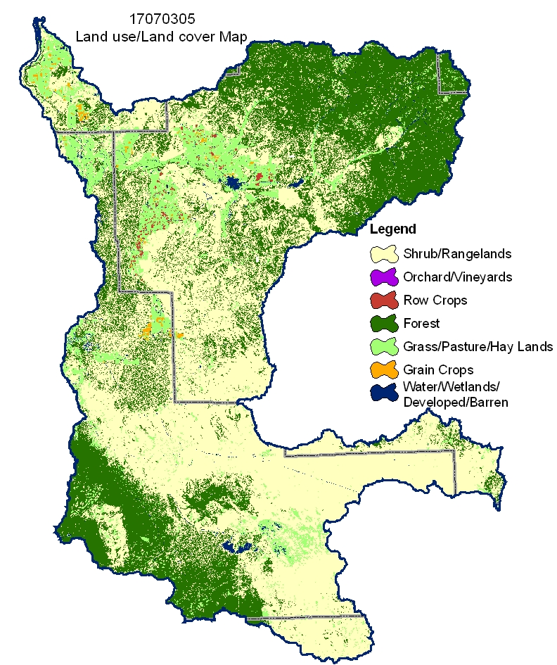
Back to Contents

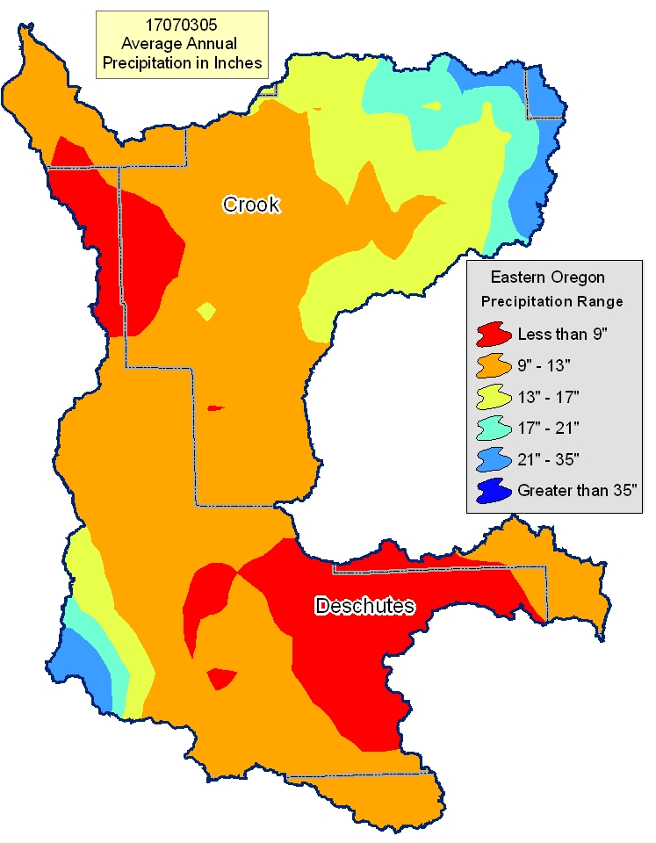

Common Resource Area Map Back to Contents

Only the major units are described below - for descriptions of every unit within the HUC, go to: http://ice.or.nrcs.usda.gov/website/cra/viewer.htm

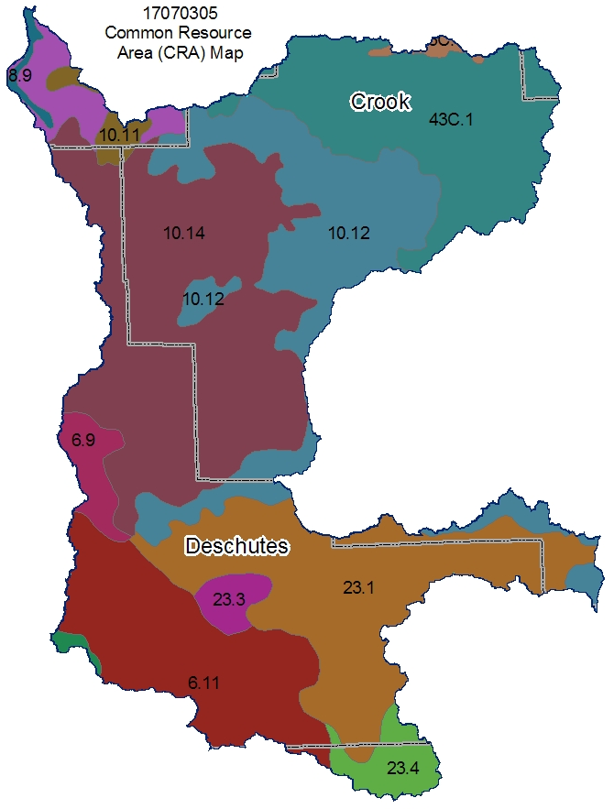
6.11 - Cascade Mountains, Eastern Slope - Pumice Plateau Forest: This unit occurs on the southern extreme of the MLRA and is characterized by nearly level to undulating pumice-mantled plateaus that support dominantly lodgepole pine and ponderosa pine. The soils consist of deep deposits of ash and pumice from Mt. Mazama. Cold temperatures and frost limit the production of ponderosa pine. The temperature regime is cryic, and the moisture regime is xeric.

10.12 - Central Rocky and Blue Mountain Foothills - Cool Dry Blue Mountain Foothills: This unit is characterized by rangeland soils on hills and mountains associated with basalt. The dominant soils are those of the Searles, Redcliff, Choptie, and Madeline series. The temperature regime is frigid, and the moisture regime is aridic. The mean annual precipitation is 10 to 12 inches. The vegetation is dominantly Wyoming big sagebrush and bluebunch wheatgrass and a lesser amount of Idaho fescue.

10.14 - Central Rocky and Blue Mountain Foothills - Bend-Redmond Lava Plains: This unit is characterized by moderately deep and shallow soils that formed in ash from Mt. Mazama and are underlain by basalt. Most areas are used for irrigated pasture and hay. Slopes are nearly level to undulating. The dominant soils are those of the Deschutes and Deskamp series. The soils are sandy loam or loamy sand throughout. The temperature regime is mesic, and the moisture regime is aridic.

23.1 - Malheur High Plateau - Ashy Pluvial Lake Basins: This unit is characterized by cold basins that contain significant amounts of volcanic ash. These basins are Millican Valley and Fort Rock Basin. The temperature regime is frigid, and the moisture regime is aridic. The dominant soils are those of the Fort Rock, Bonnick, Abert, Gardone, and Borobey series. Most of the soils are well drained. Few wetlands are present.

43C.1 - Blue and Seven Devils Mountains - John Day-Clarno Highlands: This unit is characterized by forest land that is underlain by the John Day/Clarno Formation. The temperature regime is frigid, and the moisture regime is xeric. The vegetation is dominantly ponderosa pine and scattered Douglas-fir. The amount of volcanic ash on the soils is minimal. The soils typically are clayey and have a strongly developed argillic horizon.

Physical Description – Continued Back to Contents

 |  | ACRES | ACRE-FEET
Irrigated Adjudicated Water Rights (OWRD^{/4}) | Surface | 17,698 | 65,377
Irrigated Adjudicated Water Rights (OWRD^{/4}) | Well | 9,247 | 27,883
Irrigated Adjudicated Water Rights (OWRD^{/4}) | Total Irrigated Adjudicated Water Rights | 26,945 | 93,259
Stream Flow Data | USGS 14087400 CROOKED RIVER BELOW OPAL SPRINGS, NEAR CULVER, OR | Total Avg. Yield | 1,124,938
Stream Flow Data |  | May – Sept. Yield | 421,359
 |  | MILES | PERCENT
Stream Data^{/5}  *Percent of Total Miles  of Streams in HUC | Total Miles – Major (100K Hydro GIS Layer) | 498 | --
Stream Data^{/5}  *Percent of Total Miles  of Streams in HUC | 303d/TMDL Listed Streams (DEQ) | 105 | 21%
Stream Data^{/5}  *Percent of Total Miles  of Streams in HUC | Anadromous Fish Presence (StreamNet) | 0 | 0%
Stream Data^{/5}  *Percent of Total Miles  of Streams in HUC | Bull Trout Presence (StreamNet) | 1.4 | 0%
 |  | ACRES | PERCENT
Land Cover/Use^{/2} Based on a 100-foot stretch on both  sides of all streams  in the 100K Hydro GIS Layer | Forest | 13,407 | 38%
 | Grain Crops | 235 | 1%
 | Grass/Pasture/Hay | 6,606 | 18%
 | Orchards/Vineyards | 0 | 0%
 | Row Crops | 147 | 0%
 | Shrub/Rangelands – Includes CRP Lands | 14,553 | 41%
 | Water/Wetlands/Developed/Barren | 779 | 2%
 | Total Acres of 100-foot Stream Buffers | 35,729 | --
Land Capability Class  (Croplands & Pasturelands Only)  (1997 NRI^{/3} Estimates for Non-Federal Lands Only) | 1 – slight limitations | 0 | 0%
 | 2 – moderate limitations | 15,000 | 12%
 | 3 – severe limitations | 76,200 | 63%
 | 4 – very severe limitations | 17,100 | 14%
 | 5 – no erosion hazard, but other limitations | 0 | 0%
 | 6 – severe limitations; unsuitable for cultivation; limited to pasture, range, forest | 12,800 | 11%
 | 7 – very severe limitations; unsuitable for cultivation; limited to grazing, forest, wildlife habitat | 0 | 0%
 | 8 – miscellaneous areas; limited to recreation, wildlife habitat, water supply | 0 | 0%
 | Total Croplands & Pasturelands | 121,100 | --

Confined Animal Feeding Operations – Oregon CAFO Permit – 12/2004
Animal Type | Dairy | Feedlot | Poultry | Swine | Mink | Other
No. of Permitted Farms | 5 | 4 | 0 | 0 | 0 | 2
No. of Permitted Animals | 2,235 | 7,000 | 0 | 0 | 0 | 700

Resource Concerns Back to Contents

- 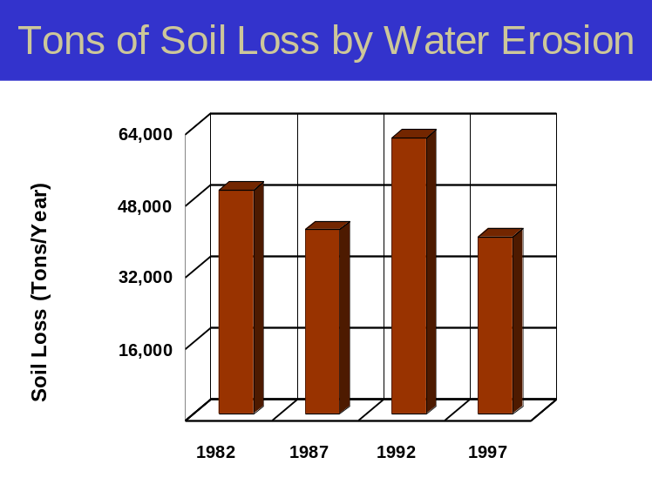Sheet and rill erosion by water on the cropland and pastureland has been reduced by more than 10,000 tons of soil per year from 1982 to 1997.

- NRI estimates indicate that 6,000 acres of the agricultural lands still had water erosion rates above a sustainable level in 1997.

- Controlling erosion not only sustains the long-term productivity of the land, but it also affects the amount of soil, pesticides, fertilizer, and other substances that move into the Nation’s waters.

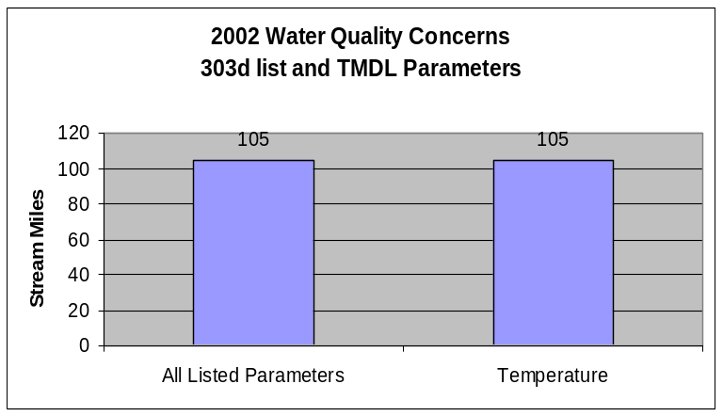
- All water quality limited streams have temperatures exceeding State water quality standards. Elevated stream temperatures may be due to inadequate riparian shade, stream channel widening, warm irrigation return flows, and other anthropogenic or natural causes.

- Conservation practices that can be used to address these water quality issues include grazing management, irrigation water management, and use of riparian buffers.

Watershed Projects, Plans, Studies, and Assessments
NRCS Watershed Projects⁶ |  |  | NRCS Watershed Plans, Studies, and Assessments⁷
Name | Status |  | Name | Status
Juniper Canyon | Installed - 1983 |  | None
ODEQ TMDL’s⁸ |  |  | ODA Agricultural Water Quality Management Plans⁹
Name | Status |  | Name | Status
None |  |  | Crooked River  Middle Deschutes  Upper Deschutes | Completed  Completed  Completed
OWEB Watershed Councils¹⁰ |  | Watershed Council Assessments¹¹ |  | NWPCC Subbasin Plans & Assessments¹⁸
Crooked River, Bridge Creek, and Upper Deschutes Watershed Councils |  | Crooked River Watershed Assessment |  | Deschutes Subbasin Plan

(Continued on page 8)

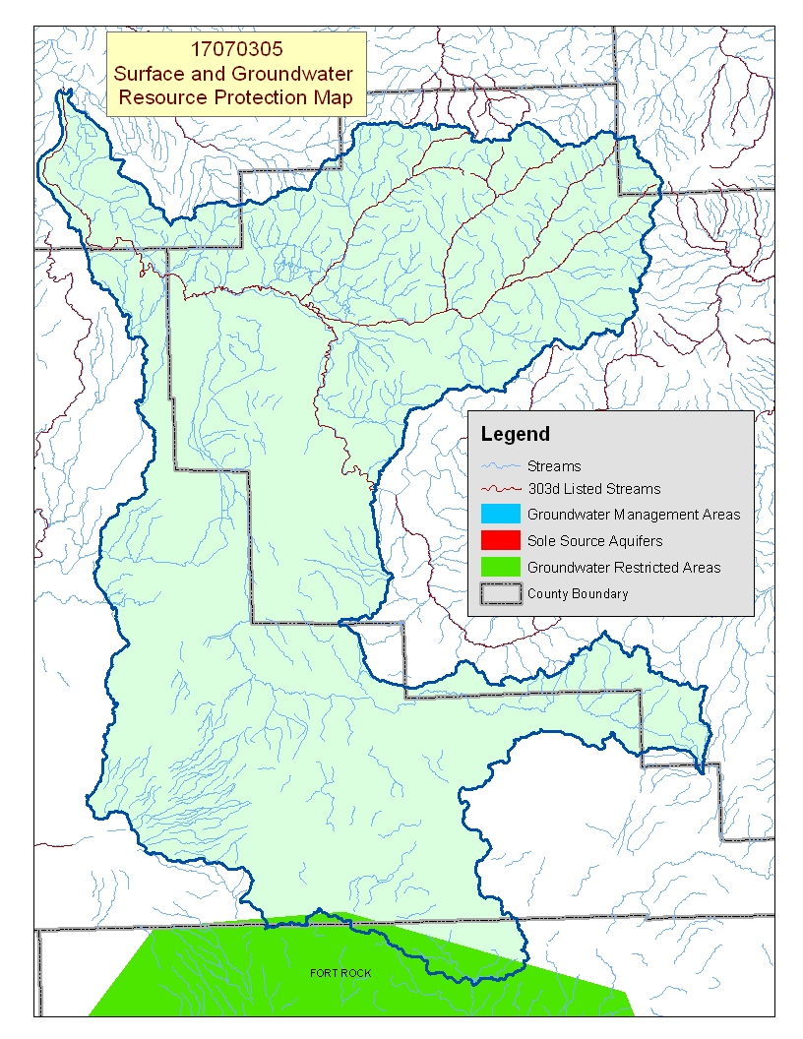
Map Footnote ^{/17}

Resource Concerns - Continued Back to Contents

Resource Concerns/Issues by Land Use
SWAPA +H Concerns | Specific Resource Concern/Issue | Grass\Pasture\Hay | Grain Crops | Row Crops | Perennial Crops (Orch/Vine/ Berries) | Shrub/Range | Forest
Soil Erosion | Wind |  | X | X
Soil Erosion | Irrigation Induced |  |  | X
Water Quantity | Water Management For Irrigated Land | X | X | X
Water Quality, Surface | Temperature | X
Plant Condition | Productivity, Health, and Vigor | X |  |  |  | X | X
Animal Habitat, Domestic | Management | X |  |  |  | X
Animal Habitat, Wildlife | Food, Cover, and/or Shelter |  |  |  |  |  | X
Human, Economics | Land Use Constraints/Restrictions |  |  |  |  | X | X
Human, Economics | High Capital/Financial Cost |  |  | X
Human, Economics | High Labor Cost or Availability |  |  | X
Human, Economics | Low or Unreliable Profitability | X | X |  |  | X | X
Human, Social | Low Community Well-Being |  |  |  |  |  | X
Human, Political | Lack of Technical Assistance | X | X | X |  | X

Grass/Pasture/Hay
- Water and grazing management are primary concerns in areas of irrigated pasture on small farms and ranches.
- Low profitability on ranches and unavailability of technical assistance for small farms and ranchettes hinder conservation efforts.

Grain and Row Crops
- Wind erosion and water management are resource concerns on irrigated cropland.
- High capital and labor cost to improve and manage more efficient irrigation systems is an obstacle to use of additional conservation practices, especially in areas used for specialty row crops.

Rangeland and Forest Land
- Overstocked lodgepole pine/ponderosa pine on forest land and invasive weeds (juniper, medusa head, etc.) on rangeland restrict the productivity for timber, grazing, and wildlife habitat.
- Juniper is encroaching onto rangeland and ponderosa pine sites.
- Some areas are under pressure for development into ranchettes and vacation and recreational property.

Federally Listed Threatened And Endangered Species¹²
THREATENED SPECIES | CANDIDATE SPECIES
Mammals - Canada lynx  Birds - Bald eagle, Northern spotted owl  Fish - Bull trout | Birds – Yellow-billed cuckoo  Amphibians and Reptiles – Oregon spotted frog, Columbia spotted frog
 | PROPOSED SPECIES: None
Essential Fish Habitat¹³ – None

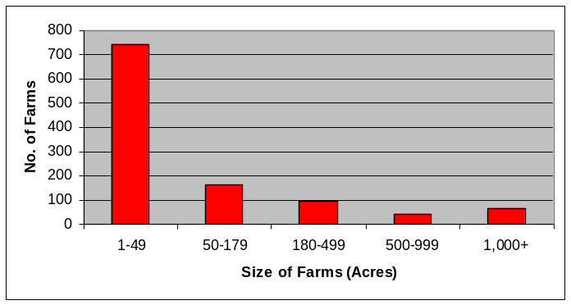
Census and Social Data^{/14} Back to Contents

Number of Farms: 1,106
Number of Operators: 1,800
- Full-time operators: 547
- Part-time operators: 1,253

Estimated Level of Willingness and Ability to Participate in Conservation^{/15}:
- Large-acreage, full-time operators: MODERATE TO HIGH
- Small-acreage, part-time operators: LOW TO MODERATE
Two-thirds of the agricultural landowners in the Lower Crooked subbasin own less than 50 acres and are relatively new to agriculture and resource management. Motivating and helping these landowners adopt conservation systems and practices may require significant time to help them become aware of local resource concerns and the connection of their operation to larger resource issues. The large-acreage, full-time operators tend to be aware of local resource concerns, have a positive stewardship attitude, and have had experience with conservation systems; however, these landowners may need financial assistance with new conservation systems and practices.

Evaluation of Social Capital^{/16}: LOW
The biggest obstacle to the widespread diffusion of conservation throughout the Lower Crooked subbasin may be a lack of social capital. Indications are that the community does not participate in public meetings and organizations; and the majority of area residents are not involved in decisions affecting the community. For the most part, however, area residents are well educated, exercise their right to vote, and have some experience completing community projects.
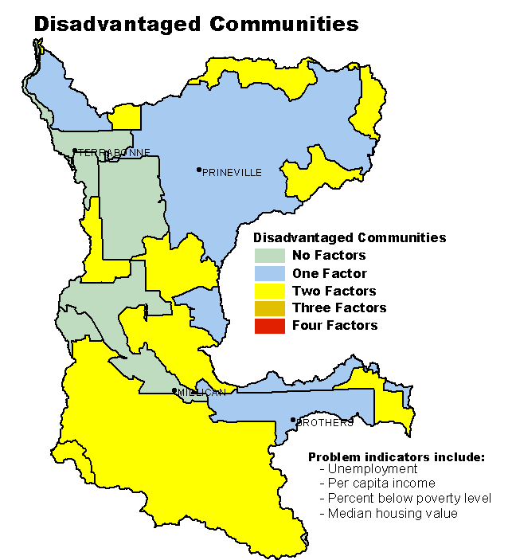
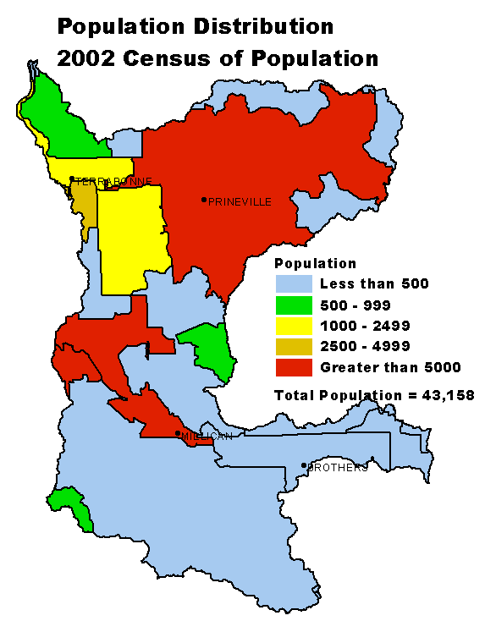
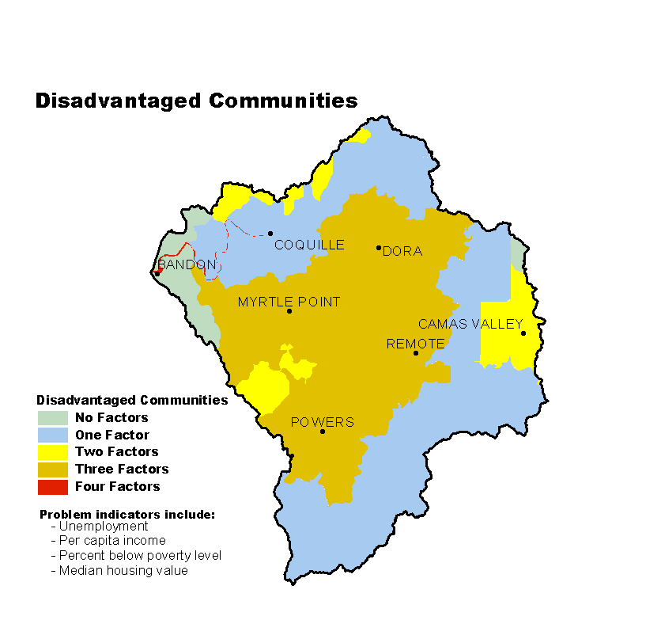

Progress/Status Back to Contents

PRMS Data | FY99 | FY00 | FY01 | FY02 | FY03 | Avg/Year | Total
Total Conservation Systems Planned (Acres) | 11,461 | 1,667 | 2,479 | 2,220 | 3,467 | 4,259 | 21,294
Total Conservation Systems Applied (Acres) | 1,645 | 1,512 | 2,348 | 2,782 | 1,201 | 1,898 | 9,488
Conservation Treatment
Waste Management (Number) | 0 | 0 | 0 | 0 | 0 | 0 | 0
Buffers (Acres) | 0 | 0 | 0 | 4 | 0 | 1 | 4
Erosion Control (Acres) | 12,228 | 1,216 | 2,462 | 2,764 | 1,263 | 3,987 | 19,933
Irrigation Water Management (Acres) | 2,148 | 1,290 | 2,542 | 2,650 | 891 | 1,904 | 9,521
Nutrient Management (Acres) | 0 | 0 | 26 | 0 | 402 | 86 | 428
Pest Management (Acres) | 371 | 0 | 26 | 0 | 260 | 131 | 649
Prescribed Grazing (Acres) | 0 | 2,020 | 0 | 0 | 0 | 404 | 2,020
Trees & Shrubs (Acres) | 0 | 0 | 1 | 0 | 0 | 0 | 1
Conservation Tillage (Acres) | 0 | 865 | 2,095 | 284 | 615 | 772 | 3,859
Wildlife Habitat (Acres) | 170 | 253 | 2,103 | 432 | 1,115 | 815 | 4,073
Wetlands (Acres) | 0 | 0 | 0 | 0 | 0 | 0 | 0
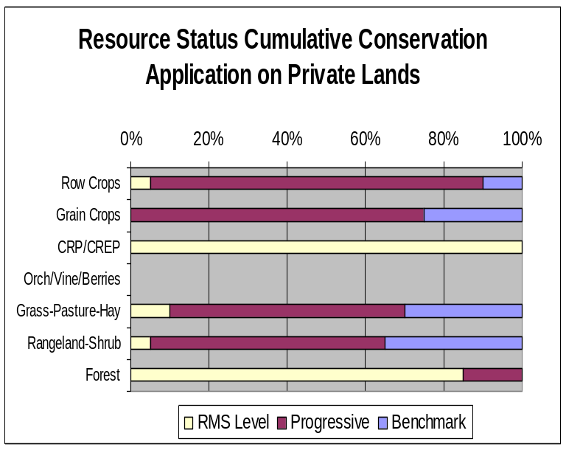
- Progress over the last five years has been focused on:
  - Erosion control and irrigation water management on irrigated lands.
  - Prescribed grazing on rangeland and pastureland.
  - Improving upland and riparian wildlife habitat.

- Low economic returns hinder adoption of conservation practices on pastureland and hayland.

- Cost to improve irrigation water management can hinder water conservation on cropland.

- Rural areas developed as homesites and recreational property commonly are not managed specifically for agricultural or forestry production.

- Most private forest land meets State forest
practices requirements.
Estimates are based on information received from local conservationists in the watershed.

Lands Removed from Production through Farm Bill Programs
- Conservation Reserve Program (CRP): 218 acres
- Wetland Restoration Program (WRP): none
- Conservation Reserve Enhancement Program (CREP): none

Footnotes/Bibliography Back to Contents
All data is provided “as is.” There are no warranties, express or implied, including the warranty of fitness
for a particular purpose, accompanying this document. Use for general planning purposes only.

- Ownership Layer – Source: The 1:24,000 scale public ownership layer is the land ownership/management for public entities, including Federal, Tribal, State, and local entities. This is a seamless, statewide Oregon Public Ownership vector layer composed of fee ownership of lands by Federal, State, Tribal, county, and city agencies. The layer is comprised of the best available data compiled at 1:24,000 scale or larger, and the line work matches GCDB boundary locations and ORMAP standards where possible. The layer is available from the State of Oregon GIS Service Center: http://www.gis.state.or.us/data/alphalist.html. For current ownership status, consult official records at appropriate Federal, State, and county offices. Ownership classes grouped to calculate Federal ownership vs. non-Federal ownership by the Water Resources Planning Team.

- National Land Cover Dataset (NLCD) - Originator: U.S. Geological Survey (USGS);
Publication date: 19990631; Title: Oregon Land Cover Data Set, Edition: 1;
Geospatial data presentation form: Raster digital data; Publisher: U.S. Geological Survey,
Sioux Falls, SD, USA; Online linkage: http://edcwww.cr.usgs.gov/programs/lccp/nationallandcover.html; Abstract: These data can be used in a geographic information system (GIS) for any number of purposes, such as assessing wildlife habitat, water quality, pesticide runoff, land use change, etc. The State data sets are provided with a 300-meter buffer beyond the State border to facilitate combining the State files into larger regions.

- ESTIMATES FROM THE 1997 NRI DATABASE (REVISED DECEMBER 2000) REPLACE ALL PREVIOUS REPORTS AND ESTIMATES. Comparisons made using data published for the 1982, 1987, or 1992 NRI may produce erroneous results. This is because of changes in statistical estimation protocols and because all data collected prior to 1997 were simultaneously reviewed (edited) as 1997 NRI data were collected. All definitions are available in the glossary. In addition, this December 2000 revision of the 1997 NRI data updates information released in December 1999 and corrects a computer error discovered in March 2000. For more information: http://www.nrcs.usda.gov/technical/NRI/

- Irrigated Adjudicated Water Rights – Water Rights Information System (WRIS), Oregon Water Resources Department, http://www.wrd.state.or.us/maps/wrexport.shtml

- StreamNet is a cooperative venture of the Pacific Northwest's fish and wildlife agencies and tribes and is administered by the Pacific States Marine Fisheries Commission. StreamNet provided data and data services in support of the region's fish and wildlife program and other efforts to manage and restore the region's aquatic resources. Official StreamNet website: http://www.streamnet.org/

- Natural Resources Conservation Service, Watershed Projects Planned and Authorized, http://www.nrcs.usda.gov/programs/watershed/Purpose.

- Natural Resources Conservation Service, Watershed Plans, Studies, and Assessments completed, http://www.nrcs.usda.gov/programs/watershed/Surveys_Plng.html#Watershed%20Surveys%20and%20Plan

- Oregon Department of Environmental Quality Total Maximum Daily Loads, http://www.deq.state.or.us/wq/TMDLs/TMDLs.htm

- Oregon Department of Agriculture, Agricultural Water Quality Management Plans, http://www.oregon.gov/ODA/NRD/water_agplans.shtml

Footnotes/Bibliography Continued Back to Contents
All data is provided “as is.” There are no warranties, express or implied, including the warranty of fitness
for a particular purpose, accompanying this document. Use for general planning purposes only.

- Oregon Watershed Enhancement Board, http://oregon.gov/OWEB/WSHEDS/index.shtml

- Watershed Assessments completed by local watershed councils following the Oregon Watershed Assessment Manual, http://oregon.gov/OWEB/docs/pubs/ws_assess_manual.shtml.

- NRCS Field Office Technical Guide, Section II, Threatened and Endangered List.

- Magnuson-Stevens Fishery Conservation and Management Act, Public Law 94-265. As amended through October 11, 1996.

- Data were taken from the 2002 Agricultural Census and adjusted by percent of HUC in the county or by percent of zip code area in the HUC, depending on the level of data available. Data were also taken from the U.S. Population Census, 2000.

- Conservation participation was estimated using NRCS Social Sciences Technical Note 1801, Guide for Estimating Participation in Conservation, 2004. Four categories of indicators were evaluated: Personal characteristics, farm structural characteristics, perceptions of conservation, and community context. Estimates are based on information received from local conservationists in the watershed.

- Social capital is an indicator of the community’s ability and willingness to work together to solve problems. A high amount of social capital helps a community to be physically healthy, socially progressive, and economically vigorous. A low amount of social capital typically results in community conflict, lack of trust and respect, and unsuccessful attempts to solve problems. The evaluation is based on NRCS Technical Report Release 4.1, March, 2002: Adding Up Social Capital: An Investment in Communities. Local conservationists provided information to measure social capital. Scores range from 0 to 76.

- Surface and Groundwater Resource Protection Map
  - 2002 303d Listed Streams designated by Oregon Department of Environmental Quality and approved by the Environmental Protection Agency, Section 303d Clean Water Act, http://www.deq.state.or.us/wq/303dlist/303dpage.htm
  - Groundwater Management Areas designated by the Oregon Department of Environmental Quality, Oregon Revised Statutes – Ground Water ORS 468B.150 to ORS 468B.190, http://www.deq.state.or.us/wq/groundwa/wqgw.htm
  - Groundwater Restricted Areas designated by Oregon Water Resources Commission, Oregon Department of Water Resources, http://egov.oregon.gov/OWRD/PUBS/aquabook_protections.shtml
  - The Sole Source Aquifer (SSA) Protection Program is authorized by Section 1424(e) of the Safe Drinking Water Act of 1974 (Public Law 93-523, 42 U.S.C. 300 et. seq), http://www.epa.gov/safewater/ssanp.html

- Subbasin assessments and plans are developed by local groups (SWCDs, watershed councils, tribes, and others) as part of the Northwest Power and Conservation Council’s fish and wildlife program in the Columbia River Basin. This program is funded and implemented by the Bonneville Power Administration. http://www.nwcouncil.org/fw/subbasinplanning/Default.htm.

