NDA # 20,637

GLIADEL® Wafer
(Polifeprosan 20 with Carmustine Implant)

Submission Date: April, 6, 2001

ODAC: December 6, 2001

Medical Reviewer: Alla Shapiro, M.D.

Statistical Reviewer: Ning Li, M.D., Ph.D.

Applicant: Guilford Pharmaceuticals

Table of Contents

DRAFT Error! Bookmark not defined.
Summary of Review Issues for sNDA 20-637 4
I Introduction and Background 6
A. Drug Established and Proposed Trade Name, Drug Class, Sponsor’s Proposed Indication(s), Dose, Regimens, Age Groups 6
B. State of Armamentarium for Indication(s) 7
C. Other Relevant Information 8
D. Important Issues with Pharmacologically Related Agents 8
II. Clinically Relevant Findings From Chemistry, Animal Pharmacology and Toxicology, Microbiology, Biopharmaceutics, Statistics and/or Other Consultant Reviews 8
III. Human Pharmacokinetics and Pharmacodynamics 8
IV. Description of Clinical Data and Sources 9
A. Overall Data 9
B. Table of Clinical Trials 9
C. Postmarketing Experience 11
D. Literature Review 11
V. Clinical Review Methods 11
A. How the Review was Conducted 11
B. Overview of Materials Consulted in Review 12
C. Clinical Inspection Summary 12
D. Were Trials Conducted in Accordance with Accepted Ethical Standards 12
E. Evaluation of Financial Disclosure 12
VI. Phase III Trial T-301 14
A. Protocol Review [Note19] 14
B. Trial Results 22
C. Efficacy Results 35
VII Review of Safety 42
VIII. Conclusions and Recommendations 56
APPENDIX I: Protocol T-301 Details 57
APPENDIX II: Current Label for GLIADEL 64
APPENDIX III: Excerpts from 1996 Review of CL-0190 (Phase 3); #9003 (Phase 1); ODAC Questions and Vote 79

Table of Reviewer Tables

Reviewer Table 1: Clinical Trials in Patients with Newly Diagnosed Malignant Glioma 11
Reviewer Table 2: Protocol T-301 Milestones 14
Reviewer Table 3: Eligibility Violations 24
Reviewer Table 4: Age Distribution by Decades and Treatment Group 26
Reviewer Table 5: Tumor Size and Extent of Resection 28
Reviewer Table 6: Tumor Characteristics – Histological Type 29
Reviewer Table 7: Chemotherapy within 30 days of randomization. 35
Reviewer Table 8: Sponsor’s Analysis for Overall Survival (ITT analysis) 36
Reviewer Table 9: FDA’s Analysis for Overall Survival (ITT analysis) 36
Reviewer Table 10: FDA Analysis of Overall Survival (ITT analysis) using different stratification variables 37
Reviewer Table 11: FDA’s Analysis for Overall Survival for GBM subgroup 38
Reviewer Table 12: ITT Analyses for Survival Using Cox Model 39
Reviewer Table 13: GBM Subgroup Analyses for Survival Using Cox Model 39
Reviewer Table 14: One Year Survival 40
Reviewer Table 15: Reasons for Death in the First 30 days of Randomization 43
Reviewer Table 16: Indication for Additional Surgeries during which Wafers were Detected and Removed. 44
Reviewer Table 17: Convulsions in Patients in the ITT population 51
Reviewer Table 18: Timeframe of Postoperative Seizures 52
Reviewer Table 19: Additional Local Treatment-Emergent Adverse Events 53
Reviewer Table 20: Surgical Complications in Selected Series 55
Reviewer Table 21: Randomization List for US Sites 57

Summary of Review Issues for sNDA 20-637

GLIADEL, a sterile, biodegradable polymer wafer containing 7.7 mg of compressed carmustine powder, is designed to deliver local chemotherapy to the surgical cavity remaining after resection of a malignant glioma. In 1996, GLIADEL was approved for “use as an adjunct to surgery to prolong survival in patients with recurrent glioblastoma multiforme for whom surgical resection is indicated.” An sNDA is now submitted requesting extension of the indication to treatment of patients undergoing initial surgery.

The efficacy claims of this sNDA rest primarily upon data from protocol T-301, a multicenter (38), international (14 countries), randomized, double-blind placebo-controlled trial in 240 patients with newly diagnosed glioma. After maximal resection of tumor, up to eight wafers of either GLIADEL or placebo were placed against the resection surfaces. All patients were to receive standard limited field radiation therapy and patients with anaplastic oligodendroglioma were also to receive systemic chemotherapy. The primary endpoint was overall survival, to be performed 12 months after the last patient was enrolled.

At the protocol-specified cutoff date, 88 patients (73.3 %) in the GLIADEL group and 93 patients (77.5 %) in the placebo group had died. Median survival in the ITT population for patients treated with GLIADEL was 13.9 months (12.1 – 15.3) and 11.6 months (10.2 – 12.6) for patients receiving placebo.

- Statistical significance is not reached by the protocol-specified logrank test (p=0.078).
- Statistical significance is reached by the sponsor’s analysis, a logrank test stratified by country (p=0.027). The sponsor’s reasoning for stratifying the logrank test includes, but is not limited to, the following: (a) randomization was stratified by center, which is within a country; (b) use of center results in over-stratification; (c) analysis by country was a prespecified interest explicitly stated as a secondary endpoint.

The secondary endpoint of greatest interest was overall survival in patients with GBM, the subgroup which supported approval in the relapsed setting, the most frequent histology in adults, and the target population during the protocol planning stage (except that histology is not available prior to wafer implantation). Of the 240 patients enrolled, 207 carried the diagnosis of GBM. Overall survival in this population demonstrates a nonsignificant trend for improvement (p=0.2).

The usual regulatory requirement for evidence of drug efficacy is more than one adequate and well-controlled trial [Section 505(d) of the FDC Act]. However, this section has been amended by FDAMA, and guidance published, to allow consideration of data from a single trial if replicability is demonstrated by internal consistency especially from a multicenter trial or by evidence of efficacy in another phase of the disease. The guidance in oncology states “therapies that are effective in one phase of a disease are often effective in other disease phases, although the magnitude of the benefit and benefit-to-risk relationship may differ…if a drug is known to be effective in patients with a refractory stage of a particular cancer, a single adequate and well-controlled study of the drug in an earlier stage of the same tumor will generally be sufficient evidence of effectiveness to support the new use.”

The 1996 approval of GLIADEL was based on a survival benefit in patients with GBM. Trial 8802 was a randomized, multicenter, placebo-controlled trial enrolling patients with anaplastic astrocytoma, anaplastic oligodendroglioma and oligodendroglioma (35%) as well as GBM (65%). The FDA generally does not approve drugs based on subgroup analyses; however, it was acknowledged that information on differences in the natural history of histologic subtypes was not well known at the time trial 8802 was designed. If trial 8802 is to be accepted as supportive, consideration should be given to the fact that it was approved only for patients with GBM; there was not convincing evidence of a survival effect in the ITT population. (Further details of trial 8802 can be found in the label in Appendix II and of the ODAC questions and vote in Appendix III.)

Study CL-0190, a study in newly diagnosed patients with malignant gliomas, was also submitted in 1996. A total of thirty two patients in Norway and Finland were enrolled when lack of drug supply closed the trial before protocol endpoints and/or target accrual were reached. A statistically significant treatment effect on survival was seen in the ITT population; however, the treatment arms were imbalanced in that all 5 patients with the more favorable histology (anaplastic astrocytoma, oligodendroglioma, ependymoma) randomized to GLIADEL. The trend for improvement in survival for patients with GBM was not statistically significant. (Further details of trial CL-0190 and the ODAC questions and vote can be found in Appendix III.)

ODAC will be asked to address whether data from trial T-301, which is submitted in this sNDA, in conjunction with data from the prior approval, provide sufficient evidence of clinical benefit in patients with newly diagnosed malignant glioma to warrant approval.

Introduction and Background

Drug Established and Proposed Trade Name, Drug Class, Sponsor’s Proposed Indication(s), Dose, Regimens, Age Groups
- Name of drug:

Established: Polifeprosan 20 with Carmustine Implant
Proprietary: GLIADEL® Wafer

• Applicant:

Guilford Pharmaceuticals Inc.
6611Tributary Street
Baltimore, MD 21224

- Drug Class: Antineoplastic

- Indication:

Current: “GLIADEL is indicated for use as an adjunct to surgery to prolong survival in patients with recurrent glioblastoma multiforme for whom surgical resection is indicated.”

Proposed: “GLIADEL wafer is indicated for use as a treatment to significantly prolong survival and maintain overall function (as measured by preservation of Karnofsky Performance Status) and neurological function in patients with malignant glioma undergoing primary and/or recurrent surgical resection.”

- Dosage and Administration

Excerpted from the label (no changes proposed): “Each GLIADEL wafer contains 7.7 mg of carmustine, resulting in a dose of 61.6 mg when eight wafers are implanted. It is recommended that eight wafers be placed in the resection cavity if the size and shape of it allows. Should the size and shape not accommodate eight wafers, the maximum number of wafers as allowed should be placed. Since there is no clinical experience, no more than eight wafers should be used per surgical procedure…

Once the tumor is resected, tumor pathology is confirmed, and hemostasis is obtained, up to eight GLIADEL wafers …may be placed to cover as much of the resection cavity as possible. Slight overlapping of the wafers is acceptable. Wafers broken in half may be used, but wafers broken in more than two pieces should be discarded in a biohazard container. Oxidized regenerated cellulose (Surgicel®) may be placed over the wafers to secure them against the cavity surface. After placement of the wafers, the resection cavity should be irrigated and the dura closed in a water tight fashion.”

- How Supplied

Excerpted from the label (final sentence is proposed addition): “GLIADEL is available in a single dose treatment box containing eight individually pouched wafers. Each wafer contains 7.7 mg of carmustine and is packaged in two aluminum foil laminate pouches. The inner pouch is sterile and is designed to maintain product sterility and protect the product from moisture. The outer pouch is a peelable overwrap. The outside surface of the outer pouch is not sterile.”

State of Armamentarium for Indication(s)

The estimated annual incidence of newly diagnosed primary brain neoplasms in adults is roughly 7 to 17 per 100,000 per year (Smirniotopoulos, 1999). Gliomas are by far the largest category of primary neoplasms: 50% are high grade. Glioblastoma multiforme accounts for 80% of adult malignant gliomas and anaplastic astrocytoma for 20% (Davis, 2000).

The revised World Health Organization (WHO) nomenclature classifies low grade histologies tumors as anaplastic oligodendrogliomas (15%), meningiomas (20%), ependymoma (3%), embryonal tumors, such as medulloblastoma, PNET, and mixed glial tumors (11% )
(Cohen, 1999).

The standard treatment of newly diagnosed gliomas consists of surgery followed by cranial radiation and, at times, adjuvant systemic chemotherapy. The median survival after surgery alone in patients with GBM is about 13 months (Shinoda, 2001).

Randomized trials of radiation therapy have consistently demonstrated statistically significant improvement in survival of about 16 to 18 weeks over surgery alone (Walker, 1980). Randomized controlled trials of systemic chemotherapy have not demonstrated a consistent improvement in survival in GBM. Prospective randomized Brain Tumor Cooperative Group
BTCG trials comparing patients with high grade gliomas (anaplastic astrocytoma and GBM) who received radiation therapy with and without BCNU have mixed results. A 1993 meta-analysis of the major adjuvant therapy trials showed that there was a 10% increase in survival at 1 year and an 8.6% increase at 2 years for patients treated with both chemotherapy and radiation therapy as opposed to those treated with radiation therapy alone (Fine, 1993). It has been argued that this improvement is confined to the subgroup of patients with anaplastic astrocytoma.

For patients with anaplastic oligodendroglioma, adjuvant therapy with PCV (procarbazine, CCNU, vincristine) may be considered standard adjuvant therapy (Prados, 1999). However, recent analysis by the Radiation Therapy Oncology Group concluded that for newly diagnosed anaplastic atrocytoma, the PCV regimen does not confer a survival advantage over BCNU as adjuvant treatment of patients with anaplastic astrocytomas (Prados, 1998).

Other Relevant Information

GLIADEL has received marketing approval for patients with recurrent malignant gliomas or GBM in the following countries as of December 2000: Canada, France, Argentina, Austria, Brazil, Chile, Columbia, Germany, Greece, Hong Kong, Israel, Ireland, Luxembourg, Malaysia, The Netherlands, New Zealand, Peru, Portugal, Singapore, South Africa, South Korea, Spain, U.K. and Uruguay. The sponsor states that “product is not yet commercially available in all of these countries.”

GLIADEL has received marketing approval for the treatment of newly diagnosed malignant gliomas in Canada based on the data submitted to the FDA in 1996. See Reviewer Table 1 in Section IVB and Appendix III.

Important Issues with Pharmacologically Related Agents

The nitrosoureas (BCNU, carmustine), which is the active ingredient of the GLIADEL wafer, have the same features as classic alkylating agents. The major dose-limiting toxicity is pulmonary, predominantly fibrosis (O’Driscol et al., 1990). The most consistently noted toxicity is delayed myelosuppression, which reaches a nadir 4 to 6 weeks after treatment and can prevent subsequent cycles of chemotherapy by 6 to 8 weeks (DeVita, 1993). High dose systemic BCNU is associated with hepatic necrosis, encephalopathy, and cardiac necrosis (Phillips et al., 1983).

Clinically Relevant Findings From Chemistry, Animal Pharmacology and Toxicology, Microbiology, Biopharmaceutics, Statistics and/or Other Consultant Reviews
This document represents a collaborative review by the primary medical and statistical reviewers. Independent medical or statistical reviews of sNDA 20-637 were not produced. New data regarding chemistry, animal pharmacology and toxicology, microbiology or biopharmaceutics were not submitted by the Sponsor. For further information, the reader is directed to the label for the marketed product (Appendix 1).

Human Pharmacokinetics and Pharmacodynamics
The following is excerpted from the current label of the original approval for GLIADEL.

“The absorption, distribution, metabolism and excretion of GLIADEL in humans is unknown. A waiver was granted of the requirements for information under Section 6, Human Pharmacokinetics and Bioavailability in 1996. Classical bioequivalence studies are hampered by assay insensitivity for uM or nM drug concentrations needed for radiolabeling studies. Obtaining tissue (brain) samples for analysis is considered inappropriate. Information on the biodegradability of the wafers in humans is based on patients who have had a reoperation or autopsy. Biodegradability of the wafers appears variable with a spectrum of complete dissolution to remnants or complete wafers recovered months later. In the few instances where BCNU content of the wafer remnants was analyzed, it has not been found to be present in the wafer remnants.

Pharmacokinetic and/or pharmacodynamic information was not studied in T-301 and no new information has been submitted with this sNDA.

IV. Description of Clinical Data and Sources

Overall Data

Supplemental NDA 20-637 contains the primary (raw) data from the trial T-301, conducted in 38 centers in 14 countries including the US.

Table of Clinical Trials

Reviewer Table 1 presents the trials of GLIADEL conducted in newly diagnosed patients with malignant glioma. Trial T-301 is new data not previously reviewed by the FDA. Studies 9003 and CL-0190 were submitted and reviewed in 1996 when study 8802 supported approval of GLIADEL for patients with recurrent GBM for whom reoperation is indicated. In 1996, ODAC did not considered the randomized trial CL-0190 sufficient to extend the indication to newly diagnosed patients. Data from study 8802 in patients with recurrent GBM can be found in the label in Appendix II. Excerpts from the 1996 review of CL-0190 and 9003 are located in Appendix III.

Reviewer Table 1: Clinical Trials in Patients with Newly Diagnosed Malignant Glioma

Protocol | Enrollment  Dates |  | Treatment | Population | #Planned/  Entered |  | Primary  Endpoints
CONTROLLED
#T-301 | 12.19.97 ⇒  06.30.99 |  | GLIADEL vs.  Placebo | Newly-dx Malignant  Glioma | 240/240 | Survival
#CL-0190* | 03.23.92 ⇒  05.14.93 |  | GLIADEL vs.  Placebo | Newly-dx Malignant  Glioma | 100/32 | DFS; Survival
UNCONTROLLED
#9003* | 07.05.90 ⇒  08.14.91 | GLIADEL |  | Newly-dx Malignant  Glioma | 22 | Safety Pilot  with XRT
*Previously reviewed; see Appendix III.

Postmarketing Experience

Postmarketing data from the FDA’s Adverse Event Reporting System (AERS), contains reports of the adverse events from the US as well as foreign reports. The most commonly reported toxicities were neurological complications such as cerebral edema, convulsions, confusion, headache, brain abscess and wound infection. Reported adverse events are consistent with the GLIADEL labeling. The Sponsor did not submit postmarketing events as part of the sNDA.

Literature Review

Review of the published literature was conducted and did not identify other randomized or single-arm efficacy trials with GLIADEL.

V. Clinical Review Methods

How the Review was Conducted

The efficacy review is primarily based on the data from the randomized trial T-301, which was the only primary data submitted in this sNDA. Additional data in patients with newly diagnosed malignant glioma reviewed in 1996 was not considered sufficient to support an indication in this population (see Reviewer Table 1 and Appendix III).

Overview of Materials Consulted in Review

The following materials were reviewed by the medical and statistical officers:

- The regulatory history of the application;
- The 1996 medical and statistical review of GLIADEL;
- INDs 30,237 and 54,658;
- Electronic submission of the sNDA, including Case Report Forms (CRFs), SAS and ACCESS datasets;
- Relevant published literature.

C. Clinical Inspection Summary

The Division of Scientific Investigations, CDER, FDA conducted an audit of the centers with the largest accrual (two centers in France: 17 and 14 patients). Only 12 patients were accrued in the US.

The detailed report of the inspection concluded that “data related to the primary endpoint (mortality) for this study are valid”. Minor deviations from the protocol were noticed in the methodology of reporting of Serious Adverse Events (SAEs), possibly attributable to differences in practice of reporting SAEs in France.

D. Were Trials Conducted in Accordance with Accepted Ethical Standards
The sponsor states that study T-301 was conducted in accordance with the Declaration of Helsinki and in compliance with local regulations and the International Conference of Harmonization (ICH) Good Clinical Practice guidelines. The protocol and its amendments were reviewed and approved by Independent Ethics Committees and/or Institutional Review Boards.

Written informed consent was required prior to entering the study.

E. Evaluation of Financial Disclosure
Louise Peltier, Senior Director, Regulatory Affairs, Guilford states, “The sponsor of this clinical study (T-301), performed to support this sNDA filing, was Aventis Pharma and was conducted under their IND #54,654. Aventis was responsible for all financial arrangements with all investigators who participated in this study.

Guilford Pharmaceuticals Inc. reacquired the rights to GLIADEL, including Aventis’s IND and NDA on October 24, 2000. It has not been possible to date to obtain the financial information required to complete item 2 of this Certificate. Guilford has and will continue to make every effort to obtain this information from Aventis.”

Reviewer comment:

Guilford Pharmaceuticals provided FDA with letters that reflect attempts to obtain information on the financial disclosure from the investigators and no responses were received.

Phase III Trial T-301

Phase III, Multicenter Randomized Double-Blind, Placebo-Controlled trial of Polifeprosan 20 with Carmustine 3.85% Implant for Patients Undergoing Initial Surgery for Newly Diagnosed Malignant Glioma

Protocol Review [Note19]

Principal Investigator:

Professor M. Westphal
Department of Neurosurgery
University Hospital Eppendorf
Martinistrasse 52, Hamburg, Germany

Reviewer Table 2: Protocol T-301 Milestones
Milestone | Date | # Pts Entered | Highlights/Comments
Amendment 1 | 6/10/97 | 0 | Not submitted to FDA. Per sNDA: (1) change in total RT from 56-60 to 55-60 Gy; (2) chemorx regimen for AO determined by investigator; (3) PD defined.
Co-sponsor = RPR | 6/20/97 | 0
First Pt Entered | 12/19/97 | 1
Full sponsor = RPR | 3/12/99 | Close to 200
Amendment 2 | 3/18/99 | Close to 200 | Sample size ↑ from 200 to 240.
Last Pt Entered | 6/30/99 | 240
Statistical Analysis Plan submitted | 11/3/99 revised?
Last Observation | 6/30/00 | -- | Per protocol, all pts followed for a minimum of 1 year or until death.
Data Cutoff Date | 6/30/00
Data Lock | 7/17/00 |  | Data unlocks after unblinding on 8/12/00, 1/23/01, and 2/19/01
Guilford “reacquired rights to GLIADEL” | 10/24/00 |  | Financial disclosure not available. AVENTIS was sponsor of trial; Guildford is applicant.
SNDA submitted | 4/6/01

Study Design/Synopsis:
Protocol T-301 was a multicenter, international, randomized, double-blind, placebo-controlled phase 3 trial of GLIADEL wafer (7.7 mg Carmustine per polifeprosan 20 copolymer implanted wafer) implanted at the time of surgery in the resection cavity of patients with newly diagnosed malignant glioma. After maximal resection, up to eight wafers of either GLIADEL or placebo were placed against the resection surfaces. Between postoperative days 14 and 28, patients on both arms were to receive standard limited field radiation therapy (RT) described as 55-60 Gy delivered in 28 to 30 fractions over six weeks. Patients with anaplastic oligodendroglioma were to receive systemic chemotherapy in addition to GLIADEL and RT.

The primary endpoint was overall survival 12 months after the last patient was enrolled. Secondary endpoints included overall survival in the subgroup of patients with glioblastoma multiforme, progression-free survival, 1-year survival, time to neurological deterioration, change in baseline Karnofsky Performance Status (KPS), and Quality of Life (QoL) measures.

Objective:
“To determine the safety and efficacy of polifeprosan 20 with carmustine 3.85% implant plus surgery and limited field radiation therapy compared to placebo implants plus surgery and limited field radiation therapy for improving the survival in patients undergoing initial surgery for newly-diagnosed malignant glioma.”

Reviewer Comment: Secondary endpoints per statistical section include adjusted analyses for survival, progression free survival, change in KPS from baseline, and quality of life measures (EORTC QLQ – C30 and Brain Cancer Module-20).

Eligibility criteria:

- 18 to 65 years old
- Radiographic evidence on cranial magnetic resonance imaging (MRI) of a unilateral,
unifocal, supratentorial cerebral tumor at the time of present surgery
- KPS > 60
- Intraoperative diagnosis of malignant glioma by frozen or squash preparation prior to wafer implantation (including patients with a prior proven biopsy)
- Adequate organ function as defined by baseline laboratory parameters

Exclusion criteria:

- Prior cytoreductive surgery (excluding diagnostic stereotactic biopsy)
- Previous and/or current use of chemotherapeutic agents
- Prior radiotherapy to the brain
- Concomitant life-threatening diseases with life expectancy less than 12 months
- Known hypersensitivity to nitrosourea
- Pregnancy

Reviewer comment: In a protocol planning meeting January 30, 1997, the FDA expressed the preference for a trial population limited to GBM, given the information on effect limited to patients with GBM in the recurrent setting. However, it was conceded that definitive histology can only be known after surgery and therefore it was not feasible to enroll only patients with GBM. The FDA recommended that the primary analysis be done in the intent-to-treat population as well as in the GBM subgroup. Therefore, the analysis of the GBM subgroup was prespecified in the protocol and statistical analysis plan. The Statistical Analysis Plan states…”Because of its resistance to chemotherapy, the study interest is mainly on GBM.”

Randomization:

The protocol states that patients will be randomized to one of two groups: resection and limited field radiation plus either GLIADEL or placebo. “Treatment assignment will be determined by sequential enrollment in ascending order into randomized blocks.” The Statistical Analysis Plan states that “the randomization list is equilibrated for each center by blocks.”
Reviewer Comment: The sNDA states that randomization was stratified by country (Final Study Report, section 5.3.2). Clarification of the randomization codes and algorithm requested from the Sponsor identify that stratification was by center. Block sizes of four were assigned to a center. Treatment assignment within a center was carried out by sequential enrollment in ascending order. Randomization was 1:1.

Treatment:
Wafer. Following maximal tumor resection and the intraoperative conformation of malignant glioma, up to eight wafers of GLIADEL or placebo were to be positioned to cover the entire resected surface.

Radiation Therapy. Between study day 14 and 30, all patients were to undergo a course of limited field radiation therapy to the tumor site and surrounding margins. Patients would receive fractionated radiation to a total of 55 to 60 Gy in 28 to 30 fractions over a six week period. (For further details of the RT protocol, see Appendix III). Patients with the diagnosis of pure anaplastic oligodendroglioma may have radiation delayed or withdrawn, per investigator.

Chemotherapy. All patients with a pathologic diagnosis of anaplastic oligodendrogloima (AO) as determined by the institution’s pathologist were to receive systemic chemotherapy “based on a regimen which will be determined at the investigator’s discretion.” (Amendment 1)

Reviewer comment: The original protocol stated that the regimen for patient’s with AO should consist of six cycles of PCV (lomustine 110 mg/m² d1; procarbazine 60 mg/m² d 8-21; vincristine 1.4 mg/m² d 8 and 29).

Patients with other histologic diagnoses were not to receive chemotherapy for treatment of their initial tumor. At the time of progressive disease, both systemic chemotherapy and reoperation were allowed.

Concomitant Medications. Supportive medication such as steroids and anti-convulsant drugs were permitted at the investigator’s discretion.

Patient Evaluation and Schedule of Tests:

Sponsor’s Table 3 (Abridged): Schedule of Tests

 | Days |  |  |  |  | Months
 | Baseline | Surgery
Visit | 1 | 2 | 3 | 4 | 5 | 6 | 7 | 8 | 9 | 10 | 11 | 12
Study Day² | -14 – 0 | 1 | 3 | 7³ | 14 | 28 | 3 | 6 | 12 | 18 | 24 | 30
Written informed consent | X
Medical history | X
Interim medical history |  | X | X | X | X | X | X | X | X | X | X | X
Medication review | X | X | X | X | X | X | X | X | X | X | X | X
Physical exam | X
Neurological exam | X | X | X | X | X | X | X | X | X | X | X | X
Focused physical exam |  |  | X | X | X | X
KPS | X | X⁴ |  | X | X | X | X | X | X | X | X | X
QoL | X |  |  |  |  | X | X | X | X | X | X | X
Brain MRI | X | X⁵ |  |  |  |  | X
Laboratory evaluations | X |  | X | X | X | X
Urine pregnancy test⁶ | X
Adverse event Reporting | X⁷ | X | X | X | X | X | X | X | X | X | X | X
Begin radiation therapy |  |  |  |  | X⁸
Begin systemic chemorx |  |  |  |  |  | X⁹
Survival |  |  | X | X | X | X | X | X | X | X | X | X
Wafer implantation |  | X
¹ All timing was relative to the Day of Study Surgery, which was defined as Study Day 1
² +3 days for Visits 5-6, +  15 days for Visits 7-12
³ Or Day of Discharge (the earlier of these dates was to be Visit 4)
⁴ Neurological exam and KPS score were to be performed pre-operatively
⁵ Post-operative MRI scan was to be performed within the 48 hours post-operatively
⁶ For women of child-bearing potential only
⁷ Adverse event reporting started after written informed consent was obtained
⁸ Post-operative, limited field radiation therapy was to begin between Study Days 14 and 30
⁹ Systemic chemotherapy was only for patients with anaplastic oligodendroglioma

Reviewer comment: The neurologic examination was designed to rate 11 pre-specified parameters (vital signs, level of consciousness, personality, speech, visual status, fundus, cranial nerves III, IV, VI, cranial nerves other, sensory status, cerebellar status and other).

Definition of Endpoints

• Survival. Overall survival was defined “from the date of randomization (study surgery) and the date of death from any cause, or to the date of last contact for censored information.”

• Progression-free survival was defined as the time between randomization (day of surgery) and the first of two events, progression or death. Progression is defined as clinical or radiologic deterioration. Clinical deterioration is defined as new neurologic signs or a decrease in the KPS of at least 10%. Radiologic progression is defined as a 25% increase in tumor size based on the product of the 2 largest perpendicular diameters or appearance of a new lesion as compared to the last previous post-operative MRI.

• Quality of Life Measures. Quality of Life Assessments were measured by the EORTC QLQ – C30 quality of life instrument as well as the specially designed questionnaire for Brain Tumors (BCM-20; 20 items). The EORTC QLQ-C30 contains 5 functional scales (physical, role, emotional, cognitive and social functioning), 3 symptom scales (fatigue, nausea and vomiting, pain) 6 single items (dyspnea, insomnia, appetite loss, constipation, diarrhea, financial difficulties) and one global health status/QoL scale. The BCM-20 assesses 4 scales (future uncertainty, visual disorder, motor dysfunction, communication deficit) and 7 single symptoms. (See Appendix 1 for the questionnaires.)

• Karnofsky Performance Status was assessed according to the schedule in Sponsor’s Table 3 above.

Definition of Adverse Events

An adverse event (AE) was defined as any symptom, sign, illness or experience which develops or worsens in severity during the course of the study. Serious Aes were an event that was fatal, life-threatening, requires or prolongs hospitalization, results in persistent or significant disability or incapacity, a congenital anomaly or birth defect or an important medical event.

Statistical Considerations:

The primary endpoint was overall survival as assessed by the Kaplan-Meier curve 12 months after enrollment of the last study patient. The secondary endpoints were progression-free survival, overall survival in a subgroup of patients with GBM, 1year survival, change in KPS scores, change in neurologic evaluation and Quality of Life.

Statistical Analysis:

The following are excerpts from the protocol:
Sample size. “Sample size estimation, based on the following assumptions using the Log-rank test to compare two survival curves, indicates that 200 patients are required for this study:

- 50%-70% 12 month survival rates of the placebo and polifeprosan 20 with carmustine implant treatment groups, respectively.
- 15% patient loss rate.
- 18 months accrual time.
- Minimum of 12 months follow-up after last patient is enrolled.
- Two-sided 5% significance level.
- 90% power.

Data from prior studies indicate that approximately 70% of patients meeting inclusion and exclusion criteria similar to the ones in this protocol have a final pathological diagnosis of glioblastoma multiforme. Thus, this study can be expected to enroll a total of 140 patients with a final pathological diagnosis of glioblastoma multiforme. Using the same assumptions mentioned above, a sample size of 140 glioblastoma multiforme patients will yield 80% power to detect a difference between the two survival curves using the logrank test.

The final tumor pathology based on the central neuropathological review of all entered patients will be monitored throughout the study in a blinded fashion. If after 200 patients are enrolled, the total number of enrolled patients with glioblastoma multiforme is less than 140, enrollment will continue until 140 patients with glioblastoma multiforme have been enrolled.

Because the sample size calculations are based on the number of events (deaths) over time, the number of deaths during the study will be monitored in a blinded fashion, and cost free adjustments of the number of patients enrolled and/or the length of follow-up may be made as necessary.

Analyses.

- Primary: Survival will be estimated by the Kaplan-Meier method 12 months after enrollment of the last study patient or after a sufficient number of deaths has been observed to reach the predetermined 90% power, whichever occurs first. The curves will be compared using the Wilcoxon test for the primary comparison (logrank test would be performed as a sensitivity test).”

Reviewer Comment: FDA review from 8/22/97: (1) sample size may not be sufficient to provide power (falls from 90% to 53%) if the true 12 month survival rate for GLIADEL is actually (not overly optimistic) 62.5% instead of 70%. (2) A logrank test is suggested as the primary analysis if a Cox regression analysis for covariate adjustment is the supporting analysis. Consistency in the direction of results across analyses is the goal in the regulatory setting. A Wilcoxon test is efficient when more deaths are expected at an early stage of a trial and eventually the total number of deaths will be similar at the end of the study, which would indicate that the proportional hazard assumption does not hold.

Amendment 2 (3/18/99): RPR states that the IDMC had a second meeting 1/28/99 to review the blinded data collected up to 1/15/99. “The hope for surgical benefit of GLIADEL of 20% at one year is probably unrealistic.” This amendment will increase accrual from 200 to 240 in order to detect a 1year survival for the GLIADEL group of 68% vs. 50% (from 70% vs. 50%) without changing the accrual period from 18 months. This would be expected to increase the number of patients with GBM from 140 to 168.

- “The effect of center will be examined using a proportional hazards model.”

- The effect of strong prognostic factors will be assessed in adjusted analyses using the proportional hazards regression model. Baseline KPS, age, and tumor type may be included depending on the validity of the proportional hazards assumptions.

- All survival analyses and proportional hazards regression analyses will also be performed for the subgroup of GBM patients.

- The SAP states that the Cox model will include country. “Countries with a small number of patients included will be pooled together. If a country effect cannot be tested due to small number of patients in each country, countries will be pooled together in a geographical continent basis (Europe + Israel, USA, Australia…)….These analyses are considered as supportive…”

- Twelve-month survival rate will be estimated.

- PFS will be estimated by Kaplan-Meier and compared by a Wilcoxon test.

- KPS. Change from baseline will be computed for each of the treatment groups at each of the post-surgical timepoints.

QoL. “… summary of the main indicators and comparison of the evolution over time of quality of life between the two treatment groups for each subscale will be performed. Analytical methods will include general linear model (repeated measures and survival techniques, time to QoL deterioration).”

The Statistical Analysis Plan states that the Global Health status/QoL scale based upon questions 29 and 30 of the EORTC QLQ-C30 will be the primary QoL parameter of interest.

B. Trial Results

B.1. Conduct of the Study

- Informed Consent

The study was conducted in accordance with the Declaration of Helsinki; patients gave written informed consent.

- Randomization

The sNDA provides the details of the randomization process. Randomization was stratified by center.

- Blinding

Placebo. The placebo wafer was manufactured and packaged by Guilford. The placebo was identical in composition to GLIADEL except that the placebo did not contain the drug substance (BCNU). The physical characteristics of the wafer differed in several regards from GLIADEL. A chemistry amendment dated August 1, 1997 describes GLIADEL as off-white to yellow and placebo as off-white to white.

Unblinding. The study was to be unblinded after the last patient enrolled was followed for 12 months. An individual investigator could decide to unblind treatment for a patient after discussion with the Clinical Project Director if this information was considered to be important for management of an adverse event. The sNDA describes, “The code information was part of the tear-off portion of the medication that was attached to the randomization page of the CRF, once the implants were used. The non-transparent layer covering the medication code on the label could be erased to reveal the medication allocated to the patient.”

Reviewer Comment: Theoretically, blinding could have been compromised in two ways:

- Physical characteristics. Color was not identical, per chemistry amendment August 1, 1997 and confirmed upon inspection by reviewers at the FDA. Reviewers also noted increased friability. Sponsor Table 42 below on page 88 presents frequency of broken wafers by treatment arm.
- Treatment code could be broken locally.

In the protocol planning stage, the value of blinding was considered important to control for supportive or treatment interventions. Balance between the arms with regard to RT, chemotherapy and reoperation will be addressed in the section, Trial Results.

- Central Refereed Pathology

All diagnoses were to be reviewed locally by the institutional pathologist and centrally by an independent neuropathologist blinded to treatment. The initial histological diagnosis was determined by the institutional (local) neuropathologist. The final histopathological diagnosis was determined during the study by a centralized neuropathological assessment. The central neuropathologist was Professor C. Daumas –Duport in France. Differences between the local and central pathology were to be sent to a referee neuropathologist whose interpretation was final. The referee neuropathologist was Dr. G. Reifenburger in Germany.

- Protocol Violations

Sponsor Table 5 presents the number and type of protocol violation per arm.

Sponsor Table 5: Recorded Protocol Deviations (All Patients)

Protocol Deviation | GLIADEL  N = 120 | Placebo  N = 120
RT outside schedule | 35 | 27
Required RT not done | 11 | 9
Anaplastic oligodendroglioma and no CT | 11 | 10
RT outside schedule/CT for reason other than progression | 0 | 2
CT for reason other than progression | 1 | 1
Required RT not done/RT outside schedule | 0 | 1
RT = radiotherapy; CT = chemotherapy
Data extracted from Appendix II.F, Listing 1.03
Sponsor Table 5, Study Summary, p. 53

Reviewer Comment: The most frequently occurring deviations were RT outside of schedule, required radiotherapy not done, and a diagnosis of anaplastic oligodendroglioma and no chemotherapy. We disagree with the Sponsor’s data on the number of patients listed as “Required RT not done”. We identified 15 patients in the GLIADEL group and 11 patients in the placebo group who did not receive radiation therapy by query of the electronic database. Communication dated August 27, 2001 with Sponsor indicates their agreement with FDA numbers.
Eligibility violations are shown in Reviewer Table 3. There were 5 violations in the GLIADEL group and 6 in the placebo group.

Reviewer Table 3: Eligibility Violations
Protocol Deviation | GLIADEL  N = 120 | Placebo  N = 120
Age > 65 | 2 | 1
Non-enhancing tumors | 1 | 2
Not supratentorial | 0 | 1
Multiple foci of tumor | 0 | 2
Tumor crossing midline | 2 | 0
Ref: Final Study Report, p. 56 and 57

- Audits

Site audits by the FDA’s Division of Scientific Investigations was conducted for the 2 largest accruing centers in France. Summary of the results is presented on p.10, Section C of the review.

B.2. Enrollment, Demographics, Baseline Characteristics

- Enrollment by Study Center

A total of 240 patients were enrolled at 38 centers in 14 countries. The largest number of patients were accrued in two countries: a total of 48 patients were accrued in 7 centers in France; 44 patients were accrued in 5 centers in Germany. Only 12 patients were accrued in 5 centers in the U.S. Equal numbers of patients, 120, were randomized to the two treatment arms.

Enrollment per country and center is displayed in Sponsor Table 1.02. on he following page.

Sponsor Table 1.02: Randomized Patients by Country and Center by Treatment Group
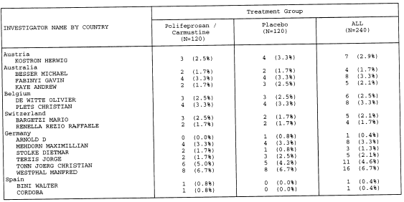
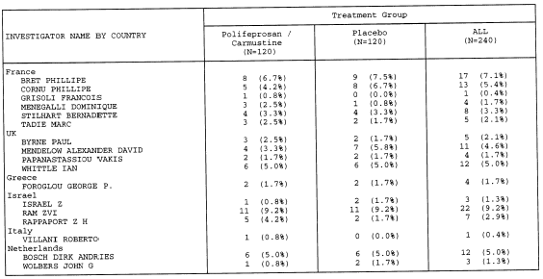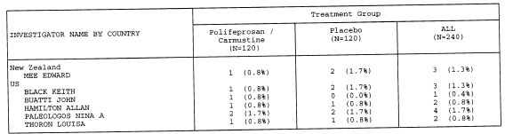

Ref: Appendix II.F

- Baseline Demographics:

Sponsor Table 6 presents demographics by study arm. The majority of patients were male, ranging from 63% to 70% in the ITT population and 64% to 69% in the GBM subgroup. All but 8 patients in the ITT and 6 in the GBM population were caucasian. Age ranged from 21 to 72, with a mean of 53 in the ITT population in the GLIADEL group and of 54 years in the placebo group. In the GBM subgroup a mean age for both treatment group was 54 years.

Sponsor Table 6: Summary of Demography
Characteristic | Overall (N = 240) |  | GBM Subgroup (N = 207)
Characteristic | GLIADEL  (N = 120) | Placebo  (N = 120) | GLIADEL  (N = 101) | Placebo  (N = 106)
Sex  Male N (%)  Female N (%) | 76 (63.3)  44 (36.7) | 84 (70.0)  36 (30.0) | 65 (64.4)  36 (35.6) | 73 (68.9)  33 (31.1)
Race  Caucasian N (%)  Black N (%)  Oriental N (%)  Hispanic N (%)  Other N (%) | 116 (96.7)  1 (0.8)  1 (0.8)  1 (0.8)  1 (0.8) | 116 (96.7)  1 (0.8)  1 (0.8)  0  2 (1.7) | 97 (96.0)  1 (1.0)  1 (1.0)  1 (1.0)  1 (1.0) | 103 (97.2)  0  1 (0.9)  0  1 (1.9)
Age (years)  Mean (SEM)  Range | 52.6 (0.8)  21–72 | 53.6 (0.8)  30-67 | 53.5 (0.84)  28-72 | 54.2 (0.78)  30-65
Ref: Final Study Report, p. 53

Age is also displayed by decade in Reviewer Table 4. No significant imbalances between the treatment arms are noted in either the ITT population or the GBM subgroup.

Reviewer Table 4: Age Distribution by Decades and Treatment Group
 | Overall Population |  | GBM Population
Age Groups | GLIADEL  N=120 (%) | Placebo  N=120 (%) | GLIADEL  N=101(%) | Placebo  N=106
21-39 | 12 (10) | 8 (7) | 7 (7) | 5 (5)
40-49 | 25 (21) | 27 (22) | 23 (23) | 23 (22)
50-59 | 49 (41) | 49 (41) | 40 (40) | 43 (41)
60-65 | 32 (27) | 35 (29) | 29 (29) | 35 (33)
>65 | 2 (2) | 1 (1) | 2 (2) | 0

- KPS:

Sponsor Table 17 presents baseline KPS scores in the ITT population and GBM subgroup by treatment arm. The KPS score was comparable between the two treatment groups at baseline for the ITT. In the GBM subgroup, slightly more patients in the placebo group (57 patients) compared to the GLIADEL group (46 patients) had a KPS score of 90 or more.

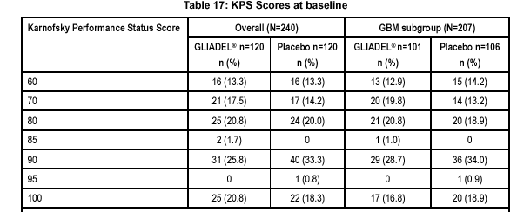
Ref: Table 2.01, Appendix II.F

- Tumor Size and Extent of Resection

Assessment of baseline tumor size is presented in two ways: (a) pre-operative imaging studies (length and width; planar volume is not presented because of 77% and 73% missing data on GLIADEL and placebo, respectively); and (b) assessment at time of surgery. Extent of resection is also presented in two ways: (a) type of surgery; and (b) percent of tumor resected.

Reviewer Table 5: Tumor Size and Extent of Resection
 | Overall Population |  | GBM Subgroup
 | GLIADEL  N=120 | Placebo  N=120 | GLIADEL  N=101 | Placebo  N=106
IMAGING DATA
Planar Size (Length)  N  Missing  Mean  SEM  Median  Range | 114  6  4.73  0.126  4.70  1.8, 9.0 | 111  9  4.47  0.143  4.00  1.2, 9.0 | 97  4  4.68  0.136  4.70  1.8, 9.0 | 97  9  4.42  0.152  4.00  1.2, 9.0
Planar Size (Width)  N  Missing  Mean  SEM  Median  Range | 114  6  4.12  0.109  4.00  1.7, 7.0 | 111  9  4.04  0.121  4.00  1.5, 7.5 | 97  4  4.14  0.117  4.00  1.7, 7.0 | 97  9  4.00  0.124  4.00  1.5, 7.2
SURGICAL DATA
Surgical Estimate of Tumor Volume (cm³)  Mean (SEM)  Range | 66.8 (5.9)  0.1-250.0 | 50.8 (5.3)  0.6-240.0 | 67.2 (6.5)  0.1-250.0 | 53.4 (5.9)  0.6-240.0
Type Resection  Subtotal  Total  Total + Lobectomy  Missing | 62 (51.7)  56 (46.7)  2 (1.7)  0 | 66 (55.0)  49 (40.8)  4 (3.3)  1 (0.8) | 51 (50.5)  48 (47.5)  2 (2.0)  0 | 56 (52.8)  46 (43.4)  4 (3.8)  0
% Resected  Mean (SEM)  Range  Missing | 89.9 (1.3)  21-100  5 (4.2) | 88.3 (1.6)  14-100  11 (9.2) | 90.1 (1.5)  21-100  4 (4.0) | 89.5 (1.5)  14-100  9 (8.5)
Ref: Sponsor Tables 9, 12 and 2.05

Reviewer Comment: If complete resection is redefined by pairing two datasets, i.e., requiring extent of resection as total or total + lobectomy and 100% resection, the absolute number of patients with a complete resection falls to 45 (37.5%) on GLIADEL and 38 (31.6%) on placebo. The relative difference between the arms, however, remains the same with an approximate 4-6% advantage to the GLIADEL arm.

- Tumor Histology:

Institutional diagnoses were reviewed by a central pathologist blinded to treatment. Disagreements were forwarded to a referee neuropathologist, whose interpretation was final. Patients with a diagnosis of giant cell glioblastoma and gliosarcoma were included in the GBM subgroup. The most common tumor type was GBM:101 (84.2%) patients in the GLIADEL arm and 106 (88.3%) patients in the placebo group. The classification system is the World Health Organization Grading System.

Reviewer Table 6: Tumor Characteristics – Histological Type
 | Treatment group
 | GLIADEL® N=120 | Placebo  N=120
Glioblastoma multiforme | 101 | 106
Non-GBM  Anaplastic oligodendroglioma | 6 | 5
Anaplastic oligoastrocytoma | 8 | 3
Anaplastic astrocytoma | 1 | 2
Metastasis/Brain Metastasis | 2 | 1
Other | 2 | 3
TOTAL | 120 | 120

Reviewer comment: Histology was verified by review of electronic database UPAT – description and disposition of patients, variables L_DIAGH – local histological diagnosis, C_DIAGN – central histological diagnosis, R_DIAGH – referee histological diagnosis. This table differs from Sponsor Table 11 in Sponsor’s Briefing Document in one respect – Sponsor agrees with FDA that one patient previously categorized as” other” should be reclassified as anaplastic oligoastrocytoma.

B.3. Protocol Treatment

- Wafer Implantation

Patients could receive up to eight wafers following maximal resection of tumor. Sponsor Table 41 presents the number of wafers implanted in the ITT population and the GBM subgroup. Approximately a third of patients received the maximum number of wafers.

Sponsor Table 41: Number of Wafers Implanted

Number of wafers  Implanted | Overall (N=240) |  | GBM subgroup (N=207)
Number of wafers  Implanted | GLIADEL® n=120  n (%) | Placebo n=120  n (%) | GLIADEL® n=101  n (%) | Placebo n=106  n (%)
8 | 44 (36.7) | 47 (39.2) | 35 (34.7) | 42 (39.6)
7.5 | 2 (1.7) | 0 | 1 (1.0) | 0
7 | 21 (17.5) | 28 (23.3) | 18 (17.8) | 25 (23.6)
6.5 | 1 (0.8) | 1 (0.8) | 1 (1.0) | 1 (0.9)
6 | 26 (21.7) | 16 (13.3) | 24 (23.8) | 14 (13.2)
<6 | 26 (21.7) | 28 (23.3) | 22 (21.8) | 24 (22.6)
The protocol permitted the use of wafers that had broken in half (either on opening the treatment box or during surgery), while those broken in more than 2 pieces were to be discarded in a biohazard container. As seen in Sponsor Table 42, GLIADEL wafers were broken at time of surgery for 56 patients (46.6%). For 19.2% of patients, the wafers were broken into more than 2 pieces and were to be discarded.

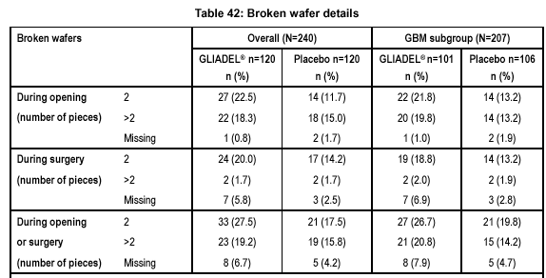
- Concomitant Medications

Corticosteroids and anticonvulants were the most commonly prescribed medication after wafer implantation. Sponsor Table 1.09 provides data on the use of concomitant medications during the study.

Sponsor Table 1.09: Summary of Patients with Concomittant Corticosteroids or Anticonvulsants Overall and by Histological Subtype and Treatment Group

 | Overall |  | GBM
 | GLIADEL  N=120 | Placebo  N=120 | GLIADEL  N=101 | Placebo  N=106
No. of Patients  Without Concomitant Rx  With Concomitant Rx | 71 (59.2%)  49 (40.8%) | 70 (58.3%)  50 (41.7%) | 59 (58.4%)  42 (41.6%) | 60 (56.6%)  46 (43.4%)
Concomitant Medication  Corticosteroid  Anticonvulsant | 29 (59.2%)  12 (24.5%) | 30 (60.0%)  5 (10.0%) | 26 (61.9%)  9 (21.4%) | 26 (56.5%)  5 (10.9%)

There were no differences between the treatment arms with respect to number of patients who received corticosteroids (59.2% in the GLIADEL group and 60% in the placebo group); however patients in the GLIADEL group were treated with anticonvulsants more frequently than patients from the placebo group (24.5% and 10.0% respectively).

- Radiation Therapy

Per protocol, patients were to receive radiation therapy between postsurgical day 14 and 30 to a total dose between 55 and 60 Gy to the tumor site and surrounding margins. See Appendix 1 for details of the radiation protocol. Sponsor Table 20 presents actual radiotherapy delivered.

Sponsor Table 20: Summary of Patients Receiving Radiotherapy During the Study

Radiotherapy Received | Overall (N=240) |  | GBM (N=207)
 | GLIADEL (N=120)  n (%) | Placebo (N=120)  n (%) | GLIADEL  (N=101)  n (%) | Placebo (N=106)  n (%)
No Radiotherapy | 11 (9.2) | 9 (7.5) | 10 (9.9) | 7 (6.6)
Standard Course of Radiotherapy | 93 (77.5) | 98 (81.7) | 80 (79.2) | 88 (83.0)
Non-standard Radiotherapy | 13 (10.8) | 8 (6.7) | 8 (7.9) | 6 (5.7)
Standard and Non-standard Radiotherapy | 3 (2.5) | 5 (4.2) | 3 (3.0) | 5 (4.7)
TOTAL | 120 | 120 | 101 | 106

Reviewer comment: Review of the electronic database confirms the number of patients who received standard XRT. However, the electronic database indicate that 6 additional patients did not receive radiation therapy: 4 patients treated with GLIADEL and 2 patients on placebo. The Sponsor has counted these patients in the category of “non-standard radiotherapy.” The total FDA count of patients who did not receive RT in the ITT population is 15 (12.5%) treated with GLIADEL and 11(9.2%) treated with placebo. Accordingly, the number of patients who received “non-standard” radiotherapy by reviewer count is 9 and 6 patients for the GLIADEL and placebo respectively, which differs from the sponsor’s data (13 and 8).

Non-standard radiotherapy is defined in Sponsor Table 21 below for all 29 patients (16 from the GLIADEL group and 13 from placebo).

Sponsor Table 21: Reasons for Patients Receiving Non-standard Radiotherapy

Reason for non-standard RT | GLIADEL | Placebo
No reason given | 4 | 6
Not well enough/deterioration/PD | 4 | 3
Lack of specialized equipment | 2 | 2
RT outside timeframe/after chemorx | 3 | 0
Metastasis | 0 | 1
RT at another institution | 2 | 1
Tumors located in multiple sites | 1 | 0
Pt also had spinat RT due to dx of primitive neuroectodermal tumor | 1 | 0
Tumor type dx anaplastic oligodendroglioma | 1 | 0

Reviewer comment: Review of electronic database URAD – radiotherapy, variables CM_RAD – non-standard radiotherapy, RAD – radiotherapy used, I_RADSR – date start reveals that a total of 6 had more than one record in the database. This can explain the difference between the Sponsor and reviewer data (by reviewer count a total of 23 patients on this study received non-standard radiotherapy). The Sponsor data shows 29 patients who received non-standard RT.

B.4 Additional Treatment

- Reoperation

Post-study treatments that could potentially confound results were examined. Treatment modalities for the patients in this study include: reoperation, chemotherapy, gamma knife surgery, radiation therapy, GLIADEL wafer re-implantation, or some combination of them.

Sponsor’s Table 23 shows a summary of patients who had additional surgical procedures for disease progression, as well as for the postsurgical complications after initial wafer implantation.

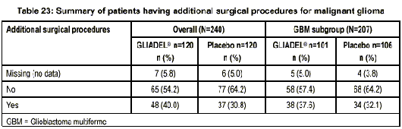

Reviewer Comment: The number of patients who underwent additional surgery for disease progression, as well as for the postsurgical complication, was confirmed by analysis of the electronic database USURG – surgery, variable ASURGY – additional surgery, CM_SURG – reason.

- Chemotherapy

The protocol states that patients with the pathological diagnosis of anaplastic oligodendroglioma will receive chemotherapy after initial surgery while others may receive chemotherapy at time of disease progression. Sponsor Table 22 summarizes the number of patients who received chemotherapy in the ITT population and GBM subgroup by treatment arm.

Sponsor Table 22: Summary of Patients Receiving Systemic Chemotherapy
for Malignant Glioma

Systemic Chemorx | Overall (N=240) |  | GBM subgroup (N=207)
Systemic Chemorx | GLIADEL N=120  N(%) | Placebo N=120  N(%) | GLIADEL N=101  N(%) | Placebo N=106  N(%)
No | 103 (85.8) | 108 (90.0) | 91 (90.1) | 99 (93.4)
Yes | 17 (14.2) | 12 (10.0) | 10 (9.9) | 7 (6.6)

Reviewer Comment: Analysis of the electronic database UMND – medication and non-drug therapy, variables – DRUGSY – medication, CHEMO – chemotherapy, as well as CRF’s reveal that 13 patients in the GLIADEL group and 11 in placebo were treated with chemotherapy at the time of the disease progression.
Review of the electronic database UMND – medication and non-drug therapy, variables – DRUGSY – medication, CHEMO – chemotherapy, as well as CRF’s, reveal patients who received chemotherapy within 30 days of randomization. Details are presented in reviewer Table 7 below.
Reviewer Table 7: Chemotherapy within 30 days of randomization.
 | Treatment group
 | GLIADEL | PLACEBO
Anaplastic oligodendroglioma | 2/6 | 2/5
Anaplastic oligoastrocytoma | 3/8 | 1/3

Reviewer comment: It was noted that of the 6 patients in the GLIADEl group with the final diagnosis of anaplastic oligodendroglioma only 2 patients received chemotherapy, and in the placebo group, only 2 of 5 patients were treated with chemotherapy. However, 4 patients (3 in the GLIADEL and 1 in placebo) with pathological diagnosis of anaplastic oligoastrocytoma received systemic chemotherapy after the wafer implantation.

- Other Treatments

At the time of the disease progression, four patients, all in the GLIADEL group, received treatments other than systemic chemotherapy. They included tumor resection with GLIADEL wafer reimplantation in 2 patients, brachytherapy in 1 patient and stereotactic radiosurgery in 1 patient.

C. Efficacy Results

Primary Efficacy Endpoint: Overall Survival (unadjusted) in the ITT.

The primary efficacy endpoint for this study was overall survival. Survival time is defined in the protocol as time from the date of randomization to the last day of follow up or the date of death. Per protocol and SAP, “The survival curve will be estimated for each treatment group using the Kaplan-Meier method.” The survival curves were to be compared by the logrank test. The Sponsor’s results are summarized in Reviewer
Table 8. The logrank analysis is stratified by country.

Reviewer comment: FDA requested and reviewed randomization codes for Study T-301. The FDA and the Sponsor reached an agreement that the randomization was stratified by center.

A total of 88 patients (73.3%) in the GLIADEL group and 93 patients (77.5%) in the placebo group died before the study cut-off date.

Reviewer Table 8: Sponsor’s Analysis for Overall Survival (ITT analysis)

ITT Population  N=240 | Median (95%CI)  (Month) | Hazard Ratio | 95% CI for Hazard Ratio | Log-rank P-value
GLIADEL  (88/120) | 13.9 (12.1-15.3) | 0.711 | 0.53-0.96
Placebo  (93/120) | 11.6 (10.2-12.6) |  |  | 0.027*
*Based on Sponsor’s logrank stratified by country.

Reviewer Table 9: FDA’s Analysis for Overall Survival (ITT analysis)

ITT Population  N=240 | Median (95%CI)  (Month) | Hazard Ratio | 95% CI for Hazard Ratio | P-value
GLIADEL  (88/120) | 13.9 (12.1-15.3) | 0.77 | 0.574-1.032 | 0.08**
Placebo  (93/120) | 11.6 (10.2-12.6) |  |  | 0.078*
*Based on non-stratified log-rank test.
** Wald test for HR.

Reviewer comment: Median survival and hazard ratios favored the GLIADEL arm, but did not reach significance in the protocol-specified analysis.
Reviewer Figure 1: Kaplan-Meier Survival Curves for Study T301
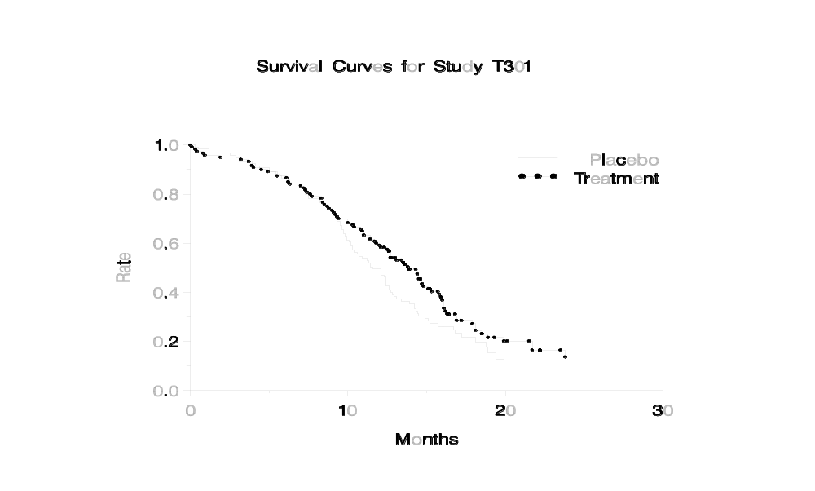

Reviewer Comment: The effect of stratifying for known and presecified prognostic factors in this disease and by center is shown in Reviewer Table 10 below. The statistical significance does not improve, in fact moves in the opposite direction, when stratified by accepted prognostic factors.

Reviewer Table 10: FDA Analysis of Overall Survival (ITT analysis) using different stratification variables*
ITT Population  N=240 | p-value  Stratified by  Country | p-value Stratified by Center | p-value  Stratified by  GBM/Other | p-value Stratified by  KPS | p-value Stratified by  Age
GLIADEL  (88/120) | 0.03 | 0.07 | 0.14 | 0.67 | 0.103
Placebo
(93/120)
*The p-value for the overall survival without stratification is 0.078

Reviewer Comment: The sample size was based upon a projected 68% one-year survival in the treatment group. However, the observed one-year survival for the treatment group is 59.2% (hazard rate of 0.044). The current power is only about 46%. Even if the data provides 100% events, the power would increase only to 57%.

- Subgroup Analysis: Survival in the GBM Group

Although median survival was longer in the GLIADEL group (13.5 months) than in placebo group (11.4 months), the Kaplan-Meier estimates compared using a stratified logrank test did not reach statistical significance (p=0.098).

Reviewer Table 11 summarizes the FDA’s survival analysis for the subgroup of patients with GBM. Figure 2 presents the K-M curves for the same subpopulation. The sponsor provided an analysis that was based upon an analysis stratified by country, which gave
a p-value of 0.10.
Reviewer Table 11: FDA’s Analysis for Overall Survival for GBM subgroup*
ITT Population  N=207 | Median (95%CI)  (Month) | Hazard Ratio | 95.6% CI for Hazard Ratio | P-value
GLIADEL 78%  (79/101) | 13.5 (11.4-14.8) | 0.82 | 0.601-1.113
Placebo 80%  (85/106) | 11.4 (10.2-12.6) |  |  | 0.20*
*Based on protocol specified non-stratified log-rank test.

Figure 2. Kaplan-Meier Survival Curves for Study T301 GBM subgroup

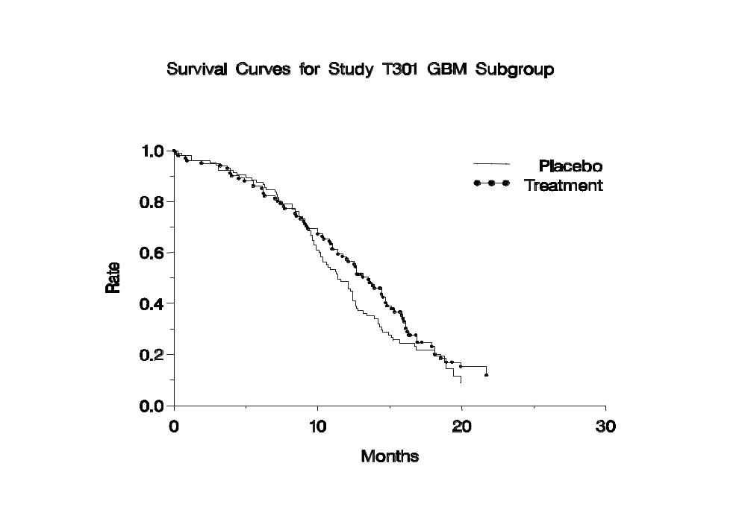
- Effect of Prognostic Factors on Survival

The accepted prognostic factors in this disease are age, KPS and histology, were prespecified, along with country, as being of interest in exploratory analyses. Reviewer Table 12 presents the effect of these factors on overall survival in the ITT population. Analyses are performed for the factors individually and together. Age is analyzed as a continuous variable; KPS as < 70 vs. > 70; histology as GBM vs. other. In a non-stratified test, none of the factors individually or together reach statistical significance. KPS exerts the strongest effect.

Reviewer Table 12: ITT Analyses for Survival Using Cox Model*
Covariates | Non-stratified test | Stratified by Center** | Stratified by Country
Treatment only | 0.08 | 0.07 | 0.03
Trt+Age | 0.20 | 0.17 | 0.12
Trt+KPS | 0.06 | 0.05 | 0.02
Trt+GBM | 0.12 | 0.14 | 0.05
Trt+Age+PSK  Trt+Age+GBM  Trt+PSK+GBM | 0.15  0.23  0.08 | 0.12  0.23  0.08 | 0.09  0.14  0.03
Trt+Age+PSK+GBM | 0.16 | 0.16 | 0.10
- p-values for the treatment effect.
**randomization was stratified by Center

Reviewer Table 13 presents the effect of prognostic factors on overall survival in the GBM population. Again KPS exerts the strongest influence (< 70% vs. >70%) but just reaches significance only if the logrank is stratified by country.

Reviewer Table 13: GBM Subgroup Analyses for Survival Using Cox Model*
Covariates | Non-stratified test | Stratified by Center** | Stratified by Country
Treatment only | 0.20 | 0.16 | 0.10
Trt +Age | 0.32 | 0.24 | 0.18
Trt+KPS | 0.12 | 0.09 | 0.055
Trt+Age+PSK | 0.22 | 0.15 | 0.11
- p-values for the treatment effect.
**randomization was stratified by Center

One-Year Survival

One-year survival was pre-specified as a secondary endpoint for both the ITT and GBM populations. A 10% difference in one-year survival is noted in both populations; however, confidence limits overlap. The difference in 1 year survival between the treatment groups in the ITT population as well as in the GBM subgroup does not show statistically significant difference even using the stratified log-rank test (p= 0.108 and p=0.26) for the ITT and GBM population, respectively.

Reviewer Table 14: One Year Survival
One Year Survival | ITT |  | GBM
One Year Survival | GLIADEL | Placebo | GLIADEL | Placebo
% | 59.2% | 49.6% | 57.4% | 48.6%
95% CI | 50.4, 68.0 | 40.6, 58.6 | 47.8, 67.1 | 39.0, 58.1
Ref: Sponsor Table 27 and 30

Progression-free survival

Sponsor’s data does not show difference between the two treatment group in the progression-free survival (p=0.901) in the stratified log-rank test.

Reviewer Comment: Further analysis by the FDA was not undertaken. The difficulty in assessing tumor size, and therefore progression, in the setting of post-operative and post-radiation changes, further confounded by edema and treatment with steroids is recognized.

- Karnofsky Performance Status

The KPS score was comparable between the two treatment groups at baseline for the ITT. In the GBM subgroup, slightly more patients in the placebo group (57 patients – 53.8%) compared to the GLIADEL group (46 patients – 45.5%) had a KPS score of 90 or more.

The Sponsor states that the median time to performance status deterioration in the ITT population was slightly longer in the GLIADEL group compared to placebo: 11.9 months (95% CI 10.4-13.7) in the GLIADEL group and 10.4 months (95% CI 9.5-11.9) in the placebo using a logrank stratified by country (p=0.05).
The Sponsor states that median time to performance status deterioration between the treatment arms in the GBM subgroup was not statisticaly significant (p=0.189, stratified log-rank test).
Reviewer comment: Karnofsky Performance Status deterioration was one of three QoL measures prespecified in the protocol. The FDA analysis of KPS shows that this prognostic factor did not reach statistical significance in a non-stratified logrank test p=0.11). KPS deterioration becomes statistically significant only if the logrank is stratified by country (p=0.05), but not center (0.27).

Quality of Life Assessment.

QoL was assessed by the Sponsor by EORTC and QoL Questionnaire-30 and Brain Cancer Module, a validated 24-questions QoL instrument designed to be used with QoL-30. The primary QoL parameter prespecified in the protocol was the Global Health Status/QoL based upon Questions #29 and #30.

The results of the analysis provided by the Sponsor did not show significant differences between two treatment groups.

Reviewer comment: In the FDA analysis no significant differences was shown between two treatment groups in this secondary endpoint in the protocol prespecified unadjusted logrank test, as well as stratified by country or by center.

Neurological Evaluation.

The Sponsor defined the time to neuroperfomance deterioration as time from the date of randomization to the date of first neuroperfomance measure. The Sponsor claims that in the ITT population as well as in the GBM subgroup the time to neuroperfomance deterioration in the GLIADEL group was longer and reached statistical significance
(p< 0.05, stratified log-rank test) in both groups. The exception was visual status that did not show statistical significance either for the ITT population group (p=0.087) nor for the GBM subgroup (p=0.269).

Reviewer comment: The comparison for the 11 neuroperformance measures is not adjusted for multiple comparisons and therefore prevents any conclusion.

VII Review of Safety

A. Extent of Exposure

All 240 patients from T-301 are evaluable for safety, 120 patients in each treatment group. Patients were evaluated on day 3, 7, and then weekly for 1 month, and at 3, 6, 12, 18 and 24 months from the day of randomization (initial surgery). Follow-up ranged from 12 months to 30 months. Forty-four patients (36.7%) in the GLIADEL group and 47 patients (39.2%) in the placebo group received the maximum of eight wafers implanted.

Deaths.
By the study cut-off date, 88 patients (73.3%) in the GLIADEL group and 93 patients (77.5%) in the placebo group died.

Sponsor Table #52 presents a summary of reasons for death.

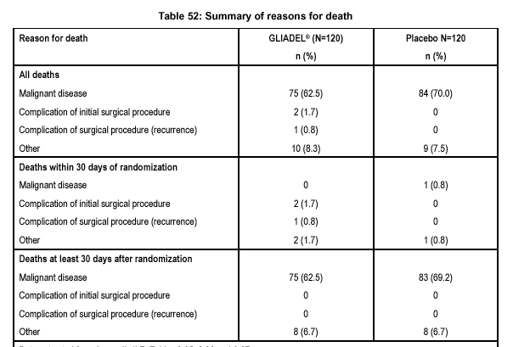
The primary cause of death was disease progression in both groups. Ten and 9 patients in the GLIADEL and placebo group, respectively, died of causes listed by the investigator as “other”. A detailed analysis of this category is as follows. The most frequent cause of death was pulmonary events: 5 patients in the GLIADEL group and 2 in the placebo group died from pulmonary embolism, 2 patients in each group died from pneumonia, and 1 patient in the GLIADEL group died of pneumothorax. Acute cardiac events caused death in one patient from each group. In the placebo group 2 patients died from the neurological complications (one patients was listed as having “progressive neurological deficit” and the other died of seizures). One patient in the placebo group committed suicide and one died of sepsis. One patient in the GLIADEL died of tumor progression (listed under “other”, per investigator).

Reviewer comment: All causes of death listed as “other” were verified by review of the CRFs.

Deaths in the first 30 days of randomization

Five patients (4.2%) in the GLIADEL group and two patients (1.7%) in the placebo group died within 30 days of randomization.

Reviewer comment: Review of database UPAT – Description and Disposition of Patients confirms the total number of deaths as well as the number of patients of the listing who died in the first 30 days of initial surgery (randomization).

Reviewer Table 15: Reasons for Death in the First 30 days of Randomization
Cause of deaths | Total number of patients
Cause of deaths | GLIADEL (N=120) | Placebo (N=120)
Cerebral hematoma+/- edema | 3 | 0
Pulmonary embolism | 1 | 0
Acute abdominal or coron. Event | 1 | 0
Sepsis | 0 | 1
Malignant disease | 0 | 1
TOTAL | 5 | 2

Ref: “Death Report Form” of CRF.

Discontinuation due to Adverse Events.

One patient (ID 01056) was discontinued from the study due to an adverse event, brain edema, on postoperative Day 5. Her condition improved on Day 6, but subsequently the patient deteriorated, and was discontinued from the study on Day 22 due to the severe confusion and aphasia.

Wafer Removal

In the study design section of the protocol, the sponsor states that “the wafers begin to degrade following intracerebral implantation”. The clinical pharmacology section of the GLIADEL label states that “although the rate of biodegradation varies from patient to patient, more than 70% of the copolymer degrades by three weeks”. Data obtained at the re-operations and autopsies, from the randomized trial supporting the approval in the recurrent GBM patients showed wafer remnants up to 232 days after GLIADEL implantation.

Reviewer Table 16 summarizes reasons for additional surgeries during which wafers were detected and removed.

Reviewer Table 16: Indication for Additional Surgeries during which Wafers were Detected and Removed.
 | GLIADEL (N=120) | Placebo (N=120)
Complications  first 30 days  30 – 80 days | 4  2 | 3  1
Tumor progression | 11 | 11
TOTAL | 17 (14.4%) | 15 (12.5%)

A total of 32 patients (17 in the GLIADEL arm and 15 in the placebo arm) had wafer removed at the time of additional surgery. The majority of patients (23 patients from both groups) underwent total wafer removal while 9 patients had partial wafer removal.

Reviewer comment: The list of patients who underwent wafer removal due to an early adverse event is presented below.

GLIADEL group:

- Patients 01293 – on post-operative Day 0 developed hematoma and underwent reopening craniotomy with subsequent wafer removal.
- Patient 02059 – on post-operative Day 19, developed a brain abscess, had reopening craniotomy and wafer removal.
- Patient 01056 (the one patient –listed by the sponsor) – had reoperation on Day 4 due to the brain edema.
- Patient 01138 – underwent recraniotomy with wafer removal on Day 22 for cyst formation.

Placebo group:

- Patients 01081 – developed brain edema on Day 22 after the initial surgery, underwent reoperation and wafers were removed.
- Patient 01137 – on the postoperative Day 13, developed abscess, underwent reoperation with wafer removal.
- Patient 01153 – on the postoperative Day 4, underwent reoperation with wafer removal because of the ventricular obstruction by a cyst.

Wafer remnants were present up to 392 days in the GLIADEL group (derived from data base USURG –Surgery, variables ASURGNY – additional surgery, USMA – Study Medication Administration, variable WAFREM – wafer removal, and NBD_WREM – number of days from randomization to wafer removal).

Reviewer comment: Since treatment is not ongoing, the category of treatment withdrawal or discontinuation is open to interpretation. The reviewer considered that reoperation for a complication during which the surgeon also removed the wafers might qualify. Of the 32 cases (17 in the GLIADEL group and 15 in the placebo) with an indication for surgery that could be interpreted as for complication, 7 patients (4 from the GLIADEL group and 3 from the placebo group), had additional surgeries in the first 30 days of randomization, i.e., perioperatively.

F. Treatment-emergent adverse events (AE)

Treatment-emergent adverse events were identified by the sponsor as “signs and symptoms that were not present at baseline, or that were present at baseline but increased in severity during the course of the study. Intercurrent illnesses or injuries should be regarded as adverse events”. In addition to an open ended form by any AE, specific Aes, as described below, were also collected.

AE form AE7-12 requested details about the following 20 events: fever in the absence of infection, pain body whole, infection, thrombophlebitis deep, pulmonary embolus, nausea, vomiting, healing abnormality, aphasia, edema brain, confusion, convulsions, headache, hemiplegia, meningitis, intracranial abscess, hydrocephalus, anemia, leucopenia and thrombocytopenia.

If “healing abnormality” was checked on form AE7-12, another checklist was to be completed identifying type of abnormality: (a) fluid, CSF or subdural collections; (b) CSF leaks; (c) wound dehiscence, breakdown or poor healing; and (d) subgaleal or wound effusions.

Events defined as serious (fatal, life-threatening, requiring prolongation of hospitalization or resulting in persistent or significant disability) were reported on the Serious AE Query Form. All convulsions were to be reported as serious events.

The incidence of common Aes defined as occurring in >5% and irrespective of causality is shown in Sponsor Table 46.

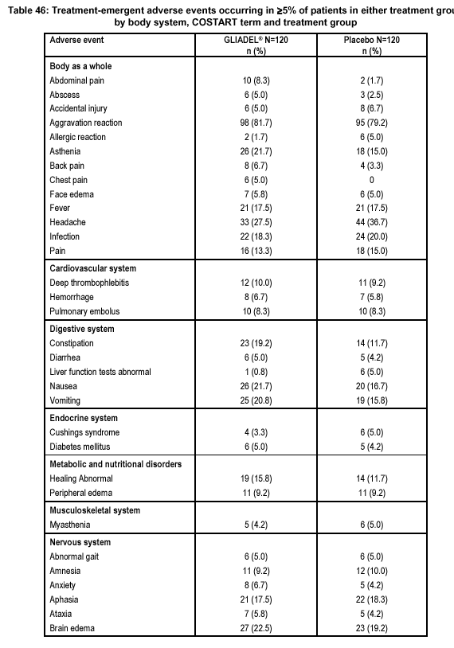

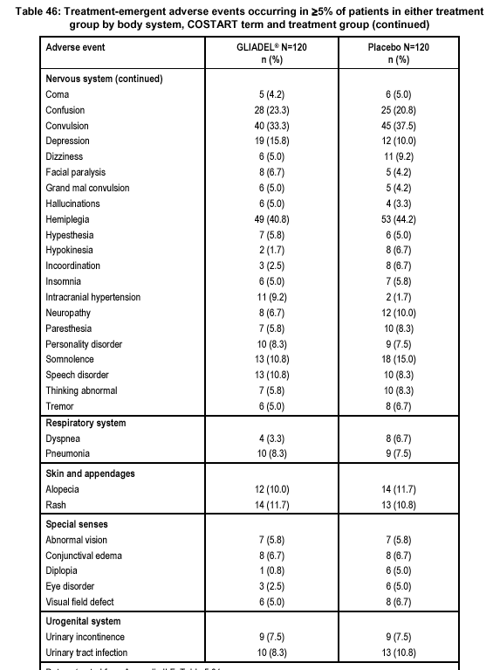
The most common Aes are related to the nervous system. Hematologic abnormalities, as seen with systemic BCNU, occurred in <5% of patients and therefore are not included. The overall incidence of nausea and vomiting, also seen with systemic BCNU, appear more common in patients treated with GLIADEL; however, similar numbers (7 on GLIADEL and 6 on placebo) were considered severe or life-threatening.
- Serious Adverse Events (SAEs)

The incidence of common Serious Adverse Events by body system is presented in sponsor Table 55 (excluding nervous system).

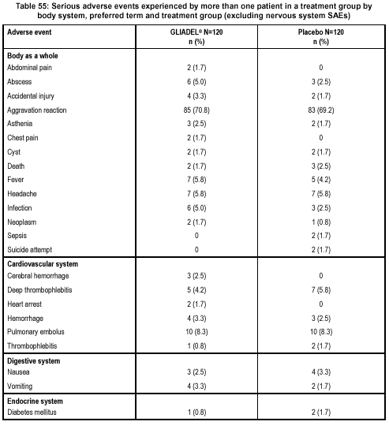
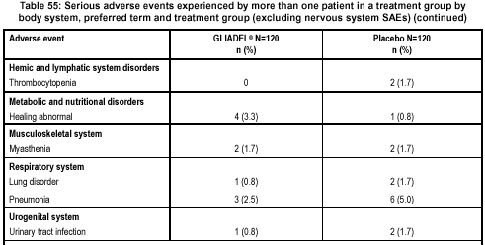
Sponsor Table 56 summarizes SAEs involving the nervous system.

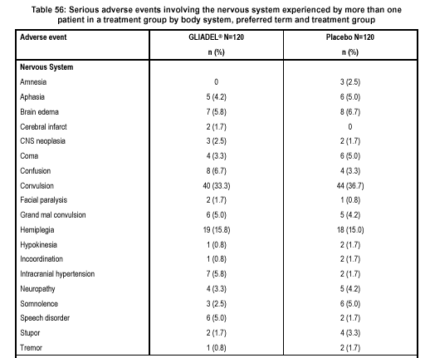

The most common serious adverse events noticed by the sponsor were “aggravation reaction” which occurred in 85 patients (70.8%) in the GLIADEL group and in 83 patients (69.2%) in the placebo group. This term, not used in the U.S., is described in Sponsor Table 45.

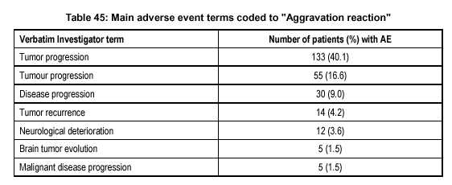
Reviewer comment: “Aggravation reaction” is a term, used in collecting data outside the US and is defined by the sponsor as “mainly tumor/disease progression or general deterioration of condition”.

Seizures

In this study seizures were the most common serious treatment-emergent adverse event involving nervous system. Reviewer Table 17 below presents the total incidence of seizures.

Reviewer Table 17: Convulsions in Patients in the ITT population
 | Treatment Group
 | GLIADEL N=120 (%) | Placebo N=120 (%)
New or worsening  Convulsions  Grand mal | 40 (33.3)  6 (5) | 45 (37.5)  5 (4.2)
TOTAL | 46 (38.3) | 50 (41.7)

Reviewer Comment: The number of patients sited by the Sponsor with seizures (grand mal and convulsions) were confirmed by the reviewer. Each patient was counted only once (derived from database UAE – adverse events, variables – D_AESR – onset date, AESERNY – serious, AECOSE – COSTART term).

In 10 patients in the GLIADEL group and 16 patients in the placebo group, convulsions occurred within the first 30 days of randomization (initial surgery).

Frequency and Distribution of Postoperative Seizures.

The incidence and distribution of postoperative seizures in both groups within the first 30 days of the wafer implantation, as well as at the later periods for up to 120 days after the initial surgery is presented in Reviewer Table 18.
Reviewer Table 18: Timeframe of Postoperative Seizures

Seizures | Treatment Group
Seizures | GLIADEL  N=120 (%)* | Placebo  N=120 (%)*
Reported at Baseline | 30 (25.0) | 28 (23.3)
First 30 Days  Patients  Events | 11 ( 9.1 )  24 ( 20.0 ) | 16 ( 13.3 )  45 ( 37.5 )
31-90 Days  Patients  Events | 12 ( 10 )  15 ( 12.5 ) | 7 ( 5.8 )  8 ( 6.6 )
91-120 Days  Patients  Events | 8 ( 6.6 )  8 ( 6.6 ) | 8 ( 6.6)  8 ( 6.6 )

* Each patient was counted only once.

Of the patients who developed seizures within the first 30 days, 6 patients in the GLIADEL group and 11 patients in the placebo group had seizures at baseline. Among the patients who had baseline seizures and postoperative seizures within the first 30 days, 5 of 6 in the GLIADEL group and 6 of 11 in the placebo group had multiple events (from 2 to 10).

Reviewer comment: The incidence of seizures within the first month of operation ranged from 9 to 13%. Although the frequency of postoperative seizures is reasonably balanced between the arms, the control arm is a placebo waver and may lead to underestimation of related seizures. A literature search was conducted to assess this possibility – see Section I on page 55.

G. Healing Abnormalities Checklist

The adverse events coded as “healing abnormalities” consisted of 4 categories: (1) fluid, CSF or subdural collection, (2) CSF leaks, (3) wound dehiscence, breakdown or poor wound healing, and (4) subgaleal or wound effusion.

Sponsor Table #50 summarizes the patients with healing abnormalities.

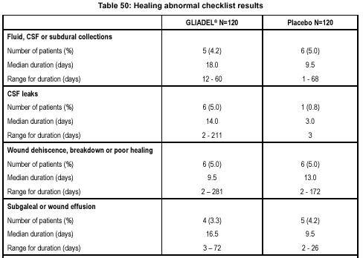
A total of 33 patients (18 and 15 in the GLIADEL and placebo group, respectively) had abnormal wound healing recorded on their checklist. Sponsor notes that patients treated with GLIADEL have an increased incidence of CSF leaks as well as a greater duration of the complications of fluid collections, CSF leaks and effusion at the wound site.

H. Additional Local Adverse Events.

Additional local adverse events from the database UPAT – Description and Disposition of Patients, UAE – Adverse Events, and USURG – Surgery) are presented in the Reviewer Table 19 below.
Reviewer Table 19: Additional Local Treatment-Emergent Adverse Events
Adverse Event | Treatment Group
Adverse Event | GLIADEL  N=120 (%) | Placebo  N=120 (%)
Cerebral hemorrhage | 8 (6) | 5 (4)
Brain cyst | 2 (1.7) | 3 (2.5)
Brain abscess | 8( 6) | 8 (6)
Intracranial hypertension | 11 (9) | 2 (1.7)
Cerebral edema | 27 (22.5) | 23 (19.2)

Reviewer comment: We confirmed the data presented by the Sponsor on the number of patients with local complications such as cerebral hemorrhages, intracranial hypertension and brain edema (by queries to the electronic database UAE – adverse events, variables AESERNY – serious, D_AESR – onset date; USURG – surgery, variables ASURGNY – additional surgical procedure). The number of patients with brain abscess and cysts differs in Sponsors and reviewer assessment. These differences are explained below.

*One patient, ID 01209 from the placebo group, was included by the sponsor only in the listing of patients who underwent an additional surgical procedure (Table 1.06). However, this patient had additional surgery on day 14 after the initial surgery due to the brain cyst formation that caused midline shift, confusion and urinary incontinence. Therefore this patient was included by the reviewer in the category of treatment-emergent AE.

Brain abscess in 3 patients (2 from the GLIADEL and 1 from the placebo group) were counted by the sponsor as “wound infection”. Reviewer included these patients in the category “brain abscess” because of the information extracted from CRF’s:

GLIADEL group:

- Patient ID 01085 – on postoperative day 14, patient developed a complication that was captured as “wound infection”. On day 15, patient underwent exploratory craniotomy and was diagnosed with a brain abscess.
- Patient ID 02059 – on postoperative day 12, patient developed a complication that was captured as “wound infection”. On day 19, patient underwent re-craniotomy and was diagnosed with a brain abscess.

Placebo group:

- Patient ID 01036 – on postoperative day 36, the patient showed evidence of clinical deterioration and the next day underwent re-craniotomy with surgical resection of a brain abscess.

FDA requested information from the Sponsor regarding type of pathogens isolated from patients who developed brain abscesses/wound infections. Since the study protocol did not require the collection of information on pathogens from patients with these AEs, this information was collected at the discretion of the investigator and information is not available for all patients. The following is a listing of the available information.

GLIADEL group: Propionobacterium acne was identified in 5 of 8 patients with brain abscesses or wound infection. For 3 patients in this group, no bacterial culture information is available.

Placebo group: Propionobacterium acne was identified in 1 of 8 patients. For the rest of the patients either no bacterial culture information was available or “event was coded Not Serious by the investigator, thus additional information was not collected.”

I. Literature Search

Reviewer comment: Although local complications appear to be balanced between both arms (exception of CSF leaks and duration of fluid collections) the control arm is a placebo wafer, an attempt was made to compare the results of local toxicity in T-301 with the data in the literature. Parameters for the literature search included: years searched: 1985 – present, patients with initially diagnosed malignant gliomas, and large studies (200 + patients) that included the multiinstitutional as well as foreign studies. The Reviewer Table 20 below presents local complications from T-301 and published literature.

Reviewer Table 20: Surgical Complications in Selected Series

Author/Year | Design¹ | Patients | Tumor | Postop. Seizures  (%) | Abscess  (%) | Hemorrhage/  Stroke  (%)
LEE  1990 | R | 321 | AA, M, mets | 1.8 | ? | ?
CABANTOG  1994 | R | 207 | GBM, AA | 1 | 1.9 | 1
SURI  1996 | R | 551 | GBM, AA | 5.9 | ? | ?
SAWAYA  1998 | P | 327 | GBM, AA, LGG | 2.5 | 1.5 | 0.5
BRELL  2000 | R | 200 | AA, GBM, M | 4 | 1.5 | 3
BUCKNER  2001 | P | 275 | AA, GBM | 2 | ? | ?
Sponsor  GLIADEL/  Placebo  (G/P) | P | 240 | GBM, AA | 9.2/13.3 | 3.3/1.7 | 5.0/2.5

¹ R = Retrospective; P = Prospective

Abbreviations: AA – anaplastic astrocytoma; GBM – glioblastoma multiforme; LGG – low grade glioma; M - medulloblastoma

Reviewer comment: The Table shows that the rate of local complications such as seizures, intracranial abscesses, and cerebral hemorrhages appear to be higher in patients in the current trial. However, the difference can be attributed to the different methodology of the AEs collecting in the presented selected series.

VIII. Conclusions and Recommendations

Study T-301 met most of the criteria for an adequate and well controlled study, e.g., statement of objectives, trial design, randomization, and method of assessment of the endpoints. Median survival in the ITT population for patients treated with GLIADEL was 13.9 months (12.1 – 15.3) and 11.6 months (10.2 – 12.6) for patients receiving placebo. Although median survival in the GBM subgroup was 13.5 months (11.4-14.8) in the GLIADEl group and 11.4 months (10.2-12.6) in placebo a stratified logrank test did not reach statistical significance.

The protocol identified the primary efficacy endpoint as survival in the ITT population assessed by logrank test. The protocol identified country as on of the potential covariates along with age, histological diagnosis, and KPS, and stated that the treatment effect “will be estimated using a model stratifying for this covariate.” This analysis was considered by the Sponsor as “supportive.” The treatment effect on survival in all patients with newly diagnosed malignant gliomas reached statistical significance only when stratified by country. The FDA and the Sponsor reached an agreement that the randomization was stratified by center. The effect of stratifying for center was not significant. We are concerned that bias was may be introduced with a retrospectively chosen modification of the analysis.

Subgroup analysis for the GBM population did not reach statistical significance in a
non-stratified or stratified logrank test. Other secondary endpoints such as one-year survival, progression-free survival, and QoL did not show significant differences. Only KPS deterioration becomes statistically significant in the logrank test stratified by country, but not by center. The strength of evidence lent by previous trials with GLIADEL in malignant gliomas will be a topic of the discussion with the Advisory Committee.

The toxicity profile of GLIADEL is consistent with a regional delivery of the drug at the time of operation. The primary toxicities were related to neurologic function (seizures, brain hemorrhages, brain cysts) and wound infection/brain abscesses. Increased incidence of CSF leaks and increased duration of fluid collection were noticed in the GLIADEL and placebo group, respectively. Risk/benefit ration will also be a topic of discussion for the Advisory Committee.

APPENDIX I: Protocol T-301 Details

Reviewer Table 21: Randomization List for US Sites

Pat ID | Arm | Date | Center | Block#
2005* | Placebo | 2/12/98 | US3096 | 2
2006 | Gliadel | 8/24/98 | US3096 | 2
2013* | Placebo | 6/25/98 | US4109 | 4
2014 | Gliadel | 10/28/98 | US4109 | 4
2021* | Placebo | 2/20/98 | US4110 | 6
2022 | Gliadel | 7/01/98 | US4110 | 6
2023 | Placebo | 8/25/98 | US4110 | 6
2024* | Gliadel | 1/30/98 | US4110 | 6
2026 | Placebo | 8/13/98 | US4288 | 7
2027 | Gliadel | 9/17/98 | US4288 | 7
2028 | Placebo | 12/01/98 | US4288 | 7
2029 | Gliadel | 2/01/99 | US4400 | 8

Reviewer comment: We reviewed the randomization codes and come to an agreement with the Sponsor that the randomization was stratified by center (not country). We can tell this by checking US patients in all 5 US sites. A fixed block size of 4 was used. If the country was the stratification factor, then the patients with similar randomization dates should be clustering together. For example, 4 patients entered the study in January and February: pt #2005, #2013, #2021, and #2024 should share the same block number.

Reviewer Table 22: Tumor Histology by Country
Country | GLIADEL |  |  |  |  |  | Placebo
Country | Histology* |  |  |  |  |  | Histology*
 | AA | AO | AOA | GBM | M/BM | Other | AA | AO | AOA | GBM | M/BM | Other
Austria |  |  |  | 3 |  |  |  |  |  | 4
Australia |  |  |  | 7 |  | 1 |  |  | 1 | 7 |  | 1
Belgium |  |  |  | 7 |  |  |  | 1 |  | 6
Switzerland |  | 2 |  | 3 |  |  |  |  |  | 4
Germany |  | 3 |  | 18 | 1 |  |  |  |  | 22
Spain |  |  |  | 2
France |  |  | 2 | 21 |  | 1 |  | 2 | 1 | 21
U.K. |  |  | 1 | 14 |  |  |  | 1 |  | 15 |  | 1
Greece |  |  |  | 2 |  |  |  |  | 1 | 1
Israel |  | 1 | 2 | 13 | 1 |  |  |  |  | 15
Italy |  |  |  | 1
Netherlands | 1 |  | 1 | 5 |  |  | 1 |  |  | 7
N. Zealand |  |  |  | 1 |  |  |  |  |  | 1 | 1
U.S. |  |  | 2 | 4 |  |  | 1 | 1 |  | 3 |  | 1
Total | 1 | 6 | 8 | 101 | 2 | 2 | 2 | 5 | 3 | 106 | 1 | 3
*AA-Anaplastic astrocytoma AO-Anaplastic oligodendroglioma AOA-Anaplastic oligoastrocytoma GBM-Glioblastoma multiforme M/BM-Metastasis/Brain Metastasis

RADIATION THERAPY PROTOCOL

1. General
Patients should be treated with involved/limited field radiotherapy to the planning target volume (PTV) including the tumour [gross tumour volume (GTV), clinical target volume (CTV)] and a defined margin with localized radiotherapy technique.

2. Patient positioning
Patients should be immobilized in an immobilization device in use in the radiation therapy center.

3. Volumes of treatment
3.1 Tumour volumes should be defined on the basis of preoperative imaging.
3.2 GTV should be defined as the region of enhancement presumed to represent tumour (on preoperative imaging –either CT or MRI). In unenhancing tumours GTV should be defined by the region of low density on CT of high signal intensity on T2 weighted MRI.
3.3 The definition of CTV is not mandatory and may include GTV plus 1 – 3 cm margin in 3 dimensions or the region of low signal intensity (CT)/high signal intensity (T2W MRI) in enhancing tumour, or other definition specific to the radiation therapy centre. Exception for the margin definition can be made for bone and meningeal structures which are considered anatomical barriers to tumour spread.
3.4 PTV definition may be related either to GTV or CTV.
Overall it is recommended that PTV is defined as GTV/CTV plus 2 – 5 cm margin in 3 dimensions as used in the radiation therapy center. Exception for the margin definition can be made for bone and meningeal structures which are considered anatomical barriers to tumour spread.
3.5 The radiation therapy may be carried out to a single PTV throughout or by a two phase technique reducing at 40 – 45 Gy to a smaller PTV.
3.6 It is recommended that the planning volumes are defined by each radiation therapy center prior to commencing the study.
4. Treatment planning.
4.1 Treatment planning should be performed on a planning computer and dose homogeneity within and coverage of the PTV should conform to the ICRU 50 criteria.
4.2 The aim of treatment planning is to minimize the amount of normal brain irradiated and minimize the dose to normal brain. Multiple field arrangements are preferred. Parallel opposed lateral field arrangements and whole brain radiotherapy should be avoided. The use of custom blocking is optional.
5. Dose fractionation
5.1 Dose should be prescribed according to the ICRU 50 criteria.
5.2 The total dose to the PTV should be 55 – 60 Gy in 30 – 33 daily fractions. All fields should be treated daily, Monday to Friday.
EORTC QLQ-C30

We are interested in some things about you and your health. Please answer all of the questions yourself by circling the number that best applies to you. There are no “right” or “wrong” answers. The information that you provide will remain strictly confidential.

Please fill in your initials : ____________________

Your birthdate (Day, Month, Year) : ____________________

Today’s date (Day, Month, Year) : ____________________

________________________________________________________________________
No Yes

1. Do you have any trouble doing strenuous activities, like carrying 1 2
a heavy shopping bag or a suitcase?

2. Do you have any trouble taking a long walk? 1 2

3. Do you have any trouble taking a short walk outside 1 2
of the house?

4. Do you have to stay in a bed or a chair for most of the day? 1 2

5. Do you need help with eating, dressing, washing yourself 1 2
or using the toilet?

6. Are you limited in any way in doing either your work or 1 2
doing household jobs?

7. Are you completely unable to work at a job or to do 1 2
household jobs?

During the past week:
Not A Little Quite Very
At All A Bit Much

8. Were you short of breath? 1 2 3 4

9. Have you had pain? 1 2 3 4

10. Did you need to rest? 1 2 3 4

11. Have you had trouble sleeping? 1 2 3 4

12. Have you felt weak? 1 2 3 4

13. Have you lacked appetite? 1 2 3 4

14. Have you felt nauseated? 1 2 3 4

15. Have you vomited? 1 2 3 4

16. Have you been constipated? 1 2 3 4

17. Have you had diarrhea? 1 2 3 4

18. Were you tired? 1 2 3 4

19. Did pain interfere with your daily 1 2 3 4
activities?

20. Have you had difficulty in concen- 1 2 3 4
trating on things, like reading a
newspaper or watching television?

21. Did you feel tense? 1 2 3 4

22. Did you worry? 1 2 3 4

23. Did you feel irritable? 1 2 3 4

24. Did you feel depressed? 1 2 3 4

25. Have you had difficulty 1 2 3 4
remembering things?

26. Has your physical condition or 1 2 3 4
medical treatment interfered with
your family life?

27. Has your physical condition or 1 2 3 4
medical treatment interfered with
your social activities?

28. Has your physical condition or 1 2 3 4
medical treatment caused you
financial difficulties?

For the following questions please circle the number between 1 and 7 that best applies to you

29. How would you rate your overall physical condition during the past week?

1 2 3 4 5 6 7

Very poor Excellent

30. How would you rate your overall quality of life during the past week?

1 2 3 4 5 6 7

Very poor Excellent

FINAL BRAIN CANCER MODULE (BCM 20) FOR USE IN COMBINATION WITH QLQ-C30

Please indicate how much you experienced the following during the past week.

______________________________________________________________________________
During the past week : Not A Little Quite Very
At All A Bit Much
1. Did you feel uncertain about the future?
2. Did you feel you had setbacks in your condition?
3. Were you concerned about disruption of family life?
4. Did you have headaches?
5. Did your outlook on the future worsen?
6. Did you have double vision?
7. Was your vision blurred?
8. Did you have difficulty reading because of your vision?
9. Did you have seizures?
10. Did you have weakness on one side of your body?
11. Did you have trouble finding the right words to
express yourself?
12. Did you have difficulty speaking?
13. Did you have trouble communicating your
thoughts?
14. Did you feel drowsy during the daytime?
15. Did you have trouble with your coordination?
16. Did hair loss bother you?
17. Did itching of your skin bother you?
18. Did you have weakness of both legs?
19. Did you feel unsteady on your feet?
20. Did you have trouble controlling your bladder?
________________________________________________________________________

APPENDIX II: Current Label for GLIADEL

Guilford Pharmaceuticals Inc.
6611 Tributary Street
Baltimore, Maryland 21224

GLIADEL® WAFER Rx only
(polifeprosan 20 with carmustine implant)

DESCRIPTION
GLIADEL® Wafer (polifeprosan 20 with carmustine implant) is a sterile, off-white to pale yellow wafer approximately 1.45 cm in diameter and 1 mm thick. Each wafer contains 192.3 mg of a biodegradable polyanhydride copolymer and 7.7 mg of carmustine [1,3-bis (2-chloroethyl)-1-nitrosourea, or BCNU]. Carmustine is a nitrosourea oncolytic agent. The copolymer, polifeprosan 20, consists of poly[bis(p-carboxyphenoxy) propane: sebacic acid] in a 20:80 molar ratio and is used to control the local delivery of carmustine. Carmustine is homogeneously distributed in the copolymer matrix.

The structural formula for polifeprosan 20 is:

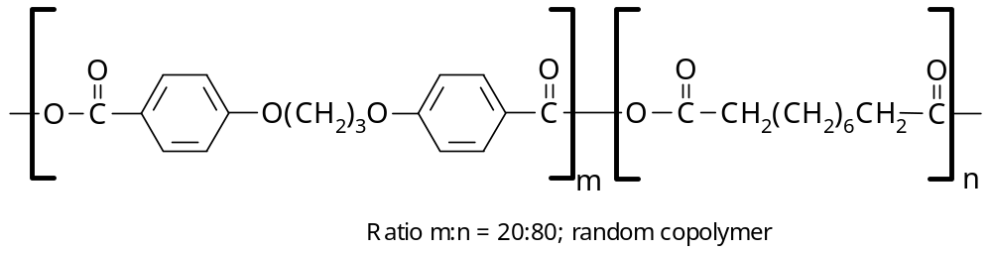

The structural formula for carmustine is:
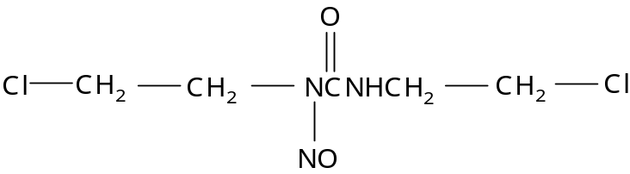

CLINICAL PHARMACOLOGY
GLIADEL is designed to deliver carmustine directly into the surgical cavity created when a brain tumor is resected. On exposure to the aqueous environment of the resection cavity, the anhydride bonds in the copolymer are hydrolyzed, releasing carmustine, carboxyphenoxypropane, and sebacic acid. The carmustine released from GLIADEL diffuses into the surrounding brain tissue and produces an antineoplastic effect by alkylating DNA and RNA.

Carmustine has been shown to degrade both spontaneously and metabolically. The production of an alkylating moiety, hypothesized to be chloroethyl carbonium ion, leads to the formation of DNA cross-links.

The tumoricidal activity of GLIADEL is dependent on release of carmustine to the tumor cavity in concentrations sufficient for effective cytotoxicity.

More than 70% of the copolymer degrades by three weeks. The metabolic disposition and excretion of the monomers differ. Carboxyphenoxypropane is eliminated by the kidney and sebacic acid, an endogenous fatty acid, is metabolized by the liver and expired as CO₂ in animals.

The absorption, distribution, metabolism, and excretion of the copolymer in humans is unknown. Carmustine concentrations delivered by GLIADEL in human brain tissue have not been determined. Plasma levels of carmustine after GLIADEL wafer implant were not determined. In rabbits implanted with wafers containing 3.85% carmustine, no detectible levels of carmustine were found in the plasma or cerebrospinal fluid.

Following an intravenous infusion of carmustine at doses ranging from 30 to 170 mg/m², the average terminal half-life, clearance, and steady-state volume of distribution were 22 minutes, 56 mL/min/kg, and 3.25 L/kg, respectively. Approximately 60% of the intravenous 200 mg/m² dose of ¹⁴C-carmustine was excreted in the urine over 96 hours and 6% was expired as CO₂.

GLIADEL wafers are biodegradable in human brain when implanted into the cavity after tumor resection. The rate of biodegradation is variable from patient to patient. During the biodegradation process, a wafer remnant may be observed on brain imaging scans or at re-operation even though extensive degradation of all components has occurred. Data obtained from review of CT scans obtained 49 days after implantation of GLIADEL demonstrated that images consistent with wafers were visible to varying degrees in the scans of 11 of 18 patients. Data obtained at re-operation and autopsies have demonstrated wafer remnants up to 232 days after GLIADEL implantation.

Wafer remnants removed at re-operation from two patients with recurrent malignant glioma, one at 64 days and the second at 92 days after implantation, were analyzed for content. The following table presents the results of analyses completed on these remnants.
COMPOSITION OF WAFER REMNANTS REMOVED FROM
TWO PATIENTS ON RE-OPERATION

Component | Patient A | Patient B
Days After GLIADEL Implantation | 64 | 92
Anhydride Bonds | None detected | None detected
Water Content (% of wafer remnant weight) | 95-97% | 74-86%
Carmustine Content (% of initial) | <0.0004% | 0.034%
Carboxyphenoxypropane Content (% of initial) | 9% | 14%
Sebacic Acid Content (% of initial) | 4% | 3%

The wafer remnants consisted mostly of water and monomeric components with minimal detectable carmustine present.

CLINICAL STUDIES

In a randomized, double-blind, placebo-controlled clinical trial in adults with recurrent malignant glioma, GLIADEL prolonged survival in in patients with glioblastoma multiforme (GBM). Ninety-five percent of the patients treated with GLIADEL had 7-8 wafers implanted.

In 222 patients with recurrent malignant glioma who had failed initial surgery and radiation therapy, the six-month survival rate after surgery increased from 47% (53/112) for patients receiving placebo to 60% (66/110) for patients treated with GLIADEL. Median survival increased by 33%, from 24 weeks with placebo to 32 weeks with GLIADEL treatment. In patients with GBM, the six-month survival rate increased from 36% (26/73) with placebo to 56% (40/72) with GLIADEL treatment. Median survival of GBM patients increased by 41% from 20 weeks with placebo to 28 weeks with GLIADEL treatment. In patients with pathologic diagnoses other than GBM at the time of surgery for tumor recurrence, GLIADEL produced no survival prolongation.

6-MONTH KAPLAN-MEIER SURVIVAL CURVES FOR PATIENTS
UNDERGOING SURGERY FOR RECURRENT GBM

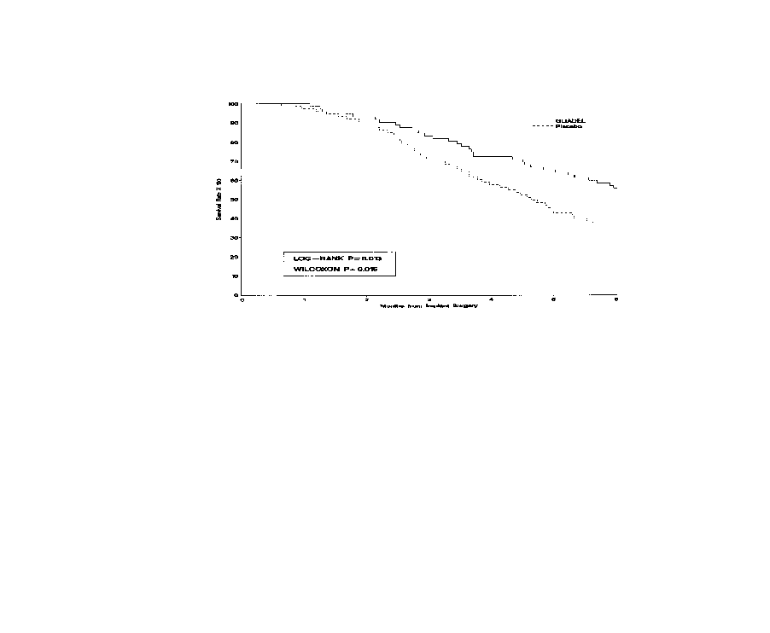

OVERALL KAPLAN-MEIER SURVIVAL CURVES FOR PATIENTS
UNDERGOING SURGERY FOR RECURRENT GBM

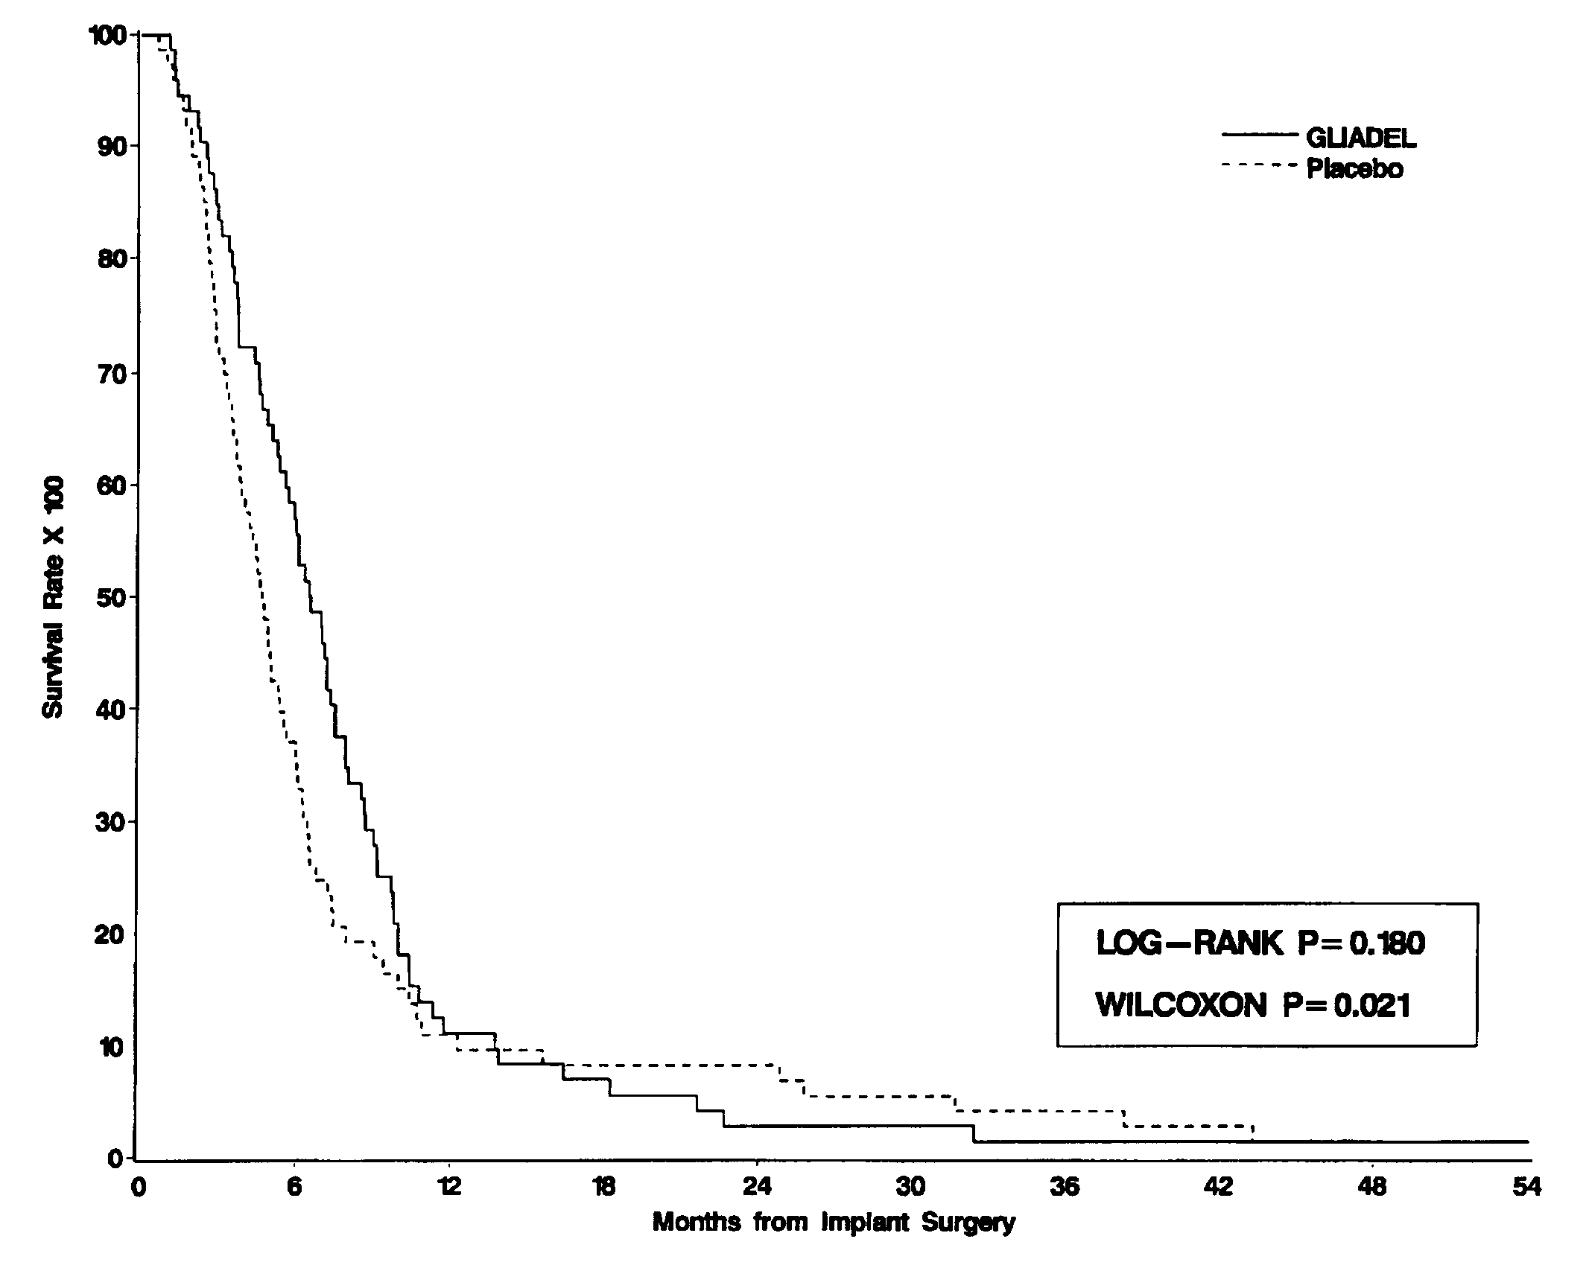
INDICATIONS AND USAGE
GLIADEL is indicated for use as an adjunct to surgery to prolong survival in patients with recurrent glioblastoma multiforme for whom surgical resection is indicated.

CONTRAINDICATIONS
GLIADEL contains carmustine. GLIADEL should not be given to individuals who have demonstrated a previous hypersensitivity to carmustine or any of the components of GLIADEL.

WARNINGS
Patients undergoing craniotomy for malignant glioma and implantation of GLIADEL should be monitored closely for known complications of craniotomy, including seizures, intracranial infections, abnormal wound healing, and brain edema. Cases of intracerebral mass effect unresponsive to corticosteroids have been described in patients treated with GLIADEL, including one case leading to brain herniation.

Pregnancy: There are no studies assessing the reproductive toxicity of GLIADEL. Carmustine, the active component of GLIADEL, can cause fetal harm when administered to a pregnant woman. Carmustine has been shown to be embryotoxic and teratogenic in rats at i.p. doses of 0.5, 1, 2, 4, or 8 mg/kg/day when given on gestation days 6 through 15. Carmustine caused fetal malformations (anophthalmia, micrognathia, omphalocele) at 1.0 mg/kg/day (about 1/6 the recommended human dose (eight wafers of 7.7 mg carmustine/wafer) on a mg/m² basis). Carmustine was embryotoxic in rabbits at i.v. doses of 4.0 mg/kg/day (about 1.2 times the recommended human dose on a mg/m² basis). Embryotoxicity was characterized by increased embryo-fetal deaths, reduced numbers of litters, and reduced litter sizes.

There are no studies of GLIADEL in pregnant women. If GLIADEL is used during pregnancy, or if the patient becomes pregnant after GLIADEL implantation, the patient must be warned of the potential hazard to the fetus.

PRECAUTIONS
General: Communication between the surgical resection cavity and the ventricular system should be avoided to prevent the wafers from migrating into the ventricular system and causing obstructive hydrocephalus. If a communication larger than the diameter of a wafer exists, it should be closed prior to wafer implantation.

Imaging Studies: Computed tomography and magnetic resonance imaging of the head may demonstrate enhancement in the brain tissue surrounding the resection cavity after implantation of GLIADEL wafers. This enhancement may represent edema and inflammation caused by GLIADEL or tumor progression.

Therapeutic Interactions: Interactions of GLIADEL with other drugs or radiotherapy have not been formally evaluated. In clinical trials, few patients have received systemic chemotherapy within 30 days of GIADEL (6) or external beam radiation therapy (36).
Chemotherapy was withheld at least four weeks (six weeks for nitrosoureas) prior to and two weeks after surgery in patients undergoing re-operation for malignant glioma.
External beam radiation therapy was initiated no sooner than three weeks after GLIADEL implantation. Of the 36 patients who received GLIADEL at initial surgery for newly diagnosed, malignant glioma followed by external beam radiation therapy, 3/15 (20%) in one study and 11/21 (52%) in the other study experienced new or worsened seizures. Patients were followed for a maximum of 24 months.

The short and long-term toxicity profiles of GLIADEL when given in conjunction with radiation or chemotherapy have not been fully explored.

Carcinogenesis, Mutagenesis, Impairment of Fertility: No carcinogenicity, mutagenicity or impairment of fertility studies have been conducted with GLIADEL. Carcinogenicity, mutagenicity and impairment of fertility studies have been conducted with carmustine, the active component of GLIADEL. Carmustine was given three times a week for six months, followed by 12 months observation, to Swiss mice at i.p. doses of 2.5 and 5.0 mg/kg (about 1/5 and 1/3 the recommended human dose (eight wafers of 7.7 mg carmustine/wafer) on a mg/m² basis) and to SD rats at i.p. dose of 1.5 mg/kg (about 1/4 the recommended human dose on a mg/m² basis). There were increases in tumor incidence in all treated animals, predominantly subcutaneous and lung neoplasms. Mutagenesis: Carmustine was mutagenic in vitro (Ames assay, human lymphoblast HGPRT assay) and clastogenic both in vitro (V79 hamster cell micronucleus assay) and in vivo (SCE assay in rodent brain tumors, mouse bone marrow micronucleus assay). Impairment of Fertility: Carmustine caused testicular degeneration at i.p. doses of 8 mg/kg/week for eight weeks (about 1.3 times the recommended human dose on a mg/m² basis) in male rats.

Pregnancy: Pregnancy Category D: see WARNINGS.

Nursing Mothers: It is not known if either carmustine, carboxyphenoxypropane, or sebacic acid is excreted in human milk. Because many drugs are excreted in human milk and because of the potential for serious adverse reactions from carmustine in nursing infants, it is recommended that patients receiving GLIADEL discontinue nursing.

Pediatric Use: The safety and effectiveness of GLIADEL in pediatric patients have not been established.

ADVERSE REACTIONS
Data in the following table are based on the experience of 222 patients with recurrent malignant glioma randomized to GLIADEL or placebo (wafer without carmustine).

The spectrum of adverse events observed in patients who received GLIADEL or placebo in clinical studies was consistent with that encountered in patients undergoing craniotomy for malignant gliomas.

GLIADEL was not reported to be the cause of death in any of the GLIADEL clinical trials.

The following post-operative adverse events were observed in 4% or more of the patients receiving GLIADEL surgery in the placebo-controlled clinical trial. Except for nervous system effects, where there is a possibility that the placebo wafers could have been responsible, only events more common in the GLIADEL group are listed. These adverse events were either not present pre-operatively or worsened post-operatively during the follow-up period. The follow-up period in the randomized trial was up to 71 months.

COMMON ADVERSE EVENTS OBSERVED IN >4% OF PATIENTS
IN THE RANDOMIZED TRIAL

Body System  Adverse Event | GLIADEL  Wafer with Carmustine  [N=110]  n (%) | PLACEBO  Wafer without Carmustine  [N=112]  n (%)
Body as a Whole  Fever  Pain* | 13 (12)  8 (7) | 9 (8)  1 (1)
Digestive System  Nausea and Vomiting | 9 (8) | 7 (6)
Metabolic and Nutritional Disorders  Healing Abnormal* | 15 (14) | 6 (5)
Nervous System  Aphasia  Brain Edema  Confusion  Convulsion  Headache  Hemiplegia  Intracranial Hypertension  Meningitis or Abscess  Somnolence  Stupor | 10 (9)  4 (4)  11 (10)  21 (19)  16 (15)  21 (19)  4 (4)  4 (4)  15 (14)  7 (6) | 12 (11)  1 (1)  9 (8)  21 (19)  14 (13)  22 (20)  7 (6)  1 (1)  12 (11)  7 (6)
Skin and Appendages  Rash | 6 (5) | 4 (4)
Urogenital System  Urinary Tract Infection | 23 (21) | 19 (17)
*p < 0.05 for comparison of GLIADEL versus placebo groups in the randomized trial (two-sided Fisher’s Exact Test)

The following adverse events were also reported in 4-9% of GLIADEL patients but were at least as frequent in the placebo group as in GLIADEL-treated patients: infection, deep thrombophlebitis, pulmonary embolism, nausea, oral moniliasis, anemia, hyponatremia, pneumonia.

The following four categories of adverse events are possibly related to treatment with GLIADEL. The frequency with which they occurred in the randomized trial along with descriptive detail are provided below.

1. Seizures: In the randomized study, the majority of seizures in the placebo and GLIADEL groups were mild or moderate in severity. The incidence of new or worsened seizures was 19% in patients treated with GLIADEL and 19% in patients receiving placebo. Of the patients with new or worsened seizures post-operatively, 12/22 (54%) of patients treated with GLIADEL and 2/22 (9%) of placebo patients experienced the first new or worsened seizure within the first five post-operative days. The median time to onset of the first new or worsened post-operative seizure was 3.5 days in patients treated with GLIADEL and 61 days in placebo patients. The occurrence of seizures did not reduce the survival benefit of GLIADEL.

2. Brain Edema: In the randomized trial, brain edema was noted in 4% of patients treated with GLIADEL and in 1% of patients treated with placebo. Development of brain edema with mass effect (due to tumor recurrence, intracranial infection, or necrosis) may necessitate re-operation and, in some cases, removal of wafer or its remnants.

3. Healing Abnormalities: The majority of these events were mild to moderate in severity. Healing abnormalities occurred in 14% of GLIADEL-treated patients compared to 5% of placebo recipients. These events included cerebrospinal fluid leaks, subdural fluid collections, subgaleal or wound effusions, and wound breakdown.

4. Intracranial Infection: In the randomized trial, intracranial infection (meningitis or abscess) occurred in 4% of patients treated with GLIADEL and in 1% of patients receiving placebo. In GLIADEL-treated patients, there were two cases of bacterial meningitis, one case of chemical meningitis, and one case of meningitis which was not further specified. A brain abscess developed in one placebo-treated patient. The rate of deep wound infection (infection of subgaleal space, bone, meninges, or neural parenchyma) was 6% in both GLIADEL and placebo treated patients.

The following adverse events, not listed in the table above, were reported in less than 4% but at least 1% of patients treated with GLIADEL in all studies (n=273). The events listed were either not present pre-operatively or worsened post-operatively. Whether GLIADEL caused these events cannot be determined.

Body as a Whole: peripheral edema (2%); neck pain (2%); accidental injury (1%); back pain (1%); allergic reaction (1%); asthenia (1%); chest pain (1%); sepsis (1%)

Cardiovascular System: hypertension (3%); hypotension (1%)

Digestive System: diarrhea (2%); constipation (2%); dysphagia (1%); gastrointestinal hemorrhage (1%); fecal incontinence (1%)

Hemic and Lymphatic System: thrombocytopenia (1%); leukocytosis (1%)
Metabolic and Nutritional Disorders: hyponatremia (3%); hyperglycemia (3%); hypokalemia (1%)

Musculoskeletal System: infection (1%)

Nervous System: hydrocephalus (3%); depression (3%); abnormal thinking (2%); ataxia (2%); dizziness (2%); insomnia (2%); monoplegia (2%); coma (1%); amnesia (1%); diplopia (1%); paranoid reaction (1%). In addition, cerebral hemorrhage and cerebral infarct were each reported in less than 1% of patients treated with GLIADEL.

Respiratory System: infection (2%); aspiration pneumonia (1%)

Skin and Appendages: rash (2%)

Special Senses: visual field defect (2%); eye pain (1%)

Urogenital System: urinary incontinence (2%)

OVERDOSAGE
There is no clinical experience with use of more than eight GLIADEL wafers per surgical procedure.

DOSAGE AND ADMINISTRATION
Each GLIADEL wafer contains 7.7 mg of carmustine, resulting in a dose of 61.6 mg when eight wafers are implanted. It is recommended that eight wafers be placed in the resection cavity if the size and shape of it allows. Should the size and shape not accommodate eight wafers, the maximum number of wafers as allowed should be placed. Since there is no clinical experience, no more than eight wafers should be used per surgical procedure.

Handling and Disposal¹⁻⁷: Wafers should only be handled by personnel wearing surgical gloves because exposure to carmustine can cause severe burning and hyperpigmentation of the skin. Use of double gloves is recommended and the outer gloves should be discarded into a biohazard waste container after use. A surgical instrument dedicated to the handling of the wafers should be used for wafer implantation. If repeat neurosurgical intervention is indicated, any wafer or wafer remnant should be handled as a potentially cytotoxic agent.

GLIADEL wafers should be handled with care. The aluminum foil laminate pouches containing GLIADEL should be delivered to the operating room and remain unopened until ready to implant the wafers. The outside surface of the outer foil pouch is not sterile.
Instructions for Opening Pouch Containing GLIADEL

Figure 1: To remove the sterile inner pouch from the
outer pouch, locate the folded corner and slowly pull in
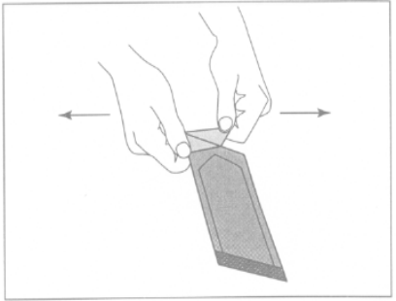an outward motion.

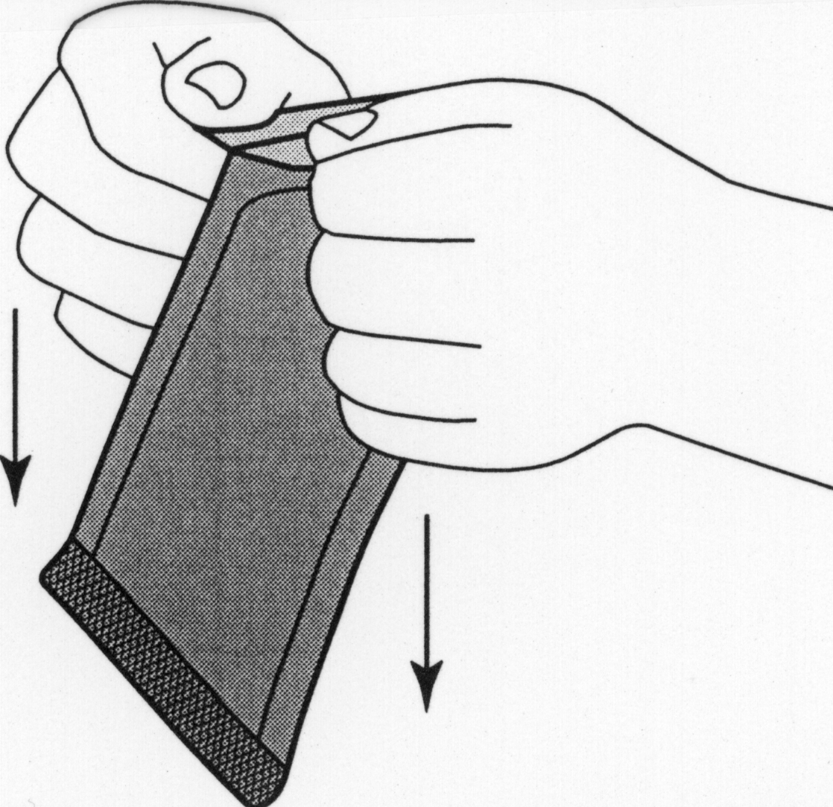
Figure 2: Do NOT pull in a downward motion rolling knuckles over the pouch. This may exert pressure on the wafer and cause it to break.

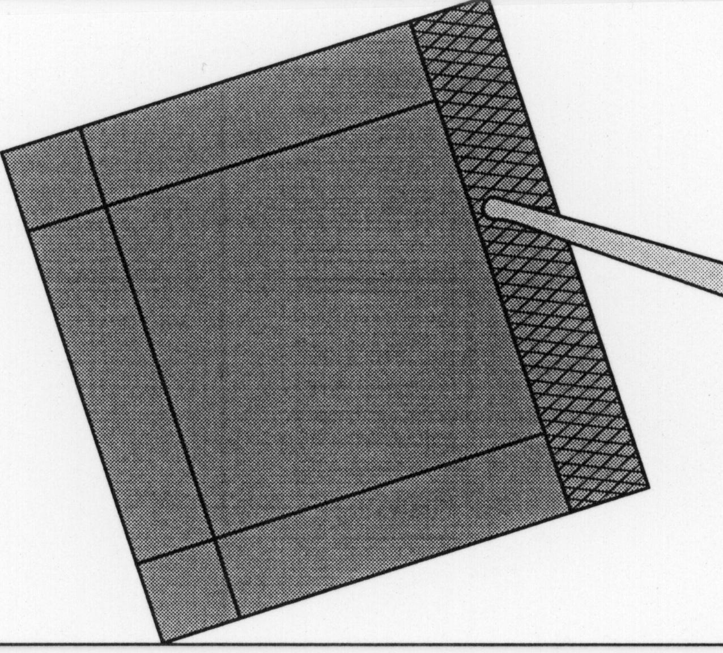
Figure 3: Remove the inner pouch by grabbing hold of the crimped edge and pulling upward.

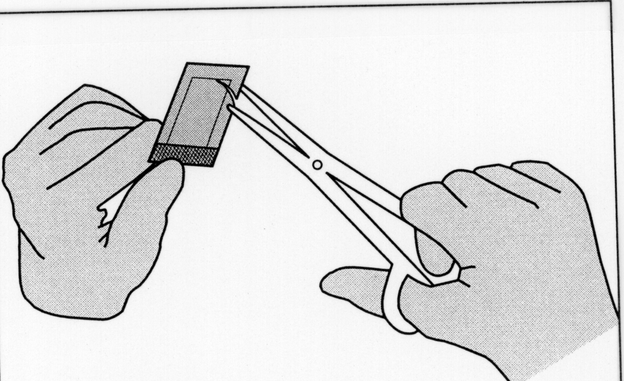
Figure 4: To open the inner pouch, gently hold the crimped edge and cut in an arc-like fashion around the wafer.

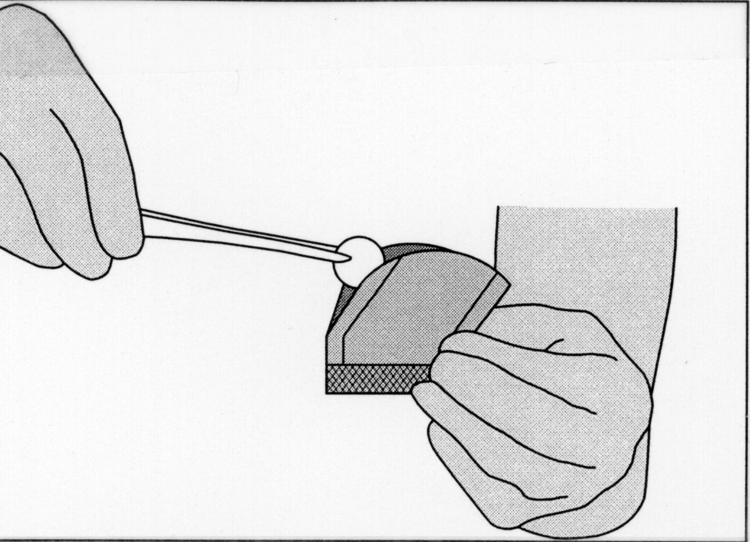

Figure 5: To remove the GLIADEL wafer, gently grasp the wafer with the aid of forceps and place it onto a designated sterile field.

Once the tumor is resected, tumor pathology is confirmed, and hemostasis is obtained, up to eight GLIADEL® Wafers (polifeprosan 20 with carmustine implant) may be placed to cover as much of the resection cavity as possible. Slight overlapping of the wafers is acceptable. Wafers broken in half may be used, but wafers broken in more than two pieces should be discarded in a biohazard container. Oxidized regenerated cellulose (Surgicel®) may be placed over the wafers to secure them against the cavity surface. After placement of the wafers, the resection cavity should be irrigated and the dura closed in a water tight fashion.

Unopened foil pouches may be kept at ambient room temperature for a maximum of six hours at a time.

HOW SUPPLIED
GLIADEL is available in a single dose treatment box containing eight individually pouched wafers. Each wafer contains 7.7 mg of carmustine and is packaged in two aluminum foil laminate pouches. The inner pouch is sterile and is designed to maintain product sterility and protect the product from moisture. The outer pouch is a peelable overwrap. The outside surface of the outer pouch is not sterile.

GLIADEL must be stored at or below -20ºC (-4ºF).

REFERENCES
1. Recommendations for the Safe Handling of Parenteral Antineoplastic Drugs, NIH Publication No. 83-2621. For sale by the Superintendent of Documents, U.S. Government Printing Office, Washington, DC 20402.
2. AMA Council Report, Guidelines for Handling Parenteral Antineoplastics. JAMA, 1985; 253(11):1590-1592.
3. National Study Commission on Cytotoxic Exposure -- Recommendations for Handling Cytotoxic Agents. Available from Louis P. Jeffrey, ScD., Chairman, National Study Commission on Cytotoxic Exposure, Massachusetts College of Pharmacy and Allied Health Sciences, 179 Longwood Avenue, Boston, Massachusetts 02115.
4. Clinical Oncological Society of Australia, Guidelines and Recommendations for Safe Handling of Antineoplastic Agents. Med J Australia, 1983; 1:426-428.
5. Jones RB, et al: Safe Handling of Chemotherapeutic Agents: A Report from the Mount Sinai Medical Center. CA -- A Cancer Journal for Clinicians, 1983; (Sept/Oct) 258-263.
6. American Society of Hospital Pharmacists Technical Assistance Bulletin on Handling Cytotoxic and Hazardous Drugs. Am J. Hosp Pharm, 1990; 47:1033-1049.
7. OSHA Work-Practice Guidelines for Personnel Dealing with Cytotoxic (Antineoplastic) Drugs. Am J Hosp Pharm, 1986; 43:1193-1204.

NDC: 61379-0100-1

CAUTION: FEDERAL LAW PROHIBITS DISPENSING WITHOUT PRESCRIPTION.

U.S. Patent Nos. 4,789,724 and 5,179,189.

Manufactured by
Guilford Pharmaceuticals Inc.
Baltimore, MD 21224

APPENDIX III: Excerpts from 1996 Review of CL-0190 (Phase 3); #9003 (Phase 1); ODAC Questions and Vote

Phase 3 Trial #CL-0190: Interstitial Chemotherapy for Malignant Glioma: A Phase 3 Placebo Controlled Study to Examine the Safety and Eficacy of GLIADEL Placed at the Time of First Surgery

Protocol CL-0190 was conducted under a foreign IND and not identified prospectively as a pivotal trial for submission with an NDA in the U.S. The NDA’s submitted protocol, statistical section, and amendments as well as decisions made during the trial are not part of the Agency’s records and are presented below as per applicant.

  - Protocol Review

- Review of Amendments

Amendment #1, 11/15/91 -- Sweden withdrew and was replaced with a center in Norway.
-- An upper age limit of 65 years was added.
-- Imaging was rearranged to be on day of discharge.

Amendment #2, 2/5/92 -- Randomization was changed from blocks of 10 patients per center (5 active + 5 placebo in random order) to blocks of 4 patients per center.

Comment: All patients were enrolled after both amendments.

- Objectives

"To determine the safety and efficacy of using GLIADEL® as adjunctive treatment with surgery and external beam radiotherapy in newly diagnosed malignant glioma patients."

Primary endpoint (per statistical section): "The primary efficacy analyses will be comparisons of survival and progression free time between the two treatment groups."

- Study Design/Schema

CL-0190 was a multicenter, randomized, double blind placebo-controlled phase III trial, designed to compare the safety and efficacy of interstitial BCNU chemotherapy in treatment-naive patients with malignant glioma. Patients were enrolled after malignant glioma was pathologically confirmed during surgery. After maximal tumor resection, up to eight wafers, GLIADEL® or placebo, were placed against the resection surface.

Eligibility Criteria:

-- 18 to 65 years of age
-- KPS > 60
-- Witnessed informed consent
-- Unilateral, unifocal tumor of > 1 cm diameter, by brain imaging. Tumor must not cross midline
-- Confirmation of high grade glioma by frozen or squash preparation surgery

Comment: High grade glioma was defined as a grade III glioma (anaplastic astrocytoma) or IV glioma (glioblastoma multiforme) in the CRF.

Exclusion Criteria:

-- Significant renal or hepatic disease, as determined by BUN, creatinine, SGOT, SGPT, LDH or bilirubin levels exceeding 2 X ULN of the center's normal range
-- Concomitant life-threatening disease that would limit lifespan to within 6 months of study entry
-- Platelets < 100,000/ml or leukocytes < 4,000/ml
-- Pregnancy
-- Hypersensitivity to contrast material to the extent that contrast-enhanced CT or MRI would not be obtained

- Procedure, Treatment, and Schedule of Tests

Randomization. Study centers received one block of 4 numbers (per amendment #2) to start and further blocks depending on accrual. When drug and placebo wafers were received from the U.S., Orion-Farmos placed a non-peelable label over the Nova Pharmaceutical label to blind the content. The labels were site-specific, and included the patient number (randomization number) and principal investigator's name.

Treatment. Following maximal tumor resection, up to eight wafers (GLIADEL® vs. polymer placebo) were to be placed in the cavity. Once adequate hemostasis was obtained, the wafers were placed to cover the entire resection surface, with overlapping permitted. Avitene, gelfoam, or surgicel could be left along the brain surface. The decompressed area could be filled with irrigation fluid prior to tight closure of the dura. "Standard methods and schedules (of radiotherapy) will be used." No systemic chemotherapy was allowed.

Schedule of Tests.

Visit #  Study Day | # 0  Baseline=B | #1  D1 | #2  D3 | #3  Discharge=D¹ | #4  RT | #5, etc.  D90, etc. q 3 mo.²
History/ P.E. | X
Karnofsky PS | X |  |  | X | X | X
Neurological Exam/  MMSE | X |  |  | X | X | X
CT or MRI  (w & w/o contrast) | X  (within 2 wks) | X |  |  | X | X
CBC, SMA, U/A | X |  | X | X | X | X
Surgery/Implantation |  | X
Radiation Therapy |  |  |  |  | X

!Visit # is the date of discharge or day 10, whichever comes first.
²Followup in #8802 is q 2 months.

- Endpoints and Statistical Analysis

Definitions of Endpoints:

Treatment failure was defined identically to #8802, by changes on contrast-enhanced CT or MRI scan and/or the Karnofsky performance status, see pages 6-7.

(Survival was not specifically defined.)

Statistical Analysis:

The protocol states..."The maximum number of 100 patients with histologically verified malignant, primary, supratentorial Grade III-IV glioma without any previous chemotherapeutic treatment will be enrolled in the study.

The expected median survival time is 12 months after the first surgery and radiotherapy. GLIADEL is considered an effective treatment, if we shall obtain a 33% (4 months) longer median survival in comparison with placebo.

Monitoring of the results is done after every tenth event using a sequential restricted triangular stopping rule. This rule will terminate the study early, with 80% power and 5% one-sided type error rate, if we find a 33% difference in the survival time.

Primary analyses divide into three parts: assessment of demographics, efficacy and safety data. Evaluations on safety and efficacy will be based on neurological, Karnofsky, MMSE, medical events, concomitant medications, imaging results, time to treatment failure and survival data. The primary efficacy analyses will be comparisons of survival and progression free time between the two treatment groups.

If there is no difference between the two treatment arms after the first 100 patients, the trial will be stopped due to ethical reasons and the analysis will be done with conventional survival analysis techniques. On the other hand, if the study stops because mortalities are different, sequential analysis of survivorship will be applied."

Comment: Further details of the statistical analysis plan are not prespecified.

9.2 Results

9.2.1 Conduct of the Study

- Early Termination.

Patient accrual was terminated early by the sponsor, Orion-Farmos, after enrollment of 32 patients due to inadequate drug supply. The applicant, Guilford, references internal memoranda from Orion-Farmos and Nova Pharmaceutical Corp. identifying two reasons. First, Orion-Farmos, after noting three cases of infection, was concerned about the lack of documentation that wafers from lot SR042-49-7 had not been retested at intervals for sterility (subsequent testing by Orion-Farmos confirmed sterility and the incidences of wound infection/meningitis were attributed to a single center mistakenly placing the unsterile packet in the sterile surgical field). The second reason is that lot SR042-49-10 did not pass a 6-month retest because of a "slightly low BCNU content". There was no other drug supply; the last patient treated on CL-0190 was the last patient treated with GLIADEL® on any trial until Guilford assumed manufacture, opening a Treatment IND in the U.S. in November 1995. An interim analysis of CL-0190 was performed in the Spring of 1994 after data was collected on 16 patients (analysis not provided with the NDA). On March 9, l994, Orion-Farmos notified the Finnish regulatory authorities that the study was completed December 22, l993.

- Randomization.

Subject ID numbers (randomization numbers) were ranked from a low of "1" to a maximum of "12" at any one center. Review of the order of these numbers showed correlation with date of surgery/wafer implantation with one exception. The Tondheim, Norway center entered the first patient with a number of "12", although drug was shipped either in a block of 10 (pre-amendment) or a block of four for the initial shipment (2 blocks of 4 for subsequent shipments). Thereafter, the numbers were consecutive and correlated in order with the date of surgery. Information on patients registered but not entered is not available (not collected).
- Eligibility.

All patients were considered evaluable and are included in the final analyses of safety and efficacy. The following were the protocol eligibility violations:

Reviewer Table 9
Eligibility Criterion | GLIADEL® | Placebo
Age 18 to 65 | 1 pt age 67 | --
KPS > 60 | -- | 1 pt with KPS 40
LFTs < 2X ULN | 2 pts without baseline LFTs | 1 pt without baseline LFTs

- Referee Neuropathologist.

By protocol direction, samples of the tumors were sent to the sponsor, and then forwarded to Dr. Hannu Kalimo at the University of Turku, Finland. The referee pathologist was blinded to treatment. The local pathologist and Dr. Kalimo agreed on the diagnoses in all but one case in which an astrocytoma grade III was upgraded to GBM.

- Quality Assurance.

Although CL-0190 was conducted by Orion-Farmos, Guilford "has independently assessed the integrity and accuracy of the clinical data...to assure their adequacy...Audits have been conducted, including comparison of case report forms to source documents, to assess the validity of selected key data variables...In addition, quality assurance audits have been conducted at a number of participating clinical sites...to evaluate the conduct of the studies and the content of the data at these sites."

9.2.2 Enrollment, Demographics, Baseline Characteristics

- Study Dates:

First Patient Randomized: 3/23/92
Last Patient Randomized: 5/14/93
Date of Last Observation: 5/14/95

- Study Centers:

Enrollment and assignment to treatment arm per center is displayed in Reviewer Table 10, derived from Applicant’s Table 4.1.
Reviewer Table 10

SITE | GLIADEL®  N = 16 | PLACEBO  N = 16
#1 Turku, Finland | 4 | 5
#2 Tampere, Finland | 3 | 2
#3 Helsinki, Finland | 4 | 5
#4 Tondheim, Norway | 5 | 4

- Baseline Demographics and Clinical Characteristics

Reviewer Table 11 is a composite of Applicant’s Tables 4.2, 4.5, 4.6, 4.8, 4.11, and 4.12. The only statistically significant difference between the treatment arms was tumor type. All patients randomized to placebo carried the diagnosis of GBM; however, 11/16 (69%) treated with GLIADEL® had GBM.

Reviewer Table 11: Baseline Demographics and Clinical Characteristics
 | GLIADEL®  (n = 16) | Placebo  (n = 16) | P-value
AGE (years)  mean (S.D.)  median  range | 53.5 (9.5)  56  37-68 | 53.9 (8.0)  54  36-65 | 0.905¹
GENDER  male  female | 88 | 106 | 0.722¹
RACE*
KARNOFSKY PS  40  60  70  80  90  100  Mean (S.D.)  Median (range) | 0  3  5  1  5  2  78.75 (14.08)  75 (60-100) | 1  1  1  4  7  2  81.94 (15.10)  90 (40-100) | 0.542²  0.402³
HISTOLOGY (referee pathology)  GBM  AA  Oligodendroglioma, gr 3  Ependymoma, gr 3 | 11 (69)  2 (13)  2 (13)  1 (6) | 16 (100)  0  0  0 | 0.043¹
MMSE (total score)  Mean (S.D.)  Median | 23.19 (4.59)  24.5 | 22.88 (4.03)  24.5 | 0.839²  0.732³
NEURO EXAM (total score)  Mean (S.D.)  Median | 4.31 (3.48)  4.00 | 3.94 (3.45)  4.00 | 0.762²  0.675³
*Not collected on the CRF in this study
¹Fisher's Exact Test for discrete variables; F-test from ANOVA for the continuous variables
²Two sample t-test for comparing means between treatment groups
³Wilcoxon Rank Sum test for comparing means between two treatment groups

- Tumor Size

The mean tumor area was 22.4 (+ 8.6) cm² in the GLIADEL® arm vs. 19.2 (+6.1) cm² in the placebo group. Median tumor areas were 20 cm² in both arms. Tumor volume estimates were not provided for this study because data was not available for one patient.

- Characteristics of Surgery

In the GLIADEL® arm, 13 patients (81%) had eight wafers implanted; in the placebo group, 10 patients (63%) received eight wafers. The least number of wafers implanted was 5 in the GLIADEL® arm and 4 in the placebo arm (Applicant's Table 4.15 which follows).

Applicant's Table 4.15: GLIADEL Dosage
Parameter | GLIADEL 3.85%  [N = 16] | PLACEBO  [N = 16] | P-valueª
Number of Wafers Implanted  Mean (S.D.)  Median  Range | 7.6 (1.0)  8  4-8 | 6.9 (1.5)  8  4-8 | 0.176
Number of Wafers Implanted 4 wafers  5 wafers  6 wafers  7 wafers  8 wafers | 0 (0)  1 (6)  2 (13)  0 (0)  13 (81) | 2 (13)  1 (6)  3 (19)  0 (0)  10 (63)
Amount of BCNU (mg)  Mean (S.D.)  Median  Range | 58.23 (7.42)  61.6  38.5 - 61.6 | N/A
__ª Fisher’s Exact test

Excerpts from Applicant’s Table 4 below comparing additional characteristics of surgery are shown below. There were no statistically significant differences between the arms.

Applicant's Table 4.12: Characteristics of Wafer Implantation Surgery
 | GLIADEL 3.85%  [N = 16] | PLACEBO  [N = 16] | P-valueª
Hemisphere |  |  | 1.000
Left  Right | 6 (38)  10 (63) | 6 (38)  10 (63)
Tumor Location by Lobe |  |  | 0.752
Frontal  Temporal  Parietal  Occipital  Temporal / Occipital | 6 (38)  7 (44)  2 (13)  1 (6)  0 (0) | 6 (38)  5 (31)  1 (6)  3 (19)  1 (6)
Duration of Anesthesia (Hours) |  |  | 0.675
Mean (S.D.)  Median  Range | 4.4 (1.3)  4.6  2.7 - 6.5 | 4.2 (1.1)  4.2  2.2 - 5.7
Surgical Resection |  |  | 1.000
Subtotal  Total  Total with Lobectomy | 14 (88)  1 (6)  1 (6) | 15 (94)  1 (6)  0 (0)
Tumor Volume (cm³) |  |  | 0.640
N  Mean (S.D.)  Median  Range | 15  103.9 (92.7)  80  1.5 - 336 | 16  91.5 (47.8)  82  18.8 - 181
% of Resection |  |  | 0.756
Mean (S.D.)  Median  Range | 79.3 (16.3)  80  40 - 100 | 77.4 (18.6)  85  40 - 98
ª P-value from Fisher's Exact Test for categorical variables, F-test for continuous variables

- Treatment After Wafer Implantation Surgery

Radiation Therapy. All but one patient, who died on study day 35 of a rapidly growing tumor, received post-operative radiation therapy. Applicant’s Table 4 presents the mean and median doses of radiation delivered.

Applicant's Table 4.14: Radiotherapy Treatment Regimen Summary
 | GLIADEL 3.85%  [N = 16] | PLACEBO  [N = 16] | P-valueª
 | Number (Percentage) of Patients
Cumulative Radiotherapy (cGy)
N | 15 | 16
Mean (SD) | 5649.5 (333.0) | 5362.9 (878.1) | 0.2454
Median | 5575 | 5403
Range | 5040 - 6000 | 2895 - 6400
ª Fisher’s Exact Test

Systemic Chemotherapy. Only one patient on the placebo arm received systemic chemotherapy, two courses of procarbazine, lomustine, and vincristine.

- Concomitant Medications

Dexamethasone was the most commonly prescribed medication after wafer implantation. All patients received dexamethasone, methylprednisolone or betamethasone. There were no statistically significant differences between the treatment arms with respect to mean daily dose and total dose per patients for each medication.
Anticonvulsants were not commonly prescribed; 3 patients on GLIADEL® and 1 on placebo were prescribed carbamazepine.

9.2.3 Efficacy Results

Orion-Farmos, the sponsor, performed an interim analysis after the first 16 patients, the results of which have not been provided. The NDA states that..."the analysis was blinded and consisted of a few tabulations and a non-parametric analysis of survival. The treatment code for the study was unblinded on June 28, l995."

Comment: The p-values provided by Guilford for the final reported survival analysis are unadjusted for this first look. However, since the p values are not borderline, this should not have a significant impact on the results

Guilford has assessed the primary endpoint of survival by survival rate at 12 months as well as Kaplan-Meier techniques at two timepoints, 12 and 24 months post wafer implantation. Guilford states, "The 12-month timepoint for the analyses was chosen because 12 months was given in the protocol as the expected median survival in the placebo treatment group, and was used as the basis for the protocol's power calculation....The 24-month timepoint for the analyses was chosen because the maximum duration of follow-up for all patients was 24 months." In addition to survival, the protocol identified a second primary endpoint as the progression-free interval.
- Twelve-Month Outcomes

Mortality Rate. Six patients on GLIADEL® and 13 on placebo died by 12 months after wafer implantation (p = 0.029, Fisher's exact test), leaving 10 alive on GLIADEL® and 3 alive on placebo.

Survival. The twelve-month Kaplan-Meier survival curve by treatment arm is shown in Applicant's Figure 2.

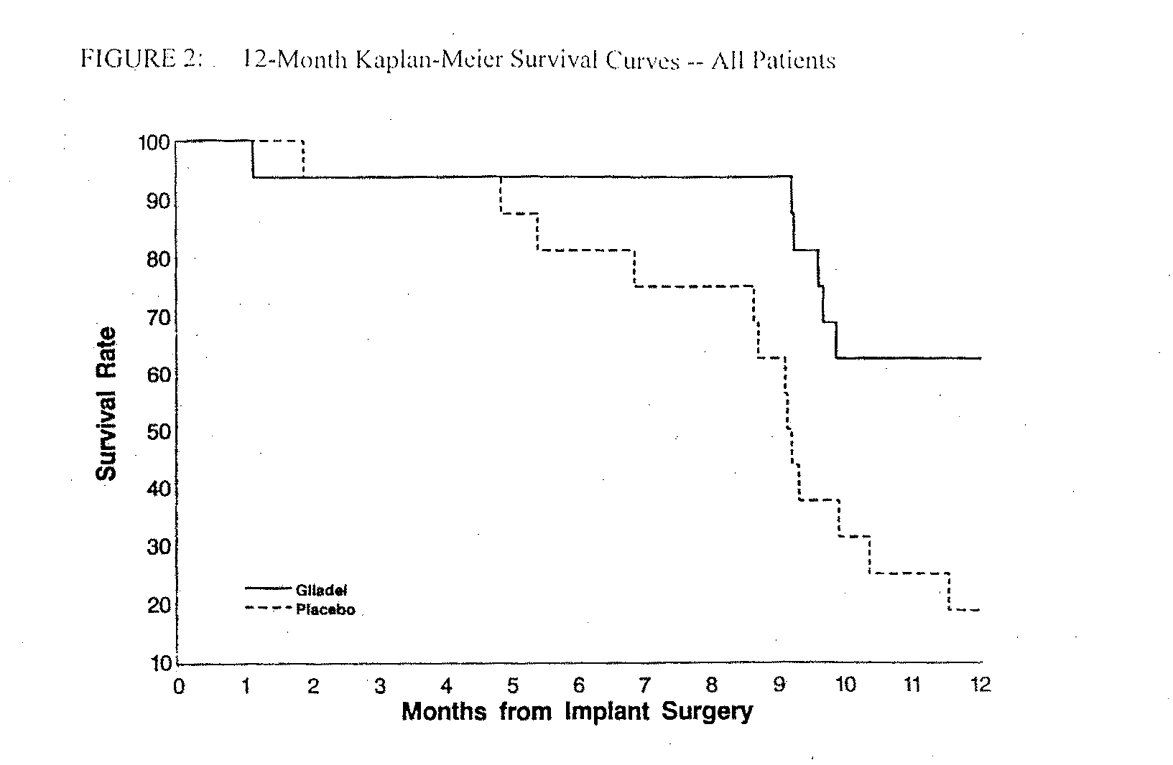
Cumulative mortality through 12 months shows a highly significantly difference between the arms, with a lower mortality for the GLIADEL® arm with a logrank p = 0.0087 and a Gehan's generalized Wilcoxon p = 0.0105.

Twelve-Month Survival Adjusted for Prognostic Factors. Eight variables were selected as being of potential clinical importance. Of the eight factors evaluated by univariate regression, three were identified as statistically significant as defined by a P < 0.15 (Applicant's Table 4.20, p.34).

Applicant's Table 4.19: Potential Prognostic Factors for Overall Patient Survival
(Univariate Cox Regression) -- All Patients
__________________________________________________________
95% Confidence Limits
Prognostic Factor Risk Ratio Lower Upper P-value*
GBM Patients vs. Non-GBM Patients 4.715 1.092 20.35 0.0377
Karnofsky Score >70 vs. 70 0.723 0.327 1.597 0.4226
75% Resection vs. <75% Resection 0.941 0.419 2.113 0.8824
Age (per Decade) 1.826 1.131 2.950 0.0138
Male vs. Female Patients 1.370 0.629 2.987 0.4280
MMSE Scores Median 0.377 0.170 0.833 0.0159
Prior Seizures vs. None 0.774 0.309 1.938 0.5845
Number of Wafers 6 vs. >6 1.037 0.449 2.395 0.9328
_____________________________________________________________________
*Wald Chi-Square test; P-values 0.15 appear in bold-face type

Comment: The NDA lacks a discussion of choice of 8 factors for the Finnish study vs. 15 for the North American Study or for 8 vs. generally accepted prognostic factors in newly diagnosed patients. No new factors are added; some deletions apply to the relapsed setting only, e.g., radiation, prior chemotherapy, years from first surgery, resection vs. biopsy at first surgery, and prior brachytherapy vs. none; information on race was not collected; the remaining two deletions were prior convulsions vs. none and prior steroid use vs. none. KPS, generally accepted as an important prognostic factor in newly diagnoses patients, was not seen to be statistically significant in the applicant's analysis. However, it was found to be significant in analyses performed by the FDA's Statistical Reviewer.

After adjustment for prognostic factors, GLIADEL® produced a statistically significant reduction in mortality compared to placebo. For all patients, the risk ratio was 0.154 (p=0.0010) and 0.179 for all patients stratified by tumor type (p=0.0038). See Applicant's Table 4.20.

Applicant Table 4.20: 12-Month Treatment Effect Adjusted for Prognostic Factors -- All Patients
Prognostic Factor | Risk Ratio | 95% Confidence Limits
 |  | Lower | Upper | P-valueª
All Patients
GLIADEL 3.85% vs. PLACEBO | 0.154 | 0.051 | 0.467 | 0.0010
Age (per decade) | 2.302 | 1.089 | 4.864 | 0.0290
Mini-Mental Scores Median | 0.207 | 0.070 | 0.613 | 0.0044
All Patients Stratified by Tumor Type
GLIADEL 3.85% vs. PLACEBO | 0.179 | 0.056 | 0.574 | 0.0038
Age (per decade) | 2.266 | 1.075 | 4.777 | 0.0315
Mini-Mental Scores Median | 0.218 | 0.074 | 0.645 | 0.0059
ª Wald Chi-Square test

- Overall Survival

As of the data cutoff date of 5/14/95 (observation period up to 24 months), six patients were alive: 5 of 16 (31%) who had received GLIADEL® and 1 of 16 (6%) who had received placebo (p = 0.172, Fisher's exact test). The median duration of survival was 13.37 months (95% CI: 9.66 - inestimable maximum) and 9.17 months (95% CI: 8.64 - 10.33) in the GLIADEL® and placebo groups, respectively.

The Kaplan-Meier curve for 24 months is shown below in Applicant's Fig. 3.

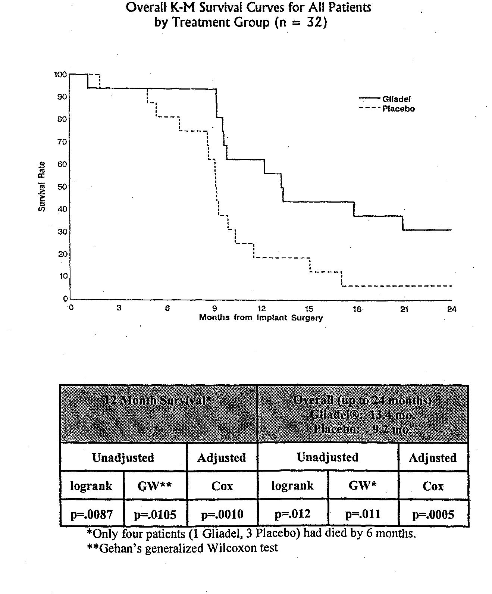
Overall Survival Adjusted for Prognostic Factors. After adjustment for prognostic factors, GLIADEL® produced significant reductions in overall survival. The risk ratios were 0.177 for all patients (p=0.0005) and 0.214 for all patients stratified by tumor type (p=0.0029), as shown in Applicant's Table 4.21.

Applicant Table 4.21: Overall Treatment Effect Adjusted for Prognostic Factors --
All Patients All Patients
Prognostic Factor | Risk Ratio | 95% Confidence Limits
 |  | Lower | Upper | P-valueª
GLIADEL 3.85% vs. PLACEBO | 0.177 | 0.067 | 0.468 | 0.0005
Age (per decade) | 2.248 | 1.208 | 4.182 | 0.0106
Mini-Mental Scores Median | 0.250 | 0.100 | 0.626 | 0.0031
All Patients Stratified by Tumor Type
GLIADEL 3.85% vs. PLACEBO | 0.214 | 0.078 | 0.590 | 0.0029
Age (per decade) | 2.219 | 1.193 | 4.131 | 0.0119
Mini-Mental Scores Median | 0.241 | 0.094 | 0.619 | 0.0031
ª Wald Chi-square test

- Subgroup Analysis: GBM Patients

Twenty-seven of 32 patients carried the diagnosis of GBM: 11/16 (69%) in the GLIADEL® arm and 16/16 (100%) in the placebo arm. Twelve and 24-month survival for all patients and for GBM vs. non-GBM patients is shown in Reviewer Table 12.

Reviewer Table 12: Survival Rates for All Patients and by Tumor Type
 | 12-Month |  |  | Overall (up to 24 months)
 | GLIADEL® | Placebo | GLIADEL® | Placebo
All Patients (n = 32)  Dead  Alive | n = 16  6  10 | n = 16  13  3 | n = 16  11  5 | n = 16  15  1
Fisher's Exact Test | p = 0.029 |  |  | p = 0.172
GBM (n = 27)  Dead  Alive | n = 11  5  6 | n = 16  13  3 | n = 11  9  2 | n = 16  15  1
Fisher's Exact Test | p = 0.097 |  |  | p = 0.5487
Non-GBM (n = 5)  Dead  Alive | n = 5  1  4 | n = 0 | n = 5  2  3 | n = 0

Applicant's Fig. 5 shows an overall Kaplan-Meier survival curve for GBM patients only. The median survival duration was 12.3 months (95% CI: 9.23 - 17.87 mo.) for patients treated with GLIADEL® and 9.2 months (95% CI: 8.64 - 10.35 mo.) for patients on placebo. The difference in 12-month and 24-month survival is shown in below.

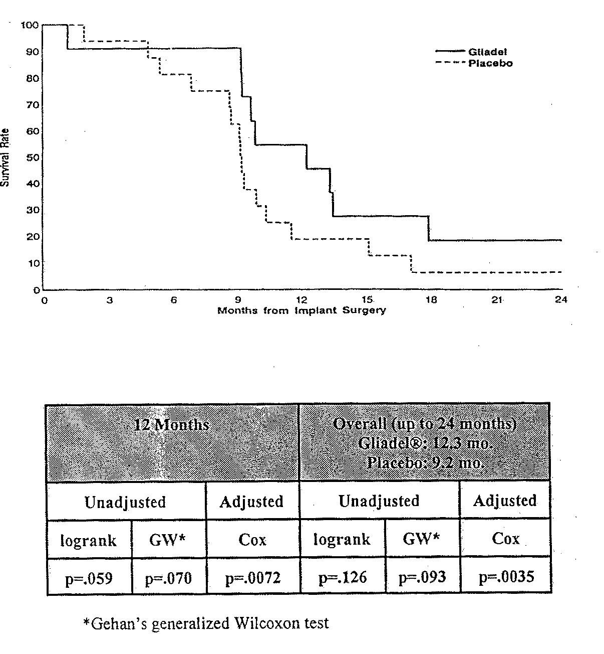

- Time to Treatment Failure (All Patients)

Time to treatment failure was measured from the time of wafer implantation surgery to the earliest point that treatment failure was declared, using protocol specified criteria. Twelve patients (75%) in the GLIADEL® arm and 14 (88%) in the placebo arm were considered to have failure of treatment. The median time to treatment failure for patients on GLIADEL® was 7.79 months (95% CI: 3.22 - 9.66 mo.) vs. 6.67 months (95% CI: 3.02 - 9.86 mo.), p = 0.4668 (logrank) or p = 0.9635 (Wilcoxon).

- Secondary Efficacy Analyses

The applicant found no significant differences between the treatment arms with regard to change in mean KPS or mini-mental status exam from baseline. See Statistical Review for further details.

- Drug-Demographic Interactions

The applicant did not provide analyses for a significant treatment by age or gender interaction for this study. Information on race was not collected on the CRF. See the Statistical Review for these analyses; an interaction with gender is seen, with survival in women greater than in men; however, these data should be interpreted cautiously given the small numbers of patients available for analysis.

9.2.4 Safety Results

Adverse events were collected on the CRF by asking the investigator to (1) list the AE; (2) judge severity on a four point scale of mild, moderate, severe, life-threatening; (3) judge its relationiship to treatment as not assessable, none, remote, possible, or probable (i.e., no "definite" category); (4) provide start and end dates; and (5) describe outcome. Specific A.E.s were not solicited.

The NDA states..."Pre-existing medical conditions that did not worsen in severity during the study period were not considered treatment-emergent adverse events. Multiple events with the same term, reported by one patient during the study period but having different severities, were treated as a single event of the worst recorded severity..."

- Deaths

Applicant Table 4.34: Summary of Cause of Death and Relationship of Death to Study Medication
 | GLIADEL 3.85%  [N = 11] | PLACEBO  [N = 15] | P-value
 | Number (Percentage) of Patients
Cause of Death  Brain Tumor  Other  Not Assessable | 10 (91)  0 (0)  1 (9) | 13 (87)  1 (7)*  1 (7) | 0.213
Relationship of Death to Study Medicationª  Probable  Possible  Remote  None | 0 (0)  0 (0)  0 (0)  10 (91) | 0 (0)  0 (0)  1 (7)  14 (93) | 0.083
*Death due to pulmonary embolus

Comment: Deaths were not clustered in the perioperative period, see K-M curves above.

- Treatment Withdrawal Due to Toxicity

There were no reports of wafer removal in this study.

- All Treatment-Emergent A.E.s by Body System

Due to the limited number of patients on this trial, all treatment-emergent A.E.s (rather than A.E.s with > 5% incidence) are presented (Applicant's Table 4.35 on the following page). Twice as many events (31 vs. 16) were reported in the GLIADEL® arm compared to the placebo arm. The body system that had the most number of A.E.s was the nervous system, with 19 reported in patients treated with GLIADEL® and 9 in patients who received placebo. The difference in the number of patients with A.E.s (vs. number of A.E.s) between the arms was not statistically significant.

Applicant Table 4.35: All Treatment-Emergent Adverse Events Summarized by Body System
 | GLIADEL 3.85%  [N = 16] |  |  | PLACEBO  [N = 16] |  |  | P-valueª
Body System^{b} | Number of Occurrences | Number (Percentage) of Patients | Number of Occurrences | Number (Percentage)  of Patients
Body as a Whole | 2 | 2 (13) | 2 | 2 (13) | 1.000
Cardiovascular | 4 | 3 (19) | 2 | 1 (6) | 0.600
Endocrine | 1 | 1 (6) | 0 | 0 (0) | 1.000
Hemic and Lymphatic | 0 | 0 (0) | 2 | 2 (13) | 0.484
Metabolic and Nutritional | 1 | 1 (6) | 0 | 0 (0) | 1.000
Musculoskeletal | 1 | 1 (6) | 0 | 0 (0) | 1.000
Nervous | 19 | 10 (63) | 9 | 6 (38) | 0.289
Respiratory | 0 | 0 (0) | 1 | 1 (6) | 1.000
Special Senses | 2 | 2 (13) | 0 | 0 (0) | 0.484
Uncertain | 1 | 1 (6) | 0 | 0 (0) | 1.000
Total | 31 events were reported  by 12 patients |  |  | 16 events were reported  by 9 patients |  |  | 0.458
ª Fisher Exact test
^{b} The investigator verbatim term* was used in place of a COSTART preferred term when the verbatim term was judged to be so nonspecific that assignment to an appropriate COSTART preferred term could not be made unambiguously, or when the most appropriate COSTART preferred term was either misleading, so general as to be uninformative, or too specific to be accurate. If a patient had more than one instance within a category, only the instance with the greatest severity is listed.

- Frequently Reported Treatment-Emergent A.E.s

A.E.s reported in > 2 patients are displayed in Applicant Table 4.36 below.

Applicant Table 4.36: Treatment-Emergent Adverse Events Occurring in Two or More Patients in Either Treatment Group by Body System and COSTART Term
 | GLIADEL 3.85%  [N = 16] | PLACEBO  [N = 16] | P-valueª
Body System/Adverse Event^{b} | Number (Percentage) of Patients
Nervous  Aphasia  Convulsion  Hemiplegia | 2 (13)  3 (19)  6 (38) | 1 (6)  2 (13)  4 (25) | 1.000  1.000  0.704
Special Senses  Visual Field Defect | 2 (13) | 0 (0) | 0.484
ª Fisher’s Exact
^{b} The investigator verbatim term* was used in place of a COSTART preferred term when the verbatim term was judged to be so nonspecific that assignment to an appropriate COSTART preferred term could not be made unambiguously, or when the most appropriate COSTART preferred term was either misleading, so general as to be uninformative, or too specific to be accurate.

- Severity of Treatment-Emergent A.E.s

In the GLIADEL® arm, 2 A.E.s (P.E. and stupor) were rated by the investigator as life-threatening and 17 severe compared to no life-threatening and 7 severe A.E.s in the placebo arm. Applicant's Table 4.38 tabulates these A.E.s by patient.

Applicant Table 4.38: Life-threatening and Severe Treatment Emergent Adverse Events
by Treatment Group and by Body System and COSTART Term
 | GLIADEL 3.85%  [N = 16] | PLACEBO  [N = 16]
Body System/  Adverse Eventª | Number (Percentage) of Patients
Cardiovascular  Pulmonary Embolus  Thrombophlebitis | 1^{b}  1 | 1  1^{c}
Metabolic and Nutritional  Diabetes Mellitus | 1 | 0
Musculoskeletal  Spondylitis VIII-IX* | 1 | 0
Nervous  Aphasia  Brain Edema  Convulsion  Depression  Hemiplegia  Hydrocephalus  Meningitis  Stupor | 2  1  1  1  5  1  1  1^{b} | 0  0  0  0  4  0  1  0
Special Senses  Visual Field Defect | 1 | 0
Uncertain  Rapid Deterioration* | 1 | 0
ª The investigator verbatim term* was used in place of a COSTART preferred term when the verbatim term was judged to be so nonspecific that assignment to an appropriate COSTART preferred term could not be made unambiguously, or when the most appropriate COSTART preferred term was either misleading, so general as to be uninformative, or too specific to be accurate. If a patient had more than 1 instance within a category, only the instance with the greatest severity is listed.
^{b} Life-threatening treatment-emergent adverse event; all other events were severe.
^{c}FDA reviewer addition to applicant table to correct typographical error

- Treatment-Related, Treatment-Emergent A.E.s

There were no A.E.s that the investigator rated as definitely (not listed as an option on the CRF) or probably related to treatment. The four that were listed as possibly related were infection, fever and headache in 3 patients on GLIADEL® and infection in one patient who received placebo wafer.

- Clinically Significant A.E.s with Possible Causal Relationship

Convulsion. There were no statistically signiciant differences in convulsions between the treatment arms. Three patients in the GLIADEL® arm and 2 patients who received placebo had treatment-emergent convulsions. The median time to onset of treatment-emergent convulsions was 207 days in the GLIADEL® group and 61 days in the placebo group.

Healing Abnormality. One patient who received placebo wafer had a CSF leak from the nose, judged to be of mild severity by the investigator.

Infection. Four serious infections occurred, 2 on GLIADEL® (wound infection and meningitis) and 2 on placebo (wound infection and CSF leak/meningitis).

Hydrocephalus/cerebral edema. One patient treated with GLIADEL® had meningitis diagnosed on day 6 and subsequently developed hydrocephalus by day 36. Another patient who received GLIADEL® experienced severe postoperative cerebral edema on day 1.

10.2 #9003: Interstitial Chemotherapy for Malignant Glioma: A Pilot Study to Examine the Safety of GLIADEL® Placed at the Time of First Surgery

#9003 was a multicenter, open-label safety pilot in a maximum of 30 patients in whom GLIADEL® would be implanted during initial resection, followed by standard external beam radiation therapy.

10.2.1 Protocol Review

Objective: "To determine the safety of GLIADEL® as an adjunctive treatment with surgery and external beam radiotherapy in newly diagnosed malignant glioma patients."

Eligibility/Exclusion Criteria: Patients with unifocal, unilateral malignant glioma at least 1.0 cm diameter, at least 18 years of age and with a KPS of > 60. (Criteria matched the other study enrolling initially diagnosed patients, #CL-0190, with the exception that #9003 did not have an upper age limit.)

Procedure: Up to eight wafers of GLIADEL® were to be placed in the resection cavity. Sample slides were to be sent to the referee pathologist, Dr. Peter Burger at Duke University. XRT was required to be consistent with "standard methods and schedules," starting three weeks post surgery.

Baseline and Followup Examinations: Physical examination and KPS, MMSE, CT or MRI, and laboratory tests. (This matched #CL-0190 with the exception that followup was every 2 months starting with the date of surgery.)

Statistical section: The protocol states that "in order to have a sufficient number of evaluable patients entered to make reasonable conclusions regarding safety, the study will be initiated at three centers. Each center will have the potential to enroll ten patients; however, when any one center reaches ten patients, study entry will be terminated at the remaining centers." All patients were to be evaluated for safety 6 months after radiation therapy for a final study evaluation but followed for a maximum of 2 years postop. Time to treatment failure was defined identically to the controlled studies although this was not a protocol objective. Adverse events were described by severity (mild, moderate or severe), relation to GLIADEL®, whether intervention was required, and information on the outcome (recovered, ongoing, died, lost to followup).

Amendments: Amendment #1 dated August 6, 1990 prohibited adjuvant systemic BCNU and provided criteria for early cessation of the study based on toxicity. Entry onto the study would cease until a thorough investigation had been completed in the following circumstances: (1) if two patients exhibit a decrement in the neurological examination score of > 2 points (scale 0-4) in > 5 of the 11 categories within two weeks of initiation of XRT that is not attributable to tumor progression; or, (2) death of two patients within one month of initiation of XRT not attributable to progressive disease. Amendment #2 dated October 3, l990 expanded the critical timeframe for noting changes in the neurological evaluation from within two weeks of XRT initiation to during XRT and within two weeks from the conclusion of XRT.

10.2.2 Results

Twenty two patients were enrolled at three institutions (JHOC 10, Columbia Presbyterian Medical Center 6, Charlotte Memorial Hospital 6) from July 5, l990 to August 14, l991. Seven patients were female (32%) and 15 male (68%) with a median age of 60 (range 40-86). Referee and institutional pathologists agreed that 20 patients had a glioblastoma multiforme and one had anaplastic astrocytoma (the diagnosis of one patient is missing). The median KPS was 85 (range 40-100).Eighteen patients had 8 wafers implanted; four had 7. Three patients (14%) had total resections, 5 patients (23%) had total resection by lobectomy, and 14 patients (64%) had subtotal resections. Twenty-one of the 22 patients received XRT (median dose 5816 cGy, range 4500-8280); followup on the remaining patient is unclear.

- Deaths. As of last followup November 10, 1995, 19/22 (86%) of patients had died, with a median survival of 41.7 weeks (95% CI 31.9 to 54.0 weeks). The earliest death occurred 132 days after surgery. The 6-, 12-, and 24-month survival rates were 82%, 36% and 14%, respectively. Deaths were secondary to brain tumor recurrence with the exception of one patient who died of a concurrent intra-abdominal malignant lymphoma, for which treatment was refused. None of the deaths occurred within 2 weeks of the conclusion of XRT.

- Adverse Events. Treatment emergent A.E.s experienced by > 2 patients were convulsion, penumonia, necrosis, and UTI; see Reviewer Table 15 derived from the data listings. The most frequent and serious treatment-emergent A.E.s were related to the nervous system. Sixteen patients (73%) experienced one or more A.E.s related to the nervous system and 7 (32%) experienced one or more events elsewhere in the body. Seventeen patients (29%) had an A.E. rated as severe; however, only the events in the central nervous system had more than one patient with a severe A.E. There were no A.E.s considered by the investigator to be definitely-related to study drug.

Reviewer Table 15

Body System | # Patients (%)  with A.E. | # Patients (%) with Severe A.D. | Treatment-Related  Probable Possible Unrelated
Nervous  Convulsion  Necrosis  Edema  Confusion, Coma, Neuro | 12 (54)  3 (14)  2 (9)  4 (18)  1 (4) | 3 (14)  1 (5)  1 (5)  4 (18)  0 (0) | 0 (0)  1 (5)  0 (0)  0 (0)  0 (0) | 2 (9)  2 (9)  2 (9)  1 (5)  1 (5) | 9 (41)  0 (0)  0 (0)  3 (14)  0 (0)
Infection  Pneumonia  UTI  Sepsis  Healing Abnormality | 4 (18)  3 (14)  1 (5)  1 (5) | 1 (5)  0 (0)  1 (5) | - | - | 4 (18)  3 (14)  1 (5)  1 (5)
DVT | 2 (9) | 1 (5) | - | - | 2 (9)
Metabolic  Dehydration | 1 (5) | 1 (5) | - | - | 1 (5)
Digestive  GI hemorrhage  Vomiting | 1 (5)  1 (5) | 1 (5)  1 (5) | - | - | 1 (5)  1 (5)
Other  Dilantin Toxicity  2nd malignancy | 2 (9)  1 (5) | 1 (5)  1 (5) | - | - | 2 (9)  1 (5)

Of the 11 patients with convulsions, the outcomes of six were considered "recovered" and of 5 to be "ongoing." Two patients had convulsion within the first month of surgery; one had a convulsion 10 days postop requiring intubation. The average time from surgery to convulsion was 2.7 months. Two of the 11 patients had convulsion listed as a baseline medical condition.

- Reoperation. Nine of 19 patients underwent reoperation. All patients had completed a course of EBRT.

Comment: In study CL-0190 in which initially diagnosed patients underwent wafer plus XRT, no patient underwent second operation, perhaps due to patterns of practice between the countries.

    - Conclusion

Toxicity was considered acceptable in this patient population. No dose-limiting toxicities as defined in the protocol were seen.

Reviewer Summary from 1996 NDA 20,637 (Gliadel)

Trial 8802 appears to be an adequate and well-controlled study. The treatment effect on overall survival for patients with high grade gliomas does not reach statistical significance. The largest treatment difference is seen at six months, which does not appear to be a surrogate for overall survival in a population with a median survival of less than a year. The robustness of such a six-month endpoint is weakened by lack of a correlation with improvement in QoL parameters, e.g., KPS, MMSE, and wide variability of results depending on adjustment for prognostic factors, which are not generally accepted in this recurrent patient population. However, the robustness improves for the subgroup of patients with glioblastoma multiforme, where the survival advantage for patients treated with Gliadel® is seen not only at six-months, but is reflected in overall survival in an unadjusted analysis (Gehan's generalized Wilcoxon test), both specified in the protocol.

Study CL-0190, which had not been discussed with the FDA prior to NDA submission, meets many of the criteria for an adequate and well-controlled study; however, the early closure of the trial and limited patient numbers are serious flaws. Even accepting the early closure as unbiased, i.e., no further study drug, only 32 patients were entered thereby possibly inflating any proposed treatment effect. Although a statistically significant treatment effect on survival is seen when all patients are analyzed, clinical trials in malignant glioma are typically conducted separately for AA vs GBM or the trial provides for stratification on the basis of histology due to inherent differences in outcomes. In CL-0190, the 5 patients with the more favorable histology all randomized to Gliadel®. When these patients are excluded in a subgroup analysis for GBM, the statistically significant difference between the treatment groups is lost.

An argument could be made that it would be biologically plausable for a treatment effect in relapsed patients to convey to newly diagnosed patients. However, the results from #8802 might not be considered robust, with variable results depending on the type of analysis and the statistical signficance depending on conducting subgroup analysis or a Cox Regression based on prognostic factors not accepted in the relapsed population. Furthermore, it is not certain that relapsed GBM is more resistant than newly diagnosed GBM, i.e., since the tumor presents as resistant initially, results may not be more dramatic in patients who have not yet received chemotherapy. Other concerns raised at the ODAC meeting were lack of knowledge of chronic toxicity, e.g., dementia which has resulted from other local treatment such as intraarterial chemotherapy to the brain or any effect related to nonbiodegradable wafers, both of which may be more relevant issues for the newly diagnosed patient. Lastly, intravenous BCNU is an available alternative while definitive trials with Gliadel® in the newly diagnosed patient are being conducted.

The toxicity profile of Gliadel® in relapsed patients is consistent with a regional delivery system at the time of operation. The primary toxicities in relapsed patients were related to neurologic function and wound healing/infection. The toxicities could be considered acceptable given the clinical setting; however, it should be noted that the incidence may be underestimated since the control arm was a foreign body. The biodegradability of the wafers appears to be variable, the clinical significance of which is not yet known.

1996 Oncology Drugs Advisory Committee Questions and Votes

Dr. Paul Bunn chaired the ODAC meeting held June 14, 1996.

Questions re. Study #8802:

1. Is Study #8802 an adequate and well-controlled study? 8/8 Yes.

- Do the survival data provide convincing evidence of efficacy of Gliadel® wafers?
4/8 Yes; 4/8 No.

3. Is the toxicity profile of Gliadel® acceptable for patients with recurrent malignant gliomas? 7/8 Yes; 1/8 abstention.

4. Is Gliadel® approvable in conjunction with surgical resection for treatment of recurrent malignant gliomas? The committee commented that the labeling should be clear that Gliadel® is an adjunct for patients in whom surgical resection is indicated, i.e., a surgical procedure is not recommended for the sole purpose of implanting Gliadel®. 6/8 Yes; 2/8 No.

5. If so, should approval be limited to glioblastoma multiforme or be for all types of malignant gliomas? 7/8 Yes; 1/8 abstention.

Questions re. Study #CL-0190:

l. Is CL-0190 an adequate and well-controlled study? The question was amended to be answered in two parts: (a) to provide supportive data for #8802, and (b) to provide efficacy data for Gliadel® in newly diagnosed patients. (a) 6/8 Yes; 2/8 No. (b) 8/8 No.

