Field Report
St. Marks National Wildlife Refuge

■ 1.0 Summary
Figure 1. View of St. Marks National Wildlife Refuge
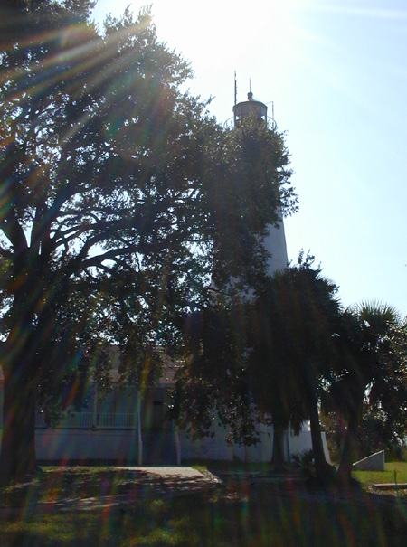
The St. Marks National Wildlife Refuge (NWR) covers nearly 68,000 acres of land along Apalachee Bay, to the south of Tallahassee, Florida. The mission of the refuge is to maintain conservation areas for wildlife populations and their habitats while providing opportunities for wildlife-related recreation and education.
The refuge attracts over 250,000 annual visitors. Refuge activities include a seven-mile wildlife drive, fishing, hunting, bird watching, boating, hiking, and picnicking. The refuge is divided into three administrative units. The St. Marks Unit contains the Visitor Center, and Lighthouse Road with various picnic areas, trails, a boat ramp and the historic St. Marks Lighthouse. The Wakulla Unit contains no facilities, but is open for hunting during the season and offers upland forests, marshes, and a small boat launch. The Panacea Unit is primarily upland pine and oak forests, with several freshwater lakes. Included in this unit are the picnic facilities and small boat launch at Otter Lake. This area is also open for hunting during the season.
In addition, the refuge hosts various events throughout the year that are related to the wildlife populations. A $4.00 entrance fee per vehicle is collected on Lighthouse Road in the St. Marks Unit. Additional charges apply to buses and vans, and at the Aucilla River Boat Ramp.
Attractions along Lighthouse Road in the refuge attract the highest visitation. The St. Marks Lighthouse is located at the mouth of the St. Marks River on Apalachee Bay. The lighthouse is currently owned by the Coast Guard and is used for Coast Guard Auxiliary meetings. The lighthouse is not open to the general public at this time. The refuge staff is currently in negotiation with the U.S. Coast Guard to obtain the ownership of the Lighthouse.
Peak season visitation during fall and spring weekends stress the parking facilities available at the refuge, especially along Lighthouse Road. Lighthouse Road, therefore, would be the most likely to benefit from a future Alternative Transportation System (ATS). Feasible ATS alternatives for the St. Marks NWR include:
- A peak season, weekend shuttle system that operates on a fixed schedule between a potential parking lot located in the town of St. Marks east of the Fort San Marcos historic site and the St. Marks Lighthouse.
- A ferry system on the St. Marks River to transport visitors between the town of St. Marks and the St. Marks Lighthouse.
■ 2.0 Background Information

2.1 Location
St. Marks NWR is located on the shores of Apalachee Bay in northwestern Florida, approximately 20 miles south of Tallahassee, Florida. The refuge is accessed by U.S. 98, also known as Coastal Highway. The closest community to the refuge is St. Marks, Florida located on State Road (S.R.) 363, approximately one and one-half miles south of U.S. 98. The refuge is located in Wakulla, Jefferson, and Taylor Counties (see Figure 2).

2.2 Administration and Classification
The St. Marks NWR is one of 16 wildlife refuges in the state of Florida. The offices for the refuge are located in the refuge on Lighthouse Road, just south of U.S. 98. There are 18 full-time employees located at the refuge.

2.3 Physical Description
The St. Marks NWR is a 68,000-acre site bounded on the south by Apalachee Bay and on the west by U.S. 319. An additional 31,700 acres of Apalachee Bay adjacent to the refuge are closed to hunting by Executive Order. The eastern boundary lies to the east of the Aucilla River. The eastern portion of the refuge is known as the St. Marks Unit, the central portion is known as the Wakulla Unit, and the western portion is known as the Panacea Unit. The refuge contains 85 miles of hiking trails, including 43 miles of the Florida National Scenic Trail, three boat launches and several picnic areas.
Figure 2. Map of St. Marks National Wildlife Refuge
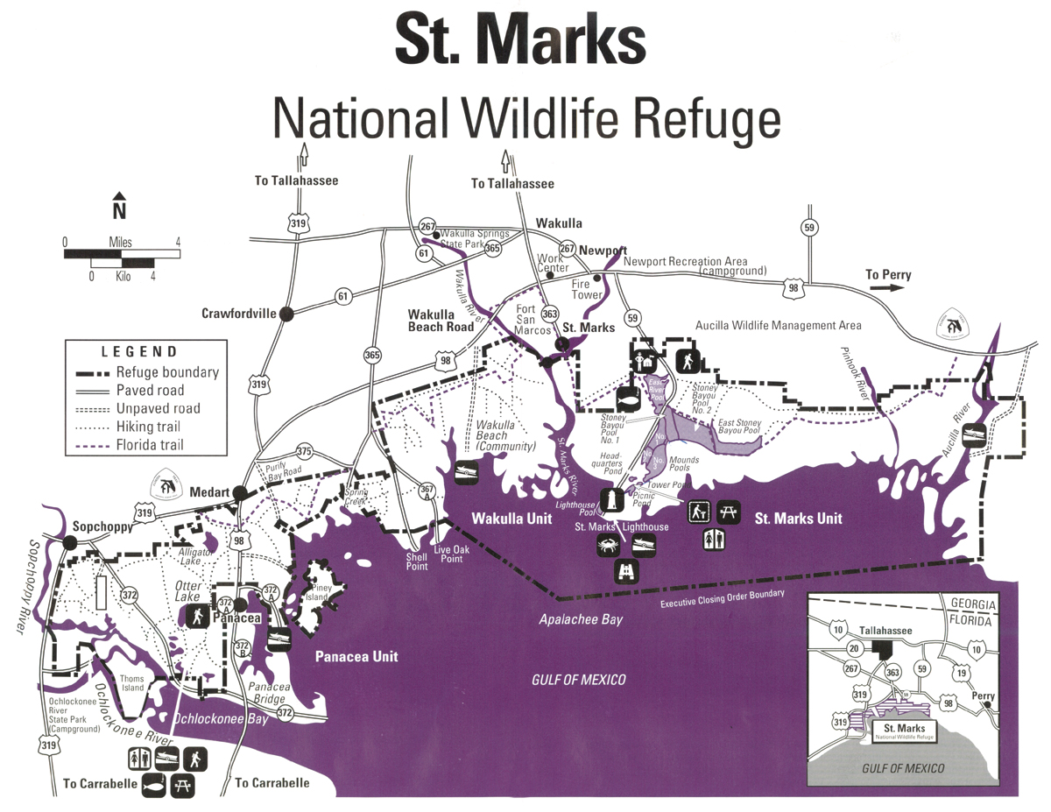

2.4 Mission and Goals of the Refuge
The St. Marks NWR was established in 1931 to provide wintering habitat for migratory birds. It is one of the oldest refuges in the NWR System. It is home to a diverse community of plant and animal life, including Federal and State Threatened and Endangered birds, wildlife, and plants. Species that inhabit the refuge include Southern bald eagle, red-cockaded woodpecker, least tern, woodstork, American alligator, eastern indigo snake, swallow tailed kite, peregrine falcon, and the Florida black bear. The goals and objectives of the refuge are to:
- Provide wintering habitat for waterfowl and other birds;
- Provide habitat for endangered species;
- Provide habitat for resident wildlife species;
- Provide for wildlife dependent recreation and environmental education for the public; and
- Restore and maintain historic landmarks located on the refuge and enhance aesthetics of the landscape.
As with many refuges, there is an inherent dichotomy in the mission of the refuge to maintain conservation areas for wildlife populations and their habitats while providing opportunities for wildlife-related recreation and education. The refuge places priority on the wildlife populations and their habitats and would curb any recreational activity that was detrimental to this primary mission.

2.5 Visitation Levels and Visitor Profile
The estimated number of annual visitors to the St. Marks NWR is over 250,000, primarily day users from the Tallahassee area. Major activities on the refuge include fishing, hiking, and bird watching. The Monarch Butterfly Festival is held each year in October to celebrate the United States’ stopping point of the butterflies as they travel toward warmer climates in Mexico. The refuge also hosts Kids’ Fishing Derbies, Duck Tours, and Night Prowls, where visitors can learn about nocturnal wildlife. The refuge experiences the most visitors during spring and fall weekends. The refuge also provides classroom programs to approximately 6,000 area school children each year.
A $4.00 per vehicle entrance fee is collected along Lighthouse Road in the St. Marks Unit. Commercial buses and vans are charged $25 for 20 visitors or less and $50 for 21 visitors or more. A $2.00 user fee is collected for the boat launch at the Aucilla River Unit.
The Florida National Scenic Trail traverses 43 miles of the refuge. While there are no overnight accommodations in the refuge, hikers with permits may camp along the Florida National Scenic Trail.
In addition, each of the units also contains recreational opportunities. The St. Marks Unit contains the Visitor Center and Lighthouse Road with various picnic areas, trails, a boat ramp and the historic St. Marks Lighthouse. Lighthouse Road is a scenic seven-mile drive that winds through fresh and brackish water impoundments, and ends at the lighthouse on Apalachee Bay. Approximately 195,000 visitors travel to the lighthouse each year, although it is currently not open to the general public. The Wakulla Unit is open for hunting during the season and offers upland forests, marshes, and a small boat launch on the Aucilla River. The Panacea Unit is primarily upland pine and oak forests, with several freshwater lakes. Picnic facilities and a small boat launch are provided at Otter Lake and the area is open for hunting during the season. The Otter Lake area is used primarily by local residents, and less used by day visitors from Tallahassee.
■ 3.0 Existing Conditions, Issues and Concerns

3.1 Transportation Conditions, Issues and Concerns
U.S. 98, a primary arterial traveling through Wakulla, Jefferson, and Taylor Counties provides the primary access for the refuge. The St. Marks Unit contains the Visitor Center, a boat launch, and the St. Marks Lighthouse. This section of the refuge is accessed by Lighthouse Road, a paved, two-lane roadway. This roadway is scheduled to be repaved in the near future. Visitors, often with boats in tow, frequently travel at excessive speeds along Lighthouse Road. During peak visitation periods, parking facilities at the attractions along Lighthouse Road become filled and visitors are forced to park along Lighthouse Road near the parking lots. The boat launch facility can accommodate approximately 30 vehicles with trailers, the lighthouse can accommodate about 15 vehicles, and the picnic/restroom area can accommodate approximately 20 vehicles. The Visitor Center has parking for approximately 20 vehicles. There are several unpaved sites near the Visitor Center that are opened for overflow parking, as needed. Also, the refuge plans to construct additional parking facilities near the picnic area. However, there is almost no available land that can be used to expand the existing parking lots without environmental impacts to wetlands. Also, very little land can be used to develop new parking lots along Lighthouse Road.
Figure 3. Parking at Lighthouse (Left) and Aucilla Boat Ramp (Right)
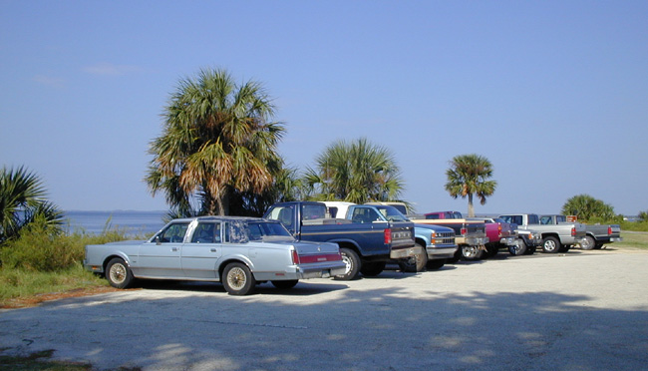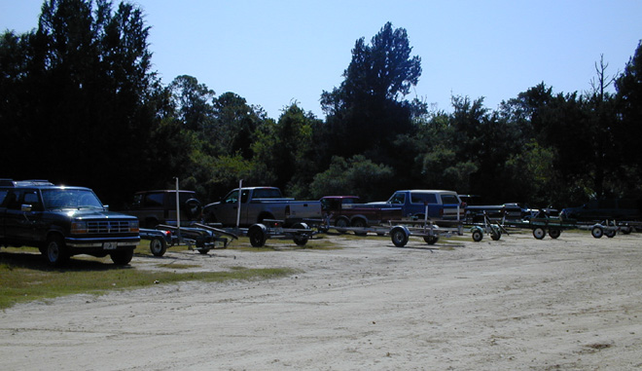
A two-lane unpaved road in good condition accesses the boat ramp on the Aucilla River, at the east boundary of the St. Marks Unit. There is an unpaved parking facility available for approximately 30 vehicles with trailers. Some overflow parking is also provided. Parking availability in this area is generally adequate.
In the Panacea Unit, a substandard two-lane paved road provides access to the Otter Lake picnic grounds and boat ramp. Parking is available for approximately 10-15 cars near the picnic area and approximately five vehicles with trailers near the boat ramp. Parking availability is generally adequate.
Figure 4. Rails to Trails Bikepath in St. Marks (to Tallahassee)
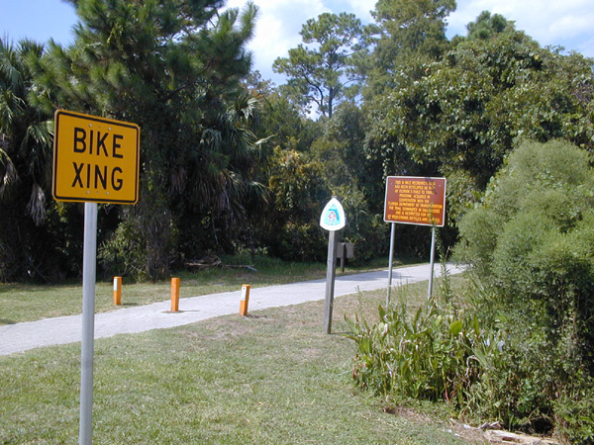
Bicycling is a popular activity in the area and on the refuge. A Rails to Trails bikepath connects Tallahassee with the town of St. Marks, and ends several miles from the refuge Visitor Center. Also, many visitors bring bicycles in by motor vehicle, park at the Visitor Center, and bike along Lighthouse Road to Apalachee Bay. There are also unpaved roads on many of the levees that are for refuge staff use and are open to the public for non-motorized travel. The refuge management would like to widen Lighthouse Road to allow safer bicycle traffic. Widening Lighthouse Road by eight feet (to allow two four-foot bike lanes) would impact 14.4 acres of wetlands, and is considered prohibitive.
The Florida National Scenic Trail also offers visitors a bicycling experience. A portion of the trail ends at the St. Marks River, across the river from the town of St. Marks. Bicyclists and hikers often shout to business owners and patrons and are provided boat rides across the river to gain access to the businesses in St. Marks.

3.2 Community Development Conditions, Issues and Concerns
The population of Wakulla County has doubled in the past eight years, primarily due to Tallahassee commuters who prefer a more rural lifestyle. The town of St. Marks, a designated Enterprise Zone, is the only incorporated area in Wakulla County. The population of St. Marks is approximately 300, but new development in the area is expected to double this population in the next few years. The largest new development in the area is the Villages of St. Marks, which will include over 130 townhomes and apartments, in addition to commercial development. Many of the new residents are anticipated to be commuters who will work in the Tallahassee area.
Figure 5. Rendering of the Villages of St. Marks

The entire town is below the 100-year floodplain, and new development must be raised above that level. The town is also considering the annexation of additional land to the north of the current town limits. St. Joseph Land and Development Company owns approximately 33,000 acres of forest to the north of the town of St. Marks and the refuge, and has discussed developing a portion of their property in conjunction with Arvida. Primex, a subsidiary of the Olen Corporation, owns most of the land to the west of St. Marks.
Employment opportunities in the St. Marks area include an oil refinery, a power plant, and commercial fishing. The Villages of St. Marks will provide additional retail employment opportunities.

3.3 Natural or Cultural Resource Conditions, Issues and Concerns
Conservation of the wildlife and their habitats is the foremost goal of the refuge. Though hunting is allowed on the refuge, this activity controls overpopulation and is monitored and regulated by the refuge. Fishing is controlled by the laws of the state of Florida.
Other than litter, damage to resources at the refuge has been caused by roadside parking and petroleum contamination. There have been incidents of oil waste dumping on the refuge and a barge carrying petroleum products has leaked its cargo into the St. Marks River and impacted the shoreline.
The St. Marks Lighthouse, currently owned by the United States Coast Guard, is an historic landmark located in the refuge. The lighthouse is located on Apalachee Bay near the St. Marks River. The refuge is currently negotiating with the Coast Guard to transfer the lighthouse to the refuge. It is not open to the general public, but is used for occasional Coast Guard Auxiliary meetings.

3.4 Recreation Conditions, Issues and Concerns
Though the refuge’s highest priority is to provide wildlife habitat, another goal of the refuge is to provide wildlife-dependent recreation and education. Visitors to the refuge are able to fish, boat, hunt, and observe bird and other wildlife, hike, and picnic. The refuge hosts organized events during the year, such as the Annual Monarch Butterfly Festival, Duck Tours, Night Prowls (nocturnal wildlife observation tours), and Kids Fishing Derbies. Refuge officials indicated that they are able to accommodate more recreational visitors, but additional motor vehicle parking is not available.
The refuge is considering the prohibition of air boats within its boundaries as an incompatible use. The refuge has also discussed limiting horseback riding on the refuge due to its questionable compatibility with the mission of the refuge.
■ 4.0 Planning and Coordination

4.1 Unit Plans
The St. Marks NWR will be preparing a Comprehensive Conservation Plan in 2001. There is currently no Comprehensive Conservation Plan in effect at St. Marks NWR although the refuge does have single subject management plans in effect for refuge activities such as public use, wildlife conservation, and prescribed burning.
The refuge has been considering the widening of Lighthouse Road to better accommodate bicycle traffic, but environmental concerns have prohibited widening the road to include two four-foot bike lanes. A parking facility near the picnic area on Lighthouse Road will be paved for parking in the near future. The refuge has an approved expansion proposal to add an additional 8,000 acres. This expansion is not currently funded.

4.2 Public and Agency Coordination
The refuge enjoys a very good relationship with the town of St. Marks, as well as the counties of Wakulla, Jefferson, and Taylor. The Aucilla boat launch is managed by Taylor County. The refuge also works closely with the Wakulla Chamber of Commerce, the Wakulla County Tourist Development Council, and the Wakulla County Commission. The refuge also enjoys a good relationship with the Apalachicola National Forest, which bounds the refuge to the west.
The refuge is currently working with the Eastern Federal Lands Division of FHWA to resurface Lighthouse Road. The refuge also has active cooperative agreements with the St. Marks Refuge Association, the Florida Trail Association, the Florida Division of Forestry, and the Tall Timbers Research Station. The refuge continues to communicate with the United States Coast Guard and the Coast Guard Auxiliary regarding the St. Marks Lighthouse.
■ 5.0 Assessment of Need

5.1 Magnitude of Need
Alternative transportation may have potential to enhance the experience of visitors to the refuge, as well as protecting the resources within the refuge. Parking along Lighthouse Road appears to be the primary transportation-related problem associated with the refuge. Opportunities to reduce the need to use private motor vehicles to access the refuge could reduce impacts on the resources of the refuge, as well as enhance the visitor experience by reducing vehicle intrusion in the refuge and ensuring that visitors will gain access to the facilities in the refuge. However, alternative transportation will not reduce the need for additional vehicle/trailer parking facilities at the boat launch along Lighthouse Road.

5.2 Feasible Alternatives
For each alternative, there is the opportunity to use a potential parking lot adjacent to the current commercial area of the town of St. Marks.
- A peak season, weekend shuttle system that operates on a fixed schedule between a potential parking lot located in the town of St. Marks east of the Fort San Marcos historic site and the St. Marks Lighthouse. The parking lot near Fort San Marcos is located near the southern terminus of the Rails to Trails bike trail that connects the city of Tallahassee, Florida with the town of St. Marks. Bicyclists could choose to use the shuttle to travel to Lighthouse Road and avoid riding on U.S. 98, a major arterial highway in the Florida Panhandle. As the shuttle system would be used only on weekends for a limited time during the year, it is possible that school buses and drivers could be used to serve this need, rather than purchasing buses.
- As the St. Marks River connects the town of St. Marks to the St. Marks Lighthouse, a ferry system may also be a feasible alternative to transport visitors between the two sites. Parking could be provided at the facility near Fort San Marcos, as described above. While this would not provide service to points along Lighthouse Road to the north of the lighthouse, it would provide transportation to the lighthouse, the primary visitor attraction along Lighthouse Road. A pontoon style boat of 20-30 feet in length would probably be sufficient to transport passengers and it may appeal to certain visitors as part of the attraction of visiting the refuge.

■ 6.0 Bibliography
Florida State University, St. Marks National Wildlife Refuge Web page, Tallahassee, Florida, 1999.
St. Marks National Wildlife Refuge, Public Use Management Plan (Draft), St. Marks, Florida, 1994.
St. Marks National Wildlife Refuge, St. Marks Light, St. Marks, Florida, Summer/Fall 1999.
U.S. Fish and Wildlife Service, St. Marks National Wildlife Refuge Bird List, St. Marks, Florida, October 1998.
U.S. Fish and Wildlife Service, St. Marks National Wildlife Refuge Reptile, Amphibian, and Mammal List, St. Marks, Florida, October 1998.

■ 7.0 Persons Interviewed
James Burnett, St. Marks National Wildlife Refuge, Manager
Chuck Shields, St. Marks, Florida, Mayor

