MODULE 5

Facilitating Participation

MODULE 5: FACILITATING PARTICIPATION

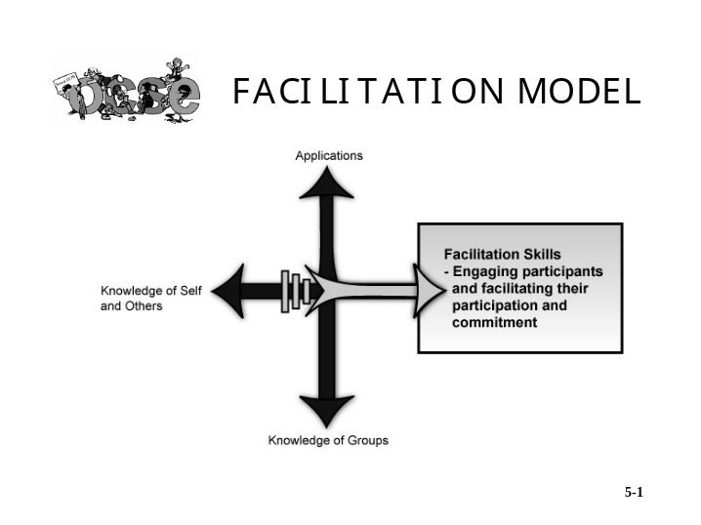

This module will focus on the third element in our Facilitation Model, Facilitation Skills.

Learning Goal

The learning goal for this module is to identify and practice the critical skills that enable facilitators to engage participants and facilitate their participation and commitment.

MODULE 5: FACILITATING PARTICIPATION, CONTINUED

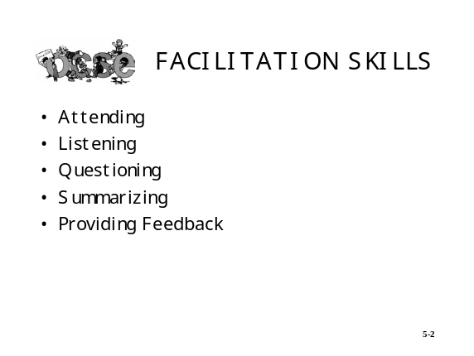

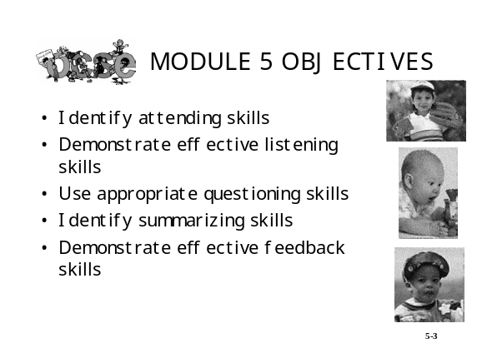

Learning Objectives

- After a demonstration, you will identify the attending skills.

- Through demonstrations and activities, you will use paraphrasing to demonstrate effective listening skills.

- After a brief lecture and participative discussion, you will use appropriate questioning skills.

- Given examples, you will identify summarizing skills.

- Given a model, you will demonstrate effective feedback skills.

EXERCISE: ASSESSING FACILITATION SKILLS

Instructions: Listed below are facilitation skills and behaviors. Rate each item by placing a dot in the appropriate box. When you have rated all the items, draw lines to connect the dots. This will give you a profile of your current ability to facilitate participation. The more your profile leans toward the right, the more able you are to effectively engage and involve participants.

 | Never | Seldom | Occasionally | Frequently | Always
I watch for people’s verbal and nonverbal behavior
I position my body so that I face a group
I give eye contact to others
I scan the group when speaking
I lean or move toward a person/group when speaking
I smile appropriately
I nod affirmatively and/or use short phrases such as “uh huh” to show I’m paying attention
I avoid distracting behaviors
I listen to a person’s words and the message they convey
I verify my understanding of what a person said
I identify internal/external barriers that prevent me from listening effectively
I ask “open-ended” questions (can’t be answered with just a “yes” or “no”)
I state questions in a clear and concise way
I know when to direct a question to an individual or to the group
I know how to handle people’s incorrect answers effectively
I summarize the major points made in a group discussion
I ask for people’s reaction to my summary
I provide specific and timely feedback on behavior and its impact on me and others
I provide constructive criticism without damaging trust and others’ self-esteem

ATTENDING SKILLS

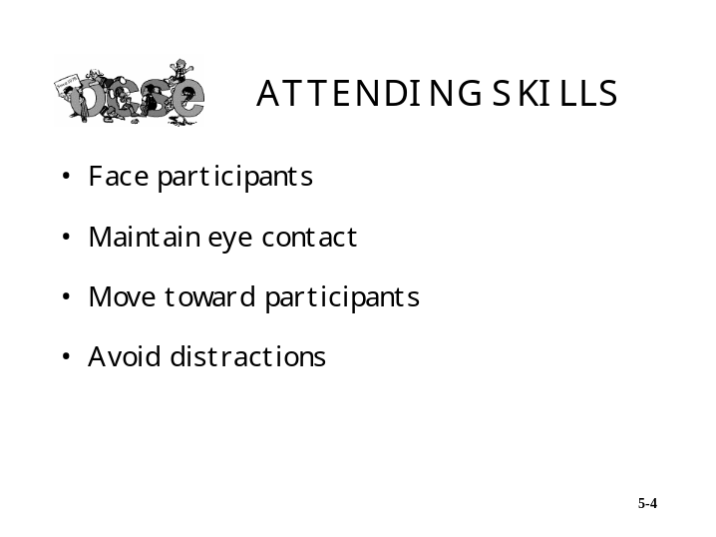

The slide shown above identifies the four attending skills. “Attending” means presenting yourself in a manner that shows you are paying attention to the person or persons speaking. When you use the attending skills, you are building rapport and communicating that you value people and are interested in what they have to say.

Attending goes hand in hand with the observing skills. Your physical positioning enables you to observe people’s behavior that is an important source of information. It also encourages people to interact verbally with you.

NONVERBAL BEHAVIORS AND THEIR POSSIBLE FEELINGS

Behaviors | Possible Feelings
Smiling  Nodding affirmatively  Leaning forward  Eye contact | Enthusiasm/Understanding
Yawning  Vacant stare  Shuffling feet  Leaning back in chair  Looking at clock | Boredom
Frowning  Scratching head  Pursing lips  Vacant stare  Avoiding eye contact | Confusion
Scowling  Frowning  Shaking head “no”  Arms crossed tightly  Fists clenched  Jaw clenched  Leaning back or rocking in chair | Anger/Frustration

RESPONDING TO BEHAVIOR

If the inference you have drawn is … | And … | Then ...
Enthusiasm/Understanding | - Several people display the behavior  - One person displays the behavior | - Continue and make a mental note that process is working.  - Continue and make a mental note to check again later.
Boredom | - Several people display the behavior  - Only one person displays the behavior | - Take a break, speed up the pace, encourage involvement, or share your observations and ask group what would help them to become more involved.  - Continue but make a mental note to reassess later.
Confusion | - Several people display the behavior  - One person displays the behavior | - Share your observations, ask about areas of confusion, and provide clarification by giving examples or rephrasing information.  - Share your observations, ask person about areas of confusion, and provide clarification. If time is limited, talk with person at next break.
Anger/Frustration | - Several people display the behavior  - One person displays the behavior | - Share your observations, ask people to share areas of frustration or source of anger, or ask what might help to improve the situation.  - Share your observations, ask person to share areas of frustration or source of anger, or ask what might help improve the situation.  - Talk privately with the person at next break.

ATTENDING SKILLS, CONTINUED

The table below provides guidelines for you to follow in using attending skills.

DO | DON’T
- Position your body so you face all the group members  - Continually scan the group with your eyes  - Move or walk toward the group  - Smile at individuals  - Look at people while they are talking  - Nod affirmatively  - Circle the room during sub-group activities to check progress  - Use natural facial expressions in talking with an individual or entire group | - Talk to a flipchart, white board, or other visual aid  - Turn your back to part of the group  - Stare at individuals  - Avoid eye contact  - Scan the group too rapidly  - Put too much distance between you and others  - Stand in fixed positions  - Shuffle papers, look at your watch, or display distracting behaviors while someone is talking  - Look judgmental

LISTENING SKILLS

Listening, as we define it, means obtaining verbal information and verifying that you understand the information. Listening skills enable you to demonstrate your understanding of what others have said. They also provide you with verbal feedback about how people are responding to what is going on in the group so that you can determine how to proceed.

The slide below lists the two key steps in listening effectively.

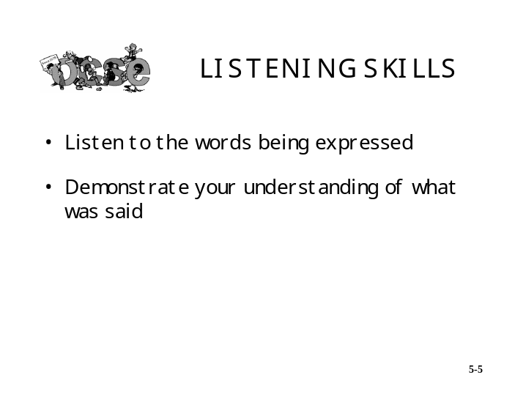

Step 1: Listen to the words being expressed.

As you listen to the words being expressed, try to grasp both the content and the meaning of the words from the person’s perspective. While this may sound simple, you will find that the major roadblocks to listening to the person’s words are the internal and external distractions that compete with good listening habits.

Internal distractions are the competing thoughts that develop inside you while the person is talking. Sometimes they relate to what the person is saying; sometimes they are mental excursions to unrelated topics. You must eliminate these distractions that keep you from focusing on what the person is saying.

External distractions are things that happen in the environment that compete for your attention. They can be sights or sounds. Exclude them or, at the least, put them out of your mind until the person has finished speaking.

Once you have focused on the person’s message, you can then proceed to the next step—demonstrating your understanding of what the person said.

Step 2: Paraphrase what was said to demonstrate understanding.

Paraphrasing to demonstrate understanding requires you to verbally interact with the person. The interaction is either to:

- Get additional information you’re missing, or
- Verify with the person what you think was said.
LISTENING SKILLS, CONTINUED

Use a phrase such as “You’re saying …” or “As I understand it …” before paraphrasing what the person said. If you then paraphrase the information accurately, the person can confirm that you have demonstrated understanding. If you paraphrase inaccurately or miss important details, the person can add the information you need to understand.

LISTENING SKILL: PARAPHRASING

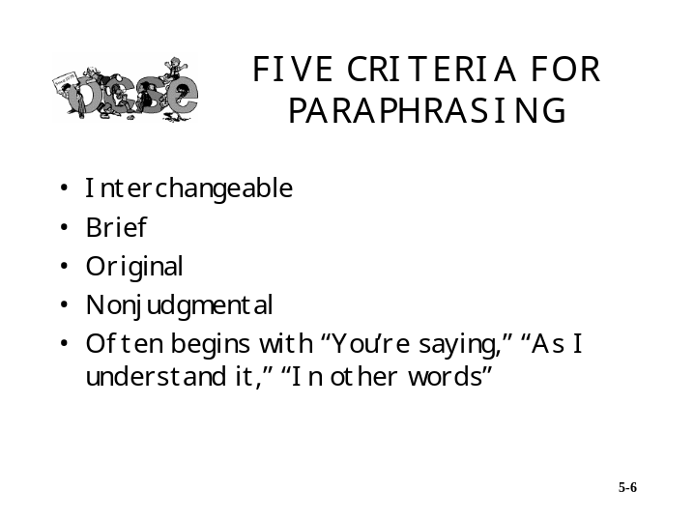

Use the five criteria to help you develop effective paraphrase statements. Good paraphrases are:

- Interchangeable—You are not elaborating on or taking away from the person’s message.

- Brief—A lengthy paraphrase statement means you’re probably conveying your own perspective rather than paraphrasing the person’s statement.

- Original—Use your own words to convey your understanding. Do not “parrotphrase.”

- Nonjudgmental—Your paraphrase statement should not convey approval or disapproval. You’re demonstrating understanding, not expressing agreement or disagreement.

- Often ones that begin with “You’re saying …,” “As I understand it …,” “In other words …,” “It sounds like …,” or “I heard you saying ….”

EXERCISE: USING LISTENING SKILLS

Part 1

Instructions: Review the criteria for effective paraphrasing on page 5-10. Then write a paraphrase response to each of the statements listed below. Begin your paraphrase with “You’re saying …,” “In other words …,” etc.

Statement 1 “We need refresher training on the revised version of the database. If we had the training, we’d be aware of the changes that have been made and be able to process our cases faster.”

Statement 2 “The new phone system will reduce interruptions while making sure I don’t miss any of the calls.”

Statement 3 “It’s hard getting the data I need and I’m not sure I’ll be ready for the meeting.”

QUESTIONING SKILLS

Questions play a major role in facilitating participation. Questions can help you engage people and get them involved in what is going on in the group.

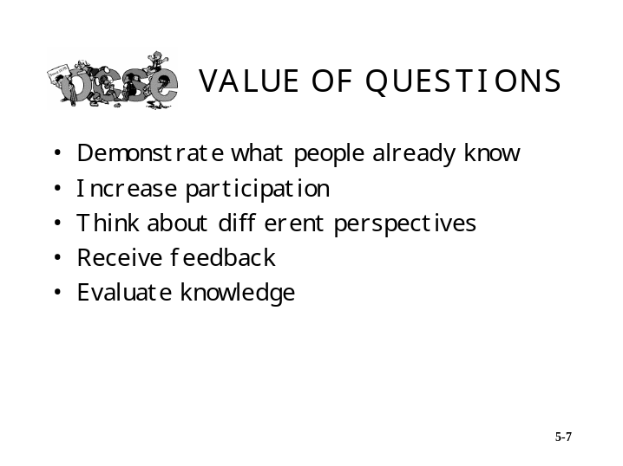

As the above slide indicates, questions can help you to determine what people already know about a subject so you can focus on what they need to learn or what additional information must be gathered. Questions also encourage people to participate. They get people to think about perspectives or opinions that may be different than their own. Effective questions also provide you with information about how people are reacting to what’s going on in a group. Lastly, questions enable people to evaluate what they know and don’t know and fill in the gaps.

QUESTIONING SKILLS, CONTINUED

The slide below identifies the three major aspects associated with the questioning process.

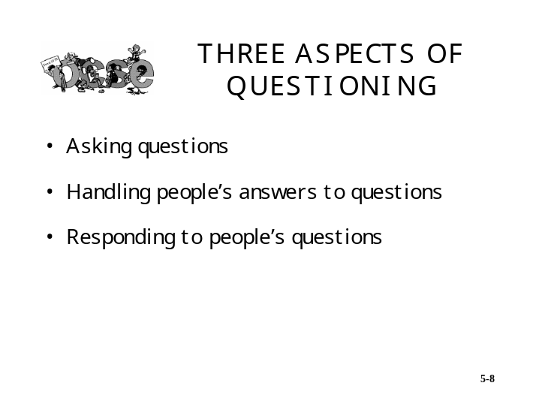

QUESTIONING SKILLS: ASPECT 1—ASKING QUESTIONS

Asking effective questions is one of the most important skills you can develop. Asking effective questions means selecting the right type of question, phrasing it so it elicits the response you’re after, and then directing the question accordingly.

There are two basic types of questions from which to choose—open questions and closed questions. The table below gives a brief description and an example of each.

TYPES OF QUESTIONS

Type of Question | Description | Example
Open | - Requires more than a “yes” or “no” or one-word answer  - Stimulates thinking  - Elicits discussion  - Usually begins with “what,” “how,” “when,” or “why” | “What ideas do you have for explaining the policy changes to our clients?”
Closed | - Requires a one-word answer  - Closes off discussion  - Usually begins with “is,” “can,” how many,” or “does” | “Does everyone understand the changes we discussed?”

QUESTIONING SKILLS: ASPECT 1—ASKING QUESTIONS, CONTINUED

PHRASING QUESTIONS

Once you have decided on the type of question you will use, you need to determine how you will phrase it. There are important considerations in phrasing questions so that the person or group will focus on the precise information you are trying to obtain. The following information will serve as a guideline for you to use when phrasing your questions.

Guidelines for Phrasing Questions

Do | Don’t
Ask clear, concise, and simply worded questions covering a single issue | Ask rambling, ambiguous, complexly worded questions covering multiple issues
Ask reasonable questions based on what people can be expected to know at that point | Ask questions that are too difficult for the majority of people to answer
Ask challenging questions that require thought | Ask questions that are too easy and provide no opportunity for thinking
Ask honest, relevant questions that direct people to logical answers | Ask “trick” questions designed to be potentially embarrassing or self-incriminating

QUESTIONING SKILLS: ASPECT 1—ASKING QUESTIONS, CONTINUED

DIRECTING QUESTIONS

The final consideration in asking effective questions is how to direct your question. There are two ways to direct questions:

- To the group

- To a specific individual.

The chart below can help you decide how to direct your questions.

Choosing How To Direct Questions

If you want to … | Then …
Stimulate all people in a group to think  Allow people to respond voluntarily  Avoid putting an individual on the spot | Direct the question to the group  Example:  “What experiences have you had implementing these regulations?”
Stimulate an individual to think and respond  Tap the known resources of an “SME” or “expert” in the group | Direct the question to an individual  Example:  “Lee, you’ve had a lot of experience applying these regulations with clients. What would you do in this case?”

QUESTIONING SKILLS: ASPECT 2—HANDLING ANSWERS TO YOUR QUESTIONS

The second skill associated with the questioning process involves the way in which you handle responses to your questions. The skill is applicable to different facilitation situations and is particularly helpful when you are training or making a presentation. The way in which you respond to a person’s answer has an impact not only on that person but also on the amount of future participation you can expect from other people in the group.

Some ways to handle responses and still maintain a high level of participation are to:

- Use positive reinforcement for those who respond to your questions.

- Acknowledge the person’s effort. In those instances where there is a correct answer, acknowledge the effort regardless of whether the answer is right or wrong.

- Minimize potential embarrassment for wrong or incomplete answers.

The following chart provides some tips for handling responses to your questions.

IF THE PERSON’S RESPONSE IS:
Correct | Incorrect | Partly Correct
Use positive reinforcement  Examples:  “Yes.”  “Good point.”  “That’s right.” | Acknowledge the effort  Then:  - Redirect the question to others or answer it yourself.  Examples:  - “I can see how you might come up with that. Who else has an idea?”  - “That’s not exactly what I was looking for. What I was looking for was ___________.” | Reinforce the correct portion  Then:  - Redirect the question to the same person, to another person, or answer it yourself.  Examples:  - “You’re on the right track. What other ideas do you have?”  - “That’s one good point, Jim. Who else has some ideas?”

QUESTIONING SKILLS: ASPECT 3—RESPONDING TO QUESTIONS

The third skill associated with the questioning process involves responding to questions from the group. Questions can provide an opportunity to maximize an entire group’s learning, as well as that of the person asking the question. The way in which you respond to people’s questions also affects whether people feel free to ask future questions.

There are three acceptable ways to respond to questions. They are to:

- Provide the answer yourself

- Redirect the question to another person

- Defer the question.

The chart below provides guidelines for deciding on the appropriate response.

RESPONDING TO QUESTIONS

Choose the following response: | When …
Provide the answer yourself | You are the only person who can provide the answer
Redirect the question back to the same person or to another individual | There is a high probability that the person will be able to come up with the answer
Defer the question | The question is beyond the scope of the group’s work  The question cannot be handled in the allotted time frame  The answer will be provided by material/information covered later  You need time to get the answer and get back to the individual or group

EXERCISE: USING QUESTIONING SKILLS

Instructions: Three typical facilitation situations are described below. Write the response that you would make for each situation. Refer to your reading for help in completing your responses.

Situation 1:

There has been considerable difficulty with caseworkers using the statewide-automated child support enforcement system. You are facilitating a meeting of caseworkers to help them analyze the problem and recommend solutions. You want to first find out their current knowledge and/or experience with the system.

Develop a question that will accomplish this goal.

Situation 2:

You are presenting a workshop on the Personal Responsibility and Work Opportunity Reconciliation Act of 1996 (PRWORA). During your training, you ask that people name the types of information state agencies have access to. One of the participants volunteers one type of information, financial records.

Develop your response to the participant.

Situation 3:

You are facilitating a work group that is tasked with improving customer service. One of the group members asks you, “How can we expect people to get their work done and still provide good service to our customers?”

Develop your response to the question.

SUMMARIZING SKILLS

Summarizing skills are another important tool of an effective facilitator. Summarizing is simply reviewing information the group has already heard and asking for a response. You want to use summarizing to help you close a discussion or topic and move on to the next one and/or at the end of a meeting. The slides shown below identify the two steps involved in summarizing and provide some examples.

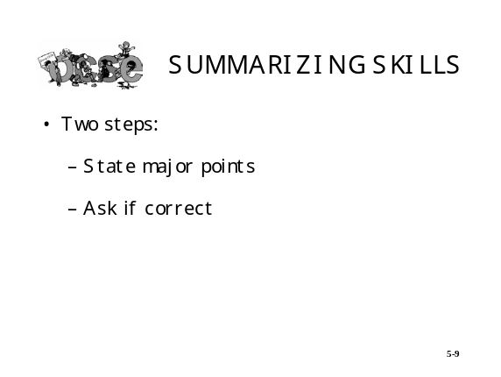

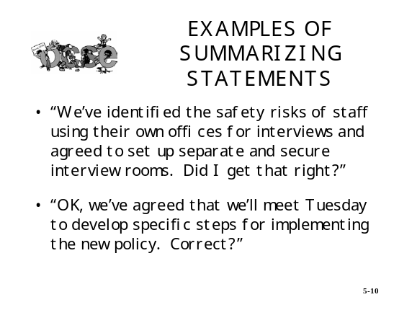

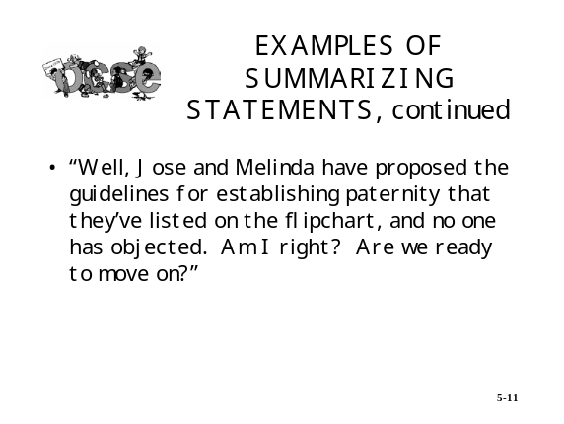

EXERCISE: FACILITATING PARTICIPATION

Instructions: In this exercise, you will practice using the skills of attending, listening, questioning, and summarizing to facilitate a group discussion. The roles of facilitator, group members, and observer will rotate so that everyone has an opportunity to practice the skills.

The first thing your group is to decide is what topic they will discuss. Then the group is to choose roles. When you are the observer, use Handout 5-1 to record your observations and provide feedback to the facilitator.

The first facilitator will begin the discussion and take 10 minutes to practice the skills. After 10 minutes, the group is to stop the discussion and begin the feedback session. Use the following process to guide your feedback session. It should take no more than 5 minutes.

- The facilitators will begin the process by sharing what they felt they did well, what was most difficult for them, and what they might do differently.

- The observers will then use the worksheet to provide feedback to the facilitators.

- The group members will provide any additional feedback on what the facilitators did that helped and/or hindered their participation in the group discussion.

After the feedback session is complete, choose another topic (or continue with the same one if the group agrees), assign roles, and begin the second discussion. Repeat this process, including the feedback session, until each person in the group has facilitated once and observed once.

Possible topics for discussion include:

- The Fatherhood Program

- Case closures

- Recruiting, retaining, and rewarding qualified staff

- Language and cultural impact on services

- Faith-based initiatives.

FEEDBACK SKILLS

The ability to provide effective feedback is another important facilitation skill. Feedback is information that you give to another that focuses on his or her behavior. It lets people “know how they are doing.” As a facilitator, you use feedback to help shape people’s behavior so that they perform in a way that helps the group or team meet its goals. The important thing to keep in mind when faced with a feedback situation is the outcome you intend to accomplish. The slide below identifies the three feedback options and intended outcomes.

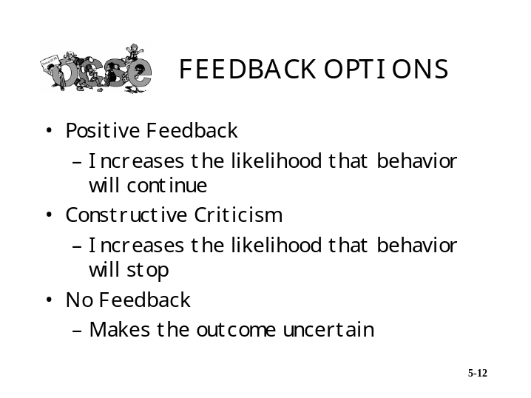

FEEDBACK SKILLS: CHARACTERISTICS OF EFFECTIVE FEEDBACK

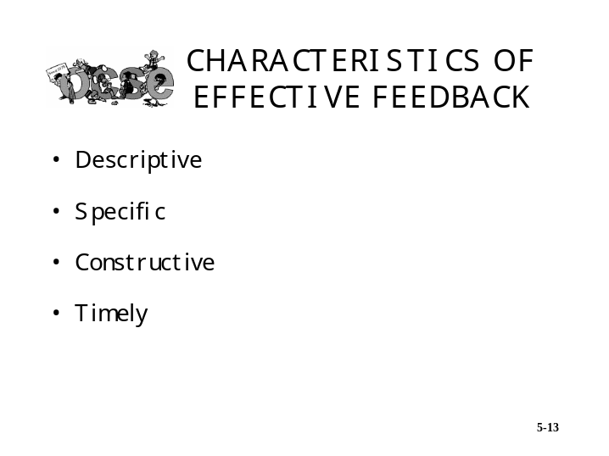

- Descriptive—The feedback should focus on describing the behavior and should avoid inferences and opinions.

- Specific—Specific details about the behavior should be provided, not vague generalities.

- Constructive—It should provide guidance as to future performance desired so that the person knows what to begin doing or do more of/less of.

- Timely—It should be provided as close to the performance as possible so that it is meaningful to the person and can be integrated into future performance as soon as possible.

FEEDBACK SKILL: POSITIVE FEEDBACK

People are usually more comfortable giving feedback to others when it is positive. Remember, it’s important to give positive feedback to individuals as well as an entire group on the behaviors that help get the job done and the way members work together. Giving positive feedback helps to shape people’s behavior by providing positive consequences when the behavior is desirable; the positive feedback is a positive consequence. It’s important to give feedback on the small steps or subtasks completed, not just the total task or end result. This keeps everyone working in a positive direction. This is particularly important for a new team or work group. Feedback should also be given for effort and risk taking even when the desired results are not achieved.

Effective positive feedback covers the following two points:

- What you liked
- Why you liked it.

FEEDBACK SKILL: CONSTRUCTIVE CRITICISM

Constructive criticism is another type of feedback. It helps to shape an individual’s or an entire team’s behavior by discouraging undesirable behavior. When used properly, it not only reduces or eliminates the behavior, but also maintains self-esteem at the same time. Constructive criticism can be used as a developmental tool and also to help set standards for behavior. An excellent way to give constructive criticism is to use the RISC Model.

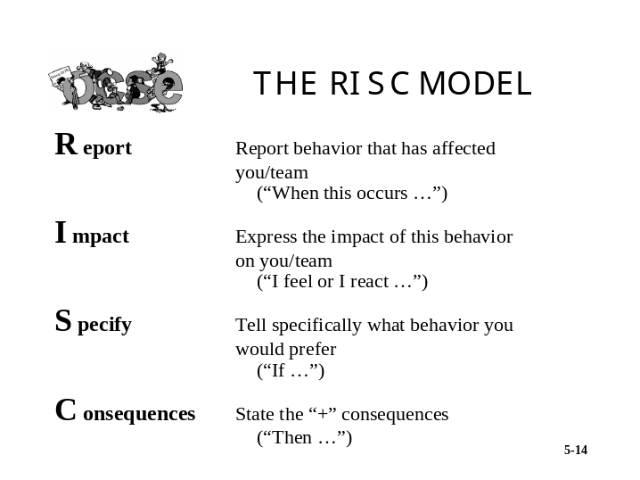

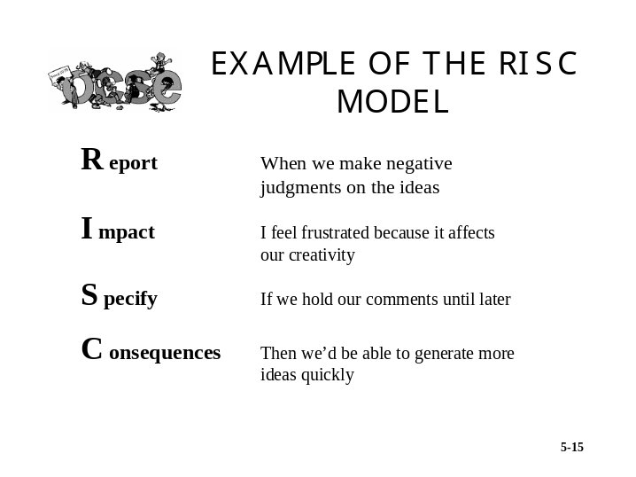

EXERCISE: WRITING RISC STATEMENTS

Part 1:

Instructions: Working individually, read the situations below and write a RISC statement for each. Once you complete this step, you will be asked to share your statements with a partner and check that each of the steps has been followed.

Situation 1:

You are facilitating a group meeting to finalize preparations for a special event. Each person had an assignment to complete by the meeting date. However, several members who had critical assignments have just said that they didn’t have time to get their assignments completed.

R When

I I feel

S If

C Then

Situation 2:

You are in a staff meeting discussing next year’s budget. Out of the blue, your manager turns to you and says, “Speaking of budget, remind me to talk to you later about those unrealistic estimates you gave me.” Needless to say, you’re angry and embarrassed and can’t concentrate during the rest of the meeting. You decide to say something to your manager after the meeting.

R When

I I feel

S If

C Then

EXERCISE: WRITING RISC STATEMENTS, CONTINUED

Part 2:

Instructions: Identify a real-life situation where you want to provide constructive criticism. Use the RISC Model below to prepare your statement. Once you’ve completed your statement, you will be asked to work in your table group to share ideas and suggestions for improving statements if necessary.

R When

I I feel

S If

C Then

MODULE 5 KEY POINT

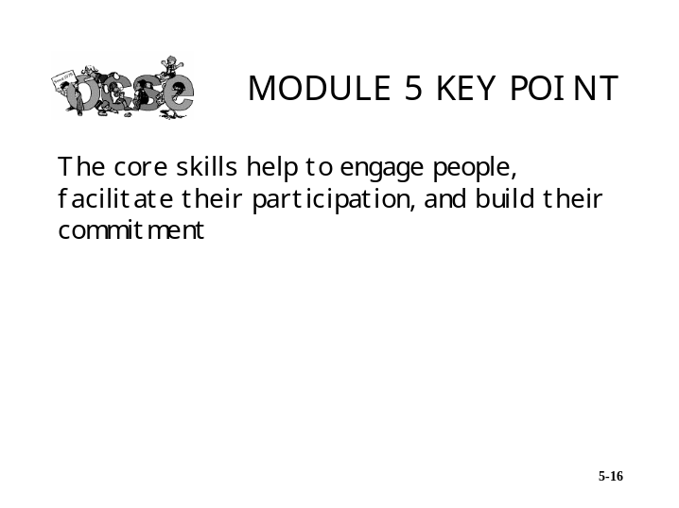

EXERCISE: REFLECTION

Instructions: You have learned and practiced the core facilitation skills. Take about 15 minutes to reflect on what you have learned and answer the questions below. It may be helpful to review the worksheets you completed throughout this module.

- What skill areas do you feel strongest in now and are you able to model for others?

- What skill areas do you want to improve?

- What support do you need and from whom?

